Finger vs Chest ECG: First Agreement Result
29 September 2026 · Dhruv · ESP32 ECG Ring project

Result
A fingertip ECG lead measured the same heartbeats as a chest lead to within 0.11 bpm and 0.2 ms per interval, over 2 minutes recorded simultaneously on 29 September 2026.
Measure | Value | Month-1 target
Beat sensitivity (Se) | 99.44% | —
Positive predictivity (P+) | 98.90% | —
Heart-rate bias (finger − chest) | −0.11 bpm | under 2 bpm
95% limits of agreement | −1.66 to +1.43 bpm | within ±5 bpm
ICC(2,1) | 0.955 | —
Lin's concordance (CCC) | 0.950 | —
RR-interval bias | −0.18 ms | —
RR limits of agreement | −10.4 to +10.1 ms | —
RMSSD | 36.2 ms chest, 37.3 ms finger | —
Of 180 chest beats in the 105 seconds both recordings share, the finger lead found 179, missed 1 and added 2. Both boards ran identical firmware at 256 samples/s, so the only difference between them was where the electrodes sat.
This is one subject, one posture, at rest, with the hands held still. It is the first valid data point, not a validation study.

How it was measured
Two boards recorded one person at the same time, one at each site, with everything except the electrode site held identical.
 | Chest (reference) | Fingers (device under test)
Board | ESP32-C3 + MAX30003 breakout | ESP32-WROOM-32 + MAX30003 PCB
Link to laptop | native USB | USB-UART bridge, 460800 baud
Cable | 3-wire (2 measurement + 1 reference) | 3-wire (2 measurement + 1 reference)
Sample rate | 256/s | 256/s
Firmware | same sketch.ino build | same sketch.ino build
The firmware is one source file for both boards, with only the pin numbers chosen at compile time. If the two devices ran different code, any difference found could be the code rather than the site, and the experiment would mean nothing.
Timing comes from the sample index, not the host clock. Each MAX30003 times its own samples from a 32.768 kHz crystal, so sample N was taken at N/256 seconds on that board’s clock. The laptop’s timestamps are only used for coarse alignment, because USB delivery jitter is tens of milliseconds.
Each board’s index counts from its own power-on, so the two clocks start minutes apart. The recording software stamps every sample with host time, which gives a rough common origin; the beat trains themselves then refine it. Measured on this recording: the boards sit 0.13 to 0.18 s apart (host-path latency, since native USB and a UART bridge deliver at different speeds) and their crystals differ by −67 ± 28 ppm, which is 7.4 ms of relative drift over the 2 minutes. Neither affects the agreement numbers, because heart rate and RR intervals are differences, and a constant offset cancels in a difference.

Why a two-electrode cable does not work
An ECG amplifier measures the difference between two electrodes, but it can only do that if it also knows roughly where your body sits relative to its own supply. With two electrodes it does not, and mains hum takes over.
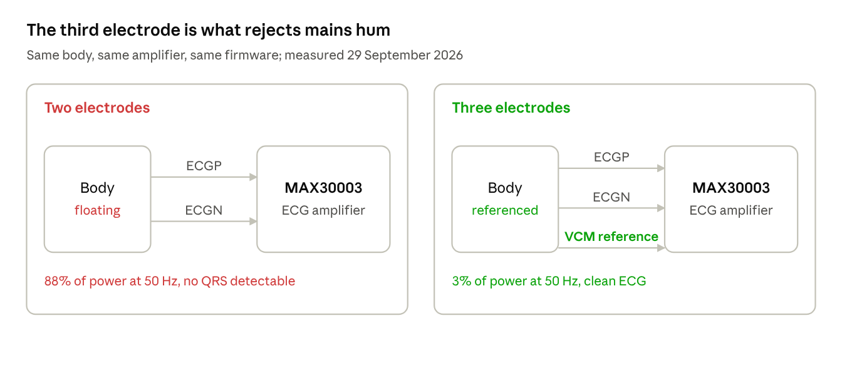
Two-electrode versus three-electrode connection.
With only two wires, the body floats. It acts as an antenna for the 50 Hz wiring in the room, and that hum arrives on both inputs at once. An amplifier rejects a signal common to both inputs only while its inputs stay inside their working range; a floating body drifts out of it, and the rejection collapses. The third electrode ties the body to the amplifier’s own reference voltage (VCM), which holds it in range.

What we measured
Each row is a 15-second capture taken during one afternoon, same person, same room, same boards.
Setup | Power at 45–55 Hz | Power at 5–15 Hz (QRS) | kSQI | Outcome
Fingers, 3 wires | 0.4% | 4.2% | 7.5 | clean ECG
Fingers, third clip removed | 43.2% | 0.6% | 4.3 | noise
Chest, 2-wire cable | 88.0% | 1.2% | 3.8 | noise
Chest, 3-wire cable | 3.3% | 37.4% | 20.5 | clean ECG
Removing one clip from an otherwise working finger recording raised mains interference from 0.4% to 43.2% of total power. Nothing else changed.

The jack makes it worse than it looks
Both boards use a three-contact socket wired the same way: tip to ECGP through 49.9 kΩ, ring to ECGN through 49.9 kΩ, sleeve straight to VCM. A two-conductor plug pushed into that socket shorts the ring to the sleeve, so ECGN is tied to VCM. The amplifier is then not making a differential measurement at all — it compares one electrode against its own reference. That works while nothing else disturbs the body, which is why the two-wire cable appeared to work early in the day and failed later.
Both sites need a reference electrode. The practical rule for the ring: a two-contact finger design cannot work, and the third contact has to be planned into the mechanical design rather than added later.

Every metric, and how it is computed
Each number below answers a different question, and each is computed from the recordings by agreement.py and analyze.py.

Step 0: integrity, before anything derived from it
No measurement below means anything if samples went missing, so integrity is checked first: every sample carries an index, and the index must advance by exactly one. Gaps, duplicates and backwards jumps are counted, and only the longest unbroken run is analysed. A gap cannot simply be closed up, because the step it leaves behind makes the filters ring and the beat detector reads that as a beat. On this recording: chest 0 missing, finger 3 missing (0.01%).

Sensitivity and positive predictivity
A detection counts as correct if a reference beat lies within 150 ms of it, the tolerance the ANSI/AAMI EC57 standard sets. Each reference beat can be claimed only once, so a detector firing ten times on one beat scores one hit and nine false alarms.
Se = TP / (TP + FN) P+ = TP / (TP + FP)
Se is the share of real beats that were found: it measures misses. P+ is the share of reported beats that were real: it measures false alarms. They trade against each other, so both are always reported.
"Accuracy" is never used. It needs a count of true negatives, and at 256 samples/s roughly 255 of every 256 samples are non-beats, so a detector that reports nothing at all scores 99.6%.

Bland–Altman: bias and limits of agreement
Heart rate is computed per 10-second window as 60 divided by the median RR interval in that window, on both devices, and the two series are compared.
bias = mean(a − b) LoA = bias ± 1.96 × SD(a − b)
Bias is the average disagreement: does the finger read systematically high or low? Limits of agreement are where 95% of individual disagreements fall. Bias alone is misleading, because a device that reads 10 bpm high half the time and 10 bpm low the other half has zero bias.
The median is used rather than the mean inside each window because one missed beat doubles a single RR interval and would drag a mean-based heart rate by several bpm. Missed beats are already reported honestly as sensitivity; letting them corrupt the heart rate too would count the same failure twice.

ICC and Lin’s CCC, and why not correlation
CCC = 2·cov(a,b) / [ var(a) + var(b) + (mean(a) − mean(b))² ]
Lin’s concordance is 1 only when the points lie on the 45° identity line. ICC(2,1) is the two-way random-effects intraclass correlation for absolute agreement, computed from the ANOVA mean squares across windows and devices. Both punish a systematic offset.
Pearson’s r does not, and this is the trap the plan warns about: a device reading exactly 20 bpm too high every time correlates perfectly, r = 1.0, while being useless. That is why r is reported last and never alone.

RR-interval agreement
RR intervals are the gaps between consecutive beats, in milliseconds, and every HRV measure is built from them. Only consecutive matched pairs are compared, since a skipped beat would fake one huge interval. RMSSD, the root mean square of successive differences, is reported for each device as a first HRV cross-check.

Signal quality: kSQI, pSQI, bSQI
These decide whether a recording deserves to be interpreted at all, and need no reference recording, which is what makes them usable on the ring where no ground truth exists.
kSQI = mean((x − x̄)⁴) / mean((x − x̄)²)² pSQI = Σ y²(5–15 Hz) / Σ y²(filtered)
kSQI is kurtosis. Gaussian noise scores exactly 3; clean ECG is mostly flat baseline punctuated by rare tall R-peaks, so it scores far higher. It was the single most useful number today: a channel reading 3.0 was noise every time, and one reading 13 to 20 was always real ECG.
pSQI is the share of power in the 5–15 Hz band where QRS energy lives. bSQI is the agreement between two independent detectors, which converge on real beats and diverge on noise; it exists in the benchmark but not yet on the phone.
Our thresholds are not calibrated. The finger channel was flagged "marginal" on pSQI (0.024, against a 0.05 bar) in the pre-check and then delivered 99.44% sensitivity. Its slow baseline movement inflated the denominator without touching the beats. The thresholds come from published convention and need fitting to our own hardware.

Mains share
Computed from a Welch power spectrum as the fraction of power between 45 and 55 Hz. It is not a quality index but a diagnostic: it names the interference directly, and it is what identified the electrode problem described above.

Figures
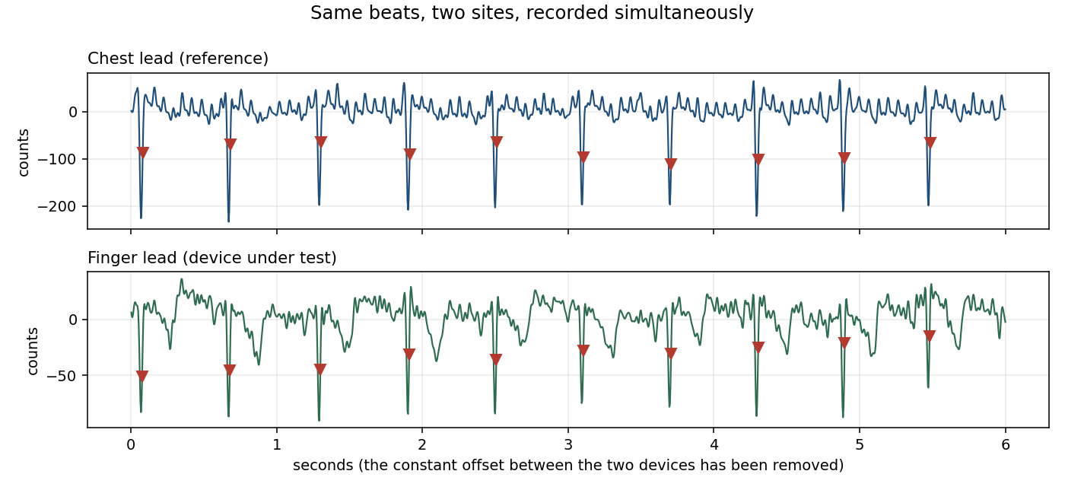
Six seconds from the middle of the recording, both devices on one time base. Every beat the chest lead sees, the finger lead sees, within the matching window. The chest R-peaks reach about 220 counts and the finger’s about 90 — the cost of the site: the finger lead catches a much smaller projection of the heart’s electrical axis.
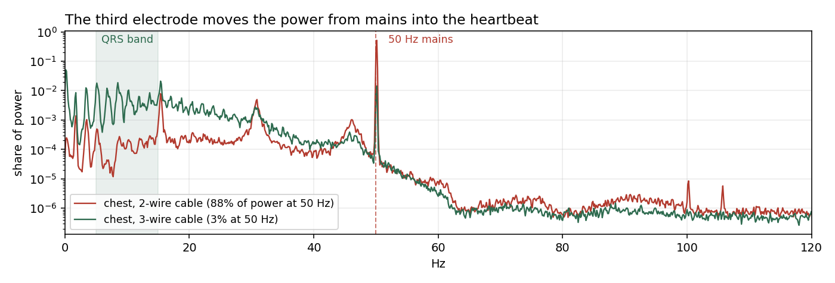
The same chest lead, same person, two cables. With two wires almost all the power sits on the 50 Hz line; with three it sits in the 5–15 Hz band where the QRS lives. The filter chain notches 50 Hz either way, but a signal that is 88% hum before filtering has almost nothing left underneath it.

Three defects fixed to get here
The first attempt at this recording produced 10 beats in 4.5 minutes. Three separate faults had to be found before the numbers above were possible.

The beat detector could deadlock, silently
Pan–Tompkins learns a threshold from the signal’s early samples. Attaching an electrode produces a step far larger than any R-peak, which sets the signal-peak estimate enormously high. Our version could never recover: its search-back rescue needs an RR history, and with zero beats found no history is ever built. The detector then produced nothing for the rest of the recording, without any error.
The fix halves the signal-peak estimate once a second whenever no beat has been seen for 3 seconds, which is below 20 bpm and therefore impossible. Recovery is geometric, so it comes back within seconds of any artifact however large.
Re-running the MIT-BIH benchmark confirmed it costs nothing on clean data: Se 98.50% / P+ 97.31%, against 98.49% / 97.31% before the change, over 12 records and 27,574 annotated beats.
MIT-BIH never exposed this because those records start already settled. BeatDetector.kt on the phone still has the original logic, so one large artifact at the start of a session would silently kill beat detection for that whole session. Porting the fix is the next code change.

Alignment assumed a shared clock that does not exist
The analysis first put both devices on index / 256 and searched ±30 s for the offset between them. But each board’s index counts from its own power-on, and these two were flashed minutes apart, so the true offset was minutes. The search locked onto a wrong alignment, the beat trains ended up with no overlap, and the code crashed on an empty array. It now aligns on the host timestamps that the recorder already saved, and refines from there.

Sensitivity was scored over the wrong window
When one recording is longer than the other, every reference beat outside the shorter one counts as a miss. On a self-test where both streams carried the same ECG, this reported 65% sensitivity instead of 98%. Beats are now scored only over the period the two recordings share.

What this does not show, and what comes next
The result covers one subject, one posture, 2 minutes, at rest, with the hands deliberately still and one electrode configuration. It shows the approach can work; it does not show how often it works.
Four specific limits:
- No motion condition. The finger site is expected to fail under movement, and that is where the real contribution lies. The one large baseline swing in this recording came from a small hand movement.
- Identical devices cannot catch a shared error. Both boards use the same AFE, firmware and detector, so a fault common to both would appear as perfect agreement. A different reference instrument is needed to rule that out.
- Both leads are non-standard. The chest pair is not a clinical Lead II and the finger pair is not a clinical Lead I, so the morphology is not comparable to a diagnostic ECG. Timing is what these numbers describe.
- The recording took an afternoon of hardware debugging to obtain, which is itself a finding: reliability of the electrode setup, not the algorithm, is the limiting factor today.

Next
- Port the threshold-decay fix into BeatDetector.kt so the phone cannot deadlock
- Repeat at 5 minutes, several subjects, and add a light-motion condition
- Calibrate the kSQI and pSQI thresholds against these recordings instead of published convention
- Record with a second reference electrode arrangement to test the two-device interaction properly

