DEBT MANAGEMENT DATABASE

Abstract

The debt management database is a project aimed at creating a debt management database to be utilized by the SMEs. The main objective is to have a centralized place where all the information regarding debt is stored accurately and, in this way, the process of managing debts will be more efficient.

By Mercy Ogero

ogeromerci@gmail.com

# **DEBT MANAGEMENT DATABASE PROJECT**

## **1.0 INTRODUCTION**

## **1.1 Defining the Problem**

Micro, Small, and Medium Enterprises (MSMEs) are important drivers of the economy by providing employment, reducing poverty, and generating income. However, these enterprises face a huge challenge, especially in debt management. Most of these businesses use traditional methods to record debtors, like the paper-based system, ledgers, and even physical books. Such traditional methods come with their limitations in that it is easy to lose such records. The following are the reasons that have prompted this initiative:

* Lack of a centralized tracking place where all the data regarding debts including the debt defaulters and the bad debts are recorded.
* Poor tracking of debts has led to inefficiency and errors.
* Limited reporting on debt-related matters in the SMEs due to unorganized information.
* Discrepancies in the current data recorded have led to poor decision-making and financial planning.
* Increased security risks lead to a possibility of a data breach with the traditional methods of recording data.

## **1.2 Defining the Solution**

Inspired by the Central Bank of Kenya (CBK) listings of all the debt defaulters, the proposed database will also work in an almost similar manner. With these records in place, clients who have a habit of taking goods on credit and failing to pay can be avoided. The solution given will serve the SMEs by creating a central database where all the information regarding bad debts is stored. The following are the solutions that will be implemented:

* Implementing a centralized tracking place where all the data regarding bad debts are stored
* Proper tracking of debts and related information thereby eliminating errors
* Enhanced reporting on debt-related matters in the SMEs due to organized information.
* Eliminating discrepancies in the debt related data thereby leading to better decision-making and financial planning.
* Scalability in the database as the SME continues to grow.

## **1.1 THE CONCEPT (Conceptual modeling)**

The following is the conceptual model for the Debt Management Database project

* Each debtor has a debt
* Each debtor has a guarantor
* The debts have interest accrued
* Each debt has an invoice linked to it
* Report on the debt status are generated monthly
* Interest is charged for debtors who fail to pay their debts on time
* Staff information on the staff who issued the debt

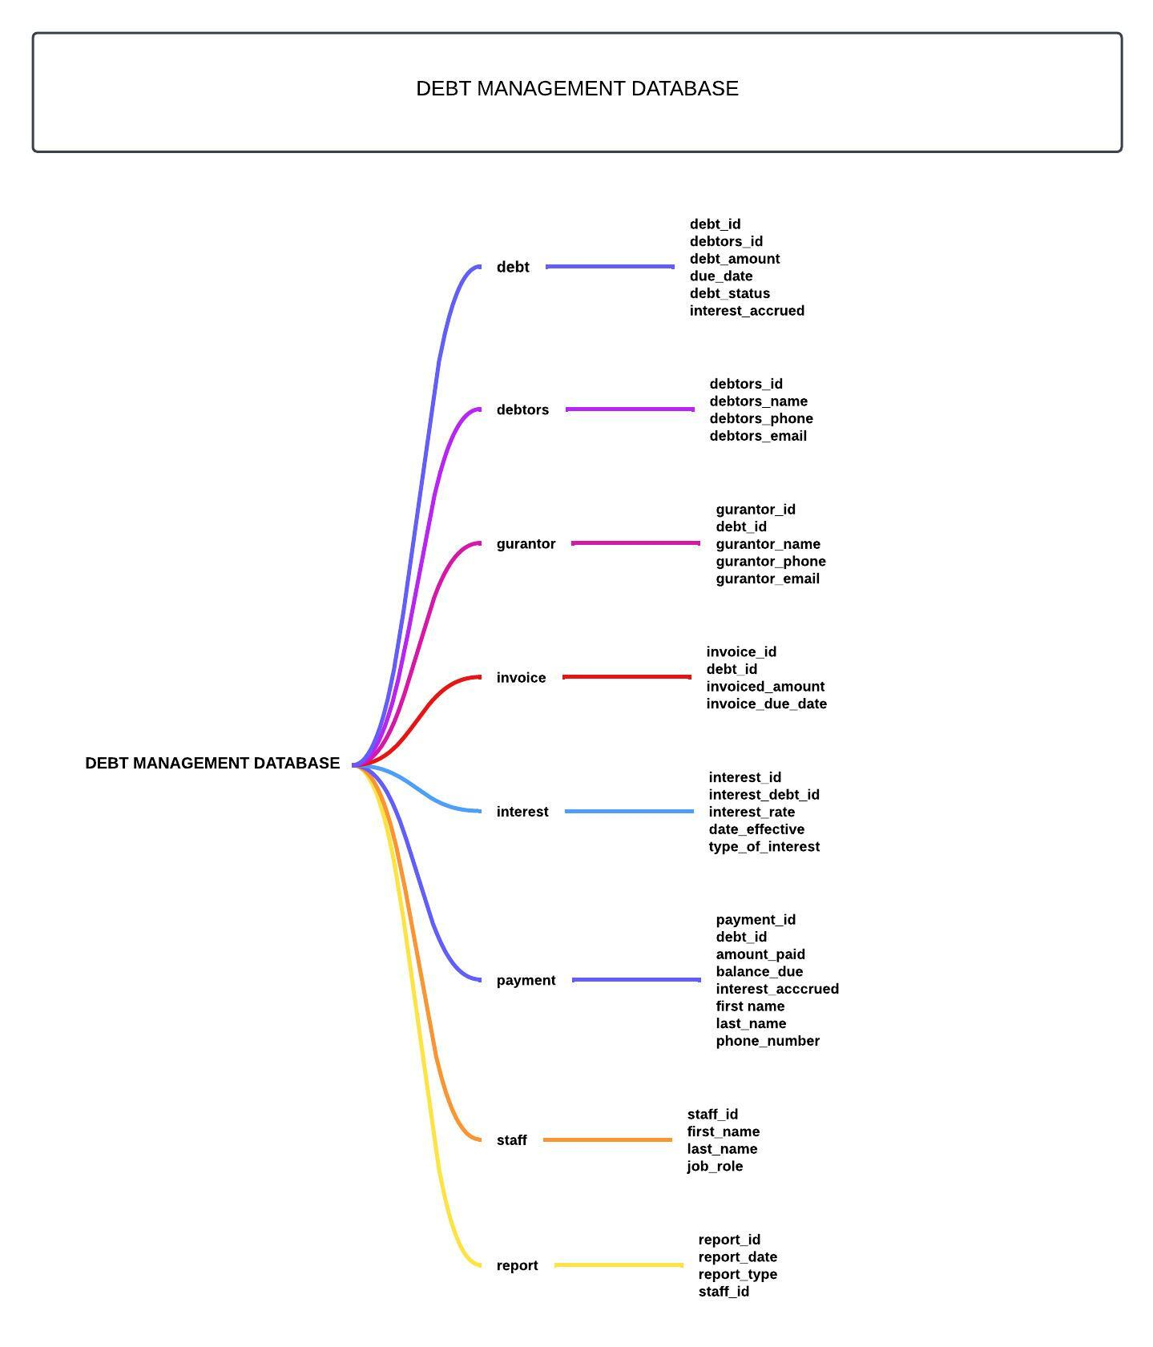

**Processes**

**Step 1: Identifying the Entities**

* Debt
* Debtors
* Guarantor
* Invoice
* Interest
* Payment
* Staff
* Report

**Step 2: Identifying connections within the entities**

* Each debtor has a debt
* Each invoice is linked to a debt
* Each debt has a guarantor
* Interests have accrued on the debts
* Payments are made on the debts
* Reports would be generated on the debt status each month
* Each debt has a staff who issued the loan

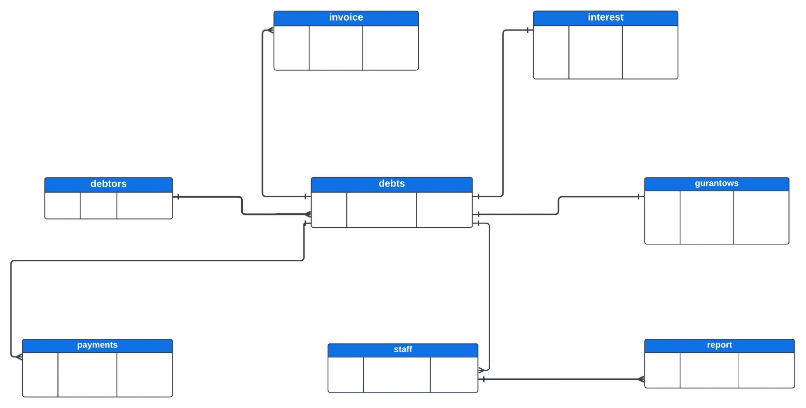

## **1.2 LOGICAL MODEL**

The logical model will involve identifying the attributes

|  |  |
| --- | --- |
| Entity | Attributes |
| Debt | debt_id  debtors_id  debt_amount  due_date  debt_interest_accrued |
| Debtors | debtors_id  debtors_name  debtors_phone  debtors_email |
| Guarantor | gurantor_id  debt_id  gurantor_name  gurantor_phone  gurantor_email |
| Invoice | invoice_id  debt_id  invoiced_amount  invoice_due_date |
| Interest | interest_id  interest_debt_id  interest_rate  date_effective  type_of_interest |
| Payment | payment_id  debt_id  amount_paid  balance_due  interest_acccrued  first_name  last_name  phone_number |
| Staff | staff_id  first_name  last_name  job_role |
| Report | report_id  report_date  report_type  staff_id |

1.3 PHYSICAL MODEL

This step involves deciding attribute’s specific data types.

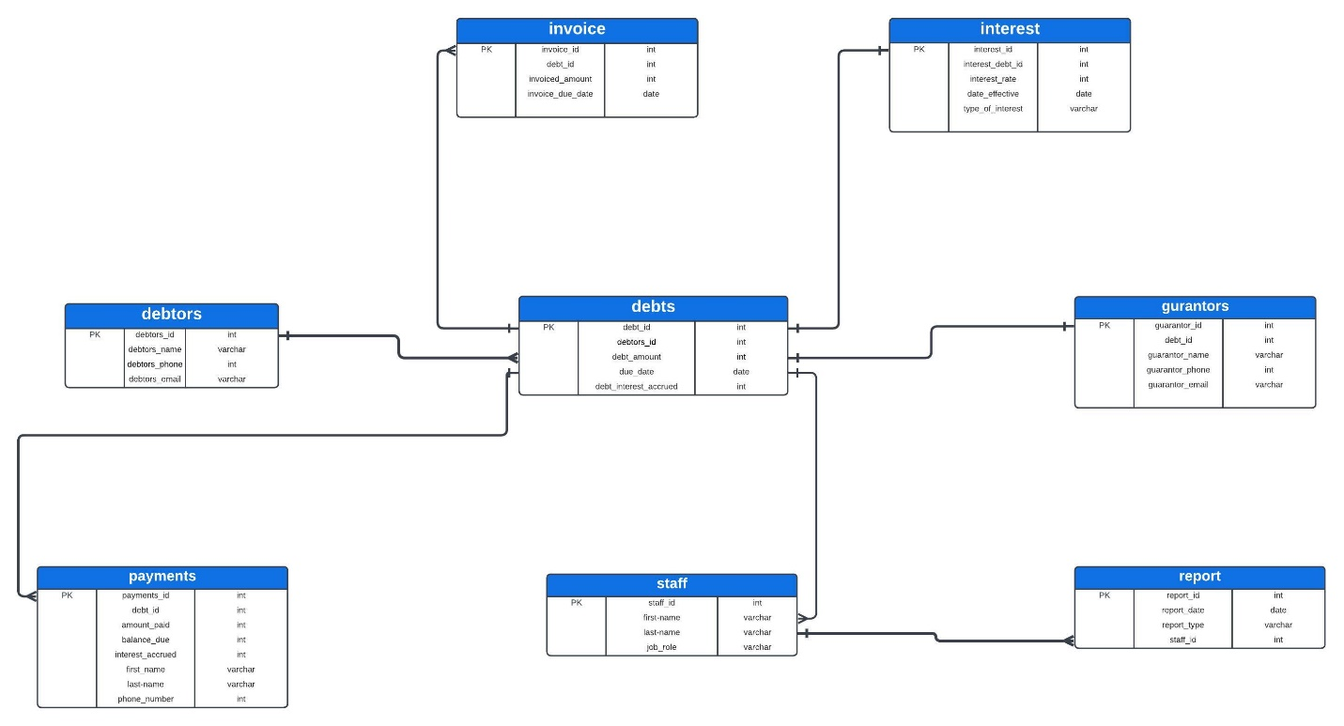

**Creating Tables in the Database**

--CREATING TABLES IN THE DATABASE---

--1. Creating under debt_management_database

--report (report_id, report_date, report_type, staff_id)

**CREATE** **TABLE** report (

report_id INTERGER **PRIMARY** **KEY**,

report_date **DATE**,

report_type **VARCHAR** (50),

staff_id INTERGER);

**SELECT** * **FROM** report;

-- Creating under debt_management_database

-- debt (debt_id, debtors_id, debt_amount, due_date, debt_interest_accrued)

**CREATE** **TABLE** **IF** **NOT** **EXISTS** debt(

debt_id **INTEGER** **PRIMARY** **KEY**,

debtors_id **INTEGER**,

debt_amount INTERGER,

due_date **DATE**,

debt_interest_accrued INTERGER);

**SELECT** * **FROM** debt;

-- Creating under debt_management_database

-- debtors (debtors_id, debtors_name, debtors_phone, debtors_email)

**CREATE** **TABLE** **IF** **NOT** **EXISTS** debtors(

debtors_id **INTEGER** **PRIMARY** **KEY**,

debtors_name **VARCHAR**(100),

debtors_phone INTERGER,

debtors_email **VARCHAR**(50));

**SELECT** * **FROM** ***debtors***;

-- Creating under debt_management_database

-- guarantors (guarantor_id, debt_id, guarantor_name, guarantor_phone, guarantor_email)

**CREATE** **TABLE** **IF** **NOT** **EXISTS** guarantors(

guarantor_id **INTEGER** **PRIMARY** **KEY**,

debt_id **INTEGER**,

guarantor_name **VARCHAR**(100),

guarantor_phone INTERGER,

guarantor_email **VARCHAR**(50));

**SELECT** * **FROM** ***guarantors***;

-- Creating under debt_management_database

-- invoice (invoice_id, debt_id, invoiced_amount, invoice_due_date)

**CREATE** **TABLE** **IF** **NOT** **EXISTS** invoice(

invoice_id **INTEGER** **PRIMARY** **KEY**,

debt_id **INTEGER**,

invoiced_amount INTERGER,

invoice_due_date **DATE**);

**SELECT** * **FROM** ***invoice***;

-- Creating under debt_management_database

-- interest (interest_id, interest_debt_id, interest_rate, date_effective, type_of_interest)

**CREATE** **TABLE** **IF** **NOT** **EXISTS** interest(

interest_id **INTEGER** **PRIMARY** **KEY**,

interest_debt_id **INTEGER**,

interest_rate **FLOAT**,

date_effective **DATE**,

type_of_interest **VARCHAR**(50));

**SELECT** * **FROM** ***interest***;

-- Creating under debt_management_database

-- payments (payment_id, debt_id, amount_paid, balance_due, interest_accrued, first_name, last_name, phone_number)

**CREATE** **TABLE** **IF** **NOT** **EXISTS** payments(

payment_id **INTEGER** **PRIMARY** **KEY**,

debt_id **INTEGER**,

amount_paid INTERGER,

balance_due INTERGER,

interest_accrued INTERGER,

first_name **VARCHAR**(50),

last_name **VARCHAR**(50),

phone_number INTERGER);

**SELECT** * **FROM** ***payments***;

-- Creating under debt_management_database

-- staff (staff_id, first_name, last_name, job_role)

**CREATE** **TABLE** **IF** **NOT** **EXISTS** staff(

staff_id **INTEGER** **PRIMARY** **KEY**,

first_name **VARCHAR**(50),

last_name **VARCHAR**(50),

job_role **VARCHAR**(50));

**SELECT** * **FROM** ***staff***;

**Sample Results**

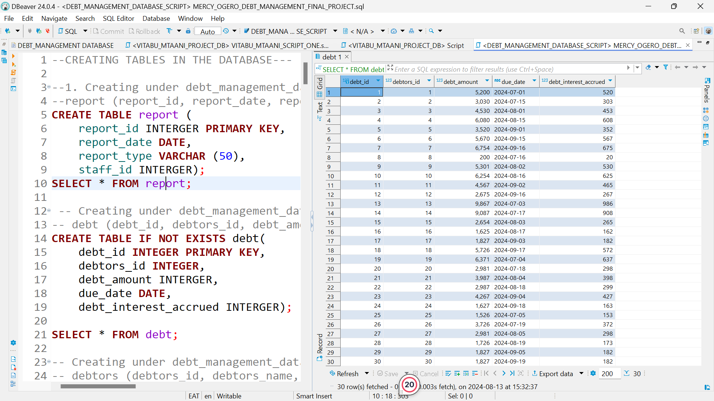

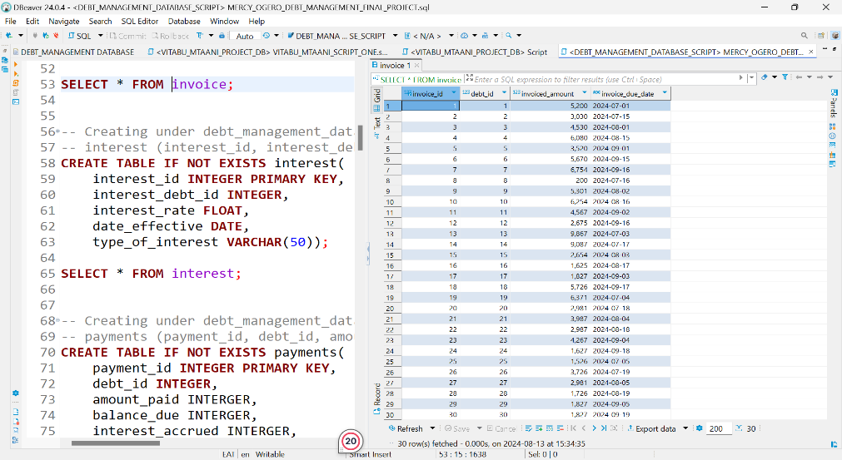

**Inserting Records into the Tables**

--INSERTING RECORDS IN THE TABLES--

--Inserting records to the reports table

**INSERT** **INTO** report (report_id, report_date, report_type, staff_id)

**VALUES**

(1, **'2024-01-07'**, **'Debt Overview Report'**, 1),

(2, **'2024-01-14'**, **'Debt Overview Report'**, 2),

(3, **'2024-01-21'**, **'Interest Accrued Report'**, 3),

(4, **'2024-01-28'**, **'Payment Summary Report'**, 4),

(5, **'2024-02-04'**, **'Interest Accrued Report'**, 5),

(6, **'2024-02-11'**, **'Invoice Summary Report'**, 6),

(7, **'2024-02-18'**, **'Guarantor Status Summary report'**, 7),

(8, **'2024-02-25'**, **'Interest Accrued Report'**, 8),

(9, **'2024-03-03'**, **'Payment Summary Report'**, 9),

(10, **'2024-03-10'**, **'Guarantor Status Summary report'**, 10),

(11, **'2024-03-17'**, **'Invoice Summary Report'**, 11),

(12, **'2024-03-24'**, **'Interest Accrued Report'**, 12),

(13, **'2024-03-31'**, **'Payment Summary Report'**, 13),

(14, **'2024-04-07'**, **'Staff Performance Report'**, 14),

(15, **'2024-04-14'**, **'Staff Performance Report'**, 15),

(16, **'2024-04-21'**, **'Interest Accrued Report'**, 16),

(17, **'2024-04-28'**, **'Payment Summary Report'**, 17),

(18, **'2024-05-05'**, **'Invoice Summary Report'**, 18),

(19, **'2024-05-12'**, **'Interest Accrued Report'**, 19),

(20, **'2024-05-19'**, **'Guarantor Status Summary report'**, 20),

(21, **'2024-05-26'**, **'Guarantor Status Summary report'**, 21),

(22, **'2024-06-02'**, **'Interest Accrued Report'**, 22),

(23, **'2024-06-09'**, **'Payment Summary Report'**, 23),

(24, **'2024-06-16'**, **'Interest Accrued Report'**, 24),

(25, **'2024-06-23'**, **'Invoice Summary Report'**, 25),

(26, **'2024-06-30'**, **'Invoice Summary Report'**, 26),

(27, **'2024-07-07'**, **'Interest Accrued Report'**, 27),

(28, **'2024-07-14'**, **'Guarantor Status Summary report'**, 28),

(29, **'2024-07-21'**, **'Payment Summary Report'**, 29),

(30, **'2024-07-28'**, **'Invoice Summary Report'**, 30);

**SELECT** * **FROM** report;

--Inserting records to the debts table

**INSERT** **INTO** debt (debt_id, debtors_id, debt_amount, due_date, debt_interest_accrued)

**VALUES**

(1, 1, 5200, **'2024-07-01'**, 520),

(2, 2, 3030, **'2024-07-15'**, 303),

(3, 3, 4530, **'2024-08-01'**, 453),

(4, 4, 6080, **'2024-08-15'**, 608),

(5, 5, 3520, **'2024-09-01'**, 352),

(6, 6, 5670, **'2024-09-15'**, 567),

(7, 7, 6754, **'2024-09-16'**, 675),

(8, 8, 200, **'2024-07-16'**, 20),

(9, 9, 5301, **'2024-08-02'**, 530),

(10, 10, 6254, **'2024-08-16'**, 625),

(11, 11, 4567, **'2024-09-02'**, 465),

(12, 12, 2675, **'2024-09-16'**, 267),

(13, 13, 9867, **'2024-07-03'**, 986),

(14, 14, 9087, **'2024-07-17'**, 908),

(15, 15, 2654, **'2024-08-03'**, 265),

(16, 16, 1625, **'2024-08-17'**, 162),

(17, 17, 1827, **'2024-09-03'**, 182),

(18, 18, 5726, **'2024-09-17'**, 572),

(19, 19, 6371, **'2024-07-04'**, 637),

(20, 20, 2981, **'2024-07-18'**, 298),

(21, 21, 3987, **'2024-08-04'**, 398),

(22, 22, 2987, **'2024-08-18'**, 299),

(23, 23, 4267, **'2024-09-04'**, 427),

(24, 24, 1627, **'2024-09-18'**, 163),

(25, 25, 1526, **'2024-07-05'**, 153),

(26, 26, 3726, **'2024-07-19'**, 372),

(27, 27, 2981, **'2024-08-05'**, 298),

(28, 28, 1726, **'2024-08-19'**, 173),

(29, 29, 1827, **'2024-09-05'**, 182),

(30, 30, 1827, **'2024-09-19'**, 182);

**SELECT** * **FROM** debt;

--Inserting records into the debtors table

**INSERT** **INTO** ***debtors*** (***debtors_id***, ***debtors_name***, ***debtors_phone***, ***debtors_email***)

**VALUES**

(1, **'Mercy'**, **'62084819'**, **'ogero@gmail.com'**),

(2, **'Teresa'**, **'47128843'**, **'Munuve@gmail.com'**),

(3, **'Michael'**, **'62920015'**, **'levin@gmail.com'**),

(4, **'Emily'**, **'57053674'**, **'masita@gmail.com'**),

(5, **'Teresa'**, **'7664413'**, **'ogero@gmail.com'**),

(6, **'Sophia'**, **'19936335'**, **'kerubo@gmail.com'**),

(7, **'James'**, **'66401543'**, **'Muiruris@gmail.com'**),

(8, **'Olivia'**, **'7221629'**, **'mbare@gmail.com'**),

(9, **'Alexander'**, **'24595077'**, **'wanjuki@gmail.com'**),

(10, **'Emma'**, **'16870671'**, **'kira@gmail.com'**),

(11, **'Daniel'**, **'13591739'**, **'wilele@gmail.com'**),

(12, **'Isabella'**, **'57797402'**, **'maore@gmail.com'**),

(13, **'Matthew'**, **'33839639'**, **'kamba@gmail.com'**),

(14, **'Mia'**, **'70042175'**, **'waru@gmail.com'**),

(15, **'Benjamin'**, **'77341808'**, **'timau@gmail.com'**),

(16, **'Ava'**, **'53474362'**, **'helsinki@gmail.com'**),

(17, **'Elijah'**, **'11097208'**, **'kauri@gmail.com'**),

(18, **'Charlotte'**, **'66152864'**, **'jambe@gmail.com'**),

(19, **'Logan'**, **'56528277'**, **'amber@gmail.com'**),

(20, **'Amelia'**, **'28776413'**, **'kiran@gmail.com'**),

(21, **'Lucas'**, **'31338183'**, **'warutere@gmail.com'**),

(22, **'Evelyn'**, **'25991772'**, **'adhiambo@gmail.com'**),

(23, **'Mary'**, **'75462294'**, **'mugure@gmail.com'**),

(24, **'William'**, **'55133569'**, **'kanyeki@gmail.com'**),

(25, **'Aiden'**, **'10506514'**, **'samba@gmail.com'**),

(26, **'Grace'**, **'25145998'**, **'waceke@gmail.com'**),

(27, **'Jackson'**, **'47448314'**, **'kilili@gmail.com'**),

(28, **'Scarlett'**, **'21622996'**, **'gachanja@gmail.com'**),

(29, **'David'**, **'22654498'**, **'kanyi@gmail.com'**),

(30, **'Victoria'**, **'23490043'**, **'rubadiri@gmail.com'**);

**SELECT** * **FROM** debtors ;

-- Insert records into guarantors table

**INSERT** **INTO** ***guarantors*** (***guarantor_id***, ***debt_id***, ***guarantor_name***, ***guarantor_phone***, ***guarantor_email***)

**VALUES**

(1, 12, **'Mercy'**, 7204766, **'mercy@gmail.com'**),

(2, 9, **'Nyamoita'**, 7339626, **'nyamoita@gmail.com'**),

(3, 5, **'Ogero'**, 7759360, **'ogero@gmail.com'**),

(4, 23, **'Bochaberi'**, 7513807, **'bochaberi@gmail.com'**),

(5, 18, **'Ombori'**, 7742616, **'ombori@gmail.com'**),

(6, 1, **'Tersae'**, 7927779, **'tersae@gmail.com'**),

(7, 8, **'Kemuntor'**, 7513953, **'kemuntor@gmail.com'**),

(8, 14, **'Ogreho'**, 7676761, **'ogreho@gmail.com'**),

(9, 27, **'Ivy'**, 7245284, **'ivy@gmail.com'**),

(10, 21, **'Mark'**, 7300502, **'mark@gmail.com'**),

(11, 20, **'Masara'**, 7859398, **'masara@gmail.com'**),

(12, 2, **'Ogerohk'**, 7961875, **'ogerohk@gmail.com'**),

(13, 15, **'Justine'**, 7744599, **'justine@gmail.com'**),

(14, 10, **'Noah'**, 7924932, **'noah@gmail.com'**),

(15, 4, **'Olivia'**, 7542787, **'olivia@gmail.com'**),

(16, 3, **'Paul'**, 7696923, **'paul@gmail.com'**),

(17, 30, **'John'**, 7368993, **'john@gmail.com'**),

(18, 28, **'Rachel'**, 7787823, **'rachel@gmail.com'**),

(19, 11, **'Samuel'**, 7330556, **'samuel@gmail.com'**),

(20, 13, **'Tina'**, 7585310, **'tina@gmail.com'**),

(21, 6, **'Victor'**, 7399459, **'victor@gmail.com'**),

(22, 19, **'Wendy'**, 7907058, **'wendy@gmail.com'**),

(23, 7, **'Menyd Maitah'**, 7100948, **'menyd@gmail.com'**),

(24, 25, **'Yvonne'**, 7499179, **'yvonne@gmail.com'**),

(25, 22, **'Zachary'**, 7566256, **'zachary@gmail.com'**),

(26, 17, **'Isabella'**, 7870831, **'isabella@gmail.com'**),

(27, 29, **'Ethan Garcia'**, 7857249, **'ethan@gmail.com'**),

(28, 26, **'Sophia'**, 7411628, **'sophia@gmail.com'**),

(29, 24, **'Jayons'**, 7737190, **'jayons@gmail.com'**),

(30, 16, **'Ruto'**, 7435445, **'ruto@gmail.com'**);

**SELECT** * **FROM** ***guarantors***;

--Inserting records into invoice table

**INSERT** **INTO** ***invoice*** (***invoice_id***, ***debt_id***, ***invoiced_amount***, ***invoice_due_date***)

**VALUES**

(1, 1, 5200, **'2024-07-01'**),

(2, 2, 3030, **'2024-07-15'**),

(3, 3, 4530, **'2024-08-01'**),

(4, 4, 6080, **'2024-08-15'**),

(5, 5, 3520, **'2024-09-01'**),

(6, 6, 5670, **'2024-09-15'**),

(7, 7, 6754, **'2024-09-16'**),

(8, 8, 200, **'2024-07-16'**),

(9, 9, 5301, **'2024-08-02'**),

(10, 10, 6254, **'2024-08-16'**),

(11, 11, 4567, **'2024-09-02'**),

(12, 12, 2675, **'2024-09-16'**),

(13, 13, 9867, **'2024-07-03'**),

(14, 14, 9087, **'2024-07-17'**),

(15, 15, 2654, **'2024-08-03'**),

(16, 16, 1625, **'2024-08-17'**),

(17, 17, 1827, **'2024-09-03'**),

(18, 18, 5726, **'2024-09-17'**),

(19, 19, 6371, **'2024-07-04'**),

(20, 20, 2981, **'2024-07-18'**),

(21, 21, 3987, **'2024-08-04'**),

(22, 22, 2987, **'2024-08-18'**),

(23, 23, 4267, **'2024-09-04'**),

(24, 24, 1627, **'2024-09-18'**),

(25, 25, 1526, **'2024-07-05'**),

(26, 26, 3726, **'2024-07-19'**),

(27, 27, 2981, **'2024-08-05'**),

(28, 28, 1726, **'2024-08-19'**),

(29, 29, 1827, **'2024-09-05'**),

(30, 30, 1827, **'2024-09-19'**);

**SELECT** * **FROM** ***invoice***;

--Inserting records into the payment table

**INSERT** **INTO** ***payments*** (***payment_id***, ***debt_id***, ***amount_paid***, ***balance_due***, ***interest_accrued***, ***first_name***, ***last_name***, ***phone_number***)

**VALUES**

(1, 1, 1500, 3700, 520, **'Mercy'**, **'Ogero'**, 62084819),

(2, 2, 1000, 2030, 303, **'Teresa'**, **'Munuve'**, 47128843),

(3, 3, 2000, 2530, 453, **'Michael'**, **'Levin'**, 62920015),

(4, 4, 2500, 3580, 608, **'Emily'**, **'Masita'**, 57053674),

(5, 5, 1200, 2320, 352, **'Teresa'**, **'Ogero'**, 7664413),

(6, 6, 3000, 2670, 567, **'Sophia'**, **'Kerubo'**, 19936335),

(7, 7, 3500, 3254, 675, **'James'**, **'Muiruri'**, 66401543),

(8, 8, 50, 150, 20, **'Olivia'**, **'Mbare'**, 7221629),

(9, 9, 2500, 2801, 530, **'Alexander'**, **'Wanjuki'**, 24595077),

(10, 10, 3000, 3254, 625, **'Emma'**, **'Kira'**, 16870671),

(11, 11, 2000, 2567, 465, **'Daniel'**, **'Wilele'**, 13591739),

(12, 12, 1000, 1675, 267, **'Isabella'**, **'Maoore'**, 57797402),

(13, 13, 4000, 5867, 986, **'Matthew'**, **'Kambar'**, 33839639),

(14, 14, 4500, 4587, 908, **'Mia'**, **'Waru'**, 70042175),

(15, 15, 1300, 1354, 265, **'Benjamin'**, **'Timau'**, 77341808),

(16, 16, 800, 825, 162, **'Ava'**, **'Helsinki'**, 53474362),

(17, 17, 1000, 827, 182, **'Elijah'**, **'Kauri'**, 11097208),

(18, 18, 3000, 2726, 572, **'Charlotte'**, **'Jambe'**, 66152864),

(19, 19, 2000, 4371, 637, **'Logan'**, **'Amber'**, 56528277),

(20, 20, 1200, 1781, 298, **'Amelia'**, **'Kiran'**, 28776413),

(21, 21, 2000, 1987, 398, **'Lucas'**, **'Warutere'**, 31338183),

(22, 22, 1000, 1987, 299, **'Evelyn'**, **'Adhiambo'**, 25991772),

(23, 23, 2000, 2267, 427, **'Mary'**, **'Mugure'**, 75462294),

(24, 24, 800, 827, 163, **'William'**, **'Kanyeki'**, 55133569),

(25, 25, 600, 926, 153, **'Aiden'**, **'Samba'**, 10506514),

(26, 26, 1500, 2226, 372, **'Grace'**, **'Waceke'**, 25145998),

(27, 27, 1000, 1981, 298, **'Jackson'**, **'Kilili'**, 47448314),

(28, 28, 1000, 726, 173, **'Scarlett'**, **'Gachanja'**, 21622996),

(29, 29, 900, 927, 182, **'David'**, **'Kanyi'**, 22654498),

(30, 30, 1000, 827, 182, **'Victoria'**, **'Rubadiri'**, 23490043);

**SELECT** * **FROM** ***payments***;

--Inserting records into the staff table

**INSERT** **INTO** ***staff*** (***staff_id***, ***first_name***, ***last_name***, ***job_role***)

**VALUES**

(1, **'Brianna'**, **'Wauche'**, **'Accountant'**),

(2, **'Talisha'**, **'Sinet'**, **'Accountant'**),

(3, **'Sironet'**, **'Chania'**, **'Accountant'**),

(4, **'Lehsan'**, **'Mangu'**, **'Accountant'**),

(5, **'Genesis'**, **'Mwangi'**, **'Accountant'**),

(6, **'Exidus'**, **'Ganjo'**, **'Accountant'**),

(7, **'Leviticus'**, **'Naarugu'**, **'Accountant'**),

(8, **'Deutronomy'**, **'Ngenda'**, **'Accountant'**),

(9, **'Teresa'**, **'Murera'**, **'Accountant'**),

(10, **'Mary'**, **'Teta'**, **'Accountant'**);

**SELECT** * **FROM** ***staff***;

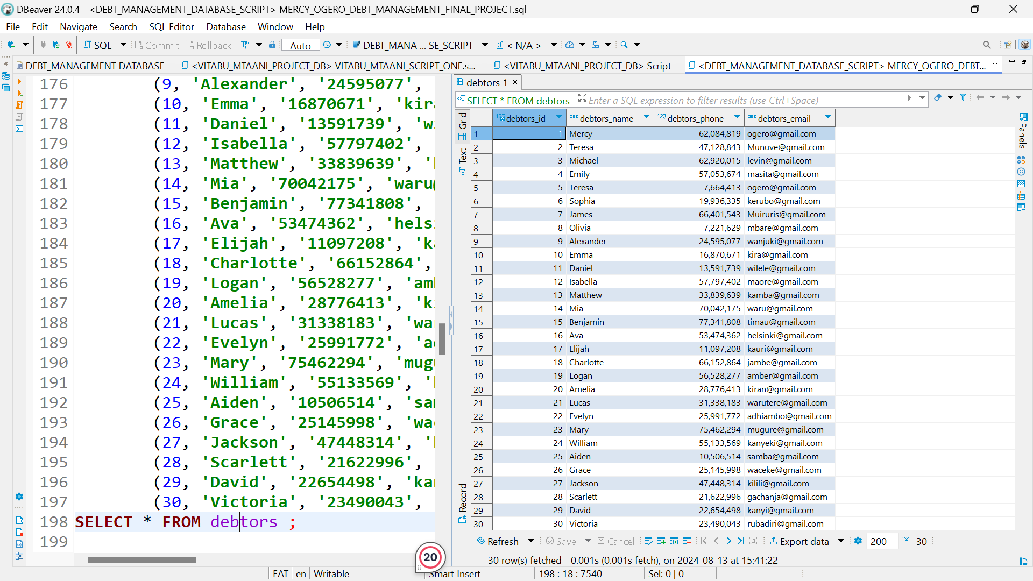

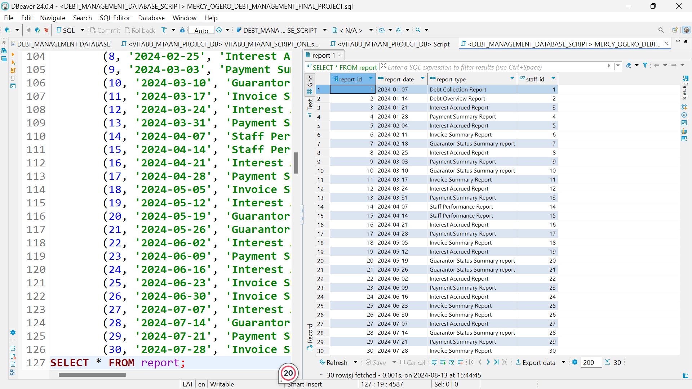

--JOINS

--Joining the debts and the debtors tab;e

**SELECT** *

**FROM** debt *d*

**INNER** **JOIN** ***debtors*** *db*

**ON** debt.***debtor_id*** = ***debtors***.debtor_id;

--Joining the debtors table and the guarantors table

**SELECT** *

**FROM** debt *d*

**RIGHT** **JOIN** ***guarantors*** *g*

**ON** *d*.debt_id = *g*.***debt_id***;