|  |
| --- |
| Close-up image showing the leaf-sides of two oversized books side-by-side on a bookshelf, with additional books in soft focus background |
| VITABU MTAANI PROJECT  Vitabu Mtaani is a project aimed at increasing the reading culture among the youths in Kiambu County. Mobile libraries will be deployed at various wards making books and other educational resources more accessible. |
| |  |  |  | | --- | --- | --- | | Mercy Ogero |  | 7/1/24 | |

# **VITABU MTAANI PROJECT**

## **INTRODUCTION**

### Defining the Problem

Vitabu Mtaani is an initiative to foster and develop a reading culture among the youths in Kiambu. The project aims at creating mobile libraries that will travel to various wards giving access to educational materials and resources. The following are the reasons that have prompted the Vitabu Mtaani initiative.

* Lack of access to library facilities in the many wards in Kiambu.
* Lack of updated materials on various topics that the youths can read.
* Less several quality reading materials in some wards.
* Lack of efficient supply and stocking of mobile libraries with the needed books.
* Youths are idle – idle minds are the devil’s workshop.
* Literacy levels are dropping due to lacking books and reading materials.
* Lack of a reading culture among the youths.
* Existing libraries are analog in a mostly digital world.

### Defining the Solution

The solution to the abovementioned problems will be deploying mobile library units across the county. The mobile libraries are managed and monitored to ensure they serve the community with maximum capacity. The following are the solutions that will be implemented:

* Deploying mobile library units to the wards in Kiambu.
* Stocking the mobile library units with quality reading materials of different genres.
* Tracking the stocking of mobile libraries with effective logistics and inventory management.
* Opportunity to increase human potential by eliminating idleness and encouraging industriousness amongst our youth.
* Increase literacy levels beyond formal learning institutions
* Inspire a reading culture within our communities, because readers are leaders.
* Leverage the increase in use of technology by the youth in Kenya by making libraries easy to access and manage.

## **THE CONCEPT (Conceptual Modeling)**

The following is the conceptual model for the Vitabu Mtaani project

* Library in every ward
* Books in every library
* Books will be of different genres
* Librarians to manage the mobile library
* Book loan information for every mobile library data
* Book donation data of every mobile library data
* Transport schedule of each mobile library
* Information on users
* Weekly report on the progress of each mobile library
* Penalties and Fines for users who misplace or overstay with the books

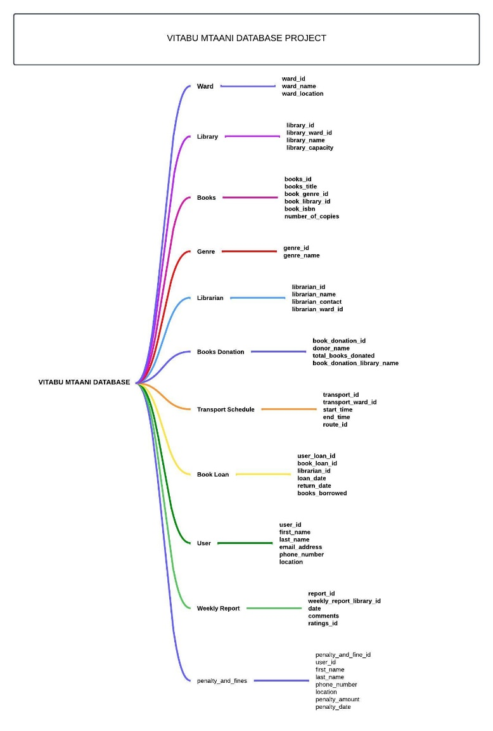

**Processes**

**Step 1: Identifying the Entities**

* Ward
* Library
* Books
* Genre
* Librarian
* Book Donations
* Transport Schedule
* Book Loan
* User
* Weekly Reports
* Penalties and Fines

**Step 2: Identifying Connections within Entities**

* Each ward will have a single mobile library unit
* Each library has several books
* Each book has a specific genre and the books are of different genres
* One librarian will manage each single mobile library unit
* A weekly report would be generated of every mobile library unit
* Each mobile library unit will have its book loan data
* Each mobile library unit will have its book donation data
* Each user will have his or her holding information if he borrowed a book
* Each mobile library unit will have its transport schedule
* Any user who has overstayed or lost a book will be charged a penalty or a fine

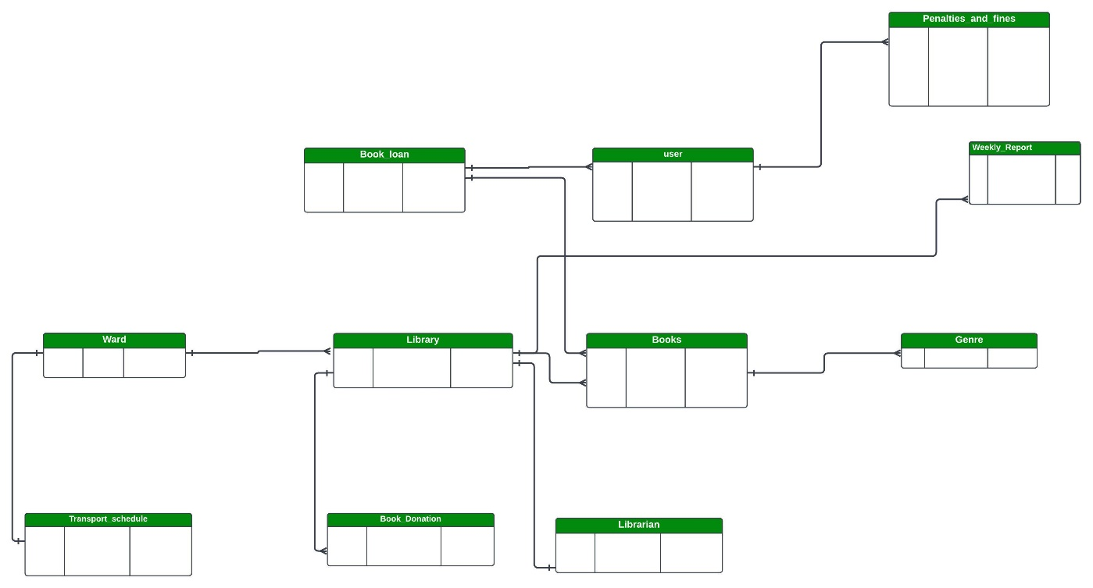

## LOGICAL MODEL

The logical model will involve identifying the entity attributes.

|  |  |
| --- | --- |
| Entity | Attributes |
| ward | ward_id  ward_name  ward_location |
| library | library_id  library_ward_id  library_name  library_capacity |
| books | books_id  books_title  book_genre_id  book_library_id  book_isbn  number_of_copies |
| genre | genre_id  genre_name |
| librarian | librarian_id  librarian_name  librarian_contact  librarian_ward_id |
| books_donation | book_donation_id  donor_name  total_books_donated  book_donation_library_name |
| transport_schedule | transport_id  transport_ward_id  start_time  end_time  route_id |
| book_loan | user_loan_id  book_loan_id  librarian_id  loan_date  return_date  books_borrowed |
| user | user_id  first_name  last_name  email_address  phone_number_location |
| weekly_report | report_id  weekly_report_library_id  date  comments  ratings_id |
| penalty_and_fines | penalty_and_fine_id  user_id  first_name  last_name  phone_number  location  penalty_amount  penalty_date |

## **PHYSICAL MODEL**

This step involves deciding the attribute’s specific data types.

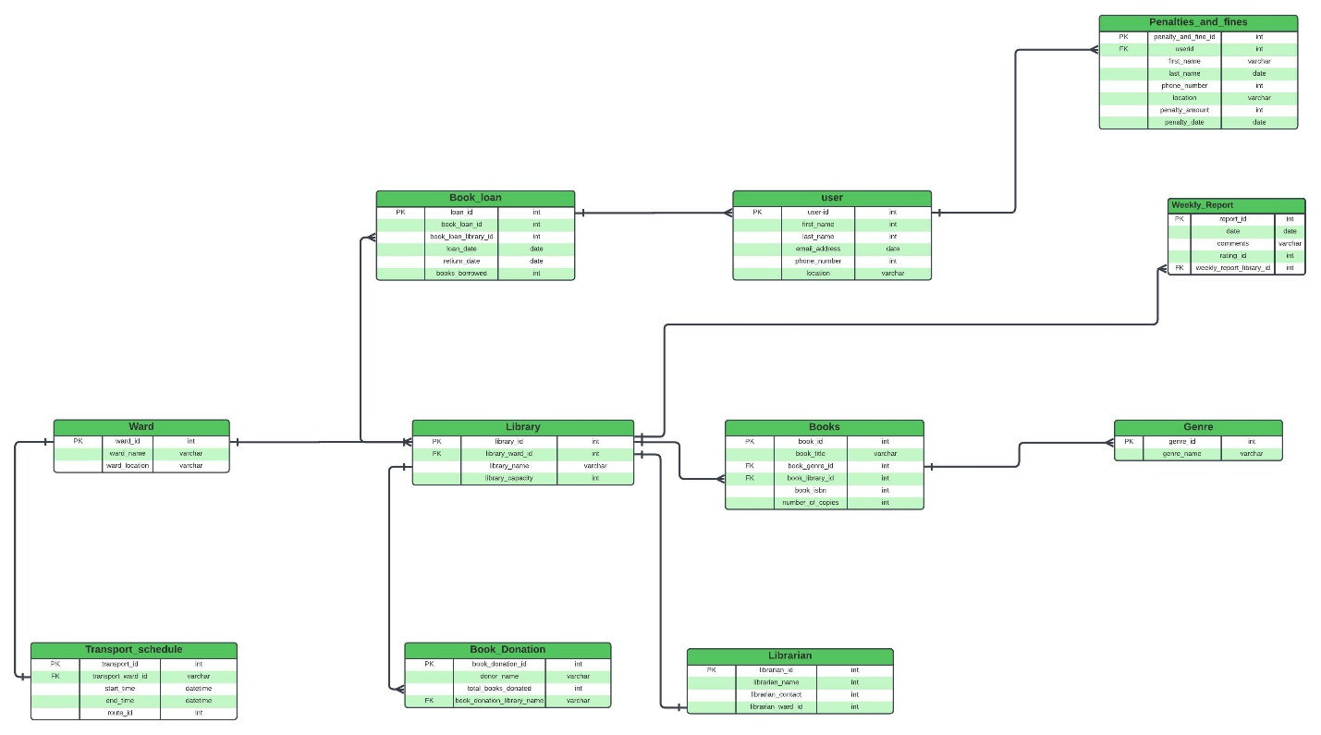

--1. Creating under vitabu_mtaani_db

--Wards (ward_id, ward_name, ward_location)

**CREATE** **TABLE** **IF** **NOT** **EXISTS** wards(

ward_id INTERGER **PRIMARY** **KEY**

ward_name **VARCHAR**(50) **UNIQUE**,

ward_location **VARCHAR**(50));

--2. Creating under vitabu_mtaani_db

--library (librarian_id, library_ward_id, library_name, librarian_capacity)

**CREATE** **TABLE** **IF** **NOT** **EXISTS** library(

library_id **INT** **PRIMARY** **KEY**,

library_ward_id INTERGER **NOT** **NULL**,

library_name **VARCHAR** (10),

library_capacity);

--3. Creating under vitabu_mtaani_db

--books (book_id, book_title, book_genre_id, book_library_id,book_isbn, number_of_copies)

**CREATE** **TABLE** **IF** **NOT** **EXISTS** books(

book_id INTERGER **PRIMARY** **KEY**,

book_title **VARCHAR** (50) **NOT** **NULL**,

book_genre_id INTERGER,

book_library_id INTERGER,

book_isbn INTERGER,

number_of_copies INTERGER

);

--4. Creating under vitabu_mtaani_db

--genre (genre_id, genre_name)

**CREATE** **TABLE** **IF** **NOT** **EXISTS** genre(

genre_id INTERGER **PRIMARY** **KEY**,

genre_name **VARCHAR**(20)

);

--5. Creating under vitabu_mtaani_db

--librarian (librarian_id, librarian_name, librarian_contact, librarian_ward_id)

**CREATE** **TABLE** **IF** **NOT** **EXISTS** librarian(

librarian_id INTERGER **PRIMARY** **KEY**,

librarian_name **VARCHAR** (20) **NOT** **NULL**,

librarian_contact INTERGER,

librarian_ward_id);

--6. Creating under the vitabu_mtaani_db

-- books_donation table (book_donation_id, donor_name, total_books_donated,book_donation_library_name)

**CREATE** **TABLE** **IF** **NOT** **EXISTS** books_donation (

book_donation_id INTERGER **NOT** **NULL**,

donor_name **VARCHAR**(20),

total_books_donated **INT**,

book_donation_library_name **VARCHAR**(20)

);

--7. Creating under the vitabu_mtaani_db

-- transport_schedule table (transport_id, transport_ward_id, start_time,end_time, route_id)

**CREATE** **TABLE** **IF** **NOT** **EXISTS** books_donation (

transport_id INTERGER **NOT** **NULL**,

transport_ward_id INTERGER,

start_time DATETIME,

end_time DATETIME,

route_id INTERGER

);

--8. Creating under the vitabu_mtaani_db

--book_loan (user_loan_id, book_loan_id, librarian_id, loan_date, return_date, books_borrowed)

**CREATE** **TABLE** **IF** **NOT** **EXISTS** book_loan(

user_loan_id INTERGER **PRIMARY** **KEY**,

book_loan_id INTERGER **NOT** **NULL**,

librarian_id INTERGER,

loan_date DATETIME,

return_date DATETIME,

books_borrowed INTERGER

);

--9. Creating under the vitabu_mtaani_db

--transport_schedule (transport_id, transport_ward_id, start_time, end_time, route_id)

**CREATE** **TABLE** **IF** **NOT** **EXISTS** transport_schedule(

transport_id **INT** **PRIMARY** **KEY**,

transport_ward_id INTERGER,

start_time **TIME**,

end_time **TIME**,

route_id INTERGER

);

--10. Creating under the vitabu_mtaani_db

--user (user_id, first_name, last_name, email_address, phone_number)

**CREATE** **TABLE** **IF** **NOT** **EXISTS** **user**(

user_id INTERGER **PRIMARY** **KEY**,

first_name **VARCHAR**(50) **NOT** **NULL**,

last_name **VARCHAR**(50),

email_address **VARCHAR**(20),

phone_number INTERGER

);

-- 11. Creating under the vitabu_mtaani_db

--weekly_report ( report_id, weekly_report_library_id, date, comments, ratings_id)

**CREATE** **TABLE** **IF** **NOT** **EXISTS** weekly_report(

report_id INTERGER **PRIMARY** **KEY**,

weekly_report_library_id INTERGER,

**date** **DATE** **NOT** **NULL**,

comments TEXT,

ratings_id **INT**

);

-- 12. Creating under the vitabu_mtaani_db

--penalty_and_fine ( user_id, first_name, last_name, phone_number, location, penalty_amount, penalty_date)

**CREATE** **TABLE** **IF** **NOT** **EXISTS** penalty_and_fine(

user_id **INT** **PRIMARY** **KEY**,

first_name **VARCHAR**(20),

last_name **VARCHAR** (20),

phone_number INTERGER,

location **VARCHAR**(30),

penalty_amount INTERGER,

penalty_date **DATE**

);

--Inserting records to wards table

**INSERT** **INTO** wards (ward_id, ward_name, ward_location)

**VALUES**

(1,**'Githobokoni Library'**, **'Gatundu North'**);

**INSERT** **INTO** wards (ward_id, ward_name, ward_location)

**VALUES**

(2,**'Gituamba Library'**, **'Gatundu North'**);

**INSERT** **INTO** wards (ward_id, ward_name, ward_location)

**VALUES**

(3,**'Chania'**, **'Gatundu North'**);

**INSERT** **INTO** wards (ward_id, ward_name, ward_location)

**VALUES**

(4,**'Mangu'**, **'Gatundu North'**);

**INSERT** **INTO** wards (ward_id, ward_name, ward_location)

**VALUES**

(5,**'Kiamwangi'**, **'Gatundu South'**);

**INSERT** **INTO** wards (ward_id, ward_name, ward_location)

**VALUES**

(6,**'Kiganjo'**, **'Gatundu South'**);

**INSERT** **INTO** wards (ward_id, ward_name, ward_location)

**VALUES**

(7,**'Nadarugu'**, **'Gatundu South'**);

**INSERT** **INTO** wards (ward_id, ward_name, ward_location)

**VALUES**

(8,**'Ngenda'**, **'Gatundu South'**);

**INSERT** **INTO** wards (ward_id, ward_name, ward_location)

**VALUES**

(9,**'Murera'**, **'Juja'**);

**INSERT** **INTO** wards (ward_id, ward_name, ward_location)

**VALUES**

(10,**'Theta'**, **'Juja'**);

**INSERT** **INTO** wards (ward_id, ward_name, ward_location)

**VALUES**

(11,**'Juja'**, **'Juja'**);

**INSERT** **INTO** wards (ward_id, ward_name, ward_location)

**VALUES**

(12,**'Witeithie'**, **'Juja'**);

**INSERT** **INTO** wards (ward_id, ward_name, ward_location)

**VALUES**

(13,**'Kalimoni'**, **'Juja'**);

**INSERT** **INTO** wards (ward_id, ward_name, ward_location)

**VALUES**

(14,**'Township'**, **'Thika Town'**);

**INSERT** **INTO** wards (ward_id, ward_name, ward_location)

**VALUES**

(15,**'Kamenu'**, **'Thika Town'**);

**INSERT** **INTO** wards (ward_id, ward_name, ward_location)

**VALUES**

(16,**'Hospital'**, **'Thika Town'**);

**INSERT** **INTO** wards (ward_id, ward_name, ward_location)

**VALUES**

(17,**'Gatuanyaga'**, **'Thika Town'**);

**INSERT** **INTO** wards (ward_id, ward_name, ward_location)

**VALUES**

(18,**'Ngoliba'**, **'Thika Town'**);

**INSERT** **INTO** wards (ward_id, ward_name, ward_location)

**VALUES**

(19,**'Githothua'**, **'Ruiru'**);

**INSERT** **INTO** wards (ward_id, ward_name, ward_location)

**VALUES**

(20,**'Biashara'**, **'Ruiru'**);

**INSERT** **INTO** wards (ward_id, ward_name, ward_location)

**VALUES**

(21,**'Gatongora'**, **'Ruiru'**);

**INSERT** **INTO** wards (ward_id, ward_name, ward_location)

**VALUES**

(22,**'Kahawa Wendani'**, **'Ruiru'**);

**INSERT** **INTO** wards (ward_id, ward_name, ward_location)

**VALUES**

(23,**'Kiuu'**, **'Ruiru'**);

**INSERT** **INTO** wards (ward_id, ward_name, ward_location)

**VALUES**

(24,**'Mwiki'**, **'Ruiru'**);

**INSERT** **INTO** wards (ward_id, ward_name, ward_location)

**VALUES**

(25,**'Mwihoko'**, **'Ruiru'**);

**INSERT** **INTO** wards (ward_id, ward_name, ward_location)

**VALUES**

(26,**'Githunguri'**, **'Githunguri'**);

**INSERT** **INTO** wards (ward_id, ward_name, ward_location)

**VALUES**

(27,**'Githiga'**, **'Githunguri'**);

**INSERT** **INTO** wards (ward_id, ward_name, ward_location)

**VALUES**

(28,**'IKinu'**, **'Githunguri'**);

**INSERT** **INTO** wards (ward_id, ward_name, ward_location)

**VALUES**

(29,**'Ngewa'**, **'Githunguri'**);

**INSERT** **INTO** wards (ward_id, ward_name, ward_location)

**VALUES**

(30,**'Komothai'**, **'Githunguri'**);

**INSERT** **INTO** wards (ward_id, ward_name, ward_location)

**VALUES**

(31,**'Ting’ang’a'**, **'Kiambu'**);

**INSERT** **INTO** wards (ward_id, ward_name, ward_location)

**VALUES**

(32,**'Ndumberi'**, **'Kiambu'**);

**INSERT** **INTO** wards (ward_id, ward_name, ward_location)

**VALUES**

(33,**'Riabai'**, **'Kiambu'**);

**INSERT** **INTO** wards (ward_id, ward_name, ward_location)

**VALUES**

(34,**'Township'**, **'Kiambu'**);

**INSERT** **INTO** wards (ward_id, ward_name, ward_location)

**VALUES**

(35,**'Cianda'**, **'Kiambaa'**);

**SELECT** * **FROM** wards *w* ;

--Inserting records into the library table

**INSERT** **INTO** library (library_id, library_ward_id, library_name, library_capacity)

**VALUES**

(1, 1, **'Githobokoni Library'**, 22),

(2, 2, **'Gituamba Library'**, 14),

(3, 3, **'Chania Library'**, 35),

(4, 4, **'Mangu Library'**, 33),

(5, 5, **'Kiamwangi Library'**, 16),

(6, 6, **'Kiganjo Library'**, 10),

(7, 7, **'Nadarugu Library'**, 22),

(8, 8, **'Ngenda Library'**, 35),

(9, 9, **'Murera Library'**, 30),

(10, 10, **'Theta Library'**, 33),

(11, 11, **'Juja Library'**, 33),

(12, 12, **'Witeithie Library'**, 34),

(13, 13, **'Kalimoni Library'**, 27),

(14, 14, **'Township Library'**, 11),

(15, 15, **'Kamenu Library'**, 22),

(16, 16, **'Hospital Library'**, 27),

(17, 17, **'Gatuanyaga Library'**, 20),

(18, 18, **'Ngoliba Library'**, 16),

(19, 19, **'Githothua Library'**, 18),

(20, 20, **'Biashara Library'**, 26),

(21, 21, **'Gatongora Library'**, 12),

(22, 22, **'Kahawa Wendani Library'**, 33),

(23, 23, **'Kiuu Library'**, 21),

(24, 24, **'Mwiki Library'**, 22),

(25, 25, **'Mwihoko Library'**, 15),

(26, 26, **'Githunguri Library'**, 18),

(27, 27, **'Githiga Library'**, 18),

(28, 28, **'IKinu Library'**, 33),

(29, 29, **'Ngewa Library'**, 25),

(30, 30, **'Komothai Library'**, 18),

(31, 31, **'Ting’ang’a Library'**, 15),

(32, 32, **'Ndumberi Library'**, 24),

(33, 33, **'Riabai Library'**, 18),

(34, 34, **'Township Library'**, 20),

(35, 35, **'Cianda Library'**, 35);

**SELECT** * **FROM** library *l* ;

**ALTER** **TABLE** books

**ADD** **COLUMN** book_isbn **INTEGER**;

**ALTER** **TABLE** books

**ADD** **COLUMN** number_of_books;

-- Inserting records into the books table

**INSERT** **INTO** books (book_id, book_title, book_genre_id, book_library_id, book_isbn, number_of_books)

**VALUES**

(1, **'Facing Mount Kenya'**, 1, 1, 10001, 5),

(2, **'The River and the Source'**, 1, 2, 10002, 3),

(3, **'Mstahiki Meya'**, 1, 3, 10003, 7),

(4, **'Kigogo'**, 1, 4, 10004, 2),

(5, **'The Oggre and the Girl'**, 1, 5, 10005, 4),

(6, **'Differential Calculus'**, 2, 6, 10006, 6),

(7, **'Ordinary Differential Equations'**, 2, 7, 10007, 5),

(8, **'Design and Analysis of Experiments'**, 2, 8, 10008, 3),

(9, **'Applied Economics'**, 3, 9, 10009, 7),

(10, **'Kenyan Economics'**, 3, 10, 10010, 2),

(11, **'IMF and the WorldBank'**, 3, 11, 10011, 4),

(12, **'Formation of Rocks'**, 4, 12, 10012, 6),

(13, **'Clean Code'**, 5, 13, 10013, 5),

(14, **'Coders at Work'**, 5, 14, 10014, 3),

(15, **'Structures and Algorithms'**, 5, 15, 10015, 7),

(16, **'Introduction to C++'**, 5, 16, 10016, 2),

(17, **'The Guns of August'**, 6, 17, 10017, 4),

(18, **'The Proud Tower'**, 6, 18, 10018, 6),

(19, **'Testament of the Youth'**, 6, 19, 10019, 5),

(20, **'The First World War'**, 6, 20, 10020, 3),

(21, **'The Second World War'**, 6, 21, 10021, 7),

(22, **'Wuthering Heights'**, 7, 22, 10022, 2),

(23, **'To Kill a Mockingbird'**, 7, 23, 10023, 4),

(24, **'Middlemarch'**, 7, 24, 10024, 6),

(25, **'A Doll’s House'**, 7, 25, 10025, 5),

(26, **'The Bell Jar'**, 7, 26, 10026, 3),

(27, **'The World Religions'**, 8, 27, 10027, 7),

(28, **'The Great Controversy'**, 8, 28, 10028, 2),

(29, **'Adventist Home'**, 8, 29, 10029, 4),

(30, **'Last Day Events'**, 8, 30, 10030, 6),

(31, **'How to Lie With Maps'**, 9, 31, 10031, 5),

(32, **'The Revenge of Geography'**, 9, 32, 10032, 3),

(33, **'Physical Geography'**, 9, 33, 10033, 5);

**SELECT** * **FROM** books *b* ;

-- Inserting records into the genre table

**INSERT** **INTO** genre (genre_id, genre_name)

**VALUES**

(1, **'Literature'**),

(2, **'mathematics'**),

(3, **'Economics and Business'**),

(4, **'Geography'**),

(5, **'Coding'**),

(6, **'History'**),

(7, **'Fiction'**),

(8, **'Religion'**),

(9, **'Physical Geography'**);

**SELECT** * **FROM** genre *g* ;

--Inserting records into the librarian table

**INSERT** **INTO** librarian (librarian_id, librarian_name, librarian_contact, librarian_ward_id)

**VALUES**

(1, **'Mercy'**, 7204766, 1),

(2, **'Nyamoita'**, 7339626, 2),

(3, **'Ogero'**, 7759360, 3),

(4, **'Bochaberi'**, 7513807, 4),

(5, **'Ombori'**, 7742616, 5),

(6, **'Tersae'**, 7927779, 6),

(7, **'Kemuntor'**, 7513953, 7),

(8, **'Ogreho'**, 7676761, 8),

(9, **'Ivy'**, 7245284, 9),

(10, **'Mark'**, 7300502, 10),

(11, **'Masara'**, 7859398, 11),

(12, **'Ogerohk'**, 7961875, 12),

(13, **'Justine'**, 7744599, 13),

(14, **'Noah'**, 7924932, 14),

(15, **'Olivia'**, 7542787, 15),

(16, **'Paul'**, 7696923, 16),

(17, **'John'**, 7368993, 17),

(18, **'Rachel'**, 7787823, 18),

(19, **'Samuel'**, 7330556, 19),

(20, **'Tina'**, 7585310, 20),

(21, **'Victor'**, 7399459, 21),

(22, **'Wendy'**, 7907058, 22),

(23, **'Menyd Maitah'**, 7100948, 23),

(24, **'Yvonne'**, 7499179, 24),

(25, **'Zachary'**, 7566256, 25),

(26, **'Isabella'**, 7870831, 26),

(27, **'Ethan Garcia'**, 7857249, 27),

(28, **'Sophia'**, 7411628, 28),

(29, **'Jayons'**, 7737190, 29),

(30, **'Ruto'**, 7435445, 30),

(31, **'Kipeklleoni'**, 7635127, 31),

(32, **'Miary'**, 7273987, 32),

(33, **'Jackson'**, 7935421, 33),

(34, **'Emily'**, 7174506, 34),

(35, **'Kenyan'**, 7773399, 35);

**SELECT** * **FROM** librarian *l* ;

-- Inserting records into the books_donation table

**INSERT** **INTO** books_donation (book_donation_id, donor_name, total_books_donated, book_donation_library_name)

**VALUES**

(1, **'Brianna'**, 7, **'Githobokoni Library'**),

(2, **'Talisha'**, 8, **'Gituamba Library'**),

(3, **'Sironet'**, 13, **'Chania Library'**),

(4, **'lehsan'**, 6, **'Mangu Library'**),

(5, **'Genesis'**, 18, **'Kiamwangi Library'**),

(6, **'Exidus'**, 12, **'Kiganjo Library'**),

(7, **'Leviticus'**, 15, **'Nadarugu Library'**),

(8, **'Deutronomy'**, 2, **'Ngenda Library'**),

(9, **'Teresa'**, 9, **'Murera Library'**),

(10, **'Mary'**, 5, **'Theta Library'**),

(11, **'Jospeh'**, 14, **'Juja Library'**),

(12, **'Absalpm'**, 4, **'Witeithie Library'**),

(13, **'David'**, 7, **'Kalimoni Library'**),

(14, **'Kendi'**, 12, **'Township Library'**),

(15, **'Mark'**, 4, **'Kamenu Library'**),

(16, **'Peter'**, 1, **'Hospital Library'**),

(17, **'Donn'**, 10, **'Gatuanyaga Library'**),

(18, **'Kenyatta'**, 9, **'Ngoliba Library'**),

(19, **'Wainaina'**, 19, **'Githothua Library'**),

(20, **'Racheal'**, 3, **'Biashara Library'**),

(21, **'Kwamboka'**, 11, **'Gatongora Library'**),

(22, **'Oger0'**, 18, **'Kahawa Wendani Library'**),

(23, **'Pharmius'**, 8, **'Kiuu Library'**),

(24, **'Helsinki'**, 17, **'Mwiki Library'**),

(25, **'Davy'**, 9, **'Mwihoko Library'**),

(26, **'Solomon'**, 10, **'Githunguri Library'**),

(27, **'Esther'**, 5, **'Githiga Library'**),

(28, **'Nehemia'**, 13, **'IKinu Library'**),

(29, **'Zechariah'**, 1, **'Ngewa Library'**),

(30, **'Malachi'**, 7, **'Komothai Library'**),

(31, **'Mathew'**, 62, **'Ting’ang’a Library'**),

(32, **'Mathia'**, 18, **'Ndumberi Library'**),

(33, **'Jerry'**, 10, **'Riabai Library'**),

(34, **'Papa'**, 4, **'Township Library'**),

(35, **'Waina'**, 13, **'Cianda Library'**);

**SELECT** * **FROM** books_donation *bd* ;

-- Inserting records into the book_loan table

**INSERT** **INTO** book_loan (user_loan_id, book_loan_id, librarian_id, loan_date, return_date, books_borrowed)

**VALUES**

(1, 1, 1, **'2023-01-01 10:00:02'**, **'2023-01-15 10:00:11'**, 3),

(2, 2, 2, **'2023-01-02 11:30:31'**, **'2023-01-16 11:30:00'**, 5),

(3, 3, 3, **'2023-01-03 09:45:52'**, **'2023-01-17 09:45:23'**, 2),

(4, 4, 4, **'2023-02-04 14:20:12'**, **'2023-02-18 14:20:43'**, 4),

(5, 5, 5, **'2023-02-05 16:00:54'**, **'2023-02-19 16:00:23'**, 1),

(6, 6, 6, **'2023-02-06 08:00:53'**, **'2023-02-20 08:00:43'**, 1),

(7, 7, 7, **'2023-02-07 12:00:30'**, **'2023-02-21 12:00:12'**, 3),

(8, 8, 8, **'2023-03-08 14:30:12'**, **'2023-03-22 14:30:13'**, 1),

(9, 9, 9, **'2023-03-09 10:45:32'**, **'2023-03-23 10:45:32'**, 5),

(10, 10, 10, **'2023-04-10 11:15:23'**, **'2023-04-24 11:15:32'**, 1),

(11, 11, 11, **'2023-04-11 13:20:14'**, **'2023-04-25 13:20:43'**, 2),

(12, 12, 12, **'2023-04-12 15:30:54'**, **'2023-04-26 15:30:32'**, 3),

(13, 13, 13, **'2023-05-13 17:00:23'**, **'2023-05-27 17:00:21'**, 4),

(14, 14, 14, **'2023-05-14 09:00:12'**, **'2023-05-28 09:00:12'**, 5),

(15, 15, 15, **'2023-05-15 10:30:13'**, **'2023-05-29 10:30:13'**, 2),

(16, 16, 16, **'2023-05-116 12:45:23'**, **'2023-06-30 14:16:14'**,1),

(17, 17, 17, **'2023-06-17 14:15:23'**, **'2023-07-31 14:15:14'**, 1),

(18, 18, 18, **'2023-06-18 16:00:43'**, **'2023-08-01 16:00:15'**, 5),

(19, 19, 19, **'2023-07-19 09:30:12'**, **'2023-08-02 09:30:42'**, 2),

(20, 20, 20, **'2023-07-20 11:00:13'**, **'2023-08-03 11:00:32'**, 3),

(21, 21, 21, **'2023-07-21 13:20:43'**, **'2023-08-04 13:20:32'**, 4),

(22, 22, 22, **'2023-08-22 15:45:32'**, **'2023-09-05 15:45:53'**, 5),

(23, 23, 23, **'2023-08-23 17:30:12'**, **'2023-09-06 17:30:52'**, 1),

(24, 24, 24, **'2023-08-24 10:00:43'**, **'2023-09-07 10:00:15'**, 3),

(25, 25, 25, **'2023-09-24 10:00:43'**, **'2023-10-08 12:15:16'**, 2),

(26, 26, 26, **'2023-09-26 14:30:22'**, **'2023-10-09 14:30:17'**, 3),

(27, 27, 27, **'2023-09-27 16:45:13'**, **'2023-10-10 16:45:42'**, 2),

(28, 28, 28, **'2023-09-28 09:00:43'**, **'2023-10-11 09:00:24'**, 4),

(29, 29, 29, **'2023-09-29 11:30:23'**, **'2023-10-12 11:30:52'**, 2),

(30, 30, 30, **'2023-10-30 13:00:54'**, **'2023-11-13 13:00:13'**, 5),

(31, 31, 31, **'2023-10-31 15:20:54'**, **'2023-11-14 15:20:13'**, 3),

(32, 32, 32, **'2023-10-01 17:00:12'**, **'2023-11-15 17:00:53'**, 2),

(33, 33, 33, **'2023-10-02 10:30:12'**, **'2023-11-16 10:30:53'**, 1),

(34, 34, 34, **'2023-11-03 12:45:15'**, **'2024-08-17 12:45:23'**, 5),

(35, 35, 35, **'2023-12-04 14:15:15'**, **'2024-08-18 14:15:23'**, 1);

**SELECT** * **FROM** book_loan bl ;

-- Insert records into the transport_schedule table

**INSERT** **INTO** transport_schedule (transport_id, transport_ward_id, start_time, end_time, route_id)

**VALUES**

(1, 1, **'08:00:00'**, **'17:00:00'**, 1),

(2, 2, **'08:00:00'**, **'17:00:00'**, 2),

(3, 3, **'08:00:00'**, **'17:00:00'**, 3),

(4, 4, **'08:00:00'**, **'17:00:00'**, 4),

(5, 5, **'08:00:00'**, **'17:00:00'**, 5),

(6, 6, **'08:00:00'**, **'17:00:00'**, 6),

(7, 7, **'08:00:00'**, **'17:00:00'**, 7),

(8, 8, **'08:00:00'**, **'17:00:00'**, 8),

(9, 9, **'08:00:00'**, **'17:00:00'**, 9),

(10, 10, **'08:00:00'**, **'17:00:00'**, 10),

(11, 11, **'08:00:00'**, **'17:00:00'**, 11),

(12, 12, **'08:00:00'**, **'17:00:00'**, 12),

(13, 13, **'08:00:00'**, **'17:00:00'**, 13),

(14, 14, **'08:00:00'**, **'17:00:00'**, 14),

(15, 15, **'08:00:00'**, **'17:00:00'**, 15),

(16, 16, **'08:00:00'**, **'17:00:00'**, 16),

(17, 17, **'08:00:00'**, **'17:00:00'**, 17),

(18, 18, **'08:00:00'**, **'17:00:00'**, 18),

(19, 19, **'08:00:00'**, **'17:00:00'**, 19),

(20, 20, **'08:00:00'**, **'17:00:00'**, 20),

(21, 21, **'08:00:00'**, **'17:00:00'**, 21),

(22, 22, **'08:00:00'**, **'17:00:00'**, 22),

(23, 23, **'08:00:00'**, **'17:00:00'**, 23),

(24, 24, **'08:00:00'**, **'17:00:00'**, 24),

(25, 25, **'08:00:00'**, **'17:00:00'**, 25),

(26, 26, **'08:00:00'**, **'17:00:00'**, 26),

(27, 27, **'08:00:00'**, **'17:00:00'**, 27),

(28, 28, **'08:00:00'**, **'17:00:00'**, 28),

(29, 29, **'08:00:00'**, **'17:00:00'**, 29),

(30, 30, **'08:00:00'**, **'17:00:00'**, 30),

(31, 31, **'08:00:00'**, **'17:00:00'**, 31),

(32, 32, **'08:00:00'**, **'17:00:00'**, 32),

(33, 33, **'08:00:00'**, **'17:00:00'**, 33),

(34, 34, **'08:00:00'**, **'17:00:00'**, 34),

(35, 35, **'08:00:00'**, **'17:00:00'**, 35);

**SELECT** * **FROM** transport_schedule ;

--Inserting records to user table

**INSERT** **INTO** **user** (***user_id***, ***first_name***, ***last_name***, ***email_address***, ***phone_number***)

**VALUES**

(1, **'Mercy'**, **'Ogero'**, **'ogero@gmail.com'**, 62084819),

(2, **'Teresa'**, **'Munuve'**, **'Munuve@gmail.com'**, 47128843),

(3, **'Michael'**, **'Levin'**, **'levin@gmail.com'**, 62920015),

(4, **'Emily'**, **'Masita'**, **'masita@gmail.com'**, 57053674),

(5, **'Teresa'**, **'Ogero'**, **'ogero@gmail.com'**, 7664413),

(6, **'Sophia'**, **'kerubo'**, **'kerubo@gmail.com'**, 19936335),

(7, **'James'**, **'Muiruri'**, **'Muiruris@gmail.com'**, 66401543),

(8, **'Olivia'**, **'mbare'**, **'mbare@gmail.com'**, 7221629),

(9, **'Alexander'**, **'wanjuki'**, **'wanjuki@gmail.com'**, 24595077),

(10, **'Emma'**, **'kira'**, **'kira@gmail.com'**, 16870671),

(11, **'Daniel'**, **'wilele'**, **'wilele@gmail.com'**, 13591739),

(12, **'Isabella'**, **'Maoore'**, **'maore@gmail.com'**, 57797402),

(13, **'Matthew'**, **'kambar'**, **'kamba@gmail.com'**, 33839639),

(14, **'Mia'**, **'waru'**, **'waru@gmail.com'**, 70042175),

(15, **'Benjamin'**, **'Timau'**, **'timau@gmail.com'**, 77341808),

(16, **'Ava'**, **'Helsinki'**, **'helsinki@gmail.com'**, 53474362),

(17, **'Elijah'**, **'Kauri'**, **'kauri@gmail.com'**, 11097208),

(18, **'Charlotte'**, **'jambe'**, **'jambe@gmail.com'**, 66152864),

(19, **'Logan'**, **'amber'**, **'amber@gmail.com'**, 56528277),

(20, **'Amelia'**, **'Kiran'**, **'kiran@gmail.com'**, 28776413),

(21, **'Lucas'**, **'Warutere'**, **'warutere@gmail.com'**, 31338183),

(22, **'Evelyn'**, **'Adhiambo'**, **'adhiambo@gmail.com'**, 25991772),

(23, **'Mary'**, **'mugure'**, **'mugure@gmail.com'**, 75462294),

(24, **'William'**, **'kanyeki'**, **'kanyeki@gmail.com'**, 55133569),

(25, **'Aiden'**, **'Samba'**, **'samba@gmail.com'**, 10506514),

(26, **'Grace'**, **'Waceke'**, **'waceke@gmail.com'**, 25145998),

(27, **'Jackson'**, **'Kilili'**, **'kilili@gmail.com'**, 47448314),

(28, **'Scarlett'**, **'Gachanja'**, **'gachanja@gmail.com'**, 21622996),

(29, **'David'**, **'kanyi'**, **'kanyi@gmail.com'**, 22654498),

(30, **'Victoria'**, **'Rubadiri'**, **'rubadiri@gmail.com'**, 23490043);

**SELECT** * **FROM** "user" *u* ;

-- Inserting records into the weekly_report table

**INSERT** **INTO** weekly_report (report_id, weekly_report_library_id, **date**, comments, ratings_id)

**VALUES**

(1, 1, **'2024-01-07'**, **'Good progress this week.'**, 5),

(2, 2, **'2024-01-14'**, **'Excellent service by the librarians.'**, 3),

(3, 3, **'2024-01-21'**, **'More attention needs to be put on time management.'**, 5),

(4, 4, **'2024-01-28'**, **'Great Service, thanks.'**, 3),

(5, 5, **'2024-02-04'**, **'I loved the services and the books present in the library.'**, 4),

(6, 6, **'2024-02-11'**, **'Significant improvement in tasks.'**, 4),

(7, 7, **'2024-02-18'**, **'Delayed on some book loan services.'**, 2),

(8, 8, **'2024-02-25'**, **'Outstanding commitment in the library performance.'**, 5),

(9, 9, **'2024-03-03'**, **'Staff were unfriendly.'**, 3),

(10, 10, **'2024-03-10'**, **'Good work by the team.'**, 5),

(11, 11, **'2024-03-17'**, **'Needs better time management.'**, 2),

(12, 12, **'2024-03-24'**, **'Impressive innovation shown by the mobile libraries.'**, 4),

(13, 13, **'2024-03-31'**, **'Consistent and reliable work.'**, 4),

(14, 14, **'2024-04-07'**, **'Well Structured library, I love it.'**, 3),

(15, 15, **'2024-04-14'**, **'Exceptional team effort.'**, 5),

(16, 16, **'2024-04-21'**, **'Tasks completed on schedule.'**, 4),

(17, 17, **'2024-04-28'**, **'The librarain could use more attention to detail.'**, 3),

(18, 18, **'2024-05-05'**, **'Very proactive and diligent.'**, 5),

(19, 19, **'2024-05-12'**, **'Needs to enhance communication.'**, 2),

(20, 20, **'2024-05-19'**, **'High quality output this week.'**, 5),

(21, 21, **'2024-05-26'**, **'The team struggled with workload, More staff should be employed.'**, 3),

(22, 22, **'2024-06-02'**, **'Great improvement in library management.'**, 4),

(23, 23, **'2024-06-09'**, **'Exceeded expectations.'**, 5),

(24, 24, **'2024-06-16'**, **'Average performance overall.'**, 3),

(25, 25, **'2024-06-23'**, **'Very effective in handling book loans.'**, 4),

(26, 26, **'2024-06-30'**, **'Good progress this week.'**, 5),

(27, 27, **'2024-07-07'**, **'Great service from librarians.'**, 3),

(28, 28, **'2024-07-14'**, **'Excellent work on the new project.'**, 5),

(29, 29, **'2024-07-21'**, **'Average performance, can improve.'**, 3),

(30, 30, **'2024-07-28'**, **'Excellent Services.'**, 4);

**SELECT** * **FROM** weekly_report *wr* ;

--Inserting records to penalty_and_fine

**INSERT** **INTO** ***penalty_and_fine*** (***penalty_and_fine_id***, ***first_name***, ***last_name***, ***phone_number***, ***location***, ***penalty_amount***, ***penalty_date***)

**VALUES**

(1, **'Teresa'**, **'Munuve'**, 47128843, **'Chania'**, 100, **'2023-01-15'**)

(2, **'Michael'**, **'ogero'**, 62920015, **'Mangu'**, 150, **'2023-01-20'**),

(3, **'Emily'**, **'Masita Johnson'**, 57053674, **'Kiamwangi'**, 200, **'2023-02-05'**),

(4, **'Sophia'**, **'Kerubo'**, 19936335, **'Ngenda'**, 350, **'2023-03-01'**),

(5, **'James'**, **'Muiruri'**, 66401543, **'Murera'**, 400, **'2023-03-10'**),

(6, **'Mia'**, **'Waru'**, 70042175, **'Theta'**, 450, **'2023-03-15'**),

(7, **'Daniel'**, **'Wilele'**, 13591739, **'Juja'**, 500, **'2023-04-01'**),

(8, **'Ava'**, **'Helsinki'**, 53474362, **'Witeithie'**, 550, **'2023-04-10'**),

(9, **'Annelia'**, **'Kiran'**, 28776413, **'Kalimoni'**, 600, **'2023-04-20'**),

(10, **'Mary'**, **'Mugure'**, 75462294, **'Township'**, 650, **'2023-04-25'**),

(11, **'Aiden'**, **'Samba'**, 10506514, **'Kamenu'**, 700, **'2023-05-05'**),

(12, **'Lucas'**, **'Warutere'**, 31338183, **'Riabai'**, 750, **'2023-05-10'**),

(13, **'Grace'**, **'Waceke'**, 25145998, **'Gatuanyaga'**, 800, **'2023-05-15'**),

(14, **'Jackson'**, **'Kiliili'**, 47448314, **'Ngoliba'**, 850, **'2023-05-20'**),

(15, **'Scarlett'**, **'Gachanja'**, 21622996, **'Githothua'**, 900, **'2023-05-25'**),

(16, **'David'**, **'Kanyi'**, 22654498, **'Biashara'**, 950, **'2023-06-01'**);

**SELECT** * **FROM** ***penalty_and_fine***;