${sampling_time},

Certificate of COVID-19 Testing

${nomor_surat}

To whom it may concern

dr. M. Candra Wijanadi on the date states above have performed the Swab Antigen test, using sample obtained from the individual name below:

|  |  |  |  |
| --- | --- | --- | --- |
| **Name** | ${nama} | **Sampling Time :** | ${sampling_time} |
| **Date of Birth** | ${dob} | **Passport Number /ID Number :** | ${nomor_pid} |
| **Gender** | ${gender} | **Nationality :** | ${nationality} |

# EXAMINATION RESULTS of COVID -19:

|  |  |  |  |
| --- | --- | --- | --- |
| **Test Name** | **Result** | **Ref. Range** | **Method** |
| ${jenis_pemeriksaan} | ${result} | ${result} | Swab Antigen Test |
| Type of test: Sample collection for the antigen test is in the form of a swab, which will better gather an individual’s nasopharyngeal and oropharyngeal (nose and throat) secretions. | | | |

# RECOMENDATION:

* Always wash hand using soap and water, wear mask when do activities outside
* Do physical distancing, at least 1 meter from another person
* Please contact hospital or any health care facilities if you have any symptoms
* If the test result is positive, kindly do PCR (polymerase chain reaction)

Bali,

Attending Physician Name, Signature and Stamp

Attending Physician

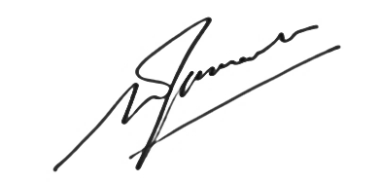

**dr. M. Candra Wijanadi**