EVALIXAI: AI-POWERED RECRUITMENT & CANDIDATE SCREENING PLATFORM

SOFTWARE REQUIREMENTS SPECIFICATION

BACHELOR OF TECHNOLOGY
(Computer Science & Engineering)

SUBMITTED BY
Aakash Sarang(2023BTCSE001)
Manish Srivastav(2023BTCSE009)

UNDER SUPERVISION OF
Dr. Dileep Kumar Singh
Professor & Head
Faculty of Science and Technology (FAST) Aug - 2025

JAGRAN SCHOOL OF ENGINEERING (JSEN)

FACULTY OF SCIENCE AND TECHNOLOGY (FAST)
JAGRAN LAKECITY UNIVERSITY, BHOPAL (M.P.)

SOFTWARE REQUIREMENTS SPECIFICATION (IEEE Std 830-1998)
EVALIXAI: AI-POWERED RECRUITMENT & CANDIDATE SCREENING PLATFORM
Formal Technical Requirements & Comprehensive Architectural Specification Baseline
B.Tech in Computer Science & Engineering | Academic Year 2025–2026
Project Authors & System Architects: | Academic Department & Institution:
Aakash Sarang (Enrollment No: 2023BTCSE001)  Manish Kumar Srivastav (Enrollment No: 2023BTCSE009) | Faculty of Engineering and Technology  Jagran Lakecity University, Bhopal, Madhya Pradesh, India
Document Version: 1.1 (Implementation Baseline) | Publication Date: September 2026

Document Revision History
Version | Primary Contributors | Approval Date | Description of Changes / Milestone Focus
1.0 | Aakash Sarang,  Manish Kumar Srivastav | August 2026 | Initial approved IEEE Std 830-1998 Software Requirements Specification drafted for university final-year evaluation, establishing functional baselines, microservices topology, and 4-month development roadmap [1], [2].
1.1 | Aakash Sarang,  Manish Kumar Srivastav | September 2026 | Architectural Alignment & Implementation Baseline: Synchronized specification with modern asynchronous cloud architecture (FastAPI 0.115, Next.js 16 App Router, MongoDB 7 via Motor async driver, Qdrant 1.12 vector search engine, Redis 7 session/rate-limiting, SeaweedFS S3 storage, and Bcrypt work factor 12 with PyJWT single-use refresh token rotation).

1. Introduction

1.1 Purpose
This Software Requirements Specification (SRS) document establishes the formal functional, and non-functional requirements for EvalixAI, a cloud-native, artificial intelligence-powered recruitment and candidate screening platform. Featuring an asynchronous multi-tier architecture powered by FastAPI, Next.js 16, MongoDB 7, Qdrant vector search, Redis 7, and SeaweedFS S3 storage, this specification functions as the primary technical contract and reference manual for software engineers, QA verification specialists, academic evaluators, and project architects throughout the system implementation, testing, and deployment phases, adhering to IEEE Std 830-1998 principles [1], [2].

1.2 Document Conventions
This document follows standard IEEE Std 830-1998 guidelines [1]. All functional requirements are cataloged with distinct alphanumeric identifiers following the syntax FR (e.g., FR-1.3 denotes requirement 3 under Feature Module 1). Each system feature is classified according to an implementation priority: High (essential core capabilities mandatory for initial release), Medium (integral workflow and analytical enhancements), or Low (optional value-added extensions). Semantic phrasing across requirement definitions alternates naturally between normative auxiliary forms ('The system shall...', 'The platform must...', 'Users shall be permitted to...', 'The application is required to...') while maintaining strict unambiguous compliance semantics [3].

1.3 Intended Audience and Reading Suggestions
This specification is structured to serve several distinct technical and operational stakeholder groups:
- Software Developers & System Architects: Consult Section 3 (External Interfaces), Section 4 (System Features), and Appendix B (Analysis Models) for implementation details, API schemas, and architectural boundaries.
- Quality Assurance & Verification Teams: Reference Section 4 (Functional Requirements) and Section 5 (Non-Functional Requirements) to design validation test plans, load tests, and security compliance matrices.
- Academic Evaluators & Project Mentors: Review Section 1 (Introduction), Section 2 (Overall Description), and Section 6 (Implementation Roadmap) for project governance, academic alignment, and milestone tracking.
- Founders & Early-Adopter Hiring Managers: Evaluate Section 2.3 (User Classes), Section 4.5 (Analytics), and Section 4.6 (Workflows) to understand product utility and operational ergonomics.

1.4 Product Scope and Key Objectives
EvalixAI is an evolution of an earlier academic intelligent assessment and proctoring engine [2], expanded into a comprehensive talent acquisition platform purpose-built for technology startups and small-to-medium enterprises (SMEs). The software automates the complete candidate screening lifecycle, transitioning an applicant from initial resume submission through cognitive testing, conversational technical interviews, and sandboxed coding tests to an explainable composite rank [4].
Core engineering goals include:
- Eliminate manual resume parsing friction via contextual LLM semantic evaluation and Qdrant dense vector embeddings against dynamic job requisitions [5].
- Deliver automated cognitive aptitude and technical screening assessments backed by anti-cheat proctoring heuristics.
- Conduct interactive conversational AI mock interviews that generate structured qualitative feedback across candidate communication and domain depth [6].
- Provide an isolated, multi-language coding execution environment capable of evaluating code correctness, runtime efficiency, and source code originality [7].

2. Overall Description

2.1 Product Perspective
EvalixAI is an autonomous, cloud-native recruitment intelligence platform designed to replace fragmented manual workflows and costly enterprise ATS suites [4]. The system operates as an asynchronous multi-tier architecture featuring a high-performance FastAPI backend service, a modern Next.js 16 (React 19, App Router) web cockpit, and dedicated modular subsystems for authentication, job management, dense vector resume screening, cognitive testing, AI conversational interviewing, sandboxed code compilation, and talent analytics [2]. The platform directly interfaces with containerized and cloud infrastructure (SeaweedFS / S3-compatible object storage, MongoDB 7 primary document store, Qdrant vector database, and Redis 7 in-memory cache) alongside third-party APIs (Anthropic Claude / OpenAI, Judge0 / Docker code execution, and SendGrid transactional email), functioning as a self-contained recruitment automation hub.

2.2 Product Functions
The core functionality of EvalixAI is divided into seven major functional modules:
- 1. Resume Intelligence: Resume parsing (PDF/DOCX), structured field extraction, and contextual LLM semantic scoring [5].
- 2. Cognitive Testing: Aptitude and technical test configuration, automated objective scoring, AI subjective grading, and proctoring.
- 3. AI Mock Interviews: Dynamic question generation, audio/text response capture, and multidimensional feedback generation [6].
- 4. Sandboxed Coding: Judge0 execution sandbox, hidden test case execution, and plagiarism detection [7].
- 5. Ranking & Analytics: Multi-criteria weighted scoring algorithm, talent leaderboards, funnel analytics, and bias telemetry [8].
- 6. Pipeline Automation: Job requisition authoring, candidate pipeline staging, automated notifications, and scorecard collaboration.
- 7. Auth & Account Management: Multi-tenant workspace management, OAuth 2.0 sign-in, session token handling, and RBAC enforcement.

2.3 User Classes and Characteristics
The system caters to five distinct user classes, characterized by distinct technical backgrounds and operational responsibilities:
User Class Persona | Operational Responsibilities & Platform Interactions | Technical Proficiency
Platform Super Admin | Manages multi-tenant cloud operations, monitors microservice health, oversees global billing, and configures LLM/sandbox rate quotas. | High (System Engineers)
Organization Admin | Provisions company workspaces, manages team memberships, configures subscription settings, and sets institutional data retention rules. | Medium (Operations / HR Leads)
Talent Acquisition / Recruiter | Creates job requisitions, tailors multi-stage screening criteria, analyzes AI candidate rankings, and initiates hiring decisions. | Low to Medium (HR Specialists)
Hiring Team Member / Reviewer | Inspects shortlisted candidate profiles, reviews interview transcripts and code scorecards, and submits collaborative interview notes. | Medium (Engineering Leads)
Job Applicant / Candidate | Discovers job openings, uploads resume files, completes proctored cognitive and coding tests, and participates in AI mock interviews. | Low (General Public / Applicants)

2.3.1 Role-Based Access Control (RBAC) Permission Matrix
Table 2.2 formalizes the operational privileges granted to each user class across core platform modules.
Functional Operation / Module | Super Admin | Org Admin | Recruiter | Reviewer | Candidate
Manage Platform Infrastructure & Quotas | Full | None | None | None | None
Provision Organization & Manage Members | Full | Full | None | None | None
Create, Edit & Publish Job Requisitions | Full | Full | Full | None | None
Configure Stage Weights & Cutoff Thresholds | Full | Full | Full | None | None
Upload Resume & Submit Application | None | None | None | None | Full
Attempt Proctored Tests & Mock Interviews | None | None | None | None | Full
Review Shortlists, Transcripts & Code Diffs | Full | Full | Full | Read/Comment | None
Trigger Candidate Offer / Rejection Status | Full | Full | Full | None | None

2.4 Operating Environment
- Client Environment: Standard modern web browsers (Google Chrome v120+, Mozilla Firefox v120+, Apple Safari v17+, Microsoft Edge v120+) executing JavaScript on desktop, laptop, and tablet devices.
- Server Infrastructure: Containerized Linux environment (Ubuntu 22.04 LTS / Debian 12) orchestrated via Docker Compose for local and microservice deployment with dedicated virtual bridge networks and container health check contracts; FastAPI 0.115 ASGI backend framework running on Python 3.12 with Uvicorn; Next.js 16.1 frontend web application (React 19, Turbopack, TypeScript 5.7, Tailwind CSS, Radix UI) [2].
- Data Storage Layer: MongoDB 7.0 Community / Atlas primary document store managed via the asynchronous Motor driver; Qdrant v1.12+ vector search engine with HNSW cosine distance metric for dense candidate embeddings; Redis 7.0 for session revocation, distributed rate-limiting token buckets, and test state caching; SeaweedFS / MinIO S3 API gateway for binary documents and media recordings.
- External Services: HTTPS connection to Anthropic Claude LLM API endpoints [5] and isolated Judge0 sandbox containers [7].

2.5 Design and Implementation Constraints
- Document Database & Vector Engine Standard (ADR-001 & ADR-002): The primary data store utilizes MongoDB 7.0 managed asynchronously via the Python Motor driver, adhering to strict Pydantic v2 schemas. The document model natively accommodates polymorphic candidate resumes, nested employment and education histories, arbitrary skill tags, and dynamic assessment responses without relational schema migration bottlenecks. Dense semantic resume embeddings (384-dimensional all-MiniLM-L6-v2 or 1536-dimensional OpenAI embeddings) are indexed and queried via Qdrant v1.12+ utilizing HNSW cosine distance metrics for sub-25ms nearest-neighbor search with payload filtering on job metadata.
- Data Privacy Compliance: The platform must comply with the European Union General Data Protection Regulation (GDPR) and India's Digital Personal Data Protection (DPDP) Act 2023 regarding candidate personal data handling and right-to-erasure.
- Execution Sandbox Isolation: All candidate-submitted source code must execute in isolated Docker containers with disabled network access and strict limits on CPU time (2 seconds) and memory (256 MB) [7].
- Algorithmic Explainability: All AI-based scoring and interview feedback must remain explainable and auditable to reduce demographic bias and discrimination risks [8].
- Deterministic Security & Storage Architecture (ADR-003 & ADR-004): Unstructured candidate files (PDF/DOCX resumes, proctoring snapshots, audio/video interview recordings) are stored in SeaweedFS S3-compatible storage via secure presigned PUT/GET URLs. Authentication enforces Bcrypt (work factor >= 12), short-lived 15-minute access JWTs in HttpOnly cookies, and 384-bit single-use refresh token rotation with SHA-256 digests and automated theft detection revoking all sessions upon replay.

2.6 User Documentation
The system incorporates embedded interactive wizards, contextual tooltips, and guided onboarding workflows within the Recruiter Dashboard to facilitate autonomous pipeline configuration. Comprehensive API technical documentation (Swagger/OpenAPI), deployment runbooks, and candidate assessment guides will be maintained as companion technical artifacts [2].

2.7 Assumptions and Dependencies
- LLM Availability: Uninterrupted availability and deterministic response latencies from third-party Large Language Model APIs (Anthropic Claude) [5].
- Client Hardware: Candidates possess standard client devices equipped with a functional camera, microphone, and stable internet connectivity (>2 Mbps) for video/audio assessments.
- Job Requisition Integrity: Recruiters provide complete, unambiguous job descriptions and valid evaluation criteria to enable accurate semantic matching.
- Commercial Policy: Subscription tiers, commercial pricing models, and payment gateway connectors remain subject to commercial policy documents and are marked as [TBD] for initial academic scope.

3. External Interface Requirements

3.1 User Interfaces
EvalixAI provides two primary web-based graphical user interfaces developed with Next.js 16, Tailwind CSS 4, and shadcn/ui:
- 1. Recruiter / Admin Dashboard: An analytical, data-dense interface enabling recruiters to create job postings, adjust stage weights, review applicant scorecards, and inspect pipeline funnel metrics.
- 2. Candidate Application Portal: A streamlined, low-cognitive-load portal guiding candidates through job application submission, automated aptitude tests, AI mock interviews, and code editors.
- Accessibility Mandate: All user interfaces must strictly adhere to WCAG 2.1 Level AA accessibility standards, providing full keyboard navigation, high color contrast ratios, screen-reader semantic tags, and responsive layouts across all viewport sizes.

3.2 Hardware Interfaces
The application requires no specialized or proprietary hardware. Client devices must provide standard webcam and microphone hardware inputs accessible via browser WebRTC APIs for video proctoring and conversational interview recording.

3.3 Software Interfaces
The software architecture establishes structured integrations across the following external services and runtime engines:
Target Software Interface | Integration Protocol & Modality | Functional Purpose in EvalixAI
Anthropic Claude / OpenAI API | HTTPS RESTful JSON Endpoints | Performs semantic resume parsing, dynamic interview question generation, multi-criteria response grading, and candidate scorecard synthesis [5].
Judge0 Code Execution Sandbox | RESTful API / Docker CLI Engine | Executes submitted candidate code in isolated containers against predefined test cases, returning runtime execution status, outputs, and memory usage [7].
MongoDB 7.0 Database | Async Motor driver over TCP/IP connection pool | Stores core document collections: users, jobs, candidates, assessments, interviews, and activity audit logs (ADR-001).
Qdrant Vector Engine v1.12+ | REST & gRPC / Qdrant Client over HTTP/2 | High-performance vector database storing 384/1536-dim candidate embeddings with HNSW cosine distance index for sub-25ms semantic resume screening (ADR-002).
Redis 7 In-Memory Store | Redis Serialization Protocol (RESP) | Provides session revocation tracking, single-use refresh token verification, fixed-window rate limiting (10 req/15 min on auth), and assessment recovery state.
SeaweedFS / S3 Object Storage | AWS SDK / Boto3 over HTTPS (S3 API) | Lightweight S3-compatible cloud storage for candidate resumes (PDF/DOCX), interview recordings, and audit report exports (ADR-003).
FastAPI 0.115 ASGI Framework | Python 3.12 / Uvicorn ASGI Server | High-performance asynchronous REST backend providing OpenAPI 3.1 contracts, Pydantic v2 validation, WebSocket streams, and security middleware.
Next.js 16 Web Framework | Node.js / Turbopack / React 19 | Modern web presentation layer hosting the Recruiter Cockpit Dashboard and Candidate Experience Portal with Tailwind CSS and Radix UI.
SendGrid / Amazon SES | SMTP / Transactional REST API | Dispatches transactional verification emails, assessment invitations, candidate pipeline status updates, and recruiter notifications.
WebRTC Media Subsystem | Browser WebRTC API / MediaStream | Captures candidate audio/video streams for interview response recording and proctoring compliance checks [6].

3.3.1 Core RESTful API Endpoint Specifications
Table 3.2 defines the primary RESTful HTTP routes orchestrating inter-service communication and client requests. In compliance with engineering standards, all endpoints are prefixed with /api/v1, return standardized envelopes, and enforce RFC 7807 problem details error contracts.
HTTP Method & Route | Invoking Component | Request Payload Schema | Response Contract & Status Codes
POST /api/v1/auth/register | Client (Auth) | JSON: {email, password, full_name, role} | 201 Created: {user_id, status: 'CREATED'}  400 Bad Request: Validation error  409 Conflict: Email exists
POST /api/v1/auth/login | Client (Auth) | JSON: {email, password} | 200 OK: Set HttpOnly access cookie (evalix_at), return refresh token  401 Unauthorized: Invalid credentials  429 Rate Limited
POST /api/v1/auth/refresh | Client (Auth) | Cookie: evalix_at, Header: {refresh_token} | 200 OK: Rotated access token & new single-use refresh token  401 Unauthorized / Token Replay Revocation
POST /api/v1/jobs | Recruiter Dashboard | JSON: {title, department, description, required_skills, weights} | 201 Created: {job_id, slug, status: 'open'}  401 Unauthorized
GET /api/v1/jobs/{slug} | Recruiter Dashboard | Path param: slug | 200 OK: {job details, criteria, stage weights, applicant counts}  404 Not Found
POST /api/v1/jobs/{slug}/screen | AI Resume Service | JSON: {candidate_ids, force_recompute: bool} | 200 OK: {screened_count, vector_matches, gap_analysis}  502 Upstream LLM / Qdrant Error
GET /api/v1/candidates | Recruiter Dashboard | Query params: {job_id, stage, min_score, search, sort} | 200 OK: {candidates: [...], total, page, limit}  401 Unauthorized
POST /api/v1/candidates | Candidate Portal / Intake | JSON: {job_id, full_name, email, phone, resume_url} | 201 Created: {candidate_id, stage: 'applied'}  422 Unprocessable Entity
GET /api/v1/candidates/{id} | Recruiter Dashboard | Path param: id | 200 OK: {profile, scores, extracted_profile, proctoring_flags}  404 Not Found
PATCH /api/v1/candidates/{id}/stage | Recruiter Dashboard | JSON: {stage: 'screened'|'assessment'|'interview'|'offer'|'rejected'} | 200 OK: {candidate_id, new_stage, updated_at}  400 Invalid Stage
POST /api/v1/assessments/start | Candidate Portal | JSON: {candidate_id, job_id} | 200 OK: {session_id, time_limit_minutes, randomized_questions}  403 Forbidden / Expired
POST /api/v1/assessments/{id}/telemetry | Candidate Portal | JSON: {event_type: 'tab_blur'|'fullscreen_exit', timestamp} | 200 OK: {logged: true, violation_count}  400 Invalid Session
POST /api/v1/assessments/{id}/submit | Candidate Portal | JSON: {answers: [{question_id, answer_value}]} | 200 OK: {objective_score, auto_graded: true, status: 'completed'}  408 Time Expired
POST /api/v1/uploads/presign | Candidate Portal | JSON: {file_name, file_type: 'application/pdf'|'docx', size_bytes} | 200 OK: {presigned_put_url, s3_key, expires_in: 900}  413 File Too Large (>10MB)
GET /api/v1/health | Monitoring / Ops | None | 200 OK: {status: 'healthy', services: {mongo: ok, redis: ok, qdrant: ok, s3: ok}}  503 Service Degraded

3.3.2 Relational Entity Data Dictionary
Table 3.3 catalogs the persistent document schemas and vector collections implemented in MongoDB 7.0 (via the asynchronous Motor driver) and Qdrant v1.12+ in accordance with ADR-001 and ADR-002.
Entity Name | Primary Key & Type | Foreign Keys & Relationships | Key Attributes & Constraints
users | _id: ObjectId | Ref by jobs.created_by, activity.user_id | email: String (unique, indexed), full_name: String, hashed_password: String (Bcrypt >= 12), role: Enum (admin, recruiter, reviewer), failed_login_attempts: Int, locked_until: ISODate, timestamps
jobs | _id: ObjectId | created_by -> users(_id), Ref by candidates.job_id | slug: String (unique, indexed), title: String, department: String, location: String, status: Enum (draft, open, paused, closed), required_skills: [String], weights: {resume, assessment, interview, coding}, created_at: ISODate
candidates | _id: ObjectId | job_id -> jobs(_id) (indexed), qdrant_point_id -> vector UUID | full_name: String, email: String (indexed), phone: String, resume_url: String (S3 key), stage: Enum (applied, screened, assessment, interview, offer, rejected), scores: {resume, assessment, interview, coding, composite}, extracted_profile: Object, proctoring_flags: [Object]
assessments | _id: ObjectId | candidate_id -> candidates(_id), job_id -> jobs(_id) | status: Enum (scheduled, in_progress, completed, expired, invalidated), time_limit_minutes: Int, started_at: ISODate, completed_at: ISODate, questions: [Object: {id, type, prompt, options, answer, is_correct, score}], total_score: Float
interviews | _id: ObjectId | candidate_id -> candidates(_id), job_id -> jobs(_id) | status: Enum (pending, completed), scores: {clarity, technical, communication}, overall_score: Float, transcript_url: String (S3 key), recording_url: String (S3 key), feedback_rubric: Object
audit_logs / activity | _id: ObjectId | user_id -> users(_id) | action: String (e.g. STAGE_CHANGE, SCORE_OVERRIDE, USER_INVITE), detail: String, ip_address: String, timestamp: ISODate (immutable audit trail)
candidate_profiles (Qdrant Vector Store) | point_id: UUID | Vector link -> candidates(_id) | Dense embedding vector (384/1536 dimensions, HNSW Cosine Index); Payload metadata: job_id (keyword), skills (keyword list), experience_years (integer range)

3.4 Communications Interfaces
- HTTPS/TLS Encryption: All web client-to-server and inter-service HTTP communications must enforce TLS 1.3 encryption.
- RESTful API Contracts: Inter-service communication utilizes standardized JSON payloads over RESTful endpoints with Bearer token authentication.
- WebSocket Event Streams: Candidate proctoring events and real-time dashboard score updates are pushed via secure WebSockets (WSS).
- Email Communications: Candidate pipeline stage notifications are dispatched via SMTP over TLS on standard secure ports.

4. System Features
This section establishes the exhaustive functional requirements for EvalixAI, organized across seven core microservice modules. Each feature includes an architectural description, priority classification, and 10–12+ granular requirements addressing standard operations, input validation, edge cases, and failure recovery.

4.1 AI-Powered Resume Screening & Parsing Engine
Description: Automatically ingests uploaded candidate resumes, extracts structured biographical and technical data profiles, and calculates contextual relevance scores against job descriptions using LLM semantic embeddings [5].
Priority: High
- FR-1.1: Recruiters shall be able to create, configure, and publish job descriptions specifying mandatory skills, minimum experience thresholds, educational requirements, and qualitative evaluation rubrics.
- FR-1.2: The system shall accept candidate resume uploads in PDF and DOCX formats up to a maximum file size of 10 MB per document.
- FR-1.3: The platform must validate uploaded document MIME types and reject unsupported, password-protected, or corrupted files with descriptive error messages.
- FR-1.4: The ingestion pipeline will extract text streams from valid documents within 10.0 seconds of upload using pypdf and python-docx extraction workers, falling back to Tesseract OCR when processing non-selectable scanned PDFs.
- FR-1.5: The module is required to structure candidate data into standardized JSON schemas extracting candidate name, contact info, educational qualifications, employment history, technical skill tags, and certifications.
- FR-1.6: The application shall compute a normalized semantic relevance score (0.0–100.0%) for each candidate by evaluating contextual alignment between resume text and job criteria using Qdrant dense vector embeddings (HNSW cosine similarity) paired with Claude LLM semantic evaluation [5].
- FR-1.7: The platform must perform explicit qualification gap analysis, flagging missing mandatory credentials, substandard experience years, and unmatched core competencies.
- FR-1.8: The system shall incorporate heuristic anomaly detection to identify and penalize artificial keyword stuffing (e.g., hidden white text, repeated token blocks) in candidate resumes [3].
- FR-1.9: Recruiters shall be permitted to filter, sort, and query parsed candidate profiles based on composite relevance scores, individual skill tags, years of experience, and geographical location.
- FR-1.10: The system must detect duplicate candidate applications using email and phone hashing, flagging repeated submissions within the same organizational workspace.
- FR-1.11: If third-party LLM parsing endpoints experience timeouts (>30 seconds) or 5xx rate-limit errors, the platform shall automatically degrade gracefully to local dictionary-based keyword matching and heuristic scoring while enqueuing retry jobs in Redis, preventing disruption to candidate application flows.

4.2 Automated Aptitude & Technical Screening Module
Description: Delivers configurable online assessment rounds incorporating objective and subjective technical questions with instant automated evaluation, AI-assisted grading, and anti-cheat proctoring heuristics.
Priority: High
- FR-2.1: Recruiters shall be able to create custom assessment tests or select curated question sets from an institutional question bank spanning quantitative aptitude, logical reasoning, and technical domains.
- FR-2.2: The platform must support multiple question archetypes, including single-choice MCQ, multiple-select, numeric input, and open-ended subjective short-answer questions.
- FR-2.3: The system shall evaluate objective question responses immediately upon candidate submission and calculate instantaneous section scores.
- FR-2.4: The application is required to employ AI-assisted evaluation for subjective short-answer responses, providing an automated score (0–100%) alongside a confidence rating and natural language grading rationale.
- FR-2.5: The assessment engine shall enforce configurable overall test durations and section-level countdown timers, with client-side synchronization, server-side authoritative expiry validation, and autosave state syncing to Redis every 15 seconds.
- FR-2.6: The platform must support dynamic question shuffling and option order randomization per candidate session to prevent peer collusion during synchronous campus drives.
- FR-2.7: The module will track client-side proctoring telemetry via browser event listeners and stream events via POST /api/v1/assessments/{id}/telemetry and WebSockets, logging tab-switching events, window blur occurrences, and full-screen exits with timestamps.
- FR-2.8: The system shall automatically terminate and flag an assessment session if a candidate exceeds a recruiter-configured threshold of proctoring violations (e.g., >3 tab switches).
- FR-2.9: If a candidate encounters network disconnection during an active test, the platform shall preserve in-progress response state in Redis and permit session resumption within a 5-minute grace window.
- FR-2.10: The system shall automatically submit all completed and partially answered questions upon timer expiration, preventing candidate lockout without submission.
- FR-2.11: Recruiters shall have the authority to inspect detailed candidate assessment logs, including time spent per question, answer revision history, and proctoring violation alerts.

4.3 AI-Driven Conversational Mock Interview Engine
Description: Conducts dynamic, role-tailored technical and behavioral interviews using a conversational AI agent that analyzes candidate responses and compiles structured qualitative feedback scorecards [6].
Priority: High
- FR-3.1: The system shall dynamically generate role-tailored technical and situational interview questions grounded in the specific job description and candidate resume profile using Claude LLM [5].
- FR-3.2: The platform must support multi-modal interview interactions across text prompts, recorded audio responses, and video capture based on recruiter configuration.
- FR-3.3: The interview engine will enforce question-level response time limits (e.g., 2 minutes per question) and provide a visual countdown timer to the candidate.
- FR-3.4: The application is required to transcribe candidate audio streams into text transcripts using speech-to-text models, handling audio noise filtering and volume normalization.
- FR-3.5: The module shall evaluate candidate responses across multiple orthogonal dimensions: technical accuracy, conceptual clarity, communication articulation, and problem-solving depth [6].
- FR-3.6: The platform must synthesize a structured interview scorecard containing itemized strengths, identified skill deficiencies, and a normalized overall readiness index (0–100%).
- FR-3.7: Recruiters shall be able to review synchronized interview recordings, timestamped text transcripts, and AI-generated qualitative feedback side-by-side.
- FR-3.8: The system shall allow candidates to optionally receive their own developmental feedback summary highlighting constructive growth areas when enabled by the recruiter.
- FR-3.9: If a candidate's media stream disconnects during an interview question, the platform shall allow one retry attempt for that specific question without corrupting prior responses.
- FR-3.10: The system shall sanitize and redact candidate PII (e.g., phone numbers, home addresses) from interview transcripts prior to long-term storage.

4.4 Sandboxed Coding Assessment & Plagiarism Detection Engine
Description: Provides an integrated browser-based coding workspace backed by isolated execution containers, evaluating algorithmic correctness, code quality, execution efficiency, and source code originality [7].
Priority: High
- FR-4.1: The platform must provide an in-browser code editor (Monaco-based, @monaco-editor/react) supporting syntax highlighting, auto-indentation, and bracket matching for Python, Java, C++, and JavaScript.
- FR-4.2: The execution runner shall compile and execute submitted code within an isolated Docker/Judge0 sandbox against predefined visible and hidden unit test cases [7].
- FR-4.3: The system shall enforce strict resource governance, terminating code executions that exceed 2.0 seconds of CPU execution time or 256 MB of RAM with appropriate error codes (Time Limit Exceeded / Memory Limit Exceeded).
- FR-4.4: The sandbox environment must enforce complete network isolation, disabling all outbound socket connections and system fork capabilities to prevent malicious execution.
- FR-4.5: Candidates shall be permitted to test their code against custom user-defined standard inputs prior to final problem submission, receiving sanitized stdout and stderr streams.
- FR-4.6: The module is required to perform static code analysis to evaluate algorithmic time/space complexity, cyclomatic complexity, code readability, and stylistic adherence.
- FR-4.7: The platform shall execute automated structural plagiarism detection comparing candidate submissions against peer solutions and open-source repositories using abstract syntax tree tokenization [7].
- FR-4.8: The system shall generate a detailed programming scorecard summarizing test case pass rates, runtime execution percentiles, static quality ratings, and plagiarism similarity flags.
- FR-4.9: If compilation fails, the platform shall capture and present sanitized compiler diagnostic messages to the candidate without exposing backend server paths.
- FR-4.10: The system shall maintain versioned submission snapshots, recording candidate incremental code edits and test execution attempts throughout the session.

4.5 Composite Candidate Ranking & Hiring Analytics Dashboard
Description: Synthesizes multi-stage evaluation data into a weighted composite score, providing recruiters with an explainable talent leaderboard and funnel conversion analytics [8].
Priority: Medium
- FR-5.1: The platform must compute an overall weighted composite score (0–100%) for each candidate based on recruiter-configured stage weights according to the formal formula: Composite Score = (w_r * Resume) + (w_a * Assessment) + (w_i * Interview) + (w_c * Coding), where sum(w) = 1.0 [4].
- FR-5.2: The system shall dynamically rank all applicants within an active job requisition according to their composite scores, supporting multi-criteria secondary sorting (e.g., coding score tie-breaking).
- FR-5.3: The recruiter dashboard is required to render pipeline funnel visualizations tracking stage-by-stage candidate throughput (Applied -> Screened -> Tested -> Interviewed -> Offered).
- FR-5.4: The platform shall provide downloadable summary reports in PDF and CSV formats encapsulating candidate rankings, score breakdowns, and evaluation notes.
- FR-5.5: The analytics engine shall calculate recruitment operational metrics, including average time-to-screen, stage drop-off rates, and applicant sourcing channels.
- FR-5.6: The application will monitor aggregate scoring patterns to identify and flag potential statistical anomalies or demographic scoring disparities for recruiter awareness [8].
- FR-5.7: Recruiters shall be able to simulate weight adjustments in real-time within a sandbox UI to observe dynamic changes in candidate leaderboard ranking.
- FR-5.8: The system shall maintain an immutable audit trail of all score computations, recruiter score overrides, and ranking recalculations.
- FR-5.9: Recruiters shall be able to export aggregate cohort analytics for university campus placement reports and institutional hiring audits.

4.6 End-to-End Pipeline Workflow & Lifecycle Automation
Description: Orchestrates the operational journey of a job posting from creation through candidate invitation, automated stage progression, and hiring finalization.
Priority: Medium
- FR-6.1: Recruiters shall be able to create, edit, archive, and publish job requisitions with custom multi-stage screening pipelines.
- FR-6.2: The platform must generate public application URLs and career page listings allowing candidates to submit applications directly.
- FR-6.3: The system shall automatically transition candidates to subsequent assessment stages when their stage scores meet recruiter-defined cutoff thresholds.
- FR-6.4: The application is required to trigger automated transactional email notifications to candidates upon stage progression, assessment assignment, or rejection via SendGrid.
- FR-6.5: Hiring team members shall be permitted to submit collaborative feedback comments, interview scorecards, and hiring recommendations on applicant profiles.
- FR-6.6: The platform must maintain comprehensive audit trails recording recruiter actions, candidate status changes, and interview notes [2].
- FR-6.7: Recruiters shall have the authority to manually override automated stage cutoff decisions and adjust candidate pipeline placement.
- FR-6.8: The system shall support batch candidate operations, enabling recruiters to send bulk invitations, advance multiple candidates, or issue batch rejections.
- FR-6.9: Candidates shall have the option to withdraw their application at any pipeline stage, triggering automated data retention lifecycle procedures.
- FR-6.10: The system shall notify recruiters when candidates fail to complete scheduled assessments within configured SLA time windows.

4.7 User Authentication, RBAC & Organization Management
Description: Manages multi-tenant organization workspaces, user identity lifecycle, secure authentication, and role-based access permissions.
Priority: High
- FR-7.1: The platform must permit users to authenticate using email/password credentials (hashed with Bcrypt >= 12 rounds) or via third-party OAuth 2.0 providers (Google and LinkedIn).
- FR-7.2: The system shall mandate email verification prior to activating new user accounts.
- FR-7.3: The security module shall temporarily lock user accounts for 15 minutes following 5 consecutive failed authentication attempts (locked_until), employing constant-time fake_compare verification to prevent user enumeration.
- FR-7.4: The platform is required to support optional Multi-Factor Authentication (MFA / TOTP) for Organization Admin and Recruiter accounts.
- FR-7.5: Organization Admins shall be permitted to invite, manage, and revoke team member accounts within a shared organizational workspace.
- FR-7.6: The application shall enforce strict Role-Based Access Control (RBAC) guaranteeing that users can only access data and operations authorized for their assigned role [3].
- FR-7.7: Authentication shall enforce short-lived 15-minute JWT access tokens in HttpOnly, SameSite=Lax, Secure cookies (evalix_at) paired with 384-bit single-use refresh token rotation with SHA-256 storage and automated theft detection revoking all sessions upon replay.
- FR-7.8: The platform shall provide an automated account deletion and candidate right-to-be-forgotten workflow in compliance with GDPR and India's DPDP Act 2023, completely purging candidate MongoDB records, Qdrant vector points, and S3 resume files.
- FR-7.9: All administrative operations (inviting users, changing permissions, modifying billing) must be logged in a tamper-evident audit table.

5. Nonfunctional Requirements

5.1 Performance Requirements
- Page Load Latency: Recruiter dashboard pages and candidate application views must achieve a First Contentful Paint (FCP) < 1.2 seconds on 4G networks, with standard REST API query latencies achieving P50 < 40 ms and P95 < 150 ms under concurrent active load [2].
- Resume Ingestion Throughput: The resume parsing and semantic scoring pipeline must complete processing of a single candidate document within 10.0 seconds from submission, with Qdrant vector nearest-neighbor queries completing in < 25 ms across 100,000 candidate profiles [5].
- Code Execution Speed: The isolated code execution sandbox must compile, execute, and evaluate candidate code against standard test suites within 5.0 seconds for standard test cases, with container spin-up overhead under 500 milliseconds and assessment answer submissions acknowledging in < 50 ms [7].
- Concurrent Assessment Scalability: The cloud infrastructure must support at least 5,000 concurrent candidate assessment and testing sessions during peak campus recruitment drives without service degradation or packet loss.

5.2 Safety & Ethical AI Requirements
Ethical Governance: EvalixAI is an enterprise productivity software platform and does not interface with physical actuators or life-critical machinery. The primary safety concerns pertain to ethical algorithmic fairness and the prevention of automated hiring discrimination [8]. To ensure safety:
- Algorithmic Transparency: Every AI-generated score, summary, and recommendation must provide an inspectable natural language rationale explaining the evaluation criteria applied [8].
- Bias Monitoring: The platform must include statistical monitoring that detects and alerts hiring teams to potential demographic skew or bias anomalies across candidate cohorts [8].
- Human-in-the-Loop Oversight: Recruiters retain full administrative authority to inspect, adjust, or override any automated AI recommendation or scoring output.

5.3 Security & Privacy Requirements
- Data at Rest Encryption: All sensitive MongoDB documents, candidate personal identifiable information (PII), evaluation scorecards, and audit logs stored at rest must be encrypted using AES-256-GCM. Unstructured files in SeaweedFS S3 buckets are protected with server-side encryption.
- Data in Transit Encryption: All network traffic in transit between browser clients, Next.js frontend, FastAPI backend services, MongoDB, Qdrant, and external APIs must be encrypted using TLS 1.3.
- Authentication Tokens: Session management enforces Bcrypt (work factor >= 12), cryptographically signed 15-minute JWT access tokens (HS256) stored in HttpOnly, SameSite=Lax, Secure cookies (evalix_at), and 384-bit single-use refresh token rotation stored as SHA-256 digests with automated replay theft detection.
- Statutory Privacy Adherence: All candidate personal information, resumes, and video recordings must be managed in strict adherence to EU GDPR and India's Digital Personal Data Protection Act (DPDP Act 2023), including candidate PII anonymization mode, automated data retention schedules, and complete right-to-erasure purging across MongoDB, Qdrant, and S3.
- Sandbox Security Boundaries: All candidate-submitted code executions must occur within unprivileged, network-isolated Docker containers with constrained kernel capabilities [7].

5.4 Software Quality Attributes
- Availability Target: The platform targets 99.9% service availability during standard operational hours, backed by automated health probes and multi-zone deployment [2].
- Disaster Recovery & Backup: Automated database backups must execute daily with a defined Recovery Point Objective (RPO) of 24 hours and a Recovery Time Objective (RTO) of under 4 hours.
- Fault Tolerance & Graceful Degradation: If third-party LLM APIs experience temporary outages or latency exceeding 30 seconds, the system automatically falls back to regex-based keyword extraction and heuristic semantic scoring so candidate submissions complete without failure, while enqueuing background retry jobs in Redis. Database connection pools implement exponential backoff with jitter, and active test sessions support 5-minute reconnect grace resumption.
- Accessibility Standards: Candidate portals must comply with WCAG 2.1 Level AA accessibility standards, ensuring full usability for individuals with visual or motor impairments.
- User Ergonomics: First-time recruiters must be capable of creating a job opening and configuring a multi-stage screening pipeline within 10 minutes without external training.

5.5 Business Rules & Gating Logic
- Administrative Authority: Only designated Organization Admins possess the authority to provision team accounts and manage company workspace subscriptions.
- Pipeline Stage Progression: Candidates may only advance to subsequent pipeline stages if their evaluated stage score equals or exceeds the threshold configured by the recruiter.
- Assessment Retake Constraints: Candidate assessment sessions are single-attempt by default and cannot be restarted without explicit recruiter administrative authorization.
- Commercial Subscription Limits: Subscription tier limits (e.g., maximum active job postings, monthly candidate parsing quotas) are governed by external commercial agreements [TBD].

6. Implementation Roadmap & Phased Delivery Schedule
The implementation of EvalixAI is scoped across a 16-week (4-month) delivery window tailored for a dedicated two-person final-year student engineering team (Aakash Sarang and Manish Kumar Srivastav). The phased roadmap ensures disciplined progression from core infrastructure to AI services, end-to-end integration, and cloud validation [2], [3].
Project Phase | Development Sprint Focus | Primary Technical Milestones | Engineering Ownership
Phase 1 (Month 1 / W1–W4) | Core Asynchronous Foundation, Auth/RBAC & Resume Vector Ingestion Engine | • FastAPI 0.115 & Next.js 16 project scaffolding  • MongoDB 7 document schemas & Motor async driver integration (ADR-001)  • Bcrypt work factor 12 & PyJWT HttpOnly cookie auth with single-use refresh token rotation (ADR-004)  • SeaweedFS S3 upload presigning pipeline (/api/v1/uploads/presign) (ADR-003)  • Qdrant v1.12+ vector collection setup with HNSW cosine index (ADR-002)  • Claude LLM & heuristic resume screening pipeline | • Aakash: Next.js Dashboard layout, Candidate table & detail drawer, Auth cookies  • Manish: FastAPI backend, MongoDB Motor models, Qdrant vector engine, S3 presigning
Phase 2 (Month 2 / W5–W8) | Cognitive Screening Engine & Sandboxed Code Execution Runner | • Assessment collection CRUD & dynamic question set generation  • Real-time browser proctoring telemetry streaming (/api/v1/assessments/{id}/telemetry)  • Server-side authoritative countdown timer with Redis recovery state  • Monaco in-browser IDE (@monaco-editor/react) & Judge0 Docker execution sandbox  • Multi-language test runner (Python, Java, C++, JS) with cgroup governance (2s CPU, 256MB RAM) | • Aakash: Assessment Room UI, timer synchronization, proctoring event listeners  • Manish: Proctoring telemetry API, Judge0 sandbox integration, code runner
Phase 3 (Month 3 / W9–W12) | Conversational AI Mock Interviewer & Composite Ranking Analytics | • Dynamic role-specific interview question generator via Claude  • WebRTC audio/video capture container & speech-to-text transcription (Web Speech / Whisper)  • Multi-criteria response evaluation rubric (clarity, depth, technical accuracy)  • Recruiter Weight Adjustment Sandbox UI & real-time composite score computation  • Downloadable candidate summary reports (PDF / CSV) | • Aakash: Interview Room WebRTC UI, audio visualizer, Weight Sandbox UI  • Manish: LLM interview grading service, composite ranking engine, CSV/PDF export
Phase 4 (Month 4 / W13–W16) | Full Pipeline Integration, Production Hardening & Docker Orchestration | • End-to-end Candidate Portal (/apply, /assessment, /interview) & Recruiter Cockpit integration  • SendGrid transactional email notifications & candidate progression triggers  • Docker Compose multi-service container orchestration with health check probes  • Load testing (5,000 concurrent assessment sessions) & WCAG 2.1 AA accessibility audit  • Comprehensive documentation suite (docs/) & final project defense presentation | • Aakash: Candidate portal workflows, UI accessibility, presentation artifacts  • Manish: Docker Compose orchestration, performance benchmarking, system documentation

Appendix A: Glossary of Terms and Acronyms
Term / Acronym | Technical Definition and Context within EvalixAI
SRS | Software Requirements Specification (formal requirements baseline under IEEE Std 830-1998 [1]).
ATS | Applicant Tracking System (software managing talent acquisition and candidate pipelines [4]).
AI / ML | Artificial Intelligence / Machine Learning computational models for automated evaluation.
LLM | Large Language Model (transformer-based model, e.g., Anthropic Claude, for NLP reasoning [5]).
NLP | Natural Language Processing (computational analysis and synthesis of human language text [5]).
JD | Job Description (formal specification of role responsibilities, qualifications, and criteria).
RBAC | Role-Based Access Control (restricting system operations based on assigned user roles [3]).
Proctoring | Automated telemetry and heuristics tracking candidate compliance during online testing.
Plagiarism Detection | Algorithmic comparison of submitted code against reference repositories to detect copying [7].
Sandboxed Execution | Running untrusted user code in isolated containers with strict resource boundaries [7].
GDPR | General Data Protection Regulation (European Union standard for personal data protection).
DPDP Act 2023 | Digital Personal Data Protection Act, 2023 (Indian statutory standard for data privacy).
WCAG 2.1 AA | Web Content Accessibility Guidelines Level AA (international web accessibility standard).
OAuth 2.0 | Open standard authorization framework enabling third-party identity authentication.
MongoDB 7 | High-performance NoSQL document database utilizing native BSON/JSON schemas for flexible candidate profiles and dynamic test data (ADR-001).
Motor | Asynchronous Python driver for MongoDB providing non-blocking I/O operations within FastAPI coroutines.
Qdrant | Dedicated open-source vector search engine providing high-throughput dense embedding storage and sub-25ms approximate nearest neighbor (ANN) search via HNSW cosine indexing (ADR-002).
HNSW | Hierarchical Navigable Small World graphs, an efficient algorithm for high-dimensional vector similarity search used in Qdrant.
SeaweedFS | Fast, distributed S3-compatible object storage system utilized for storing resume documents, audio/video interview recordings, and audit exports (ADR-003).
FastAPI | Modern, high-performance web framework for building asynchronous APIs with Python 3.12, based on standard Python type hints and Pydantic v2.
Bcrypt | Adaptive password-hashing function designed to defend against brute-force hardware attacks, configured in EvalixAI with a work factor >= 12.
Refresh Token Rotation | Security technique where a single-use cryptographically random refresh token is exchanged for a new token pair upon each refresh, with automatic session revocation upon replay detection (ADR-004).

Appendix B: System Analysis and Design Models
This appendix consolidates the formal structural, behavioral, and data models illustrating the architectural implementation of EvalixAI [2].

B.1 High-Level System Architecture Model
Figure B.1 presents the multi-tiered cloud-native architecture of EvalixAI. Web clients (Candidate Experience Portal and Recruiter Cockpit Dashboard) connect via Edge CDN and Next.js 16 Web Application (:3000) to the FastAPI Backend Service (:8000). The asynchronous backend dispatches operations to MongoDB 7 Document Data Store (:27018) via the Motor driver, Qdrant Vector Engine (:6333) for dense semantic embeddings, Redis 7 In-Memory Store (:6380) for session revocation and distributed rate limits, and SeaweedFS S3 Storage (:9000) for binary resumes and media. External integrations include Anthropic Claude / OpenAI APIs and isolated Judge0 sandbox containers.
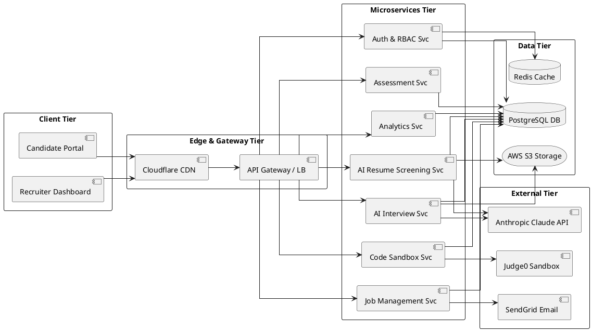
Figure B.1: Comprehensive System Architecture and Microservices Interconnections

B.2 Container Orchestration & Deployment Topology
Figure B.2 details the container orchestration and deployment topology. In both development and staging environments, services are orchestrated via Docker Compose across dedicated virtual bridge networks (frontend-network and backend-network). Dedicated container health check contracts ensure resilient dependency ordering between the Next.js frontend, FastAPI ASGI server, MongoDB 7, Redis 7, Qdrant vector database, and SeaweedFS S3 gateway, ensuring horizontal scaling, fault isolation, and reproducible deployments [2].
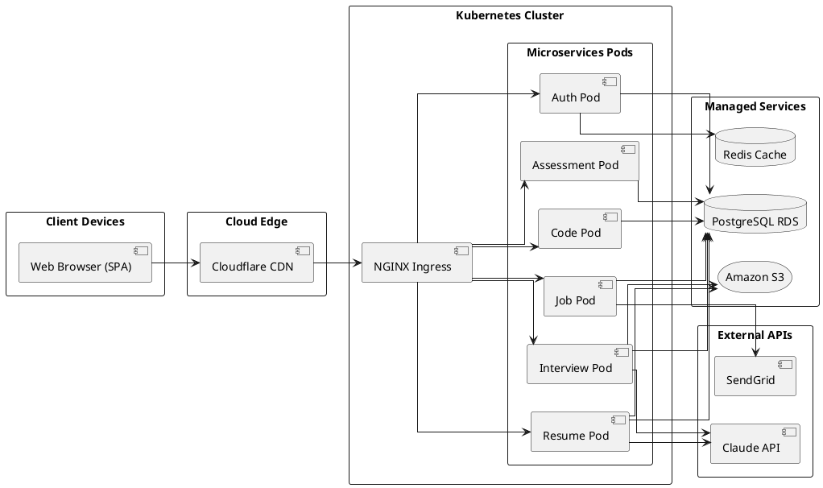
Figure B.2: Container Network Topology and Multi-Service Deployment Infrastructure Mapping

B.3 Document Data Model & Entity Relationship Topology
Figure B.3 depicts the document schema architecture implemented in MongoDB 7.0 and Qdrant v1.12+. The primary collections comprise users (authentication, RBAC roles, Bcrypt hashes, lockout state), jobs (requisition details, skill criteria, and dynamic stage weights), candidates (applicant profiles, pipeline stages, composite score breakdown, extracted work/education histories, and proctoring violation logs), assessments (timed test sessions, questions, candidate answers, and objective scores), interviews (transcripts, audio/video S3 references, and multi-criteria evaluation rubrics), and activity (immutable administrative and audit logs). The candidate_profiles Qdrant vector collection links to candidate documents via UUID point IDs with 384/1536-dimensional dense embeddings and HNSW cosine distance indexing.
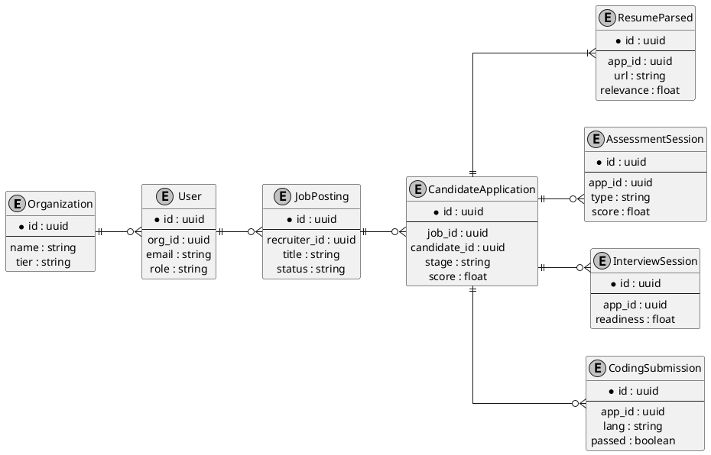
Figure B.3: Document Collections and Vector Schema Relationship Model

B.4 Sequence Diagram — AI Resume Screening Transaction Flow
Figure B.4 specifies the sequence of interactions during resume processing. A recruiter creates a job requisition via the Next.js dashboard, persisting criteria and stage weights to MongoDB. When a candidate uploads a resume (PDF/DOCX), the client requests a presigned S3 PUT URL from FastAPI and streams the binary directly to SeaweedFS S3 storage. FastAPI triggers the asynchronous screening worker: pypdf and python-docx extract normalized text, Qdrant indexes dense embeddings for vector similarity matching, and Claude LLM evaluates qualifications and missing skill gaps [5]. Scores are persisted in the candidates collection in MongoDB and broadcast in real time to the Recruiter Cockpit via WebSockets.
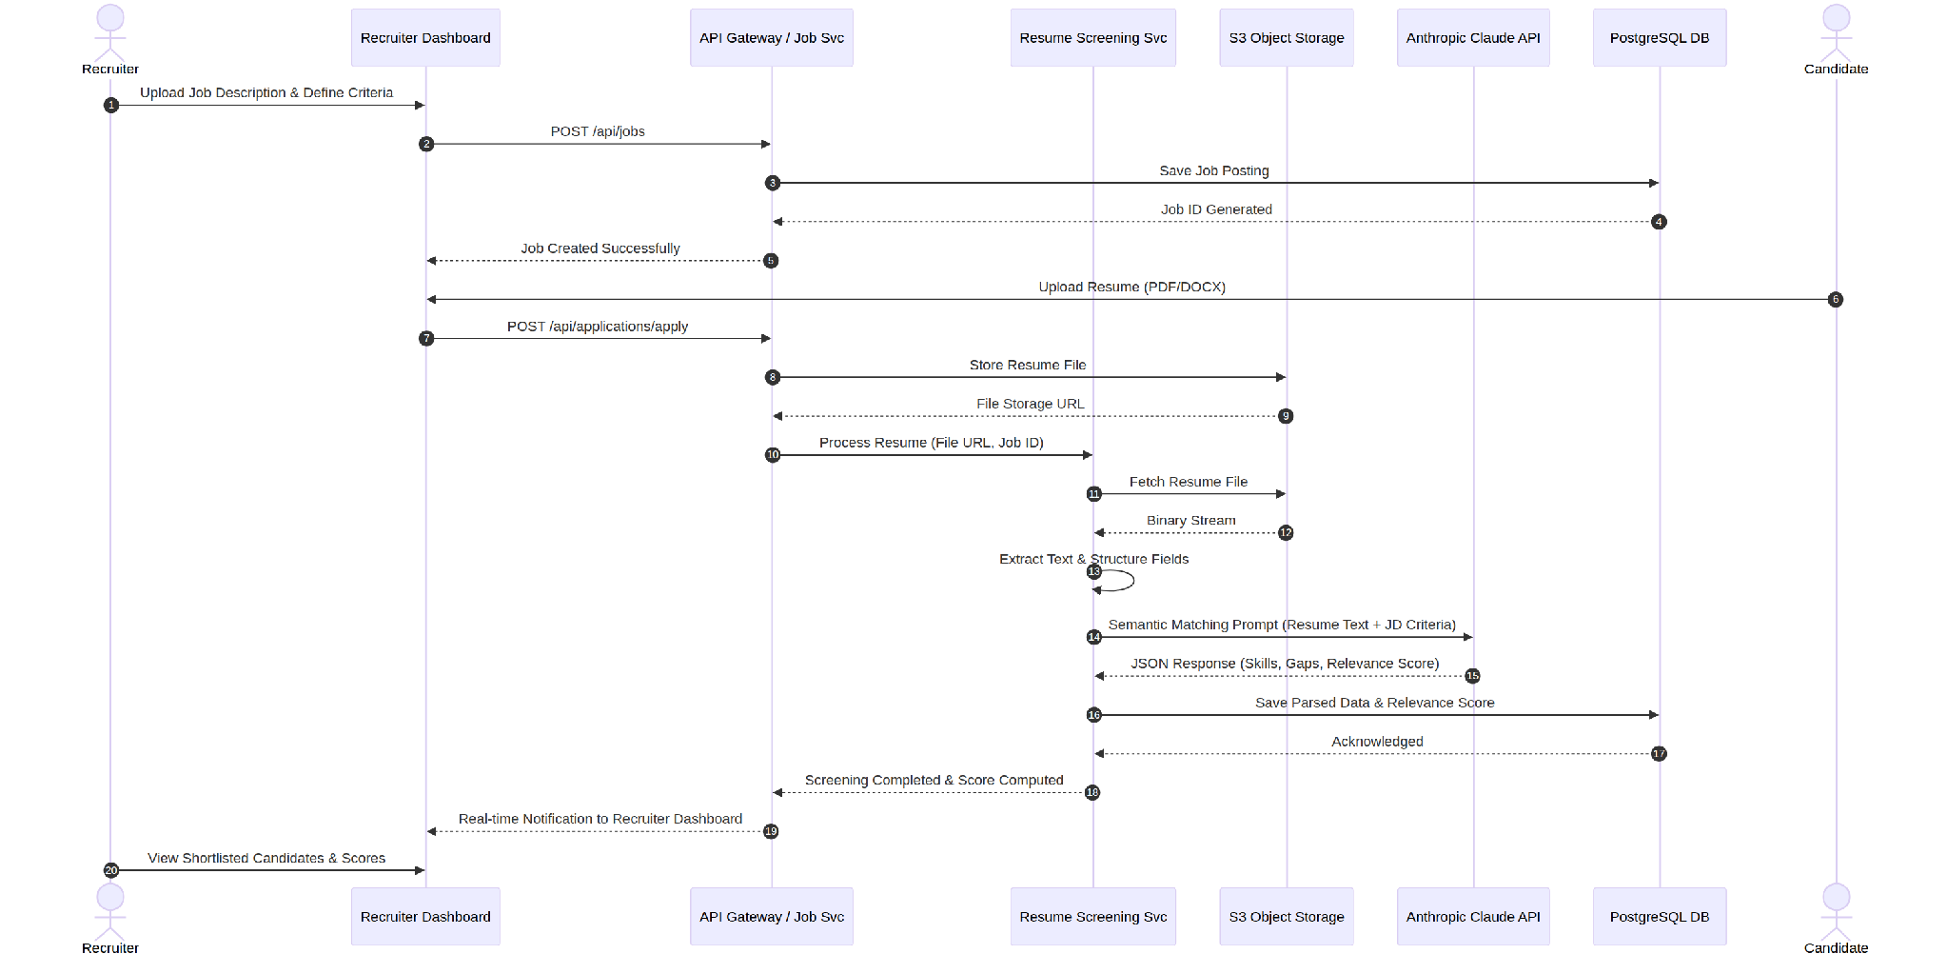
Figure B.4: Transactional Sequence Diagram for Resume Ingestion and LLM Semantic Evaluation

B.5 System Use Case Model
Figure B.5 defines the primary use case boundaries for the core platform actors: Candidate (discovers openings, uploads resume via presigned S3 URL, attempts timed proctored aptitude assessments, participates in AI mock interviews, and executes code in Monaco sandbox), Recruiter (configures job requisitions, adjusts dynamic stage weights, monitors real-time candidate screening, inspects detailed candidate scorecards, and triggers pipeline advancement), Reviewer (collaborates on shortlisted profiles and submits interview notes), and Super/Org Admin (provisions organization workspaces, manages team members, monitors system health, and audits security logs).
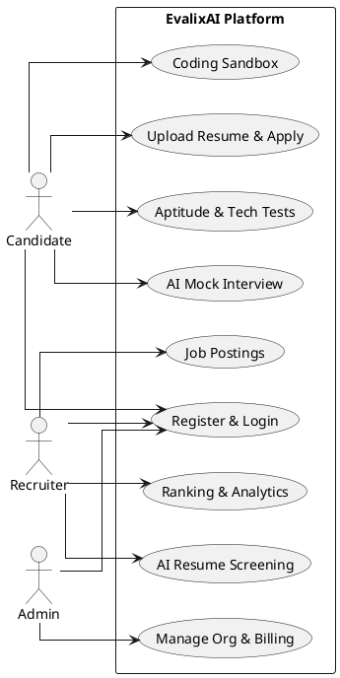
Figure B.5: System Use Case Model Depicting Actor Roles and Operational Boundaries

Appendix C: To Be Determined (TBD) List
The following operational and technical items are tracked as pending finalization in subsequent commercial or engineering phases:
- TBD-1: Final selection of managed commercial WebRTC media streaming SDK provider (e.g., LiveKit vs. Agora vs. Daily.co) for high-definition video interview recording and real-time proctoring.
- TBD-2: Integration specifications for payment gateway and recurring subscription billing infrastructure (e.g., Stripe vs. Razorpay) for post-academic commercial monetization, and lightweight non-intrusive AdMob / Google Ad Manager placements on public candidate practice portals (as specified in docs/11_ADMOB_SPEC.md).
- TBD-3: Formal pricing tier schedules, candidate volume quotas, and seat licensing parameters, to be defined in a dedicated commercial policy document.
- TBD-4: Detailed low-fidelity wireframes and interactive user journey flowcharts for the Recruiter/Admin Dashboard and Candidate Portal, maintained in the companion UI/UX Design Specification.

Appendix D: Academic References and Bibliography
[1] IEEE Computer Society, "IEEE Recommended Practice for Software Requirements Specifications," IEEE Std 830-1998 (R2009), Institute of Electrical and Electronics Engineers, Piscataway, NJ, 1998.
[2] I. Sommerville, Software Engineering, 10th ed. Boston, MA: Pearson Education, 2016.
[3] R. S. Pressman and B. R. Maxim, Software Engineering: A Practitioner's Approach, 9th ed. New York, NY: McGraw-Hill, 2020.
[4] C. Faliagkas, L. Iliadis, I. Karydis, and G. Tzimas, "Online recruitment system with automated candidate ranking," Information Systems, vol. 40, pp. 23–30, 2014.
[5] D. Jurafsky and J. H. Martin, Speech and Language Processing: An Introduction to Natural Language Processing, Computational Linguistics, and Speech Recognition, 3rd ed. draft, Upper Saddle River, NJ: Prentice Hall, 2023.
[6] H.-Y. Suen, K.-E. Hung, and C.-L. Lin, "Intelligent video interview agent using machine learning for assessing interviewees' personality traits and communication skills," Computers in Human Behavior, vol. 95, pp. 260–272, 2019.
[7] P. Ihantola, T. Ahoniemi, V. Karavirta, and O. Seppälä, "Review of recent systems for automated assessment of programming assignments," in Proc. 10th Koli Calling Int. Conf. Comput. Educ. Res., pp. 86–93, 2010.
[8] M. Raghavan, S. Barocas, J. Kleinberg, and K. Levy, "Mitigating bias in algorithmic hiring: Evaluating claims and practices," in Proc. ACM Conf. Fairness, Accountability, and Transparency (FAccT), pp. 469–481, 2020.

