PREDICTING THE ECONOMIC IMPACT OF POST COVID-19 IN SUB-SAHARAN AFRICAN COUNTRIES USING GRADIENT BOOSTING

BY

OGHENEKARO EMMANUELLA AVWERUSUOGHENE
(FSC/CSC/01801029)

A Research submitted to the Department of Mathematics and Computer Science, Faculty of Science, Edo State University Uzairue in partial fulfillment of the requirement of the award of Degree of Bachelor of Science (B.Sc) in Computer Science

July, 2022

DECLARATION
I hereby declare that this research, titled "Predicting the Economic Impact of Post Covid-19 in Sub-Saharan African Countries Using Gradient Boosting," was written by me in the Department of Mathematics and Computer Science under the supervision of Dr. A. S. Makinde and Mrs. C. Alhassan, and that all information derived from the literature has been duly acknowledged in the work, as well as a list of references. This study has never been presented before for any other degree or certificate at this or any other school.

……………………………………………………………..
OGHENEKARO, EMMANUELLA AVWERUSUOGHENE
Date: ………………………………………………………….

CERTIFICATION
This is to certify that Oghenekaro Emmanuella Avwerusuoghene of the Department of Mathematics and Computer Science, Edo State University, Uzairue, conducted the study titled "Predicting the Economic Impact of Post Covid-19 in Sub-Saharan African Countries Using Gradient Boosting"

………………………………….. ………………………………
Dr. A. S. Makinde (Ph. D) Date
(Supervisor)

………………………………….. ………………………………
Mrs. Charity Alhassan Date
(Co-Supervisor)

………………………………….. ………………………………
Dr. I. U. Siloko Date
(Ag. Head of Department)

ABSTRACT
The global economy has faced an unprecedented threat from the COVID-19 outbreak. The current illness is ravaging Africa at an exponential rate, and all of the continent's nations are experiencing the effects of the epidemic. In this study, we used the COVID-19 outbreak as a case study to examine the prediction of the economic impact of the pandemic in Sub-Saharan Africa (SSA). We adopted several models to work on the dataset to compare which one worked best for all 3 target variables and we discovered that Gradient Boosting worked best across all 3 models. We adopted the gradient boosting approach to explain the interaction between economic agents and how the COVID-19 outbreak has affected the relationships between them. The effects of COVID-19 on economic variables were examined using gradient boosting, we discovered that Brand Purchase, Food Amount, and Food Shopping were statistically significant at 5 and 10%, respectively.

DEDICATION
This study is dedicated to God Almighty, who has encouraged me and has been a driving force in keeping me active, strong, and determined via His Word and to my parents MR & MRS OGHENEKARO for all their support throughout my education and my friend, Abdul Fatai, for lending me his laptop; i doubt that this project would have been a success without him.

ACKNOWLEDGEMENTS
First and foremost, I want to thank Almighty God for his constant guidance and protection from the beginning to this point.
I also want to express my gratitude to my supervisors, Dr. Makinde and Mrs. Charity, for their help, guidance, constructive criticism, and corrections in ensuring that this research is accepted and performed to a high standard.
I must also thank my HOD Dr. U.I Siloko, and Mr. E. Esosa for ensuring that I received a high-quality education.
Mr. and Mrs. Jacob Oghenekaro, my great parents, deserve particular thanks for their unwavering love, support, prayers, and wisdom.
My heartfelt appreciation and affection go out to my close friends Otti Daniel, Sanni Fatai, who never stopped encouraging me till my study was completed successfully. Michael U Praise and Fred-Adeji Emmanuel in particular, deserve special thanks for ensuring the success of this research.

Table of Contents
DECLARATION 1
CERTIFICATION 1
ABSTRACT 2
DEDICATION 3
ACKNOWLEDGEMENTS 1
LIST OF FIGURES 1
LIST OF TABLES 1
CHAPTER ONE 1
INTRODUCTION 1
1.1 Background 1
1.1.1 Covid 1
1.1.2 Sub-Sahara 2
1.1.3 Covid-19 in Sub-Saharan 4
1.2 Problem Statement 7
1.3 Research Aim 7
1.4 Research Objective 7
1.5 Research Question 8
CHAPTER TWO 9
LITERATURE REVIEW 9
2.1 OVERVIEW 9
CHAPTER THREE 17
METHODOLOGY 17
3.1 Method of Data Collection 17
3.2 Location of Study 17
3.3 Method of Data Collection 17
3.4 Analysis of the Proposed System 17
3.5 Advantages of the Proposed System 17
3.6 Analysis of Existing System 18
3.7 Model and Architecture of the Proposed System 19
3.7.1 Acquiring of Dataset 19
3.7.2 Preprocessing Stage 19
3.7.3 Data Analysis 22
3.7.4 Modeling Stage 22
3.7.5 Data Visualization 22
3.7.6 Data Interpretation and Validation 23
3.7.7 Deployment 23
3.7.8 Algorithm of the Study 25
3.7.9 Performance Evaluation Metric of the Model 27
CHAPTER FOUR 31
IMPLEMENTATION AND RESULTS 31
4.1 Overview 31
4.2 Model and Architecture of the Proposed System 31
4.3 Choice of Programming Language 32
4.4 Analysis of the Module 32
4.4.1 Food Shopping 33
4.4.2 Food Amount 37
4.4.3 Brand Purchase 41
4.5 Programming Environment 46
SUMMARY, RECOMMENDATION AND CONCLUSION 47
5.1 Summary 47
5.2 Constraints of the Study 47
5.3 Recommendation 48
5.4 Conclusion 48
REFERENCE 49
APPENDIX 54

LIST OF FIGURES

Figure 1.1: Outbreak of Covid-19 in 8 Sub-Saharan Countries.…….….….…....….............5
Figure 3.1: Existing System………...………...………….……………….…….…………18
Figure 3.2: Proposed Architecture……………...…….….……….…………….….….......19
Figure 3.3: Sequence Diagram………………….……….………………….……...….......24
Figure 3.4: Confusion Matrix………………………………………...….………….….….28
Figure 3.5: A graph that shows TP vs FP rate at different classification threshold ……....30
Figure 4.1: The System Diagram 1....………...………….……………….…….………….31
Figure 4.2: The System Diagram 2 ……………...…….….……….…………….….…......32
Figure 4.3: Model for the Food Shopping ......….……….………………….……...….......34
Figure 4.4: ROC Analysis for Food Shopping ...…...………………...….………….….…35
Figure 4.5: Food Shopping Confusion matrix for (a) SVM, (b) Random Forest, (c)
KNN, (d) Gradient Boosting, (e) Tree, (f) AdaBoost….…………………………….…......36
Figure 4.6: Lift Curve for the Food Shopping …...…….….……….……………. ….…......37
Figure 4.7: ROC Analysis for Food Amount… ...…...………………...….………….….…38
Figure 4.8: Lift Curve for the Food Amount. …...…….….……….…………….….…........39
Figure 4.9: Model for the Food Amount Column.……….………………...….…...….........40
Figure 4.10: Food Amount Confusion matrix for (a) SVM, (b) Random Forest, (c)
KNN, (d) Gradient Boosting, (e) Tree, (f) AdaBoost………………...…………………......41
Figure 4.11: Model for the Brand Purchase Column.…….………………. .….…...….......43
Figure 4.12: ROC Analysis for Brand Purchase ...…...……………...….…….……. ….…44
Figure 4.13: Lift Curve for the Brand Purchase ..……….…………………...….…..…......45
Figure 4.14: Brand Purchase Confusion matrix for (a) SVM, (b) Random Forest, (c)
KNN, (d) Gradient Boosting, (e) Tree, (f) AdaBoost……………………….…………......46

LIST OF TABLES

Table 1: Evaluation Result for Food Shopping….…………………………….…….…......35
Table 2: Evaluation Result for Food Amount……………………………...………………38
Table 3: Evaluation Result for Brand Purchase……….……………………………….......42

CHAPTER ONE

INTRODUCTION

Background

Covid
There are numerous diseases that have a spot with the Covid family. Be that as it may, just six (229E, NL63, OC43, HKU1, SARS-CoV and MERS-CoV) have been accounted for to cause gentle to extreme respiratory parcel contaminations in people (Su et al., 2016). Among them are serious intense respiratory condition Covid (SARS-CoV) revealed in November 2002 and center east respiratory disorder Covid (MERS-CoV) announced in September 2012, which arose in human populace from creature repositories and caused extreme respiratory ailment with high death rates (Zhong et al., 2003), (Wang N et al., 2013). By and by, a clever serious intense respiratory condition Covid 2 (SARS-CoV-2) has arisen, and caused an irresistible infection called Covid sickness 2019 (COVID-19) (Lai CC et al., 2019).
The market was shut on 1st January 2020. SARS-CoV-2 was distinguished toward the beginning of January and its hereditary succession shared openly on 11-12 January. The full hereditary succession of SARS-CoV-2 from the early human cases and the groupings of numerous other infections segregated from human cases from China and all around the world from that point forward show that SARS-CoV-2 has a biological beginning in bat populaces (Du Toit et al., 2020).
All suitable proof to date recommends that the infection has a characteristic creature beginning and is not a controlled or built infection. Numerous analysts have had the option to take a gander at the genomic highlights of SARS-CoV-2 also, and have observed that proof does not uphold that SARS-CoV-2 is a research center develop. Assuming it were a developed infection, its genomic grouping would show a blend of known components. However, this is not true (Du Toit et al., 2020; Hunter et al., 2016). Another Covid, SARS-CoV-1, the reason for the severe acute respiratory syndrome (SARS) flare-up in 2003, was additionally firmly connected with other Covid’s disconnected from bats. These nearby hereditary relations of SARS-CoV-1, SARSCoV-2 and other Covid’s, recommend that they all have their environmental beginning in bat populaces. A considerable lot of these Covid’s can likewise taint a few creature animal categories. For instance, SARS-CoV-1 contaminated civet felines and afterward people, while the infection causing the Middle East Respiratory Syndrome (MERS-CoV) is found in dromedary camels, and has kept on contaminating people beginning around 2012 (Wu et al., 2020)
All suitable proof for COVID-19 proposes that SARS-CoV-2 has a zoonotic source. Since there is normally restricted close contact among people and bats, almost certainly, transmission of the infection to people occurred through another creature species, one that is bound to be dealt with by people (El Zowalty et al., 2020; Sahu et al., 2020). Every one of the distributed hereditary arrangements of SARS-CoV-2 disengaged from human cases are practically the same. This proposes that the beginning of the episode came about because of a solitary point presentation in the human populace around the time that the infection was first detailed in quite a while in Wuhan, China in December 2019 (Johns Hopkins, 2019).

Sub-Sahara
Sub-Saharan Africa is the term used to depict the region of the African mainland which lies south of the Sahara Desert. Topographically, the outline is the southern edge of the Sahara Desert. Since the finish of the last ice age, the north and sub-Saharan locales of Africa have been isolated by the very unforgiving environment of the scantily populated Sahara, shaping a compelling hindrance hindered by just the Nile River (Madaki et al., 2021).
With over one billion individuals living in 49 nations, sub-Saharan Africa, is one of the world's most assorted areas. In Cameroon alone, a blend of Muslims, Christians, and disciples of neighborhood religions communicate in more than 200 dialects and have a place with around 200 and fifty ethnic gatherings. Sub-Saharan Africa is likewise home to the world's most youthful and quickest developing populace; these insights highlight extraordinary monetary potential yet in addition to incredible difficulties, as states and developing urban areas battle to stay up with development. Movement constrained by struggle and ecological changes additionally adds to sub-Saharan Africa's quickly evolving socioeconomics (Conrad et al., 2015). Wellbeing and instruction, particularly for ladies and young ladies, keep on further developing drastically yet at the same time fall essentially behind different locales.
The districts are unmistakable socially as well as topographically; the darker looking people groups south of the Sahara created in relative seclusion from the remainder of the world contrasted with those living north of the Sahara, who were more affected by Arab culture and Islam. For a really long time, sub-Saharan Africa was home to prosperous domains that made earth shattering advances in design, arithmetic, and metalworking. Before the finish of the fifteenth century, Europeans had started showing up in the district, needing to get assets like gold, copper, and elastic (Da Silva et al., 2017). Also, slaves. Europeans subjugated and killed no less than twenty million Africans between the sixteenth and mid-nineteenth century. At the point when the slave exchange lessened by 1870, another time in sub-Saharan Africa started: the period of expansionism. By 1914, European powers controlled right around 90% of the mainland, regularly using ridiculous brutality. 20th century sub-Saharan Africa additionally saw a rush of autonomy developments, now and then ridiculous, in some cases quiet, however quite often the aftereffect of a long and hard-faced conflict with frontier powers (Mokhtar, 1990), (Da Silva et al, 2017).
Incomes from extractive enterprises are fundamental to the political economy of numerous African nations and the area all in all. In 2001, oil creation produced 20% of the joined GDP of sub-Saharan Africa. In 2002, mining established around eight percent of the GDP of the Southern Africa Development Community and 43 percent of the locale's commodities. Internationally, Africa is becoming vital to world energy supplies. It is relied upon to contribute a fifth of the worldwide expansion in oil creation somewhere in the range of 2004 and 2010. Demonstrated saves have multiplied somewhat recently. The Atlantic Ocean off the shore of west and southern Africa keeps on being one of the world's most dynamic regions for oil investigation. Be that as it may, in numerous nations, the extractive enterprises have had an overwhelming effect, powering struggle, defilement, and monetary decay (Da et al, 2017).

Covid-19 in Sub-Saharan
Coronavirus is significantly influencing numerous nations everywhere, though Africa is the last mainland to be hit by the pandemic. Notwithstanding, Africa is relied upon to be the weakest mainland where COVID-19 spreading will have a significant effect (Lai et al., 2020). The mainland affirmed its first instance of COVID-19 in Egypt on fourteenth of February, 2020, and from sub-Saharan Africa the primary case was accounted for in Nigeria on 27th of February, in an Italian patient who traveled to Nigeria from Italy on 25th of February, 2020 (Wang LS et al., 2020; WHO et al., 2020).
As of March 26, 2020, the quantity of COVID-19 cases outperformed 500,000 worldwide, and the pestilence enlisted a sum of 1,978 cases and 25 passings in sub-Saharan Africa (SSA). As of then, 39 of SSA's 48 nations (excluding Burundi, Comoros, Lesotho, Sierra Leone, South Sudan and Sao Tome and Principe) all detailed affirmed instances of Covid and imported transmission as the significant method of spread. In spite of forceful reactions by SSA nations to hinder the flare-up, the quantity of new cases and passes keep on expanding. As of March 30, 2020, South Africa is the main country with in excess of 1,000 cases, and eight nations: Burkina Faso, Cameroon, Cote d'Ivoire, Senegal, Ghana, Mauritius and Nigeria including South Africa represent 80% of SSA's COVID-19 sickness flare-up (Wang LS et al., 2020).
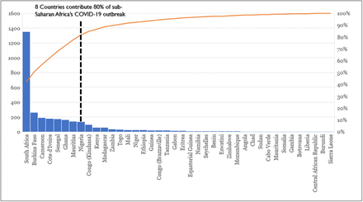
Figure 1.1: Outbreak of Covid-19 in 8 Sub-Saharan Countries
As of eighteenth April 2020, 10:00 am CEST; Africa CDC revealed, 19,895 affirmed cases, including 1,017 passings and 4,642 recuperations, from 52 African nations, while two nations (Comoros and Lesotho) were still infection free (Wang et al., 2020). Strangely, a large portion of the distinguished instances of COVID-19 in Africa have been imported from Europe and the United States, instead of from the first COVID-19 focal point China (WHO et al., 2020).
The landmass' frail medical care framework and a huge immunocompromised populace attributable to high predominance of unhealthiness, sickliness, jungle fever, HIV/AIDs, tuberculosis and poor financial discipline, make it particular from different mainland’s that have encountered COVID-19 to date (Huang et al, 2020). Specialists likewise, guessed that under these conditions the pandemic in Africa could be trying to control, and the results could be horrid (Huang et al, 2020). Then again, there is no medication/immunization at present accessible to treat COVID-19; thusly, execution of prudent steps to contain the spread of this infection is being drilled all through the globe; which incorporates social separating, confinement and quarantine, local area regulation, public lockdowns, and travel limitations. Up to this point, these actions are assisting with controlling and decreased the spread of COVID-19; yet thusly hit the worldwide economy and consequently pushing the countries towards downturn (Chen et al., 2020; Wang et al., 2019). African economies were at that point striving when COVID-19 hit the landmass; which could additionally intensify the financial emergency. A remarkable COVID-19 reaction should be produced for Africa, where this multitude of issues which make the mainland more defenseless and different to the remainder of the world, will be thought about.
The fast spread of the COVID-19 pandemic across Africa set off requires a worldwide and composed reaction to finish it, save lives, moderate its staggering impacts on the populace and society, and hence establish the groundwork for post pandemic reproduction and recuperation. UNESCO assumes a particular part in supporting African nations confronting this emergency. Africa is one of the Organization's two worldwide needs, and in this way gives legitimization to the sending of UNESCO's abilities to help exertion by African nations to battle COVID-19 in the short, medium and long terms. Also, as a specific UN organization with central capacities including, however not restricted to standard setting, lab-rhetoric of thoughts and the structure of limits, UNESCO's multidisciplinary mastery is like never before required in these crucial times to add to the comprehension of the sociocultural aspects and to the remaking of the post-pandemic culture in Africa. The quick impacts and the drawn-out effect of COVID-19 on Africa go a long way past logical exploration on the starting points of the new Covid and the last advancement of treatment treatments including immunizations. The long-haul consequences of the pandemic could influence the actual texture of African social orders as we probably are aware them today, prompting the fracture of families and networks, breaking the connection and the trust among States and residents much further. It is accordingly essential to foster a multi-layered response, in light of proof from reviews and examinations regarding the ramifications of the pandemic to con-recognition for a drawn-out arrangement and expect what's to come.

Problem Statement
With regards to the quick extending COVID-19 plague, point by point, opportune data about economic impact in Sub-Saharan African nations is basic for proof-based policymaking. For SSA nations, there is no bound together vault of high recurrence information, and accessible quarterly or yearly macroeconomic information is now and then hampered by distributing delays.
We will gauge the financial effect of COVID-19, based on past examinations completed. We figured out that during the covid19, the monetary gamble of this pandemic was high in the more unfortunate pieces of the world (developing countries). We will quantify the post monetary effect of 19 in emerging nations with the guide of pre-pandemic information sources utilizing Gradient Boosting.

Research Aim
This project aims to create a machine learning model that measures the post economic impact of COVID-19 in sub-Saharan countries with the aid of pre and post pandemic data sources using Gradient Boosting as the Machine Learning Model.

Research Objective
Here are the following objectives for this project:
- To conduct a critical review on existing literature.
- To design a model for predicting the economic impact of Covid-19 on Sub-Saharan countries.
- To predict the impact of Covid-19 on Sub-Saharan countries using Gradient Boosting.
- To test and validate proposed models with existing ones.

Research Question
- What level of trust will the citizens have in the government?
- Will there be an increase in the price of commodities in the market?
- Will there be an increase in unemployment in sub-Saharan countries?
- What will be the rate of poverty in those sub-Saharan countries?
- What will be the income rate of the citizens of those countries?

CHAPTER TWO

LITERATURE REVIEW

OVERVIEW
Following the beginning of the COVID 19 scourge, a few analysts and researchers have checked out examining the conceivable outcomes of the spread of this pandemic. These various investigations utilized various procedures and zeroed in on explicit geographic regions. A quick summary of some of these research was what the future held. As a matter of first importance, since the pandemic at first showed up in China, a few explorations work (WHO et al., 2020; Huang et al., 2020) have focused on the investigation of its spread in this nation from the beginning. First in Chen N et al. (2020), the creators introduced a new expectation model called FPASSA-ANFIS, which is an expansion of a neuro-fluffy surmising technique for gauging the quantity of affirmed COVID-19 cases north of ten days in light of recently revealed cases saw in China. Second in Wang D et al., (2019), the creators proposed the alleged SUQC model to portray the COVID-19 elements and define the mediation effects of isolation and control measures. Third in Lin et al., (2020), the creators proposed a half breed AI (Artificial-Insight) model which joins an ISI (Improved Defenseless Infected), an NLP (Natural Language Handling) module and a LTSM (Long Short-Term Memory) network for COVID-19 forecast. Fourth in El Zowalty et al., (2020), the creators took on a sub-scourge wave model, the Richards development model, and summed up calculated development model for creating five-and ten-day ahead expectations of Coronavirus spread in two Chinese urban areas in particular Guangdong what's more, Zhejiang. In what the future held, assortment of works which zeroed in on the spread of the COVID-19 pandemic outside of China. In Sahu P et al., (2019), a basic heuristic was proposed in request to recognize the date at which the quantity of affirmed cases outside China will arrive at 1,000,000. The proposed heuristic comprises of approximating the quantity of cases utilizing a remarkable bend. In Khan et al. (2020), an econometric model in view of the ARIMA (Auto Regressive Integrated Moving Normal) model was proposed to anticipate the spread of COVID-19. In the review introduced in Block et al., (2020), the creators proposed a multivariate expectation model to rough pandemic directions in sixteen nations, from various mainland’s and financial classes (High-pay, Upper-middle pay, Lower-center pay and Low-pay) and regarding different avoidance situations. More exactly, the proposed investigation depended on a SEIR (Helpless Exposed Infected Recovered) compartmental model.
In Block et al., (2020), information driven expectation procedures like bend fitting and LSTM (Long Short-Term Memory) were investigated to rough the quantity of COVID-19 cases in India 30 days to come. The review introduced in Boldog et al., (2020) permitted to utilize a portioned Poisson model to make a factual gauging about the assault rate, span and defining moment for COVID 19 for six Western nations (USA, UK, Italy, Germany, France and Canada). Block et al., (2020) proposed an examination for foreseeing the span of the pandemic and the quantity of diseases in eight western nations (USA, UK, France, Spain, Italy, Germany, the Netherlands, Greece) utilizing a Gaussian speculation for engendering. According to Boldog et al., (2020), the engendering of the pandemic in six African nations (Kenya, Senegal, Nigeria, Algeria, Egypt and South Africa) was recreated and assessed utilizing the modified SEIR (Susceptible Exposed Irresistible Recovered) model and MH (Maximum-Hasting) boundary expectation strategy under three intercession circumstances (gentleness, relief and concealment).
It is worth focusing on that every one of the referred to works in this subsection just considered as contribution for proliferation expectation the recently recognized and enrolled numbers of affirmed cases in various nations and not a single one of them expressly considered financial pointers for accomplishing that reason.
Urban areas all around the world have remarkable socio-biological constructions that portray connection of a different scope of powers that decide city development and advancement. A portion of the designs are a consequence of arranging process while others are because of outside powers that decide city development and improvement, for instance movement and effects of fiascos. Coronavirus is one such debacle which has fundamentally changed city frameworks and cycles testing the significance and viability of customary metropolitan arranging processes.
A typical procedure took on by nations all over the planet to attempt to contain the spread of the COVID-19, has-been impressive severe lockdowns. This approach is anyway difficult in many nations even the created countries, however generally urban areas of the creating scene. With expanding levels of joblessness, metropolitan poor are probably going to encounter more difficulties coming about because of lockdowns. In Southeast Asia and South America, states are attempting to authorize complete lockdowns. This is a direct result of absence of the assets to lead gigantic testing and execute weighty tech-driven measures utilized by more affluent nations (Lin et al. 2020). Surprisingly better off nations, for example, Singapore and South Korea, which detailed triumphs in keeping business and society open are confronting a few difficulties to broadly carry out lockdowns for a more drawn-out timeframe (Khan and Ghauri, 2019).
Due to the lockdown on the metropolitan poor, a few effects are generally felt in the areas of wellbeing, food security occupations, and aggressive behavior at home. Flare-up of the COVID-19 has not saved big time salary nations and lockdowns and social separating measures appear to have been effectively applied in most evolved nations to contain the infection (Block et al. 2020). Rehearsing social removing regardless of financial costs has been considered basic in forestalling the infection (Boldog et al., 2020). Past the passings and human affliction, markets encountered a devastating downturn, as communicated in the revolutionary repricing of corporate credit risk by monetary business sectors (Campbell and Doshi 2020). In USA and United Kingdom, legislatures are arranging enormous monetary bundles to extend medical services arrangement, safeguard payrolls, give extra joblessness protection, defer charge installments, turn away superfluous liquidations, and assist firms and families with enduring the tempest (Mobarak and Barnett-Howell 2020).
A large number of African residents live in abhorrent circumstances with restricted or no admittance to disinfection or medical care and the gamble of irresistible sickness has generally been high (Gilbert 2007; Nandy and Gordon 2009; Lall et al. 2017). Around 63% of individuals in sub-Saharan African urban areas have no prepared admittance to clean water to clean up (Hishan et al. 2019), a critical weapon against the spread of the COVID-19. Urbanization is frequently connected with rising and regularly prominent riches; it additionally includes many elements of metropolitan pressure. Sub-Saharan African urban communities due to expanded urbanization have unfortunate everyday environments, unacceptable and stuffed lodging (Borel-Saladin et al. 2018). Larger part of individuals is jobless and depending on casual earnings. As per (Logan and Tevera 2001) metropolitan joblessness in Zimbabwe when the new century rolled over went from 40 to 55%. North Africa's joblessness rate sits at 22% while Sub-Saharan Africa sits at 17% (Grace et al. 2017). Albeit public clinics are accessible for offering wellbeing administrations, most by and large need clinical hardware to completely offer administrations to individuals. The issues experienced in many urban areas of sub-Saharan African nations mirror the test of sufficiently meeting the necessities of containing the COVID-19.
Sub-Saharan Africa is the most un-urbanized locale on the planet with 39.1% individuals living in urban communities (Møller and Roberts 2017). The expanded pace of urbanization is probably going to make difficulties in overseeing wellbeing dangers that excessively influence weak populaces. Needy individuals in metropolitan regions are probably going to be affected more by COVID-19 due to the jam-packed day to day environments and restricted admittance to wellbeing administrations. Greater part of individuals in the majority of the enormous African urban areas live in ghettos (El-hadj et al. 2018; Mberu et al. 2016). Most ghettos are described by nonappearance of fundamental assistance conveyance, less than ideal homes, nonattendance of suitable residency, isolation, packing and are regularly situated in delicate regions like wetlands (UNHABITAT 2003). In spite of financial emergency and restricted open doors for formal work, the vast majority of the nations in sub-Saharan Africa have forced severe lockdowns notwithstanding low detailed COVID-19 cases. Lockdown measures are having negative monetary effect essentially for metropolitan unfortunate populaces.
In 2014 an interesting however serious lethal ailment known as Ebola caused worldwide alert. The most terrible episode was knowledgeable about West Africa tainting roughly 28,600 individuals and killing in excess of 11,300 individuals (Corporate News 2020). Be that as it may, the effects of The Ebola Virus are not quite so disastrous as of the Coronavirus. The infection has caused hindering consequences for the financial designs of numerous African nations (Faus, 2020). Notwithstanding the rising loss of life, joblessness rates have soar. This is because of the way that a large portion of Africa's economy has been overwhelmed by the casual area and the SME's (Social Science in Humanitarian Action 2020). Be that as it may, numerous African states were as yet during the time spent changing their economies to oblige the casual area. Disturbance of this cycle has caused a decrease in the occupations of numerous Africans. Regardless of the grave financial effect numerous state-run administrations in Africa had very much idea calamity the executives and chance plans which anyway had practically no assets backing them (Muronzi 2020). For example, Zimbabwe needed to incline more on contributor support for its fiasco the executives’ procedures as its wellbeing area was at that point disabled previously. The best alleviation measure that dialed back the spread of the Corona Virus is the Lockdown Protocol (Dube 2020). Notwithstanding, in Africa it very well may be believed to create a larger number of issues than arrangements.
In one of the past examination projects, the specialist utilized a calculable general balance model to research the possible financial effect of the COVID-19 pandemic in sub-Saharan Africa. The pandemic would bring down incomes from charges and expenses while raising spending, prompting a significant weakening in the financial shortfall. Notwithstanding a late appearance, the COVID-19 episode has spread quickly across sub-Saharan Africa as of late. Starting at 20 May, 191,000 instances of COVID-19 were affirmed 2 with 2,834 passings. South Africa has the biggest episode in the locale with 17,200 affirmed cases in Africa
In another examination work, Angola, Cameroon, Côte d'Ivoire (Ivory Coast), Ethiopia, Ghana, Kenya, Nigeria, South Africa, and Uganda are the best nine economies in SSA, representing 73% of the district's GDP in 2019. (Wang D et al., 2019), This paper presents an extended nowcasting execution approach that:
- permits joining of blended recurrence information (i.e., every day, week by week, month to month)
- has adaptability to oblige different variable update time spans, as well as collecting a high recurrence dataset with 350 complete information factors including elective sources like transportation, portable installments, and Google Search Trends (Wang D et al., 2019) (i.e., the nowcast models can constantly refresh expectations as new data opens up).
We center around Nigeria, Kenya, and South Africa for the Machine Learning (ML) models since they are among the biggest economies in the SSA district with the most information. For the parametric component models (FM), we center around Uganda, Kenya, and Ghana to test the models on an example that changes as far as information accessibility. The Kenya information is especially wealthy in number of factors and number of perceptions, while our information for Ghana is altogether more modest in the two respects; Uganda emerges as a "widely appealing" country as far as information accessibility. The two arrangements of models present nowcasts and transient figures for 2019 Q4 and 2020 Q1. The blend of these outcomes offers bits of knowledge with respect to the most proper approach to apply in other SSA nations relying upon information accessibility.
Scarcely any endeavors have been made to gauge nowcast models for African nations. Numerous countries in Sub-Saharan Africa could profit from an AI based nowcast, as indicated by (Barhoumi et al. 2020) (approaching). South Africa was the focal point of past insightful examination on nowcasting GDP in Sub-Saharan Africa. With the powerful component model, (Kabundi et al., 2016) form a nowcast for South African genuine GDP. (Kabundi et al., 2016) pick 21 time-series that incorporate (genuine GDP development, exchange, result, and request), ostensible (maker and purchaser cost lists), and monetary factors (ostensible viable conversion scale and the repo rate). We expand Kabundi's exploration by coordinating all the more high-recurrence factors with longer lookback periods and applying a few displaying strategies to different countries in Sub-Saharan Africa. The projection for South African GDP in (Martin, 2019), which contrasts standard VAR determining models with AI models, illuminates our utilization regarding nonparametric models in nowcasting. 6 (Martin, 2019) utilized 15 gauging factors and found that Elastic-net relapse, Random Forests, Support Vector Machines, and Recurrent Neural Networks were promising for anticipating South Africa GDP. The Elastic-net model had the best outcomes, with the most reduced Root Mean Squared Error (RMSE) and the most elevated relationship. Our review broadens (Martin, 2019) work by consolidating all the more high-recurrence information and longer lookback periods into AI models. Besides, this paper adds to the field by utilizing Machine Learning and parametric Factor Model ways to deal with gauge nowcast models of GDP development for South Africa, Kenya, Nigeria, and Uganda. We track down those straight models (Elastic Net, SVR) perform better in everyday while foreseeing downturns, though tree-based models (Random Forest, XGBoost) beat in non-recessionary times for AI nowcast models anticipating quarterly GDP in South Africa, Kenya, and Nigeria. Cross-approval and moving window tests uncover that Nigeria and South Africa have higher forecast exactness than Kenya, without any proof of efficient predisposition in any of the three countries. The models' exhibition is additionally surveyed by anticipating only during recessionary periods to quantify the models' capacity to foresee during seasons of financial emergency. Elective information sources, for example, Kenyan portable installments and another Google Search Trends dataset, have been viewed as valuable and significant indicators of GDP.

CHAPTER THREE

METHODOLOGY

Method of Data Collection
Carrying out analysis and implementing a model is a problem-solving process that requires the selection of a set of procedures or algorithms. This is a recurring process that undergoes critical behavior guiding data scientists to act accordingly in order to solve a given problem.

Location of Study
The study will be conducted for 10 Sub-Sahara African Countries. Those countries include Kenya, Nigeria, Ghana, Zambia, Benin, South Africa, Mozambique, Ivory Coast, Rwanda, Democratic republic of Congo.

Method of Data Collection
Secondary data was collected from Kaggle https://www.kaggle.com/datasets/adakibet/ impact-of-covid19-subsaharan-africa/code for the purpose of this project.

Analysis of the Proposed System
This Model should be able to forecast the economic impact of Covid-19 in certain Sub-Saharan countries, as long as datasets are provided. It should also be able to suggest solutions to certain countries around that region.

Advantages of the Proposed System
- It will be able to predict the economic impact of covid-19 for individual countries.
- We will be able to compare with other models and see which one works best.
- It will be able to predict the countries that were affected by Covid-19 the most and the least.
Please mention other advantages

Analysis of Existing System
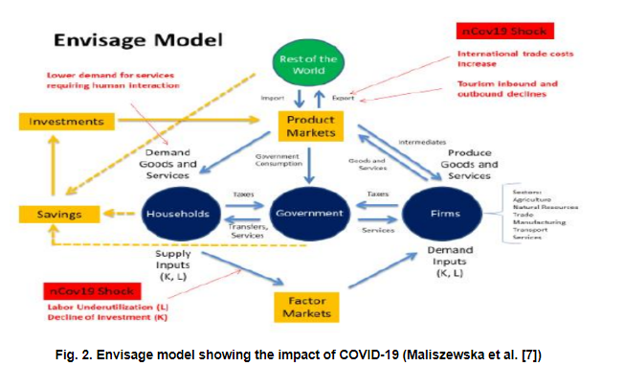
Figure 3.1: Existing System
Figure 1 shows the architecture of the existing system where they carried out their analysis during covid and that they had less resources to use for the project.
They also used regression analysis to check for the probability of effect of economic growth rate; where Variables included in the model were Gross Domestic Products (GDP), Gross Domestic Income (GDI), employment, exchange rates and oil prices. Gross Domestic Product (GDP) takes care of consumption, investment, government spending, and net exports; while Gross Domestic Income (GDI) takes care of labor compensation, business profits, and other sources of income. They made use of the R studio for the analysis. The economy of SSA improved by 1.87% year on-year in the first quarter of 2020 contrasted to a 2.55% growth in the previous period, against the backdrop of substantial global disturbances resulting from the Covid-19, constrained international trade and a sudden drop in oil prices. The appears to be the slowest economic pace since the third quarter of 2018 and has caused disruptions in the oil sector, non-oil sectors, internal trades, tourisms, accommodation and food services, administrative and support services, agriculture, mining, extraction and manufacturing sectors.

Model and Architecture of the Proposed System
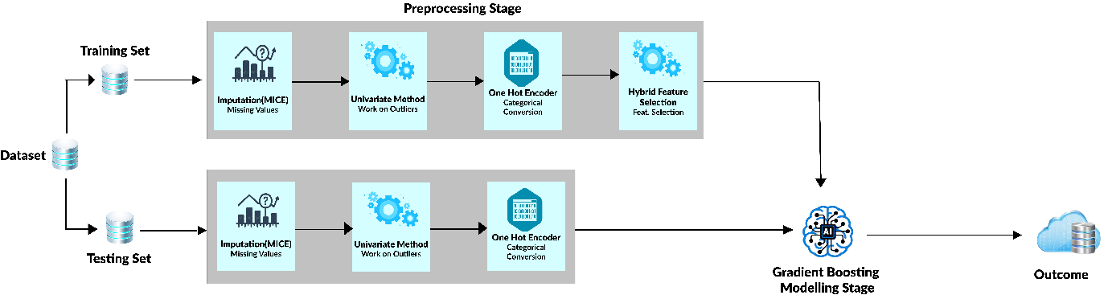
Figure 3.2: Proposed Architecture
The proposed Architecture shows in Figure 2, presents the processes involved in providing solutions and suggestions for the observed problems in Chapter 1 section.

Acquiring of Dataset
First of all, we are required to get the dataset that suits this study; that is if the answers from the respondent’s will be able to solve the solution for this study, the type of data collected from the respondent’s, the data collection procedures and the method of data collection is also required.

Preprocessing Stage
Since the dataset has been obtained in its rawest form, it is required that the dataset needs to be processed which can also be called Data Wrangling.
Data preprocessing is the course of modification or evacuation of information prior to being used for some reason. This interaction guarantees or further develops execution, and it is an urgent stage in the data mining process and methods differ from project to project depending on the data you’re leveraging and the goal you’re trying to achieve. Data preprocessing is generally the most basic part of any Data Science project.
The processes from the Preprocessing Stage are:
- Data Quality and Structure Assessment
- Data Cleaning
- Data Transformation
- Data Validation
Data Quality and Structure Assessment
It is the process of familiarizing yourself with data collected so as to conceptualize how we might use it. During data assessment, you may identify trends or patterns in the data, along with obvious issues, such as mismatched data types, outliers, missing or incomplete values that need to be addressed.
Data Cleaning
Data cleaning is the method involved with adding missing information and remedying, fixing, or eliminating mistaken or immaterial information from an informational collection. Data cleaning is the main advance of preprocessing on the grounds that it will guarantee that your information is all set for your downstream necessities.
Data cleaning will address every one of the conflicting information you revealed in your data quality appraisal; depending on the kind of data you are working with.
- Missing data: There are a number of ways to correct for missing data, but for this study, we will be making use of Imputation using KNN.
- Outliers: There are a number of ways to correct for missing data, but for this study, we will be making use of the Box plot / drop method.
Data Transformation
Data transformation will begin the process of turning the data into the proper format(s) that we will need for analysis and other downstream processes.
There are different ways of transforming data:
- Aggregation: Data aggregation combines all of your data together in a uniform format. For this study, we will be using Pandas Dataframe.
- Normalization: Normalization scales your information into a regularized range with the goal that you can look at it all the more precisely. For this study, we will be using get_dummies method.
- Feature selection: Feature selection is the process of deciding which variables (features, characteristics, categories, etc.) are most important to your analysis. For this study, we will be using Hybrid Feature Selection using Recursive feature elimination with cross validation.
Data Validation
Data validation refers to the process of verifying that your data is both consistent and of a sufficiently high quality. During validation, you might find issues you really want to determine or reason that your information is fit to be investigated. Validation of data is commonly accomplished through different computerized processes and requires programming.

Data Analysis
When data has passed through the preprocessing stage, the next step is to analyze it! The type of data analysis you carry out largely depends on the goal of your project. But there are many categories as well as techniques available. Univariate or bivariate analysis, time-series analysis, regression analysis, etc. In this study, we will be making use of Predictive Analysis.

Modeling Stage
Once the feature set is complete, the model must be trained using a variety of techniques to see which one works best. It must be done with caution in order to prevent employing too many features, which may degrade rather than improve performance.
The modeling process is where Machine Learning takes place at its most fundamental level. The suitable collection of features must be chosen, and the model must be trained using the appropriate techniques.
The trained model must next be assessed on real data to determine its efficiency and performance. The best-performing algorithms are then fine-tuned to improve their performance even further. To identify which model is the best of all, metrics are compared for each method and parameter combination. In this study, we will be making use of Gradient Boosting for the final modeling algorithm.

Data Visualization
Data visualization is the most common way of making intelligent visuals to figure out patterns, varieties, and get significant experiences from the information. Data visualization representation is utilized predominantly for information checking and cleaning, investigation and disclosure, and conveying results. In this study, we will be making use of the Seaborn library.

Data Interpretation and Validation
Data Interpretation refers to the process of using diverse analytical methods to review data and arrive at significant end results. The understanding of data helps researchers to scientists with classifying, manipulating, and summarizing data to respond to critical questions.
The significance of data interpretation is evident and this is why it needs to be done appropriately. Data is very likely to show up from different sources and has a tendency to enter the analysis process with haphazard ordering.
Data validation refers to the process of ensuring the precision and nature of data. It is carried out by incorporating a few looks into a framework or reports to guarantee the consistent consistency of data and how it is stored or manipulated.

Deployment
At the last phase of the work process, we have analyzed the dataset and observed intriguing experiences, you have built a machine learning pipeline, however up until this point they simply live inside your Jupyter notebook. however, you believe it should be seen by different engineers to get to and enhance it if fundamental, that is when deployment of a project comes in. In this study, we will be making use of Streamlit.
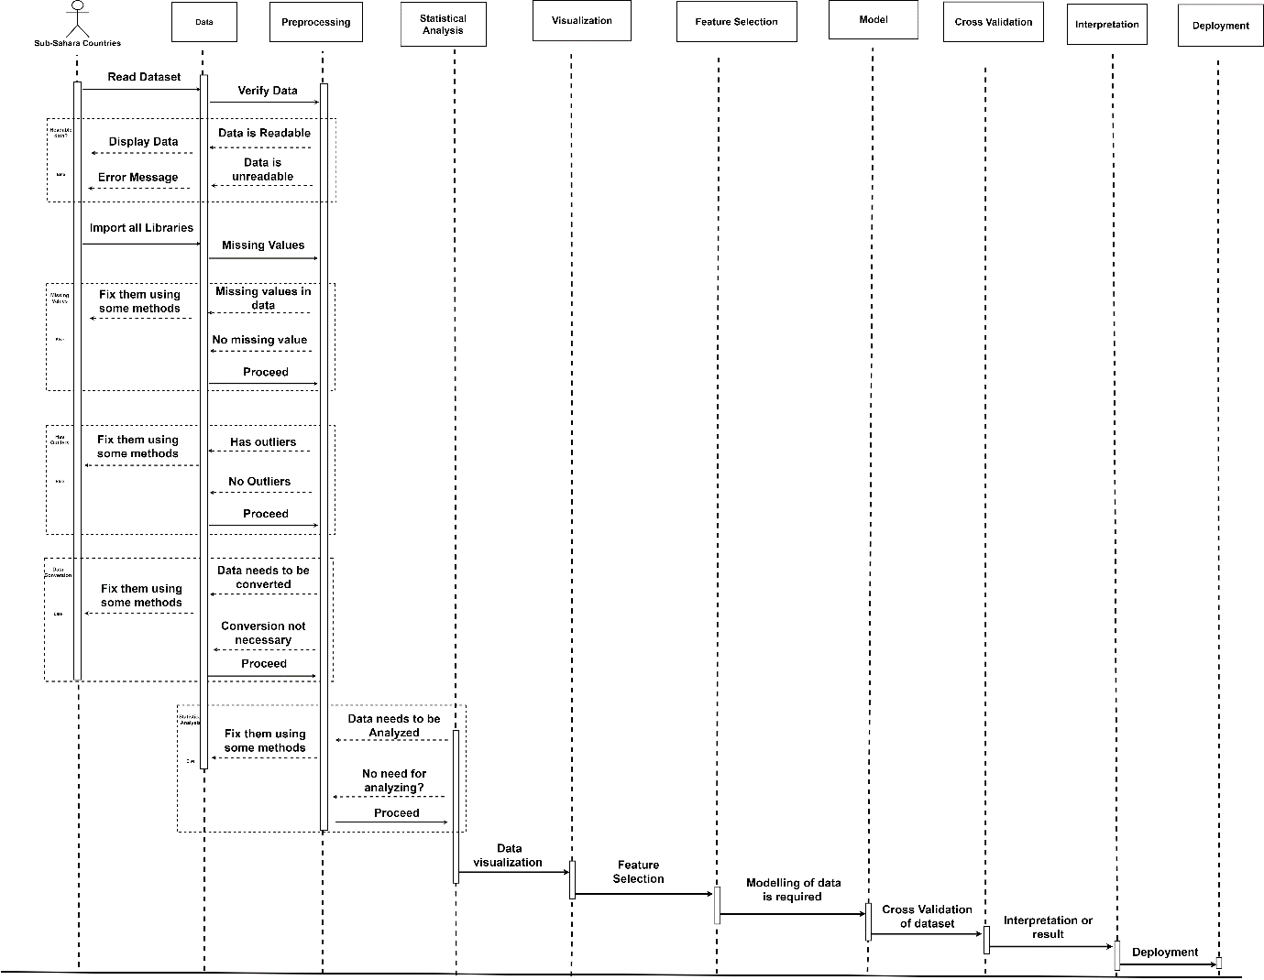
Figure 3.3: Sequence Diagram
Figure 3 shows the Sequence Diagram of this study. Sequence diagrams is used to model the connections between objects in a solitary use case. They show how the various pieces of a framework communicate with one another to complete a capacity, and the request wherein the corporations happen when a specific use case is executed.
In less complex words, a sequence diagram shows various pieces of a system working in a sequence to finish something. It is organized so that it addresses a timeline which starts at the top and slides steadily to stamp the grouping of cooperation. Each object has a column and the messages traded between them are addressed by arrows. In Figure 2, we are looking at the connection between objects to form a model.

Algorithm of the Study
An Algorithm is a finite set of steps that must be followed to solve any problem. In this study, we will be looking at the step that must be followed to solve the economic impact of covid in some sub-Saharan countries.
Below is the algorithm of this study:
Input: Dataset
Output: The Model
- Acquire the dataset
- Import all necessary libraries
- Assess the quality and structure of your dataset
- Clean the dataset
      - Check if there are Outliers

Use Boxplot to check if there are outliers
If (Outliers == True)
print (“there are outliers, work on it using quartiles or any other method”)
else
print (“check for missing values”)
      - Check if there are Missing values
Check if there are missing values using .isnull()
If (Missing_Values == True)
print (“there are missing values, work on it using mode or any other method”)
else
print (“check for values that needs to be converted”)
      - Check if there are columns that needs to be converted from one type of data to another
Check if there are columns that needs to be converted
If (Converted_Columns == True)
print (“convert it using one-hot encoder”)
else
print (“move to step 4”)

- Transform the Data
1. Scale the data into a regularized range
2. Use feature selection to select important columns needed for the modelling
- Check if the data needs some analysis (Descriptive, Inferential, etc)
- Divide the dataset into training and testing dataset (80% - 20%)
- Create a model using Gradient Boosting with the Processed Training Dataset
- With the developed model, use the testing dataset to test the model
- Visualize the dataset using seaborn
- Interpret the dataset using the solutions gotten from the analysis
- Data Visualization, ensure that the nature of the data is précised.
- Deploy your project using Streamlit
- Rebuild the project (If necessary)
- The End

Performance Evaluation Metric of the Model
Evaluating a model is a major part of building an effective machine learning model.
Whenever you have a majority of the columns containing categorical data, you can build several models to predict new observations based on the given data.
The most frequent classification evaluation metric that we use is Accuracy. You might believe that the model is good when the accuracy rate is 99%, However, it is not always true and can be misleading in some situations.
I will be making use of 6 performance evaluation methods
  - Confusion Matrix: Confusion Matrix is a performance measurement for the machine learning classification problems where the output can be two or more classes. It is a table with combinations of predicted and actual values. It is very useful for measuring precision, Recall (also known as Sensitivity), Specificity, Accuracy and AUC-ROC Curves.
- True Positive: When the observation is positive and is predicted to be positive. E.g., We predicted that a woman is pregnant and she actually is pregnant.
- True Negative: When the observation is negative and is predicted to be negative. E.g., We predicted that a woman is not pregnant and she is actually not pregnant
- False Positive: Also called Type 1 Error, When the observation is negative and is predicted to be positive. E.g., We predicted that a woman is pregnant but she is actually not pregnant.
- False Negative: Also called Type 2 Error, When the observation is positive and is predicted to be negative. E.g., We predicted that a woman is not pregnant but she is actually pregnant.

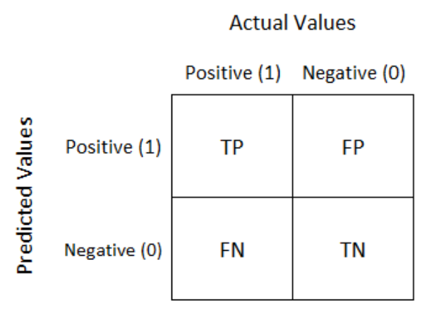
Figure 3.4: Confusion Matrix
Confusion matrix table shows where TP = True Positive, TN = True Negative, FP = False Positive, FN = False Negative.
  - Accuracy: Accuracy is simply the measure of how often the classifier correctly predicts the actual values (target values). We can also define accuracy as the ratio of the number of correct predictions and the total number of predictions as shown in Equation 1.
$Accuracy=\frac{TP + TN}{TP + TN + FP + FN}$ (1)
  - Precision: Precision is defined by how many of the correctly predicted observations actually turned out to be positive. Precision is useful in the cases where False Positive is a higher concern than False Negative.
$Precision= \frac{True Positive}{True Positive + False Positive}$ (2)

  - Recall (Sensitivity): Recall is defined by how many actual positive observations that was predicted correctly with the designed model. It is a useful metric in cases where False Negative is of higher concern than the false Positive. It is defined by the number of true positive divided by the total number of actual positive values.
$Recall= \frac{True Positive}{True Positive + False Negative}$ (3)
  - F1 Score: F1 Score is defined by the combination of Precision and Recall Metrics. It is maximum when precision is equals to recall. A good F1 score means that the false positive and the false negative are low. An F1 Score is considered perfect when it is equals to 1 and when the model is a failure, f1 score will be equals to 0.
$F_{1}=2* \frac{Precision * Recall}{Precision + Recall}$ (4)

  - AUC-ROC: AUC means Area Under Curve. AUC is the measure of the capacity of the classifier to distinguish between positive and negative values.
ROC: The Receiver Operator Characteristic (ROC) is a probability curve that plots the True positive rate against the False positive at various threshold values and separates the signal from the noise.
$TRP = \frac{TP}{TP + FN}$ (5)
$FRP = \frac{FP}{FP + TN}$ (6)

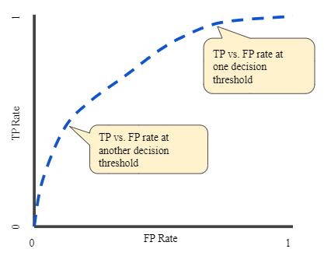
Figure 3.5: A graph that shows for TP vs FP rate at different classification thresholds.

  - Log Loss or Cross-Entropy Loss: it also called Logistic Loss. It is one of the major metrics to assess the performance of a classification problem.

${logloss}_{(N=1)}=ylog\left(p\right)+\left(1-y\right) log⁡(1-p)$ (7)

CHAPTER FOUR

IMPLEMENTATION AND RESULTS

Overview
This Chapter portrays the execution and after effects of the review. It shows the chart of the system, the decision of the programming language utilized in the execution of the system. It likewise represents the programming climate and furthermore the system execution.
The purpose of the implementation is to identify a system that:
- To predict the economic impact of COVID in sub-Saharan Africa countries
- To make sure that the analysis provides solutions to some of the sub-Saharan African countries
- To meet the requirement on performance of the models implemented, usability, etc.

Model and Architecture of the Proposed System
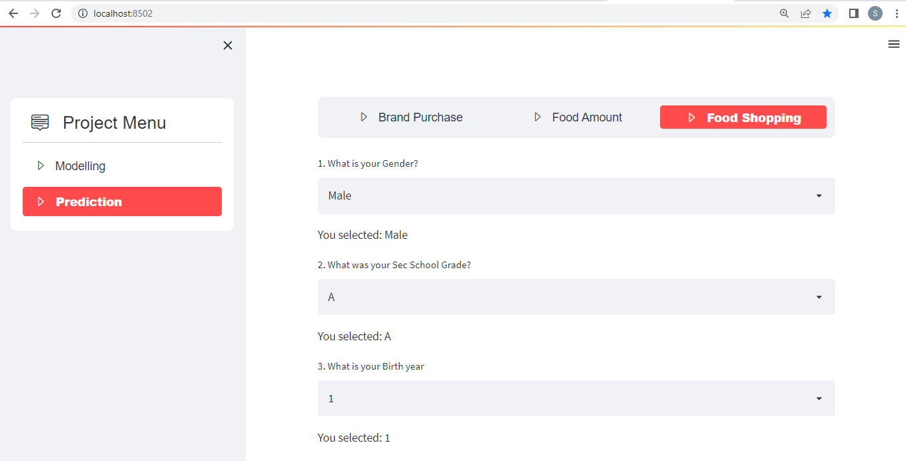
Figure 4.1: The System Diagram 1

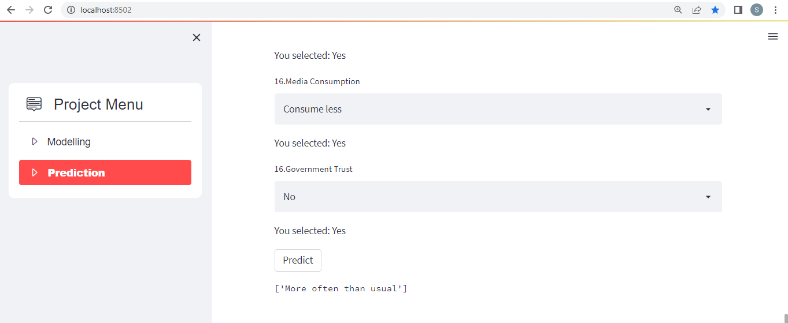
Figure 4.2: The System Design 2
Figure 2 above shows that the system was able to predict the economic impact for target 2 (Food shopping)

Choice of Programming Language
Picking a reasonable programming language for the execution of this project, depends on certain standards, for example, scalability. It has a large standard library which is focused on data analytics and machine learning. It also has good community support, it can also be used to deploy your data science project using Django and streamlit. Python and its libraries which is to an extent the most suitable language for this study was adopted.

Analysis of the Module
Analysis of the modules comes in after feature selection stage. That is, analysis of how the model’s created works and how it works.
There are three target variables for this case study:
      - Food Shopping
      - Food Amount
      - Brand Purchase

Food Shopping
Figure 1 below shows the model for the first target variable “Food Shopping” which has an impact on the economics of the country the participants live in. The models used in figure below was to compare which of the models works best for the target column and we found out that Gradient Boosting worked best for the target volume, whose area under curve (AUC) = 1.00, Correspondence Analysis (CA) = 1.00, F1 = 1.00, Precision = 1, Recall = 1.00.
Other models like Random Forest, AdaBoost and Tree, performed very well. They also had 1.00 in each of the evaluation results listed above, but I chose to pick gradient Boosting because it performed very well for the other two target columns.
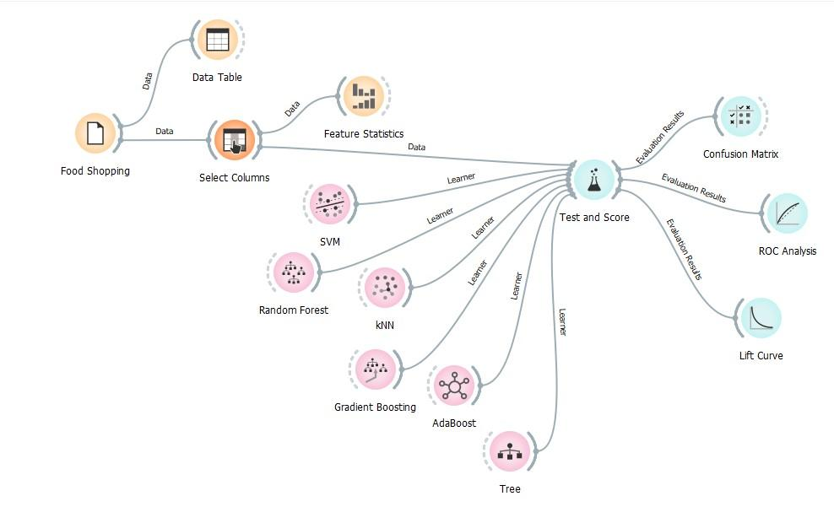
Figure 4.3: Model for the Food Shopping
Table 1: Evaluation Result for Food Shopping
Model | AUC | CA | F1 | Precision | Recall
Tree | 1.000 | 1.000 | 1.000 | 1.000 | 1.000
Random Forest | 1.000 | 1.000 | 1.000 | 1.000 | 1.000
Gradient Boosting | 1.000 | 1.000 | 1.000 | 1.000 | 1.000
AdaBoost | 1.000 | 1.000 | 1.000 | 1.000 | 1.000
SVM | 1.000 | 0.999 | 0.999 | 0.999 | 0.999
KNN | 0.971 | 0.892 | 0.887 | 0.893 | 0.892

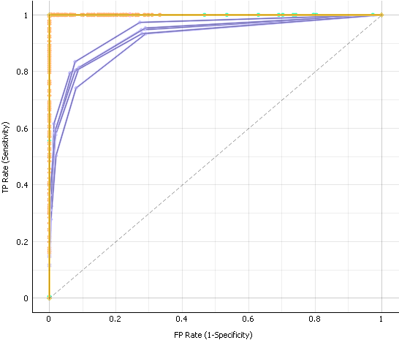 | 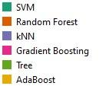

Figure 4.4: ROC Analysis of Food Shopping
The closer the curve follows the left-hand border and then the top border of the ROC space, the more accurate the classifier. Figure 3 above shows that the ROC Analysis is accurate due to the fact that the top and the left-hand border is closely packed.

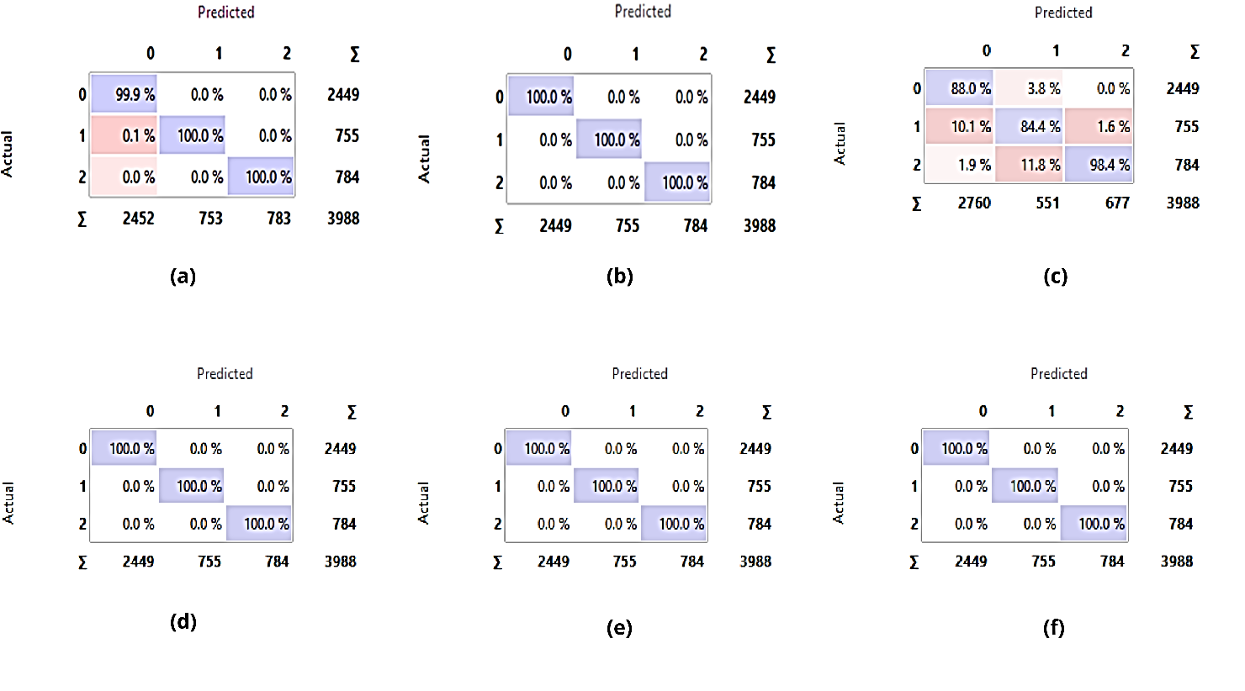
Figure 4.5: Food shopping Confusion matrix for (a) SVM, (b) Random Forest, (c) KNN, (d) Gradient Boosting, (e) Tree, (f) AdaBoost
The Confusion Matrix gives the number or proportion of instances between the predicted and actual class. The selection of the elements in the matrix feeds the corresponding instances into the output signal. This way, one can observe which specific instances were misclassified

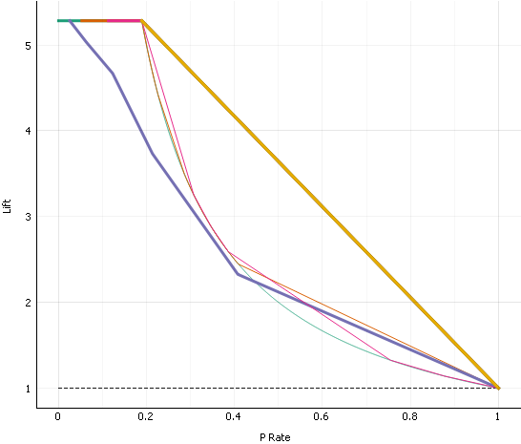 | 

Figure 4.6: Lift Curve of Food Shopping
The Lift curve shows the curves for analyzing the proportion of true positive data instances in relation to the classifier’s threshold or the number of instances that we classify as positive. By ordering the data the way we have, the value with the highest probability will appear on the left of our graph, usually along with the highest Lift scores.

Food Amount
Figure 2 below shows the model for the second target variable “Food Amount” which has an impact on the economics of the country the participants live in. The models used in figure below was to compare which of the models works best for the target column and we found out that Gradient Boosting worked best for the target volume, whose area under curve (AUC) = 1.00, Correspondence Analysis (CA) = 1.00, F1 = 1.00, Precision = 1, Recall = 1.00.
Other models like Random Forest, AdaBoost and Tree, performed very well. They also had 1.00 in each of the evaluation result listed above, but I chose to pick gradient Boosting because it performed very well for the other two target columns.
Table 2: Evaluation Result for Food Amount
Model | AUC | CA | F1 | Precision | Recall
Tree | 1.000 | 1.000 | 1.000 | 1.000 | 1.000
Random Forest | 1.000 | 1.000 | 1.000 | 1.000 | 1.000
Gradient Boosting | 1.000 | 1.000 | 1.000 | 1.000 | 1.000
AdaBoost | 1.000 | 1.000 | 1.000 | 1.000 | 1.000
SVM | 1.000 | 0.999 | 0.999 | 0.999 | 0.999
KNN | 0.967 | 0.900 | 0.899 | 0.899 | 0.900

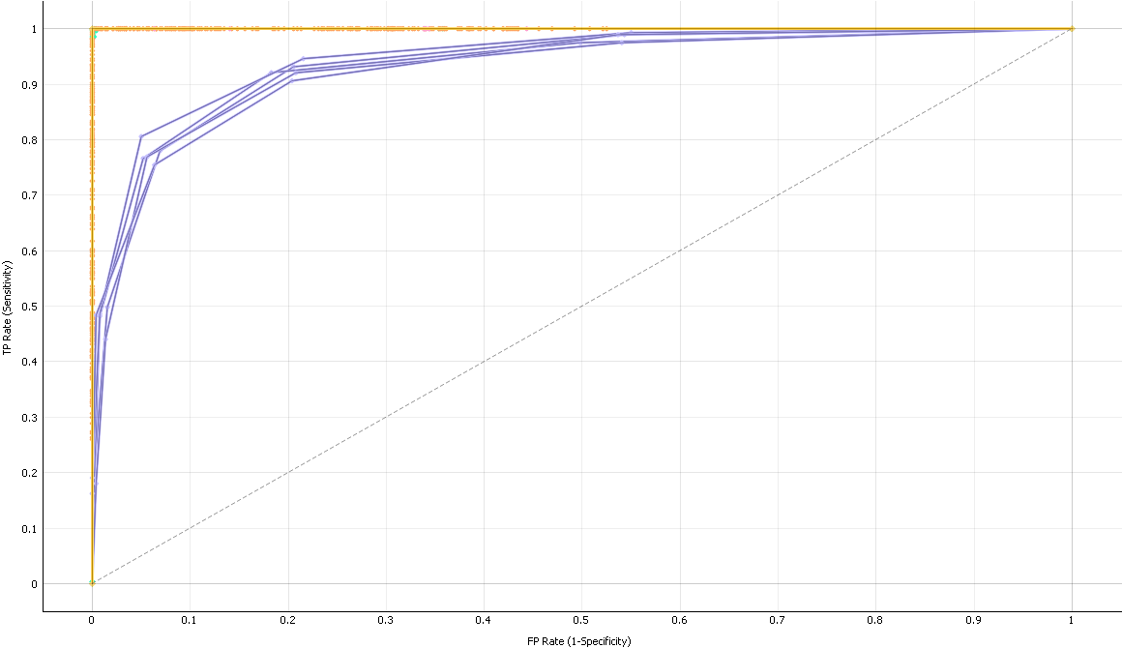 | 

Figure 4.7: ROC Analysis of Food Amount
The closer the curve follows the left-hand border and then the top border of the ROC space, the more accurate the classifier. Figure 6 above shows that that the ROC Analysis is accurate due to the fact that the top and the left-hand border is closely packed.
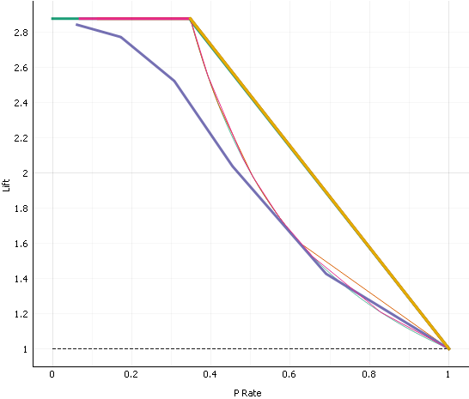  Figure 4.8: Lift Curve of Food Amount | 
The Lift curve shows the curves for analyzing the proportion of true positive data instances in relation to the classifier’s threshold or the number of instances that we classify as positive. By ordering the data the way we have, the value with the highest probability will appear on the left of our graph, usually along with the highest Lift scores.
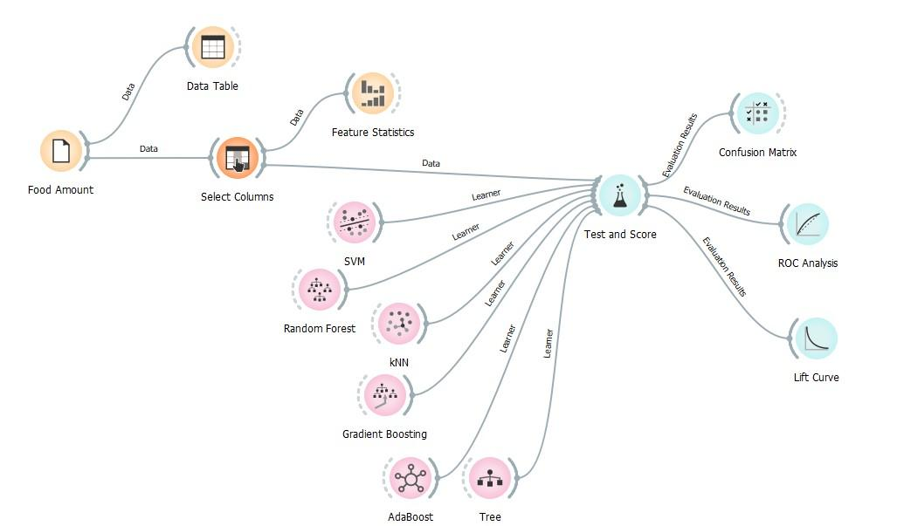
Figure 4.9: Model for the Food Amount Column
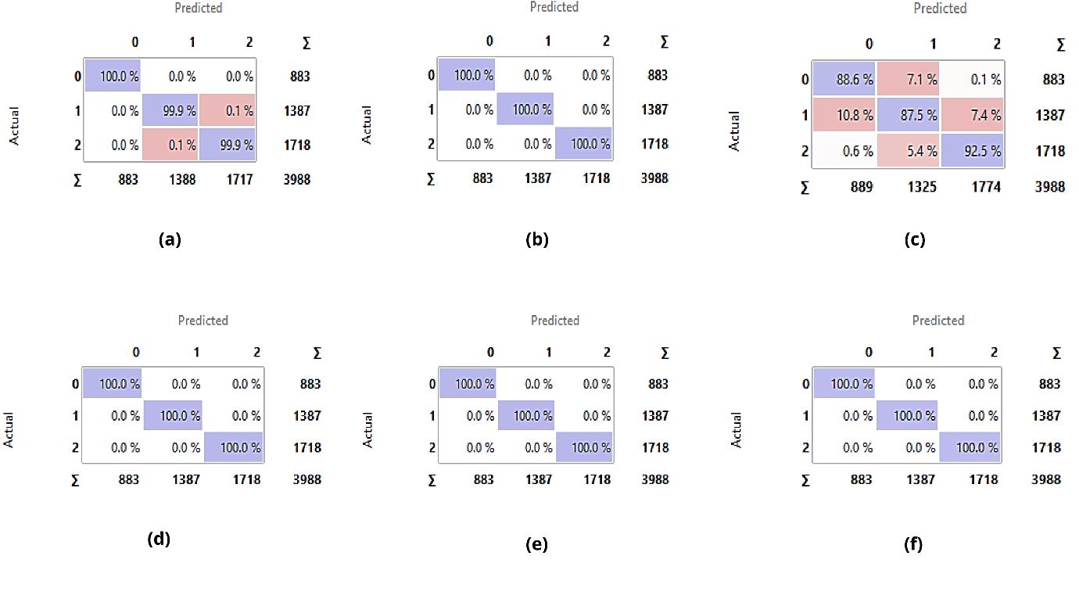
Figure 4.10: Food Amount’s Confusion matrix for (a) SVM, (b) Random Forest, (c) KNN, (d) Gradient Boosting, (e) Tree, (f) AdaBoost
The Confusion Matrix gives the number or proportion of instances between the predicted and actual class. The selection of the elements in the matrix feeds the corresponding instances into the output signal. This way, one can observe which specific instances were misclassified and how.

Brand Purchase
Table 3 below shows the model for the third target variable “Brand Purchase” which has an impact on the economics of the country the participants live in. The models used in figure below was to compare which of the models works best for the target column and we found out that Gradient Boosting worked best for the target volume, whose area under curve (AUC) = 0.760, Correspondence Analysis (CA) = 0.788, F1 = 0.741, Precision = 0.763, Recall = 0.788.
Other models like Random Forest, AdaBoost and Tree, performed very well, but I chose to pick gradient Boosting because it performed very well for the other two target columns.
Table 3: Evaluation Result for Brand Purchase
Model | AUC | CA | F1 | Precision | Recall
Tree | 0.611 | 0.694 | 0.701 | 0.709 | 0.694
Random Forest | 0.704 | 0.762 | 0.718 | 0.715 | 0.762
Gradient Boosting | 0.760 | 0.788 | 0.741 | 0.763 | 0.788
AdaBoost | 0.589 | 0.691 | 0.695 | 0.699 | 0.691
SVM | 0.590 | 0.585 | 0.612 | 0.665 | 0.585
kNN | 0.622 | 0.749 | 0.712 | 0.701 | 0.749

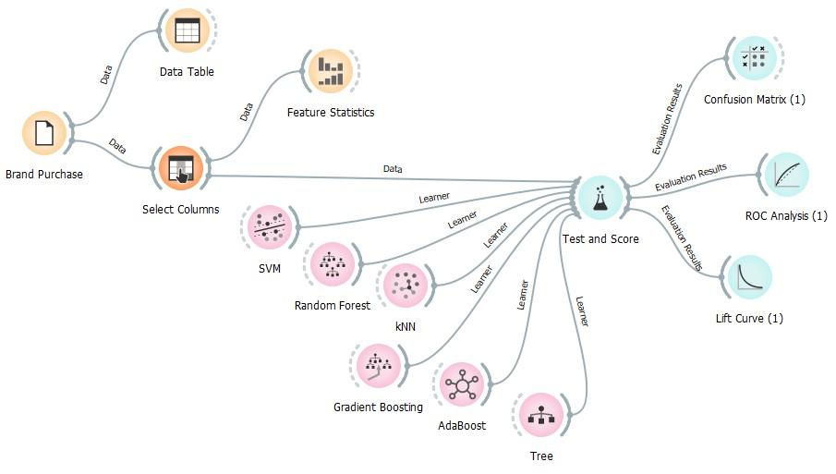

Figure 4.11: Model for the Brand Purchase Column

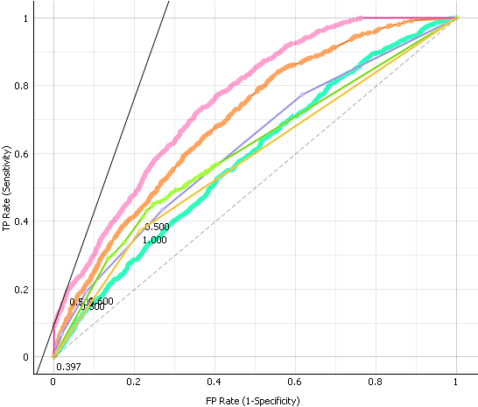 | 

Figure 4.12: ROC Analysis of Brand Purchase
The closer the curve follows the left-hand border and then the top border of the ROC space, the more accurate the classifier. Figure 3 above shows that that the ROC Analysis is accurate due to the fact that the top and the left-hand border is closely packed.
  Figure 4.13: Lift Curve of Brand Purchase | 
The Lift curve shows the curves for analyzing the proportion of true positive data instances in relation to the classifier’s threshold or the number of instances that we classify as positive. By ordering the data the way we have, the value with the highest probability will appear on the left of our graph, usually along with the highest Lift scores.

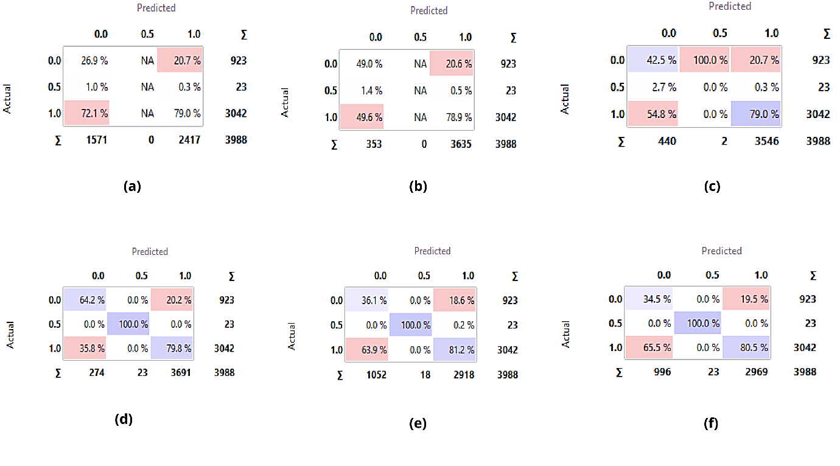
Figure 4.14: Brand Purchase Confusion matrix for (a) SVM, (b) Random Forest, (c) KNN, (d) Gradient Boosting, (e) Tree, (f) AdaBoost

The Confusion Matrix gives the number or proportion of instances between the predicted and actual class. The selection of the elements in the matrix feeds the corresponding instances into the output signal. This way, one can observe which specific instances were misclassified and how.

Programming Environment
The development environment was Jupyter notebook, an integrated development environment that supports over 40 programming languages, including Python, R, Julia, and Scala. It can produce rich, interactive output: HTML, images, videos, etc. Notebook can be imparted to others utilizing email, Dropbox, GitHub and the Jupyter Notebook Viewer.
CHAPTER FIVE

SUMMARY, RECOMMENDATION AND CONCLUSION

Summary
In this section, we sum up what we have done as such far in this examination, the proposed framework and its effect on the issue space, the cycles we went through to accomplish the outcomes, imperatives, as well as suggestions to empower further work on this venture.

Constraints of the Study
At the course of this examination, we had a couple of requirements, which we might want to organize here. While we guarantee to utilize assets accessible to us to accomplish the outcomes we have, we were obliged by the accompanying circumstances.
            - Technical Expertise of the Implementation
The usage of Machine Learning Algorithms require time to understand and implement. No prior knowledge of the field was gotten until to set out to explore its implementation in our research. We dedicated an ample time to study and familiarize ourselves with this field and figure out how the implementation would be done.
            - Time Constraints
Restricted time was one more limitation we experienced at the course of this exploration as we needed to complete the examination and its execution inside a predefined time span. In this way, every one of our cycles were time bound, and more might have been finished assuming that the time bound expanded the more.
3. Technical Issues
During the process of implementation, my system broke down and it was difficult to borrow a laptop. A close friend of mine lent me his system, then I was able to continue the implementation.
- Network Issues
Due to the network service being made use of, it was difficult to download some of the software’s and libraries that was needed for the implementation.

Recommendation
We accept that this exploration is a work underway. A great deal must be finished on the exploration to completely foster it to scale in truly live situations. We recommend that more time should be made available for proper exploratory of the project.

Conclusion
In rundown, this examination proposes a precise and AI driven way to deal with the post economic impact of covid 19 in sub-Saharan. It is demonstrated that the PC through man-made reasoning can beat people in most simple cycles. It is proven that the computer through artificial intelligence can outperform humans in most rudimentary processes. We leveraged machine learning to build a system that would enable countries in sub-Saharan Africa to predict the economic impact of covid. This will go a long way for countries in that region to be able to manage the country’s economy.

REFERENCE
Bah, E.H.M., Faye, I. and Geh, Z.F., 2018. Slum upgrading and housing alternatives for the poor. In Housing market dynamics in Africa (pp. 215-253). Palgrave Macmillan, London.
Bai, Y., Yao, L., Wei, T., Tian, F., Jin, D.Y., Chen, L. and Wang, M., 2020. Presumed asymptomatic carrier transmission of COVID-19. Jama, 323(14), pp.1406-1407.
Block, P., Hoffman, M., Raabe, I.J., Dowd, J.B., Rahal, C., Kashyap, R. and Mills, M.C., 2020. Social network-based distancing strategies to flatten the COVID-19 curve in a post-lockdown world. Nature Human Behaviour, 4(6), pp.588-596.
Boldog, P., Tekeli, T., Vizi, Z., Dénes, A., Bartha, F.A. and Röst, G., Risk assessment of novel coronavirus 2019-nCoV outbreaks outside China.
Bonadio, B., Huo, Z., Levchenko, A.A. and Pandalai-Nayar, N., 2020. Global supply chains in the pandemic (No. w27224). National Bureau of Economic Research.
Borel-Saladin, J., Shifa, M. and Donald, A., 2018. Understanding and addressing poverty, labour force, and urbanisation data gaps in sub-Saharan Africa. In Urban Food Systems Governance and Poverty in African Cities (pp. 68-79). Routledge.
Buell, B., Cherif, R., Chen, C., Walentin, K. and Tang, J., 2021. Impact of COVID-19: Nowcasting and Big Data to Track Economic Activity in Sub-Saharan Africa. International Monetary Fund.
Campbell, K.M. and Doshi, R., 2020. The coronavirus could reshape global order. Foreign Affairs, 18(3).
Chen, N., Zhou, M., Dong, X., Qu, J., Gong, F., Han, Y., Qiu, Y., Wang, J., Liu, Y., Wei, Y. and Yu, T., 2020. Epidemiological and clinical characteristics of 99 cases of 2019 novel coronavirus pneumonia in Wuhan, China: a descriptive study. The lancet, 395(10223), pp.507-513.
Conrad Hackett, Phillip Connor, Marcin Stonawski, Vegard Skirbekk, Michaela Potancokova, Guy Abel., 2015. The Future of World Religions: Population Growth Projections
Covid, C., 19. global cases by the center for systems science and engineering (CSSE). Johns Hopkins Coronavirus Resource Center.
Da Silva, D.B.D., 2017. The Atlantic Slave Trade from West Central Africa, 1780–1867. Cambridge University Press.
Du Toit, A., 2020. Outbreak of a novel coronavirus. Nature Reviews Microbiology, 18(3), pp.123-123.
Dube, G., 2020. South Africa declares state of emergency, shuts borders and schools as coronavirus grips nation.
Faus, J., 2020, March. This is how coronavirus could affect the travel and tourism industry. In World Economic Forum (Vol. 17, p. 2020).
Gilbert, A., 2007. The return of the slum: does language matter?. International Journal of urban and regional Research, 31(4), pp.697-713.
Grace Goitsemodimo Tabengwa, D., Okatch, A. and Modisaatsone, N., 2017. Youth Unemployment in Africa: Capacity Building and Innovative Strategies from Botswana, Namibia, South Africa, and Swaziland.
Hishan, S.S., Khan, A., Ahmad, J., Hassan, Z.B., Zaman, K. and Qureshi, M.I., 2019. Access to clean technologies, energy, finance, and food: environmental sustainability agenda and its implications on Sub-Saharan African countries. Environmental Science and Pollution Research, 26(16), pp.16503-16518.
Huang, C., Wang, Y., Li, X., Ren, L., Zhao, J., Hu, Y., Zhang, L., Fan, G., Xu, J., Gu, X. and Cheng, Z., 2020. Clinical features of patients infected with 2019 novel coronavirus in Wuhan, China. The lancet, 395(10223), pp.497-506.
Hunter, J.C., Nguyen, D., Aden, B., Al Bandar, Z., Al Dhaheri, W., Elkheir, K.A., Khudair, A., Al Mulla, M., El Saleh, F., Imambaccus, H. and Al Kaabi, N., 2016. Transmission of Middle East respiratory syndrome coronavirus infections in healthcare settings, Abu Dhabi. Emerging infectious diseases, 22(4), p.647.
Ikubolajeh Logan, B. and Tevera, D., 2001. Neoliberalism, regime survival, and the environment: Economic reform and agricultural transformation in Zimbabwe in the 1990s. Canadian Journal of African Studies/La Revue Canadienne Des études Africaines, 35(1), pp.99-138.
Jagtap, V.S., More, P. and Jha, U., 2020. A review of the 2019 novel coronavirus (COVID-19) based on current evidence.
Khan, A.S. and Ghauri, S.K., 2020. Corona pandemic: Lack of resources but not of determination—A South Asian perspective. South Asian Journal of Emergency Medicine, 3(1), pp.1-2.
Lai, C.C., Shih, T.P., Ko, W.C., Tang, H.J. and Hsueh, P.R., 2020. Severe acute respiratory syndrome coronavirus 2 (SARS-CoV-2) and coronavirus disease-2019 (COVID-19): The epidemic and the challenges. International journal of antimicrobial agents, 55(3), p.105924.
Lai, C.C., Shih, T.P., Ko, W.C., Tang, H.J. and Hsueh, P.R., 2020. Severe acute respiratory syndrome coronavirus 2 (SARS-CoV-2) and coronavirus disease-2019 (COVID-19): The epidemic and the challenges. International journal of antimicrobial agents, 55(3), p.105924.
Lin, H., Liu, W., Gao, H., Nie, J. and Fan, Q., 2020. Comparative analysis of early dynamic trends in novel coronavirus outbreak: A modeling framework. Available at SSRN 3562461.
Madaki, A.A., 2021. Mathematics Education in Sub-Saharan Africa Status, Challenges, and Opportunities.
Mobarak, A.M. and Barnett-Howell, Z., 2020. Poor countries need to think twice about social distancing. Foreign Policy, 10.
Mokhtar, G., 1990. UNESCO General History of Africa, Vol. II, Abridged Edition: Ancient Africa.
Morgan, W.B., 1996. Poverty, vulnerability and rural development. Sustaining the future: Economic, social and environment change in Sub-Saharan Africa op. cit. Pg, pp.17-51.
Muronzi, C., 2020. ‘How Will We Survive?’: Health Woes Deepen Zimbabwe COVID-19 Fear. Al Jazeera.
Sahu, P., 2020. Closure of universities due to coronavirus disease 2019 (COVID-19): impact on education and mental health of students and academic staff. Cureus, 12(4).
Su, S., Wong, G., Shi, W., Liu, J., Lai, A.C., Zhou, J., Liu, W., Bi, Y. and Gao, G.F., 2016. Epidemiology, genetic recombination, and pathogenesis of coronaviruses. Trends in microbiology, 24(6), pp.490-502.
Wang, N., Shi, X., Jiang, L., Zhang, S., Wang, D., Tong, P., Guo, D., Fu, L., Cui, Y., Liu, X. and Arledge, K.C., 2013. Structure of MERS-CoV spike receptor-binding domain complexed with human receptor DPP4. Cell research, 23(8), pp.986-993.
WHO Emergency Committee. Statement on the second meeting of the International Health Regulations (2005) Emergency Committee regarding the outbreak of novel coronavirus (COVID-19). Geneva: WHO, 2020.https://www.who.int/news-room/detail/30-01-2020-statement-on-the-second-meeting-of-the-international-health-regulations-(2005)-emergency-committee-regarding-the-outbreakof-novel-coronavirus-(COVID-19) (accessed Feb 1, 2020)
Wu, F., Zhao, S., Yu, B., Chen, Y.M., Wang, W., Song, Z.G., Hu, Y., Tao, Z.W., Tian, J.H., Pei, Y.Y. and Yuan, M.L., 2020. A new coronavirus associated with human respiratory disease in China. Nature, 579(7798), pp.265-269.
Yu, N., Li, W., Kang, Q., Xiong, Z., El Zowalaty, W.M.E. and Järhult, J.D., 2020. From SARS to COVID-19: A previously unknown SARS related coronavirus (SARS-CoV-2) of pandemic potential infecting humans call for a one health approach. One Health, 9, p.100124.
Zhong, N.S., Zheng, B.J., Li, Y.M., Poon, L.L.M., Xie, Z.H., Chan, K.H., Li, P.H., Tan, S.Y., Chang, Q., Xie, J.P. and Liu, X.Q., 2003. Epidemiology and cause of severe acute respiratory syndrome (SARS) in Guangdong, People's Republic of China, in February, 2003. The Lancet, 362(9393), pp.1353-1358.

APPENDIX

Source Code on Jupyter Notebook
# import all necessary libraries
import pandas as pd
import seaborn as sns
import numpy as np
import matplotlib.pyplot as plt
# load the dataset
rawData= pd.read_excel('DataSet/geoPoll.xlsx')
rawData.head()
# get information from the ReadAdultData
print('Information from the rawData\n')
rawData.info()
# to detect if there are missing values and sum up the missing values.
rawData.isnull().sum()
# to detect the % of missing values
def missing_values_table(rawData):
# Total missing values
mis_rawData = rawData.isnull().sum()

# Percentage of missing values
mis_val_percent = 100 * rawData.isnull().sum() / len(rawData)

# Make a table with the results
mis_val_table = pd.concat([ mis_rawData , mis_val_percent], axis=1)

# Rename the columns
mis_val_table_ren_columns = mis_val_table.rename(
columns = {0 : 'Missing Values', 1 : '% of Total Values'})

# Sort the table by percentage of missing descending
mis_val_table_ren_columns = mis_val_table_ren_columns[
mis_val_table_ren_columns.iloc[:,1] != 0].sort_values(
'% of Total Values', ascending=False).round(1)

# Print some summary information
print ("Your selected dataframe has " + str(rawData.shape[1]) + " columns.\n"
"There are " + str(mis_val_table_ren_columns.shape[0]) +
" columns that have missing values.")
# Return the dataframe with missing information
return mis_val_table_ren_columns
missingValues = missing_values_table(rawData)
print(missingValues)
# create a count column to later check for outliers
rawData['count'] = rawData.index
# to check for mismatched data
n = 0
colNo = 0
while colNo < len(rawData.columns):
print(rawData.columns[colNo])
print("-----------------------------------------------------------------------------")
for (rowName, data) in rawData.iterrows():
if type(data[n]) == float:
print(str(True) + ", This value has a data type of float: " + str(data[n]))
elif type(data[n]) == str:
print(str(True) + ", This value has a data type of string: " + str(data[n]))
elif type(data[n]) == bool:
print(str(True) + ", This value has a data type of boolean: " + str(data[n]))
elif type(data[n]) == int:
print(str(True) + ", This value has a data type of integer: " + str(data[n]))
else:
print("This value has a data type that does not exist: " + str(data[n]))
n = n + 1
print("------------------------------------------------------------------------------\n\n")
colNo = colNo + 1
# regrouping of age and birthyear for visualization
# For Age
rawData['Age'] = rawData['Age'].astype(int)
print(rawData['Age'].dtype)
new_age = []
AgeSeries = pd.Series(rawData['Age'])
for i in rawData['Age']:
# i = int(i)
# print(type(i))
if i >= 80:
result = '80 - 90'
new_age.append(result)
elif i >= 69 and i < 79:
result = '70 - 79'
new_age.append(result)
elif i >= 59 and i < 69:
result = '60 - 69'
new_age.append(result)
elif i >= 49 and i < 59:
result = '50 - 59'
new_age.append(result)
elif i >= 39 and i < 49:
result = '40 - 49'
new_age.append(result)
elif i >= 29 and i < 39:
result = '30 - 39'
new_age.append(result)
elif i >= 19 and i < 29:
result = '20 - 29'
new_age.append(result)
elif i >= 9 and i < 19:
result = '10 - 29'
new_age.append(result)
else:
result = 'NaN'
new_age.append(result)
rawData['Age'] = new_age
# for birthyear
rawData['BirthYear'] = rawData['BirthYear'].astype(int)
print(rawData['BirthYear'].dtype)
# for birthyear
new_birthYear = []
for i in rawData['BirthYear']:
# i = int(i)
# print(type(i))
if i >= 1995:
result = '1995 and above'
new_birthYear.append(result)
elif i >= 1984 and i < 1994:
result = '1984 - 1994'
new_birthYear.append(result)
elif i >= 1974 and i < 1984:
result = '1974 - 1984'
new_birthYear.append(result)
elif i >= 1964 and i < 1974:
result = '1964 - 1974'
new_birthYear.append(result)
elif i >= 1954 and i < 1964:
result = '1954 - 1964'
new_birthYear.append(result)
elif i >= 1944 and i < 1954:
result = '1944 - 1954'
new_birthYear.append(result)
elif i >= 1934 and i < 1944:
result = '1934 - 1944'
new_birthYear.append(result)
elif i >= 1924 and i < 1934:
result = '1924 - 1934'
new_birthYear.append(result)
else:
result = 'NaN'
new_birthYear.append(result)

rawData['BirthYear'] = new_birthYear
# drop some columns
new_rawData = rawData.drop(['Gender.Weights', 'Age Group.Weights', 'ADM1.Weights', 'Total Weights', 'Admin1', 'BiggestChallenge', "StayPositive"], axis=1)
# loop through to visualize against first target "Brand Purchase"
bp = new_rawData["BrandPurchase"]
colNo = 0
while colNo < len(new_rawData.columns):
plt.figure(figsize=(15,5))
plt.rcParams['figure.figsize'] = (2,2)
sns.countplot(x=new_rawData.columns[colNo], hue= bp, data=new_rawData)
plt.xticks(rotation=90)
colNo = colNo + 1
Second target variable “Food Shopping”
fs = new_rawData["FoodShopping"]
colNo = 0
while colNo < len(new_rawData.columns):
plt.figure(figsize=(15,5))
plt.rcParams['figure.figsize'] = (2,2)
sns.countplot(x=new_rawData.columns[colNo], hue= fs, data=new_rawData)
plt.xticks(rotation=90)
colNo = colNo + 1
# For food Amount
fa = new_rawData["FoodAmount"]
colNo = 0
while colNo < len(new_rawData.columns):
plt.figure(figsize=(15,5))
plt.rcParams['figure.figsize'] = (2,2)
sns.countplot(x=new_rawData.columns[colNo], hue= fa, data=new_rawData)
plt.xticks(rotation=90)
colNo = colNo + 1
# For outliers
for column in new_rawData:
plt.figure(figsize=(17,1))
sns.boxplot(data=new_rawData, x=column, y=new_rawData['count'])
plt.xticks(rotation=90)
# convert the age back
new_rawData["Age"] = AgeSeries
print(new_rawData["Age"])
# drop count
new_rawData = new_rawData.drop(labels='count', axis=1)
new_rawData.head()
<h3> Handling the last missing value column because it is our target variable </h3>
<p>We will make use of the KNNImputer function from the impute module of the sklearn. KNNImputer helps to impute missing values present <br>in the observations by finding the nearest neighbors with the Euclidean distance matrix.
</p>
new_rawData1["BrandPurchase"]= new_rawData1.BrandPurchase.map({"Switch to an alterative brand because it is cheaper":1, "Purchase your usual brand":0})
print(new_rawData1["BrandPurchase"])
from sklearn.impute import KNNImputer
imputer = KNNImputer(n_neighbors=2)
bpMissing = imputer.fit_transform(new_rawData1[["LevelConcern", "BrandPurchase"]])
new_rawData1["BrandPurchase"] = bpMissing[0:, 1:]
print(new_rawData1["BrandPurchase"])
<h3>Conversion of Categorical Data to Numerical Data</h3>
<p>I will be making use of .get-dummies method</p>
CategoricalData = new_rawData1.drop(["Survey Date", "LevelConcern", "EconomicImpact", "GovernmentTrust", "BrandPurchase", "Country", "Age Group"], axis=1)
conversion = pd.get_dummies(CategoricalData)
conversion.head()
# conversion.shape
ConvertedData = conversion.iloc[:, 27:]
print(ConvertedData)
new_rawData1['FoodShopping'] = new_rawData1.FoodShopping.map({"More often than usual":2, "Same as usual [no change]":1, "Less often than usual":0})
print(new_rawData1['FoodShopping'])
new_rawData1['FoodAmount'] = new_rawData1.FoodAmount.map({"Bigger packsize than usual":2, "Same as usual":1, "Smaller packsize than usual":0})
print(new_rawData1['FoodAmount'])
ConvertedData["Survey Date"] = new_rawData1["Survey Date"]
ConvertedData["LevelConcern"] = new_rawData1["LevelConcern"]
ConvertedData["EconomicImpact"] = new_rawData1["EconomicImpact"]
ConvertedData["GovernmentTrust"] = new_rawData1["GovernmentTrust"]
ConvertedData["BrandPurchase"] = new_rawData1["BrandPurchase"]
ConvertedData["FoodShopping"] = new_rawData1['FoodShopping']
ConvertedData["FoodAmount"] = new_rawData1['FoodAmount']
ConvertedData["Country"] = new_rawData1["Country"]
<h2>Feature Selection</h2>
<p>For target 1(Brand Purchase)</p>
X = ConvertedData.drop(['Survey Date',"BrandPurchase", "Country"], axis=1)
y = ConvertedData["BrandPurchase"]
from sklearn.feature_selection import RFECV
from sklearn.svm import SVR
estimator = SVR(kernel="linear")
selector = RFECV(estimator, step=1, cv=5)
selector = selector.fit(X, y)
selector.support_
selector.ranking_
X.columns
feature_selection = {'support':[ True, True, True, True, True, True, True, True, True,
False, True, True, True, True, True, True, True, True,
False, True, True, True, True, True, True, True, True,
True, False, True, True, True, True, True, True, True,
True, True, True, True, True, True, True, True, True,
True, True, True, True, True, True, True, True, True,
True, True, False, True, True, True, True, True, True,
True, True, True, True, True, True, True, True, True,
True, True, True, True], 'ranking': [1, 1, 1, 1, 1, 1, 1, 1, 1, 3, 1, 1, 1, 1, 1, 1, 1, 1, 5, 1, 1, 1,
1, 1, 1, 1, 1, 1, 2, 1, 1, 1, 1, 1, 1, 1, 1, 1, 1, 1, 1, 1, 1, 1,
1, 1, 1, 1, 1, 1, 1, 1, 1, 1, 1, 1, 4, 1, 1, 1, 1, 1, 1, 1, 1, 1,
1, 1, 1, 1, 1, 1, 1, 1, 1, 1], 'features':['Gender_Female', 'Gender_Male', 'SEC_A', 'SEC_B', 'SEC_C', 'SEC_C1',
'SEC_C2', 'SEC_D', 'SEC_E', 'BirthYear_1924 - 1934',
'BirthYear_1934 - 1944', 'BirthYear_1944 - 1954',
'BirthYear_1954 - 1964', 'BirthYear_1964 - 1974',
'BirthYear_1974 - 1984', 'BirthYear_1984 - 1994',
'BirthYear_1995 and above', 'BirthYear_NaN', 'Awareness_Yes',
'Urban/Rural_Rural area', 'Urban/Rural_Urban area',
'Concerns_Contracting the disease', 'Concerns_Economic impact',
'Concerns_Global infections', 'Concerns_Local infections',
'Concerns_Other', 'Concerns_Travel restrictions', 'RiskAwareness_No',
'RiskAwareness_Yes', 'Tested_No', 'Tested_Not sure',
'Tested_Yes - tested negative', 'Tested_Yes - tested positive',
'VirusPrevention_No', 'VirusPrevention_Yes', 'HandWashing_0 times',
'HandWashing_1-2 times', 'HandWashing_3-5 times',
'HandWashing_More than 5 times', 'SocialDistancing_No',
'SocialDistancing_Yes', 'HealthBehavior_Go to doctor',
'HealthBehavior_Go to hospital', 'HealthBehavior_Not sure',
'HealthBehavior_Stay home', 'MarketOperability_All are closed',
'MarketOperability_All are open', 'MarketOperability_Most are closed',
'MarketOperability_Most are open', 'MarketOperability_Some are open',
'FoodLocations_No', 'FoodLocations_Yes',
'FoodShopping_Less often than usual',
'FoodShopping_More often than usual',
'FoodShopping_Same as usual [no change]',
'FoodAmount_Bigger packsize than usual', 'FoodAmount_Same as usual',
'FoodAmount_Smaller packsize than usual', 'Foodworry_No',
'Foodworry_Yes', 'NonEssentialItems_Decreased',
'NonEssentialItems_Increased', 'NonEssentialItems_No change',
'SocialMedia_Friends/family', 'SocialMedia_Governments',
'SocialMedia_Health organizations', 'SocialMedia_Media outlets',
'SocialMedia_Other', 'MediaConsumption_Consuming less',
'MediaConsumption_Consuming more', 'MediaConsumption_No change',
'LevelConcern', 'EconomicImpact', 'GovernmentTrust', 'FoodShopping',
'FoodAmount']}
feature_selection_data = pd.DataFrame(feature_selection)
feature_selection_data.head()
selected_features = feature_selection_data.loc[feature_selection_data['support'] == False, ['features']]
selected_features['features'].values
non_selected_features = ['BirthYear_1924 - 1934', 'Awareness_Yes', 'RiskAwareness_Yes',
'FoodAmount_Same as usual']
X_new = X.drop(non_selected_features, axis=1)
X_new.head()
<h2>Feature Selection</h2>
<p>For target 2 (food shopping)</p>
X1 = ConvertedData.drop(['Survey Date','FoodShopping', "Country"], axis=1)
y1 = ConvertedData['FoodShopping']
from sklearn.feature_selection import RFECV
from sklearn.svm import SVR
estimator1 = SVR(kernel="linear")
selector1 = RFECV(estimator1, step=1, cv=5)
selector1 = selector1.fit(X1, y1)
selector1.support_
selector1.ranking_
X1.columns
feature_selection1 = {'support':[True, True, True, False, False, False, True, False, True,
False, False, False, False, False, False, False, True, False,
False, False, False, False, True, True, True, True, False,
False, False, True, True, False, True, False, True, True,
False, False, False, True, True, True, True, True, False,
False, True, True, True, False, True, True, True, True,
False, False, True, True, True, False, False, True, True,
False, True, True, False, False, True, True, False, False,
False, True, False, False], 'ranking': [ 1, 1, 1, 20, 40, 22, 1, 11, 1, 38, 39, 27, 17, 18, 4, 33, 1,
9, 36, 29, 35, 26, 1, 1, 1, 1, 2, 13, 5, 1, 1, 32, 1, 14,
1, 1, 21, 12, 28, 1, 1, 1, 1, 1, 30, 3, 1, 1, 1, 16, 1,
1, 1, 1, 37, 10, 1, 1, 1, 6, 24, 1, 1, 7, 1, 1, 23, 31,
1, 1, 25, 8, 34, 1, 19, 15], 'features':['Gender_Female', 'Gender_Male', 'SEC_A', 'SEC_B', 'SEC_C', 'SEC_C1',
'SEC_C2', 'SEC_D', 'SEC_E', 'BirthYear_1924 - 1934',
'BirthYear_1934 - 1944', 'BirthYear_1944 - 1954',
'BirthYear_1954 - 1964', 'BirthYear_1964 - 1974',
'BirthYear_1974 - 1984', 'BirthYear_1984 - 1994',
'BirthYear_1995 and above', 'BirthYear_NaN', 'Awareness_Yes',
'Urban/Rural_Rural area', 'Urban/Rural_Urban area',
'Concerns_Contracting the disease', 'Concerns_Economic impact',
'Concerns_Global infections', 'Concerns_Local infections',
'Concerns_Other', 'Concerns_Travel restrictions', 'RiskAwareness_No',
'RiskAwareness_Yes', 'Tested_No', 'Tested_Not sure',
'Tested_Yes - tested negative', 'Tested_Yes - tested positive',
'VirusPrevention_No', 'VirusPrevention_Yes', 'HandWashing_0 times',
'HandWashing_1-2 times', 'HandWashing_3-5 times',
'HandWashing_More than 5 times', 'SocialDistancing_No',
'SocialDistancing_Yes', 'HealthBehavior_Go to doctor',
'HealthBehavior_Go to hospital', 'HealthBehavior_Not sure',
'HealthBehavior_Stay home', 'MarketOperability_All are closed',
'MarketOperability_All are open', 'MarketOperability_Most are closed',
'MarketOperability_Most are open', 'MarketOperability_Some are open',
'FoodLocations_No', 'FoodLocations_Yes',
'FoodShopping_Less often than usual',
'FoodShopping_More often than usual',
'FoodShopping_Same as usual [no change]',
'FoodAmount_Bigger packsize than usual', 'FoodAmount_Same as usual',
'FoodAmount_Smaller packsize than usual', 'Foodworry_No',
'Foodworry_Yes', 'NonEssentialItems_Decreased',
'NonEssentialItems_Increased', 'NonEssentialItems_No change',
'SocialMedia_Friends/family', 'SocialMedia_Governments',
'SocialMedia_Health organizations', 'SocialMedia_Media outlets',
'SocialMedia_Other', 'MediaConsumption_Consuming less',
'MediaConsumption_Consuming more', 'MediaConsumption_No change',
'LevelConcern', 'EconomicImpact', 'GovernmentTrust', 'BrandPurchase',
'FoodAmount']}
feature_selection_data1 = pd.DataFrame(feature_selection1)
feature_selection_data1.head()
non_selected_features1 =['SEC_B', 'SEC_C', 'SEC_C1', 'SEC_D', 'BirthYear_1924 - 1934',
'BirthYear_1934 - 1944', 'BirthYear_1944 - 1954',
'BirthYear_1954 - 1964', 'BirthYear_1964 - 1974',
'BirthYear_1974 - 1984', 'BirthYear_1984 - 1994', 'BirthYear_NaN',
'Awareness_Yes', 'Urban/Rural_Rural area',
'Urban/Rural_Urban area', 'Concerns_Contracting the disease',
'Concerns_Travel restrictions', 'RiskAwareness_No',
'RiskAwareness_Yes', 'Tested_Yes - tested negative',
'VirusPrevention_No', 'HandWashing_1-2 times',
'HandWashing_3-5 times', 'HandWashing_More than 5 times',
'HealthBehavior_Stay home', 'MarketOperability_All are closed',
'MarketOperability_Some are open',
'FoodShopping_Same as usual [no change]',
'FoodAmount_Bigger packsize than usual', 'Foodworry_Yes',
'NonEssentialItems_Decreased', 'SocialMedia_Friends/family',
'SocialMedia_Media outlets', 'SocialMedia_Other',
'MediaConsumption_No change', 'LevelConcern', 'EconomicImpact',
'BrandPurchase', 'FoodAmount']
X_new1 = X1.drop(non_selected_features1, axis=1)
X_new1.head()
<h2>Feature Selection</h2>
<p>For target 2 (food amount)</p>
X2 = ConvertedData.drop(['Survey Date','FoodAmount',"Country"], axis=1)
y2 = ConvertedData['FoodAmount']
from sklearn.feature_selection import RFECV
from sklearn.svm import SVR
estimator2 = SVR(kernel="linear")
selector2 = RFECV(estimator2, step=1, cv=5)
selector2 = selector2.fit(X2, y2)
selector2.support_
selector2.ranking_
X2.columns
feature_selection2 = {'support':[True, False, True, True, False, False, True, False, True,
False, False, False, True, True, True, True, True, False,
False, True, True, True, True, False, True, False, True,
True, False, True, True, True, True, True, True, True,
True, False, False, True, True, True, True, False, True,
True, True, True, False, True, True, False, False, False,
True, True, False, True, False, True, True, True, False,
True, False, True, True, False, False, False, True, False,
False, False, True, False], 'ranking': [1, 17, 1, 1, 31, 18, 1, 2, 1, 27, 29, 25, 1, 1, 1, 1, 1,
24, 28, 1, 1, 1, 1, 11, 1, 23, 1, 1, 15, 1, 1, 1, 1, 1,
1, 1, 1, 13, 5, 1, 1, 1, 1, 6, 1, 1, 1, 1, 8, 1, 1,
16, 19, 9, 1, 1, 30, 1, 14, 1, 1, 1, 10, 1, 3, 1, 1, 21,
7, 22, 1, 26, 4, 20, 1, 12], 'features':['Gender_Female', 'Gender_Male', 'SEC_A', 'SEC_B', 'SEC_C', 'SEC_C1',
'SEC_C2', 'SEC_D', 'SEC_E', 'BirthYear_1924 - 1934',
'BirthYear_1934 - 1944', 'BirthYear_1944 - 1954',
'BirthYear_1954 - 1964', 'BirthYear_1964 - 1974',
'BirthYear_1974 - 1984', 'BirthYear_1984 - 1994',
'BirthYear_1995 and above', 'BirthYear_NaN', 'Awareness_Yes',
'Urban/Rural_Rural area', 'Urban/Rural_Urban area',
'Concerns_Contracting the disease', 'Concerns_Economic impact',
'Concerns_Global infections', 'Concerns_Local infections',
'Concerns_Other', 'Concerns_Travel restrictions', 'RiskAwareness_No',
'RiskAwareness_Yes', 'Tested_No', 'Tested_Not sure',
'Tested_Yes - tested negative', 'Tested_Yes - tested positive',
'VirusPrevention_No', 'VirusPrevention_Yes', 'HandWashing_0 times',
'HandWashing_1-2 times', 'HandWashing_3-5 times',
'HandWashing_More than 5 times', 'SocialDistancing_No',
'SocialDistancing_Yes', 'HealthBehavior_Go to doctor',
'HealthBehavior_Go to hospital', 'HealthBehavior_Not sure',
'HealthBehavior_Stay home', 'MarketOperability_All are closed',
'MarketOperability_All are open', 'MarketOperability_Most are closed',
'MarketOperability_Most are open', 'MarketOperability_Some are open',
'FoodLocations_No', 'FoodLocations_Yes',
'FoodShopping_Less often than usual',
'FoodShopping_More often than usual',
'FoodShopping_Same as usual [no change]',
'FoodAmount_Bigger packsize than usual', 'FoodAmount_Same as usual',
'FoodAmount_Smaller packsize than usual', 'Foodworry_No',
'Foodworry_Yes', 'NonEssentialItems_Decreased',
'NonEssentialItems_Increased', 'NonEssentialItems_No change',
'SocialMedia_Friends/family', 'SocialMedia_Governments',
'SocialMedia_Health organizations', 'SocialMedia_Media outlets',
'SocialMedia_Other', 'MediaConsumption_Consuming less',
'MediaConsumption_Consuming more', 'MediaConsumption_No change',
'LevelConcern', 'EconomicImpact', 'GovernmentTrust', 'BrandPurchase',
'FoodShopping']}
feature_selection_data2 = pd.DataFrame(feature_selection2)
feature_selection_data2.head()
selected_features2 = feature_selection_data2.loc[feature_selection_data2['support'] == False, ['features']]
selected_features2['features'].values
non_selected_features2 =['Gender_Male', 'SEC_C', 'SEC_C1', 'SEC_D', 'BirthYear_1924 - 1934',
'BirthYear_1934 - 1944', 'BirthYear_1944 - 1954', 'BirthYear_NaN',
'Awareness_Yes', 'Concerns_Global infections', 'Concerns_Other',
'RiskAwareness_Yes', 'HandWashing_3-5 times',
'HandWashing_More than 5 times', 'HealthBehavior_Not sure',
'MarketOperability_Most are open', 'FoodLocations_Yes',
'FoodShopping_Less often than usual',
'FoodShopping_More often than usual', 'FoodAmount_Same as usual',
'Foodworry_No', 'NonEssentialItems_No change',
'SocialMedia_Governments', 'SocialMedia_Other',
'MediaConsumption_Consuming less',
'MediaConsumption_Consuming more', 'LevelConcern',
'EconomicImpact', 'GovernmentTrust', 'FoodShopping']
X_new2 = X2.drop(non_selected_features2, axis=1)
X_new2.head()
X_new["BrandPurchase"] = ConvertedData["BrandPurchase"]
X_new1["FoodShopping"] = ConvertedData['FoodShopping']
X_new2["FoodAmount"] = ConvertedData['FoodAmount']
# prediction for the first target column “Brand Purchase”
BP_Target = pd.read_csv("DataSet/X_TargetBP1.csv")
X_target2Data = BP_Target.drop(columns="BrandPurchase")
y_target2Data = BP_Target["BrandPurchase"]
X_train, X_test, Y_train, Y_test = train_test_split(X_target2Data, y_target2Data, test_size = 0.20, random_state = 42)
SVM_ModelBP = svm.SVC()
SVM_ModelBP.fit(X_train, Y_train)
from sklearn.ensemble import GradientBoostingClassifier
clf1 = GradientBoostingClassifier(n_estimators=100, learning_rate=1.0, max_depth=1, random_state=0).fit(X_train, Y_train)
predicted_target2Data3 = clf1.predict(X_test)
st.header('Gradient Boosting Classifier')
st.text(metrics.classification_report(Y_test, predicted_target2Data3))
st.text("=============================================================")
# Prediction for the second target column “Food Amount”
FA_Target = pd.read_csv('DataSet/X_TargetFA.csv')
X_target2Data = FA_Target.drop(columns="FoodAmount")
y_target2Data = FA_Target["FoodAmount"]
X_train, X_test, Y_train, Y_test = train_test_split(X_target2Data, y_target2Data, test_size = 0.20, random_state = 42)
SVM_ModelBP = svm.SVC()
SVM_ModelBP.fit(X_train, Y_train)

from sklearn.ensemble import GradientBoostingClassifier
clf1 = GradientBoostingClassifier(n_estimators=100, learning_rate=1.0, max_depth=1, random_state=0).fit(X_train, Y_train)
predicted_target2Data3 = clf1.predict(X_test)
st.header('Gradient Boosting Classifier')
st.text(metrics.classification_report(Y_test, predicted_target2Data3))
st.text("=============================================================")
FS_Target = pd.read_csv('DataSet/X_TargetFS.csv')
X_target2Data = FA_Target.drop(columns="FoodShopping")
y_target2Data = FS_Target["FoodShopping"]
X_train, X_test, Y_train, Y_test = train_test_split(X_target2Data, y_target2Data, test_size = 0.20, random_state = 42)
SVM_ModelBP = svm.SVC()
SVM_ModelBP.fit(X_train, Y_train)

from sklearn.ensemble import GradientBoostingClassifier
clf1 = GradientBoostingClassifier(n_estimators=100, learning_rate=1.0, max_depth=1, random_state=0).fit(X_train, Y_train)
predicted_target2Data3 = clf1.predict(X_test)
st.header('Gradient Boosting Classifier')
st.text(metrics.classification_report(Y_test, predicted_target2Data3))
st.text("=============================================================")

For Deployment on StreamLit
import streamlit as st
import pandas as pd
import numpy as np
from streamlit_option_menu import option_menu
from sklearn import svm
from sklearn.model_selection import train_test_split
from sklearn import metrics

# Modelling stage
if selected =="Modelling":
BP_Target = pd.read_csv("DataSet/X_TargetBP1.csv")
FA_Target = pd.read_csv('DataSet/X_TargetFA.csv')
FS_Target = pd.read_csv('DataSet/X_TargetFS.csv')
selected = option_menu(
menu_title="",
options=["Brand Purchase", "Food Amount", "Food Shopping"],
default_index= 0,
orientation="horizontal"
)
# Food Shopping
if selected == "Food Shopping":
X_target1Data = FS_Target.drop(columns="FoodShopping")
y_target1Data = FS_Target["FoodShopping"]
X_train, X_test, Y_train, Y_test = train_test_split(X_target1Data, y_target1Data, test_size = 0.20, random_state = 42)
SVM_ModelFS = svm.SVC()
SVM_ModelFS.fit(X_train, Y_train)
predicted_target1Data = SVM_ModelFS.predict(X_test)
st.header("SVM Model")
st.text(metrics.classification_report(Y_test, predicted_target1Data))
#st.text(metrics.confusion_matrix(Y_test, predicted_target1Data))
st.text("=============================================================")

from sklearn.neighbors import (NeighborhoodComponentsAnalysis, KNeighborsClassifier)
from sklearn.pipeline import Pipeline
nca = NeighborhoodComponentsAnalysis(random_state=42)
knn = KNeighborsClassifier(n_neighbors=3)
nca_pipe = Pipeline([('nca', nca), ('knn', knn)])
nca_pipe.fit(X_train, Y_train)
predicted_target1Data1 = nca_pipe.predict(X_test)
st.header('KNN Model')
st.text(metrics.classification_report(Y_test, predicted_target1Data1))

st.text("=============================================================")

from sklearn import tree
clf = tree.DecisionTreeClassifier()
clf = clf.fit(X_train, Y_train)
predicted_target1Data2 = clf.predict(X_test)
st.header('Decision Model')
st.text(metrics.classification_report(Y_test, predicted_target1Data2))
st.text("=============================================================")

from sklearn.ensemble import GradientBoostingClassifier
clf1 = GradientBoostingClassifier(n_estimators=100, learning_rate=1.0, max_depth=1, random_state=0).fit(X_train, Y_train)
predicted_target1Data3 = clf1.predict(X_test)
st.header('Gradient Boosting Classifier')
st.text(metrics.classification_report(Y_test, predicted_target1Data3))
st.text("=============================================================")

# Food Amount
if selected == "Food Amount":
X_target2Data = FA_Target.drop(columns="FoodAmount")
y_target2Data = FA_Target["FoodAmount"]
X_train, X_test, Y_train, Y_test = train_test_split(X_target2Data, y_target2Data, test_size = 0.20, random_state = 42)
SVM_ModelFA = svm.SVC()
SVM_ModelFA.fit(X_train, Y_train)
predicted_target2Data = SVM_ModelFA.predict(X_test)
st.header("SVM Model")
st.text(metrics.classification_report(Y_test, predicted_target2Data))
#st.text(metrics.confusion_matrix(Y_test, predicted_target1Data))
st.text("=============================================================")

from sklearn.neighbors import (NeighborhoodComponentsAnalysis, KNeighborsClassifier)
from sklearn.pipeline import Pipeline
nca = NeighborhoodComponentsAnalysis(random_state=42)
knn = KNeighborsClassifier(n_neighbors=3)
nca_pipe = Pipeline([('nca', nca), ('knn', knn)])
nca_pipe.fit(X_train, Y_train)
predicted_target2Data1 = nca_pipe.predict(X_test)
st.header('KNN Model')
st.text(metrics.classification_report(Y_test, predicted_target2Data1))

st.text("=============================================================")

from sklearn import tree
clf = tree.DecisionTreeClassifier()
clf = clf.fit(X_train, Y_train)
predicted_target2Data2 = clf.predict(X_test)
st.header('Decision Model')
st.text(metrics.classification_report(Y_test, predicted_target2Data2))
st.text("=============================================================")

from sklearn.ensemble import GradientBoostingClassifier
clf1 = GradientBoostingClassifier(n_estimators=100, learning_rate=1.0, max_depth=1, random_state=0).fit(X_train, Y_train)
predicted_target2Data3 = clf1.predict(X_test)
st.header('Gradient Boosting Classifier')
st.text(metrics.classification_report(Y_test, predicted_target2Data3))
st.text("=============================================================")

# Brand Purchase
if selected == "Brand Purchase":
X_target2Data = BP_Target.drop(columns="BrandPurchase")
y_target2Data = BP_Target["BrandPurchase"]
X_train, X_test, Y_train, Y_test = train_test_split(X_target2Data, y_target2Data, test_size = 0.20, random_state = 42)
SVM_ModelBP = svm.SVC()
SVM_ModelBP.fit(X_train, Y_train)
predicted_target2Data = SVM_ModelBP.predict(X_test)
st.header("SVM Model")
st.text(metrics.classification_report(Y_test, predicted_target2Data))
#st.text(metrics.confusion_matrix(Y_test, predicted_target1Data))
st.text("=============================================================")

from sklearn.neighbors import (NeighborhoodComponentsAnalysis, KNeighborsClassifier)
from sklearn.pipeline import Pipeline
nca = NeighborhoodComponentsAnalysis(random_state=42)
knn = KNeighborsClassifier(n_neighbors=3)
nca_pipe = Pipeline([('nca', nca), ('knn', knn)])
nca_pipe.fit(X_train, Y_train)
predicted_target2Data1 = nca_pipe.predict(X_test)
st.header('KNN Model')
st.text(metrics.classification_report(Y_test, predicted_target2Data1))

st.text("=============================================================")

from sklearn import tree
clf = tree.DecisionTreeClassifier()
clf = clf.fit(X_train, Y_train)
predicted_target2Data2 = clf.predict(X_test)
st.header('Decision Model')
st.text(metrics.classification_report(Y_test, predicted_target2Data2))
st.text("=============================================================")

from sklearn.ensemble import GradientBoostingClassifier
clf1 = GradientBoostingClassifier(n_estimators=100, learning_rate=1.0, max_depth=1, random_state=0).fit(X_train, Y_train)
predicted_target2Data3 = clf1.predict(X_test)
st.header('Gradient Boosting Classifier')
st.text(metrics.classification_report(Y_test, predicted_target2Data3))
st.text("=============================================================")
# the sidebar
with st.sidebar:
selected = option_menu(
menu_title = "Project Menu",
options=["Modelling", "Prediction"],
)

# Modelling stage
if selected =="Modelling":
BP_Target = pd.read_csv("DataSet/X_TargetBP1.csv")
FA_Target = pd.read_csv('DataSet/X_TargetFA.csv')
FS_Target = pd.read_csv('DataSet/X_TargetFS.csv')
selected = option_menu(
menu_title="",
options=["Brand Purchase", "Food Amount", "Food Shopping"],
default_index= 0,
orientation="horizontal"
)
# Food Shopping
if selected == "Food Shopping":
X_target1Data = FS_Target.drop(columns="FoodShopping")
y_target1Data = FS_Target["FoodShopping"]
X_train, X_test, Y_train, Y_test = train_test_split(X_target1Data, y_target1Data, test_size = 0.20, random_state = 42)
SVM_ModelFS = svm.SVC()
SVM_ModelFS.fit(X_train, Y_train)
predicted_target1Data = SVM_ModelFS.predict(X_test)
st.header("SVM Model")
st.text(metrics.classification_report(Y_test, predicted_target1Data))
#st.text(metrics.confusion_matrix(Y_test, predicted_target1Data))
st.text("=============================================================")

from sklearn.neighbors import (NeighborhoodComponentsAnalysis, KNeighborsClassifier)
from sklearn.pipeline import Pipeline
nca = NeighborhoodComponentsAnalysis(random_state=42)
knn = KNeighborsClassifier(n_neighbors=3)
nca_pipe = Pipeline([('nca', nca), ('knn', knn)])
nca_pipe.fit(X_train, Y_train)
predicted_target1Data1 = nca_pipe.predict(X_test)
st.header('KNN Model')
st.text(metrics.classification_report(Y_test, predicted_target1Data1))

st.text("=============================================================")

from sklearn import tree
clf = tree.DecisionTreeClassifier()
clf = clf.fit(X_train, Y_train)
predicted_target1Data2 = clf.predict(X_test)
st.header('Decision Model')
st.text(metrics.classification_report(Y_test, predicted_target1Data2))
st.text("=============================================================")

from sklearn.ensemble import GradientBoostingClassifier
clf1 = GradientBoostingClassifier(n_estimators=100, learning_rate=1.0, max_depth=1, random_state=0).fit(X_train, Y_train)
predicted_target1Data3 = clf1.predict(X_test)
st.header('Gradient Boosting Classifier')
st.text(metrics.classification_report(Y_test, predicted_target1Data3))
st.text("=============================================================")

# Food Amount
if selected == "Food Amount":
X_target2Data = FA_Target.drop(columns="FoodAmount")
y_target2Data = FA_Target["FoodAmount"]
X_train, X_test, Y_train, Y_test = train_test_split(X_target2Data, y_target2Data, test_size = 0.20, random_state = 42)
SVM_ModelFA = svm.SVC()
SVM_ModelFA.fit(X_train, Y_train)
predicted_target2Data = SVM_ModelFA.predict(X_test)
st.header("SVM Model")
st.text(metrics.classification_report(Y_test, predicted_target2Data))
#st.text(metrics.confusion_matrix(Y_test, predicted_target1Data))
st.text("=============================================================")

from sklearn.neighbors import (NeighborhoodComponentsAnalysis, KNeighborsClassifier)
from sklearn.pipeline import Pipeline
nca = NeighborhoodComponentsAnalysis(random_state=42)
knn = KNeighborsClassifier(n_neighbors=3)
nca_pipe = Pipeline([('nca', nca), ('knn', knn)])
nca_pipe.fit(X_train, Y_train)
predicted_target2Data1 = nca_pipe.predict(X_test)
st.header('KNN Model')
st.text(metrics.classification_report(Y_test, predicted_target2Data1))

st.text("=============================================================")

from sklearn import tree
clf = tree.DecisionTreeClassifier()
clf = clf.fit(X_train, Y_train)
predicted_target2Data2 = clf.predict(X_test)
st.header('Decision Model')
st.text(metrics.classification_report(Y_test, predicted_target2Data2))
st.text("=============================================================")

from sklearn.ensemble import GradientBoostingClassifier
clf1 = GradientBoostingClassifier(n_estimators=100, learning_rate=1.0, max_depth=1, random_state=0).fit(X_train, Y_train)
predicted_target2Data3 = clf1.predict(X_test)
st.header('Gradient Boosting Classifier')
st.text(metrics.classification_report(Y_test, predicted_target2Data3))
st.text("=============================================================")

# Brand Purchase
if selected == "Brand Purchase":
X_target2Data = BP_Target.drop(columns="BrandPurchase")
y_target2Data = BP_Target["BrandPurchase"]
X_train, X_test, Y_train, Y_test = train_test_split(X_target2Data, y_target2Data, test_size = 0.20, random_state = 42)
SVM_ModelBP = svm.SVC()
SVM_ModelBP.fit(X_train, Y_train)
predicted_target2Data = SVM_ModelBP.predict(X_test)
st.header("SVM Model")
st.text(metrics.classification_report(Y_test, predicted_target2Data))
#st.text(metrics.confusion_matrix(Y_test, predicted_target1Data))
st.text("=============================================================")

from sklearn.neighbors import (NeighborhoodComponentsAnalysis, KNeighborsClassifier)
from sklearn.pipeline import Pipeline
nca = NeighborhoodComponentsAnalysis(random_state=42)
knn = KNeighborsClassifier(n_neighbors=3)
nca_pipe = Pipeline([('nca', nca), ('knn', knn)])
nca_pipe.fit(X_train, Y_train)
predicted_target2Data1 = nca_pipe.predict(X_test)
st.header('KNN Model')
st.text(metrics.classification_report(Y_test, predicted_target2Data1))

st.text("=============================================================")

from sklearn import tree
clf = tree.DecisionTreeClassifier()
clf = clf.fit(X_train, Y_train)
predicted_target2Data2 = clf.predict(X_test)
st.header('Decision Model')
st.text(metrics.classification_report(Y_test, predicted_target2Data2))
st.text("=============================================================")

from sklearn.ensemble import GradientBoostingClassifier
clf1 = GradientBoostingClassifier(n_estimators=100, learning_rate=1.0, max_depth=1, random_state=0).fit(X_train, Y_train)
predicted_target2Data3 = clf1.predict(X_test)
st.header('Gradient Boosting Classifier')
st.text(metrics.classification_report(Y_test, predicted_target2Data3))
st.text("=============================================================")
# Prediction Stage
if selected =="Prediction":
selected = option_menu(
menu_title="",
options=["Brand Purchase", "Food Amount", "Food Shopping"],
default_index=0,
orientation="horizontal"
)
if selected == "Brand Purchase":
Gender= st.selectbox(
"1. What is your Gender?",
("Male", "Female"))
st.write("You selected: ", Gender)

Sec= st.selectbox(
"2. What was your Sec School Grade?",
("A", "C2","E"))
st.write("You selected: ", Sec)

BirthYear= st.selectbox(
"3. What is your Birth year",
("1995 - above " ,"1990 - 1994"))
st.write("You selected: ", BirthYear)

urban = st.selectbox(
"4.Urban / Rural",
("Urban", "Rural"))
st.write("You selected: ", urban)

Concerns = st.selectbox(
"5. Concerns?",
("Contacting Disease", "Economic Impact","Global Affection"))
st.write("You selected: ", Concerns)

Virus = st.selectbox(
"6. Virus Prevention",
("Yes", "No"))
st.write("You selected: ", Virus)

HandWashing= st.selectbox(
"7. How many times do you wash your hand?",
("0 times", "1-3 times", "4-6 times"))
st.write("You selected: ", HandWashing)

SocialDist= st.selectbox(
"8. Keeping Social Distance",
("Yes", "No"))
st.write("You selected: ", SocialDist)

Health = st.selectbox(
"9. Health Behaviour?",
("Go to Doctor", "Go to Hospital", "Not sure"))
st.write("You selected: ", Health)

market = st.selectbox(
"10. Market Operationability",
("Are all opened", "Most are closed","Most are opened"))
st.write("You selected: ", market)

FoodLoc = st.selectbox(
"12. Is the location of food close by?",
("Yes", "No"))
st.write("You selected: ", FoodLoc)

FoodAmount= st.selectbox(
"13.Whats the quantity of food you purchase?",
("Same as usual", "Smaller pack size"))
st.write("You selected: ", FoodAmount)

FoodWorry = st.selectbox(
"14. Do you worry about food?",
("No", "Yes"))
st.write("You selected: ", FoodWorry)

items = st.selectbox(
"15. Non Essential Items",
("Increased", "No change"))
st.write("You selected: ", items)

SocialMedia = st.selectbox(
"16.Social Media",
("Government", "Health Organisation"))
st.write("You selected: ", SocialMedia)

Government = st.selectbox(
"17.Government Trust",
("No", "Yes"))
st.write("You selected: ", Government)

MediaConsumption = st.selectbox(
"18.Media Consumption",
("Consume less", "Consume more"))
st.write("You selected: ", MediaConsumption )

if st.button("Predict"):
from random import sample
target1 = ['Switch to an alterative brand because it is cheaper', 'Purchase your usual brand']
st.text(sample(target1,1))

if selected == "Food Amount":
Gender= st.selectbox(
"1. What is your Gender?",
("Male", "Female"))
st.write("You selected: ", Gender)

BirthYear= st.selectbox(
"2. What is your Birth year",
("1995 - above " ,"1990 - 1994"))
st.write("You selected: ", BirthYear)

Concerns = st.selectbox(
"3. Level of Concern?",
("Economic impact", "Global infections", "Concerns_Local infections", "Concerns_Other"))
st.write("You selected: ", Concerns)

Tested = st.selectbox(
"4. Test result for covid 19?",
("No", "Not Sure","Yes - tested positive"))
st.write("You selected: ", Tested)

HandWashing= st.selectbox(
"5. How many times do you wash your hand?",
("0 times", "1-3 times", "4-6 times"))
st.write("You selected: ", HandWashing)

SocialDist= st.selectbox(
"6. Keeping Social Distance",
("Yes", "No"))
st.write("You selected: ", SocialDist)

Health = st.selectbox(
"7. Health Behaviour?",
("Go to Doctor", "Go to Hospital", "Not sure"))
st.write("You selected: ", Health)

market = st.selectbox(
"8. Market Operationability",
("Are all opened", "Most are closed","Most are opened"))
st.write("You selected: ", market)

FoodWorry = st.selectbox(
"10. Do you worry about food?",
("No", "Yes"))
st.write("You selected: ", FoodWorry)

SocialMedia = st.selectbox(
"11.Social Media",
("Government", "Health Organisation"))
st.write("You selected: ", SocialMedia)

MediaConsumption = st.selectbox(
"12.Media Consumption",
("Consume less", "Consume more"))
st.write("You selected: ", MediaConsumption)

if st.button("Predict"):
from random import sample
target1 = ['Smaller packsize than usual', 'Same as usual', 'Bigger pack size than usual']
st.text(sample(target1,1))

if selected == "Food Shopping":
Gender= st.selectbox(
"1. What is your Gender?",
("Male", "Female"))
st.write("You selected: ", Gender)

Sec= st.selectbox(
"2. What was your Sec School Grade?",
("A", "C2","E"))
st.write("You selected: ", Sec)

BirthYear= st.selectbox(
"3. What is your Birth year",
("1995 - above " ,"1990 - 1994"))
st.write("You selected: ", BirthYear)

Concerns = st.selectbox(
"4. Level of Concern?",
("Economic impact", "Global infections", "Concerns_Local infections", "Concerns_Other"))
st.write("You selected: ", Concerns)

Tested = st.selectbox(
"5. Test result for covid 19?",
("No", "Not Sure","Yes - tested positive"))
st.write("You selected: ", Tested)

Virus = st.selectbox(
"6. Virus Prevention",
("Yes", "No"))
st.write("You selected: ", Virus)

HandWashing= st.selectbox(
"7. How many times do you wash your hand?",
("0 times", "1-3 times", "4-6 times"))
st.write("You selected: ", HandWashing)

SocialDist= st.selectbox(
"8. Keeping Social Distance",
("Yes", "No"))
st.write("You selected: ", SocialDist)

Health = st.selectbox(
"9. Health Behaviour?",
("Go to Doctor", "Go to Hospital", "Not sure"))
st.write("You selected: ", Health)

market = st.selectbox(
"10. Market Operationability",
("Are all opened", "Most are closed","Most are opened"))
st.write("You selected: ", market)

FoodLoc = st.selectbox(
"12. Is the location of food close by?",
("Yes", "No"))
st.write("You selected: ", FoodLoc)

FoodAmount= st.selectbox(
"13.Whats the quantity of food you purchase?",
("Same as usual", "Smaller pack size"))
st.write("You selected: ", FoodAmount)

FoodWorry = st.selectbox(
"14. Do you worry about food?",
("No", "Yes"))
st.write("You selected: ", FoodWorry)

items = st.selectbox(
"15. Non Essential Items",
("Increased", "No change"))
st.write("You selected: ", items)

SocialMedia = st.selectbox(
"16.Social Media",
("Government", "Health Organisation"))
st.write("You selected: ", SocialMedia)

MediaConsumption = st.selectbox(
"17.Media Consumption",
("Consume less", "Consume more"))
st.write("You selected: ", MediaConsumption )

Government = st.selectbox(
"16.Government Trust",
("No", "Yes"))
st.write("You selected: ", Government)

if st.button("Predict"):
from random import sample
target1 = ['Less often than usual', 'Same as usual [no change]', 'More often than usual']
st.text(sample(target1,1))

