CHANGE MANAGEMENT
Project name | Trading software
Project description | Develop a web-based software that help to provide end users some easy and efficient tools that help them to make decision on trading stocks with maximum return.  In the first phrase, the project focuses mainly on technical analysis and in further phrases, more advanced functions will be developed (value analysis, company portfolio. …)
Document name | Database design
Creation | 12 Mar 11 by Dung Vu
Reviewed | 14 Mar 11 by Quan Nguyen (v1.0)  21 Mar 11 by Quan Nguyen (v1.1)
Modified | 17 Mar 11 by Dung Vu (v1.1)  25 Mar 11 by Dung Vu (v1.2)
Accepted:

- Database design

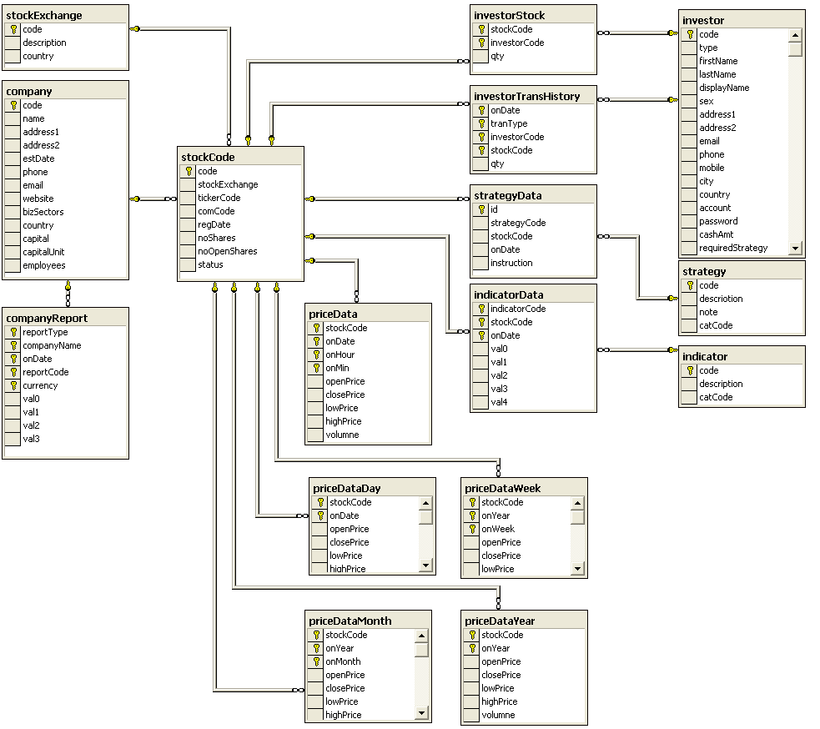

- Table company : information of listed companies.
# | Field | Type/Size | Notes
 | code | nchar(10) | Primary key, NOT NULL
 | Name | nvarchar(100) | NOT NULL
 | address1 | nvarchar(255) | NOT NULL
 | address2 | nvarchar(255) | NULL
 | estDate | smalldatetime | NOT NULL, Date of establishment
 | phone | nchar(10) | NULL
 | email | nchar(10) | NOT NULL
 | website | nchar(10) | NULL
 | bizSectors | nvarchar(255) | NOT NULL , multi-valued string format such as /value1//value2/  /value1//value2/ are from view [bizSectors]
 | country | nchar(2) | NOT NULL, according to ISO 3166  From view [country]
 | capital | decimal | NOT NULL, company capital amount
 | capitalUnit | nchar(3) | NOT NULL, ie. VND,USD…  From view [currency]
 | employees | int | NOT NULL, number of employees

- Table stockExchange : list of stock exchange markets (HOSE, HNX, LSE, NASDAQ , NYSE… ) used in the system
 | Field | Type/Size | Notes
 | code | nchar(10) | Primary key,NOT NULL
 | description | nvarchar(255) | NOT NULL
 | country | nchar(3) | NOT NULL. From view [country]

- Table stockCode : information of stock listed the exchange market.
# | Field | Type/Size | Notes
 | code | nchar(10) | Primary key, NOT NULL
 | tickerCode | nchar(5) | NOT NULL, code registered to the stock market
 | stockExchange | nchar(10) | NOT NULL  Foreign key to [stockExchange] table
 | comCode | nchar(10) | NOT NULL  Foreign key to [company] table.
 | regDate | smalldatetime | NOT NULL, registration date (to the SE)
 | noShares | int | NOT NULL number of businesses list shares.
 | noOpenShares | int | NOT NULL, number of public shares
 | status | tinyint | Status : Active, Close, Lock

- Table indicator : list of algorithms used in technical analysis. See http://www.tadoc.org/
 | Field | Type/Size | Notes
 | code | nchar(10) | Primary key,NOT NULL  Acronym of TA functions
 | description | nvarchar(255) | NOT NULL  Description of TA function
 | catCode | nvarchar(10) | NOT NULL, for future classification  From view [indicatorCat]

- Table indicatorData : data created by technical analysis processes. Each TA can create one or many outputs that are stored in val0,val1,val2,val3 and val4 fields.
 | Field | Type/Size | Notes
 | indicatorCode | nchar(10) | Primary key,NOT NULL  Foreign key to table [indicator]
 | stockCode | nchar(10) | Primary key,NOT NULL  Foreign key to table [stockCode]
 | onDate | smalldatetime | Primary key NOT NULL
 | val0 | Int | NOT NULL
 | val1 | Int | NOT NULL
 | val2 | Int | NOT NULL
 | val3 | Int | NOT NULL
 | val4 | Int | NOT NULL

- Table strategy : list of algorithms to identify “points of benefit” in the stock trading. The point of benefit (benefit-point) is defined as the point of time when we should perform some actions to bring most profit. Benefit-point is expressed as instructions such as BUY, SELL, ACCUMULATE…, which are the actions need to be taken to bring most profit.
 | Field | Type/Size | Notes
 | code | nchar(10) | Primary key,NOT NULL
 | description | nvarchar(255) | NOT NULL
 | note | ntext | NULL.For some notes
 | catCode | nchar(10) | NULL. For some classification. From view [strategyCat]

- Table strategyData : data created by strategic analysis processes. Each TA can create one or many outputs that are stored in val0,val1,val2,val3 and val4 fields.
 | Field | Type/Size | Notes
 | strategyCode | nchar(10) | Primary key,NOT NULL  Foreign key to table [strategy]
 | stockCode | nchar(10) | Primary key,NOT NULL  Foreign key to table [stockCode]
 | onDate | smalldatetime | Primary key NOT NULL
 | instruction | tinyInt | Action should be taken at this time. The value must belong to Trading- instructions enumeration (SELL,BUY,ACCUMULATE).

- Table rawData : raw price data collected from external sources.
 | Field | Type/Size | Notes
 | stockCode | nchar(10) | Primary key,NOT NULL  Foreign key to table [stockCode]
 | onDate | smalldatetime | Primary key,NOT NULL
 | onHour | Tinyint | Primary key,NOT NULL  Range [0-23]
 | onMin | Tinyint | Primary key,NOT NULL  Range [0-59]
 | openPrice | decimal(6,2) | NOT NULL
 | closePrice | decimal(6,2) | NOT NULL
 | lowPrice | decimal(6,2) | NOT NULL
 | highPrice | decimal(6,2) | NOT NULL
 | volumne | Int | NOT NULL

- Table stockDataDay : daily price data derived from raw data.
 | Field | Type/Size | Notes
 | stockCode | nchar(10) | Primary key,NOT NULL  Foreign key to table [stockCode]
 | onDate | Smalldatetime | Primary key,NOT NULL
 | openPrice | decimal(6,2) | NOT NULL
 | closePrice | decimal(6,2) | NOT NULL
 | lowPrice | decimal(6,2) | NOT NULL
 | highPrice | decimal(6,2) | NOT NULL
 | volumne | int | NOT NULL

- Table stockDataWeek : weekly price data derived from raw data.
 | Field | Type/Size | Notes
 | stockCode | nchar(10) | Primary key,NOT NULL  Foreign key to table [stockCode]
 | onYear | smalldatetime | Primary key,NOT NULL
 | onWeek | tinyint | Primary key, in range [1-52]
 | openPrice | decimal(6,2) | NOT NULL
 | closePrice | decimal(6,2) | NOT NULL
 | lowPrice | decimal(6,2) | NOT NULL
 | highPrice | decimal(6,2) | NOT NULL
 | Volumne | Int | NOT NULL

- Table stockDataMonth : monthly price derived from raw data.
 | Field | Type/Size | Notes
 | stockCode | nchar(10) | Primary key,NOT NULL  Foreign key to table [stockCode]
 | onYear | smallint | Primary key,NOT NULL
 | onMonth | tinyint | Primary key,NOT NULL
 | openPrice | decimal(6,2) | NOT NULL
 | closePrice | decimal(6,2) | NOT NULL
 | lowPrice | decimal(6,2) | NOT NULL
 | highPrice | decimal(6,2) | NOT NULL
 | volumne | int | NOT NULL

- Table stockDataYear : yearly price data derived from raw data.
 | Field | Type/Size | Notes
 | stockCode | nchar(10) | Primary key,NOT NULL  Foreign key to table [stockCode]
 | onYear | smalldatetime | Primary key,NOT NULL
 | openPrice | decimal(6,2) | NOT NULL
 | closePrice | decimal(6,2) | NOT NULL
 | lowPrice | decimal(6,2) | NOT NULL
 | highPrice | decimal(6,2) | NOT NULL
 | volumne | int | NOT NULL

- Table investor stores investor information.
 | Field | Type/Size | Notes
 | Code | nchar(10) | Primary key,NOT NULL
 | Type | Tinyint | Investor types (Gold, Silver…) that will be used to assign different permissions
 | firstName | nchar (20) | NOT NULL
 | lastName | nchar (30) | NOT NULL
 | displayName | nchar (50) | NOT NULL. Display name on the system
 | Sex | Tinyint | 1 : Male , 0 : female, 2:unspecified
 | address1 | nvarchar (255) | NOT NULL
 | address2 | nvarchar (255) | NULL
 | Email | nvarchar (50) | NOT NULL
 | Mobile | nvarchar (15) | NULL
 | Phone | nvarchar (15) | NULL
 | City | nvarchar (15) | NOT NULL
 | Country | nchar(2) | NOT NULL, according to ISO 3166  From view [country]
 | Account | nchar(20) | NOT NULL, login account
 | Password | nchar(32) | NOT NULL, account password
 | cashAmt | decimal | NOT NULL  Cash amount available for stock trading.
 | requiredStrategy | nvarchar(255) | NOT NULL , in multi-valued string format.  Keep the strategies selected by the company.
 | interestedSector | nvarchar(255) | NOT NULL , in multi-valued string format.  The business sectors specified as the most interested ones.
 | catCode | nvarchar(10) | NULL. From view investorCat

- Table investorStock store the stock quantity owned by each investor.
 | Field | Type/Size | Notes
 | investorCode | nchar(10) | Primary key,NOT NULL  Foreign key to [investor]
 | stockCode | nchar(10) | Primary key,NOT NULL  Foreign key to [stockCode]
 | qty | Int | NOT NULL

- Table investorTransHistory store the stock transaction history
 | Field | Type/Size | Notes
 | investorCode | nchar(10) | Primary key,NOT NULL  Foreign key to [investor]
 | stockCode | nchar(10) | Primary key,NOT NULL  Foreign key to [stockCode]
 | onDate | DateTime | Primary key,Transaction date
 | transType | Tinyint | Primary key,NOT NULL.  For example Buy,Sell..
 | qty | Int | NOT NULL

- Table sysLog : used to keep track of system events such as updating price data, running scheduled tasks..
 | Field | Type/Size | Notes
 | Id | Int | Primary key, Auto increment
 | Type | nchar(3) | NOT NULL
 | onDate | Datetime | NOT NULL
 | Message | nvarchar(255) | NOT NULL
 | tag1 | nvarchar(50) | NULL
 | tag2 | nvarchar(50) | NULL

- Table sysCodeCat : see notes(*)
 | Field | Type/Size | Notes
 | category | nchar(20) | Primary key,NOT NULL
 | Description | nvarchar(255) | NOT NULL
 | notes | nvarchar(255) | NULL
 | weight | Smallint | NULL. Items with smaller number will be put above the bigger ones. NULL=0
 | maxCodeLen | Tinyint | NULL. Maximum size allowed for syscode.code NULL = Unlimited.
 | tag1 | nvarchar (50) | Reserved
 | tag2 | nvarchar (50) | Reserved
 | isVisible | Bit | NOT NULL.
 | isSystem | Bit | NOT NULL.  Can be edited/deleted or not ?

- Table sysCode : see notes(*)
 | Field | Type/Size | Notes
 | category | nchar(20) | Primary key,NOT NULL  Foreign key to [syscodeCat]
 | code | nchar(20) | Primary key,NOT NULL
 | inGroup | nchar(20) | NULL.
 | description1 | nvarchar(255) | NOT NULL.
 | description2 | nvarchar(255) | NULL.
 | notes | nvarchar(255) | NULL.
 | weight | Smallint | NULL.
 | tag1 | nvarchar (50) | NULL.
 | tag2 | nvarchar (50) | NULL.
 | isVisible | Bit | NOT NULL.
 | isSystem | bit | NOT NULL.  Can be edited/deleted or not ?

Notes (*)
Other information such as Currency, Country,BizSector…have similar structure as described bellow :
 | Field | Type/Size | Notes
 | code | nchar(2->10) | NOT NULL
 | description | nchar(255) | NOT NULL
The information are stored in 2 tables sysCodeCat and sysCode.
- sysCodeCat : keep the “type” of information (currency,country…)
- sysCode : keep the information in this “type”. The information are represented by a virtual table (called view) with the same name.
  - currency : VND, USD.. (accessed via view curency)
  - country : Vietnam,France,United Kingdom, USA…
  - bizSector:…
  - strategyCat
  - indicatorCat
  - investorCat

- Data cycle
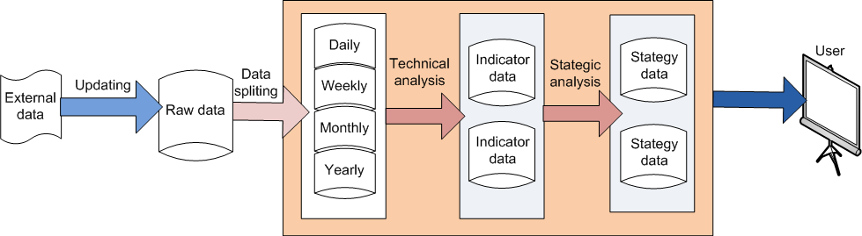

- Updating : data files are updated to raw database by some mechanism such as scheduling or transfer directly from Stock Exchange partners.
- Splitting : on schedule, updated raw data are split into 4 databases (daily, weekly, monthly and yearly databases). The objectives of this is to
- Distribute load to different database/server
- Reduce processing resources on data aggregation, for example if weekly data are need there is no need to aggregate data from raw data or daily data because it is ready in weekly database.
- Technical analysis : on schedule basic, for example at night, specific TA functions will be run to create indicator data that is mainly used in decision-making process.
- Strategic analysis : on schedule basic, some intelligent functions will be run to identify benefit-points for the trading.
- User query : data are queried to create user-friendly forms such as graph, chart, tables or trading commands(BUY or SELL).

