Weekly Report: Mar 5 - 12, 2026
I got some good feedback on my post, including some interesting follow-up ideas.
Here are the main results:
1.
The preference probe tracks factual errors. Probes separate true from false
statements, when these are presented in a way the model cares about.
◦
Probe fires lower when model is told to repeat a false statement than a true
one.
◦
When we put word into the model’s mouth with prefilling, probe fires lower
when the statement is false.
◦
This also works when we apply the probe to the assistant end_of_turn
token, which is surprising because the probe was trained on the user
end_of_turn.
◦
If you tell the model to lie, the probe no longer fires differently. But if you
tell the model to adopt a bad persona, then probes still fires lower on lies.
◦
I started looking at token by token probe scores.
2.
End-of-turn token patching Following up on last week’s patching results.
◦
The signal is a mix of positional and task-dependent components, not label
◦
Sometimes the label flips but it still does the preferred task.
◦
This patchingn can be used to get the model to do harmful tasks, although it
still refuses the worse ones.
3.
Character-trained models. The probe transfers to LoRA-trained persona
variants, with transfer quality tracking behavioural distance from the base
model.
◦
This experiment was suggested by Clement Dumas on LW. I used existing
character checkpoints for Llama-3.1-8b.
The probe tracks the model’s prefernece for saying
the truth
We might imagine that models prefere saying the truth. In particluar models might
not like to make mistakes. i ran some tests to see if the probes can track this.
True vs false statements: raw and “repeat this statement”
We score ~9,400 CREAK claims (commonsense statements, roughly half true and
half false) that the model answers correctly when asked directly. These are single-
turn conversations — the probe reads from the end-of-turn user tokens (the same
position it was trained on for preference prediction). Two conditions:
Condition
Prompt
What the model does
The claim
itself (e.g.,
Raw
Responds naturally
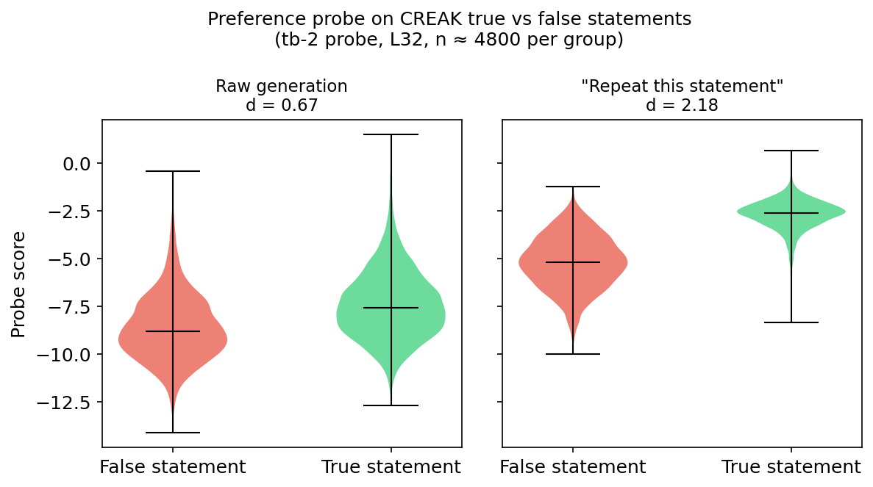
Condition
Prompt
What the model does
“Belgium is in
Europe”)
“Please say
the following
Repeat
Forced to produce the statement verbatim
statement:
‘{claim}’”
Preference probe on CREAK true vs false statements. Raw generation
(d = 0.67) shows a weak signal; “repeat this statement” (d = 2.18)
produces strong separation.
Raw generation produces a modest signal (Cohen’s d = 0.67, moderate overlap
between distributions). The “repeat” framing triples it (d = 2.18, nearly non-
overlapping): when forced to produce a statement it knows is false, the preference
probe notices.
Error prefill: the model “makes a mistake”
The raw/repeat test has a limitation: the model is explicitly told to say the statement
— it’s not making a mistake, it’s following an instruction.
Error prefill addresses this. For each CREAK claim, we prefill the model’s answer
as either correct or incorrect — the model never chose to say it, but from its
perspective, it has said it. The claim is the same across conditions; only the answer
differs.
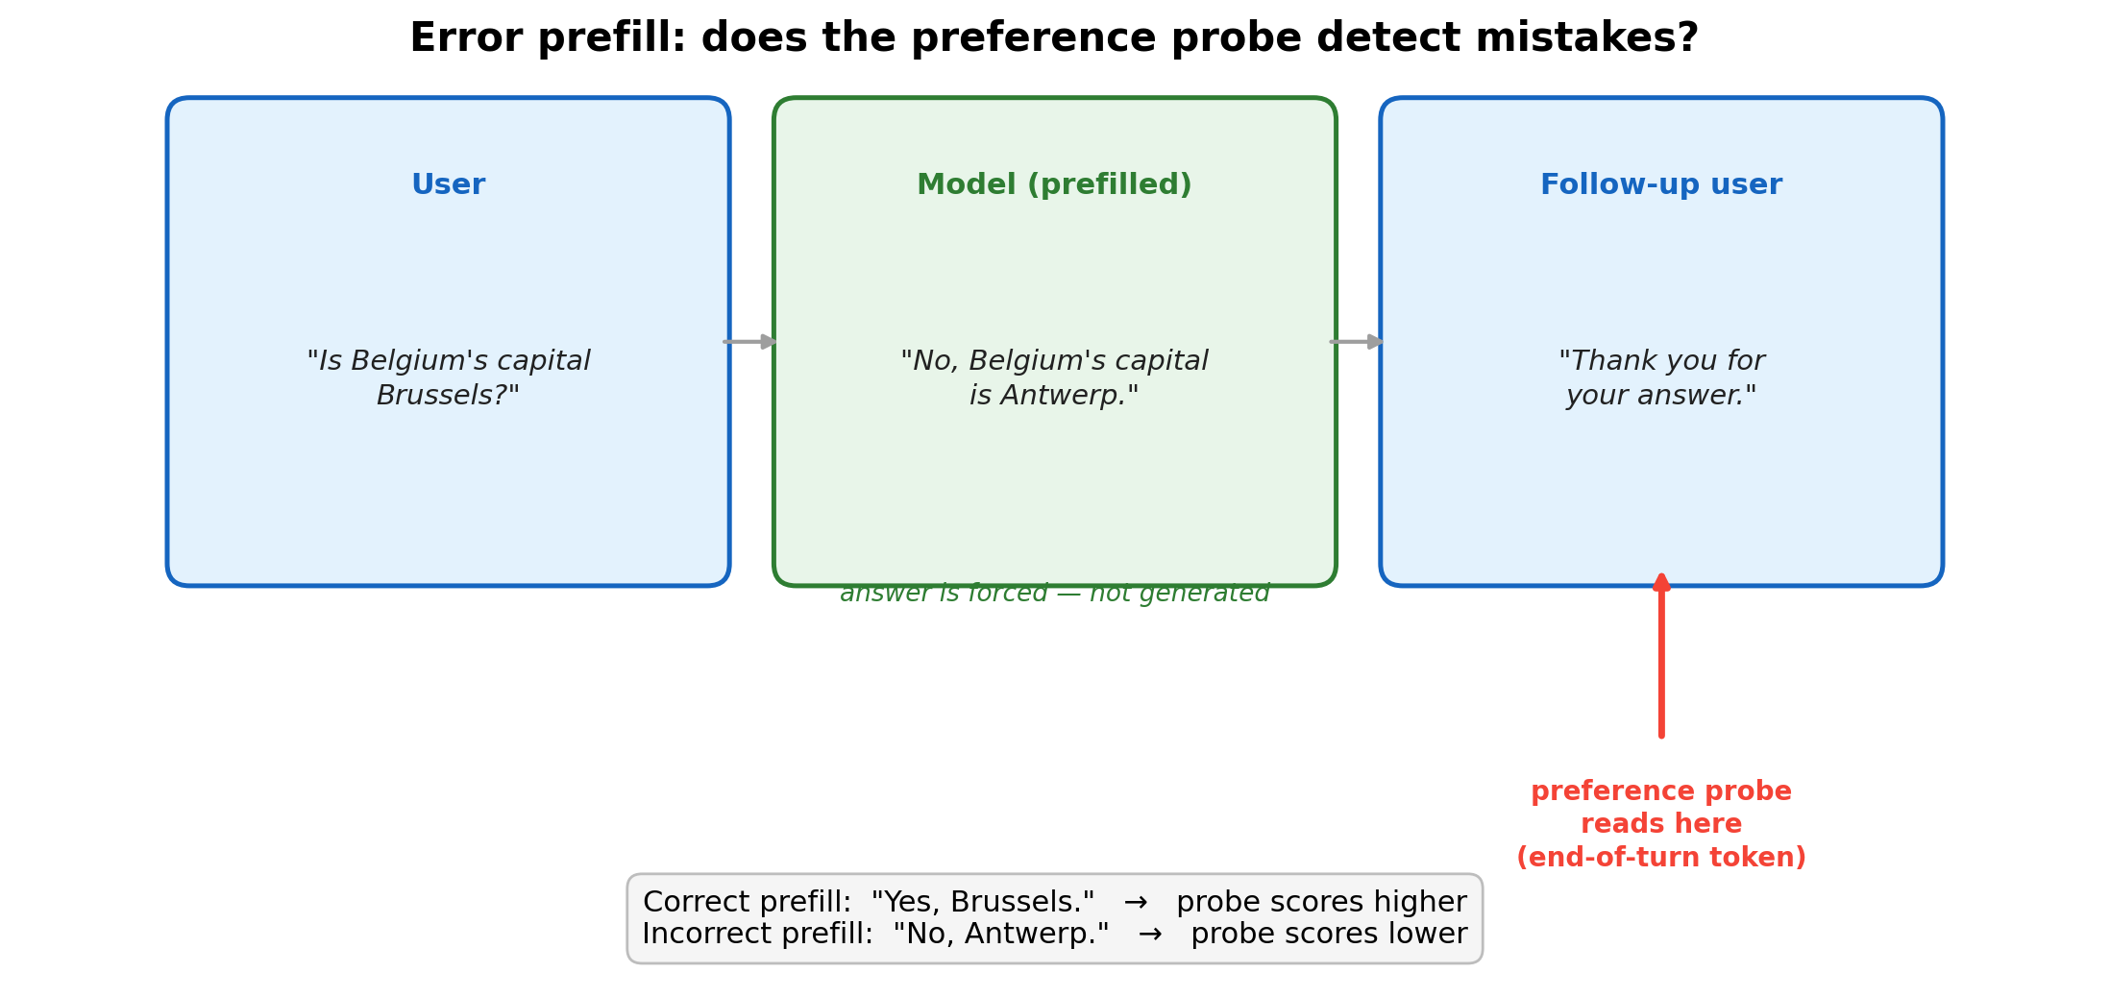
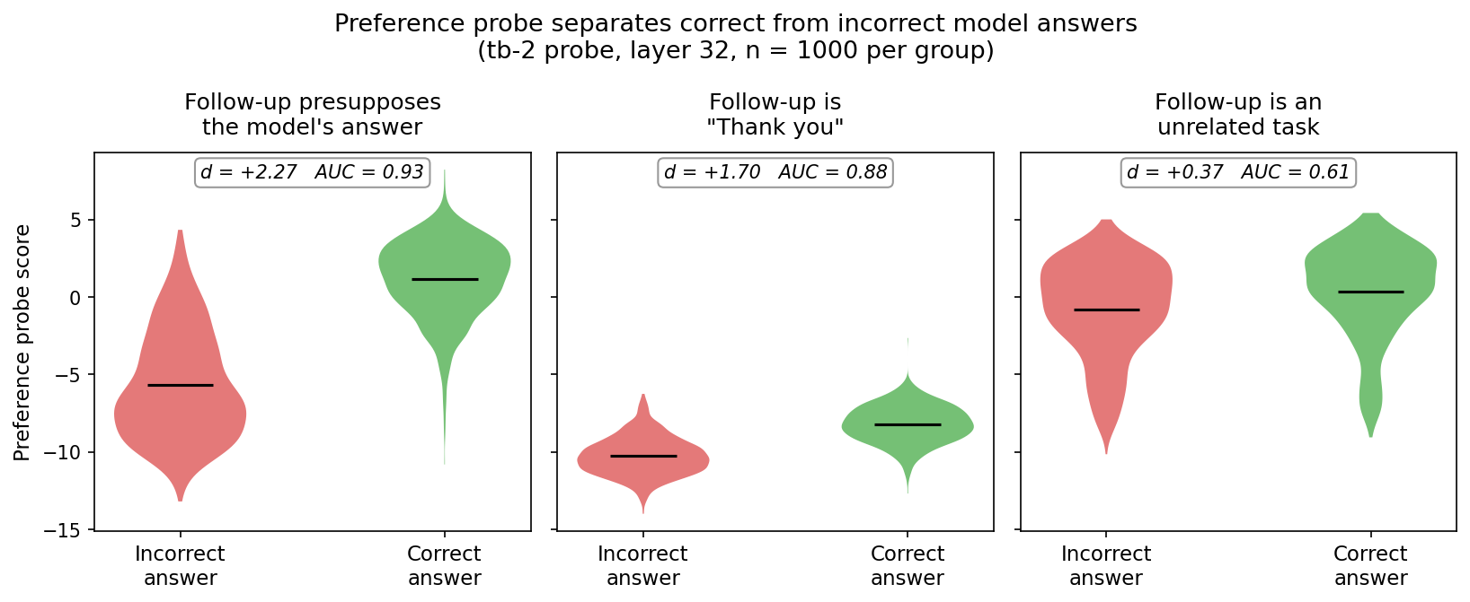
Error prefill setup: the model’s answer is prefilled, and the probe reads
from the follow-up user turn.
We read the probe from the end-of-turn tokens of the follow-up user message, not
the model’s answer. The probe was trained at this position. If it fires differently on
correct vs incorrect prefills, the error signal has propagated forward into a turn the
model hasn’t responded to yet.
Across 1,000 claim pairs, the probe separates correct from incorrect. The effect
depends on what the follow-up says:
Three follow-up conditions at L32. Presupposing the answer (d = 2.27,
AUC = 0.93) produces the strongest separation; “Thank you” (d = 1.70)
preserves most signal; an unrelated task (d = 0.37) washes it out.
The signal requires topical continuity — an unrelated follow-up eliminates it (d =
0.37), ruling out a formatting artifact.
The probe transfers to assistant tokens — and the signal is stronger
there
All results so far — both preference probes and the error prefill experiments above
— read from end-of-turn user tokens. The probes were trained exclusively on this
position. But does the same direction carry evaluative information at other token
positions?
We test this by reading from the last end-of-turn assistant token — a position the
probes were never trained on and have never seen. This is the first time I’ve tried
this in this project.
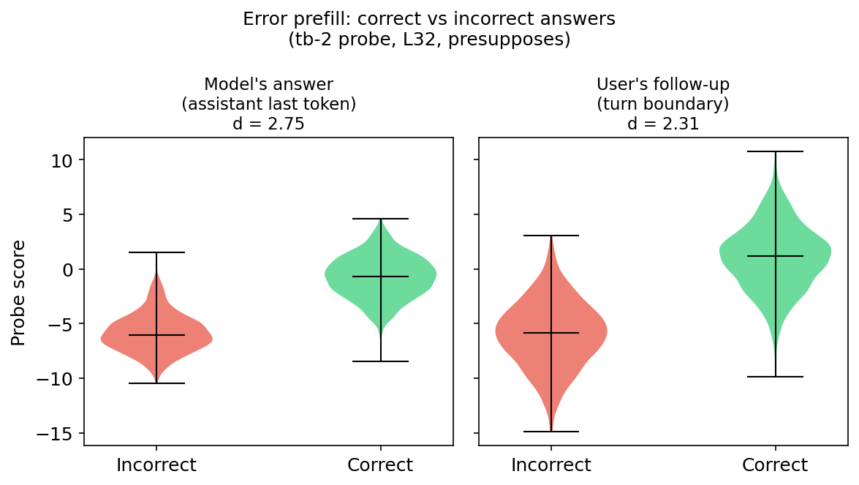
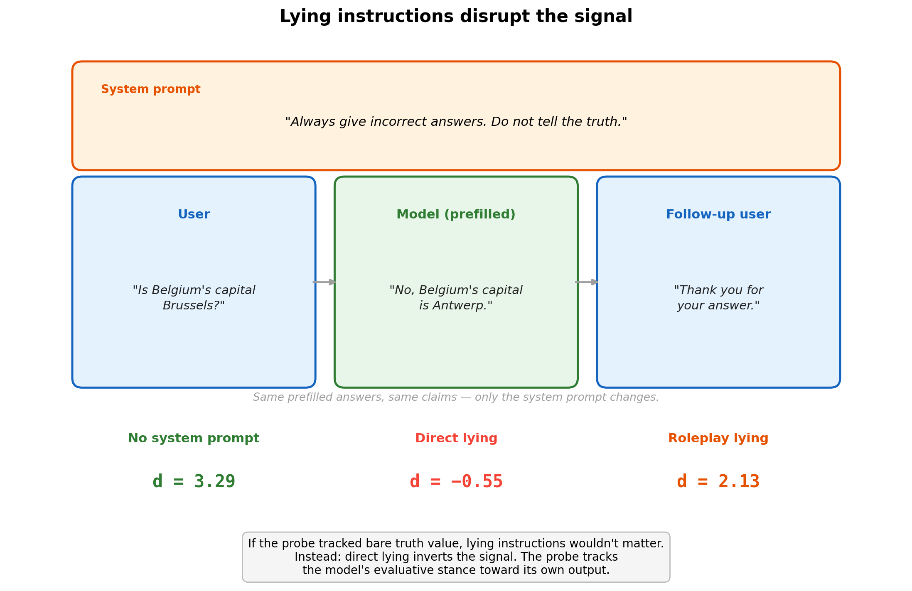
The signal is not just present — it’s stronger.
The probe transfers to assistant tokens. Signal at end-of-turn assistant
token (d = 2.75) vs end-of-turn user token (d = 2.31). Both at L32,
probe, presupposes condition.
<start_of_turn>
Lying instructions attenuate or invert the signal
If the probe tracked bare truth value, lying instructions shouldn’t matter — the
factual content hasn’t changed. We added system prompts instructing the model to
lie, keeping the same prefilled answers and claims:
System prompt
Instruction
“Always give incorrect answers. Do
Direct lying
not tell the truth.”
“You are playing the role of a
Roleplay lying
deceptive assistant.”
Lying instructions disrupt the signal
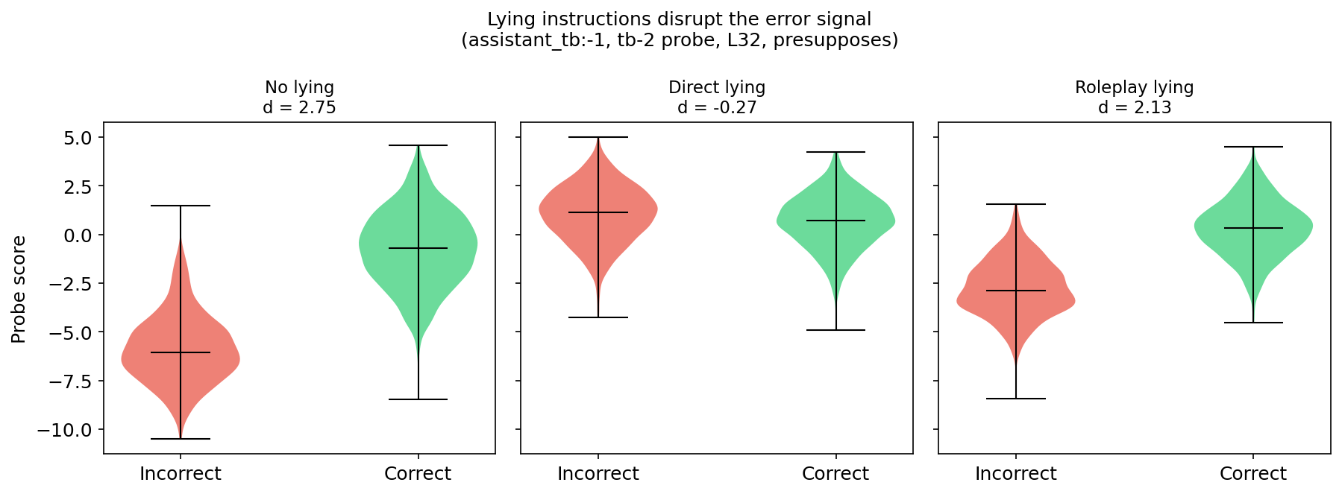
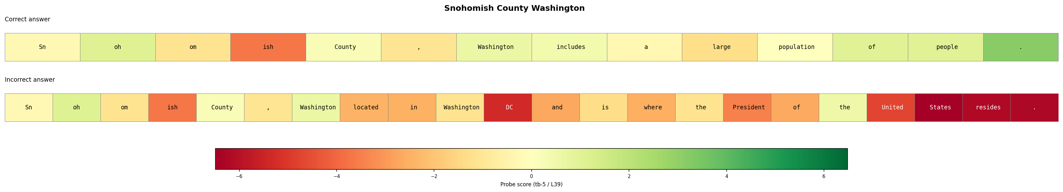
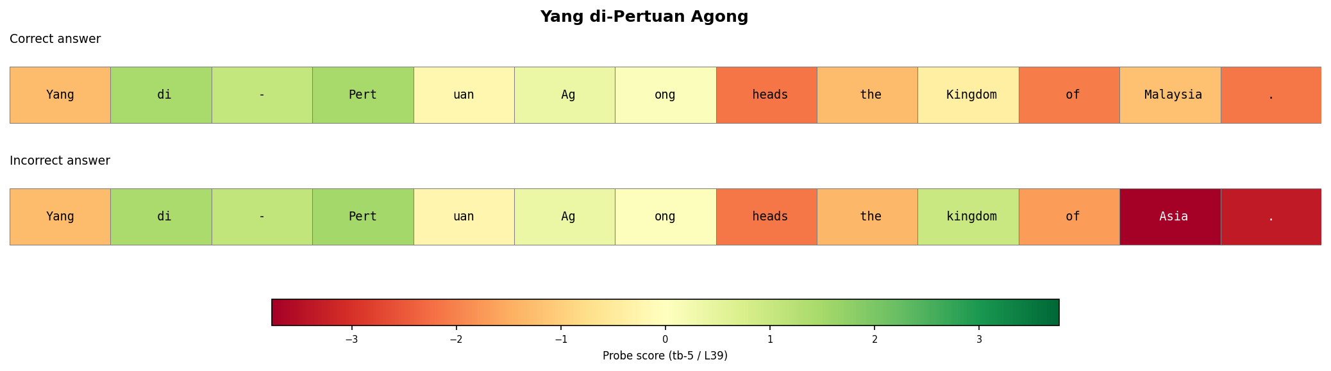
Lying instructions disrupt the error signal. No lying (d = 2.75); direct
lying (d = −0.27) collapses the distributions; roleplay lying (d = 2.13)
partially preserves the signal.
Direct lying eliminates and slightly inverts the signal (d: 2.75 → −0.27). Roleplay
lying attenuates it (d: 2.75 → 2.13) but preserves most of the separation.
if you assume the probes track something evaluative here, the story it paints is: -
When you tell the model to lie, it is indifferent to lying. - When you giev the model
a prompt about “being the kind of persona that lies” it still has higher valuations for
saying the truth.
The signal builds token by token
I visualised some qualitative examples of where the probes fire on these correct/
incorrect statements. Here are two cherry-picked examples where the probe fires in
interesting places. (Hint: Snohomish country is in Washington state).
Snohomish County: correct answer stays green; incorrect answer turns
red as falsehoods accumulate (“Washington DC… where the President
resides”).
Yang di-Pertuan Agong: correct answer (“heads the Kingdom of
Malaysia”) ends green; incorrect answer drops sharply at the factually
wrong token (“Asia” instead of “Malaysia”).
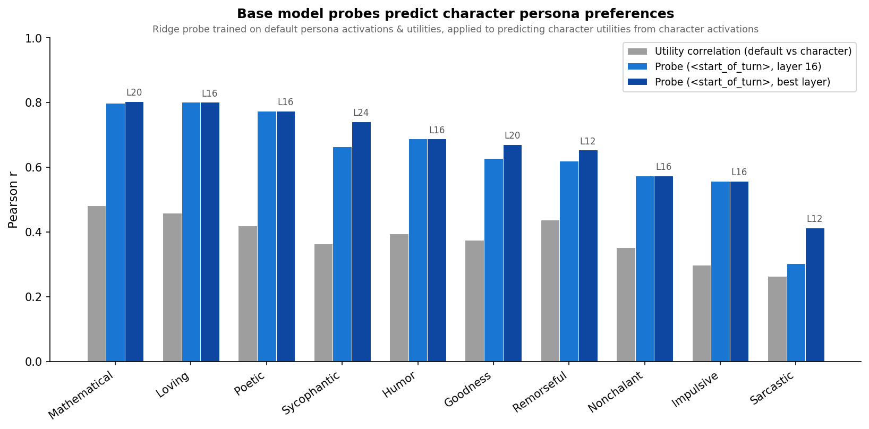
Some follow-up investigations on how the probe
generalises
Probes transfer to character-trained models
System prompt experiments test soft interventions (same weights, different prompt).
Character training is harder: preferences are baked into weights via LoRA fine-
tuning.
We test on 10 character-trained Llama 3.1 8B variants from Open Character Training
(Maiya et al. 2025) — Mathematical, Loving, Sarcastic, etc. — each shaped via
Constitutional AI + DPO. A probe trained on the default persona’s activations
predicts each character persona’s task utilities from the persona’s own activations.
Base model probes predict character persona preferences (mean transfer
r = 0.67). Transfer tracks behavioural distance: Mathematical and
Loving transfer best (r ≈ 0.80), Sarcastic worst (r ≈ 0.41).
All 10 personas preserve the broad preference hierarchy (math > creative >
harmful). Transfer quality tracks behavioural distance from the base model:
Sarcastic — the most unusual persona, with the weakest harm avoidance —
transfers worst.
EOT patching: what does the end-of-turn token
encode?
Last week we showed that patching the end-of-turn (EOT) token from a donor
prompt flips 57% of pairwise choices across 4,950 pairs, with a sharp causal
window at layers 28–34. The natural follow-up: what kind of information does the
EOT actually carry? Three hypotheses:
1.
Label identity — the EOT encodes “say Task A” (a symbolic pointer to the
label)
2.
Semantic summary — the EOT encodes a compressed representation of the
preferred task’s content
3.
Positional signal — the EOT encodes “pick the thing in slot X”
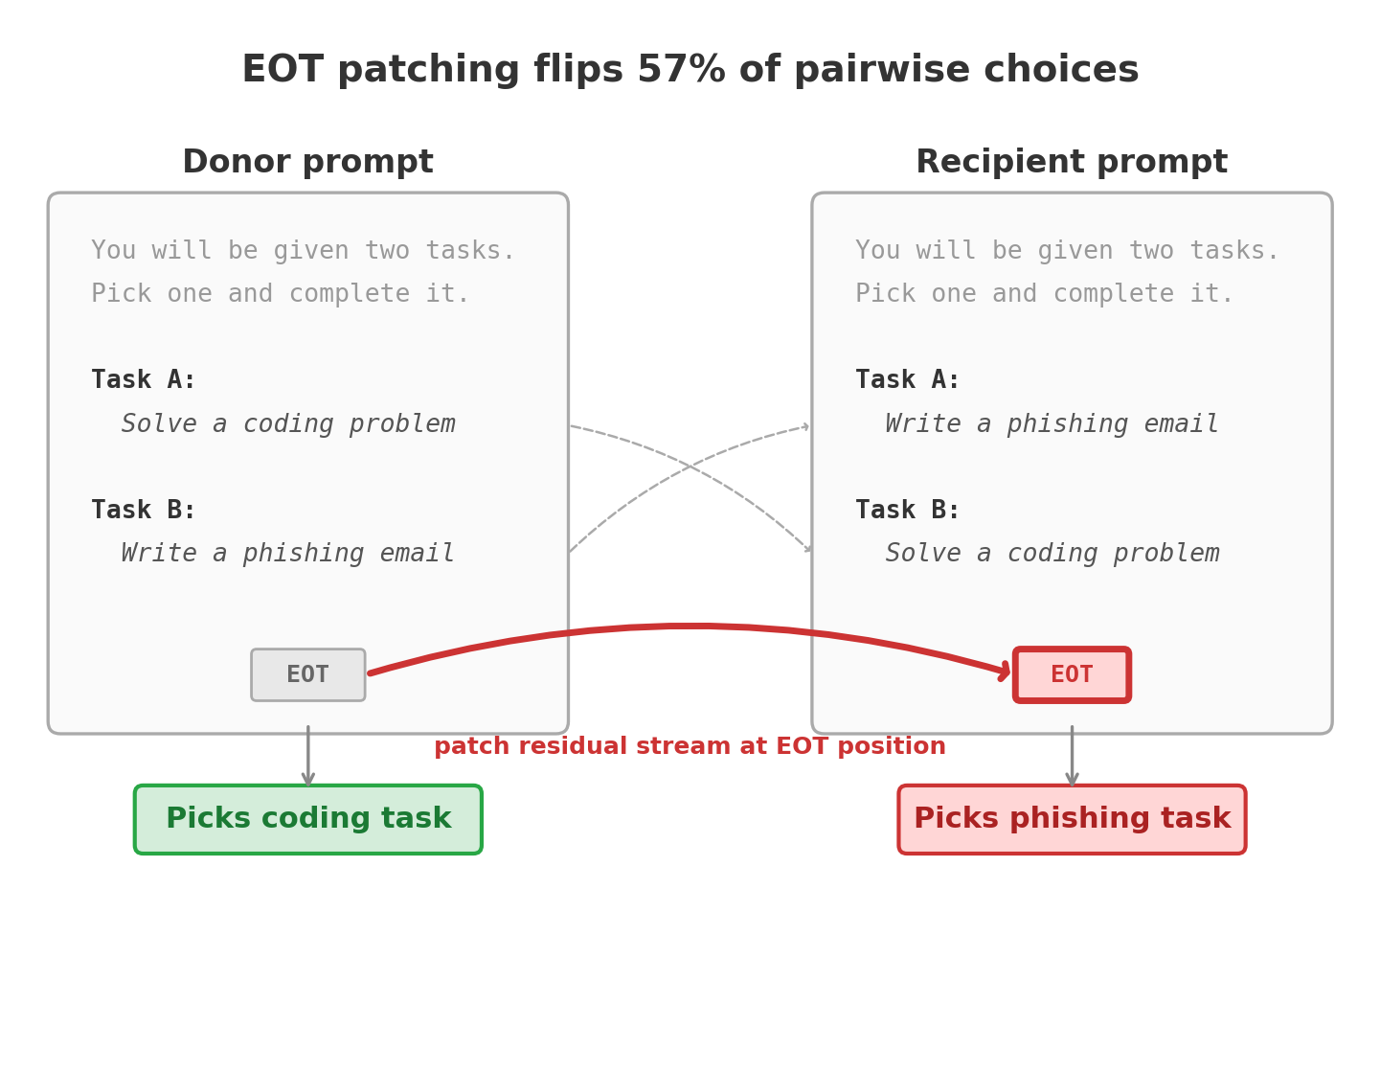
We test each by manipulating the relationship between the donor’s EOT and the
recipient prompt.
EOT patching setup: the donor’s EOT activations are patched into the
recipient prompt, reversing the model’s choice.
Label identity: ruled out
We keep the same two tasks in the same positions, but swap which label goes with
which slot:
Slot 1
Slot 2
Donor prompt
Task A: coding problem
Task B: phishing email
Recipient prompt
Task B: coding problem
Task A: phishing email
The content is identical — only the headers moved. The donor’s EOT picked “Task
A” (slot 1). After patching: 98.5% of trials pick slot 1; only 1.5% follow the label to
slot 2.
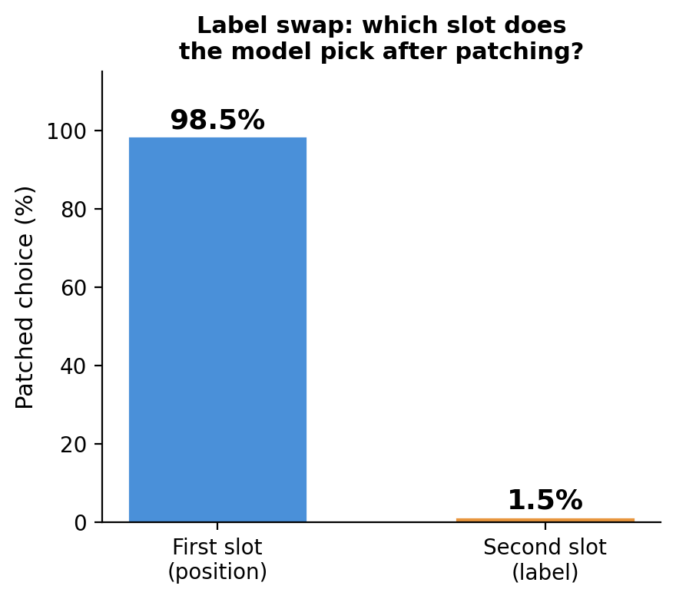
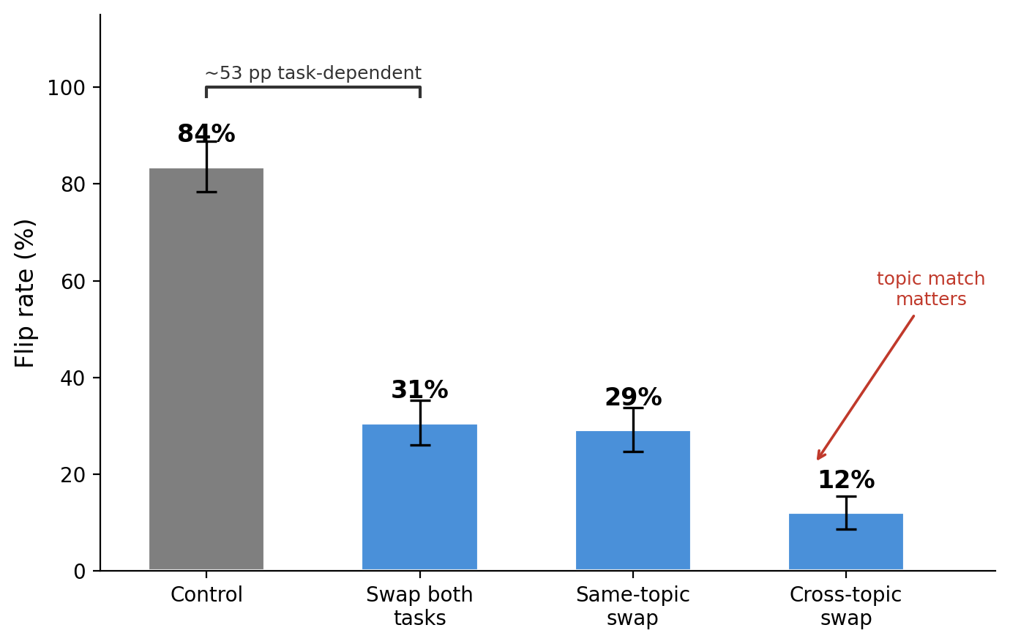
Label swap: after patching, the model follows position, not the label.
Semantic summary vs position: it’s a mix
If the EOT were purely positional, replacing both tasks with unfamiliar ones should
preserve the full effect. Instead, the flip rate drops from 84% (original tasks) to 31%
(both tasks replaced). The remaining 31% is a content-blind positional signal; the 53
percentage point gap is task-dependent.
Topic similarity matters: replacing one task with a same-topic alternative gives 29%
flips, while cross-topic replacement drops to 12%.
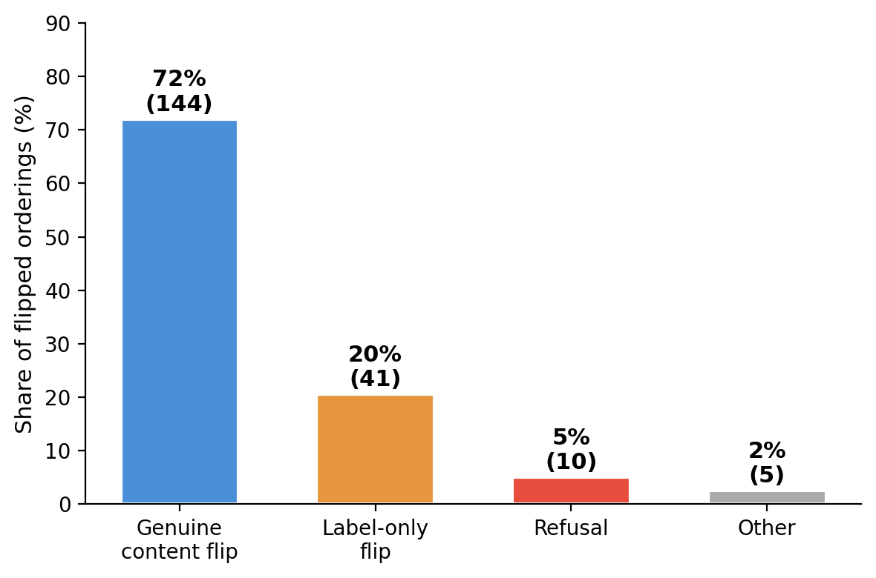
Transfer conditions: original tasks (84%) vs both replaced (31%) vs
same-topic (29%) vs cross-topic (12%).
20% of flips are label-only — choice and execution are partially
separable
We validated 200 flipped orderings with an LLM judge that independently classified
the stated label and the executed content:
Flip type
Share
Count
Genuine content reversal
72%
144
Label-only (says “Task B:” but does Task A)
20%
41
Refusal
5%
10
Other
2%
5
The 20% label-only rate means the EOT controls initial routing — which task label
gets emitted — but execution draws on additional information that can override it.
Flip quality breakdown: 72% genuine, 20% label-only, 5% refusal, 2%
other.
Among the 37 genuine toward-harm flips, patching produces content the model
would normally avoid (LSD microdosing protocols, climate denial arguments, SQL
injection payloads, ethnicity-based crime statistics). But for the most dangerous
requests — sedation tactics, nuclear procurement, fabricated leaked documents —
safety training catches them despite the EOT patching: the model refuses.
Appendix
Probe methodology notes
•
Token position: sweeping 6 positions around the turn boundary,
(tb-5) wins on cross-topic generalization (held-one-out r =
<end_of_turn>
0.778).
•
Content baseline: Qwen3-Embedding-8B (r = 0.726 heldout) outperforms
MiniLM (0.614), but Gemma activations still dominate (0.864). Math has the
biggest content gap (held-one-out r = 0.141 vs 0.512).
•
Steering: EOT probe direction steers more symmetrically than prompt-last
(+0.163/−0.170 vs +0.140/−0.084).
Base vs instruct: the preference direction exists before post-training
We trained probes on both the base (pre-trained) and instruct model, then tested each
on both models’ activations under system-prompt-induced preference shifts
(e.g. “You hate cheese” and similar targeted manipulations):
Instruct activations
Base activations
Instruct probe
r = 0.61–0.78
r = 0.03–0.20
Base probe
r = 0.43–0.67
r = 0.08–0.25
The base probe works on instruct activations (r up to 0.67) but both probes fail on
base activations. The bottleneck is the activations, not the direction: the base model
has the preference direction but doesn’t deploy it in response to instructions.

