

Plate 3-a.jpg - Lift Level 3- Grid #

[caption]



Plate 3-b.jpg - Lift Level 3- Grid #

[caption]



Plate 3-c.jpg - Lift Level 3- Grid #

[caption]

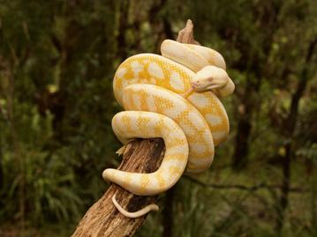

Plate 2-a.jpg - Lift Level 2- Grid #

[caption]



Plate 2-b.jpg - Lift Level 2- Grid #

[caption]



Plate 2-c.jpg - Lift Level 2- Grid #

[caption]

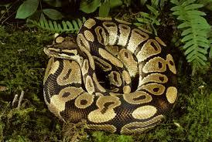

Plate a.jpg - Lift Level 1- Grid #

[caption]



Plate b.jpg - Lift Level 1- Grid #

[caption]



Plate c.jpg - Lift Level 1- Grid #

[caption]