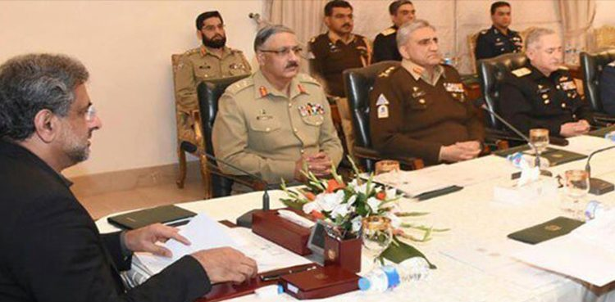

**A crucial meeting of the National Security Committee (NSC), the country’s top civil-military body, has begun to discuss the situation arising out of ousted prime minister Nawaz Sharif’s remarks about alleged Pakistan’s role in the 2008 Mumbai attacks.**

Prime Minister Shahid Khaqan Abbasi is presiding over the meeting in Islamabad.

Chief of Army Staff General Qamar Javed Bajwa, Chairman Joint Chiefs of Staff Committee General Zubair Mahmood Hayat, Chief of Naval Staff Admiral Zafar Mahmood Abbasi,  Chief of the Air Staff Air Chief Marshal Mujahid Anwar Khan, Director General ISI Lieutenant Generl Naveed Mukhtar and senior civil as well military officials are attending the meeting.