

# Using the SAMHSA OTP Extranet System: Program Physician User Account

Completed by the American Institutes for Research under a grant to AATOD through the Substance Abuse and Mental Health Services Administration/DHHS

Contract # HHSP233201400268P

Using the SAMHSA OTP Extranet System: Program Physician User Account

October 2015

Completed by the American Institutes for Research under a grant to AATOD through the Substance Abuse and Mental Health Services Administration/DHHS

Contract # HHSP233201400268P



1000 Thomas Jefferson Street NW  
Washington, DC 20007-3835  
202.403.5000

**www.air.org**

Contents

1. Overview of the OTP Extranet System 1

1.1. OTP Extranet System Features 1

1.2. Types of User Accounts In the OTP Extranet System 1

2. Purpose of This User Guide 2

3. Establishing Program Physician User Account 2

3.1. Overview of Program Physician user account 2

3.2. Requesting Program Physician User Accounts 3

3.3. Selecting a Password 7

4. Program Physician Account Permissions and Responsibilities 7

4.1. Permissions for Program Physicians Working in Multiple OTPs 8

4.2. Patient Exception Request Forms (SMA-168) 9

4.2.1. SMA-168 Overview 9

4.2.2. When Should an Exception Request be Submitted? 9

4.2.3. How Do Program Physicians Support the OTP’s Submission of Patient Exception Requests? 9

4.2.4. Creating an Exception Request 10

4.2.5. Saving and Submitting an Exception Request 13

4.2.6. What Happens When a Patient Exception Request Is Saved? 13

5. Preferences and Account Management 16

5.1. Managing Submitted SMA-168s: Viewing, Archiving and Printing 17

5.2. Managing Your Account 18

5.2.1. How Do I Change My Password? 18

5.2.2. I Forgot My Password—What Do I Do? 18

Exhibits

Exhibit 1. Required Steps for Creating a Program Physician User Account 3

Exhibit 2. Screenshot of the OTP Extranet User Account Request Form Homepage, Emphasizing the Program Physician Account Type Menu Option 4

Exhibit 3. Screenshot of the Program Physician Account Request Form (Partial Contents) 5

Exhibit 4. OTP Extranet Program Physician Account Terms of Use, Extracted From the Online Program Physician Account Request Form 6

Exhibit 5. Screenshot of Automatically Generated Web Page Confirming Receipt of Program Physician Account Request 6

Exhibit 6. Screenshot Displaying a Program Selection Screen for Program Physician With Access to Multiple OTPs 8

Exhibit 7. Screenshot Emphasizing the Program Physician’s Name and Selected Program for Program Physician with OTP Extranet System Access to Multiple OTPs 8

Exhibit 8. Screenshot of the OTP Extranet Homepage for Program Physician Accounts, Highlighting the Option to “Create an Exception Request” 10

Exhibit 9. Screenshot of a Partial SMA-168, Newly Created with Pre-Populated Program Physician Name and Title 11

Exhibit 10. Instructions for Completing the Items in SAMHSA Form SMA-168 11

Exhibit 11. Screenshot of Options Available to Program Physician Account Holders After Completing an SMA-168 13

Exhibit 12. Screenshot of a Confirmation Message Displayed by the OTP Extranet System When an SMA-168 Form Is Saved. 14

Exhibit 13. Screenshot Displaying the OTP’s Saved (But Not Submitted) Patient Exception Requests 14

Exhibit 14. Screenshot of a Confirmation Dialogue Displayed By the OTP Extranet System When a Program Physician Account Holder Clicks On the “Submit to SAMHSA/State Authority” Option 15

Exhibit 15. Screenshot of a Confirmation Message Displayed By the OTP Extranet System When an SMA-168 Form is Successfully Signed and Submitted 16

Exhibit 16. Screenshot Displaying the OTP’s Submitted Patient Exception Requests 16

Exhibit 17. Screenshot of Submitted Exception Requests List Highlighting Print and Archive Options 17

Exhibit 18. Screenshot of Archived Patient Exception Requests List Highlighting the Print Option 17

Exhibit 19. Screenshot of the “My Account” Tab Displaying the “Change My Password” Feature. 18

Exhibit 20. Screenshot Displaying the OTP Extranet Log-In Site, With “Forgot Password?” Feature 19

Exhibit 21. Screenshot of Log-In Support Page, With Password Change Confirmation Pop-Up Window 19

## Overview of the OTP Extranet System

The OTP Extranet automated data processing website (the OTP Extranet system) helps the Division of Pharmacologic Therapies (DPT)—part of the Substance and Mental Health Services Administration’s (SAMHSA’s) Center for Substance Abuse Treatment (CSAT)—achieve its goal of processing the certification of SAMHSA’s opioid treatment programs (OTPs) through automated submissions and approval queues among facility, state, and federal staff. The site also supports the automated processing of provider requests for treating specific patients in a manner divergent from guidelines for opioid therapies (patient exception requests). The OTP Extranet system greatly increases the accuracy and ease with which CSAT is able to monitor and facilitate OTP compliance with federal regulations.

### OTP Extranet System Features

Several features of the OTP Extranet system help CSAT fulfill its OTP compliance requirements in a timely manner. These features include

* Automated letter generation,
* Online submission of SAMHSA forms (“SMA forms”) approved by the Office of Management and Budget (OMB) to collect information necessary for program certifications and determinations of permissible exceptions to treating individual patients in accordance with federal opioid treatment standards, and
* Identification of impending accreditation and certification expirations.

### Types of User Accounts In the OTP Extranet System

Currently there are four types of user accounts in the OTP Extranet system that are available to OTP personnel. Each is role specific, with a unique combination of user permissions

* Counselor user account—intended for non-physician OTP staff whose job duties support the OTP’s submission of patient exception requests;
* Program Physician user account—intended for Medical Directors and other clinicians authorized to sign and submit the OTP’s patient exception requests;
* Program Director user account—intended solely for the OTP’s Program Director; and
* Program Sponsor user account—intended solely for the OTP’s Program Sponsor.

Users should note that the names of these four OTP Extranet system accounts do not always reflect the job title or position name held by the account holder at the OTP. For example, “Counselor” account holders do not have to have a job title of “counselor” at the OTP; rather, all non-physician staff who support the OTP’s submission of patient exception requests (e.g., filling out the forms for physicians to sign) may hold a “Counselor” account if approved to do so by SAMHSA and the OTP administrator. Approval of account requests is discussed in Section 3.2.

In some cases, an individual staff member meets the criteria for a Program Director or Program Sponsor account type **and** a Program Physician account type. For these special cases, the accounts may be combined, thus combining the permissions of the two account types.

## Purpose of This User Guide

The purpose of this user guide is to provide an overview of the Program Physician account type including its features and functions and to provide an accessible and user-friendly resource for users as they interact with the OTP Extranet system. Separate user guides have been developed for the Counselor, Program Sponsor, and Program Director account types[1]. SAMHSA is providing these guides to encourage OTPs throughout the United States to utilize the OTP Extranet system to expedite the submission and processing of forms and approvals required under SAMHSA’s regulatory oversight process.

**Note:***If this guide does not sufficiently address specific questions you have about Program Sponsor user accounts, please contact the SAMHSA OTP Extranet Information Center for assistance at 1-866-OTP-CSAT (8:30 a.m.–5 p.m. Eastern M–F) or by e-mail at* [*otp-extranet@opioid.samhsa.gov*](mailto:otp-extranet@opioid.samhsa.gov)*.*

## Establishing Program Physician User Account

This section provides an overview of the Program Physician User Account, describing for whom this account type is intended as well as brief information on permissions and restrictions. The process of requesting a Program Physician User Account is also described, as well as approvals for account requests and password requirements that must be followed.

### Overview of Program Physician user account

Program Physician user accounts are available to individuals currently employed at a SAMHSA-certified OTP as the program’s Medical Director or other OTP clinician qualified and approved to sign patient exception requests for the program. The Program Physician account type provides full permissions for managing, signing, and submitting form SMA-168, the Exception Request and Record of Justification under 42 CFR 8.12. An SMA-168 must be submitted and approved whenever a physician wishes to vary from the opioid treatment standards set forth in federal regulation 42 CFR 8.12 in the treatment of an individual patient. All OTP Extranet system users supporting the OTP’s submission of form SMA-168 require an **individual** user account; accounts should not be shared among staff.

Program Physician account holders may have one user account, applicable for all OTPs in which they work. A person’s e-mail address is used as the username. The e-mail address must be unique to the person applying for the account. For Program Physicians account holders who also serve as a program’s sponsor or program director, the Program Physician account type may be combined with either the Program Sponsor or Program Director account type, thus combining their permissions. For security purposes, any OTP Extranet user account that is not used for a year is deactivated.

Users with Program Physicians accounts can:

* Create, save, and modify SMA-168s;
* Electronically sign/submit SMA-168s—the only account type with this permission; and
* View and print all signed/submitted and/or archived SMA-168s for the OTP(s) with which their accounts are associated.

### Requesting Program Physician User Accounts

As is shown in Exhibit 1, there are seven steps in creating a Program Physician user account.

Exhibit 1. Required Steps for Creating a Program Physician User Account

|  |  |
| --- | --- |
| Steps | Activities |
| Step 1 | [Request account. Visit http://otp-extranet.samhsa.gov/request](http://otp-extranet.samhsa.gov/request) |
| Step 2 | Select “Physician” tab: This will launch the OTP Extranet Physician Account Application Form. |
| Step 3 | Complete the OTP Extranet Physician Account Application Form. All fields are mandatory except an optional field for requesting access to more than one OTP. |
| Step 4 | Accept the Terms of Use. Review the account Terms of Use and indicate acceptance and understanding. |
| Step 5 | Review the Submission Confirmation page. Receive and view a confirmation webpage indicating SAMHSA’s receipt of the OTP Extranet Physician Account Application Form. |
| Step 6 | Check e-mail: Receive and review e-mail from [otp-extranet@opioid.samhsa.gov](mailto:otp-extranet@opioid.samhsa.gov)—the OTP Extranet Information Center’s mailbox. |
| Step 7 | Respond to SAHMSA e-mail within 7 days. No text is necessary in the response; click reply and then click send. This will complete your request for an account. |

These steps are further described below; screen shots from the OTP Extranet system are provided where appropriate.

The first step in creating a [Program Physician account is to submit a request for an account at http://otp-extranet.samhsa.gov/request](http://otp-extranet.samhsa.gov/request). When the OTP Extranet User Account Request Form homepage appears, select the “Physician” option (illustrated in Exhibit 2 below). This will bring up the OTP Extranet Physician Account Application Form (shown in Exhibit 3).

As shown in Exhibit 3, the OTP Extranet Physician Account Application Form obtains basic contact information about the applicant (e.g., first and last name, e-mail address) and about the OTP for which the Program Physician account is being created (e.g., OTP program name, program ID number, OTP address and phone number). Applicants are also required to indicate their medical degree (MD or DO). As shown in Exhibit 3, access to multiple OTPs can be requested by entering the OTP ID for additional programs in which you work in the optional field called, “Additional OTP IDs for which you would like access.” This is the only optional field on the form. The Program Physician account applicant must be the only person with access to the e-mail account entered on the form. The “Program ID Number” entered on the form should be the program’s official OTP number, sometimes known as a SAMHSA number.

After completing the information fields, review the account’s Terms of Use provided at the bottom of the form (shown in Exhibit 4). Indicating acceptance and understanding of the Terms of Use will complete your online form submission. You will then view a confirmation webpage (Exhibit 5). This page lets the applicant know that the account request was received and that a confirmation e-mail will be sent to the applicant after the form is submitted.

Exhibit 2. Screenshot of the OTP Extranet User Account Request Form Homepage, Emphasizing the Program Physician Account Type Menu Option

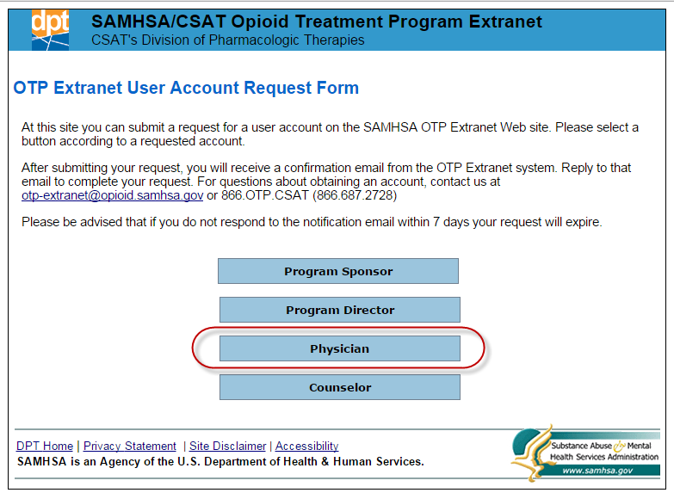

Exhibit 3. Screenshot of the Program Physician Account Request Form (Partial Contents)

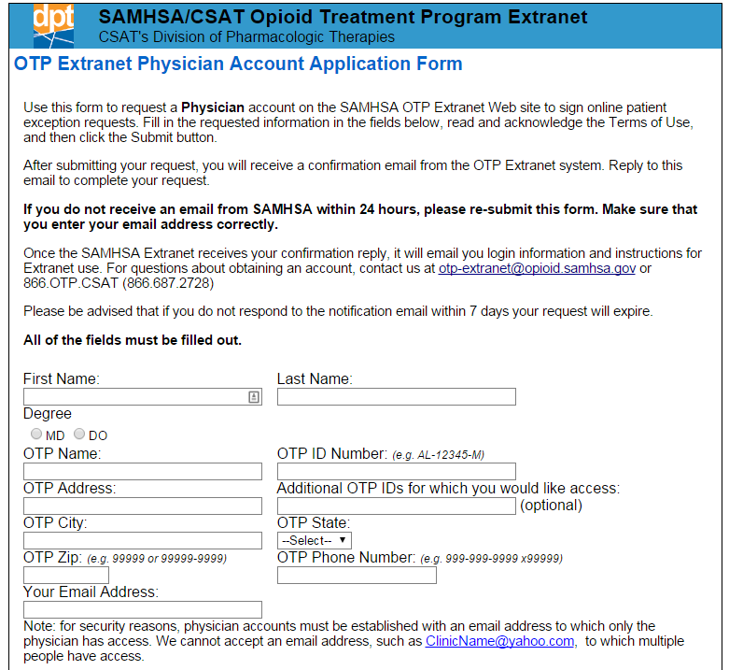

As indicated in the screenshot of the confirmation webpage shown in Exhibit 5, each applicant who completes a Program Physician Account Request Form will receive a confirmation e-mail. Reply to the confirmation e-mail within 7 days using the same e-mail address to which the confirmation e-mail was sent. No text is needed in the body of the e-mail reply; simply hit “reply” and send the e-mail. SAMHSA OTP Extranet Information Center staff can process the account request only after receiving a reply to the confirmation e-mail. If a reply is not received within 7 days, Information Center staff considers the request to be unverified and a new Program Physician Account Request Form will need to be completed and submitted.

Upon receipt of the response to the confirmation e-mail, SAMHSA will verify your current employment at the program for which you are requesting the account, and will obtain permission from the program’s administrator to create the account. An e-mail notification containing a temporary password for accessing the Program Physician account will be sent to you.

Exhibit 4. OTP Extranet Program Physician Account Terms of Use, Extracted From the Online Program Physician Account Request Form

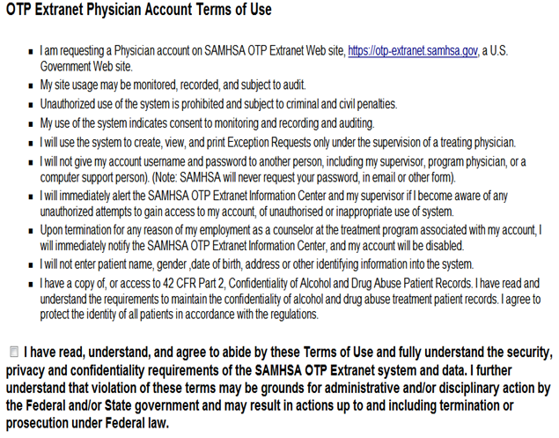

Exhibit 5. Screenshot of Automatically Generated Web Page Confirming Receipt of Program Physician Account Request

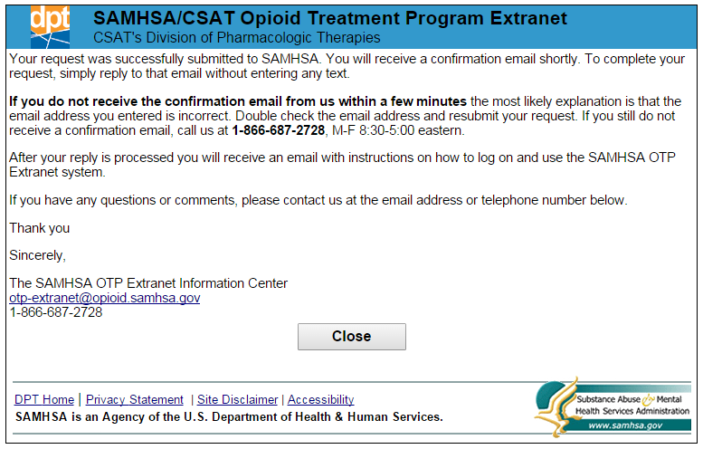

### Selecting a Password

You will be prompted to change the password the first time you log in to the OTP Extranet system with your new account. Your password must meet the following Department of Health and Human Services (HHS) security requirements:

* Must be between 8 and 30 characters.
* Must contain at least one uppercase (capital) letter (e.g., A, B, etc.) and at least one lowercase letter (e.g., a, b, etc.).
* Must contain at least one digit (e.g., 1, 2, 3, etc.).
* Must contain at least one special character. Special characters can be a punctuation mark or any other symbol on your keyboard (e.g., @ ! $ % * ? +).
* Cannot include any actual words (referred to as “dictionary words”). For example, you may not use the word “book” in your password, but you may use“b00k” instead (using zeroes instead of the letter “o”). Certain common names may also be considered words, so please keep this in mind when selecting a password.

Once your account is established, you will be required to change your password every 90 days. Instructions for changing your password and for resetting a forgotten password, are provided in section 5.2 of this user guide.

## Program Physician Account Permissions and Responsibilities

This section provides additional information about the SMA-168 and describes Program Physician account permissions related to an OTP’s online submission of patient exception requests. For Program Physicians who work in more than one OTP, account permissions for accessing SMA-168 forms from multiple OTPs are also discussed. Program Physician account permissions discussed in this section include the following:

* Creating a new SMA-168;
* Saving an SMA-168 for later completion, or for later submission;
* Signing and submitting SMA-168 to SAMHSA and the State Opioid Treatment Authority (SOTA);
* Modifying an SMA-168 that has not yet been submitted; and
* Viewing, printing, and archiving patient exception requests for the OTP(s) associated with the Program Physician’s account.

### Permissions for Program Physicians Working in Multiple OTPs

Program Physicians who work at multiple OTPs may request OTP Extranet system access rights for each of the OTPs in which they work. Program Physicians account holders approved to access multiple OTPs may select the OTP they want to initially access during their OTP Extranet session by selecting from among their listed programs during the log-in process as shown in Exhibit 6.

Exhibit 6. Screenshot Displaying a Program Selection Screen for Program Physician With Access to Multiple OTPs

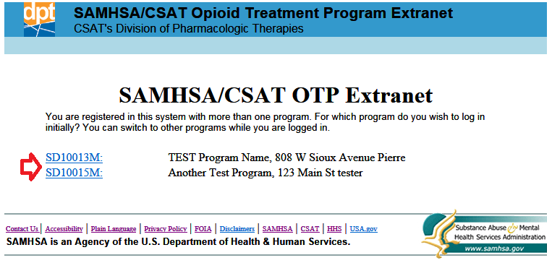

The OTP number of the selected program appears in a drop-down menu located under the Program Physician’s name, as shown in Exhibit 7. During an OTP Extranet session, Program Physicians may switch to any of their authorized programs by selecting a different program on the drop-down list.

Exhibit 7. Screenshot Emphasizing the Program Physician’s Name and Selected Program for Program Physician with OTP Extranet System Access to Multiple OTPs

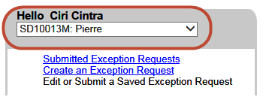

### Patient Exception Request Forms (SMA-168)

#### SMA-168 Overview

Section 8.12 of federal regulation 42 CFR sets forth federal standards for the administration and management of opioid treatment. Included in the standards is a schedule of maximum allowable unsupervised use (i.e., take-home medications), and standards for the provision of detoxification treatment.

On occasion, patients may need exceptions from the federal opioid treatment standards due to transportation hardships, employment, vacation, medical disabilities, and so forth. In these instances, the physician must submit to SAMHSA and (where applicable) the State Opioid Treatment Authority (SOTA) an "exception request" for approval to change the patient care regimen from the requirements specified in regulation 42 CFR Part 8.

**Any deviation from the opioid treatment standards set forth in regulation 42 CFR Part 8 requires the submission and approval of an SMA-168 exception request. Failure to submit an SMA-168 exception request and obtain approval from SAMHSA and (where applicable) the SOTA prior to providing care that deviates from the federal opioid treatment standards constitutes a serious regulatory violation which may threaten a program's federal and state compliance, accreditation, and certification.**

As noted in Section 3.1, patient exception requests are submitted to SAMHSA and the applicable SOTA using SAMHSA form SMA-168, *Exception Request and Record of Justification under 42 CFR 8.12*. SAMHSA strongly recommends on-line submission of the form for fastest processing. SAMHSA's decision on on-line exception requests is typically viewable by the submitting OTP within one hour of submission.

#### When Should an Exception Request be Submitted?

An SMA-168 exception request must be submitted (and approved) whenever a physician wishes to vary from the opioid treatment standards set forth in federal regulation 42 CFR 8.12 in the treatment of an individual patient.

The most common reasons for submitting patient exception requests are to request

* A temporary increase in the number of take-home doses permitted for unsupervised use; or
* An exception to the detoxification standards outlined in the regulation.

#### How Do Program Physicians Support the OTP’s Submission of Patient Exception Requests?

Program Physician account holders have unique permissions in the OTP Extranet system to sign and submit patient exception requests on behalf of the OTP. An SMA-168 is not submitted to SAMHSA and the SOTA without the signature of a Program Physician account holder. Other types of OTP Extranet account holders play a significant but supporting role in the OTP’s online submission of patient exception requests. For example, program physicians do not have to complete the SMA-168 themselves; other OTP personnel also support this function by filling out SMA-168 forms and saving them for later submission by a Program Physician account holder. Most of the SMA-168 forms created in the OTP Extranet system are created by OTP users holding a Counselor account type. However many Program Physicians do use their accounts to create SMA-168s themselves, in addition to signing them.

Program Physician account permissions include creating new SMA-168s, saving an SMA-168 for later completion or later submission, modifying an SMA-168 that has not yet been submitted and, most notably, signing and submitting the OTP’s patient exception requests. OTP Extranet Users with Program Physician accounts can also view, print, and archive patient exception requests for their associated OTP(s).

#### Creating an Exception Request

Exhibit 8 displays a screenshot of the OTP Extranet homepage for Program Physician account holders. To create a new SMA-168, select “Create an Exception Request” from the side menu, as illustrated in Exhibit 8.

Exhibit 8. Screenshot of the OTP Extranet Homepage for Program Physician Accounts, Highlighting the Option to “Create an Exception Request”

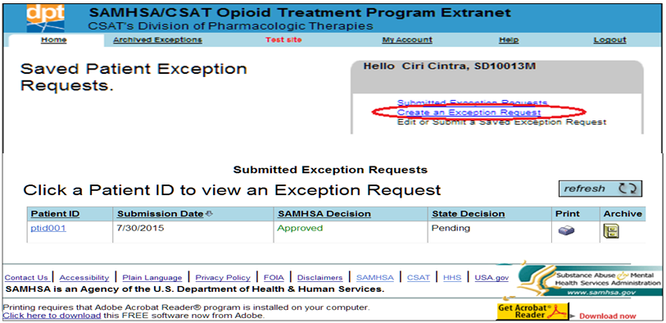

When the online SMA-168 form is opened, the requestor’s name and title are pre-populated. Exhibit 9 shows a screenshot of a new pre-populated SMA-168 form.

Exhibit 9. Screenshot of a Partial SMA-168, Newly Created with Pre-Populated Program Physician Name and Title

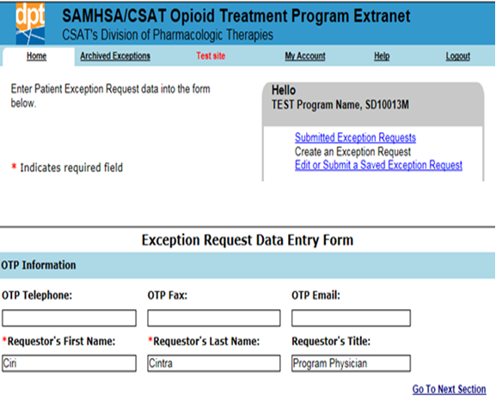

The full set of items requested on the SMA-168 are shown in Exhibit 10, along with guidance for completing the online form. The exhibit shows each item from the SMA-168 form in **bold text** on the left, with instructions describing the requested information on the right. Please complete **ALL** items on the form. As appropriate, there is space on the SMA-168 form to indicate if an item does not apply. The SMA-168 form also includes asterisks to indicate required fields. These fields are also noted by an asterisk in Exhibit 10.

Exhibit 10. Instructions for Completing the Items in SAMHSA Form SMA-168

|  |  |
| --- | --- |
| Item | Instruction |
| **BACKGROUND INFORMATION ON PROGRAM AND PATIENT** |  |
| **OTP Telephone** | Voice telephone number of the OTP **or** of the SMA-168 requester, with area code. |
| **OTP Fax** | Facsimile (FAX) number of the OTP **or** the SMA-168 requester, with area code. |
| **OTP E-mail** | Central electronic mail (e-mail) address for the OTP **or** the e-mail address of the CONTACT person for this request. |
| **Patient ID Number\*** | Confidential number the program uses to identify the patient. Please do not use the patient's name or other identifying information. |
| **Patient's Admission Date\*** | Date patient enrolled at this facility. |
| **Patient's current dosage level\*** | Dosage patient receives **NOW.** Please indicate the dosage in milligrams (mg) in the provided text box. |
| **Methadone/LAAM/Buprenorphine/Other** | Select the medication the patient takes. If "Other," write in the name of the medication in the provided text box. |
| **Patient's program attendance and schedule per week** | Check each day per week the patient **NOW** reports to the clinic for medication. |
| **If current attendance is less than once per week, please enter the schedule** | If patient **NOW** reports to the clinic **LESS** than once a week, please indicate how often he or she reports. |
| **Patient status** | Check all items that best describe the patient's **CURRENT** status. If the patient's status does not appear on the list on the form, select “Other" and write in the patient's **CURRENT** status. |
| **REQUIREMENTS FOR CHANGE** |  |
| **Nature of request\*** | Select from among three provided categories to **BEST** describe the nature of the request. If the three provided categories do not describe your request, select "Other" and describe your request in the provided text box. For security purposes, DO NOT INCLUDE PATIENT-IDENTIFYING INFORMATION IN THE TEXT BOX OTHER THAN THE PATIENT’S ID NUMBER (if needed). |
| **Decrease regular attendance to** | Select each day per week that the patient is to report for medication. |
| **Beginning date** | Enter the date that the exception is scheduled to begin. |
| **If new attendance is less than once per week, please enter the schedule** | If you are asking to reduce the patient's attendance schedule to **LESS THAN** once per week, please indicate the schedule on the line provided. |
| **Dates of Exception** | Please indicate the dates that the exception will be effective. |
| **Number of doses needed** | Indicate how many doses will be dispensed during the exception period. |
| **Justification\*** | Please select the best description of the reason for this request from the list of provided justification categories. If the reason is not reflected in the category list, select "Other" from the category options and describe the reason for the exception request in the text box provided. Note: some of the justification categories (e.g., Transportation Hardship, Employment, Medical, and Split Dose) require a written explanation to be provided in the text box. If one of these justification categories is selected, use the text box to provide more details about the request. For security purposes, DO NOT INCLUDE PATIENT-IDENTIFYING INFORMATION IN THE TEXT BOX OTHER THAN THE PATIENT’S ID NUMBER (if needed). |
| **REGULATION REQUIREMENTS** |  |
| **Three questions to confirm compliance with 42 CFR Part 8.12** | There are certain guidelines that programs must follow regarding take-home medication and detoxification admissions. Next to each of the 3 questions listed in this item on the SMA-168 form, please indicate whether the OTP followed the stipulated requirements. For each statement that does not apply, select "N/A" (not applicable). |

* The asterisk denotes fields on the SMA-168 form that must be completed.

#### Saving and Submitting an Exception Request

Program Physician account holders have three options after completing the SMA-168 form: submitting the form to SAMHSA and the SOTA, saving the form for later submission, or quitting without saving the form. These options are illustrated by the screenshot in Exhibit 11.

Exhibit 11. Screenshot of Options Available to Program Physician Account Holders After Completing an SMA-168

This is an Exhibit of options available to Program Physician account holders after completing an SMA-168. The Exhibit shows three rectangular tabs for Program Physician decisions from left to right. The first tab shows “Submit to SAMHSA/State Authority”. The second tab shows “Save for Later Submission”; the third tab shows “Quit Without Saving”. All of these Tabs are activated, and the “Submit to SAMHSA/State Authority” tab is activated only for user accounts with Program Physician system permissions.

Completed forms can be saved by clicking on the “Save for Later Submission” button. If additional information is needed before finishing the form, the “Quit Without Saving” button will close the form without saving, and you will leave the page.

Program Physicians also have access to the “Submit to SAMHSA/State Authority” option, as shown in Exhibit 11. This option is only active for OTP Extranet users who hold a Program Physician account type, or a Program Sponsor or Program Director account type that is combined with a Program Physician account[2]. Only the Program Physician account type has OTP Extranet system permissions to sign and submit the SMA-168.

#### What Happens When a Patient Exception Request Is Saved?

When the SMA-168 form is saved, the user is notified with the system’s display of the message shown in Exhibit 12.

Exhibit 12. Screenshot of a Confirmation Message Displayed by the OTP Extranet System When an SMA-168 Form Is Saved.

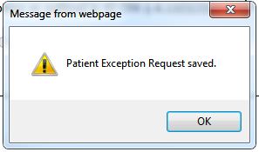

Saved forms created by both the Program Physician account holder and by other OTP Extranet users in the OTP become accessible to the Program Physician account holder for review and submission. Online forms are automatically submitted to SAMHSA and the State Authority when they are signed by a Program Physician account holder. All saved (but not submitted) forms appear on the Saved Exception Requests list as shown in Exhibit 13.

Exhibit 13. Screenshot Displaying the OTP’s Saved (But Not Submitted) Patient Exception Requests

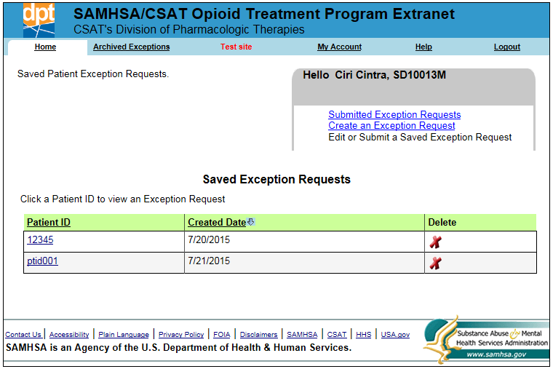

A ***saved*** SMA-168 form can be modified online by OTP personnel holding any type of OTP Extranet user account. However, no modification is allowed once the form is ***submitted***. To modify a saved SMA-168 prior to its submission, it should be selected from the list of “Saved Exception Requests” by clicking the link for the Patient ID associated with the request you want to modify (e.g., Patient ID “12345” in the screenshot shown in Exhibit 13). The selected SMA-168 may also be viewed or deleted from the “Saved Exception Requests” list.

##### 4.2.6.1 What Happens When a Patient Exception Request Is Ready To Be Submitted?

Completed and saved SMA-168 forms must be signed electronically by a Program Physician account holder before being submitted to SAMHSA and the SOTA. To submit the SMA-168 for processing, click on the “Submit to SAMHSA/State Authority” button that was shown in Exhibit 11. When the button is clicked, a Confirmation dialog is displayed, as is shown in Exhibit 14. To sign the form, enter your password in the text box next to “Password” and click on the “I Agree” button. As noted in Exhibit 14, by providing your password and clicking “I Agree”, you are

* Affixing your electronic signature to the patient exception request;
* Submitting the form to SAMHSA and your SOTA for processing; and
* Affirming that you are the formally assigned user of the Program Physician account associated with your username and password. This assurance is made in accordance with the False Claims Act. Thus, patient exception requests being submitted from your account should only be submitted **by you**.

Exhibit 14. Screenshot of a Confirmation Dialogue Displayed By the OTP Extranet System When a Program Physician Account Holder Clicks On the “Submit to SAMHSA/State Authority” Option

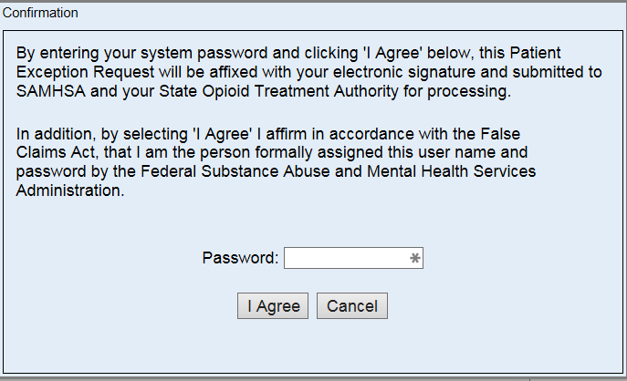

If the SMA-168 is successfully signed and submitted a confirmation message will be displayed, as is shown in Exhibit 15. The OTP Extranet system automatically moves the submitted patient exception request from the “Saved Exception Requests” list to the “Submitted Exception Requests” list, displayed in Exhibit 16.

Exhibit 15. Screenshot of a Confirmation Message Displayed By the OTP Extranet System When an SMA-168 Form is Successfully Signed and Submitted

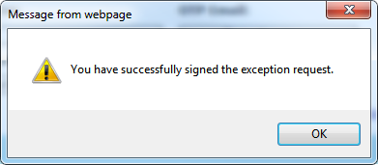

Exhibit 16. Screenshot Displaying the OTP’s Submitted Patient Exception Requests

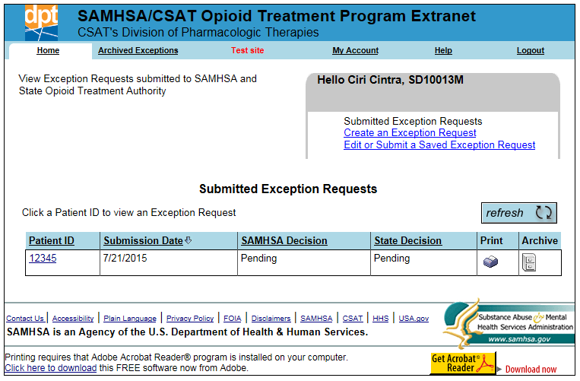

## Preferences and Account Management

This section describes account features for managing submitted SMA-168s. Account management features are also discussed, including updating a password through the “My Account” tab and resetting forgotten passwords.

### Managing Submitted SMA-168s: Viewing, Archiving and Printing

A list of the OTP’s submitted patient exception requests can be viewed by selecting the “Submitted Exception Requests” link on the Program Physician user home screen as shown in Exhibit 17. By default, the list of Submitted Exception Requests is sorted by the date the request was created, but they can be sorted by either “Created Date” or “Patient ID.” When the list of submitted exception requests becomes long, OTP Extranet users may prefer to archive older exception requests by clicking the “Archive” button shown in the exhibit.

Exhibit 17. Screenshot of Submitted Exception Requests List Highlighting Print and Archive Options

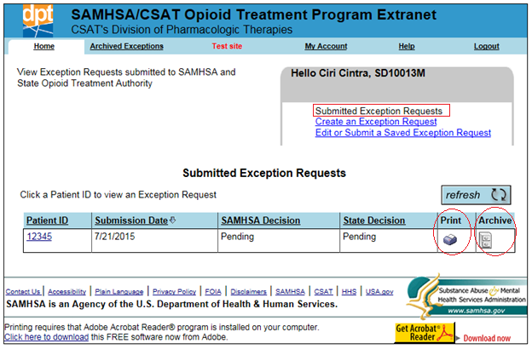

The archived SMA-168s can be viewed by selecting “Archived Exceptions” from the top menu, as shown in Exhibit 18. OTP Extranet system users wanting or needing paper copies of submitted patient exception requests can print any of the requests listed on either the “Archived Patient Exception Requests” or the “Submitted Exceptions Request” screens, as shown in Exhibits 17 and 18. Both lists also display the status of the decision as processed by SAMHSA and the State.

Exhibit 18. Screenshot of Archived Patient Exception Requests List Highlighting the Print Option

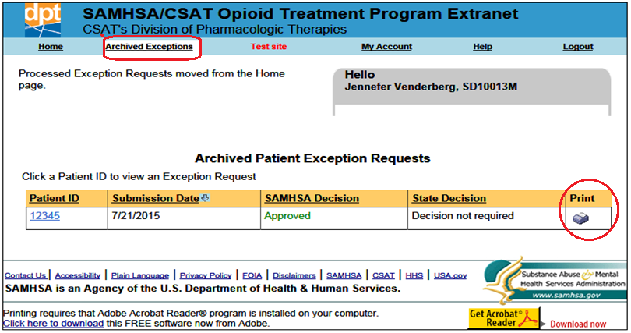

### Managing Your Account

#### How Do I Change My Password?

As described in Section 3.3, account passwords must be changed every 90 days. To change a password from within the OTP Extranet system, select “My Account” from the top menu, as shown in Exhibit 19. The screen provides a reminder of the password requirements (described in Section 3.3 of this user guide) as well as text boxes for entering the current and new password. The new password must be entered twice to confirm its accuracy.

You can reset your password by selecting “My Account” from the top menu.

Exhibit 19. Screenshot of the “My Account” Tab Displaying the “Change My Password” Feature.

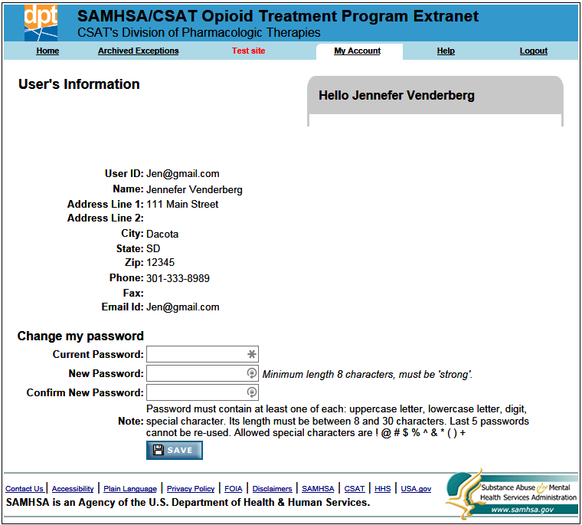

#### I Forgot My Password—What Do I Do?

When a password is forgotten, it must be reset. You do not need to know your password in order to reset it. The OTP Extranet website allows you to reset your password prior to logging in by using the “Forgot Password?” feature on the OTP Extranet website log- in screen. To reset a forgotten password, follow these steps:

**Step 1.** Go to the [OTP Extranet website at https://otp-extranet.samhsa.gov](https://otp-extranet.samhsa.gov/).

**Step 2.** Click on the "Forgot password?" link at the center of the page, next to the "Sign In" button as shown in Exhibit 20.

Exhibit 20. Screenshot Displaying the OTP Extranet Log-In Site, With “Forgot Password?” Feature

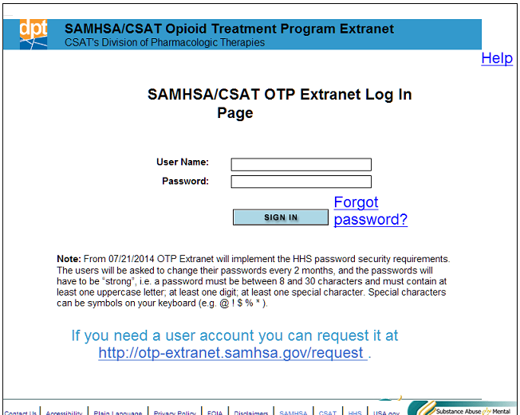

**Step 3.** The “Forgot password?” link leads to the log-in support screen shown in Exhibit 21.

Exhibit 21. Screenshot of Log-In Support Page, With Password Change Confirmation Pop-Up Window

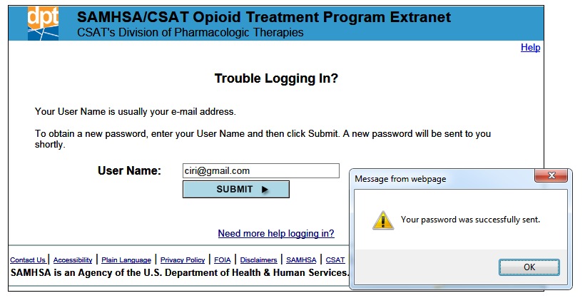

**Step 4.** Enter your e-mail address into the box and click “Submit.”

**Step 5.** A pop-up message will appear (as shown in Exhibit 21) to confirm that your password has been reset.

**Step 6.** You will receive an e-mail with the new temporary password. If the message is not in your inbox, you may need to check your spam or junk e-mail folders.

**Step 7.** Once you log in with the temporary password, you will be prompted to change it. Directions for changing a password are provided Section 5.2.1 of this user guide.

Please note: for security reasons, the SAMHSA OTP Extranet Information Center staff cannot look up your password. Therefore, the above steps must be taken to reset a forgotten password.



 

4171_10/15

1. As noted in Section 1.2, some OTP Extranet Program Physician account holders also hold either a Program Sponsor or Program Director user account. Users with a “combined” account should also review the appropriate user guide of their second account type for permissions not covered in the Program Physician user guide.
2. See section 1.2 for more information on combined accounts.