Interleave Scanning and LiftMode

Interleave is an advanced feature of NanoScope software that allows the simultaneous acquisition of two data types. Enabling **Interleave** alters the scan pattern of the piezo: after the trace and retrace of each main scan line (in which topography is typically measured), a second trace and retrace is inserted to obtain non-topographical information.

The Interleave commands use a set of Interleave controls that allow several scan controls (**Drive Amplitude**, [**setpoint[D:\Program Files\Nanoscope\8.15\Help\Icon\Content\SkinSupport\ExpandingClosed.gif](javascript:void(0);)**](javascript:void(0);)Operator-selected threshold used as the target of the feedback control loop., and various [**gains[D:\Program Files\Nanoscope\8.15\Help\Icon\Content\SkinSupport\ExpandingClosed.gif](javascript:void(0);)**](javascript:void(0);)The gains are scaling factors for the error signal to determine how quickly corrections should be applied in the feedback loop. There are two important gain factors: the proportional gain scales to the current value of the error signal, and the integral gain scales the aggregate of the past values of the error signal (the "area under the curve").) to be set independently of those in the main scan controls.

Typical applications of interleave scanning include [Magnetic Force Microscopy (MFM)](file:///D:\Program%20Files\Nanoscope\8.15\Help\Icon\Content\Interleave%20Scanning\Magnetic%20Force%20Microscopy%20(MFM).htm) and [Electric Force Microscopy (EFM)](file:///D:\Program%20Files\Nanoscope\8.15\Help\Icon\Content\Interleave%20Scanning\Electric%20Force%20Microscopy%20(EFM).htm) measurements. There are two forms of Interleave scanning available:

**LiftMode**

Enabling Interleave with the mode set to Lift enacts **LiftMode**. During the interleave scan, the feedback is turned off and the tip is lifted to a user-selected height above the surface to perform far field measurements such as magnetic or electric forces. By recording the cantilever deflection or resonance shifts caused by the magnetic or electric forces on the tip, an image map of force changes can be produced. LiftMode was developed to isolate purely MFM and EFM data from topographic data.

**Interleave Mode**

Interleave can also be used in **Interleave Mode**. In this mode, the feedback is kept on while additional topography, phase lateral force, or data is acquired.

How Interleave Mode Works

Enabling **Interleave** changes the scan pattern of the tip relative to the imaged area. With Interleave mode disabled, the tip scans back and forth in the fast scan direction while slowly moving in the orthogonal direction as shown on the left of figure 1, below. This is the standard scan pattern of NanoScope systems.

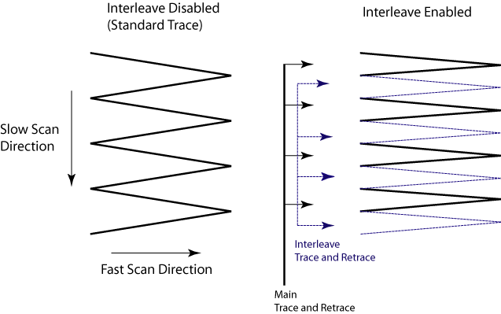

**Figure 1:** Comparison of standard (left) and Interleave (right) raster scan patterns.

With Interleave mode enabled, the system first performs a standard trace and retrace with the main Feedback controls in effect. The tip moves at half the normal rate in the slow scan direction. An additional trace and retrace are then performed with the Interleave feedback controls enacted. The frame rate halves because twice as many scan lines are performed for the same scan rate. This modification of the scan pattern is illustrated to the right in figure 1, above.

Two modes are possible for Interleave scan: Interleave and Lift. With **Interleave** selected, the feedback remains on during the interleave pass with the values under Interleave feedback controls (**[setpoint[D:\Program Files\Nanoscope\8.15\Help\Icon\Content\SkinSupport\ExpandingClosed.gif](javascript:void(0);)](javascript:void(0);)**Operator-selected threshold used as the target of the feedback control loop., [**gains[D:\Program Files\Nanoscope\8.15\Help\Icon\Content\SkinSupport\ExpandingClosed.gif](javascript:void(0);)**](javascript:void(0);)The gains are scaling factors for the error signal to determine how quickly corrections should be applied in the feedback loop. There are two important gain factors: the proportional gain scales to the current value of the error signal, and the integral gain scales the aggregate of the past values of the error signal (the "area under the curve")., etc.) in effect. In **Lift** mode the feedback is turned off and the tip is lifted off the surface and scanned at a user-selected height for the interleave trace and retrace. Topography data recorded during the main pass is used to keep the tip a constant distance from the surface during the Interleave trace and retrace:

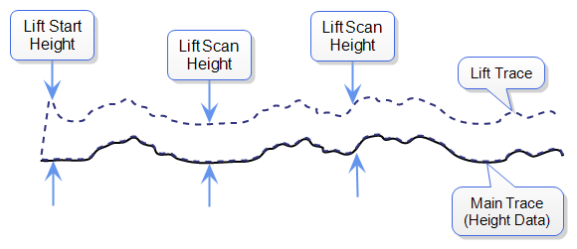

The tip first moves to the **Lift Start Height**, then to the **Lift Scan Height**. A large Lift Start Height can be used to pull the tip from the surface and eliminate sticking. The Lift Scan Height is the distance maintained between the sample topography and the tip during the scan. This value is added point-by-point to the height data obtained during the Main topography trace and retrace. Values can be positive or negative.

**NOTE:** A new feature in NanoScope 8.15 allows the user to run a lifted scan at a set distance from the sample surface, ignoring the sample topography during the lifted, interleaved, scan lines. To enable this parameter, set Interleave Mode to **Linear** in the Interleave parameter list.

# Operation of Interleave Scanning and LiftMode

These instructions apply to [Scanning Tunneling Microscopy (STM)](file:///D:\Program%20Files\Nanoscope\8.15\Help\Icon\Content\STM\Scanning%20Tunneling%20Microscopy%20(STM).htm), [Contact AFM](file:///D:\Program%20Files\Nanoscope\8.15\Help\Icon\Content\Contact%20AFM\Contact%20AFM.htm), or [TappingMode AFM](file:///D:\Program%20Files\Nanoscope\8.15\Help\Icon\Content\TappingMode%20AFM\TappingMode%20AFM.htm). You must be familiar with TappingMode or Contact AFM to obtain good images of surface topography. The interleave scanning procedure is described below; further detail is given for specific modes elsewhere: see [Magnetic Force Microscopy (MFM)](file:///D:\Program%20Files\Nanoscope\8.15\Help\Icon\Content\Interleave%20Scanning\Magnetic%20Force%20Microscopy%20(MFM).htm) and [Electric Force Microscopy (EFM)](file:///D:\Program%20Files\Nanoscope\8.15\Help\Icon\Content\Interleave%20Scanning\Electric%20Force%20Microscopy%20(EFM).htm).

1. Obtain a topography scan using the appropriate method (usually Contact or TappingMode).

When using LiftMode, it is important that the [**gains[D:\Program Files\Nanoscope\8.15\Help\Icon\Content\SkinSupport\ExpandingClosed.gif](javascript:void(0);)**](javascript:void(0);)The gains are scaling factors for the error signal to determine how quickly corrections should be applied in the feedback loop. There are two important gain factors: the proportional gain scales to the current value of the error signal, and the integral gain scales the aggregate of the past values of the error signal (the "area under the curve"). and [**setpoint[D:\Program Files\Nanoscope\8.15\Help\Icon\Content\SkinSupport\ExpandingClosed.gif](javascript:void(0);)**](javascript:void(0);)Operator-selected threshold used as the target of the feedback control loop. under Feedback controls be adjusted to give a faithful image of the surface. Because the height data is used in the lift pass to trace the topography, a poor measurement of surface height may give inaccurate measurement during the lift pass or cause the tip to strike the surface. Typically, the height data is displayed on Channel 1.

1. Choose the Interleave Mode (Interleave, Lift, or Linear) appropriate for the measurements to be performed.
2. Adjust the Interleave controls panel to the desired settings.

When using TappingMode, the [**Drive Amplitude[D:\Program Files\Nanoscope\8.15\Help\Icon\Content\SkinSupport\ExpandingClosed.gif](javascript:void(0);)**](javascript:void(0);)Amplitude of the signal used to oscillate a tip in TappingMode., [**Drive Frequency[D:\Program Files\Nanoscope\8.15\Help\Icon\Content\SkinSupport\ExpandingClosed.gif](javascript:void(0);)**](javascript:void(0);)Frequency of the signal used to oscillate a tip in TappingMode., gains, and Amplitude Setpoint can be set differently in the Interleave panel than in the main Feedback panel. However, it is often convenient to begin with the main and interleave controls set to the same values. Do this by toggling the parameters of the appropriate Interleave parameters to an “off” (grayed) condition. The values can be changed once the probe is engaged.

* If you are using LiftMode or Linear Lift Mode, set the Lift Scan height.
* If you are using Interleave mode, set the Gains and Amplitude Setpoint. For more information, refer to [Use of LiftMode with TappingMode](file:///D:\Program%20Files\Nanoscope\8.15\Help\Icon\Content\Interleave%20Scanning\Use%20of%20LiftMode%20with%20TappingMode.htm).

NOTE: Certain constraints are imposed: scan sizes, offsets, angles, rates and numbers of samples per scan line are the same for the main and interleave data, and the imaging mode (Contact, TappingMode, or force modulation) must also match.

1. Choose the Interleave Data Type.

Depending on the type of microscope, Interleave mode allows the options of amplitude, phase, frequency, potential, input potential, or data types for doing far-field (MFM or EFM) imaging. Auxiliary channels are also available for some applications.

Once the Interleave Scan Line is chosen, Interleave mode is automatically enabled, triggering interleave scanning. Interleave data typically displays as the second image. Notice that the scan rate in the slow direction is halved.

1. Display the interleave data by switching Scan Line (in the Channel panels) to Interleave.

### Final Considerations

* Lift Scan Height: The lateral and vertical resolutions of the Lift data depend on the distance between tip and sample: the lower the tip, the higher the resolution. However, the Lift Scan Height must be high enough that the tip does not contact the sample during the Lift trace and retrace.
* Tip Shape: As shown below, the tip separation in the LiftMode is defined in terms of the Z direction only. The Lift Scan Height is added to the height values taken from previous scan lines point-by-point. However, the tip may be closer to the sample than the Z separation indicates. On features with steep edges, the tip may get very close to the sample even though the Z separation is constant.



* Line Direction: The Line Direction should be set to Retrace for both the main and interleaved scans. If it is set instead to Trace, a band may appear along the left side of the images due to the ramp between the surface and the Lift Scan Height.

# Use of LiftMode with TappingMode

Additional considerations when using LiftMode with [TappingMode AFM](file:///D:\Program%20Files\Nanoscope\8.15\Help\Icon\Content\TappingMode%20AFM\TappingMode%20AFM.htm) are discussed below.

### Main Drive Amplitude and Frequency selection

As usual, these parameters are set when you tune the cantilever prior to engaging. It is helpful to keep in mind the measurements to be done in LiftMode when setting these values. For example, if Amplitude data will be monitored during the Lift scan for [Magnetic Force Microscopy (MFM)](file:///D:\Program%20Files\Nanoscope\8.15\Help\Icon\Content\Interleave%20Scanning\Magnetic%20Force%20Microscopy%20%28MFM%29.htm), the Drive Frequency should be set to the side of the resonance (however, certain parameters can be set independently for the interleave scan; see below.)

### Setpoint Selection

When the main and interleave [Drive Amplitude[D:\Program Files\Nanoscope\8.15\Help\Icon\Content\SkinSupport\ExpandingClosed.gif](javascript:void(0);)](javascript:void(0);) and [Drive Frequency[D:\Program Files\Nanoscope\8.15\Help\Icon\Content\SkinSupport\ExpandingClosed.gif](javascript:void(0);)](javascript:void(0);) are set to the same value (i.e., when these parameters in the Interleave panel are grayed out), the cantilever oscillation amplitude increases to the free oscillation amplitude when the tip is lifted off the surface in LiftMode. If a small [setpoint[D:\Program Files\Nanoscope\8.15\Help\Icon\Content\SkinSupport\ExpandingClosed.gif](javascript:void(0);)](javascript:void(0);) value forces a large decrease in oscillation amplitude while the feedback is running, the amplitude can grow considerably when the tip is lifted free of the sample surface. The change can also be large if the main Drive Amplitude was increased or the main Drive Frequency altered after the tip was engaged. The vibration amplitude remains at the setpoint during the main scan even if these parameters are changed. This could result in the tip hitting the surface in the lift scan for small Lift Scan Heights.

### Interleave Drive Amplitude and Frequency Selection

The cantilever Drive Amplitude for the Lift scan can be set independently of the main Drive Amplitude. Click on the parameter in the Interleave panel to enable it (turns green) and adjust the value. This allows the tuning of a measurement in the Lift scan lines without disturbing the topography data acquired during the Main scan lines. The Interleave Drive Amplitude must be set low enough that the tip does not strike the surface during the Lift pass.

Caution/Attention/Vorsicht:

* Before enabling the Interleave Drive Amplitude, check that its value is not much larger than the main Drive Amplitude value to prevent possible damage to the tip.

The Interleave Drive Frequency can also be adjusted, which may be useful if acquiring amplitude data in LiftMode.

### Amplitude Data Interpretation

When monitoring amplitude data in LiftMode, brighter regions correspond to larger amplitude, and darker regions to smaller amplitude.

### Cantilever Oscillation Amplitude

The selection of the oscillation amplitude in LiftMode depends on the quantity to be measured. For force gradients that are small in magnitude but occur over relatively large distances (sometimes hundreds of nanometers, as with magnetic or electric forces), the oscillation amplitude can be large, which for some applications may be beneficial. The Lift Scan Height must be correspondingly large so that the tip does not strike the surface. However, the lateral resolution of far field (MFM or EFM) measurements decreases with distance from the surface. Typically, the resolution is limited to a value (in nm) roughly equal to the Lift scan height.

Small amplitudes must be used to sense force gradients, such as Van der Waals forces, which occur over short distances (typically a few nm). As much of the cantilever travel as possible should be within the range of the force gradient.

Electric Techniques

The two most common electric techniques used with the Dimension Icon microscope are Electric Force Microscopy (EFM) and Surface Potential Detection. Both modes make use of **Interleave** and **LiftMode** procedures. Ensure you are familiar with before attempting electric measurements.

Electric techniques are similar to . The two-pass LiftMode measurement allows the imaging of relatively weak but long-range electrostatic interactions while minimizing the influence of topography. In the case of MFM, the system is measuring long-range magnetic fields. LiftMode records measurements in two passes, each consisting of one trace and one retrace, across each scan line. First, LiftMode records topographical data in TappingMode on one trace and retrace. Then, the tip raises to the Lift Scan Height, and performs a second trace and retrace while maintaining a constant separation between the tip and local surface topography.

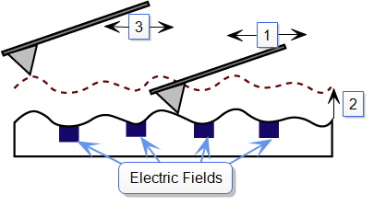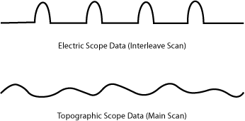

1. Cantilever measures surface topography on first (main) scan (trace and retrace).
2. Cantilever ascends to lift scan height.
3. Cantilever follows stored surface topography at the lift height above the sample while responding to electric influences on second (interleave) scan (trace and retrace).

**Electric Force Microscopy Overview**

measures variations in the electric field gradient above a sample. The sample may be conducting, nonconducting, or mixed. Because the surface topography shapes the electric field gradient, large differences in topography make it difficult to distinguish electric field variations due to topography or due to a true variation in the field source. The best samples for EFM are samples with fairly smooth surface topography. The field source could be trapped charges, applied voltage, and so on. Samples with insulating layers (passivation) on top of conducting regions are also good candidates for EFM.

**Surface Potential Imaging Overview**

Bruker provides several methods for surface potential imaging:

* [Surface Potential Detection](file:///D:\Program%20Files\Nanoscope\8.15\Help\Icon\Content\Interleave%20Scanning\Surface%20Potential%20Detection.htm) (aka AM-KPFM) measures the effective surface voltage of the sample by adjusting the voltage on the tip so that it feels a minimum electric force from the sample.
* [PeakForce KPFM-AM Imaging](file:///D:\Program%20Files\Nanoscope\8.15\Help\Icon\Content\Interleave%20Scanning\PF-KPFM.htm) combines the [Surface Potential Detection](file:///D:\Program%20Files\Nanoscope\8.15\Help\Icon\Content\Interleave%20Scanning\Surface%20Potential%20Detection.htm) mode with Bruker's proprietary [Peak Force Tapping Mode](file:///D:\Program%20Files\Nanoscope\8.15\Help\Icon\Content\PeakForceQNM\Operation\OperatingPrinciples.htm#Peak).
* [FM-KPFM Imaging](file:///D:\Program%20Files\Nanoscope\8.15\Help\Icon\Content\Interleave%20Scanning\FM-KPFM.htm) uses a frequency modulation technique to measure surface potential. FM-KPFM is generally more accurate and has higher spatial resolution than AM-KPFM.
* [PeakForce KPFM Imaging](file:///D:\Program%20Files\Nanoscope\8.15\Help\Icon\Content\Interleave%20Scanning\PF-FM-KPFM.htm) combines [FM-KPFM Imaging](file:///D:\Program%20Files\Nanoscope\8.15\Help\Icon\Content\Interleave%20Scanning\FM-KPFM.htm) with Bruker's proprietary [Peak Force Tapping Mode](file:///D:\Program%20Files\Nanoscope\8.15\Help\Icon\Content\PeakForceQNM\Operation\OperatingPrinciples.htm#Peak), combining the benefits of both modes.
* [PeakForce KPFM-HV Imaging](file:///D:\Program%20Files\Nanoscope\8.15\Help\Icon\Content\Interleave%20Scanning\PF-KPFM%20HV%20Imaging.htm) combines Bruker's proprietary [Peak Force Tapping Mode](file:///D:\Program%20Files\Nanoscope\8.15\Help\Icon\Content\PeakForceQNM\Operation\OperatingPrinciples.htm#Peak) with an AC technique that enables measurement of surface potentials up to approximately ±200 V.

**Electrical** **Sample Preparation**

The sample should be electrically connected directly to the chuck, so that it can be held at ground potential (normal operation) or biased through the chuck. The sample can either be mounted directly on the chuck or onto a standard sample puck using conductive epoxy or silver paint as shown below:

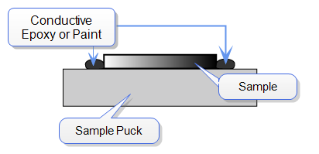

**Figure 1:** Schematic diagram showing how to electrically connect a sample onto a sample puck.

**HINT:** If the surface of your sample is conductive and the base of the sample is insulative, you will need to ensure that the conductive epoxy or paint contacts one edge of the sample surface and one edge of the conductive mount (either sample puck or the chuck itself). Ensure that the large "glob" of glue/paint required is *NOT* located directly underneath the cantilever substrate, as the substrate may come in contact with the glue/paint, completing the circuit and preventing the tip from contacting the sample:

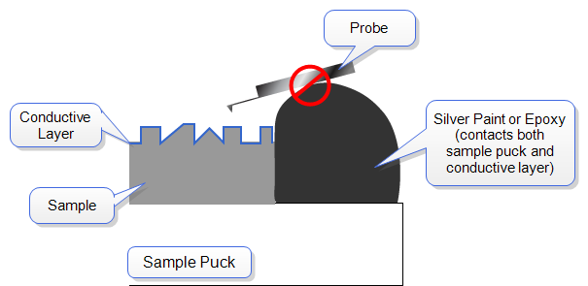

**Figure 2:** Schematic diagram showing how NOT to electrically connect a sample onto a sample puck.

# Surface Potential Detection

Bruker provides several methods for surface potential imaging:

* [Lift Mode Surface Potential Imaging (AM-KPFM)](file:///D:\Program%20Files\Nanoscope\8.15\Help\Icon\Content\Interleave%20Scanning\LiftMode%20SurfacePotentialDetectionPrinciples.htm) (aka AM-KPFM) measures the effective surface voltage of the sample by adjusting the voltage on the tip so that it feels a minimum electric force from the sample. (In this state, the voltage on the tip and sample is the same.) Samples for surface potential measurements should have an equivalent surface voltage of less than ±10 V, and operation is easiest for voltage ranges of ±5 V. The noise level of this technique is typically 10 mV. Samples may consist of conducting and nonconducting regions, but the conducting regions should not be passivated. Samples with regions of different materials will also show contrast due to contact potential differences. Quantitative voltage measurements can be made of the relative voltages within a single image.
* [PeakForce KPFM-AM Imaging](file:///D:\Program%20Files\Nanoscope\8.15\Help\Icon\Content\Interleave%20Scanning\PF-KPFM.htm) combines the [Surface Potential Detection](file:///D:\Program%20Files\Nanoscope\8.15\Help\Icon\Content\Interleave%20Scanning\Surface%20Potential%20Detection.htm) mode with Bruker's proprietary [Peak Force Tapping Mode](file:///D:\Program%20Files\Nanoscope\8.15\Help\Icon\Content\PeakForceQNM\Operation\OperatingPrinciples.htm#Peak).
* [FM-KPFM Imaging](file:///D:\Program%20Files\Nanoscope\8.15\Help\Icon\Content\Interleave%20Scanning\FM-KPFM.htm) uses a frequency modulation technique to measure surface potential. FM-KPFM is generally more accurate and has higher spatial resolution than AM-KPFM.
* [PeakForce KPFM Imaging](file:///D:\Program%20Files\Nanoscope\8.15\Help\Icon\Content\Interleave%20Scanning\PF-FM-KPFM.htm) combines [FM-KPFM Imaging](file:///D:\Program%20Files\Nanoscope\8.15\Help\Icon\Content\Interleave%20Scanning\FM-KPFM.htm) with Bruker's proprietary [Peak Force Tapping Mode](file:///D:\Program%20Files\Nanoscope\8.15\Help\Icon\Content\PeakForceQNM\Operation\OperatingPrinciples.htm#Peak), combining the benefits of both modes.
* [PeakForce KPFM-HV Imaging](file:///D:\Program%20Files\Nanoscope\8.15\Help\Icon\Content\Interleave%20Scanning\PF-KPFM%20HV%20Imaging.htm) combines Bruker's proprietary [Peak Force Tapping Mode](file:///D:\Program%20Files\Nanoscope\8.15\Help\Icon\Content\PeakForceQNM\Operation\OperatingPrinciples.htm#Peak) with an AC technique that enables measurement of surface potentials up to approximately ±200 V.

# Lift Mode Surface Potential Imaging (AM-KPFM)

Lift Mode surface potential imaging, also referred to as Amplitude Modulated KPFM (AM-KPFM), is a two-pass procedure where the surface topography is obtained by standard [TappingMode AFM](file:///D:\Program%20Files\Nanoscope\8.15\Help\Icon\Content\TappingMode%20AFM\TappingMode%20AFM.htm) in the first pass and the surface potential is measured on the second pass. The two measurements are interleaved: that is, they are each measured one line at a time with both images displayed on the screen simultaneously. A block diagram of the this Surface Potential measurement system is shown in [Figure 1](file:///D:\Program%20Files\Nanoscope\8.15\Help\Icon\Content\Interleave%20Scanning\LiftMode%20SurfacePotentialDetectionPrinciples.htm#SPoMBlockDiagram).

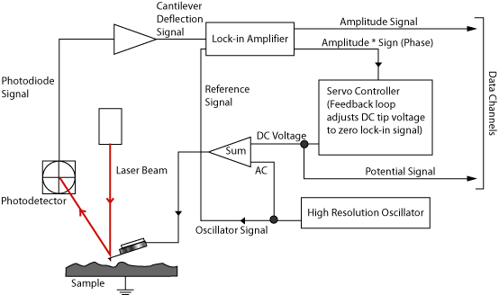

Figure 1: Block diagram of signals for Lift Mode Surface Potential Detection

On the first pass, in TappingMode, the cantilever is mechanically vibrated near its resonant frequency by a small piezoelectric element. On the second pass, the tapping drive piezo is turned off and an oscillating voltage VACsin(ωt) is applied directly to the probe tip. If there is a DC voltage difference between the tip and sample, then there will be an oscillating electric force on the cantilever at the frequency ω. This causes the cantilever to vibrate, and an amplitude can be detected.



1. Cantilever measures surface topography on first (main) scan (trace and retrace).
2. Cantilever ascends to lift scan height.
3. Cantilever follows stored surface topography at the lift height above the sample while responding to electric influences on second (interleave) scan (trace and retrace).

If the tip and sample are at the same DC voltage, there is no force on the cantilever at frequency ω and the cantilever amplitude will go to zero. Local surface potential is determined by adjusting the DC voltage on the tip, Vtip, until the oscillation amplitude becomes zero and the tip voltage is the same as the surface potential. The voltage applied to the probe tip is recorded by the NanoScope Controller to construct a voltage map of the surface.

Surface Potential Detection Theory

[Surface Potential Detection](file:///D:\Program%20Files\Nanoscope\8.15\Help\Icon\Content\Interleave%20Scanning\Surface%20Potential%20Detection.htm) microscopy can be modeled as a parallel plate capacitor. When two materials with different work functions are brought together, electrons in the material with the lower work function flow to the material with the higher work function (see [Figure 1](file:///D:\Program%20Files\Nanoscope\8.15\Help\Icon\Content\Interleave%20Scanning\Surface%20Potential%20Detection%20Theory.htm#UnequalEnergies)). If these materials are charged, the system can be thought of as a parallel plate capacitor with equal and opposite surface charges on each side. The voltage developed over this capacitor is called the contact potential. Measuring the contact potential is done by applying an external backing potential to the capacitor until the surface charges disappear. At that point the backing potential will equal the contact potential. In surface potential microscopy (scanning Kelvin probe force microscopy), this “zero-charge” point is determined by adjusting the tip voltage so the electrical force felt by the AFM cantilever is “0”.

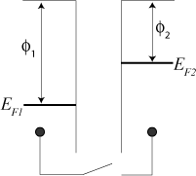

**Figure 1:** The electric energy level diagram for 2 conducting specimens, where Φ1 and Φ2 are the respective work functions. Ef1 and Ef2 are the respective Fermi energies.

If an external electrical contact is made between the two electrodes, their Fermi levels equalize and the resulting flow of charge (in the direction indicated in [Figure 2](file:///D:\Program%20Files\Nanoscope\8.15\Help\Icon\Content\Interleave%20Scanning\Surface%20Potential%20Detection%20Theory.htm#EqualPotentials)) produces a potential gradient, termed the contact potential Vc, between the plates. The two surfaces become equally and oppositely charged.

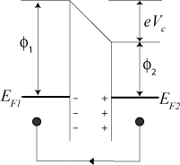

**Figure 2:** Electrical contact between 2 specimens

Inclusion of a variable backing potential, Vb, in the external circuit permits biasing of one electrode with respect to the other. When Vb = Vc = (Φ1 – Φ2)/e, the electric field between the plates vanishes (see [Figure 3](file:///D:\Program%20Files\Nanoscope\8.15\Help\Icon\Content\Interleave%20Scanning\Surface%20Potential%20Detection%20Theory.htm#VariablePotential)).

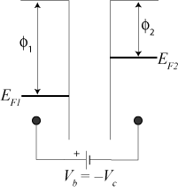

**Figure 3:** Variable backing potential, Vb, added

A good way to understand the response of the cantilever during Surface Potential operation is to start with the energy in a parallel plate capacitor:

D:\Program Files\Nanoscope\8.15\Help\Icon\Content\Resources\Graphics\Interleave\SurfacePotential_Eqn1.png

**Equation 4:**

where C is the local capacitance between the AFM tip and the sample and ΔV is the voltage difference between the two.

The force on the tip and sample is the rate of change of the energy with separation distance:

D:\Program Files\Nanoscope\8.15\Help\Icon\Content\Resources\Graphics\Interleave\SurfacePotential_Eqn2.png

**Equation 5:**

The voltage difference, ΔV, in Surface Potential operation consists of both a DC and an AC component. The AC component is applied from the oscillator, VACsinωt, where ω is the resonant frequency of the cantilever:

D:\Program Files\Nanoscope\8.15\Help\Icon\Content\Resources\Graphics\Interleave\SurfacePotential_Eqn3.png

**Equation 6:**

ΔVDC includes applied DC voltages (from the feedback loop), work function differences, surface charge effects, etc. Squaring ΔV and using the relation 2sin2x = 1 – cos(2x) produces:

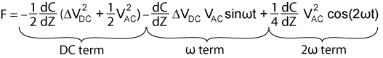

**Equation 7:**

The oscillating electric force at ω acts as a sinusoidal driving force that can excite motion in the cantilever. The cantilever responds only to forces at or very near its resonance, so the DC and 2ω terms do not cause any significant oscillation of the cantilever. In regular TappingMode, the cantilever response (RMS amplitude) is directly proportional to the drive amplitude of the tapping piezo. Here the response is directly proportional to the amplitude of the Fω drive term:

D:\Program Files\Nanoscope\8.15\Help\Icon\Content\Resources\Graphics\Interleave\SurfacePotential_Eqn5.png

**Equation 8:**

The goal of the Surface Potential feedback loop is to adjust the voltage on the tip until it equals the voltage of the sample (ΔVDC=0), at which point the cantilever amplitude should be zero (Fω = 0).

The larger the DC voltage difference between the tip and sample, the larger the driving force and resulting amplitude will be. But the Fω amplitude alone does not provide sufficient information to adjust the voltage on the tip. The driving force generated from a 2 V difference between the tip and sample is the same as from a –2 V difference (see [Figure 9](file:///D:\Program%20Files\Nanoscope\8.15\Help\Icon\Content\Interleave%20Scanning\Surface%20Potential%20Detection%20Theory.htm#ForceVsVoltage)).

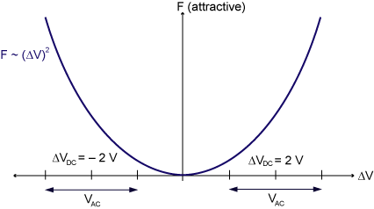

**Figure 9:** Force as a function of voltage

What differentiates these states is the phase. The phase relationship between the AC voltage and the force it generates is different for positive and negative DC voltages (see [Figure 10](file:///D:\Program%20Files\Nanoscope\8.15\Help\Icon\Content\Interleave%20Scanning\Surface%20Potential%20Detection%20Theory.htm#VatW) through [Figure 13](file:///D:\Program%20Files\Nanoscope\8.15\Help\Icon\Content\Interleave%20Scanning\Surface%20Potential%20Detection%20Theory.htm#OutOfPhase)).

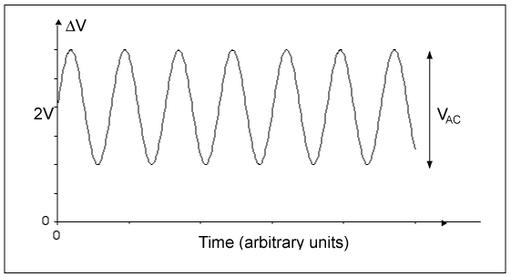

**Figure 10:** VAC at ω, ΔVDC= 2 V

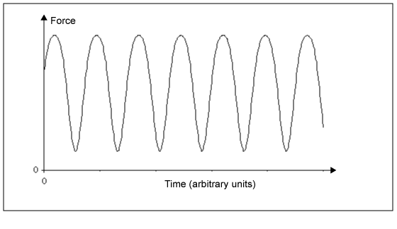

**Figure 11:** Major force component in phase with VAC at Frequency ω, ΔVDC= 2 V

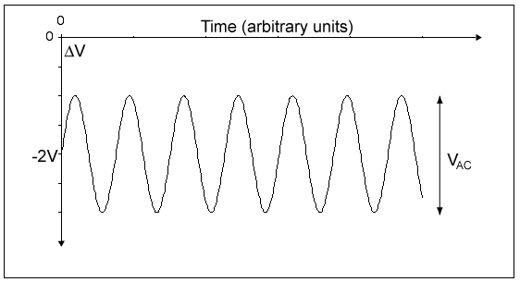

**Figure 12:** ΔVACat ω, ΔVDC= –2 V

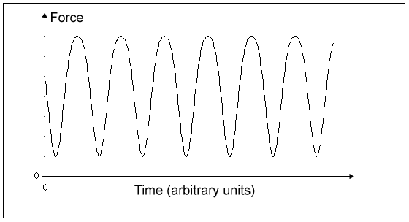

**Figure 13:** Major force component 180° out of phase with VAC at Frequency ω, ΔVDC= –2 V

In the case where ΔVDC = 2 V, the force is in phase with VAC. When ΔVDC = –2 V, the force is out of phase with VAC. Thus, the cantilever oscillation will have a different phase, relative to the reference signal VAC, depending on whether the tip voltage is larger or smaller than the sample voltage. Both the cantilever amplitude and phase are needed for the feedback loop to correctly adjust the tip voltage. The input signal to the Surface Potential feedback loop is the cantilever amplitude multiplied by the sign of its phase (i.e., positive value voltage for phase ≥ 0 degrees, negative value voltage for phase < 0 degrees). This signal can be accessed in the software by selecting **Potential Input** (interleave scan line) in one of the channel panels.

If ΔVDC = 0, the electric drive force is at the frequency 2ω. The component of the force at ω is zero so the cantilever does not oscillate (see [Figure 14](file:///D:\Program%20Files\Nanoscope\8.15\Help\Icon\Content\Interleave%20Scanning\Surface%20Potential%20Detection%20Theory.htm#DVis0) and [Figure 15](file:///D:\Program%20Files\Nanoscope\8.15\Help\Icon\Content\Interleave%20Scanning\Surface%20Potential%20Detection%20Theory.htm#2W)). The Surface Potential feedback loop adjusts the applied DC potential on the tip, Vtip, until the cantilever’s response is zero. Vtip is the Potential data that is used to generate a voltage map of the surface.

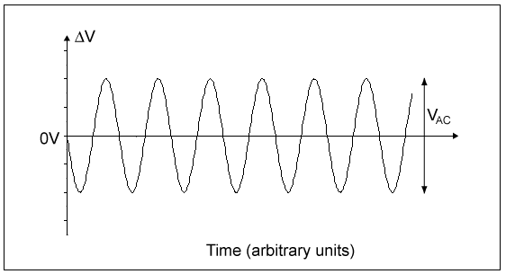

**Figure 14:** VAC at ω, ΔVDC= 0 V

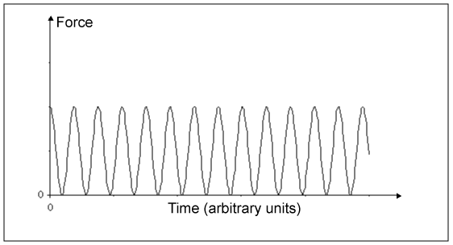

**Figure 15:** Force at Frequency of 2ω, ΔVDC= 0 V

# LiftMode Surface Potential Detection (AM-KPFM) Procedure

## Sample Preparation

Prepare the sample as described in [Electrical Sample Preparation](file:///D:\Program%20Files\Nanoscope\8.15\Help\Icon\Content\Interleave%20Scanning\Electric%20Techniques.htm#Sample_Preparation).

## Probe Selection

* [MESP](http://www.brukerafmprobes.com/p-3309-mesp.aspx) (cost-effective electrically conductive probes coated with cobalt/chromium)
* Custom-coated [FESP](http://www.brukerafmprobes.com/p-3259-fesp.aspx) silicon TappingMode cantilevers (ensure that any deposited metal you use adheres strongly to the silicon cantilever)
* [SCM-PIT](http://www.brukerafmprobes.com/p-3392-scm-pit.aspx) (platinum/iridium coated probes)
* [OSCM-PT](http://www.brukerafmprobes.com/p-3379-oscm-pt.aspx) (platinum coated probes)
* FESP or [LTESP](http://www.brukerafmprobes.com/p-3297-ltesp.aspx) (uncoated, highly-doped Si)

## Procedure

|  |  |
| --- | --- |
|  | 1. Mount a sample onto the sample holder. 2. Mount a metal-coated cantilever into the standard probe holder (see [Prepare and Load the Probe Holder](file:///D:\Program%20Files\Nanoscope\8.15\Help\Icon\Content\Basic%20AFM%20Operation\Prepare%20and%20Load%20the%20Cantilever%20Holder.htm) for details). |
| D:\Program Files\Nanoscope\8.15\Help\Icon\Content\Resources\Graphics\Icons\SelectExperimentIcon.png | 1. Click the Select Experiment icon. |
|  | 1. Select the following:    * Experiment Category: Electrical & Magnetic    * Experiment Group: Electrical & Magnetic Lift Modes    * Select Experiment: Surface Potential (AM-KPFM) 2. Click Load Experiment. 3. Set up the AFM for [Basic TappingMode Operation](file:///D:\Program%20Files\Nanoscope\8.15\Help\Icon\Content\TappingMode%20AFM\Basic%20TappingMode%20Operation.htm). |
| D:\Program Files\Nanoscope\8.15\Help\Icon\Content\Resources\Graphics\Icons\TuneIcon.png | 1. Use the AutoTune button in the Tune Cantilever panel of the Setup view to locate the cantilever’s resonant peak.   If you were to click the Manual Tune button, the Cantilever Tune window would appear displaying 2 peaks—the amplitude curve and the phase curve. In the event you find more than one resonance, use Manual Tune and select a resonance that is sharp and clearly defined, but not necessarily the largest. It is also helpful to select a resonant peak where the lock-in phase also changes very sharply across the peak. Multiple peaks can often be eliminated by making sure the cantilever holder is clean and the cantilever is tightly secured. See [Manual Cantilever Tuning](file:///D:\Program%20Files\Nanoscope\8.15\Help\Icon\Content\TappingMode%20AFM\Manual%20Cantilever%20Tuning.htm) for more information. |
| D:\Program Files\Nanoscope\8.15\Help\Icon\Content\Resources\Graphics\Icons\EngageIcon.png | 1. Engage the AFM and make the necessary adjustments for a good TappingMode image while displaying height data. |
|  | 1. Activate the Expanded Mode to see all the Interleave parameters available (in the Check Parameters or Scan view from the workflow toolbar). |
|  | 1. In the Interleave panel, set the following:    * Integral Igain: 0.5    * Proportional Gain: 5    * Interleave Mode: Lift    * Lift Scan Height: 100 nm (can be optimized later) |

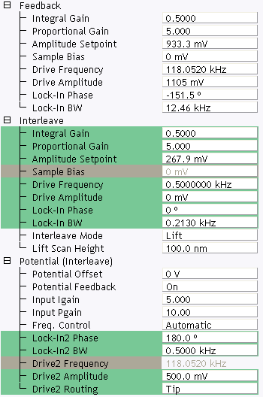

|  |  |
| --- | --- |
|  | 1. In the Potential (Interleave) panel, set the following:  * Potential Feedback: On * Leave the Drive2 Frequency at the main Feedback value (gray)  1. Enter a Drive2 Amplitude.   This is the AC voltage that is applied to the AFM tip. Higher Drive Amplitude produces a larger electrostatic force on the cantilever and this makes for more sensitive potential measurements. Conversely, the maximum total voltage (AC + DC) that may be applied to the tip is ±10 V, so a large Drive Amplitude reduces the range of the DC voltage that can be applied to the cantilever. If the sample surface potentials to be measured are very large, it is necessary to choose a small Drive Amplitude, while small surface potentials can be imaged more successfully with large Drive Amplitudes. A suggested starting Drive Amplitude is 500 mV.   1. Ensure the the Channel 4 image Data Type is set to Potential. 2. Set the scan Line Direction for the main and interleave scans to Retrace.   Remember to choose the Retrace direction because the lift step occurs on the trace scan and can cause artifacts in the data.   1. Set the Channel 4 Scan Line to Interleave. 2. Adjust the Input gains.   As with the topography gains, the scan can be optimized by increasing the gains to maximize feedback response, but not so high that oscillation sets in. See [Troubleshooting the Surface Potential Feedback Loop](file:///D:\Program%20Files\Nanoscope\8.15\Help\Icon\Content\Interleave%20Scanning\Troubleshooting%20the%20Surface%20Potential%20Feedback%20Loop.htm) for more information.   1. Optimize the lift heights.   Set the Lift Scan Height at the smallest value possible that does not make the Potential feedback loop unstable or cause the tip to crash into the sample surface. When the tip crashes into the surface during the Potential measurement, dark or light streaks appear in the Potential image. In this case, increase the Lift Scan Height until these streaks are minimized. |
| D:\Program Files\Nanoscope\8.15\Help\Icon\Content\Resources\Graphics\815_Icons\SetPhaseIcon.png | 1. Optimize the drive phase by clicking the Set Phase icon in the NanoScope toolbar. |
|  | As discussed in [Surface Potential Detection Theory](file:///D:\Program%20Files\Nanoscope\8.15\Help\Icon\Content\Interleave%20Scanning\Surface%20Potential%20Detection%20Theory.htm), the correct phase relationship must exist between the reference and the input signals to the lock-in for the potential feedback loop to perform correctly. Lock-In Phase adjusts the phase of the reference signal to the lock-in amplifier and depends on the mechanical properties of the cantilever.   1. For large sample voltages or qualitative work, set a Data Type to Phase (in addition to Channel 4 Data Type set to Potential).   When the controller has been configured for surface potential measurements, the “phase” signal is actually the cantilever amplitude signal, as measured by a lock-in amplifier. If the feedback loop is not enabled by selecting the Data Type = Potential, the lock-in cantilever amplitude depends on the voltage difference between the tip and sample in a roughly linear fashion. (The lock-in amplifier produces a voltage that is proportional to the cantilever amplitude.) Qualitative surface potential images can be collected using this lock-in signal. Also, if the sample has a surface potential that exceeds ±10 V (greater than the range of the “Potential” signal), it is possible to use the lock-in signal to provide qualitative images that reflect the sample surface potential. To view the lock-in signal with the reconfigured controller, select the Data type = Phase. |

# Determination of Lock-in Phase

For surface potential microscopy (also called scanning Kelvin probe force microscopy, SKPFM) measurements, the feedback adjusts the DC voltage applied between the tip and sample to compensate their intrinsic potential difference. The DC voltage map across the surface thus reflects surface potential variations of the sample surface.

When the difference is perfectly compensated, the tapping oscillation amplitude of the metal coated AFM cantilever (excited by an AC bias field) approaches “0”—the very reason this technique is called a *nulling* technique. In doing so, the feedback uses the tapping amplitude and phase to determine whether to increase or decrease the DC voltage.

|  |  |
| --- | --- |
| D:\Program Files\Nanoscope\8.15\Help\Icon\Content\Resources\Graphics\815_Icons\SetPhaseIcon.png | To facilitate setting the Phase parameter, NanoScope Version 8.15 software now features a Set Phase tool, which enables the user to determine the lock-in phase with a single click. |

### The following describes the NanoScope procedures initiated by the Set Phase tool:

NOTE: Knowledge of the inner workings of Set Phase is generally not necessary.

Generic Sweeps are taken on Interleave. In some cases, it is helpful to switch back and forth between Main and Interleave for the sweep parameters to take effect. Some inconsistency may occur—for instance, potential feedback may not actually be on when Input Igain and Input Pgain are non-zero.

[***[D:\Program Files\Nanoscope\8.15\Help\Icon\Content\SkinSupport\DropDownOpen.gif](javascript:void(0);)Interleave Tuning Curve - Phase Lag***](javascript:void(0);)

A phase difference (–90° in the lower graph in [Figure 1](file:///D:\Program%20Files\Nanoscope\8.15\Help\Icon\Content\Interleave%20Scanning\Determination%20of%20Lock-in%20Phase.htm#InterleaveTuneCurve)) is usually seen between tip oscillation signal and the AC bias driving signal. This phase lag varies from tip to tip, with operating frequency, and the potential difference between the tip and the spot on the sample.

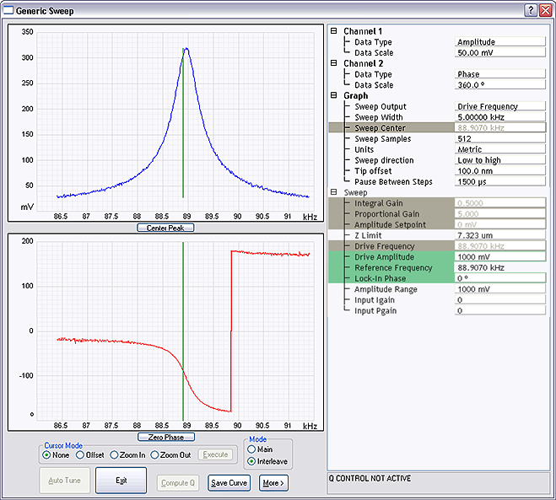

Figure 1: Interleave Tuning Curve - Phase Lag

[***[D:\Program Files\Nanoscope\8.15\Help\Icon\Content\SkinSupport\DropDownOpen.gif](javascript:void(0);)Amplitude and Phase vs. Sample Bias—Feedback Off***](javascript:void(0);)

[Figure 2](file:///D:\Program%20Files\Nanoscope\8.15\Help\Icon\Content\Interleave%20Scanning\Determination%20of%20Lock-in%20Phase.htm#AmplitudeAndPhaseVsBias) shows a Generic Sweep of Sample Bias while the potential feedback is turned off. Note that Input Igain and Input Pgain are 0.

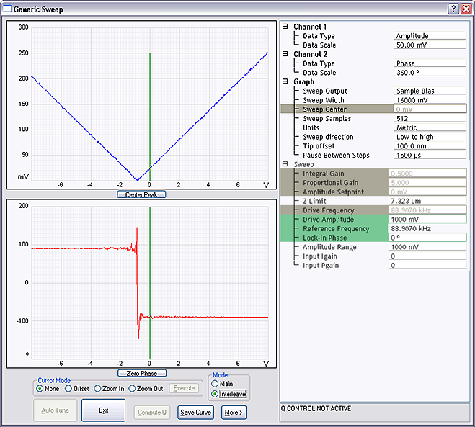

Figure 2: Amplitude and Phase vs. Sample Bias (Feedback Off)

The amplitude, shown in the upper plot, dips to 0 when the sample is biased to match the tip potential; as the bias voltage moves away from that point, the amplitude increases. Potential feedback seeks that zero point. Because amplitude alone can not determine whether one is on the left side or right side of that zero amplitude point, the feedback relies on the phase to determine which direction to move the DC bias.

The bottom graph in [Figure 2](file:///D:\Program%20Files\Nanoscope\8.15\Help\Icon\Content\Interleave%20Scanning\Determination%20of%20Lock-in%20Phase.htm#AmplitudeAndPhaseVsBias) shows the phase changing by 180° across “0” amplitude. Choose a Lock-In Phase to offset the oscillation phase so that the phase is negative when the tip voltage is positive relative to the sample. As you can see in [Figure 2](file:///D:\Program%20Files\Nanoscope\8.15\Help\Icon\Content\Interleave%20Scanning\Determination%20of%20Lock-in%20Phase.htm#AmplitudeAndPhaseVsBias), when the sample bias is –2 V (tip is positive), the output Lock-In Phase is 90°. The Interleave Lock-In Phase then needs to be set to –180° to make it –90°.

[***[D:\Program Files\Nanoscope\8.15\Help\Icon\Content\SkinSupport\DropDownOpen.gif](javascript:void(0);)Phase vs. Lock-In Phase, Feedback On—The Straightforward Approach***](javascript:void(0);)

It is logical to sweep the lock-in phase in a full circle to determine the phase range where feedback is working while the feedback is turned on (Input Igain and Input Pgain are non-zero).

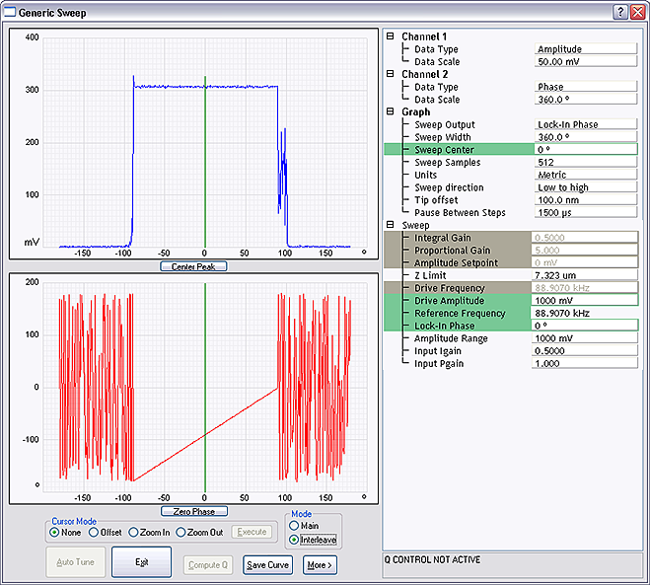

Figure 3: Phase vs. Lock-in Phase (Feedback On)

The top plot in [Figure 3](file:///D:\Program%20Files\Nanoscope\8.15\Help\Icon\Content\Interleave%20Scanning\Determination%20of%20Lock-in%20Phase.htm#PhaseVsLockIn) shows how the amplitude changes while lock-in phase is swept. In the mid-range of the phase sweep (approximately –100° to +100°), the amplitude stays non-zero, indicating that the phase is not correct for the feedback to work properly. On both ends, the amplitude remains around “0”, implying that feedback is working properly in “nulling” the amplitude. In principle, it is fine to choose any lock-in phase in these two regions 100° ~ 180° and –180° ~ –90° (equivalent to 180° ~ 270°); actually a combined region of 100° ~ 270°. It makes practical sense, however, to choose a value somewhere in the middle to have a good margin, e.g. –170°.

The lower plot in [Figure 3](file:///D:\Program%20Files\Nanoscope\8.15\Help\Icon\Content\Interleave%20Scanning\Determination%20of%20Lock-in%20Phase.htm#PhaseVsLockIn) shows phase changing linearly in the middle of the sweep range, while jumping around when feedback is working on either end. This is explained above under Amplitude and Phase vs. Sample Bias—Feedback Off.

[***[D:\Program Files\Nanoscope\8.15\Help\Icon\Content\SkinSupport\DropDownOpen.gif](javascript:void(0);)Phase vs. Lock-In Phase Feedback Off—An Alternative Approach***](javascript:void(0);)

[Figure 4](file:///D:\Program%20Files\Nanoscope\8.15\Help\Icon\Content\Interleave%20Scanning\Determination%20of%20Lock-in%20Phase.htm#AlternativePhase) depicts a Generic Sweep of Lock-in phase while potential feedback is off and Input Igain and Input Pgain are “0”.

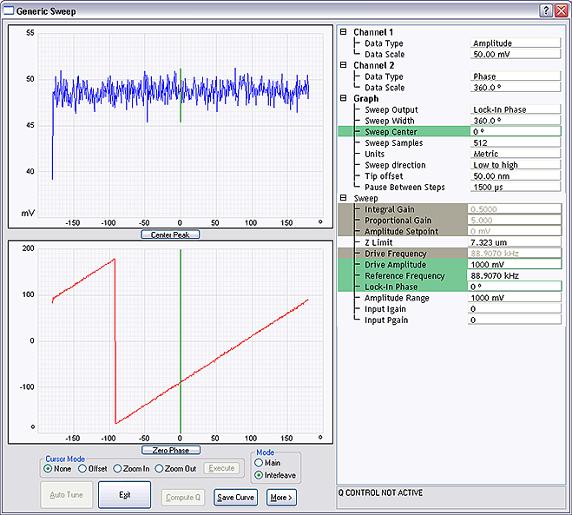

Figure 4: Alternative Phase vs. Lock-in Phase (Feedback Off)

The top plot in [Figure 4](file:///D:\Program%20Files\Nanoscope\8.15\Help\Icon\Content\Interleave%20Scanning\Determination%20of%20Lock-in%20Phase.htm#AlternativePhase) shows the amplitude remaining unchanged while the Lock-In Phase is swept.

The bottom plot shows the phase changing linearly as the lock-in phase is swept. There is one exception where the phase jumps from 180° to –180°, so-called phase wrapping.

In case the plots in the previous section were not obtained (due to software inconsistency), do the following:

* From the left bottom plot, choose a lock-in phase where oscillation phase falls within –180°~0° (or 0~180°), e.g. 10° (–170°)
* If this does not work, add/subtract 180°, e.g. –170° (10°)

Of course, you can simply pick any lock-in phase, if it works, fine. Otherwise, change the phase by 180°. The difference is that with the above outlined approach you know what kind of margin you have.

Recall: Lock-In Phase depends on the mechanical properties of the cantilever. For cantilevers with resonant frequencies from 60–80 kHz (such as MESP, SCM-PIT, and FESP), use an interleave Lock-In Phase of 170 degrees. For cantilevers with higher resonant frequencies, increased electronics phase lag must be compensated. For cantilevers with resonant frequencies around 300 kHz (such as TESP, RTESP) an interleave Lock-In Phase near 130 degrees often works well.

# FM-KPFM Imaging

FM-KPFM (Frequency Modulated-Kelvin Probe Force Microscopy) applies an AC signal to the probe at a low frequency, *fm*, while mechanically driving the probe at its resonant frequency, *f0*, and uses the amplitude of the 1st sideband at *f0* + *fm* as the error signal to drive a DC voltage that nulls that signal.

FM-KPFM is a [TappingMode AFM](file:///D:\Program%20Files\Nanoscope\8.15\Help\Icon\Content\TappingMode%20AFM\TappingMode%20AFM.htm) single-pass technique and, unlike other electric modes, does not use [LiftMode](file:///D:\Program%20Files\Nanoscope\8.15\Help\Icon\Content\Interleave%20Scanning\Interleave%20Scanning.htm#LiftMode). FM-KPFM has higher spatial resolution than [Lift Mode Surface Potential Imaging (AM-KPFM)](file:///D:\Program%20Files\Nanoscope\8.15\Help\Icon\Content\Interleave%20Scanning\LiftMode%20SurfacePotentialDetectionPrinciples.htm) but its signal-to-noise ratio is frequently lower.

[***[D:\Program Files\Nanoscope\8.15\Help\Icon\Content\SkinSupport\DropDownOpen.gif](javascript:void(0);)FM-KPFM Theory***](javascript:void(0);)

An AC voltage with amplitude VAC and frequency *fm* (angular frequency *ωm*) superimposed on a DC voltage, VDC, is applied between the probe tip and the sample. The resulting electrostatic force is given by

D:\Program Files\Nanoscope\8.15\Help\Icon\Content\Resources\Graphics\Interleave\KPFM\Eqn1.png

Equation 1:

where

D:\Program Files\Nanoscope\8.15\Help\Icon\Content\Resources\Graphics\Interleave\KPFM\Eqn2.png

Equation 2:

where Δφ is the contact potential difference between the probe and sample.

Equation 1 may be separated into three terms:

D:\Program Files\Nanoscope\8.15\Help\Icon\Content\Resources\Graphics\Interleave\KPFM\Eqn3.png

Equation 3:

The electric field gradient is given by:

D:\Program Files\Nanoscope\8.15\Help\Icon\Content\GeneratedImages\Equations\Equation18.png

Equation 4:

The applied AC voltage modulates the force and force gradient at frequencies *ωm* and *2ωm*.

### Frequency Modulation

Hooke's law states:

D:\Program Files\Nanoscope\8.15\Help\Icon\Content\GeneratedImages\Equations\Equation19.png

Equation 5:

Taking the derivative,

D:\Program Files\Nanoscope\8.15\Help\Icon\Content\GeneratedImages\Equations\Equation20.png

Equation 6:

The force gradient and spring constant are thus seen to be equivalent.

The electrostatic force shifts the resonant frequency of a cantilever with effective mass m\* as follows:

D:\Program Files\Nanoscope\8.15\Help\Icon\Content\GeneratedImages\Equations\Equation21.png

Equation 7:

The applied AC voltage modulates *Fel* and ∂*Fel*/∂*z* according to [Equation 4](file:///D:\Program%20Files\Nanoscope\8.15\Help\Icon\Content\Interleave%20Scanning\FM-KPFM.htm#Eqn4). [Equation 6](file:///D:\Program%20Files\Nanoscope\8.15\Help\Icon\Content\Interleave%20Scanning\FM-KPFM.htm#Eqn6) then shows that the mechanical resonance of the cantilever is modulated with frequencies *fm* and *2fm* with sidebands, shown schematically in [Figure 8](file:///D:\Program%20Files\Nanoscope\8.15\Help\Icon\Content\Interleave%20Scanning\FM-KPFM.htm#Fig1), appearing at *f0*±*fm* and *f0*±2*fm*.

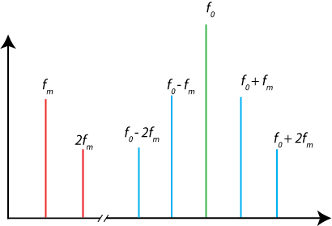

Figure 8: Schematic of the frequency spectrum of the probe tip oscillation

### Resolution

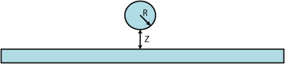

Figure 9: Charged sphere at separation z above an infinite plane

The force between a charged sphere at separation z above an infinite plane, shown in [Figure 9](file:///D:\Program%20Files\Nanoscope\8.15\Help\Icon\Content\Interleave%20Scanning\FM-KPFM.htm#ChargedSphere), is:

D:\Program Files\Nanoscope\8.15\Help\Icon\Content\GeneratedImages\Equations\Equation22.png

Equation 10:

and its derivative is:

D:\Program Files\Nanoscope\8.15\Help\Icon\Content\GeneratedImages\Equations\Equation23.png

Equation 11:

The electric force gradient has a steeper dependence on Z than the electric force. It also has a steeper dependence on X and Y.

## FM-KPFM Probe Requirements

Bruker recommends [PFQNE-AL](http://www.brukerafmprobes.com/Product.aspx?ProductID=3817) probes for FM-KPFM measurements.

## Sample Preparation

Prepare the sample as described in [Electrical Sample Preparation](file:///D:\Program%20Files\Nanoscope\8.15\Help\Icon\Content\Interleave%20Scanning\Electric%20Techniques.htm#Sample_Preparation).

## FM-KPFM Procedure

|  |  |  |
| --- | --- | --- |
|  | | 1. Mount a sample onto the sample holder. 2. Mount an appropriate probe into the standard probe holder (see Prepare and Load the Cantilever Holder for details). |
| D:\Program Files\Nanoscope\8.15\Help\Icon\Content\Resources\Graphics\810_Icons\SelectExperimentIcon.png | | 1. Click the Select Experiment icon to open the Select Experiment window, shown in [Figure 12](file:///D:\Program%20Files\Nanoscope\8.15\Help\Icon\Content\Interleave%20Scanning\FM-KPFM.htm#SelectExperimentWindow). |
| D:\Program Files\Nanoscope\8.15\Help\Icon\Content\Resources\Graphics\810_Icons\ElectricalAndMagneticIcon.png | | 1. Select the following:    * Experiment Category: Electrical & Magnetic    * Experiment Group: Electrical & Magnetic Lift Modes    * Select Experiment: Surface Potential (FM-KPFM) |
|  | | 1. Click Load Experiment. |
| D:\Program Files\Nanoscope\8.15\Help\Icon\Content\Resources\Graphics\Icons\SetupIcon.png | | 1. Click the Setup icon to open the Setup window. |
|  | | 1. Align the laser on the cantilever and place the crosshair there. See [Figure 13](file:///D:\Program%20Files\Nanoscope\8.15\Help\Icon\Content\Interleave%20Scanning\FM-KPFM.htm#AlignLaser). |
|  | 1. Fast Thermal tuning, used to find the cantilever resonance, is performed when you exit the Setup view. This is made visible by the HDSC window, shown in [Figure 14](file:///D:\Program%20Files\Nanoscope\8.15\Help\Icon\Content\Interleave%20Scanning\FM-KPFM.htm#HSDC). | |
| D:\Program Files\Nanoscope\8.15\Help\Icon\Content\Resources\Graphics\Icons\EngageIcon.png | | 1. Engage the probe onto the sample |
| D:\Program Files\Nanoscope\8.15\Help\Icon\Content\Resources\Graphics\Icons\ScanIconWorkflowToolbar.png | | 1. Scan the sample |
|  | | 1. Entering a value in the Potential Offset field adds that value to the measured value in the Potential channel. This can be particularly useful when measuring work functions as this function measures the difference in potential between the probe and the sample - entering the value of the work function of the probe will then provide a direct measurement of work function of the sample.   NOTE: The stored data is unaffected by the Potential Offset. I.e. offline measurements do not see this input. |

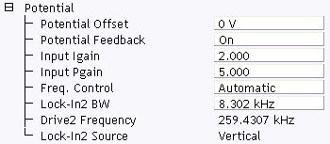

Figure 15: Potential Offset in the FM-KPFM Potential window

## Advanced FM-KPFM Imaging

Automatic frequency selection is the default for FM-KPFM imaging. You may wish, however, to manually select an operating frequency. To do this:

|  |  |
| --- | --- |
|  | 1. Enter the Expanded mode. |
|  | 1. Set Freq. Control in the Potential (Interleave), shown in [Figure 16](file:///D:\Program%20Files\Nanoscope\8.15\Help\Icon\Content\Interleave%20Scanning\FM-KPFM.htm#FreqControl), panel to User-defined. |

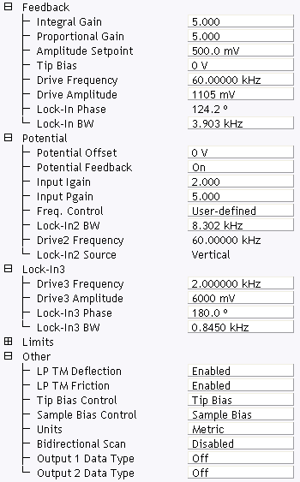

Figure 16: Selecting User-defined Frequency Control

|  |  |
| --- | --- |
| D:\Program Files\Nanoscope\8.15\Help\Icon\Content\Resources\Graphics\Icons\TuneIcon.png | 1. You may then, if you wish, Tune the cantilever. |

### FM-KPFM Parameters

You may wish to manually adjust the parameters shown in [Table 1](file:///D:\Program%20Files\Nanoscope\8.15\Help\Icon\Content\Interleave%20Scanning\FM-KPFM.htm#FMKPFMParms).

| Parameter | Description |
| --- | --- |
| Lock-In BW | Needs to be smaller than twice the Drive 3 Frequency which is *fm* in [Figure 8](file:///D:\Program%20Files\Nanoscope\8.15\Help\Icon\Content\Interleave%20Scanning\FM-KPFM.htm#Fig1). This lets the Lock-In respond to *f0* while filtering *f0* ± *fm*. If the Lock-In BW is too low, the tracking ability will be reduced. Automatic Freq. Control is thus easier to use than User-defined Freq. Control. |
| Lock-In2 BW | Needs to be larger than four times the Drive 3 Frequency which is *fm* in [Figure 8](file:///D:\Program%20Files\Nanoscope\8.15\Help\Icon\Content\Interleave%20Scanning\FM-KPFM.htm#Fig1). This is used to include the first and second harmonics, *f0* ± 2*fm*. Extra bandwidth of Lock-In2 does not degrade image quality as Lock-In3 follows. |
| Lock-In3 BW | Lock-In3, cascaded with Lock-In2, is used for the surface potential feedback. |
| Drive3 Amplitude | Higher Drive3 Amplitudes will result in higher signal-to-noise ratios. |

Table 1: Adjustable FM-KPFM parameters

# PeakForce KPFM-AM Imaging

PeakForce-KPFM-AM is a is a two-pass procedure where the surface topography and nanomechanical properties are obtained using Bruker's proprietary [Peak Force Tapping Mode](file:///D:\Program%20Files\Nanoscope\8.15\Help\Icon\Content\PeakForceQNM\Operation\OperatingPrinciples.htm#Peak) in the first pass and the surface potential or work function in the second pass using the [Lift Mode Surface Potential Imaging (AM-KPFM)](file:///D:\Program%20Files\Nanoscope\8.15\Help\Icon\Content\Interleave%20Scanning\LiftMode%20SurfacePotentialDetectionPrinciples.htm) mode:

1. The cantilever measures surface topography and nanomechanical properties on the first (main) scan (trace and retrace).
2. The cantilever ascends to the Lift Scan Height.
3. The cantilever then follows the stored surface topography at the lift height above the sample while an oscillating voltage VACsin(ωt) is applied directly to the probe tip. If there is a DC voltage difference between the tip and sample, then there will be an oscillating electric force on the cantilever at the frequency ω. This causes the cantilever to vibrate, and an amplitude can be detected on the second (interleave) scan.

PeakForce KPFM-AM leverages the advantages of PeakForce Tapping:

* Direct force control, eliminating artifacts that result from tip and sample damage
* Self-optimization using ScanAsyst
* Dramatically improved ease of use through the ScanAsyst™ imaging mode
* Spatially correlated nanomechanical information with PeakForce QNM

## PeakForce KPFM-AM Probe Requirements

Bruker recommends [PFQNE-AL](http://www.brukerafmprobes.com/Product.aspx?ProductID=3817) probes for PeakForce KPFM measurements.

## Sample Preparation

Prepare the sample as described in [Electrical Sample Preparation](file:///D:\Program%20Files\Nanoscope\8.15\Help\Icon\Content\Interleave%20Scanning\Electric%20Techniques.htm#Sample_Preparation).

## PeakForce KPFM-AM Procedure

|  |  |  |  |
| --- | --- | --- | --- |
|  | | 1. Mount a sample onto the sample holder. 2. Mount an appropriate probe into the standard probe holder (see Prepare and Load the Cantilever Holder for details). | |
| D:\Program Files\Nanoscope\8.15\Help\Icon\Content\Resources\Graphics\810_Icons\SelectExperimentIcon.png | | 1. Click the Select Experiment icon to open the Select Experiment window, shown in [Figure 1](file:///D:\Program%20Files\Nanoscope\8.15\Help\Icon\Content\Interleave%20Scanning\PF-KPFM.htm#SelectExperiment). | |
| D:\Program Files\Nanoscope\8.15\Help\Icon\Content\Resources\Graphics\810_Icons\ElectricalAndMagneticIcon.png | | | 1. Select the following:    * Experiment Category: Electrical & Magnetic    * Experiment Group: Electrical & Magnetic Lift Modes    * Select Experiment: PeakForce KPFM-AM |
|  | | | 1. Click Load Experiment. |
| D:\Program Files\Nanoscope\8.15\Help\Icon\Content\Resources\Graphics\Icons\SetupIcon.png | | | 1. Click the Setup icon to open the Setup window. |
|  | | | 1. Align the laser on the cantilever and place the crosshair there. See [Figure 2](file:///D:\Program%20Files\Nanoscope\8.15\Help\Icon\Content\Interleave%20Scanning\PF-KPFM.htm#AlignLaser). |
|  | 1. Fast Thermal tuning, used to find the cantilever resonance, is performed when you exit the Setup view. This is made visible by the HSDC window, shown in [Figure 3](file:///D:\Program%20Files\Nanoscope\8.15\Help\Icon\Content\Interleave%20Scanning\PF-KPFM.htm#HSDC). | | |
| D:\Program Files\Nanoscope\8.15\Help\Icon\Content\Resources\Graphics\Icons\EngageIcon.png | | 1. Engage the probe onto the sample | |
| D:\Program Files\Nanoscope\8.15\Help\Icon\Content\Resources\Graphics\Icons\ScanIconWorkflowToolbar.png | | 1. Scan the sample. | |
|  | | 1. Set the Lift Scan Height as low as possible without hitting the sample, typically 75 - 100 nm. 2. Entering a value in the Potential Offset field adds that value to the measured value in the Potential channel. This can be particularly useful when measuring work functions as this function measures the difference in potential between the probe and the sample - entering the value of the work function of the probe will then provide a direct measurement of work function of the sample.   NOTE: The stored data is unaffected by the Potential Offset. I.e. offline measurements do not see this input.   1. Refer to the [PeakForce QNM Operation](file:///D:\Program%20Files\Nanoscope\8.15\Help\Icon\Content\PeakForceQNM\Operation\OperatingProcedures.htm) sections for details regarding PeakForce mode imaging. | |

## Advanced PeakForce KPFM-AM Operation

Automatic frequency selection is the default for PeakForce KPFM imaging. You may wish, however, to manually select an operating frequency. To do this:

|  |  |
| --- | --- |
|  | 1. Enter the Expanded mode. |
|  | 1. Set Freq. Control in the Potential (Interleave), shown in [Figure 4](file:///D:\Program%20Files\Nanoscope\8.15\Help\Icon\Content\Interleave%20Scanning\PF-KPFM.htm#FreqControl), panel to User-defined. |

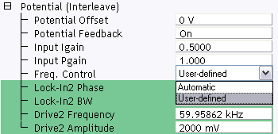

Figure 4: Selecting User-defined Frequency Control

|  |  |
| --- | --- |
|  | 1. You will then need to manually tune the cantilever: 2. Select Microscope > Generic Lockin from the NanoScope Menu Bar. This opens the Generic Lock-In window, shown in [Figure 5](file:///D:\Program%20Files\Nanoscope\8.15\Help\Icon\Content\Interleave%20Scanning\PF-KPFM.htm#LockIn). |

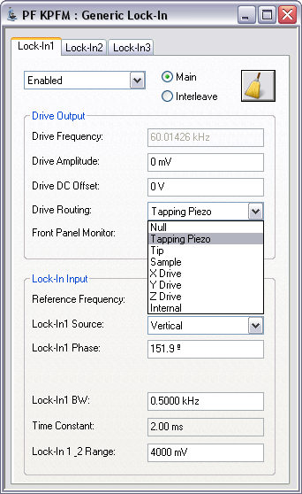

Figure 5: The PeakForce KPFM Generic Lock-In window

|  |  |
| --- | --- |
|  | 1. Select Tapping Piezo in the Drive Routing panel of Lock-In1. |
| D:\Program Files\Nanoscope\8.15\Help\Icon\Content\Resources\Graphics\Icons\GenericSweepIconWorkflowToolbar.png | 1. Click Sweep to open the Generic Sweep window, shown in [Figure 6](file:///D:\Program%20Files\Nanoscope\8.15\Help\Icon\Content\Interleave%20Scanning\PF-KPFM.htm#GenericSweep). |

[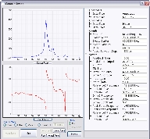](javascript:void(0);)

*(Hover over the image to view larger)*

Figure 6: The Generic Sweep window

|  |  |
| --- | --- |
|  | 1. Standard tune procedures, with the exception of Auto Tune, apply. You may use the Offset command to center the peak on the cursor... 2. You will also need to follow the manual procedures described in [Determination of Lock-in Phase](file:///D:\Program%20Files\Nanoscope\8.15\Help\Icon\Content\Interleave%20Scanning\Determination%20of%20Lock-in%20Phase.htm). 3. Reset the Drive Routing to Internal before closing the PF KPFM Generic Lock-In window. See [Figure 7](file:///D:\Program%20Files\Nanoscope\8.15\Help\Icon\Content\Interleave%20Scanning\PF-KPFM.htm#Internal). |

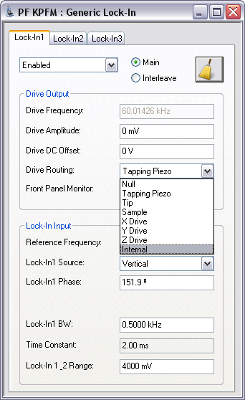

Figure 7: Set the Drive Routing to Internal

|  |  |
| --- | --- |
|  | 1. Enter your chosen frequency and amplitude into the Drive2 Frequency and Amplitude windows, shown in [Figure 4](file:///D:\Program%20Files\Nanoscope\8.15\Help\Icon\Content\Interleave%20Scanning\PF-KPFM.htm#FreqControl). |

# PeakForce KPFM Imaging

PeakForce KPFM (PeakForce Frequency Modulated-Kelvin Probe Force Microscopy) is a combination of Peak Force Tapping Mode and frequency modulated KPFM (FM-KPFM) mode.

PeakForce KPFM measures surface potential or work function using a [Lift Mode Surface Potential Imaging (AM-KPFM)](file:///D:\Program%20Files\Nanoscope\8.15\Help\Icon\Content\Interleave%20Scanning\LiftMode%20SurfacePotentialDetectionPrinciples.htm) variation of the [FM-KPFM Imaging](file:///D:\Program%20Files\Nanoscope\8.15\Help\Icon\Content\Interleave%20Scanning\FM-KPFM.htm) mode while simultaneously providing correlated nanomechanical property information using the Bruker's proprietary [Peak Force Tapping Mode](file:///D:\Program%20Files\Nanoscope\8.15\Help\Icon\Content\PeakForceQNM\Operation\OperatingPrinciples.htm#Peak).

PeakForce KPFM leverages the advantages of PeakForce Tapping:

* Direct force control, eliminating artifacts that result from tip and sample damage
* Self-optimization using ScanAsyst™
* Dramatically improved ease of use through the ScanAsyst™ imaging mode
* Spatially correlated nanomechanical information with PeakForce QNM

Because of PeakForce's direct force control, softer probes may be used in this mode, thereby increasing sensitivity.

## PeakForce KPFM Probe Requirements

Bruker recommends [PFQNE-AL](http://www.brukerafmprobes.com/Product.aspx?ProductID=3817) probes for PF FM-KPFM measurements.

## Sample Preparation

Prepare the sample as described in [Electrical Sample Preparation](file:///D:\Program%20Files\Nanoscope\8.15\Help\Icon\Content\Interleave%20Scanning\Electric%20Techniques.htm#Sample_Preparation).

## PeakForce KPFM Procedure

|  |  |  |  |
| --- | --- | --- | --- |
|  | | 1. Mount a sample onto the sample holder. 2. Mount an appropriate probe into the standard probe holder (see [Prepare and Load the Probe Holder](file:///D:\Program%20Files\Nanoscope\8.15\Help\Icon\Content\Basic%20AFM%20Operation\Prepare%20and%20Load%20the%20Cantilever%20Holder.htm) for details). | |
| D:\Program Files\Nanoscope\8.15\Help\Icon\Content\Resources\Graphics\810_Icons\SelectExperimentIcon.png | | 1. Click the Select Experiment icon to open the Select Experiment window. | |
| D:\Program Files\Nanoscope\8.15\Help\Icon\Content\Resources\Graphics\810_Icons\ElectricalAndMagneticIcon.png | | | 1. Select the following:    * Experiment Category: Electrical & Magnetic    * Experiment Group: Electrical & Magnetic Lift Modes    * Select Experiment: PeakForce KPFM |
|  | | | 1. Click Load Experiment. |
| D:\Program Files\Nanoscope\8.15\Help\Icon\Content\Resources\Graphics\Icons\SetupIcon.png | | | 1. Click the Setup icon to open the Setup window. |
|  | | | 1. Align the laser on the cantilever and place the crosshair there. See [Figure 2](file:///D:\Program%20Files\Nanoscope\8.15\Help\Icon\Content\Interleave%20Scanning\PF-FM-KPFM.htm#AlignLaser). |
|  | 1. Fast Thermal tuning, used to find the cantilever resonance, is performed when you exit the Setup view. This is made visible by the HSDC window, shown in [Figure 3](file:///D:\Program%20Files\Nanoscope\8.15\Help\Icon\Content\Interleave%20Scanning\PF-FM-KPFM.htm#HSDC). | | |
| D:\Program Files\Nanoscope\8.15\Help\Icon\Content\Resources\Graphics\Icons\EngageIcon.png | | 1. Engage the probe onto the sample | |
| D:\Program Files\Nanoscope\8.15\Help\Icon\Content\Resources\Graphics\Icons\ScanIconWorkflowToolbar.png | | 1. Scan the sample | |
|  | | 1. Set the Lift Scan Height as low as possible without hitting the sample, typically 75 - 100 nm. 2. Entering a value in the Potential Offset field adds that value to the measured value in the Potential channel. This can be particularly useful when measuring work functions as this function measures the difference in potential between the probe and the sample - entering the value of the work function of the probe will then provide a direct measurement of work function of the sample.   NOTE: The stored data is unaffected by the Potential Offset. I.e. offline measurements do not see this input.   1. Refer to the [PeakForce QNM Operation](file:///D:\Program%20Files\Nanoscope\8.15\Help\Icon\Content\PeakForceQNM\Operation\OperatingProcedures.htm) sections for details regarding PeakForce mode imaging. | |

A sample result showing the surface potentials (work functions) of three different materials is shown in [Fig 4](file:///D:\Program%20Files\Nanoscope\8.15\Help\Icon\Content\Interleave%20Scanning\PF-FM-KPFM.htm#Scan).

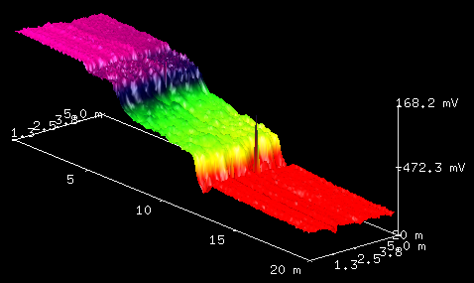

Figure 4: PeakForce KPFM scan of a Au-Si-Al (left to right) sample.

## Advanced PeakForce KPFM Imaging

Automatic frequency selection is the default for PeakForce KPFM imaging. You may wish, however, to manually select an operating frequency. To do this:

|  |  |
| --- | --- |
|  | 1. Enter the Expanded mode. |
|  | 1. Set Freq. Control in the Potential (Interleave), shown in [Figure 5](file:///D:\Program%20Files\Nanoscope\8.15\Help\Icon\Content\Interleave%20Scanning\PF-FM-KPFM.htm#FreqControl), panel to User-defined. |

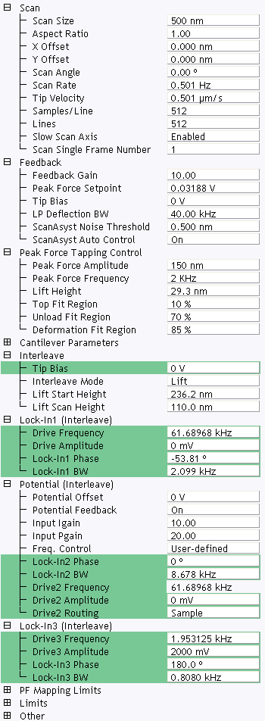

Figure 5: Selecting User-defined Frequency Control

You can manually select the operating frequency of the LiftMode. For details, refer to [Advanced PeakForce KPFM-AM Operation](file:///D:\Program%20Files\Nanoscope\8.15\Help\Icon\Content\Interleave%20Scanning\PF-KPFM.htm#Advanced).

### PeakForce KPFM Parameters

You may wish to manually adjust the parameters shown in [Table 1](file:///D:\Program%20Files\Nanoscope\8.15\Help\Icon\Content\Interleave%20Scanning\PF-FM-KPFM.htm#FMKPFMParms).

| Parameter | Description |
| --- | --- |
| Lock-In1 BW | Needs to be smaller than twice the Drive 3 Frequency which is *fm* in [Figure 8](file:///D:\Program%20Files\Nanoscope\8.15\Help\Icon\Content\Interleave%20Scanning\FM-KPFM.htm#Fig1) of [FM-KPFM Imaging](file:///D:\Program%20Files\Nanoscope\8.15\Help\Icon\Content\Interleave%20Scanning\FM-KPFM.htm). This lets the Lock-In respond to *f0* while filtering *f0* ± *fm*. If the Lock-In BW is too low, the tracking ability will be reduced. Automatic Freq. Control is thus easier to use than User-defined Freq. Control. |
| Lock-In2 BW | Needs to be larger than four times the Drive 3 Frequency which is *fm* in [Figure 8](file:///D:\Program%20Files\Nanoscope\8.15\Help\Icon\Content\Interleave%20Scanning\FM-KPFM.htm#Fig1) of [FM-KPFM Imaging](file:///D:\Program%20Files\Nanoscope\8.15\Help\Icon\Content\Interleave%20Scanning\FM-KPFM.htm). This is used to include the first and second harmonics, *f0* ± 2*fm*. Extra bandwidth of Lock-In2 does not degrade image quality as Lock-In3 follows. |
| Lock-In3 BW | Lock-In3, cascaded with Lock-In2, is used for the surface potential feedback. |
| Drive3 Amplitude | Higher Drive3 Amplitudes will result in higher signal-to-noise ratios. |

Table 1: Adjustable FM-KPFM parameters

# PeakForce KPFM-HV Imaging

The PeakForce Kelvin Probe Force Microscopy-HV mode maps the electrostatic potential at the sample surface by applying an AC voltage to the probe and measuring harmonics of that voltage. This AC technique extends the measurement range of AM-KPFM (see [Lift Mode Surface Potential Imaging (AM-KPFM)](file:///D:\Program%20Files\Nanoscope\8.15\Help\Icon\Content\Interleave%20Scanning\LiftMode%20SurfacePotentialDetectionPrinciples.htm)) up to approximately ±200 V.

PeakForce KPFM-HV also leverages the advantages of PeakForce Tapping:

* Direct force control, eliminating artifacts that result from tip and sample damage
* Self-optimization using ScanAsyst™
* Dramatically improved ease of use through the ScanAsyst™ imaging mode
* Spatially correlated nanomechanical information with PeakForce QNM

[***[D:\Program Files\Nanoscope\8.15\Help\Icon\Content\SkinSupport\DropDownOpen.gif](javascript:void(0);)PeakForce KPFM HV Theory***](javascript:void(0);)

 The electrostatic force on the cantilever is the derivative of the potential:

D:\Program Files\Nanoscope\8.15\Help\Icon\Content\GeneratedImages\Equations\Equation24.png

Equation 1:

where the voltage difference is:

D:\Program Files\Nanoscope\8.15\Help\Icon\Content\GeneratedImages\Equations\Equation25.png

Equation 2:

Combining [Equation 1](file:///D:\Program%20Files\Nanoscope\8.15\Help\Icon\Content\Interleave%20Scanning\PF-KPFM%20HV%20Imaging.htm#Eqn1) with [Equation 2](file:///D:\Program%20Files\Nanoscope\8.15\Help\Icon\Content\Interleave%20Scanning\PF-KPFM%20HV%20Imaging.htm#Eqn2) we get:

D:\Program Files\Nanoscope\8.15\Help\Icon\Content\GeneratedImages\Equations\Equation26.pngD:\Program Files\Nanoscope\8.15\Help\Icon\Content\GeneratedImages\Equations\Equation27.pngD:\Program Files\Nanoscope\8.15\Help\Icon\Content\GeneratedImages\Equations\Equation28.png

Equation 3:

For *VDC* = 0 we have

D:\Program Files\Nanoscope\8.15\Help\Icon\Content\GeneratedImages\Equations\Equation29.png

Equation 4:

and

D:\Program Files\Nanoscope\8.15\Help\Icon\Content\GeneratedImages\Equations\Equation30.png

Equation 5:

Measuring the amplitudes at ω and 2ω, we use [Equation 4](file:///D:\Program%20Files\Nanoscope\8.15\Help\Icon\Content\Interleave%20Scanning\PF-KPFM%20HV%20Imaging.htm#Eqn4) to measure the surface potential φ. [Equation 5](file:///D:\Program%20Files\Nanoscope\8.15\Help\Icon\Content\Interleave%20Scanning\PF-KPFM%20HV%20Imaging.htm#Eqn5) provides an additional property channel, ∂*C*/∂*z*.

## PeakForce KPFM HV Operation

PeakForce KPFM HV requires a PF KPFM-HV Application Module, shown in [Figure 6](file:///D:\Program%20Files\Nanoscope\8.15\Help\Icon\Content\Interleave%20Scanning\PF-KPFM%20HV%20Imaging.htm#AppMod).

The PF-KPFM HV Application Module requires an [Applications Module Probe Holder](http://www.brukerafmprobes.com/a-3501-dtrch-am.aspx). Either the Dimension SCM Probe Holder or the Dimension SSRM, TUNA and C-AFM Probe Holder will work.

## PF KPFM-HV Probe Requirements

Bruker recommends [PFQNE-AL](http://www.brukerafmprobes.com/Product.aspx?ProductID=3817) probes for PeakForce KPFM-HV measurements.

## Sample Preparation

Prepare the sample as described in [Electrical Sample Preparation](file:///D:\Program%20Files\Nanoscope\8.15\Help\Icon\Content\Interleave%20Scanning\Electric%20Techniques.htm#Sample_Preparation).

## PF KPFM-HV Procedure

|  |  |  |
| --- | --- | --- |
|  | 1. Mount a sample onto the sample holder. 2. Mount an appropriate probe into the standard probe holder (see Prepare and Load the Cantilever Holder for details). | |
| D:\Program Files\Nanoscope\8.15\Help\Icon\Content\Resources\Graphics\810_Icons\SelectExperimentIcon.png | 1. Click the Select Experiment icon to open the Select Experiment window. | |
| D:\Program Files\Nanoscope\8.15\Help\Icon\Content\Resources\Graphics\810_Icons\ElectricalAndMagneticIcon.png | | 1. Select the following:    * Experiment Category: Electrical & Magnetic    * Experiment Group: Electrical & Magnetic Lift Modes    * Select Experiment: PeakForce KPFM-HV |
|  | | 1. Click Load Experiment. |
| D:\Program Files\Nanoscope\8.15\Help\Icon\Content\Resources\Graphics\Icons\SetupIcon.png | | 1. Click the Setup icon to open the Setup window. |
|  | | 1. Align the laser on the cantilever and place the crosshair there. See [Figure 8](file:///D:\Program%20Files\Nanoscope\8.15\Help\Icon\Content\Interleave%20Scanning\PF-KPFM%20HV%20Imaging.htm#AlignLaser). |
| D:\Program Files\Nanoscope\8.15\Help\Icon\Content\Resources\Graphics\Icons\EngageIcon.png | 1. Engage the probe onto the sample | |
| D:\Program Files\Nanoscope\8.15\Help\Icon\Content\Resources\Graphics\Icons\ScanIconWorkflowToolbar.png | 1. Scan the sample | |
|  | 1. Set the Lift Scan Height as low as possible without hitting the sample. Increase the Lift Scan Height if the probe touches the sample - symptoms will be a very noisy potential scan. 2. Refer to the [PeakForce QNM Operation](file:///D:\Program%20Files\Nanoscope\8.15\Help\Icon\Content\PeakForceQNM\Operation\OperatingProcedures.htm) sections for details regarding PeakForce mode imaging. | |

# Troubleshooting the Surface Potential Feedback Loop

The [Surface Potential Detection](file:///D:\Program%20Files\Nanoscope\8.15\Help\Icon\Content\Interleave%20Scanning\Surface%20Potential%20Detection.htm) signal feedback loop can be unstable. This instability can cause the potential signal to oscillate or become stuck at either +10 V or –10 V. Below are some tips to ensure the feedback loop is working properly with no oscillation. Look at the scope display for the Potential signal:

* If oscillation noise is evident in the Potential signal:
  + Reduce the [**gains[D:\Program Files\Nanoscope\8.15\Help\Icon\Content\SkinSupport\ExpandingClosed.gif](javascript:void(0);)**](javascript:void(0);)The gains are scaling factors for the error signal to determine how quickly corrections should be applied in the feedback loop. There are two important gain factors: the proportional gain scales to the current value of the error signal, and the integral gain scales the aggregate of the past values of the error signal (the "area under the curve").. (The gains are scaling factors for the error signal to determine how quickly corrections should be applied in the feedback loop. There are two important gain factors: the proportional gain scales to the current value of the error signal, and the integral gain scales the aggregate of the past values of the error signal (the "area under the curve").)
  + If oscillations persist even at very low gains, try increasing the Lift Scan Height and/or reducing the Drive Amplitude until oscillation stops.
  + If the tip crashes into the surface the Lock-in signal becomes unstable and can cause the feedback loop to malfunction. Increasing the Lift Height and reducing the Drive Amplitude can prevent this problem.
  + Once oscillation stops, the gains may be increased for improved performance.
* If the Potential signal is perfectly flat and shows no noise even with a small Z-range:
  + The feedback loop is probably stuck at ±10 V—you can verify this by changing the value of Realtime Plane Fit to None in the Channel 1 panel.
  + Reduce the Scan Rate and watch the scope trace, which indicates the cantilever amplitude. On the topographic trace, the voltage displayed should be the [**setpoint[D:\Program Files\Nanoscope\8.15\Help\Icon\Content\SkinSupport\ExpandingClosed.gif](javascript:void(0);)**](javascript:void(0);)Operator-selected threshold used as the target of the feedback control loop. selected for the Main scan. On the Potential trace, this voltage drops close to zero if the cantilever oscillation is being successfully reduced.
  + If the value instead goes to a large nonzero value, the feedback loop is probably not working properly. In this case, try reducing the Drive Amplitude and increasing the Lift Scan Height or optimizing the Lock-In Phase (see [Determination of Lock-in Phase](file:///D:\Program%20Files\Nanoscope\8.15\Help\Icon\Content\Interleave%20Scanning\Determination%20of%20Lock-in%20Phase.htm)).
  + It may also be helpful to momentarily turn the Interleave Mode to Disabled, then back to Interleave.
  + Try reducing any external voltage that is being applied to the sample to stabilize the feedback loop, then turn the voltage back up.