[](https://www.oasis-open.org/)

TOSCA Simple Profile in YAML Version 1.1

Committee Specification Draft 01 /  
Public Review Draft 01

25 August 2016

Specification URIs

This version:

<http://docs.oasis-open.org/tosca/TOSCA-Simple-Profile-YAML/v1.1/csprd01/TOSCA-Simple-Profile-YAML-v1.1-csprd01.pdf> (Authoritative)

<http://docs.oasis-open.org/tosca/TOSCA-Simple-Profile-YAML/v1.1/csprd01/TOSCA-Simple-Profile-YAML-v1.1-csprd01.html>

<http://docs.oasis-open.org/tosca/TOSCA-Simple-Profile-YAML/v1.1/csprd01/TOSCA-Simple-Profile-YAML-v1.1-csprd01.docx>

Previous version:

N/A

Latest version:

<http://docs.oasis-open.org/tosca/TOSCA-Simple-Profile-YAML/v1.1/TOSCA-Simple-Profile-YAML-v1.1.pdf> (Authoritative)

<http://docs.oasis-open.org/tosca/TOSCA-Simple-Profile-YAML/v1.1/TOSCA-Simple-Profile-YAML-v1.1.html>

<http://docs.oasis-open.org/tosca/TOSCA-Simple-Profile-YAML/v1.1/TOSCA-Simple-Profile-YAML-v1.1.docx>

Technical Committee:

[OASIS Topology and Orchestration Specification for Cloud Applications (TOSCA) TC](https://www.oasis-open.org/committees/tosca/)

Chairs:

Paul Lipton ([paul.lipton@ca.com](mailto:paul.lipton@ca.com)), [CA Technologies](http://www.ca.com/)

Simon Moser ([smoser@de.ibm.com](mailto:smoser@de.ibm.com)), [IBM](http://www.ibm.com/)

Editors:

Matt Rutkowski ([mrutkows@us.ibm.com](mailto:mrutkows@us.ibm.com)), [IBM](http://www.ibm.com/)

Luc Boutier ([luc.boutier@fastconnect.fr](mailto:luc.boutier@fastconnect.fr)), [FastConnect](http://www.fastconnect.fr/)

Related work:

This specification is related to:

* *Topology and Orchestration Specification for Cloud Applications Version 1.0*. Edited by Derek Palma and Thomas Spatzier. 25 November 2013. OASIS Standard. <http://docs.oasis-open.org/tosca/TOSCA/v1.0/os/TOSCA-v1.0-os.html>.

Declared XML namespace:

* <http://docs.oasis-open.org/tosca/ns/simple/yaml/1.1>

Abstract:

This document defines a simplified profile of the TOSCA Version 1.0 specification in a YAML rendering which is intended to simplify the authoring of TOSCA service templates. This profile defines a less verbose and more human-readable YAML rendering, reduced level of indirection between different modeling artifacts as well as the assumption of a base type system.

Status:

This document was last revised or approved by the OASIS Topology and Orchestration Specification for Cloud Applications (TOSCA) TC on the above date. The level of approval is also listed above. Check the “Latest version” location noted above for possible later revisions of this document. Any other numbered Versions and other technical work produced by the Technical Committee (TC) are listed at <https://www.oasis-open.org/committees/tc_home.php?wg_abbrev=tosca#technical>.

TC members should send comments on this specification to the TC’s email list. Others should send comments to the TC’s public comment list, after subscribing to it by following the instructions at the “[Send A Comment](https://www.oasis-open.org/committees/comments/index.php?wg_abbrev=tosca)” button on the TC’s web page at <https://www.oasis-open.org/committees/tosca/>.

For information on whether any patents have been disclosed that may be essential to implementing this specification, and any offers of patent licensing terms, please refer to the Intellectual Property Rights section of the TC’s web page (<https://www.oasis-open.org/committees/tosca/ipr.php>).

Citation format:

When referencing this specification the following citation format should be used:

[TOSCA-Simple-Profile-YAML-v1.1]

*TOSCA Simple Profile in YAML Version 1.1*. Edited by Matt Rutkowski and Luc Boutier. 25 August 2016. OASIS Committee Specification Draft 01 / Public Review Draft 01. <http://docs.oasis-open.org/tosca/TOSCA-Simple-Profile-YAML/v1.1/csprd01/TOSCA-Simple-Profile-YAML-v1.1-csprd01.html>. Latest version: <http://docs.oasis-open.org/tosca/TOSCA-Simple-Profile-YAML/v1.1/TOSCA-Simple-Profile-YAML-v1.1.html>.

Notices

Copyright © OASIS Open 2016. All Rights Reserved.

All capitalized terms in the following text have the meanings assigned to them in the OASIS Intellectual Property Rights Policy (the "OASIS IPR Policy"). The full [Policy](https://www.oasis-open.org/policies-guidelines/ipr) may be found at the OASIS website.

This document and translations of it may be copied and furnished to others, and derivative works that comment on or otherwise explain it or assist in its implementation may be prepared, copied, published, and distributed, in whole or in part, without restriction of any kind, provided that the above copyright notice and this section are included on all such copies and derivative works. However, this document itself may not be modified in any way, including by removing the copyright notice or references to OASIS, except as needed for the purpose of developing any document or deliverable produced by an OASIS Technical Committee (in which case the rules applicable to copyrights, as set forth in the OASIS IPR Policy, must be followed) or as required to translate it into languages other than English.

The limited permissions granted above are perpetual and will not be revoked by OASIS or its successors or assigns.

This document and the information contained herein is provided on an "AS IS" basis and OASIS DISCLAIMS ALL WARRANTIES, EXPRESS OR IMPLIED, INCLUDING BUT NOT LIMITED TO ANY WARRANTY THAT THE USE OF THE INFORMATION HEREIN WILL NOT INFRINGE ANY OWNERSHIP RIGHTS OR ANY IMPLIED WARRANTIES OF MERCHANTABILITY OR FITNESS FOR A PARTICULAR PURPOSE.

OASIS requests that any OASIS Party or any other party that believes it has patent claims that would necessarily be infringed by implementations of this OASIS Committee Specification or OASIS Standard, to notify OASIS TC Administrator and provide an indication of its willingness to grant patent licenses to such patent claims in a manner consistent with the IPR Mode of the OASIS Technical Committee that produced this specification.

OASIS invites any party to contact the OASIS TC Administrator if it is aware of a claim of ownership of any patent claims that would necessarily be infringed by implementations of this specification by a patent holder that is not willing to provide a license to such patent claims in a manner consistent with the IPR Mode of the OASIS Technical Committee that produced this specification. OASIS may include such claims on its website, but disclaims any obligation to do so.

OASIS takes no position regarding the validity or scope of any intellectual property or other rights that might be claimed to pertain to the implementation or use of the technology described in this document or the extent to which any license under such rights might or might not be available; neither does it represent that it has made any effort to identify any such rights. Information on OASIS' procedures with respect to rights in any document or deliverable produced by an OASIS Technical Committee can be found on the OASIS website. Copies of claims of rights made available for publication and any assurances of licenses to be made available, or the result of an attempt made to obtain a general license or permission for the use of such proprietary rights by implementers or users of this OASIS Committee Specification or OASIS Standard, can be obtained from the OASIS TC Administrator. OASIS makes no representation that any information or list of intellectual property rights will at any time be complete, or that any claims in such list are, in fact, Essential Claims.

The name "OASIS" is a trademark of [OASIS](https://www.oasis-open.org/), the owner and developer of this specification, and should be used only to refer to the organization and its official outputs. OASIS welcomes reference to, and implementation and use of, specifications, while reserving the right to enforce its marks against misleading uses. Please see <https://www.oasis-open.org/policies-guidelines/trademark> for above guidance.

Table of Contents

Table of Examples 7

Table of Figures 7

1 Introduction 8

1.1 Objective 8

1.2 Summary of key TOSCA concepts 8

1.3 Implementations 8

1.4 Terminology 9

1.5 Notational Conventions 9

1.6 Normative References 9

1.7 Non-Normative References 10

1.8 Glossary 10

2 TOSCA by example 12

2.1 A “hello world” template for TOSCA Simple Profile in YAML 12

2.2 TOSCA template for a simple software installation 14

2.3 Overriding behavior of predefined node types 16

2.4 TOSCA template for database content deployment 17

2.5 TOSCA template for a two-tier application 19

2.6 Using a custom script to establish a relationship in a template 22

2.7 Using custom relationship types in a TOSCA template 23

2.8 Defining generic dependencies between nodes in a template 25

2.9 Describing abstract requirements for nodes and capabilities in a TOSCA template 26

2.10 Using node template substitution for model composition 30

2.11 Using node template substitution for chaining subsystems 34

2.12 Grouping node templates 40

2.13 Using YAML Macros to simplify templates 43

2.14 Passing information as inputs to Nodes and Relationships 44

2.15 Topology Template Model versus Instance Model 45

2.16 Using attributes implicitly reflected from properties 46

3 TOSCA Simple Profile definitions in YAML 48

3.1 TOSCA Namespace URI and alias 48

3.2 Parameter and property types 49

3.3 Normative values 58

3.4 TOSCA Metamodel 60

3.5 Reusable modeling definitions 60

3.6 Type-specific definitions 89

3.7 Template-specific definitions 107

3.8 Topology Template definition 119

3.9 Service Template definition 125

4 TOSCA functions 138

4.1 Reserved Function Keywords 138

4.2 Environment Variable Conventions 138

4.3 Intrinsic functions 141

4.4 Property functions 142

4.5 Attribute functions 145

4.6 Operation functions 146

4.7 Navigation functions 147

4.8 Artifact functions 147

4.9 Context-based Entity names (global) 150

5 TOSCA normative type definitions 151

5.1 Assumptions 151

5.2 TOSCA normative type names 151

5.3 Data Types 151

5.4 Artifact Types 160

5.5 Capabilities Types 163

5.6 Requirement Types 174

5.7 Relationship Types 174

5.8 Interface Types 177

5.9 Node Types 183

5.10 Group Types 196

5.11 Policy Types 196

6 TOSCA Cloud Service Archive (CSAR) format 198

6.1 Overall Structure of a CSAR 198

6.2 TOSCA Meta File 198

6.3 Archive without TOSCA-Metadata 199

7 TOSCA workflows 200

7.1 Normative workflows 200

7.2 Declarative workflows 200

7.3 Imperative workflows 204

7.4 Making declarative more flexible and imperative more generic 219

8 TOSCA networking 222

8.1 Networking and Service Template Portability 222

8.2 Connectivity Semantics 222

8.3 Expressing connectivity semantics 223

8.4 Network provisioning 225

8.5 Network Types 229

8.6 Network modeling approaches 235

9 Non-normative type definitions 240

9.1 Artifact Types 240

9.2 Capability Types 240

9.3 Node Types 242

10 Component Modeling Use Cases 246

11 Application Modeling Use Cases 253

11.1 Use cases 253

12 TOSCA Policies 301

12.1 A declarative approach 301

12.2 Consideration of Event, Condition and Action 301

12.3 Types of policies 301

12.4 Policy relationship considerations 302

12.5 Use Cases 303

13 Conformance 306

13.1 Conformance Targets 306

13.2 Conformance Clause 1: TOSCA YAML service template 306

13.3 Conformance Clause 2: TOSCA processor 306

13.4 Conformance Clause 3: TOSCA orchestrator 306

13.5 Conformance Clause 4: TOSCA generator 307

13.6 Conformance Clause 5: TOSCA archive 307

Appendix A. Known Extensions to TOSCA v1.0 308

A.1 Model Changes 308

A.2 Normative Types 308

Appendix B. Acknowledgments 310

Appendix C. Revision History 311

Table of Examples

Example 1 - TOSCA Simple "Hello World" 12

Example 2 - Template with input and output parameter sections 13

Example 3 - Simple (MySQL) software installation on a TOSCA Compute node 15

Example 4 - Node Template overriding its Node Type's "configure" interface 16

Example 5 - Template for deploying database content on-top of MySQL DBMS middleware 17

Example 6 - Basic two-tier application (web application and database server tiers) 20

Example 7 - Providing a custom relationship script to establish a connection 22

Example 8 - A web application Node Template requiring a custom database connection type 24

Example 9 - Defining a custom relationship type 25

Example 10 - Simple dependency relationship between two nodes 25

Example 11 - An abstract "host" requirement using a node filter 27

Example 12 - An abstract Compute node template with a node filter 28

Example 13 - An abstract database requirement using a node filter 29

Example 14 - An abstract database node template 30

Example 15 - Referencing an abstract database node template 32

Example 16 - Using substitution mappings to export a database implementation 33

Example 17 - Declaring a transaction subsystem as a chain of substitutable node templates 35

Example 18 - Defining a TransactionSubsystem node type 37

Example 19 - Implementation of a TransactionSubsytem node type using substitution mappings 38

Example 20 - Grouping Node Templates for possible policy application 40

Example 21 - Grouping nodes for anti-colocation policy application 41

Example 22 - Using YAML anchors in TOSCA templates 43

Example 23 - Properties reflected as attributes 46

Table of Figures

Figure 1: Using template substitution to implement a database tier 31

Figure 2: Substitution mappings 33

Figure 3: Chaining of subsystems in a service template 35

Figure 4: Defining subsystem details in a service template 38

Figure‑5: Typical 3-Tier Network 226

Figure‑6: Generic Service Template 235

Figure‑7: Service template with network template A 236

Figure‑8: Service template with network template B 236

# Introduction

## Objective

The TOSCA Simple Profile in YAML specifies a rendering of TOSCA which aims to provide a more accessible syntax as well as a more concise and incremental expressiveness of the TOSCA DSL in order to minimize the learning curve and speed the adoption of the use of TOSCA to portably describe cloud applications.

This proposal describes a YAML rendering for TOSCA. YAML is a human friendly data serialization standard (<http://yaml.org/>) with a syntax much easier to read and edit than XML. As there are a number of DSLs encoded in YAML, a YAML encoding of the TOSCA DSL makes TOSCA more accessible by these communities.

This proposal prescribes an isomorphic rendering in YAML of a subset of the TOSCA v1.0 XML specification ensuring that TOSCA semantics are preserved and can be transformed from XML to YAML or from YAML to XML. Additionally, in order to streamline the expression of TOSCA semantics, the YAML rendering is sought to be more concise and compact through the use of the YAML syntax.

## Summary of key TOSCA concepts

The TOSCA metamodel uses the concept of service templates to describe cloud workloads as a topology template, which is a graph of node templates modeling the components a workload is made up of and as relationship templates modeling the relations between those components. TOSCA further provides a type system of node types to describe the possible building blocks for constructing a service template, as well as relationship type to describe possible kinds of relations. Both node and relationship types may define lifecycle operations to implement the behavior an orchestration engine can invoke when instantiating a service template. For example, a node type for some software product might provide a ‘create’ operation to handle the creation of an instance of a component at runtime, or a ‘start’ or ‘stop’ operation to handle a start or stop event triggered by an orchestration engine. Those lifecycle operations are backed by implementation artifacts such as scripts or Chef recipes that implement the actual behavior.

An orchestration engine processing a TOSCA service template uses the mentioned lifecycle operations to instantiate single components at runtime, and it uses the relationship between components to derive the order of component instantiation. For example, during the instantiation of a two-tier application that includes a web application that depends on a database, an orchestration engine would first invoke the ‘create’ operation on the database component to install and configure the database, and it would then invoke the ‘create’ operation of the web application to install and configure the application (which includes configuration of the database connection).

The TOSCA simple profile assumes a number of base types (node types and relationship types) to be supported by each compliant environment such as a ‘Compute’ node type, a ‘Network’ node type or a generic ‘Database’ node type. Furthermore, it is envisioned that a large number of additional types for use in service templates will be defined by a community over time. Therefore, template authors in many cases will not have to define types themselves but can simply start writing service templates that use existing types. In addition, the simple profile will provide means for easily customizing and extending existing types, for example by providing a customized ‘create’ script for some software.

## Implementations

Different kinds of processors and artifacts qualify as implementations of the TOSCA simple profile. Those that this specification is explicitly mentioning or referring to fall into the following categories:

* TOSCA YAML service template (or “service template”): A YAML document artifact containing a (TOSCA) service template (see sections 3.9 “Service template definition”) that represents a Cloud application. (see sections 3.8 “Topology template definition”)
* TOSCA processor (or “processor”): An engine or tool that is capable of parsing and interpreting a TOSCA service template for a particular purpose. For example, the purpose could be validation, translation or visual rendering.
* TOSCA orchestrator (also called orchestration engine): A TOSCA processor that interprets a TOSCA service template or a TOSCA CSAR in order to instantiate and deploy the described application in a Cloud.
* TOSCA generator: A tool that generates a TOSCA service template. An example of generator is a modeling tool capable of generating or editing a TOSCA service template (often such a tool would also be a TOSCA processor).
* TOSCA archive (or TOSCA Cloud Service Archive, or “CSAR”): a package artifact that contains a TOSCA service template and other artifacts usable by a TOSCA orchestrator to deploy an application.

The above list is not exclusive. The above definitions should be understood as referring to and implementing the TOSCA simple profile as described in this document (abbreviated here as “TOSCA” for simplicity).

## Terminology

The TOSCA language introduces a YAML grammar for describing service templates by means of Topology Templates and towards enablement of interaction with a TOSCA instance model perhaps by external APIs or plans. The primary currently is on design time aspects, i.e. the description of services to ensure their exchange between Cloud providers, TOSCA Orchestrators and tooling.

The language provides an extension mechanism that can be used to extend the definitions with additional vendor-specific or domain-specific information.

## Notational Conventions

The key words “MUST”, “MUST NOT”, “REQUIRED”, “SHALL”, “SHALL NOT”, “SHOULD”, “SHOULD NOT”, “RECOMMENDED”, “MAY”, and “OPTIONAL” in this document are to be interpreted as described in [RFC2119].

### Notes

* Sections that are titled “Example” throughout this document are considered non-normative.

## Normative References

|  |  |
| --- | --- |
| [RFC2119] | S. Bradner, *Key words for use in RFCs to Indicate Requirement Levels*, <http://www.ietf.org/rfc/rfc2119.txt>, IETF RFC 2119, March 1997. |
| [TOSCA-1.0] | Topology and Orchestration Topology and Orchestration Specification for Cloud Applications (TOSCA) Version 1.0, an OASIS Standard, 25 November 2013, <http://docs.oasis-open.org/tosca/TOSCA/v1.0/os/TOSCA-v1.0-os.pdf> |
| [YAML-1.2] | YAML, Version 1.2, 3rd Edition, Patched at 2009-10-01, Oren Ben-Kiki, Clark Evans, Ingy döt Net <http://www.yaml.org/spec/1.2/spec.html> |
| [YAML-TS-1.1] | Timestamp Language-Independent Type for YAML Version 1.1, Working Draft 2005-01-18, <http://yaml.org/type/timestamp.html> |

## Non-Normative References

|  |  |
| --- | --- |
|  |  |
| [Apache] | Apache Server, <https://httpd.apache.org/> |
| [Chef] | Chef, <https://wiki.opscode.com/display/chef/Home> |
| [NodeJS] | Node.js, <https://nodejs.org/> |
| [Puppet] | Puppet, <http://puppetlabs.com/> |
| [WordPress] | WordPress, <https://wordpress.org/> |
| [Maven-Version] | Apache Maven version policy draft:  <https://cwiki.apache.org/confluence/display/MAVEN/Version+number+policy> |

## Glossary

The following terms are used throughout this specification and have the following definitions when used in context of this document.

|  |  |
| --- | --- |
| Term | Definition |
| Instance Model | A deployed service is a running instance of a Service Template. More precisely, the instance is derived by instantiating the Topology Template of its Service Template, most often by running a special plan defined for the Service Template, often referred to as build plan. |
| Node Template | A *Node Template* specifies the occurrence of a software component node as part of a Topology Template. Each Node Template refers to a Node Type that defines the semantics of the node (e.g., properties, attributes, requirements, capabilities, interfaces). Node Types are defined separately for reuse purposes. |
| Relationship Template | A *Relationship Template* specifies the occurrence of a relationship between nodes in a Topology Template. Each Relationship Template refers to a Relationship Type that defines the semantics relationship (e.g., properties, attributes, interfaces, etc.). Relationship Types are defined separately for reuse purposes. |
| Service Template | A *Service Template* is typically used to specify the “topology” (or structure) and “orchestration” (or invocation of management behavior) of IT services so that they can be provisioned and managed in accordance with constraints and policies.  Specifically, TOSCA Service Templates optionally allow definitions of a TOSCA Topology Template, TOSCA types (e.g., Node, Relationship, Capability, Artifact, etc.), groupings, policies and constraints along with any input or output declarations. |
| Topology Model | The term Topology Model is often used synonymously with the term Topology Template with the use of “model” being prevalent when considering a Service Template’s topology definition as an ***abstract******representation*** of an application or service to facilitate understanding of its functional components and by eliminating unnecessary details. |
| Topology Template | A Topology Template defines the structure of a service in the context of a Service Template. A Topology Template consists of a set of Node Template and Relationship Template definitions that together define the topology model of a service as a (not necessarily connected) directed graph.  The term Topology Template is often used synonymously with the term Topology Model. The distinction is that a topology template can be used to instantiate and orchestrate the model as a ***reusable pattern*** and includes all details necessary to accomplish it. |
| Abstract Node Template | An abstract node template is a node that doesn’t define an implementation artifact for the create operation of the TOSCA lifecycle.  The create operation can be delegated to the TOSCA Orchestrator.  Being delegated an abstract node may not be able to execute user provided implementation artifacts for operations post create (for example configure, start etc.). |
| No-Op Node Template | A No-Op node template is a specific abstract node template that does not specify any implementation for any operation. |
|  |  |

# TOSCA by example

This **non-normative** section contains several sections that show how to model applications with TOSCA Simple Profile using YAML by example starting with a “Hello World” template up through examples that show complex composition modeling.

## A “hello world” template for TOSCA Simple Profile in YAML

As mentioned before, the TOSCA simple profile assumes the existence of a small set of pre-defined, normative set of node types (e.g., a ‘Compute’ node) along with other types, which will be introduced through the course of this document, for creating TOSCA Service Templates. It is envisioned that many additional node types for building service templates will be created by communities some may be published as profiles that build upon the TOSCA Simple Profile specification. Using the normative TOSCA Compute node type, a very basic “Hello World” TOSCA template for deploying just a single server would look as follows:

Example - TOSCA Simple "Hello World"

|  |
| --- |
| tosca_definitions_version: tosca_simple_yaml_1_0  description: Template for deploying a single server with predefined properties.  topology_template:  node_templates:  my_server:  type: tosca.nodes.Compute  capabilities:  # Host container properties  host:  properties:  num_cpus: 1  disk_size: 10 GB  mem_size: 4096 MB  # Guest Operating System properties  os:  properties:  # host Operating System image properties  architecture: x86_64  type: linux  distribution: rhel  version: 6.5 |

The template above contains a very simple topology template with only a single ‘Compute’ node template that declares some basic values for properties within two of the several capabilities that are built into the Compute node type definition. All TOSCA Orchestrators are expected to know how to instantiate a Compute node since it is normative and expected to represent a well-known function that is portable across TOSCA implementations. This expectation is true for all normative TOSCA Node and Relationship types that are defined in the Simple Profile specification. This means, with TOSCA’s approach, that the application developer does not need to provide any deployment or implementation artifacts that contain code or logic to orchestrate these common software components. TOSCA orchestrators simply select or allocate the correct node (resource) type that fulfills the application topologies requirements using the properties declared in the node and its capabilities.

In the above example, the “host” capability contains properties that allow application developers to optionally supply the number of CPUs, memory size and disk size they believe they need when the Compute node is instantiated in order to run their applications. Similarly, the “os” capability is used to provide values to indicate what host operating system the Compute node should have when it is instantiated.

The logical diagram of the “hello world” Compute node would look as follows:

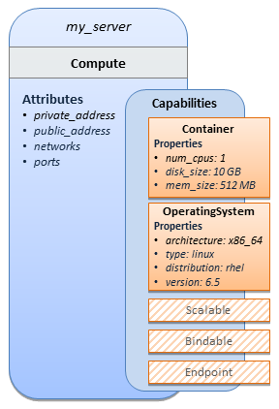

As you can see, the Compute node also has attributes and other built-in capabilities, such as Bindable and Endpoint, each with additional properties that will be discussed in other examples later in this document. Although the Compute node has no direct properties apart from those in its capabilities, other TOSCA node type definitions may have properties that are part of the node type itself in addition to having Capabilities. TOSCA orchestration engines are expected to validate all property values provided in a node template against the property definitions in their respective node type definitions referenced in the service template. The tosca_definitions_version keyname in the TOSCA service template identifies the versioned set of normative TOSCA type definitions to use for validating those types defined in the TOSCA Simple Profile including the Compute node type. Specifically, the value tosca_simple_yaml_1_0 indicates Simple Profile v1.0.0 definitions would be used for validation. Other type definitions may be imported from other service templates using the import keyword discussed later.

### Requesting input parameters and providing output

Typically, one would want to allow users to customize deployments by providing input parameters instead of using hardcoded values inside a template. In addition, output values are provided to pass information that perhaps describes the state of the deployed template to the user who deployed it (such as the private IP address of the deployed server). A refined service template with corresponding inputs and outputs sections is shown below.

Example - Template with input and output parameter sections

|  |
| --- |
| tosca_definitions_version: tosca_simple_yaml_1_0  description: Template for deploying a single server with predefined properties.  topology_template:  inputs:  cpus:  type: integer  description: Number of CPUs for the server.  constraints:  - valid_values: [ 1, 2, 4, 8 ]  node_templates:  my_server:  type: tosca.nodes.Compute  capabilities:  # Host container properties  host:  properties:  # Compute properties  num_cpus: { get_input: cpus }  mem_size: 2048 MB  disk_size: 10 GB  outputs:  server_ip:  description: The private IP address of the provisioned server.  value: { get_attribute: [ my_server, private_address ] } |

The inputs and outputs sections are contained in the topology_template element of the TOSCA template, meaning that they are scoped to node templates within the topology template. Input parameters defined in the inputs section can be assigned to properties of node template within the containing topology template; output parameters can be obtained from attributes of node templates within the containing topology template.

Note that the inputs section of a TOSCA template allows for defining optional constraints on each input parameter to restrict possible user input. Further note that TOSCA provides for a set of intrinsic functions like get_input, get_property or get_attribute to reference elements within the template or to retrieve runtime values.

## TOSCA template for a simple software installation

Software installations can be modeled in TOSCA as node templates that get related to the node template for a server on which the software would be installed. With a number of existing software node types (e.g. either created by the TOSCA work group or a community) template authors can just use those node types for writing service templates as shown below.

Example - Simple (MySQL) software installation on a TOSCA Compute node

|  |
| --- |
| tosca_definitions_version: tosca_simple_yaml_1_0  description: Template for deploying a single server with MySQL software on top.  topology_template:  inputs:  # omitted here for brevity  node_templates:  mysql:  type: tosca.nodes.DBMS.MySQL  properties:  root_password: { get_input: my_mysql_rootpw }  port: { get_input: my_mysql_port }  requirements:  - host: db_server  db_server:  type: tosca.nodes.Compute  capabilities:  # omitted here for brevity |

The example above makes use of a node type tosca.nodes.DBMS.MySQL for the mysql node template to install MySQL on a server. This node type allows for setting a property root_password to adapt the password of the MySQL root user at deployment. The set of properties and their schema has been defined in the node type definition. By means of the **get_input** function, a value provided by the user at deployment time is used as value for the **root_password** property. The same is true for the **port** property.

The **mysql** node template is related to the **db_server** node template (of type tosca.nodes.Compute) via the **requirements** section to indicate where MySQL is to be installed. In the TOSCA metamodel, nodes get related to each other when one node has a requirement against some feature provided by another node. What kinds of requirements exist is defined by the respective node type. In case of MySQL, which is software that needs to be installed or hosted on a compute resource, the underlying node type named DBMS has a predefined requirement called **host**, which needs to be fulfilled by pointing to a node template of type tosca.nodes.Compute.

The logical relationship between the mysql node and its host db_server node would appear as follows:

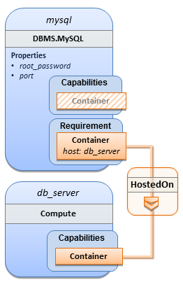

Within the requirements section, all entries simple entries are a map which contains the symbolic name of a requirement definition as the *key* and the identifier of the fulfilling node as the *value.* The value is essentially the symbolic name of the other node template; specifically, or the example above, the **host** requirement is fulfilled by referencing the db_server node template. The underlying TOSCA DBMS node type already defines a complete requirement definition for the host requirement of type Container and assures that a HostedOn TOSCA relationship will automatically be created and will only allow a valid target host node is of type Compute. This approach allows the template author to simply provide the name of a valid Compute node (i.e., db_server) as the value for the mysql node’s host requirement and not worry about defining anything more complex if they do not want to.

## Overriding behavior of predefined node types

Node types in TOSCA have associated implementations that provide the automation (e.g. in the form of scripts such as Bash, Chef or Python) for the normative lifecycle operations of a node. For example, the node type implementation for a MySQL database would associate scripts to TOSCA node operations like configure, start, or stop to manage the state of MySQL at runtime.

Many node types may already come with a set of operational scripts that contain basic commands that can manage the state of that specific node. If it is desired, template authors can provide a custom script for one or more of the operation defined by a node type in their node template which will override the default implementation in the type. The following example shows a mysql node template where the template author provides their own configure script:

Example - Node Template overriding its Node Type's "configure" interface

|  |
| --- |
| tosca_definitions_version: tosca_simple_yaml_1_0  description: Template for deploying a single server with MySQL software on top.  topology_template:  inputs:  # omitted here for brevity  node_templates:  mysql:  type: tosca.nodes.DBMS.MySQL  properties:  root_password: { get_input: my_mysql_rootpw }  port: { get_input: my_mysql_port }  requirements:  - host: db_server  interfaces:  Standard:  configure: scripts/my_own_configure.sh  db_server:  type: tosca.nodes.Compute  capabilities:  # omitted here for brevity |

In the example above, the my_own_configure.sh script is provided for the configure operation of the MySQL node type’s Standard lifecycle interface. The path given in the example above (i.e., ‘scripts/’) is interpreted relative to the template file, but it would also be possible to provide an absolute URI to the location of the script.

In other words, operations defined by node types can be thought of as “hooks” into which automation can be injected. Typically, node type implementations provide the automation for those “hooks”. However, within a template, custom automation can be injected to run in a hook in the context of the one, specific node template (i.e. without changing the node type).

## TOSCA template for database content deployment

In the Example 4, shown above, the deployment of the MySQL middleware only, i.e. without actual database content was shown. The following example shows how such a template can be extended to also contain the definition of custom database content on-top of the MySQL DBMS software.

Example - Template for deploying database content on-top of MySQL DBMS middleware

|  |
| --- |
| tosca_definitions_version: tosca_simple_yaml_1_0  description: Template for deploying MySQL and database content.  topology_template:  inputs:  # omitted here for brevity  node_templates:  my_db:  type: tosca.nodes.Database.MySQL  properties:  name: { get_input: database_name }  user: { get_input: database_user }  password: { get_input: database_password }  port: { get_input: database_port }  artifacts:  db_content:  file: files/my_db_content.txt  type: tosca.artifacts.File  requirements:  - host: mysql  interfaces:  Standard:  create:  implementation: db_create.sh  inputs:  # Copy DB file artifact to server’s staging area  db_data: { get_artifact: [ SELF, db_content ] }  mysql:  type: tosca.nodes.DBMS.MySQL  properties:  root_password: { get_input: mysql_rootpw }  port: { get_input: mysql_port }  requirements:  - host: db_server  db_server:  type: tosca.nodes.Compute  capabilities:  # omitted here for brevity |

In the example above, the my_db node template or type tosca.nodes.Database.MySQL represents an actual MySQL database instance managed by a MySQL DBMS installation. The requirements section of the my_db node template expresses that the database it represents is to be hosted on a MySQL DBMS node template named mysqlwhich is also declared in this template.

In its **artifacts** section of the my_db the node template, there is an artifact definition named db_content which represents a text file my_db_content.txt which in turn will be used to add content to the SQL database as part of the create operation. The **requirements** section of the **my_db** node template expresses that the database is hosted on a MySQL DBMS represented by the **mysql** node.

As you can see above, a script is associated with the create operation with the name db_create.sh. The TOSCA Orchestrator sees that this is not a named artifact declared in the node’s artifact section, but instead a filename for a normative TOSCA implementation artifact script type (i.e., tosca.artifacts.Implementation.Bash). Since this is an implementation type for TOSCA, the orchestrator will execute the script automatically to create the node on db_server, but first it will prepare the local environment with the declared inputs for the operation. In this case, the orchestrator would see that the db_data input is using the get_artifact function to retrieve the file (my_db_content.txt) which is associated with the db_content artifact name prior to executing the db_create.sh script.

The logical diagram for this example would appear as follows:

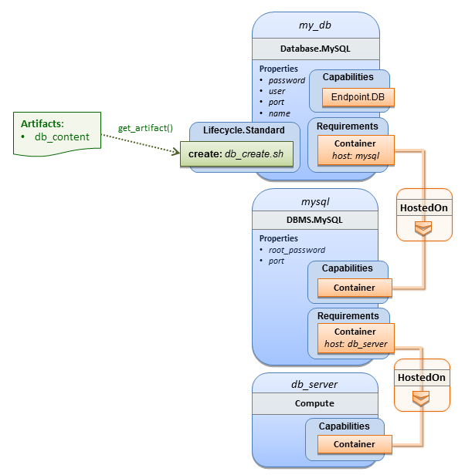

Note that while it would be possible to define one node type and corresponding node templates that represent both the DBMS middleware and actual database content as one entity, TOSCA normative node types distinguish between middleware (container) and application (containee) node types. This allows on one hand to have better re-use of generic middleware node types without binding them to content running on top of them, and on the other hand this allows for better substitutability of, for example, middleware components like a DBMS during the deployment of TOSCA models.

## TOSCA template for a two-tier application

The definition of multi-tier applications in TOSCA is quite similar to the example shown in section 2.2, with the only difference that multiple software node stacks (i.e., node templates for middleware and application layer components), typically hosted on different servers, are defined and related to each other. The example below defines a web application stack hosted on the **web_server** “compute” resource, and a database software stack similar to the one shown earlier in section 6 hosted on the **db_server** compute resource.

Example - Basic two-tier application (web application and database server tiers)

|  |
| --- |
| tosca_definitions_version: tosca_simple_yaml_1_0  description: Template for deploying a two-tier application servers on two  topology_template:  inputs:  # Admin user name and password to use with the WordPress application  wp_admin_username:  type: string  wp_admin_password:  type: string  wp_db_name:  type: string  wp_db_user:  type: string  wp_db_password:  type: string  wp_db_port:  type: integer  mysql_root_password:  type: string  mysql_port:  type: integer  context_root:  type: string  node_templates:  wordpress:  type: tosca.nodes.WebApplication.WordPress  properties:  context_root: { get_input: context_root }  admin_user: { get_input: wp_admin_username }  admin_password: { get_input: wp_admin_password }  db_host: { get_attribute: [ db_server, private_address ] }  requirements:  - host: apache  - database_endpoint: wordpress_db  interfaces:  Standard:  inputs:  db_host: { get_attribute: [ db_server, private_address ] }  db_port: { get_property: [ wordpress_db, port ] }  db_name: { get_property: [ wordpress_db, name ] }  db_user: { get_property: [ wordpress_db, user ] }  db_password: { get_property: [ wordpress_db, password ] }  apache:  type: tosca.nodes.WebServer.Apache  properties:  # omitted here for brevity  requirements:  - host: web_server  web_server:  type: tosca.nodes.Compute  capabilities:  # omitted here for brevity  wordpress_db:  type: tosca.nodes.Database.MySQL  properties:  name: { get_input: wp_db_name }  user: { get_input: wp_db_user }  password: { get_input: wp_db_password }  port: { get_input: wp_db_port }  requirements:  - host: mysql  mysql:  type: tosca.nodes.DBMS.MySQL  properties:  root_password: { get_input: mysql_root_password }  port: { get_input: mysql_port }  requirements:  - host: db_server  db_server:  type: tosca.nodes.Compute  capabilities:  # omitted here for brevity |

The web application stack consists of the **wordpress** [WordPress], the **apache** [Apache] and the **web_server** node templates. The **wordpress** node template represents a custom web application of type **tosca.nodes.WebApplication.WordPress** which is hosted on an Apache web server represented by the **apache** node template. This hosting relationship is expressed via the **host** entry in the **requirements** section of the **wordpress** node template. The **apache** node template, finally, is hosted on the **web_server** compute node.

The database stack consists of the **wordpress_db**, the **mysql** and the **db_server** node templates. The **wordpress_db** node represents a custom database of type **tosca.nodes.Database.MySQL** which is hosted on a MySQL DBMS represented by the **mysql** node template. This node, in turn, is hosted on the **db_server** compute node.

The **wordpress** node requires a connection to the **wordpress_db** node, since the WordPress application needs a database to store its data in. This relationship is established through the **database**_endpoint entry in the **requirements** section of the **wordpress** node template’s declared node type. For configuring the WordPress web application, information about the database to connect to is required as input to the **configure** operation. Therefore, the input parameters are defined and values for them are retrieved from the properties and attributes of the **wordpress_db** node via the **get_property** and get_attribute functions. In the above example, these inputs are defined at the interface-level and would be available to all operations of the Standard interface (i.e., the tosca.interfaces.node.lifecycle.Standard interface) within the wordpress node template and not just the configure operation.

## Using a custom script to establish a relationship in a template

In previous examples, the template author did not have to think about explicit relationship types to be used to link a requirement of a node to another node of a model, nor did the template author have to think about special logic to establish those links. For example, the **host** requirement in previous examples just pointed to another node template and based on metadata in the corresponding node type definition the relationship type to be established is implicitly given.

In some cases, it might be necessary to provide special processing logic to be executed when establishing relationships between nodes at runtime. For example, when connecting the WordPress application from previous examples to the MySQL database, it might be desired to apply custom configuration logic in addition to that already implemented in the application node type. In such a case, it is possible for the template author to provide a custom script as implementation for an operation to be executed at runtime as shown in the following example.

Example - Providing a custom relationship script to establish a connection

|  |
| --- |
| tosca_definitions_version: tosca_simple_yaml_1_0  description: Template for deploying a two-tier application on two servers.  topology_template:  inputs:  # omitted here for brevity  node_templates:  wordpress:  type: tosca.nodes.WebApplication.WordPress  properties:  # omitted here for brevity  requirements:  - host: apache  - database_endpoint:  node: wordpress_db  relationship: my_custom_database_connection  wordpress_db:  type: tosca.nodes.Database.MySQL  properties:  # omitted here for the brevity  requirements:  - host: mysql  relationship_templates:  my_custom_database_connection:  type: ConnectsTo  interfaces:  Configure:  pre_configure_source: scripts/wp_db_configure.sh  # other resources not shown for this example ... |

The node type definition for the wordpress node template is WordPress which declares the complete **database_endpoint** requirement definition. This database_endpoint declaration indicates it must be fulfilled by any node template that provides an Endpoint.Database Capability Type using a ConnectsTo relationship. The wordpress_db node template’s underlying MySQL type definition indeed provides the Endpoint.DatabaseCapability type. In this example however, no explicit relationship template is declared; therefore, TOSCA orchestrators would automatically create a ConnectsTo relationship to establish the link between the wordpress node and the wordpress_db node at runtime.

The ConnectsTo relationship (see 5.7.4) also provides a default Configure interface with operations that optionally get executed when the orchestrator establishes the relationship. In the above example, the author has provided the custom script wp_db_configure.sh to be executed for the operation calledpre_configure_source. The script file is assumed to be located relative to the referencing service template such as a relative directory within the TOSCA Cloud Service Archive (CSAR) packaging format. This approach allows for conveniently hooking in custom behavior without having to define a completely new derived relationship type.

## Using custom relationship types in a TOSCA template

In the previous section it was shown how custom behavior can be injected by specifying scripts inline in the requirements section of node templates. When the same custom behavior is required in many templates, it does make sense to define a new relationship type that encapsulates the custom behavior in a re-usable way instead of repeating the same reference to a script (or even references to multiple scripts) in many places.

Such a custom relationship type can then be used in templates as shown in the following example.

Example - A web application Node Template requiring a custom database connection type

|  |
| --- |
| tosca_definitions_version: tosca_simple_yaml_1_0  description: Template for deploying a two-tier application on two servers.  topology_template:  inputs:  # omitted here for brevity  node_templates:  wordpress:  type: tosca.nodes.WebApplication.WordPress  properties:  # omitted here for brevity  requirements:  - host: apache  - database_endpoint:  node: wordpress_db  relationship: my.types.WordpressDbConnection  wordpress_db:  type: tosca.nodes.Database.MySQL  properties:  # omitted here for the brevity  requirements:  - host: mysql  # other resources not shown here ... |

In the example above, a special relationship type **my.types.WordpressDbConnection** is specified for establishing the link between the **wordpress** node and the **wordpress_db** node through the use of the **relationship** (keyword) attribute in the **database** reference. It is assumed, that this special relationship type provides some extra behavior (e.g., an operation with a script) in addition to what a generic “connects to” relationship would provide. The definition of this custom relationship type is shown in the following section.

### Definition of a custom relationship type

The following YAML snippet shows the definition of the custom relationship type used in the previous section. This type derives from the base “ConnectsTo” and overrides one operation defined by that base relationship type. For the pre_configure_source operation defined in the Configure interface of the ConnectsTo relationship type, a script implementation is provided. It is again assumed that the custom configure script is located at a location relative to the referencing service template, perhaps provided in some application packaging format (e.g., the TOSCA Cloud Service Archive (CSAR) format).

Example - Defining a custom relationship type

|  |
| --- |
| tosca_definitions_version: tosca_simple_yaml_1_0  description: Definition of custom WordpressDbConnection relationship type  relationship_types:  my.types.WordpressDbConnection:  derived_from: tosca.relationships.ConnectsTo  interfaces:  Configure:  pre_configure_source: scripts/wp_db_configure.sh |

In the above example, the Configure interface is the specified alias or shorthand name for the TOSCA interface type with the full name of tosca.interfaces.relationship.Configure which is defined in the appendix.

## Defining generic dependencies between nodes in a template

In some cases, it can be necessary to define a generic dependency between two nodes in a template to influence orchestration behavior, i.e. to first have one node processed before another dependent node gets processed. This can be done by using the generic dependency requirement which is defined by the TOSCA Root Node Type and thus gets inherited by all other node types in TOSCA (see section 5.9.1).

Example - Simple dependency relationship between two nodes

|  |
| --- |
| tosca_definitions_version: tosca_simple_yaml_1_0  description: Template with a generic dependency between two nodes.  topology_template:  inputs:  # omitted here for brevity  node_templates:  my_app:  type: my.types.MyApplication  properties:  # omitted here for brevity  requirements:  - dependency: some_service  some_service:  type: some.nodetype.SomeService  properties:  # omitted here for brevity |

As in previous examples, the relation that one node depends on another node is expressed in the requirements section using the built-in requirement named dependency that exists for all node types in TOSCA. Even if the creator of the MyApplication node type did not define a specific requirement for SomeService (similar to the database requirement in the example in section 2.6), the template author who knows that there is a timing dependency and can use the generic dependency requirement to express that constraint using the very same syntax as used for all other references.

## Describing abstract requirements for nodes and capabilities in a TOSCA template

In TOSCA templates, nodes are either:

* **Concrete**: meaning that they have a deployment and/or one or more implementation artifacts that are declared on the “create” operation of the node’s Standard lifecycle interface, or they are
* **Abstract**: where the template describes the node type along with its required capabilities and properties that must be satisfied.

TOSCA Orchestrators, by default, when finding an abstract node in TOSCA Service Template during deployment will attempt to “select” a concrete implementation for the abstract node type that best matches and fulfills the requirements and property constraints the template author provided for that abstract node. The concrete implementation of the node could be provided by another TOSCA Service Template (perhaps located in a catalog or repository known to the TOSCA Orchestrator) or by an existing resource or service available within the target Cloud Provider’s platform that the TOSCA Orchestrator already has knowledge of.

TOSCA supports two methods for template authors to express requirements for an abstract node within a TOSCA service template.

1. ***Using a target node_filter***: where a node template can describe a requirement (relationship) for another node without including it in the topology. Instead, the node provides a node_filter to describe the target node type along with its capabilities and property constrains
2. ***Using an abstract node template***: that describes the abstract node’s type along with its property constraints and any requirements and capabilities it also exports. This first method you have already seen in examples from previous chapters where the Compute node is abstract and selectable by the TOSCA Orchestrator using the supplied Container and OperatingSystem capabilities property constraints.

These approaches allow architects and developers to create TOSCA service templates that are composable and can be reused by allowing flexible matching of one template’s requirements to another’s capabilities. Examples of both these approaches are shown below.

### Using a node_filter to define hosting infrastructure requirements for a software

Using TOSCA, it is possible to define only the software components of an application in a template and just express constrained requirements against the hosting infrastructure. At deployment time, the provider can then do a late binding and dynamically allocate or assign the required hosting infrastructure and place software components on top.

This example shows how a single software component (i.e., the mysql node template) can define its host requirements that the TOSCA Orchestrator and provider will use to select or allocate an appropriate host Compute node by using matching criteria provided on a node_filter.

Example - An abstract "host" requirement using a node filter

|  |
| --- |
| tosca_definitions_version: tosca_simple_yaml_1_0  description: Template with requirements against hosting infrastructure.  topology_template:  inputs:  # omitted here for brevity  node_templates:  mysql:  type: tosca.nodes.DBMS.MySQL  properties:  # omitted here for brevity  requirements:  - host:  node_filter:  capabilities:  # Constraints for selecting “host” (Container Capability)  - host:  properties:  - num_cpus: { in_range: [ 1, 4 ] }  - mem_size: { greater_or_equal: 2 GB }  # Constraints for selecting “os” (OperatingSystem Capability)  - os:  properties:  - architecture: { equal: x86_64 }  - type: linux  - distribution: ubuntu |

In the example above, the **mysql** component contains a host requirement for a node of type **Compute** which it inherits from its parent DBMS node type definition; however, there is no declaration or reference to any node template of type Compute. Instead, the mysql node template augments the abstract “host” requirement with a node_filter which contains additional selection criteria (in the form of property constraints that the provider must use when selecting or allocating a host Compute node.

Some of the constraints shown above narrow down the boundaries of allowed values for certain properties such as mem_size or num_cpus for the “host” capability by means of qualifier functions such as **greater_or_equal**. Other constraints, express specific values such as for the architecture or distribution properties of the “os” capability which will require the provider to find a precise match.

Note that when no qualifier function is provided for a property (filter), such as for the distribution property, it is interpreted to mean the equal operator as shown on the architecture property.

### Using an abstract node template to define infrastructure requirements for software

This previous approach works well if no other component (i.e., another node template) other than mysql node template wants to reference the same Compute node the orchestrator would instantiate. However, perhaps another component wants to also be deployed on the same host, yet still allow the flexible matching achieved using a node-filter. The alternative to the above approach is to create an abstract node template that represents the Compute node in the topology as follows:

Example - An abstract Compute node template with a node filter

|  |
| --- |
| tosca_definitions_version: tosca_simple_yaml_1_0    description: Template with requirements against hosting infrastructure.  topology_template:  inputs:  # omitted here for brevity  node_templates:  mysql:  type: tosca.nodes.DBMS.MySQL  properties:  # omitted here for brevity  requirements:  - host: mysql_compute  # Abstract node template (placeholder) to be selected by provider  mysql_compute:  type: Compute  node_filter:  capabilities:  - host:  properties:  num_cpus: { equal: 2 }  mem_size: { greater_or_equal: 2 GB }  - os:  properties:  architecture: { equal: x86_64 }  type: linux  distribution: ubuntu |

As you can see the resulting mysql_compute node template looks very much like the “hello world” template as shown in Chapter 2.1 (where the Compute node template was abstract), but this one also allows the TOSCA orchestrator more flexibility when “selecting” a host Compute node by providing flexible constraints for properties like mem_size.

As we proceed, you will see that TOSCA provides many normative node types like Compute for commonly found services (e.g., BlockStorage, WebServer, Network, etc.). When these TOSCA normative node types are used in your application’s topology they are always assumed to be “selectable” by TOSCA Orchestrators which work with target infrastructure providers to find or allocate the best match for them based upon your application’s requirements and constraints.

### Using a node_filter to define requirements on a database for an application

In the same way requirements can be defined on the hosting infrastructure (as shown above) for an application, it is possible to express requirements against application or middleware components such as a database that is not defined in the same template. The provider may then allocate a database by any means, (e.g. using a database-as-a-service solution).

Example - An abstract database requirement using a node filter

|  |
| --- |
| tosca_definitions_version: tosca_simple_yaml_1_0  description: Template with a TOSCA Orchestrator selectable database requirement using a node_filter.  topology_template:  inputs:  # omitted here for brevity  node_templates:  my_app:  type: my.types.MyApplication  properties:  admin_user: { get_input: admin_username }  admin_password: { get_input: admin_password }  db_endpoint_url: { get_property: [SELF, database_endpoint, url_path ] }  requirements:  - database_endpoint:  node: my.types.nodes.MyDatabase  node_filter:  properties:  - db_version: { greater_or_equal: 5.5 } |

In the example above, the application my_app requires a database node of type MyDatabase which has a db_version property value of greater_or_equal to the value 5.5.

This example also shows how the get_property intrinsic function can be used to retrieve the url_path property from the database node that will be selected by the provider and connected to my_app at runtime due to fulfillment of the database_endpoint requirement. To locate the property, the get_property’s first argument is set to the keyword SELF which indicates the property is being referenced from something in the node itself. The second parameter is the name of the requirement named **database_endpoint** which contains the property we are looking for. The last argument is the name of the property itself (i.e., url_path) which contains the value we want to retrieve and assign to db_endpoint_url.

The alternative representation, which includes a node template in the topology for database that is still selectable by the TOSCA orchestrator for the above example, is as follows:

Example - An abstract database node template

|  |
| --- |
| tosca_definitions_version: tosca_simple_yaml_1_0  description: Template with a TOSCA Orchestrator selectable database using node template.  topology_template:  inputs:  # omitted here for brevity  node_templates:  my_app:  type: my.types.MyApplication  properties:  admin_user: { get_input: admin_username }  admin_password: { get_input: admin_password }  db_endpoint_url: { get_property: [SELF, database_endpoint, url_path ] }  requirements:  - database_endpoint: my_abstract_database  my_abstract_database:  type: my.types.nodes.MyDatabase  properties:  - db_version: { greater_or_equal: 5.5 } |

## Using node template substitution for model composition

From an application perspective, it is often not necessary or desired to dive into platform details, but the platform/runtime for an application is abstracted. In such cases, the template for an application can use generic representations of platform components. The details for such platform components, such as the underlying hosting infrastructure at its configuration, can then be defined in separate template files that can be used for substituting the more abstract representations in the application level template file.

### Understanding node template instantiation through a TOSCA Orchestrator

When a topology template is instantiated by a TOSCA Orchestrator, the orchestrator has to look for realizations of the single node templates according to the node types specified for each node template. Such realizations can either be node types that include the appropriate implementation artifacts and deployment artifacts that can be used by the orchestrator to bring to life the real-world resource modeled by a node template. Alternatively, separate topology templates may be annotated as being suitable for realizing a node template in the top-level topology template.

In the latter case, a TOSCA Orchestrator will use additional substitution mapping information provided as part of the substituting topology templates to derive how the substituted part gets “wired” into the overall deployment, for example, how capabilities of a node template in the top-level topology template get bound to capabilities of node templates in the substituting topology template.

Thus, in cases where no “normal” node type implementation is available, or the node type corresponds to a whole subsystem that cannot be implemented as a single node, additional topology templates can be used for filling in more abstract placeholders in top level application templates.

### Definition of the top-level service template

The following sample defines a web application web_app connected to a database db. In this example, the complete hosting stack for the application is defined within the same topology template: the web application is hosted on a web server web_server, which in turn is installed (hosted) on a compute node server.

The hosting stack for the database db, in contrast, is not defined within the same file but only the database is represented as a node template of type tosca.nodes.Database. The underlying hosting stack for the database is defined in a separate template file, which is shown later in this section. Within the current template, only a number of properties (user, password, name) are assigned to the database using hardcoded values in this simple example.

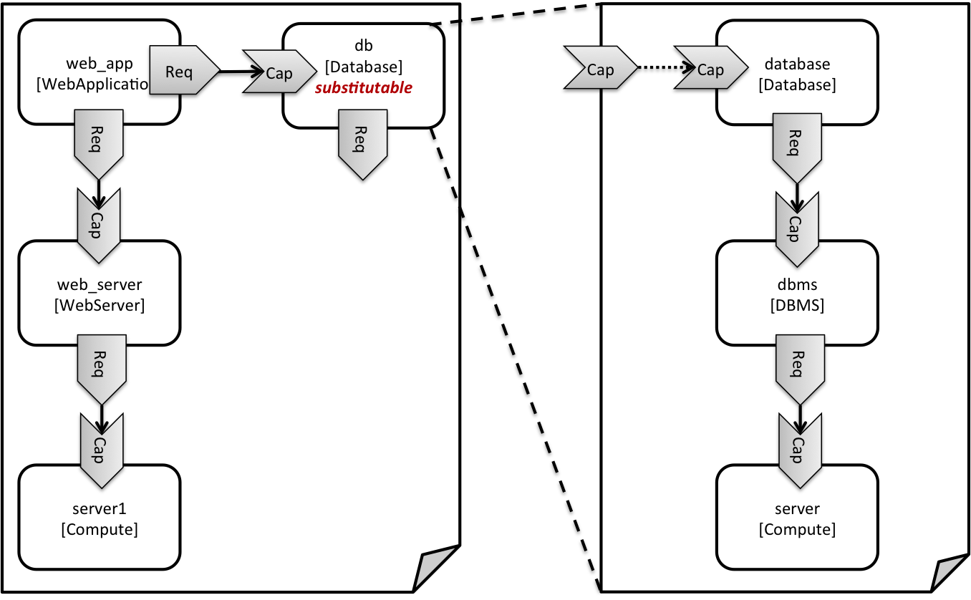

Figure : Using template substitution to implement a database tier

When a node template is to be substituted by another service template, this has to be indicated to an orchestrator by means of a special “*substitutable*” directive. This directive causes, for example, special processing behavior when validating the left-hand service template in Figure 1. The hosting requirement of the db node template is not bound to any capability defined within the service template, which would normally cause a validation error. When the “*substitutable*” directive is present, the orchestrator will however first try to perform substitution of the respective node template and after that validate if all mandatory requirements of all nodes in the resulting graph are fulfilled.

Note that in contrast to the use case described in section 2.9.2 (where a database was abstractly referred to in the requirements section of a node and the database itself was not represented as a node template), the approach shown here allows for some additional modeling capabilities in cases where this is required.

For example, if multiple components need to use the same database (or any other sub-system of the overall service), this can be expressed by means of normal relations between node templates, whereas such modeling would not be possible in requirements sections of disjoint node templates.

Example - Referencing an abstract database node template

|  |
| --- |
| tosca_definitions_version: tosca_simple_yaml_1_0  topology_template:  description: Template of an application connecting to a database.  node_templates:  web_app:  type: tosca.nodes.WebApplication.MyWebApp  requirements:  - host: web_server  - database_endpoint: db  web_server:  type: tosca.nodes.WebServer  requirements:  - host: server  server:  type: tosca.nodes.Compute  # details omitted for brevity  db:  # This node is abstract (no Deployment or Implementation artifacts on create)  # and can be substituted with a topology provided by another template  # that exports a Database type’s capabilities.  type: tosca.nodes.Database  properties:  user: my_db_user  password: secret  name: my_db_name |

### Definition of the database stack in a service template

The following sample defines a template for a database including its complete hosting stack, i.e. the template includes a database node template, a template for the database management system (dbms) hosting the database, as well as a computer node server on which the DBMS is installed.

This service template can be used standalone for deploying just a database and its hosting stack. In the context of the current use case, though, this template can also substitute the database node template in the previous snippet and thus fill in the details of how to deploy the database.

In order to enable such a substitution, an additional metadata section substitution_mappings is added to the topology template to tell a TOSCA Orchestrator how exactly the topology template will fit into the context where it gets used. For example, requirements or capabilities of the node that gets substituted by the topology template have to be mapped to requirements or capabilities of internal node templates for allow for a proper wiring of the resulting overall graph of node templates.

In short, the substitution_mappings section provides the following information:

1. It defines what node templates, i.e. node templates of which type, can be substituted by the topology template.
2. It defines how capabilities of the substituted node (or the capabilities defined by the node type of the substituted node template, respectively) are bound to capabilities of node templates defined in the topology template.
3. It defines how requirements of the substituted node (or the requirements defined by the node type of the substituted node template, respectively) are bound to requirements of node templates defined in the topology template.

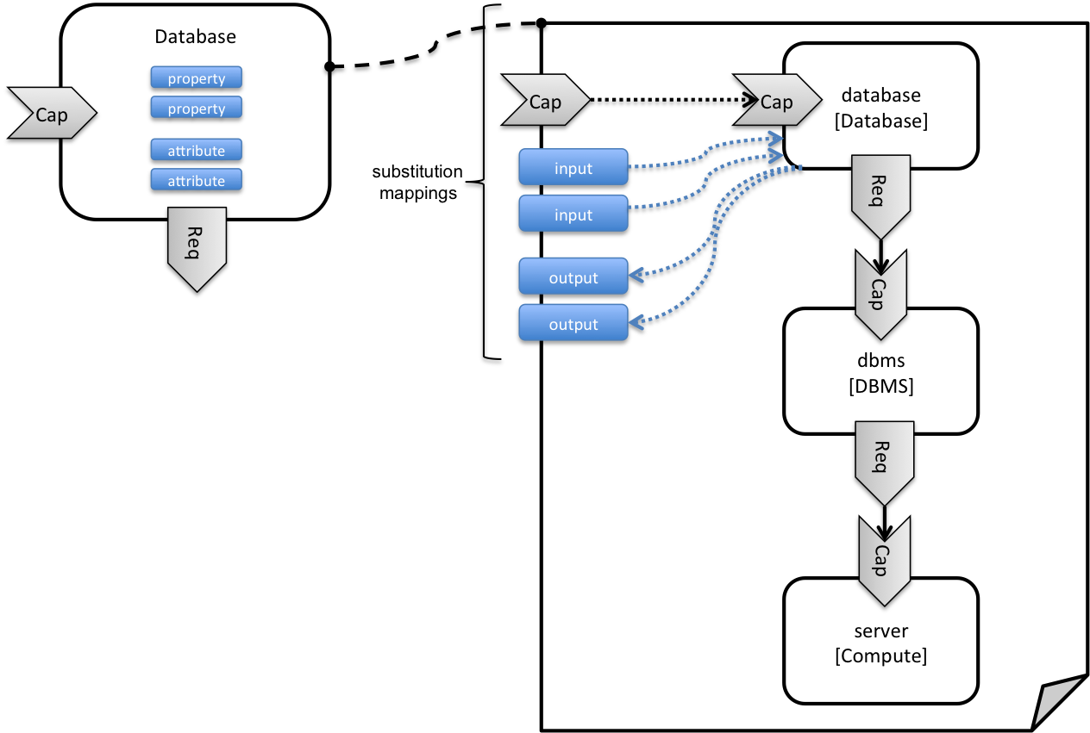

Figure : Substitution mappings

The substitution_mappings section in the sample below denotes that this topology template can be used for substituting node templates of type tosca.nodes.Database. It further denotes that the database_endpoint capability of the substituted node gets fulfilled by the database_endpoint capability of the database node contained in the topology template.

Example - Using substitution mappings to export a database implementation

|  |
| --- |
| tosca_definitions_version: tosca_simple_yaml_1_0  topology_template:  description: Template of a database including its hosting stack.  inputs:  db_user:  type: string  db_password:  type: string  # other inputs omitted for brevity  substitution_mappings:  node_type: tosca.nodes.Database  capabilities:  database_endpoint: [ database, database_endpoint ]  node_templates:  database:  type: tosca.nodes.Database  properties:  user: { get_input: db_user }  # other properties omitted for brevity  requirements:  - host: dbms  dbms:  type: tosca.nodes.DBMS  # details omitted for brevity  server:  type: tosca.nodes.Compute  # details omitted for brevity |

Note that the substitution_mappings section does not define any mappings for requirements of the Database node type, since all requirements are fulfilled by other nodes templates in the current topology template. In cases where a requirement of a substituted node is bound in the top-level service template as well as in the substituting topology template, a TOSCA Orchestrator should raise a validation error.

Further note that no mappings for properties or attributes of the substituted node are defined. Instead, the inputs and outputs defined by the topology template have to match the properties and attributes or the substituted node. If there are more inputs than the substituted node has properties, default values must be defined for those inputs, since no values can be assigned through properties in a substitution case.

## Using node template substitution for chaining subsystems

A common use case when providing an end-to-end service is to define a chain of several subsystems that together implement the overall service. Those subsystems are typically defined as separate service templates to (1) keep the complexity of the end-to-end service template at a manageable level and to (2) allow for the re-use of the respective subsystem templates in many different contexts. The type of subsystems may be specific to the targeted workload, application domain, or custom use case. For example, a company or a certain industry might define a subsystem type for company- or industry specific data processing and then use that subsystem type for various end-user services. In addition, there might be generic subsystem types like a database subsystem that are applicable to a wide range of use cases.

### Defining the overall subsystem chain

Figure 3 shows the chaining of three subsystem types – a message queuing subsystem, a transaction processing subsystem, and a databank subsystem – that support, for example, an online booking application. On the front end, this chain provides a capability of receiving messages for handling in the message queuing subsystem. The message queuing subsystem in turn requires a number of receivers, which in the current example are two transaction processing subsystems. The two instances of the transaction processing subsystem might be deployed on two different hosting infrastructures or datacenters for high-availability reasons. The transaction processing subsystems finally require a database subsystem for accessing and storing application specific data. The database subsystem in the backend does not require any further component and is therefore the end of the chain in this example.

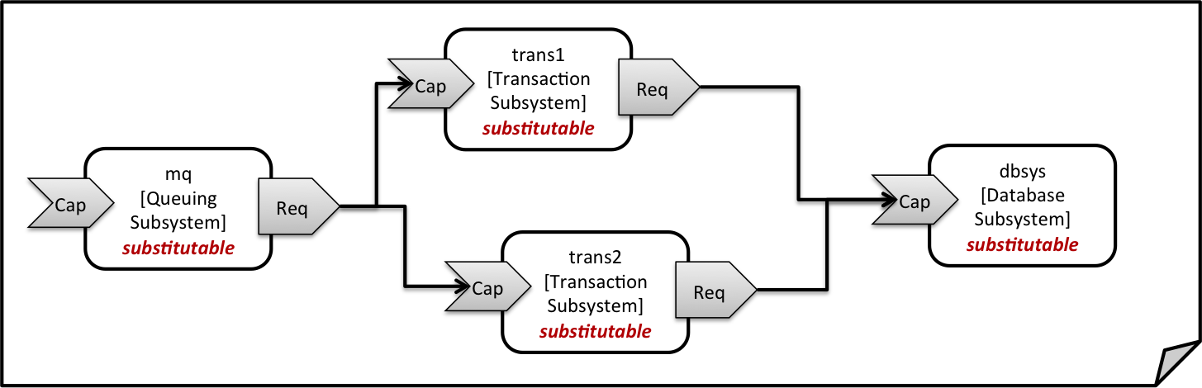

Figure : Chaining of subsystems in a service template

All of the node templates in the service template shown above are abstract and considered substitutable where each can be treated as their own subsystem; therefore, when instantiating the overall service, the orchestrator would realize each substitutable node template using other TOSCA service templates. These service templates would include more nodes and relationships that include the details for each subsystem. A simplified version of a TOSCA service template for the overall service is given in the following listing.

Example - Declaring a transaction subsystem as a chain of substitutable node templates

|  |
| --- |
| tosca_definitions_version: tosca_simple_yaml_1_0  topology_template:  description: Template of online transaction processing service.  node_templates:  mq:  type: example.QueuingSubsystem  properties:  # properties omitted for brevity  capabilities:  message_queue_endpoint:  # details omitted for brevity  requirements:  - receiver: trans1  - receiver: trans2  trans1:  type: example.TransactionSubsystem  properties:  mq_service_ip: { get_attribute: [ mq, service_ip ] }  receiver_port: 8080  capabilities:  message_receiver:  # details omitted for brevity  requirements:  - database_endpoint: dbsys  trans2:  type: example.TransactionSubsystem  properties:  mq_service_ip: { get_attribute: [ mq, service_ip ] }  receiver_port: 8080  capabilities:  message_receiver:  # details omitted for brevity  requirements:  - database_endpoint: dbsys  dbsys:  type: example.DatabaseSubsystem  properties:  # properties omitted for brevity  capabilities:  database_endpoint:  # details omitted for brevity |

As can be seen in the example above, the subsystems are chained to each other by binding requirements of one subsystem node template to other subsystem node templates that provide the respective capabilities. For example, the receiver requirement of the message queuing subsystem node template mq is bound to transaction processing subsystem node templates trans1 and trans2.

Subsystems can be parameterized by providing properties. In the listing above, for example, the IP address of the message queuing server is provided as property mq_service_ip to the transaction processing subsystems and the desired port for receiving messages is specified by means of the receiver_port property.

If attributes of the instantiated subsystems need to be obtained, this would be possible by using the get_attribute intrinsic function on the respective subsystem node templates.

### Defining a subsystem (node) type

The types of subsystems that are required for a certain end-to-end service are defined as TOSCA node types as shown in the following example. Node templates of those node types can then be used in the end-to-end service template to define subsystems to be instantiated and chained for establishing the end-to-end service.

The realization of the defined node type will be given in the form of a whole separate service template as outlined in the following section.

Example - Defining a TransactionSubsystem node type

|  |
| --- |
| tosca_definitions_version: tosca_simple_yaml_1_0  node_types:  example.TransactionSubsystem:  properties:  mq_service_ip:  type: string  receiver_port:  type: integer  attributes:  receiver_ip:  type: string  receiver_port:  type: integer  capabilities:  message_receiver: tosca.capabilities.Endpoint  requirements:  - database_endpoint: tosca.capabilities.Endpoint.Database |

Configuration parameters that would be allowed for customizing the instantiation of any subsystem are defined as properties of the node type. In the current example, those are the properties mq_service_ip and receiver_port that had been used in the end-to-end service template in section 2.11.1.

Observable attributes of the resulting subsystem instances are defined as attributes of the node type. In the current case, those are the IP address of the message receiver as well as the actually allocated port of the message receiver endpoint.

### Defining the details of a subsystem

The details of a subsystem, i.e. the software components and their hosting infrastructure, are defined as node templates and relationships in a service template. By means of substitution mappings that have been introduced in section 2.10.2, the service template is annotated to indicate to an orchestrator that it can be used as realization of a node template of certain type, as well as how characteristics of the node type are mapped to internal elements of the service template.

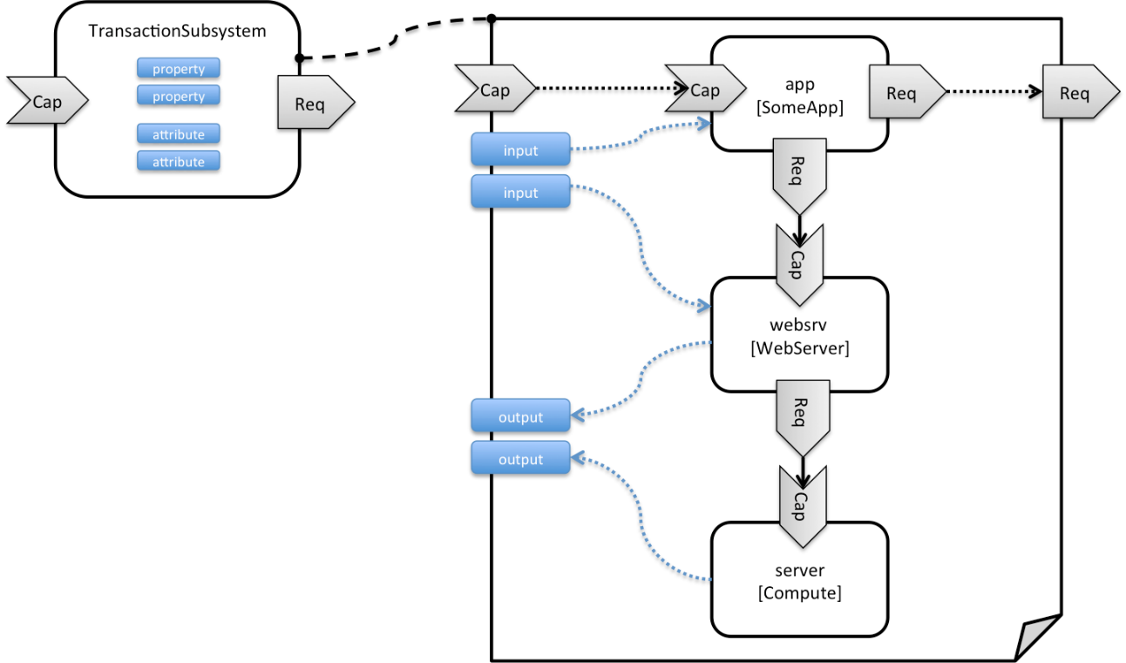

Figure : Defining subsystem details in a service template

Figure 1 illustrates how a transaction processing subsystem as outlined in the previous section could be defined in a service template. In this example, it simply consists of a custom application app of type SomeApp that is hosted on a web server websrv, which in turn is running on a compute node.

The application named app provides a capability to receive messages, which is bound to the message_receiver capability of the substitutable node type. It further requires access to a database, so the application’s database_endpoint requirement is mapped to the database_endpoint requirement of the TransactionSubsystem node type.

Properties of the TransactionSubsystem node type are used to customize the instantiation of a subsystem. Those properties can be mapped to any node template for which the author of the subsystem service template wants to expose configurability. In the current example, the application app and the web server middleware websrv get configured through properties of the TransactionSubsystem node type. All properties of that node type are defined as inputs of the service template. The input parameters in turn get mapped to node templates by means of get_input function calls in the respective sections of the service template.

Similarly, attributes of the whole subsystem can be obtained from attributes of particular node templates. In the current example, attributes of the web server and the hosting compute node will be exposed as subsystem attributes. All exposed attributes that are defined as attributes of the substitutable TransactionSubsystem node type are defined as outputs of the subsystem service template.

An outline of the subsystem service template is shown in the listing below. Note that this service template could be used for stand-alone deployment of a transaction processing system as well, i.e. it is not restricted just for use in substitution scenarios. Only the presence of the substitution_mappings metadata section in the topology_template enables the service template for substitution use cases.

Example - Implementation of a TransactionSubsytem node type using substitution mappings

|  |
| --- |
| tosca_definitions_version: tosca_simple_yaml_1_0  topology_template:  description: Template of a database including its hosting stack.  inputs:  mq_service_ip:  type: string  description: IP address of the message queuing server to receive messages from  receiver_port:  type: string  description: Port to be used for receiving messages  # other inputs omitted for brevity  substitution_mappings:  node_type: example.TransactionSubsystem  capabilities:  message_receiver: [ app, message_receiver ]  requirements:  database_endpoint: [ app, database ]  node_templates:  app:  type: example.SomeApp  properties:  # properties omitted for brevity  capabilities:  message_receiver:  properties:  service_ip: { get_input: mq_service_ip }  # other properties omitted for brevity  requirements:  - database:  # details omitted for brevity  - host: websrv  websrv:  type: tosca.nodes.WebServer  properties:  # properties omitted for brevity  capabilities:  data_endpoint:  properties:  port_name: { get_input: receiver_port }  # other properties omitted for brevity  requirements:  - host: server  server:  type: tosca.nodes.Compute  # details omitted for brevity  outputs:  receiver_ip:  description: private IP address of the message receiver application  value: { get_attribute: [ server, private_address ] }  receiver_port:  description: Port of the message receiver endpoint  value: { get_attribute: [ app, app_endpoint, port ] } |

## Grouping node templates

In designing applications composed of several interdependent software components (or nodes) it is often desirable to manage these components as a named group. This can provide an effective way of associating policies (e.g., scaling, placement, security or other) that orchestration tools can apply to all the components of group during deployment or during other lifecycle stages.

In many realistic scenarios it is desirable to include scaling capabilities into an application to be able to react on load variations at runtime. The example below shows the definition of a scaling web server stack, where a variable number of servers with apache installed on them can exist, depending on the load on the servers.

Example - Grouping Node Templates for possible policy application

|  |
| --- |
| tosca_definitions_version: tosca_simple_yaml_1_0  description: Template for a scaling web server.  topology_template:  inputs:  # omitted here for brevity  node_templates:  apache:  type: tosca.nodes.WebServer.Apache  properties:  # Details omitted for brevity  requirements:  - host: server  server:  type: tosca.nodes.Compute  # details omitted for brevity  groups:  webserver_group:  type: tosca.groups.Root  members: [ apache, server ] |

The example first of all uses the concept of grouping to express which components (node templates) need to be scaled as a unit – i.e. the compute nodes and the software on-top of each compute node. This is done by defining the webserver_group in the groups section of the template and by adding both the apache node template and the **server** node template as a member to the group.

Furthermore, a scaling policy is defined for the group to express that the group as a whole (i.e. pairs of **server** node and the **apache** component installed on top) should scale up or down under certain conditions.

In cases where no explicit binding between software components and their hosting compute resources is defined in a template, but only requirements are defined as has been shown in section 2.9, a provider could decide to place software components on the same host if their hosting requirements match, or to place them onto different hosts.

It is often desired, though, to influence placement at deployment time to make sure components get collocation or anti-collocated. This can be expressed via grouping and policies as shown in the example below.

Example - Grouping nodes for anti-colocation policy application

|  |
| --- |
| tosca_definitions_version: tosca_simple_yaml_1_0  description: Template hosting requirements and placement policy.  topology_template:  inputs:  # omitted here for brevity  node_templates:  wordpress_server:  type: tosca.nodes.WebServer  properties:  # omitted here for brevity  requirements:  - host:  # Find a Compute node that fulfills these additional filter reqs.  node_filter:  capabilities:  - host:  properties:  - mem_size: { greater_or_equal: 512 MB }  - disk_size: { greater_or_equal: 2 GB }  - os:  properties:  - architecture: x86_64  - type: linux  mysql:  type: tosca.nodes.DBMS.MySQL  properties:  # omitted here for brevity  requirements:  - host:  node: tosca.nodes.Compute  node_filter:  capabilities:  - host:  properties:  - disk_size: { greater_or_equal: 1 GB }  - os:  properties:  - architecture: x86_64  - type: linux  groups:  my_co_location_group:  type: tosca.groups.Root  members: [ wordpress_server, mysql ]    policies:  - my_anti_collocation_policy:  type: my.policies.anticolocateion  targets: [ my_co_location_group ]  # For this example, specific policy definitions are considered  # domain specific and are not included here |

In the example above, both software components **wordpress_server** and **mysql** have similar hosting requirements. Therefore, a provider could decide to put both on the same server as long as both their respective requirements can be fulfilled. By defining a group of the two components and attaching an anti-collocation policy to the group it can be made sure, though, that both components are put onto different hosts at deployment time.

## Using YAML Macros to simplify templates

The YAML 1.2 specification allows for defining of [aliases](http://yaml.org/spec/1.2/spec.html#id2786196), which allow for authoring a block of YAML (or node) once and indicating it is an “anchor” and then referencing it elsewhere in the same document as an “alias”. Effectively, YAML parsers treat this as a “macro” and copy the anchor block’s code to wherever it is referenced. Use of this feature is especially helpful when authoring TOSCA Service Templates where similar definitions and property settings may be repeated multiple times when describing a multi-tier application.

For example, an application that has a web server and database (i.e., a two-tier application) may be described using two Compute nodes (one to host the web server and another to host the database). The author may want both Compute nodes to be instantiated with similar properties such as operating system, distribution, version, etc.

To accomplish this, the author would describe the reusable properties using a named anchor in the “dsl_definitions” section of the TOSCA Service Template and reference the anchor name as an alias in any Compute node templates where these properties may need to be reused. For example:

Example - Using YAML anchors in TOSCA templates

|  |
| --- |
| tosca_definitions_version: tosca_simple_yaml_1_0  description: >  TOSCA simple profile that just defines a YAML macro for commonly reused Compute  properties.  dsl_definitions:  my_compute_node_props: &my_compute_node_props  disk_size: 10 GB  num_cpus: 1  mem_size: 2 GB  topology_template:  node_templates:  my_server:  type: Compute  capabilities:  - host:  properties: *my_compute_node_props  my_database:  type: Compute  capabilities:  - host:  properties: *my_compute_node_props |

## Passing information as inputs to Nodes and Relationships

It is possible for type and template authors to declare input variables within an inputs block on interfaces to nodes or relationships in order to pass along information needed by their operations (scripts). These declarations can be scoped such as to make these variable values available to all operations on a node or relationships interfaces or to individual operations. TOSCA orchestrators will make these values available as environment variables within the execution environments in which the scripts associated with lifecycle operations are run.

### Example: declaring input variables for all operations on a single interface

|  |
| --- |
| node_templates:  wordpress:  type: tosca.nodes.WebApplication.WordPress  requirements:  ...  - database_endpoint: mysql_database  interfaces:  Standard:  inputs:  wp_db_port: { get_property: [ SELF, database_endpoint, port ] } |

### Example: declaring input variables for a single operation

|  |
| --- |
| node_templates:  wordpress:  type: tosca.nodes.WebApplication.WordPress  requirements:  ...  - database_endpoint: mysql_database  interfaces:  Standard:  create: wordpress_install.sh  configure:  implementation: wordpress_configure.sh  inputs:  wp_db_port: { get_property: [ SELF, database_endpoint, port ] } |

In the case where an input variable name is defined at more than one scope within the same interfaces section of a node or template definition, the lowest (or innermost) scoped declaration would override those declared at higher (or more outer) levels of the definition.

### Example: setting output variables to an attribute

|  |
| --- |
| node_templates:  frontend:     type: MyTypes.SomeNodeType  attributes:       url: { **get_operation_output**: [ SELF, Standard, create, generated_url ] }     interfaces:       Standard:         create:           implementation: scripts/frontend/create.sh |

In this example, the Standard create operation exposes / exports an environment variable named “generated_url” attribute which will be assigned to the WordPress node’s url attribute.

### Example: passing output variables between operations

|  |
| --- |
| node_templates:  frontend:     type: MyTypes.SomeNodeType     interfaces:       Standard:         create:           implementation: scripts/frontend/create.sh  configure:           implementation: scripts/frontend/configure.sh           inputs:             data_dir: { get_operation_output: [ SELF, Standard, create, data_dir ] } |

In this example, the Standard lifecycle’s create operation exposes / exports an environment variable named “data_dir” which will be passed as an input to the Standard lifecycle’s configure operation.

## Topology Template Model versus Instance Model

A TOSCA service template contains a **topology template,** which models the components of an application, their relationships and dependencies (a.k.a., a topology model) that get interpreted and instantiated by TOSCA Orchestrators. The actual node and relationship instances that are created represent a set of resources distinct from the template itself, called a **topology instance (model)**. The direction of this specification is to provide access to the instances of these resources for management and operational control by external administrators. This model can also be accessed by an orchestration engine during deployment – i.e. during the actual process of instantiating the template in an incremental fashion, That is, the orchestrator can choose the order of resources to instantiate (i.e., establishing a partial set of node and relationship instances) and have the ability, as they are being created, to access them in order to facilitate instantiating the remaining resources of the complete topology template.

## Using attributes implicitly reflected from properties

Most entity types in TOSCA (e.g., Node, Relationship, Requirement and Capability Types) have property definitions, which allow template authors to set the values for as inputs when these entities are instantiated by an orchestrator. These property values are considered to reflect the desired state of the entity by the author. Once instantiated, the actual values for these properties on the realized (instantiated) entity are obtainable via attributes on the entity with the same name as the corresponding property.

In other words, TOSCA orchestrators will automatically reflect (i.e., make available) any property defined on an entity making it available as an attribute of the entity with the same name as the property.

Use of this feature is shown in the example below where a source node named my_client, of type ClientNode, requires a connection to another node named my_server of type ServerNode. As you can see, the ServerNode type defines a property named notification_port which defines a dedicated port number which instances of my_client may use to post asynchronous notifications to it during runtime. In this case, the TOSCA Simple Profile assures that the notification_port property is implicitly reflected as an attribute in the my_server node (also with the name notification_port) when its node template is instantiated.

Example - Properties reflected as attributes

|  |
| --- |
| tosca_definitions_version: tosca_simple_yaml_1_0    description: >  TOSCA simple profile that shows how the (notification_port) property is reflected as an attribute and can be referenced elsewhere.  node_types:  ServerNode:  derived_from: SoftwareComponent  properties:  notification_port:  type: integer  capabilities:  # omitted here for brevity  ClientNode:  derived_from: SoftwareComponent  properties:  # omitted here for brevity  requirements:  - server:  capability: Endpoint  node: ServerNode  relationship: ConnectsTo  topology_template:  node_templates:  my_server:  type: ServerNode  properties:  notification_port: 8000  my_client:  type: ClientNode  requirements:  - server:  node: my_server  relationship: my_connection  relationship_templates:  my_connection:  type: ConnectsTo  interfaces:  Configure:  inputs:  targ_notify_port: { get_attribute: [ TARGET, notification_port ] }  # other operation definitions omitted here for brevity |

Specifically, the above example shows that the ClientNode type needs the notification_port value anytime a node of ServerType is connected to it using the ConnectsTo relationship in order to make it available to its Configure operations (scripts). It does this by using the get_attribute function to retrieve the notification_port attribute from the TARGET node of the ConnectsTo relationship (which is a node of type ServerNode) and assigning it to an environment variable named targ_notify_port.

It should be noted that the actual port value of the notification_port attribute may or may not be the value 8000 as requested on the property; therefore, any node that is dependent on knowing its actual “runtime” value would use the get_attribute function instead of the get_property function.

# TOSCA Simple Profile definitions in YAML

Except for the examples, this section is **normative** and describes all of the YAML grammar, definitions and block structure for all keys and mappings that are defined for the TOSCA Version 1.0 Simple Profile specification that are needed to describe a TOSCA Service Template (in YAML).

## TOSCA Namespace URI and alias

The following TOSCA Namespace URI alias and TOSCA Namespace Alias are reserved values which SHALL be used when identifying the TOSCA Simple Profile version 1.0 specification.

|  |  |  |
| --- | --- | --- |
| Namespace Alias | Namespace URI | Specification Description |
| tosca_simple_yaml_1_1 | <http://docs.oasis-open.org/tosca/ns/simple/yaml/1.1> | The TOSCA Simple Profile v1.1 (YAML) target namespace and namespace alias. |

### TOSCA Namespace prefix

The following TOSCA Namespace prefix is a reserved value and SHALL be used to reference the default TOSCA Namespace URI as declared in TOSCA Service Templates.

|  |  |
| --- | --- |
| Namespace Prefix | Specification Description |
| tosca | The reserved TOSCA Simple Profile Specification prefix that can be associated with the default TOSCA Namespace URI |

### TOSCA Namespacing in TOSCA Service Templates

In the TOSCA Simple Profile, TOSCA Service Templates MUST always have, as the first line of YAML, the keyword “tosca_definitions_version” with an associated TOSCA Namespace Alias value. This single line accomplishes the following:

1. Establishes the TOSCA Simple Profile Specification version whose grammar MUST be used to parse and interpret the contents for the remainder of the TOSCA Service Template.
2. Establishes the default TOSCA Namespace URI and Namespace Prefix for all types found in the document that are not explicitly namespaced.
3. Automatically imports (without the use of an explicit import statement) the normative type definitions (e.g., Node, Relationship, Capability, Artifact, etc.) that are associated with the TOSCA Simple Profile Specification the TOSCA Namespace Alias value identifies.
4. Associates the TOSCA Namespace URI and Namespace Prefix to the automatically imported TOSCA type definitions.

### Rules to avoid namespace collisions

TOSCA Simple Profiles allows template authors to declare their own types and templates and assign them simple names with no apparent namespaces. Since TOSCA Service Templates can import other service templates to introduce new types and topologies of templates that can be used to provide concrete implementations (or substitute) for abstract nodes. Rules are needed so that TOSCA Orchestrators know how to avoid collisions and apply their own namespaces when import and nesting occur.

#### Additional Requirements

* Since TOSCA Service Templates can import (or substitute in) other Service Templates, TOSCA Orchestrators and tooling will encounter the “tosca_definitions_version” statement for each imported template. In these cases, the following additional requirements apply:
  + Imported type definitions with the same Namespace URI, local name and version SHALL be equivalent.
  + If different values of the “tosca_definitions_version” are encountered, their corresponding type definitions MUST be uniquely identifiable using their corresponding Namespace URI using a different Namespace prefix.
* Duplicate local names (i.e., within the same Service Template SHALL be considered an error. These include, but are not limited to duplicate names found for the following definitions:
  + Repositories (repositories)
  + Data Types (data_types)
  + Node Types (node_types)
  + Relationship Types (relationship_types)
  + Capability Types (capability_types)
  + Artifact Types (artifact_types)
  + Interface Types (interface_types)
* Duplicate Template names within a Service Template’s Topology Template SHALL be considered an error. These include, but are not limited to duplicate names found for the following template types:
  + Node Templates (node_templates)
  + Relationship Templates (relationship_templates)
  + Inputs (inputs)
  + Outputs (outputs)
  + Groups (groups)
* Duplicate names for the following keynames within Types or Templates SHALL be considered an error. These include, but are not limited to duplicate names found for the following keynames:
  + Properties (properties)
  + Attributes (attributes)
  + Artifacts (artifacts)
  + Requirements (requirements)
  + Capabilities (capabilities)
  + Interfaces (interfaces)

## Parameter and property types

This clause describes the primitive types that are used for declaring normative properties, parameters and grammar elements throughout this specification.

### Referenced YAML Types

Many of the types we use in this profile are built-in types from the [YAML 1.2 specification](http://www.yaml.org/spec/1.2/spec.html) (i.e., those identified by the “tag:yaml.org,2002” version tag) [YAML-1.2].

The following table declares the valid YAML type URIs and aliases that SHALL be used when possible when defining parameters or properties within TOSCA Service Templates using this specification:

|  |  |
| --- | --- |
| Valid aliases | Type URI |
| string | tag:yaml.org,2002:str (default) |
| integer | tag:yaml.org,2002:int |
| float | tag:yaml.org,2002:float |
| boolean | tag:yaml.org,2002:bool (i.e., a value either ‘true’ or ‘false’) |
| timestamp | tag:yaml.org,2002:timestamp [YAML-TS-1.1] |
| null | tag:yaml.org,2002:null |

#### Notes

* The “string” type is the default type when not specified on a parameter or property declaration.
* While YAML supports further type aliases, such as “str” for “string”, the TOSCA Simple Profile specification promotes the fully expressed alias name for clarity.

### TOSCA version

TOSCA supports the concept of “reuse” of type definitions, as well as template definitions which could be version and change over time. It is important to provide a reliable, normative means to represent a version string which enables the comparison and management of types and templates over time. Therefore, the TOSCA TC intends to provide a normative version type (string) for this purpose in future Working Drafts of this specification.

|  |  |
| --- | --- |
| Shorthand Name | version |
| Type Qualified Name | tosca:version |

#### Grammar

TOSCA version strings have the following grammar:

|  |
| --- |
| <major_version>.<minor_version>[.<fix_version>[.<qualifier>[-<build_version] ] ] |

In the above grammar, the pseudo values that appear in angle brackets have the following meaning:

* major_version: is a required integer value greater than or equal to 0 (zero)
* minor_version: is a required integer value greater than or equal to 0 (zero).
* fix_version: is an optional integer value greater than or equal to 0 (zero).
* qualifier: is an optional string that indicates a named, pre-release version of the associated code that has been derived from the version of the code identified by the combination major_version, minor_version and fix_version numbers.
* build_version: is an optional integer value greater than or equal to 0 (zero) that can be used to further qualify different build versions of the code that has the same qualifer_string.

#### Version Comparison

* When comparing TOSCA versions, all component versions (i.e., *major*, *minor* and *fix*) are compared in sequence from left to right.
* TOSCA versions that include the optional qualifier are considered older than those without a qualifier.
* TOSCA versions with the same major, minor, and fix versions and have the same qualifier string, but with different build versions can be compared based upon the build version.
* Qualifier strings are considered domain-specific. Therefore, this specification makes no recommendation on how to compare TOSCA versions with the same major, minor and fix versions, but with different qualifiers strings and simply considers them different named branches derived from the same code.

#### Examples

Examples of valid TOSCA version strings:

|  |
| --- |
| # basic version strings  6.1  2.0.1  # version string with optional qualifier  3.1.0.beta  # version string with optional qualifier and build version  1.0.0.alpha-10 |

#### Notes

* [Maven-Version] The TOSCA version type is compatible with the Apache Maven versioning policy.

#### Additional Requirements

* A version value of zero (i.e., ‘0’, ‘0.0’, or ‘0.0.0’) SHALL indicate there no version provided.
* A version value of zero used with any qualifiers SHALL NOT be valid.

### TOSCA range type

The range type can be used to define numeric ranges with a lower and upper boundary. For example, this allows for specifying a range of ports to be opened in a firewall.

|  |  |
| --- | --- |
| Shorthand Name | range |
| Type Qualified Name | tosca:range |

#### Grammar

TOSCA range values have the following grammar:

|  |
| --- |
| [<lower_bound>, <upper_bound>] |

In the above grammar, the pseudo values that appear in angle brackets have the following meaning:

* lower_bound: is a required integer value that denotes the lower boundary of the range.
* upper_bound: is a required integer value that denotes the upper boundary of the range. This value MUST be greater than lower_bound.

#### Keywords

The following Keywords may be used in the TOSCA range type:

| Keyword | Applicable Types | Description |
| --- | --- | --- |
| UNBOUNDED | scalar | Used to represent an unbounded upper bounds (positive) value in a set for a scalar type. |

#### Examples

Example of a node template property with a range value:

|  |
| --- |
| # numeric range between 1 and 100  a_range_property: [ 1, 100 ]  # a property that has allows any number 0 or greater  num_connections: [ 0, UNBOUNDED ] |

### TOSCA list type

The list type allows for specifying multiple values for a parameter of property. For example, if an application allows for being configured to listen on multiple ports, a list of ports could be configured using the list data type.

Note that entries in a list for one property or parameter must be of the same type. The type (for simple entries) or schema (for complex entries) is defined by the entry_schema attribute of the respective property definition, attribute definitions, or input or output parameter definitions.

|  |  |
| --- | --- |
| Shorthand Name | list |
| Type Qualified Name | tosca:list |

#### Grammar

TOSCA lists are essentially normal YAML lists with the following grammars:

##### Square bracket notation

|  |
| --- |
| [ <list_entry_1>, <list_entry_2>, ... ] |

##### Bulleted (sequenced) list notation

|  |
| --- |
| - <list_entry_1>  - ...  - <list_entry_n> |

In the above grammars, the pseudo values that appear in angle brackets have the following meaning:

* <list_entry_*>: represents one entry of the list.

#### Declaration Examples

##### List declaration using a simple type

The following example shows a list declaration with an entry schema based upon a simple integer type (which has additional constraints):

|  |
| --- |
| <some_entity>:  ...  properties:  listen_ports:  type: list  entry_schema:  description: listen port entry (simple integer type)  type: integer  constraints:  - max_length: 128 |

##### List declaration using a complex type

The following example shows a list declaration with an entry schema based upon a complex type:

|  |
| --- |
| <some_entity>:  ...  properties:  products:  type: list  entry_schema:  description: Product information entry (complex type) defined elsewhere  type: ProductInfo |

#### Definition Examples

These examples show two notation options for defining lists:

* A single-line option which is useful for only short lists with simple entries.
* A multi-line option where each list entry is on a separate line; this option is typically useful or more readable if there is a large number of entries, or if the entries are complex.

##### Square bracket notation

|  |
| --- |
| listen_ports: [ 80, 8080 ] |

##### Bulleted list notation

|  |
| --- |
| listen_ports:  - 80  - 8080 |

### TOSCA map type

The map type allows for specifying multiple values for a parameter of property as a map. In contrast to the list type, where each entry can only be addressed by its index in the list, entries in a map are named elements that can be addressed by their keys.

Note that entries in a map for one property or parameter must be of the same type. The type (for simple entries) or schema (for complex entries) is defined by the entry_schema attribute of the respective property definition, attribute definition, or input or output parameter definition.

|  |  |
| --- | --- |
| Shorthand Name | map |
| Type Qualified Name | tosca:map |

#### Grammar

TOSCA maps are normal YAML dictionaries with following grammar:

##### Single-line grammar

|  |
| --- |
| { <entry_key_1>: <entry_value_1>, ..., <entry_key_n>: <entry_value_n> }  ...  <entry_key_n>: <entry_value_n> |

##### Multi-line grammar

|  |
| --- |
| <entry_key_1>: <entry_value_1>  ...  <entry_key_n>: <entry_value_n> |

In the above grammars, the pseudo values that appear in angle brackets have the following meaning:

* entry_key_*: is the required key for an entry in the map
* entry_value_*: is the value of the respective entry in the map

#### Declaration Examples

##### Map declaration using a simple type

The following example shows a map with an entry schema definition based upon an existing string type (which has additional constraints):

|  |
| --- |
| <some_entity>:  ...  properties:  emails:  type: map  entry_schema:  description: basic email address  type: string  constraints:  - max_length: 128 |

##### Map declaration using a complex type

The following example shows a map with an entry schema definition for contact information:

|  |
| --- |
| <some_entity>:  ...  properties:  contacts:  type: map  entry_schema:  description: simple contact information  type: ContactInfo |

#### Definition Examples

These examples show two notation options for defining maps:

* A single-line option which is useful for only short maps with simple entries.
* A multi-line option where each map entry is on a separate line; this option is typically useful or more readable if there is a large number of entries, or if the entries are complex.

##### Single-line notation

|  |
| --- |
| # notation option for shorter maps  user_name_to_id_map: { user1: 1001, user2: 1002 } |

##### Multi-line notation

|  |
| --- |
| # notation for longer maps  user_name_to_id_map:  user1: 1001  user2: 1002 |

### TOSCA scalar-unit type

The scalar-unit type can be used to define scalar values along with a unit from the list of recognized units provided below.

#### Grammar

TOSCA scalar-unit typed values have the following grammar:

|  |
| --- |
| <scalar> <unit> |

In the above grammar, the pseudo values that appear in angle brackets have the following meaning:

* scalar: is a required scalar value.
* unit: is a required unit value. The unit value MUST be type-compatible with the scalar.

#### Additional requirements

* **Whitespace**: any number of spaces (including zero or none) **SHALL** be allowed between the scalar value and the unit value.
* It **SHALL** be considered an error if either the scalar or unit portion is missing on a property or attribute declaration derived from any scalar-unit type.
* When performing constraint clause evaluation on values of the scalar-unit type, both the scalar value portion and unit value portion **SHALL** be compared together (i.e., both are treated as a single value). For example, if we have a property called storage_size. which is of type scalar-unit, a valid range constraint would appear as follows:
  + storage_size: in_range [ 4 GB, 20 GB ]

where storage_size’s range would be evaluated using both the numeric and unit values (combined together), in this case ‘4 GB’ and ’20 GB’.

#### Concrete Types

|  |  |
| --- | --- |
| Shorthand Names | scalar-unit.size, scalar-unit.size |
| Type Qualified Names | tosca:scalar-unit.size, tosca:scalar-unit.time |

The scalar-unit type grammar is abstract and has two recognized concrete types in TOSCA:

* **scalar-unit.size** – used to define properties that have scalar values measured in size units.
* **scalar-unit.time** – used to define properties that have scalar values measured in size units.
* **scalar-unit.frequency** – used to define properties that have scalar values measured in units per second.

These types and their allowed unit values are defined below.

#### scalar-unit.size

##### Recognized Units

| Unit | Usage | Description |
| --- | --- | --- |
| B | size | byte |
| kB | size | kilobyte (1000 bytes) |
| KiB | size | kibibytes (1024 bytes) |
| MB | size | megabyte (1000000 bytes) |
| MiB | size | mebibyte (1048576 bytes) |
| GB | size | gigabyte (1000000000 bytes) |
| GiB | size | gibibytes (1073741824 bytes) |
| TB | size | terabyte (1000000000000 bytes) |
| TiB | size | tebibyte (1099511627776 bytes) |

##### Examples

|  |
| --- |
| # Storage size in Gigabytes  properties:  storage_size: 10 GB |

##### Notes

* The unit values recognized by TOSCA Simple Profile for size-type units are based upon a subset of those defined by GNU at <http://www.gnu.org/software/parted/manual/html_node/unit.html>, which is a non-normative reference to this specification.
* TOSCA treats these unit values as case-insensitive (e.g., a value of ‘kB’, ‘KB’ or ‘kb’ would be equivalent), but it is considered best practice to use the case of these units as prescribed by GNU.
* Some Cloud providers may not support byte-level granularity for storage size allocations. In those cases, these values could be treated as desired sizes and actual allocations would be based upon individual provider capabilities.

#### scalar-unit.time

##### Recognized Units

| Unit | Usage | Description |
| --- | --- | --- |
| d | time | days |
| h | time | hours |
| m | time | minutes |
| s | time | seconds |
| ms | time | milliseconds |
| us | time | microseconds |
| ns | time | nanoseconds |

##### Examples

|  |
| --- |
| # Response time in milliseconds  properties:  respone_time: 10 ms |

##### Notes

* The unit values recognized by TOSCA Simple Profile for time-type units are based upon a subset of those defined by International System of Units whose recognized abbreviations are defined within the following reference:
  + <http://www.ewh.ieee.org/soc/ias/pub-dept/abbreviation.pdf>
  + This document is a non-normative reference to this specification and intended for publications or grammars enabled for Latin characters which are not accessible in typical programming languages

#### scalar-unit.frequency

##### Recognized Units

| Unit | Usage | Description |
| --- | --- | --- |
| Hz | frequency | Hertz, or Hz. equals one cycle per second. |
| kHz | frequency | Kilohertz, or kHz, equals to 1,000 Hertz |
| MHz | frequency | Megahertz, or MHz, equals to 1,000,000 Hertz or 1,000 kHz |
| GHz | frequency | Gigahertz, or GHz, equals to 1,000,000,000 Hertz, or 1,000,000 kHz, or 1,000 MHz. |

##### Examples

|  |
| --- |
| # Processor raw clock rate  properties:  clock_rate: 2.4 GHz |

##### Notes

* The value for Hertz (Hz) is the International Standard Unit (ISU) as described by the Bureau International des Poids et Mesures (BIPM) in the “*SI Brochure: The International System of Units (SI) [8th edition, 2006; updated in 2014]*”, <http://www.bipm.org/en/publications/si-brochure/>

## Normative values

### Node States

As components (i.e., nodes) of TOSCA applications are deployed, instantiated and orchestrated over their lifecycle using normative lifecycle operations (see section 5.8 for normative lifecycle definitions) it is important define normative values for communicating the states of these components normatively between orchestration and workflow engines and any managers of these applications.

The following table provides the list of recognized node states for TOSCA Simple Profile that would be set by the orchestrator to describe a node instance’s state:

| Node State | | |
| --- | --- | --- |
| Value | Transitional | Description |
| initial | no | Node is not yet created. Node only exists as a template definition. |
| creating | yes | Node is transitioning from initial state to created state. |
| created | no | Node software has been installed. |
| configuring | yes | Node is transitioning from created state to configured state. |
| configured | no | Node has been configured prior to being started. |
| starting | yes | Node is transitioning from configured state to started state. |
| started | no | Node is started. |
| stopping | yes | Node is transitioning from its current state to a configured state. |
| deleting | yes | Node is transitioning from its current state to one where it is deleted and its state is no longer tracked by the instance model. |
| error | no | Node is in an error state. |

### Relationship States

Similar to the Node States described in the previous section, Relationships have state relative to their (normative) lifecycle operations.

The following table provides the list of recognized relationship states for TOSCA Simple Profile that would be set by the orchestrator to describe a node instance’s state:

| Node State | | |
| --- | --- | --- |
| Value | Transitional | Description |
| initial | no | Relationship is not yet created. Relationship only exists as a template definition. |

#### Notes

* Additional states may be defined in future versions of the TOSCA Simple Profile in YAML specification.

### Directives

There are currently no directive values defined for this version of the TOSCA Simple Profile.

### Network Name aliases

The following are recognized values that may be used as aliases to reference types of networks within an application model without knowing their actual name (or identifier) which may be assigned by the underlying Cloud platform at runtime.

| Alias value | Description |
| --- | --- |
| PRIVATE | An alias used to reference the first private network within a property or attribute of a Node or Capability which would be assigned to them by the underlying platform at runtime.  A private network contains IP addresses and ports typically used to listen for incoming traffic to an application or service from the Intranet and not accessible to the public internet. |
| PUBLIC | An alias used to reference the first public network within a property or attribute of a Node or Capability which would be assigned to them by the underlying platform at runtime.  A public network contains IP addresses and ports typically used to listen for incoming traffic to an application or service from the Internet. |

#### Usage

These aliases would be used in the tosca.capabilities.Endpoint Capability type (and types derived from it) within the network_name field for template authors to use to indicate the type of network the Endpoint is supposed to be assigned an IP address from.

## TOSCA Metamodel

This section defines all modelable entities that comprise the TOSCA Version 1.0 Simple Profile specification along with their keynames, grammar and requirements.

### Required Keynames

The TOSCA metamodel includes complex types (e.g., Node Types, Relationship Types, Capability Types, Data Types, etc.) each of which include their own list of reserved keynames that are sometimes marked as **required**. These types may be used to derive other types. These derived types (e.g., child types) do not have to provide required keynames as long as they have been specified in the type they have been derived from (i.e., their parent type).

## Reusable modeling definitions

### Description definition

This optional element provides a means include single or multiline descriptions within a TOSCA Simple Profile template as a scalar string value.

#### Keyname

The following keyname is used to provide a description within the TOSCA Simple Profile specification:

|  |
| --- |
| description |

#### Grammar

Description definitions have the following grammar:

|  |
| --- |
| description: <string> |

#### Examples

Simple descriptions are treated as a single literal that includes the entire contents of the line that immediately follows the description key:

|  |
| --- |
| description: This is an example of a single line description (no folding). |

The YAML “folded” style may also be used for multi-line descriptions which “folds” line breaks as space characters.

|  |
| --- |
| description: >  This is an example of a multi-line description using YAML. It permits for line  breaks for easier readability...  if needed. However, (multiple) line breaks are folded into a single space  character when processed into a single string value. |

#### Notes

* Use of “folded” style is discouraged for the YAML string type apart from when used with the description keyname.

### Constraint clause

A constraint clause defines an operation along with one or more compatible values that can be used to define a constraint on a property or parameter’s allowed values when it is defined in a TOSCA Service Template or one of its entities.

#### Operator keynames

The following is the list of recognized operators (keynames) when defining constraint clauses:

| Operator | Type | Value Type | Description |
| --- | --- | --- | --- |
| equal | scalar | any | Constrains a property or parameter to a value equal to (‘=’) the value declared. |
| greater_than | scalar | comparable | Constrains a property or parameter to a value greater than (‘>’) the value declared. |
| greater_or_equal | scalar | comparable | Constrains a property or parameter to a value greater than or equal to (‘>=’) the value declared. |
| less_than | scalar | comparable | Constrains a property or parameter to a value less than (‘<’) the value declared. |
| less_or_equal | scalar | comparable | Constrains a property or parameter to a value less than or equal to (‘<=’) the value declared. |
| in_range | dual scalar | comparable, range | Constrains a property or parameter to a value in range of (inclusive) the two values declared.  Note: subclasses or templates of types that declare a property with the in_range constraint MAY only further restrict the range specified by the parent type. |
| valid_values | list | any | Constrains a property or parameter to a value that is in the list of declared values. |
| length | scalar | string, list, map | Constrains the property or parameter to a value of a given length. |
| min_length | scalar | string, list, map | Constrains the property or parameter to a value to a minimum length. |
| max_length | scalar | string, list, map | Constrains the property or parameter to a value to a maximum length. |
| pattern | regex | string | Constrains the property or parameter to a value that is allowed by the provided regular expression.  **Note**: Future drafts of this specification will detail the use of regular expressions and reference an appropriate standardized grammar. |

##### Comparable value types

In the Value Type column above, an entry of “comparable” includes integer, float, timestamp, string, version, and scalar-unit types while an entry of “*any*” refers to any type allowed in the TOSCA simple profile in YAML.

#### Additional Requirements

* If no operator is present for a simple scalar-value on a constraint clause, it **SHALL** be interpreted as being equivalent to having the “equal” operator provided; however, the “equal” operator may be used for clarity when expressing a constraint clause.
* The “length” operator **SHALL** be interpreted mean “size” for set types (i.e., list, map, etc.).
* Values provided by the operands (i.e., values and scalar values) **SHALL** be type-compatible with their associated operations.
* Future drafts of this specification will detail the use of regular expressions and reference an appropriate standardized grammar.

#### Grammar

Constraint clauses have one of the following grammars:

|  |
| --- |
| # Scalar grammar  <operator>: <scalar_value>  # Dual scalar grammar  <operator>: [ <scalar_value_1>, <scalar_value_2> ]  # List grammar  <operator> [ <value_1>, <value_2>, ..., <value_n> ]  # Regular expression (regex) grammar  pattern: <regular_expression_value> |

In the above grammar, the pseudo values that appear in angle brackets have the following meaning:

* operator: represents a required operator from the specified list shown above (see section 3.5.2.1 “Operator keynames”).
* scalar_value, scalar_value_*: represents a required scalar (or atomic quantity) that can hold only one value at a time. This will be a value of a primitive type, such as an integer or string that is allowed by this specification.
* value_*: represents a required value of the operator that is not limited to scalars.
* reqular_expression_value: represents a regular expression (string) value.

#### Examples

Constraint clauses used on parameter or property definitions:

|  |
| --- |
| # equal  equal: 2  # greater_than  greater_than: 1  # greater_or_equal  greater_or_equal: 2  # less_than  less_than: 5  # less_or_equal  less_or_equal: 4  # in_range  in_range: [ 1, 4 ]  # valid_values  valid_values: [ 1, 2, 4 ]  # specific length (in characters)  length: 32  # min_length (in characters)  min_length: 8  # max_length (in characters)  max_length: 64 |

### Property Filter definition

A property filter definition defines criteria, using constraint clauses, for selection of a TOSCA entity based upon it property values.

#### Grammar

Property filter definitions have one of the following grammars:

##### Short notation:

The following single-line grammar may be used when only a single constraint is needed on a property:

|  |
| --- |
| <property_name>: <property_constraint_clause> |

##### Extended notation:

The following multi-line grammar may be used when multiple constraints are needed on a property:

|  |
| --- |
| <property_name>:  - <property_constraint_clause_1>  - ...  - <property_constraint_clause_n> |

In the above grammars, the pseudo values that appear in angle brackets have the following meaning:

* property_name: represents the name of property that would be used to select a property definition with the same name (property_name) on a TOSCA entity (e.g., a Node Type, Node Template, Capability Type, etc.).
* property_constraint_clause_*: represents constraint clause(s) that would be used to filter entities based upon the named property’s value(s).

#### Additional Requirements

* Property constraint clauses must be type compatible with the property definitions (of the same name) as defined on the target TOSCA entity that the clause would be applied against.

### Node Filter definition

A node filter definition defines criteria for selection of a TOSCA Node Template based upon the template’s property values, capabilities and capability properties.

#### Keynames

The following is the list of recognized keynames for a TOSCA node filter definition:

| Keyname | Required | Type | Description |
| --- | --- | --- | --- |
| properties | no | list of  property filter definition | An optional sequenced list of property filters that would be used to select (filter) matching TOSCA entities (e.g., Node Template, Node Type, Capability Types, etc.) based upon their property definitions’ values. |
| capabilities | no | list of capability names or capability type names | An optional sequenced list of capability names or types that would be used to select (filter) matching TOSCA entities based upon their existence. |

#### Additional filtering on named Capability properties

Capabilities used as filters often have their own sets of properties which also can be used to construct a filter.

| Keyname | Required | Type | Description |
| --- | --- | --- | --- |
| <capability name_or_type>  name>:  properties | no | list of  property filter definitions | An optional sequenced list of property filters that would be used to select (filter) matching TOSCA entities (e.g., Node Template, Node Type, Capability Types, etc.) based upon their capabilities’ property definitions’ values. |

#### Grammar

Node filter definitions have following grammar:

|  |
| --- |
| <filter_name>:  properties:  - <property_filter_def_1>  - ...  - <property_filter_def_n>  capabilities:  - <capability_name_or_type_1>:  properties:  - <cap_1_property_filter_def_1>  - ...  - <cap_m_property_filter_def_n>  - ...  - <capability_name_or_type_n>:  properties:  - <cap_1_property_filter_def_1>  - ...  - <cap_m_property_filter_def_n> |

In the above grammar, the pseudo values that appear in angle brackets have the following meaning:

* property_filter_def_*: represents a property filter definition that would be used to select (filter) matching TOSCA entities (e.g., Node Template, Node Type, Capability Types, etc.) based upon their property definitions’ values.
* capability_name_or_type_*: represents the type or name of a capability that would be used to select (filter) matching TOSCA entities based upon their existence.
* cap_*_property_def_*: represents a property filter definition that would be used to select (filter) matching TOSCA entities (e.g., Node Template, Node Type, Capability Types, etc.) based upon their capabilities’ property definitions’ values.

#### Additional requirements

* TOSCA orchestrators **SHALL** search for matching capabilities listed on a target filter by assuming the capability name is first a symbolic name and secondly it is a type name (in order to avoid namespace collisions).

#### Example

The following example is a filter that would be used to select a TOSCA Compute node based upon the values of its defined capabilities. Specifically, this filter would select Compute nodes that supported a specific range of CPUs (i.e., num_cpus value between 1 and 4) and memory size (i.e., mem_size of 2 or greater) from its declared “host” capability.

|  |
| --- |
| my_node_template:  # other details omitted for brevity  requirements:  - host:  node_filter:  capabilities:  # My “host” Compute node needs these properties:  - host:  properties:  - num_cpus: { in_range: [ 1, 4 ] }  - mem_size: { greater_or_equal: 512 MB } |

### Repository definition

A repository definition defines a named external repository which contains deployment and implementation artifacts that are referenced within the TOSCA Service Template.

#### Keynames

The following is the list of recognized keynames for a TOSCA repository definition:

| Keyname | Required | Type | Constraints | Description |
| --- | --- | --- | --- | --- |
| description | no | description | None | The optional description for the repository. |
| url | yes | string | None | The required URL or network address used to access the repository. |
| credential | no | Credential | None | The optional Credential used to authorize access to the repository. |

#### Grammar

Repository definitions have one the following grammars:

##### Single-line grammar (no credential):

|  |
| --- |
| <repository_name>: <repository_address> |

##### Multi-line grammar

|  |
| --- |
| <repository_name>:  description: <repository_description>  url: <repository_address>  credential: <authorization_credential> |

In the above grammar, the pseudo values that appear in angle brackets have the following meaning:

* repository_name: represents the required symbolic name of the repository as a string.
* repository_description: contains an optional description of the repository.
* repository_address: represents the required URL of the repository as a string.
* authorization_credential: represents the optional credentials (e.g., user ID and password) used to authorize access to the repository.

#### Example

The following represents a repository definition:

|  |
| --- |
| repositories:  my_code_repo:  description: My project’s code repository in GitHub  url: https://github.com/my-project/ |

### Artifact definition

An artifact definition defines a named, typed file that can be associated with Node Type or Node Template and used by orchestration engine to facilitate deployment and implementation of interface operations.

#### Keynames

The following is the list of recognized keynames for a TOSCA artifact definition when using the extended notation:

| Keyname | Required | Type | Description |
| --- | --- | --- | --- |
| type | yes | string | The required artifact type for the artifact definition. |
| file | yes | string | The required URI string (relative or absolute) which can be used to locate the artifact’s file. |
| repository | no | string | The optional name of the repository definition which contains the location of the external repository that contains the artifact. The artifact is expected to be referenceable by its file URI within the repository. |
| description | no | description | The optional description for the artifact definition. |
| deploy_path | no | string | The file path the associated file would be deployed into within the target node’s container. |

#### Grammar

Artifact definitions have one of the following grammars:

##### Short notation

The following single-line grammar may be used when the artifact’s type and mime type can be inferred from the file URI:

|  |
| --- |
| <artifact_name>: <artifact_file_URI> |

##### Extended notation:

The following multi-line grammar may be used when the artifact’s definition’s type and mime type need to be explicitly declared:

|  |
| --- |
| <artifact_name>:  description: <artifact_description>  type: <artifact_type_name>  file: <artifact_file_URI>  repository: <artifact_repository_name>  deploy_path: <file_deployment_path> |

In the above grammars, the pseudo values that appear in angle brackets have the following meaning:

* artifact_name: represents the required symbolic name of the artifact as a string.
* artifact_description: represents the optional description for the artifact.
* artifact_type_name: represents the required artifact type the artifact definition is based upon.
* artifact_file_URI: represents the required URI string (relative or absolute) which can be used to locate the artifact’s file.
* artifact_repository_name: represents the optional name of the repository definition to use to retrieve the associated artifact (file) from.
* file_deployement_path: represents the optional path the artifact_file_URI would be copied into within the target node’s container.

#### Example

The following represents an artifact definition:

|  |
| --- |
| my_file_artifact: ../my_apps_files/operation_artifact.txt |

### Import definition

An import definition is used within a TOSCA Service Template to locate and uniquely name another TOSCA Service Template file which has type and template definitions to be imported (included) and referenced within another Service Template.

#### Keynames

The following is the list of recognized keynames for a TOSCA import definition:

| Keyname | Required | Type | Constraints | Description |
| --- | --- | --- | --- | --- |
| file | yes | string | None | The required symbolic name for the imported file. |
| repository | no | string | None | The optional symbolic name of the repository definition where the imported file can be found as a string. |
| namespace_uri | no | string | None | The optional namespace URI to that will be applied to type definitions found within the imported file as a string. |
| namespace_prefix | no | string | None | The optional namespace prefix (alias) that will be used to indicate the namespace_uri when forming a qualified name (i.e., qname) when referencing type definitions from the imported file. |

#### Grammar

Import definitions have one the following grammars:

##### Single-line grammar:

|  |
| --- |
| imports:  - <file_URI_1>  - <file_URI_2> |

##### Multi-line grammar

|  |
| --- |
| imports:  - file: <file_URI>  repository: <repository_name>  namespace_uri: <definition_namespace_uri>  namespace_prefix: <definition_namespace_prefix> |

In the above grammar, the pseudo values that appear in angle brackets have the following meaning:

* file_uri: contains the required name (i.e., URI) of the file to be imported as a string.
* repository_name: represents the optional symbolic name of the repository definition where the imported file can be found as a string.
* namespace_uri: represents the optional namespace URI to that will be applied to type definitions found within the imported file as a string.
* namespace_prefix: represents the optional namespace prefix (alias) that will be used to indicate the namespace_uri when forming a qualified name (i.e., qname) when referencing type definitions from the imported file as a string.

#### Example

The following represents how import definitions would be used for the imports keyname within a TOSCA Service Template:

|  |
| --- |
| imports:  - some_definition_file: path1/path2/some_defs.yaml  - another_definition_file:  file: path1/path2/file2.yaml  repository: my_service_catalog  namespace_uri: http://mycompany.com/tosca/1.0/platform  namespace_prefix: mycompany |

### Property definition

A property definition defines a named, typed value and related data that can be associated with an entity defined in this specification (e.g., Node Types, Relationship Types, Capability Types, etc.). Properties are used by template authors to provide input values to TOSCA entities which indicate their “desired state” when they are instantiated. The value of a property can be retrieved using the get_property function within TOSCA Service Templates.

##### Attribute and Property reflection

The actual state of the entity, at any point in its lifecycle once instantiated, is reflected by Attribute definitions. TOSCA orchestrators automatically create an attribute for every declared property (with the same symbolic name) to allow introspection of both the desired state (property) and actual state (attribute).

#### Keynames

The following is the list of recognized keynames for a TOSCA property definition:

| Keyname | Required | Type | Constraints | Description |
| --- | --- | --- | --- | --- |
| type | yes | string | None | The required data type for the property. |
| description | no | description | None | The optional description for the property. |
| required | no | boolean | default: true | An optional key that declares a property as required (true) or not (false). |
| default | no | <any> | None | An optional key that may provide a value to be used as a default if not provided by another means. |
| status | no | string | default: supported | The optional status of the property relative to the specification or implementation. See table below for valid values. |
| constraints | no | list of  constraint clauses | None | The optional list of sequenced constraint clauses for the property. |
| entry_schema | no | string | None | The optional key that is used to declare the name of the Datatype definition for entries of set types such as the TOSCA list or map. |

#### Status values

The following property status values are supported:

| Value | Description |
| --- | --- |
| **supported** | Indicates the property is supported. This is the **default** value for all property definitions. |
| **unsupported** | Indicates the property is not supported. |
| **experimental** | Indicates the property is experimental and has no official standing. |
| **deprecated** | Indicates the property has been deprecated by a new specification version. |

#### Grammar

Named property definitions have the following grammar:

|  |
| --- |
| <property_name>:  type: <property_type>  description: <property_description>  required: <property_required>  default: <default_value>  status: <status_value>  constraints:  - <property_constraints>  entry_schema:  description: <entry_description>  type: <entry_type>  constraints:  - <entry_constraints> |

In the above grammar, the pseudo values that appear in angle brackets have the following meaning:

* property_name: represents the required symbolic name of the property as a string.
* property_description: represents the optional description of the property.
* property_type: represents the required data type of the property.
* property_required: represents an optional boolean value (true or false) indicating whether or not the property is required. If this keyname is not present on a property definition, then the property SHALL be considered **required** (i.e., true) by **default**.
* default_value: contains a type-compatible value that may be used as a default if not provided by another means.
* status_value: a string that contains a keyword that indicates the status of the property relative to the specification or implementation.
* property_constraints: represents the optional *sequenced* list of one or more constraint clauses on the property definition.
* entry_description: represents the optional description of the entry schema.
* entry_type: represents the required type name for entries in a list or map  property type.
* entry_constraints: represents the optional *sequenced* list of one or more constraint clauses on entries in a list or map property type.

#### Additional Requirements

* Implementations of the TOSCA Simple Profile **SHALL** automatically reflect (i.e., make available) any property defined on an entity as an attribute of the entity with the same name as the property.
* A property **SHALL** be considered required by default (i.e., as if the required keyname on the definition is set to true) unless the definition’s required keyname is explicitly set to false.
* The value provided on a property definition’s default keyname **SHALL** be type compatible with the type declared on the definition’s type keyname.
* Constraints of a property definition **SHALL** be type-compatible with the type defined for that definition.

#### Notes

* This element directly maps to the PropertiesDefinition element defined as part of the schema for most type and entities defined in the TOSCA v1.0 specification.
* In the TOSCA v1.0 specification constraints are expressed in the XML Schema definitions of Node Type properties referenced in the PropertiesDefinition element of NodeType definitions.

#### Example

The following represents an example of a property definition with constraints:

|  |
| --- |
| properties:  num_cpus:  type: integer  description: Number of CPUs requested for a software node instance.  default: 1  required: true  constraints:  - valid_values: [ 1, 2, 4, 8 ] |

### Property assignment

This section defines the grammar for assigning values to named properties within TOSCA Node and Relationship templates that are defined in their corresponding named types.

#### Keynames

The TOSCA property assignment has no keynames.

#### Grammar

Property assignments have the following grammar:

##### Short notation:

The following single-line grammar may be used when a simple value assignment is needed:

|  |
| --- |
| <property_name>: <property_value> | { <property_value_expression> } |

In the above grammars, the pseudo values that appear in angle brackets have the following meaning:

* property_name: represents the name of a property that would be used to select a property definition with the same name within on a TOSCA entity (e.g., Node Template, Relationship Template, etc.,) which is declared in its declared type (e.g., a Node Type, Node Template, Capability Type, etc.).
* property_value, property_value_expression: represent the type-compatible value to assign to the named property. Property values may be provided as the result from the evaluation of an expression or a function.

### Attribute definition

An attribute definition defines a named, typed value that can be associated with an entity defined in this specification (e.g., a Node, Relationship or Capability Type). Specifically, it is used to expose the “actual state” of some property of a TOSCA entity after it has been deployed and instantiated (as set by the TOSCA orchestrator). Attribute values can be retrieved via the get_attribute function from the instance model and used as values to other entities within TOSCA Service Templates.

#### Attribute and Property reflection

TOSCA orchestrators automatically create Attribute definitions for any Property definitions declared on the same TOSCA entity (e.g., nodes, node capabilities and relationships) in order to make accessible the actual (i.e., the current state) value from the running instance of the entity.

#### Keynames

The following is the list of recognized keynames for a TOSCA attribute definition:

| Keyname | Required | Type | Constraints | Description |
| --- | --- | --- | --- | --- |
| type | yes | string | None | The required data type for the attribute. |
| description | no | description | None | The optional description for the attribute. |
| default | no | <any> | None | An optional key that may provide a value to be used as a default if not provided by another means.  This value SHALL be type compatible with the type declared by the property definition’s type keyname. |
| status | no | string | default: supported | The optional status of the attribute relative to the specification or implementation. See supported status values defined under the Property definition section. |
| entry_schema | no | string | None | The optional key that is used to declare the name of the Datatype definition for entries of set types such as the TOSCA list or map. |

#### Grammar

Attribute definitions have the following grammar:

|  |
| --- |
| attributes:  <attribute_name>:  type: <attribute_type>  description: <attribute_description>  default: <default_value>  status: <status_value> |

In the above grammar, the pseudo values that appear in angle brackets have the following meaning:

* attribute_name: represents the required symbolic name of the attribute as a string.
* attribute_type: represents the required data type of the attribute.
* attribute_description: represents the optional description of the attribute.
* default_value: contains a type-compatible value that may be used as a default if not provided by another means.
* status_value: contains a value indicating the attribute’s status relative to the specification version (e.g., supported, deprecated, etc.). Supported status values for this keyname are defined under Property definition.

#### Additional Requirements

* In addition to any explicitly defined attributes on a TOSCA entity (e.g., Node Type, RelationshipType, etc.), implementations of the TOSCA Simple Profile **MUST** automatically reflect (i.e., make available) any property defined on an entity as an attribute of the entity with the same name as the property.
* Values for the default keyname **MUST** be derived or calculated from other attribute or operation output values (that reflect the actual state of the instance of the corresponding resource) and not hard-coded or derived from a property settings or inputs (i.e., desired state).

#### Notes

* Attribute definitions are very similar to Property definitions; however, properties of entities reflect an input that carries the template author’s requested or desired value (i.e., desired state) which the orchestrator (attempts to) use when instantiating the entity whereas attributes reflect the actual value (i.e., actual state) that provides the actual instantiated value.
  + For example, a property can be used to request the IP address of a node using a property (setting); however, the actual IP address after the node is instantiated may by different and made available by an attribute.

#### Example

The following represents a required attribute definition:

|  |
| --- |
| actual_cpus:  type: integer  description: Actual number of CPUs allocated to the node instance. |

### Attribute assignment

This section defines the grammar for assigning values to named attributes within TOSCA Node and Relationship templates which are defined in their corresponding named types.

#### Keynames

The TOSCA attribute assignment has no keynames.

#### Grammar

Attribute assignments have the following grammar:

##### Short notation:

The following single-line grammar may be used when a simple value assignment is needed:

|  |
| --- |
| <attribute_name>: <attribute_value> | { <attribute_value_expression> } |

##### Extended notation:

The following multi-line grammar may be used when a value assignment requires keys in addition to a simple value assignment:

|  |
| --- |
| <attribute_name>:  description: <attribute_description>  value: <attribute_value> | { <attribute_value_expression> } |

In the above grammars, the pseudo values that appear in angle brackets have the following meaning:

* attribute_name: represents the name of an attribute that would be used to select an attribute definition with the same name within on a TOSCA entity (e.g., Node Template, Relationship Template, etc.) which is declared (or reflected from a Property definition) in its declared type (e.g., a Node Type, Node Template, Capability Type, etc.).
* attribute_value, attribute_value_expresssion: represent the type-compatible value to assign to the named attribute. Attribute values may be provided as the result from the evaluation of an expression or a function.
* attribute_description: represents the optional description of the attribute.

#### Additional requirements

* Attribute values **MAY** be provided by the underlying implementation at runtime when requested by the get_attribute function or it **MAY** be provided through the evaluation of expressions and/or functions that derive the values from other TOSCA attributes (also at runtime).

### Parameter definition

A parameter definition is essentially a TOSCA property definition; however, it also allows a value to be assigned to it (as for a TOSCA property assignment). In addition, in the case of output parameters, it can optionally inherit the data type of the value assigned to it rather than have an explicit data type defined for it.

#### Keynames

The TOSCA parameter definition has all the keynames of a TOSCA Property definition, but in addition includes the following additional or changed keynames:

| Keyname | Required | Type | Constraints | Description |
| --- | --- | --- | --- | --- |
| type | no | string | None | The required data type for the parameter.  **Note**: This keyname is required for a TOSCA Property definition, but is not for a TOSCA Parameter definition. |
| value | no | <any> | N/A | The type-compatible value to assign to the named parameter. Parameter values may be provided as the result from the evaluation of an expression or a function. |

#### Grammar

Named parameter definitions have the following grammar:

|  |
| --- |
| <parameter_name>:  type: <parameter_type>  description: <parameter_description>  value: <parameter_value> | { <parameter_value_expression> }  required: <parameter_required>  default: <parameter_default_value>  status: <status_value>  constraints:  - <parameter_constraints>  entry_schema:  description: <entry_description>  type: <entry_type>  constraints:  - <entry_constraints> |

In the above grammar, the pseudo values that appear in angle brackets have the following meaning:

* parameter_name: represents the required symbolic name of the parameter as a string.
* parameter_description: represents the optional description of the parameter.
* parameter_type: represents the optional data type of the parameter. Note, this keyname is required for a TOSCA Property definition, but is not for a TOSCA Parameter definition.
* parameter_value, parameter_value_expresssion: represent the type-compatible value to assign to the named parameter. Parameter values may be provided as the result from the evaluation of an expression or a function.
* parameter_required: represents an optional boolean value (true or false) indicating whether or not the parameter is required. If this keyname is not present on a parameter definition, then the property SHALL be considered **required** (i.e., true) by **default**.
* default_value: contains a type-compatible value that may be used as a default if not provided by another means.
* status_value: a string that contains a keyword that indicates the status of the parameter relative to the specification or implementation.
* parameter_constraints: represents the optional *sequenced* list of one or more constraint clauses on the parameter definition.
* entry_description: represents the optional description of the entry schema.
* entry_type: represents the required type name for entries in a list or map  parameter type.
* entry_constraints: represents the optional *sequenced* list of one or more constraint clauses on entries in a list or map parameter type.

#### Additional Requirements

* A parameter **SHALL** be considered required by default (i.e., as if the required keyname on the definition is set to true) unless the definition’s required keyname is explicitly set to false.
* The value provided on a parameter definition’s default keyname **SHALL** be type compatible with the type declared on the definition’s type keyname.
* Constraints of a parameter definition **SHALL** be type-compatible with the type defined for that definition.

#### Example

The following represents an example of an input parameter definition with constraints:

|  |
| --- |
| inputs:  cpus:  type: integer  description: Number of CPUs for the server.  constraints:  - valid_values: [ 1, 2, 4, 8 ] |

The following represents an example of an (untyped) output parameter definition:

|  |
| --- |
| outputs:  server_ip:  description: The private IP address of the provisioned server.  value: { get_attribute: [ my_server, private_address ] } |

### Operation definition

An operation definition defines a named function or procedure that can be bound to an implementation artifact (e.g., a script).

#### Keynames

The following is the list of recognized keynames for a TOSCA operation definition:

| Keyname | Required | Type | Description |
| --- | --- | --- | --- |
| description | no | description | The optional description string for the associated named operation. |
| implementation | no | string | The optional implementation artifact name (e.g., a script file name within a TOSCA CSAR file). |
| inputs | no | list of  property definitions | The optional list of input properties definitions (i.e., parameter definitions) for operation definitions that are within TOSCA Node or Relationship Type definitions. This includes when operation definitions are included as part of a Requirement definition in a Node Type. |
| no | list of  property assignments | The optional list of input property assignments (i.e., parameters assignments) for operation definitions that are within TOSCA Node or Relationship Template definitions. This includes when operation definitions are included as part of a Requirement assignment in a Node Template. |

The following is the list of recognized keynames to be used with the implementation keyname within a TOSCA operation definition:

| Keyname | Required | Type | Description |
| --- | --- | --- | --- |
| primary | no | string | The optional implementation artifact name (i.e., the primary script file name within a TOSCA CSAR file). |
| dependencies | no | list of  string | The optional ordered list of one or more dependent or secondary implementation artifact name which are referenced by the primary implementation artifact (e.g., a library the script installs or a secondary script). |

#### Grammar

Operation definitions have the following grammars:

##### Short notation

The following single-line grammar may be used when only an operation’s implementation artifact is needed:

|  |
| --- |
| <operation_name>: <implementation_artifact_name> |

##### Extended notation for use in Type definitions

The following multi-line grammar may be used in Node or Relationship Type definitions when additional information about the operation is needed:

|  |
| --- |
| <operation_name>:  description: <operation_description>  implementation: <implementation_artifact_name>  inputs:  <property_definitions> |

##### Extended notation for use in Template definitions

The following multi-line grammar may be used in Node or Relationship Template definitions when there are multiple artifacts that may be needed for the operation to be implemented:

|  |
| --- |
| <operation_name>:  description: <operation_description>  implementation:  primary: <implementation_artifact_name>  dependencies:  - <list_of_dependent_artifact_names>  inputs:  <property_assignments> |

In the above grammars, the pseudo values that appear in angle brackets have the following meaning:

* operation_name: represents the required symbolic name of the operation as a string.
* operation_description: represents the optional description string for the corresponding operation_name.
* implementation_artifact_name: represents the optional name (string) of an implementation artifact definition (defined elsewhere), or the direct name of an implementation artifact’s relative filename (e.g., a service template-relative, path-inclusive filename or absolute file location using a URL).
* property_definitions: represents the optional list of property definitions which the TOSCA orchestrator would make available (i.e., or pass) to the corresponding implementation artifact during its execution.
* property_assignments: represents the optional list of property assignments for passing parameters to Node or Relationship Template operations providing values for properties defined in their respective type definitions.
* list_of_dependent_artifact_names: represents the optional ordered list of one or more dependent or secondary implementation artifact names (as strings) which are referenced by the primary implementation artifact. TOSCA orchestrators will copy these files to the same location as the primary artifact on the target node so as to make them accessible to the primary implementation artifact when it is executed.

#### Additional requirements

* The default sub-classing behavior for implementations of operations SHALL be override. That is, implementation artifacts assigned in subclasses override any defined in its parent class.
* Template authors MAY provide property assignments on operation inputs on templates that do not necessarily have a property definition defined in its corresponding type.
* Implementation artifact file names (e.g., script filenames) may include file directory path names that are relative to the TOSCA service template file itself when packaged within a TOSCA Cloud Service ARchive (CSAR) file.

#### Examples

##### Single-line implementation example

|  |
| --- |
| interfaces:  Standard:  start: scripts/start_server.sh |

##### Multi-line implementation example

|  |
| --- |
| interfaces:  Configure:  pre_configure_source:  implementation:  primary: scripts/pre_configure_source.sh  dependencies:  - scripts/setup.sh  - binaries/library.rpm  - scripts/register.py |

### Interface definition

An interface definition defines a named interface that can be associated with a Node or Relationship Type

#### Keynames

The following is the list of recognized keynames for a TOSCA interface definition:

| Keyname | Required | Type | Description |
| --- | --- | --- | --- |
| inputs | no | list of  property definitions | The optional list of input property definitions available to all defined operations for interface definitions that are within TOSCA Node or Relationship Type definitions. This includes when interface definitions are included as part of a Requirement definition in a Node Type. |
| no | list of  property assignments | The optional list of input property assignments (i.e., parameters assignments) for interface definitions that are within TOSCA Node or Relationship Template definitions. This includes when interface definitions are referenced as part of a Requirement assignment in a Node Template. |

#### Grammar

Interface definitions have the following grammar:

##### Extended notation for use in Type definitions

The following multi-line grammar may be used in Node or Relationship Type definitions:

|  |
| --- |
| <interface_definition_name>:  type: <interface_type_name>  inputs:  <property_definitions>  <operation_definitions> |

##### Extended notation for use in Template definitions

The following multi-line grammar may be used in Node or Relationship Template definitions:

|  |
| --- |
| <interface_definition_name>:  inputs:  <property_assignments>  <operation_definitions> |

In the above grammars, the pseudo values that appear in angle brackets have the following meaning:

* interface_definition_name: represents the required symbolic name of the interface as a string.
* interface_type_name: represents the required name of the Interface Type for the interface definition.
* property_definitions: represents the optional list of property definitions (i.e., parameters) which the TOSCA orchestrator would make available (i.e., or pass) to all defined operations.
  + *This means these properties and their values would be accessible to the implementation artifacts (e.g., scripts) associated to each operation during their execution.*
* property_assignments: represents the optional list of property assignments for passing parameters to Node or Relationship Template operations providing values for properties defined in their respective type definitions.
* operation_definitions: represents the required name of one or more operation definitions.

### Event Filter definition

An event filter definition defines criteria for selection of an attribute, for the purpose of monitoring it, within a TOSCA entity, or one its capabilities.

#### Keynames

The following is the list of recognized keynames for a TOSCA event filter definition:

| Keyname | Required | Type | Description |
| --- | --- | --- | --- |
| node | yes | string | The required name of the node type or template that contains either the attribute to be monitored or contains the requirement that references the node that contains the attribute to be monitored. |
| requirement | no | string | The optional name of the requirement within the filter’s node that can be used to locate a referenced node that contains an attribute to monitor. |
| capability | no | string | The optional name of a capability within the filter’s node or within the node referenced by its requirement that contains the attribute to monitor. |

#### Grammar

Event filter definitions have following grammar:

|  |
| --- |
| node: <node_type_name> | <node_template_name>  requirement: <requirement_name>  capability: <capability_name> |

In the above grammar, the pseudo values that appear in angle brackets have the following meaning:

* node_type_name: represents the required name of the node type that would be used to select (filter) the node that contains the attribute to monitor or contains the requirement that references another node that contains the attribute to monitor.
* node_template_name: represents the required name of the node template that would be used to select (filter) the node that contains the attribute to monitor or contains the requirement that references another node that contains the attribute to monitor.
* requirement_name: represents the optional name of the requirement that would be used to select (filter) a referenced node that contains the attribute to monitor.
* capability_name: represents the optional name of a capability that would be used to select (filter) the attribute to monitor.

### Trigger definition

A trigger definition defines the event, condition and action that is used to “trigger” a policy it is associated with.

#### Keynames

The following is the list of recognized keynames for a TOSCA trigger definition:

| Keyname | Required | Type | Description |
| --- | --- | --- | --- |
| description | no | description | The optional description string for the named trigger. |
| event_type | yes | string | The required name of the event type that activates the trigger’s action. |
| schedule | no | TimeInterval | The optional time interval during which the trigger is valid (i.e., during which the declared actions will be processed). |
| target_filter | no | event filter | The optional filter used to locate the attribute to monitor for the trigger’s defined condition. This filter helps locate the TOSCA entity (i.e., node or relationship) or further a specific capability of that entity that contains the attribute to monitor. |
| condition | no | constraint clause | The optional condition which contains an attribute constraint that can be monitored. Note: this is optional since sometimes the event occurrence itself is enough to trigger the action. |
| constraint | no | constraint clause | The optional condition which contains an attribute constraint that can be monitored. Note: this is optional since sometimes the event occurrence itself is enough to trigger the action. |
| period | no | scalar-unit.time | The optional period to use to evaluate for the condition. |
| evaluations | no | integer | The optional number of evaluations that must be performed over the period to assert the condition exists. |
| method | no | string | The optional statistical method name to use to perform the evaluation of the condition. |
| action | yes | string or operation | The if of the workflow to be invoked when the event is triggered and the condition is met (i.e, evaluates to true). Or  The required operation to invoke when the event is triggered and the condition is met (i.e., evaluates to true). |

#### Grammar

Trigger definitions have the following grammars:

|  |
| --- |
| <trigger_name>:  description: <trigger_description>  # TBD: need to separate “simple” and “full” grammar for event type name  event: <event_type_name>  type: <event_type_name>  schedule: <time_interval_for_trigger>  target_filter:  <event_filter_definition>  condition: <attribute_constraint_clause>  constraint: <constraint_clause>  period: <scalar-unit.time> # e.g., 60 sec  evaluations: <integer> # e.g., 1  method: <string> # e.g., average  action:  <operation_definition> |

In the above grammar, the pseudo values that appear in angle brackets have the following meaning:

* trigger_name: represents the required symbolic name of the trigger as a string.
* trigger_description: represents the optional description string for the corresponding trigger_name.
* event_type_name: represents the required name of the TOSCA Event Type that would be monitored on the identified resource (node).
* time_interval_for_trigger: represents the optional time interval that the trigger is valid for.
* event_filter_definition: represents the optional filter to use to locate the resource (node) or capability attribute to monitor.
* attribute_constraint_clause: represents the optional attribute constraint that would be used to test for a specific condition on the monitored resource.
* operation_definition: represents the required action to take if the event and (optionally) condition are met.

### Workflow activity definition

A workflow activity defines an operation to be performed in a TOSCA workflow. Activities allows to:

* Delegate the workflow for a node expected to be provided by the orchestrator
* Set the state of a node
* Call an operation defined on a TOSCA interface of a node, relationship or group
* Inline another workflow defined in the topology (to allow reusability)

#### Keynames

The following is the list of recognized keynames for a TOSCA workflow activity definition. Note that while each of the key is not required, one and only one of them is required (mutualy exclusive).

| Keyname | Required | Type | Description |
| --- | --- | --- | --- |
| delegate | no | string | The name of the delegate workflow.  This activity requires the target to be provided by the orchestrator (no-op node or relationship) |
| set_state | no | string | Value of the node state. |
| call_operation | no | string | A string that defines the name of the interface and operation to be called on the node using the <interface_name>.<operation_name> notation. |
| inline | no | string | The name of a workflow to be inlined. |

#### Grammar

Workflow activity definitions have one of the following grammars:

##### Delegate activity

|  |
| --- |
| - delegate: <delegate_workflow_name> |

In the above grammar, the pseudo values that appear in angle brackets have the following meaning:

* delegate_workflow_name: represents the name of the workflow of the node provided by the TOSCA orchestrator.

##### Set state activity

|  |
| --- |
| - set_state: <new_node_state> |

In the above grammar, the pseudo values that appear in angle brackets have the following meaning:

* new_node_state: represents the state that will be affected to the node once the activity is performed.

##### Call operation activity:

|  |
| --- |
| - call_operation: <interface_name>.<operation_name> |

In the above grammar, the pseudo values that appear in angle brackets have the following meaning:

* interface_name: represents the name of the interface in which the operation to be called is defined.
* operation_name: represents the name of the operation of the interface that will be called during the workflow execution.

##### Inline activity

|  |
| --- |
| - inline: <workflow_name> |

In the above grammar, the pseudo values that appear in angle brackets have the following meaning:

* workflow_name: represents the name of the workflow to inline.

#### Additional Requirements

* Keynames are mutually exclusive, i.e. an activity MUST define only one of delegate, set_state, call_operation or inline keyname.

#### Example

following represents a list of workflow activity definitions:

|  |
| --- |
| - delegate: deploy  - set_state: started  - call_operation: tosca.interfaces.node.lifecycle.Standard.start  - inline: my_workflow |

### Assertion definition

A workflow assertion is used to specify a single condition on a workflow filter definition. The assertion allows to assert the value of an attribute based on TOSCA constraints.

#### Keynames

The TOSCA workflow assertion definition has no keynames.

#### Grammar

Workflow assertion definitions have the following grammar:

|  |
| --- |
| <attribute_name>: <list_of_constraint_clauses> |

In the above grammars, the pseudo values that appear in angle brackets have the following meaning:

* **attribute_name:** represents the name of an attribute defined on the assertion context entity (node instance, relationship instance, group instance) and from which value will be evaluated against the defined constraint clauses.
* **list_of_constraint_clauses:** represents the list of constraint clauses that will be used to validate the attribute assertion.

#### Example

Following represents a workflow assertion with a single equals constraint:

|  |
| --- |
| my_attribute: [{equal : my_value}] |

Following represents a workflow assertion with mutliple constraints:

|  |
| --- |
| my_attribute:  - min_length: 8  - max_length : 10 |

### Condition clause definition

A workflow condition clause definition is used to specify a condition that can be used within a workflow precondition or workflow filter.

#### Keynames

The following is the list of recognized keynames for a TOSCA workflow condition definition:

| Keyname | Required | Type | Description |
| --- | --- | --- | --- |
| and | no | list of condition clause definition | An and clause allows to define sub-filter clause definitions that must all be evaluated truly so the and clause is considered as true. |
| or | no | list of condition clause definition | An or clause allows to define sub-filter clause definitions where one of them must all be evaluated truly so the or clause is considered as true.  Note in opposite to assert |
| assert | no | list of assertion definition | A list of filter assertions to be evaluated on entity attributes. Assert acts as a and clause, i.e. every defined filter assertion must be true so the assertion is considered as true. |

#### Grammar

Workflow assertion definitions have the following grammars:

##### And clause

|  |
| --- |
| and: <list_of_condition_clause_definition> |

In the above grammars, the pseudo values that appear in angle brackets have the following meaning:

* **list_of_condition_clause_definition:** represents the list of condition clauses. All condition clauses MUST be asserted to true so that the and clause is asserted to true.

##### Or clause

|  |
| --- |
| or: <list_of_condition_clause_definition> |

In the above grammars, the pseudo values that appear in angle brackets have the following meaning:

* **list_of_condition_clause_definition:** represents the list of condition clauses. One of the condition clause have to be asserted to true so that the or clause is asserted to true.

##### Assert clause

|  |
| --- |
| assert: <list_of_assertion_definition> |

In the above grammars, the pseudo values that appear in angle brackets have the following meaning:

* **list_of_assertion_definition:** represents the list of assertions. All assertions MUST be asserted to true so that the assert clause is asserted to true.

#### Additional Requirement

* Keynames are mutually exclusive, i.e. a filter definition can define only one of *and*, *or*, or *assert* keyname.

#### Notes

* The TOSCA processor SHOULD perform assertion in the order of the list for every defined condition clause or assertion definition.

#### Example

Following represents a workflow condition clause with a single equals constraint:

|  |
| --- |
| condition:  - assert:  - my_attribute: [{equal: my_value}] |

Following represents a workflow condition clause with a single equals constraints on two different attributes:

|  |
| --- |
| condition:  - assert:  - my_attribute: [{equal: my_value}]}  - my_other_attribute: [{equal: my_other_value}]} |

Following represents a workflow condition clause with a or constraint on two different assertions:

|  |
| --- |
| condition:  - or:  - assert:  - my_attribute: [{equal: my_value}]}  - assert:  - my_other_attribute: [{equal: my_other_value}]} |

Following represents multiple levels of condition clauses to build the following logic: one_attribute equal one_value AND (my_attribute equal my_value OR my_other_attribute equal my_other_value):

|  |
| --- |
| condition:  - assert:  - one_attribute: [{equal: one_value }]  - or:  - assert:  - my_attribute: [{equal: my_value}]}  - assert:  - my_other_attribute: [{equal: my_other_value}]} |

### Workflow precondition definition

A workflow condition can be used as a filter or precondition to check if a workflow can be processed or not based on the state of the instances of a TOSCA topology deployment. When not met, the workflow will not be triggered.

#### Keynames

The following is the list of recognized keynames for a TOSCA workflow condition definition:

| Keyname | Required | Type | Description |
| --- | --- | --- | --- |
| target | yes | string | The target of the precondition (this can be a node template name, a group name) |
| target_relationship | no | string | The optional name of a requirement of the target in case the precondition has to be processed on a relationship rather than a node or group. Note that this is applicable only if the target is a node. |
| condition | no | list of condition clause definitions | A list of workflow condition clause definitions. Assertion between elements of the condition are evaluated as an AND condition. |

#### Grammar

Workflow precondition definitions have the following grammars:

|  |
| --- |
| - target: <target_name>  target_relationship: <target_requirement_name>  condition:  <list_of_condition_clause_definition> |

In the above grammar, the pseudo values that appear in angle brackets have the following meaning:

* target_name: represents the name of a node template or group in the topology.
* target_requirement_name: represents the name of a requirement of the node template (in case target_name refers to a node template.
* list_of_condition_clause_definition: represents the list of condition clauses to be evaluated. The value of the resulting condition is evaluated as an AND clause between the different elements.

### Workflow step definition

A workflow step allows to define one or multiple sequenced activities in a workflow and how they are connected to other steps in the workflow. They are the building blocks of a declarative workflow.

#### Keynames

The following is the list of recognized keynames for a TOSCA workflow step definition:

| Keyname | Required | Type | Description |
| --- | --- | --- | --- |
| target | yes | string | The target of the step (this can be a node template name, a group name) |
| target_relationship | no | string | The optional name of a requirement of the target in case the step refers to a relationship rather than a node or group. Note that this is applicable only if the target is a node. |
| operation_host | no | string | The node on which operations should be executed (for TOSCA call_operation activities).  This element is required only for relationships and groups target.  If target is a relationships operation_host is required and valid_values are SOURCE or TARGET – referring to the relationship source or target node.  If target is a group operation_host is optional.  If not specified the operation will be triggered on every node of the group.  If specified the valid_value is a node_type or the name of a node template. |
| filter | no | list of constraint clauses | Filter is a map of attribute name, list of constraint clause that allows to provide a filtering logic. |
| activities | yes | list of activity_definition | The list of sequential activities to be performed in this step. |
| on_success | no | list of string | The optional list of step names to be performed after this one has been completed with success (all activities has been correctly processed). |
| on_failure | no | list of string | The optional list of step names to be called after this one in case one of the step activity failed. |

#### Grammar

Workflow step definitions have the following grammars:

|  |
| --- |
| steps:  <step_name>  target: <target_name>  target_relationship: <target_requirement_name>  operation_host: <operation_host_name>  filter:  - <list_of_condition_clause_definition>  activities:  - <list_of_activity_definition>  on_success:  - <target_step_name>  on_failure:  - <target_step_name> |

In the above grammar, the pseudo values that appear in angle brackets have the following meaning:

* target_name: represents the name of a node template or group in the topology.
* target_requirement_name: represents the name of a requirement of the node template (in case target_name refers to a node template.
* **operation_host:** the node on which the operation should be executed
* **<list_of_condition_clause_definition>:** represents a list of condition clause definition.
* **list_of_activity_definition**: represents a list of activity definition
* **target_step_name**: represents the name of another step of the workflow.

## Type-specific definitions

### Entity Type Schema

An Entity Type is the common, base, polymorphic schema type which is extended by TOSCA base entity type schemas (e.g., Node Type, Relationship Type, Artifact Type, etc.) and serves to define once all the commonly shared keynames and their types. This is a “meta” type which is abstract and not directly instantiatable.

#### Keynames

The following is the list of recognized keynames for a TOSCA Entity Type definition:

| Keyname | Required | Type | Constraints | Description |
| --- | --- | --- | --- | --- |
| derived_from | no | string | ‘None’  is the only allowed value | An optional parent Entity Type name the Entity Type derives from. |
| version | no | version | N/A | An optional version for the Entity Type definition. |
| metadata | no | map of string | N/A | Defines a section used to declare additional metadata information. |
| description | no | description | N/A | An optional description for the Entity Type. |

#### Grammar

Entity Types have following grammar:

|  |
| --- |
| <entity_keyname>:  # The only allowed value is ‘None’  derived_from: None  version: <version_number>  metadata:  <metadata_map>  description: <interface_description> |

In the above grammar, the pseudo values that appear in angle brackets have the following meaning:

* version_number: represents the optional TOSCA version number for the entity.
* entity_description: represents the optional description string for the entity.
* metadata_map: represents the optional map of string.

#### Additional Requirements

* The TOSCA Entity Type SHALL be the common base type used to derive all other top-level base TOSCA Types.
* The TOSCA Entity Type SHALL NOT be used to derive or create new base types apart from those defined in this specification or a profile of this specification.

### Capability definition

A capability definition defines a named, typed set of data that can be associated with Node Type or Node Template to describe a transparent capability or feature of the software component the node describes.

#### Keynames

The following is the list of recognized keynames for a TOSCA capability definition:

| Keyname | Required | Type | Constraints | Description |
| --- | --- | --- | --- | --- |
| type | yes | string | N/A | The required name of the Capability Type the capability definition is based upon. |
| description | no | description | N/A | The optional description of the Capability definition. |
| properties | no | list of  property definitions | N/A | An optional list of property definitions for the Capability definition. |
| attributes | no | list of  attribute definitions | N/A | An optional list of attribute definitions for the Capability definition. |
| valid_source_types | no | string[] | N/A | An optional list of one or more valid names of Node Types that are supported as valid sources of any relationship established to the declared Capability Type. |
| occurrences | no | range of integer | implied default of [1,UNBOUNDED] | The optional minimum and maximum occurrences for the capability. By default, an exported Capability should allow at least one relationship to be formed with it with a maximum of UNBOUNDED relationships.  Note: the keyword UNBOUNDED is also supported to represent any positive integer. |

#### Grammar

Capability definitions have one of the following grammars:

##### Short notation

The following grammar may be used when only a list of capability definition names needs to be declared:

|  |
| --- |
| <capability_definition_name>: <capability_type> |

##### Extended notation

The following multi-line grammar may be used when additional information on the capability definition is needed:

|  |
| --- |
| <capability_definition_name>:  type: <capability_type>  description: <capability_description>  properties:  <property_definitions>  attributes:  <attribute_definitions>  valid_source_types: [ <node type_names> ] |

In the above grammars, the pseudo values that appear in angle brackets have the following meaning:

* capability_definition_name**:** represents the symbolic name of the capability as a string.
* capability_type: represents the required name of a capability type the capability definition is based upon.
* capability_description: represents the optional description of the capability definition.
* property_definitions: represents the optional list of property definitions for the capability definition.
* attribute_definitions: represents the optional list of attribute definitions for the capability definition.
* node_type_names: represents the optional list of one or more names of Node Types that the Capability definition supports as valid sources for a successful relationship to be established to itself.

#### Examples

The following examples show capability definitions in both simple and full forms:

##### Simple notation example

|  |
| --- |
| # Simple notation, no properties defined or augmented  some_capability: mytypes.mycapabilities.MyCapabilityTypeName |

##### Full notation example

|  |
| --- |
| # Full notation, augmenting properties of the referenced capability type  some_capability:  type: mytypes.mycapabilities.MyCapabilityTypeName  properties:  limit:  type: integer  default: 100 |

#### Additional requirements

* Any Node Type (names) provides as values for the valid_source_types keyname SHALL be type-compatible (i.e., derived from the same parent Node Type) with any Node Types defined using the same keyname in the parent Capability Type.
* Capability symbolic names SHALL be unique; it is an error if a capability name is found to occur more than once.

#### Notes

* The Capability Type, in this example MyCapabilityTypeName, would be defined elsewhere and have an integer property named limit.
* This definition directly maps to the CapabilitiesDefinition of the Node Type entity as defined in the TOSCA v1.0 specification.

### Requirement definition

The Requirement definition describes a named requirement (dependencies) of a TOSCA Node Type or Node template which needs to be fulfilled by a matching Capability definition declared by another TOSCA modelable entity. The requirement definition may itself include the specific name of the fulfilling entity (explicitly) or provide an abstract type, along with additional filtering characteristics, that a TOSCA orchestrator can use to fulfill the capability at runtime (implicitly).

#### Keynames

The following is the list of recognized keynames for a TOSCA requirement definition:

| Keyname | Required | Type | Constraints | Description |
| --- | --- | --- | --- | --- |
| capability | yes | string | N/A | The required reserved keyname used that can be used to provide the name of a valid Capability Type  that can fulfill the requirement. |
| node | no | string | N/A | The optional reserved keyname used to provide the name of a valid Node Type that contains the capability definition that can be used to fulfill the requirement. |
| relationship | no | string | N/A | The optional reserved keyname used to provide the name of a valid Relationship Type to construct when fulfilling the requirement. |
| occurrences | no | range of integer | implied default of [1,1] | The optional minimum and maximum occurrences for the requirement.  Note: the keyword UNBOUNDED is also supported to represent any positive integer. |

##### Additional Keynames for multi-line relationship grammar

The Requirement definition contains the Relationship Type information needed by TOSCA Orchestrators to construct relationships to other TOSCA nodes with matching capabilities; however, it is sometimes recognized that additional properties may need to be passed to the relationship (perhaps for configuration). In these cases, additional grammar is provided so that the Node Type may declare additional Property definitions to be used as inputs to the Relationship Type’s declared interfaces (or specific operations of those interfaces).

| Keyname | Required | Type | Constraints | Description |
| --- | --- | --- | --- | --- |
| type | yes | string | N/A | The optional reserved keyname used to provide the name of the Relationship Type for the requirement definition’s relationship keyname. |
| interfaces | no | list of interface definitions | N/A | The optional reserved keyname used to reference declared (named) interface definitions of the corresponding Relationship Type in order to declare additional Property definitions for these interfaces or operations of these interfaces. |

#### Grammar

Requirement definitions have one of the following grammars:

##### Simple grammar (Capability Type only)

|  |
| --- |
| <requirement_name>: <capability_type_name> |

##### Extended grammar (with Node and Relationship Types)

|  |
| --- |
| <requirement_name>:  capability: <capability_type_name>  node: <node_type_name>  relationship: <relationship_type_name>  occurrences: [ <min_occurrences>, <max_occurrences> ] |

##### Extended grammar for declaring Property Definitions on the relationship’s Interfaces

The following additional multi-line grammar is provided for the relationship keyname in order to declare new Property definitions for inputs of known Interface definitions of the declared Relationship Type.

|  |
| --- |
| <requirement_name>:  # Other keynames omitted for brevity  relationship:  type: <relationship_type_name>  interfaces:  <interface_definitions> |

In the above grammars, the pseudo values that appear in angle brackets have the following meaning:

* requirement_name: represents the required symbolic name of the requirement definition as a string.
* capability_type_name: represents the required name of a Capability type that can be used to fulfill the requirement.
* node_type_name: represents the optional name of a TOSCA Node Type that contains the Capability Type definition the requirement can be fulfilled by.
* relationship_type_name: represents the optional name of a Relationship Type to be used to construct a relationship between this requirement definition (i.e., in the source node) to a matching capability definition (in a target node).
* min_occurrences, max_occurrences: represents the optional minimum and maximum occurrences of the requirement (i.e., its cardinality).
* interface_definitions: represents one or more already declared interface definitions in the Relationship Type (as declared on the type keyname) allowing for the declaration of new Property definition for these interfaces or for specific Operation definitions of these interfaces.

#### Additional Requirements

* Requirement symbolic names SHALL be unique; it is an error if a requirement name is found to occur more than once.
* If the occurrences keyname is not present, then the occurrence of the requirement **SHALL** be one and only one; that is a default declaration as follows would be assumed:
  + occurrences: [1,1]

#### Notes

* This element directly maps to the RequirementsDefinition of the Node Type entity as defined in the TOSCA v1.0 specification.
* The requirement symbolic name is used for identification of the requirement definition only and not relied upon for establishing any relationships in the topology.

#### Requirement Type definition is a tuple

A requirement definition allows type designers to govern which types are allowed (valid) for fulfillment using three levels of specificity with only the Capability Type being required.

1. Node Type (optional)
2. Relationship Type (optional)
3. Capability Type (required)

The first level allows selection, as shown in both the simple or complex grammar, simply providing the node’s type using the node keyname. The second level allows specification of the relationship type to use when connecting the requirement to the capability using the relationship keyname. Finally, the specific named capability type on the target node is provided using the capability keyname.

##### Property filter

In addition to the node, relationship and capability types, a filter, with the keyname node_filter, may be provided to constrain the allowed set of potential target nodes based upon their properties and their capabilities’ properties. This allows TOSCA orchestrators to help find the “best fit” when selecting among multiple potential target nodes for the expressed requirements.

### Artifact Type

An Artifact Type is a reusable entity that defines the type of one or more files that are used to define implementation or deployment artifacts that are referenced by nodes or relationships on their operations.

#### Keynames

The Artifact Type is a TOSCA Entity and has the common keynames listed in section 3.6.1 TOSCA Entity Schema.

In addition, the Artifact Type has the following recognized keynames:

| Keyname | Required | Type | Description |
| --- | --- | --- | --- |
| mime_type | no | string | The required mime type property for the Artifact Type. |
| file_ext | no | string[] | The required file extension property for the Artifact Type. |
| properties | no | list of  property definitions | An optional list of property definitions for the Artifact Type. |

#### Grammar

Artifact Types have following grammar:

|  |
| --- |
| <artifact_type_name>:  derived_from: <parent_artifact_type_name>  version: <version_number>  metadata:  <map of string>  description: <artifact_description>  mime_type: <mime_type_string>  file_ext: [ <file_extensions> ]  properties:  <property_definitions> |

In the above grammar, the pseudo values that appear in angle brackets have the following meaning:

* artifact_type_name: represents the name of the Artifact Type being declared as a string.
* parent_artifact_type_name: represents the name of the Artifact Type this Artifact Type definition derives from (i.e., its “parent” type).
* version_number: represents the optional TOSCA version number for the Artifact Type.
* artifact_description: represents the optional description string for the Artifact Type.
* mime_type_string: represents the optional Multipurpose Internet Mail Extensions (MIME) standard string value that describes the file contents for this type of Artifact Type as a string.
* file_extensions: represents the optional list of one or more recognized file extensions for this type of artifact type as strings.
* property_definitions: represents the optional list of property definitions for the artifact type.

#### Examples

|  |
| --- |
| my_artifact_type:  description: Java Archive artifact type  derived_from: tosca.artifact.Root  mime_type: application/java-archive  file_ext: [ jar ] |

#### Notes

* The ‘mime_type’ keyname is meant to have values that are Apache mime types such as those defined here: http://svn.apache.org/repos/asf/httpd/httpd/trunk/docs/conf/mime.types

### Interface Type

An Interface Type is a reusable entity that describes a set of operations that can be used to interact with or manage a node or relationship in a TOSCA topology.

#### Keynames

The Interface Type is a TOSCA Entity and has the common keynames listed in section 3.6.1 TOSCA Entity Schema.

In addition, the Interface Type has the following recognized keynames:

| Keyname | Required | Type | Description |
| --- | --- | --- | --- |
| inputs | no | list of  property definitions | The optional list of input parameter definitions. |

#### Grammar

Interface Types have following grammar:

|  |
| --- |
| <interface_type_name>:  derived_from: <parent_interface_type_name>  version: <version_number>  metadata:  <map of string>  description: <interface_description>  inputs:  <property_definitions>  <operation_definitions> |

In the above grammar, the pseudo values that appear in angle brackets have the following meaning:

* interface_type_name: represents the required name of the interface as a string.
* parent_interface_type_name: represents the name of the Interface Type this Interface Type definition derives from (i.e., its “parent” type).
* version_number: represents the optional TOSCA version number for the Interface Type.
* interface_description: represents the optional description string for the Interface Type.
* property_definitions: represents the optional list of property definitions (i.e., parameters) which the TOSCA orchestrator would make available (i.e., or pass) to all implementation artifacts for operations declared on the interface during their execution.
* operation_definitions:represents the required list of one or more operation definitions.

#### Example

The following example shows a custom interface used to define multiple configure operations.

|  |
| --- |
| mycompany.mytypes.myinterfaces.MyConfigure:  derived_from: tosca.interfaces.relationship.Root  description: My custom configure Interface Type  inputs:  mode:  type: string  pre_configure_service:  description: pre-configure operation for my service  post_configure_service:  description: post-configure operation for my service |

#### Additional Requirements

* Interface Types **MUST NOT** include any implementations for defined operations; that is, the implementation keyname is invalid.
* The inputs keyname is reserved and **SHALL** **NOT** be used for an operation name.

### Data Type

A Data Type definition defines the schema for new named datatypes in TOSCA.

#### Keynames

The Data Type is a TOSCA Entity and has the common keynames listed in section 3.6.1 TOSCA Entity Schema.

In addition, the Data Type has the following recognized keynames:

| Keyname | Required | Type | Description |
| --- | --- | --- | --- |
| constraints | no | list of  constraint clauses | The optional list of *sequenced* constraint clauses for the Data Type. |
| properties | no | list of  property definitions | The optional list property definitions that comprise the schema for a complex Data Type in TOSCA. |

#### Grammar

Data Types have the following grammar:

|  |
| --- |
| <data_type_name>:  derived_from: <existing_type_name>  version: <version_number>  metadata:  <map of string>  description: <datatype_description>  constraints:  - <type_constraints>  properties:  <property_definitions> |

In the above grammar, the pseudo values that appear in angle brackets have the following meaning:

* data_type_name: represents the required symbolic name of the Data Type as a string.
* version_number: represents the optional TOSCA version number for the Data Type.
* datatype_description: represents the optional description for the Data Type.
* existing_type_name: represents the optional name of a valid TOSCA type this new Data Type would derive from.
* type_constraints: represents the optional *sequenced* list of one or more type-compatible constraint clauses that restrict the Data Type.
* property_definitions: represents the optional list of one or more property definitions that provide the schema for the Data Type.

#### Additional Requirements

* A valid datatype definition **MUST** have either a valid derived_from declaration or at least one valid property definition.
* Any constraint clauses **SHALL** be type-compatible with the type declared by the derived_from keyname.
* If a properties keyname is provided, it **SHALL** contain one or more valid property definitions.

#### Examples

The following example represents a Data Type definition based upon an existing string type:

##### Defining a complex datatype

|  |
| --- |
| # define a new complex datatype  mytypes.phonenumber:  description: my phone number datatype  properties:  countrycode:  type: integer  areacode:  type: integer  number:  type: integer |

##### Defining a datatype derived from an existing datatype

|  |
| --- |
| # define a new datatype that derives from existing type and extends it  mytypes.phonenumber.extended:  derived_from: mytypes.phonenumber  description: custom phone number type that extends the basic phonenumber type  properties:  phone_description:  type: string  constraints:  - max_length: 128 |

### Capability Type

A Capability Type is a reusable entity that describes a kind of capability that a Node Type can declare to expose. Requirements (implicit or explicit) that are declared as part of one node can be matched to (i.e., fulfilled by) the Capabilities declared by another node.

#### Keynames

The Capability Type is a TOSCA Entity and has the common keynames listed in section 3.6.1 TOSCA Entity Schema.

In addition, the Capability Type has the following recognized keynames:

| Keyname | Required | Type | Description |
| --- | --- | --- | --- |
| properties | no | list of property definitions | An optional list of property definitions for the Capability Type. |
| attributes | no | list of  attribute definitions | An optional list of attribute definitions for the Capability Type. |
| valid_source_types | no | string[] | An optional list of one or more valid names of Node Types that are supported as valid sources of any relationship established to the declared Capability Type. |

#### Grammar

Capability Types have following grammar:

|  |
| --- |
| <capability_type_name>:  derived_from: <parent_capability_type_name>  version: <version_number>  description: <capability_description>  properties:  <property_definitions>  attributes:  <attribute_definitions>  valid_source_types: [ <node type_names> ] |

In the above grammar, the pseudo values that appear in angle brackets have the following meaning:

* capability_type_name: represents the required name of the Capability Type being declared as a string.
* parent_capability_type_name: represents the name of the Capability Type this Capability Type definition derives from (i.e., its “parent” type).
* version_number: represents the optional TOSCA version number for the Capability Type.
* capability_description: represents the optional description string for the corresponding capability_type_name.
* property_definitions: represents an optional list of property definitions that the Capability type exports.
* attribute_definitions: represents the optional list of attribute definitions for the Capability Type.
* node_type_names: represents the optional list of one or more names of Node Types that the Capability Type supports as valid sources for a successful relationship to be established to itself.

#### Example

|  |
| --- |
| mycompany.mytypes.myapplication.MyFeature:  derived_from: tosca.capabilities.Root  description: a custom feature of my company’s application  properties:  my_feature_setting:  type: string  my_feature_value:  type: integer |

### Requirement Type

A Requirement Type is a reusable entity that describes a kind of requirement that a Node Type can declare to expose. The TOSCA Simple Profile seeks to simplify the need for declaring specific Requirement Types from nodes and instead rely upon nodes declaring their features sets using TOSCA Capability Types along with a named Feature notation.

Currently, there are no use cases in this TOSCA Simple Profile in YAML specification that utilize an independently defined Requirement Type. This is a desired effect as part of the simplification of the TOSCA v1.0 specification.

### Node Type

A Node Type is a reusable entity that defines the type of one or more Node Templates. As such, a Node Type defines the structure of observable properties via a *Properties Definition, the Requirements and Capabilities of the node as well as its supported interfaces.*

#### Keynames

The Node Type is a TOSCA Entity and has the common keynames listed in section 3.6.1 TOSCA Entity Schema.

In addition, the Node Type has the following recognized keynames:

| Keyname | Required | Type | Description |
| --- | --- | --- | --- |
| attributes | no | list of  attribute definitions | An optional list of attribute definitions for the Node Type. |
| properties | no | list of  property definitions | An optional list of property definitions for the Node Type. |
| requirements | no | list of  requirement definitions | An optional *sequenced* list of requirement definitions for the Node Type. |
| capabilities | no | list of  capability definitions | An optional list of capability definitions for the Node Type. |
| interfaces | no | list of  interface definitions | An optional list of interface definitions supported by the Node Type. |
| artifacts | no | list of  artifact definitions | An optional list of named artifact definitions for the Node Type. |

#### Grammar

Node Types have following grammar:

|  |
| --- |
| <node_type_name>:  derived_from: <parent_node_type_name>  version: <version_number>  metadata:  <map of string>  description: <node_type_description>  attributes:  <attribute_definitions>  properties:  <property_definitions>  requirements:  - <requirement_definitions>  capabilities:  <capability_definitions>  interfaces:  <interface_definitions>  artifacts:  <artifact_definitions> |

In the above grammar, the pseudo values that appear in angle brackets have the following meaning:

* node_type_name: represents the required symbolic name of the Node Type being declared.
* parent_node_type_name: represents the name (string) of the Node Type this Node Type definition derives from (i.e., its “parent” type).
* version_number: represents the optional TOSCA version number for the Node Type.
* node_type_description: represents the optional description string for the corresponding node_type_name.
* property_definitions: represents the optional list of property definitions for the Node Type.
* attribute_definitions: represents the optional list of attribute definitions for the Node Type.
* requirement_definitions: represents the optional *sequenced* list of requirement definitions for the Node Type.
* capability_definitions: represents the optional list of capability definitions for the Node Type.
* interface_definitions: represents the optional list of one or more interface definitions supported by the Node Type.
* artifact_definitions: represents the optional list of artifact definitions for the Node Type.

#### Additional Requirements

* Requirements are intentionally expressed as a sequenced list of TOSCA Requirement definitions which **SHOULD** be resolved (processed) in sequence order by TOSCA Orchestrators. .

#### Best Practices

* It is recommended that all Node Types **SHOULD** derive directly (as a parent) or indirectly (as an ancestor) of the TOSCA Root Node Type (i.e., tosca.nodes.Root) to promote compatibility and portability. However, it is permitted to author Node Types that do not do so.
* TOSCA Orchestrators, having a full view of the complete application topology template and its resultant dependency graph of nodes and relationships, **MAY** prioritize how they instantiate the nodes and relationships for the application (perhaps in parallel where possible) to achieve the greatest efficiency

#### Example

|  |
| --- |
| my_company.my_types.my_app_node_type:  derived_from: tosca.nodes.SoftwareComponent  description: My company’s custom applicaton  properties:  my_app_password:  type: string  description: application password  constraints:  - min_length: 6  - max_length: 10  attributes:  my_app_port:  type: integer  description: application port number  requirements:  - some_database:  capability: EndPoint.Database  node: Database  relationship: ConnectsTo |

### Relationship Type

A Relationship Type is a reusable entity that defines the type of one or more relationships between Node Types or Node Templates.

#### Keynames

The Relationship Type is a TOSCA Entity and has the common keynames listed in section 3.6.1 TOSCA Entity Schema.

In addition, the Relationship Type has the following recognized keynames:

|  |  |  |  |
| --- | --- | --- | --- |
| Keyname | Required | Definition/Type | Description |
| properties | no | list of  property definitions | An optional list of property definitions for the Relationship Type. |
| attributes | no | list of  attribute definitions | An optional list of attribute definitions for the Relationship Type. |
| interfaces | no | list of  interface definitions | An optional list of interface definitions interfaces supported by the Relationship Type. |
| valid_target_types | no | string[] | An optional list of one or more names of Capability Types that are valid targets for this relationship. |

#### Grammar

Relationship Types have following grammar:

|  |
| --- |
| <relationship_type_name>:  derived_from: <parent_relationship_type_name>  version: <version_number>  metadata:  <map of string>  description: <relationship_description>  properties:  <property_definitions>  attributes:  <attribute_definitions>  interfaces:  <interface_definitions>  valid_target_types: [ <capability_type_names> ] |

In the above grammar, the pseudo values that appear in angle brackets have the following meaning:

* relationship_type_name: represents the required symbolic name of the Relationship Type being declared as a string.
* parent_relationship_type_name: represents the name (string) of the Relationship Type this Relationship Type definition derives from (i.e., its “parent” type).
* relationship_description: represents the optional description string for the corresponding relationship_type_name.
* version_number: represents the optional TOSCA version number for the Relationship Type.
* property_definitions: represents the optional list of property definitions for the Relationship Type.
* attribute_definitions: represents the optional list of attribute definitions for the Relationship Type.
* interface_definitions: represents the optional list of one or more names of valid interface definitions supported by the Relationship Type.
* capability_type_names: represents one or more names of valid target types for the relationship (i.e., Capability Types).

#### Best Practices

* For TOSCA application portability, it is recommended that designers use the normative Relationship types defined in this specification where possible and derive from them for customization purposes.
* The TOSCA Root Relationship Type (tosca.relationships.Root) SHOULD be used to derive new types where possible when defining new relationships types. This assures that its normative configuration interface (tosca.interfaces.relationship.Configure) can be used in a deterministic way by TOSCA orchestrators.

#### Examples

|  |
| --- |
| mycompanytypes.myrelationships.AppDependency:  derived_from: tosca.relationships.DependsOn  valid_target_types: [ mycompanytypes.mycapabilities.SomeAppCapability ] |

### Group Type

A Group Type defines logical grouping types for nodes, typically for different management purposes. Groups can effectively be viewed as logical nodes that are not part of the physical deployment topology of an application, yet can have capabilities and the ability to attach policies and interfaces that can be applied (depending on the group type) to its member nodes.

Conceptually, group definitions allow the creation of logical “membership” relationships to nodes in a service template that are not a part of the application’s explicit requirement dependencies in the topology template (i.e. those required to actually get the application deployed and running). Instead, such logical membership allows for the introduction of things such as group management and uniform application of policies (i.e., requirements that are also not bound to the application itself) to the group’s members.

#### Keynames

The Group Type is a TOSCA Entity and has the common keynames listed in section 3.6.1 TOSCA Entity Schema.

In addition, the Group Type has the following recognized keynames:

| Keyname | Required | Type | Description |
| --- | --- | --- | --- |
| attributes | no | list of  attribute definitions | An optional list of attribute definitions for the Group Type. |
| properties | no | list of  property definitions | An optional list of property definitions for the Group Type. |
| members | no | string[] | An optional list of one or more names of Node Types that are valid (allowed) as members of the Group Type.  Note: This can be viewed by TOSCA Orchestrators as an implied relationship from the listed members nodes to the group, but one that does not have operational lifecycle considerations. For example, if we were to name this as an explicit Relationship Type we might call this “MemberOf” (group). |
| requirements | no | list of  requirement definitions | An optional *sequenced* list of requirement definitions for the Group Type. |
| capabilities | no | list of  capability definitions | An optional list of capability definitions for the Group Type. |
| interfaces | no | list of  interface definitions | An optional list of interface definitions supported by the Group Type. |

#### Grammar

Group Types have one the following grammars:

|  |
| --- |
| <group_type_name>:  derived_from: <parent_group_type_name>  version: <version_number>  metadata:  <map of string>  description: <group_description>  properties:  <property_definitions>  members: [ <list_of_valid_member_types> ]  requirements:  - <requirement_definitions>  capabilities:  <capability_definitions>  interfaces:  <interface_definitions> |

In the above grammar, the pseudo values that appear in angle brackets have the following meaning:

* group_type_name: represents the required symbolic name of the Group Type being declared as a string.
* parent_group_type_name: represents the name (string) of the Group Type this Group Type definition derives from (i.e., its “parent” type).
* version_number: represents the optional TOSCA version number for the Group Type.
* group_description: represents the optional description string for the corresponding group_type_name.
* property_definitions: represents the optional list of property definitions for the Group Type.
* list_of_valid_member_types: represents the optional list of TOSCA types (e.g.,., Node, Capability or even other Group Types) that are valid member types for being added to (i.e., members of) the Group Type.
* interface_definitions: represents the optional list of one or more interface definitions supported by the Group Type.

#### Additional Requirements

* Group definitions **SHOULD** **NOT** be used to define or redefine relationships (dependencies) for an application that can be expressed using normative TOSCA Relationships within a TOSCA topology template.
* The list of values associated with the “members” keyname **MUST** only contain types that or homogenous (i.e., derive from the same type hierarchy).

#### Example

The following represents a Group Type definition:

|  |
| --- |
| group_types:  mycompany.mytypes.groups.placement:  description: My company’s group type for placing nodes of type Compute  members: [ tosca.nodes.Compute ] |

### Policy Type

A Policy Type defines a type of requirement that affects or governs an application or service’s topology at some stage of its lifecycle, but is not explicitly part of the topology itself (i.e., it does not prevent the application or service from being deployed or run if it did not exist).

#### Keynames

The Policy Type is a TOSCA Entity and has the common keynames listed in section 3.6.1 TOSCA Entity Schema.

In addition, the Policy Type has the following recognized keynames:

| Keyname | Required | Type | Description |
| --- | --- | --- | --- |
| properties | no | list of  property definitions | An optional list of property definitions for the Policy Type. |
| targets | no | string[] | An optional list of valid Node Types or Group Types the Policy Type can be applied to.  Note: This can be viewed by TOSCA Orchestrators as an implied relationship to the target nodes, but one that does not have operational lifecycle considerations. For example, if we were to name this as an explicit Relationship Type we might call this “AppliesTo” (node or group). |
| triggers | no | list of trigger | An optional list of policy triggers for the Policy Type. |

#### Grammar

Policy Types have the following grammar:

|  |
| --- |
| <policy_type_name>:  derived_from: <parent_policy_type_name>  version: <version_number>  metadata:  <map of string>  description: <policy_description>  properties:  <property_definitions>  targets: [ <list_of_valid_target_types> ]  triggers:  <list_of_trigger_definitions> |

In the above grammar, the pseudo values that appear in angle brackets have the following meaning:

* policy_type_name: represents the required symbolic name of the Policy Type being declared as a string.
* parent_policy_type_name: represents the name (string) of the Policy Type this Policy Type definition derives from (i.e., its “parent” type).
* version_number: represents the optional TOSCA version number for the Policy Type.
* policy_description: represents the optional description string for the corresponding policy_type_name.
* property_definitions: represents the optional list of property definitions for the Policy Type.
* list_of_valid_target_types: represents the optional list of TOSCA types (i.e., Group or Node Types) that are valid targets for this Policy Type.
* list_of_trigger_definitions: represents the optional list of trigger definitions for the policy.

#### Example

The following represents a Policy Type definition:

|  |
| --- |
| policy_types:  mycompany.mytypes.policies.placement.Container.Linux:  description: My company’s placement policy for linux  derived_from: tosca.policies.Root |

## Template-specific definitions

The definitions in this section provide reusable modeling element grammars that are specific to the Node or Relationship templates.

### Capability assignment

A capability assignment allows node template authors to assign values to properties and attributes for a named capability definition that is part of a Node Template’s type definition.

#### Keynames

The following is the list of recognized keynames for a TOSCA capability assignment:

| Keyname | Required | Type | Description |
| --- | --- | --- | --- |
| properties | no | list of  property assignments | An optional list of property definitions for the Capability definition. |
| attributes | no | list of  attribute assignments | An optional list of attribute definitions for the Capability definition. |

#### Grammar

Capability assignments have one of the following grammars:

|  |
| --- |
| <capability_definition_name>:  properties:  <property_assignments>  attributes:  <attribute_assignments> |

In the above grammars, the pseudo values that appear in angle brackets have the following meaning:

* **capability_definition_name:** represents the symbolic name of the capability as a string.
* property_assignments: represents the optional list of property assignments for the capability definition.
* attribute_assignments: represents the optional list of attribute assignments for the capability definition.

#### Example

The following example shows a capability assignment:

##### Notation example

|  |
| --- |
| node_templates:  some_node_template:  capabilities:  some_capability:  properties:  limit: 100 |

### Requirement assignment

A Requirement assignment allows template authors to provide either concrete names of TOSCA templates or provide abstract selection criteria for providers to use to find matching TOSCA templates that are used to fulfill a named requirement’s declared TOSCA Node Type.

#### Keynames

The following is the list of recognized keynames for a TOSCA requirement assignment:

| Keyname | Required | Type | Description |
| --- | --- | --- | --- |
| capability | no | string | The optional reserved keyname used to provide the name of either a:   * **Capability definition** within a *target* node template that can fulfill the requirement. * **Capability Type** that the provider will use to select a type-compatible *target* node template to fulfill the requirement at runtime. |
| node | no | string | The optional reserved keyname used to identify the target node of a relationship. specifically, it is used to provide either a:   * **Node Template** name that can fulfill the target node requirement. * **Node Type** name that the provider will use to select a type-compatible node template to fulfill the requirement at runtime. |
| relationship | no | string | The optional reserved keyname used to provide the name of either a:   * **Relationship Template** to use to relate the *source* node to the (capability in the) *target* node when fulfilling the requirement. * **Relationship Type** that the provider will use to select a type-compatible relationship template to relate the *source* node to the *target* node at runtime. |
| node_filter | no | node filter | The optional filter definition that TOSCA orchestrators or providers would use to select a type-compatible *target* node that can fulfill the associated abstract requirement at runtime. |

The following is the list of recognized keynames for a TOSCA requirement assignment’s relationship keyname which is used when Property assignments need to be provided to inputs of declared interfaces or their operations:

| Keyname | Required | Type | Description |
| --- | --- | --- | --- |
| type | no | string | The optional reserved keyname used to provide the name of the Relationship Type for the requirement assignment’s relationship keyname. |
| properties | no | list of  interface definitions | The optional reserved keyname used to reference declared (named) interface definitions of the corresponding Relationship Type in order to provide Property assignments for these interfaces or operations of these interfaces. |

#### Grammar

Named requirement assignments have one of the following grammars:

##### Short notation:

The following single-line grammar may be used if only a concrete Node Template for the target node needs to be declared in the requirement:

|  |
| --- |
| <requirement_name>: <node_template_name> |

This notation is only valid if the corresponding Requirement definition in the Node Template’s parent Node Type declares (at a minimum) a valid Capability Type which can be found in the declared target Node Template. A valid capability definition always needs to be provided in the requirement declaration of the *source* node to identify a specific capability definition in the *target* node the requirement will form a TOSCA relationship with.

##### Extended notation:

The following grammar would be used if the requirement assignment needs to provide more information than just the Node Template name:

|  |
| --- |
| <requirement_name>:  node: <node_template_name> | <node_type_name>  relationship: <relationship_template_name> | <relationship_type_name>  capability: <capability_symbolic_name> | <capability_type_name>  node_filter:  <node_filter_definition>  occurrences: [ min_occurrences, max_occurrences ] |

##### Extended grammar with Property Assignments for the relationship’s Interfaces

The following additional multi-line grammar is provided for the relationship keyname in order to provide new Property assignments for inputs of known Interface definitions of the declared Relationship Type.

|  |
| --- |
| <requirement_name>:  # Other keynames omitted for brevity  relationship:  type: <relationship_template_name> | <relationship_type_name>  properties:  <property_assignments>  interfaces:  <interface_assignments> |

Examples of uses for the extended requirement assignment grammar include:

* The need to allow runtime selection of the target node based upon an abstract Node Type rather than a concrete Node Template. This may include use of the node_filter keyname to provide node and capability filtering information to find the “best match” of a concrete Node Template at runtime.
* The need to further clarify the concrete Relationship Template or abstract Relationship Type to use when relating the source node’s requirement to the target node’s capability.
* The need to further clarify the concrete capability (symbolic) name or abstract Capability Type in the target node to form a relationship between.
* The need to (further) constrain the occurrences of the requirement in the instance model.

In the above grammars, the pseudo values that appear in angle brackets have the following meaning:

* requirement_name: represents the symbolic name of a requirement assignment as a string.
* node_template_name: represents the optional name of a Node Template that contains the capability this requirement will be fulfilled by.
* relationship_template_name: represents the optional name of a Relationship Type to be used when relating the requirement appears to the capability in the target node.
* capability_symbolic_name: represents the optional ordered list of specific, required capability type or named capability definition within the target Node Type or Template.
* node_type_name: represents the optional name of a TOSCA Node Type the associated named requirement can be fulfilled by. This must be a type that is compatible with the Node Type declared on the matching requirement (same symbolic name) the requirement’s Node Template is based upon.
* relationship_type_name: represents the optional name of a Relationship Type that is compatible with the Capability Type in the target node.
* property_assignments: represents the optional list of property value assignments for the declared relationship.
* interface_assignments: represents the optional list of interface definitions for the declared relationship used to provide property assignments on inputs of interfaces and operations.
* capability_type_name: represents the optional name of a Capability Type definition within the target Node Type this requirement needs to form a relationship with.
* node_filter_definition: represents the optional node filter TOSCA orchestrators would use to fulfill the requirement for selecting a target node. Note that this SHALL only be valid if the node keyname’s value is a Node Type and is invalid if it is a Node Template.

#### Examples

##### Example 1 – Abstract hosting requirement on a Node Type

A web application node template named ‘my_application_node_template’ of type WebApplication declares a requirement named ‘host’ that needs to be fulfilled by any node that derives from the node type WebServer.

|  |
| --- |
| # Example of a requirement fulfilled by a specific web server node template  node_templates:  my_application_node_template:  type: tosca.nodes.WebApplication  ...  requirements:  - host:  node: tosca.nodes.WebServer |

In this case, the node template’s type is WebApplication which already declares the Relationship Type HostedOn to use to relate to the target node and the Capability Type of Container to be the specific target of the requirement in the target node.

##### Example 2 - Requirement with Node Template and a custom Relationship Type

This example is similar to the previous example; however, the requirement named ‘database’ describes a requirement for a connection to a database endpoint (Endpoint.Database) Capability Type in a named node template (my_database). However, the connection requires a custom Relationship Type (my.types.CustomDbConnection’) declared on the keyname ‘relationship’.

|  |
| --- |
| # Example of a (database) requirement that is fulfilled by a node template named  # “my_database”, but also requires a custom database connection relationship  my_application_node_template:  requirements:  - database:  node: my_database  capability: Endpoint.Database  relationship: my.types.CustomDbConnection |

##### Example 3 - Requirement for a Compute node with additional selection criteria (filter)

This example shows how to extend an abstract ‘host’ requirement for a Compute node with a filter definition that further constrains TOSCA orchestrators to include additional properties and capabilities on the target node when fulfilling the requirement.

|  |
| --- |
| node_templates:  mysql:  type: tosca.nodes.DBMS.MySQL  properties:  # omitted here for brevity  requirements:  - host:  node: tosca.nodes.Compute  node_filter:  capabilities:  - host:  properties:  - num_cpus: { in_range: [ 1, 4 ] }  - mem_size: { greater_or_equal: 512 MB }  - os:  properties:  - architecture: { equal: x86_64 }  - type: { equal: linux }  - distribution: { equal: ubuntu }  - mytypes.capabilities.compute.encryption:  properties:  - algorithm: { equal: aes }  - keylength: { valid_values: [ 128, 256 ] } |

### Node Template

A Node Template specifies the occurrence of a manageable software component as part of an application’s topology model which is defined in a TOSCA Service Template. A Node template is an instance of a specified Node Type and can provide customized properties, constraints or operations which override the defaults provided by its Node Type and its implementations.

#### Keynames

The following is the list of recognized keynames for a TOSCA Node Template definition:

| Keyname | Required | Type | Description |
| --- | --- | --- | --- |
| type | yes | string | The required name of the Node Type the Node Template is based upon. |
| description | no | description | An optional description for the Node Template. |
| metadata | no | map of string | Defines a section used to declare additional metadata information. |
| directives | no | string[] | An optional list of directive values to provide processing instructions to orchestrators and tooling. |
| properties | no | list of  property assignments | An optional list of property value assignments for the Node Template. |
| attributes | no | list of  attribute assignments | An optional list of attribute value assignments for the Node Template. |
| requirements | no | list of  requirement assignments | An optional *sequenced* list of requirement assignments for the Node Template. |
| capabilities | no | list of  capability assignments | An optional list of capability assignments for the Node Template. |
| interfaces | no | list of  interface definitions | An optional list of named interface definitions for the Node Template. |
| artifacts | no | list of  artifact definitions | An optional list of named artifact definitions for the Node Template. |
| node_filter | no | node filter | The optional filter definition that TOSCA orchestrators would use to select the correct target node. This keyname is only valid if the directive has the value of “selectable” set. |
| copy | no | string | The optional (symbolic) name of another node template to copy into (all keynames and values) and use as a basis for this node template. |

#### Grammar

|  |
| --- |
| <node_template_name>:  type: <node_type_name>  description: <node_template_description>  directives: [<directives>]  metadata:  <map of string>  properties:  <property_assignments>  attributes:  <attribute_assignments>  requirements:  - <requirement_assignments>  capabilities:  <capability_assignments>  interfaces:  <interface_definitions>  artifacts:  <artifact_definitions>  node_filter:  <node_filter_definition>  copy: <source_node_template_name> |

In the above grammar, the pseudo values that appear in angle brackets have the following meaning:

* node_template_name: represents the required symbolic name of the Node Template being declared.
* node_type_name: represents the name of the Node Type the Node Template is based upon.
* node_template_description: represents the optional description string for Node Template.
* directives: represents the optional list of processing instruction keywords (as strings) for use by tooling and orchestrators.
* property_assignments: represents the optional list of property assignments for the Node Template that provide values for properties defined in its declared Node Type.
* attribute_assignments: represents the optional list of attribute assignments for the Node Template that provide values for attributes defined in its declared Node Type.
* requirement_assignments: represents the optional *sequenced* list of requirement assignments for the Node Template that allow assignment of type-compatible capabilities, target nodes, relationships and target (node filters) for use when fulfilling the requirement at runtime.
* capability_assignments: represents the optional list of capability assignments for the Node Template that augment those provided by its declared Node Type.
* interface_definitions: represents the optional list of interface definitions for the Node Template that augment those provided by its declared Node Type.
* artifact_definitions: represents the optional list of artifact definitions for the Node Template that augment those provided by its declared Node Type.
* node_filter_definition: represents the optional node filter TOSCA orchestrators would use for selecting a matching node template.
* source_node_template_name: represents the optional (symbolic) name of another node template to copy into (all keynames and values) and use as a basis for this node template.

#### Additional requirements

* The node_filter keyword (and supporting grammar) **SHALL** only be valid if the Node Template has a directive keyname with the value of “selectable” set.
* The source node template provided as a value on the copy keyname **MUST** **NOT** itself use the copy keyname (i.e., it must itself be a complete node template description and not copied from another node template).

#### Example

|  |
| --- |
| node_templates:  mysql:  type: tosca.nodes.DBMS.MySQL  properties:  root_password: { get_input: my_mysql_rootpw }  port: { get_input: my_mysql_port }  requirements:  - host: db_server  interfaces:  Standard:  configure: scripts/my_own_configure.sh |

### Relationship Template

A Relationship Template specifies the occurrence of a manageable relationship between node templates as part of an application’s topology model that is defined in a TOSCA Service Template. A Relationship template is an instance of a specified Relationship Type and can provide customized properties, constraints or operations which override the defaults provided by its Relationship Type and its implementations.

#### Keynames

The following is the list of recognized keynames for a TOSCA Relationship Template definition:

| Keyname | Required | Type | Description |
| --- | --- | --- | --- |
| type | yes | string | The required name of the Relationship Type the Relationship Template is based upon. |
| description | no | description | An optional description for the Relationship Template. |
| metadata | no | map of string | Defines a section used to declare additional metadata information. |
| properties | no | list of  property assignments | An optional list of property assignments for the Relationship Template. |
| attributes | no | list of  attribute assignments | An optional list of attribute assignments for the Relationship Template. |
| interfaces | no | list of  interface definitions | An optional list of named interface definitions for the Node Template. |
| copy | no | string | The optional (symbolic) name of another relationship template to copy into (all keynames and values) and use as a basis for this relationship template. |

#### Grammar

|  |
| --- |
| <relationship_template_name>:  type: <relationship_type_name>  description: <relationship_type_description>  metadata:  <map of string>  properties:  <property_assignments>  attributes:  <attribute_assignments>  interfaces:  <interface_definitions>  copy:  <source_relationship_template_name> |

In the above grammar, the pseudo values that appear in angle brackets have the following meaning:

* relationship_template_name: represents the required symbolic name of the Relationship Template being declared.
* relationship_type_name: represents the name of the Relationship Type the Relationship Template is based upon.
* relationship_template_description: represents the optional description string for the Relationship Template.
* property_assignments: represents the optional list of property assignments for the Relationship Template that provide values for properties defined in its declared Relationship Type.
* attribute_assignments: represents the optional list of attribute assignments for the Relationship Template that provide values for attributes defined in its declared Relationship Type.
* interface_definitions: represents the optional list of interface definitions for the Relationship Template that augment those provided by its declared Relationship Type.
* source_relationship_template_name: represents the optional (symbolic) name of another relationship template to copy into (all keynames and values) and use as a basis for this relationship template.

#### Additional requirements

* The source relationship template provided as a value on the copy keyname MUST NOT itself use the copy keyname (i.e., it must itself be a complete relationship template description and not copied from another relationship template).

#### Example

|  |
| --- |
| relationship_templates:  **storage_attachment**:  type: AttachesTo  properties:  location: /my_mount_point |

### Group definition

A group definition defines a logical grouping of node templates, typically for management purposes, but is separate from the application’s topology template.

#### Keynames

The following is the list of recognized keynames for a TOSCA group definition:

|  |  |  |  |
| --- | --- | --- | --- |
| Keyname | Required | Type | Description |
| type | yes | string | The required name of the group type the group definition is based upon. |
| description | no | description | The optional description for the group definition. |
| metadata | no | map of string | Defines a section used to declare additional metadata information. |
| properties | no | list of  property assignments | An optional list of property value assignments for the group definition. |
| members | no | list of string | The optional list of one or more node template names that are members of this group definition. |
| interfaces | no | list of  interface definitions | An optional list of named interface definitions for the group definition. |

#### Grammar

Group definitions have one the following grammars:

|  |
| --- |
| <group_name>:  type: <group_type_name>  description: <group_description>  metadata:  <map of string>  properties:  <property_assignments>  members: [ <list_of_node_templates> ]  interfaces:  <interface_definitions> |

In the above grammar, the pseudo values that appear in angle brackets have the following meaning:

* group_name: represents the required symbolic name of the group as a string.
* group_type_name: represents the name of the Group Type the definition is based upon.
* group_description: contains an optional description of the group.
* property_assignments: represents the optional list of property assignments for the group definition that provide values for properties defined in its declared Group Type.
* list_of_node_templates: contains the required list of one or more node template names (within the same topology template) that are members of this logical group.
* interface_definitions: represents the optional list of interface definitions for the group definition that augment those provided by its declared Group Type.

#### Additional Requirements

* Group definitions **SHOULD** **NOT** be used to define or redefine relationships (dependencies) for an application that can be expressed using normative TOSCA Relationships within a TOSCA topology template.

#### Example

The following represents a group definition:

|  |
| --- |
| groups:  my_app_placement_group:  type: tosca.groups.Root  description: My application’s logical component grouping for placement  members: [ my_web_server, my_sql_database ] |

### Policy definition

A policy definition defines a policy that can be associated with a TOSCA topology or top-level entity definition (e.g., group definition, node template, etc.).

#### Keynames

The following is the list of recognized keynames for a TOSCA policy definition:

| Keyname | Required | Type | Description |
| --- | --- | --- | --- |
| type | yes | string | The required name of the policy type the policy definition is based upon. |
| description | no | description | The optional description for the policy definition. |
| metadata | no | map of string | Defines a section used to declare additional metadata information. |
| properties | no | list of  property assignments | An optional list of property value assignments for the policy definition. |
| targets | no | string[] | An optional list of valid Node Templates or Groups the Policy can be applied to. |

#### Grammar

Policy definitions have one the following grammars:

|  |
| --- |
| <policy_name>:  type: <policy_type_name>  description: <policy_description>  metadata:  <map of string>  properties:  <property_assignments>  targets: [<list_of_policy_targets>]  triggers:  <list_of_trigger_definitions> |

In the above grammar, the pseudo values that appear in angle brackets have the following meaning:

* policy_name: represents the required symbolic name of the policy as a string.
* policy_type_name: represents the name of the policy the definition is based upon.
* policy_description: contains an optional description of the policy.
* property_assignments: represents the optional list of property assignments for the policy definition that provide values for properties defined in its declared Policy Type.
* list_of_policy_targets: represents the optional list of names of node templates or groups that the policy is to applied to.
* list_of_trigger_definitions: represents the optional list of trigger definitions for the policy.

#### Example

The following represents a policy definition:

|  |
| --- |
| policies:  - my_compute_placement_policy:  type: tosca.policies.placement  description: Apply my placement policy to my application’s servers  targets: [ my_server_1, my_server_2 ]  # remainder of policy definition left off for brevity |

### Imperative Workflow definition

A workflow definition defines an imperative workflow that is associated with a TOSCA topology.

#### Keynames

The following is the list of recognized keynames for a TOSCA workflow definition:

| Keyname | Required | Type | Description |
| --- | --- | --- | --- |
| description | no | description | The optional description for the workflow definition. |
| metadata | no | map of string | Defines a section used to declare additional metadata information. |
| inputs | no | list of  property definitions | The optional list of input parameter definitions. |
| preconditions | no | list of precondition definitions | List of preconditions to be validated before the workflow can be processed. |
| steps | No | list of step definitions | An optional list of valid Node Templates or Groups the Policy can be applied to. |

#### Grammar

Imperative workflow definitions have the following grammar:

|  |
| --- |
| <workflow_name>:  description: <workflow_description>  metadata:  <map of string>  inputs:  <property_definitions>  preconditions:  - <workflow_precondition_definition>  steps:  <workflow_steps> |

In the above grammar, the pseudo values that appear in angle

## Topology Template definition

This section defines the topology template of a cloud application. The main ingredients of the topology template are node templates representing components of the application and relationship templates representing links between the components. These elements are defined in the nested node_templates section and the nested relationship_templates sections, respectively. Furthermore, a topology template allows for defining input parameters, output parameters as well as grouping of node templates.

### Keynames

The following is the list of recognized keynames for a TOSCA Topology Template:

| Keyname | Required | Type | Description |
| --- | --- | --- | --- |
| description | no | description | The optional description for the Topology Template. |
| inputs | no | list of  parameter definitions | An optional list of input parameters (i.e., as parameter definitions) for the Topology Template. |
| node_templates | no | list of  node templates | An optional list of node template definitions for the Topology Template. |
| relationship_templates | no | list of  relationship templates | An optional list of relationship templates for the Topology Template. |
| groups | no | list of  group definitions | An optional list of Group definitions whose members are node templates defined within this same Topology Template. |
| policies | no | list of  policy definitions | An optional list of Policy definitions for the Topology Template. |
| outputs | no | list of  parameter definitions | An optional list of output parameters (i.e., as parameter definitions) for the Topology Template. |
| substitution_mappings | no | N/A | An optional declaration that exports the topology template as an implementation of a Node type.  This also includes the mappings between the external Node Types named capabilities and requirements to existing implementations of those capabilities and requirements on Node templates declared within the topology template. |
| workflows | no | list of imperative workflow definitions | An optional map of imperative workflow definition for the Topology Template. |

### Grammar

The overall grammar of the topology_template section is shown below.–Detailed grammar definitions of the each sub-sections are provided in subsequent subsections.

|  |
| --- |
| topology_template:  description: <template_description>  inputs: <input_parameter_list>  outputs: <output_parameter_list>  node_templates: <node_template_list>  relationship_templates: <relationship_template_list>  groups: <group_definition_list>  policies:  - <policy_definition_list>  workflows: <workflow_list>  # Optional declaration that exports the Topology Template  # as an implementation of a Node Type.  substitution_mappings:  node_type: <node_type_name>  capabilities:  <map_of_capability_mappings_to_expose>  requirements:  <map_of_requirement_mapping_to_expose> |

In the above grammar, the pseudo values that appear in angle brackets have the following meaning:

* template_description: represents the optional description string for Topology Template.
* input_parameter_list: represents the optional list of input parameters (i.e., as property definitions) for the Topology Template.
* output_parameter_list: represents the optional list of output parameters (i.e., as property definitions) for the Topology Template.
* group_definition_list: represents the optional list of group definitions whose members are node templates that also are defined within this Topology Template.
* policy_definition_list: represents the optional sequenced list of policy definitions for the Topology Template.
* **workflow_list:** represents the optional list of imperative workflow definitions for the Topology Template.
* node_template_list: represents the optional list of node template definitions for the Topology Template.
* relationship_template_list: represents the optional list of relationship templates for the Topology Template.
* node_type_name: represents the optional name of a Node Type that the Topology Template implements as part of the substitution_mappings.
* map_of_capability_mappings_to_expose: represents the mappings that expose internal capabilities from node templates (within the topology template) as capabilities of the Node Type definition that is declared as part of the substitution_mappings.
* map_of_requirement_mappings_to_expose: represents the mappings of link requirements of the Node Type definition that is declared as part of the substitution_mappings to internal requirements implementations within node templates (declared within the topology template).

More detailed explanations for each of the Topology Template grammar’s keynames appears in the sections below.

#### inputs

The inputs section provides a means to define parameters using TOSCA parameter definitions, their allowed values via constraints and default values within a TOSCA Simple Profile template. Input parameters defined in the inputs section of a topology template can be mapped to properties of node templates or relationship templates within the same topology template and can thus be used for parameterizing the instantiation of the topology template.

This section defines topology template-level input parameter section.

* Inputs here would ideally be mapped to BoundaryDefinitions in TOSCA v1.0.
* Treat input parameters as fixed global variables (not settable within template)
* If not in input take default (nodes use default)

##### Grammar

The grammar of the inputs section is as follows:

|  |
| --- |
| inputs:  <parameter_definition_list> |

##### Examples

This section provides a set of examples for the single elements of a topology template.

Simple inputs example without any constraints:

|  |
| --- |
| inputs:  fooName:  type: string  description: Simple string typed property definition with no constraints.  default: bar |

Example of inputs with constraints:

|  |
| --- |
| inputs:  SiteName:  type: string  description: string typed property definition with constraints  default: My Site  constraints:  - min_length: 9 |

#### node_templates

The node_templates section lists the Node Templates that describe the (software) components that are used to compose cloud applications.

##### grammar

The grammar of the node_templates section is a follows:

|  |
| --- |
| node_templates:  <node_template_defn_1>  ...  <node_template_defn_n> |

##### Example

Example of node_templates section:

|  |
| --- |
| node_templates:  my_webapp_node_template:  type: WebApplication  my_database_node_template:  type: Database |

#### relationship_templates

The relationship_templates section lists the Relationship Templates that describe the relations between components that are used to compose cloud applications.

Note that in the TOSCA Simple Profile, the explicit definition of relationship templates as it was required in TOSCA v1.0 is optional, since relationships between nodes get implicitly defined by referencing other node templates in the requirements sections of node templates.

##### Grammar

The grammar of the relationship_templates section is as follows:

|  |
| --- |
| relationship_templates:  <relationship_template_defn_1>  ...  <relationship_template_defn_n> |

##### Example

Example of relationship_templates section:

|  |
| --- |
| relationship_templates:  my_connectsto_relationship:  type: tosca.relationships.ConnectsTo  interfaces:  Configure:  inputs:  speed: { get_attribute: [ SOURCE, connect_speed ] } |

#### outputs

The outputs section provides a means to define the output parameters that are available from a TOSCA Simple Profile service template. It allows for exposing attributes of node templates or relationship templates within the containing topology_template to users of a service.

##### Grammar

The grammar of the outputs section is as follows:

|  |
| --- |
| outputs:  <parameter_def_list> |

##### Example

Example of the outputs section:

|  |
| --- |
| outputs:  server_address:  description: The first private IP address for the provisioned server.  value: { get_attribute: [ HOST, networks, private, addresses, 0 ] } |

#### groups

The groups section allows for grouping one or more node templates within a TOSCA Service Template and for assigning special attributes like policies to the group.

##### Grammar

The grammar of the groups section is as follows:

|  |
| --- |
| groups:  <group_defn_1>  ...  <group_defn_n> |

##### Example

The following example shows the definition of three Compute nodes in the node_templates section of a topology_template as well as the grouping of two of the Compute nodes in a group server_group_1.

|  |
| --- |
| node_templates:  server1:  type: tosca.nodes.Compute  # more details ...  server2:  type: tosca.nodes.Compute  # more details ...  server3:  type: tosca.nodes.Compute  # more details ...  groups:  # server2 and server3 are part of the same group  server_group_1:  type: tosca.groups.Root  members: [ server2, server3 ] |

#### policies

The policies section allows for declaring policies that can be applied to entities in the topology template.

##### Grammar

The grammar of the policies section is as follows:

|  |
| --- |
| policies:  - <policy_defn_1>  - ...  - <policy_defn_n> |

##### Example

The following example shows the definition of a placement policy.

|  |
| --- |
| policies:  - my_placement_policy:  type: mycompany.mytypes.policy.placement |

#### Notes

* The parameters (properties) that are listed as part of the inputs block can be mapped to PropertyMappings provided as part of BoundaryDefinitions as described by the TOSCA v1.0 specification.
* The node templates listed as part of the node_templates block can be mapped to the list of NodeTemplate definitions provided as part of TopologyTemplate of a ServiceTemplate as described by the TOSCA v1.0 specification.
* The relationship templates listed as part of the relationship_templates block can be mapped to the list of RelationshipTemplate definitions provided as part of TopologyTemplate of a ServiceTemplate as described by the TOSCA v1.0 specification.
* The output parameters that are listed as part of the outputs section of a topology template can be mapped to PropertyMappings provided as part of BoundaryDefinitions as described by the TOSCA v1.0 specification.
  + Note, however, that TOSCA v1.0 does not define a direction (input vs. output) for those mappings, i.e. TOSCA v1.0 PropertyMappings are underspecified in that respect and TOSCA Simple Profile’s inputs and outputs provide a more concrete definition of input and output parameters.

## Service Template definition

A TOSCA Service Template (YAML) document contains element definitions of building blocks for cloud application, or complete models of cloud applications. This section describes the top-level structural elements (TOSCA keynames) along with their grammars, which are allowed to appear in a TOSCA Service Template document.

### Keynames

The following is the list of recognized keynames for a TOSCA Service Template definition:

| Keyname | Required | Type | Description |
| --- | --- | --- | --- |
| tosca_definitions_version | yes | string | Defines the version of the TOSCA Simple Profile specification the template (grammar) complies with. |
| metadata | no | map of string | Defines a section used to declare additional metadata information. Domain-specific TOSCA profile specifications may define keynames that are required for their implementations. |
| description | no | description | Declares a description for this Service Template and its contents. |
| dsl_definitions | no | N/A | Declares optional DSL-specific definitions and conventions. For example, in YAML, this allows defining reusable YAML macros (i.e., YAML alias anchors) for use throughout the TOSCA Service Template. |
| repositories | no | list of  Repository definitions | Declares the list of external repositories which contain artifacts that are referenced in the service template along with their addresses and necessary credential information used to connect to them in order to retrieve the artifacts. |
| imports | no | list of  Import Definitions | Declares import statements external TOSCA Definitions documents. For example, these may be file location or URIs relative to the service template file within the same TOSCA CSAR file. |
| artifact_types | no | list of  Artifact Types | This section contains an optional list of artifact type definitions for use in the service template |
| data_types | no | list of  Data Types | Declares a list of optional TOSCA Data Type definitions. |
| capability_types | no | list of  Capability Types | This section contains an optional list of capability type definitions for use in the service template. |
| interface_types | no | list of  Interface Types | This section contains an optional list of interface type definitions for use in the service template. |
| relationship_types | no | list of  Relationship Types | This section contains a set of relationship type definitions for use in the service template. |
| node_types | no | list of  Node Types | This section contains a set of node type definitions for use in the service template. |
| group_types | no | list of  Group Types | This section contains a list of group type definitions for use in the service template. |
| policy_types | no | list of  Policy Types | This section contains a list of policy type definitions for use in the service template. |
| topology_template | no | Topology Template definition | Defines the topology template of an application or service, consisting of node templates that represent the application’s or service’s components, as well as relationship templates representing relations between the components. |

#### Metadata keynames

The following is the list of recognized metadata keynames for a TOSCA Service Template definition:

| Keyname | Required | Type | Description |
| --- | --- | --- | --- |
| template_name | no | string | Declares a descriptive name for the template. |
| template_author | no | string | Declares the author(s) or owner of the template. |
| template_version | no | string | Declares the version string for the template. |

### Grammar

The overall structure of a TOSCA Service Template and its top-level key collations using the TOSCA Simple Profile is shown below:

|  |
| --- |
| tosca_definitions_version: # Required TOSCA Definitions version string  # Optional metadata keyname: value pairs  metadata:  template_name: <value> # Optional name of this service template  template_author: <value> # Optional author of this service template  template_version: <value> # Optional version of this service template  # Optional list of domain or profile specific metadata keynames  # Optional description of the definitions inside the file.  description: <template_type_description>  dsl_definitions:  # list of YAML alias anchors (or macros)  repositories:  # list of external repository definitions which host TOSCA artifacts  imports:  # ordered list of import definitions  artifact_types:  # list of artifact type definitions  data_types:  # list of datatype definitions  capability_types:  # list of capability type definitions  interface_types  # list of interface type definitions  relationship_types:  # list of relationship type definitions  node_types:  # list of node type definitions  group_types:  # list of group type definitions  policy_types:  # list of policy type definitions  topology_template:  # topology template definition of the cloud application or service |

#### Notes

* TOSCA Service Templates do not have to contain a topology_template and MAY contain simply type definitions (e.g., Artifact, Interface, Capability, Node, Relationship Types, etc.) and be imported for use as type definitions in other TOSCA Service Templates.

### Top-level keyname definitions

#### tosca_definitions_version

This required element provides a means to include a reference to the TOSCA Simple Profile specification within the TOSCA Definitions YAML file. It is an indicator for the version of the TOSCA grammar that should be used to parse the remainder of the document.

##### Keyname

|  |
| --- |
| tosca_definitions_version |

##### Grammar

Single-line form:

|  |
| --- |
| tosca_definitions_version: <tosca_simple_profile_version> |

##### Examples:

TOSCA Simple Profile version 1.0 specification using the defined namespace alias (see Section 3.1):

|  |
| --- |
| tosca_definitions_version: tosca_simple_yaml_1_0 |

TOSCA Simple Profile version 1.0 specification using the fully defined (target) namespace (see Section 3.1):

|  |
| --- |
| tosca_definitions_version: <http://docs.oasis-open.org/tosca/ns/simple/yaml/1.0> |

#### metadata

This keyname is used to associate domain-specific metadata with the Service Template. The metadata keyname allows a declaration of a map of keynames with string values.

##### Keyname

|  |
| --- |
| metadata |

##### Grammar

|  |
| --- |
| metadata:  <map_of_string_values> |

##### Example

|  |
| --- |
| metadata:  creation_date: 2015-04-14  date_updated: 2015-05-01  status: developmental |

#### template_name

This optional metadata keyname can be used to declare the name of service template as a single-line string value.

##### Keyname

|  |
| --- |
| template_name |

##### Grammar

|  |
| --- |
| template_name: <name string> |

##### Example

|  |
| --- |
| template_name: My service template |

##### Notes

* Some service templates are designed to be referenced and reused by other service templates. Therefore, in these cases, the template_name value SHOULD be designed to be used as a unique identifier through the use of namespacing techniques.

#### template_author

This optional metadata keyname can be used to declare the author(s) of the service template as a single-line string value.

##### Keyname

|  |
| --- |
| template_author |

##### Grammar

|  |
| --- |
| template_author: <author string> |

##### Example

|  |
| --- |
| template_author: My service template |

#### template_version

This optional metadata keyname can be used to declare a domain specific version of the service template as a single-line string value.

##### Keyname

|  |
| --- |
| template_version |

##### Grammar

|  |
| --- |
| template_version: <version> |

##### Example

|  |
| --- |
| template_version: 2.0.17 |

##### Notes:

* Some service templates are designed to be referenced and reused by other service templates and have a lifecycle of their own. Therefore, in these cases, a template_version value SHOULD be included and used in conjunction with a unique template_name value to enable lifecycle management of the service template and its contents.

#### description

This optional keyname provides a means to include single or multiline descriptions within a TOSCA Simple Profile template as a scalar string value.

##### Keyname

|  |
| --- |
| description |

#### dsl_definitions

This optional keyname provides a section to define macros (e.g., YAML-style macros when using the TOSCA Simple Profile in YAML specification).

##### Keyname

|  |
| --- |
| dsl_definitions |

##### Grammar

|  |
| --- |
| dsl_definitions:  <dsl_definition_1>  ...  <dsl_definition_n> |

##### Example

|  |
| --- |
| dsl_definitions:  ubuntu_image_props: &ubuntu_image_props  architecture: x86_64  type: linux  distribution: ubuntu  os_version: 14.04  redhat_image_props: &redhat_image_props  architecture: x86_64  type: linux  distribution: rhel  os_version: 6.6 |

#### repositories

This optional keyname provides a section to define external repositories which may contain artifacts or other TOSCA Service Templates which might be referenced or imported by the TOSCA Service Template definition.

##### Keyname

|  |
| --- |
| repositories |

##### Grammar

|  |
| --- |
| repositories:  <repository_definition_1>  ...  <repository_definition_n> |

##### Example

|  |
| --- |
| repositories:  my_project_artifact_repo:  description: development repository for TAR archives and Bash scripts  url: http://mycompany.com/repository/myproject/ |

#### imports

This optional keyname provides a way to import a *block sequence* of one or more TOSCA Definitions documents. TOSCA Definitions documents can contain reusable TOSCA type definitions (e.g., Node Types, Relationship Types, Artifact Types, etc.) defined by other authors. This mechanism provides an effective way for companies and organizations to define normative types and/or describe their software applications for reuse in other TOSCA Service Templates.

##### Keyname

|  |
| --- |
| imports |

##### Grammar

|  |
| --- |
| imports:  - <import_definition_1>  - ...  - <import_definition_n> |

##### Example

|  |
| --- |
| # An example import of definitions files from a location relative to the  # file location of the service template declaring the import.  imports:  - some_definitions: relative_path/my_defns/my_typesdefs_1.yaml  - file: my_defns/my_typesdefs_n.yaml  repository: my_company_repo  namespace_uri: http://mycompany.com/ns/tosca/2.0  namespace_prefix: mycompany |

#### artifact_types

This optional keyname lists the Artifact Types that are defined by this Service Template.

##### Keyname

|  |
| --- |
| artifact_types |

##### Grammar

|  |
| --- |
| artifact_types:  <artifact_type_defn_1>  ...  <artifact type_defn_n> |

##### Example

|  |
| --- |
| artifact_types:  mycompany.artifacttypes.myFileType:  derived_from: tosca.artifacts.File |

#### data_types

This optional keyname provides a section to define new data types in TOSCA.

##### Keyname

|  |
| --- |
| data_types |

##### Grammar

|  |
| --- |
| data_types:  <tosca_datatype_def_1>  ...  <tosca_datatype_def_n> |

##### Example

|  |
| --- |
| data_types:  # A complex datatype definition  simple_contactinfo_type:  properties:  name:  type: string  email:  type: string  phone:  type: string  # datatype definition derived from an existing type  full_contact_info:  derived_from: simple_contact_info  properties:  street_address:  type: string  city:  type: string  state:  type: string  postalcode:  type: string |

#### capability_types

This optional keyname lists the Capability Types that provide the reusable type definitions that can be used to describe features Node Templates or Node Types can declare they support.

##### Keyname

|  |
| --- |
| capability_types |

##### Grammar

|  |
| --- |
| capability_types:  <capability_type_defn_1>  ...  <capability type_defn_n> |

##### Example

|  |
| --- |
| capability_types:  mycompany.mytypes.myCustomEndpoint:  derived_from: tosca.capabilities.Endpoint  properties:  # more details ...  mycompany.mytypes.myCustomFeature:  derived_from: tosca.capabilities.Feature  properties:  # more details ... |

#### interface_types

This optional keyname lists the Interface Types that provide the reusable type definitions that can be used to describe operations for on TOSCA entities such as Relationship Types and Node Types.

##### Keyname

|  |
| --- |
| interface_types |

##### Grammar

|  |
| --- |
| interface_types:  <interface_type_defn_1>  ...  <interface type_defn_n> |

##### Example

|  |
| --- |
| interface_types:  mycompany.interfaces.service.Signal:  signal_begin_receive:  description: Operation to signal start of some message processing.  signal_end_receive:  description: Operation to signal end of some message processed. |

#### relationship_types

This optional keyname lists the Relationship Types that provide the reusable type definitions that can be used to describe dependent relationships between Node Templates or Node Types.

##### Keyname

|  |
| --- |
| relationship_types |

##### Grammar

|  |
| --- |
| relationship_types:  <relationship_type_defn_1>  ...  <relationship type_defn_n> |

##### Example

|  |
| --- |
| relationship_types:  mycompany.mytypes.myCustomClientServerType:  derived_from: tosca.relationships.HostedOn  properties:  # more details ...  mycompany.mytypes.myCustomConnectionType:  derived_from: tosca.relationships.ConnectsTo  properties:  # more details ... |

#### node_types

This optional keyname lists the Node Types that provide the reusable type definitions for software components that Node Templates can be based upon.

##### Keyname

|  |
| --- |
| node_types |

##### Grammar

|  |
| --- |
| node_types:  <node_type_defn_1>  ...  <node_type_defn_n> |

##### Example

|  |
| --- |
| node_types:  my_webapp_node_type:  derived_from: WebApplication  properties:  my_port:  type: integer  my_database_node_type:  derived_from: Database  capabilities:  mytypes.myfeatures.transactSQL |

##### Notes

* The node types listed as part of the node_types block can be mapped to the list of NodeType definitions as described by the TOSCA v1.0 specification.

#### group_types

This optional keyname lists the Group Types that are defined by this Service Template.

##### Keyname

|  |
| --- |
| group_types |

##### Grammar

|  |
| --- |
| group_types:  <group_type_defn_1>  ...  <group type_defn_n> |

##### Example

|  |
| --- |
| group_types:  mycompany.mytypes.myScalingGroup:  derived_from: tosca.groups.Root |

#### policy_types

This optional keyname lists the Policy Types that are defined by this Service Template.

##### Keyname

|  |
| --- |
| policy_types |

##### Grammar

|  |
| --- |
| policy_types:  <policy_type_defn_1>  ...  <policy type_defn_n> |

##### Example

|  |
| --- |
| policy_types:  mycompany.mytypes.myScalingPolicy:  derived_from: tosca.policies.Scaling |

# TOSCA functions

Except for the examples, this section is **normative** and includes functions that are supported for use within a TOSCA Service Template.

## Reserved Function Keywords

The following keywords MAY be used in some TOSCA function in place of a TOSCA Node or Relationship Template name. A TOSCA orchestrator will interpret them at the time the function would be evaluated at runtime as described in the table below. Note that some keywords are only valid in the context of a certain TOSCA entity as also denoted in the table.

| Keyword | Valid Contexts | Description |
| --- | --- | --- |
| SELF | Node Template or Relationship Template | A TOSCA orchestrator will interpret this keyword as the Node or Relationship Template instance that contains the function at the time the function is evaluated. |
| SOURCE | Relationship Template only. | A TOSCA orchestrator will interpret this keyword as the Node Template instance that is at the source end of the relationship that contains the referencing function. |
| TARGET | Relationship Template only. | A TOSCA orchestrator will interpret this keyword as the Node Template instance that is at the target end of the relationship that contains the referencing function. |
| HOST | Node Template only | A TOSCA orchestrator will interpret this keyword to refer to the all nodes that “host” the node using this reference (i.e., as identified by its HostedOn relationship).  Specifically, TOSCA orchestrators that encounter this keyword when evaluating the get_attribute or get_property functions SHALL search each node along the “HostedOn” relationship chain starting at the immediate node that hosts the node where the function was evaluated (and then that node’s host node, and so forth) until a match is found or the “HostedOn” relationship chain ends. |

## Environment Variable Conventions

### Reserved Environment Variable Names and Usage

TOSCA orchestrators utilize certain reserved keywords in the execution environments that implementation artifacts for Node or Relationship Templates operations are executed in. They are used to provide information to these implementation artifacts such as the results of TOSCA function evaluation or information about the instance model of the TOSCA application

The following keywords are reserved environment variable names in any TOSCA supported execution environment:

| **Keyword** | **Valid Contexts** | **Description** |
| --- | --- | --- |
| TARGETS | Relationship Template only. | * For an implementation artifact that is executed in the context of a relationship, this keyword, if present, is used to supply a list of Node Template instances in a TOSCA application’s instance model that are currently target of the context relationship. * The value of this environment variable will be a comma-separated list of identifiers of the single target node instances (i.e., the tosca_id attribute of the node). |
| TARGET | Relationship Template only. | * For an implementation artifact that is executed in the context of a relationship, this keyword, if present, identifies a Node Template instance in a TOSCA application’s instance model that is a target of the context relationship, and which is being acted upon in the current operation. * The value of this environment variable will be the identifier of the single target node instance (i.e., the tosca_id attribute of the node). |
| SOURCES | Relationship Template only. | * For an implementation artifact that is executed in the context of a relationship, this keyword, if present, is used to supply a list of Node Template instances in a TOSCA application’s instance model that are currently source of the context relationship. * The value of this environment variable will be a comma-separated list of identifiers of the single source node instances (i.e., the tosca_id attribute of the node). |
| SOURCE | Relationship Template only. | * For an implementation artifact that is executed in the context of a relationship, this keyword, if present, identifies a Node Template instance in a TOSCA application’s instance model that is a source of the context relationship, and which is being acted upon in the current operation. * The value of this environment variable will be the identifier of the single source node instance (i.e., the tosca_id attribute of the node). |

For scripts (or implementation artifacts in general) that run in the context of relationship operations, select properties and attributes of both the relationship itself as well as select properties and attributes of the source and target node(s) of the relationship can be provided to the environment by declaring respective operation inputs.

Declared inputs from mapped properties or attributes of the source or target node (selected via the SOURCE or TARGET keyword) will be provided to the environment as variables having the exact same name as the inputs. In addition, the same values will be provided for the complete set of source or target nodes, however prefixed with the ID if the respective nodes. By means of the SOURCES or TARGETS variables holding the complete set of source or target node IDs, scripts will be able to iterate over corresponding inputs for each provided ID prefix.

The following example snippet shows an imaginary relationship definition from a load-balancer node to worker nodes. A script is defined for the add_target operation of the Configure interface of the relationship, and the ip_address attribute of the target is specified as input to the script:

|  |
| --- |
| node_templates:  load_balancer:  type: some.vendor.LoadBalancer  requirements:  - member:  relationship: some.vendor.LoadBalancerToMember  interfaces:  Configure:  add_target:  inputs:  member_ip: { get_attribute: [ TARGET, ip_address ] }  implementation: scripts/configure_members.py |

The add_target operation will be invoked, whenever a new target member is being added to the load-balancer. With the above inputs declaration, a member_ip environment variable that will hold the IP address of the target being added will be provided to the configure_members.py script. In addition, the IP addresses of all current load-balancer members will be provided as environment variables with a naming scheme of <target node ID>_member_ip. This will allow, for example, scripts that always just write the complete list of load-balancer members into a configuration file to do so instead of updating existing list, which might be more complicated.

Assuming that the TOSCA application instance includes five load-balancer members, node1 through node5, where node5 is the current target being added, the following environment variables (plus potentially more variables) would be provided to the script:

|  |
| --- |
| # the ID of the current target and the IDs of all targets  TARGET=node5  TARGETS=node1,node2,node3,node4,node5  # the input for the current target and the inputs of all targets  member_ip=10.0.0.5  node1_member_ip=10.0.0.1  node2_member_ip=10.0.0.2  node3_member_ip=10.0.0.3  node4_member_ip=10.0.0.4  node5_member_ip=10.0.0.5 |

With code like shown in the snippet below, scripts could then iterate of all provided member_ip inputs:

|  |
| --- |
| #!/usr/bin/python  import os  targets = os.environ['TARGETS'].split(',')  for t in targets:  target_ip = os.environ.get('%s_member_ip' % t)  # do something with target_ip ... |

### Prefixed vs. Unprefixed TARGET names

The list target node types assigned to the TARGETS key in an execution environment would have names prefixed by unique IDs that distinguish different instances of a node in a running model Future drafts of this specification will show examples of how these names/IDs will be expressed.

#### Notes

* Target of interest is always un-prefixed. Prefix is the target opaque ID. The IDs can be used to find the environment var. for the corresponding target. Need an example here.
* If you have one node that contains multiple targets this would also be used (add or remove target operations would also use this you would get set of all current targets).

## Intrinsic functions

These functions are supported within the TOSCA template for manipulation of template data.

### concat

The concat function is used to concatenate two or more string values within a TOSCA service template.

#### Grammar

|  |
| --- |
| concat: [<string_value_expressions_*> ] |

#### Parameters

| Parameter | Required | Type | Description |
| --- | --- | --- | --- |
| <string_value_expressions_*> | yes | list of  string or  string value expressions | A list of one or more strings (or expressions that result in a string value) which can be concatenated together into a single string. |

#### Examples

|  |
| --- |
| outputs:  description: Concatenate the URL for a server from other template values  server_url:  value: { concat: [ 'http://',  get_attribute: [ server, public_address ],  ':',  get_attribute: [ server, port ] ] } |

### token

The token function is used within a TOSCA service template on a string to parse out (tokenize) substrings separated by one or more token characters within a larger string.

#### Grammar

|  |
| --- |
| token: [ <string_with_tokens>, <string_of_token_chars>, <substring_index> ] |

#### Parameters

| Parameter | Required | Type | Description |
| --- | --- | --- | --- |
| string_with_tokens | yes | string | The composite string that contains one or more substrings separated by token characters. |
| string_of_token_chars | yes | string | The string that contains one or more token characters that separate substrings within the composite string. |
| substring_index | yes | integer | The integer indicates the index of the substring to return from the composite string. Note that the first substring is denoted by using the ‘0’ (zero) integer value. |

#### Examples

|  |
| --- |
| outputs:  webserver_port:  description: the port provided at the end of my server’s endpoint’s IP address  value: { token: [ get_attribute: [ my_server, data_endpoint, ip_address ],  ‘:’,  1 ] } |

## Property functions

These functions are used within a service template to obtain property values from property definitions declared elsewhere in the same service template. These property definitions can appear either directly in the service template itself (e.g., in the inputs section) or on entities (e.g., node or relationship templates) that have been modeled within the template.

Note that the get_input and get_property functions may only retrieve the static values of property definitions of a TOSCA application as defined in the TOSCA Service Template. The get_attribute function should be used to retrieve values for attribute definitions (or property definitions reflected as attribute definitions) from the runtime instance model of the TOSCA application (as realized by the TOSCA orchestrator).

### get_input

The get_input function is used to retrieve the values of properties declared within the inputs section of a TOSCA Service Template.

#### Grammar

|  |
| --- |
| get_input: <input_property_name> |

#### Parameters

| Parameter | Required | Type | Description |
| --- | --- | --- | --- |
| <input_property_name> | yes | string | The name of the property as defined in the inputs section of the service template. |

#### Examples

|  |
| --- |
| inputs:  cpus:  type: integer  node_templates:  my_server:  type: tosca.nodes.Compute  capabilities:  host:  properties:  num_cpus: { get_input: cpus } |

### get_property

The get_property function is used to retrieve property values between modelable entities defined in the same service template.

#### Grammar

|  |
| --- |
| get_property: [ <modelable_entity_name>, <optional_req_or_cap_name>, <property_name>, <nested_property_name_or_index_1>, ..., <nested_property_name_or_index_n> ] |

#### Parameters

| Parameter | Required | Type | Description |
| --- | --- | --- | --- |
| <modelable entity name> | SELF | SOURCE | TARGET | HOST | yes | string | The required name of a modelable entity (e.g., Node Template or Relationship Template name) as declared in the service template that contains the named property definition the function will return the value from. See section B.1 for valid keywords. |
| <optional_req_or_cap_name> | no | string | The optional name of the requirement or capability name within the modelable entity (i.e., the <modelable_entity_name> which contains the named property definition the function will return the value from.  **Note**: If the property definition is located in the modelable entity directly, then this parameter MAY be omitted. |
| <property_name> | yes | string | The name of the property definition the function will return the value from. |
| <nested_property_name_or_index_*> | no | string| integer | Some TOSCA properties are complex (i.e., composed as nested structures). These parameters are used to dereference into the names of these nested structures when needed.  Some properties represent list types. In these cases, an index may be provided to reference a specific entry in the list (as named in the previous parameter) to return. |

#### Examples

The following example shows how to use the get_property function with an actual Node Template name:

|  |
| --- |
| node_templates:  mysql_database:  type: tosca.nodes.Database  properties:  name: sql_database1  wordpress:  type: tosca.nodes.WebApplication.WordPress  ...  interfaces:  Standard:  configure:  inputs:  wp_db_name: { get_property: [ mysql_database, name ] } |

The following example shows how to use the get_property function using the SELF keyword:

|  |
| --- |
| node_templates:  mysql_database:  type: tosca.nodes.Database  ...  capabilities:  database_endpoint:  properties:  port: 3306  wordpress:  type: tosca.nodes.WebApplication.WordPress  requirements:  ...  - database_endpoint: mysql_database  interfaces:  Standard:  create: wordpress_install.sh  configure:  implementation: wordpress_configure.sh  inputs:  ...  wp_db_port: { get_property: [ SELF, database_endpoint, port ] } |

The following example shows how to use the get_property function using the TARGET keyword:

|  |
| --- |
| relationship_templates:  my_connection:  type: ConnectsTo  interfaces:  Configure:  inputs:  targets_value: { get_property: [ TARGET, value ] } |

## Attribute functions

These functions (attribute functions) are used within an instance model to obtain attribute values from instances of nodes and relationships that have been created from an application model described in a service template. The instances of nodes or relationships can be referenced by their name as assigned in the service template or relative to the context where they are being invoked.

### get_attribute

The **get_attribute** function is used to retrieve the values of named attributes declared by the referenced node or relationship template name.

#### Grammar

|  |
| --- |
| get_attribute: [ <modelable_entity_name>, <optional_req_or_cap_name>, <attribute_name>, <nested_attribute_name_or_index_1>, ..., <nested_attribute_name_or_index_n> ] |

#### Parameters

| Parameter | Required | Type | Description |
| --- | --- | --- | --- |
| <modelable entity name> | SELF | SOURCE | TARGET | HOST | yes | string | The required name of a modelable entity (e.g., Node Template or Relationship Template name) as declared in the service template that contains the named attribute definition the function will return the value from. See section B.1 for valid keywords. |
| <optional_req_or_cap_name> | no | string | The optional name of the requirement or capability name within the modelable entity (i.e., the <modelable_entity_name> which contains the named attribute definition the function will return the value from.  **Note**: If the attribute definition is located in the modelable entity directly, then this parameter MAY be omitted. |
| <attribute_name> | yes | string | The name of the attribute definition the function will return the value from. |
| <nested_attribute_name_or_index_*> | no | string| integer | Some TOSCA attributes are complex (i.e., composed as nested structures). These parameters are used to dereference into the names of these nested structures when needed.  Some attributes represent list types. In these cases, an index may be provided to reference a specific entry in the list (as named in the previous parameter) to return. |

#### Examples:

The attribute functions are used in the same way as the equivalent Property functions described above. Please see their examples and replace “get_property” with “get_attribute” function name.

#### Notes

These functions are used to obtain attributes from instances of node or relationship templates by the names they were given within the service template that described the application model (pattern).

* These functions only work when the orchestrator can resolve to a single node or relationship instance for the named node or relationship. This essentially means this is acknowledged to work only when the node or relationship template being referenced from the service template has a cardinality of 1 (i.e., there can only be one instance of it running).

## Operation functions

These functions are used within an instance model to obtain values from interface operations. These can be used in order to set an attribute of a node instance at runtime or to pass values from one operation to another.

### get_operation_output

The **get_operation_output** function is used to retrieve the values of variables exposed / exported from an interface operation.

#### Grammar

|  |
| --- |
| get_operation_output: <modelable_entity_name>, <interface_name>, <operation_name>, <output_variable_name> |

#### Parameters

| Parameter | Required | Type | Description |
| --- | --- | --- | --- |
| <modelable entity name> | SELF | SOURCE | TARGET | yes | string | The required name of a modelable entity (e.g., Node Template or Relationship Template name) as declared in the service template that implements the named interface and operation. |
| <interface_name> | Yes | string | The required name of the interface which defines the operation. |
| <operation_name> | yes | string | The required name of the operation whose value we would like to retrieve. |
| <output_variable_name> | Yes | string | The required name of the variable that is exposed / exported by the operation. |

#### Notes

* If operation failed, then ignore its outputs. Orchestrators should allow orchestrators to continue running when possible past deployment in the lifecycle. For example, if an update fails, the application should be allowed to continue running and some other method would be used to alert administrators of the failure.

## Navigation functions

* This version of the TOSCA Simple Profile does not define any model navigation functions.

### get_nodes_of_type

The **get_nodes_of_type** function can be used to retrieve a list of all known instances of nodes of the declared Node Type.

#### Grammar

|  |
| --- |
| get_nodes_of_type: <node_type_name> |

#### Parameters

| Parameter | Required | Type | Description |
| --- | --- | --- | --- |
| <node_type_name> | yes | string | The required name of a Node Type that a TOSCA orchestrator would use to search a running application instance in order to return all unique, named node instances of that type. |

#### Returns

| Return Key | Type | Description |
| --- | --- | --- |
| TARGETS | <see above> | The list of node instances from the current application instance that match the node_type_name supplied as an input parameter of this function. |

## Artifact functions

### get_artifact

The get_artifact function is used to retrieve artifact location between modelable entities defined in the same service template.

#### Grammar

|  |
| --- |
| get_artifact: [ <modelable_entity_name>, <artifact_name>, <location>, <remove> ] |

#### Parameters

| Parameter | Required | Type | Description |
| --- | --- | --- | --- |
| <modelable entity name> | SELF | SOURCE | TARGET | HOST | yes | string | The required name of a modelable entity (e.g., Node Template or Relationship Template name) as declared in the service template that contains the named property definition the function will return the value from. See section B.1 for valid keywords. |
| <artifact_name> | yes | string | The name of the artifact definition the function will return the value from. |
| <location> | LOCAL_FILE | no | string | Location value must be either a valid path e.g. ‘/etc/var/my_file’ or ‘LOCAL_FILE’.  If the value is LOCAL_FILE the orchestrator is responsible for providing a path as the result of the get_artifact call where the artifact file can be accessed. The orchestrator will also remove the artifact from this location at the end of the operation.  If the location is a path specified by the user the orchestrator is responsible to copy the artifact to the specified location. The orchestrator will return the path as the value of the get_artifact function and leave the file here after the execution of the operation. |
| remove | no | boolean | Boolean flag to override the orchestrator default behavior so it will remove or not the artifact at the end of the operation execution.  If not specified the removal will depends of the location e.g. removes it in case of ‘LOCAL_FILE’ and keeps it in case of a path.  If true the artifact will be removed by the orchestrator at the end of the operation execution, if false it will not be removed. |

#### Examples

The following example uses a snippet of a WordPress [WordPress] web application to show how to use the get_artifact function with an actual Node Template name:

##### Example: Retrieving artifact without specified location

|  |
| --- |
| node_templates:  wordpress:  type: tosca.nodes.WebApplication.WordPress  ...  interfaces:  Standard:  configure:  create:  implementation: wordpress_install.sh  inputs  wp_zip: { get_artifact: [ SELF, zip ] }  artifacts:  zip: /data/wordpress.zip |

In such implementation the TOSCA orchestrator may provide the wordpress.zip archive as

* a local URL (example: file://home/user/wordpress.zip) or
* a remote one (example: <http://cloudrepo:80/files/wordpress.zip>) where some orchestrator may indeed provide some global artifact repository management features.

##### Example: Retrieving artifact as a local path

The following example explains how to force the orchestrator to copy the file locally before calling the operation’s implementation script:

|  |
| --- |
| node_templates:  wordpress:  type: tosca.nodes.WebApplication.WordPress  ...  interfaces:  Standard:  configure:  create:  implementation: wordpress_install.sh  inputs  wp_zip: { get_artifact: [ SELF, zip, LOCAL_FILE] }  artifacts:  zip: /data/wordpress.zip |

In such implementation the TOSCA orchestrator must provide the wordpress.zip archive as a local path (example: /tmp/wordpress.zip) and **will remove it** after the operation is completed.

##### Example: Retrieving artifact in a specified location

The following example explains how to force the orchestrator to copy the file locally to a specific location before calling the operation’s implementation script :

|  |
| --- |
| node_templates:  wordpress:  type: tosca.nodes.WebApplication.WordPress  ...  interfaces:  Standard:  configure:  create:  implementation: wordpress_install.sh  inputs  wp_zip: { get_artifact: [ SELF, zip, C:/wpdata/wp.zip ] }  artifacts:  zip: /data/wordpress.zip |

In such implementation the TOSCA orchestrator must provide the wordpress.zip archive as a local path (example: C:/wpdata/wp.zip ) and **will let it** after the operation is completed.

## Context-based Entity names (global)

Future versions of this specification will address methods to access entity names based upon the context in which they are declared or defined.

#### Goals

* Using the full paths of modelable entity names to qualify context with the future goal of a more robust get_attribute function: e.g., get_attribute( <context-based-entity-name>, <attribute name>)

# TOSCA normative type definitions

Except for the examples, this section is **normative** and contains normative type definitions which must be supported for conformance to this specification.

The declarative approach is heavily dependent of the definition of basic types that a declarative container must understand. The definition of these types must be very clear such that the operational semantics can be precisely followed by a declarative container to achieve the effects intended by the modeler of a topology in an interoperable manner.

## Assumptions

* Assumes alignment with/dependence on XML normative types proposal for TOSCA v1.1
* Assumes that the normative types will be versioned and the TOSCA TC will preserve backwards compatibility.
* Assumes that security and access control will be addressed in future revisions or versions of this specification.

## TOSCA normative type names

Every normative type has three names declared:

1. **Type URI** – This is the unique identifying name for the type.
   1. These are reserved names within the TOSCA namespace.
2. **Shorthand Name** – This is the shorter (simpler) name that can be used in place of its corresponding, full **Type URI** name.
   1. These are reserved names within TOSCA namespace that MAY be used in place of the full Type URI.
   2. Profiles of the OASIS TOSCA Simple Profile specifcaition SHALL assure non-collision of names for new types when they are introduced.
   3. TOSCA type designers SHOULD NOT create new types with names that would collide with any TOSCA normative type Shorthand Name.
3. **Type Qualified Name** – This is a modified **Shorthand Name** that includes the “***tosca*:**” namespace prefix which clearly qualifies it as being part of the TOSCA namespace.
   1. This name MAY be used to assure there is no collision when types are imported from other (non) TOSCA approved sources.

### Additional requirements

* **Case sensitivity** - TOSCA Type URI, Shorthand and Type Qualified names SHALL be treated as case sensitive.
  + The case of each type name has been carefully selected by the TOSCA working group and TOSCA orchestrators and processors SHALL strictly recognize the name casing as specified in this specification or any of its approved profiles.

## Data Types

### tosca.datatypes.Root

This is the default (root) TOSCA Root Type definition that all complex TOSCA Data Types derive from.

#### Definition

The TOSCA Credential type is defined as follows:

|  |
| --- |
| tosca.datatypes.Root:  description: The TOSCA root Data Type all other TOSCA base Data Types derive from |

### tosca.datatypes.Credential

The Credential type is a complex TOSCA data Type used when describing authorization credentials used to access network accessible resources.

|  |  |
| --- | --- |
| Shorthand Name | Credential |
| Type Qualified Name | tosca:Credential |
| Type URI | tosca.datatypes.Credential |

#### Properties

| Name | Required | Type | Constraints | Description |
| --- | --- | --- | --- | --- |
| protocol | no | string | None | The optional protocol name. |
| token_type | yes | string | default: password | The required token type. |
| token | yes | string | None | The required token used as a credential for authorization or access to a networked resource. |
| keys | no | map of string | None | The optional list of protocol-specific keys or assertions. |
| user | no | string | None | The optional user (name or ID) used for non-token based credentials. |

#### Definition

The TOSCA Credential type is defined as follows:

|  |
| --- |
| tosca.datatypes.Credential:  derived_from: tosca.datatypes.Root  properties:  protocol:  type: string  required: false  token_type:  type: string  default: password  token:  type: string  keys:  type: map  required: false  entry_schema:  type: string  user:  type: string  required: false |

#### Additional requirements

* TOSCA Orchestrators SHALL interpret and validate the value of the token property based upon the value of the token_type property.

#### Notes

* Specific token types and encoding them using network protocols are not defined or covered in this specification.
* The use of transparent user names (IDs) or passwords are not considered best practice.

#### Examples

##### Provide a simple user name and password without a protocol or standardized token format

|  |
| --- |
| <some_tosca_entity>:  properties:  my_credential:  type: Credential  properties:  user: myusername  token: mypassword |

##### HTTP Basic access authentication credential

|  |
| --- |
| <some_tosca_entity>:  properties:  my_credential: # type: Credential  protocol: http  token_type: basic_auth  # Username and password are combined into a string  # Note: this would be base64 encoded before transmission by any impl.  token: myusername:mypassword |

##### X-Auth-Token credential

|  |
| --- |
| <some_tosca_entity>:  properties:  my_credential: # type: Credential  protocol: xauth  token_type: X-Auth-Token  # token encoded in Base64  token: 604bbe45ac7143a79e14f3158df67091 |

##### OAuth bearer token credential

|  |
| --- |
| <some_tosca_entity>:  properties:  my_credential: # type: Credential  protocol: oauth2  token_type: bearer  # token encoded in Base64  token: 8ao9nE2DEjr1zCsicWMpBC |

#### OpenStack SSH Keypair

|  |
| --- |
| <some_tosca_entity>:  properties:  my_ssh_keypair: # type: Credential  protocol: ssh  token_type: identifier  # token is a reference (ID) to an existing keypair (already installed)  token: <keypair_id> |

### tosca.datatypes.TimeInterval

The TimeInterval type is a complex TOSCA data Type used when describing a period of time using the YAML ISO 8601 format to declare the start and end times.

|  |  |
| --- | --- |
| Shorthand Name | TimeInterval |
| Type Qualified Name | tosca:TimeInterval |
| Type URI | tosca.datatypes.TimeInterval |

#### Properties

| Name | Required | Type | Constraints | Description |
| --- | --- | --- | --- | --- |
| start_time | yes | timestamp | None | The **inclusive** start time for the time interval. |
| end_time | yes | timestamp | None | The **inclusive** end time for the time interval. |

#### Definition

The TOSCA TimeInterval type is defined as follows:

|  |
| --- |
| tosca.datatypes.TimeInterval:  derived_from: tosca.datatypes.Root  properties:  start_time:  type: timestamp  required: true  end_time:  type: timestamp  required: true |

#### Examples

##### Multi-day evaluation time period

|  |
| --- |
| properties:  description:  evaluation_period: Evaluate a service for a 5-day period across time zones  type: TimeInterval  start_time: 2016-04-04-15T00:00:00Z  end_time: 2016-04-08T21:59:43.10-06:00 |

### tosca.datatypes.network.NetworkInfo

The Network type is a complex TOSCA data type used to describe logical network information.

|  |  |
| --- | --- |
| Shorthand Name | NetworkInfo |
| Type Qualified Name | tosca:NetworkInfo |
| Type URI | tosca.datatypes.network.NetworkInfo |

#### Properties

| Name | Type | Constraints | Description |
| --- | --- | --- | --- |
| network_name | string | None | The name of the logical network.  e.g., “public”, “private”, “admin”. etc. |
| network_id | string | None | The unique ID of for the network generated by the network provider. |
| addresses | string [] | None | The list of IP addresses assigned from the underlying network. |

#### Definition

The TOSCA NetworkInfo data type is defined as follows:

|  |
| --- |
| tosca.datatypes.network.NetworkInfo:  derived_from: tosca.datatypes.Root  properties:  network_name:  type: string  network_id:  type: string  addresses:  type: list  entry_schema:  type: string |

#### Examples

Example usage of the NetworkInfo data type:

|  |
| --- |
| <some_tosca_entity>:  properties:  private_network:  network_name: private  network_id: 3e54214f-5c09-1bc9-9999-44100326da1b  addresses: [ 10.111.128.10 ] |

#### Additional Requirements

* It is expected that TOSCA orchestrators MUST be able to map the network_name from the TOSCA model to underlying network model of the provider.
* The properties (or attributes) of NetworkInfo may or may not be required depending on usage context.

### tosca.datatypes.network.PortInfo

The PortInfo type is a complex TOSCA data type used to describe network port information.

|  |  |
| --- | --- |
| Shorthand Name | PortInfo |
| Type Qualified Name | tosca:PortInfo |
| Type URI | tosca.datatypes.network.PortInfo |

#### Properties

| Name | Type | Constraints | Description |
| --- | --- | --- | --- |
| port_name | string | None | The logical network port name. |
| port_id | string | None | The unique ID for the network port generated by the network provider. |
| network_id | string | None | The unique ID for the network. |
| mac_address | string | None | The unique media access control address (**MAC address**) assigned to the port. |
| addresses | string [] | None | The list of IP address(es) assigned to the port. |

#### Definition

The TOSCA PortInfo type is defined as follows:

|  |
| --- |
| tosca.datatypes.network.PortInfo:  derived_from: tosca.datatypes.Root  properties:  port_name:  type: string  port_id:  type: string  network_id:  type: string  mac_address:  type: string  addresses:  type: list  entry_schema:  type: string |

#### Examples

Example usage of the PortInfo data type:

|  |
| --- |
| ethernet_port:  properties:  port_name: port1  port_id: 2c0c7a37-691a-23a6-7709-2d10ad041467  network_id: 3e54214f-5c09-1bc9-9999-44100326da1b  mac_address: f1:18:3b:41:92:1e  addresses: [ 172.24.9.102 ] |

#### Additional Requirements

* It is expected that TOSCA orchestrators MUST be able to map the port_name from the TOSCA model to underlying network model of the provider.
* The properties (or attributes) of PortInfo may or may not be required depending on usage context.

### tosca.datatypes.network.PortDef

The PortDef type is a TOSCA data Type used to define a network port.

|  |  |
| --- | --- |
| Shorthand Name | PortDef |
| Type Qualified Name | tosca:PortDef |
| Type URI | tosca.datatypes.network.PortDef |

#### Definition

The TOSCA PortDef type is defined as follows:

|  |
| --- |
| tosca.datatypes.network.PortDef:  derived_from: integer  constraints:  - in_range: [ 1, 65535 ] |

#### Examples

Simple usage of a PortDef property type:

|  |
| --- |
| properties:  listen_port: 9090 |

Example declaration of a property for a custom type based upon PortDef:

|  |
| --- |
| properties:  listen_port:  type: PortDef  default: 9000  constraints:  - in_range: [ 9000, 9090 ] |

### tosca.datatypes.network.PortSpec

The PortSpec type is a complex TOSCA data Type used when describing port specifications for a network connection.

|  |  |
| --- | --- |
| Shorthand Name | PortSpec |
| Type Qualified Name | tosca:PortSpec |
| Type URI | tosca.datatypes.network.PortSpec |

#### Properties

| Name | Required | Type | Constraints | Description |
| --- | --- | --- | --- | --- |
| protocol | yes | string | default: tcp | The required protocol used on the port. |
| source | no | PortDef | See PortDef | The optional source port. |
| source_range | no | range | in_range: [ 1, 65536 ] | The optional range for source port. |
| target | no | PortDef | See PortDef | The optional target port. |
| target_range | no | range | in_range: [ 1, 65536 ] | The optional range for target port. |

#### Definition

The TOSCA PortSpec type is defined as follows:

|  |
| --- |
| tosca.datatypes.network.PortSpec:  derived_from: tosca.datatypes.Root  properties:  protocol:  type: string  required: true  default: tcp  constraints:  - valid_values: [ udp, tcp, igmp ]  target:  type: PortDef  required: false  target_range:  type: range  required: false  constraints:  - in_range: [ 1, 65535 ]  source:  type: PortDef  required: false  source_range:  type: range  required: false  constraints:  - in_range: [ 1, 65535 ] |

#### Additional requirements

* A valid PortSpec MUST have at least one of the following properties: target, target_range, source or source_range.
* A valid PortSpec MUST have a value for the source property that is within the numeric range specified by the property source_range when source_range is specified.
* A valid PortSpec MUST have a value for the target property that is within the numeric range specified by the property target_range when target_range is specified.

#### Examples

Example usage of the PortSpec data type:

|  |
| --- |
| # example properties in a node template  some_endpoint:  properties:  ports:  user_port:  protocol: tcp  target: 50000  target_range: [ 20000, 60000 ]  source: 9000  source_range: [ 1000, 10000 ] |

## Artifact Types

TOSCA Artifacts Types represent the types of packages and files used by the orchestrator when deploying TOSCA Node or Relationship Types or invoking their interfaces. Currently, artifacts are logically divided into three categories:

* **Deployment Types**: includes those artifacts that are used during deployment (e.g., referenced on create and install operations) and include packaging files such as RPMs, ZIPs, or TAR files.
* **Implementation Types**: includes those artifacts that represent imperative logic and are used to implement TOSCA Interface operations. These typically include scripting languages such as Bash (.sh), Chef [Chef] and Puppet [Puppet].
* **Runtime Types**: includes those artifacts that are used during runtime by a service or component of the application. This could include a library or language runtime that is needed by an application such as a PHP or Java library.

**Note**: Additional TOSCA Artifact Types will be developed in future drafts of this specification.

### tosca.artifacts.Root

This is the default (root) TOSCA Artifact Type definition that all other TOSCA base Artifact Types derive from.

#### Definition

|  |
| --- |
| tosca.artifacts.Root:  description: The TOSCA Artifact Type all other TOSCA Artifact Types derive from |

### tosca.artifacts.File

This artifact type is used when an artifact definition needs to have its associated file simply treated as a file and no special handling/handlers are invoked (i.e., it is not treated as either an implementation or deployment artifact type).

|  |  |
| --- | --- |
| Shorthand Name | File |
| Type Qualified Name | tosca:File |
| Type URI | tosca.artifacts.File |

#### Definition

|  |
| --- |
| tosca.artifacts.File:  derived_from: tosca.artifacts.Root |

### Deployment Types

#### tosca.artifacts.Deployment

This artifact type represents the parent type for all deployment artifacts in TOSCA. This class of artifacts typically represents a binary packaging of an application or service that is used to install/create or deploy it as part of a node’s lifecycle.

##### Definition

|  |  |  |  |
| --- | --- | --- | --- |
| |  |  |  | | --- | --- | --- | | tosca.artifacts.Deployment:  derived_from: tosca.artifacts.Root  description: TOSCA base type for deployment artifacts |  |  | |

#### Additional Requirements

* TOSCA Orchestrators MAY throw an error if it encounters a non-normative deployment artifact type that it is not able to process.

#### tosca.artifacts.Deployment.Image

This artifact type represents a parent type for any “image” which is an opaque packaging of a TOSCA Node’s deployment (whether real or virtual) whose contents are typically already installed and pre-configured (i.e., “stateful”) and prepared to be run on a known target container.

|  |  |
| --- | --- |
| Shorthand Name | Deployment.Image |
| Type Qualified Name | tosca:Deployment.Image |
| Type URI | tosca.artifacts.Deployment.Image |

##### Definition

|  |
| --- |
| tosca.artifacts.Deployment.Image:  derived_from: tosca.artifacts.Deployment |

#### tosca.artifacts.Deployment.Image.VM

This artifact represents the parent type for all Virtual Machine (VM) image and container formatted deployment artifacts. These images contain a stateful capture of a machine (e.g., server) including operating system and installed software along with any configurations and can be run on another machine using a hypervisor which virtualizes typical server (i.e., hardware) resources**.**

##### Definition

|  |
| --- |
| tosca.artifacts.Deployment.Image.VM:  derived_from: tosca.artifacts.Deployment.Image  description: Virtual Machine (VM) Image |

##### Notes

* Future drafts of this specification may include popular standard VM disk image (e.g., ISO, VMI, VMDX, QCOW2, etc.) and container (e.g., OVF, bare, etc.) formats. These would include consideration of disk formats such as:

### Implementation Types

#### tosca.artifacts.Implementation

This artifact type represents the parent type for all implementation artifacts in TOSCA. These artifacts are used to implement operations of TOSCA interfaces either directly (e.g., scripts) or indirectly (e.g., config. files).

##### Definition

|  |  |  |  |
| --- | --- | --- | --- |
| |  |  |  | | --- | --- | --- | | tosca.artifacts.Implementation:  derived_from: tosca.artifacts.Root  description: TOSCA base type for implementation artifacts |  |  | |

#### Additional Requirements

* TOSCA Orchestrators **MAY** throw an error if it encounters a non-normative implementation artifact type that it is not able to process.

#### tosca.artifacts.Implementation.Bash

This artifact type represents a Bash script type that contains Bash commands that can be executed on the Unix Bash shell.

|  |  |
| --- | --- |
| Shorthand Name | Bash |
| Type Qualified Name | tosca:Bash |
| Type URI | tosca.artifacts.Implementation.Bash |

##### Definition

|  |
| --- |
| tosca.artifacts.Implementation.Bash:  derived_from: tosca.artifacts.Implementation  description: Script artifact for the Unix Bash shell  mime_type: application/x-sh  file_ext: [ sh ] |

#### tosca.artifacts.Implementation.Python

This artifact type represents a Python file that contains Python language constructs that can be executed within a Python interpreter.

|  |  |
| --- | --- |
| Shorthand Name | Python |
| Type Qualified Name | tosca:Python |
| Type URI | tosca.artifacts.Implementation.Python |

##### Definition

|  |
| --- |
| tosca.artifacts.Implementation.Python:  derived_from: tosca.artifacts.Implementation  description: Artifact for the interpreted Python language  mime_type: application/x-python  file_ext: [ py ] |

## Capabilities Types

### tosca.capabilities.Root

This is the default (root) TOSCA Capability Type definition that all other TOSCA Capability Types derive from.

#### Definition

|  |
| --- |
| tosca.capabilities.Root:  description: The TOSCA root Capability Type all other TOSCA base Capability Types derive from |

### tosca.capabilities.Node

The Node capability indicates the base capabilities of a TOSCA Node Type.

|  |  |
| --- | --- |
| Shorthand Name | Node |
| Type Qualified Name | tosca:Node |
| Type URI | tosca.capabilities.Node |

#### Definition

|  |
| --- |
| tosca.capabilities.Node:  derived_from: tosca.capabilities.Root |

### tosca.capabilities.Compute

The Compute capability, when included on a Node Type or Template definition, indicates that the node can provide hosting on a named compute resource.

|  |  |
| --- | --- |
| Shorthand Name | Compute |
| Type Qualified Name | tosca:Compute |
| Type URI | tosca.capabilities.Compute |

#### Properties

| Name | Required | Type | Constraints | Description |
| --- | --- | --- | --- | --- |
| name | no | string | None | The otional name (or identifier) of a specific compute resource for hosting. |
| num_cpus | no | integer | greater_or_equal: 1 | Number of (actual or virtual) CPUs associated with the Compute node. |
| cpu_frequency | no | scalar-unit.frequency | greater_or_equal: 0.1 GHz | Specifies the operating frequency of CPU's core. This property expresses the expected frequency of one (1) CPU as provided by the property “num_cpus”. |
| disk_size | no | scalar-unit.size | greater_or_equal: 0 MB | Size of the local disk available to applications running on the Compute node (default unit is MB). |
| mem_size | no | scalar-unit.size | greater_or_equal: 0 MB | Size of memory available to applications running on the Compute node (default unit is MB). |

#### Definition

|  |
| --- |
| tosca.capabilities.Compute:  derived_from: tosca.capabilities.Root  properties:  name:  type: string  required: false  num_cpus:  type: integer  required: false  constraints:  - greater_or_equal: 1  cpu_frequency:  type: scalar-unit.frequency  required: false  constraints:  - greater_or_equal: 0.1 GHz  disk_size:  type: scalar-unit.size  required: false  constraints:  - greater_or_equal: 0 MB  mem_size:  type: scalar-unit.size  required: false  constraints:  - greater_or_equal: 0 MB |

### tosca.capabilities.Network

The Storage capability, when included on a Node Type or Template definition, indicates that the node can provide addressiblity for the resource a named network with the specified ports.

|  |  |
| --- | --- |
| Shorthand Name | Network |
| Type Qualified Name | tosca:Network |
| Type URI | tosca.capabilities.Network |

#### Properties

| Name | Required | Type | Constraints | Description |
| --- | --- | --- | --- | --- |
| name | no | string | None | The otional name (or identifier) of a specific network resource. |

#### Definition

|  |
| --- |
| tosca.capabilities.Network:  derived_from: tosca.capabilities.Root  properties:  name:  type: string  required: false |

### tosca.capabilities.Storage

The Storage capability, when included on a Node Type or Template definition, indicates that the node can provide a named storage location with specified size range.

|  |  |
| --- | --- |
| Shorthand Name | Storage |
| Type Qualified Name | tosca:Storage |
| Type URI | tosca.capabilities.Storage |

#### Properties

| Name | Required | Type | Constraints | Description |
| --- | --- | --- | --- | --- |
| name | no | string | None | The otional name (or identifier) of a specific storage resource. |

#### Definition

|  |
| --- |
| tosca.capabilities.Storage:  derived_from: tosca.capabilities.Root  properties:  name:  type: string  required: false |

### tosca.capabilities.Compute.Container

The Container capability, when included on a Node Type or Template definition, indicates that the node can act as a container for (or a host for) one or more other declared Node Types.

|  |  |
| --- | --- |
| Shorthand Name | Container |
| Type Qualified Name | tosca:Container  tosca:Compute.Container |
| Type URI | tosca.capabilities.Container  tosca.capabilities.Compute.Container |

#### Properties

| Name | Required | Type | Constraints | Description |
| --- | --- | --- | --- | --- |
| N/A | N/A | N/A | N/A | N/A |

#### Definition

|  |
| --- |
| tosca.capabilities.compute.Container:  derived_from: tosca.capabilities.Compute |

### tosca.capabilities.Endpoint

This is the default TOSCA type that should be used or extended to define a network endpoint capability. This includes the information to express a basic endpoint with a single port or a complex endpoint with multiple ports. By default the Endpoint is assumed to represent an address on a private network unless otherwise specified.

|  |  |
| --- | --- |
| Shorthand Name | Endpoint |
| Type Qualified Name | tosca:Endpoint |
| Type URI | tosca.capabilities.Endpoint |

#### Properties

| Name | Required | Type | Constraints | Description |
| --- | --- | --- | --- | --- |
| protocol | yes | string | default: tcp | The name of the protocol (i.e., the protocol prefix) that the endpoint accepts (any OSI Layer 4-7 protocols)  Examples: http, https, ftp, tcp, udp, etc. |
| port | no | PortDef | greater_or_equal: 1  less_or_equal: 65535 | The optional port of the endpoint. |
| secure | no | boolean | default: false | Requests for the endpoint to be secure and use credentials supplied on the ConnectsTo relationship. |
| url_path | no | string | None | The optional URL path of the endpoint’s address if applicable for the protocol. |
| port_name | no | string | None | The optional name (or ID) of the network port this endpoint should be bound to. |
| network_name | no | string | default: PRIVATE | The optional name (or ID) of the network this endpoint should be bound to.  network_name: PRIVATE | PUBLIC |<network_name> | <network_id> |
| initiator | no | string | one of:   * source * target * peer   default: source | The optional indicator of the direction of the connection. |
| ports | no | map of PortSpec | None | The optional map of ports the Endpoint supports (if more than one) |

#### Attributes

| Name | Required | Type | Constraints | Description |
| --- | --- | --- | --- | --- |
| ip_address | yes | string | None | Note: This is the IP address as propagated up by the associated node’s host (Compute) container. |

#### Definition

|  |
| --- |
| tosca.capabilities.Endpoint:  derived_from: tosca.capabilities.Root  properties:  protocol:  type: string  required: true  default: tcp  port:  type: PortDef  required: false  secure:  type: boolean  required: false  default: false  url_path:  type: string  required: false  port_name:  type: string  required: false  network_name:  type: string  required: false  default: PRIVATE  initiator:  type: string  required: false  default: source  constraints:  - valid_values: [ source, target, peer ]  ports:  type: map  required: false  constraints:  - min_length: 1  entry_schema:  type: PortSpec  attributes:  ip_address:  type: string |

#### Additional requirements

* Although both the port and ports properties are not required, one of port or ports must be provided in a valid Endpoint.

### tosca.capabilities.Endpoint.Public

This capability represents a public endpoint which is accessible to the general internet (and its public IP address ranges).

This public endpoint capability also can be used to create a floating (IP) address that the underlying network assigns from a pool allocated from the application’s underlying public network. This floating address is managed by the underlying network such that can be routed an application’s private address and remains reliable to internet clients.

|  |  |
| --- | --- |
| Shorthand Name | Endpoint.Public |
| Type Qualified Name | tosca:Endpoint.Public |
| Type URI | tosca.capabilities.Endpoint.Public |

#### Definition

|  |
| --- |
| tosca.capabilities.Endpoint.Public:  derived_from: tosca.capabilities.Endpoint  properties:  # Change the default network_name to use the first public network found  network_name:  type: string  default: PUBLIC  constraints:  - equal: PUBLIC  floating:  description: >  indicates that the public address should be allocated from a pool of floating IPs that are associated with the network.  type: boolean  default: false  status: experimental  dns_name:  description: The optional name to register with DNS  type: string  required: false  status: experimental |

#### Additional requirements

* If the network_name is set to the reserved value PRIVATE or if the value is set to the name of network (or subnetwork) that is not public (i.e., has non-public IP address ranges assigned to it) then TOSCA Orchestrators **SHALL** treat this as an error.
* If a dns_name is set, TOSCA Orchestrators SHALL attempt to register the name in the (local) DNS registry for the Cloud provider.

### tosca.capabilities.Endpoint.Admin

This is the default TOSCA type that should be used or extended to define a specialized administrator endpoint capability.

|  |  |
| --- | --- |
| Shorthand Name | Endpoint.Admin |
| Type Qualified Name | tosca:Endpoint.Admin |
| Type URI | tosca.capabilities.Endpoint.Admin |

#### Properties

| Name | Required | Type | Constraints | Description |
| --- | --- | --- | --- | --- |
| None | N/A | N/A | N/A | N/A |

#### Definition

|  |
| --- |
| tosca.capabilities.Endpoint.Admin:  derived_from: tosca.capabilities.Endpoint  # Change Endpoint secure indicator to true from its default of false  properties:  secure:  type: boolean  default: true  constraints:  - equal: true |

#### Additional requirements

* TOSCA Orchestrator implementations of Endpoint.Admin (and connections to it) **SHALL** assure that network-level security is enforced if possible.

### tosca.capabilities.Endpoint.Database

This is the default TOSCA type that should be used or extended to define a specialized database endpoint capability.

|  |  |
| --- | --- |
| Shorthand Name | Endpoint.Database |
| Type Qualified Name | tosca:Endpoint.Database |
| Type URI | tosca.capabilities.Endpoint.Database |

#### Properties

| Name | Required | Type | Constraints | Description |
| --- | --- | --- | --- | --- |
| None | N/A | N/A | N/A | N/A |

#### Definition

|  |
| --- |
| tosca.capabilities.Endpoint.Database:  derived_from: tosca.capabilities.Endpoint |

### tosca.capabilities.Attachment

This is the default TOSCA type that should be used or extended to define an attachment capability of a (logical) infrastructure device node (e.g., BlockStorage node).

|  |  |
| --- | --- |
| Shorthand Name | Attachment |
| Type Qualified Name | tosca:Attachment |
| Type URI | tosca.capabilities.Attachment |

#### Properties

| Name | Required | Type | Constraints | Description |
| --- | --- | --- | --- | --- |
| N/A | N/A | N/A | N/A | N/A |

#### Definition

|  |
| --- |
| tosca.capabilities.Attachment:  derived_from: tosca.capabilities.Root |

### tosca.capabilities.OperatingSystem

This is the default TOSCA type that should be used to express an Operating System capability for a node.

|  |  |
| --- | --- |
| Shorthand Name | OperatingSystem |
| Type Qualified Name | tosca:OperatingSystem |
| Type URI | tosca.capabilities.OperatingSystem |

#### Properties

| Name | Required | Type | Constraints | Description |
| --- | --- | --- | --- | --- |
| architecture | no | string | None | The Operating System (OS) architecture.  Examples of valid values include:  x86_32, x86_64, etc. |
| type | no | string | None | The Operating System (OS) type.  Examples of valid values include:  linux, aix, mac, windows, etc. |
| distribution | no | string | None | The Operating System (OS) distribution.  Examples of valid values for an “type” of “Linux” would include: debian, fedora, rhel and ubuntu. |
| version | no | version | None | The Operating System version. |

#### Definition

|  |
| --- |
| tosca.capabilities.OperatingSystem:  derived_from: tosca.capabilities.Root  properties:  architecture:  type: string  required: false  type:  type: string  required: false  distribution:  type: string  required: false  version:  type: version  required: false |

#### Additional Requirements

* Please note that the string values for the properties architecture, type and distribution SHALL be normalized to lowercase by processors of the service template for matching purposes. For example, if a “type” value is set to either “Linux”, “LINUX” or “linux” in a service template, the processor would normalize all three values to “linux” for matching purposes.

### tosca.capabilities.Scalable

This is the default TOSCA type that should be used to express a scalability capability for a node.

|  |  |
| --- | --- |
| Shorthand Name | Scalable |
| Type Qualified Name | tosca:Scalable |
| Type URI | tosca.capabilities.Scalable |

#### Properties

| Name | Required | Type | Constraints | Description |
| --- | --- | --- | --- | --- |
| min_instances | yes | integer | default: 1 | This property is used to indicate the minimum number of instances that should be created for the associated TOSCA Node Template by a TOSCA orchestrator. |
| max_instances | yes | integer | default: 1 | This property is used to indicate the maximum number of instances that should be created for the associated TOSCA Node Template by a TOSCA orchestrator. |
| default_instances | no | integer | N/A | An optional property that indicates the requested default number of instances that should be the starting number of instances a TOSCA orchestrator should attempt to allocate.  **Note**: The value for this property MUST be in the range between the values set for ‘min_instances’ and ‘max_instances’ properties. |

#### Definition

|  |
| --- |
| tosca.capabilities.Scalable:  derived_from: tosca.capabilities.Root  properties:  min_instances:  type: integer  default: 1  max_instances:  type: integer  default: 1  default_instances:  type: integer |

#### Notes

* The actual number of instances for a node may be governed by a separate scaling policy which conceptually would be associated to either a scaling-capable node or a group of nodes in which it is defined to be a part of. This is a planned future feature of the TOSCA Simple Profile and not currently described.

### tosca.capabilities.network.Bindable

A node type that includes the Bindable capability indicates that it can be bound to a logical network association via a network port.

|  |  |
| --- | --- |
| Shorthand Name | network.Bindable |
| Type Qualified Name | tosca:network.Bindable |
| Type URI | tosca.capabilities.network.Bindable |

#### Properties

| Name | Required | Type | Constraints | Description |
| --- | --- | --- | --- | --- |
| N/A | N/A | N/A | N/A | N/A |

#### Definition

|  |
| --- |
| tosca.capabilities.network.Bindable:  derived_from: tosca.capabilities.Node |

## Requirement Types

There are no normative Requirement Types currently defined in this working draft. Typically, Requirements are described against a known Capability Type

## Relationship Types

### tosca.relationships.Root

This is the default (root) TOSCA Relationship Type definition that all other TOSCA Relationship Types derive from.

#### Attributes

| Name | Required | Type | Constraints | Description |
| --- | --- | --- | --- | --- |
| tosca_id | yes | string | None | A unique identifier of the realized instance of a Relationship Template that derives from any TOSCA normative type. |
| tosca_name | yes | string | None | This attribute reflects the name of the Relationship Template as defined in the TOSCA service template. This name is not unique to the realized instance model of corresponding deployed application as each template in the model can result in one or more instances (e.g., scaled) when orchestrated to a provider environment. |
| state | yes | string | default: initial | The state of the relationship instance. See section “Relationship States” for allowed values. |

#### Definition

|  |
| --- |
| tosca.relationships.Root:  description: The TOSCA root Relationship Type all other TOSCA base Relationship Types derive from  attributes:  tosca_id:  type: string  tosca_name:  type: string  interfaces:  Configure:  type: tosca.interfaces.relationship.Configure |

### tosca.relationships.DependsOn

This type represents a general dependency relationship between two nodes.

|  |  |
| --- | --- |
| Shorthand Name | DependsOn |
| Type Qualified Name | tosca:DependsOn |
| Type URI | tosca.relationships.DependsOn |

#### Definition

|  |
| --- |
| tosca.relationships.DependsOn:  derived_from: tosca.relationships.Root  valid_target_types: [ tosca.capabilities.Node ] |

### tosca.relationships.HostedOn

This type represents a hosting relationship between two nodes.

|  |  |
| --- | --- |
| Shorthand Name | HostedOn |
| Type Qualified Name | tosca:HostedOn |
| Type URI | tosca.relationships.HostedOn |

#### Definition

|  |
| --- |
| tosca.relationships.HostedOn:  derived_from: tosca.relationships.Root  valid_target_types: [ tosca.capabilities.Container ] |

### tosca.relationships.ConnectsTo

This type represents a network connection relationship between two nodes.

|  |  |
| --- | --- |
| Shorthand Name | ConnectsTo |
| Type Qualified Name | tosca:ConnectsTo |
| Type URI | tosca.relationships.ConnectsTo |

#### Definition

|  |
| --- |
| tosca.relationships.ConnectsTo:  derived_from: tosca.relationships.Root  valid_target_types: [ tosca.capabilities.Endpoint ]  properties:  credential:  type: tosca.datatypes.Credential  required: false |

#### Properties

| Name | Required | Type | Constraints | Description |
| --- | --- | --- | --- | --- |
| credential | no | Credential | None | The security credential to use to present to the target endpoint to for either authentication or authorization purposes. |

### tosca.relationships.AttachesTo

This type represents an attachment relationship between two nodes. For example, an AttachesTo relationship type would be used for attaching a storage node to a Compute node.

|  |  |
| --- | --- |
| Shorthand Name | AttachesTo |
| Type Qualified Name | tosca:AttachesTo |
| Type URI | tosca.relationships.AttachesTo |

#### Properties

| Name | Required | Type | Constraints | Description |
| --- | --- | --- | --- | --- |
| location | yes | string | min_length: 1 | The relative location (e.g., path on the file system), which provides the root location to address an attached node.  e.g., a mount point / path such as ‘/usr/data’  Note: The user must provide it and it cannot be “root”. |
| device | no | string | None | The logical device name which for the attached device (which is represented by the target node in the model).  e.g., ‘/dev/hda1’ |

#### Attributes

| Name | Required | Type | Constraints | Description |
| --- | --- | --- | --- | --- |
| device | no | string | None | The logical name of the device as exposed to the instance.  Note: A runtime property that gets set when the model gets instantiated by the orchestrator. |

#### Definition

|  |
| --- |
| tosca.relationships.AttachesTo:  derived_from: tosca.relationships.Root  valid_target_types: [ tosca.capabilities.Attachment ]  properties:  location:  type: string  constraints:  - min_length: 1  device:  type: string  required: false |

### tosca.relationships.RoutesTo

This type represents an intentional network routing between two Endpoints in different networks.

|  |  |
| --- | --- |
| Shorthand Name | RoutesTo |
| Type Qualified Name | tosca:RoutesTo |
| Type URI | tosca.relationships.RoutesTo |

#### Definition

|  |
| --- |
| tosca.relationships.RoutesTo:  derived_from: tosca.relationships.ConnectsTo  valid_target_types: [ tosca.capabilities.Endpoint ] |

## Interface Types

Interfaces are reusable entities that define a set of operations that that can be included as part of a Node type or Relationship Type definition. Each named operations may have code or scripts associated with them that orchestrators can execute for when transitioning an application to a given state.

### Additional Requirements

* Designers of Node or Relationship types are not required to actually provide/associate code or scripts with every operation for a given interface it supports. In these cases, orchestrators SHALL consider that a “No Operation” or “no-op”.
* The default behavior when providing scripts for an operation in a sub-type (sub-class) or a template of an existing type which already has a script provided for that operation SHALL be override. Meaning that the subclasses’ script is used in place of the parent type’s script.

### Best Practices

* When TOSCA Orchestrators substitute an implementation for an abstract node in a deployed service template it SHOULD be able to present a confirmation to the submitter to confirm the implementation chosen would be acceptable.

### tosca.interfaces.Root

This is the default (root) TOSCA Interface Type definition that all other TOSCA Interface Types derive from.

#### Definition

|  |
| --- |
| tosca.interfaces.Root:  derived_from: tosca.entity.Root  description: The TOSCA root Interface Type all other TOSCA base Interface Types derive from |

### tosca.interfaces.node.lifecycle.Standard

This lifecycle interface defines the essential, normative operations that TOSCA nodes may support.

|  |  |
| --- | --- |
| Shorthand Name | Standard |
| Type Qualified Name | tosca: Standard |
| Type URI | tosca.interfaces.node.lifecycle.Standard |

#### Definition

|  |
| --- |
| tosca.interfaces.node.lifecycle.Standard:  derived_from: tosca.interfaces.Root  create:  description: Standard lifecycle create operation.  configure:  description: Standard lifecycle configure operation.  start:  description: Standard lifecycle start operation.  stop:  description: Standard lifecycle stop operation.  delete:  description: Standard lifecycle delete operation. |

#### Create operation

The create operation is generally used to create the resource or service the node represents in the topology. TOSCA orchestrators expect node templates to provide either a deployment artifact or an implementation artifact of a defined artifact type that it is able to process. This specification defines normative deployment and implementation artifact types all TOSCA Orchestrators are expected to be able to process to support application portability.

#### TOSCA Orchestrator processing of Deployment artifacts

TOSCA Orchestrators, when encountering a deployment artifact on the create operation; will automatically attempt to deploy the artifact based upon its artifact type. This means that no implementation artifacts (e.g., scripts) are needed on the create operation to provide commands that deploy or install the software.

For example, if a TOSCA Orchestrator is processing an application with a node of type SoftwareComponent and finds that the node’s template has a create operation that provides a filename (or references to an artifact which describes a file) of a known TOSCA deployment artifact type such as an Open Virtualization Format (OVF) image it will automatically deploy that image into the SoftwareComponent’s host Compute node.

#### Operation sequencing and node state

The following diagrams show how TOSCA orchestrators sequence the operations of the Standard lifecycle in normal node startup and shutdown procedures.

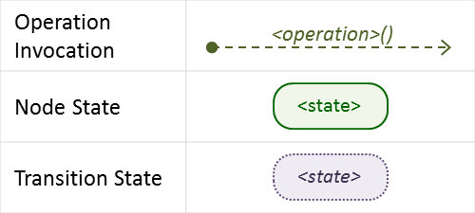The following key should be used to interpret the diagrams:

##### Normal node startup sequence diagram

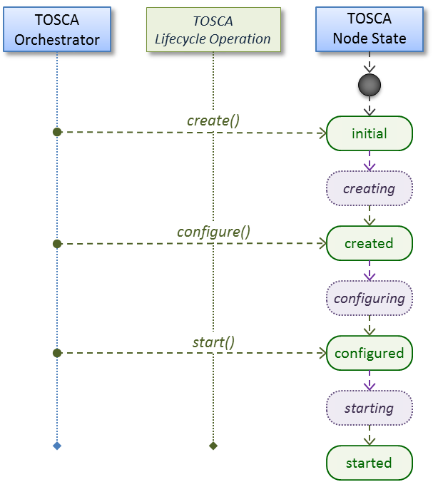The following diagram shows how the TOSCA orchestrator would invoke operations on the Standard lifecycle to startup a node.

##### Normal node shutdown sequence diagram

The following diagram shows how the TOSCA orchestrator would invoke operations on the Standard lifecycle to shut down a node.

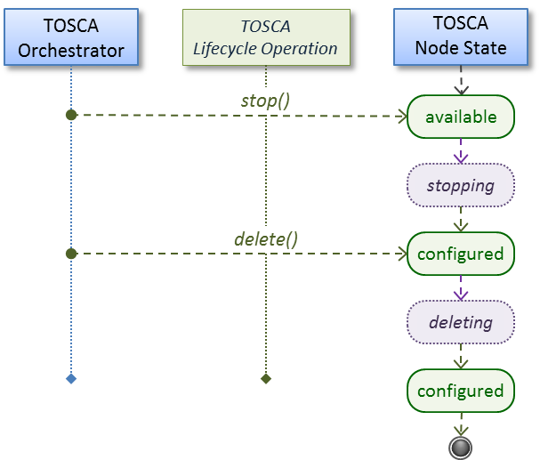

### tosca.interfaces.relationship.Configure

The lifecycle interfaces define the essential, normative operations that each TOSCA Relationship Types may support.

|  |  |
| --- | --- |
| Shorthand Name | Configure |
| Type Qualified Name | tosca:Configure |
| Type URI | tosca.interfaces.relationship.Configure |

#### Definition

|  |
| --- |
| tosca.interfaces.relationship.Configure:  derived_from: tosca.interfaces.Root  pre_configure_source:  description: Operation to pre-configure the source endpoint.  pre_configure_target:  description: Operation to pre-configure the target endpoint.  post_configure_source:  description: Operation to post-configure the source endpoint.  post_configure_target:  description: Operation to post-configure the target endpoint.  add_target:  description: Operation to notify the source node of a target node being added via a relationship.  add_source:  description: Operation to notify the target node of a source node which is now available via a relationship.  description:  target_changed:  description: Operation to notify source some property or attribute of the target changed  remove_target:  description: Operation to remove a target node. |

#### Invocation Conventions

TOSCA relationships are directional connecting a source node to a target node. When TOSCA Orchestrator connects a source and target node together using a relationship that supports the Configure interface it will “interleave” the operations invocations of the Configure interface with those of the node’s own Standard lifecycle interface. This concept is illustrated below:

#### Normal node start sequence with Configure relationship operations

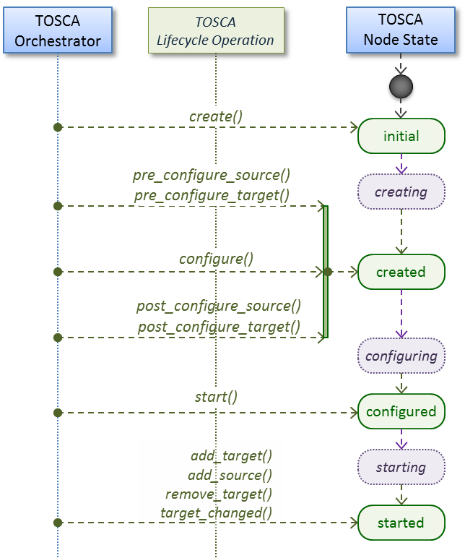The following diagram shows how the TOSCA orchestrator would invoke Configure lifecycle operations in conjunction with Standard lifecycle operations during a typical startup sequence on a node.

#### Node-Relationship configuration sequence

Depending on which side (i.e., source or target) of a relationship a node is on, the orchestrator will:

* Invoke either the pre_configure_source or pre_configure_target operation as supplied by the relationship on the node.
* Invoke the node’s configure operation.
* Invoke either the post_configure_source or post_configure_target as supplied by the relationship on the node.

Note that the pre_configure_xxx and post_configure_xxx are invoked only once per node instance.

##### Node-Relationship add, remove and changed sequence

Since a topology template contains nodes that can dynamically be added (and scaled), removed or changed as part of an application instance, the Configure lifecycle includes operations that are invoked on node instances that to notify and address these dynamic changes.

For example, a source node, of a relationship that uses the Configure lifecycle, will have the relationship operations add_target, or remove_target invoked on it whenever a target node instance is added or removed to the running application instance. In addition, whenever the node state of its target node changes, the target_changed operation is invoked on it to address this change. Conversely, the add_source and remove_source operations are invoked on the source node of the relationship.

#### Notes

* The target (provider) MUST be active and running (i.e., all its dependency stack MUST be fulfilled) prior to invoking add_target
* In other words, all Requirements MUST be satisfied before it advertises its capabilities (i.e., the attributes of the matched Capabilities are available).
* In other words, it cannot be “consumed” by any dependent node.
* Conversely, since the source (consumer) needs information (attributes) about any targets (and their attributes) being removed before it actually goes away.
* The remove_target operation should only be executed if the target has had add_target executed. BUT in truth we’re first informed about a target in pre_configure_source, so if we execute that the source node should see remove_target called to cleanup.
* **Error handling**: If any node operation of the topology fails processing should stop on that node template and the failing operation (script) should return an error (failure) code when possible.

## Node Types

### tosca.nodes.Root

The TOSCA Root Node Type is the default type that all other TOSCA base Node Types derive from. This allows for all TOSCA nodes to have a consistent set of features for modeling and management (e.g., consistent definitions for requirements, capabilities and lifecycle interfaces).

|  |  |
| --- | --- |
| Shorthand Name | Root |
| Type Qualified Name | tosca:Root |
| Type URI | tosca.nodes.Root |

#### Properties

| Name | Required | Type | Constraints | Description |
| --- | --- | --- | --- | --- |
| N/A | N/A | N/A | N/A | The TOSCA Root Node type has no specified properties. |

#### Attributes

| Name | Required | Type | Constraints | Description |
| --- | --- | --- | --- | --- |
| tosca_id | yes | string | None | A unique identifier of the realized instance of a Node Template that derives from any TOSCA normative type. |
| tosca_name | yes | string | None | This attribute reflects the name of the Node Template as defined in the TOSCA service template. This name is not unique to the realized instance model of corresponding deployed application as each template in the model can result in one or more instances (e.g., scaled) when orchestrated to a provider environment. |
| state | yes | string | default: initial | The state of the node instance. See section “Node States” for allowed values. |

#### Definition

|  |
| --- |
| tosca.nodes.Root:  derived_from: tosca.entity.Root  description: The TOSCA Node Type all other TOSCA base Node Types derive from  attributes:  tosca_id:  type: string  tosca_name:  type: string  state:  type: string  capabilities:  feature:  type: tosca.capabilities.Node  requirements:  - dependency:  capability: tosca.capabilities.Node  node: tosca.nodes.Root  relationship: tosca.relationships.DependsOn  occurrences: [ 0, UNBOUNDED ]  interfaces:  Standard:  type: tosca.interfaces.node.lifecycle.Standard |

#### Additional Requirements

* All Node Type definitions that wish to adhere to the TOSCA Simple Profile **SHOULD** extend from the TOSCA Root Node Type to be assured of compatibility and portability across implementations.

### tosca.nodes.Compute

The TOSCA Compute node represents one or more real or virtual processors of software applications or services along with other essential local resources. Collectively, the resources the compute node represents can logically be viewed as a (real or virtual) “server”.

|  |  |
| --- | --- |
| Shorthand Name | Compute |
| Type Qualified Name | tosca:Compute |
| Type URI | tosca.nodes.Compute |

#### Properties

| Name | Required | Type | Constraints | Description |
| --- | --- | --- | --- | --- |
| N/A | N/A | N/A | N/A | N/A |

#### Attributes

| Name | Required | Type | Constraints | Description |
| --- | --- | --- | --- | --- |
| private_address | no | string | None | The primary private IP address assigned by the cloud provider that applications may use to access the Compute node. |
| public_address | no | string | None | The primary public IP address assigned by the cloud provider that applications may use to access the Compute node. |
| networks | no | map of NetworkInfo | None | The list of logical networks assigned to the compute host instance and information about them. |
| ports | no | map of PortInfo | None | The list of logical ports assigned to the compute host instance and information about them. |

#### Definition

|  |
| --- |
| tosca.nodes.Compute:  derived_from: tosca.nodes.Root  attributes:  private_address:  type: string  public_address:  type: string  networks:  type: map  entry_schema:  type: tosca.datatypes.network.NetworkInfo  ports:  type: map  entry_schema:  type: tosca.datatypes.network.PortInfo  requirements:  - local_storage:  capability: tosca.capabilities.Attachment  node: tosca.nodes.BlockStorage  relationship: tosca.relationships.AttachesTo  occurrences: [0, UNBOUNDED]  capabilities:  host:  type: tosca.capabilities.Container  valid_source_types: [tosca.nodes.SoftwareComponent]  endpoint:  type: tosca.capabilities.Endpoint.Admin  os:  type: tosca.capabilities.OperatingSystem  scalable:  type: tosca.capabilities.Scalable  binding:  type: tosca.capabilities.network.Bindable |

#### Additional Requirements

* The underlying implementation of the Compute node SHOULD have the ability to instantiate guest operating systems (either actual or virtualized) based upon the OperatingSystem capability properties if they are supplied in the a node template derived from the Compute node type.

### tosca.nodes.SoftwareComponent

The TOSCA SoftwareComponent node represents a generic software component that can be managed and run by a TOSCA Compute Node Type.

|  |  |
| --- | --- |
| Shorthand Name | SoftwareComponent |
| Type Qualified Name | tosca:SoftwareComponent |
| Type URI | tosca.nodes.SoftwareComponent |

#### Properties

| Name | Required | Type | Constraints | Description |
| --- | --- | --- | --- | --- |
| component_version | no | version | None | The optional software component’s version. |
| admin_credential | no | Credential | None | The optional credential that can be used to authenticate to the software component. |

#### Attributes

| Name | Required | Type | Constraints | Description |
| --- | --- | --- | --- | --- |
| N/A | N/A | N/A | N/A | N/A |

#### Definition

|  |
| --- |
| tosca.nodes.SoftwareComponent:  derived_from: tosca.nodes.Root  properties:  # domain-specific software component version  component_version:  type: version  required: false  admin_credential:  type: tosca.datatypes.Credential  required: false  requirements:  - host:  capability: tosca.capabilities.Container  node: tosca.nodes.Compute  relationship: tosca.relationships.HostedOn |

#### Additional Requirements

* Nodes that can directly be managed and run by a TOSCA Compute Node Type **SHOULD** extend from this type.

### tosca.nodes.WebServer

This TOSA WebServer Node Type represents an abstract software component or service that is capable of hosting and providing management operations for one or more WebApplication nodes.

|  |  |
| --- | --- |
| Shorthand Name | WebServer |
| Type Qualified Name | tosca:WebServer |
| Type URI | tosca.nodes.WebServer |

#### Properties

| Name | Required | Type | Constraints | Description |
| --- | --- | --- | --- | --- |
| None | N/A | N/A | N/A | N/A |

#### Definition

|  |
| --- |
| tosca.nodes.WebServer:  derived_from: tosca.nodes.SoftwareComponent  capabilities:  # Private, layer 4 endpoints  data_endpoint: tosca.capabilities.Endpoint  admin_endpoint: tosca.capabilities.Endpoint.Admin  host:  type: tosca.capabilities.Container  valid_source_types: [ tosca.nodes.WebApplication ] |

#### Additional Requirements

* This node **SHALL** export both a secure endpoint capability (i.e., admin_endpoint), typically for administration, as well as a regular endpoint (i.e., data_endpoint) for serving data.

### tosca.nodes.WebApplication

The TOSCA WebApplication node represents a software application that can be managed and run by a TOSCA WebServer node. Specific types of web applications such as Java, etc. could be derived from this type.

|  |  |
| --- | --- |
| Shorthand Name | WebApplication |
| Type Qualified Name | tosca: WebApplication |
| Type URI | tosca.nodes.WebApplication |

#### Properties

| Name | Required | Type | Constraints | Description |
| --- | --- | --- | --- | --- |
| context_root | no | string | None | The web application’s context root which designates the application’s URL path within the web server it is hosted on. |

#### Definition

|  |
| --- |
| tosca.nodes.WebApplication:  derived_from: tosca.nodes.Root  properties:  context_root:  type: string  capabilities:  app_endpoint:  type: tosca.capabilities.Endpoint  requirements:  - host:  capability: tosca.capabilities.Container  node: tosca.nodes.WebServer  relationship: tosca.relationships.HostedOn |

### tosca.nodes.DBMS

The TOSCA DBMS node represents a typical relational, SQL Database Management System software component or service.

#### Properties

| Name | Required | Type | Constraints | Description |
| --- | --- | --- | --- | --- |
| root_password | no | string | None | The optional root password for the DBMS server. |
| port | no | integer | None | The DBMS server’s port. |

#### Definition

|  |
| --- |
| tosca.nodes.DBMS:  derived_from: tosca.nodes.SoftwareComponent  properties:  root_password:  type: string  required: false  description: the optional root password for the DBMS service  port:  type: integer  required: false  description: the port the DBMS service will listen to for data and requests  capabilities:  host:  type: tosca.capabilities.Container  valid_source_types: [ tosca.nodes.Database ] |

### tosca.nodes.Database

The TOSCA Database node represents a logical database that can be managed and hosted by a TOSCA DBMS node.

|  |  |
| --- | --- |
| Shorthand Name | Database |
| Type Qualified Name | tosca:Database |
| Type URI | tosca.nodes.Database |

#### Properties

| Name | Required | Type | Constraints | Description |
| --- | --- | --- | --- | --- |
| name | yes | string | None | The logical database Name |
| port | no | integer | None | The port the database service will use to listen for incoming data and requests. |
| user | no | string | None | The special user account used for database administration. |
| password | no | string | None | The password associated with the user account provided in the ‘user’ property. |

#### Definition

|  |
| --- |
| tosca.nodes.Database:  derived_from: tosca.nodes.Root  properties:  name:  type: string  description: the logical name of the database  port:  type: integer  description: the port the underlying database service will listen to for data  user:  type: string  description: the optional user account name for DB administration  required: false  password:  type: string  description: the optional password for the DB user account  required: false  requirements:  - host:  capability: tosca.capabilities.Container  node: tosca.nodes.DBMS  relationship: tosca.relationships.HostedOn  capabilities:  database_endpoint:  type: tosca.capabilities.Endpoint.Database |

### tosca.nodes.Storage.ObjectStorage

The TOSCA ObjectStorage node represents storage that provides the ability to store data as objects (or BLOBs of data) without consideration for the underlying filesystem or devices.

|  |  |
| --- | --- |
| Shorthand Name | ObjectStorage |
| Type Qualified Name | tosca:ObjectStorage |
| Type URI | tosca.nodes.Storage.ObjectStorage |

#### Properties

| Name | Required | Type | Constraints | Description |
| --- | --- | --- | --- | --- |
| name | yes | string | None | The logical name of the object store (or container). |
| size | no | scalar-unit.size | greater_or_equal: 0 GB | The requested initial storage size (default unit is in Gigabytes). |
| maxsize | no | scalar-unit.size | greater_or_equal: 0 GB | The requested maximum storage size (default unit is in Gigabytes). |

#### Definition

|  |
| --- |
| tosca.nodes.Storage.ObjectStorage:  derived_from: tosca.nodes.Root  properties:  name:  type: string  size:  type: scalar-unit.size  constraints:  - greater_or_equal: 0 GB  maxsize:  type: scalar-unit.size  constraints:  - greater_or_equal: 0 GB  capabilities:  storage_endpoint:  type: tosca.capabilities.Endpoint |

#### Notes:

* Subclasses of the tosca.nodes.ObjectStorage node type may impose further constraints on properties. For example, a subclass may constrain the (minimum or maximum) length of the ‘name’ property or include a regular expression to constrain allowed characters used in the ‘name’ property.

### tosca.nodes.Storage.BlockStorage

The TOSCA BlockStorage node currently represents a server-local block storage device (i.e., not shared) offering evenly sized blocks of data from which raw storage volumes can be created.

**Note**: In this draft of the TOSCA Simple Profile, distributed or Network Attached Storage (NAS) are not yet considered (nor are clustered file systems), but the TC plans to do so in future drafts.

|  |  |
| --- | --- |
| Shorthand Name | BlockStorage |
| Type Qualified Name | tosca:BlockStorage |
| Type URI | tosca.nodes.Storage.BlockStorage |

#### Properties

| Name | Required | Type | Constraints | Description |
| --- | --- | --- | --- | --- |
| size | yes * | scalar-unit.size | greater_or_equal: 1 MB | The requested storage size (default unit is MB).  * **Note**:   * **Required** when an existing volume (i.e., volume_id) is not available. * If volume_id is provided, size is ignored. Resize of existing volumes is not considered at this time. |
| volume_id | no | string | None | ID of an existing volume (that is in the accessible scope of the requesting application). |
| snapshot_id | no | string | None | Some identifier that represents an existing snapshot that should be used when creating the block storage (volume). |

#### Attributes

| Name | Required | Type | Constraints | Description |
| --- | --- | --- | --- | --- |
| N/A | N/A | N/A | N/A | N/A |

#### Definition

|  |
| --- |
| tosca.nodes.Storage.BlockStorage:  derived_from: tosca.nodes.Root  properties:  size:  type: scalar-unit.size  constraints:  - greater_or_equal: 1 MB  volume_id:  type: string  required: false  snapshot_id:  type: string  required: false  capabilities:  attachment:  type: tosca.capabilities.Attachment |

#### Additional Requirements

* The size property is required when an existing volume (i.e., volume_id) is not available. However, if the property volume_id is provided, the size property is ignored.

#### Notes

* Resize is of existing volumes is not considered at this time.
* It is assumed that the volume contains a single filesystem that the operating system (that is hosting an associate application) can recognize and mount without additional information (i.e., it is operating system independent).
* Currently, this version of the Simple Profile does not consider regions (or availability zones) when modeling storage.

### tosca.nodes.Container.Runtime

The TOSCA Container Runtime node represents operating system-level virtualization technology used to run multiple application services on a single Compute host.

|  |  |
| --- | --- |
| Shorthand Name | Container.Runtime |
| Type Qualified Name | tosca:Container.Runtime |
| Type URI | tosca.nodes.Container.Runtime |

#### Definition

|  |
| --- |
| tosca.nodes.Container.Runtime:  derived_from: tosca.nodes.SoftwareComponent  capabilities:  host:  type: tosca.capabilities.Container  scalable:  type: tosca.capabilities.Scalable |

### tosca.nodes.Container.Application

The TOSCA Container Application node represents an application that requires Container-level virtualization technology.

|  |  |
| --- | --- |
| Shorthand Name | Container.Application |
| Type Qualified Name | tosca:Container.Application |
| Type URI | tosca.nodes.Container.Application |

#### Definition

|  |
| --- |
| tosca.nodes.Container.Application:  derived_from: tosca.nodes.Root  requirements:  - host:  capability: tosca.capabilities.Container  node: tosca.nodes.Container.Runtime  relationship: tosca.relationships.HostedOn  - storage:  capability: tosca.capabilities.Storage  - network:  capability: tosca.capabilities.EndPoint |

### tosca.nodes.LoadBalancer

The TOSCA Load Balancer node represents logical function that be used in conjunction with a Floating Address to distribute an application’s traffic (load) across a number of instances of the application (e.g., for a clustered or scaled application).

|  |  |
| --- | --- |
| Shorthand Name | LoadBalancer |
| Type Qualified Name | tosca:LoadBalancer |
| Type URI | tosca.nodes.LoadBalancer |

#### Definition

|  |
| --- |
| tosca.nodes.LoadBalancer:  derived_from: tosca.nodes.Root  properties:  algorithm:  type: string  required: false  status: experimental  capabilities:  client:  type: tosca.capabilities.Endpoint.Public  occurrences: [0, UNBOUNDED]  description: the Floating (IP) client’s on the public network can connect to  requirements:  - application:  capability: tosca.capabilities.Endpoint  relationship: tosca.relationships.RoutesTo  occurrences: [0, UNBOUNDED]  description: Connection to one or more load balanced applications |

#### Notes:

* A LoadBalancer node can still be instantiated and managed independently of any applications it would serve; therefore, the load balancer’s application requirement allows for zero occurrences.

## Group Types

TOSCA Group Types represent logical groupings of TOSCA nodes that have an implied membership relationship and may need to be orchestrated or managed together to achieve some result. Some use cases being developed by the TOSCA TC use groups to apply TOSCA policies for software placement and scaling while other use cases show groups can be used to describe cluster relationships.

**Note**: Additional normative TOSCA Group Types and use cases for them will be developed in future drafts of this specification.

### tosca.groups.Root

This is the default (root) TOSCA Group Type definition that all other TOSCA base Group Types derive from.

#### Definition

|  |
| --- |
| tosca.groups.Root:  description: The TOSCA Group Type all other TOSCA Group Types derive from  interfaces:  Standard:  type: tosca.interfaces.node.lifecycle.Standard |

#### Notes:

* Group operations are not necessarily tied directly to member nodes that are part of a group.
* Future versions of this specification will create sub types of the tosca.groups.Root type that will describe how Group Type operations are to be orchestrated.

## Policy Types

TOSCA Policy Types represent logical grouping of TOSCA nodes that have an implied relationship and need to be orchestrated or managed together to achieve some result. Some use cases being developed by the TOSCA TC use groups to apply TOSCA policies for software placement and scaling while other use cases show groups can be used to describe cluster relationships.

### tosca.policies.Root

This is the default (root) TOSCA Policy Type definition that all other TOSCA base Policy Types derive from.

#### Definition

|  |
| --- |
| tosca.policies.Root:  description: The TOSCA Policy Type all other TOSCA Policy Types derive from |

### tosca.policies.Placement

This is the default (root) TOSCA Policy Type definition that is used to govern placement of TOSCA nodes or groups of nodes.

#### Definition

|  |
| --- |
| tosca.policies.Placement:  derived_from: tosca.policies.Root  description: The TOSCA Policy Type definition that is used to govern placement of TOSCA nodes or groups of nodes. |

### tosca.policies.Scaling

This is the default (root) TOSCA Policy Type definition that is used to govern scaling of TOSCA nodes or groups of nodes.

#### Definition

|  |
| --- |
| tosca.policies.Scaling:  derived_from: tosca.policies.Root  description: The TOSCA Policy Type definition that is used to govern scaling of TOSCA nodes or groups of nodes. |

### tosca.policies.Update

This is the default (root) TOSCA Policy Type definition that is used to govern update of TOSCA nodes or groups of nodes.

#### Definition

|  |
| --- |
| tosca.policies.Update:  derived_from: tosca.policies.Root  description: The TOSCA Policy Type definition that is used to govern update of TOSCA nodes or groups of nodes. |

### tosca.policies.Performance

This is the default (root) TOSCA Policy Type definition that is used to declare performance requirements for TOSCA nodes or groups of nodes.

#### Definition

|  |
| --- |
| tosca.policies.Performance:  derived_from: tosca.policies.Root  description: The TOSCA Policy Type definition that is used to declare performance requirements for TOSCA nodes or groups of nodes. |

# TOSCA Cloud Service Archive (CSAR) format

Except for the examples, this section is **normative** and defines changes to the TOSCA archive format relative to the TOSCA v1.0 XML specification.

TOSCA Simple Profile definitions along with all accompanying artifacts (e.g. scripts, binaries, configuration files) can be packaged together in a CSAR file as already defined in the TOSCA version 1.0 specification [TOSCA-1.0]. In contrast to the TOSCA 1.0 CSAR file specification (see chapter 16 in [TOSCA-1.0]), this simple profile makes a few simplifications both in terms of overall CSAR file structure as well as meta-file content as described below.

## Overall Structure of a CSAR

A CSAR zip file is required to contain one of the following:

* a **TOSCA-Metadata** directory, which in turn contains the **TOSCA.meta** metadata file that provides entry information for a TOSCA orchestrator processing the CSAR file.
* a yaml (.yml or .yaml) file at the root of the archive. The yaml file being a valid tosca definition template that MUST define a metadata section where template_name and template_version are required.

The CSAR file may contain other directories with arbitrary names and contents. Note that in contrast to the TOSCA 1.0 specification, it is not required to put TOSCA definitions files into a special “Definitions” directory, but definitions YAML files can be placed into any directory within the CSAR file.

## TOSCA Meta File

The **TOSCA.meta** file structure follows the exact same syntax as defined in the TOSCA 1.0 specification. However, it is only required to include *block_0* (see section 16.2 in [TOSCA-1.0]) with the **Entry-Definitions** keyword pointing to a valid TOSCA definitions YAML file that a TOSCA orchestrator should use as entry for parsing the contents of the overall CSAR file.

Note that it is not required to explicitly list TOSCA definitions files in subsequent blocks of the **TOSCA.meta** file, but any TOSCA definitions files besides the one denoted by the **Entry-Definitions** keyword can be found by a TOSCA orchestrator by processing respective **imports** statements in the entry definitions file (or in recursively imported files).

Note also that any additional artifact files (e.g. scripts, binaries, configuration files) do not have to be declared explicitly through blocks in the **TOSCA.meta** file. Instead, such artifacts will be fully described and pointed to by relative path names through artifact definitions in one of the TOSCA definitions files contained in the CSAR.

Due to the simplified structure of the CSAR file and **TOSCA.meta** file compared to TOSCA 1.0, the **CSAR-Version** keyword listed in *block_0* of the meta-file is required to denote version **1.1**.

### Example

The following listing represents a valid **TOSCA.meta** file according to this TOSCA Simple Profile specification.

|  |
| --- |
| TOSCA-Meta-File-Version: 1.0  CSAR-Version: 1.1  Created-By: OASIS TOSCA TC  Entry-Definitions: definitions/tosca_elk.yaml |

This **TOSCA.meta** file indicates its simplified TOSCA Simple Profile structure by means of the **CSAR-Version** keyword with value **1.1**. The **Entry-Definitions** keyword points to a TOSCA definitions YAML file with the name **tosca_elk.yaml** which is contained in a directory called **definitions** within the root of the CSAR file.

## Archive without TOSCA-Metadata

In case the archive doesn’t contains a TOSCA-Metadata directory the archive is required to contains a single YAML file at the root of the archive (other templates may exits in sub-directories).

This file must be a valid TOSCA definitions YAML file with the additional restriction that the metadata section (as defined in 3.9.3.2) is required and template_name and template_version metadata are also required.

TOSCA processors should recognized this file as being the CSAR Entry-Definitions file. The CSAR-Version is defined by the template_version metadata section. The Created-By value is defined by the template_author metadata.

### Example

The following represents a valid TOSCA template file acting as the CSAR Entry-Definitions file in an archive without TOSCA-Metadata directory.

|  |
| --- |
| tosca_definitions_version: tosca_simple_yaml_1_1  metadata:  template_name: my_template  template_author: OASIS TOSCA TC  template_version: 1.0 |

# TOSCA workflows

TOSCA defines two different kinds of workflows that can be used to deploy (instantiate and start), manage at runtime or undeploy (stop and delete) a TOSCA topology: declarative workflows and imperative workflows. Declarative workflows are automatically generated by the TOSCA orchestrator based on the nodes, relationships, and groups defined in the topology. Imperative workflows are manually specified by the author of the topology and allows the specification of any use-case that has not been planned in the definition of node and relationships types or for advanced use-case (including reuse of existing scripts and workflows).

Workflows can be triggered on deployment of a topology (deploy workflow) on undeployment (undeploy workflow) or during runtime, manually, or automatically based on policies defined for the topology.

**Note:** The TOSCA orchestrators will execute a single workflow at a time on a topology to guarantee that the defined workflow can be consistent and behave as expected.

## Normative workflows

TOSCA defines several normative workflows that are used to operate a Topology. That is, reserved names of workflows that should be preserved by TOSCA orchestrators and that, if specified in the topology will override the workflow generated by the orchestrator :

* deploy: is the workflow used to instantiate and perform the initial deployment of the topology.
* undeploy: is the workflow used to remove all instances of a topology.

### Notes

Future versions of the specification will describe the normative naming and declarative generation of additional workflows used to operate the topology at runtime.

* scaling workflows: defined for every scalable nodes or based on scaling policies
* auto-healing workflows: defined in order to restart nodes that may have failed

## Declarative workflows

Declarative workflows are the result of the weaving of topology’s node, relationships, and groups workflows.

The weaving process generates the workflow of every single node in the topology, insert operations from the relationships and groups and finally add ordering consideration. The weaving process will also take care of the specific lifecycle of some nodes and the TOSCA orchestrator is responsible to trigger errors or warnings in case the weaving cannot be processed or lead to cycles for example.

This section aims to describe and explain how a TOSCA orchestrator will generate a workflow based on the topology entities (nodes, relationships and groups).

### Notes

This section details specific constraints and considerations that applies during the weaving process.

#### Orchestrator provided nodes lifecycle and weaving

When a node is abstract the orchestrator is responsible for providing a valid matching resources for the node in order to deploy the topology. This consideration is also valid for dangling requirements (as they represents a quick way to define an actual node).

The lifecycle of such nodes is the responsibility of the orchestrator and they may not answer to the normative TOSCA lifecycle. Their workflow is considered as "delegate" and acts as a black-box between the initial and started state in the install workflow and the started to deleted states in the uninstall workflow.

If a relationship to some of this node defines operations or lifecycle dependency constraint that relies on intermediate states, the weaving SHOULD fail and the orchestrator SHOULD raise an error.

### Relationship impacts on topology weaving

This section explains how relationships impacts the workflow generation to enable the composition of complex topologies.

#### tosca.relationships.DependsOn

The depends on relationship is used to establish a dependency from a node to another. A source node that depends on a target node will be created only after the other entity has been started.

#### Note

DependsOn relationship SHOULD not be implemented. Even if the Configure interface can be implemented this is not considered as a best-practice. If you need specific implementation, please have a look at the ConnectsTo relationship.

##### Example DependsOn

This example show the usage of a generic DependsOn relationship between two custom software components.

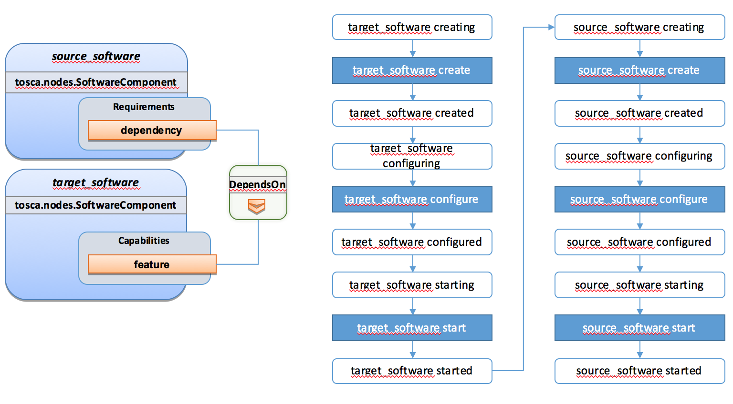

In this example the relationship configure interface doesn’t define operations so they don’t appear in the generated lifecycle.

#### tosca.relationships.ConnectsTo

The connects to relationship is similar to the DependsOn relationship except that it is intended to provide an implementation. The difference is more theoretical than practical but helps users to make an actual distinction from a meaning perspective.

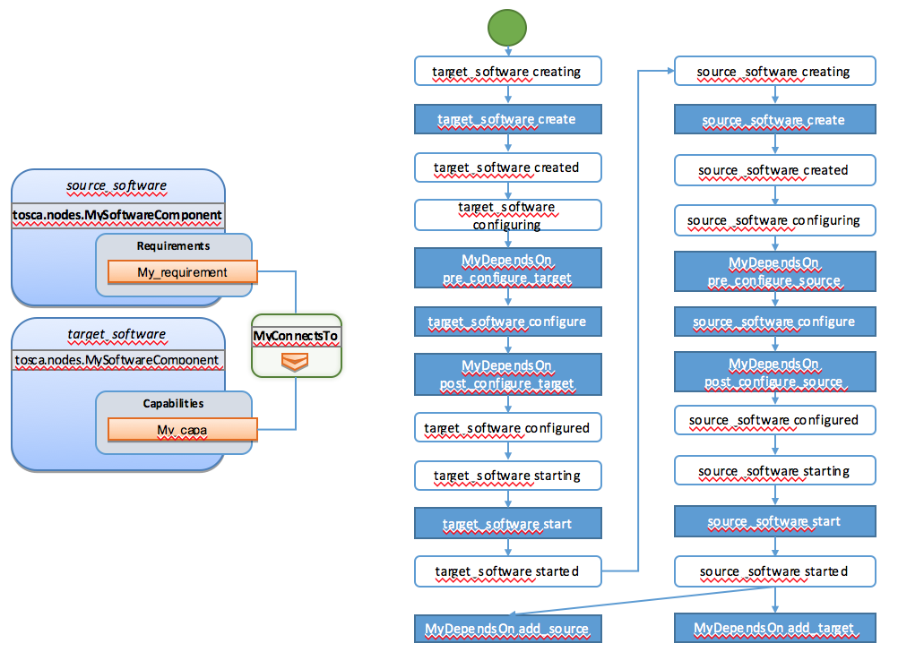

#### tosca.relationships.HostedOn

The hosted_on dependency relationship allows to define a hosting relationship between an entity and another. The hosting relationship has multiple impacts on the workflow and execution:

* The implementation artifacts of the source node is executed on the same host as the one of the target node.
* The create operation of the source node is executed only once the target node reach the started state.
* When multiple nodes are hosted on the same host node, the defined operations will not be executed concurrently even if the theoretical workflow could allow it (actual generated workflow will avoid concurrency).

##### Example Software Component HostedOn Compute

This example explain the TOSCA weaving operation of a custom SoftwareComponent on a tosca.nodes.Compute instance. The compute node is an orchestrator provided node meaning that it’s lifecycle is delegated to the orchestrator. This is a black-box and we just expect a started compute node to be provided by the orchestrator.

The software node lifecycle operations will be executed on the Compute node (host) instance.

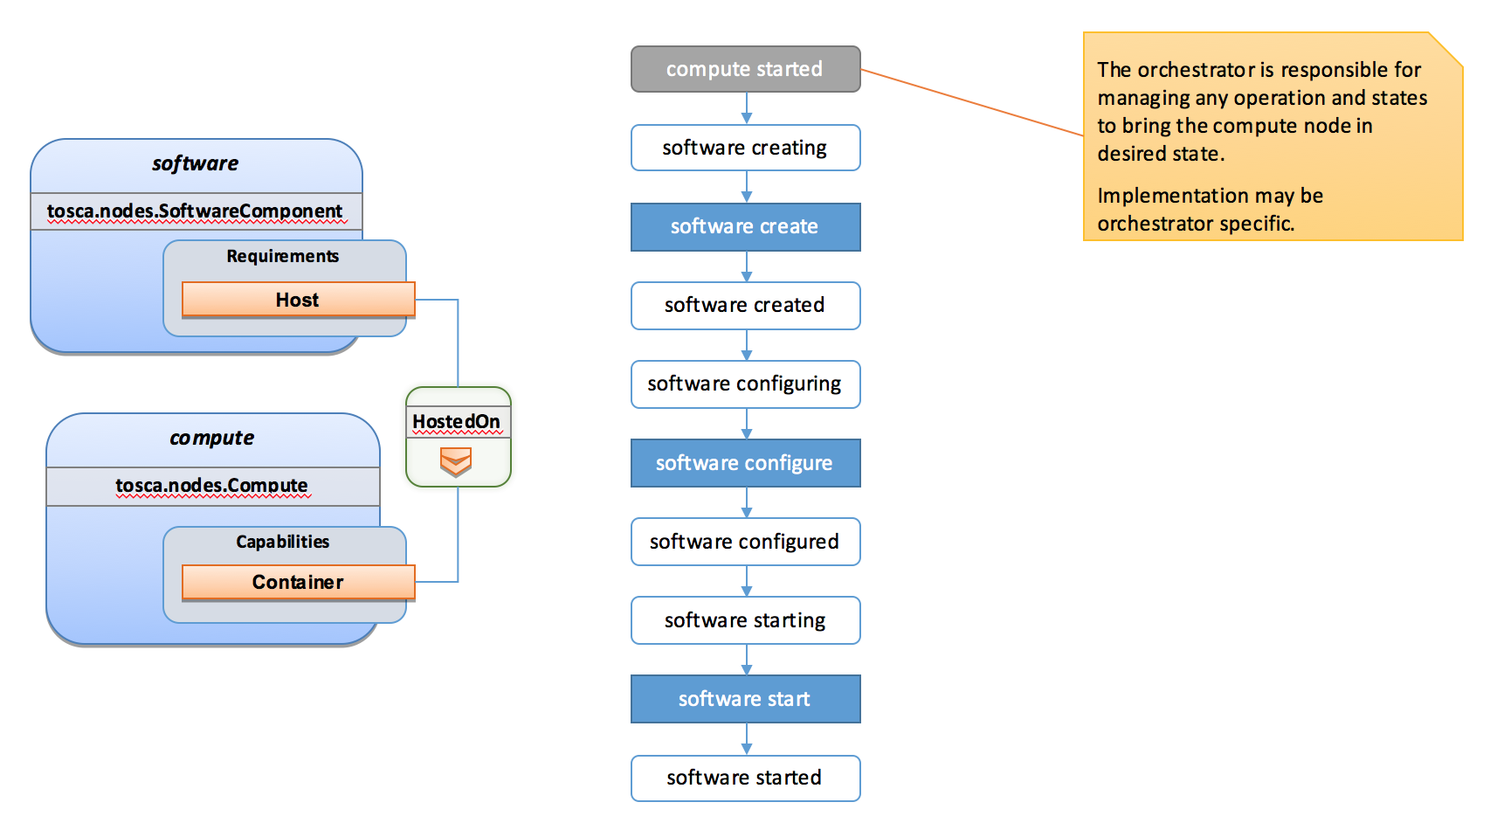

##### Example Software Component HostedOn Software Component

Tosca allows some more complex hosting scenarios where a software component could be hosted on another software component.

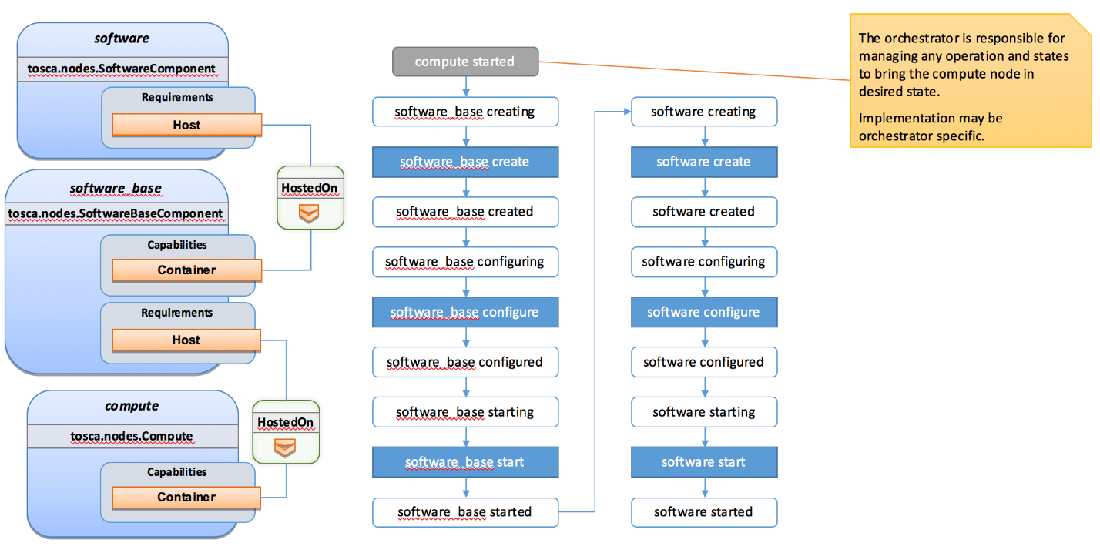

In such scenarios the software create operation is triggered only once the software_base node has reached the started state.

##### Example 2 Software Components HostedOn Compute

This example illustrate concurrency constraint introduced by the management of multiple nodes on a single compute.

### Limitations

#### Hosted nodes concurrency

TOSCA implementation currently does not allow concurrent executions of scripts implementation artifacts (shell, python, ansible, puppet, chef etc.) on a given host. This limitation is not applied on multiple hosts. This limitation is expressed through the HostedOn relationship limitation expressing that when multiple components are hosted on a given host node then their operations will not be performed concurrently (generated workflow will ensure that operations are not concurrent).

#### Dependent nodes concurrency

When a node depends on another node no operations will be processed concurrently. In some situations, especially when the two nodes lies on different hosts we could expect the create operation to be executed concurrently for performance optimization purpose. The current version of the specification will allow to use imperative workflows to solve this use-case. However, this scenario is one of the scenario that we want to improve and handle in the future through declarative workflows.

#### Target operations and get_attribute on source

The current ConnectsTo workflow implies that the target node is started before the source node is even created. This means that pre_configure_target and post_configure_target operations cannot use any input based on source attribute. It is however possible to refer to get_property inputs based on source properties. For advanced configurations the add_source operation should be used.

Note also that future plans on declarative workflows improvements aims to solve this kind of issues while it is currently possible to use imperative workflows.

## Imperative workflows

Imperative workflows are user defined and can define any really specific constraints and ordering of activities. They are really flexible and powerful and can be used for any complex use-case that cannot be solved in declarative workflows. However, they provide less reusability as they are defined for a specific topology rather than being dynamically generated based on the topology content.

### Defining sequence of operations in an imperative workflow

Imperative workflow grammar defines two ways to define the sequence of operations in an imperative workflow:

* Leverage the on_success definition to define the next steps that will be executed in parallel.
* Leverage a sequence of activity in a step.

#### Using on_success to define steps ordering

The graph of workflow steps is build based on the values of on_success elements of the various defined steps. The graph is built based on the following rules:

* All steps that defines an on_success operation must be executed before the next step can be executed. So if A and C defines an on_success operation to B, then B will be executed only when both A and C have been successfully executed.
* The multiple nodes defined by an on_success construct can be executed in parallel.
* Every step that doesn’t have any predecessor is considered as an initial step and can run in parallel.
* Every step that doesn’t define any successor is considered as final. When all the final nodes executions are completed then the workflow is considered as completed.

##### Example

The following example defines multiple steps and the on_success relationship between them.

|  |
| --- |
| topology_template:  workflows:  deploy:  description: Workflow to deploy the application  steps:  A:  on_success:  - B  - C  B:  on_success:  - D  C:  on_success:  - D  D:  E:  on_success:  - C  - F  F: |

The following schema is the visualization of the above definition in term of sequencing of the steps.

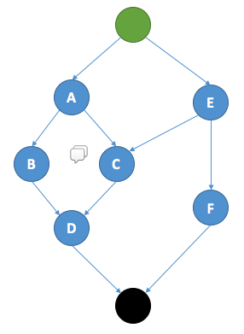

#### Define a sequence of activity on the same element

The step definition of a TOSCA imperative workflow allows multiple activities to be defined :

|  |
| --- |
| workflows:  my_workflow:  steps:  create_my_node:  target: my_node  activities:  - set_state: creating  - call_operation: tosca.interfaces.node.lifecycle.Standard.create  - set_state: created |

The sequence defined here defines three different activities that will be performed in a sequential way. This is just equivalent to writing multiple steps chained by an on_success together :

|  |
| --- |
| workflows:  my_workflow:  steps:  creating_my_node:  target: my_node  activities:  - set_state: creating  on_success: create_my_node  create_my_node:  target: my_node  activities:  - call_operation: tosca.interfaces.node.lifecycle.Standard.create  on_success: created_my_node  created_my_node:  target: my_node  activities:  - set_state: created |

In both situations the resulting workflow is a sequence of activities:

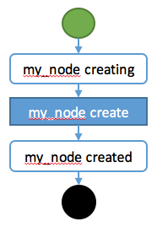

### Definition of a simple workflow

Imperative workflow allow user to define custom workflows allowing them to add operations that are not normative, or for example, to execute some operations in parallel when TOSCA would have performed sequential execution.

As Imperative workflows are related to a topology, adding a workflow is as simple as adding a workflows section to your topology template and specifying the workflow and the steps that compose it.

#### Example: Adding a non-normative custom workflow

This sample topology add a very simple custom workflow to trigger the mysql backup operation.

|  |
| --- |
| topology_template:  node_templates:  my_server:  type: tosca.nodes.Compute  mysql:  type: tosca.nodes.DBMS.MySQL  requirements:  - host: my_server  interfaces:  tosca.interfaces.nodes.custom.Backup:  operations:  backup: backup.sh  workflows:  backup:  description: Performs a snapshot of the MySQL data.  steps:  my_step:  target: mysql  activities:  - call_operation: tosca.interfaces.nodes.custom.Backup.backup |

In such topology the TOSCA container will still use declarative workflow to generate the deploy and undeploy workflows as they are not specified and a backup workflow will be available for user to trigger.

#### Example: Creating two nodes hosted on the same compute in parallel

TOSCA declarative workflow generation constraint the workflow so that no operations are called in parallel on the same host. Looking at the following topology this means that the mysql and tomcat nodes will not be created in parallel but sequentially. This is fine in most of the situations as packet managers like apt or yum doesn’t not support concurrency, however if both create operations performs a download of zip package from a server most of people will hope to do that in parallel in order to optimize throughput.

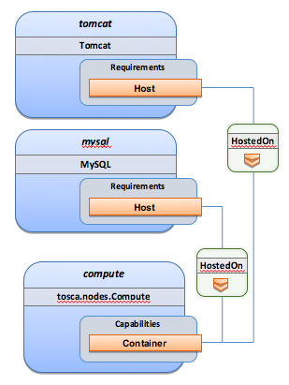

Imperative workflows can help to solve this issue. Based on the above topology we will design a workflow that will create tomcat and mysql in parallel but we will also ensure that tomcat is started after mysql is started even if no relationship is defined between the components:

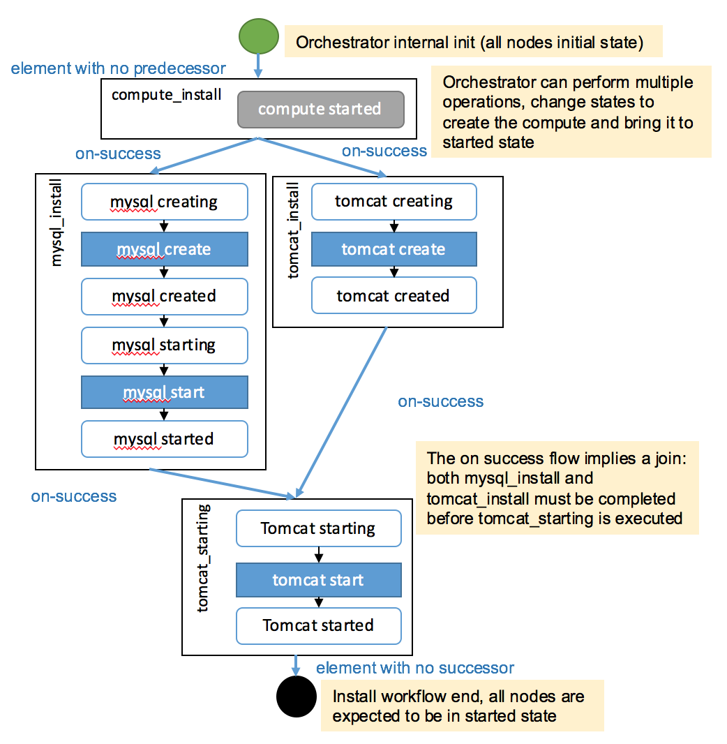

To achieve such workflow, the following topology will be defined:

|  |
| --- |
| topology_template:  node_templates:  my_server:  type: tosca.nodes.Compute  mysql:  type: tosca.nodes.DBMS.MySQL  requirements:  - host: my_server  tomcat:  type: tosca.nodes.WebServer.Tomcat  requirements:  - host: my_server  workflows:  deploy:  description: Override the TOSCA declarative workflow with the following.  steps:  compute_install  target: my_server  activities:  - delegate: deploy  on_success:  - mysql_install  - tomcat_install  tomcat_install:  target: tomcat  activities:  - set_state: creating  - call_operation: tosca.interfaces.node.lifecycle.Standard.create  - set_state: created  on_success:  - tomcat_starting  mysql_install:  target: mysql  activities:  - set_state: creating  - call_operation: tosca.interfaces.node.lifecycle.Standard.create  - set_state: created  - set_state: starting  - call_operation: tosca.interfaces.node.lifecycle.Standard.start  - set_state: started  on_success:  - tomcat_starting  tomcat_starting:  target: tomcat  activities:  - set_state: starting  - call_operation: tosca.interfaces.node.lifecycle.Standard.start  - set_state: started |

### Specifying preconditions to a workflow

Pre conditions allows the TOSCA orchestrator to determine if a workflow can be executed based on the states and attribute values of the topology’s node. Preconditions must be added to the initial workflow.

#### Example : adding precondition to custom backup workflow

In this example we will use precondition so that we make sure that the mysql node is in the correct state for a backup.

|  |
| --- |
| topology_template:  node_templates:  my_server:  type: tosca.nodes.Compute  mysql:  type: tosca.nodes.DBMS.MySQL  requirements:  - host: my_server  interfaces:  tosca.interfaces.nodes.custom.Backup:  operations:  backup: backup.sh  workflows:  backup:  description: Performs a snapshot of the MySQL data.  preconditions:  - target: my_server  condition:  - assert:  - state: [{equal: available}]  - target: mysql  condition:  - assert:  - state: [{valid_values: [started, available]}]  - my_attribute: [{equal: ready }]  steps:  my_step:  target: mysql  activities:  - call_operation: tosca.interfaces.nodes.custom.Backup.backup |

When the backup workflow will be triggered (by user or policy) the TOSCA engine will first check that preconditions are fulfilled. In this situation the engine will check that *my_server* node is in *available* state AND that *mysql* node is in *started* OR *available* states AND that *mysql* *my_attribute* value is equal to *ready*.

### Workflow reusability

TOSCA allows the reusability of a workflow in other workflows. Such concepts can be achieved thanks to the inline activity.

#### Reusing a workflow to build multiple workflows

The following example show how a workflow can inline an existing workflow and reuse it.

|  |
| --- |
| topology_template:  node_templates:  my_server:  type: tosca.nodes.Compute  mysql:  type: tosca.nodes.DBMS.MySQL  requirements:  - host: my_server  interfaces:  tosca.interfaces.nodes.custom.Backup:  operations:  backup: backup.sh  workflows:  start_mysql:  steps:  start_mysql:  target: mysql  activities :  - set_state: starting  - call_operation: tosca.interfaces.node.lifecycle.Standard.start  - set_state: started  stop_mysql:  steps:  stop_mysql:  target: mysql  activities:  - set_state: stopping  - call_operation: tosca.interfaces.node.lifecycle.Standard.stop  - set_state: stopped  backup:  description: Performs a snapshot of the MySQL data.  preconditions:  - target: my_server  condition:  - assert:  - state: [{equal: available}]  - target: mysql  condition:  - assert:  - state: [{valid_values: [started, available]}]  - my_attribute: [{equal: ready }]  steps:  backup_step:  activities:  - inline: stop  - call_operation: tosca.interfaces.nodes.custom.Backup.backup  - inline: start  restart:  steps:  backup_step:  activities:  - inline: stop  - inline: start |

The example above defines three workflows and show how the start_mysql and stop_mysql workflows are reused in the backup and restart workflows.

Inlined workflows are inlined sequentially in the existing workflow for example the backup workflow would look like this:

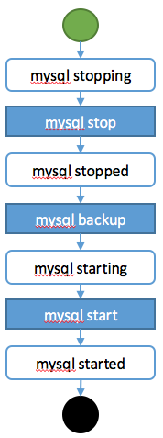

#### Inlining a complex workflow

It is possible of course to inline more complex workflows. The following example defines an inlined workflows with multiple steps including concurrent steps:

|  |
| --- |
| topology_template:  workflows:  inlined_wf:  steps:  A:  target: node_a  activities:  - call_operation: a  on_success:  - B  - C  B:  target: node_a  activities:  - call_operation: b  on_success:  - D  C:  target: node_a  activities:  - call_operation: c  on_success:  - D  D:  target: node_a  activities:  - call_operation: d  E:  target: node_a  activities:  - call_operation: e  on_success:  - C  - F  F:  target: node_a  activities:  - call_operation: f  main_workflow:  steps:  G:  target: node_a  activities:  - set_state: initial  - inline: inlined_wf  - set_state: available |

To describe the following workflow:

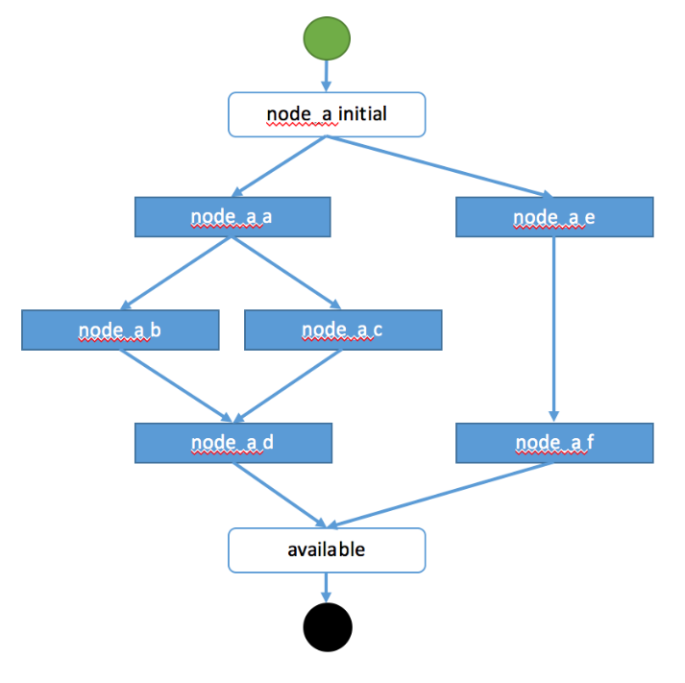

### Defining conditional logic on some part of the workflow

Preconditions are used to validate if the workflow should be executed only for the initial workflow. If a workflow that is inlined defines some preconditions theses preconditions will be used at the instance level to define if the operations should be executed or not on the defined instance.

This construct can be used to filter some steps on a specific instance or under some specific circumstances or topology state.

|  |
| --- |
| topology_template:  node_templates:  my_server:  type: tosca.nodes.Compute  cluster:  type: tosca.nodes.DBMS.Cluster  requirements:  - host: my_server  interfaces:  tosca.interfaces.nodes.custom.Backup:  operations:  backup: backup.sh  workflows:  backup:  description: Performs a snapshot of the MySQL data.  preconditions:  - target: my_server  condition:  - assert:  - state: [{equal: available}]  - target: mysql  condition:  - assert:  - state: [{valid_values: [started, available]}]  - my_attribute: [{equal: ready }]  steps:  backup_step:  target: cluster  filter: # filter is a list of clauses. Matching between clauses is and.  - or: # only one of sub-clauses must be true.  - assert:  - foo: [{equals: true}]  - assert:  - bar: [{greater_than: 2}, {less_than: 20}]  activities:  - call_operation: tosca.interfaces.nodes.custom.Backup.backup |

### Define inputs for a workflow

Inputs can be defined in a workflow and will be provided in the execution context of the workflow. If an operation defines a get_input function on one of its parameter the input will be retrieved from the workflow input, and if not found from the topology inputs.

Workflow inputs will never be configured from policy triggered workflows and SHOULD be used only for user triggered workflows. Of course operations can still refer to topology inputs or template properties or attributes even in the context of a policy triggered workflow.

#### Example

|  |
| --- |
| topology_template:  node_templates:  my_server:  type: tosca.nodes.Compute  mysql:  type: tosca.nodes.DBMS.MySQL  requirements:  - host: my_server  interfaces:  tosca.interfaces.nodes.custom.Backup:  operations:  backup:  implementation: backup.sh  inputs:  storage_url: { get_input: storage_url }  workflows:  backup:  description: Performs a snapshot of the MySQL data.  preconditions:  - target: my_server  valid_states: [available]  - target: mysql  valid_states: [started, available]  attributes:  my_attribute: [ready]  inputs:  storage_url:  type: string  steps:  my_step:  target: mysql  activities:  - call_operation: tosca.interfaces.nodes.custom.Backup.backup |

To trigger such a workflow, the TOSCA engine must allow user to provide inputs that match the given definitions.

### Handle operation failure

By default, failure of any activity of the workflow will result in the failure of the workflow and will results in stopping the steps to be executed.

Exception: uninstall workflow operation failure SHOULD not prevent the other operations of the workflow to run (a failure in an uninstall script SHOULD not prevent from releasing resources from the cloud).

For any workflow other than install and uninstall failures may leave the topology in an unknown state. In such situation the TOSCA engine may not be able to orchestrate the deployment. Implementation of on_failure construct allows to execute rollback operations and reset the state of the affected entities back to an orchestrator known state.

#### Example

|  |
| --- |
| topology_template:  node_templates:  my_server:  type: tosca.nodes.Compute  mysql:  type: tosca.nodes.DBMS.MySQL  requirements:  - host: my_server  interfaces:  tosca.interfaces.nodes.custom.Backup:  operations:  backup:  implementation: backup.sh  inputs:  storage_url: { get_input: storage_url }  workflows:  backup:  steps:  backup_step:  target: mysql  activities:  - set_state: backing_up # this state is not a TOSCA known state  - call_operation: tosca.interfaces.nodes.custom.Backup.backup  - set_state: available # this state is known by TOSCA orchestrator  on_failure:  - rollback_step  rollback_step:  target: mysql  activities:  - call_operation: tosca.interfaces.nodes.custom.Backup.backup  - set_state: available # this state is known by TOSCA orchestrator |

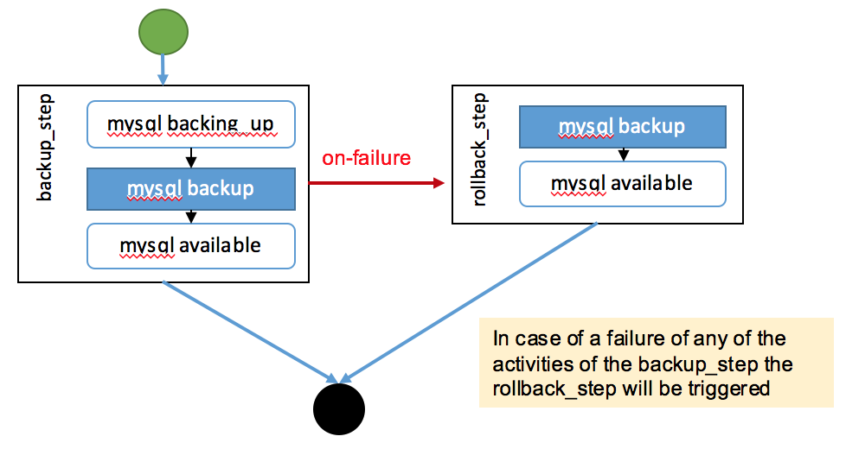

## Making declarative more flexible and imperative more generic

TOSCA simple profile 1.1 version provides the genericity and reusability of declarative workflows that is designed to address most of use-cases and the flexibility of imperative workflows to address more complex or specific use-cases.

Each approach has some pros and cons and we are working so that the next versions of the specification can improve the workflow usages to try to allow more flexibility in a more generic way. Two non-exclusive leads are currently being discussed within the working group and may be included in the future versions of the specification.

* Improvement of the declarative workflows in order to allow people to extend the weaving logic of TOSCA to fit some specific need.
* Improvement of the imperative workflows in order to allow partial imperative workflows to be automatically included in declarative workflows based on specific constraints on the topology elements.

Implementation of the improvements will be done by adding some elements to the specification and will not break compatibility with the current specification.

#### Notes

* The weaving improvement section is a Work in Progress and is not final in 1.1 version. The elements in this section are incomplete and may be subject to change in next specification version.
* Moreover, the weaving improvements is one of the track of improvements. As describe improving the reusability of imperative workflow is another track (that may both co-exists in next specifications).

### Weaving improvements

Making declarative better experimental option.

#### Node lifecycle definition

Node workflow is defined at the node type level. The node workflow definition is used to generate the declarative workflow of a given node.

The tosca.nodes.Root type defines workflow steps for both the install workflow (used to instantiate or deploy a topology) and the uninstall workflow (used to destroy or undeploy a topology). The workflow is defined as follows:

|  |
| --- |
| node_types:  tosca.nodes.Root:  workflows:  install:  steps:  install_sequence:  activities:  - set_state: creating  - call_operation: tosca.interfaces.node.lifecycle.Standard.create  - set_state: created  - set_state: configuring  - call_operation: tosca.interfaces.node.lifecycle.Standard.configure  - set_state: configured  - set_state: starting  - call_operation: tosca.interfaces.node.lifecycle.Standard.start  - set_state: started  uninstall:  steps:  uninstall_sequence:  activities:  - set_state: stopping  - call_operation: tosca.interfaces.node.lifecycle.Standard.stop  - set_state: stopped  - set_state: deleting  - call_operation: tosca.interfaces.node.lifecycle.Standard.delete  - set_state: deleted |

#### Relationship lifecycle and weaving

While the workflow of a single node is quite simple the TOSCA weaving process is the real key element of declarative workflows. The process of weaving consist of the ability to create complex management workflows including dependency management in execution order between node operations, injection of operations to process specific instruction related to the connection to other nodes based the relationships and groups defined in a topology.

This section describes the relationship weaving and how the description at a template level can be translated on an instance level.

|  |
| --- |
| relationship_types:  tosca.relationships.ConnectsTo:  workflow:  install: # name of the workflow for wich the weaving has to be taken in account  source_weaving: # Instruct how to weave some tasks on the source workflow (executed on SOURCE instance)  - after: configuring # instruct that this operation should be weaved after the target reach configuring state  wait_target: created # add a join from a state of the target  activity: tosca.interfaces.relationships.Configure.pre_configure_source  - before: configured # instruct that this operation should be weaved before the target reach configured state  activity: tosca.interfaces.relationships.Configure.post_configure_source  - before: starting  wait_target: started # add a join from a state of the target  - after: started  activity: tosca.interfaces.relationships.Configure.add_target  target_weaving: # Instruct how to weave some tasks on the target workflow (executed on TARGET instance)  - after: configuring # instruct that this operation should be weaved after the target reach configuring state  after_source: created # add a join from a state of the source  activity: tosca.interfaces.relationships.Configure.pre_configure_target  - before: configured # instruct that this operation should be weaved before the target reach configured state  activity: tosca.interfaces.relationships.Configure.post_configure_target  - after: started  activity: tosca.interfaces.relationships.Configure.add_source |

# TOSCA networking

Except for the examples, this section is **normative** and describes how to express and control the application centric network semantics available in TOSCA.

## Networking and Service Template Portability

TOSCA Service Templates are application centric in the sense that they focus on describing application components in terms of their requirements and interrelationships. In order to provide cloud portability, it is important that a TOSCA Service Template avoid cloud specific requirements and details. However, at the same time, TOSCA must provide the expressiveness to control the mapping of software component connectivity to the network constructs of the hosting cloud.

TOSCA Networking takes the following approach.

1. The application component connectivity semantics and expressed in terms of Requirements and Capabilities and the relationships between these. Service Template authors are able to express the interconnectivity requirements of their software components in an abstract, declarative, and thus highly portable manner.
2. The information provided in TOSCA is complete enough for a TOSCA implementation to fulfill the application component network requirements declaratively (i.e., it contains information such as communication initiation and layer 4 port specifications) so that the required network semantics can be realized on arbitrary network infrastructures.
3. TOSCA Networking provides full control of the mapping of software component interconnectivity to the networking constructs of the hosting cloud network independently of the Service Template, providing the required separation between application and network semantics to preserve Service Template portability.
4. Service Template authors have the choice of specifying application component networking requirements in the Service Template or completely separating the application component to network mapping into a separate document. This allows application components with explicit network requirements to express them while allowing users to control the complete mapping for all software components which may not have specific requirements. Usage of these two approaches is possible simultaneously and required to avoid having to re-write components network semantics as arbitrary sets of components are assembled into Service Templates.
5. Defining a set of network semantics which are expressive enough to address the most common application connectivity requirements while avoiding dependencies on specific network technologies and constructs. Service Template authors and cloud providers are able to express unique/non-portable semantics by defining their own specialized network Requirements and Capabilities.

## Connectivity Semantics

TOSCA’s application centric approach includes the modeling of network connectivity semantics from an application component connectivity perspective. The basic premise is that applications contain components which need to communicate with other components using one or more endpoints over a network stack such as TCP/IP, where connectivity between two components is expressed as a <source component, source address, source port, target component, target address, target port> tuple. Note that source and target components are added to the traditional 4 tuple to provide the application centric information, mapping the network to the source or target component involved in the connectivity.

Software components are expressed as Node Types in TOSCA which can express virtually any kind of concept in a TOSCA model. Node Types offering network based functions can model their connectivity using a special Endpoint Capability, tosca.capabilities.Endpoint, designed for this purpose. Node Types which require an Endpoint can specify this as a TOSCA requirement. A special Relationship Type, tosca.relationships.ConnectsTo, is used to implicitly or explicitly relate the source Node Type’s endpoint to the required endpoint in the target node type. Since tosca.capabilities.Endpoint and tosca.relationships.ConnectsTo are TOSCA types, they can be used in templates and extended by subclassing in the usual ways, thus allowing the expression of additional semantics as needed.

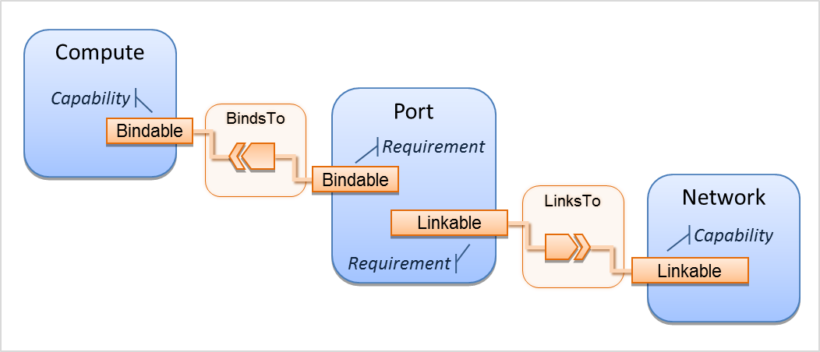The following diagram shows how the TOSCA node, capability and relationship types enable modeling the application layer decoupled from the network model intersecting at the Compute node using the Bindable capability type.

As you can see, the Port node type effectively acts a broker node between the Network node description and a host Compute node of an application.

## Expressing connectivity semantics

This section describes how TOSCA supports the typical client/server and group communication semantics found in application architectures.

### Connection initiation semantics

The tosca.relationships.ConnectsTo expresses that requirement that a source application component needs to be able to communicate with a target software component to consume the services of the target. ConnectTo is a component interdependency semantic in the most general sense and does not try imply how the communication between the source and target components is physically realized.

Application component intercommunication typically has conventions regarding which component(s) initiate the communication. Connection initiation semantics are specified in tosca.capabilities.Endpoint. Endpoints at each end of the tosca.relationships.ConnectsTo must indicate identical connection initiation semantics.

The following sections describe the normative connection initiation semantics for the tosca.relationships.ConnectsTo Relationship Type.

#### Source to Target

The Source to Target communication initiation semantic is the most common case where the source component initiates communication with the target component in order to fulfill an instance of the tosca.relationships.ConnectsTo relationship. The typical case is a “client” component connecting to a “server” component where the client initiates a stream oriented connection to a pre-defined transport specific port or set of ports.

It is the responsibility of the TOSCA implementation to ensure the source component has a suitable network path to the target component and that the ports specified in the respective tosca.capabilities.Endpoint are not blocked. The TOSCA implementation may only represent state of the tosca.relationships.ConnectsTo relationship as fulfilled after the actual network communication is enabled and the source and target components are in their operational states.

Note that the connection initiation semantic only impacts the fulfillment of the actual connectivity and does not impact the node traversal order implied by the tosca.relationships.ConnectsTo Relationship Type.

#### Target to Source

The Target to Source communication initiation semantic is a less common case where the target component initiates communication with the source comment in order to fulfill an instance of the tosca.relationships.ConnectsTo relationship. This “reverse” connection initiation direction is typically required due to some technical requirements of the components or protocols involved, such as the requirement that SSH mush only be initiated from target component in order to fulfill the services required by the source component.

It is the responsibility of the TOSCA implementation to ensure the source component has a suitable network path to the target component and that the ports specified in the respective tosca.capabilities.Endpoint are not blocked. The TOSCA implementation may only represent state of the tosca.relationships.ConnectsTo relationship as fulfilled after the actual network communication is enabled and the source and target components are in their operational states.

Note that the connection initiation semantic only impacts the fulfillment of the actual connectivity and does not impact the node traversal order implied by the tosca.relationships.ConnectsTo Relationship Type.

#### Peer-to-Peer

The Peer-to-Peer communication initiation semantic allows any member of a group to initiate communication with any other member of the same group at any time. This semantic typically appears in clustering and distributed services where there is redundancy of components or services.

It is the responsibility of the TOSCA implementation to ensure the source component has a suitable network path between all the member component instances and that the ports specified in the respective tosca.capabilities.Endpoint are not blocked, and the appropriate multicast communication, if necessary, enabled. The TOSCA implementation may only represent state of the tosca.relationships.ConnectsTo relationship as fulfilled after the actual network communication is enabled such that at least one-member component of the group may reach any other member component of the group.

Endpoints specifying the Peer-to-Peer initiation semantic need not be related with a tosca.relationships.ConnectsTo relationship for the common case where the same set of component instances must communicate with each other.

Note that the connection initiation semantic only impacts the fulfillment of the actual connectivity and does not impact the node traversal order implied by the tosca.relationships.ConnectsTo Relationship Type.

### Specifying layer 4 ports

TOSCA Service Templates must express enough details about application component intercommunication to enable TOSCA implementations to fulfill these communication semantics in the network infrastructure. TOSCA currently focuses on TCP/IP as this is the most pervasive in today’s cloud infrastructures. The layer 4 ports required for application component intercommunication are specified in tosca.capabilities.Endpoint. The union of the port specifications of both the source and target tosca.capabilities.Endpoint which are part of the tosca.relationships.ConnectsTo Relationship Template are interpreted as the effective set of ports which must be allowed in the network communication.

The meaning of Source and Target port(s) corresponds to the direction of the respective tosca.relationships.ConnectsTo.

## Network provisioning

### Declarative network provisioning

TOSCA orchestrators are responsible for the provisioning of the network connectivity for declarative TOSCA Service Templates (Declarative TOSCA Service Templates don’t contain explicit plans). This means that the TOSCA orchestrator must be able to infer a suitable logical connectivity model from the Service Template and then decide how to provision the logical connectivity, referred to as “fulfillment”, on the available underlying infrastructure. In order to enable fulfillment, sufficient technical details still must be specified, such as the required protocols, ports and QOS information. TOSCA connectivity types, such as tosca.capabilities.Endpoint, provide well defined means to express these details.

### Implicit network fulfillment

TOSCA Service Templates are by default network agnostic. TOSCA’s application centric approach only requires that a TOSCA Service Template contain enough information for a TOSCA orchestrator to infer suitable network connectivity to meet the needs of the application components. Thus Service Template designers are not required to be aware of or provide specific requirements for underlying networks. This approach yields the most portable Service Templates, allowing them to be deployed into any infrastructure which can provide the necessary component interconnectivity.

### Controlling network fulfillment

TOSCA provides mechanisms for providing control over network fulfillment.

This mechanism allows the application network designer to express in service template or network template how the networks should be provisioned.

For the use cases described below let’s assume we have a typical 3-tier application which is consisting of FE (frontend), BE (backend) and DB (database) tiers. The simple application topology diagram can be shown below:





Figure‑: Typical 3-Tier Network

#### Use case: OAM Network

When deploying an application in service provider’s on-premise cloud, it’s very common that one or more of the application’s services should be accessible from an ad-hoc OAM (Operations, Administration and Management) network which exists in the service provider backbone.

As an application network designer, I’d like to express in my TOSCA network template (which corresponds to my TOSCA service template) the network CIDR block, start ip, end ip and segmentation ID (e.g. VLAN id).

The diagram below depicts a typical 3-tiers application with specific networking requirements for its FE tier server cluster:



#### Use case: Data Traffic network

The diagram below defines a set of networking requirements for the backend and DB tiers of the 3-tier app mentioned above.



#### Use case: Bring my own DHCP

The same 3-tier app requires for its admin traffic network to manage the IP allocation by its own DHCP which runs autonomously as part of application domain.

For this purpose, the app network designer would like to express in TOSCA that the underlying provisioned network will be set with DHCP_ENABLED=false. See this illustrated in the figure below:



## Network Types

### tosca.nodes.network.Network

The TOSCA Network node represents a simple, logical network service.

|  |  |
| --- | --- |
| Shorthand Name | Network |
| Type Qualified Name | tosca:Network |
| Type URI | tosca.nodes.network.Network |

#### Properties

| Name | Required | Type | Constraints | Description |
| --- | --- | --- | --- | --- |
| ip_version | no | integer | valid_values: [4, 6]  default: 4 | The IP version of the requested network |
| cidr | no | string | None | The cidr block of the requested network |
| start_ip | no | string | None | The IP address to be used as the 1st one in a pool of addresses derived from the cidr block full IP range |
| end_ip | no | string | None | The IP address to be used as the last one in a pool of addresses derived from the cidr block full IP range |
| gateway_ip | no | string | None | The gateway IP address. |
| network_name | no | string | None | An Identifier that represents an existing Network instance in the underlying cloud infrastructure – OR – be used as the name of the new created network.   * If network_name is provided along with network_id they will be used to uniquely identify an existing network and not creating a new one, means all other possible properties are not allowed. * network_name should be more convenient for using. But in case that network name uniqueness is not guaranteed then one should provide a network_id as well. |
| network_id | no | string | None | An Identifier that represents an existing Network instance in the underlying cloud infrastructure.  This property is mutually exclusive with all other properties except network_name.   * Appearance of network_id in network template instructs the Tosca container to use an existing network instead of creating a new one. * network_name should be more convenient for using. But in case that network name uniqueness is not guaranteed then one should add a network_id as well. * network_name and network_id can be still used together to achieve both uniqueness and convenient. |
| segmentation_id | no | string | None | A segmentation identifier in the underlying cloud infrastructure (e.g., VLAN id, GRE tunnel id). If the segmentation_id is specified, the network_type or physical_network properties should be provided as well. |
| network_type | no | string | None | Optionally, specifies the nature of the physical network in the underlying cloud infrastructure. Examples are flat, vlan, gre or vxlan. For flat and vlan types, physical_network should be provided too. |
| physical_network | no | string | None | Optionally, identifies the physical network on top of which the network is implemented, e.g. physnet1. This property is required if network_type is flat or vlan. |
| dhcp_enabled | no | boolean | default: true | Indicates the TOSCA container to create a virtual network instance with or without a DHCP service. |

#### Attributes

| Name | Required | Type | Constraints | Description |
| --- | --- | --- | --- | --- |
| segmentation_id | no | string | None | The actual *segmentation_id* that is been assigned to the network by the underlying cloud infrastructure. |

#### Definition

|  |
| --- |
| tosca.nodes.network.Network:  derived_from: tosca.nodes.Root  properties:  ip_version:  type: integer  required: false  default: 4  constraints:  - valid_values: [ 4, 6 ]  cidr:  type: string  required: false  start_ip:  type: string  required: false  end_ip:  type: string  required: false  gateway_ip:  type: string  required: false  network_name:  type: string  required: false  network_id:  type: string  required: false  segmentation_id:  type: string  required: false  network_type:  type: string  required: false  physical_network:  type: string  required: false  capabilities:  link:  type: tosca.capabilities.network.Linkable |

### tosca.nodes.network.Port

The TOSCA Port node represents a logical entity that associates between Compute and Network normative types.

The Port node type effectively represents a single virtual NIC on the Compute node instance.

|  |  |
| --- | --- |
| Shorthand Name | Port |
| Type Qualified Name | tosca:Port |
| Type URI | tosca.nodes.network.Port |

#### Properties

| Name | Required | Type | Constraints | Description |
| --- | --- | --- | --- | --- |
| ip_address | no | string | None | Allow the user to set a fixed IP address.  Note that this address is a request to the provider which they will attempt to fulfill but may not be able to dependent on the network the port is associated with. |
| order | no | integer | greater_or_equal: 0  default: 0 | The order of the NIC on the compute instance (e.g. eth2).  **Note**: when binding more than one port to a single compute (aka multi vNICs) and ordering is desired, it is *mandatory* that all ports will be set with an order value and. The *order* values must represent a positive, arithmetic progression that starts with 0 (e.g. 0, 1, 2, …, n). |
| is_default | no | boolean | default: false | Set is_default=true to apply a default gateway route on the running compute instance to the associated network gateway.  Only one port that is associated to single compute node can set as default=true. |
| ip_range_start | no | string | None | Defines the starting IP of a range to be allocated for the compute instances that are associated by this Port.  Without setting this property the IP allocation is done from the entire CIDR block of the network. |
| ip_range_end | no | string | None | Defines the ending IP of a range to be allocated for the compute instances that are associated by this Port.  Without setting this property the IP allocation is done from the entire CIDR block of the network. |

#### Attributes

| Name | Required | Type | Constraints | Description |
| --- | --- | --- | --- | --- |
| ip_address | no | string | None | The IP address would be assigned to the associated compute instance. |

#### Definition

|  |
| --- |
| tosca.nodes.network.Port:  derived_from: tosca.nodes.Root  properties:  ip_address:  type: string  required: false  order:  type: integer  required: true  default: 0  constraints:  - greater_or_equal: 0  is_default:  type: boolean  required: false  default: false  ip_range_start:  type: string  required: false  ip_range_end:  type: string  required: false  requirements:  - link:  capability: tosca.capabilities.network.Linkable  relationship: tosca.relationships.network.LinksTo  - binding:  capability: tosca.capabilities.network.Bindable  relationship: tosca.relationships.network.BindsTo |

### tosca.capabilities.network.Linkable

A node type that includes the Linkable capability indicates that it can be pointed to by a tosca.relationships.network.LinksTo relationship type.

|  |  |
| --- | --- |
| Shorthand Name | Linkable |
| Type Qualified Name | tosca:.Linkable |
| Type URI | tosca.capabilities.network.Linkable |

#### Properties

| Name | Required | Type | Constraints | Description |
| --- | --- | --- | --- | --- |
| N/A | N/A | N/A | N/A | N/A |

#### Definition

|  |
| --- |
| tosca.capabilities.network.Linkable:  derived_from: tosca.capabilities.Node |

### tosca.relationships.network.LinksTo

This relationship type represents an association relationship between Port and Network node types.

|  |  |
| --- | --- |
| Shorthand Name | LinksTo |
| Type Qualified Name | tosca:LinksTo |
| Type URI | tosca.relationships.network.LinksTo |

#### Definition

|  |
| --- |
| tosca.relationships.network.LinksTo:  derived_from: tosca.relationships.DependsOn  valid_target_types: [ tosca.capabilities.network.Linkable ] |

### tosca.relationships.network.BindsTo

This type represents a network association relationship between Port and Compute node types.

|  |  |
| --- | --- |
| Shorthand Name | network.BindsTo |
| Type Qualified Name | tosca:BindsTo |
| Type URI | tosca.relationships.network.BindsTo |

#### Definition

|  |
| --- |
| tosca.relationships.network.BindsTo:  derived_from: tosca.relationships.DependsOn  valid_target_types: [ tosca.capabilities.network.Bindable ] |

## Network modeling approaches

### Option 1: Specifying a network outside the application’s Service Template

This approach allows someone who understands the application’s networking requirements, mapping the details of the underlying network to the appropriate node templates in the application.

The motivation for this approach is providing the application network designer a fine-grained control on how networks are provisioned and stitched to its application by the TOSCA orchestrator and underlying cloud infrastructure while still preserving the portability of his service template. Preserving the portability means here not doing any modification in service template but just “plug-in” the desired network modeling. The network modeling can reside in the same service template file but the best practice should be placing it in a separated self-contained network template file.

This “pluggable” network template approach introduces a new normative node type called Port, capability called tosca.capabilities.network.Linkableand relationship type called tosca.relationships.network.LinksTo.

The idea of the Port is to elegantly associate the desired compute nodes with the desired network nodes while not “touching” the compute itself.

The following diagram series demonstrate the plug-ability strength of this approach.

Let’s assume an application designer has modeled a service template as shown in Figure 1 that describes the application topology nodes (compute, storage, software components, etc.) with their relationships. The designer ideally wants to preserve this service template and use it in any cloud provider environment without any change.

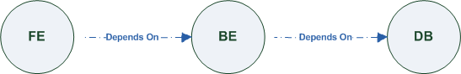

Figure‑: Generic Service Template

When the application designer comes to consider its application networking requirement they typically call the network architect/designer from their company (who has the correct expertise).

The network designer, after understanding the application connectivity requirements and optionally the target cloud provider environment, is able to model the network template and plug it to the service template as shown in Figure 2:

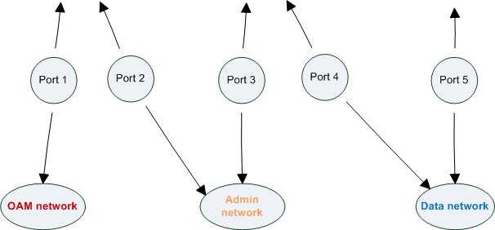

Figure‑: Service template with network template A

When there’s a new target cloud environment to run the application on, the network designer is simply creates a new network template B that corresponds to the new environmental conditions and provide it to the application designer which packs it into the application CSAR.

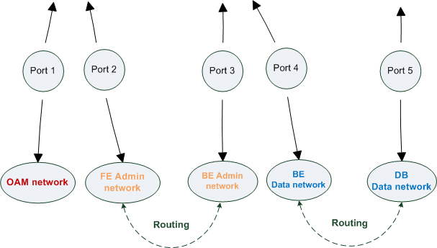

Figure‑: Service template with network template B

The node templates for these three networks would be defined as follows:

|  |
| --- |
| node_templates:  frontend:  type: tosca.nodes.Compute  properties: # omitted for brevity  backend:  type: tosca.nodes.Compute  properties: # omitted for brevity  database:  type: tosca.nodes.Compute  properties: # omitted for brevity  oam_network:  type: tosca.nodes.network.Network  properties: # omitted for brevity  admin_network:  type: tosca.nodes.network.Network  properties: # omitted for brevity  data_network:  type: tosca.nodes.network.Network  properties: # omitted for brevity    # ports definition  fe_oam_net_port:  type: tosca.nodes.network.Port  properties:  is_default: true  ip_range_start: { get_input: fe_oam_net_ip_range_start }  ip_range_end: { get_input: fe_oam_net_ip_range_end }  requirements:  - link: oam_network  - binding: frontend    fe_admin_net_port:  type: tosca.nodes.network.Port  requirements:  - link: admin_network  - binding: frontend    be_admin_net_port:  type: tosca.nodes.network.Port  properties:  order: 0  requirements:  - link: admin_network  - binding: backend    be_data_net_port:  type: tosca.nodes.network.Port  properties:  order: 1  requirements:  - link: data_network  - binding: backend  db_data_net_port:  type: tosca.nodes.network.Port  requirements:  - link: data_network  - binding: database |

### Option 2: Specifying network requirements within the application’s Service Template

This approach allows the Service Template designer to map an endpoint to a logical network.

The use case shown below examines a way to express in the TOSCA YAML service template a typical 3-tier application with their required networking modeling:

|  |
| --- |
| node_templates:  frontend:  type: tosca.nodes.Compute  properties: # omitted for brevity  requirements:  - network_oam: oam_network  - network_admin: admin_network  backend:  type: tosca.nodes.Compute  properties: # omitted for brevity  requirements:  - network_admin: admin_network  - network_data: data_network  database:  type: tosca.nodes.Compute  properties: # omitted for brevity  requirements:  - network_data: data_network  oam_network:  type: tosca.nodes.network.Network  properties:  ip_version: { get_input: oam_network_ip_version }  cidr: { get_input: oam_network_cidr }  start_ip: { get_input: oam_network_start_ip }  end_ip: { get_input: oam_network_end_ip }  admin_network:  type: tosca.nodes.network.Network  properties:  ip_version: { get_input: admin_network_ip_version }  dhcp_enabled: { get_input: admin_network_dhcp_enabled }  data_network:  type: tosca.nodes.network.Network  properties:  ip_version: { get_input: data_network_ip_version }  cidr: { get_input: data_network_cidr } |

# Non-normative type definitions

This section defines **non-normative** types which are used only in examples and use cases in this specification and are included only for completeness for the reader. Implementations of this specification are not required to support these types for conformance.

## Artifact Types

This section contains are non-normative Artifact Types used in use cases and examples.

### tosca.artifacts.Deployment.Image.Container.Docker

This artifact represents a Docker “image” (a TOSCA deployment artifact type) which is a binary comprised of one or more (a union of read-only and read-write) layers created from snapshots within the underlying Docker **Union File System.**

#### Definition

|  |
| --- |
| tosca.artifacts.Deployment.Image.Container.Docker:  derived_from: tosca.artifacts.Deployment.Image  description: Docker Container Image |

### tosca.artifacts.Deployment.Image.VM.ISO

A Virtual Machine (VM) formatted as an ISO standard disk image.

#### Definition

|  |
| --- |
| tosca.artifacts.Deployment.Image.VM.ISO:  derived_from: tosca.artifacts.Deployment.Image.VM  description: Virtual Machine (VM) image in ISO disk format  mime_type: application/octet-stream  file_ext: [ iso ] |

### tosca.artifacts.Deployment.Image.VM.QCOW2

A Virtual Machine (VM) formatted as a QEMU emulator version 2 standard disk image.

#### Definition

|  |
| --- |
| tosca.artifacts.Deployment.Image.VM.QCOW2:  derived_from: tosca.artifacts.Deployment.Image.VM  description: Virtual Machine (VM) image in QCOW v2 standard disk format  mime_type: application/octet-stream  file_ext: [ qcow2 ] |

## Capability Types

This section contains are non-normative Capability Types used in use cases and examples.

### tosca.capabilities.Container.Docker

The type indicates capabilities of a Docker runtime environment (client).

|  |  |
| --- | --- |
| Shorthand Name | Container.Docker |
| Type Qualified Name | tosca:Container.Docker |
| Type URI | tosca.capabilities.Container.Docker |

#### Properties

| Name | Required | Type | Constraints | Description |
| --- | --- | --- | --- | --- |
| version | no | version[] | None | The Docker version capability (i.e., the versions supported by the capability). |
| publish_all | no | boolean | default: false | Indicates that all ports (ranges) listed in the *dockerfile* using the EXPOSE keyword be published. |
| publish_ports | no | list of PortSpec | None | List of ports mappings from source (Docker container) to target (host) ports to publish. |
| expose_ports | no | list of PortSpec | None | List of ports mappings from source (Docker container) to expose to other Docker containers (not accessible outside host). |
| volumes | no | list of string | None | The *dockerfile* VOLUME command which is used to enable access from the Docker container to a directory on the host machine. |
| host_id | no | string | None | The optional identifier of an existing host resource that should be used to run this container on. |
| volume_id | no | string | None | The optional identifier of an existing storage volume (resource) that should be used to create the container’s mount point(s) on. |

#### Definition

|  |
| --- |
| tosca.capabilities.Container.Docker:  derived_from: tosca.capabilities.Container  properties:  version:  type: list  required: false  entry_schema: version  publish_all:  type: boolean  default: false  required: false  publish_ports:  type: list  entry_schema: PortSpec  required: false  expose_ports:  type: list  entry_schema: PortSpec  required: false  volumes:  type: list  entry_schema: string  required: false |

#### Notes

* When the expose_ports property is used, only the source and source_range properties of PortSpec wouldbe valid for supplying port numbers or ranges, the target and target_range properties would be ignored.

## Node Types

This section contains non-normative node types referenced in use cases and examples. All additional Attributes, Properties, Requirements and Capabilities shown in their definitions (and are not inherited from ancestor normative types) are also considered to be non-normative.

### tosca.nodes.Database.MySQL

#### Properties

| Name | Required | Type | Constraints | Description |
| --- | --- | --- | --- | --- |
| N/A | N/A | N/A | N/A | N/A |

#### Definition

|  |
| --- |
| tosca.nodes.Database.MySQL:  derived_from: tosca.nodes.Database  requirements:  - host:  node: tosca.nodes.DBMS.MySQL |

### tosca.nodes.DBMS.MySQL

#### Properties

| Name | Required | Type | Constraints | Description |
| --- | --- | --- | --- | --- |
| N/A | N/A | N/A | N/A | N/A |

#### Definition

|  |
| --- |
| tosca.nodes.DBMS.MySQL:  derived_from: tosca.nodes.DBMS  properties:  port:  description: reflect the default MySQL server port  default: 3306  root_password:  # MySQL requires a root_password for configuration  # Override parent DBMS definition to make this property required  required: true  capabilities:  # Further constrain the ‘host’ capability to only allow MySQL databases  host:  valid_source_types: [ tosca.nodes.Database.MySQL ] |

### tosca.nodes.WebServer.Apache

#### Properties

| Name | Required | Type | Constraints | Description |
| --- | --- | --- | --- | --- |
| N/A | N/A | N/A | N/A | N/A |

#### Definition

|  |
| --- |
| tosca.nodes.WebServer.Apache:  derived_from: tosca.nodes.WebServer |

### tosca.nodes.WebApplication.WordPress

This section defines a non-normative Node type for the WordPress [WordPress] application.

#### Properties

| Name | Required | Type | Constraints | Description |
| --- | --- | --- | --- | --- |
| N/A | N/A | N/A | N/A | N/A |

#### Definition

|  |
| --- |
| tosca.nodes.WebApplication.WordPress:  derived_from: tosca.nodes.WebApplication  properties:  admin_user:  type: string  admin_password:  type: string  db_host:  type: string  requirements:  - database_endpoint:  capability: tosca.capabilities.Endpoint.Database  node: tosca.nodes.Database  relationship: tosca.relationships.ConnectsTo |

### tosca.nodes.WebServer.Nodejs

This non-normative node type represents a Node.js [NodeJS] web application server.

#### Properties

| Name | Required | Type | Constraints | Description |
| --- | --- | --- | --- | --- |
| N/A | N/A | N/A | N/A | N/A |

#### Definition

|  |
| --- |
| tosca.nodes.WebServer.Nodejs:  derived_from: tosca.nodes.WebServer  properties:  # Property to supply the desired implementation in the Github repository  github_url:  required: no  type: string  description: location of the application on the github.  default: https://github.com/mmm/testnode.git  interfaces:  Standard:  inputs:  github_url:  type: string |

### tosca.nodes.Container.Application.Docker

#### Properties

| Name | Required | Type | Constraints | Description |
| --- | --- | --- | --- | --- |
| N/A | N/A | N/A | N/A | N/A |

#### Definition

|  |
| --- |
| tosca.nodes.Container.Application.Docker:  derived_from: tosca.nodes.Containertosca.nodes.Container.Applicationtosca.nodes.Container.Application  requirements:  - host:  capability: tosca.capabilities.Container.Docker |

# Component Modeling Use Cases

This section is **non-normative** and includes use cases that explore how to model components and their relationships using TOSCA Simple Profile in YAML.

### Use Case: Exploring the HostedOn relationship using WebApplication and WebServer

This use case examines the ways TOSCA YAML can be used to express a simple hosting relationship (i.e., HostedOn) using the normative TOSCA WebServer and WebApplication node types defined in this specification.

#### WebServer declares its “host” capability

For convenience, relevant parts of the normative TOSCA Node Type for WebServer are shown below:

|  |
| --- |
| tosca.nodes.WebServer  derived_from: SoftwareComponent  capabilities:  ...  host:  type: tosca.capabilities.Container  valid_source_types: [ tosca.nodes.WebApplication ] |

As can be seen, the WebServer Node Type declares its capability to “contain” (i.e., host) other nodes using the symbolic name “host” and providing the Capability Type tosca.capabilities.Container. It should be noted that the symbolic name of “host” is not a reserved word, but one assigned by the type designer that implies at or betokens the associated capability. The Container capability definition also includes a required list of valid Node Types that can be contained by this, the WebServer, Node Type. This list is declared using the keyname of valid_source_types and in this case it includes only allowed type WebApplication.

#### WebApplication declares its “host” requirement

The WebApplication node type needs to be able to describe the type of capability a target node would have to provide in order to “host” it. The normative TOSCA capability type tosca.capabilities.Container is used to describe all normative TOSCA hosting (i.e., container-containee pattern) relationships. As can be seen below, the WebApplication accomplishes this by declaring a requirement with the symbolic name “host” with the **capability** keyname set to tosca.capabilities.Container.

Again, for convenience, the relevant parts of the normative WebApplication Node Type are shown below:

|  |
| --- |
| tosca.nodes.WebApplication:  derived_from: tosca.nodes.Root  requirements:  - host:  capability: tosca.capabilities.Container  node: tosca.nodes.WebServer  relationship: tosca.relationships.HostedOn |

##### Notes

* The symbolic name “host” is not a keyword and was selected for consistent use in TOSCA normative node types to give the reader an indication of the type of requirement being referenced. A valid HostedOn relationship could still be established between WebApplicaton and WebServer in a TOSCA Service Template regardless of the symbolic name assigned to either the requirement or capability declaration.

### Use Case: Establishing a ConnectsTo relationship to WebServer

This use case examines the ways TOSCA YAML can be used to express a simple connection relationship (i.e., ConnectsTo) between some service derived from the SoftwareComponent Node Type, to the normative WebServer node type defined in this specification.

The service template that would establish a ConnectsTo relationship as follows:

|  |
| --- |
| node_types:  MyServiceType:  derived_from: SoftwareComponent  requirements:  # This type of service requires a connection to a WebServer’s data_endpoint  - connection1:  node: WebServer  relationship: ConnectsTo  capability: Endpoint  topology_template:  node_templates:  my_web_service:  type: MyServiceType  ...  requirements:  - connection1:  node: my_web_server  my_web_server:  # Note, the normative WebServer node type declares the “data_endpoint”  # capability of type tosca.capabilities.Endpoint.  type: WebServer |

Since the normative WebServer Node Type only declares one capability of type tosca.capabilties.Endpoint (or Endpoint, its shortname alias in TOSCA) using the symbolic name data_endpoint, the my_web_service node template does not need to declare that symbolic name on its requirement declaration. If however, the my_web_server node was based upon some other node type that declared more than one capability of type Endpoint, then the capability keyname could be used to supply the desired symbolic name if necessary.

#### Best practice

It should be noted that the best practice for designing Node Types in TOSCA should not export two capabilities of the same type if they truly offer different functionality (i.e., different capabilities) which should be distinguished using different Capability Type definitions.

### Use Case: Attaching (local) BlockStorage to a Compute node

This use case examines the ways TOSCA YAML can be used to express a simple AttachesTo relationship between a Compute node and a locally attached BlockStorage node.

The service template that would establish an AttachesTo relationship follows:

|  |
| --- |
| node_templates:  my_server:  type: Compute  ...  requirements:  # contextually this can only be a relationship type  - local_storage:  # capability is provided by Compute Node Type  node: my_block_storage  relationship:  type: AttachesTo  properties:  location: /path1/path2  # This maps the local requirement name ‘local_storage’ to the  # target node’s capability name ‘attachment’  my_block_storage:  type: BlockStorage  properties:  size: 10 GB |

### Use Case: Reusing a BlockStorage Relationship using Relationship Type or Relationship Template

This builds upon the previous use case (10.1.3) to examine how a template author could attach multiple Compute nodes (templates) to the same BlockStorage node (template), but with slightly different property values for the AttachesTo relationship.

Specifically, several notation options are shown (in this use case) that achieve the same desired result.

#### Simple Profile Rationale

Referencing an explicitly declared Relationship Template is a convenience of the Simple Profile that allows template authors an entity to set, constrain or override the properties and operations as defined in its declared (Relationship) Type much as allowed now for Node Templates. It is especially useful when a complex Relationship Type (with many configurable properties or operations) has several logical occurrences in the same Service (Topology) Template; allowing the author to avoid configuring these same properties and operations in multiple Node Templates.

#### Notation Style #1: Augment AttachesTo Relationship Type directly in each Node Template

This notation extends the methodology used for establishing a HostedOn relationship, but allowing template author to supply (dynamic) configuration and/or override of properties and operations.

**Note:** This option will remain valid for Simple Profile regardless of other notation (copy or aliasing) options being discussed or adopted for future versions.

|  |
| --- |
| node_templates:    my_block_storage:  type: BlockStorage  properties:  size: 10  my_web_app_tier_1:  type: Compute  requirements:  - local_storage:  node: my_block_storage  relationship: MyAttachesTo  # use default property settings in the Relationship Type definition  my_web_app_tier_2:  type: Compute  requirements:  - local_storage:  node: my_block_storage  relationship:  type: MyAttachesTo  # Override default property setting for just the ‘location’ property  properties:  location: /some_other_data_location  relationship_types:  MyAttachesTo:  derived_from: AttachesTo  properties:  location: /default_location  interfaces:  Configure:  post_configure_target:  implementation: default_script.sh |

#### Notation Style #2: Use the ‘template’ keyword on the Node Templates to specify which named Relationship Template to use

This option shows how to explicitly declare different named Relationship Templates within the Service Template as part of a relationship_templates section (which have different property values) and can be referenced by different Compute typed Node Templates.

|  |
| --- |
| node_templates:    my_block_storage:  type: BlockStorage  properties:  size: 10  my_web_app_tier_1:  derived_from: Compute  requirements:  - local_storage:  node: my_block_storage  relationship: storage_attachesto_1  my_web_app_tier_2:  derived_from: Compute  requirements:  - local_storage:  node: my_block_storage  relationship: storage_attachesto_2  relationship_templates:  storage_attachesto_1:  type: MyAttachesTo  properties:  location: /my_data_location  storage_attachesto_2:  type: MyAttachesTo  properties:  location: /some_other_data_location  relationship_types:  MyAttachesTo:  derived_from: AttachesTo  interfaces:  some_interface_name:  some_operation:  implementation: default_script.sh |

#### Notation Style #3: Using the “copy” keyname to define a similar Relationship Template

How does TOSCA make it easier to create a new relationship template that is mostly the same as one that exists without manually copying all the same information? TOSCA provides the copy keyname as a convenient way to copy an existing template definition into a new template definition as a starting point or basis for describing a new definition and avoid manual copy. The end results are cleaner TOSCA Service Templates that allows the description of only the changes (or deltas) between similar templates.

The example below shows that the Relationship Template named storage_attachesto_1 provides some overrides (conceptually a large set of overrides) on its Type which the Relationship Template named storage_attachesto_2 wants to “copy” before perhaps providing a smaller number of overrides.

|  |
| --- |
| node_templates:    my_block_storage:  type: BlockStorage  properties:  size: 10  my_web_app_tier_1:  derived_from: Compute  requirements:  - attachment:  node: my_block_storage  relationship: storage_attachesto_1  my_web_app_tier_2:  derived_from: Compute  requirements:  - attachment:  node: my_block_storage  relationship: storage_attachesto_2  relationship_templates:  storage_attachesto_1:  type: MyAttachesTo  properties:  location: /my_data_location  interfaces:  some_interface_name:  some_operation_name_1: my_script_1.sh  some_operation_name_2: my_script_2.sh  some_operation_name_3: my_script_3.sh  storage_attachesto_2:  # Copy the contents of the “storage_attachesto_1” template into this new one  copy: storage_attachesto_1  # Then change just the value of the location property  properties:  location: /some_other_data_location  relationship_types:  MyAttachesTo:  derived_from: AttachesTo  interfaces:  some_interface_name:  some_operation:  implementation: default_script.sh |

# Application Modeling Use Cases

This section is **non-normative** and includes use cases that show how to model Infrastructure-as-a-Service (IaaS), Platform-as-a-Service (PaaS) and complete application uses cases using TOSCA Simple Profile in YAML.

## Use cases

Many of the use cases listed below can by found under the following link:

<https://github.com/openstack/heat-translator/tree/master/translator/tests/data>

### Overview

|  |  |
| --- | --- |
| Name | Description |
| **Compute**: Create a single Compute instance with a host Operating System | Introduces a TOSCA Compute node type which is used to stand up a single compute instance with a host Operating System Virtual Machine (VM) image selected by the platform provider using the Compute node’s properties. |
| **Software Component 1**: Automatic deployment of a Virtual Machine (VM) image artifact | Introduces the SoftwareComponent node type which declares software that is hosted on a Compute instance. In this case, the SoftwareComponent declares a VM image as a deployment artifact which includes its own pre-packaged operating system and software. The TOSCA Orchestrator detects this known deployment artifact type on the SoftwareComponent node template and automatically deploys it to the Compute node. |
| **BlockStorage-1**: Attaching Block Storage to a single Compute instance | Demonstrates how to attach a TOSCA BlockStorage node to a Compute node using the normative AttachesTo relationship. |
| **BlockStorage-2**: Attaching Block Storage using a custom Relationship Type | Demonstrates how to attach a TOSCA BlockStorage node to a Compute node using a custom RelationshipType that derives from the normative AttachesTo relationship. |
| **BlockStorage-3**: Using a Relationship Template of type AttachesTo | Demonstrates how to attach a TOSCA BlockStorage node to a Compute node using a TOSCA Relationship Template that is based upon the normative AttachesTo Relationship Type. |
| **BlockStorage-4**: Single Block Storage shared by 2-Tier Application with custom AttachesTo Type and implied relationships | This use case shows 2 Compute instances (2 tiers) with one BlockStorage node, and also uses a custom AttachesTo Relationship that provides a default mount point (i.e., location) which the 1st tier uses, but the 2nd tier provides a different mount point. |
| **BlockStorage-5**: Single Block Storage shared by 2-Tier Application with custom AttachesTo Type and explicit Relationship Templates | This use case is like the previous BlockStorage-4 use case, but also creates two relationship templates (one for each tier) each of which provide a different mount point (i.e., location) which overrides the default location defined in the custom Relationship Type. |
| **BlockStorage-6**: Multiple Block Storage attached to different Servers | This use case demonstrates how two different TOSCA BlockStorage nodes can be attached to two different Compute nodes (i.e., servers) each using the normative AttachesTo relationship. |
| **Object Storage 1**: Creating an Object Storage service | Introduces the TOSCA ObjectStorage node type and shows how it can be instantiated. |
| **Network-1**: Server bound to a new network | Introduces the TOSCA Network and Port nodes used for modeling logical networks using the LinksTo and BindsTo Relationship Types. In this use case, the template is invoked without an existing network_name as an input property so a new network is created using the properties declared in the Network node. |
| **Network-2**: Server bound to an existing network | Shows how to use a network_name as an input parameter to the template to allow a server to be associated with (i.e. bound to) an existing Network. |
| **Network-3**: Two servers bound to a single network | This use case shows how two servers (Compute nodes) can be associated with the same Network node using two logical network Ports. |
| **Network-4**: Server bound to three networks | This use case shows how three logical networks (Network nodes), each with its own IP address range, can be associated with the same server (Compute node). |
| **WebServer-DBMS-1**: WordPress [WordPress] + MySQL, single instance | Shows how to host a TOSCA WebServer with a TOSCA WebApplication, DBMS and Database Node Types along with their dependent HostedOn and ConnectsTo relationships. |
| **WebServer-DBMS-2**: Nodejs with PayPal Sample App and MongoDB on separate instances | Instantiates a 2-tier application with Nodejs and its (PayPal sample) WebApplication on one tier which connects a MongoDB database (which stores its application data) using a ConnectsTo relationship. |
| **Multi-Tier-1**: Elasticsearch, Logstash, Kibana (ELK) | Shows Elasticsearch, Logstash and Kibana (ELK) being used in a typical manner to collect, search and monitor/visualize data from a running application.  This use case builds upon the previous Nodejs/MongoDB 2-tier application as the one being monitored. The collectd and rsyslog components are added to both the WebServer and Database tiers which work to collect data for Logstash.  In addition to the application tiers, a 3rd tier is introduced with Logstash to collect data from the application tiers. Finally a 4th tier is added to search the Logstash data with Elasticsearch and visualize it using Kibana.  **Note**: This use case also shows the convenience of using a single YAML macro (declared in the dsl_definitions section of the TOSCA Service Template) on multiple Compute nodes. |
| **Container-1**: Containers using Docker single Compute instance (Containers only) | Minimalist TOSCA Service Template description of 2 Docker containers linked to each other. Specifically, one container runs **wordpress** and connects to second **mysql** database container both on a single server (i.e., Compute instance). The use case also demonstrates how TOSCA declares and references Docker images from the Docker Hub repository.  **Variation 1**: Docker Container nodes (only) providing their Docker Requirements allowing platform (orchestrator) to select/provide the underlying Docker implementation (Capability). |

### Compute: Create a single Compute instance with a host Operating System

#### Description

This use case demonstrates how the TOSCA Simple Profile specification can be used to stand up a single Compute instance with a guest Operating System using a normative TOSCA Compute node. The TOSCA Compute node is declarative in that the service template describes both the processor and host operating system platform characteristics (i.e., properties declared on the capability named “os” sometimes called a “flavor”) that are desired by the template author. The cloud provider would attempt to fulfill these properties (to the best of its abilities) during orchestration.

#### Features

This use case introduces the following TOSCA Simple Profile features:

* A node template that uses the normative TOSCA Compute Node Type along with showing an exemplary set of its properties being configured.
* Use of the TOSCA Service Template inputs section to declare a configurable value the template user may supply at runtime. In this case, the “host” property named “num_cpus” (of type integer) is declared.
  + Use of a property constraint to limit the allowed integer values for the “num_cpus” property to a specific list supplied in the property declaration.
* Use of the TOSCA Service Template outputs section to declare a value the template user may request at runtime. In this case, the property named “instance_ip” is declared
  + The “instance_ip” output property is programmatically retrieved from the Compute node’s “public_address” attribute using the TOSCA Service Template-level get_attribute function.

#### Logical Diagram

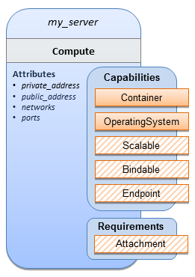

#### Sample YAML

|  |
| --- |
| tosca_definitions_version: tosca_simple_yaml_1_0  description: >  TOSCA simple profile that just defines a single compute instance and selects a (guest) host Operating System from the Compute node’s properties. Note, this example does not include default values on inputs properties.  topology_template:  inputs:  cpus:  type: integer  description: Number of CPUs for the server.  constraints:  - valid_values: [ 1, 2, 4, 8 ]  node_templates:  my_server:  type: Compute  capabilities:  host:  properties:  disk_size: 10 GB  num_cpus: { get_input: cpus }  mem_size: 1 GB  os:  properties:  architecture: x86_64  type: Linux  distribution: ubuntu  version: 12.04  outputs:  private_ip:  description: The private IP address of the deployed server instance.  value: { get_attribute: [my_server, private_address] } |

#### Notes

* This use case uses a versioned, Linux Ubuntu distribution on the Compute node.

### Software Component 1: Automatic deployment of a Virtual Machine (VM) image artifact

#### Description

This use case demonstrates how the TOSCA SoftwareComponent node type can be used to declare software that is packaged in a standard Virtual Machine (VM) image file format (i.e., in this case QCOW2) and is hosted on a TOSCA Compute node (instance). In this variation, the SoftwareComponent declares a VM image as a deployment artifact that includes its own pre-packaged operating system and software. The TOSCA Orchestrator detects this known deployment artifact type on the SoftwareComponent node template and automatically deploys it to the Compute node.

#### Features

This use case introduces the following TOSCA Simple Profile features:

* A node template that uses the normative TOSCA SoftwareComponent Node Type along with showing an exemplary set of its properties being configured.
* Use of the TOSCA Service Template artifacts section to declare a Virtual Machine (VM) image artifact type which is referenced by the SoftwareComponent node template.
* The VM file format, in this case QCOW2, includes its own guest Operating System (OS) and therefore does **not** “require” a TOSCA OperatingSystem capability from the TOSCA Compute node.

#### Assumptions

This use case assumes the following:

* That the TOSCA Orchestrator (working with the Cloud provider’s underlying management services) is able to instantiate a Compute node that has a hypervisor that supports the Virtual Machine (VM) image format, in this case QCOW2, which should be compatible with many standard hypervisors such as XEN and KVM.
* This is not a “bare metal” use case and assumes the existence of a hypervisor on the machine that is allocated to “host” the Compute instance supports (e.g. has drivers, etc.) the VM image format in this example.

#### Logical Diagram

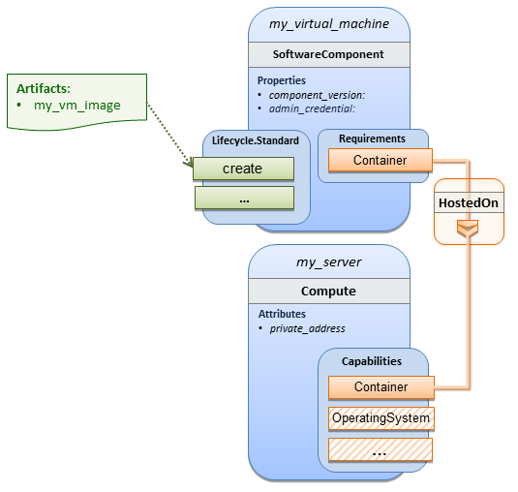

#### Sample YAML

|  |
| --- |
| tosca_definitions_version: tosca_simple_yaml_1_0  description: >  TOSCA Simple Profile with a SoftwareComponent node with a declared Virtual machine (VM) deployment artifact that automatically deploys to its host Compute node.  topology_template:    node_templates:  my_virtual_machine:  type: SoftwareComponent  artifacts:  my_vm_image:  file: images/fedora-18-x86_64.qcow2  type: tosca.artifacts.Deployment.Image.VM.QCOW2  requirements:  - host: my_server  # Automatically deploy the VM image referenced on the create operation  interfaces:  Standard:  create: my_vm_image  # Compute instance with no Operating System guest host  my_server:  type: Compute  capabilities:  # Note: no guest OperatingSystem requirements as these are in the image.  host:  properties:  disk_size: 10 GB  num_cpus: { get_input: cpus }  mem_size: 4 GB  outputs:  private_ip:  description: The private IP address of the deployed server instance.  value: { get_attribute: [my_server, private_address] } |

#### Notes

* The use of the type keyname on the artifact definition (within the my_virtual_machine node template) to declare the ISO image deployment artifact type (i.e., tosca.artifacts.Deployment.Image.VM.ISO) is redundant since the file extension is “.iso” which associated with this known, declared artifact type.
* This use case references a filename on the my_vm_image artifact, which indicates a Linux, Fedora 18, x86 VM image, only as one possible example.

### Block Storage 1: Using the normative AttachesTo Relationship Type

#### Description

This use case demonstrates how to attach a TOSCA BlockStorage node to a Compute node using the normative AttachesTo relationship.

#### Logical Diagram

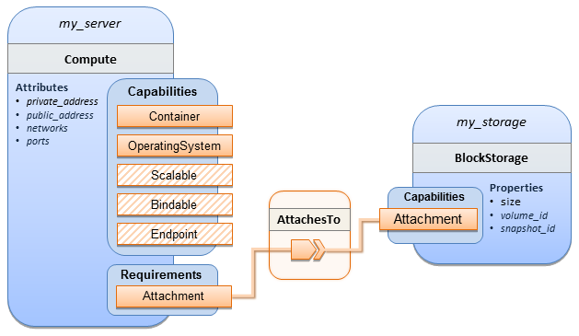

#### Sample YAML

|  |
| --- |
| tosca_definitions_version: tosca_simple_yaml_1_0  description: >  TOSCA simple profile with server and attached block storage using the normative AttachesTo Relationship Type.  topology_template:  inputs:  cpus:  type: integer  description: Number of CPUs for the server.  constraints:  - valid_values: [ 1, 2, 4, 8 ]  storage_size:  type: scalar-unit.size  description: Size of the storage to be created.  default: 1 GB  storage_snapshot_id:  type: string  description: >  Optional identifier for an existing snapshot to use when creating storage.  storage_location:  type: string  description: Block storage mount point (filesystem path).  node_templates:  my_server:  type: Compute  capabilities:  host:  properties:  disk_size: 10 GB  num_cpus: { get_input: cpus }  mem_size: 1 GB  os:  properties:  architecture: x86_64  type: linux  distribution: fedora  version: 18.0  requirements:  - local_storage:  node: my_storage  relationship:  type: AttachesTo  properties:  location: { get_input: storage_location }  my_storage:  type: BlockStorage  properties:  size: { get_input: storage_size }  snapshot_id: { get_input: storage_snapshot_id }  outputs:  private_ip:  description: The private IP address of the newly created compute instance.  value: { get_attribute: [my_server, private_address] }  volume_id:  description: The volume id of the block storage instance.  value: { get_attribute: [my_storage, volume_id] } |

### Block Storage 2: Using a custom AttachesTo Relationship Type

#### Description

This use case demonstrates how to attach a TOSCA BlockStorage node to a Compute node using a custom RelationshipType that derives from the normative AttachesTo relationship.

#### Logical Diagram

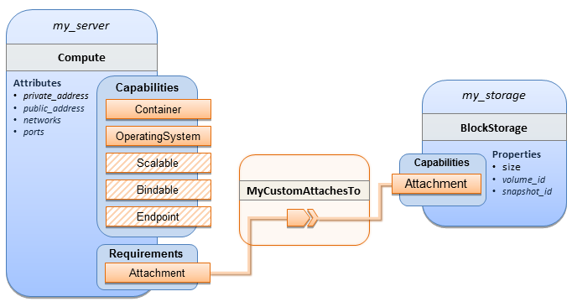

#### Sample YAML

|  |
| --- |
| tosca_definitions_version: tosca_simple_yaml_1_0  description: >  TOSCA simple profile with server and attached block storage using a custom AttachesTo Relationship Type.  relationship_types:  **MyCustomAttachesTo**:  derived_from: AttachesTo  topology_template:  inputs:  cpus:  type: integer  description: Number of CPUs for the server.  constraints:  - valid_values: [ 1, 2, 4, 8 ]  storage_size:  type: scalar-unit.size  description: Size of the storage to be created.  default: 1 GB  storage_snapshot_id:  type: string  description: >  Optional identifier for an existing snapshot to use when creating storage.  storage_location:  type: string  description: Block storage mount point (filesystem path).  node_templates:  my_server:  type: Compute  capabilities:  host:  properties:  disk_size: 10 GB  num_cpus: { get_input: cpus }  mem_size: 4 GB  os:  properties:  architecture: x86_64  type: Linux  distribution: Fedora  version: 18.0  requirements:  - local_storage:  node: my_storage  # Declare custom AttachesTo type using the ‘relationship’ keyword  relationship:  type: **MyCustomAttachesTo**  properties:  location: { get_input: storage_location }  my_storage:  type: BlockStorage  properties:  size: { get_input: storage_size }  snapshot_id: { get_input: storage_snapshot_id }  outputs:  private_ip:  description: The private IP address of the newly created compute instance.  value: { get_attribute: [my_server, private_address] }  volume_id:  description: The volume id of the block storage instance.  value: { get_attribute: [my_storage, volume_id] } |

### Block Storage 3: Using a Relationship Template of type AttachesTo

#### Description

This use case demonstrates how to attach a TOSCA BlockStorage node to a Compute node using a TOSCA Relationship Template that is based upon the normative AttachesTo Relationship Type.

#### Logical Diagram

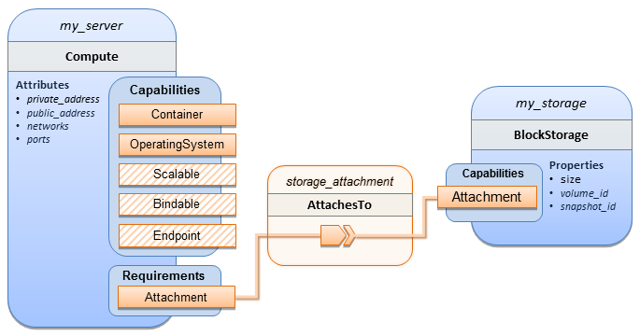

#### Sample YAML

|  |
| --- |
| tosca_definitions_version: tosca_simple_yaml_1_0  description: >  TOSCA simple profile with server and attached block storage using a named Relationship Template for the storage attachment.  topology_template:  inputs:  cpus:  type: integer  description: Number of CPUs for the server.  constraints:  - valid_values: [ 1, 2, 4, 8 ]  storage_size:  type: scalar-unit.size  description: Size of the storage to be created.  default: 1 GB  storage_location:  type: string  description: Block storage mount point (filesystem path).  node_templates:  my_server:  type: Compute  capabilities:  host:  properties:  disk_size: 10 GB  num_cpus: { get_input: cpus }  mem_size: 4 GB  os:  properties:  architecture: x86_64  type: Linux  distribution: Fedora  version: 18.0  requirements:  - local_storage:  node: my_storage  # Declare template to use with ‘relationship’ keyword  relationship**:** **storage_attachment**  my_storage:  type: BlockStorage  properties:  size: { get_input: storage_size }  relationship_templates:  **storage_attachment**:  type: AttachesTo  properties:  location: { get_input: storage_location }  outputs:  private_ip:  description: The private IP address of the newly created compute instance.  value: { get_attribute: [my_server, private_address] }  volume_id:  description: The volume id of the block storage instance.  value: { get_attribute: [my_storage, volume_id] } |

### Block Storage 4: Single Block Storage shared by 2-Tier Application with custom AttachesTo Type and implied relationships

#### Description

This use case shows 2 compute instances (2 tiers) with one BlockStorage node, and also uses a custom AttachesTo Relationship that provides a default mount point (i.e., location) which the 1st tier uses, but the 2nd tier provides a different mount point.

Please note that this use case assumes both Compute nodes are accessing different directories within the shared, block storage node to avoid collisions.

#### Logical Diagram

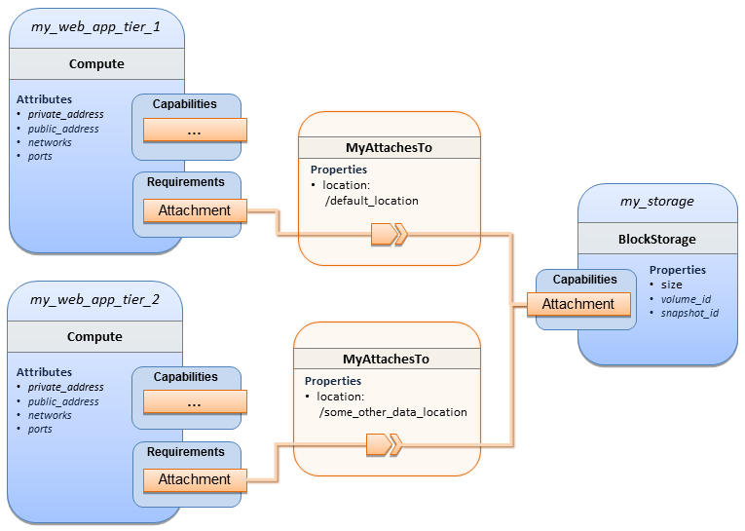

#### Sample YAML

|  |
| --- |
| tosca_definitions_version: tosca_simple_yaml_1_0  description: >  TOSCA simple profile with a Single Block Storage node shared by 2-Tier Application with custom AttachesTo Type and implied relationships.  relationship_types:  MyAttachesTo:  derived_from: tosca.relationships.AttachesTo  properties:  location:  type: string  default: /default_location  topology_template:  inputs:  cpus:  type: integer  description: Number of CPUs for the server.  constraints:  - valid_values: [ 1, 2, 4, 8 ]  storage_size:  type: scalar-unit.size  default: 1 GB  description: Size of the storage to be created.  storage_snapshot_id:  type: string  description: >  Optional identifier for an existing snapshot to use when creating storage.  node_templates:  my_web_app_tier_1:  type: tosca.nodes.Compute  capabilities:  host:  properties:  disk_size: 10 GB  num_cpus: { get_input: cpus }  mem_size: 4096 MB  os:  properties:  architecture: x86_64  type: Linux  distribution: Fedora  version: 18.0  requirements:  - local_storage:  node: my_storage  relationship: MyAttachesTo  my_web_app_tier_2:  type: tosca.nodes.Compute  capabilities:  host:  properties:  disk_size: 10 GB  num_cpus: { get_input: cpus }  mem_size: 4096 MB  os:  properties:  architecture: x86_64  type: Linux  distribution: Fedora  version: 18.0  requirements:  - local_storage:  node: my_storage  relationship:  type: MyAttachesTo  properties:  location: /some_other_data_location  my_storage:  type: tosca.nodes.BlockStorage  properties:  size: { get_input: storage_size }  snapshot_id: { get_input: storage_snapshot_id }  outputs:  private_ip_1:  description: The private IP address of the application’s first tier.  value: { get_attribute: [my_web_app_tier_1, private_address] }  private_ip_2:  description: The private IP address of the application’s second tier.  value: { get_attribute: [my_web_app_tier_2, private_address] }  volume_id:  description: The volume id of the block storage instance.  value: { get_attribute: [my_storage, volume_id] } |

### Block Storage 5: Single Block Storage shared by 2-Tier Application with custom AttachesTo Type and explicit Relationship Templates

#### Description

This use case is like the Notation1 use case, but also creates two relationship templates (one for each tier) each of which provide a different mount point (i.e., location) which overrides the default location defined in the custom Relationship Type.

Please note that this use case assumes both Compute nodes are accessing different directories within the shared, block storage node to avoid collisions.

#### Logical Diagram

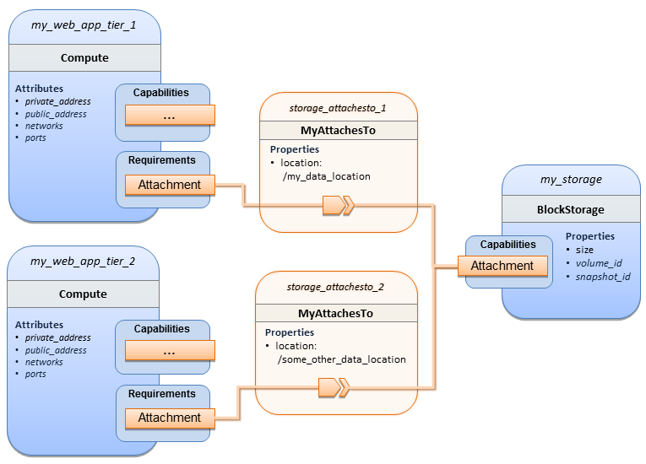

#### Sample YAML

|  |
| --- |
| tosca_definitions_version: tosca_simple_yaml_1_0  description: >  TOSCA simple profile with a single Block Storage node shared by 2-Tier Application with custom AttachesTo Type and explicit Relationship Templates.  relationship_types:  MyAttachesTo:  derived_from: tosca.relationships.AttachesTo  properties:  location:  type: string  default: /default_location  topology_template:  inputs:  cpus:  type: integer  description: Number of CPUs for the server.  constraints:  - valid_values: [ 1, 2, 4, 8 ]  storage_size:  type: scalar-unit.size  default: 1 GB  description: Size of the storage to be created.  storage_snapshot_id:  type: string  description: >  Optional identifier for an existing snapshot to use when creating storage.  storage_location:  type: string  description: >  Block storage mount point (filesystem path).  node_templates:  my_web_app_tier_1:  type: tosca.nodes.Compute  capabilities:  host:  properties:  disk_size: 10 GB  num_cpus: { get_input: cpus }  mem_size: 4096 MB  os:  properties:  architecture: x86_64  type: Linux  distribution: Fedora  version: 18.0  requirements:  - local_storage:  node: my_storage  relationship: storage_attachesto_1  my_web_app_tier_2:  type: tosca.nodes.Compute  capabilities:  host:  properties:  disk_size: 10 GB  num_cpus: { get_input: cpus }  mem_size: 4096 MB  os:  properties:  architecture: x86_64  type: Linux  distribution: Fedora  version: 18.0  requirements:  - local_storage:  node: my_storage  relationship: storage_attachesto_2  my_storage:  type: tosca.nodes.BlockStorage  properties:  size: { get_input: storage_size }  snapshot_id: { get_input: storage_snapshot_id }  relationship_templates:  storage_attachesto_1:  type: MyAttachesTo  properties:  location: /my_data_location  storage_attachesto_2:  type: MyAttachesTo  properties:  location: /some_other_data_location  outputs:  private_ip_1:  description: The private IP address of the application’s first tier.  value: { get_attribute: [my_web_app_tier_1, private_address] }  private_ip_2:  description: The private IP address of the application’s second tier.  value: { get_attribute: [my_web_app_tier_2, private_address] }  volume_id:  description: The volume id of the block storage instance.  value: { get_attribute: [my_storage, volume_id] } |

### Block Storage 6: Multiple Block Storage attached to different Servers

#### Description

This use case demonstrates how two different TOSCA BlockStorage nodes can be attached to two different Compute nodes (i.e., servers) each using the normative AttachesTo relationship.

#### Logical Diagram

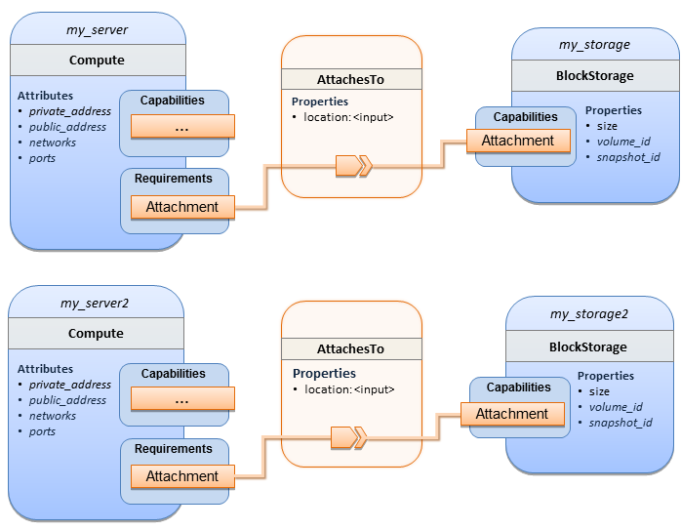

#### Sample YAML

|  |
| --- |
| tosca_definitions_version: tosca_simple_yaml_1_0  description: >  TOSCA simple profile with 2 servers each with different attached block storage.  topology_template:  inputs:  cpus:  type: integer  description: Number of CPUs for the server.  constraints:  - valid_values: [ 1, 2, 4, 8 ]  storage_size:  type: scalar-unit.size  default: 1 GB  description: Size of the storage to be created.  storage_snapshot_id:  type: string  description: >  Optional identifier for an existing snapshot to use when creating storage.  storage_location:  type: string  description: >  Block storage mount point (filesystem path).  node_templates:  my_server:  type: tosca.nodes.Compute  capabilities:  host:  properties:  disk_size: 10 GB  num_cpus: { get_input: cpus }  mem_size: 4096 MB  os:  properties:  architecture: x86_64  type: Linux  distribution: Fedora  version: 18.0  requirements:  - local_storage:  node: my_storage  relationship:  type: AttachesTo  properties:  location: { get_input: storage_location }  my_storage:  type: tosca.nodes.BlockStorage  properties:  size: { get_input: storage_size }  snapshot_id: { get_input: storage_snapshot_id }  my_server2:  type: tosca.nodes.Compute  capabilities:  host:  properties:  disk_size: 10 GB  num_cpus: { get_input: cpus }  mem_size: 4096 MB  os:  properties:  architecture: x86_64  type: Linux  distribution: Fedora  version: 18.0  requirements:  - local_storage:  node: my_storage2  relationship:  type: AttachesTo  properties:  location: { get_input: storage_location }  my_storage2:  type: tosca.nodes.BlockStorage  properties:  size: { get_input: storage_size }  snapshot_id: { get_input: storage_snapshot_id }  outputs:  server_ip_1:  description: The private IP address of the application’s first server.  value: { get_attribute: [my_server, private_address] }  server_ip_2:  description: The private IP address of the application’s second server.  value: { get_attribute: [my_server2, private_address] }  volume_id_1:  description: The volume id of the first block storage instance.  value: { get_attribute: [my_storage, volume_id] }  volume_id_2:  description: The volume id of the second block storage instance.  value: { get_attribute: [my_storage2, volume_id] } |

### Object Storage 1: Creating an Object Storage service

#### Description

#### Logical Diagram

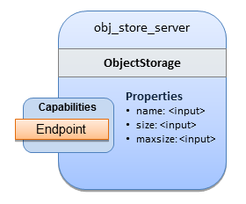

#### Sample YAML

|  |
| --- |
| tosca_definitions_version: tosca_simple_yaml_1_0  description: >  Tosca template for creating an object storage service.  topology_template:  inputs:  objectstore_name:  type: string  node_templates:  obj_store_server:  type: tosca.nodes.ObjectStorage  properties:  name: { get_input: objectstore_name }  size: 4096 MB  maxsize: 20 GB |

### Network 1: Server bound to a new network

#### Description

Introduces the TOSCA Network and Port nodes used for modeling logical networks using the LinksTo and BindsTo Relationship Types. In this use case, the template is invoked without an existing network_name as an input property so a new network is created using the properties declared in the Network node.

#### Logical Diagram

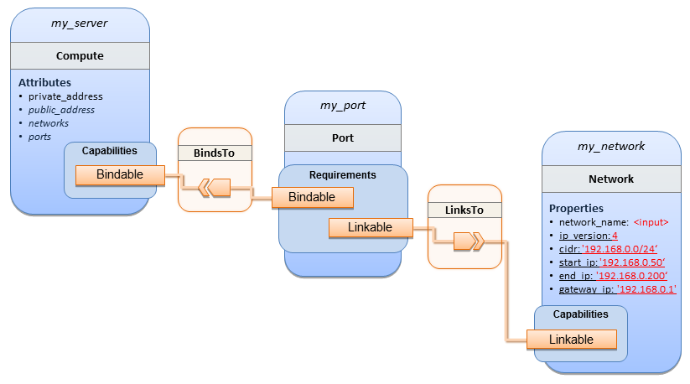

#### Sample YAML

|  |
| --- |
| tosca_definitions_version: tosca_simple_yaml_1_0  description: >  TOSCA simple profile with 1 server bound to a new network  topology_template:  inputs:  network_name:  type: string  description: Network name  node_templates:  my_server:  type: tosca.nodes.Compute  capabilities:  host:  properties:  disk_size: 10 GB  num_cpus: 1  mem_size: 4096 MB  os:  properties:  architecture: x86_64  type: Linux  distribution: CirrOS  version: 0.3.2  my_network:  type: tosca.nodes.network.Network  properties:  network_name: { get_input: network_name }  ip_version: 4  cidr: '192.168.0.0/24'  start_ip: '192.168.0.50'  end_ip: '192.168.0.200'  gateway_ip: '192.168.0.1'  my_port:  type: tosca.nodes.network.Port  requirements:  - binding: my_server  - link: my_network |

### Network 2: Server bound to an existing network

#### Description

This use case shows how to use a network_name as an input parameter to the template to allow a server to be associated with an existing network.

#### Logical Diagram

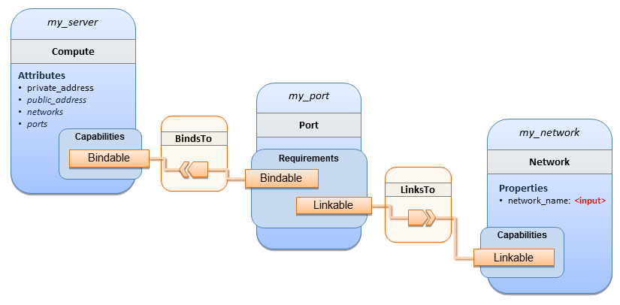

#### Sample YAML

|  |
| --- |
| tosca_definitions_version: tosca_simple_yaml_1_0  description: >  TOSCA simple profile with 1 server bound to an existing network  topology_template:  inputs:  network_name:  type: string  description: Network name  node_templates:  my_server:  type: tosca.nodes.Compute  capabilities:  host:  properties:  disk_size: 10 GB  num_cpus: 1  mem_size: 4096 MB  os:  properties:  architecture: x86_64  type: Linux  distribution: CirrOS  version: 0.3.2  my_network:  type: tosca.nodes.network.Network  properties:  network_name: { get_input: network_name }  my_port:  type: tosca.nodes.network.Port  requirements:  - binding:  node: my_server  - link:  node: my_network |

### Network 3: Two servers bound to a single network

#### Description

This use case shows how two servers (Compute nodes) can be bound to the same Network (node) using two logical network Ports.

#### Logical Diagram

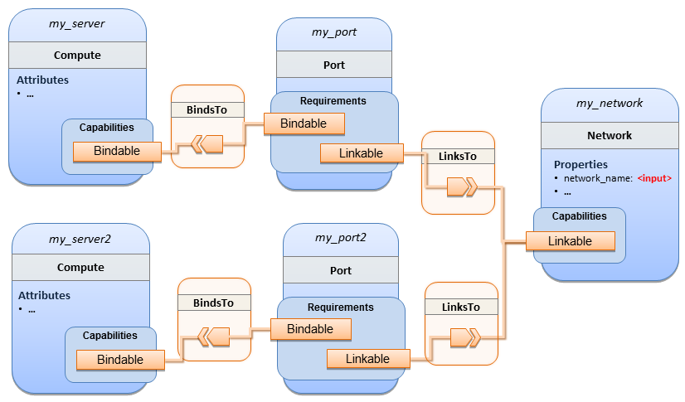

#### Sample YAML

|  |
| --- |
| tosca_definitions_version: tosca_simple_yaml_1_0  description: >  TOSCA simple profile with 2 servers bound to the 1 network  topology_template:  inputs:  network_name:  type: string  description: Network name  network_cidr:  type: string  default: 10.0.0.0/24  description: CIDR for the network  network_start_ip:  type: string  default: 10.0.0.100  description: Start IP for the allocation pool  network_end_ip:  type: string  default: 10.0.0.150  description: End IP for the allocation pool  node_templates:  my_server:  type: tosca.nodes.Compute  capabilities:  host:  properties:  disk_size: 10 GB  num_cpus: 1  mem_size: 4096 MB  os:  properties:  architecture: x86_64  type: Linux  distribution: CirrOS  version: 0.3.2  my_server2:  type: tosca.nodes.Compute  capabilities:  host:  properties:  disk_size: 10 GB  num_cpus: 1  mem_size: 4096 MB  os:  properties:  architecture: x86_64  type: Linux  distribution: CirrOS  version: 0.3.2  my_network:  type: tosca.nodes.network.Network  properties:  ip_version: 4  cidr: { get_input: network_cidr }  network_name: { get_input: network_name }  start_ip: { get_input: network_start_ip }  end_ip: { get_input: network_end_ip }  my_port:  type: tosca.nodes.network.Port  requirements:  - binding: my_server  - link: my_network  my_port2:  type: tosca.nodes.network.Port  requirements:  - binding: my_server2  - link: my_network |

### Network 4: Server bound to three networks

#### Description

This use case shows how three logical networks (Network), each with its own IP address range, can be bound to with the same server (Compute node).

#### Logical Diagram

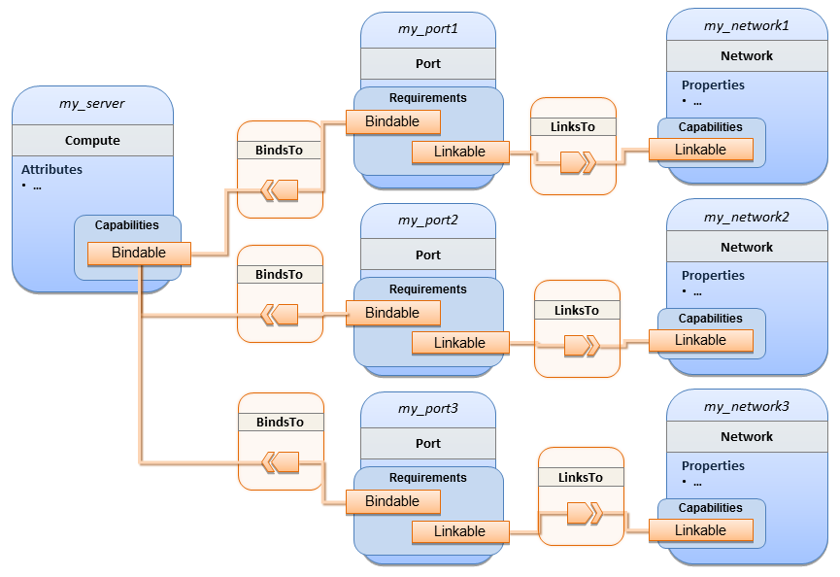

#### Sample YAML

|  |
| --- |
| tosca_definitions_version: tosca_simple_yaml_1_0  description: >  TOSCA simple profile with 1 server bound to 3 networks  topology_template:  node_templates:  my_server:  type: tosca.nodes.Compute  capabilities:  host:  properties:  disk_size: 10 GB  num_cpus: 1  mem_size: 4096 MB  os:  properties:  architecture: x86_64  type: Linux  distribution: CirrOS  version: 0.3.2  my_network1:  type: tosca.nodes.network.Network  properties:  cidr: '192.168.1.0/24'  network_name: net1  my_network2:  type: tosca.nodes.network.Network  properties:  cidr: '192.168.2.0/24'  network_name: net2  my_network3:  type: tosca.nodes.network.Network  properties:  cidr: '192.168.3.0/24'  network_name: net3  my_port1:  type: tosca.nodes.network.Port  properties:  order: 0  requirements:  - binding: my_server  - link: my_network1  my_port2:  type: tosca.nodes.network.Port  properties:  order: 1  requirements:  - binding: my_server  - link: my_network2  my_port3:  type: tosca.nodes.network.Port  properties:  order: 2  requirements:  - binding: my_server  - link: my_network3 |

### WebServer-DBMS 1: WordPress + MySQL, single instance

#### Description

TOSCA simple profile service showing the WordPress web application with a MySQL database hosted on a single server (instance).

#### Logical Diagram

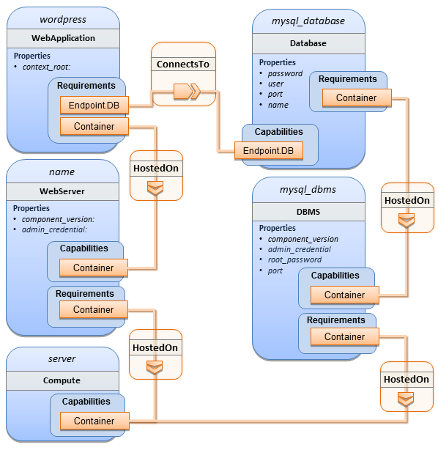

#### Sample YAML

|  |
| --- |
| tosca_definitions_version: tosca_simple_yaml_1_0  description: >  TOSCA simple profile with WordPress, a web server, a MySQL DBMS hosting the application’s database content on the same server. Does not have input defaults or constraints.  topology_template:  inputs:  cpus:  type: integer  description: Number of CPUs for the server.  db_name:  type: string  description: The name of the database.  db_user:  type: string  description: The username of the DB user.  db_pwd:  type: string  description: The WordPress database admin account password.  db_root_pwd:  type: string  description: Root password for MySQL.  db_port:  type: PortDef  description: Port for the MySQL database  node_templates:  wordpress:  type: tosca.nodes.WebApplication.WordPress  properties:  context_root: { get_input: context_root }  requirements:  - host: webserver  - database_endpoint: mysql_database  interfaces:  Standard:  create: wordpress_install.sh  configure:  implementation: wordpress_configure.sh  inputs:  wp_db_name: { get_property: [ mysql_database, name ] }  wp_db_user: { get_property: [ mysql_database, user ] }  wp_db_password: { get_property: [ mysql_database, password ] }  # In my own template, find requirement/capability, find port property  wp_db_port: { get_property: [ SELF, database_endpoint, port ] }  mysql_database:  type: Database  properties:  name: { get_input: db_name }  user: { get_input: db_user }  password: { get_input: db_pwd }  port: { get_input: db_port }  capabilities:  database_endpoint:  properties:  port: { get_input: db_port }  requirements:  - host: mysql_dbms  interfaces:  Standard:  configure: mysql_database_configure.sh  mysql_dbms:  type: DBMS  properties:  root_password: { get_input: db_root_pwd }  port: { get_input: db_port }  requirements:  - host: server  interfaces:  Standard:  inputs:  db_root_password: { get_property: [ mysql_dbms, root_password ] }  create: mysql_dbms_install.sh  start: mysql_dbms_start.sh  configure: mysql_dbms_configure.sh  webserver:  type: WebServer  requirements:  - host: server  interfaces:  Standard:  create: webserver_install.sh  start: webserver_start.sh    server:  type: Compute  capabilities:  host:  properties:  disk_size: 10 GB  num_cpus: { get_input: cpus }  mem_size: 4096 MB  os:  properties:  architecture: x86_64  type: linux  distribution: fedora  version: 17.0  outputs:  website_url:  description: URL for Wordpress wiki.  value: { get_attribute: [server, public_address] } |

#### Sample scripts

Where the referenced implementation scripts in the example above would have the following contents

##### wordpress_install.sh

|  |
| --- |
| yum -y install wordpress |

##### wordpress_configure.sh

|  |
| --- |
| sed -i "/Deny from All/d" /etc/httpd/conf.d/wordpress.conf  sed -i "s/Require local/Require all granted/" /etc/httpd/conf.d/wordpress.conf  sed -i s/database_name_here/name/ /etc/wordpress/wp-config.php  sed -i s/username_here/user/ /etc/wordpress/wp-config.php  sed -i s/password_here/password/ /etc/wordpress/wp-config.php  systemctl restart httpd.service |

##### mysql_database_configure.sh

|  |
| --- |
| # Setup MySQL root password and create user  cat << EOF | mysql -u root --password=db_root_password  CREATE DATABASE name;  GRANT ALL PRIVILEGES ON name.* TO "user"@"localhost"  IDENTIFIED BY "password";  FLUSH PRIVILEGES;  EXIT  EOF |

##### mysql_dbms_install.sh

|  |
| --- |
| yum -y install mysql mysql-server  # Use systemd to start MySQL server at system boot time  systemctl enable mysqld.service |

##### mysql_dbms_start.sh

|  |
| --- |
| # Start the MySQL service (NOTE: may already be started at image boot time)  systemctl start mysqld.service |

##### mysql_dbms_configure

|  |
| --- |
| # Set the MySQL server root password  mysqladmin -u root password db_root_password |

##### webserver_install.sh

|  |
| --- |
| yum -y install httpd  systemctl enable httpd.service |

##### webserver_start.sh

|  |
| --- |
| # Start the httpd service (NOTE: may already be started at image boot time)  systemctl start httpd.service |

### WebServer-DBMS 2: Nodejs with PayPal Sample App and MongoDB on separate instances

#### Description

This use case Instantiates a 2-tier application with Nodejs and its (PayPal sample) WebApplication on one tier which connects a MongoDB database (which stores its application data) using a ConnectsTo relationship.

#### Logical Diagram

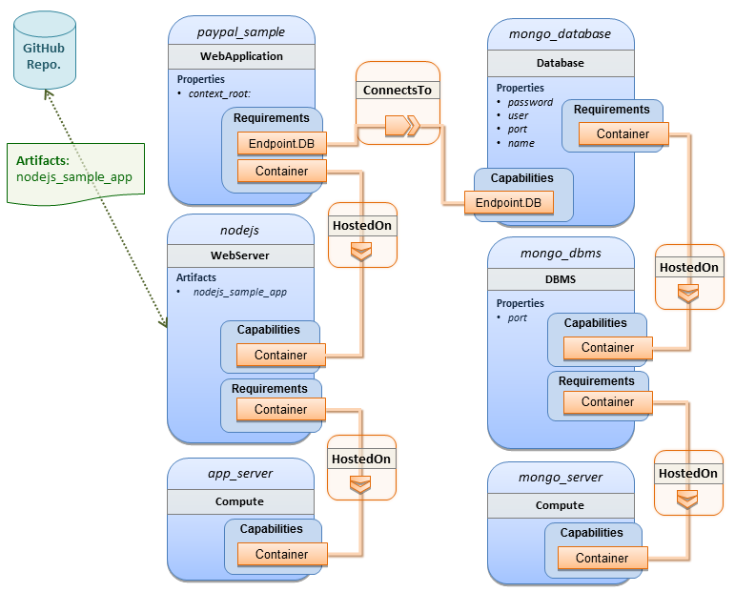

#### Sample YAML

|  |
| --- |
| tosca_definitions_version: tosca_simple_yaml_1_0  description: >  TOSCA simple profile with a nodejs web server hosting a PayPal sample application which connects to a mongodb database.  imports:  - custom_types/paypalpizzastore_nodejs_app.yaml  dsl_definitions:  ubuntu_node: &ubuntu_node  disk_size: 10 GB  num_cpus: { get_input: my_cpus }  mem_size: 4096 MB  os_capabilities: &os_capabilities  architecture: x86_64  type: Linux  distribution: Ubuntu  version: 14.04  topology_template:  inputs:  my_cpus:  type: integer  description: Number of CPUs for the server.  constraints:  - valid_values: [ 1, 2, 4, 8 ]  default: 1  github_url:  type: string  description: The URL to download nodejs.  default: https://github.com/sample.git  node_templates:  paypal_pizzastore:  type: tosca.nodes.WebApplication.PayPalPizzaStore  properties:  github_url: { get_input: github_url }  requirements:  - host:nodejs  - database_connection: mongo_db  interfaces:  Standard:  configure:  implementation: scripts/nodejs/configure.sh  inputs:  github_url: { get_property: [ SELF, github_url ] }  mongodb_ip: { get_attribute: [mongo_server, private_address] }  start: scriptsscripts/nodejs/start.sh    nodejs:  type: tosca.nodes.WebServer.Nodejs  requirements:  - host: app_server  interfaces:  Standard:  create: scripts/nodejs/create.sh  mongo_db:  type: tosca.nodes.Database  requirements:  - host: mongo_dbms  interfaces:  Standard:  create: create_database.sh  mongo_dbms:  type: tosca.nodes.DBMS  requirements:  - host: mongo_server  properties:  port: 27017  interfaces:  tosca.interfaces.node.lifecycle.Standard:  create: mongodb/create.sh  configure:  implementation: mongodb/config.sh  inputs:  mongodb_ip: { get_attribute: [mongo_server, private_address] }  start: mongodb/start.sh  mongo_server:  type: tosca.nodes.Compute  capabilities:  os:  properties: *os_capabilities  host:  properties: *ubuntu_node  app_server:  type: tosca.nodes.Compute  capabilities:  os:  properties: *os_capabilities  host:  properties: *ubuntu_node  outputs:  nodejs_url:  description: URL for the nodejs server, http://<IP>:3000  value: { get_attribute: [app_server, private_address] }  mongodb_url:  description: URL for the mongodb server.  value: { get_attribute: [ mongo_server, private_address ] } |

#### Notes:

* Scripts referenced in this example are assumed to be placed by the TOSCA orchestrator in the relative directory declared in TOSCA.meta of the TOSCA CSAR file.

### Multi-Tier-1: Elasticsearch, Logstash, Kibana (ELK) use case with multiple instances

#### Description

TOSCA simple profile service showing the Nodejs, MongoDB, Elasticsearch, Logstash, Kibana, rsyslog and collectd installed on a different server (instance).

This use case also demonstrates:

* Use of TOSCA macros or dsl_definitions
* Multiple SoftwareComponents hosted on same Compute node
* Multiple tiers communicating to each other over ConnectsTo using Configure interface.

#### Logical Diagram

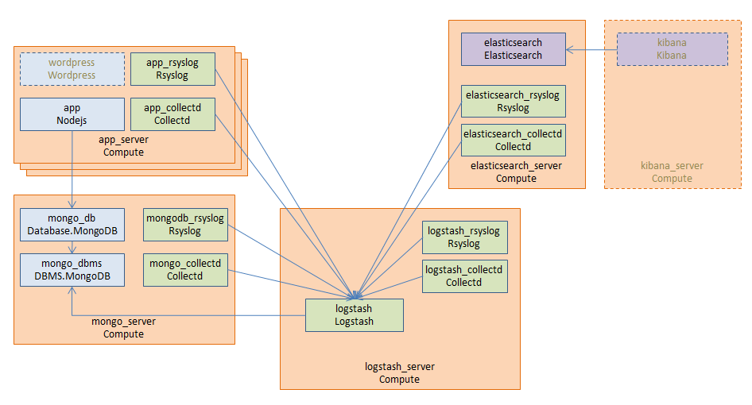

#### Sample YAML

##### Master Service Template application (Entry-Definitions)

TheThe following YAML is the primary template (i.e., the Entry-Definition) for the overall use case. The imported YAML for the various subcomponents are not shown here for brevity.

|  |
| --- |
| tosca_definitions_version: tosca_simple_yaml_1_0  description: >  This TOSCA simple profile deploys nodejs, mongodb, elasticsearch, logstash and kibana each on a separate server with monitoring enabled for nodejs server where a sample nodejs application is running. The syslog and collectd are installed on a nodejs server.  imports:  - paypalpizzastore_nodejs_app.yaml  - elasticsearch.yaml  - logstash.yaml  - kibana.yaml  - collectd.yaml  - rsyslog.yaml  dsl_definitions:  host_capabilities: &host_capabilities  # container properties (flavor)  disk_size: 10 GB  num_cpus: { get_input: my_cpus }  mem_size: 4096 MB  os_capabilities: &os_capabilities  architecture: x86_64  type: Linux  distribution: Ubuntu  version: 14.04  topology_template:  inputs:  my_cpus:  type: integer  description: Number of CPUs for the server.  constraints:  - valid_values: [ 1, 2, 4, 8 ]  github_url:  type: string  description: The URL to download nodejs.  default: https://github.com/sample.git    node_templates:  paypal_pizzastore:  type: tosca.nodes.WebApplication.PayPalPizzaStore  properties:  github_url: { get_input: github_url }  requirements:  - host: nodejs  - database_connection: mongo_db  interfaces:  Standard:  configure:  implementation: scripts/nodejs/configure.sh  inputs:  github_url: { get_property: [ SELF, github_url ] }  mongodb_ip: { get_attribute: [mongo_server, private_address] }  start: scripts/nodejs/start.sh    nodejs:  type: tosca.nodes.WebServer.Nodejs  requirements:  - host: app_server  interfaces:  Standard:  create: scripts/nodejs/create.sh  mongo_db:  type: tosca.nodes.Database  requirements:  - host: mongo_dbms  interfaces:  Standard:  create: create_database.sh  mongo_dbms:  type: tosca.nodes.DBMS  requirements:  - host: mongo_server  interfaces:  tosca.interfaces.node.lifecycle.Standard:  create: scripts/mongodb/create.sh  configure:  implementation: scripts/mongodb/config.sh  inputs:  mongodb_ip: { get_attribute: [mongo_server, ip_address] }  start: scripts/mongodb/start.sh  elasticsearch:  type: tosca.nodes.SoftwareComponent.Elasticsearch  requirements:  - host: elasticsearch_server  interfaces:  tosca.interfaces.node.lifecycle.Standard:  create: scripts/elasticsearch/create.sh  start: scripts/elasticsearch/start.sh  logstash:  type: tosca.nodes.SoftwareComponent.Logstash  requirements:  - host: logstash_server  - search_endpoint: elasticsearch  interfaces:  tosca.interfaces.relationship.Configure:  pre_configure_source:  implementation: python/logstash/configure_elasticsearch.py  input:  elasticsearch_ip: { get_attribute: [elasticsearch_server, ip_address] }  interfaces:  tosca.interfaces.node.lifecycle.Standard:  create: scripts/lostash/create.sh  configure: scripts/logstash/config.sh  start: scripts/logstash/start.sh  kibana:  type: tosca.nodes.SoftwareComponent.Kibana  requirements:  - host: kibana_server  - search_endpoint: elasticsearch  interfaces:  tosca.interfaces.node.lifecycle.Standard:  create: scripts/kibana/create.sh  configure:  implementation: scripts/kibana/config.sh  input:  elasticsearch_ip: { get_attribute: [elasticsearch_server, ip_address] }  kibana_ip: { get_attribute: [kibana_server, ip_address] }  start: scripts/kibana/start.sh  app_collectd:  type: tosca.nodes.SoftwareComponent.Collectd  requirements:  - host: app_server  - collectd_endpoint: logstash  interfaces:  tosca.interfaces.relationship.Configure:  pre_configure_target:  implementation: python/logstash/configure_collectd.py  interfaces:  tosca.interfaces.node.lifecycle.Standard:  create: scripts/collectd/create.sh  configure:  implementation: python/collectd/config.py  input:  logstash_ip: { get_attribute: [logstash_server, ip_address] }  start: scripts/collectd/start.sh  app_rsyslog:  type: tosca.nodes.SoftwareComponent.Rsyslog  requirements:  - host: app_server  - rsyslog_endpoint: logstash  interfaces:  tosca.interfaces.relationship.Configure:  pre_configure_target:  implementation: python/logstash/configure_rsyslog.py  interfaces:  tosca.interfaces.node.lifecycle.Standard:  create: scripts/rsyslog/create.sh  configure:  implementation: scripts/rsyslog/config.sh  input:  logstash_ip: { get_attribute: [logstash_server, ip_address] }  start: scripts/rsyslog/start.sh  app_server:  type: tosca.nodes.Compute  capabilities:  host:  properties: *host_capabilities  os:  properties: *os_capabilities  mongo_server:  type: tosca.nodes.Compute  capabilities:  host:  properties: *host_capabilities  os:  properties: *os_capabilities  elasticsearch_server:  type: tosca.nodes.Compute  capabilities:  host:  properties: *host_capabilities  os:  properties: *os_capabilities  logstash_server:  type: tosca.nodes.Compute  capabilities:  host:  properties: *host_capabilities  os:  properties: *os_capabilities  kibana_server:  type: tosca.nodes.Compute  capabilities:  host:  properties: *host_capabilities  os:  properties: *os_capabilities  outputs:  nodejs_url:  description: URL for the nodejs server.  value: { get_attribute: [ app_server, private_address ] }  mongodb_url:  description: URL for the mongodb server.  value: { get_attribute: [ mongo_server, private_address ] }  elasticsearch_url:  description: URL for the elasticsearch server.  value: { get_attribute: [ elasticsearch_server, private_address ] }  logstash_url:  description: URL for the logstash server.  value: { get_attribute: [ logstash_server, private_address ] }  kibana_url:  description: URL for the kibana server.  value: { get_attribute: [ kibana_server, private_address ] } |

#### Sample scripts

Where the referenced implementation scripts in the example above would have the following contents

### Container-1: Containers using Docker single Compute instance (Containers only)

#### Description

This use case shows a minimal description of two Container nodes (only) providing their Docker Requirements allowing platform (orchestrator) to select/provide the underlying Docker implementation (Capability). Specifically, wordpress and mysql Docker images are referenced from Docker Hub.

This use case also demonstrates:

* Abstract description of Requirements (i.e., Container and Docker) allowing platform to dynamically select the appropriate runtime Capabilities that match.
* Use of external repository (Docker Hub) to reference image artifact.

#### Logical Diagram

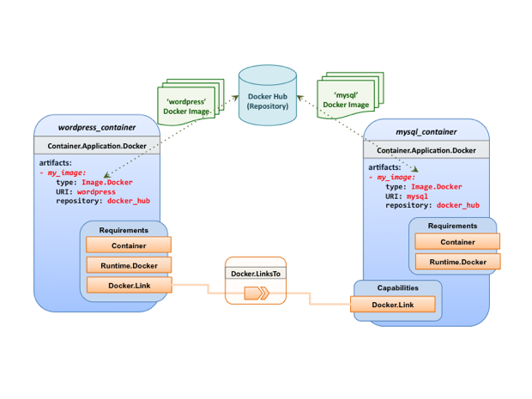

#### Sample YAML

##### Two Docker “Container” nodes (Only) with Docker Requirements

|  |
| --- |
| tosca_definitions_version: tosca_simple_yaml_1_0  description: >  TOSCA simple profile with wordpress, web server and mysql on the same server.  # Repositories to retrieve code artifacts from  repositories:  docker_hub: https://registry.hub.docker.com/  topology_template:  inputs:  wp_host_port:  type: integer  description: The host port that maps to port 80 of the WordPress container.  db_root_pwd:  type: string  description: Root password for MySQL.  node_templates:  # The MYSQL container based on official MySQL image in Docker hub  mysql_container:  type: tosca.nodes.Container.Application.Docker  capabilities:  # This is a capability that would mimic the Docker –link feature  database_link: tosca.capabilities.Docker.Link  artifacts:  my_image:  file: mysql  type: tosca.artifacts.Deployment.Image.Container.Docker  repository: docker_hub  interfaces:  Standard:  create:  implementation: my_image  inputs:  db_root_password: { get_input: db_root_pwd }  # The WordPress container based on official WordPress image in Docker hub  wordpress_container:  type: tosca.nodes.Container.Application.Docker  requirements:  - database_link: mysql_container  artifacts:  my_image:  file: wordpress  type: tosca.artifacts.Deployment.Image.Container.Docker  repository: docker_hub  interfaces:  Standard:  create:  implementation: my_image  inputs:  host_port: { get_input: wp_host_port } |

# TOSCA Policies

This section is **non-normative** and describes the approach TOSCA Simple Profile plans to take for policy description with TOSCA Service Templates. In addition, it explores how existing TOSCA Policy Types and definitions might be applied in the future to express operational policy use cases.

## A declarative approach

TOSCA Policies are a type of requirement that govern use or access to resources which can be expressed independently from specific applications (or their resources) and whose fulfillment is not discretely expressed in the application’s topology (i.e., via TOSCA Capabilities).

TOSCA deems it not desirable for a declarative model to encourage external intervention for resolving policy issues (i.e., via imperative mechanisms external to the Cloud). Instead, the Cloud provider is deemed to be in the best position to detect when policy conditions are triggered, analyze the affected resources and enforce the policy against the allowable actions declared within the policy itself.

### Declarative considerations

* Natural language rules are not realistic, too much to represent in our specification; however, regular expressions can be used that include simple operations and operands that include symbolic names for TOSCA metamodel entities, properties and attributes.
* Complex rules can actually be directed to an external policy engine (to check for violation) returns true|false then policy says what to do (trigger or action).
* Actions/Triggers could be:
* Autonomic/Platform corrects against user-supplied criteria
* External monitoring service could be utilized to monitor policy rules/conditions against metrics, the monitoring service could coordinate corrective actions with external services (perhaps Workflow engines that can analyze the application and interact with the TOSCA instance model).

## Consideration of Event, Condition and Action

## Types of policies

Policies typically address two major areas of concern for customer workloads:

* **Access Control** – assures user and service access to controlled resources are governed by rules which determine general access permission (i.e., allow or deny) and conditional access dependent on other considerations (e.g., organization role, time of day, geographic location, etc.).
* **Placement** – assures affinity (or anti-affinity) of deployed applications and their resources; that is, what is allowed to be placed where within a Cloud provider’s infrastructure.
* **Quality-of-Service** (and continuity) - assures performance of software components (perhaps captured as quantifiable, measure components within an SLA) along with consideration for scaling and failover.

### Access control policies

Although TOSCA Policy definitions could be used to express and convey access control policies, definitions of policies in this area are out of scope for this specification. At this time, TOSCA encourages organizations that already have standards that express policy for access control to provide their own guidance on how to use their standard with TOSCA.

### Placement policies

There must be control mechanisms in place that can be part of these patterns that accept governance policies that allow control expressions of what is allowed when placing, scaling and managing the applications that are enforceable and verifiable in Cloud.

These policies need to consider the following:

* Regulated industries need applications to control placement (deployment) of applications to different countries or regions (i.e., different logical geographical boundaries).

#### Placement for governance concerns

In general, companies and individuals have security concerns along with general “loss of control” issues when considering deploying and hosting their highly valued application and data to the Cloud. They want to control placement perhaps to ensure their applications are only placed in datacenter they trust or assure that their applications and data are not placed on shared resources (i.e., not co-tenanted).

In addition, companies that are related to highly regulated industries where compliance with government, industry and corporate policies is paramount. In these cases, having the ability to control placement of applications is an especially significant consideration and a prerequisite for automated orchestration.

#### Placement for failover

Companies realize that their day-to-day business must continue on through unforeseen disasters that might disable instances of the applications and data at or on specific data centers, networks or servers. They need to be able to convey placement policies for their software applications and data that mitigate risk of disaster by assuring these cloud assets are deployed strategically in different physical locations. Such policies need to consider placement across geographic locations as wide as countries, regions, datacenters, as well as granular placement on a network, server or device within the same physical datacenter. Cloud providers must be able to not only enforce these policies but provide robust and seamless failover such that a disaster’s impact is never perceived by the end user.

### Quality-of-Service (QoS) policies

Quality-of-Service (apart from failover placement considerations) typically assures that software applications and data are available and performant to the end users. This is usually something that is measurable in terms of end-user responsiveness (or response time) and often qualified in SLAs established between the Cloud provider and customer. These QoS aspects can be taken from SLAs and legal agreements and further encoded as performance policies associated with the actual applications and data when they are deployed. It is assumed that Cloud provider is able to detect high utilization (or usage load) on these applications and data that deviate from these performance policies and is able to bring them back into compliance.

## Policy relationship considerations

* Performance policies can be related to scalability policies. Scalability policies tell the Cloud provider exactly **how** to scale applications and data when they detect an application’s performance policy is (or about to be) violated (or triggered).
* Scalability policies in turn are related to placement policies which govern **where** the application and data can be scaled to.
* There are general “tenant” considerations that restrict what resources are available to applications and data based upon the contract a customer has with the Cloud provider. This includes other constraints imposed by legal agreements or SLAs that are not encoded programmatically or associated directly with actual application or data.

## Use Cases

This section includes some initial operation policy use cases that we wish to describe using the TOSCA metamodel. More policy work will be done in future versions of the TOSCA Simple Profile in YAML specification.

### Placement

#### Use Case 1: Simple placement for failover

##### Description

This use case shows a failover policy to keep at least 3 copies running in separate containers. In this simple case, the specific containers to use (or name is not important; the Cloud provider must assure placement separation (anti-affinity) in three physically separate containers.

##### Features

This use case introduces the following policy features:

* Simple separation on different “compute” nodes (up to discretion of provider).
* Simple separation by region (a logical container type) using an allowed list of region names relative to the provider.
  + Also, shows that set of allowed “regions” (containers) can be greater than the number of containers requested.

##### Logical Diagram

Sample YAML: Compute separation

|  |
| --- |
| failover_policy_1:  type: tosca.policy.placement.Antilocate  description: My placement policy for Compute node separation  properties:  # 3 diff target containers  container type: Compute  container_number: 3 |

##### Notes

* There may be availability (constraints) considerations especially if these policies are applied to “clusters”.
* There may be future considerations for controlling max # of instances per container.

#### Use Case 2: Controlled placement by region

##### Description

This use case demonstrates the use of named “containers” which could represent the following:

* Datacenter regions
* Geographic regions (e.g., cities, municipalities, states, countries, etc.)
* Commercial regions (e.g., North America, Eastern Europe, Asia Pacific, etc.)

##### Features

This use case introduces the following policy features:

* Separation of resources (i.e., TOSCA nodes) by logical regions, or zones.

##### Sample YAML: Region separation amongst named set of regions

|  |
| --- |
| failover_policy_2:  type: tosca.policy.placement  description: My failover policy with allowed target regions (logical containers)  properties:  container type: region  container_number: 3  # If “containers” keyname is provided, they represent the allowed set  # of target containers to use for placement for .  containers: [ region1, region2, region3, region4 ] |

#### Use Case 3: Co-locate based upon Compute affinity

##### Description

Nodes that need to be co-located to achieve optimal performance based upon access to similar Infrastructure (IaaS) resource types (i.e., Compute, Network and/or Storage).

This use case demonstrates the co-location based upon Compute resource affinity; however, the same approach could be taken for Network as or Storage affinity as well. :

##### Features

This use case introduces the following policy features:

* Node placement based upon Compute resource affinity.

#### Notes

* The concept of placement based upon IaaS resource utilization is not future-thinking, as Cloud should guarantee equivalent performance of application performance regardless of placement. That is, all network access between application nodes and underlying Compute or Storage should have equivalent performance (e.g., network bandwidth, network or storage access time, CPU speed, etc.).

##### Sample YAML: Region separation amongst named set of regions

|  |
| --- |
| keep_together_policy:  type: tosca.policy.placement.Colocate  description: Keep associated nodes (groups of nodes) based upon Compute  properties:  affinity: Compute |

### Scaling

#### Use Case 1: Simple node autoscale

##### Description

Start with X nodes and scale up to Y nodes, capability to do this from a dashboard for example.

##### Features

This use case introduces the following policy features:

* Basic autoscaling policy

##### Sample YAML

|  |
| --- |
| my_scaling_policy_1:  type: tosca.policy.scaling  description: Simple node autoscaling  properties:  min_instances: <integer>  max_instances: <integer>  default_instances: <integer>  increment: <integer> |

##### Notes

* Assume horizontal scaling for this use case
  + Horizontal scaling, implies “stack-level” control using Compute nodes to define a “stack” (i.e., The Compute node’s entire HostedOn relationship dependency graph is considered part of its “stack”)
* Assume Compute node has a SoftwareComponent that represents a VM application.
* Availability Zones (and Regions if not same) need to be considered in further use cases.
* If metrics are introduced, there is a control-loop (that monitors). Autoscaling is a special concept that includes these considerations.
* Mixed placement and scaling use cases need to be considered:
  + *Example*: Compute1 and Compute2 are 2 node templates. Compute1 has 10 instances, 5 in one region 5 in other region.

# Conformance

## Conformance Targets

The implementations subject to conformance are those introduced in Section 11.3 “Implementations”. They are listed here for convenience:

* TOSCA YAML service template
* TOSCA processor
* TOSCA orchestrator (also called orchestration engine)
* TOSCA generator
* TOSCA archive

## Conformance Clause 1: TOSCA YAML service template

A document conforms to this specification as TOSCA YAML service template if it satisfies all the statements below:

1. It is valid according to the grammar, rules and requirements defined in section 3 “TOSCA Simple Profile definitions in YAML”.
2. When using functions defined in section 4 “TOSCA functions”, it is valid according to the grammar specified for these functions.
3. When using or referring to data types, artifact types, capability types, interface types, node types, relationship types, group types, policy types defined in section 5 “TOSCA normative type definitions”, it is valid according to the definitions given in section 5.

## Conformance Clause 2: TOSCA processor

A processor or program conforms to this specification as TOSCA processor if it satisfies all the statements below:

1. It can parse and recognize the elements of any conforming TOSCA YAML service template, and generates errors for those documents that fail to conform as TOSCA YAML service template while clearly intending to.
2. It implements the requirements and semantics associated with the definitions and grammar in section 3 “TOSCA Simple Profile definitions in YAML”, including those listed in the “additional requirements” subsections.
3. It resolves the imports, either explicit or implicit, as described in section 3 “TOSCA Simple Profile definitions in YAML”.
4. It generates errors as required in error cases described in sections 3.1 (TOSCA Namespace URI and alias), 3.2 (Parameter and property type) and 3.6 (Type-specific definitions).
5. It normalizes string values as described in section 5.4.9.3 (Additional Requirements)

## Conformance Clause 3: TOSCA orchestrator

A processor or program conforms to this specification as TOSCA orchestrator if it satisfies all the statements below:

1. It is conforming as a TOSCA Processor as defined in conformance clause 2: TOSCA Processor.
2. It can process all types of artifact described in section 5.3 “Artifact types” according to the rules and grammars in this section.
3. It can process TOSCA archives as intended in section 6 “TOSCA Cloud Service Archive (CSAR) format” and other related normative sections.
4. It can understand and process the functions defined in section 4 “TOSCA functions” according to their rules and semantics.
5. It can understand and process the normative type definitions according to their semantics and requirements as described in section 5 “TOSCA normative type definitions”.
6. It can understand and process the networking types and semantics defined in section 7 “TOSCA Networking”.
7. It generates errors as required in error cases described in sections 2.10 (Using node template substitution for chaining subsystems), 5.4 (Capabilities Types) and 5.7 (Interface Types).).

## Conformance Clause 4: TOSCA generator

A processor or program conforms to this specification as TOSCA generator if it satisfies at least one of the statements below:

1. When requested to generate a TOSCA service template, it always produces a conforming TOSCA service template, as defined in Clause 1: TOSCA YAML service template,
2. When requested to generate a TOSCA archive, it always produces a conforming TOSCA archive, as defined in Clause 5: TOSCA archive.

## Conformance Clause 5: TOSCA archive

A package artifact conforms to this specification as TOSCA archive if it satisfies all the statements below:

1. It is valid according to the structure and rules defined in section 6 “TOSCA Cloud Service Archive (CSAR) format”.
2. Known Extensions to TOSCA v1.0

The following items will need to be reflected in the TOSCA (XML) specification to allow for isomorphic mapping between the XML and YAML service templates.

* 1. Model Changes
* The “TOSCA Simple ‘Hello World’” example introduces this concept in Section 2. Specifically, a VM image assumed to accessible by the cloud provider.
* Introduce template Input and Output parameters
* The “Template with input and output parameter” example introduces concept in Section 2.1.1.
* “Inputs” could be mapped to BoundaryDefinitions in TOSCA v1.0. Maybe needs some usability enhancement and better description.
* “outputs” are a new feature.
* Grouping of Node Templates
* This was part of original TOSCA proposal, but removed early on from v1.0 This allows grouping of node templates that have some type of logically managed together as a group (perhaps to apply a scaling or placement policy).
* Lifecycle Operation definition independent/separate from Node Types or Relationship types (allows reuse). For now, we added definitions for “node.lifecycle” and “relationship.lifecycle”.
* Override of Interfaces (operations) in the Node Template.
* Service Template Naming/Versioning
* Should include TOSCA spec. (or profile) version number (as part of namespace)
* Allow the referencing artifacts using a URL (e.g., as a property value).
* Repository definitions in Service Template.
* Substitution mappings for Topology template.
* Addition of Group Type, Policy Type, Group def., Policy def. along with normative TOSCA base types for policies and groups.
  1. Normative Types
* Constraints
* constraint clauses, regex
* Types / Property / Parameters
* list, map, range, scalar-unit types
* Includes YAML intrinsic types
* NetworkInfo, PortInfo, PortDef, PortSpec, Credential
* TOSCA Version based on Maven
* Node
* Root, Compute, ObjectStorage, BlockStorage, Network, Port, SoftwareComponent, WebServer, WebApplicaton, DBMS, Database, Container, and others
* Relationship
* Root, DependsOn, HostedOn, ConnectsTo, AttachesTo, RoutesTo, BindsTo, LinksTo and others
* Artifact
* Deployment: Image Types (e.g., VM, Container), ZIP, TAR, etc.
* Implementation: File, Bash, Python, etc.
* Requirements
* None
* Capabilities
* Container, Endpoint, Attachment, Scalable, …
* Lifecycle
* Standard (for Node Types)
* Configure (for Relationship Types)
* Functions
* get_input, get_attribute, get_property, get_nodes_of_type, get_operation_output and others
* concat, token
* get_artifact
* Groups
* Root
* Policies
* Root, Placement, Scaling, Update, Performance
* Workflow

1. Acknowledgments

The following individuals have participated in the creation of this specification and are gratefully acknowledged:

Contributors:

Avi Vachnis ([avi.vachnis@alcatel-lucent.com](mailto:avi.vachnis@alcatel-lucent.com)), Alcatel-Lucent

Chris Lauwers ([lauwers@ubicity.com](mailto:lauwers@ubicity.com))

Derek Palma ([dpalma@vnomic.com](mailto:dpalma@vnomic.com)), Vnomic

Frank Leymann (Frank.Leymann@informatik.uni-stuttgart.de), Univ. of Stuttgart

Gerd Breiter ([gbreiter@de.ibm.com](mailto:gbreiter@de.ibm.com)), IBM

Hemal Surti ([hsurti@cisco.com](mailto:hsurti@cisco.com)), Cisco

Ifat Afek ([ifat.afek@alcatel-lucent.com](mailto:ifat.afek@alcatel-lucent.com)), Alcatel-Lucent

Idan Moyal, ([idan@gigaspaces.com](mailto:idan@gigaspaces.com)), Gigaspaces

Jacques Durand ([jdurand@us.fujitsu.com](mailto:jdurand@us.fujitsu.com)), Fujitsu

Jin Qin, ([chin.qinjin@huawei.com](mailto:chin.qinjin@huawei.com)), Huawei

Jeremy Hess, ([jeremy@gigaspaces.com](mailto:jeremy@gigaspaces.com)) , Gigaspaces

John Crandall, (<mailto:jcrandal@brocade.com>), Brocade

Juergen Meynert ([juergen.meynert@ts.fujitsu.com](mailto:juergen.meynert@ts.fujitsu.com)), Fujitsu

Kapil Thangavelu (kapil.thangavelu@canonical.com), Canonical

Karsten Beins ([karsten.beins@ts.fujitsu.com](mailto:karsten.beins@ts.fujitsu.com)), Fujitsu

Kevin Wilson ([kevin.l.wilson@hp.com](mailto:kevin.l.wilson@hp.com)), HP

Krishna Raman (kraman@redhat.com), Red Hat

Luc Boutier ([luc.boutier@fastconnect.fr](mailto:luc.boutier@fastconnect.fr)), FastConnect

Luca Gioppo, ([luca.gioppo@csi.it](mailto:luca.gioppo@csi.it)), CSI-Piemonte

Matt Rutkowski ([mrutkows@us.ibm.com](mailto:mrutkows@us.ibm.com)), IBM

Moshe Elisha ([moshe.elisha@alcatel-lucent.com](mailto:moshe.elisha@alcatel-lucent.com)), Alcatel-Lucent

Nate Finch ([nate.finch@canonical.com](mailto:nate.finch@canonical.com)), Canonical

Nikunj Nemani (nnemani@vmware.com), WMware

Richard Probst (richard.probst@sap.com), SAP AG

Sahdev Zala ([spzala@us.ibm.com](mailto:spzala@us.ibm.com)), IBM

Shitao li ([lishitao@huawei.com](mailto:lishitao@huawei.com)), Huawei

Simeon Monov ([sdmonov@us.ibm.com](mailto:sdmonov@us.ibm.com)), IBM

Sivan Barzily, ([sivan@gigaspaces.com](mailto:sivan@gigaspaces.com)), Gigaspaces

Sridhar Ramaswamy ([sramasw@brocade.com](mailto:sramasw@brocade.com)), Brocade

Stephane Maes ([stephane.maes@hp.com](mailto:stephane.maes@hp.com)), HP

Thomas Spatzier ([thomas.spatzier@de.ibm.com](mailto:thomas.spatzier@de.ibm.com)), IBM

Ton Ngo ([ton@us.ibm.com](mailto:ton@us.ibm.com)), IBM

Travis Tripp ([travis.tripp@hp.com](mailto:travis.tripp@hp.com)), HP

**Vahid Hashemian** ([vahidhashemian@us.ibm.com](mailto:vahidhashemian@us.ibm.com)), IBM

Wayne Witzel ([wayne.witzel@canonical.com](mailto:wayne.witzel@canonical.com)), Canonical

Yaron Parasol ([yaronpa@gigaspaces.com](mailto:yaronpa@gigaspaces.com)), Gigaspaces

1. Revision History

|  |  |  |  |
| --- | --- | --- | --- |
| **Revision** | **Date** | **Editor** | **Changes Made** |
| WD01, Rev01 | 2016-01-06 | Matt Rutkowski, IBM | * Initial WD01, Revision 01 baseline for TOSCA Simple Profile in YAML v1.1 * Cha. 10 Removed URL column for use cases in favor of a single link to Git directory where they can be found. * Metadata added to top-level entities * Policy grammar/schema fully defined. * Ch5. Defined TOSCA Entity Root type which is now the parent type for all TOSCA top-level types (i.e., Artifact, Capability, Relationship, Node, Group, Policy, etc.). Updated all top-level definitions to reflect in “derived_from” keyname. * Added TimeInterval Data Type * 3.5.16.1: Added keyname “schedule”. |
| WD01, Rev02 | 2016-01-25 | Matt Rutkowski, IBM | * 5: Removed tosca.Root type from chapter 5 until ad-hoc can agree on use cases likely to come from the TOSCA instance model WG. * Cleaned up TOSCA Entity Root Reorganization. |
| WD01, Rev03 | 2016-03-22 | Matt Rutkowski, IBM | * 3.5.7, 3.9.3: Fixed “import” grammar (section 3.5.7) and reference to it in repository example (section 3.9.3.9.3) * 3.6.11.2 – Group Type – clarified group types could have members that were other groups types. * 5.2.5: Fixed NetworkInfo (section 5.2.5) example which was missing the ‘properties’ keyword. * 5.2.6: Clarified PortDef examples (section 5.2.6) * 5.2.7: Fixed PortSpec (section 5.2.7) definition to assure that target, target_range, source and source_range properties were not ‘required’ in schema. * Fixed the following issues raised by TC Admin.: * Margins should be 1" top, 1" right and left, 0.5" bottom. [this will center the "new" footer, which is currently offset]. * The footer uses different font size (Arial 10 instead of Arial 8) and wording ("Standards Track Draft" instead of "Standards Track Work Product"). * Set the following three styles to use Arial 10: * "Normal around table" * "List Paragraph" * "List Bullet 3" * Around section 2.10.1, we corrected some text in the wrong font by re-applying the "normal" style. * In Section 1.8 Glossary that "Node Template" definition starts off with "Relationship Template" Is that correct? Also, the paragraph formatting of the definitions seems to use weird indenting. * In section 5.7.4.4, the diagram overlays the footer. We fixed this on our side by setting the preceding paragraph attribute to "keep with next". * In section 2.10.2, second paragraph after Figure 1, there is a reference to "Section 0". The link jumps to 2.9.2. Is this correct? * The table of examples is labelled Table of Figures. Also, the paragraph styles of these two titles should be changed from "Body text" to "Level 1", so they will show up in the TOC.   3.6.5 Interface Type – missing “derived_from” in keyname table, grammar and example. |
| WD01, Rev04 | 2016-03-23 | Matt Rutkowski, IBM | * 5.2: Added section discussing TOSCA normative type names, their treatment and requirements to respect case (i.e., be case sensitive) when processing. * 3.6: All data types that are entity types now have their keyname tables reference the common keynames listed in section 3.6.1 TOSCA Entity schema. * 3.6.11: Added attributes, requirements and capabilities keynames to Group Type making it more like a Node Type (no artifacts, still logical aggregator of a set of nodes). * 5.9.11: Added the “network” (i.e, Endpoint) and “storage” (i.e., Storage) capabilities to the Container.Application node type. |
| WD01, Rev05 | 2016-04-20 | Matt Rutkowski, IBM | * 3.1: Bumped version number to 1.1 * 5.3.2: typo. ‘userh’ -> ‘user’ in keyname table * 3.6.4.4 Artifact Type - Added a note regarding “mime types” to reference official list of Apache mime types to give reader a sutiable reference for expected values. |
| WDO1, Rev06 | 2016-17-05 | Luc Boutier, FastConnect | * 3.5.14.2.2 replaced Node Type by Node Template. * 3.5.17: Add workflow activity definition * 3.5.18: Add workflow precondition definition * 3.5.19: Add workflow step definition * 3.7.7.: Add Imperative workflow definition * 3.8: Add the workflows keyname to the topology template definition * 6.3: Added a simplified way to declare a CSAR without the meta file. * 7: Added a TOSCA workflows section. |
| WDO1, Rev07 | 2016-19-05 | Luc Boutier, FastConnect | * 3.5.18: Add assertion definition * 3.5.19: Add condition clause definition * 3.5.20: Leverage condition clause in precondition definition * 3.5.21: Leverage condition clause as filter in step definition * 7.2: Add documentation and example on TOSCA normative weaving * 7.3: Fix examples in imperative workflows definition |
| WDO1, Rev08 | 2016-31-05 | Luc Boutier,  FastConnect | * 7.2: Specifies current expected declarative workflows and limitations. |
| WD01, Rev09 | 2016-31-05 | Luc Boutier,  FastConnect; Matt Rutkowski, IBM | * 1.8: Add description for abstract nodes and no-op nodes to the glossary * Fixed typos, spelling/grammar and fixed numerous broken hyperlinks. |