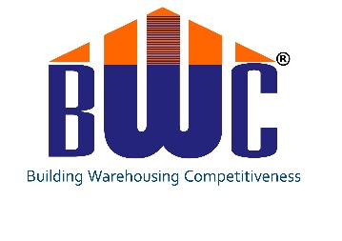

***CALIBRATING BUILDING WAREHOUSE COMPETITIVENESS TO EXCEL***

***17 – 18 November 2016, Hotel Eros, New Delhi***

**CONCEPT NOTE**

The Indian warehousing industry is growing at a CAGR of 10% year on year.

The Warehousing industry generated employment of 45 million in comparision to 4.3 million in IT industry in 2014 – 2015.

The Government of India’s initiatives to support economic growth has also reflected well on the industry. Adoption of GST, the roll out of Make in India and economic liberalisation policies will continue to drive demand and move businesses closer to customers.

The Government plans to develop infrastructure such as dedicated freight corridors, Delhi Mumbai Industrial Corridor (DMIC), development of ports alongside the coastline of India. There are also plans to continue to develop national highways through National Highways Development Plan (NHDP) and other major city to city corridors.

This will enhance the role of the Supply Chain function and infrastructure.

Considering the existing and future growth rate and the points mentioned above, it becomes increasingly important for the warehousing industry to further develop competitiveness.

The past Building Warehousing Competitiveness conferences have stressed on topics, gaps and issues related to Infrastructure, Resources and Technology and successfully created awareness in industries, supply chain professionals and service providers.

Supply Chain professionals and warehouse operators have gained knowledge and successfully implemented various concepts over a period of time in their warehouse infrastructure and operations leading to building warehouse competitiveness.

Businesses have started recognising the importance of Optimum layouts, streamlining processes, identifying the right automation and mechanisation systems, aligning infrastructure to the processes and throughputs that need to pass through the infrastructure.

This will help in developing competencies and capabilities in operating complex SOP’s, understanding and use of technology by professionals and promote continuous measurement and improvement in all the links of the chain.

With growth in outsourcing warehousing operations and distribution management through 3PL’s the calibration process will help in transforming the 3PL’s from generalists to specialists and will open new avenues in industries.

In recent years many Supply Chain Professionals and Warehousing companies have invested in resources, infrastructure, technology and equipment; however continue to be in search of the optimum benefits from these elements.

Perhaps these decisions have not been taken considering the relation and dynamics between these elements leading to sub-optimal gains.

Therefore it is time to calibrate these isolated but vital elements.

Calibration will involve taking a holistic and comprehensive view to integrate and deliver optimum productivity, increased accuracy, enhanced efficiency and high impact effectiveness; which will create benchmarking standards in the warehousing processes in particular and industry at large.

The conference will focus on developing relevant skill sets, overcoming operational hurdles, channelling advantages gained from changes in Government policies, developing and using performance measurement, use of modern equipment and development of relevant IT & Automation technologies.

The sessions developed for this conference will provide insight on how to build, develop, calibrate and sustain these elements to achieve the desired competitiveness.