**Critical Approaches to Literature**

*Standard critical thinking tools are readily adaptable to the study of literature. It's possible to analyze, question, interpret, synthesize, and evaluate the literary works you read in the course of pondering, analyzing and discussing them. Literary criticism is the field of study which systematizes this sort of activity, and several critical approaches to literature are possible. Some of the more popular ones, along with their basic tenants, are listed below:*

**FORMALIST CRITICISM**

1. Literature is a form of knowledge with intrinsic elements--style, structure, imagery, tone, genre.
2. What gives a literary work status as art, or as a great work of art, is how all of its elements work together to create the reader's total *experience* (thought, feeling, gut reactions, etc.)
3. The appreciation of literature as an art requires close reading--a careful, step-by-step analysis and explication of the text (the language of the work). An analysis may follow from questions like, how do various elements work together to shape the effect on the reader?
4. Style and theme influence eachother and can't be separated if meaning is to be retained. It's this interdependence in form and content that makes a text "literary." "Extracting" elements in isolation (theme, character, ploy, setting, etc.) may destroy a reader's aesthetic experience of the whole.
5. Formalist critics don't deny the historical, political situation of a work, they just believe works of art have the power to transcend by being "organic wholes"--akin to a being with a life of its own.

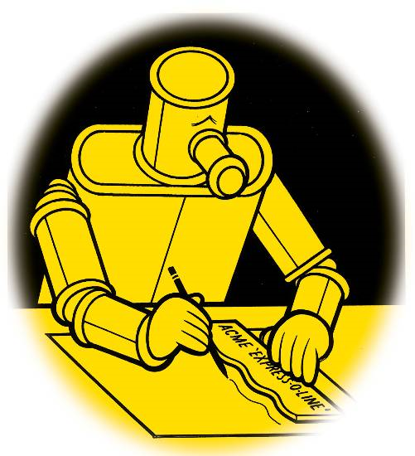

1. Formalist criticism is evaluative in that it differentiates great works of art from poor works of art. Other kinds of criticism don't necessarily concern themselves with this distinction.
2. Formalist criticism is decidedly a "scientific" approach to literary analysis, focusiing on "facts amenable to "verification" (evidence in the text).

**BIOGRAPHICAL CRITICISM**

1. Real life experience can help shape (either directly or indirectly) an author's work.
2. Understanding an author's life can help us better understand the work.
3. Facts from the author's life are used to help the reader better understand the work; the focus is always on the literary work under investigation.

**HISTORICAL CRITICISM**

1. Historical criticism investigates the social, cultural, and intellectual context that produced it. This investigation includes the author's biography and the social milieu.
2. Historical criticism often seeks to understand the impact of a work in its day, and it may also explore how meanings change over time.
3. Historical criticism expolores how time and place of creation affect meaning in the work.

**PSYCHOLOGICAL CRITICISM**

1. These critics hold the belief that great literature truthfully reflects life and is a realistic representation of human motivation and behavior.
2. Psychological critics may choose to focus on the creative process of the artist, the artist's motivation or behavior, or analyze fictional characters' motivations and behaviors.

**MYTHOLOGICAL CRITICISM**

1. Mythological criticism studies recurrent universal patterns underlying most literary works (for example, "the hero's journey").
2. It combines insights from a variety of academic disciplines--anthropology, psychology, history, comparative religion...it concerns itself with demonstrating how the individual imagination shares a common humanity by identifying common symbols, images, plots, etc.
3. Mythological critics identify "archetypes" (symbols, characters, situations, or images evoking a universal response).

**MARXIST (SOCIOLOGICAL) CRITICISM**

1. These critics examine literature in its cultural, economic, and political context; they explore the relation between the artist and the society--how might the profession of authorship have affected what's been written?

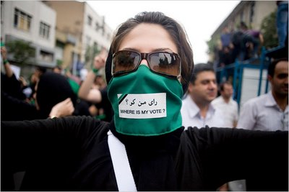

1. It is concerned with the social content of literary works, pursuing such questions as: What cultural, economic or political values does the text implicitly or explicitly promote? What is the role of the audience in shaping what's been written?
2. Marxist critics assume that all art is political.
3. Marxist critics judge a work's "ideology"
4. Marxist critics ask how power and money (socio-economic status affect how we realte to each other)

**READER-RESPONSE CRITICISM**

1. This type of criticism attempts to describe the internal workings of the reader's mental processes. it recognizes reading as a creative act, a creative process.
2. No text is self-contained, independent of a reader's interpretive design.
3. The plurality of readings possible are all explored. Critics study how different readers see the same text differently, and how religious, cultural, and social values affect readings.
4. Instead of focusing only on the values embedded in the text, this type of criticism studies the values embedded in the reader. Intersections between the two are explored.

**DECONSTRUCTIVE CRITICISM**

1. Deconstructive critics believe that language doesn't accurately reflect reality becuase it's an unstable medium; literary texts therefore have no stable meaning.
2. Deconstructive criticism resembles formalist criticism in its close attention to the text, its close analysis of individual words and images. There the similarity ends, because their aims are in fact opposite. Whereas formalist criticism is interested in "aesthetic wholes" or *constructs*, deconstructionists aim to demonstrate irreconcilable positions--they *destruct* (or deconstruct)--by proving the instability of language, its inability to express anything definte.

**Critical Approaches - Thesis ideas**

*Use the handout on critical approaches to fill in possible thesis statement that could be used to write a literary critical essay from each approach.*

**FORMALIST CRITICISM**

**Example:** Dahl uses foreshadowing to prepare readers for the story’s ending.

**Example:** Dahl uses food symbols – lamb, ice, and alcohol -- to add depth to the characters.

**Your example:**

**BIOGRAPHICAL CRITICISM**

**Example:** Dahl’s childhood dream of becoming a police officer, and problems in his marriage directly influenced the writing of “Lamb to the Slaughter”.

**Your example:**

**HISTORICAL CRITICISM**

**Example:** Mary gets away with committing “the perfect crime” because crime-detecting technology was less advanced than it is today. In today’s world, she would surely be caught.

**Your example:**

**PSYCHOLOGICAL CRITICISM**

**Example:** Mary Maloney is highly skilled at deceiving herself.

**Example:** Mary is driven to murder because she has not found an appropriate outlet for her negative thoughts.

**Your example:**

**MYTHOLOGICAL CRITICISM**

**Example:** The symbol of lamb in the story evokes the Biblical metaphor, and emphasizes the brutish nature of the crime. This makes Mary a lion.

**Your example:**

**MARXIST (SOCIOLOGICAL) CRITICISM**

**Example:** Mary is a victim of her culture and time. Her society offers her little autonomy, and severely restricts her choices.

**Example:** Mary’s lack of economic power is the root cause of the crime.

**Your example:**

**READER-RESPONSE CRITICISM**

**Example:** “Lamb to the Slaughter” can be perceived very differently by different readers. A reader who is a police officer, and a reader who is a single mother would come away with very different perceptions of the characters.

**Your example:**

**DECONSTRUCTIVE CRITICISM**

**Example:** The story shows that our systems of law and justice are insufficient in light of the complexity of human motivation and morality.

**Your example:**