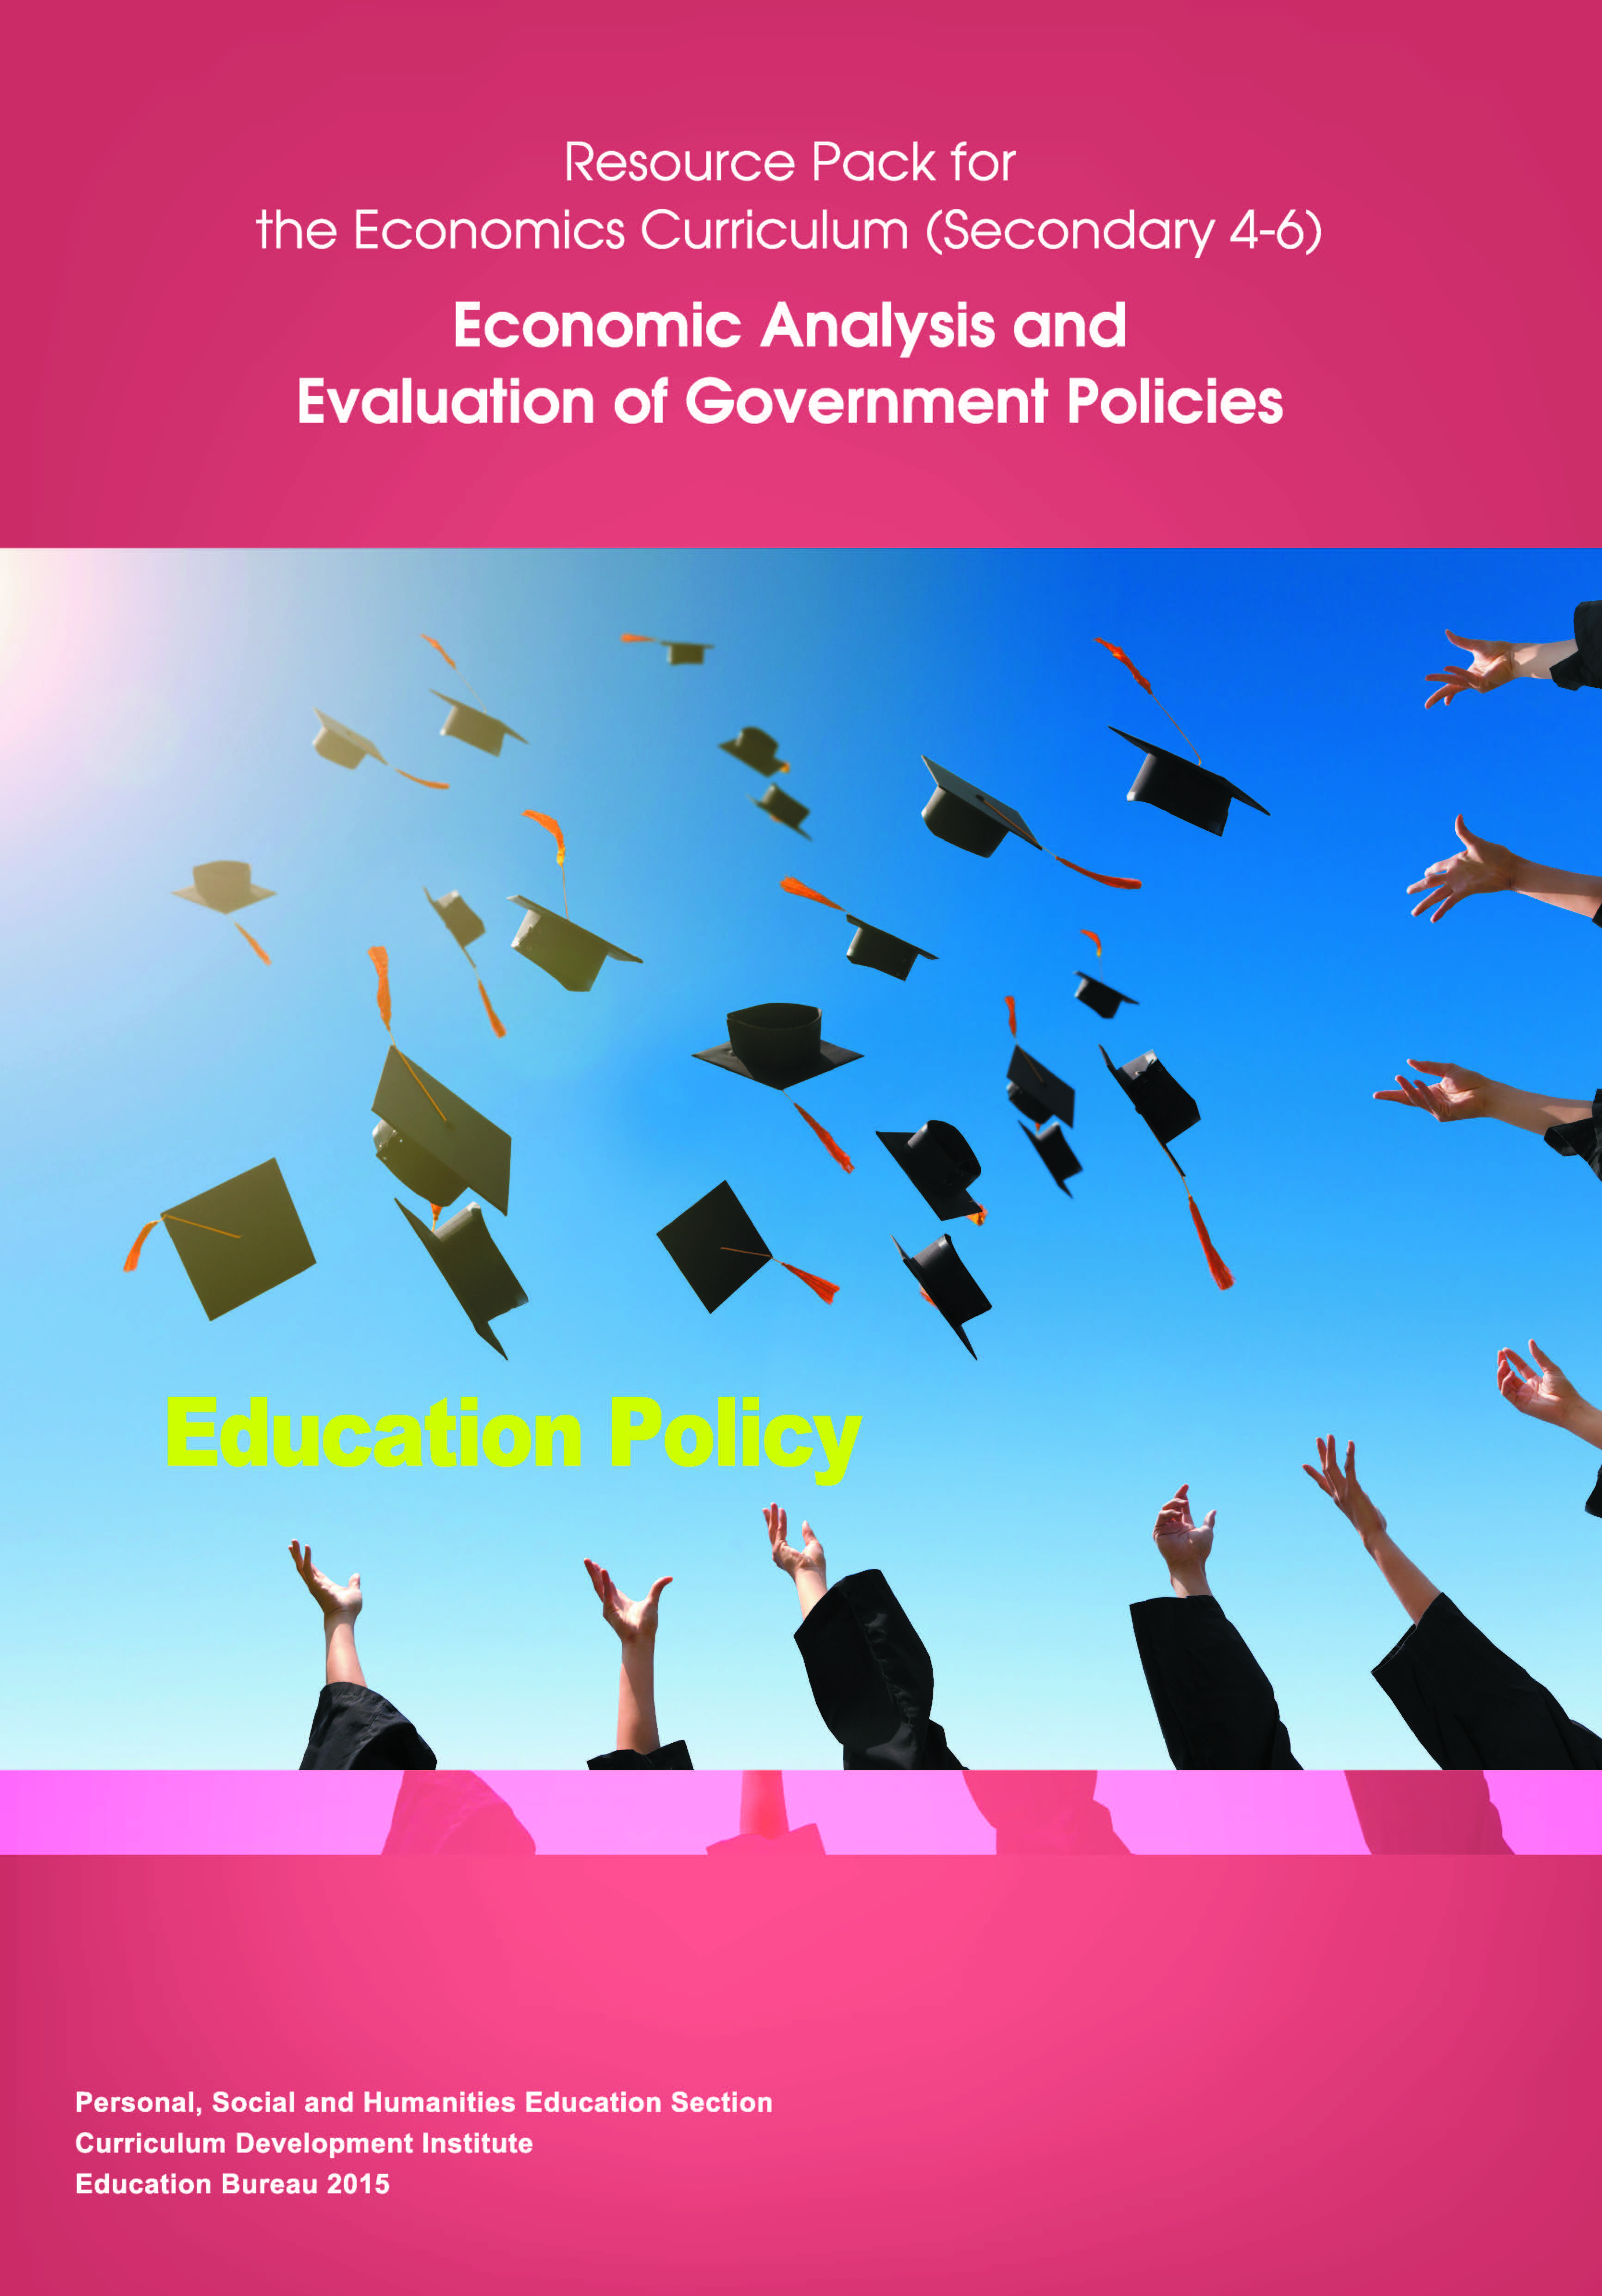

**Contents**

1. Public Spending on Education 1

2. Education System in Hong Kong 4

2.1. Primary and Secondary Education 5

2.2. Post-Secondary Education 6

3. A Microeconomic Perspective: External Benefits and Market Failure 13

3.1. Education as an Investment 13

3.2. External Benefits of Education 16

3.3. Market Failure and Internalizing the Externality 20

4. A Macroeconomic Perspective: Human Capital and Economic Growth 24

5. Policy Analysis and Evaluation 29

5.1. Policy 1: An Increase in the Number of Places on UGC-Funded Undergraduate Programmes 31

5.2. Policy 2: Study Subsidy Scheme for Designated Professions / Sectors (SSSDP) 38

6. Discussion Questions 41

7. References 45

2. Public Spending on Education

Education is one of the most important areas that government spends the most. In 2013-14, for example, the Hong Kong government’s spending on education was HK$76.9 billion, representing 17.6% of the total government expenditure, or 3.6% of the Gross Domestic Product (GDP) of Hong Kong. It was also the policy area with the largest share of public spending in the financial year of 2013-14. The figure below shows the public expenditure of the Hong Kong government in terms of policy area groups:

Figure 1-1 Public Expenditure by Policy Area Groups, 2013-14

Source: Hong Kong Government Yearbook, 2013

In fact, education has been one of the policy areas with a substantial share in the total public expenditure. It takes up about 20% of the public spending in the past decade, though having the ratio decreased in recent years. The total budgeted expenditure on education in the financial year of 2014-15 amounted to $75.4 billion, which occupied 18.3% of the government expenditure. The following table shows the spending on education as a percentage of government spending and GDP for Hong Kong since 2000:

Figure 1-2 Expenditure on Education as a Percentage of

Government Spending and GDP, 2000 - 2013

Source: Hong Kong Government Yearbook, 2013

Hong Kong is not the only city with a considerable spending on education. Governments of most of the developed countries or regions also heavily subsidize education through the provision of public schools or other forms of subsidy. The following table shows the spending on education of some countries in recent years.

Table 1-1 Spending on Education of Selected Countries

|  |  |  |
| --- | --- | --- |
| Countries / Places | Education spending as a percentage of total government spending (%) | Education spending as a percentage of GDP (%) |
| France | 10.2 | 5.9 |
| Germany | 10.5 | 5.1 |
| Hong Kong | 18.2 | 3.8 |
| Korea | 25.0 | 5.0 |
| Singapore | 21.0 | 3.0 |
| United Kingdom | 11.3 | 6.2 |
| United States | 13.1 | 5.4 |

Source: The World Bank (the most up-to-date figures from 2009 – 2012)

1. Education System in Hong Kong

The mainstream education system in Hong Kong can be divided into four categories – kindergarten education, primary education, secondary education, and higher education. These consist of both private and public schools. The table below gives an overview of the curriculum stages and the respective age groups of the education system in Hong Kong.

Table 2-1 Education System in Hong Kong

|  |  |
| --- | --- |
| Normal Age in the school year | Curriculum Stages |
| 3 – 5 | Kindergarten Education |
| 6 – 11 | Primary Education |
| 12 – 14 | Junior Secondary Education |
| 15 – 17 | Senior Secondary Education |
| 18 – 21 | Higher Education |

Source: Education Bureau, HKSAR Government

* 1. Primary and Secondary Education

Primary education is compulsory for all children above six in Hong Kong. The education provided by schools in the public sector is universal and free. The core subjects of the primary education include Chinese, English, Mathematics, General Studies, Music, Visual Arts and Physical Education. In the academic year of 2012-13, there were 528 local schools, 41 English Schools Foundation (ESF) schools and other international primary schools in Hong Kong. The number of students in 2012-13 was over 317,000 at that time, and the average class size was 27.5 students for one class, having a student-teacher ratio of 14.4:1.

The junior secondary education in Hong Kong is also mandatory, and starting from 2009, all students are expected to undertake the Senior Secondary Curriculum, and they have to sit for a public examination – Hong Kong Diploma of Secondary Education (HKDSE) after completing six years of secondary education. The secondary education is provided free of charge by the government through public schools. In the senior secondary education, students have some freedom over what subjects to study. Chinese Language, English Language, Mathematics and Liberal Studies are the four core subjects, and students can choose two or three more elective subjects. In 2012-13, there were 490 local secondary schools, 29 ESF schools and other international schools, serving a total of over 418,000 students. The average class size was 32.2, which was slightly higher than that in primary schools. The student-teacher ratio was 14.2:1, which was roughly equal to that in primary schools. In 2013, about 82,000 students sat for the HKDSE examination.

* 1. Post-Secondary Education

The local higher education in Hong Kong can be divided into publicly-funded programmes and self-financing programmes. There are 18 local degree-awarding higher education institutions, and eight of them are funded by the University Grants Committee, aka UGC. It is a non-statutory advisory committee responsible for advising the government on the development and funding needs of tertiary institutions in Hong Kong. In 2000, the government launched a policy to allow more students to receive post-secondary education, and the target enrolment number of students receiving post-secondary education to the average population aged 17-20 was set to 60% (the figure was 33% in 2000). Since then, there has been a drastic growth in the number of programmes, as well as student enrolment in higher education[1]. Since the academic year 2005-06, the post-secondary education entry rate has been around 65% to 70% in accordance to the statistics from UGC[2]. If we only focus on the programmes funded by the UGC, the entry rate dropped to below 20%. According to the official statistics and the figures from the Organization for Economic Co-operation and Development (OECD), similar measures were adopted by other countries like Singapore, the United States, the United Kingdom, and Japan and the rates were 25%, 65%, 55%, and 46% in 2007 and 2008 respectively. The figure of Hong Kong was apparently low.

Publicly-funded Programmes

Table 2-2 UGC-Funded Degree-Awarding Higher Education Institutions in Hong Kong

|  |
| --- |
| UGC-funded Institutions |
| City University of Hong Kong |
| Hong Kong Baptist University |
| Lingnan University |
| The Chinese University of Hong Kong |
| The Hong Kong Institute of Education |
| The Hong Kong Polytechnic University |
| The Hong Kong University of Science and Technology |
| The University of Hong Kong |

Source: Education Bureau, HKSAR Government

Every academic year, approximately 15,000 first-year first-degree (FYFD) places are offered by the eight UGC-funded institutions. In the academic year 2013 – 14, the eight UGC funded institutions in total offered 84,800 full-time, 3,800 part-time undergraduate and postgraduate programme places, as well as 6,700 sub-degree programme places.

The Hong Kong Academy for Performing Arts is also a publicly-funded institution although its funding is not monitored by the UGC. It offers diploma, bachelor’s, and master’s degrees in dance, drama, film and television, music, theatre, and entertainment arts and Chinese traditional theatre.

**Self-Financing Programme**

There are both self-financing degree and sub-degree programmes. Sub-degree programmes include associate degree, higher diploma, and professional diploma programmes. The number of self-financing programmes has increased drastically since the academic year 2001-02. For example, in 2001-02, there were 38 self-financing sub-degree programmes (16 associate degree programmes and 22 higher diploma programmes) and 3 self-financing degree programmes. In contrast, the number of programmes in 2012-13 was 532, representing a rise in almost 13 times in 11 years.

Figure 2-1 Full-time Self-financing Post-secondary Programmes, 2001-02 - 2012-13

Note: Figures of Top-up Degrees also include enrolment of degree programmes with senior year intakes. Figures are available since the academic year 2008-09

Source: Information Portal for Accredited Post-secondary Programmes, HKSAR Government

Not only has the number of programmes increased by almost 13 times, the number of students enrolled in self-financing programmes also has experienced a dramatic growth. The number of student enrolment in 2001-02 was 9,163 (sub-degree: 8,895), and the number was 84,157 (sub-degree: 58,694) in 2012-13. This has indicated an increase of more than 9 times in 11 years.

Figure 2-2 Enrolment of Full-time Self-financing Post-secondary Programmes,

2001-02 - 2012-13

Note: Figures of Top-up Degrees also include enrolment of degree programmes with senior year intakes. Figures are available since the academic year 2008-09

Source: Information Portal for Accredited Post-secondary Programmes, HKSAR Government

In the academic year 2013-14, there were 25 higher institutions offering self-financing programmes, and nine of them are degree-awarding.

Table 2-3 Self-Financing Degree-Awarding Higher Education Institutions in Hong Kong

|  |
| --- |
| Self-Financing Institutions |
| The Open University of Hong Kong |
| Hong Kong Nang Yan College of Higher Education |
| Hong Kong Shue Yan University |
| Chu Hai College of Higher Education |
| Hang Seng Management College |
| Tung Wah College |
| Caritas Institute of Higher Education |
| Centennial College |
| Technological and Higher Education Institute of Hong Kong, Vocational Training Council |

Source: Education Bureau, HKSAR Government

The quality of sub-degree programmes, especially the self-financing ones, has been a matter of great concern for years. For example, it was reported in the Survey on Opinions of Employers on Major Aspects of Performance of Sub-degree Graduates in Year 2010, a study released by the Education Bureau in late 2013, that the score of overall performance of these students hit the record low in the past decade when they were assessed by employers.

Table 2-4 Overall Performance Score of Sub-Degree Graduates

by Years of Graduation[3]

|  |  |  |  |  |
| --- | --- | --- | --- | --- |
|  | 2000 Graduates | 2003 Graduates | 2006 Graduates | 2010 Graduates |
| Overall Performance | 3.36 | 3.44 | 3.41 | 3.35 |

**Scale:**

|  |  |
| --- | --- |
| **Score** | **Performance** |
| 5 | Always exceeds the employers’ requirements |
| 4 | Sometimes exceeds the employers’ requirements |
| 3 | Generally meets the employers’ requirements |
| 2 | Sometimes fails to meet the employers’ requirements |
| 1 | Always fails to meet the employers’ requirements |

Source: “Survey on Opinions of Employers on Major Aspects of Performance of Sub-degree Graduates in Year 2010”, Education Bureau, HKSAR Government, 2013

1. A Microeconomic Perspective: External Benefits and Market Failure

In this part we will address several basic issues related to education. We will first discuss the nature of education as an investment, followed by the various external benefits generated by education. After that, we will proceed to the analysis of market failure as a result of such external benefits. We will briefly outline the policies that can address the problem of market failure at the end of this section.

3.1. Education as an Investment

From an economic perspective, education is not merely an activity of consumption, but also an investment. Investment usually refers to the accumulation of physical capital, such as factories, machineries, tools, and inventories. Such physical capital can help boost productivity and hence the economy. The role of education is similar – education is a way to accumulate human capital, which will raise the labour productivity of an individual.

Education benefits individuals. For instance, it is believed that by receiving more education, one can become more productive and usually can generate a higher level of income and wealth in the future. That is to say that education increases social mobility, and it is potentially a ladder for the relatively poor to climb up. There are numerous theoretical and empirical studies that confirm the above relationship. For instance, Greenstone and Looney (2011) estimated that in the United States, a four-year college degree was, on average, equivalent to an investment that yielded 15.2% per year.

The figure below shows Hong Kong’s median monthly employment earnings by education level grouped by gender in 2013 and the figures exclude foreign domestic helpers. The median incomes of a degree holder were $30,000 and $22,000 for male and female respectively, and those for upper secondary school graduates were only $14,000 and $11,000.

Figure 3-1 Median Monthly Employment Earnings (HK$) by

Educational Attainment and Gender, 2013

Source: Census and Statistics Department, the Government of HKSAR

Using the census data of 2011, Professor Francis Lui from the Hong Kong University of Science and Technology estimated that, after controlling for all other factors, a person with a college degree in Hong Kong earned 30% more than those graduated from secondary schools[4].

The accumulation of physical capital involves opportunity cost – the value of whatever must be given up to invest. In most cases, producing more tools (investment) means producing less consumption goods, and thus investment can be viewed as a trade-off between current consumption and (higher) future consumption. Similarly, education (the accumulation of human capital) involves opportunity cost. For families with a financially humble background, they may not be able to afford such an investment of human capital. And notice that while a well-developed and well-functioning financial market is here to help firms with the investment of physical capital, an investment of human capital is much more difficult to finance. It is one of the reasons why most governments in the world are actively intervening in the education market. Apart from this, we will also discuss in later sections the argument of external benefits.

3.2. External Benefits of Education

In Economics, externality refers to the uncompensated impacts of one person's actions on the well-being of a bystander[5]. If the impact is negative, it is called a negative externality, also known as an external cost. The release of exhaust gases into the environment from private cars is an example of external cost–when deciding whether (and how much) to drive, drivers take into account only their private costs (e.g., cost of gasoline), but not the full cost of pollution they create. Bystanders are adversely affected and receive no compensation from the drivers. Thus, drivers tend to drive excessively and cause too much pollution unless the government adopts some preventive measures or discourage them from doing so.

On the other hand, if the impacts on bystanders are positive, it is called a positive externality or an external benefit. A classic example of positive externality is the research into new technologies – it brings about knowledge that does not only benefit the researchers, but also society as a whole as other people can use too.

Education has long been regarded as an activity with external benefits. Beyond the private benefits to individuals, education yields significant external benefits to others in society which are studied in detail through theoretical and empirical research. In the following, we will first discuss some important external benefits generated by education, and then analyze the situation using a demand and supply model.

**Tax Contribution and Social Welfare**

Higher earnings from education not only represent more private benefits to the individual, but they also generate external benefits to society. For example, higher earnings mean that the individual will pay more taxes, and thus education has indirectly contributed to the tax revenue. Higher education level also is usually correlated with higher health insurance and pension contributions, meaning a reduced financial burden to the government.

Figure 3-2 Number of Unemployed Recipients of Comprehensive Social

Security Assistance (CSSA), November 2012

Source: Social Welfare Department, the Government of HKSAR

Taking the example from 2012, the total number of unemployed recipients of Comprehensive Social Security Assistance (CSSA) was 25,755. Only 317 (1.2%) of them received post-secondary education. This piece of evidence suggests that individuals with higher educational attainments usually have less reliance on social welfare schemes.

**Crime Rate**

Crime is undesirable not only by its nature, but also due to the fact that it generates negative externalities and thus less social welfare. If education can reduce criminal behaviours, it has then created external benefits that individuals are not taking into account when deciding how much schooling to receive. In other words, the private benefits will be smaller than the social benefits.

There are many reasons why education can lower crime rate. For example, a better education attainment equates more earnings of an individual, and thus raises the opportunity cost of committing crime and the time cost of possible imprisonment. On the other hand, education may also make one more patient and reluctant to take risks. All these attributes are expected to make one less likely to commit a crime.

There are lots of empirical research aiming to verify this theoretical relationship between education and crime. For example, Lochner and Moretti (2004) studied this relationship using data from the U.S. and published their results in the American Economic Review, one of the most prestigious and respected academic journals in the field of economics. They found that schooling significantly reduces the probability of committing crimes, and a significant part of the effect can be attributed to the increase in earnings due to higher education. The researchers also estimated the external benefits of education through crime reduction. They concluded that ‘a 1% increase in the high school completion rate of all men ages 20-60 would save the United States as much as $1.4 billion per year in reduced costs from crime incurred by victims and society at large’. The number was estimated to be 14-26% of the private returns to schooling.

**Health**

Economists study the relationship between education level and health status. It is usually believed that educational level is positively correlated to health even though the relationship may sometimes be complex. Simply speaking, higher educational level helps people to make better and more informed choices. At the same time, more educated beings usually have higher level of income, and they tend to consume more ‘health’. To put it in another way, health can be regarded as a normal good, and its income elasticity is positive. Empirical research has been done to verify this theoretical conjecture. For instance, Cutler and Muney (2006) found that ‘better educated people have lower morbidity rates from the most common acute and chronic diseases, independent of basic demographic and labour market factors’. This is to say when we are comparing two persons of the same age, gender, family income and such, the one receiving more years of schooling has a lesser chance to suffer from acute and chronic diseases. At the same time, they found that there is a difference with regard to the life expectancy between a college degree holder and non-degree holder in the U.S. This difference is growing over time. Likewise, Clark and Royer (2010) found that education level and smoking rate in a population are negatively correlated. Baum, Ma, and Payea (2013) came into realization that people with bachelor’s degrees were less likely to be obese. These findings suggest that more educated people tend to pursue a healthier lifestyle.

As many health care services are provided by the public sectors, being one of the heaviest financial burdens to the government of many developed countries, better health (as a result of higher education) does not only benefit the individuals, but also means a reduced financial burden to the government and society.

3.3. Market Failure and Internalizing the Externality

As discussed earlier, an individual cannot capture all benefits of education. There is a divergence between private benefit and social benefit, and the difference of the two is called external benefit. We will analyze the positive externalities and discuss what the government can do to correct the market failure below.

Figure 3-3 Analysis of External Benefits

Individual considers only private benefits when deciding how much education to receive. Thus, the demand curve represents only the private value of education to the individual, and does not reflect the social value of education. Since the social value is greater than the private value, the social benefit curve (in red) lies above the demand curve. The optimal quantity of education (e.g. the years of schooling) is given by the intersection of the social benefit curve and the social cost curve (which is also the supply), and is denoted by QOPTIMUM. On the other hand, since the individual considers only his private benefit, he is going to choose the intersection of the private value (which reflects the demand) and the supply curve, and this market equilibrium quantity is denoted by QMARKET. As shown in the figure, the market quantity is lower than the social optimum one, and the reason is that the individual cannot capture part of the benefits of education. It is called under-production (or under-consumption).

The triangular area in between the two quantities represents the deadweight loss, which is the net welfare loss to society as a whole. To understand the nature of deadweight loss associated with underproduction, consider a quantity Q1 which is in between the equilibrium and optimal quantity in the figure below.

Figure 3-4 The Under-Production Problem and

the Deadweight Loss of Positive Externality

Point (a) represents the social margin cost (SMC) at quantity Q1, while point (b) represents the social marginal benefit (SMB). For that quantity, SMB is greater than the SMC, and the vertical distance between point (a) and (b) is the additional total surplus associated with Q1. However, as the individual fails to capture the external benefit of education and receives only the private one, he will not consume up to Q1. In other words, the private market results in under-production (or under-consumption) and it fails to maximize the social welfare measured in terms of total surplus. Increasing the consumption of education will raise the total surplus of society as a whole.

In theory, the government can raise the consumption level of education. One possible way would be to subsidize individuals for each year of schooling. Keeping all other things constant, the subsidy will shift the demand curve upward by the size of the subsidy. If the size of subsidy accurately reflects the external benefit of education, the new demand curve (with subsidy) will coincide with the social benefit curve, as shown in the figure below.

Figure 3-5 Subsidy and the Social Optimum

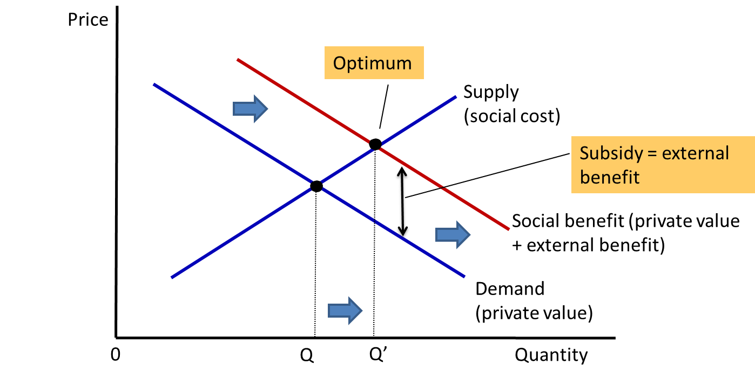

The new market equilibrium found by the intersection of the supply and the new demand (which is also the social benefit curve). Being given the subsidy, the individual will increase his consumption of education to the social optimal level (Q’).

The use of this subsidy is called internalizing the externality as it gives the individual an incentive to take the external effects of his actions into account. The individual will increase the level of education consumption because the subsidy will raise his private value by the size of external benefit, and because of the increase in demand and thus that in the price, suppliers will also have an incentive to expand their production, which is reflected by an increase in the quantity supplied (Qs). The analysis above provides a theoretical ground for the public policy of education – education is heavily subsidized around the world through public schools and other policies. In the case of Hong Kong, for example, the government runs public schools, and provides scholarships and loans, as well as tax incentives, for people pursuing further education.

1. A Macroeconomic Perspective: Human Capital and Economic Growth

Besides the external benefit mentioned in the last section, there is another external benefit of education which has far-reaching impacts on society – the impacts on human capital and economic growth.

Human capital is the accumulation of knowledge and skills in people, such as education and on-the-job training. Thus, education can be viewed as an expenditure of resources to raise the productivity of an individual in the future. We have seen that individuals with higher educational level, and thus human capital, on average earn more than those with lower educational level. For instance, a study by Lui (2014) showed that a person with a college degree earned 30% more than those without a degree in Hong Kong. And roughly speaking, the difference in earnings represents the difference in terms of the productivity.

Human capital is one of the important factors for a country’s long-run economic success. Since 1980s, much economic research has focused on the long-run economic growth of a country, and the importance of education and human capital has been confirmed by numerous empirical studies. An article by Professor Robert Barro published in the American Economic Review in 2001 is a good example. In the article, he studied the role of human capital in the determination of economic growth by investigating the macroeconomic data of around 30 years across 100 countries, which showed drastic differences in economic developments. With some econometric and statistical techniques, he was able to identify the effects of various contributing factors of economic growth. He found that education was positively related to economic growth, and he also pointed out the importance of the diffusion of technology – new technologies in production can only be adopted when there are sufficient amount of educated workers in the economy. Barro further suggested that while education contributes directly to human capital formation, and thus leading to higher labour productivity, it also complements the development and diffusion of new technologies which can further boost the economic success of an economy.

Moreover, it is usually believed that the role of human capital in developed countries is different from that in developing ones. For developed and more advanced economies, the education and human capital can support innovations through research and development (R&D). For developing countries which are farther away from the technological frontier, education can help in the process of adopting the state-of-the-art technologies.

**Comparison between Hong Kong and Singapore**

Professor Richard Wong from the University of Hong Kong studied the difference in economic growth between Hong Kong and Singapore, and discussed the important role of human capital as a determinant of economic growth[6].

Hong Kong and Singapore are two cities with economies that share many similarities, especially the rapid development and economic success since the 60s. Using the data from the official statistics from the two governments as well as the Penn World Tables, an internationally reputable data source, he found that the real GDP growth rates of both economies have been declining but the growth rate of Singapore was nearly always higher than that of Hong Kong since 1960.

Figure 4-1 RGDP* Growth Rates of Hong Kong and Singapore, 1960 – 2011

Source: Penn World Tables version 8.0

* The Real GDP used here is the expenditure-based estimate.

The finding suggests that the standard of living in Singapore has been rising faster than that in Hong Kong in the past 50 years, and Wong attributed this result to two factors: the difference between the housing policies[7], and the difference of human capital between the two economies.

The Penn estimated the human capital of economies based on the average years of schooling for those who are over 15 years old. When comparing the human capital of the two city economies, Wong found that while both economies’ human capital has been greatly improving since the 60s, the difference in growth rates in the past 20 years were very significant.

Figure 4-2 Human Capital Index of Hong Kong and Singapore, 1960 – 2011

Source: Penn World Tables version 8.0

As shown in the figure, the human capital index of Singapore was catching up Hong Kong’s significantly in 80s and 90s. One obvious reason was that the Singapore’s aggressive policies attracted highly skilled immigrants and expanded post-secondary education. In contrast, Hong Kong lost some talent and experienced work force during some mass migration waves prompted by the uncertainties about the 1997 handover and the future development. Actually the average growth of human capital index for 1990-2000 was -0.07, indicating a drop in the overall stock of human capital.

On the other hand, considering the total factor productivity (TFP), which measures the productivity of all inputs including capital and labour, of the two economies shown in the data, we can see that the TFP of Hong Kong has been higher than the TFP of Singapore but Singapore’s has been catching up. The figure below shows the ratio of the total factor productivity of the two economies (HK’s TFP / SG’s TFP). The ratio in the 60s was 1.54 and it dropped to 1.04 in 2000s.

Figure 4-3 Ratio of the Total Factor Productivity (TFP) of

Hong Kong and Singapore, 1960 – 2011

Source: Penn World Tables version 8.0

Wong argued that the deteriorating position of Hong Kong relative to Singapore’s is the result of the relatively slower growth in employment and human capital index. Comparing to Hong Kong, Singapore has a very steady growth in population both in terms of the size (around 2.5% since 1980s) and quality, whereas the population growth of Hong Kong has been decreasing sharply and the growth in human capital has been low. These lower the critical mass of human capital talent of Hong Kong which is vital for economic development and growth. To conclude, Wong suggested that the difference in the growth of human capital is the main driver of the differential economic growth of the two economies.

1. Policy Analysis and Evaluation

We will analyze the impacts of the following policies on important stakeholders using simple economic models. The important stakeholders related to policies of higher education and the assumptions used in the following analysis are listed below.

* UGC-funded Institutions: these are 8 institutions funded by the University Grants Committee. For simplicity, assume that they offer only full-time undergraduate programmes.
* Other Institutions: these are universities and institutions that offer self-financing degree and sub-degree programmes. In general they are competing with UGC-funded institutions for students and academics. Assume that their requirements for student admission are relatively lower than those of UGC-funded institutions, and that their programmes are of relatively lower quality compared to that of UGC-funded institutions’ programmes, which is probably due to their sources constraints.
* Academics and Staff: these are individuals employed by tertiary institutions to perform research, teaching, and / or administrative tasks.
* Current Students and Recent Graduates: the welfare impacts of current students and recent graduates of tertiary institutions are very much similar, and thus we will analyze the impacts to these two groups together.
* Secondary Students: they are prospective students for post-secondary education. For simplicity, assume that secondary school students prefer UGC-funded programmes to self-financing programmes.
* Business: it refers to the potential employers.

Figure 5-1 Important Stakeholders of Education Policy

5.1. Policy 1: An Increase in the Number of Places on UGC-Funded Undergraduate Programmes

Suppose before the expansion, 20% of the secondary school students can obtain a place on UGC-funded programmes, and 40% of the students will be admitted to a self-financing programme; the remaining 40% of the students will leave the education system and enter the job market.

In the figure below, students are arranged according to their overall performances, including the academic performances in the HKDSE examination and the performances in other related areas, like interviews and extra-curricular activities. Before the expansion, the top 20% (80th - 100th percentile) of the students will be admitted to the UGC-funded institutions, while the middle 40% (40th – 80th percentile) will be admitted to the self-financing programmes offered by other institutions, and the lower 40% of the students (0th – 40th percentile) will enter the job market without pursuing higher education.

Figure 5-2 Expansion in Number of Places on UGC-Funded Programmes

Suppose now the government allocates more resources to the UGC-funded institutions, and now the top 40% of the students can obtain a place on UGC-funded programmes. If the number of places on self-financing programmes offered by other institutions is unchanged, the next 40% of the students will be admitted to the self-financing programmes offered by other institutions if they can satisfy the minimum requirements for these programmes.

* **Overall Impact on Hong Kong**

Education is an investment in human capital. Whether or not an investment is worthy depends on the cost and benefits.

The cost of expansion in the number of places on UGC-funded programmes includes not only the increased resources needed for providing education, but also the sacrificed production: there will be more students (the 20th – 40th percentile) entering the higher education system instead of the job market, which will result in a drop in the aggregate production of the economy. The value of the sacrificed production depends on a number of factors, including the productivity of these secondary school graduates, the speed of experience (and thus productivity) accumulation, as well as whether there are jobs available for them. For example, if the economy is undergoing a recession and the job market is doing badly, the majority of these secondary school graduates may end up unemployed, and thus the cost of expanding higher education will be lower.

On the other hand, the social benefits of the investment in higher education depend on how much it can raise the productivity of workers, and also the external benefits that we discussed earlier. In particular, the rise in productivity can come from both the students in the 20th – 40th percentile and those in the 60th – 80th percentile, if we assume UGC-funded programmes are of higher quality and can lead to a further increase in productivity.

* **UGC-funded Institutions**

The UGC-funded institutions receive extra financial support from the government and expand their programmes. In order to increase the number of places on their programmes, they will need to expand both the infrastructure and manpower. However, expansion of infrastructure like campus takes time, and congestion problems can be expected at least in the short run. Moreover, more manpower will be needed to take care of the additional teaching and administrative work. They need to compete with other local and overseas institutions for teaching and administrative staff, which may imply a rise in the labour cost.

In addition, with the expansion, the overall quality of students drops. More resources may be needed to uphold the quality of their graduates.

* **Other Institutions**

Because of the expansion of places on UGC-funded programmes, non-UGC-funded institutions will face a significant pressure. First, the expansion will lead to a higher demand for teaching and administrative staff, and thus these institutions will find it more difficult to hire quality staff, or even face the problem of a brain drain. To hire suitable and qualified individuals, they will have to offer more attractive compensation package to their employees, and it implies a higher labour cost. Second, as the students of higher quality (60th – 80th percentile) will be admitted to UGC-funded programmes, the quality of students admitted by non-UGC-funded institutions will be lower. These institutions are likely to face difficulty in maintaining the standard of their teaching and curriculum. If we assume that students with the lowest performance in HKDSE may choose not to further their studies in higher education, these institutions will face an additional challenge: they may need to compete with other institutions for the limited number of potential students, and that will be transformed into a financial pressure as these institutions receive no subsidies from the UGC.

* **Academics and Staff**

With the expansion, more academics and staff are demanded. Suppose the labour market is competitive, the higher demand for labour will lead to a rise in the equilibrium wage rate and the number of labour employed.

Figure 5-3 An Increase in the Demand for Academics and Staff

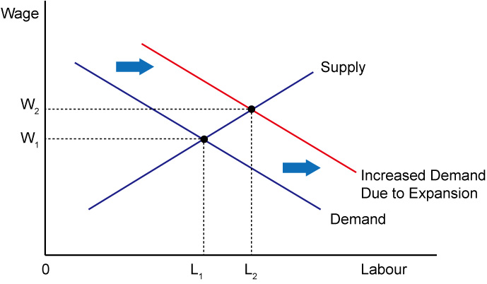

However, it is likely that the rate of increase in the number of academics and staff hired will be smaller than that of the student enrolment. In other words, the student-teacher ratio is likely to increase, and it implies a heavier workload for teachers. Similarly, the workload of administrative and other staff is also expected to rise. Thus, even though the wage rate is likely to increase, the overall change in welfare is ambiguous.

* **Current Students and Recent Graduates**

Current Students: As the expansion and upgrades of campus and facilities take time, the increase in the number of places on UGC-funded programmes is likely to bring a congestion problem to university students at least in the short run. Besides, even though universities may be able to cater the increased demand for academic courses (e.g., through enlarging the class size) due to the increase in the number of undergraduate students, the development of other experiential learning opportunities are unlikely to be able to cope with the increase. For instance, the quota for exchange programmes, internship programmes, and even hostels is, to some extent, beyond the full control of the universities in the short run. In other words, the increase in the number of places on UGC-funded programmes will lead to a more intense competition among students and it will probably lower the overall quality of the learning experience of students. Moreover, an expansion of higher education sector will lead to an increase in the labour supply of highly-educated workers in the near future. The job market will then adjust and the equilibrium wage of highly-educated workers will likely to drop, as shown in the figure below.

Figure 5-4 Market for Highly-Educated Workers

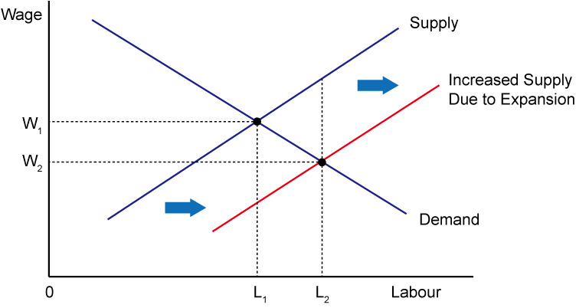

For some industries with growing demand for labour and thus growing wages, the effect of the increased supply of labour may be undermined / cancelled out. However, a slowdown of the growth in wages can be expected.

Recent Graduates: Even though recent graduates of universities / institutes have accumulated several years of working experience, they may not be too different from the fresh graduates from the point of view of employers. In other words, those soon-to-be fresh graduates are imperfect substitutes for them, and thus they will face more intense competition in the job market for highly-educated workers. The equilibrium wage is likely to decrease (refer to figure 5-4).

There is another interesting aspect of education. One of the roles of higher education is to serve as a signal of higher quality of an individual in the job market. Traditional economic theory suggests that the one’s wage earning in the job market will be directly related to his productivity or quality. Firms are willing to pay more to hire employees with higher quality because they are more productive and are going to bring more revenue for firms. However, the quality of an individual is usually known to himself, but unobservable to the potential employers. This situation is called asymmetric information. Assuming that usually only individuals with higher ability (say, the top 20% of students) can gain an admission to a UGC-funded programme, pursuing higher education in (and graduating from) UGC-funded institutes is then a way for the individuals to send out a signal to the potential employers, indicating that they are of higher quality. This is the signaling effect of education. This impact is particularly significant for those who have just graduated recently and have little working experience and evidence to demonstrate his own ability level. However, an expansion in the number of places on UGC-funded programmes will tend to lower the overall quality of graduates, and thus diluting the signaling effect of UGC-funded programmes, which and may cause negative impacts on the graduates.

* **Secondary School Students**

With an expansion of places on UGC-funded undergraduate programme, more secondary school students will be able to obtain a bachelor degree from these institutions. Notice that the policy has the most significant impacts on those marginal students, i.e., the students in the 60th– 80th percentile and the 20th– 40th percentile. The former will be able to obtain a UGC-funded programme place, while the latter will have a chance to pursue a degree or a sub-degree in self-financing institutions. These students are expected to benefit because, as discussed earlier, receiving higher education can raise one’s ability and his future earnings. The students in the 60th– 80th percentile will receive extra benefits in the sense that they can pay less and receive higher quality education (the tuition fees of UGC-funded institutions are usually lower than that of non-UGC-funded ones); while students in the 20th– 40th percentile will sacrifice their current earnings and invest in their own human capital through education. Meanwhile, the learning experience in higher education for the top 20% of the secondary school students is likely to deteriorate, as UGC-funded institutions may not be able to maintain the quality of education they provide in every aspect.

* **Business**

With more graduates from higher education and thus a larger supply of highly-educated workers, the equilibrium wage tends to be lower (refer to figure 5-4). It means that businesses will be able to hire more workers with a lower cost. In addition, higher education tends to raise the aggregate earning of the whole population through improvements in productivity. It indirectly benefits businesses that are selling normal goods with an increase in income and a stronger demand for goods and services in the economy; yet it harms businesses selling inferior goods.

5.2. Policy 2: Study Subsidy Scheme for Designated Professions / Sectors (SSSDP)

The government proposed a new subsidy scheme starting from 2015-16 academic year to subsidize up to 1,000 students to pursue designated full-time self-financing degree programmes in selected disciplines. The aim is to nurture talents to meet Hong Kong’s social and economic needs in the near future. Health care, architecture and engineering, testing and certification, creative industry, logistics, and tourism and hospitality have been identified as the key disciplines that will receive the subsidy.

* **Overall Impact on Hong Kong**

The subsidy scheme does not affect those students who can obtain an UGC-funded place (the top 20% of students). It does, however, affect the middle 40% of students (40th – 80th percentile) who will study in self-financing programmes. The subsidy scheme by itself does not directly lead to an expansion of self-financing programmes. It provides incentives for these 40% students to study the designated disciplines instead of their originally preferred programme choice. In other words, it is likely to trigger a change in the distribution of students across different disciplines and / or across different institutions, in case some programmes are offered exclusively by some institutions. Selected programmes are likely to attract higher quality students with the subsidy, and thus related industries are likely to benefit from having a higher quality labour supply in the near future.

Note, however, that the subsidy scheme distorts the programme choice of the students and it has an implication on the social welfare. Different jobs require different kinds of skill sets, and different individuals will have advantages (and interests) in different areas. Assume that students know their own advantages and interests, they are likely to pursue their studies in the areas in which their advantages lie. However, the subsidy scheme distorts their choices, and it will likely to lead to a less efficient allocation of programme places. Last but not least, the allocation of programme places is heavily affected by the subsidy scheme’s discipline selection. If the government makes a wrong forecast on the labour demand of industries, it may have harmful impacts on the future graduates of the selected programmes.

* **UGC-funded Institutions**

Assuming that students will not switch from UGC-funded programmes to self-financing programmes due to the subsidy, the UGC-funded institutions will not be affected directly as the subsidy scheme targets only self-financing degree programmes.

* **Other Institutions**

Institutions offering self-financing programmes in designated disciplines will benefit directly by the subsidy. As mentioned, the subsidy can provide an extra incentive for students to pursue higher education in these disciplines instead of other choices. The subsidy scheme itself does not increase the number of places offered by self-financing programmes, but is likely to trigger a change in the students’ priority of their programme choices among self-financing programmes. Students’ programme choices will be distorted and thus triggering a change in the distribution of students across different disciplines in the non-UGC-funded institutions. For example, better performing students may concentrate on those subsidized programmes, while the average quality of new student intake of other programmes may fall. Thus, the subsidy is likely to benefit the development of the selected programmes as students usually learn better when their peers are of higher quality.

* **Academics and Staff**

As the subsidy scheme does not directly lead to an expansion of programmes and the scale is relatively small, the overall impacts on academics and staff in the job market are likely to be negligible.

* **Current Students and Recent Graduates**

Given the relatively small scale of the scheme and that it affects only the distribution but not the total number of students, its impacts on current students and recent graduates are likely to be insignificant.

* **Secondary School Students**

Secondary school students who are in the 40th – 80th percentile are directly affected by the scheme, while other students are not directly affected. The students in the 40th – 80th percentile are the group of students who will be admitted to a self-financing programme. Students choose a discipline to study based on a number of factors: interest in the subject, career prospect of the field, reputation of the institutions offering the programme, tuition fees, and others. Unlike UGC-funded programmes that charge a universal tuition fee, the tuition fees of self-financing programmes vary and may be calculated based on the number of credits taken. A subsidy scheme on specific programmes provides an incentive for students to pursue their degrees in the fields, and their programme choices will be distorted. Students with higher quality are usually given a priority in programme selection, and thus they may concentrate in the designated programmes. As students usually learn better when their peers are of higher quality, students’ developments are likely to be enhanced in these programmes.

* **Business**

Health care, architecture and engineering, testing and certification, creative industry, logistics, and tourism and hospitality industries are likely benefit from the scheme. First, the quality of student in these programmes is likely to rise, as discussed earlier. Thus, the quality of labour supply will rise and it is likely to benefit the related businesses. Second, the subsidy scheme may actually increase the number of student intake of related programmes, and thus will increase the labour supply for these fields in the near future.

1. Discussion Questions

1. What are the private costs of pursuing education? What are the corresponding social costs? Are they always the same?

2. Suppose to promote higher education, the government decides to launch a tuition subsidy scheme for non UGC-funded programmes. Students admitted to a non UGC-funded programme will be awarded a scholarship of $50,000.

a. How would the demand for higher education be affected by this policy?

b. It is difficult to expand the scale of higher education service in the short run due to various constraints. What is its implication on the price elasticity of supply of higher education?

c. Given your answer in part (b), illustrate how the subsidy will benefit students and the institutions offering non UGC-funded programmes using a demand and supply analysis.

3. Suppose there is a market for sub-degree programmes, and that non UGC-funded institutions are free to charge for the sub-degree programmes offered. Explain how would the tuition fee and the number of students enrolled of sub-degree programmes be affected in each of the following cases:

a. More top-up programmes for graduates of sub-degree programmes are available

b. Potential employers believe that the quality of graduates of sub-degree programmes is rising over time

c. More private universities are established and more degree programmes are offered for high school students

d. Loans by Hong Kong government are made available for students studying overseas degree programmes upon graduation from secondary school

e. The salary of academics increases

Suggested Solution

1. The private costs of pursuing education include both the explicit and implicit costs – the former includes the tuition fees, books, and perhaps transportation costs. The latter includes the value of the best alternative use of the student’s time, which is usually measured by the after-tax earnings forgone. The social costs include the (explicit) cost of providing educational service: cost of teachers and other school employees, the rental rate of the buildings, equipment, and campus (depending on situation, these rental costs may be implicit), and also the implicit cost, which is the students’ before-tax earnings forgone.

If education service is provided by private schools through the market for education, then the explicit private and social costs will be the same. On the other hand, if the government subsidizes education, then the private explicit cost will be lower than the social explicit cost.

Furthermore, the implicit private and social costs are slightly different – the former is represented by the after-tax earnings forgone, which is the actual disposal income of the individual, while the latter is represented by the before-tax earnings forgone, which is the value of production forgone.

2. a. Given the scholarship, the demand for higher education will increase.

b. As it is difficult to expand the scale of ‘production’ of higher education, its price elasticity of supply will be low.

c. Given the low price elasticity of supply, the following diagram shows the impact of the scholarship.

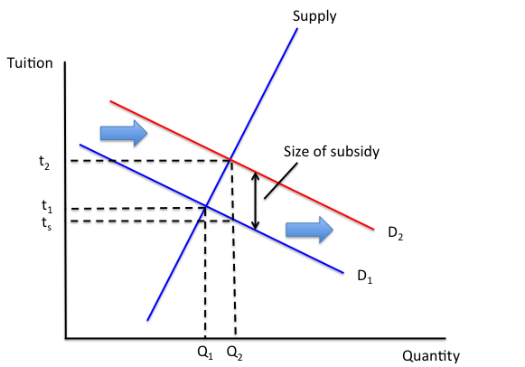

The initial equilibrium price and quantity are given by t1 and Q1. With the subsidy, demand for higher education increases from D1 to D2. The new equilibrium price increases t2, and the quantity increases to Q2. The total subsidy is given by the product of size of subsidy (t2 – ts) and the new equilibrium quantity Q2. The difference in tuition, (t2 – t1), represents the proportion of subsidy received by the institutions for each programme place / student; whereas (t1 – ts) represents the proportion of subsidy received by students. As shown in the diagram, given the relatively low price elasticity of supply, a large portion of subsidy will be received by institutions offering non UGC-funded programmes.

3. a. With more top-up programmes available, more secondary school students will be willing to study the sub-degree programmes. The increase in demand for sub-degree programmes will lead to an increase in the equilibrium tuition fee and the number of students enrolled.

b. The market wage rate for graduates of sub-degree programmes will increase, and it will lead to an increase in the demand for programmes. It will raise the tuition fee and the number of student enrollment.

c. When more degree programmes are offered by private universities, less high school students may pursue a sub-degree. The decrease in demand will lead to a drop in the tuition fees and the student enrollment.

d. More secondary school graduates may choose to further their studies overseas with the loan, and thus there will be lower demand for the local sub-degree programmes, and thus the tuition fee and student enrollment will fall.

e. The salary of academics is part of the ‘production cost’ of institutes. An increase in salary leads to an increase in the cost of offering the sub-degree programmes, and thus a drop in supply. The tuition fee will rise and the student enrollment will fall.

1. References

**Barro, R.**, 2001, "Human Capital: Growth, History, and Policy - A Session to Honor Stanley Engerman", American Economic Review, Vol. 91, No. 2

**Baum, S., Ma, J.** and **Payea, K.**, 2013, "Education Pays 2013: The Benefits of Higher Education for Individuals and Society", College Board

**Clark, D.** and **Royer, H.**, 2010, “The Effect of Education on Adult Health and Mortality: Evidence from Britain", National Bureau of Economic Research Working Paper Series, Working Paper no. 16013

**Concourse for Self-Financing Post-Secondary Education**

**Cutler, D.,** and **Lleras-Muney, A.**, 2006, "Education and Health: Evaluating Theories and Evidence", National Bureau of Economic Research Working Paper Series, Working Paper no. 12352

**Education Bureau,** Publications and Statistics

**Education Bureau**, 2013, “Survey on Opinions of Employers on Major Aspects of Performance of Sub-Degree Graduates in year 2010”

**Greenstone, M.** and **Looney, A.**, 2011,"Where is the best place to invest $102,000 — In stocks, bonds, or a college degree?" Washington, DC: Hamilton Project, The Brookings Institution.

**Hong Kong Examinations and Assessment Authority**, 2013 HKDSE Entry Statistics

**Hong Kong Government Yearbook**, various years

**Information Portal for Accredited Post-Secondary Programmes**, HKSAR Government

**Lochner, L.** and **Moretti, E.**, 2004, "The Effect of Education on Crime: Evidence from Prison Inmates, Arrests, and Self-Reports", American Economic Review, 94(1): 155-189

**Mankiw, G.**, 2012, Principles of Economics, Cengage Learning

**Groningen Growth and Development Centre**, Penn World Table Version 8.0

**University Grants Committee**, General Statistics on UGC-funded Institutions / Programmes and Commonly Used Statistical Tables

**Wong, R**., 2013, “The Population Quality Challenge – Rekindling Hong Kong’s Magic (Part III)”, Hong Kong Economic Journal

**Wong, R.**, 2013, “Understanding Differential Growth Rates in Singapore and Hong Kong: Role of Policy and Human Capital”, Hong Kong Economic Journal

1. Notice that the growth has been almost exclusive in the self-financing sector. The public-funded and self-financing programmes will be discussed in the subsections below.
2. “Aspirations for the Higher Education System in Hong Kong - Report of the University Grants Committee”, 2010
3. It is stated in the report that “the coverage of the surveys on 2000 and 2003 graduates was different from the surveys on 2006 and 2010 graduates. Hence, the overall performance score of 2000 and 2003 graduates were presented here for reference only and are not recommended for direct comparison.”
4. 《雷鳴天下》，《晴報》，2013年1月25日
5. Mankiw, 2012, Principles of Economics, Cengage Learning
6. Richard Wong, 2013, “Understanding Differential Growth Rates in Singapore and Hong Kong: Role of Policy and Human Capital”, Hong Kong Economic Journal
7. Wong suggested that the market value of public subsidized housing units in Hong Kong was not accurately reflected in the GDP figures as these units were not allowed to trade in open market. In contrast, subsidized housing units in Singapore were tradable and thus the values could be evaluated.