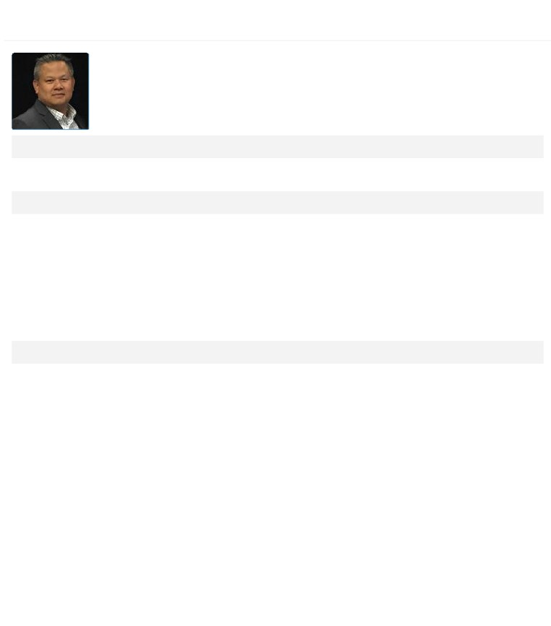

Resume

HIEN NGUYEN

District Management

Director Pharmacy and Retail Operations

Current Position

Director Pharmacy and Retail Operations

Current Job Experience

Director of pharmacy and retail operations in urban and suburban cities in New York and Connecticut   
with a total sales revenue of $700 Million. Develop strategies, plans, and operational guidelines to   
improve team Engagement, Customer Experience, Execution and increase Efficiencies. Identify future top   
talents for the enterprise. Accountable for business results, meeting or exceeding objectives. Provide   
leadership to company employees by serving as a role model and instilling ownership, empowerment,   
and motivation. Empower district leaders to take responsibility for major decisions and inspire team to   
maintain momentum and commitment in the face of obstacles. Gain commitment from staff by building   
credibility, setting high standards and holding people accountable. Promote teamwork and cooperation   
by working closely with district managers, Organization Learning Specialists and Healthcare Supervisors.

Past Job Experience

Company and Position : Walgreens District Manager , *Start Date: 6/1/2005* End Date: 4/30/2015 ,

Details / Accomplishments in Role :

Accountable for store operations in one of the largest urban cities in America. Develop strategies, plans,   
and operational guidelines to build customer relationships and analyze customer service data to   
develop action plans for the district. Provide opportunities for people to develop skills by regularly   
providing balanced and constructive feedback. Share and accept talent across divisions to build   
successors and talent pools while encouraging and coaching staff to build their skills. Address and   
improve poor performance through proper documentation, feedback and follow-up. Effectively transfer   
accurate, complete, and timely ideas to the district team and to management. Maintain open   
communication between corporate and the stores to gather ideas and provide feedback. Accountable   
for business results, meeting or exceeding objectives. Evaluate store reports and results, and other   
complex situations in a logical and systematic way to identify operating issues and trends. Identify the   
most critical issues and factors that need to be addressed and exhibit skills in quantitative analysis.   
Balance priorities for sales growth and merchandising goals. Make detailed action plans that improve   
the overall success and profitability of individual stores, the district, and the Company. Review financial   
information with others in order to gain insight into issues and opportunities, and to gain commitment   
to making improvements. Understand the skills required for each management position and make job   
assignments based on those skills and the current workload. Develop strategies for recruiting and   
promoting both internal and external diverse candidates. Provide leadership to company employees by   
serving as a role model and instilling ownership, empowerment, and motivation. Empower team   
members to take responsibility for major decisions and inspire team to maintain momentum and

HIEN NGUYEN Last Modified: HIEN NGUYEN, 4/13/2016

commitment in the face of obstacles. Gain commitment from staff by building credibility, setting high

standards and holding people accountable. Promote teamwork and cooperation by working closely with peers as well as Pharmacy Supervisor, Store Managers, Pharmacy Managers, and district staff. Actively involved with pharmacy operations. Able to analyze pharmacy data and KPI’s ﴾Key Performance   
Indicators﴿ to understand pharmacy volume, staffing needs, workflow, and customer service levels.   
Number of Staff Managed : 25 to 50

Size of Budget Managed: Greater than $10 million

Company and Position : Store Manager , *Start Date: 8/1/1999* End Date: 5/30/2005 , Details / Accomplishments in Role : Number of Staff Managed : 51 to 75

Size of Budget Managed: Less than $1 million

Company and Position : Executive Assistant Manager , *Start Date: 4/10/1998* End Date: 7/31/1999 , Details / Accomplishments in Role :   
Number of Staff Managed : 11 to 24

Size of Budget Managed: Not Specified

Company and Position : Assistant Manager , *Start Date: 2/1/1998* End Date: 4/9/1998 , Details / Accomplishments in Role :   
Number of Staff Managed : Not Specified

Size of Budget Managed: Not Specified

Company and Position : Pharmacy Manager , *Start Date: 9/1/1993* End Date: 1/31/1998 , Details / Accomplishments in Role :   
Number of Staff Managed : 11 to 24

Size of Budget Managed: Not Specified

Company and Position : Registered Staff Pharmacist , *Start Date: 5/12/1992* End Date: 8/31/1993 , Details / Accomplishments in Role :   
Number of Staff Managed : Fewer than 5

Size of Budget Managed: Not Specified

Do you have store experience?

Details: ,

Pharmacist, Pharmacy Manager, Executive Assistant, Store Manager and District Manager

*Managed a rural store:*

Managed an urban store: , Managed a 24-hour store:

Opened a new location: ,

Highest sales volume at time of management: High ﴾greater than $13 million ﴿ Highest script volume at time of management: High ﴾501 scripts or greater﴿ , Worked in a rural store:

Worked in an urban store: , Worked in a 24-hour store:

Cross Functional/Matrix Leadership Experience Critical Experiences

HIEN NGUYEN Last Modified: HIEN NGUYEN, 4/13/2016

Global Experiences

Training / Development Experiences

Training Completed : On-the-Job Development ﴾special projects, etc﴿ , *Date Received: 1/31/1998*   
Details:

Zenger Miller Management Training Program

Relevant Non-Work Experiences

Organization: Staten Island Chamber of Commerce , *Position: Member* Start Date: 2/11/2009 , End Date: 12/31/2010

Details:

Education

Degree : B.A./B.S.

Institution: Rutgers College of Pharmacy , Major: Pharmacy   
Minor:

Degree in Progress: Comments :

Certifications and Licenses

Certification / License : Healthcare/Rx Certifications/Licenses , *Date Received: 2/14/2006*   
Details:

NY Board of Pharmacy License

Certification / License : Healthcare/Rx Certifications/Licenses , *Date Received: 5/12/1992*   
Details:

NJ Board of Pharmacy License

Languages

Language : Spanish , *Proficiency: Basic* Years of experience: 26 , Current Skill: Last Used: , Details:

Language : Other , *Proficiency: Fluent* Years of experience: 42 , Current Skill: Last Used: , Details:

Vietnamese

Skills

Other Key Accomplishments

HIEN NGUYEN Last Modified: HIEN NGUYEN, 4/13/2016

Key Food and Walgreens open in Windsor Terrace, Brooklyn, NY: "Please refer to the following website"   
﴾[http://www.brooklyndowntownstar.com/view/full_story/21829113/article-Key-Food-and-Walgreens-to-](http://www.brooklyndowntownstar.com/view/full_story/21829113/article-key-food-and-walgreens-to-/)  
share-space?instance=lead_story_left_column﴿

Promoted Walgreens at the 2011 Brooklyn Seaside Summer Concert Series, by speaking to a crowd of approximately 4,000 New York City Residents ﴾8/4/2011﴿

Grand opening of store #12855 in brooklyn, New York was attended by one councilman, an assemblyman, a senator and the Brooklyn Borough president

Participated in the revitalization of Walgreens Louisiana Stores following Hurricane Katrina in 2005

Performed over 20 store Buy-Outs and implemented over 5 340B contracts in the New York metro area

Organized and hosted the 7000th Store Grand Opening for the Walgreens company ﴾October 2009﴿

Continuously coordinate community involvement through political events and public speaking at local organizations with political figures Marty Markowitz ﴾Brooklyn Borough President﴿ and Vincent Gentile ﴾Bayridge Councilman﴿

Coordinated "Walk with Walgreens" in Staten Island with celebrity marathon runner Dean Karnazas together with the "Regis and Kelly" show ﴾May 2011﴿

Participated in Jerry Lewis Telethon September 2010 for Walgreens

Attended over 20 job fairs. Participated in information sessions with elementary school students in an urban district and college students ﴾2005 - Present﴿

Created a partnership with Long Island University to coordinate Pharmacy Technician Internships in 2010

Participated in the integration process for the acquisition of Drug Fair in 2010

What are your short-term career aspirations?

Comments:

Pursue corporate rotation or field project lead with large mergers and acquisition Involve in corporate   
initiatives

I'd like to stay in my current role : , I'd like more responsibility in my current role :

I'd like a role in a different area ﴾lateral move﴿: ,

I'd like to be promoted in the next 12 months: Yes

What are your LONG-TERM career aspirations?

Comments:

Achieve the level of Vice President of Operations or higher Corporate rotation Mergers and Acquisition transitioning project lead

I'd like to stay in my current role : , I'd like more responsibility in my current role :

HIEN NGUYEN Last Modified: HIEN NGUYEN, 4/13/2016

I'd like a role in a different area ﴾lateral move﴿: , I'd like a promotion in 2 years or more:

What awards have you received?

Title, description, and any relevant details:

Received the Key to the city of Garwood, NJ for performing life saving CPR on a Walgreens Customer

1996 Proclamation by Brooklyn Borough President Marty Markowitz Proclamation by Councilman Vincent   
Gentile

Choose the type of award from the list. : Community Award

Best or Most Recent Work Accomplishments

HIEN NGUYEN Last Modified: HIEN NGUYEN, 4/13/2016