[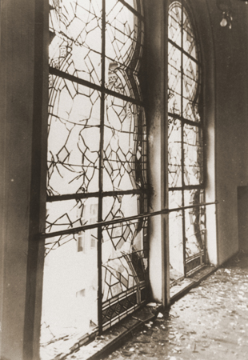](http://www.ushmm.org/wlc/en/media_ph.php?ModuleId=10005201&MediaId=6386)KRISTALLNACHT: A NATIONWIDE POGROM, NOVEMBER 9–10, 1938

The shattered stained glass windows of the Zerrennerstrasse synagogue after its destruction on Kristallnacht. Pforzheim, Germany, ca. November 10, 1938.

*— Stadtarchiv Pforzheim*

*Kristallnacht*, literally, "Night of Crystal," is often referred to as the "Night of Broken Glass." The name refers to the wave of violent anti Jewish [pogroms](http://www.ushmm.org/wlc/en/article.php?ModuleId=10005183) which took place on November 9 and 10, 1938, throughout Germany, annexed Austria, and in areas of the Sudetenland in Czechoslovakia recently occupied by German troops.

Instigated primarily by Nazi Party officials and members of the SA (*Sturmabteilungen*: literally Assault Detachments, but commonly known as Storm Troopers) and Hitler Youth, *Kristallnacht*owes its name to the shards of shattered glass that lined German streets in the wake of the pogrom—broken glass from the windows of synagogues, homes, and Jewish-owned businesses plundered and destroyed during the violence.

In its aftermath, German officials announced that *Kristallnacht*had erupted as a spontaneous outburst of public sentiment in response to the assassination of Ernst vom Rath, a German embassy official stationed in Paris. Herschel Grynszpan, a 17-year-old Polish Jew, had shot the diplomat on November 7, 1938. A few days earlier, German authorities had expelled thousands of Jews of Polish citizenship living in Germany from the Reich; Grynszpan had received news that his parents, residents in Germany since 1911, were among them.

Initially denied entry into their native Poland, Grynszpan's parents and the other expelled Polish Jews found themselves stranded in a refugee camp near the town of Zbaszyn in the border region between Poland and Germany. Already living illegally in Paris himself, a desperate Grynszpan apparently sought revenge for his family's precarious circumstances by appearing at the German embassy and shooting the diplomatic official assigned to assist him.

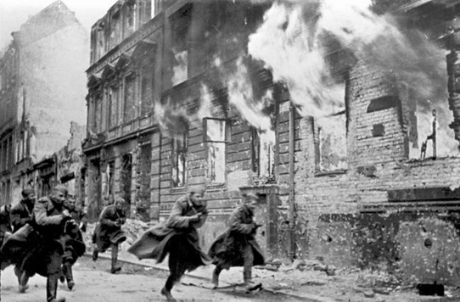Vom Rath died on November 9, 1938, two days after the shooting. The day happened to coincide with the anniversary of the 1923[Beer Hall Putsch](http://www.ushmm.org/wlc/en/article.php?ModuleId=10007884), an important date in the National Socialist calendar. The Nazi Party leadership, assembled in Munich for the commemoration, chose to use the occasion as a pretext to launch a night of antisemitic excesses. [Propaganda](http://www.ushmm.org/wlc/en/article.php?ModuleId=10005202) minister Joseph Goebbels, a chief instigator of the pogrom, intimated to the convened Nazi 'Old Guard' that 'World Jewry' had conspired to commit the assassination and announced that, "the Führer has decided that … demonstrations should not be prepared or organized by the Party, but insofar as they erupt spontaneously, they are not to be hampered."

Goebbels' words appear to have been taken as a command for unleashing the pogrom. After his speech, the assembled regional Party leaders issued instructions to their local offices. Violence began to erupt in various parts of the Reich throughout the late evening and early morning hours of November 9–10. At 1:20 a.m. on November 10, Reinhard Heydrich, in his capacity as head of the Security Police (*Sicherheitspolizei*) sent an urgent telegram to headquarters and stations of the State Police and to SA leaders in their various districts, which contained directives regarding the riots. SA and Hitler Youth units throughout Germany and its annexed territories engaged in the destruction of Jewish-owned homes and businesses; members of many units wore civilian clothes to support the fiction that the disturbances were expressions of 'outraged public reaction.'

Despite the outward appearance of spontaneous violence, and the local cast which the pogrom took on in various regions throughout the Reich, the central orders Heydrich relayed gave specific instructions: the "spontaneous" rioters were to take no measures endangering non-Jewish German life or property; they were not to subject foreigners (even Jewish foreigners) to violence; and they were to remove all synagogue archives prior to vandalizing synagogues and other properties of the Jewish communities, and to transfer that archival material to the Security Service (*Sicherheitsdienst*, or SD). The orders also indicated that police officials should arrest as many Jews as local jails could hold, preferably young, healthy men.

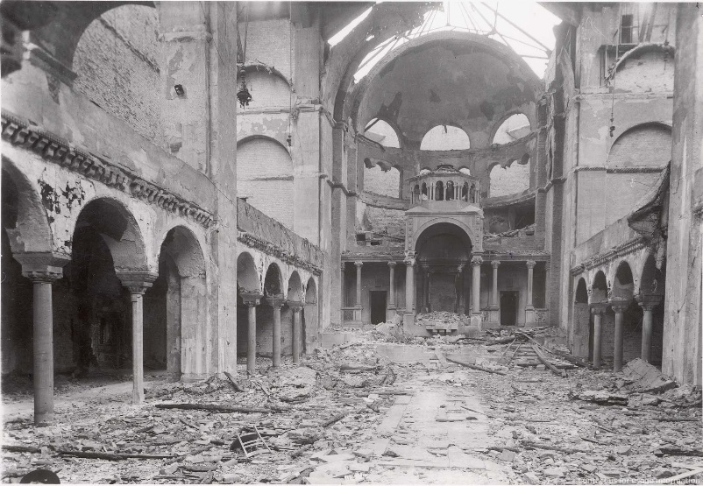The rioters destroyed 267 synagogues throughout Germany, Austria, and the Sudetenland. Many synagogues burned throughout the night, in full view of the public and of local firefighters, who had received orders to intervene only to prevent flames from spreading to nearby buildings. SA and Hitler Youth members across the country shattered the shop windows of an estimated 7,500 Jewish-owned commercial establishments, and looted their wares. Jewish cemeteries became a particular object of desecration in many regions.

The pogrom proved especially destructive in Berlin and Vienna, home to the two largest Jewish communities in the German Reich. Mobs of SA men roamed the streets, attacking Jews in their houses and forcing Jews they encountered to perform acts of public humiliation. Although murder did not figure in the central directives, *Kristallnacht* claimed the lives of at least 91 Jews between 9 and 10 November. Police records of the period document a high number of rapes and of suicides in the aftermath of the violence.

As the pogrom spread, units of the SS and Gestapo (Secret State Police), following Heydrich's instructions, arrested up to 30,000 Jewish males, and transferred most of them from local prisons to[Dachau](http://www.ushmm.org/wlc/en/article.php?ModuleId=10005214), [Buchenwald](http://www.ushmm.org/wlc/en/article.php?ModuleId=10005198), [Sachsenhausen](http://www.ushmm.org/wlc/en/article.php?ModuleId=10005538), and other concentration camps. Significantly, *Kristallnacht*marks the first instance in which the Nazi regime incarcerated Jews on a massive scale simply on the basis of their ethnicity. Hundreds died in the camps as a result of the brutal treatment they endured; most obtained release over the next three months on the condition that they begin the process of [emigration](http://www.ushmm.org/wlc/en/article.php?ModuleId=10005468) from Germany. Indeed*,*the effects of*Kristallnacht* would serve as a spur to the emigration of Jews from Germany in the months to come.

In the immediate aftermath of the pogrom, many German leaders, like Hermann Göring, criticized the extensive material losses produced by the antisemitic riots, pointing out that if nothing were done to intervene, German insurance companies—not Jewish-owned businesses—would have to carry the costs of the damages. Nevertheless, Göring and other top Party leaders decided to use the opportunity to introduce measures to eliminate Jews and perceived Jewish influence from the German economic sphere. The German government made an immediate pronouncement that “the Jews” themselves were to blame for the pogrom and imposed a punitive fine of one billion *Reichsmark*(some 400 million US dollars at 1938 rates) on the German Jewish community. The Reich government confiscated all insurance payouts to Jews whose businesses and homes were looted or destroyed, leaving the Jewish owners personally responsible for the cost of all repairs.

[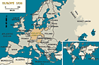](http://www.ushmm.org/wlc/en/gallery.php?ModuleId=10005201&MediaType=NM)In the weeks that followed, the German government promulgated dozens of laws and decrees designed to deprive Jews of their property and of their means of livelihood. Many of these laws enforced “Aryanization” policy—the transfer of Jewish-owned enterprises and property to “Aryan” ownership, usually for a fraction of their true value. Ensuing legislation barred Jews, already ineligible for employment in the public sector, from practicing most professions in the private sector, and made further strides in removing Jews from public life. German education officials expelled Jewish children still attending German schools. German Jews lost their right to hold a driver's license or own an automobile; legislation fixed restrictions on access to public transport. Jews could no longer gain admittance to “German” theaters, movie cinemas, or concert halls.

The events of *Kristallnacht*represented one of the most important turning points in National Socialist antisemitic policy. Historians have noted that after the pogrom, anti-Jewish policy was concentrated more and more concretely into the hands of the [SS](http://www.ushmm.org/wlc/en/article.php?ModuleId=10007403). Moreover, the passivity with which most German civilians responded to the violence signaled to the Nazi regime that the German public was prepared for more radical measures. The Nazi regime expanded and radicalized measures aimed at removing Jews entirely from German economic and social life in the forthcoming years, moving eventually towards policies of forced emigration, and finally towards the realization of a Germany “free of Jews” (*judenrein*) by deportation of the Jewish population “to the East.”

Thus, *Kristallnacht* figures as an essential turning point in Nazi Germany's persecution of Jews, which culminated in the attempt to [annihilate](http://www.ushmm.org/wlc/en/article.php?ModuleId=10005143) the European Jews.

Copyright © United States Holocaust Memorial Museum, Washington, DC

AUSCHWITZ I CAMP, 1944

# http://www.ushmm.org/wlc/shared/spacer.gif AUSCHWITZ

Barracks in the Auschwitz-Birkenau camp. This photograph was taken after the liberation of the camp. Auschwitz-Birkenau, Poland, after January 29, 1945.

[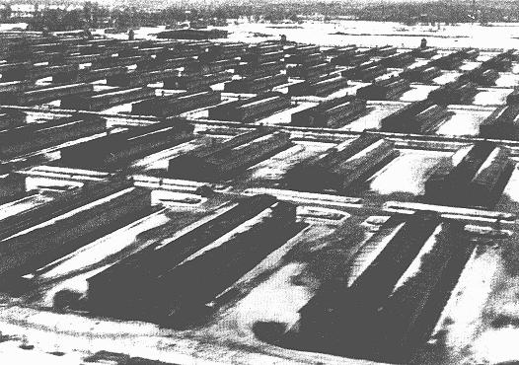](http://www.ushmm.org/outreach/en/media_ph.php?ModuleId=10007718&MediaId=1499)

Auschwitz was the largest camp established by the Germans. It was a complex of camps, including a concentration, extermination, and forced-labor camp. It was located near Cracow (Krakow), Poland. Three large camps constituted the Auschwitz camp complex: Auschwitz I, Auschwitz II (Birkenau), and Auschwitz III (Monowitz). More than one million people lost their lives at Auschwitz, nine out of ten of them Jewish. The four largest gas chambers could each hold 2,000 people at one time.

A sign over the entrance to the camp read ARBEIT MACHT FREI, which means "work makes one free." In actuality, the opposite was true. Labor became another form of genocide that the Nazis called "extermination through work."

Victims who were spared immediate death by being selected for labor were systematically stripped of their individual identities. They had their hair shaved off and a registration number tattooed on their left forearm. Men were forced to wear ragged, striped pants and jackets, and women wore work dresses. Both were issued ill-fitting work shoes, sometimes clogs. They had no change of clothing and slept in the same clothes they worked in.

[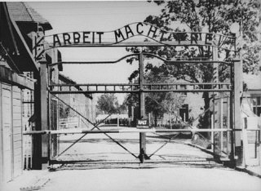](http://www.ushmm.org/outreach/en/gallery.php?ModuleId=10007718&MediaType=PH)Each day was a struggle for survival under unbearable conditions. Prisoners were housed in primitive barracks that had no windows and were not insulated from the heat or cold. There was no bathroom, only a bucket. Each barrack held about 36 wooden bunkbeds, and inmates were squeezed in five or six across on the wooden plank. As many as 500 inmates lodged in a single barrack.

Inmates were always hungry. Food consisted of watery soup made with rotten vegetables and meat, a few ounces of bread, a bit of margarine, tea, or a bitter drink resembling coffee. Diarrhea was common. People weakened by dehydration and hunger fell easy victim to the contagious diseases that spread through the camp.

Some inmates worked as forced laborers inside the camp, in the kitchen or as barbers, for example. Women often sorted the piles of shoes, clothes, and other prisoner belongings, which would be shipped back to Germany for use there. The storage warehouses at Auschwitz-Birkenau, located near two of the crematoria, were called "Canada," because the Poles regarded that country as a place of great riches. At Auschwitz, as at hundreds of other camps in the Reich and occupied Europe where the Germans used forced laborers, prisoners were also employed outside the camps, in coal mines and rock quarries, and on construction projects, digging tunnels and canals. Under armed guard, they shoveled snow off roads and cleared rubble from roads and towns hit during air raids. A large number of forced laborers eventually were used in factories that produced weapons and other goods that supported the German war effort. Many private companies, such as I. G. Farben and Bavarian Motor Works (BMW), which produced automobile and airplane engines, eagerly sought the use of prisoners as a source of cheap labor.

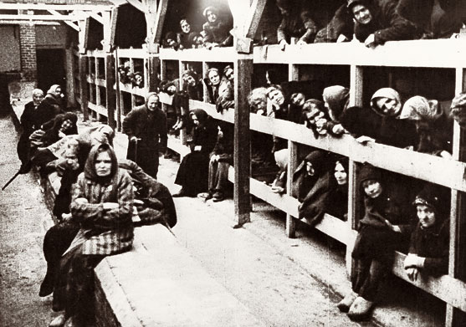Escape from Auschwitz was almost impossible. Electrically charged barbed-wire fences surrounded both the concentration camp and the killing center. Guards, equipped with machine guns and automatic rifles, stood in the many watchtowers. The lives of the prisoners were completely controlled by their guards, who on a whim could inflict cruel punishment on them. Prisoners were also mistreated by fellow inmates who were chosen to supervise the others in return for special favors by the guards.

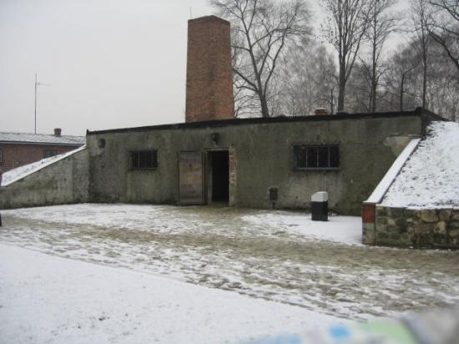Cruel "medical experiments" were conducted at Auschwitz. Men, women, and children were used as subjects. SS physician Dr. Josef Mengele carried out painful and traumatic experiments on dwarfs and twins, including young children. The aim of some experiments was to find better medical treatments for German soldiers and airmen. Other experiments were aimed at improving methods of sterilizing people the Nazis considered inferior.Many people died during the experiments. Others were killed after the "research" was completed and their organs removed for further study.

Most prisoners at Auschwitz survived only a few weeks or months. Those who were too ill or too weak to work were condemned to death in the gas chambers. Some committed suicide by throwing themselves against the electric wires. Others resembled walking corpses, broken in body and spirit. Yet other inmates were determined to stay alive.

KEY DATES

**MAY 20, 1940: AUSCHWITZ I CAMP OPENS**   
Auschwitz I, the main camp in the Auschwitz camp complex, is the first camp established near Oswiecim. Construction began in May 1940 in the Zasole suburb of Oswiecim, in artillery barracks formerly used by the Polish army. The camp is continuously expanded through the use of forced labor. Although Auschwitz I is primarily a concentration camp, serving a penal function, it also has a gas chamber and crematorium. An improvised gas chamber is located in the basement of the prison (Block 11). Later, a gas chamber is constructed in the crematorium.

**OCTOBER 8, 1941: CONSTRUCTION OF AUSCHWITZ II (BIRKENAU) BEGINS**  
Construction of Auschwitz II, or Auschwitz-Birkenau, begins in Brzezinka. Of the three camps established near Oswiecim as part of the Auschwitz camp complex, Auschwitz-Birkenau has the largest prisoner population. It is divided into nine sections separated by electrified barbed-wire fences and patrolled by SS guards and dogs. The camp includes sections for women, men, Roma (Gypsies), and families deported from the Theresienstadt ghetto. Auschwitz-Birkenau plays a central role in the German plan to exterminate the Jews of Europe. Four large crematoria buildings are constructed between March and June 1943. Each has three components: a disrobing area, a large gas chamber, and crematorium ovens. Gassing operations continue until November 1944.

**OCTOBER 1942: AUSCHWITZ III CAMP OPENS**  
The Germans establish Auschwitz III, also called Buna or Monowitz, in Monowice to provide forced laborers for the Buna synthetic rubber works (part of the German conglomerate I.G. Farben). I.G. Farben invested more than 700 million Reichsmarks (about 1.4 million US dollars in 1942) in Auschwitz III. Prisoners selected for forced labor are registered and tattooed with identification numbers on their left arms in Auschwitz I. They are then assigned to forced labor in Auschwitz or in one of the many sub-camps attached to Auschwitz III.

**JANUARY 27, 1945: SOVIET ARMY LIBERATES AUSCHWITZ CAMP COMPLEX**  
The Soviet army enters Auschwitz and liberates the remaining prisoners. Only a few thousand prisoners remain in the camp. Almost 60,000 prisoners, mostly Jews, were forced on a death march from the camp shortly before its liberation. During the forced evacuation of Auschwitz, prisoners were brutally mistreated and many were killed. SS guards shot anyone who fell behind. During its brief existence, nearly 1 million Jews were killed in Auschwitz. Other victims included between 70,000 and 74,000 Poles, 21,000 Roma (Gypsies), and about 15,000 Soviet prisoners of war.

Copyright © United States Holocaust Memorial Museum, Washington, DC

[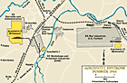](http://www.ushmm.org/outreach/en/media_nm.php?ModuleId=10007718&MediaId=306)AUSCHWITZ: CHRONOLOGY

**January 25, 1940**  
The SS decides to construct a concentration camp near Oswiecim ([Auschwitz](http://www.ushmm.org/wlc/en/article.php?ModuleId=10005189)).

**May 20, 1940**  
The first concentration camp prisoners—30 recidivist criminals from [Sachsenhausen](http://www.ushmm.org/wlc/en/article.php?ModuleId=10005538)—arrive at Auschwitz concentration camp.

**March 1, 1941**  
Reichsfuehrer SS and Chief of German Police Heinrich Himmler inspects Oswiecim (Auschwitz). Because nearby factories use prisoners for [forced labor](http://www.ushmm.org/wlc/en/article.php?ModuleId=10005180), Himmler is concerned about the prisoner capacity of the camp. On this visit, he orders both the expansion of Auschwitz I camp facilities to hold 30,000 prisoners and the building of a camp near Birkenau for an expected influx of 100,000 Soviet prisoners of war. Himmler also orders that the camp supply 10,000 prisoners for forced labor to construct an I.G. Farben factory complex at Dwory, about a mile away. Himmler will make additional visits to Auschwitz in 1942, when he will witness the killing of prisoners in the gas chambers.

**September 3, 1941**  
The first [gassings](http://www.ushmm.org/wlc/en/article.php?ModuleId=10005220) of prisoners occur in Auschwitz I. The SS tests Zyklon B gas by killing 600 [Soviet prisoners of war](http://www.ushmm.org/wlc/en/article.php?ModuleId=10007178) and 250 other ill or weak prisoners. Testing takes place in a makeshift gas chamber in the cellar of Block 11 in Auschwitz I. Zyklon B was the commercial name for crystalline hydrogen cyanide gas, manufactured by I.G. Farben and normally used as an insecticide. The "success" of these experiments will lead to the adoption of Zyklon B as the killing agent for the yet-to-be-constructed Auschwitz-Birkenau killing center.

**January 25, 1942**  
SS chief Heinrich Himmler informs Richard Gluecks, the Inspector of Concentration Camps, that 100,000 Jewish men and 50,000 Jewish women would be deported from Germany to Auschwitz as forced laborers.

**February 15, 1942**  
The first transport of Jews from Bytom (Beuthen) in German-annexed Upper Silesia arrives in Auschwitz I. The SS camp authorities kill all those on the transport immediately upon arrival with Zyklon B gas.

**December 31, 1942**  
German SS and police authorities deported approximately 175,000 Jews to Auschwitz in 1942.

**January 1 - March 31, 1943**  
German SS and police authorities deport approximately 105,000 Jews to Auschwitz.

**January 29, 1943**  
The Reich Central Office for Security orders all designated [Roma](http://www.ushmm.org/wlc/en/article.php?ModuleId=10005219)(Gypsies) residing in Germany, Austria, and the Protectorate of Bohemia and Moravia to be deported to Auschwitz.

**February 26, 1943**  
The first transport of Roma (Gypsies) from Germany arrives at Auschwitz. The SS authorities house them in Section B-IIe of Auschwitz-Birkenau, which becomes known as the "Gypsy family camp." By the end of 1943 more than 18,000 Roma (Gypsies) will have been incarcerated in the so-called family camp and as many as 23,000 Gypsies deported to the Auschwitz camp complex.

**April 1, 1943 - March 1944**  
German SS and police authorities deport approximately 160,000 Jews to Auschwitz.

**May 2, 1944**  
The first two transports of Hungarian Jews arrive in Auschwitz.

**July 6, 1944**  
The deportation of Hungarian Jews is halted by order of Regent Miklos Horthy. The last transport from Hungary arrives on July 11.

**August 2, 1944**  
SS camp authorities murder the last residents—just under 3,000—of the so-called Gypsy family camp in Auschwitz-Birkenau. The SS murders an estimated total of 20,000 Roma (Gypsies) in the Auschwitz concentration camp complex.

**April 1944 - November 1944**  
SS and Police authorities deport more than 585,000 Jews to Auschwitz.

**October 7, 1944**  
Members of the Jewish prisoner "special detachment" (Sonderkommando) that was forced to remove bodies from the gas chambers and operate the crematoria stage an uprising. They successfully blow up Crematorium IV and kill several guards. Women prisoners had smuggled gunpowder out of nearby factories to members of the Sonderkommando. The SS quickly suppresses the revolt and kills all the Sonderkommando members. On January 6, 1945, just weeks before Soviet forces liberate the camp, the SS will also hang four women who smuggled gunpowder into the camp.

**November 25, 1944**  
As Soviet forces continue to approach, SS chief Heinrich Himmler orders the destruction of the Auschwitz-Birkenau gas chambers and crematoria. During this SS attempt to destroy the evidence of mass killings, prisoners will be forced to dismantle and dynamite the structures.

**January 12, 1945**  
A Soviet offensive breaches the German defenses on the Vistula; Soviet troops take Warsaw and advance rapidly on Krakow and Oswiecim.

**January 18 - 27, 1945**  
As Soviet units approach, the SS evacuates to the west the prisoners of the Auschwitz concentration camp complex. Tens of thousands of prisoners, mostly Jews, are [forced to march](http://www.ushmm.org/wlc/en/article.php?ModuleId=10005162) to the cities of Wodzislaw and Gliwice in the western part of Upper Silesia. During the march, SS guards shoot anyone who cannot continue. In Wodzislaw and Gliwice, the prisoners will be put on unheated freight trains and deported to concentration camps in Germany, particularly to [Flossenbürg](http://www.ushmm.org/wlc/en/article.php?ModuleId=10005537), [Sachsenhausen](http://www.ushmm.org/wlc/en/article.php?ModuleId=10005538), [Gross-Rosen](http://www.ushmm.org/wlc/en/article.php?ModuleId=10005454), [Buchenwald](http://www.ushmm.org/wlc/en/article.php?ModuleId=10005198), and [Dachau](http://www.ushmm.org/wlc/en/article.php?ModuleId=10005214), and to [Mauthausen](http://www.ushmm.org/wlc/en/article.php?ModuleId=10005196) in Austria. In all, nearly 60,000 prisoners are forced on death marches from the Auschwitz camp system. As many as 15,000 die during the forced marches. Thousands more were killed in the days before the evacuation.

**January 27, 1945**  
Soviet troops enter the Auschwitz camp complex and liberate approximately 7,000 prisoners remaining in the camp. During the existence of Auschwitz, the SS camp authorities killed nearly one million Jews from across Europe. Other victims included approximately 74,000 [Poles](http://www.ushmm.org/wlc/en/article.php?ModuleId=10005473), approximately 21,000 Roma (Gypsies), and approximately 15,000 Soviet prisoners of war.

Copyright © United States Holocaust Memorial Museum, Washington, DC ENCYCLOPEDIA LAST UPDATED: JUNE 20, 2014

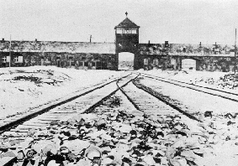**Auschwitz-Birkenau - "The Death Factory"**

The main entrance of Birkenau (1945)

* **L**ocation: Oswiecim, Poland
* **E**stablished: May 26th1940
* **L**iberation: January 27th, 1945, by the Soviet Army.
* **E**stimated number of victims: 2,1 to 2,5 million (This estimated number of death is considered by historians as a strict minimum. The real number of death is unknown but probably much higher, maybe 4 millions)
* **S**ub-camps : 51

**T**he Auschwitz complex was divided in three major camps: **Auschwitz I** main camp or Stammlager; **Auschwitz II**, or **Birkenau**, established on October 8th, 1941 as a 'Vernichtungslager' (extermination camp); **Auschwitz III** or **Monowitz**, established on May 31th, 1942 as an 'Arbeitslager' or work camp; also several sub-camps. There were up to seven gas chambers using Zyklon-B poison gas and three crematoria. Auschwitz II included a camp for new arrivals and those to be sent on to labor elsewhere; a Gypsy camp; a family camp; a camp for holding and sorting plundered goods and a women's camp. Auschwitz III provided slave labor for a major industrial plant run by I G Farben for producing synthetic rubber (see Blechhammer). Highest number of inmates, including sub-camps: 155,000. The estimated number of deaths: 2.1 to 2.5 million killed in gas chambers, of whom about 2 million were Jews, and Poles, Gypsies and Soviet POWs. About 330,000 deaths from other causes.

**I**n April 1940, Rudolph Höss, who become the first commandant, identified the Silesian town of Oswiecim as a possible site for a concentration camp. The function of the camp was initially to intimidate Poles and prevent resistance to German rule. It was also perceived as a cornerstone of the policy to re-colonize Upper Silesia, which had once been a German region, with 'pure Aryans'. On April 27th, Himmler ordered construction of the camp.

**I**n May 1940, Poles were evicted from the vicinity of the barracks (most of them were executed), and a work crew comprising concentration camp prisoners was sent from Sachsenhausen. 300 Jews from the large Jewish community of Oswiecim were also pressed into service.

**T**he first transport of prisoners, almost all Polish civilians, arrived in June 1940 and the SS administration and staff was established. On March 1th, 1941, the camp population was 10,900. The camp quickly developed a reputation for torture and mass shootings.

**H**immler visited Auschwitz in March 1941 and commanded its enlargement to hold 30,000 prisoners. Himmler also ordered the construction of a second camp for 100,000 inmates on the site of the village of Brzezinka (Birkenau), roughly 4 km from the main camp. This massive camp was intended to be filled with captured Russian POWs who would provide the slave labor to build the SS 'utopia' in Upper Silesia. The chemical giant I G Farben expressed an interest in utilizing this labor force, too. Extensive construction work began in October 1941, under terrible conditions and with massive loss of life. About 10,000 Russian POWs died in the process.

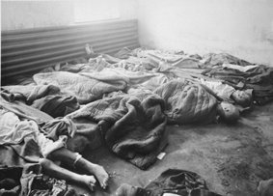  
The Death Factory... (1945)

**T**he main camp population grew from 18,000 in December 1942 to 30,000 in March 1943. In July or August 1941, Himmler briefed Höss about the 'Final Solution'. On September 3th, 1941, Soviet POWs at the Auschwitz main camp were used in trials of the poison gas Zyklon-B. This poison gas was produced by the German company "Degesch" (Deutsche Gesellschaft zur Schädlingsbekämpfung). The were gassed in underground cells in Block 11. After this trial, a gas chamber was rigged-up just outside the main camp and in February 1942, two temporary gas chambers opened at Birkenau. The crematories were built by the German company "Topf & son" located at Erfurt.

**I**n March 1942, a women's camp is established at Auschwitz with 6,000 inmates. In August 1942, it was moved to Birkenau. By January 1944, 27,000 women were living in Birkenau, in section B1a, in separated quarters.

**I**n February 1943, a section for Gypsies was established at Birkenau, camp BIIe, and in September 1943 an area was reserved for Czech Jews deported from Theresienstadt, the so-called 'Family Camp', BIIb. The gas chambers and crematoria opened in March 1943.

**I**n Autumn 1943, the camp administration was reorganized following a corruption scandal. By the end of 1943, the prisoner population of Auschwitz main camp, Birkenau, Monowitz and other sub-camps was over 80,000: 18,437 in the main camp, 49,114 in Birkenau, and 13,288 at Monowitz where I G Farben had its synthetic rubber plant. Up to 50,000 prisoners were scattered around 51 sub-camps such as Rajsko, an experimental agricultural station, and Gleiwitz, a coal mine

**T**he situation in the sub-camps was often even worse than in the main camps. In mid-1944, Auschwitz was designated a huge SS -run security area in Upper Silesia of over 40 sq. The camp population reached in August 1944 105,168. The last roll-call on January 18th, 1945 showed 64,000 inmates.

**D**uring its history, the prison population of Auschwitz changed composition significantly. At first, its inmates were almost entirely Polish. From April 1940 to March 1942, on about 27,000 inmates, 30 percent were Poles and 57 percent were Jews. From March 1942 to March 1943 of 162,000 inmates, 60 percent were Jews.**A**uschwitz became a significant source of slave labor locally and functioned as an international clearing house. Of 2.5 million people who were deported to Auschwitz, 405,000 were given prisoner status and serial numbers. Of these, approximately 50 percent were Jews and 50 percent were Poles and other nationalities. Of those who received numbers, 65,000 survived. It is estimated that about 200,000 people passed through the Auschwitz camps and survived.

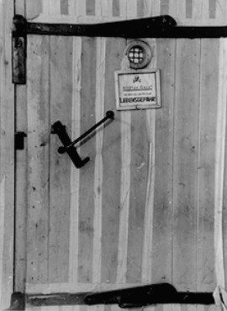**T**hose deported to Auschwitz arrived at the nearby train station and were marched or trucked to the main camp where they were registered, tattooed, undressed, deloused, had their body hair shaven off, showered while their clothes were disinfected with Zyklon-B gas, and entered the camp under the infamous gateway inscribed 'Arbeit Macht Frei' ("Labor make you free")

**A** parallel system operated later at Birkenau in 1942-43, except that for the majority the 'showers' proved to be gas chambers. Only about 10 percent of Jewish transports were registered, disinfected, shaven and showered in the 'central sauna' before being assigned barracks. In May 1944, a spur line was built right into the camp to accelerate and simplify the handling of the tens of thousands of Hungarian and other Jews deported in the spring and summer of 1944.

**T**he history of Auschwitz-Birkenau as an extermination center is complex. From late 1941 to October 1942, the mortuary at Auschwitz main camp, which was already equipped with a crematorium, was adapted as a gas chamber. It measured approximately 835 square feet. In the spring of 1942, two provisional gas chambers at Birkenau were constructed out of peasant huts, known as the 'bunkers'.

**T**he first 'bunker', with two sealed rooms, operated from January 1942 to the end of that year. The second, with four air tight rooms, became redundant in the spring of 1943, but remained standing and was used again in the autumn of 1944 when extra 'capacity' was needed for the murder of Hungarian Jews and the liquidation of the ghettos. The second measured about 1.134 square feet. The victims murdered in the 'bunkers' were first obliged to undress in temporary wooden barracks erected nearby. Their bodies were taken out of the gas chambers and pushed to pits where they were burned in the open. Between January 1942 and March 1943, 175,000 Jews were gassed to death here, of whom 105,000 were killed from January to March 1943.

Entrance of a gas chamber in Auscwitz. (1945)

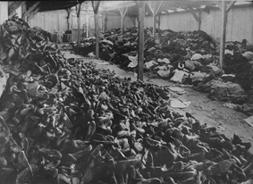**U**p to this point, Auschwitz accounted for only 11 percent of the victims of the 'Final Solution'. However, in August 1942, planning began for the construction of four large-scale gassing facilities. It appears from the plans that the first two gas chambers were adapted from mortuaries which, with the huge crematoria attached to them, were initially intended to cope with mortalities amongst the slave labor force in the camp, now approaching 100,000 and subject to a horrifying death rate. But from the autumn of 1942, it seems clear that the SS planners and civilian contractors were intending to build a mass-murder plant.

**T**he twin pairs of gas chambers were numbered II and III, and IV and V. The first opened on March 31, 1943, the last on April 4, 1943. The total area of the gas chambers was 2,255 square meters; the capacity of these crematoria was 4,420 people. Those selected to die were undressed in the undressing room and then pushed into the gas chambers. It took about 20 minutes for all the people to death. In II and III, the killings took place in underground rooms, and the corpses were carried to the five ovens by an electrically operated lift. Before cremation gold teeth and any other valuables, such as rings, were removed from the corpses. In IV and V the gas chambers and ovens were on the same level, but the ovens were so poorly built and the usage was so great that they repeatedly malfunctioned and had to be abandoned. The corpses were finally burned outside, in the open, as in 1943. Jewish sonderkommandos worked the crematoria under SS supervision.

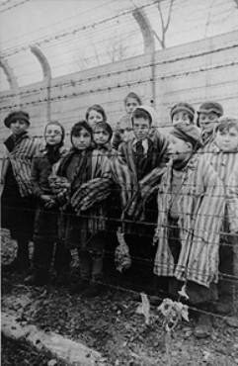**I**nitially the new facilities were "underutilized". From April 1943 to March 1944, "only" 160,000 Jews were killed at Birkenau, but from March 1944 to November 1944, when all the other death camps had been abandoned, Birkenau surpassed all previous records for mass killing. The Hungarian deportations and the liquidation of the remaining Polish ghettos, such as Lodz, resulted in the gassing of 585,000 Jews. This period made Auschwitz-Birkenau into the most notorious killing site of all time.**I**n October 1944, the 'Sonderkommando' crew crematoria IV revolted and destroyed the crematories. In November Himmler ordered gassings to stop, and a 'cleanup' operation was inaugurated to conceal traces of the mass murder. In January 1945, the Germans evacuated 58,000 prisoners who could walk. They left behind in the main camp, Birkenau and in Monowitz about 7,000 sick or incapacitated who they did not expect would live for long.

**W**hen Soviet troops liberated Auschwitz on January 27, 1945, they found these pitiful survivors as well as 836,525 items of women clothing, 348,820 items of men clothing, 43,525 pairs of shoes and vast numbers of toothbrushes, glasses and other personal effects. They found also 460 artificial limbs and seven tons of human hair shaved from Jews before they were murdered. The human hairs were used by the company "Alex Zink" (located in Bavaria) for confection of cloth. This company was paying the human hairs 50 pfennig/kilo.

**R**emarkably, there were instances of individual resistance and collective efforts at fighting back inside Auschwitz. Poles, Communists and other national groups established networks in the main camp. A few Jews escaped from Birkenau, and there were recorded assaults on Nazi guards even at the entrance to the gas chambers. The 'Sonderkommando' revolt in October 1944 was the extraordinary example of physical resistance.

**Kristallnacht**

On November 9 to November 10, 1938, in an incident known as “Kristallnacht”, Nazis in Germany torched synagogues, vandalized Jewish homes, schools and businesses and killed close to 100 Jews. In the aftermath of Kristallnacht, also called the “Night of Broken Glass,” some 30,000 Jewish men were arrested and sent to Nazi concentration camps. German Jews had been subjected to repressive policies since 1933, when Nazi Party leader Adolf Hitler (1889-1945) became chancellor of Germany. However, prior to Kristallnacht, these Nazi policies had been primarily nonviolent. After Kristallnacht, conditions for German Jews grew increasingly worse. During World War II (1939-45), Hitler and the Nazis implemented their so-called “Final Solution” to the what they referred to as the “Jewish problem,” and carried out the systematic murder of some 6 million European Jews in what came to be known as the Holocaust.

**HITLER AND ANTI-SEMITISM**

Soon after Adolph Hitler became Germany’s chancellor in January 1933, he began instituting policies that isolated German Jews and subjected them to persecution. Among other things, Hitler’s [Nazi Party](http://www.history.com/topics/world-war-ii/nazi-party), which espoused extreme German nationalism and anti-Semitism, commanded that all Jewish businesses be boycotted and all Jews be dismissed from civil-service posts. In May 1933, the writings of Jewish and other “un-German” authors were burned in a communal ceremony at Berlin’s Opera House. Within two years, German businesses were publicly announcing that they no longer serviced Jews. The Nuremberg Laws, passed in September 1935, decreed that only Aryans could be full German citizens. Furthermore, it became illegal for Aryans and Jews to marry or have extramarital intercourse.

***Did You Know?***

*Shortly before Kristallnacht, U.S. aviator Charles Lindbergh toured Germany and was given a medal by Hermann Göring, commander of the German air force. After Kristallnacht, Lindbergh declined to return the medal. This, plus his ensuing anti-Semitic comments, stained his status as an American hero.*

Despite the repressive nature of these policies, through most of 1938, the harassment of Jews was primarily nonviolent. However, on the night of November 9, all that changed dramatically.

**FROM HARASSMENT TO VIOLENCE**

In the fall of 1938, Herschel Grynszpan (1921-45), a 17-year-old ethnically Polish Jew who had been living in France for several years, learned that the Nazis had exiled his parents to Poland from Hanover, Germany, where Herschel had been born and his family had lived for years. As retaliation, on November 7, 1938, the agitated teenager shot Ernst vom Rath (1909-38), a German diplomat in Paris. Rath died two days later from his wounds, and Hitler attended his funeral. [Joseph Goebbels](http://www.history.com/topics/world-war-ii/joseph-goebbels) (1897-1945), the Nazi minister for public enlightenment and propaganda, immediately seized on the assassination to rile Hitler’s supporters into an anti-Semitic frenzy.

Kristallnacht was the result of that rage. Starting in the late hours of November 9 and continuing into the next day, Nazi mobs torched or otherwise vandalized hundreds of synagogues throughout Germany and damaged, if not completely destroyed, thousands of Jewish homes, schools, businesses, hospitals and cemeteries. Nearly 100 Jews were murdered during the violence. Nazi officials ordered German police officers and firemen to do nothing as the riots raged and buildings burned, although firefighters were allowed to extinguish blazes that threatened Aryan-owned property.

In the immediate aftermath of Kristallnacht, the streets of Jewish communities were littered with broken glass from vandalized buildings, giving rise to the name Night of Broken Glass. The Nazis held the German-Jewish community responsible for the damage and imposed a collective fine of $400 million (in 1938 rates), according to the U.S. Holocaust Memorial Museum. Additionally, more than 30,000 Jewish men were arrested and sent to the[Dachau](http://www.history.com/topics/world-war-ii/dachau), Buchenwald and Sachsenhausen concentration camps in Germany–camps that were specifically constructed to hold Jews, political prisoners and other perceived enemies of the Nazi state.

**U.S. REACTION TO KRISTALLNACHT**

On November 15, 1938, [Franklin D. Roosevelt](http://www.history.com/topics/us-presidents/franklin-d-roosevelt) (1882-1945), the American president, responded to Kristallnacht by reading a statement to the media in which he harshly denounced the rising tide of anti-Semitism and violence in Germany. He also recalled Hugh Wilson, his ambassador to Germany.

Despite Roosevelt’s condemnation of the Nazi violence, the U.S. refused to ease the immigration restrictions it then had in place, constraints that prevented masses of German Jews from seeking safety in America. One reason was anxiety over the possibility that Nazi infiltrators would be encouraged to legally settle in the U.S. A more obscured reason was the anti-Semitic views held by various upper-echelon officials in the U.S. State Department. One such administrator was Breckinridge Long (1881-1958), who was responsible for carrying out policies relating to immigration. Long took an obstructionist role in granting visas to European Jews, and maintained this policy even when America entered [World War II](http://www.history.com/topics/world-war-ii) after the December 7, 1941, Japanese attack on [Pearl Harbor](http://www.history.com/topics/world-war-ii/pearl-harbor), [Hawaii](http://www.history.com/topics/us-states/hawaii).

**A WAKE-UP CALL TO GERMAN JEWS**

The violence of Kristallnacht served notice to German Jews that Nazi anti-Semitism was not a temporary predicament and would only intensify. As a result, many Jews began to plan an escape from their native land.

Arthur Spanier (1899-1944) and Albert Lewkowitz (1883-1954) were two who wanted to come to the U.S.; however, their task was not a simple one. Spanier had been the Hebraica librarian at the Prussian State Library and an instructor at the Hochschule für die Wissenschaft des Judentums (Higher Institute for Jewish Studies), both located in Berlin, Germany. After Kristallnacht, he was sent to a concentration camp, but was released upon receiving a job offer from the Cincinnati, Ohio-based Hebrew Union College. Spanier applied for an American visa, but none was forthcoming. Julian Morgenstern (1881-1976), president of the college, traveled to [Washington](http://www.history.com/topics/us-states/washington), D.C., for an explanation. Morgenstern was told that Spanier was denied the visa because he was a librarian and, according to U.S. State Department rules, a visa could not be issued to an academic in a secondary educational position even if a major American educational institution had pledged to support him.

Lewkowitz, a philosophy professor at the Breslau Jewish Theological Seminary, was granted a visa. He and Spanier traveled to Rotterdam, the Netherlands, but were trapped there when the Germans invaded in May 1940. Lewkowitz’s visa was destroyed as the Germans bombarded the city. Bureaucrats at the American consulate suggested that he acquire another visa from Germany. Given the circumstances, this would be impossible. Both men soon found themselves in the Bergen-Belsen concentration camp. Spanier lost his life there, while Lewkowitz was released in 1944 during a prisoner exchange. That year, he settled in Palestine.

**A WAKE-UP CALL TO NON-JEWS**

Not all those who were impacted by Kristallnacht were practicing Jews. Edith Stein (1891-1942), a German philosopher and nun, was born a Jew but converted to Catholicism. In 1933, she was accepted as an initiate at the Carmelite convent in Cologne, Germany, and took the name Teresa Benedicta a Cruce. She was joined there by her older sister Rosa, who had also become a Catholic.

After Kristallnacht, the Steins left Germany and resettled in a Carmelite convent in Echt, the Netherlands. In 1942, as the Germans began deporting Jews from the Netherlands, Edith Stein successfully applied for a visa that would allow her to move to a convent in neutral Switzerland. However, Rosa was unable to obtain a visa and Edith declined to leave the Netherlands without her.

In August 1942, the Nazis arrested both women and dispatched them to a concentration camp at Amersfoort, the Netherlands. Shortly afterward, they were sent to the Auschwitz-Birkenau death camp where they perished in a gas chamber. In 1987, Edith Stein was beatified as a Catholic martyr by Pope John Paul II (1920-2005).

**CONDITIONS WORSEN AFTER KRISTALLNACHT**

Kristallnacht marked a turning point toward more violent and repressive treatment of Jews by the Nazis. By the end of 1938, Jews were prohibited from schools and most public places in Germany–and conditions only worsened from there. During World War II, Hitler and the Nazis implemented their so-called “Final Solution” to what they referred to as the “Jewish problem,” and carried out the systematic murder of some 6 million European Jews (along with, by some estimates, 4 million to 6 million non-Jews) in what came to be known as the Holocaust.

As for Herschel Grynszpan, whose shooting of a German diplomat was used as an excuse by the Nazis to perpetrate the Kristallnacht violence, his fate remains a mystery. What is known is that he was incarcerated in a Paris prison and later transferred to Germany. According to some accounts, Grynzpan was eventually executed by the Nazis. However, other sources claim he survived the war and resettled in Paris, where he married and started a family under an assumed name.

<http://www.history.com/topics/kristallnacht>

BUCHENWALD

[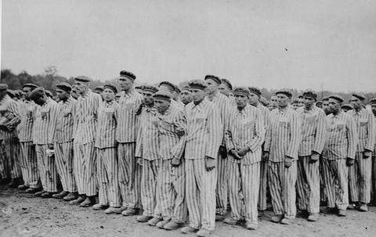](http://www.ushmm.org/wlc/en/media_ph.php?ModuleId=10005198&MediaId=599)

Prisoners during a roll call at the Buchenwald concentration camp. Their uniforms bear classifying triangular badges and identification numbers. Buchenwald, Germany, 1938-1941.

*— US Holocaust Memorial Museum*

[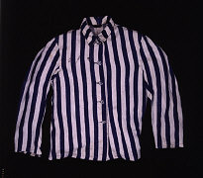](http://www.ushmm.org/wlc/en/gallery.php?ModuleId=10005198&MediaType=DA)Together with its many satellite camps, Buchenwald was one of the largest [concentration camps](http://www.ushmm.org/wlc/en/article.php?ModuleId=10005144) established within the old German borders of 1937. The camp was constructed in 1937 in a wooded area on the northern slopes of the Ettersberg, about five miles northwest of Weimar in east-central Germany. Before the Nazi [takeover of power](http://www.ushmm.org/wlc/en/article.php?ModuleId=10005204), Weimar was best known as the home of leading literary figure Johann Wolfgang von Goethe, a product of German liberal tradition in the eighteenth and early nineteenth centuries, and as the birthplace of German constitutional democracy in 1919, the Weimar Republic. During the Nazi regime, "Weimar" became associated with the Buchenwald concentration camp.

SS authorities opened Buchenwald for male prisoners in July 1937. Women were not part of the Buchenwald camp system until late 1943 or early 1944. Prisoners were confined in the northern part of the camp in an area known as the main camp, while SS guard barracks and the camp administration compound were located in the southern part. An electrified barbed-wire fence, watchtowers, and a chain of sentries outfitted with automatic machine guns, surrounded the main camp.The detention area, also known as the Bunker, was located at the entrance to the main camp. The SS often shot prisoners in the stables and hanged other prisoners in the crematorium area.

Most of the early inmates at Buchenwald were political prisoners. However, in 1938, in the aftermath of [Kristallnacht](http://www.ushmm.org/wlc/en/article.php?ModuleId=10005201), German SS and police sent almost 10,000 Jews to Buchenwald where the camp authorities subjected them to extraordinarily cruel treatment upon arrival. 255 of them died as a result of their initial mistreatment at the camp.

Jews and political prisoners were not the only groups within the Buchenwald prisoner population, although the “politicals,” given their long-term presence at the site, played an important role in the camp's prisoner infrastructure. The SS also interned recidivist criminals, Jehovah's Witnesses, Roma and Sinti (Gypsies), and German military deserters at Buchenwald. Buchenwald was one of the only concentration camps that held so-called “work-shy” individuals, persons whom the regime incarcerated as “asocials” because they could not, or would not, find gainful employment. In the camp's later stages, the SS also incarcerated prisoners-of-war of various nations [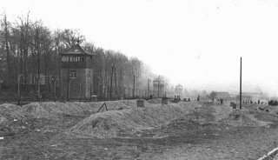](http://www.ushmm.org/wlc/en/gallery.php?ModuleId=10005198&MediaType=PH)(including the United States), resistance fighters, prominent former government officials of German-occupied countries, and foreign forced laborers.

Beginning in 1941, a number of physicians and scientists carried out a varied program of [medical experimentation](http://www.ushmm.org/wlc/en/article.php?ModuleId=10005168) on prisoners at Buchenwald in special barracks in the northern part of the main camp. Medical experiments aimed at testing the efficacy of vaccines and treatments against contagious diseases such as typhus, typhoid, cholera, and diphtheria resulted in hundreds of deaths. In 1944, Danish physician Dr. Carl Vaernet began a series of experiments that he claimed would "cure" homosexual inmates through hormonal transplants.

[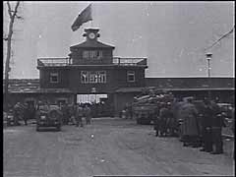](http://www.ushmm.org/wlc/en/gallery.php?ModuleId=10005198&MediaType=FI)Also in 1944, camp officials established a "special compound" for prominent German political prisoners near the camp administration building in Buchenwald. In August 1944, the SS staff murdered Ernst Thälmann, chairman of the Communist Party of Germany before Hitler's rise to power in 1933, in Buchenwald after holding him there for several years.

**Buchenwald: Forced Labor and Subcamps**  
During World War II, the Buchenwald camp system became an important source of [forced labor](http://www.ushmm.org/wlc/en/article.php?ModuleId=10005180). The prisoner population expanded rapidly, reaching 112,000 by February 1945. The camp authorities deployed Buchenwald prisoners in the German Equipment Works (Deutsche-Ausrüstungs-Werke; DAW), an enterprise owned and operated by the SS; in camp workshops; and in the camp's stone quarry. In February 1942, the Gustloff firm established a subcamp of Buchenwald to support its armaments works, and in March 1943 opened a large munitions plant adjacent to the camp. A rail siding completed in 1943 connected the camp with the freight yards in Weimar, facilitating the shipment of war supplies.

Buchenwald administered at least 88 subcamps located across Germany, from Düsseldorf in the Rhineland to the border with the Protectorate of Bohemia and Moravia in the east. SS authorities and firm executives (both state-owned and private) deployed prisoners in the satellite camps, mostly in armaments factories, in stone quarries, and on construction projects. Periodically, the SS staff conducted selections throughout the Buchenwald camp system and dispatched those too weak or disabled to work to so-called [euthanasia](http://www.ushmm.org/wlc/en/article.php?ModuleId=10005200) facilities such as Bernburg, where euthanasia operatives gasse them as part of Operation 14f13, the extension of euthanasia killing operations to ill and exhausted concentration camp prisoners. SS physicians or orderlies killed, by phenol injection, other prisoners unable to work.

**The Liberation of Buchenwald**  
As Soviet forces swept through Poland, the Germans evacuated thousands of concentration camp prisoners from German-occupied areas under threat. After long, brutal [marches](http://www.ushmm.org/wlc/en/article.php?ModuleId=10005162), more than 10,000 weak and exhausted prisoners from [Auschwitz](http://www.ushmm.org/wlc/en/article.php?ModuleId=10005189) and[Gross-Rosen](http://www.ushmm.org/wlc/en/article.php?ModuleId=10005454), most of them Jews, arrived in Buchenwald in January 1945.

In early April 1945, as US forces approached the camp, the Germans began to evacuate some 28,000 prisoners from the main camp and an additional several thousand prisoners from the subcamps of Buchenwald. About a third of these prisoners died from exhaustion en route or shortly after arrival, or were shot by the SS. The underground resistance organization in Buchenwald, whose members held key administrative posts in the camp, saved many lives. They obstructed Nazi orders and delayed the evacuation.

On April 11, 1945, in expectation of liberation, starved and emaciated prisoners stormed the watchtowers, seizing control of the camp. Later that afternoon, US forces entered Buchenwald. Soldiers from the 6th Armored Division, part of the Third Army, found more than 21,000 people in the camp. Between July 1937 and April 1945, the SS imprisoned some 250,000 persons from all countries of Europe in Buchenwald. Exact mortality figures for the Buchenwald site can only be estimated, as camp authorities never registered a significant number of the prisoners. The SS murdered at least 56,000 male prisoners in the Buchenwald camp system, some 11,000 of them Jews.

<http://www.ushmm.org/wlc/en/article.php?ModuleId=10005198>

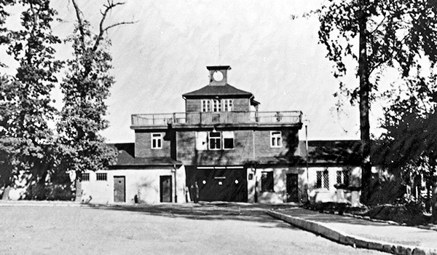*Photo: Georges Angéli*

**Gate building**

of the former Buchenwald Special Camp, 1950. The cast-iron camp gate with the SS inscription “Jedem das Seine” (“To Each His Own”) is concealed behind the board fence, a typical feature of the special camp.

Soviet Special Camp No. 2 1945-1950

The so-called Special Camp 2 Buchenwald was one of the altogether ten camps and three prisons located in the Soviet-occupied zone and used by the occupying power for the internment of Germans. The Soviet Security Service took charge of the still-existing structural facilities of Buchenwald Concentration Camp beginning from August 1945 and initially committed persons from the region. Primarily local functionaries of the NSDAP, but also adolescents and victims of denunciation were interned. All contact to the outside was prohibited, and no trials of an even remotely legal nature took place.  
  
In the winter of 1946-47 more than 7,000 of the 28,000 inmates died as a result of hunger-related diseases. The camp was dissolved by the Soviets in February 1950, shortly after the founding of the GDR.

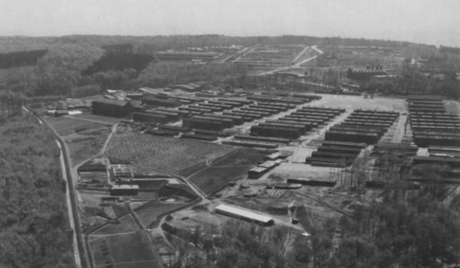

AERIAL VIEW OF BUCHENWALD CONCENTRATION CAMP FOLLOWING LIBERATION, END OF APRIL 1945. PHOTO: U.S. AIR RECONNAISSANCE. NATIONAL ARCHIVES WASHINGTON

Buchenwald Concentration Camp, 1937–1945

In July 1937, the SS has the forest cleared on the Ettersberg near Weimar and builds a new concentration camp in its place. The purpose of the camp is to combat political opponents, persecute Jews, Sinti and Roma, and permanently ostracize “strangers to the community” – among them homosexuals, homeless persons, Jehovah’s Witnesses and ex-convicts – from the “body of the German people”. It is not long before Buchenwald has become a synonym for the Nazi concentration camp system.

After the war begins, people are deported to Buchenwald from all over Europe. Altogether more than 250,000 persons are ultimately imprisoned in the concentration camp on the Ettersberg and its 136 subcamps. The SS forces them to perform labour for the German armament industry.

By the end of the war, Buchenwald is the largest concentration camp in the German Reich. More than 56,000 die there as the result of torture, medical experiments and consumption. Over 8,000 Soviet prisoners of war are shot to death in a killing facility erected especially for that purpose. Members of the resistance form an underground organization in the camp in the effort to curb SS violence. The “Little Camp” nevertheless becomes the “hell of Buchenwald”. The enfeebled inmates continue to die by the thousands right up until the camp’s liberation.

When the Americans reach Buchenwald and its subcamps in April 1945, the supreme commander of the Allied Forces, Dwight D. Eisenhower, writes: *"Nothing has ever shocked me as much as that sight."*

Buchenwald:  
History & Overview

[Buchenwald](http://www.jewishvirtuallibrary.org/jsource/Holocaust/buchtoc.html) was one of the largest [concentration camps](http://www.jewishvirtuallibrary.org/jsource/Holocaust/cc.html) established by the [Nazis](http://www.jewishvirtuallibrary.org/jsource/Holocaust/nazipartytoc.html). The camp was constructed in [1937](http://www.jewishvirtuallibrary.org/jsource/Holocaust/Chronology_1937.html) in a wooded area on the northern slopes of the Ettersberg, about five miles northwest of Weimar in east-central [Germany](http://www.jewishvirtuallibrary.org/jsource/vjw/Germanytoc.html). Before the Nazi takeover of power, Weimar was best known as the home of Johann Wolfgang von Goethe, who embodied the German enlightenment of the eighteenth century, and as the birthplace of German constitutional democracy in 1919, the Weimar Republic. During the Nazi regime, “Weimar” became associated with the Buchenwald concentration camp.

Buchenwald first opened for male prisoners in July 1937. Women were not part of the Buchenwald camp system until [1944](http://www.jewishvirtuallibrary.org/jsource/Holocaust/Chronology_1944.html). Prisoners were confined in the northern part of the camp in an area known as the main camp, while [SS](http://www.jewishvirtuallibrary.org/jsource/Holocaust/sstoc.html) guard barracks and the camp administration compound were located in the southern part. The main camp was surrounded by an electrified barbed-wire fence, watchtowers, and a chain of sentries outfitted with automatically activated machine guns. The jail, also known as the Bunker, was located at the entrance to the main camp. The SS carried out shootings in the stables and hangings in the crematorium area.

Most of the early inmates at Buchenwald were political prisoners. However, in [1938](http://www.jewishvirtuallibrary.org/jsource/Holocaust/Chronology_1938.html), in the aftermath of [Kristallnacht](http://www.jewishvirtuallibrary.org/jsource/Holocaust/kristalltoc.html), German SS and police sent almost 10,000 Jews to Buchenwald where they were subjected to extraordinarily cruel treatment. 600 prisoners died between November [1938](http://www.jewishvirtuallibrary.org/jsource/Holocaust/Chronology_1938.html) and February [1939](http://www.jewishvirtuallibrary.org/jsource/Holocaust/Chronology_1939.html).

Beginning in [1941](http://www.jewishvirtuallibrary.org/jsource/Holocaust/Chronology_1941.html), a varied program of involuntary [medical experiments](http://www.jewishvirtuallibrary.org/jsource/Holocaust/medtoc.html) on prisoners took place at Buchenwald in special barracks in the northern part of the main camp. Medical experiments involving viruses and contagious diseases such as typhus resulted in hundreds of deaths. In 1944, SS Dr. Carl Vaernet began a series of experiments that he claimed would “cure” homosexual inmates.

Also in [1944](http://www.jewishvirtuallibrary.org/jsource/Holocaust/Chronology_1944.html), a “special compound” for prominent German political prisoners was established near the camp administration building in Buchenwald. Ernst Thaelmann, chairman of the Communist Party of Germany before Hitler's rise to power in [1933](http://www.jewishvirtuallibrary.org/jsource/Holocaust/Chronology_1933.html), was murdered there in August 1944.

During [World War II](http://www.jewishvirtuallibrary.org/jsource/Holocaust/wwtoc.html), the Buchenwald camp system became an important source of [forced labor](http://www.jewishvirtuallibrary.org/jsource/Holocaust/labortoc.html). The prisoner population expanded rapidly, reaching 110,000 by the end of 1945. Buchenwald prisoners were used in the German Equipment Works (DAW), an enterprise owned and operated by the SS; in camp workshops; and in the camp's stone quarry. In March [1943](http://www.jewishvirtuallibrary.org/jsource/Holocaust/Chronology_1943.html) the Gustloff firm opened a large munitions plant in the eastern part of the camp. A rail siding completed in 1943 connected the camp with the freight yards in Weimar, facilitating the shipment of war supplies.

Buchenwald administered at least 87 subcamps located across Germany, from Duesseldorf in the Rhineland to the border with the Protectorate of Bohemia and Moravia in the east. Prisoners in the satellite camps were put to work mostly in armaments factories, in stone quarries, and on construction projects. Periodically, prisoners throughout the Buchenwald camp system underwent selection. The SS staff sent those too weak or disabled to continue working to the Bernburg or Sonnenstein [euthanasia killing centers](http://www.jewishvirtuallibrary.org/jsource/Holocaust/t4toc.html), where they were killed by [gas](http://www.jewishvirtuallibrary.org/jsource/Holocaust/gastoc.html). Other weakened prisoners were killed by phenol injections administered by the camp doctor.

As Soviet forces swept through [Poland](http://www.jewishvirtuallibrary.org/jsource/vjw/Polandtoc.html), the Germans evacuated thousands of concentration camp prisoners from western Poland. After long, brutal marches, more than 10,000 weak and exhausted prisoners from [Auschwitz](http://www.jewishvirtuallibrary.org/jsource/Holocaust/autoc.html) and [Gross-Rosen](http://www.jewishvirtuallibrary.org/jsource/Holocaust/grosstoc.html), most of them Jews, arrived in Buchenwald in January 1945.

In early April [1945](http://www.jewishvirtuallibrary.org/jsource/Holocaust/Chronology_1945.html), as American forces approached the camp, the Germans began to evacuate some 28,000 prisoners from the main camp and an additional 10,000 prisoners from the subcamps of Buchenwald. About a third of these prisoners died from exhaustion en route or shortly after arrival, or were shot by the SS. Many lives were saved by the Buchenwald [resistance](http://www.jewishvirtuallibrary.org/jsource/Holocaust/resisttoc.html), whose members held key administrative posts in the camp. They obstructed Nazi orders and delayed the evacuation.

On April 11, 1945, starved and emaciated prisoners stormed the watchtowers, seizing control of the camp. Later that afternoon,[American forces entered](http://www.jewishvirtuallibrary.org/jsource/Holocaust/libtoc.html) Buchenwald. Soldiers from the Third U.S. Army division found more than 20,000 people in the camp, 4,000 of them Jews. Approximately 56,000 people were murdered in the Buchenwald camp system, the majority of them after 1942.

<http://www.jewishvirtuallibrary.org/jsource/Holocaust/buchenwald.html>

**Winston Churchill**

The name Winston Churchill is recognised across the globe as a major political influence throughout World War 2. Born on 30 November 1874, Churchill was a British politician (a member of the Conservative party) and a statesman who was well known for his leadership and the now famous speeches that he made to the people of the United Kingdom during the events of World War 2. Serving as Prime Minister twice (1940–45 and 1951–55),  
Churchill is now regarded by many people as one of the greatest wartime leaders of the century.

However, many people may not be aware that Churchill, a noted statesman and orator, was also an officer in the British Army, a writer, a historian and an artist.  
In fact, he remains to this day the only British prime minister to ever have received the Nobel Prize in Literature, and he was also the first person to be made an Honorary Citizen of the United States.

[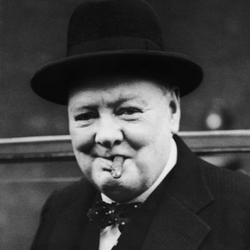](http://worldwar2.org.uk/wp-content/uploads/2012/02/Sir-Winston-Leonard-Spencer-Churchill-9248186-1-402.jpg)

With an impressive background, it could be said that Churchill was always destined for greatness – however, very few people could have predicted his epic rise from political ‘wilderness’ in the 1930s to eventually take the lead in warning the nation about the intentions of Nazi Germany and in the campaigning for rearmament.

Appointed First Lord of the Admiralty upon the initial outbreak of World War 2 – [Churchill became Prime Minister](http://en.wikipedia.org/wiki/Winston_Churchill) following the resignation of Neville Chamberlain on 10 May 1940. Over the years to follow, his steadfast refusal to consider surrender, defeat or compromise made him a formidable figure – and perhaps the perfect leader for the nation during the early part of World War 2, when Britain stood alone in its active opposition to [Hitler](http://www.hitler.org.uk/) and Nazi Germany plans.  
Perhaps best noted for his morale-boosting radio broadcasts and speeches, Winston Churchill led Britain as Prime Minister until complete victory over Nazi Germany had been obtained.

Perhaps surprisingly, following Churchill’s pivotal role in World War 2, he was defeated in the 1945 election – however, he remained leader of the opposition for many years and continued to have a huge impact on world affairs. Then, in the General Election of 1951, Churchill held the office of Minister of Defence – a task that ran from October 1951 to January 1952 and in October 1951, he once again became Prime Minister. His second reign as Prime Minister ended in his resignation in April 1955.

After leaving his position as Prime Minister, Churchill spent considerably less time as an active member of parliament until he eventually stood down during the 1964 General Election. As a “back-bencher” and advancing in years, Churchill then spent the majority of his remaining years at his home in Hyde Park Gate, in London.

At this point, it was reported that Churchill suffered from depression as his mental and physical faculties began to suffer. However, one thing is for sure, Winston Churchill will remain a key figure in the events of World War 2 and his work over the years continues to be celebrated by many.

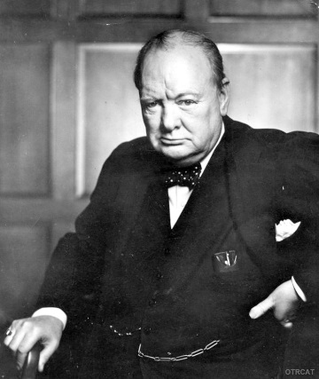**Winston Churchill** is one of the best-known, and some say one of the greatest, statesmen of the 20th century. Though he was born into a life of privilege, he dedicated himself to public service. His legacy is a complicated one–he was an idealist and a pragmatist; an orator and a soldier; an advocate of progressive social reforms and an unapologetic elitist; a defender of democracy as well as of Britain’s fading empire–but for many people in Great Britain and elsewhere, Winston Churchill is simply a hero.

**WINSTON CHURCHILL’S EARLY LIFE**

Winston Churchill came from a long line of English aristocrat-politicians. His father, Lord Randolph Churchill, was descended from the First Duke of Marlborough and was himself a well-known figure in Tory politics in the 1870s and 1880s. His mother, born Jennie Jerome, was an American heiress whose father was a stock speculator and part owner of The [New York](http://www.history.com/topics/us-states/new-york) Times. (Rich American girls like Jerome who married European noblemen were known as “dollar princesses.”)

Churchill was born at the family’s estate near Oxford on November 30, 1874. He was educated at the Harrow prep school, where he performed so poorly that he did not even bother to apply to Oxford or Cambridge. Instead, in 1893 young Winston Churchill headed off to military school at Sandhurst.

**CHURCHILL: BATTLES AND BOOKS**

After he left Sandhurst, Churchill traveled all around the British Empire as a soldier and as a journalist. In 1896, he went to India; his first book, published in 1898, was an account of his experiences in India’s Northwest Frontier Province. In 1899, the London Morning Post sent him to cover the Boer War in South Africa, but he was captured by enemy soldiers almost as soon as he arrived. (News of Churchill’s daring escape through a bathroom window made him a minor celebrity back home in Britain.) By the time he returned to England in 1900, the 26-year-old Churchill had published five books.

**CHURCHILL: “CROSSING THE CHAMBER”**

That same year, Winston Churchill joined the House of Commons as a Conservative. Four years later, he “crossed the chamber” and became a Liberal. His work on behalf of progressive social reforms such as an eight-hour workday, a government-mandated minimum wage, a state-run labor exchange for unemployed workers and a system of public health insurance infuriated his Conservative colleagues, who complained that this new Churchill was a traitor to his class.

**WINSTON CHURCHILL AND WORLD WAR I**

In 1911, Churchill turned his attention away from domestic politics when he became the First Lord of the Admiralty (akin to the Secretary of the Navy in the U.S.). Noting that Germany was growing more and more bellicose, Churchill began to prepare Great Britain for war: He established the Royal Naval Air Service, modernized the British fleet and invented one of the earliest tanks.

Despite Churchill’s prescience and preparation, [World War I](http://www.history.com/topics/world-war-i) was a stalemate from the start. In an attempt to shake things up, Churchill proposed a military campaign that soon dissolved into disaster: the 1915 invasion of the Gallipoli Peninsula in Turkey. Churchill hoped that this offensive would drive Turkey out of the war and encourage the Balkan states to join the Allies, but Turkish resistance was much stiffer than he had anticipated. After nine months and 250,000 casualties, the Allies withdrew in disgrace. After the debacle at Gallipoli, Churchill left the Admiralty.

**CHURCHILL: BETWEEN THE WARS**

During the 1920s and 1930s, Churchill bounced from government job to government job, and in 1924 he rejoined the Conservatives. Especially after the Nazis came to power in 1933, Churchill spent a great deal of time warning his countrymen about the perils of German nationalism, but Britons were weary of war and reluctant to get involved in international affairs again. Likewise, the British government ignored Churchill’s warnings and did all it could to stay out of Hitler’s way. In 1938, Prime Minister Neville Chamberlain even signed an agreement giving Germany a chunk of Czechoslovakia–“throwing a small state to the wolves,” Churchill scolded–in exchange for a promise of peace.

A year later, however, Hitler broke his promise and invaded Poland. Britain and France declared war. Chamberlain was pushed out of office, and Winston Churchill took his place as prime minister in May 1940.

**CHURCHILL: THE “BRITISH BULLDOG”**

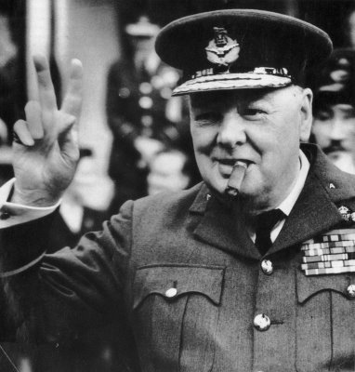“I have nothing to offer but blood, toil, tears and sweat,” Churchill told the House of Commons in his first speech as prime minister. “We have before us many, many long months of struggle and of suffering. You ask, what is our policy? I can say: It is to wage war, by sea, land and air, with all our might and with all the strength that God can give us; to wage war against a monstrous tyranny, never surpassed in the dark, lamentable catalogue of human crime. That is our policy. You ask, what is our aim? I can answer in one word: It is victory, victory at all costs, victory in spite of all terror, victory, however long and hard the road may be; for without victory, there is no survival.”

Just as Churchill predicted, the road to victory in [World War II](http://www.history.com/topics/world-war-ii) was long and difficult: France fell to the Nazis in June 1940. In July, German fighter planes began three months of devastating air raids on Britain herself. Though the future looked grim, Churchill did all he could to keep British spirits high. He gave stirring speeches in Parliament and on the radio. He persuaded U.S. President Franklin Roosevelt to provide war supplies–ammunition, guns, tanks, planes–to the Allies, a program known as Lend-Lease, before the Americans even entered the war.

Though Churchill was one of the chief architects of the Allied victory, war-weary British voters ousted the Conservatives and their prime minister from office just two months after Germany’s surrender in 1945.

**CHURCHILL: FIGHTING COMMUNISM**

The now-former prime minister spent the next several years warning Britons and Americans about the dangers of Soviet expansionism. In a speech in Fulton, [Missouri](http://www.history.com/topics/us-states/missouri), in 1946, for example, Churchill declared that an anti-democratic “Iron Curtain,” “a growing challenge and peril to Christian civilization,” had descended across Europe. Churchill’s speech was the first time anyone had used that now-common phrase to describe the Communist threat.

In 1951, 77-year-old Winston Churchill became prime minister for the second time. He spent most of this term working (unsuccessfully) to build a sustainable détente between the East and the West. He retired from the post in 1955.

In 1953, Queen Elizabeth made Winston Churchill a knight of the Order of the Garter. He died in 1965, one year after retiring from Parliament.

<http://www.history.com/topics/british-history/winston-churchill>

D-Day

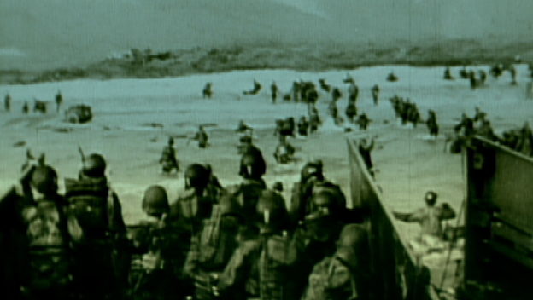During World War II (1939-1945), the Battle of Normandy, which lasted from June 1944 to August 1944, resulted in the Allied liberation of Western Europe from Nazi Germany’s control. Codenamed Operation Overlord, the battle began on June 6, 1944, also known as D-Day, when some 156,000 American, British and Canadian forces landed on five beaches along a 50-mile stretch of the heavily fortified coast of France’s Normandy region. The invasion was one of the largest amphibious military assaults in history and required extensive planning. Prior to D-Day, the Allies conducted a large-scale deception campaign designed to mislead the Germans about the intended invasion target. By late August 1944, all of northern France had been liberated, and by the following spring the Allies had defeated the Germans. The Normandy landings have been called the beginning of the end of war in Europe.

**PREPARING FOR D-DAY**

After [World War II](http://www.history.com/topics/world-war-ii) began, Germany invaded and occupied northwestern France beginning in May 1940. The Americans entered the war in December 1941, and by 1942 they and the British (who had been evacuated from the beaches of Dunkirk in May 1940 after being cut off by the Germans in the Battle of France) were considering the possibility of a major Allied invasion across the English Channel. The following year, Allied plans for a cross-Channel invasion began to ramp up. In November 1943, [Adolf Hitler](http://www.history.com/topics/world-war-ii/adolf-hitler) (1889-1945), who was aware of the threat of an invasion along France’s northern coast, put [Erwin Rommel](http://www.history.com/topics/world-war-ii/erwin-rommel-erwin) (1891-1944) in charge of spearheading defense operations in the region, even though the Germans did not know exactly where the Allies would strike. Hitler charged Rommel with finishing the Atlantic Wall, a 2,400-mile fortification of bunkers, landmines and beach and water obstacles.

*The Normandy American Cemetery, overlooking Omaha Beach and the English Channel, was established on June 8, 1944, as the first U.S. cemetery in Europe during World War II. It holds the graves of more than 9,300 U.S. servicemen who died in the D-Day invasion or subsequent missions.*

In January 1944, General Dwight Eisenhower (1890-1969) was appointed commander of Operation Overlord. In the months and weeks before D-Day, the Allies carried out a massive deception operation intended to make the Germans think the main invasion target was Pas-de-Calais (the narrowest point between Britain and France) rather than Normandy. In addition, they led the Germans to believe that Norway and other locations were also potential invasion targets. Many tactics was used to carry out the deception, including fake equipment; a phantom army commanded by George Patton and supposedly based in England, across from Pas-de-Calais; double agents; and fraudulent radio transmissions.

**A WEATHER DELAY: JUNE 5, 1944**

Eisenhower selected June 5, 1944, as the date for the invasion; however, bad weather on the days leading up to the operation caused it to be delayed for 24 hours. On the morning of June 5, after his meteorologist predicted improved conditions for the following day, Eisenhower gave the go-ahead for Operation Overlord. He told the troops: “You are about to embark upon the Great Crusade, toward which we have striven these many months. The eyes of the world are upon you.”

Later that day, more than 5,000 ships and landing craft carrying troops and supplies left England for the trip across the Channel to France, while more than 11,000 aircraft were mobilized to provide air cover and support for the invasion.

**D-DAY LANDINGS: JUNE 6, 1944**

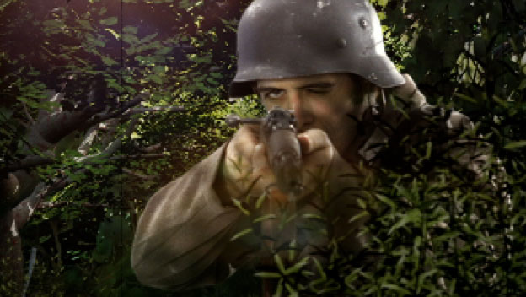By dawn on June 6, thousands of paratroopers and glider troops were already on the ground behind enemy lines, securing bridges and exit roads. The amphibious invasions began at 6:30 a.m. The British and Canadians overcame light opposition to capture beaches codenamed Gold, Juno and Sword, as did the Americans at [Utah](http://www.history.com/topics/us-states/utah) Beach. U.S. forces faced heavy resistance at Omaha Beach, where there were over 2,000 American casualties. However, by day’s end, approximately 156,000 Allied troops had successfully stormed Normandy’s beaches. According to some estimates, more than 4,000 Allied troops lost their lives in the D-Day invasion, with thousands more wounded or missing.

Less than a week later, on June 11, the beaches were fully secured and over 326,000 troops, more than 50,000 vehicles and some 100,000 tons of equipment had landed at Normandy.

For their part, the Germans suffered from confusion in the ranks and the absence of celebrated commander Rommel, who was away on leave. At first, Hitler, believing the invasion was a feint designed to distract the Germans from a coming attack north of the Seine River, refused to release nearby divisions to join the counterattack. Reinforcements had to be called from further afield, causing delays. He also hesitated in calling for armored divisions to help in the defense. Moreover, the Germans were hampered by effective Allied air support, which took out many key bridges and forced the Germans to take long detours, as well as efficient Allied naval support, which helped protect advancing Allied troops.

In the ensuing weeks, the Allies fought their way across the Normandy countryside in the face of determined German resistance, as well as a dense landscape of marshes and hedgerows. By the end of June, the Allies had seized the vital port of Cherbourg, landed approximately 850,000 men and 150,000 vehicles in Normandy, and were poised to continue their march across France.

**VICTORY IN NORMANDY**

By the end of August 1944, the Allies had reached the Seine River, Paris was liberated and the Germans had been removed from northwestern France, effectively concluding the Battle of Normandy. The Allied forces then prepared to enter Germany, where they would meet up with Soviet troops moving in from the east.

The Normandy invasion began to turn the tide against the Nazis. A significant psychological blow, it also prevented Hitler from sending troops from France to build up his Eastern Front against the advancing Soviets. The following spring, on May 8, 1945, the Allies formally accepted the unconditional surrender of Nazi Germany. Hitler had committed suicide a week earlier, on April 30.

<http://www.history.com/topics/world-war-ii/d-day>

D-Day, Normandy, France June 6, 1944   
by Brian Williams and John Barratt   
  
[The Atlantic Wall](http://www.militaryhistoryonline.com/wwii/dday/prelude.aspx)   
After the invasion and subsequent fall of France in 1940, the German army controlled the entire coast of Northern France.  Following the Allied evacuation at Dunkirk, Hitler had hoped that Britain would agree to settle the war.  But, because of British determination and Germany's inability to carry out an invasion of England, Germany was forced to maintain a defensive posture along the coast. In 1944, the German war machine was still very powerful despite the many setbacks on the Eastern Front.  What it lacked in Luftwaffe and materials, it made up for in highly experienced and trained men.  Also, its armor, heavy infantry weapons, and anti-tank capabilities were years ahead of the Americans and British.  But, the Allies controlled the air and sea and what they lacked in quality, they hoped to make up for in quantity. The German high command was actually anticipatory about the upcoming Allied invasion.  It meant that finally the British and American threat could be "dealt with" once and for all. 

[Overlord Preparations](http://www.militaryhistoryonline.com/wwii/dday/overlord.aspx)  
Operation Overlord, the Allied codename for the invasion of Normandy, involved more than 150,000 men and 5,000 ships.  It consisted of American, British, Canadian, Polish, and Free French Armies under command of General Eisenhower, the Supreme Commander of the Allied Expeditionary Force (the choice of Eisenhower was officially made by President Roosevelt in December 1943, and agreed upon by the British). The Deputy Supreme Commander of the invasion was British Air Chief Marshal Arthur W. Tedder, who had been the commander of the Allied Air Forces in the Mediterranean.  While British Admiral Bertram H. Ramsay, was appointed naval commander.  He had conducted the evacuation at Dunkirk and also planned the Torch landing in North Africa.  British Air Chief Marshal Trafford L. Leigh-Mallory was appointed as commander of the air forces. Montgomery was chosen as the ground forces' commander, despite his well-known personality problems.  Eisenhower's first choice was in fact General Harold Alexander, but Churchill needed Alexander to remain in Italy.  Montgomery arrived in Britain in January 1944 and began to evaluate the feasibility of the operation.  He proposed the expansion of the invasion area to include landings west of the Vire River - allowing for the encirclement of Cherbourg (this would later become Utah Beach).   
  
  
[The Airborne Landings](http://www.militaryhistoryonline.com/wwii/dday/airborne.aspx)  
The first three of these units were given the missions of securing the eastern and western flanks of the beachhead by destroying bridges and laying mines.  Their main mission was to allow for the main invasion force to come ashore without the immediate threat of German flank attacks.  They were tasked to destroy bridges where the enemy was likely to stage a counterattack, and to secure bridges where Allied forces were expected to go immediately on the offensive.The US 82nd Airborne Division's mission was to protect the far right flank of the invasion in the Cotentin peninsula.  It hoped to accomplish this by destroying bridges over the Douve River and by securing the Merderet River by occupying both sides.  It also had the mission to capture Ste. Mere-Eglise from the German garrison stationed there.  The capture of Ste. Mere-Eglise was important because it straddled the main road between Carentan and Cherbourg. The US 101st Airborne Division's mission was to secure four exits across the marshland near the coast for the invading US 4th Infantry Division at Utah beach.  These causeways needed to be secured because on each side of the exits, it was flooded several feet deep in places.  The 101st also were tasked to destroy two bridges over the Douve and to capture the La Barquette lock just north of Carentan.  The lock controlled the water height of the flooded areas and it was essential that it be captured. The British 6th Airborne Division was to land Northeast of Caen and secure the left flank of the invasion force by controlling bridges over the Orne Canal and River. The left flank of the invasion force was much more vulnerable to German armored attack since the 21st Panzer was stationed just outside of Caen and the 12th SS Panzer miles to the east. Potentially, if the Panzer Divisions were not stopped by the British 6th, they could attack Sword and the rest of the landing beaches.   
  
[Utah](http://www.militaryhistoryonline.com/wwii/dday/utah.aspx)  
At 0300 on the morning of June 6th, fleets of Allied bombers roared overhead delivering thousands of tons of bombs onto the German coastal defenses.  These were followed at 0500 by the naval bombardment which had been planned to immediately precede the invasion itself. The battleship USS Nevada's 14-inch guns were assigned to the bombardment of the German batteries on Utah beach, while the USS Texas was to fire at Pointe-du-Hoc where the Rangers were to land as part of the Omaha landing.  On the western end of Omaha proper, the USS Arkansas pounded a battery at Les Moulins.  Several cruisers and destroyers also jumped into the bombardment with pre-determined targets and as opportunity arose.  At such close range, there was very little trajectory to the shots and many Americans who were coming in to land, could feel the vacuum of the shells passing overhead.  Needless to say, the bombardment was a very welcome sight to those troops about to land. At approximately 0620, the Nevada turned its guns to the beach and began bombarding a concrete seawall.  Immediately after the bombardment, the plan called for a rocket bombardment by LCT(R)s (Landing Craft, Tank with Rocket launcher).  This was to be followed by the 2nd Battalion, 8th Infantry, in 20 Higgins boats which carried a 30-man assault team each.  
  
[Pointe du Hoc](http://www.militaryhistoryonline.com/wwii/dday/pointeduhoc.aspx)  
Pointe du Hoc was located on the coast to the west of the Omaha beach landings and was the position of six 155mm cannons with a range of 25,000 yards.  These cannons had a commanding view of both Omaha and Utah beaches and the potential to cause much damage to the invading force.  The area had been bombed since May and then grew in intensity during the three days and nights before D-Day.  During D-Day, the USS Texas bombarded the point as did 18 medium bombers of the Ninth Air Force at H-20. The point stood on cliffs between 85 to over 100 feet high at whose base was a very small rocky beach that offered no protection.  Because the point was positioned on near impregnable cliffs, the Germans had concentrated their defenses in anticipation of a ground assault from inland.  Above were heavily fortified concrete casements interlaced with tunnels, trenches, and machine-gun positions around the perimeter.  Although the 716th Infantry Division was thinly stretched along 30 miles of the shoreline, approximately 200 German troops (125 infantry and 85 artillery men) were garrisoned in or around the point. The task fell to Lt. Col. James Earl Rudder's 2nd Ranger Battalion and called for 3 Companies (D, E, and F) of the battalion to scale the heights.  Company D was to approach the heights on the west, while E and F were to attack on the east.  The main Ranger force (5th Battalion and Companies A and B of the 2nd) were to wait off shore for signal of success and then land at the Point.   
  
[Omaha](http://www.militaryhistoryonline.com/wwii/dday/omaha.aspx)  
The US 1st Army, V Corps had the mission of securing the beachhead between Port-en-Bessin and the Vire River and to advance towards St. Lo. The Corps was to arrive in 4 stages with the 1st Division (with the 29th attached) leading the landings with about 34,000 men in the morning, followed by another 25,000 men after noon. The 1st Division was a veteran unit which had served through the campaigns of North Africa and Sicily.  While for the most part, Normandy would be the 29th Division's first experience in combat.  Two American Regimental Combat Teams (RCTs) of four rifle companies each, were tasked with the initial landing (the US 29th 116th RCT and the US 1st 16th RCT), followed by the remainder of the 1st and 29th Infantry Divisions.  Fire support included naval gunfire from the battleships, cruisers, and destroyers offshore, heavy bombing by B-24 Liberators, the 741st and 743rd DD (dual-drive amphibious) tank battalions, several battalions of engineers and naval demolition personnel, and several howitzer battalions.    
  
[Gold Beach](http://www.militaryhistoryonline.com/wwii/dday/gold.aspx)  
Gold Beach was the code name for the center of the landings on the Normandy coast.  The British 50th (Northumbrian) Infantry Division of the 2nd Army under Lieutenant General Miles Dempsey was to land at H-Hour + 1 (0730), seize Arromanches and drive inland to capture the road junction at Bayeux.  Its additional objectives were to make contact with the US forces to the west at Omaha Beach and the Canadians to their east at Juno Beach.  In addition to the 50th, the 47th Royal Marine Commandos were to land on sector Item and to attack south of Arromanches and Longues and take Port-en-Bessin from the rear. Gold Beach spanned nearly 10 miles long although the areas where landings were to occur were about 5 miles wide.  Gold was characterized mainly by the 3 sea villages of La Rivière, Le Hamel, and the small port of Arromanches to the west.  The Allied sectors were designated from west to east: How, Item, Jig, and King.  Of these four sectors, only the easternmost 3 were to actually become assault sectors. Units of the German 716th Division and elements of the veteran 1st Battalion of the 352nd Division defended the coast in the beach houses along the coast with concentrations at Le Hamel and Le Riviere.  Fortunately for the Allies, these houses proved to be vulnerable to naval and air bombardment.  In addition, an observation post and battery of four 155mm cannon was located at Longues-sur-Mer.   
  
[Juno Beach](http://www.militaryhistoryonline.com/wwii/dday/juno.aspx)  
Of all the troops involved in the D-Day landings, the men of the Canadian Army , with raw memories of the disaster suffered by Canadian forces in 1942 at Dieppe, might have had greatest cause for apprehension. The Canadian 3rd Infantry Division, (Maj-Gen R.F.L. Keller) supported by the 2nd Canadian Armoured Brigade, formed part of I Corps (Lieutenant-General J.T. Crocker), whose D-Day objective was to secure Caen and push 11 miles inland to seize Carpiquet airfield. These were ambitious aims, particularly as the presence of rocks offshore meant that the tide would not be high enough for the landings to begin until half an hour later than those elsewhere, and so probably facing an alerted enemy. The main immediate opposition would come from three, fairly low grade, battalions of the 716th Division, but of more concern was the possibility that 21st Panzer Division, believed to be south-east of Caen, might intervene quickly, possibly reinforced during the afternoon by 12th SS Panzer.   
  
[Sword Beach](http://www.militaryhistoryonline.com/wwii/dday/sword.aspx)  
AAs well as being the furthest east of the landing beaches, "Sword" was also the smallest, only wide enough for a brigade-sized landing force. The 3rd British Division was tasked with getting enough troops ashore to push inland quickly and seize Caen, and link up with 6th Airborne Division. It would prove to be a seriously over-ambitious aim. Early on June 6th Naval Force"S", carrying the assault force and support units, moved into position off the mouth of the River Orne. It was here that the only notable German naval activity of the day occurred, when three E-boats emerged through the Allied smoke screen, fired a salvo of torpedoes, which sank the Norwegian destroyer Largs, and made off unscathed. It proved to be the only appearance of the Kriegsmarine that day, and the Allied bombardment force, including the battleships Warspite and Ramillies, proceeded to lay down the heaviest barrage of the day on the three-mile wide stretch of beach where the 8th British Brigade was to land.   
  
[Counterattack](http://www.militaryhistoryonline.com/wwii/dday/counterattack.aspx)  
As Rommel had recognised, Germany's main chance of defeating the invasion lay in prompt counterattacks, particularly by her panzer forces. However, for a variety of reasons, the powerful striking force within easy reach of the invasion beaches which he had called for was not immediately available. A major problem resulted from a lack of clarity in the panzer command structure. The newly formed 47th Panzer Corps was still in process of taking over command of 21st, 116th and 2nd Panzer Divisions, whilst administrative and supply matters remained under Panzer Group West, with both responsible to Rommel's Army Group B. To complicate matters further, Field Marshal Gerd von Rundstedt, Commander in Chief West, was powerless to commit the strategic reserve without the authority of OKW, meaning in effect Hitler.   
  
[The Fight for the Foothold](http://www.militaryhistoryonline.com/wwii/dday/foothold.aspx)  
By nightfall on June 6th 1944-D-Day, Hitler's Atlantic Wall on the coast of Normandy had been breached. The Allies, at a cost of 9,500 casualties compared with 4-10,000 Germans, were ashore in Fortress Europe. But their position remained precarious; the beachheads had less depth than had been hoped for, and British and US forces had not yet linked up. Supplies and reinforcements were not coming ashore as rapidly as had been planned, and the initially slow and piecemeal enemy reaction could not be expected to remain so favorable. The Allies had to link up and expand their currently insecure toeholds into something more substantial as rapidly as possible. [[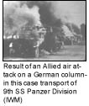](http://www.militaryhistoryonline.com/wwii/dday/images/foothold/IMG01207140914A.jpg)](http://www.militaryhistoryonline.com/wwii/dday/images/foothold/IMG01207140914A.jpg)For Germany, the result of the first day of fighting had been disappointing, but was not viewed as disastrous. Partly as a result of Hitler's hesitancy, and also as a consequence of virtually complete Allied air supremacy over the approaches to the battle area, 21st and 12th SS Panzer Divisions, forming the immediate mobile reserve, had not intervened effectively on June 6th. Indeed losses from enemy air attack were so substantial that it is unlikely that their earlier release would have made any significant difference.

Rommel, absent in Bavaria during the opening hours of the battle, arrived back at Army Group B Headquarters late in the evening, and began re-organising the currently fragmented command structure.

<http://www.militaryhistoryonline.com/wwii/dday/>

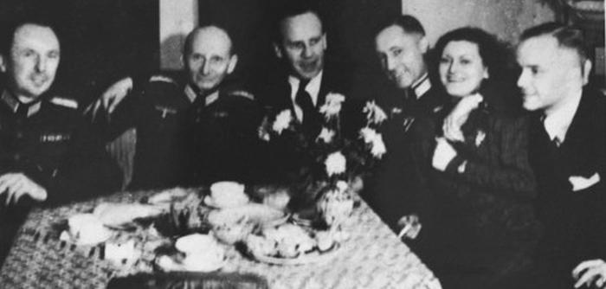[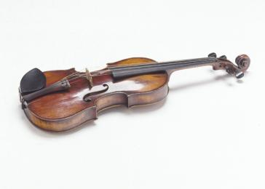](http://www.ushmm.org/information/exhibitions/online-features/special-focus/oskar-schindler)Oskar Schindler (center) at a dinner party in Krakow *—US Holocaust Memorial Museum, courtesy of Leopold*

A 19th-century Italian violin owned by Henry Rosner, a professional Jewish violinist from Krakow who was saved by Oskar Schindler during World War II. *—US Holocaust Memorial Museum, courtesy of Murray Pantirer*

Oskar Schindler (third from left) at a party with local SS officials on his 34th birthday. Schindler attempted to use his connections with German officials to obtain information that might protect his Jewish employees. *—US Holocaust Memorial Museum, courtesy of Leopold Page Photographic Collection*

At Yad Vashem, the Israeli national institution of Holocaust commemoration, Oskar Schindler stands next to the tree planted in honor of his rescue efforts. Jerusalem, Israel, 1970. *—US Holocaust Memorial Museum, courtesy of Leopold Page Photographic Collection*

**Asked why he had intervened on behalf of the Jews, Schindler replied:**

*The persecution of Jews in the General Government in Polish territory gradually worsened in its cruelty. In 1939 and 1940 they were forced to wear the Star of David and were herded together and confined in ghettos. In 1941 and 1942 this unadulterated sadism was fully revealed. And then a thinking man, who had overcome his inner cowardice, simply had to help. There was no other choice. —Oskar Schindler, 1964 interview.*

Oskar Schindler’s actions to protect Jews during the Holocaust have earned him a special place among honored rescuers.

Schindler was an unlikely hero. An ethnic German living in Moravia, Czechoslovakia, he joined the Nazi party in 1939. In the wake of the German invasion of Poland, Schindler went to Krakow. He assumed responsibility for the operation of two formerly Jewish-owned manufacturers of enamel kitchenware and then established his own enamel works in Zablocie, outside Krakow. Through army contracts and the exploitation of cheap labor from the Krakow ghetto, he amassed a fortune. Dealing on the black market, he lived in high style.

In 1942 and early 1943, the Germans decimated the ghetto’s population of some 20,000 Jews through shootings and deportations. Several thousand Jews who survived the ghetto’s liquidation were taken to Plaszow, a forced labor camp run by the sadistic SS commandant Amon Leopold Goeth. Moved by the cruelties he witnessed, Schindler contrived to transfer his Jewish workers to barracks at his factory.

In late summer 1944, through negotiations and bribes from his war profits, Schindler secured permission from German army and SS officers to move his workers and other endangered Jews to Bruennlitz, near his hometown of Zwittau. Each of these Jews was placed on “Schindler’s List.” Schindler and his workforce set up a bogus munitions factory, which sustained them in relative safety until the war ended.

Oskar Schindler’s transformation from Nazi war profiteer to protector of Jews is the subject of several documentaries, the best-selling novel *Schindler’s List*.

[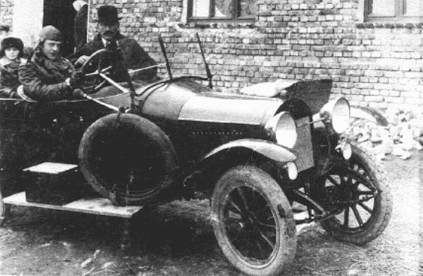](http://www.ushmm.org/wlc/en/media_ph.php?ModuleId=10005787&MediaId=3174)OSKAR SCHINDLER

Oskar Schindler (at wheel) with his father, Hans. Svitavy (Zwittau), Czechoslovakia, 1929.

*— courtesy of Leopold Page Photographic Collection; US Holocaust Memorial Museum*

Oskar Schindler (1908-1974) was born on April 28, 1908 in Svitavy (Zwittau), Moravia, at that time a province of the Austro-Hungarian Monarchy. An ethnic German and a Catholic, he remained in Svitavy during the interwar period and held Czech citizenship after Moravia was incorporated into the newly established Czechoslovak Republic in 1918.

After attending a series of trade schools in Brno and marrying Emilie Pelzl in 1928, Schindler held a variety of jobs, including working in his father's farm machinery business in Svitavy, opening a driving school in Sumperk, and selling government property in Brno. He also served in the Czechoslovak army and in 1938 attained the rank of lance corporal in the reserves. Schindler began working with the *Amt Auslands/Abwehr*(Office of the Military Foreign Intelligence) of the German Armed Forces in 1936. In February 1939, five months after the German annexation of the Sudetenland, he joined the Nazi Party. An opportunist businessman with a taste for the finer things in life, he seemed an unlikely candidate to become a wartime rescuer. During World War II, Schindler rescued more than 1,000 Jews from deportation to Auschwitz, Nazi Germany's largest killing center.

Following the German [invasion and occupation of Poland](http://www.ushmm.org/wlc/en/article.php?ModuleId=10005070), Schindler moved to Krakow from Svitavy in October 1939. Taking advantage of the German occupation program to “Aryanize” and “Germanize” Jewish-owned and Polish-owned businesses in the so-called General Government (Generalgouvernement), he bought Rekord Ltd., a Jewish-owned enamelware manufacturer and converted its plant to establish the *Deutsche Emalwarenfabrik Oskar Schindler* (German Enamelware Factory Oskar Schindler), also known as Emalia, in November 1939. While Schindler operated two other factories in Krakow, only at Emalia did he employ Jewish workers who resided in the nearby [Krakow ghetto](http://www.ushmm.org/wlc/en/article.php?ModuleId=10005169). At its peak strength in 1944, Emalia employed 1,700 workers; at least 1,000 were Jewish forced laborers, whom the Germans had relocated from the Krakow ghetto after its liquidation in March 1943 to the forced labor camp and later concentration camp Krakau-Plaszow.

[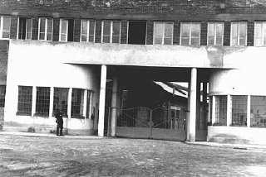](http://www.ushmm.org/wlc/en/gallery.php?ModuleId=10005787&MediaType=PH)Although the prisoners deployed at Emalia were still subject to the brutal conditions of the [Plaszow](http://www.ushmm.org/wlc/en/article.php?ModuleId=10005301) concentration camp, Schindler intervened repeatedly on their behalf, through bribes and personal diplomacy, both for the well-being of Jews threatened on an individual basis and to ensure, until late 1944, that the SS did not deport his Jewish workers. In order to claim the Jewish workers to be essential to the war effort, he added an armaments manufacturing division to Emalia. During the liquidation of the Krakow ghetto in March 1943, Schindler allowed his Jewish workers to stay at the factory overnight.

After the SS re-designated Plaszow as a concentration camp in August 1943, Schindler persuaded the SS to convert Emalia into a subcamp of Plaszow. In addition to the approximately 1,000 Jewish forced laborers registered as factory workers, Schindler permitted 450 Jews working in other nearby factories to live at Emalia as well, saving them from the systematic brutality and arbitrary murder that was part of daily life in Plaszow. Schindler did not act here without risk or cost; his protection of his Jewish workers and some of his shady business dealings led SS and police authorities to suspect him of corruption and of giving unauthorized aid to Jews. German SS and police officials arrested him three times, while he owned Emalia, but were unable to charge him.

In October 1944, after the SS transferred the Emalia Jews to Plaszow, Schindler sought and obtained authorization to relocate his plant to Brünnlitz (Brnenec) in Moravia, and reopen it exclusively as an armaments factory. One of his assistants drew several versions of a list of up to 1,200 Jewish prisoners needed to work in the new factory. These lists came to be known collectively as “Schindler's List.” Schindler met the specifications required by the SS to classify Brünnlitz as a sub-camp of [Gross-Rosen](http://www.ushmm.org/wlc/en/article.php?ModuleId=10005454)concentration camp and thereby facilitated the survival of around 800 Jewish men whom the SS deported from Plaszow via Gross-Rosen to Brünnlitz and between 300 and 400 Jewish women from Plaszow via [Auschwitz](http://www.ushmm.org/wlc/en/article.php?ModuleId=10005189).

Though classified as an armaments factory, the Brünnlitz plant produced just one wagonload of live ammunition in just under eight months of operation. By presenting bogus production figures, Schindler justified the existence of the sub-camp as an armaments factory and thus facilitated the survival of over 1,000 Jews, sparing them the horrors and brutality of conventional camp life. Schindler left Brünnlitz only on May 9, 1945, the day that Soviet troops liberated the camp.

After the war, Schindler and his wife Emilie settled in Regensburg, Germany, until 1949, when they immigrated to Argentina. In 1957, permanently separated but not divorced from Emilie, Schindler returned alone to Germany. In 1962, Yad Vashem awarded Schindler the title "Righteous Among the Nations" in recognition of his efforts to save Jews during the Holocaust at great personal risk. Emilie was similarly honored in 1993.

Schindler died in Germany, penniless and almost unknown, in October 1974. Many of those whose survival he facilitated-and their descendants-lobbied for and financed the transfer of his body for burial in Israel. In 1993, the United States Holocaust Memorial Council posthumously presented the Museum's Medal of Remembrance to Schindler. Rarely presented, this medal honors deserving recipients for extraordinary deeds during the Holocaust and in the cause of Remembrance. Emilie Schindler accepted the medal on behalf of her ex-husband at a ceremony in the Museum's Hall of Remembrance.

Schindler's story garnered more attention thanks to Steven Spielberg's 1993 film *Schindler's List*, based on a 1983 novel of the same name by Thomas Keneally that recounted Schindler's life and works. The movie received popular and critical acclaim.

*Further Reading*

David M. Crowe, *Oskar Schindler: The Untold Account of his Life, Wartime Activities, and the True Story Behind the List*(Cambridge, MA: Westview Press, 2004).

<http://www.ushmm.org/wlc/en/article.php?ModuleId=10005787>

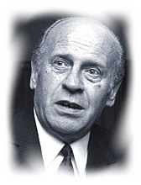[**Oscar Schindler**](http://www.oskarschindler.com/)

This is the true story of one remarkable man who outwitted [Hitler's](http://www.shoah.dk/Hitler/) SS men to save more Jews from the gas chambers than any other single person during World War II.  
  
Oscar Schindler surfaced from the chaos of madness, spent millions bribing and paying off the Nazis and eventually risked his life to rescue the Schindler-Jews in the shadow of Auschwitz.  
  
Today his name is known to millions as a household word for courage in a world of brutality - the flawed hero who saved hundreds of Jews from Hitler's gas chambers. A saint walking through hell.  
  
No one will ever know exactly what made this complex man do what no German had the courage to do. A large part of the fascination of Schindler is that not even those who admire him most can figure out his motives.  
  
But Oscar Schindler rose to the highest level of humanity and gave his Jews a second chance at life. He earned the everlasting gratitude of his Schindler Jews. No matter ***why***, no matter that he was an alcoholic and a shameless womanisor of the worst sort - what matters to his Jews is that he surfaced from the chaos of madness and risked everything for them.  
  
To more than 1200 Jews Schindler was all that stood between them and death at the hands of the Nazis. But he remained true to his Jews, the workers he referred to as *my children*. In the shadow of [Auschwitz](http://www.auschwitz.dk/) he kept the SS out and everyone alive.  
  
Today there are 7,000 descendants of Schindler's Jews living in US and Europe, and many in Israel. Before the Second World War, the Jewish population of Poland was 3.5 million. Today there are between 3,000 and 4,000 left.  
  
Here you find Schindler Jews sharing memories of their unlikely savior - stories to bear witness to goodness, love and compassion. To serve as eulogy to the millions with a yellow star who lived and died during the dark years of the Nazi genocide.  
  
Generations will remember Oscar Schindler for what he did ..  
  
*- Louis Bülow*

<http://www.oskarschindler.net/>

|  |
| --- |
| **SIMON WIESENTHAL** 1908-2005  At the end of World War II, thousands of Nazis who participated in the systematic murder of some 6,000,000 Jews and millions of Gypsies, Poles and other "inferior" peoples, slipped through the Allied net and escaped to countries around the globe, where many still live in freedom.  Simon Wiesenthal, a survivor of the Nazi death camps, dedicated his life to documenting the crimes of the Holocaust and to hunting down the perpetrators still at large. "When history looks back," Wiesenthal explained, "I want people to know the Nazis weren’t able to kill millions of people and get away with it." His work stands as a reminder and a warning for future generations.  As founder and head of the Jewish Documentation Center in Vienna, the freelance Nazi hunter, usually with the cooperation of the Israeli, Austrian, former West German and other governments, ferreted out nearly 1,100 Nazi war criminals, including Adolf Eichmann, the administrator of the slaughter of the Jews; Franz Murer, "The Butcher of Wilno," and Erich Rajakowitsch, in charge of the "death transports" in Holland. Accounts of his grim sleuthing are detailed in his memoirs, The Murderers Among Us (1967). His other books include, Sails of Hope (1973), Sunflower (1970), Max and Helen" (1982), Krystyna (1987), Every Day Remembrance Day (1987), and Justice Not Vengeance (1989). In 1989, a film based on Mr. Wiesenthal’s life entitled, Murderers Among Us: The Simon Wiesenthal Story was produced by Home Box Office and starred Academy Award-winning actor Ben Kingsley as Simon Wiesenthal.  Simon Wiesenthal was born on December 31, 1908 in Buczacz, in what is now the Lvov Oblast section of the Ukraine. When Wiesenthal's father was killed in World War I, Mrs. Wiesenthal took her family and fled to Vienna for a brief period, returning to Buczacz when she remarried. The young Wiesenthal graduated from the Gymnasium in 1928 and applied for admission to the Polytechnic Institute in Lvov. Turned away because of quota restrictions on Jewish students, he went instead to the Technical University of Prague, from which he received his degree in architectural engineering in 1932.  In 1936, Simon married Cyla Mueller and worked in an architectural office in Lvov. Their life together was happy until 1939 when Germany and Russia signed their "non-aggression" pact and agreed to partition Poland between them; the Russian army soon occupied Lvov, and shortly afterward began the Red purge of Jewish merchants, factory owners and other professionals. In the purge of "bourgeois" elements that followed the Soviet occupation of Lvov Oblast at the beginning of World War II, Wiesenthal's stepfather was arrested by the NKVD (People's Commissariat of Internal Affairs - Soviet Secret Police) and eventually died in prison, his stepbrother was shot, and Wiesenthal himself, forced to close his business, became a mechanic in a bedspring factory. Later he saved himself, his wife, and his mother from deportation to Siberia by bribing an NKVD commissar. When the Germans displaced the Russians in 1941, a former employee of his, then serving the collaborationist Ukrainian Auxiliary police, helped him to escape execution by the Nazis. But he did not escape incarceration. Following initial detention in the Janowska concentration camp just outside Lvov, he and his wife were assigned to the forced labor camp serving the Ostbahn Works, the repair shop for Lvov's Eastern Railroad.  Early in 1942, the Nazi hierarchy formally decided on the "Final Solution" to the "Jewish problem" -- annihilation. Throughout occupied Europe a terrifying genocide machine was put into operation. In August 1942, Wiesenthal's mother was sent to the Belzec death camp. By September, most of his and his wife's relatives were dead; a total of eighty-nine members of both families perished.  Because his wife's blonde hair gave her a chance of passing as an "Aryan," Wiesenthal made a deal with the Polish underground. In return for detailed charts of railroad junction points made by him for use by saboteurs, his wife was provided with false papers identifying her as "Irene Kowalska," a Pole, and spirited out of the camp in the autumn of 1942. She lived in Warsaw for two years and then worked in the Rhineland as a forced laborer, without her true identity ever being discovered.  With the help of the deputy director, Wiesenthal himself escaped the Ostbahn camp in October 1943, just before the Germans began liquidating all the inmates. In June 1944, he was recaptured and sent back to Janowska where he would almost certainly have been killed had the German eastern front not collapsed under the advancing Red Army. Knowing they would be sent into combat if they had no prisoners to justify their rear-echelon assignment, the SS guards at Janowska decided to keep the few remaining inmates alive. With 34 prisoners out of an original 149,000, the 200 guards joined the general retreat westward, picking up the entire population of the village of Chelmiec along the way to adjust the prisoner-guard ratio.  Very few of the prisoners survived the westward trek through Plaszow, Gross-Rosen and Buchenwald, which ended at Mauthausen in upper Austria. Weighing less than 100 pounds and lying helplessly in a barracks where the stench was so strong that even hardboiled SS guards would not enter, Wiesenthal was barely alive when Mauthausen was liberated by the 11th Armored Division of the Third U.S. Army on May 5, 1945.  As soon as his health was sufficiently restored, Wiesenthal began gathering and preparing evidence on Nazi atrocities for the War Crimes Section of the United States Army. After the war, he also worked for the Army's Office of Strategic Services and Counter-Intelligence Corps and headed the Jewish Central Committee of the United States Zone of Austria, a relief and welfare organization. Late in 1945, he and his wife, each of whom had believed the other to be dead, were reunited, and in 1946, their daughter Pauline was born.  The evidence supplied by Wiesenthal was utilized in the American zone war crime trials. When his association with the United States Army ended in 1947, Wiesenthal and thirty volunteers opened the Jewish Historical Documentation Center in Linz, Austria, for the purpose of assembling evidence for future trials. But, as the Cold War between the United States and the Soviet Union intensified, both sides lost interest in prosecuting Germans, and Wiesenthal's volunteers, succumbing to frustration, drifted away to more ordinary pursuits. In 1954, the office in Linz was closed and its files were given to the Yad Vashem Archives in Israel, except for one - the dossier on Adolf Eichmann, the inconspicuous technocrat who, as chief of the Gestapo's Jewish Department, had supervised the implementation of the "Final Solution."  While continuing his salaried relief and welfare work, including the running of an occupational training school for Hungarian and other Iron Curtain refugees, Wiesenthal never relaxed in his pursuit of the elusive Eichmann who had disappeared at the time of Germany's defeat in World War II. In 1953, Wiesenthal received information that Eichmann was in Argentina from people who had spoken to him there. He passed this information on to Israel through the Israeli embassy in Vienna and in 1954 also informed Nahum Goldmann, but the FBI had received information that Eichmann was in Damascus, Syria. It was not until 1959 that Israel was informed by Germany that Eichmann was in Buenos Aires living under the alias of Ricardo Klement. He was captured there by Israeli agents and brought to Israel for trial. Eichmann was found guilty of mass murder and executed on May 31, 1961.  Encouraged by the capture of Eichmann, Wiesenthal reopened the Jewish Documentation Center, this time in Vienna, and concentrated exclusively on the hunting of war criminals. One of his high priority cases was Karl Silberbauer, the Gestapo officer who arrested Anne Frank, the fourteen year-old German-Jewish girl who was murdered by the Nazis after hiding in an Amsterdam attic for two years. Dutch neo-Nazi propagandists were fairly successful in their attempts to discredit the authenticity of Anne Frank's famous diary until Wiesenthal located Silberbauer, then a police inspector in Austria, in 1963. "Yes," Silberbauer confessed, when confronted, "I arrested Anne Frank."  In October 1966, sixteen SS officers, nine of them found by Wiesenthal, went on trial in Stuttgart, West Germany, for participation in the extermination of Jews in Lvov. High on Wiesenthal's most-wanted list was Franz Stangl, the commandant of the Treblinka and Sobibor concentration camps in Poland. After three years of patient undercover work by Wiesenthal, Stangl was located in Brazil and remanded to West Germany for imprisonment in 1967. He was sentenced to life imprisonment and died in prison.  Wiesenthal's book of memoirs, The Murderers Among Us, was published in 1967. During a visit to the United States to promote the book, Wiesenthal announced that he had found Mrs. Hermine Ryan, nee Braunsteiner, a housewife living in Queens, New York. According to the dossier, Mrs. Ryan had supervised the killings of several hundred children at Majdanek. She was extradited to Germany for trial as a war criminal in 1973 and received life imprisonment.  The Jewish Documentation Center in Vienna was a nondescript, sparsely furnished three-room office with a staff of four, including Wiesenthal. Contrary to belief, Wiesenthal did not usually track down the Nazi fugitives himself. His chief task was gathering and analyzing information. In that work he was aided by a vast, informal, international network of friends, colleagues, and sympathizers, including German World War II veterans, appalled by the horrors they witnessed. He even received tips from former Nazis with grudges against other former Nazis. A special branch of his Vienna office documented the activities of right-wing groups, neo-Nazis and similar organizations.  Painstakingly, Wiesenthal culled every pertinent document and record he got and listened to the many personal accounts told him by individual survivors. With an architect's structural acumen, a Talmudist's thoroughness, and a brilliant talent for investigative thinking, he pieced together the most obscure, incomplete, and apparently irrelevant and unconnected data to build cases solid enough to stand up in a court of law. The dossiers were then presented to the appropriate authorities. When, as often happens, they failed to take action, whether from indifference, pro-Nazi sentiment, or some other consideration, Wiesenthal went to the press and other media, for experience taught him that publicity and an outraged public opinion are powerful weapons.  The work yet to be done was enormous. Germany’s war criminal files contained more than 90,000 names, most of them of people who have never been tried. Thousands of former Nazis, not named in any files, are also known to be at large, often in positions of prominence, throughout Germany. Aside from the cases themselves, there is the tremendous task of persuading authorities and the public that the Nazi Holocaust was massive and pervasive. In the final paragraph of his memoirs, he quotes what an SS corporal told him in 1944: "You would tell the truth [about the death camps] to the people in America. That's right. And you know what would happen, Wiesenthal? They wouldn't believe you. They’d say you were mad. Might even put you into an asylum. How can anyone believe this terrible business - unless he has lived through it?"  Among Mr. Wiesenthal's many honors include an Honorary Knighthood of the British Empire from Queen Elizabeth II of Great Britain, the Presidential Medal of Freedom from President Clinton, decorations from the Austrian and French resistance movements, the Dutch Freedom Medal, the Luxembourg Freedom Medal, the United Nations League for the Help of Refugees Award, the U.S. Congressional Gold Medal presented to him by President Jimmy Carter in 1980, and the French Legion of Honor which he received in 1986. Wiesenthal was a consultant for the motion picture thriller, The Odessa File(Paramount, 1974). The Boys from Brazil (Twentieth Century Fox, 1978), a major motion picture based on Ira Levin's book of the same name, starring Sir Laurence Olivier as Herr Lieberman, a character styled after Wiesenthal.  In November 1977, the Simon Wiesenthal Center was founded. Today, together with its world renowned Museum of Tolerance in Los Angeles and the New York Tolerancenter, it is an international center for Holocaust remembrance, the defense of human rights and the Jewish people. With offices throughout the world, the Wiesenthal Center carries on the continuing fight against bigotry and antisemitism and pursues an active agenda of related contemporary issues. "I have received many honors in my lifetime," said Mr. Wiesenthal. "When I die, these honors will die with me. But the Simon Wiesenthal Center will live on as my legacy."  In 1981, the Wiesenthal Center produced the Academy AwardTM-winning documentary, Genocide, narrated by Elizabeth Taylor and the late Orson Welles, and introduced by Simon Wiesenthal.  Wiesenthal lived in a modest apartment in Vienna and spent his evenings answering letters, studying books and files, and working on his stamp collection. He lived there with his wife Cyla until her death on November 10, 2003.  Simon Wiesenthal received numerous anonymous threats and insulting letters. In June 1982, a bomb exploded at the front door of his house causing a great deal of damage. Fortunately, no one was hurt. After that, his house and office were guarded by an armed policeman. One German and several Austrian neo-Nazis were arrested for the bombing. The German, who was found to be the main perpetrator, was sentenced to five years in prison.  Wiesenthal was often asked to explain his motives for becoming a Nazi hunter. According to Clyde Farnsworth in the New York Times Magazine (February 2, 1964), Wiesenthal once spent the Sabbath at the home of a former Mauthausen inmate, now a well-to-do jewelry manufacturer. After dinner his host said, "Simon, if you had gone back to building houses, you'd be a millionaire. Why didn't you?" "You're a religious man," replied Wiesenthal. "You believe in God and life after death. I also believe. When we come to the other world and meet the millions of Jews who died in the camps and they ask us, ‘What have you done?,’ there will be many answers. You will say, ‘I became a jeweler,’ Another will say, ‘I have smuggled coffee and American cigarettes,’ Another will say, ‘I built houses,’ But I will say, ‘I did not forget you’."  On September 20, 2005, Simon Wiesenthal died peacefully in his sleep at his home. After a service at Vienna’s Central Cemetery attended by Austrian Prime Minister Wolfgang Schuessel, government officials, diplomats and leaders of religious communities, he was taken to Israel and laid to rest in Herzliya.  In his eulogy, Rabbi Marvin Hier, founder and dean of the Simon Wiesenthal Center said, "As you go to your eternal repose, I am sure there is a great stirring in heaven as the soul of the millions murdered during the Nazi Holocaust get ready to welcome Simon Wiesenthal, the man who stood up for their honor and never let the world forget them." |

<http://www.wiesenthal.com/site/pp.asp?c=lsKWLbPJLnF&b=4441293#.U_Z7lfldWSo>

**NAZI HUNTING: SIMON WIESENTHAL**

“When history looks back I want people to know the Nazis weren't able to kill millions of people and get away with it.”  
—*Simon Wiesenthal*

Simon Wiesenthal, a Holocaust survivor, dedicated his life to raising public awareness of the need to hunt and prosecute Nazis who have evaded justice.

After liberation, Wiesenthal worked for the War Crimes Section of the United States Army, and in 1947 he opened the Jewish Historical Documentation Center in Austria. For decades, Wiesenthal pressured Western governments to locate and prosecute escaped Nazi offenders and also offered leads that sometimes led to their extradition. Among those about whom Wiesenthal provided leads for war crimes investigators were Adolf Eichmann, administrator of the “Final Solution”; Franz Stangl, commandant of the Sobibor and Treblinka killing centers; and Karl Silberbauer, the Gestapo (German Secret State Police) agent who led the arrest of Anne Frank and her family. Wiesenthal also provided information prompting the discovery that Hermine Braunsteiner Ryan, a former concentration camp guard, was living in New York as an unassuming housewife. Braunsteiner Ryan was the first Nazi criminal to be extradited from the US.

Wiesenthal's tenacity and unflagging passion for tracking down perpetrators inspired survivors of the Holocaust and other genocides to believe that justice can and will prevail, even with the passage of time. He died in September 2005 after a lifetime of vocal activism.

<http://www.ushmm.org/wlc/en/article.php?ModuleId=10007151>

Nazi Hunting

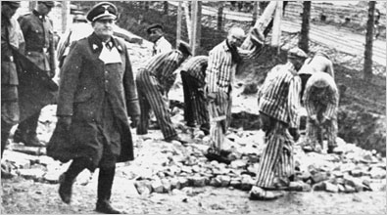

Courtesy of the United States Holocaust Memorial Museum

In the years immediately after World War II, the four Allied powers that occupied Germany -- the United States, Great Britain, France, and the Soviet Union -- resolved to prosecute those individuals responsible for crimes committed against civilian populations under Adolf Hitler's Nazi regime. Trials were held in domestic and international courts, the most notable of which were the 1945-46 hearings at the International Military Tribunal (IMT) in Nuremberg, Germany.

Although many civilian and military leaders were apprehended and brought to justice in the years after the war, many more suspected of Nazi-era war crimes remained at large. Private groups, some led by Holocaust survivors, took it upon themselves to track down Nazi-era war criminals. The 1960 capture of Adolf Eichmann, often referred to as the "architect of the Holocaust," by two Israeli-backed groups was the most notable case.

Simon Wiesenthal, a survivor of the Mauthausen concentration camp, had been instrumental in tracking down Eichmann, and devoted the rest of his life to pursuing other Nazi-era war criminals and persuading governments to do the same.

In 1979, the United States created the Office of Special Investigations (O.S.I.) within the Department of Justice, giving it the mission of pursuing, investigating and prosecuting any U.S. citizen or resident linked to acts of persecution on behalf of Nazi Germany or its Axis allies. Under civil immigration laws, the O.S.I. seeks to denaturalize individuals who have obtained United States citizenship and ultimately to remove or extradite them to countries where they might stand trial for their crimes. As of 2008, the O.S.I. had successfully prosecuted 107 people linked to Nazi-era war crimes. <http://topics.nytimes.com/top/reference/timestopics/subjects/n/nazi_hunting/index.html>

EINSATZGRUPPEN (MOBILE KILLING UNITS)

[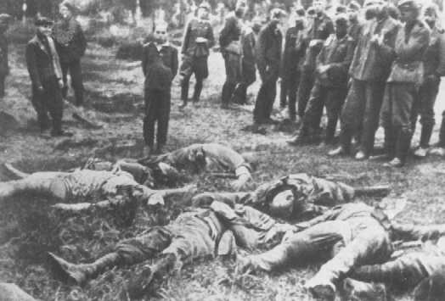](http://www.ushmm.org/wlc/en/media_ph.php?ModuleId=10005130&MediaId=3140)

Members of an Einsatzkommando (mobile killing squad) before shooting a Jewish youth. The boy's murdered family lies in front of him; the men to the left are ethnic Germans aiding the squad. Slarow, Soviet Union, July 4, 1941.

*— Dokumentationsarchiv des Oesterreichischen Widerstandes*

Einsatzgruppen (in this context, mobile killing units) were squads composed primarily of German [SS](http://www.ushmm.org/wlc/en/article.php?ModuleId=10007393) and police personnel. Under the command of the German Security Police (Sicherheitspolizei; Sipo) and Security Service (Sicherheitsdienst; SD) officers, the Einsatzgruppen had among their tasks the murder of those perceived to be racial or political enemies found behind German combat lines in the occupied Soviet Union.

These victims included Jews, Roma (Gypsies), and officials of the Soviet state and the Soviet Communist party. The Einsatzgruppen also murdered thousands of residents of institutions for the mentally and physically disabled. Many scholars believe that the systematic killing of Jews in the occupied Soviet Union by Einsatzgruppen and Order Police (Ordnungspolizei) battalions was the first step of the ["Final Solution,"](http://www.ushmm.org/wlc/en/article.php?ModuleId=10005151) the Nazi program to murder all European Jews.

During the [invasion of the Soviet Union](http://www.ushmm.org/wlc/en/article.php?ModuleId=10005164) in June 1941, the Einsatzgruppen followed the German army as it advanced deep into Soviet territory. The Einsatzgruppen, often drawing on local civilian and police support, carried out mass-murder operations. In contrast to the methods later instituted of deporting Jews from their own towns and cities or from [ghetto](http://www.ushmm.org/wlc/en/article.php?ModuleId=10005059)settings to [killing centers](http://www.ushmm.org/wlc/en/article.php?ModuleId=10005145), Einsatzgruppen came directly to the home communities of Jews and massacred them.

[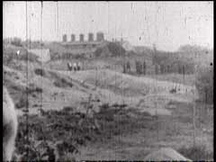](http://www.ushmm.org/wlc/en/media_fi.php?ModuleId=10005130&MediaId=183)The German army provided logistical support to the Einsatzgruppen, including supplies, transportation, housing, and occasionally manpower in the form of units to guard and transport prisoners. At first the Einsatzgruppen shot primarily Jewish men. By late summer 1941, however, wherever the Einsatzgruppen went, they shot Jewish men, women, and [children](http://www.ushmm.org/wlc/en/article.php?ModuleId=10005142)without regard for age or sex, and buried them in mass graves. Often with the help of local informants and interpreters, Jews in a given locality were identified and taken to collection points. Thereafter they were marched or transported by truck to the execution site, where trenches had been prepared. In some cases the captive victims had to dig their own graves. After the victims had handed over their valuables and undressed, men, women, and children were shot, either standing before the open trench, or lying face down in the prepared pit.

Shooting was the most common form of killing used by the Einsatzgruppen. Yet in the late summer of 1941, Heinrich Himmler, noting the psychological burden that mass shootings produced on his men, requested that a more convenient mode of killing be developed. The result was the gas van, a mobile gas chamber surmounted on the chassis of a cargo truck which employed carbon monoxide from the truck's exhaust to kill its victims. Gas vans made their first appearance on the eastern front in late fall 1941, and were eventually utilized, along with shooting, to murder Jews and other victims in most areas where the Einsatzgruppen operated.

[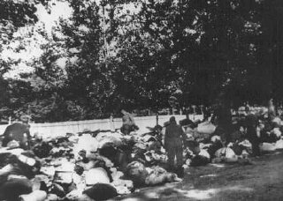](http://www.ushmm.org/wlc/en/gallery.php?ModuleId=10005130&MediaType=PH)The Einsatzgruppen following the German army into the Soviet Union were composed of four battalion-sized operational groups. Einsatzgruppe A fanned out from East Prussia across Lithuania, Latvia, and Estonia toward Leningrad (now St. Petersburg). It massacred Jews in [Kovno](http://www.ushmm.org/wlc/en/article.php?ModuleId=10005174), [Riga](http://www.ushmm.org/wlc/en/article.php?ModuleId=10005463), and [Vilna](http://www.ushmm.org/wlc/en/article.php?ModuleId=10005173). Einsatzgruppe B started from [Warsaw](http://www.ushmm.org/wlc/en/article.php?ModuleId=10005069) in occupied Poland, and fanned out across Belorussia toward Smolensk and [Minsk](http://www.ushmm.org/wlc/en/article.php?ModuleId=10005187), massacring Jews in Grodno, Minsk, Brest-Litovsk, Slonim, Gomel, and Mogilev, among other places. Einsatzgruppe C began operations from[Krakow](http://www.ushmm.org/wlc/en/article.php?ModuleId=10005169) (Cracow) and fanned out across the western Ukraine toward Kharkov and Rostov-on-Don. Its personnel directed massacres in [Lvov](http://www.ushmm.org/wlc/en/article.php?ModuleId=10005171), Tarnopol, Zolochev, Kremenets, Kharkov, Zhitomir, and Kiev, where famously in two days in late September 1941 units of Einsatzgruppe detachment 4a massacred 33,771 Kiev Jews in the ravine at [Babi Yar](http://www.ushmm.org/wlc/en/article.php?ModuleId=10005421). Of the four units, Einsatzgruppe D operated farthest south. Its personnel carried out massacres in the southern Ukraine and the Crimea, especially in Nikolayev, Kherson, Simferopol, Sevastopol, Feodosiya, and in the Krasnodar region.

The Einsatzgruppen received much assistance from German and Axis soldiers, local [collaborators](http://www.ushmm.org/wlc/en/article.php?ModuleId=10005466), and other SS units. Einsatzgruppen members were drawn from the [SS](http://www.ushmm.org/wlc/en/article.php?ModuleId=10007403), [Waffen SS](http://www.ushmm.org/wlc/en/article.php?ModuleId=10007405)(military formations of the SS), SD, Sipo, Order Police, and other police units.

By the spring of 1943, the Einsatzgruppen and Order Police battalions had killed over a million Soviet Jews and tens of thousands of Soviet political commissars, partisans, Roma, and institutionalized disabled persons. The mobile killing methods, particularly shooting, proved to be inefficient and psychologically burdensome to the killers. Even as Einsatzgruppen units carried out their operations, the German authorities planned and began construction of special stationary [gassing facilities](http://www.ushmm.org/wlc/en/article.php?ModuleId=10005220) at centralized killing centers in order to murder vast numbers of Jews.

<http://www.ushmm.org/wlc/en/article.php?ModuleId=10005130>

*an essay by*[*Yale F. Edeiken*](mailto:yawen@enter.net?Subject=Einsatzgruppen)

Like every historical event, the Holocaust evokes certain specific images. When the Holocaust is mentioned most people immediately think of the concentration camps. They immediately envision emaciated victims in dirty striped uniforms staring incomprehensibly at their liberators or piles of corpses, too numerous to bury individually, being bulldozed into mass graves.

Those are accurate images. Those horrific scenes are real. They happened. But they are not all of the Holocaust. They are merely the end product of the systematization of the genocide committed by the Third Reich. The reality of that genocide began not in the camps or in the gas chambers but with four small groups of murderers known as the Einsatzgruppen formed by Himmler and Heydrich immediately before the invasion of the Soviet Union. They operated in the territories captured by the German armies during the invasion of the Soviet Union and, with the cooperation of German army units and local militias, murdered over a million men, women, and children. It was a story that did not end until 1952 when Otto Ohlendorf, the last surviving commander of an Einsatzgruppe (Einsatzgruppe D), climbed the steps of the gallows to pay for the more than 90,000 murders his command committed.

**The Einsatzgruppen**

The Einsatzgruppen were four paramilitary units established before the invasion of the Soviet Union for the purpose of "liquidating" (murdering) Jews, Romany, and political operatives of the Communist party. Ultimately three of these groups (Einsatzgruppen A, B. and C) were attached to army groups taking part in the invasion. A fourth group (Einsatzgruppe D) was sent to the Ukraine without being attached to any army group. All operated in the territories occupied by the Third Reich on the eastern front. Most of the crimes perpetrated by the Eisnsatzgruppen took place in the Ukraine and the Baltic states of Latvia, Estonia and Lithuania.

After negotiations with the German army conducted between Eduard Wagner, the Quartermaster of the Army, and Heydrich, it was agreed that in the front lines the Einsatzgruppen would be under army control but that in the operations area and in the rear areas the army's authority would not extend beyond tactical matters. (Harris, p. 176-7, IMT III, 246,290) Ohlendorf was one of the particiants at ths meeting. In effect the Einsatzgruppen were almost always operationally independent taking their orders directly from Heinrich Himmler and, until his death, Reinhard Heydrich. While there were plans to establish similar units in other territories controlled by the Nazis (Ohlendorf; Nuremberg testimony), these plans were never implemented.

This was not the first time that "Einsatzgruppen" were used by the Third Reich. During the invasion of Poland in 1939, similar units, also known as "Einsatzgruppen" accompanied the invading armies and performed similar tasks such as the arrest or "liquidation" of priests and other Polish intelligentsia. They were not, however, given a task of mass murder like that carried out by the Einsatzgruppen during the invasion of the Soviet Union. The Einsatzgruppen who took part in the invasion of the Soviet Union were new units, formed and trained immediately before that invasion with no organizational history connecting them to the Einsatzgruppen that existed during the invasion of Poland.

**The Purpose of the Einsatzgruppen**

The most succinct description of the purpose of the Einsatzgruppen was given at the trial of Adolph Eichmann by Dr. Michael Musmanno, Justice of the Pennsylvania Supreme Court, who presided over the trial of 23 of the leaders of the Einsatzgruppen. He stated "The purpose of the Einsatzgruppen was to murder Jews and deprive them of their property." SS General Erich von dem Bach-Zelewski confirmed this at the main Nuremberg Trial when he testified that "The principal task [of the Einsatzgruppen] was the annihilation of the Jews, gypsies, and political commissars." (Taylor, Anatomy, p. 259)

The Einsatzgruppen were given orders directly by Himmler and Heydrich on several occasions. There were at least two meetings of the leaders of the Einsatzgruppen in June, 1941 in which they were briefed as to their duties. In a third meeting, which probably took place on June 22, 1941, Heydrich briefed the commanders on the plans for their operations. Otto Ohlendorf, commander of Einsatzgruppe D and a close associate of Himmler, confirmed these orders when he testified at the Nuremberg Trial:

COL. AMEN: Did you have any other conversations with Himmler concerning this Order?

OHLENDORF: Yes, in late summer of 1941 Himmler was in Nikolaiev. He assembled the leaders and the men of the Einsatzkommandos, repeated to them the liquidation order, and pointed out that the leaders and men who were taking part in the liquidation bore no responsibility for the execution of this order. The responsibility was his, alone, and the Fuhrer's.

COL. AMEN: And you yourself heard that said?

OHLENDORF: Yes.

Tracing the process by which the orders of the Einsatzgruppen to eliminate the Jews in the captured territories were developed is difficult. The process seems to have begun in March, 1941, while the plans for Operation Barbarossa (the invasion of the Soviet Union ordered by Hitler on December 18, 1940) were being made.

The decision to use units from the SD (security services) to perform special political actions was made early in the planning stages of the invasion. On March 13, 1941, Gen. Keitel, the commander of the OKW, issued a supplement to Barbarossa which discussed special tasks, independent of the military needs of the invasion, that would be supervised by Himmler. Keitel wrote:

"In the theater of operations of the Army, the Reichsfuehrer-SS has special assignments from the Fuehrer for the preparation of the political administration, which special assignments result from the final and decisive struggle between two opposed political systems. In the conduct of these assignments, the Reichsfuehrer-SS acts independently and on his own authority.

*   *   *

"At the beginning of the operations, the German-Soviet Russian border is to be closed to non-military personnel traffic, with the exception of the police units to be deployed by the Reichsfuehrer-SS on order of the Fuehrer."

*"Hitlers Weisungen fuer die Kreigfuehrung" [Hitler's Directives for the Conduct of the War], edited by Walther Hubatsch, Deutscher Taschenbuch Verlag, Frankfurt am main, 1962, pp. 102-3, translation by Gord McFee.*

The initial policy was orally communicated to the officers of the Einsatzgruppen. They were later embodied in the "Commissar Order" issued by Heydrich Himmler and never revoked. (Harris, 241) The Commisar Order issued on July 17, 1941, called for "the separation and further treatment of . . . . all Jews." (TMWC IV 258-9)

**The Composition of the Einsatzgruppen**

There were approximately 600 to 1000 men in each Einsatzgruppe, although many were support staff. The active members of the Einsatzgruppen were drawn from various military and non-military organizations of the Third Reich. The bulk of the members were drawn from the Waffen-SS, the military arm of the SS. In Einsatzgruppen A, for example, the breakdown of active members was:

|  |  |  |
| --- | --- | --- |
| Waffen-SS: |  | 340 |
| Gestapo: |  | 89 |
| SD (security service): |  | 35 |
| Order Police: |  | 133 |
| Kripo: |  | 41 |
| *(Taylor, Anatomy, p. 510.)* | | |

Each of the Einsatzgruppen were further broken down into operational subunits known as Einsatzkommandos or Sonderkommandos.

**The Victims of the Einsatzgruppen**

The overwhelming proportion of the men, women, and children murdered by the Einsatzgruppen were Jews. The Einsatzgruppen also murdered Romany (gypsies), those identified as functionaries of the Communist Party, those accused of defying the occupying armies of the Third Reich, and those accused of being partisans or guerilla fighters against the invading armies. In all cases the murders were contrary to accepted law.

Although an exact figure will never be known, approximately 1,500,000 people were murdered by the Einsatzgruppen. The Einsatzgruppen submitted detailed and specific reports of their actions to their superiors both by radio and written communication; these reports were checked against each other for accuracy at Heydrich's headquarters. According to those reports approximately 1,500,000 people were murdered. In evaluating this large number Justice Michael Musmanno, who presided at the trial of the Einsatzgruppen wrote:

One million human corpses is a concept too bizarre and too fantastical for normal mental comprehension. As suggested before, the mention of one million deaths produces no shock at all commensurate with its enormity because to the average brain one million is more a symbol than a quantitative measure. However, if one reads through the reports of the Einsatzgruppen and observes the small numbers getting larger, climbing into ten thousand, tens of thousands, a hundred thousand and beyond, then one can at last believe that this actually happened -- the cold-blooded, premeditated killing of one million human beings.

**The Crimes of the Einsatzgruppen**

As Justice Musmanno stated the Einsatzgruppen murdered over well over a million men, women, and children and stole their property. The only possible interpretation of the reports that the Einsatzgruppen made to Heydrich is that the majority of those men, women, and children were murdered and robbed because they were Jewish. There is no other reason evident from the reports or the defenses that were presented at the various trials.

One of the most notable of these reports is the "Jaeger Report" which details the murders committed by Einsatzkommandos 8 and 3, attached to Einsatzgruppe A in the Vilna-Kaunas area of Lithuania from July 4, 1941 through November 25, 1941. This lengthy report describes the murder of over 130,000 people in that short period of time. This report consists of six sheets listing the murders of Einsatzkommandos 8 and 3 and concluding: "Today I can confirm that our objective, to solve the Jewish problem for Lithuania, has been achieved by EK 3. In Lithuania there are no more Jews, apart from Jewish workers and their families." Most of the report consists of entries such as:

|  |  |  |
| --- | --- | --- |
| 29.10.41 | Kauen-F.IX | 2,007 Jews, 2,290 Jewesses, 4,273 Jewish children (mopping up ghetto of superfluous Jews) |
| 3.11.41 | Lazdjai | 485 Jews, 511 Jewesses, 539 Jewish children |
| 15.11.41 | Wilkowski | 36 Jews, 48 Jewesses, 31 Jewish children |
| 25.11.41 | Kauen-F.IX | 1.159 Jews, 1,600 Jewesses, 175 Jewish children (resettlers from Berlin, Munich, and Frankfurt am main) |
| *Jaeger report Sheet 5, which contains 11 such entries.* | | |

The reports also give detailed information about the money and other valuables stolen from the victims. The scope of these activities is illustrated by "Operational Report No. 73" dated September 4, 1941 (NO-2844) and "Operational Report No. 133" dated November 14, 1941 (NO-2825). Both of these reports describe the activities of Einsatzkommando 8, a subunit of one of the Einsatzgruppen. The first of these reports states "On the occasion of a purge at Tsherwon 125,880 rubels were found on 139 liquidated Jews and were confiscated. This brings the total of the money confiscated by Einsatzkommando 8 to 1,510,399 rubels." Two months later the same sub-unit was able to report that they had stolen an additional million rubels: "During the period covered by this report, Einsatzkommando 8 confiscated a further 491,705 rubles as well as 15 gold rubles. They were entered into the ledgers and passed to the Administration of Einsatzkommando 8. The total amount of rubels so far secured by Einsatzkommando 8 now amounts to 2,511,226 rubels."

Nor was this thievery limited to their victim's money. Watches, jewelry and even clothing were even plundered. One particularly callous act of murder was described by Justice Musmanno in his decision:

One of the defendants related how during the winter of 1941 he was ordered to obtain fur coats for his men, and that since the Jews had so much winter clothing, it would not matter so much to them if they gave up a few fur coats. In describing the execution which he attended, the defendant was asked whether the victims were undressed before the execution, he replied: "No, the clothing wasn't taken -- this was a fur coat procurement operation."

*Judgment, p. 36.*

**Other Participants**

The Einsatzgruppen did not act alone. They had help. The Einsatzgruppen could call on the Wehrmacht for assistance but far more important were local militia groups willing to cooperate in the massacres. At Babi Yar where 33,771 Jews were murdered on September 29-30, 1941, there were two Ukrainian "kommandos" assisting Sonderkommando 4a. In Lithuania Operational Report 19 (July 11, 1941) states that "We have retained approximately 205 Lithuanian partisans as a Sonderkommando, sustained them and deployed them for executions as necessary even outside the area." In the Ukraine the Einsatzgruppen frequently welcomed the participation of local militia both because they needed the help of these auxiliaries but because they hoped to involve the locals in the pogrom they were conducting. (Operational Report 81, from Einsatzkommando 6, September 12, 1941)

There are many known instances of these local militias assisting the Einsatzgruppen. During the "Gross Aktion" of October 28-29, 1941, at Kaunas in Lithuania during which 9,200 Jews were murdered, Lithuanian militia worked with the Einsatzgruppen. (100 F.3rd at 308) Other examples are Zhitomir on September 18, 1941, in the Ukraine where 3,145 Jews were murdered with the assistance of Ukrainian militia (Operational Report 106) and Korosten where Ukrainian militia rounded up 238 Jews for liquidation (Operational Report 80). At times the assistance was more active. Operational Report 88, for example, reports that on September 6, 1941, 1,107 Jewish adults were shot while the Ukrainian militia unit assisting them liquidated 561 Jewish children and youths.

In many cases the militia that assisted the Einsatzgruppen were paid from the money and valuables stolen from the victims.

**The Victims of the Murders Were Not Partisans**

The reports and the testimony at the various trials tell us that any claim the Einsatzgruppen were dealing with "partisans" is a misrepresentation of history.

Erich von dem Bach-Zelewski -- the SS general (his rank was equivalent to the U.S. rank of lieutenant general) in charge of all anti-partisan warfare on the eastern front -- was a witness before the IMT at Nuremberg. Not only did he testify that the purpose of the Einsatzgruppen was the "annihilation" of Jews, Romany, and Communist political operatives but that the Einsatzgruppen were not involved in antipartisan activity. When asked which units were used for antipartisan activity, he responded: "For antipartisan activities formations of the Waffen-SS, of the Ordungspolizei [regular "order keeping" police], and, above all, of the Wehrmacht were used." (Taylor, Anatomy, p. 259) The reports of the Einsatzgruppen are consistent with Bach-Zelewski's testimony. In most of the murder victims are described by class and actions against partisans are specifically described. In all cases "partisans" and "Communists" are listed separately from "Jews."

Many of the reports detail the victims by age and sex. We can see from these entries that a majority of the victims were women and children. It is obvious that a report of the murder of "2,007 Jews; 2,920 Jewesses, 4,273 Jewish children (mopping up ghetto of superfluous Jews)" on October 29, 1941 or "1,159 Jews, 1,600 Jewesses, 175 Jewish children (resettlers from Berlin, Munich, and Frankfurt am main)" [Jaeger Report; sheet 5] cannot accurately be characterized as describing "partisans."

When put on trial for his life Otto Ohlendorf, Commander of Einsatzgruppen D, did not use the excuse that the victims were "partisans." Instead he gave the Court a far different rationalization for the murder of the children:

I believe that it is very simple to explain, if one starts with the fact that this order did not only try to achieve a temporary security (for Germany) but also a permanent security. For that reason, the children were people who would grow up and surely, being the children of parents who had been killed, would constitute a danger no smaller than that of their parents.

When he made this statement Ohlendorf was not speaking just as an individual and a dedicated national socialist; he was repeating the statements of his superior, Heinrich Himmler. Himmler and Ohlendorf were close associates and, in fact, were travelling together when they were captured after the collapse of the Third Reich. In his famous speech to a gathering of SS officers at Posen on October 6, 1943, Himmler made comments remarkably similar to those of Ohlendorf:

We came to the question: what to do with the women and children? I decided to find a clear solution here as well. I did not consider myself justified to exterminate the men -- that is, kill them or allow them to be killed -- and allow the avengers of our sons and grandsons in the form of their children to grow up. The difficult resolve had to be taken to make this race disappear from the earth.

*(Translation by Gord McFee.)*

Another problem with justifying the murders as actions against "partisans" is that Jewish partisan movements did not even exist in the most populous regions until the Einsatzgruppen began murdering Jews. In Lithuania, for example, the Jaeger Report covers the period from July 4, 1941 through November 25, 1941 including what is known as the "Gross Aktion" which was conducted with the help of Lithuanian militia in October, 1941. The Jewish resistance movement did not begin until December 31, 1941, with a manifesto promulgated by Abner Kovner. Prior to that time, Jewish resistance was ruthlessly suppressed by the Jewish leader, Jacob Gens, who went so far as to turn Yitzhak Witenberg, the leading proponent of Jewish resistance, over to the Gestapo. (Hilberg, PVB, page 180-1) Thus, Jewish resistance in Lithuania was, in reality, a reaction to the murders of the Einsatzgruppen.

The reactions of the Jews of Lithuania was not unique. There were similar reactions in many parts of the Ukraine where the majority of the Jews caught up in the German invasion of the Soviet Union lived. In this region, for example, a German inspector reported to the Chief of the Industrial Armament Department:

The attitude of the Jewish population was anxious -- obliging from the beginning. They tried to avoid everything that might displease the German administration. That they hated the German administration and army inwardly goes without saying and cannot be surprising. However, there is no proof that Jewry as a whole or even to a greater part was implicated in acts of sabotage. Surely, there were some terrorists or saboteurs among them just as among the Ukrainians. But is cannot be said that the Jews as such represented a danger to the German armed forces. The output produced by Jews who, of course, were prompted by nothing but the feeling of fear, were satisfactory to the troops and the German administration.

*Exhibit 3257 PS (Einsatzgruppen Trial).*

Finally it should be noted that "partisan" or "guerilla" forces are, under the Hague Convention, to be treated as POWs. Germany was signer of this Convention and the out-of-hand killing of "partisans" is murder.

**The Methods of the Einsatzgruppen**

The Einsatzgruppen shot people. It's as simple as that. Using various pretexts they rounded up their victims, transported them to a central killing ground and shot them.

At Babi Yar the Jews of Kiev were informed by placards posted around the city by Ukrainian militia for Jews to assemble at 8:00 a.m. on September 29, 1941, at a cemetery near a railroad siding for "resettlement." They were told to bring with them food, warm clothing, documents, money, and valuables. (Dawidowicz, What, 103-4). The scene was described by one officer at his trial in 1967. He stated "It was like a mass migration . . . the Jews sang religious songs on the way." At the railroad siding their food and belongings were taken from them and:

Then the Germans began shoving the Jews into new, narrower lines. They moved very slowly. After a long walk, they came to a passageway formed by German soldiers with truncheons and police dogs. The Jews were whipped through. The dogs went at those who fell but the pressure uof the surging lines behind was irresistible, and the weak and injured were trod underfoot.

Bruised and bloodied, numbed by the incomprehensibility of their fate, the Jews emerged onto a grassy clearing. They had arrived at Babi Yar; ahead of them lay the ravine. The ground was strewn with clothing. Ukrainian militiamen, supervised by Germans, ordered the Jews to undress. Those who balked, who resisted, were assaulted, their clothes ripped off. Naked bleeding people were everywhere. Screams and hysterical laughter filled the air.

*Dawidowicz, "What is the Use of Jewish History?" pp. 106-107*

After this brutal processing, the victims were lined up at edge of the ravine and gunned down by teams of machine gunners. By the time they were finished on Spetember 30, 1941, 33,700 people had been killed.

Otto Ohlendorf testified about the methods used both at his own trial and the trial of the leaders of the Third Reich at Nuremberg. At Nuremberg he told the court that Jews were gathered for mass murders "on the pretext that they were to be resettled." He then told the Tribunal: "After the registration the Jews were collected at one place; and from there they were later transported to the place of execution, which was, as a rule, an antitank ditch or natural excavation. The executions were carried out in a military manner, by firing squads under command." Not all of the groups committed their murders with the military precision of Ohlendorf's. As he testified "Some of the unit leaders did not carry out liquidations in the military manner, but killed the victims singly by shooting them in the back of the neck."

After December, 1941, the nazis experimented with vans designed by Dr. Becker using lethal gas, exhaust from the motors. Not only was this method slow but, according to Otto Ohlendorf, it was not popular with his men because "the unloading of the corpses was an unnecessary mental strain." Almost all of the victims of these experiments were women and children and, throughout the Einsatzgruppen's reign of terror, shooting was the primary means of execution.

**The Shooting Was Efficient, But Other Methods Were Tried**

Himmler was a chicken as well as a chicken farmer. In July or August, 1941, Himmler visited Einsatzgruppe B where he witnessed a mass shooting at Minsk. An eyewitness describing what happened during Himmler's visit to Minsk while watched the killing of a group of one hundred Jews:

As the firing started, Himmler became more and more nervous. At each volley, he looked down at the ground .... The other witness was Obergruppenfuehrer von dem Bach-Zelewski...Von dem Bach addressed Himmler: "Reichsfuehrer, those were only a hundred....Look at the eyes of the men in this commando, how deeply shaken they are. Those men are finished ["fertig"] for the rest of their lives. What kind of followers are we training here? Either neurotics or savages."

*Arad, "Belzec, Sobibor, Treblinka", p. 8.*

In reaction to the experience of watching 100 human beings murdered in this fashion, Himmler ordered that a more "humane" method of execution be found. (Reitlinger SS 183) Otto Ohlendorf explained in his testimony at Nuremberg "That was a special order from Himmler to the effect that women and children were not to be exposed to the mental strain of the executions; and thus the men of the kommandos, mostly married men, should not be compelled to aim at women and children."

This order was first implemented with gas vans designed by Dr. Becker. Later the terrible extermination camps, where millions of people were gassed and starved, were established.

The infamous extermination camps were set up shortly after Himmler's visit to Minsk. The first of these was Chelmo which began gassing Jews and others on December 8, 1941. Treblinka, Sobibor, and Majdanek followed in the spring of 1942. Additionally the most famous extermination camp, Auschwitz, began experimenting with Zyclon-B in September, 1941. While mass gassings were conducted at Auschwitz in the spring of 1942, the real work of mass extermination started with the operation of "Bunker 2" on July 4, 1942 (D-VP 305)

<http://www.holocaust-history.org/intro-einsatz/>

**Mengele's Children: The Twins of Auschwitz**

By [Jennifer Rosenberg](http://history1900s.about.com/bio/Jennifer-Rosenberg-7900.htm)

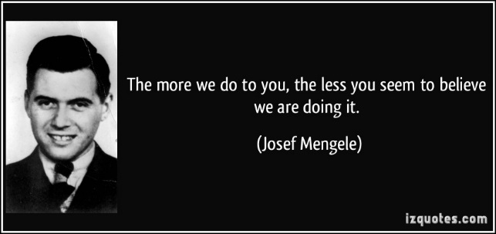The notorious doctor of Auschwitz, [Josef Mengele](http://history1900s.about.com/od/josefmengele/index.htm), has become an enigma of the twentieth century. Mengele's handsome physical appearance, fastidious dress, and calm demeanor greatly contradicted his attraction to murder and gruesome experiments.

Mengele's seeming omnipresence at the ramp as well as his fascination with twins have incited images of a mad, evil monster. His ability to elude capture had increased his notoriety as well as given him a mystical and devious persona.

But in May 1943, Mengele entered [Auschwitz](http://history1900s.about.com/od/holocaust/a/auschwitz.htm) as an educated, experienced, medical researcher. With funding for his experiments, he worked alongside some of the top medical researchers of the time. Anxious to make a name for himself, Mengele searched for the secrets of heredity. The Nazi ideal of the future would benefit from the help of genetics: if Aryan women could assuredly give birth to twins who were sure to be blond and blue eyed - then the future could be saved.

Mengele, as he learned while working for Professor Otmar Freiherr von Vershuer, believed that twins held these secrets. Auschwitz seemed the best location for such research because of the large number of available twins to use as specimens.

**The Ramp**

Mengele took his turn as the selector on the ramp, but unlike most of the other selectors, he arrived sober. With a small flick of his finger or riding crop, a person would either be sent to the left or to the right, to the gas chamber or to hard labor. Mengele would get very excited when finding twins. The other SS who helped unload the transports had been given special instructions to find twins, dwarfs, giants, or anyone else with a unique hereditary trait like a club foot or heterochromia (each eye a different color). Mengele's seeming omnipresence on the ramp stemmed not only from his selection duty, but his additional appearance when it was not his turn as selector to ensure twins would not be missed.

As the unsuspecting people were herded off the train and ordered into separate lines, SS would shout "Zwillinge!" ("twins!"). Parents were forced to make a quick decision. Unsure of their situation, already being separated from family members when forced to form lines, seeing barbed wire, smelling an unfamiliar stench - was it good or bad to be a twin?

Some parents did announce their twins. Some relatives, friends, or neighbors would announce the twins. Some mothers tried to hide their twins. The SS and Mengele would search through the surging ranks of people in search of twins and anyone with unusual traits. While many twins were either announced or discovered, some sets of twins were successfully hidden and walked with their mother into the gas chamber.

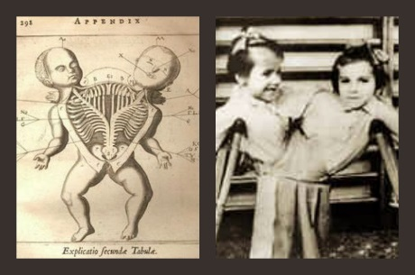Which was the right decision - to announce or not to announce their twins? I don't think there necessarily was one. Approximately three thousand twins were pulled from the masses on the ramp, most of them children; only around two hundred survived.

When the twins were found, they were taken away from their parents.

Once the SS guard knew we were twins, Miriam and I were taken away from our mother, without any warning or explanation.

Our screams fell on deaf ears. I remember looking back and seeing my mother's arms stretched out in despair as we were led away by a soldier.

That was the last time I saw her.1

As the twins were led away to be processed, their parents and family stayed on the ramp and went through selection. Occasionally, if the twins were very young Mengele would allow the mother to join her children in order for their health to be assured for the experiments.

**Processing**

After the twins had been taken from their parents, they were taken to the showers. Since they were "Mengele's children," they were treated differently than other prisoners. Besides the obvious, suffering through medical experiments, the twins were often allowed to keep their hair and allowed to keep their own clothes.

The twins were then tattooed. They were given a number from a special sequence.2 They were then taken to the twin's barracks where they were required to fill out a form. The form asked for a brief history and basic measurements such as age and height. Many of the twins were too young to fill the form out by themselves so the Zwillingsvater ("Twin's Father") helped them. (This inmate was assigned to the job of taking care of the male twins.) Once the form was filled out, the twins were taken to Mengele. Mengele asked them more questions and looked for any unusual traits.

**Life for the Twins**

Each morning, life for the twins began at six o'clock. The twins were required to report for roll call in front of their barracks no matter what the weather. After roll call, they ate a small breakfast. Then each morning, Mengele would appear for an inspection.

Mengele's presence did not necessarily connote fear in the children. He was often known to appear with pockets full of candy and chocolates, to pat them on the head, to talk with them, and sometimes even play. Many of the children, especially the younger ones, called him "Uncle Mengele."3

The twins were given brief instruction in makeshift "classes" and were sometimes even allowed to play soccer.4 The children were not required to do hard work and had jobs like being a messenger. Twins were also spared from punishments as well as from the frequent selections within the camp.

Conditions for the twins were one of the best in Auschwitz, until the trucks came to take them to the experiments.

**Experiments**

Generally, every day, every twin had to have blood drawn.

Blood, often in large quantities, was drawn from twins' fingers and arms, and sometimes both their arms simultaneously. The youngest children, whose arms and hands were very small, suffered the most: Blood was drawn from their necks, a painful and frightening procedure.5

It was estimated that approximately ten cubic centimeters of blood was drawn daily.6

Besides having blood drawn, the twins were to undergo various medical experiments. Mengele kept his exact reasoning for his experiments a secret. Many of the twins that he experimented on weren't sure for what purpose the individual experiments were for nor what exactly what was being injected or done to them.

Each morning, the twins would wonder what was in store for them that day. Would their number be called? If yes, then the trucks would pick them up and take them to one of several laboratories.

* 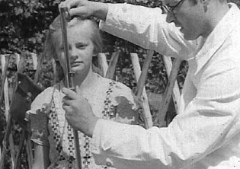**Measurements**  
  The twins were forced to undress and lay next to each other. Then every detail of their anatomy was carefully examined, studied, and measured. What was the same was deemed to be hereditary and was different was deemed to be the result of the environment. These tests would last for several hours.
* **Blood**  
  Blood tests included mass transfusions of blood from one twin to another.
* **Eyes**  
  In attempts to fabricate blue eyes, drops or injections of chemicals would be put in the eyes. This often caused severe pain, infections, and temporary or permanent blindness.
* **Shots and Diseases**  
  Mysterious injections that caused severe pain. Injections into the spine and spinal taps with no anesthesia. Diseases, including typhus and tuberculosis, would be purposely given to one twin and not the other. When one died, the other was often killed to examine and compare the effects of the disease.
* **Surgeries**  
  Various surgeries without anesthesia including organ removal, castration, and amputations.

One day, my twin brother, Tibi, was taken away for some special experiments. Dr. Mengele had always been more interested in Tibi. I am not sure why - perhaps because he was the older twin.

Mengele made several operations on Tibi. One surgery on his spine left my brother paralyzed. He could not walk anymore. Then they took out his sexual organs. After the fourth operation, I did not see Tibi anymore.

I cannot tell you how I felt. It is impossible to put into words how I felt. They had taken away my father, my mother, my two older brothers - and now, my twin.7

* **Death**  
  Dr Miklos Nyiszli was Mengele's prisoner pathologist. The autopsies became the final experiment. Dr. Nyiszli performed autopsies on twins whom had died from the experiments or whom had been purposely killed just for after-death measurements and examination. Some of the twins had been stabbed with a needle that pierced their heart and then were injected with chloroform or phenol which caused near immediate blood coagulation and death.

Some of the organs, eyes, blood samples, and tissues would be sent to Verschuer for further study.

<http://history1900s.about.com/od/auschwitz/a/mengeletwins.htm>

Dr. Mengele: The Angel of Death

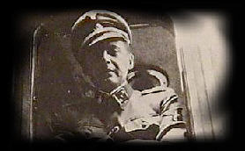Nazi persecution, arrests, and deportations were directed against all members of Jewish families, as well as many Gypsy families, without concern for age. Homeless, often orphaned, many children had frequently witnessed the murder of parents, siblings, and relatives. They faced starvation, illness, brutal labor, and other indignities until they were consigned to the gas chambers.

At Auschwitz [Josef Mengele](http://www.mengele.dk/)did a number of twin studies

At death camps like [Auschwitz](http://auschwitz.dk/Auschwitz.htm)children did not fare well: they were generally killed upon arrival.Children born in the camps were generally killed on the spot, especially if the child was Jewish.

So called camp doctors, especially the notorious Josef Mengele, would torture Jewish children, Gypsy children and many others. "Patients" were put into pressure chambers, tested with drugs, castrated, frozen to death, and exposed to various other traumas.

Dr. Josef Mengele was born on March 16, 1911, the eldest of three sons of Karl and Walburga Mengele. Josef was refined, intelligent and popular in his town. He studied philosophy at Munich and medicine at Frankfurt University. In 1935 his dissertation dealt with racial differences in the structure of the lower jaw.

In 1937 he joined the Nazi party, then in 1938 he went to the SS. In 1942 he was wounded at the Russian front and was pronounced unfit for duty. After that he volunteered to go to the concentration camp, he was sent to the death camp, Auschwitz. Dr. Josef Mengele, nicknamed "the Angel of Death", became the surviving symbol of Adolf Hitler's ["Final Solution"](http://auschwitz.dk/).

Mengele was always immaculately prepared for the long-drawn-out rituals of death, the hellish selections which the young SS doctor so regularly attended during his twenty-one months at Auschwitz.

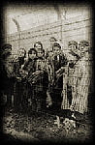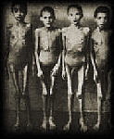Josef Mengele was the chief provider for the gas chambers and their crematoria."He had a look that said 'I am the power,'" said one survivor. When it was reported that one block was infected with lice, Mengele solved the problem by gassing all the 750 women assigned to it. At the time, Mengele was only 32 years old.

The Angel of Death fed his legend by dramatizing murderous policies, such as his drawing a line on the wall of the children's block between 150 and 156 centimeters (about 5 feet or 5 feet 2 inches) from the floor.Then sending those whose heads could not reach the line to the gas chamber ... (Lifton, p. 346.)

Mengele - and a victim ..

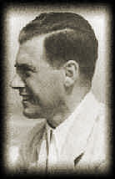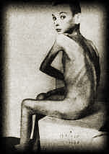The memory of this slightly built man, scarcely a hair out of place, his dark green tunic neatly pressed, his face well scrubbed, his Death's Head SS cap tilted rakishly to one side, remains vivid for those who survived his scrutiny when they arrived at the Auschwitz railhead. Polished boots slightly apart, his thumb resting on his pistol belt, he surveyed his prey with those dead gimlet eyes. Death to the left, life to the right. Four hundred thousand souls - babies, small children, young girls, mothers, fathers, and grandparents - are said to have been casually waved to the lefthand side with a flick of the cane clasped in a gloved hand.

In another case in which a mother did not want to be separated from her thirteen-year-old daughter, and bit and scratched the face of the SS man who tried to force her to her assigned line, Mengele drew his gun and shot both the woman and the child. As a blanket punishment, he then sent to the gas all people from that transport who had previously been selected for work, with the comment: "Away with this shit!" (Robert Jay Lifton, The Nazi Doctors.)

There were moments when his death mask gave way to a more animated expression, when Mengele came alive. There was excitement in his eyes, a tender touch in his hands. This was the moment when Josef Mengele, the geneticist, found a pair of twins.

Mengele was almost fanatical about drawing blood from twins, mostly identical twins. He is reported to have bled some to death this way.

Once Mengele's assistant rounded up 14 pairs of Gypsy twins during the night. Mengele placed them on his polished marble dissection table and put them to sleep. He then proceeded to inject chloroform into their hearts, killing them instantaneously. Mengele then began dissecting and meticulously noting each and every piece of the twins' bodies.

[The Holocaust Children](http://www.izieu.com/index.htm)

At Auschwitz Mengele did a number of twin studies, and these twins were usually murdered after the experiment was over and their bodies dissected. He supervised an operation by which two Gypsy children were sewn together to create Siamses twins; the hands of the children became badly infected where the veins had been resected.

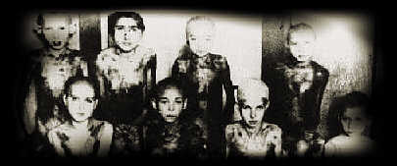Mengele injected chemicals into the eyes of children in an attempt to change their eye color. Unfortunately a strict veil of secrecy over the experiments enabled Mengele to do his work more effectively. The full extent of his gruesome work will never be known because the records he sent to Dr. Von Verschuer at the Kaiser Wilhelm Institute were shipped out in two truckloads and destroyed by the latter.

Twins undergoing his experiments didn't know what the objectives were. It is known that he had a special pathology lab where he performed autopsies on twins who had died from experiments. It was located next to the crematorium.

Any remaining notes Mengele carried with him on his escape to South America and those were never found. Some forty years after the war, only a few of these twins could be found, many living in Israel and the United States. Strangely enough, many of them recall Mengele as a gentle, affable man who befriended them as children and gave them chocolates. Since many had immediately been separated from their families upon entering the camp, Mengele became a sort of father figure. Still a tension existed, that at any time they could be killed if they did not keep a low profile. Older twins recognized his kindness as a deception…

The horrors of the Holocaust

Mengele performed both physical and psychological experiments, experimental surgeries performed without anesthesia, transfusions of blood from one twin to another, isolation endurance, reaction to various stimuli. He made injections with lethal germs, sex change operations, the removal of organs and limbs, incestuous impregnations.

The book Children of the Flames by Joe E. White chronicles the notorious medical experimental activities of Josef Mengele on approximately three thousand twins who passed through the Auschwitz death camp during WWII until its liberation at the end of the war. Only a few of the three thousand twins survived and now fifty years later they have told their story of how they were given special privileges in Auschwitz due to Mengele’s interest in twins and how as a result they have suffered during the past fifty years as the children who survived the still unknown and unexplained medical experiments and injections which they were subjected to at the hands of Josef Mengele.

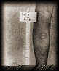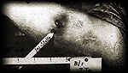

[Photos: Medical experiments](http://www.photographs.dk/)

The survivors tell how as children in Auschwitz they were visited by a smiling "Uncle Mengele" who brought them candy and clothes.Then he had them delivered to his medical laboratory either in trucks painted with the Red Cross emblem or in his own personal car to undergo his experiments.

One twin recalls the death of his brother:

"Dr. Mengele had always been more interested in Tibi. I am not sure why - perhaps because he was the older twin. Mengele made several operations on Tibi. One surgery on his spine left my brother paralyzed. He could not walk anymore. Then they took out his sexual organs. After the fourth operation, I did not see Tibi anymore. I cannot tell you how I felt. It is impossible to put into words how I felt. They had taken away my father, my mother, my two older brothers - and now, my twin ..."

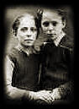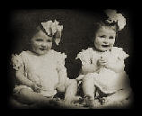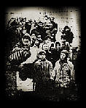

Josef Mengele's twins

The twins, Bernard and Simon Zajdner, born Dec. 28, 1929, were deported with their sister, Micheline, on May 20, 1944.They were victims of Josef Mengele's inhuman "medical experiments." Eva Mozes and her identical twin, Miriam, were survivors of the deadly genetic experiments conducted by Josef Mengele. Their parents, grandparents, two older sisters, uncles, aunts and cousins were killed in the Holocaust. After the liberation of the camp, Eva and Miriam were the first two twins in the famous film taken by the Soviets - often shown in footage about the horrors of Holocaust.

Likewise at Auschwitz Dr. Herta Oberhauser killed children with oil and evipan injections, removed their limbs and vital organs, rubbed ground glass and sawdust into wounds. She drew a twenty-year sentence as a war criminal, but was released in 1952 and became a family doctor at Stocksee in Germany. Her license to practice medicine was revoked in 1960. (Laska)

Near the end of the war, in order to cut expenses and save gas, "cost- accountant considerations" led to an order to place living children directly into the ovens or throw them into open burning pits.

According to U.S. Holocaust Memorial Museum full statistics for the tragic fate of children who died during the Holocaust will never be known. Some estimates range as high as 1.5 million murdered children. This figure includes more than 1.2 million Jewish children, tens of thousands of Gypsy children and thousands of institutionalized handicapped children who were murdered under Nazi rule in Germany and occupied Europe.

Josef Mengele left Auschwitz disguised as a member of the regular German infantry. He turned up at the Gross-Rosen work camp and left well before it was liberated on February 11, 1945. He was then seen at Matthausen and shortly after he was captured as a POW and held near Munich. He was released by the allies, who had no idea that he was in their midst.

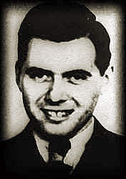

[Mengele - the Angel of Death](http://www.mengele.dk/)

By the fall of 1948, Mengele had made up his mind to leave Germany and build a life elsewhere. Argentina was the preferred choice of sanctuary. There was a groundswell of Nazi sympathy in Argentina. And his father, Karl Sr., who owned a firm that manufactured agricultural equipment, thought that though his company had no branches in Argentina, he had made several business connections there that Josef might develop.

Today it seems that Nazi war criminals escaped to Argentina using false identities supplied by the Red Cross, the humanitarian organisation has admitted ... The International Committee of the Red Cross has said it unwittingly provided travel papers to at least 10 top Nazis, including Adolf Eichmann, Klaus Barbie, Erich Priebke and Josef Mengele ... A statement issued by the ICRC, from its Geneva headquarters, said they were among thousands of people found in refugee camps who were given Red Cross travel documents.

Mengele gave an Italian residency document with a false name and permission to enter Argentina. He received his passport in 1949. So Mengele fled to South America, but moved from country to country afraid of being caught There were many warrants, rewards, and bounties offered, but he was lucky.

|  |  |
| --- | --- |
| http://www.auschwitz.dk/Mengele3.jpg | Josef Mengele hid in South America after the war and he divorced Irene Mengele.In 1958, Mengele married his brother Karl's widow, Martha, and later she and her son moved to Argentina to join Mengele. Mengele's life had now established itself into the comfortable and secure routine of a family man in a 9-to-5 job with good prospects. |

Despite international efforts to track him down, he was never apprehended and lived for 35 years hiding under various aliases. He lived in Paraguay and Brazil until his death in 1979. One afternoon, living in Brazil, he went for a swim. While in the ocean he suffered a massive stroke and began to drown. By the time he was dragged to shore, he was dead.

People didn't find out about Mengele's death until the mid 1980's when Nazi hunters, using newly discovered information, uncovered his grave marked "Wolfgang Gerhard" at Embu. It was then that his family admitted they had shielded him all those years and they turned over his diaries and letters to investigators.

But the possibility of a hoax kept the case open for several years. It was not until 1992, after coaxing DNA from a bone, and matching it to DNA in blood samples taken from Mengele's son and wife that the official conclusion is announced: "The remains are those of Josef Mengele".

The mystery of Josef Mengele, the evil symbol of the Nazi's, was solved.

<http://www.auschwitz.dk/mengele.htm>

HISTORY OF THE SWASTIKA

[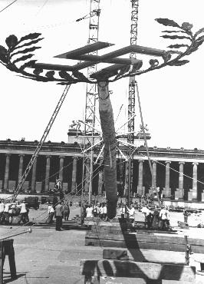](http://www.ushmm.org/wlc/en/media_ph.php?ModuleId=10007453&MediaId=6567)

A Maypole topped with a swastika is raised for a May Day parade in the Lustgarten in Berlin. The May holiday became an important celebration in the Nazi calendar. Germany, April 26, 1939.

*— National Archives and Records Administration, College Park, Md.*

The swastika has an extensive history. It was used at least 5,000 years before Adolf Hitler designed the Nazi flag. The word *swastika* comes from the Sanskrit *svastika*, which means “good fortune” or “well-being." The motif (a hooked cross) appears to have first been used in Neolithic Eurasia, perhaps representing the movement of the sun through the sky. To this day it is a sacred symbol in Hinduism, Buddhism, Jainism, and Odinism. It is a common sight on temples or houses in India or Indonesia. Swastikas also have an ancient history in Europe, appearing on artifacts from pre-Christian European cultures.

The symbol experienced a resurgence in the late nineteenth century, following extensive archeological work such as that of the famous archeologist Heinrich Schliemann. Schliemann discovered the hooked cross on the site of ancient Troy. He connected it with similar shapes found on pottery in Germany and speculated that it was a “significant religious symbol of our remote ancestors.”

In the beginning of the twentieth century the swastika was widely used in Europe. It had numerous meanings, the most common being a symbol of good luck and auspiciousness. However, the work of Schliemann soon was taken up by *völkisch*movements, for whom the swastika was a symbol of “Aryan identity” and German nationalist pride

[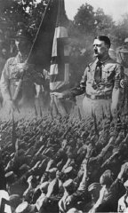](http://www.ushmm.org/wlc/en/gallery.php?ModuleId=10007453&MediaType=PH)This conjecture of Aryan cultural descent of the German people is likely one of the main reasons why the Nazi party formally adopted the swastika or *Hakenkreuz* (Ger., hooked cross) as its symbol in 1920.

The Nazi party, however, was not the only party to use the swastika in Germany. After World War I, a number of far-right nationalist movements adopted the swastika. As a symbol, it became associated with the idea of a racially “pure” state. By the time the Nazis gained control of Germany, the connotations of the swastika had forever changed.

In *Mein Kampf*, Adolf Hitler wrote: “I myself, meanwhile, after innumerable attempts, had laid down a final form; a flag with a red background, a white disk, and a black swastika in the middle. After long trials I also found a definite proportion between the size of the flag and the size of the white disk, as well as the shape and thickness of the swastika.”

The swastika would become the most recognizable icon of Nazi[propaganda](http://www.ushmm.org/wlc/en/article.php?ModuleId=10005202), appearing on the flag referred to by Hitler in *Mein Kampf*as well as on election posters, arm bands, medallions, and badges for military and other organizations. A potent symbol intended to elicit pride among Aryans, the swastika also struck terror into Jews and others deemed enemies of Nazi Germany.

Despite its origins, the swastika has become so widely associated with Nazi Germany that contemporary uses frequently incite controversy.

<http://www.ushmm.org/wlc/en/article.php?ModuleId=10007453>

**What Is the Origin of the Swastika**

**Answer:**The swastika is actually an ancient symbol, but its origin is hard to define.

In "The Swastika,"*Folklore*, Vol. 55, No. 4 (Dec., 1944), pp. 167-168, W. G. V. Balchin says the word swastika is of Sanskrit origin and the symbol is one of good luck or a charm or a religious symbol (the last, among the Jains and Buddhists) that goes back to at least the Bronze Age. It appears in various parts of the ancient and modern world. This article mentions Christians did, indeed, consider the swastika for their symbol.

In response to this forum question about the origins of the swastika, other forum members have researched the historically popular symbol now associated almost exclusively with the much-hated Nazis and Hitler. Here is the swastika lore they found.

One popular notion holds that it is a very old solar symbol. Relatedly, recent scholarship with ancient Indian and Vedic documents reveals a legend concerning a mythical demonic semi-deity who was obsessed with world conquest and the destruction of subject people/races. His name is difficult to translate from Sanskrit, but it's phonetic rendering into English sounds something like "Putz."  
-Mizta Bumpy (HERRBUMPY)

I just know that many symbols (as well as philosophers like Nietzsche, etc.) were misunderstood / mistreated / badly-used by Nazis. One of them was the swastika, which, I think, symbolized the four powers of nature. I think it was found in other ancient lands too, apart from Sumeria.

The swastika resembles a lot the "Greek" cross in its symmetry, if you take out those little "wings" from the swastika. That's the only connection I can find with Christianity. Of course many pre-Christian symbols were redefined and "used" by Christians of all times (with varying success).

The swastika is indeed a sun symbol from antiquity, appropriate in many themes & on many occasions. Like flood legends, the swastika (in various recognizable styles) is one of many symbols found thru-out ancient civilisations having no possible contact (as we understand contact) with each other. Usually it meant the sun, in its scheme as "the wheel of life". (Mayan, I believe.) It was also a popular good luck symbol. For example, it can be found on pre-1930 American New Year's greeting cards.

A white swastika on a black field was the flag of an American Boy Scout Troop from its founding to some point in the 1930's, when the Troop itself voted to discontinue its use, in light of the rise of the Nazi regime. The German-American Bundt (the pre-War American Nazi movement), who also used the swastika, may also have influenced their decision.

The Indian and Vedic connection you mention is likely the swastika's oldest incarnation. The symbol itself may still be found as an architectural element, decorating sufficiently aged temples to whatever deity is involved. There is a simply fascinating documentary on the swastika, and its journey from mystic rune to fascist emblem. Unhappily, I can't recall the title.

German woman of wealth, and the upper class, made it her cause to sponsor the swastika into its position as The Emblem of the Nazi party. As often happens after wars, mysticism and spiritualism was popular thru-out post WW1 and the 1920's. She appears to have been a true believer of some kind, and felt the swastika itself had the power to lead Germany to ultimate triumph, that soldiers who fought under it would obtain super-strength, etc.

The swastika is (or was, depending on your WWII point of view) actually a symbol of good luck, and possibly of fertility and regeneration.

I once read that several ancient cultures associated the symbol with the sun, although I'm not sure of the actual details on this. The Navajo Indians also had a similar symbol - depicting their gods of the mountains, rivers, and rain.

In India, the swastika is an auspicious mark - worn as jewelry or marked on objects as a symbol of good luck. The symbol, though, is extremely ancient and predates Hinduism. The Hindus associated it with the sun and wheel of birth and rebirth. It is an emblem of the Hindu god Vishnu, one of the supreme Hindu deities.

Swastika has nothing to do with Christ and with Christianism. It is a Buddhist symbol for peace, as it still appears nowadays on Buddhist temples in Asia. I have seen one in a bi-lingual edition of a Taiwanese magazine. The editors felt the necessity of explaining in the English text that Swastika is a Buddhist symbol of peace, and this is why the puzzled European reader could see it in pictures showing temples.

A difference however can be noticed: the orientation of the arms is clockwise in the Buddhist swastika and anti-clockwise in the one adapted by the Nazis. Unfortunately I don't know how this change occurred or its significance.  
- MYKK1

The swastika... has nothing to do with the swastika used as the symbol in Nazi Germany. That symbol is from Nordic runes and was used in Nordic tribes' pagan culture. Later it was also used by the Teutonic Knights formed in the 12th century. From this source the Nazis got a lot of their symbols, like the SS rune.

<http://ancienthistory.about.com/od/ancientart/f/swastika.htm>

**The Nazi Party:** **The Swastika**

While commonly associated with [Nazi Germany](https://www.jewishvirtuallibrary.org/jsource/Holocaust/nazipartytoc.html), the swastika symbol is more than 3,000 years old. The term "Swastika" was originally the name for a hooked cross in Sanskrit, and swastikas have been found on artifacts, such as coins and pottery, from the ancient city of Troy.

Not only are swastikas associated with ancient Troy, the symbols are found in many other cultures, such as Chinese, Japanese, Indian and southern European. By the Middle Ages, the swastika was a well-known symbol and had many different names, depending on the country. In some cultures, such as in ancient [China](https://www.jewishvirtuallibrary.org/jsource/vjw/chinajews.html), the symbol is turned counterclockwise (sauvastika).

Throughout its history, the swastika represented life, sun, power, strength and good luck. In the early 20th century, it was still considered a positive symbol. During World War I, it was found on shoulder patches of members of the American 45th Division and the Finnish air force. Only after the Nazi period did its connotation change.

German nationalists chose to use the swastika in the mid-19th century because it was associated with the Aryan race and Germanic history. At the end of the 19th century, German nationalists used the symbol on periodicals and for the official emblem of the German Gymnasts’ League. By the 20th century, it was a common symbol used in [Germany](https://www.jewishvirtuallibrary.org/jsource/vjw/germany.html) to represent German nationalism and pride, for example, as the emblem for the Wandervogel, a German youth group. Swastikas also were used, however, in [anti-Semitic](https://www.jewishvirtuallibrary.org/jsource/antisem.html)periodicals.

The swastika officially became the emblem for the [Nazi Party](https://www.jewishvirtuallibrary.org/jsource/Holocaust/nazipartytoc.html) on August, 7, 1920, at the Salzburg Congress. Describing the new flag in [Mein Kampf](https://www.jewishvirtuallibrary.org/jsource/Holocaust/kampf.html), Hitler said the swastika symbolized the victory of the Aryan man.

Today the symbol is most commonly associated with Nazi Germany, the [Holocaust](https://www.jewishvirtuallibrary.org/jsource/holo.html), neo-Nazis and other hate groups.

<https://www.jewishvirtuallibrary.org/jsource/Holocaust/Swastika.html>

[**THE SWASTIKA BEFORE WORLD WAR II**](http://thesocietypages.org/socimages/2014/05/23/symbolism-the-swastika/)

by Wendy Christensen PhD, May 23, 2014, at 09:00 am

[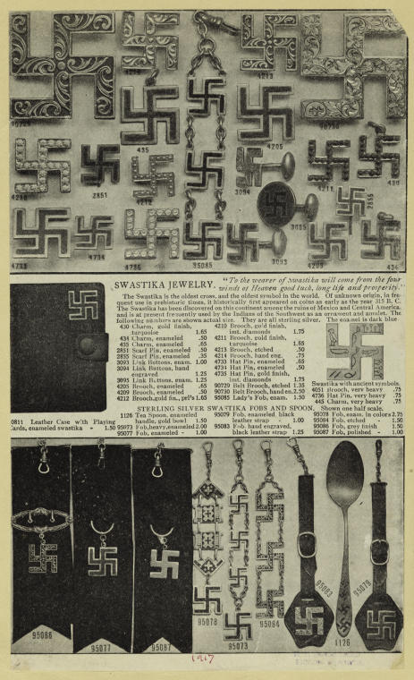](http://thesocietypages.org/socimages/files/2008/06/6.jpg)*.*

I found this 1917 advertisement for swastika jewelry while browsing through the [NY Public Library Digital Gallery](http://digitalgallery.nypl.org/nypldigital/index.cfm). The text reads in part:

To the wearer of swastika will come from the four winds of heaven good luck, long life and prosperity. The swastika is the oldest cross, and the oldest symbol in the world. Of unknown origin, in frequent use in the prehistoric items, it historically first appeared on coins as early as the year 315 B.C.

As this suggests, while the symbol of the swastika is most frequently associated with Hitler and Nazis during World War II, and is still used by neo-Nazi groups, the symbol itself has a much longer history.

Archaeological evidence of swastika-shaped ornaments dates from the Neolithic period. An ancient symbol, it occurs mainly in the cultures that are in modern day India and the surrounding area, sometimes as a geometrical motif and sometimes as a religious symbol. It was long widely used in major world religions such as Hinduism, Buddhism and Jainism.

Before it was co-opted by the Nazis, the swastika decorated all kinds of things.  [Uni Watch](http://www.uniwatchblog.com/2007/11/01/and-look-theres-a-young-marge-schott-in-the-front-row/) has tons of examples. Here it is on a Finnish military plane:

[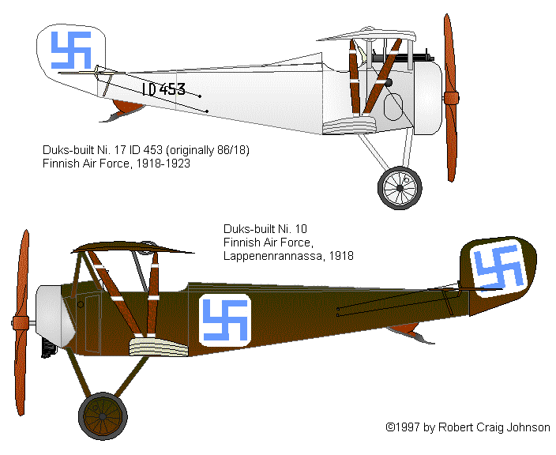](http://thesocietypages.org/socimages/files/2008/12/finn_n.gif)

A Boy Scout badge:

[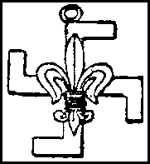](http://thesocietypages.org/socimages/files/2008/12/staff4.gif)

A women’s hockey team called the Swastikas from Edmonton (from 1916):

[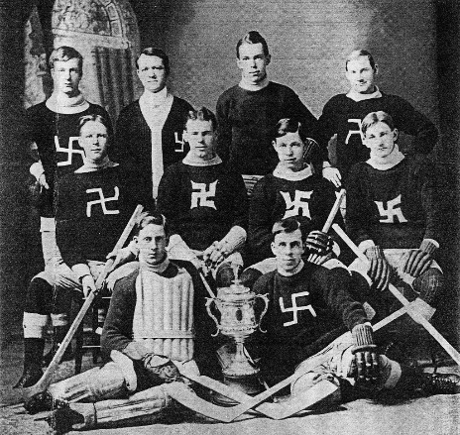](http://thesocietypages.org/socimages/files/2008/12/1584590906_43db8add1d_b.jpg)[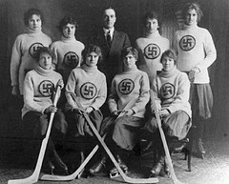](http://thesocietypages.org/socimages/files/2008/12/1562287125_f2a2d5b472_m.jpg)

Another hockey team:

In the comments, Felicity pointed to [this example](http://www.proswastika.org/page.php?7.2):

[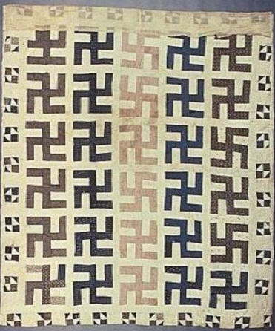](http://thesocietypages.org/socimages/files/2009/01/america_quilt2-mi.jpg)

She writes:

My mom is a quilter and collects antique quilts (when she can afford them). She says that while in general, antique quilts and quilt-tops have gone up a great deal in price over the decades, there’s still one sort you can pick up for a song — swastika quilts.

It’s kind of sad to think of somebody in 1900 putting all that time and hand-stitching into a ‘good luck’ quilt that is now reviled.

All of these examples occurred before the Nazis adopted the swastika as their symbol (and changed it slightly by tilting it on a 45-degree angle). Of course, the original meaning or usage of the swastika is beside the point now. Because it is so strongly associated with the Nazis, it’s impossible to use it now without people reading it as a Nazi symbol. And in fact it’s unimaginable that a group in the U.S. or Europe would use the swastika today without intentionally meaning to draw on the Nazi association and the ideas espoused by Hitler and his party.

[*Wendy Christensen*](http://wendyphd.weebly.com/)*is an Assistant Professor at*[*William Paterson University*](http://www.wpunj.edu/cohss/departments/sociology/faculty/wendy-christensen.dot)*whose specialty includes the intersection of gender, war, and the media.  You can follow her on*[*Twitter*](https://twitter.com/wendyphd)*.*

<http://thesocietypages.org/socimages/2014/05/23/symbolism-the-swastika/>

RAOUL WALLENBERG AND THE RESCUE OF JEWS IN BUDAPEST

[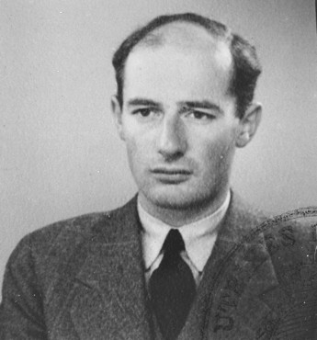](http://www.ushmm.org/wlc/en/media_ph.php?ModuleId=10005211&MediaId=561)

Passport photograph of Raoul Wallenberg. Sweden, June 1944.

*— US Holocaust Memorial Museum*

Raoul Wallenberg was born on August 4, 1912, in Stockholm, Sweden.

After studying in the United States in the 1930s and establishing himself in a business career in Sweden, Wallenberg was recruited by the US War Refugee Board (WRB) in June 1944 to travel to Hungary. Given status as a diplomat by the Swedish legation, Wallenberg's task was to do what he could to assist and save Hungarian Jews.

Assigned as first secretary to the Swedish legation in Hungary, Wallenberg arrived in Budapest on July 9, 1944. Despite a complete lack of experience in diplomacy and clandestine operations, he led one of the most extensive and successful rescue efforts during the [Holocaust](http://www.ushmm.org/wlc/en/article.php?ModuleId=10005143). His work with the WRB and the World Jewish Congress prevented the deportation of tens of thousands of Hungarian Jews to the [Auschwitz-Birkenau](http://www.ushmm.org/wlc/en/article.php?ModuleId=10005189) killing center.

Hungary had been an ally of Germany, but German defeats and mounting Hungarian losses led Hungary to seek an armistice with the western Allies. To forestall these peace feelers, German forces [occupied Hungary](http://www.ushmm.org/wlc/en/article.php?ModuleId=10005458) on March 19, 1944, and forced the Hungarian head of state, Miklos Horthy, to appoint a pro-German government under Dome Sztojay. The Sztojay government was prepared not only to continue the war but also to deport Hungarian Jews to German-occupied Poland. Shortly after the occupation, Hungarian officials began to round up Hungarian Jews and to transfer them into German custody.

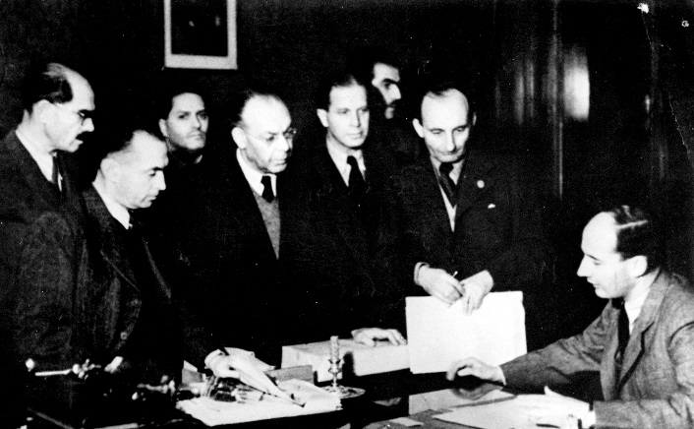

By July 1944, the Hungarians and the Germans had deported nearly 440,000 Jews from Hungary, almost all of them to Auschwitz-Birkenau, where the SS killed approximately 320,000 of them upon arrival and deployed the rest at forced labor in Auschwitz and other camps. Nearly 200,000 Jews remained in Budapest; the Hungarian authorities intended to deport them as well, in compliance with German requests.

With authorization from the Swedish government, Wallenberg began distributing certificates of protection issued by the Swedish legation to Jews in Budapest shortly after his arrival in the Hungarian capital. He used WRB and Swedish funds to establish hospitals, nurseries and a soup kitchen, and to designate more than 30 “safe” houses that together formed the core of the "international ghetto" in Budapest. The international ghetto was reserved for Jews and their families holding certificates of protection from a neutral country.

After the Hungarian fascist Arrow Cross movement seized power with the help of the Germans on October 15, 1944, the Arrow Cross government resumed the deportation of Hungarian Jews, which Horthy had halted in July before the Budapest Jews could be deported. As Soviet troops had already cut off rail transport routes to Auschwitz, Hungarian authorities forced tens of thousands of Budapest Jews to march west to the Hungarian border with Austria. During the autumn of 1944, Wallenberg repeatedly—and often personally—intervened to secure the release of those with certificates of protection or forged papers, saving as many people as he could from the marching columns.

Wallenberg's colleagues in the Swedish legation and diplomats from other neutral countries also participated in [rescue](http://www.ushmm.org/wlc/en/article.php?ModuleId=10005185) operations. Carl Lutz, the consul general in the Swiss legation, issued certificates of emigration, placing nearly 50,000 Jews in Budapest under Swiss protection as potential emigrants to Palestine. Italian businessman Giorgio Perlasca posed as a Spanish diplomat. Closely assisted by Laszlo and Eugenia Szamosi, Perlasca issued to many Jews in Budapest certificates of protection for nations whose interests neutral Spain represented and established safe houses, including one for Jewish children.

When Soviet forces liberated Budapest in February 1945, more than 100,000 Jews remained, mostly because of the efforts of Wallenberg and his colleagues. Wallenberg was last seen in the company of Soviet officials in mid-January 1945. He reportedly died in a Soviet prison in 1947, although the exact date and circumstances of his death are still unknown. <http://www.ushmm.org/wlc/en/article.php?ModuleId=10005211>

Raoul Wallenberg

(1921 - ?)

Raoul Wallenberg was a Swedish diplomat in Nazi-occupied [Hungary](http://www.jewishvirtuallibrary.org/jsource/vjw/Hungary.html) who led an extensive and successful mission to save the lives of nearly 100,000 Hungarian Jews. Though his efforts to save Jews from the [Holocaust](http://www.jewishvirtuallibrary.org/jsource/holo.html) is one of the most treasured aspects of that time, his fate and ultimate death is unknown still to this day.

Early Life & Education

Raoul Wallenberg was born August 4, 1912, three months after his father's death and six years before his mother, Maj Wising Wallenberg, became remarried to Fredrik von Dardel in 1918. Raoul belonged to one of the most famous families in [Sweden](http://www.sweden.com/), the large Wallenberg family. It was a family that contributed to Sweden bankers, diplomats and politicians during several generations in the country. Raoul's father, Raoul Oscar Wallenberg, was an officer in the navy, and his cousins Jacob and Marcus Wallenberg were two of Sweden's most famous bankers and industrialists.

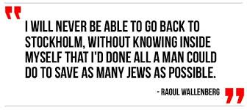Raoul's grandfather, Gustav Wallenberg, took care of Raoul's education. The plan was for him to continue the family tradition and become a banker, but he was more interested in architecture and trade.

In 1930, Wallenberg graduated with top grades in Russian and drawing. After his army service he traveled to the USA in 1931 to study architecture at the [University of Michigan](http://www.umich.edu/) in Ann Arbor. Wallenberg's personal letters reveal that he enjoyed his studies and that he spent most of his free time in studying. Still, he thoroughly enjoyed his time in Ann Arbor - he wrote to his grandfather, "When I now look back upon the last school year, I find I have had a completely wonderful time."

Wallenberg graduated with honors in only three and a half years and won a university medal that went to the student with the most impressive academic record.

Professional Life During the Rise of Hitler

In 1935, he received his bachelor degree of Science in Architecture and returned to Sweden. But the market for architects was small in Sweden, so his grandfather sent him to Cape Town, [South Africa](http://www.jewishvirtuallibrary.org/jsource/vjw/South_Africa.html), where he practiced at a Swedish firm selling building materials. After six months, his grandfather arranged a new job for him at a Dutch bank office in [Haifa](http://www.jewishvirtuallibrary.org/jsource/Society_&_Culture/geo/Haifatoc.html), Palestine (now [Israel](http://www.israel-mfa.gov.il/)).

It was in Palestine he first met Jews that had escaped [Hitler's](http://www.jewishvirtuallibrary.org/jsource/Holocaust/hitlertoc.html) Germany. Their stories of the [Nazi persecutions](http://www.jewishvirtuallibrary.org/jsource/holo.html#persec) affected him deeply. Perhaps because he had a very humane attitude to life and because he owned a drop of Jewish blood (Raoul's grandmother's grandfather was a Jew by the name of Benedicks whom arrived to Sweden by the end of the 18th century). Wallenberg returned to Sweden from Haifa in 1936 and resumed his old interest for business.

Through his cousin Jacobs' good contacts in the business world, Raoul was eventually brought together with Koloman Lauer, a Hungarian Jew, who was the director of a Swedish based import and export company specializing in food and delicacies. Thanks to Raoul's excellent language skills and his greater freedom of movement through Europe (Jews were not allowed to travel extensively after the rise of Hitler), he was a perfect business partner for Lauer. Within eight months, Wallenberg was a joint owner and international director of the Mid-European Trading Company.

Through his trips in Nazi-occupied [France](http://www.jewishvirtuallibrary.org/jsource/vjw/Francetoc.html) and in [Germany](http://www.jewishvirtuallibrary.org/jsource/vjw/Germanytoc.html) itself, Raoul quickly learned how the German bureaucracy functioned. He also made several trips to [Hungary](http://www.jewishvirtuallibrary.org/jsource/vjw/Hungarytoc.html) and [Budapest](http://www.jewishvirtuallibrary.org/jsource/vjw/Budapest.html), where he visited Lauer's family. At that time, Hungary was still a relatively safe place in a hostile surrounding.

The Holocaust Hits Hungary

During the spring of 1944 the world had mostly awoken to realize what Hitler's "[final solution](http://www.jewishvirtuallibrary.org/jsource/Holocaust/final.html) to the Jewish problem" actually meant. In May 1944, the first authentic [eye witness report](http://www.jewishvirtuallibrary.org/jsource/Holocaust/knewtoc.html) of what was happening in the [Auschwitz](http://www.jewishvirtuallibrary.org/jsource/Holocaust/autoc.html)extermination camp finally reached the western world . It came from two Jews who had managed to escape the [gas chambers](http://www.jewishvirtuallibrary.org/jsource/Holocaust/gastoc.html) and Nazi Germany all together.

Hitler's plans for the extermination of European Jewry were now known. At the beginning of 1944, there still lived an estimated 700,000 Jews in Hungary, a country which had joined Germany in the war against the Soviet Union already in 1941.

When the Germans lost the battle of [Stalingrad](http://www.jewishvirtuallibrary.org/jsource/ww2/Stalingrad.html) in 1943, Hungary wanted to follow [Italy's](http://www.jewishvirtuallibrary.org/jsource/vjw/Italy.html) example and demand a separate peace. Hitler called the Hungarian head of state, Miklós Horthy, and demanded that he display continued solidarity with Germany. When Horthy refused to meet these demands, an angered Hitler had the German army invade Hungary in March 1944. Following soon thereafter, the deportations of Hungarian Jews to the concentration camps began. For the vast majority of these Jews, the lone destination was [Auschwitz-Birkenau](http://www.jewishvirtuallibrary.org/jsource/Holocaust/autoc.html) in southern [Poland](http://www.jewishvirtuallibrary.org/jsource/vjw/Polandtoc.html) - a ride that brought with it almost certain death.

Though the Germans began by deporting Jews from the Hungarian country side, the Jewish citizens of Budapest knew that their hour of fate was also soon to come. In desperation they sought help from embassies of the neutral countries where provisional identity passes were issued for Jews with special connections to these countries.

Efforts at Saving Jews from Persecution

The Swedish legation in Budapest succeeded in negotiating with the Germans that the bearers of these protective passes would be treated as Swedish citizens and exempt from wearing the yellow [Star of David](http://www.jewishvirtuallibrary.org/jsource/Judaism/star.html) on their chest. It was[Per Anger](http://www.jewishvirtuallibrary.org/jsource/biography/anger.html), a young diplomat at the legation in Budapest, who initiated the first of these Swedish protective passes. (In 1982, Per Anger was awarded the honor of ["Righteous Among the Nations](http://www.jewishvirtuallibrary.org/jsource/Holocaust/righteous.html)" by [Yad Vashem](http://www.jewishvirtuallibrary.org/jsource/Holocaust/Vashem.html) for his heroic actions to save Jews during the war.)

In a short period of time the Swedish legation issued 700 passes, though this represented a mere drop in the ocean compared to the enormous number of Jews being threatened by Hitler. To deal with the great number of Jews looking for help, the legation requested immediate staff reinforcements from the foreign department in Stockholm.

In 1944, the United States established The [War Refugee Board (WRB)](http://www.jewishvirtuallibrary.org/jsource/Holocaust/wrb.html), an organization created with the mission of saving Jews from Nazi persecution. The WRB soon realized that serious attempts were being made from the Swedish side to rescue the Jewish population in Hungary. The WRB's representative in Stockholm called a committee with prominent Swedish Jews to discuss suitable persons to lead a mission in Budapest for an extensive rescue operation. Among the participants was Raoul Wallenberg's business partner Koloman Lauer, chosen as an expert on Hungary.

The committee's first choice was [Folke Bernadotte](http://www.jewishvirtuallibrary.org/jsource/biography/Bernadotte.html), chairman of the Swedish Red Cross and a relative of the Swedish king. After Bernadotte was disapproved by the Hungarian government, Koloman Lauer suggested that his business partner - Raoul Wallenberg - be asked to lead the mission, emphasizing Wallenberg's familiarity with Hungary from the many trips he had made there while working for their joint company. Raoul was considered too young and inexperienced, but Lauer was persistent in his belief that Wallenberg was the right man — a quick thinker, energetic, brave and compassionate. And he had a famous name.

Soon the committee approved Wallenberg and by the end of June 1944, he was appointed first secretary at the Swedish legation in Budapest with the mission to start a rescue operation for the Jews.

Raoul was very excited to go to Hungary, but first he wrote a memo to the Swedish foreign department. He was determined not to get caught in the protocol and paperwork bureaucracy of diplomacy. He demanded full authorization to deal with whom he wanted without having to contact the ambassador first. He also wanted to have the right to send diplomatic couriers beyond the usual channels. The memo was so unusual that it was sent all the way to Prime Minister Per Albin Hansson, who consulted the king before he announced that the demands had been approved.

Wallenberg Arrives in Hungary

By the time Wallenberg arrived in Budapest in July 1944, the Germans, under the leadership of [SS](http://www.jewishvirtuallibrary.org/jsource/Holocaust/sstoc.html) officer [Adolf Eichmann](http://zelda.thomson.com/routledge/who/germany/eichmann.html), had already deported more than 400,000 Jewish men, women and children from Hungary. They had been deported on 148 freight trains between May 14 and July 8.

Only about 230,000 Jews, out of a population that once numbered close to three-quarters of a million, were now left.

That same July, [Eichmann](http://www.jewishvirtuallibrary.org/jsource/Holocaust/eichmann.html) was preparing a plan that in one day would exterminate the enitre Jewish population in Budapest, the only Hungarian region remaining with large pockets of Jews intact. In a report to Berlin, though, he wrote that "the technical details will take a few days."

If this plan had been but into action, Raoul Wallenberg's mission would have been completely meaningless as the "Jewish issue" would have been "permanently solved" for the Jews of Budapest.

Horthy, the head of state, meanwhile received a letter from the Swedish King, Gustav V, with an appeal to halt all the deportations. Horthy sent a note back to the Swedish king saying he would do "everything in his power to ensure that the principals of humanity and justice would be respected." Soon after, the Nazi's deportations in Hungary were canceled and one train with 1,600 Jews was even stopped at the border and sent back to Budapest.

Oddly enough, the German authorities approved the cancellation of the deportations. The explanation may have been that [Heinrich Himmler](http://www.jewishvirtuallibrary.org/jsource/Holocaust/Himmlertoc.html), one of the top Nazi officials during this time, played a high level game for peace. He thought he could negotiate a separate peace with the western allies and might have thought he'd stand a better chance if the pressure on the Jews was decreased. [Eichmann](http://www.jewishvirtuallibrary.org/jsource/Holocaust/eichmann.html) could do nothing but wait and sit on his plan.

During this time, minister Carl Ivar Danielsson was head of the Swedish legation. His closest aide was secretary [Per Anger](http://www.jewishvirtuallibrary.org/jsource/biography/anger.html). Raoul Wallenberg now headed the department responsible for helping the Jews. Before Wallenber even started, the head of the Red Cross in Hungary, [Valdemar Langlet](http://www.angelfire.com/me/ae/langlet.html), was already helping the Swedish legation by renting buildings for the Red Cross and putting signs like "The Swedish Library" or "The Swedish Research Institute" on their doors. The buildings were then used as hiding places for Jews.

**Wallenberg's Diplomacy**

Raoul Wallenberg did not use traditional diplomacy. He more or less shocked the diplomats at the Swedish legation with his unconventional methods. Everything from bribes to extortion threats were used with success. But when the rest of the staff of the legation saw how Wallenberg's tactics got results, he quickly got their unreserved support.

|  |
| --- |
| alt  A copy of Wallenberg's  fake protective pass |

Wallenberg's first task was to design a Swedish protective pass to help the Jews against the Germans and their Hungarian allies. In previous experience, Wallenberg had noted that both the German and Hungarian authorities were weak for flashy symbols and he therefore had the passes printed in yellow and blue with the coat of arms of the Three Crowns of Sweden in the middle and the appropriate stamps and signatures throughout. Of course, Wallenberg's protective passes had no actual value whatsoever according to international laws, but they provoked respect.

At the start, Wallenberg was only given permission to issue 1,500 of his passes. Quickly, though, he managed to negotiate another 1,000, and through promises and empty threats to the Hungarian foreign ministry he eventually managed to raise the quota to 4,500 protective passes.

In reality, Wallenberg managed to issue more than three times as many protective passes as he was officially allowed. For instance, he controlled a staff of several hundred co-workers - all Jews - and due to their work with Wallenberg, they didn't have to wear the degrading [yellow star](http://www.jewishvirtuallibrary.org/jsource/Holocaust/markings.html).

In August 1944, the Hungarian head of state Horthy fired his pro-German Prime Minister Sztójay and let General Lakatos succeed him. The situation for the Jews improved considerably. Through diplomatic pressure, mediated and emphasized by Wallenberg, the responsibility to "solve the Jewish issue in Hungary" was taken away from [Adolf Eichmann](http://www.jewishvirtuallibrary.org/jsource/Holocaust/eichmann.html).

Following this decisive "victory," Wallenberg believed that his department at the legation could be dismantled and that he himself could return to Sweden. He expected the invading troops of the Soviet Union to soon take over Budapest from the Nazi's.

On October 15, the Horthy declared that he wanted peace with the Soviets. But his radio speech had barely been broadcast when the German troops took command. Horthy was immediately overthrown and replaced by the leader of the Hungarian Nazis, Ferenc Szálasi. Szálasi was the leader of the Arrow Cross organization, who was just as feared as the German Nazis for their cruel methods against the Jewish population. Adolf Eichmann returned to Hungary and received a free hand to continue the terror against the Jews.

**"Swedish Houses" & Other Efforts to Save Jews**

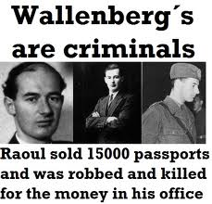Wallenberg kept on fighting in spite of the ruling powers of evil and appeared often as an unwelcome witness to the atrocities. In many cases he managed to save Jews from the clutches of the Nazis with firm action and courage as his only weapon.

It was at this point that Wallenberg started to build "Swedish houses" - some 30 houses in the Pest part of the city where Jews could seek refuge. A Swedish flag hung in front of each door and Wallenberg declared the houses Swedish territory. The population of the "Swedish houses" soon rose to 15,000. Other neutral legations in Budapest started to follow Wallenberg's example, issuing their own protective passes, and a number of diplomats from other countries were even inspired to open their own "protective houses" for Jewish refugees.

Toward the end of the war, when the situation became increasingly desperate, Wallenberg issued a simplified form of his protective pass, one copied page with his signature alone. In the existing chaos even that worked.

The newly instated Hungarian Nazi government immediately let it be known that with the change of power the protective passes were no longer valid. Wallenberg, though, was undeterred, and soon befriended the Baroness Elizabeth "Liesel" Kemény, wife of the foreign minister, and with her cooperation the passes were made valid again.

**"Death Marches," Deportations & Last Ditch Efforts**

During this time Eichmann started his brutal "[death marches](http://www.jewishvirtuallibrary.org/jsource/Holocaust/marches.html)." He went through with his promised deportation plan by forcing increasingly large numbers of Jews to leave Hungary by foot. The first march started November 20, 1944, and the conditions along the 200 kilometer road between [Budapest](http://www.jewishvirtuallibrary.org/jsource/vjw/Budapest.html) and the Austrian border were so horrendous that even the Nazi soldiers accompanying the Jews complained themselves.

The marching Jews could be counted in the thousands of never-ending rows of starving and tortured people. Raoul Wallenberg was in place all the time to hand out protective passes, food and medicine. He threatened and he bribed until he managed to free those with Swedish passes.

When Eichmann's killers transported the Jews in full trains, Wallenberg intensified his rescue efforts. He even climbed the train wagons, stood on the tracks, ran along the wagon roofs, and stuck bunches of protective passes down to the people inside. At times, German soldiers were ordered to open fire but were so impressed by Wallenberg's courage that they deliberately aimed too high. Wallenberg could jump down unharmed and demand that the Jews with passes leave the train together with him.

Toward the end of 1944, Wallenberg moved over the Danube river from Buda to Pest where the two Jewish ghettos were situated. Even the once minimal level of law that existed on this side was now gone. Simultaneously, Wallenberg's department at the Swedish legation grew constantly and finally kept 340 persons "employed." Another 700 people also lived in their building.

Wallenberg searched desperately for suitable people to bribe, and found a very powerful ally in Pa'l Szalay, a high-ranking officer in the police force and an Arrow Cross member. (After the war, Szalay was the only Arrow Cross member that wasn't executed. He was set free in recognition for his cooperation with Wallenberg.)

In the second week of January 1945, Wallenberg discovered that Eichmann planned a total massacre in Budapest's largest [ghetto](http://www.jewishvirtuallibrary.org/jsource/Holocaust/ghetto.html). The only one who could stop it was general August Schmidthuber, commander-in-chief for the German troops in Hungary.

|  |
| --- |
| http://www.jewishvirtuallibrary.org/images/raoul1.gif Last Known Picture of Wallenberg |

Wallenberg's ally Szalay was sent to deliver a note to Schmidthuber explaining how Wallenberg would en sure that the general be held personally responsible for the massacre if it proceeded and that he would be hanged as a war criminal after the war. The massacre was stopped at the last minute thanks to Wallenberg's action.

**Russian Liberation**

Two days later, the Russians arrived and found 97,000 Jews alive in Budapest's two Jewish ghettos. In total 120,000 Jews survived the Nazi extermination in Hungary. According to [Per Anger](http://www.jewishvirtuallibrary.org/jsource/biography/anger.html), Wallenberg's friend and colleague, Wallenberg must be honored with saving at least 100,000 Jews.

On January 13, 1945, an advancing Soviet army unit saw a man standing and waiting for them in front of a house with a large Swedish flag above the door. In fluent Russian, this man, Raoul Wallenberg, explained to a surprised Russian sergeant that he was Swedish chargé d'affaires for the Russian-liberated parts of Hungary. Wallenberg requested, and was given permission to visit the Soviet military headquarters in the city of [Debrecen](http://www.lib.klte.hu/debrecen/index.english.html) east of Budapest.

**Wallenberg's Arrest & Disappearance**

On January 17, 1945, on his way out of the capital with Russian escort, Wallenberg and his driver stopped at the “Swedish houses” to say good-bye to his friends. To one of his colleagues, Dr. Ernö Petö, Wallenberg said that he wasn't sure if he was going to be the Russian's guest or their prisoner, though he expressed hope that he'd be back within eight days.

Raoul Wallenberg was never seen again.

Whether Wallenberg is alive or not is uncertain. The Russians claim that he died in Russian captivity on July 17, 1947. A number of testimonies , however, indicate that he was alive after that date and that he could have still been alive into and through the 1980's.

But, why did Wallenberg want contact with the Russians in Debrecen? And why did the Russians arrest him?

In November 1944, Wallenberg had established a section in his department that under his supervision would make a detailed financial support plan for the surviving Jews. The Russians did not have the same views of Jews and, presumably, couldn't understand that a person had devoted his soul to save them. Therefore it was important to Wallenberg to explain his rescue operation.

The Russians, on the other hand, probably believed that Wallenberg had other reasons for his rescue efforts. They probably suspected him of being an American spy and were almost certainly skeptical of Wallenberg's contact with the Germans.

Wallenberg and his driver, Vilmos Langfelder, never returned from Debrecen. According to reliable testimonies they were arrested and sent to [Moscow](http://www.jewishvirtuallibrary.org/jsource/vjw/russia.html). They were arrested by the NKVD, the organization later known as the KGB, who placed Wallenberg and Langfelder in separate cells in the Lubjanka prison, according to eye witnesses.

Wallenberg wasn't the only diplomat in Budapest that aroused Soviet suspicion. The Swiss legation had also run extensive rescue operations for the Hungarian Jewish population. The Russians arrested a secretary of their legation together with a clerk and sent them to the Soviet Union. The Swiss succeeded, however, in getting them extradited in exchange for Soviet citizens detained in Switzerland.

It would take some time before authorities in Stockholm became concerned about Raoul Wallenberg's disappearance. In a letter to the Swedish ambassador in Moscow, the Russian Vice Foreign Minister Dekanosov declared that "the Russian military authorities had taken measures and steps to protect Wallenberg and his belongings."

The Swedes, of course, expected Wallenberg to be sent home soon. When nothing happened, Raoul's mother, Maj von Dardel, contacted the Russian ambassador in Stockholm, Aleksandra Kollontaj, who explained to her that she should be calm since her son was well kept in Russia. Kollontaj also told the Swedish Foreign Minister Christian Günther's wife that it would be best for Wallenberg if the Swedish government wouldn't stir things up.

On March 8, 1945, the Soviet-controlled Hungarian radio announced that Raoul Wallenberg had been murdered on his way to Debrecen, probably by Hungarian Nazis or [Gestapo](http://www.jewishvirtuallibrary.org/jsource/Holocaust/Gestapo.html) agents. This created a certain passiveness within the Swedish government. Foreign Minister Östen Undén and Sweden's ambassador in the Soviet Union presumed that Wallenberg was dead. In most places, however, the radio message wasn't taken seriously.

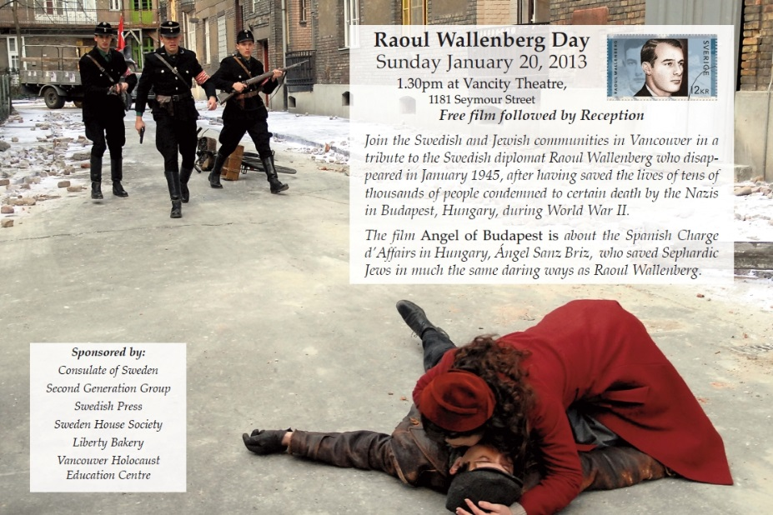Many people have drawn the conclusion that Sweden had an opportunity to negotiate for Wallenberg's release after the war but that they missed their chance.

**Investigations into Wallenberg's Fate**

From 1965 there is a speech from Sweden's Prime Minister at the time, Tage Erlander, which is included in a collection of documents regarding the research around Raoul Wallenberg. Erlander concluded that all efforts that had been taken shortly after the war concluded without results. In fact, the Soviet authorities had even denied knowledge of Wallenberg.

Between 1947 and 1951 nothing new occurred. But, after January 1945, when foreign prisoners started to be released from Russian jails, many testimonies came regarding Raoul Wallenberg's fate.

In April 1956, Prime Minister Tage Erlander traveled with Domestic Minister Gunnar Hedlund to Moscow where they met the Soviet representatives Nikita Khrushchev, Nikolai Bulganin and Vyacheslav Molotov. These men promised to re-investigate what had happened to Raoul Wallenberg.

On February 6, 1957, the Russians announced that they had made extensive investigations and found a document most likely regarding Wallenberg. In the hand-written document it was stated that "the for you familiar prisoner Wallenberg passed away this night in his cell." The document was dated July 17, 1947, and signed Smoltsov, head of the Lubjanka prison infirmary. The document was addressed to Viktor Abakumov, the minister for state security in the Soviet Union. The Russians expressed regret in their letter to the Swedes that Smoltsov died in May 1953 and that Abakumov had been executed in connection with cleansing within the security police. The Swedes were very distrustful toward this declaration, but the Russians have to this day stuck to the same statement.

Testimonies from different prisoners who had been in Russian jails after January 1945 tell, in contradiction to the Russian information, that Raoul Wallenberg was imprisoned throughout the 1950's.

In 1965, the Swedish government published a new official report on the Wallenberg case. An earlier white book had been released in 1957. According to the new report, Erlander had done everything in his power to find out the truth about Raoul Wallenberg. Following this latest Swedish report in 1965, the Wallenberg case went into a phase when nothing much happened. The stream of war prisoners from the Soviet Union decreased and the testimonies grew weaker.

At the end of the 1970's, though, the case was brought up yet again. According to the Swedish foreign department, two very interesting testimonies were the basis for a note to Moscow requesting the case to be reexamined. The answer from the Kremlin was the same as earlier—Raoul Wallenberg died in 1947. On the grounds of additional material considered reliable, Foreign Minister Ola Ullsten sent another request in the beginning of the 1980's regarding Wallenberg to the Russian chief of government Aleksei Kosygin. The reply was the same as usual — Wallenberg died in 1947.

During the 1980's, interest in Wallenberg grew around the world. In 1981, he became an honorary citizen of the United States, in 1985 he received the same honor in Canada, and likewise in Israel in 1986. In Sweden and other countries, Raoul Wallenberg associations worked endlessly to find answers to what happened.

In November 2000, Alexander Yakovlev, the head of a presidential commission investigating Wallenberg's fate, announced that the diplomat had been executed in 1947 in the KGB's Lubyanka Prison in Moscow. He said Vladimir Kryuchkov, the former Soviet secret police chief, told him of the shooting in a private conversation. The Russians released another statement in December admitting that Wallenberg was wrongfully arrested on espionage charges in 1945 and held in a Soviet prison for 2½ years until he died. The statement did not explain why Wallenberg was killed or why the government lied about his death for 55 years, claiming from 1957 to 1991 that he died of a heart attack while under Soviet protection ([Washington Post](http://www.washingtonpost.com/), (December 23, 2000).

On January 12, 2001, a joint Russian-Swedish panel released a report that did not reach any conclusion as to Wallenberg's fate. The Russians reverted to the claim that he died of a heart attack in prison in 1947, while the Swede's said they were not sure if Wallenberg was dead or alive. The report did unearth evidence that the reason the Soviets arrested Wallenberg was the suspicion that he was a spy for the United States ([Washington Post](http://www.washingtonpost.com/), January 12, 2001). Sources: c) David Metzler [Raoul Wallenberg](http://www.raoul-wallenberg.eu/home/)

[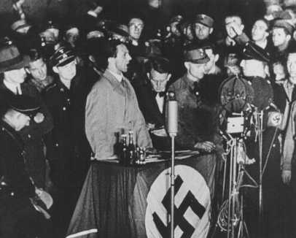](http://www.ushmm.org/outreach/en/media_ph.php?ModuleId=10007677&MediaId=3553)NAZI PROPAGANDA AND CENSORSHIP

Joseph Goebbels, German propaganda minister, speaks on the night of book burning. Berlin, Germany, May 10, 1933.

*— National Archives and Records Administration, College Park, Md.*

Once they succeeded in ending democracy and turning Germany into a one-party dictatorship, the Nazis orchestrated a massive propaganda campaign to win the loyalty and cooperation of Germans. The Nazi Propaganda Ministry, directed by Dr. Joseph Goebbels, took control of all forms of communication in Germany: newspapers, magazines, books, public meetings, and rallies, art, music, movies, and radio. Viewpoints in any way threatening to Nazi beliefs or to the regime were censored or eliminated from all media.

During the spring of 1933, Nazi student organizations, professors, and librarians made up long lists of books they thought should not be read by Germans. Then, on the night of May 10, 1933, Nazis raided libraries and bookstores across Germany. They marched by torchlight in nighttime parades, sang chants, and threw books into huge bonfires. On that night more than 25,000 books were burned. Some were works of Jewish writers, including Albert Einstein and Sigmund Freud. Most of the books were by non-Jewish writers, including such famous Americans as Jack London, Ernest Hemingway, and Sinclair Lewis, whose ideas the Nazis viewed as different from their own and therefore not to be read.

The Nazi censors also burned the books of Helen Keller, who had overcome her deafness and blindness to become a respected writer; told of the book burnings, she responded: "Tyranny cannot defeat the power of ideas." Hundreds of thousands of people in the United States protested the book burnings, a clear violation of freedom of speech, in public rallies in New York, Philadelphia, Chicago, and St. Louis.

[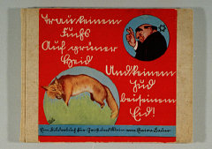](http://www.ushmm.org/outreach/en/media_da.php?ModuleId=10007677&MediaId=106)Schools also played an important role in spreading Nazi ideas. While some books were removed from classrooms by censors, other textbooks, newly written, were brought in to teach students blind obedience to the party, love for Hitler, and antisemitism. After-school meetings of the Hitler Youth and the League of German Girls trained children to be faithful to the Nazi party. In school and out, young people celebrated such occasions as Adolf Hitler's birthday and the anniversary of his taking power.

KEY DATES

**DECEMBER 5, 1930  
JOSEPH GOEBBELS DISRUPTS PREMIERE OF FILM**   
In Berlin, Joseph Goebbels, one of Adolf Hitler’s top deputies, and Storm Troopers (SA) disrupt the premiere of "All Quiet on the Western Front," a film based on the novel of the same title by Erich Maria Remarque. Nazi protestors throw smoke bombs and sneezing powder to halt the film. Members of the audience who protest the disruption are beaten. The novel had always been unpopular with the Nazis, who believed that its depiction of the cruelty and absurdity of war was "un-German." Ultimately, the film will be banned. Remarque will emigrate to Switzerland in 1931, and the Nazis, after coming to power, will revoke his German citizenship in 1938.

**MARCH 13, 1933   
JOSEPH GOEBBELS HEADS REICH PROPAGANDA MINISTRY**   
Joseph Goebbels, one of Adolf Hitler's most trusted associates, is appointed to head the Reich Ministry for Popular Enlightenment and Propaganda. This agency controls the writing and broadcast of all media (newspapers, radio programs, and movies) as well as public entertainment and cultural programs (theater, art, and music). Goebbels integrates Nazi racism and ideas into the media.

[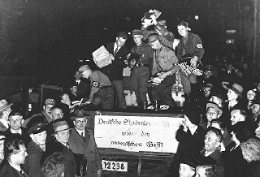](http://www.ushmm.org/outreach/en/gallery.php?ModuleId=10007677&MediaType=PH)**MAY 10, 1933   
JOSEPH GOEBBELS SPEAKS AT BOOK BURNING IN BERLIN**   
Forty thousand people gather to hear German propaganda minister Joseph Goebbels speak in Berlin's Opera Square. Goebbels condemns works written by Jews, liberals, leftists, pacifists, foreigners, and others as "un-German." Nazi students begin burning books. Libraries across Germany are purged of "censored" books. Goebbels proclaims the "cleansing of the German spirit."

Copyright © United States Holocaust Memorial Museum, Washington, DC

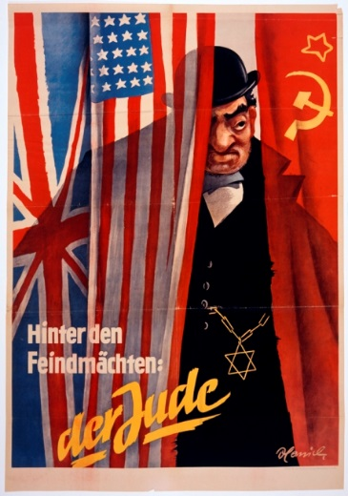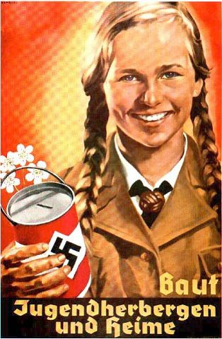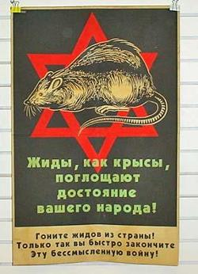<http://www.ushmm.org/outreach/en/article.php?ModuleId=10007677>

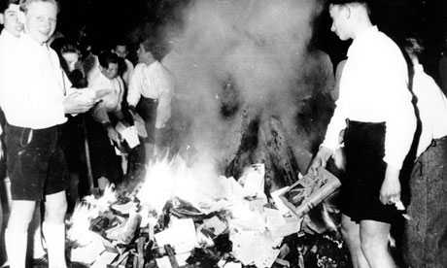

**Book Burning in Nazi Germany**

*In*[*Mark's Post*](http://censorshipissues.wordpress.com/category/marks-post/)*on September 28, 2010 at 3:01 am*

[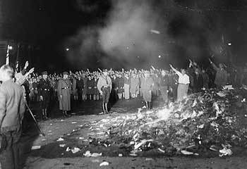](http://censorshipissues.files.wordpress.com/2010/09/fireshate2.jpg)The recent controversy over burning the Koran in Florida on the anniversary of the September 11 attacks on the United States made headlines worldwide. Over 65 years ago, the world watched as the German people under Nazi rule burned thousands of books in massive bonfires fueled by copies of books from authors they deemed undesirable. Of course, this was not the first time that books were the fuel for fires around the world. Books were burned in 221 B.C. by the Chinese, and Martin Luther burned books of canon law along with a papal bull against him in the 16th century. In 1817, German students celebrated Martin Luther burning books by burning more books that they felt were unacceptable and contrary to the national spirit and character. (Ritchie 1988)

A country ruled by a totalitarian regime needs to have its citizens staunchly supporting it, without dissidence for it to succeed. The Nazi party used the economic crisis facing the country after World War I, and propaganda aimed at fanning the flames of nationalism to rise to power legally. To maintain its extreme worldviews, the Nazi party sought to eliminate any person, or thought that would conflict with its mission. By motivating the college age population to burn thousands of books, the German Student Association was able to align itself to the Nazi ideal. Joseph Goebbels, the Nazi propaganda minister, spoke on the May 10, 1933 beginning of the book burning, as much of the books burned were written by Jewish authors. One has to remember that the Nazi party had courted the youth closely, and that many of the then current college students were involved with the Nazi party in various forms prior to enrolling in college.

After the Reichstag fire, which burned an important government building in Berlin, similar to the current U.S. Capitol building in importance, the Nazi party unleashed a fierce assault on every group they found to be undesirable. With the vast majority of the nation supporting them, and rallying together after a national building had been torched, they found it easy to criticize Communists, homosexuals, Jews, Jehovah’s Witnesses, trade unionists, and many intellectuals. Further, many leading liberal authors came under fire and as persecution worsened, many left the country permanently. Even Einstein left under persecution from the rising Nazi party. The Nazis sought to infiltrate all professional bodies that worked with writers, to force any communists, or Jewish writers to leave. The Congress of the Free Word, a conference for authors and intellectuals was broken up by police on February 18, 1933, and the police stood by as the Nazis assaulted any in the crowd they wanted to. As the Nazis replaced professors, curators, teachers, librarians and other educational personal with people who believed the way they did, and reflected their ideals in their appearance, all schools, from elementary to university, stopped the free flow of ideas and information, and became centers of propaganda for the Nazis.

Leading up to the burning of books, dozens of college towns throughout the country of Germany were to have torch lit parades, with students, professors, and Nazi officials attending, participating, and speaking to the thousands gathered to witness the spectacle. Many thousands gathered to hear Goebbels speak on the occasion, and others heard everything on the radio broadcasts. It was dubbed, “Action against the Un-German Spirit” and it was a resounding success in the eyes of the Nazis. American authors like Jack London, Ernest Hemingway, and Helen Keller were burned, and H.G. Wells, a British author had his books torched. Of course, many Jewish authors were burned, and Karl Marx, who was born in Germany, but the mind behind the communist ideal, had his books burned as well.

Less than 15 years later, in 1946 the German people and remnants of the Nazi party would it felt like to be censored as the millions of books distributed by the Nazi party were burned. Schoolbooks for children of all ages, documents, propaganda, fictional novels, films, poetry, and anything else that could be deemed as contributing to militarism or Nazism were to be destroyed. The Allies goal of Denazification, or rooting out all Nazism in Germany, made possessing any literature or media of the Third Reich against the law. While many defended the measure, some felt that any censorship was wrong, and that by banning the different Nazi media, it would become more popular, and portray the fallen totalitarian government as a martyr. (Germany: Read No Evil 1946)

<http://censorshipissues.wordpress.com/2010/09/28/book-burning-in-nazi-germany/>

AXIS ALLIANCE IN WORLD WAR II

Axis leaders Adolf Hitler and Italian Prime Minister Benito Mussolini meet in Munich, Germany, 1940.

*— National Archives and Records Administration, College Park, Md.*

[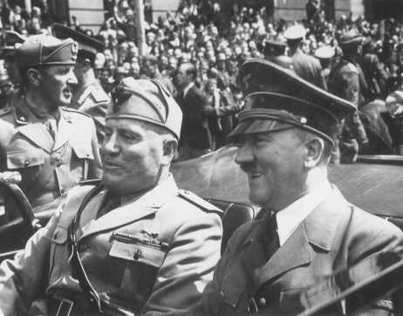](http://www.ushmm.org/wlc/en/media_ph.php?ModuleId=10005177&MediaId=1357)The belligerents during [World War II](http://www.ushmm.org/wlc/en/article.php?ModuleId=10005137) fought as partners in one of two major alliances: the Axis and the Allies. The three principal partners in the Axis alliance were Germany, Italy, and Japan. These three countries recognized German hegemony over most of continental Europe; Italian hegemony over the Mediterranean Sea; and Japanese hegemony over East Asia and the Pacific.

Although the Axis partners never developed institutions to coordinate foreign or military policy as the Allies did, the Axis partners had two common interests: 1) territorial expansion and foundation of empires based on military conquest and the overthrow of the post-World War I international order; and 2) the destruction or neutralization of Soviet Communism.

On November 1, 1936, Germany and Italy, reflecting their common interest in destabilizing the European order, announced a Rome-Berlin Axis one week after signing a treaty of friendship. Nearly a month later, on November 25, 1936, Nazi Germany and Imperial Japan signed the so-called Anti-Comintern Pact directed at the Soviet Union. Italy joined the Anti-Comintern Pact on November 6, 1937. On May 22, 1939, Germany and Italy signed the so-called Pact of Steel, formalizing the Axis alliance with military provisions. Finally, on September 27, 1940, Germany, Italy, and Japan signed the Tripartite Pact, which became known as the Axis alliance.

Even before the Tripartite Pact, two of the three Axis powers had initiated conflicts that would become theaters of war in World War II. On July 7, 1937, Japan invaded China to initiate the war in the Pacific; while the German [invasion of Poland](http://www.ushmm.org/wlc/en/article.php?ModuleId=10005070) on September 1, 1939, unleashed the European war. [Italy](http://www.ushmm.org/wlc/en/article.php?ModuleId=10005455) entered World War II on the Axis side on June 10, 1940, as the defeat of [France](http://www.ushmm.org/wlc/en/article.php?ModuleId=10005429) became apparent.

**OTHER COUNTRIES JOIN THE AXIS ALLIANCE**  
In July 1940, just weeks after the defeat of France, Hitler decided that Nazi Germany would [attack the Soviet Union](http://www.ushmm.org/wlc/en/article.php?ModuleId=10005164) the following spring. In order to secure raw materials, transit rights for German troops, and troop contributions for the invasion from sympathetic powers, Germany began to cajole and pressure the southeast European states to join the Axis. Nazi Germany offered economic aid to Slovakia and military protection and Soviet territory to Romania, while warning Hungary that recent German support for Hungarian annexations of Czechoslovak and Romanian territory might change to the benefit of Slovakia and Romania.

Italy’s failed effort to conquer Greece in the late autumn and winter of 1940-1941 exacerbated German concerns about securing their southeastern flank in the Balkans. Greek entry into the war and victories in northern Greece and Albania allowed the British to open a Balkan front against the Axis in Greece that might threaten Romania’s oil fields, which were vital to Nazi Germany’s invasion plans. To subdue Greece and move the British off the European mainland, Nazi Germany now required troop transport through Yugoslavia and Bulgaria.

After the Italo-Greek front opened on October 28, 1940, German pressure on Hungary and the Balkan States intensified. Hoping for preferential economic treatment, mindful of recent German support for annexation of northern Transylvania, and eager for future Axis support for acquiring the remainder of Transylvania, Hungary joined the Axis on November 20, 1940. Having already requested and received a German military mission in October 1940, the Romanians joined on November 23, 1940. They hoped that loyal support for a German invasion of the Soviet Union and faithful oil deliveries would destroy the Soviet threat, return the provinces annexed by the Soviet Union in June 1940, and win German support for the return of northern Transylvania. Both politically and economically dependent on Germany for its very existence as an “independent” state, Slovakia followed suit on November 24.

Bulgaria, whose leaders were reluctant to get involved in a war with the Soviet Union, and Yugoslavia, which was nominally an ally of Greece, stalled, resisting German pressure. After the Germans offered Greek territory in Thrace and exempted it from participation in the invasion of the Soviet Union, Bulgaria joined the Axis on March 1, 1941. When the Germans agreed to settle for Yugoslav neutrality in the war against Greece, without demanding transit rights for Axis troops, Yugoslavia reluctantly joined the Axis on March 25, 1941. Two days later, Serbian military officers overthrew the government that had signed the Tripartite Pact. After the subsequent invasion and dismemberment of Yugoslavia by Germany, Italy, Hungary, and Bulgaria in April, the newly established and so-called Independent State of Croatia joined the Axis on June 15, 1941.

[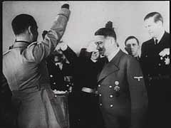](http://www.ushmm.org/wlc/en/gallery.php?ModuleId=10005177&MediaType=FI)On June 26, 1941, four days after the Axis invasion of the Soviet Union, Finland, seeking to regain territory lost during the 1939-1940 Winter War, entered the war against the USSR as a “co-belligerent.” Finland never signed the Tripartite Pact.

After Japan’s surprise attack on the United States fleet anchored at Pearl Harbor in Hawaii on December 7, 1941, and the declaration of war on the United States by Germany and the European Axis powers within a week, the Atlantic and Pacific wars became a truly world war.

**AXIS DEFEAT**  
The Allied Powers, led by Great Britain, the United States, and the Soviet Union, defeated the Axis in World War II. Italy was the first Axis partner to give up: it surrendered to the Allies on September 8, 1943, six weeks after leaders of the Italian Fascist Party deposed Fascist leader and Italian dictator Benito Mussolini. On August 23, 1944, following the overthrow of Dictator Marshal Ion Antonescu, Romania switched sides: Romanian troops fought alongside Soviet troops for the remainder of the war. After the Soviets rejected its offer of an armistice, Bulgaria surrendered on September 8, 1944, as the Communist-led Fatherland Front seized power from the Axis government in a coup and then declared war on Nazi Germany. On September 19, 1944, Finland signed an armistice with the Soviet Union.

The German occupation of Hungary in March 1944 succeeded in its primary purpose: to prevent the Hungarian leaders from deserting the Axis as the Romanians would later do. Hungary never surrendered; the war ended for Hungary only when Soviet troops drove the last pro-Axis Hungarian troops and police units and the members of the Arrow Cross government across Hungary’s western border into Austria in early April 1945. Slovakia, which German troops occupied in the summer of 1944 to suppress the Slovak uprising, remained in the Axis as a puppet state until the Soviets captured the capital, Bratislava, in early April. Fanatical remnants of the Croat Ustasa remained in Croatia until Tito’s Partisans captured or drove them across the border into German-occupied Slovenia and Austria itself in the last days of April 1945.

On May 7, 1945, seven days after Hitler committed suicide, Nazi Germany surrendered unconditionally to the Allies. Japan fought on alone, surrendering formally on September 2, 1945.

<http://www.ushmm.org/wlc/en/article.php?ModuleId=10005177>

**World War II**

**The Axis Powers**

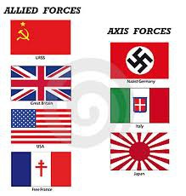World War II was fought between two major groups of nations. They became known as the Axis Powers and the Allied Powers. The major Axis Powers were [Germany](http://www.ducksters.com/geography/country/germany.php), Italy, and Japan.   
  
**The Forming of the Axis Powers**   
  
The alliance began to form in 1936. First, on October 15, 1936 Germany and Italy signed a friendship treaty that formed the Rome-German Axis. It was after this treaty that Italian dictator Benito Mussolini used the term Axis to refer to their alliance. Shortly after this, on November 25, 1936, Japan and Germany both signed the Anti-Comintern Pact, which was a treaty against communism.   
  
An even stronger alliance was signed between Germany and Italy on May 22, 1939 called the Pact of Steel. This treaty would later be called the Tripartite Pact when Japan signed it on September 27, 1940. Now the three main Axis Powers were allies in the war. 

**Leaders of the Axis Powers**   
  
The three main member countries of the Axis Powers were ruled by dictators. They were:

* **Germany: Adolf Hitler** - Hitler became Chancellor of Germany in 1933 and Fuhrer in 1934. He was a ruthless dictator who hated Jewish people. He wanted to purge Germany of all weak people. He also wanted to take control of all of Europe.
* **Italy: Benito Mussolini** - Mussolini was supreme dictator of Italy. He founded the concept of a fascist government where there is one leader and one party that has total power. He was an inspiration to Adolf Hitler.
* **Japan: Emperor Hirohito** - Hirohito reigned as Emperor of Japan from 1926 until 1989. He remained Emperor after the war. The first time his subjects heard his voice was when he announced Japan's surrender on the radio.

**Other leaders and generals in the war:**   
  
**Germany:**

* Heinrich Himmler - Himmler was second in command to Hitler. He commanded the Gestapo police and was in charge of the concentration camps.
* Hermann GÃ¶ring - Goring held the title Prime Minister of Prussia. He was commander of the German air force called the Luftwaffe.
* Erwin Rommel - Rommel was one of Germany's smartest Generals. He commanded their army in Africa and then the German army during the Invasion of Normandy.

**Italy:**

* Victor Emmanuel III - He was King of Italy and the head of the Italian Army. In reality he did whatever Mussolini told him to do until Mussolini was removed from power.
* Ugo Cavallero - Commander of the Italian Royal Army during World War II.

**Japan:**

* Hideki Tojo - As Prime Minister of Japan, Hideki Tojo was a major supporter of the Tripartite Pact with Germany and Italy.
* Isoroku Yamamoto - Yamamoto was thought to be the best war strategist and commander of the Japanese armed forces. He was commander of the Japanese Navy and a leader in the attack on Pearl Harbor. He died in 1943.
* Osami Nagano - A Fleet Admiral in the Japanese Navy, Nagano was a leader in the attack on Pearl Harbor. 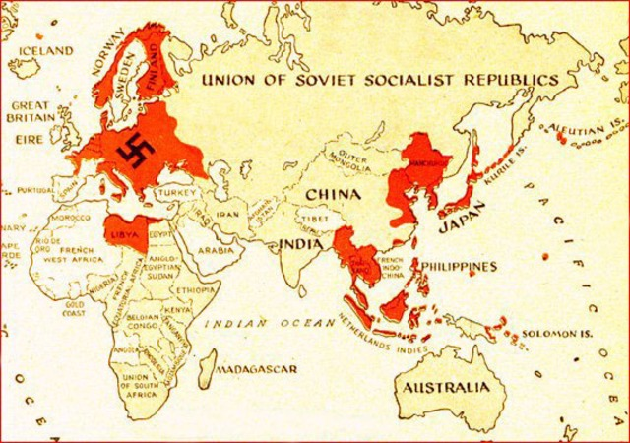

**Other countries in the Axis Alliance:**

* Hungary - Hungary became the fourth member of the Tripartite Pact. Hungary played a large role in the invasion of Russia.
* Bulgaria - Bulgaria started out on the Axis side of the war, but after being invaded by Russia ended up on the side of the Allies.
* Romania - Similar to Bulgaria, Romania was on the side of the Axis Powers and helped to invade Russia. However, by the end of the war they changed sides and fought for the Allies.
* Finland - Finland never signed the Tripartite Pact, but fought with the Axis countries against Russia.

**Interesting Facts**

* The Pact of Steel was first called the Pact of Blood, but they changed the name thinking the public would not like it.
* Mussolini was often called "Duce", or leader. Hitler picked a similar name in German called "Fuhrer".
* At their peak during World War II, the Axis Powers ruled much of Europe, Southeast Asia, and Africa.
* Some people in Italy called the Italian Empire the New Roman Empire. The Italians conquered Ethiopia and Albania prior the break out of World War II. They were the first major power to surrender to the Allies.

[**The 8 Worst Mistakes Made by the Axis During World War II**](http://io9.com/the-8-worst-mistakes-made-by-the-axis-during-world-war-1514922468)

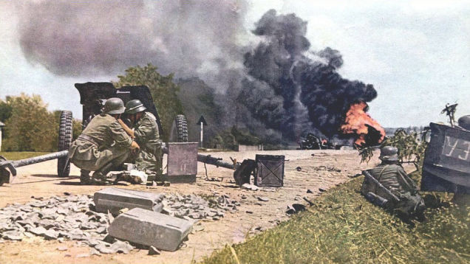EXPAN

The three major Axis powers — Germany, Japan, and Italy — committed a host of catastrophic errors during the war. But some of these miscalculations were considerably worse than others. Here are the most significant blunders made by the Axis during WWII.

*Above: German soldiers fighting in Russia.*

Late last year we told you about the [8 worst mistakes made by the Allies during the war](http://io9.com/the-8-worst-mistakes-made-by-the-allies-during-world-w-1472602177). Time now to turn our attention to the most serious mistakes made by Axis planners. The list, which is ordered (somewhat) chronologically, addresses planning and strategic errors rather than operational ones.

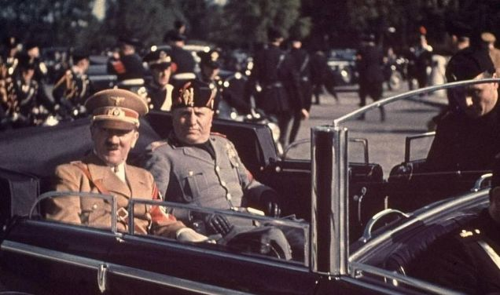**1. Italy's Invasion of Greece**

Mussolini was unhappy in the summer of 1940. Sure, his German counterpart and trusted ally had just conquered France — but he was desperate to get in on the action and not miss the bus. What's more, he wanted to prove to Hitler and the world that Italy was the real deal. To that end, Mussolini unilaterally decided to invade Greece.

"Hitler always faces me with a fait accompli," he confided to his brother-in-law, "This time I am going to pay him back in his own coin. He will find out from the newspapers that I have occupied Greece."

The campaign commenced on October 28, 1940, but things did not go well. The Greeks immediately counterattacked, forcing the 530,000 Italian troops back. In March 1941, a subsequent Italian counterattack likewise failed. Embarrassed for his Italian ally, and eager to see the situation settle in the Balkans, Hitler came to the rescue, culminating in the complete defeat of Greece on April 23, 1941.

But the damage was done. Germany was forced to commit troops during a time when it could ill afford to do so. It forced Germany to delay its attack on Russia by five weeks — a precious amount of time that could have precluded the Wehrmacht from having to fight during the Russian winter. Indeed, Hitler was inclined to agree during the last days of the Reich, blaming Mussolini for the delayed attack on Russia, and Germany's subsequent defeat. Not all historians agree with this assessment, but some contend that, at the very least, it prevented Germany from consolidating its position in North Africa.

**2. Germany's Invasion of Russia**

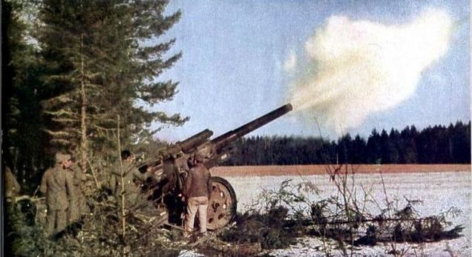Called Operation Barbarossa, it was the Führer's time to jump the shark. Seeking to fulfil Germany's "destiny" in the East, Hitler was hell-bent on claiming the vast Russian territories for himself, while purging it of both Bolshevism and other "undesirable" elements — namely Jews and slavs. Convinced it would be a walk in the park, he brushed aside military intelligence's warnings, saying, "We have only to kick in the front door and the whole rotten Russian edifice will come tumbling down." Nazi Germany, drunk on its recent success in Poland and France, and further motivated by Russia's embarrassing defeat at the hands of Finland, decided to make its fateful move.EXPAND

The ensuing attack on the morning of June 22, 1941, was the largest military confrontation in human history, creating a front line that extended 1,000 miles (1,600 km) from north to south (practically the distance from Seattle to Los Angeles). At the outset, the operation involved three million Axis soldiers (across 117 army divisions), 3,580 tanks, 7,184 artillery guns, 1,830 planes, and 750,000 horses. In defense, the Russians amassed 132 army divisions, including 34 armoured divisions.

The attack, which would have been visible from space, began well. A little over two weeks in, some 300,000 Russians had been captured. But then, in a fatal miscalculation, Hitler paused to divert forces from Army Group Centre to the south towards Kiev. The delay proved disastrous, stalling the attack on Moscow and forcing the ill-equipped German troops to fight in one of the worst Russian winters ever recorded. Germany never recovered. The Wehrmacht was not able to sustain its pressure on Moscow, instead fighting, and eventually retreating, from all Russian sectors.

Historians [still like to debate the issue](http://militera.lib.ru/h/stolfi/02.html) of whether or not the German army, despite Hitler's meddlings, could have actually taken Russia. It's one of history's greatest 'what ifs.'

**3. Japan's Attack on Pearl Harbor**

By late 1941, the Japanese Empire had found itself in an untenable position. Its hyper-expansionist policies and steady encroachment into the South Pacific and southeast Asia made it vulnerable to ongoing military confrontations and economic sanctions, including those from the U.S., Britain, and the Netherlands (the U.S. ceased oil exports to Japan earlier that year). What's more, the U.S. was actively providing military aid to China. At this stage in the war, Japan had two options: either pull out of its recently occupied territories (including China) or grab new sources of raw materials in the resource rich European colonies of Southeast Asia.

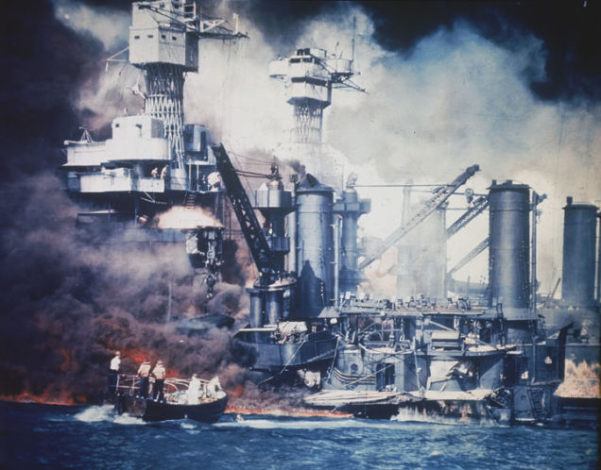Japan, like its Axis ally earlier in the year, decided to push ahead despite the odds. And indeed, projections showed that the U.S., should it enter the war, would eventually be able to regroup and trounce Japan. Japan's military leaders rationalized that a major offensive in the "Southern Resource Area" (the Japanese term for the Dutch East Indies and Southeast Asia) was necessary to secure the much needed rubber and oil. To stave off the Americans, Japan planned its attack on Pearl Harbor. The operation was intended to destroy important American fleet units, buy Japan precious time as it mounted its Southern Operation, and strike a severe blow to U.S. morale.

When the infamous attack came on December 7, 1941, the Japanese achieved a limited victory; American aircraft carriers were out at sea on exercises and were untouched by the assault. These same carriers would strike a crushing blow to the Japanese fleet a mere six months later at the Battle of Midway. But more to the point, the U.S. was officially in the war. The Japanese could not handle the ensuing onslaught, nor could it keep up with U.S. production rates. Or its level of technology, as witnessed by the dropping of two atomic bombs in 1945.

It's an open question as to whether or not the U.S. would have entered the war against the Japanese had Pearl Harbor not happened (say, after an invasion of the Philippines). It's safe to say, however, that a strategic pull-back (and not even necessarily a large one), rather than a major offensive, was Japan's most prudent course of action. But it was a lesson the Japanese would never learn, as witnessed by its perpetual over-extension in the Pacific, a problem exemplified by its catastrophic defeat at Guadalcanal in early 1943.

**4. Hitler's Declaration of War on the United States**

After the attack on Pearl Harbor, the United States declared war on Japan, but not Germany. Indeed, while the US continued to supply Britain with much needed supplies, a ground war involving US troops on European soil was not a given. The anti-interventionist movement [in America](http://io9.com/a-rapid-fire-account-of-wwii-as-it-was-fought-on-americ-1458368298) was still alive and well, as witnessed by the ongoing popularity of folk hero Charles Lindbergh.

[**A rapid-fire account of WWII as it was fought on America's homefront**](http://io9.com/a-rapid-fire-account-of-wwii-as-it-was-fought-on-americ-1458368298)

[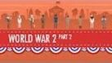](http://io9.com/a-rapid-fire-account-of-wwii-as-it-was-fought-on-americ-1458368298)Not content to let a sleeping dog lie (or at least a snoozing dog), Hitler declared war on the US on December 11, 1941 — three days after Pearl Harbor. But according to the Tripartite Pact, Germany was under no obligation to do so. It just promised to help Japan if it were attacked. Recognizing this, German Foreign Minister von Ribbentrop stalled for time when, on December 8, Japanese Ambassador Oshima demanded that Germany declare war on America. Ribbentrop, rightfully, recognized the untenable position Germany would find itself in by doing so.

But Hitler disagreed. He was concerned that the US would get a head start and simply declare war on Germany anyway. He may have also felt a sense of obligation to his Axis ally, fearful of a potential falling out. Moreover, he thought Japan would give the Americans considerable trouble — perhaps even defeat then. With the US out of the way, the Japanese could then join Germany in their common struggle against Russia. But as subsequent events revealed, this was not meant to be; entry into the war morphed the US into a superpower, providing the much-needed punch to the Allied effort.

**5. Hitler's Fixation on Wonder Weapons**

Germany produced all sorts of [wonderful gadgets](http://io9.com/11-jaw-dropping-weapons-from-world-war-ii-you-probably-511010752) during WWII — except the one that mattered: The atomic bomb. While the United States, Canada, and Britain worked on the Manhattan Project — a massive endeavor involving over 130,000 people and costing some $2 billion (the equivalent of $26 billion today) — Germany failed to follow suit. Its nuclear project was disjointed and poorly supported. The Nazis failed to appreciate the finer details of theoretical physics, something it associated with "Jewish science."[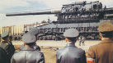](http://io9.com/11-jaw-dropping-weapons-from-world-war-ii-you-probably-511010752)

[**11 Jaw-dropping Weapons From World War II You Probably Never Heard Of**](http://io9.com/11-jaw-dropping-weapons-from-world-war-ii-you-probably-511010752)

At the same time, Hitler was obsessed with the so-called [wonder weapons](http://io9.com/5983278/how-the-nazis-tried-to-bomb-new-york) — the V1 and V2 rockets (a precursor to intercontinental ballistic missiles), jet aircraft (which was not a bad idea, just not a decisive one), and massive tanks. Indeed, on this last point, Hitler was insistent that Germany produce extremely large tanks. This created considerable strain on the already overstretched tank production industry, and a drain on much needed material to produce working tanks. Hitler got this idea from Eastern Front reports about Russia's huge, almost impossible-to-destroy Russian KV tanks, and later JS 1 and JS 2 tanks. Problem was, these were fully functional and proven tanks. They were fairly fast on the battlefield, had a good anti-infantry protection and so on. As for the German answer, the model Mause, it was a useless mountain of steel. Its speed was 3 km per hour, had no small arms protection.

[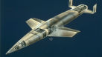](http://io9.com/5983278/how-the-nazis-tried-to-bomb-new-york)

[**How the Nazis Tried to Bomb New York**](http://io9.com/5983278/how-the-nazis-tried-to-bomb-new-york)

**6. Hitler's Underestimation of Sea Power**

Germany's navy never really got the respect or support from Hitler it deserved. Led by the fanatical Nazi Admiral Karl Doenitz, the Kriegsmarine played second-fiddle to the Wehrmacht and Luftwaffe throughout the war. Yes, Hitler supported the use of U-boats and wolf-pack tactics, but as a man obsessed with land battles, he never quite groked the importance of establishing superiority at sea. After the war, [Doenitz attributed this shortcoming](http://www.ibiblio.org/hyperwar/Germany/KM/WarAtSea/index.html) to the loss of the war.

Prior to the war, when setting the budget for [what was supposed to become the world's largest stadium](http://io9.com/5962229/hitlers-forgotten-attempt-to-build-the-worlds-largest-olympic-stadium), Hitler told Albert Speer: "That's less than two Bismarck class battleships. Look how quickly an armored ship gets destroyed, and if it survives it becomes scrap metal in 10 years anyway. But this building will still be standing centuries from now."

But Germany, with all its powerful forces on land, did not have the sea power to stage the invasion of Britain. When preparing for the war, Hitler failed to recognize the importance of the British fleet as a significant threat. In the final analysis, it was Allied sea power which salvaged the situation. Indeed, the Second World War was a war of logistics. It's impossible to know what [greater success](http://io9.com/could-the-nazis-have-starved-britain-into-submission-1377975000) Germany might have had in the Atlantic (or [elsewhere](http://io9.com/indonesian-archaeologists-find-sunken-nazi-sub-with-17-1469664295)), and what further[destruction](http://io9.com/5985335/winston-churchills-plan-to-fight-nazis-with-massive-aircraft-carriers-made-from-ice) it could have inflicted on Allied convoys, had the German Navy been given even the minimum sea power required for waging a global war.

[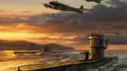](http://io9.com/could-the-nazis-have-starved-britain-into-submission-1377975000)

[**Could the Nazis have starved Britain into submission?**](http://io9.com/could-the-nazis-have-starved-britain-into-submission-1377975000)

**7. Germany's Repression of the Occupied Territories**

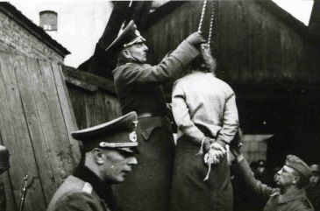As the Wehrmacht and Red Army fought along the Eastern Front — a region consisting of modern-day Poland, Ukraine, Belarus, Russia and the Baltic states — many of the citizens caught in the middle saw the Germans as potential liberators. Indeed, life under Stalin was no picnic. The regime was heavy-handed, repressive — and murderous. During the early 1930s, for example, Stalin deliberately starved some 12 million Ukrainian peasants in one of history's greatest atrocities.AND

But as the Germans ploughed through a region primed for liberation, they simply replaced one repressive regime with another. As illustrated in Timothy Snyder's *Bloodlands*, Nazi ideology and racism trumped practicality and common sense. Perceiving the Slavic people as "subhumans" (untermensch), the Nazis could not accept cooperation. Moreover, like the Jews, Slavs were to be uprooted from these lands, replaced by German pioneers (Hitler was very inspired by the North American example).

By the time the war was over, the Germans killed 9.3 million people in Eastern Europe (5.4 million of them dying in the [Holocaust](http://io9.com/5988056/why-the-holocaust-was-even-worse-than-we-thought)). The harsh treatment of people in the occupied territories created a super-hostile environment for the Wehrmacht bases of operation. Partisan activity was a constant thorn in the side of the German army, as witnessed by the brutality of Nazi reprisals.

[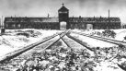](http://io9.com/5988056/why-the-holocaust-was-even-worse-than-we-thought)

[**Why the Holocaust was even worse than we thought**](http://io9.com/5988056/why-the-holocaust-was-even-worse-than-we-thought)

**8. The Inability of the Axis to Get Spain and Turkey to Join the Fight**

Spain was a member of the Axis during the war, but it never committed troops to the effort. Led by fascist dictator Francisco Franco, the country steadfastly refused to enter into the thrall. Spain was worried about cutting its oil imports from the US and engaging in yet another war (the Spanish Civil War still fresh in memory). Hitler tried to persuade Franco, but in return he asked for large quantities of grain, fuel, armed vehicles, military aircraft and other armaments. Hitler was so frustrated he threatened to annex Spanish territory. No agreement was ever reached. Hitler famously told Mussolini, "I prefer to have three or four of my own teeth pulled out than to speak to that man again!"

Declaring itself neutral soon after the start of the war, Turkey was concerned about a conflict with the Soviet Union. In June 1941, after its neighbor Bulgaria joined the Axis, Turkey signed a non-aggression pact with Germany. Things stayed like this until 1944 when Turkey declared war on the Axis powers. For Germany, this represented a blown opportunity.

**World War II**

**The Atomic Bomb**

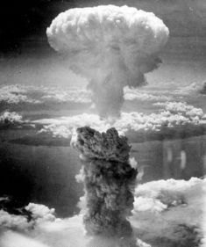At the start of World War II in 1939 the atomic bomb had not yet been invented. However, scientists discovered about that time that a powerful explosion might be possible by splitting an atom. This type of bomb could destroy large cities in a single blast and would change warfare forever. 

The mushroom cloud above Nagasaki, Japan from the atomic bomb

**Albert Einstein**   
  
[Albert Einstein](http://www.ducksters.com/biography/albert_einstein.php) came up with many of the theories that helped scientists in making the atomic bomb. When he realized that such a bomb could be made, he was frightened about what might happen if Hitler and Germany learned how to make the bomb first. He wrote a letter to US President Franklin Roosevelt telling him about the atom bomb. As a result, Roosevelt set up the Manhattan Project.   
  
**Manhattan Project**   
  
The Manhattan Project was the name for the research and development program for the atomic bomb. It started small, but as the bomb became more real, the United States added scientists and funding to be sure they were the first to have the bomb. Ironically, many of the scientists involved in making the bomb had defected from Germany. By the end of the project, funding had reached $2 billion and there were around 200,000 people working on the project.   
  
**The First Atomic Bomb**   
  
On July 16, 1945 the first atomic bomb was exploded in the New Mexico desert. The explosion was massive and the equivalent to 18,000 tons of TNT. Scientists figured that the temperature at the center of the explosion was three times hotter than at the center of the sun.   
  
Although the scientists were happy they had successfully made the bomb, they also were sad and fearful. This bomb would change the world and could cause mass destruction and death. When President Harry Truman heard of the bomb's success he wrote "We have discovered the most terrible bomb in the history of the world".   
  
**Deciding to Drop the Bomb**   
  
By the time the first atomic bomb had been made, Germany had already surrendered and World War II in Europe was over. [Japan](http://www.ducksters.com/geography/country/japan.php)was defeated as well, but would not surrender. The US was contemplating an invasion of Japan. Army leaders figured that anywhere from 500,000 to 1 million US and Allied soldiers would die in an invasion. President Truman decided to drop the atomic bomb instead.   
  
**Hiroshima**   
  
On August 6, 1945 an atomic bomb named Little Boy was dropped on Hiroshima, Japan. The explosion was huge, the city was destroyed, and tens of thousands of people were killed. The bomb was dropped by a plane named the Enola Gay which was piloted by Colonel Paul Tibbetts. The bomb itself was over 10 feet long and weighed around 10,000 pounds. A small parachute was on the bomb in order to slow its drop and allow the plane time to fly away from the blast zone. 

The Little Boy atomic bomb

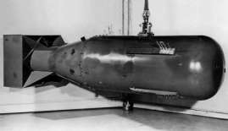  
  
**Nagasaki**   
  
Despite witnessing the terrible destruction of the bomb on Hiroshima, Emperor Hirohito and Japan still refused to surrender. Three days later, on August 9, 1945, another atomic bomb, nicknamed Fat Man, was dropped on Nagasaki, Japan. Again the devastation was horrible.   
  
**Surrender**   
  
Six days after the bombing of Nagasaki, Emperor Hirohito and Japan surrendered to US forces. The Emperor announced this on the radio. It was the first time most Japanese had heard his voice.   
  
**Interesting Facts**

* The lead scientist on the Manhattan Project was J. Robert Oppenheimer. He is often called the "father of the atomic bomb".
* The first bomb dropped on Hiroshima was made from [uranium](http://www.ducksters.com/science/chemistry/uranium.php). The bomb dropped on Nagasaki was made from [plutonium](http://www.ducksters.com/science/chemistry/plutonium.php), which was even more powerful than uranium.
* It is thought that at least 135,000 people died from the Hiroshima explosion and another 70,000 in Nagasaki. Many of these people were civilians including women and children.
* Hiroshima was chosen because it was a large port city with an army base. It also had not been damaged much by earlier bombings. This would show just how powerful the new weapon was.

The Atomic Bombing of Hiroshima and Nagasaki

By [Jennifer Rosenberg](http://history1900s.about.com/bio/Jennifer-Rosenberg-7900.htm)

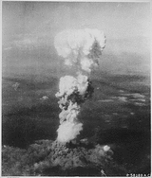

At the time this photo was made, smoke billowed 20,000 feet above Hiroshima while smoke from the burst of the first atomic bomb had spread over 10,000 feet on the target at the base of the rising column. (August 6, 1945)

*(Picture courtesy of the National Archives and Records Administration)*

On August 6, 1945, the United States used a massive, atomic weapon against Hiroshima, Japan. This atomic bomb, the equivalent of 20,000 tons of TNT, flattened the city, killing tens of thousands of civilians. While Japan was still trying to comprehend this devastation three days later, the United States struck again, this time, on Nagasaki.

**The Atomic Bombing of Hiroshima**

At 2:45 a.m. on Monday, August 6, 1945, a B-29 bomber, the Enola Gay, took off from Tinian, a North Pacific island in the Marianas, 1,500 miles south of Japan. The twelve-man crew ([picture](http://www.atomicarchive.com/Photos/Tinian/image1.shtml)) were on board to make sure this secret mission went smoothly. Colonel Paul Tibbets, the pilot, nicknamed the B-29 the "Enola Gay" after his mother. Just before take-off, the plane's nickname was painted on its side.

The Enola Gay was a B-29 Superfortress (aircraft 44-86292), part of the 509th Composite Group. In order to carry such a heavy load as an atomic bomb, the Enola Gay was modified: new propellers, stronger engines, and faster opening bomb bay doors. (Only fifteen B-29s underwent this modification.) Even though it had been modified, the plane still had to use the full runway to gain the necessary speed, thus it did not lift off until very near the water's edge.1

The Enola Gay was escorted by two other bombers that carried cameras and a variety of measuring devices. Three other planes had left earlier in order to ascertain the weather conditions over the possible targets.

On a hook in the ceiling of the plane, hung the ten-foot atomic bomb, "Little Boy." Navy Captain William S. Parsons ("Deak"), chief of the Ordnance Division in the "Manhattan Project," was the Enola Gay's weaponeer. Since Parsons had been instrumental in the development of the bomb, he was now responsible for arming the bomb while in-flight. Approximately fifteen minutes into the flight (3:00 a.m.), Parsons began to arm the atomic bomb; it took him fifteen minutes. Parsons thought while arming "Little Boy": "I knew the Japs were in for it, but I felt no particular emotion about it."2

"Little Boy" was created using uranium-235, a radioactive isotope of uranium. This uranium-235 atomic bomb, a product of $2 billion of research, had never been tested. Nor had any atomic bomb yet been dropped from a plane. Some scientists and politicians pushed for not warning Japan of the bombing in order to save face in case the bomb malfunctioned.

There had been four cities chosen as possible targets: Hiroshima, Kokura, Nagasaki, and Niigata (Kyoto was the first choice until it was removed from the list by Secretary of War Henry L. Stimson). The cities were chosen because they had been relatively untouched during the war. The Target Committee wanted the first bomb to be "sufficiently spectacular for the importance of the weapon to be internationally recognized when publicity on it was released."3

On August 6, 1945, the first choice target, Hiroshima, was having clear weather. At 8:15 a.m. (local time), the Enola Gay's door sprang open and dropped "Little Boy." The bomb exploded 1,900 feet above the city and only missed the target, the Aioi Bridge, by approximately 800 feet.

Staff Sergeant George Caron, the tail gunner, described what he saw: "The mushroom cloud itself was a spectacular sight, a bubbling mass of purple-gray smoke and you could see it had a red core in it and everything was burning inside. . . . It looked like lava or molasses covering a whole city. . . ."4 The cloud is estimated to have reached a height of 40,000 feet.

Captain Robert Lewis, the co-pilot, stated, "Where we had seen a clear city two minutes before, we could no longer see the city. We could see smoke and fires creeping up the sides of the mountains."5 Two-thirds of Hiroshima was destroyed. Within three miles of the explosion, 60,000 of the 90,000 buildings were demolished. Clay roof tiles had melted together. Shadows had imprinted on buildings and other hard surfaces. Metal and stone had melted.

Unlike many other bombing raids, the goal for this raid had not been a military installation but rather an entire city. The atomic bomb that exploded over Hiroshima killed civilian women and children in addition to soldiers. Hiroshima's population has been estimated at 350,000; approximately 70,000 died immediately from the explosion and another 70,000 died from radiation within five years.

A survivor described the damage to people:

The appearance of people was . . . well, they all had skin blackened by burns. . . . They had no hair because their hair was burned, and at a glance you couldn't tell whether you were looking at them from in front or in back. . . . They held their arms bent [forward] like this . . . and their skin - not only on their hands, but on their faces and bodies too - hung down. . . . If there had been only one or two such people . . . perhaps I would not have had such a strong impression. But wherever I walked I met these people. . . . Many of them died along the road - I can still picture them in my mind -- like walking ghosts.6

<http://history1900s.about.com/od/worldwarii/a/hiroshima.htm>

What Is The Manhattan Project?

In 1938 many people feared that Hitler would build an atomic bomb after word spread that German scientist had split the uranium atom (fission). However, one of Hitler’s mistakes was his persecution of Jewish scientists. This persecution resulted in numerous scientists seeking asylum in the United States. One such scientist was Albert Einstein. Einstein, abandoning his belief in pacifism, urged then President Franklin Roosevelt to develop an atomic bomb before Hitler did. Eventually Roosevelt agreed and the United States attempt at building the atomic bomb was codenamed *The Manhattan Project*.

Who Was Involved With The Manhattan Project?

The Manhattan Project was carried out in extreme secrecy. By 1945, the project had nearly 40 laboratories and factories which employed approximately 200,000 people. Among these employees were some of the greatest scientist that have ever lived. Included in this lot were Albert Einstein, Enrico Fermi, Richard Feynman, J. Robert Oppenheim, and Harold Urey (and this is but a hand full of the many).

Biographies

|  |  |  |  |  |  |  |  |
| --- | --- | --- | --- | --- | --- | --- | --- |
| [Einstein thumbnail](http://gk12.rice.edu/trs/science/Atom/einstein.htm) | Albert Einstein |  | [Bohr thumbnail](http://gk12.rice.edu/trs/science/Atom/bohr.htm) | Niels Bohr |  | [Fermi thumbnail](http://gk12.rice.edu/trs/science/Atom/fermi.htm) | Enrico Fermi |

What Was The Outcome Of The Manhattan Project?

In 1945 the United States covert operation known as The Manhattan Project achieved its goal - to create the first atomic bomb. Since its inception in 1939, scientist had struggled to find a way to harness the power of [fission](http://gk12.rice.edu/trs/science/Atom/fission.htm). Through the combined efforts of many, a test bomb known as "Fat Boy" was finally created. On July 16, 1945 in a desert in New Mexico the world’s first nuclear test, codenamed Trinity, was conducted and ushered in the Atomic Age. The Trinity test success led to the creation of two more atomic bombs that would be used in WWII.

On August 6, 1945 the American B-29 bomber known as the Enola Gay released the first atomic bomb to be used in warfare. The 9,000 pound bomb nicknamed "Little Boy" detonated in Hiroshima, Japan. "Little Boy's" explosion was catastrophic and resulted in 66 thousand instantaneous deaths. Total vaporization from the blast measured one half a mile in diameter. Total destruction ranged one mile in diameter and serious blazes extended as far as three miles in diameter.

Three days after the release of "Little Boy" a second bomb named "Fat Man" was released on the town of Nagasaki. "Fat Man" weighed 10,000 pounds and annihilated nearly half of the city. In one split-second, the population of Nagasaki dropped from 422,000 to 383,000. As astonishing as this seems, scientist estimate that both "Little Boy" and "Fat Man" only utilized 1/10th of 1 percent of their explosive capabilities.

|  |  |  |
| --- | --- | --- |
|  |  | Source: 1998 Grolier Multimedia Encyclopedia |

Long Term Implications of the Manhattan Project

The initial explosion of an atomic bomb is devastating but its destructive capabilities do not end there. Rain that follows an atomic bomb is heavily contaminated with radioactive particles. Many survivors of the initial blast eventually died due to radiation poison. Those survivors that did not die suffered severe burns, nausea, vomiting, fatigue, diarrhea, and hair loss. Other effects are still being discovered to date. One such discovery is the passing on of Leukemia to offspring.

Not all by-products of the atomic bomb have been negative. Through the atom bomb, scientist have discovered how to harness the power of nuclear energy. Nuclear power plants are far more efficient than traditional power plants. The medical field has also taken advantage of the atomic bomb. Technology used in the atomic bomb is also used for CAT scans and chemotherapy.

Pictures of the Manhattan Project

|  |  |  |  |  |
| --- | --- | --- | --- | --- |
| [Trinity Test cloud](http://gk12.rice.edu/trs/science/Atom/pica.htm) | [Fat Man bomb](http://gk12.rice.edu/trs/science/Atom/picb.htm) | [Little Boy bomb](http://gk12.rice.edu/trs/science/Atom/picc.htm) | [Hiroshima explosion](http://gk12.rice.edu/trs/science/Atom/picd.htm) | [Nagasaki explosion](http://gk12.rice.edu/trs/science/Atom/pice.htm) |
| Trinity Test | "Fat Man" | "Little Boy" | Hiroshima | Nagasaki |

**World War II**

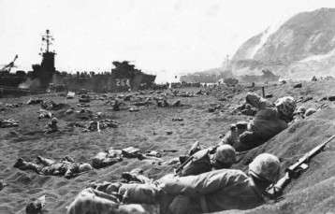**Battle of Iwo Jima**

The Battle of Iwo Jima took place during World War II between the United States and [Japan](http://www.ducksters.com/geography/country/japan.php). It was the first major battle of World War II to take place on Japanese homeland. The island of Iwo Jima was a strategic location because the US needed a place for fighter planes and bombers to land and take off when attacking Japan.   
 

US Marines storm the beach of Iwo Jima

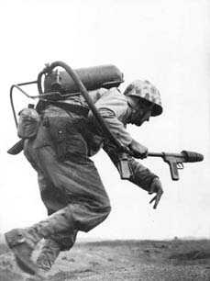  
  
**Where is Iwo Jima?**   
  
Iwo Jima is a small island located 750 miles south of Tokyo, Japan. The island is only 8 square miles in size. It is mostly flat except for a mountain, called Mount Suribachi, located on the southern end of the island.   
  
**When was the battle?**   
  
The Battle of Iwo Jima took place near the end of World War II. US Marines first landed on the island on February 19, 1945. The generals who planned the attack had thought that it would take around a week to take the island. They were wrong. The Japanese had many surprises for the US soldiers and it took over a month (36 days) of furious fighting for the US to finally capture the island.   
  
**The Battle**   
  
On the first day of the battle 30,000 US marines landed on the shores of Iwo Jima. The first soldiers that landed weren't attacked by the Japanese. They thought that the bombings from US planes and battleships may have killed the Japanese. They were wrong. 

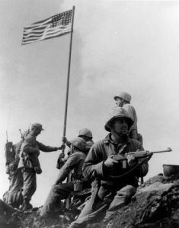   
 Soldier using flame thrower

The Japanese had dug all sorts of tunnels and hiding places all over the island. They were waiting quietly for more marines to get on shore. Once a number of marines were on shore they attacked. Many US soldiers were killed.   
  
The battle went on for days. The Japanese would move from area to area in their secret tunnels. Sometimes the US soldiers would kill the Japanese in a bunker. They would move on thinking it was safe. However, more Japanese would sneak into the bunker through a tunnel and then attack from behind. 

The first flag that was raised on Iwo Jima

**Raising the Flag of the United States**   
  
After 36 days of brutal fighting, the US had finally secured the island of Iwo Jima. They placed a flag on top of Mount Suribachi. When they raised the flag a picture was taken by photographer Joe Rosenthal. This picture became famous in the United States. Later a statue was made of the picture. It became the US Marine Corps Memorial located just outside Washington, DC.   
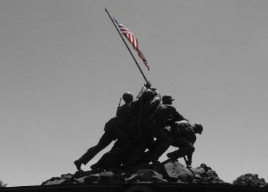

Marine Corps Memorial

**Interesting Facts**

* The famous picture of the US Flag being raised on Iwo Jima was actually not the first flag raised by the US. Another smaller flag pole had been put there earlier.
* Although the US had more soldiers wounded on Iwo Jima than the Japanese, the Japanese had many more deaths. This was because the Japanese had decided to fight to the death. Out of 18,000 Japanese soldiers only 216 were taken prisoner. The rest died in the battle.
* Around 6,800 American soldiers died in the battle.
* The US government awarded 27 soldiers with the Medal of Honor for their bravery during the battle.
* There were six men in the famous picture showing the US flag being raised. Three were killed later in the battle. The other three became famous celebrities in the US.
* The Japanese dug 11 miles of tunnels within the island of Iwo Jima.

**Iwo Jima and Okinawa in World War II: Home Front**

Feb 19, 1945 - Jun 21, 1945

By February 1945, the United States had turned back the Japanese advance in the Pacific and had re-taken a sweeping arc of islands that surrounded the enemy nation.  For all these gains, however, two small islands remained crucial to an invasion of Japan: Iwo Jima and Okinawa. Located to the southeast and south of Japan, they were only 750 miles from major military and political targets.  Their capture would bring even the city of Tokyo within the range of American B-29 bombers.

Iwo Jima was attacked first.  On 19 February, marines landed at the southeastern end of the island and began working their way toward Mt. Suribachi, a 550 foot dead volcano that the Japanese had turned into an island fortress.  For two months preceding the attack, American bombers had blasted the Japanese defenses.  But the almost daily attacks had forced the Japanese to just dig-in deeper.  In addition to their concrete bunkers, they dug caves into the mountain linked by an intricate web of tunnels.

Against these defenses, the US marines now had to advance. Subject to relentless gunfire and shelling from the artillery planted in the mountainside, they moved by the inch not the mile.  It took four days to advance 1000 yards, scale the volcano, and plant the flag captured in the iconic photograph.  But this was hardly the end of the battle.  The marines still had to root out Japanese defenses stretched across the rest of the four-mile long island.  American planes, dropping bombs and napalm, tried to force the Japanese from their concrete bunkers.  Yet they clung tenaciously to their positions.  In fact, they had been ordered not to mount suicidal banzai charges that secured their honor but exposed them to deadly fire. Instead, they stuck to their positions, forcing the Americans to roust them out bunker by bunker.

The island was not fully secured until the end of March.  Almost 7000 Americans were killed; another 18,000 were wounded. But the Japanese casualties were horrific.  Only 200 of the 21,000 soldiers deployed survived to be taken prisoner.

Next came Okinawa. It presented a far more serious challenge.  The island was within range of the land-based planes in southern Japan but beyond range of American planes launched from the Philippines.  The American landing would, therefore, have to be covered by carrier-launched fighters—carriers that would then be vulnerable to attack. The Japanese had also deployed more than three times the force on Okinawa than they had committed to Iwo Jima.

On 1 April, American units landed along the central western coast of the island.  Marines were sent to the north; the army was sent to the south.  The marines encountered little resistance and were able to secure this portion of the island by the middle of April.  But the army found the going more tough to the south where the Japanese had constructed more intricate defenses. Three well-fortified lines crossed the southern tip of the island—when the American troops managed to take the first line; the Japanese fell back to the second. This second line proved particularly difficult, but then, rather foolishly, the Japanese abandoned their defensive position in an attempt to drive back the Americans.  The attack was repelled and, even more critically, cost the Japanese valuable reserves.  Soon after the ill-advised attack, American forces were able to overrun the second and third lines.  In late June, thousands of Japanese soldiers committed suicide rather than be taken prisoner.

Suicidal warfare, in fact, became Japan’s last hope.  Japanese Admiral Seiichi Ito piloted his massive 80,000 ton battleship—the Yamato—toward Okinawa without enough fuel for the return trip.  He would not need it.  Half way to Okinawa, the ship was sunk by American fighters launched from American carriers well beyond the range of the Yamato's guns.  The kamikazes—that had made their first appearance during the Battle of Leyte Gulf—also showed up in Okinawa in force.  Close to 2000 Japanese pilots flew a final mission for the emperor. But most of the damage they inflicted (about 35 ships) was on the radar ships sent to provide advance warning of the kamikazes’ arrival and smaller ships sent to draw the kamikazes’ attention away from the more valuable carriers.

The Americans paid a large price for Okinawa: 12,000 Allied dead and another 38,000 wounded.  But the Japanese lost more than 100,000 men and an island critical to the defense of Japan. The end of the battle and, perhaps more graphically, the tactics used by the Japanese during the battle, left little doubt that the end of the war was near.

**Battle for Iwo Jima, 1945**

**Battle**

Amphibious tractors approaching Iwo Jima, February 1945.**e for Iwo Jima**

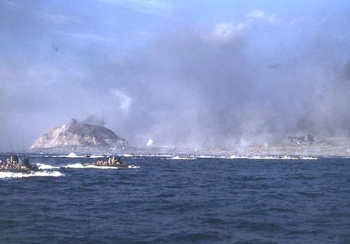*"The battle of Iwo Island has been won. The United States Marines by their individual and collective courage have conquered a base which is as necessary to us in our continuing forward movement toward final victory as it was vital to the enemy in staving off ultimate defeat.*

*By their victory, the 3rd, 4th and 5th Marine Divisions and other units of the Fifth Amphibious Corps have made an accounting to their country which only history will be able to value fully. Among the Americans who served on Iwo Island, uncommon valor was a common virtue."*

--Admiral Chester W. Nimitz

Iwo Jima, which means Sulfur Island, was strategically important as an air base for fighter escorts supporting long-range bombing missions against mainland Japan. Because of the distance between mainland Japan and U.S. bases in the Mariana Islands, the capture of Iwo Jima would provide an emergency landing strip for crippled B-29s returning from bombing runs. The seizure of Iwo would allow for sea and air blockades, the ability to conduct intensive air bombardment and to destroy the enemy's air and naval capabilities.

The seizure of Iwo Jima was deemed necessary, but the prize would not come easy. The fighting that took place during the 36-day assault would be immortalized in the words of Commander, Pacific Fleet/Commander in Chief, Pacific Ocean Areas Admiral Chester W. Nimitz, who said, "Among the Americans who served on Iwo 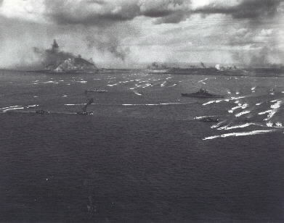Island, uncommon valor was a common virtue."

To the Japanese leadership, the capture of Iwo Jima meant the battle for Okinawa, and the invasion of Japan itself, was not far off.

**Commanders**

Commanders for the operation, code named Detachment, were assigned as follows:   
--Admiral Raymond A. Spruance was the operation's overall commander.   
--Joint Expeditionary Force commander was Vice Admiral Richmond Kelly Turner. Second in command of the Joint Expeditionary Force was Rear Admiral Harry W. Hill.   
--Lieutenant General Holland M. "Howlin' Mad" Smith was assigned as the commanding general of the expeditionary troops.   
--The 5th Amphibious Corps was commanded by Major General Harry Schmidt. Under his command fell the 3rd Marine Division commander, Major General Graves B. Erskine; the 4th Marine Division commander, Major General Clifton B. Cates; and the 5th Marine Division commander, Major General Keller E. Rockey.

**Bombardment**

Initial carrier raids against Iwo Jima began in June 1944. Prior to the invasion, the 8-square-mile island would suffer the longest, most intensive shelling of any Pacific island during the war. The 7th Air Force, working out of the Marianas, supplied the B-24 heavy bombers for the campaign.

In addition to the air assaults on Iwo, the Marines requested 10 days of pre-invasion naval bombardment. Due to other operational commitments and the fact that a prolonged air assault had been waged on Iwo Jima, Navy planners authorized only three days of naval bombardment. Unfavorable weather conditions would further hamper the effects of naval bombardment. Despite this, Turner decided to keep the invasion date as planned, and the Marines prepared for the Feb. 19 D-day.

**D-day**

More than 450 ships massed off Iwo as the H-hour bombardment pounded the island. Shortly after 9 a.m., Marines of the 4th and 5th divisions hit beaches Green, Red, Yellow and Blue abreast, initially finding little enemy resistance. Coarse volcanic sand hampered the movement of men and machines as they struggled to move up the beach. As the protective naval gunfire subsided to allow for the Marine advance, the Japanese emerged from their fortified underground positions to begin a heavy barrage of fire against the invading force.

The 4th Marine Division pushed forward against heavy opposition to take the Quarry, a Japanese strong point. The 5th Marine Division's 28th Marines had the mission of isolating Mount Suribachi. Both tasks were accomplished that day.

**The Battle Continues**

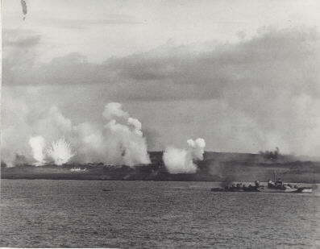Feb. 20, one day after the landing, the 28th Marines secured the southern end of Iwo and moved to take the summit of Suribachi. By day's end, one third of the island and Motoyama Airfield No. 1 was controlled by the Marines. By Feb. 23, the 28th Marines would reach the top of Mount Suribachi and raise the U.S. flag.

The 3rd Marine Division joined the fighting on the fifth day of the battle. These Marines immediately began the mission of securing the center sector of the island. Each division fought hard to gain ground against a determined Japanese defender. The Japanese leaders knew with the fall of Suribachi and the capture of the airfields that the Marine advance on the island could not be stopped; however, they would make the Marines fight for every inch of land they won.

Lieutenant General Tadamishi Kuribayashi, commander of the ground forces on Iwo Jima, concentrated his energies and his forces in the central and northern sections of the island. Miles of interlocking caves, concrete blockhouses and pillboxes proved to be one of the most impenetrable defenses encountered by the Marines in the Pacific.

The Marines worked together to drive the enemy from the high ground. Their goal was to capture the area that appropriately became known as the "Meat Grinder." This section of the island included three distinct terrain features, which were the highest point on the northern portion of the island, Hill 382; an elevation known as "Turkey Knob," which had been reinforced with concrete and was home to a large enemy communications center, and the "Amphitheater," a southeastern extension of Hill 382.

The 3rd Marine Division encountered the most heavily fortified portion of the island in their move to take Airfield No. 2. As with most of the fighting on Iwo Jima, frontal assault was the method used to gain each inch of ground. By nightfall on March 9, the 3rd division reached the island's northeastern beach, cutting the enemy 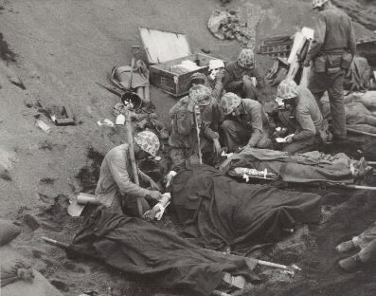defenses in two.

On the left of the 3rd Marine Division, the 5th Marine Division pushed up the western coast of Iwo Jima from the central airfield to the island's northern tip. Moving to seize and hold the eastern portion of the island, the 4th Marine Division encountered a "mini banzai" attack from the final members of the Japanese Navy serving on Iwo. This attack resulted in the death of nearly 700 enemy and ended the centralized resistance of enemy forces in the 4th division's sector. The 4th division would join forces with the 3rd and 5th on the coast on March 10.

A proud moment for those who worked so hard to gain control of the island was when the first emergency landing was made by a B-29 bomber on March 4. Repairs were made, refueling was completed and the aircraft was off to complete its mission.

Operations entered the final phases March 11; enemy resistance was no longer centralized. Individual pockets of resistance were taken one by one.

Finally on March 26, following a banzai attack against troops and air corps personnel near the beaches, the island was declared secure. The U.S. Army's 147th Infantry regiment assumed ground control of the island on April 4, relieving the largest body of Marines committed in combat in one operation during World War II.

**Campaign results**

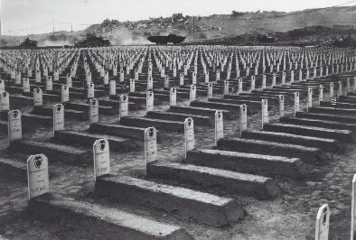The 36-day assault resulted in more than 26,000 American casualties, including 6,800 dead. Of the 20,000 Japanese defenders, only 1,083 survived. The Marines' efforts, however, provided a vital link in the U.S. chain of bomber bases. By war's end, 2,400 B-29 bombers carrying 27,000 crewmen made unscheduled landings on the island.

Historians described U.S. forces' attack against the Japanese defense as "throwing human flesh against reinforced concrete." In the end, Iwo Jima was won not only by the fighting spirit of the Marines, but by the meticulous planning and support provided by the Navy and Army through supply efforts, medical care, and air and naval gunfire.

Twenty-seven Medals of Honor were awarded to Marines and sailors, many posthumously, more than were awarded for any other single operation during the war.

**Two flag raisings**

At 8 a.m., on Feb. 23, a patrol of 40 men from 3rd Platoon, E Company, 2nd Battalion, 28th Marines, led by 1st Lieutenant Harold G. Schrier, assembled at the base of Mount Suribachi. The platoon's mission was to take the crater at Suribachi's peak and raise the U.S. flag.

The platoon slowly climbed the steep trails to the summit, but encountered no enemy fire. As they reached the top, the patrol members took positions around the crater watching for pockets of enemy resistance as other members of the patrol looked for something on which to raise the flag.

At 10:20 a.m., the flag was hoisted on a steel pipe above the island. This symbol of victory sent a wave of strength to the battle-weary fighting men below, and struck a further mental blow against the island's defenders.

Marine Corps photographer Sergeant Lou Lowery captured this first flag raising on film just as the enemy hurled a grenade in his direction. Dodging the grenade, Lowery hurled his body over the edge of the crater and tumbled 50 feet. His camera lens was shattered, but he and his film were safe.

Three hours later another patrol was dispatched to raise another, larger flag. The battle for Iwo Jima is encapsulated by this historic flag raising atop Suribachi, which was captured on film by Associated Press photographer Joe Rosenthal. His photo, seen around the world as a symbol of American values, would earn him many awards including the 1945 Pulitzer Prize.

Over the years, the flag raising has come to symbolize the spirit of the Corps to all Marines. On Nov. 19, 1954, a bronze monument of the flag raising, sculpted by Felix de Weldon and located near Arlington National Cemetery, was dedicated to all Marines who have given their lives in defense of their country.

Then Vice President Richard M. Nixon said, "This statue symbolizes the hopes and dreams of America, and the real purpose of our foreign policy. We realize that to retain freedom for ourselves, we must be concerned when people in other parts of the world may lose theirs. There is no greater challenge to statesmanship than to find a way that such sacrifices as this statue represents are not necessary in the future, and to build the kind of world in which people can be free, in which nations can be independent, and in which people can live together in peace and friendship."

**US Navy Ships Sunk or Badly Damaged By Enemy Action at Iwo Jima**

|  |  |  |  |  |
| --- | --- | --- | --- | --- |
| **Date** | **Name** | **Cause** | **Killed** | **Wounded** |
| 17 Feb | *LCI(G)-438* | Coastal battery | 0 | 4 |
|  | *LCI(G)-441* | Coastal battery | 7 | 21 |
|  | *LCI(G)-449* | Coastal battery | 21 | 18 |
|  | *LCI(G)-450* | Coastal battery | 0 | 6 |
|  | *LCI(G)-457* | Coastal battery | 1 | 20 |
|  | *LCI(G)-466* | Coastal battery | 5 | 19 |
|  | *LCI(G)-469* | Coastal battery | 0 | 7 |
|  | *LCI(G)-473* | Coastal battery | 0 | 31 |
|  | *LCI(G)-474* | Coastal battery | 3 | 18 |
|  | | | | |
| 18 Feb | *Blessman* (DE-69) | Air attack | 42 | 29 |
|  | *Gamble* (DD-123) | Air attack | 5 | 9 |
|  | | | | |
| 20 Feb | *LSM-216* | Air attack | 0 | 0 |
|  | | | | |
| 21 Feb | *Bismarck Sea* (CVE-95) | Air attack | 119 | 99 |
|  | *Saratoga*(CV-3) | Air attack | 123 | 192 |
|  | *Napa* (APA-157) | Air attack | 0 | 0 |
|  | | | | |
| 25 Feb | *LCI(M)-760* | Coastal battery | 0 | 2 |
|  | | | | |
| 28 Feb | *Terry* (DD-513) | Coastal battery | 11 | 19 |
|  | *Whitley* (AKA-91) | Air attack | 0 | 5 |

**Source:** Adapted from Miller, Kimberly J. "Battle for Iwo Jima: WWII Fact Sheet" Wasington, D.C.: Navy & Marine Corps WWII Commemorative Committee [subsequently disestablished], Navy Office of Information, n.d.; and Morison, Samuel Eliot. *Victory in the Pacific, 1945 – History of the United States Naval Operations in World War II*, Vol 14. (Boston: Little, Brown, 1960): 389.