**Supplementary Material**

**Power-Free Chip Enzyme Immunoassay for Detection of Prostate Specific Antigen (PSA) in Serum**

**Heba Adel Ahmed1 and Hassan M. E. Azzazy 1, 2**

**1 Yousef Jameel Science and Technology Center (STRC), The American University in Cairo, AUC Ave, PO Box 74, New Cairo Egypt 11835. E-mail:** [**heba_adel@aucegypt.edu**](mailto:heba_adel@aucegypt.edu)

**2 Department of Chemistry, The American University in Cairo, AUC Ave, PO Box 74, New Cairo Egypt 11835. Fax: +20227957565; Tel: +20226152559; E-mail:** [**hazzazy@aucegypt.edu**](mailto:hazzazy@aucegypt.edu)

**Corresponding author**

**Hassan M. E. Azzazy. Department of Chemistry, The American University in Cairo, AUC Ave, PO Box 74, New Cairo Egypt 11835. Fax: +20227957565; Tel: +20226152559; E-mail:** [**hazzazy@aucegypt.edu**](mailto:hazzazy@aucegypt.edu)

**1. Materials**

Polymethyl-methacrylate (PMMA) (Spiroplastics, Cairo, Egypt) and double-sided adhesive film (iTapstore, Scotch Plains, NJ) were cut using a LASER cutter (VersaLaser ™, Scottsdale AZ).

The antibodies for the enzyme-immunoassay were purchased from K.HyTest Ltd (HyTest Ltd., Finland). The capture antibody was purchased from K. HyTest Ltd (Monoclonal mouse anti-prostate specific antigen (PSA) Cat. # 4P33(HyTest Ltd., Finland)) for detection of total PSA (tPSA), and was used to coat the paramagnetic nanoparticles at a concentration of 1.5 μg/mL in coating buffer (0.01 M PBS pH7.2, and 0.05% Tween 20). The secondary biotin labeled PSA antibody was purchased from K.HyTest Ltd. (polyclonal mouse anti-prostate specific antigen (PSA) Cat. # 4P33B) for detection of tPSA, and used in the assay at a concentration of 1μgmL-1. Recombinant prostate specific antigen was purchased from K.HyTest Ltd (Cat. # 8P78). The anti-mouse streptavidin conjugated poly horseradish detector antibody (streptavidin-HRP antibody) was purchased from Pierce Thermo Fischer scientific Inc., Rockford, IL, USA (Cat. # 21140). The HRP substrate kit was purchased from Bio- Rad Laboratories, Inc. (Hercules, California, USA cat. # 1721064) containing Solution A (ABTS reagent) and solution B (Citrate/peroxide) to be mixed in equal amounts right before use. ELISA Stop Solution was obtained from (Bio-Rad Laboratories Inc., Hercules, California, USA Catalogue # 933040). Light mineral oil was purchased from Sigma-Aldrich (St. Louis, MO), product # 330779-1L. The ELISA buffers were prepared in-house: wash buffer (0.1 M PBST pH 7.2 composed of 10 mM phosphate buffer pH 7.4 (Sigma-Aldrich, product # P3619-72 1GA), 150 mM NaCl (Sigma-Aldrich, product # S9888), and 0.05% Tween 20 (Sigma-Aldrich, product # P2287).

To coat the magnetic nanoparticles, 100 mM bicarbonate/carbonate coating buffer pH 9.2 was prepared (Sigma-Aldrich sodium carbonate, product # S2127 and Sigma-Aldrich sodium bicarbonate, product # S8875). A Secondary antibody dilution buffer was also prepared (1% BSA, 0.01M PBS pH 7.2). A streptavidin HRP-antibody dilution buffer was prepared (0.05 M Tris buffer saline TBS pH 8, 0.05% with Tween 20 from Sigma-Aldrich product # T9039). Also, Streptavidin conjugated HRP detector antibody dilution buffer was prepared (0.01M PBS pH 7.2, and 0.05% tween 20).

To dilute the serum samples, a serum dilution buffer was made of 200 μg/mL BSA (Sigma-Aldrich product # A3675), 0.5 M NaCl, and 0.5% Tween 20 in 1000 mL 1X PBS pH 7.2.

Pictures of the PSA Chip EIA were taken using an Apple ® iPhone 4. A comparison between different phone cameras of different resolutions was done using iPhone 4G ® (Apple®) 5 megapixel camera, Sony Ericsson i790 3.2 megapixel camera, and Blackberry ® Bold 9650 Smartphone 5 megapixel camera. The images were analyzed for red color intensity per pixel using Matlab ® software.

## 2. Methods

## 2.1 Synthesis of magnetic nanoparticles

## Briefly, iron (II) chloride and iron (III) chloride (1:2) were dissolved in nanopure water at a concentration of 0.25 M. 1 M NaOH at a pH 10 was added to chemically precipitate the particles at room temperature (25 °C). The precipitates were heated at 80 °C for 35 min under continuous mixing and were washed four times with water and several times in ethanol. During washing, the magnetic nanoparticles were separated from the supernatant using a magnet, and the particles were finally dried in a vacuum oven at 70 °C.

### 2.2 Magnetic nanoparticles surface functionalization with amino groups.

Briefly, magnetic nanoparticles (1 g) were washed with 99.5% methanol, twice with Nanopure water and soaked in 10 mL of 3 mM (3-aminopropyl)-trimethoxysilane) (APTMS) solution in a toluene/methanol (1:1 v/v) mix. The suspension was then transferred into a three-necked flask with a water-cooled condenser and temperature controller with a nitrogen gas flow at 80 °C for 20 h under vigorous stirring. Silanization was bound to occur at the surfaces of the particles bearing hydroxyl groups, which in the presence of an organic solvent results in the formation of an APTMS coating with a large density of amines. The particles were recovered by applying an external magnetic field after the silanization process, washed three times with methanol and dried at 50 °C in a vacuum oven.

**2.3 Characterization of Magnetic Nanoparticles**

The prepared magnetic nanoparticles were characterized by scanning electron microscopy (SEM) for size and particles distribution determination (Fig.S1). Moreover, Fourier transform infrared spectroscopy (FT-IR) was used to record the IR spectra of the samples using the potassium bromide (KBr) pellet technique (Fig.S2).

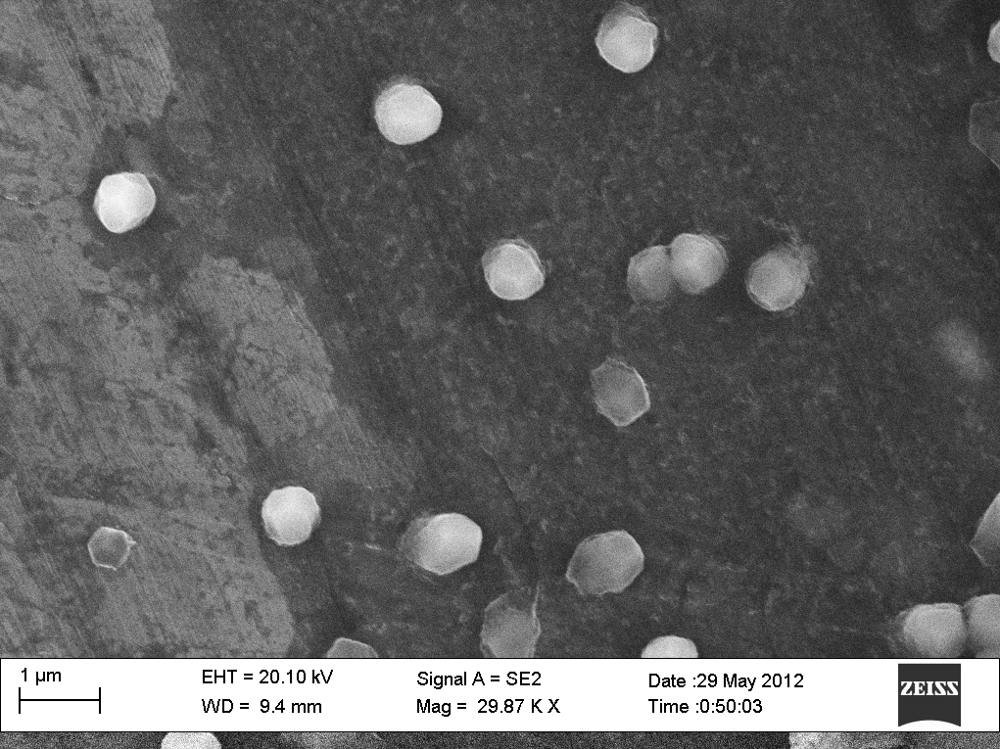

Fig. S1. Characterization of amine modified magnetic nanoparticles by scanning electron microscopy (SEM). (3-aminopropyl)-trimethoxysilane) (APTMS) functionalized magnetic nanoparticles of size ranges 50 nm - 100 nm.



Fig. S2. Characterization of amine modified magnetic nanoparticles by Fourier transform infrared spectroscopy (FT-IR). FT-IR was used to record the IR spectra of the samples using the potassium bromide (KBr) pellet technique. The band at 583cm-1 corresponds to the Fe-O bond, the ones at 1050 cm-1 and 1380 cm-1 corresponds to the vibrations of SiOCH2 and Si-CH2 scissoring vibrations respectively, while the bands at 1625 cm-1 and 3436 cm-1 correspond to the N-H bending mode and stretching vibrations of the free amino groups respectively. The propyl group of the APTMS is seen at 2923 cm-1.

**2.4 Magnetic nanoparticles conjugation to anti-PSA antibody**

Briefly, 1 mg of the nanoparticles were carefully weighed and washed with 1 mL of 0.1 M PBST wash buffer, pH 7.2, with gentle vortexing. The tube was then placed on a magnet to allow the magnetic nanoparticles to collect on the walls of the tube and the supernatant was discarded. The particles were then re-suspended in 1 mL 0.01 M PBS buffer pH 7; the magnetic nanoparticles were then retained using a magnet and the solution was removed. 1 mL of 5% glutaraldehyde cross-linker in 0.01 M PBS buffer pH 7 was then added to the magnetic nanoparticles and allowed to react for 2 hours at 4 °C. The nanoparticles were then retained by a magnet, and the solution was removed, followed by four washes each in 1 mL of PBST. 1 mL of 1.5 μg/mL of PSA primary antibody in primary antibody dilution buffer (0.01 M PBS, 1% BSA, 0.05% sodium azide) was then added and mixed by vortexing and incubated for 3 h at 37 °C under constant rotation. The tube was then placed on a magnet to collect the nanoparticles and the supernatant was separated and measured using a spectrophotometer at 280 nm to determine the capture efficiency. The particles were washed three times and the nanoparticles re-suspended in 1 mL of primary antibody dilution buffer (0.01 M PBS, 1% BSA, 0.05% sodium azide) and stored at 4 °C until use. The recombinant PSA was captured on the surface of the magnetic nanoparticles by adding 100 μL of conjugated nanoparticles to 50 μL of different concentrations of the recombinant PSA diluted in human serum (1.5-100 ng/mL). The tubes were mixed on an orbital shaker for 7 min at 37 °C and the magnetic nanoparticles were removed using a magnet. The nanoparticles were then washed 3 times with 150 μL wash buffer and re-suspended in 65 μL of assay buffer (0.01 M PBS, pH 7.2, and 0.05% Tween 20).

**2.5 PSA Chip EIA design and fabrication**

Briefly, PMMA and double-sided adhesive film were cut using a LASER cutter (VersaLaser ™, Scottsdale AZ). The pieces were cut with dimensions of 5 x 4 cm. Three layers of PMMA of two different thicknesses were used in the fabrication of the PSA Chip EIA platform. The bottom layer and the top layer, containing the inlets and outlets, were made of PMMA sheet of thickness 1.5 mm. The middle layer comprising the channels was cut from 3mm PMMA. Different layers of PMMA were aligned and arranged using intermediate layers of double sided adhesive.

The sample chamber (antigen-secondary antibody chamber): first chamber in figure 2a) contains 50 μL of secondary biotinylated PSA antibody; 65 μL of the magnetic nanoparticles coated with the primary/capture antibody-antigen, that have been left to react with the sample outside the chip, were pipetted into the chamber. The detector chamber – detector antibody chamber contains 115 μL the detector antibody conjugated to horseradish peroxidase (HRP). The signal chamber (fifth chamber in figure 2a) contains the HRP substrate [ABTS (2,2'-Azinobis [3-ethylbenzothiazoline-6-sulfonic acid]-diammonium salt]. Second and fourth chambers (figure 2a) are wash chambers containing the wash buffers.

**2.6 Manipulation of magnetic particles along the channel in the PSA Chip EIA platform using a magnet**

Loading of reagents and oil into the different channels was timed so that the antigen had a time of 7 min to react with the primary/capture antibody coated on the magnetic particles (this reaction took place outside the chip). After 7 min, 65 μl of the conjugated magnetic nanoparticle-antigen complex of each concentration was pipetted in the sample chamber of each chip containing 50 μL of biotin conjugated PSA antibody (1.5 μg/mL in 0.01M PBS pH7.2, and 0.05% Tween 20) and incubated for 7 min. A strong magnet was used to collect the magnetic nanoparticles at the first water-oil interphase and move them to the first wash chamber. Care was taken to collect the maximum number of magnetic particles before moving them so as to have maximum recovery. The movement of the magnetic particles through the oil phase was facilitated by their lyophobic nature. The magnetic particles were allowed to stay in the wash chamber for a 2 min with intermittent swirling using the magnet to facilitate their spreading throughout the channel. Then the particles were collected at the interphase and moved to the detector chamber containing the detector antibody (horse radish peroxidase conjugated streptavidin antibody; 1.5 μg/mL in 0.01M PBS pH 7.2, and 0.05% Tween 20), and incubated for 7 min taking care to recover maximum amount of nanoparticles. The magnetic particles were moved to the second wash chamber and left to soak for 2 min. The magnetic nanoparticles with the (capture antibody-antigen-secondary antibody- detector antibody) complex were then moved to the signal chamber containing the HRP substrate (ABTS) for green color development and a picture was taken with cell phone camera after 5 min of the development of the green color.

**2.7 Quantitative image processing**

The steps performed for image processing were (i) taking images with the cell phone camera, (ii) selecting and cropping representative regions within the channels for data analysis, (iii) obtaining color intensity using Matlab® in terms of R values, (iv) normalizing R values from tested samples by that of the background, (v) calculating and plotting the standard curve, and (vi) obtaining the concentration of patient samples from the standard curve equation.

**3. Figure Legends**

**Fig. S1. Characterization of amine modified magnetic nanoparticles by scanning electron microscopy (SEM).** *(3-aminopropyl)-trimethoxysilane) (APTMS) functionalized magnetic nanoparticles of size ranges 50 nm - 100 nm.*

**Fig. S2. Characterization of amine modified magnetic nanoparticles by Fourier transform infrared spectroscopy (FT-IR).** *FT-IR was used to record the IR spectra of the samples using the potassium bromide (KBr) pellet technique. The band at 583cm-1 corresponds to the Fe-O bond, the ones at 1050 cm-1 and 1380 cm-1 corresponds to the vibrations of SiOCH2 and Si-CH2 scissoring vibrations respectively, while the bands at 1625 cm-1 and 3436 cm-1 correspond to the N-H bending mode and stretching vibrations of the free amino groups respectively. The propyl group of the APTMS is seen at 2923 cm-1.*