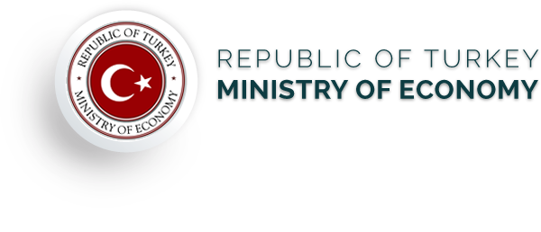

***Investment Climate and Investment Opportunities in Turkey***

**09.00-09.15 : Registration**

**09.15-09.30 : Opening Remarks by H.E A. Hakan OKÇAL, Ambassador of the Republic of Turkey**

**09.30-10.00 : General Economic Outlook and Investment Climate of Turkish Economy**

**10.00-10.30 : Investment Incentives in Turkey**

**10.30-11.00 : Investment Experiences from Turkey (POSCO ASSAN TST, Mr. Hae-Ik Jeong)**

**11.00-11.30 : Q&A**

**Date: 8 December, 2016**

**Venue: KCCI Seminar Room 1 (B2)**

**RSVP by 1 December, 2016 to [seul@ekonomi.gov.tr](mailto:seul@ekonomi.gov.tr) (+82-2-794-1382)**

<Application Form>

- Name : (Korean) (English)

- Company : (Korean) (English)

- Tel :

- E-mail :