LAB: OBSERVING AND IDENTIFYING ELEMENTS USING EMISSION SPECTRA

***Spectroscopy*** is a branch of science in which “***light****”(or* ***electromagnetic radiation****)* is used to identify ***unknown*** substances.

Recall that different types of electromagnetic radiation have different amounts of ***energy***

(Figure 1). For example, red light is less energetic than blue light.

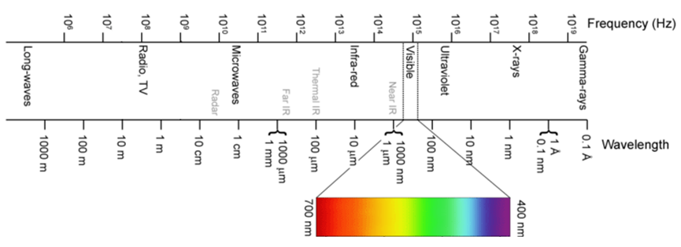

low ν

long λ

high ν

short λ

**increasing energy**

**Figure 1**. The Electromagnetic Spectrum

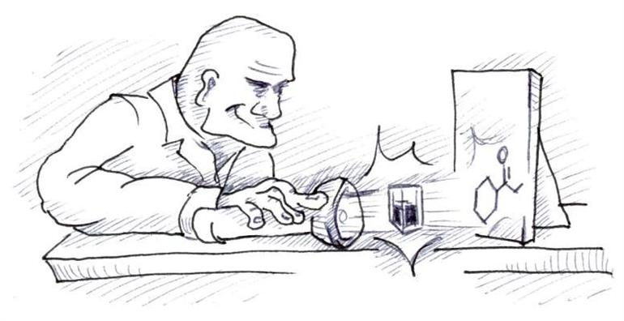Interestingly, when we shine light at matter, the matter will only ***absorb*** and **emit** only**specific** frequencies oflight; That is, it depends the ***structure*** of theelement or compound in question!

Byusing tools which allow us to ***measure*** the light absorbed or emitted, we can gain information about the ***identity*** of an unknown substance.

Different types of spectroscopy use different types of electromagnetic radiationand as such,they provide us with different information about our unknown.

In this lab exercise, you will be using ***emission spectroscopy***to identify unknown elements. This is the same technique used to discover helium (the second most abundant element in the universe) in 1868!

**HOW IT WORKS:**

* When ***electricity*** is passed through a sample of a gaseous element in discharge tube, theelectrons in the atoms become***excited***; That is, they absorbenergy and move from their original orbits (called their ***ground state***) to higher energy orbits (called their ***excited state***).
* When they eventually ***relax*** (move back down to their ground state), they give off the energy in the form of ***visible light***.
* By directing this light through a hand-held device called ***spectroscope***, it can be separated into a banded pattern of colours called a ***line*** or ***emission spectrum*** (Figure *).
* Each line corresponds to the specific transitions between the orbits that occur within the atoms.
* Since every element has a different electronic structure, their emission spectra are ***unique*** to them (like a fingerprint!) In this way, emission spectra can be used to ***identify unknown elements*** as well as ***predict the existence of new elements***!

SAFETY PRECAUTIONS:

* Gas discharge tubes operate at a voltage that is high enough to cause serious injury. Observe them only from a safe distance, as determined by your teacher.**DO NOT TOUCH THEM** during operation.

PROCEDURE:

1. Use the spectroscope to observe the light that is emitted from an ordinary ***incandescent light bulb***. Make a quick sketch of its emission spectrum on your Results Sheet. **Indicate the colour of each line you observed or use coloured pencils.**
2. Use the spectroscope to observe the light that is emitted from the ***fluorescent lights*** in the classroom.Sketchyour observations on your Results Sheet.
3. Observe the light that is emitted from the ***hydrogen gas discharge tube***. Sketch your observations.
4. Observe the light that is emitted from the discharge tubes containing the***unknownelements***. Sketch your observations on your Results Sheet.**\*\*\*If the patterns are complex, do the best that you can to note and record the differences in number, colour, and spacing of the spectral lines\*\*\***

ANALYSIS:

1. Identify the unknown elements by comparing their emission spectra with the ones provided by your teacher.
2. How do the spectra of the fluorescent light and incandescent light sources compare? What do the differences suggest about the light that is produced by each of the sources?
3. If the electrons in a discharge tube are moving everywhere in the space around the nucleus, their spectrum should look like the spectrum of an ordinary incandescent light bulb. Explain why they look different.
4. Hydrogen only has one electron. Why then does its spectrum have four coloured lines?
5. Why is the light that is emitted from hydrogen different from the light emitted by other elements? Explain the difference in terms of electrons.
6. Which element produced the largest number of spectral lines?
7. Describe how emission spectroscopy can be used as a qualitative analysis technique. Provide examples of situations in which this technique may be useful.

APPLICATION:

1. What do gas discharge tubes have in common with street lights? Do some research to find out which gases are used in street lamps, and why certain gases are chosen for certain locations.

**RESULTS SHEET** OBSERVED EMISSION SPECTRA

1. Incandescent light bulb
2. Fluorescent lights
3. Hydrogen discharge tube
4. Unknown 1
5. Unknown 2
6. Unknown 3