
Registered Nurse |Health Information Student |Data Analytics

Location: Essen,Germany

ABOUT ME
I am Onyeka-Richards Ogochukwu Blissful. I am a Registered Nurse and Health informatics student passionate about using data to improve healthcare decision-making. I have experience with Excel, Power BI, Power Query, und Python, and I enjoy transforming data into meaningful insights through interactive dashboards and reports.
SKILLS
- Microsoft Excel
- Power BI
- Python (Beginner)
- Power Query
- Data Cleaning
- Data Visualization
- Dax
- Health Informatics
- Clinical Assessment
- Medication Administration
- Patient Care
- Electronic Health Records (EHR)

- Nursing Skill
- Patient Care
- Clinical Assessment
- Medication Administration
- Clinical Documentation
- Infection Prevention and Control
- Electronic Health Records (EHR)

PROJECTS
Sales Performance Dashboard (Power BI)
- Built an interactive Power BI dashboard to analyse sales performance, KPIs, trends, and regional sales.

Confectionary Sales Dashboard
- Cleaned Data with Power Query and created DAX measures to visualize business performance.

Excel Sales Dashboard
- Used Pivots Tables, charts, und formulas to analyse sales trends and summarize business insights.
Healthcare Data Analysis (future project)
- planned projects focused on healthcare data visualization and clinical reporting.
Education
IU Internationale Hochschule
- B.Sc. Health Informatics (Ongoing)

University of Nigeria Nsukka
- B.Ed. English and Literary Studies

General Nursing
- Registered Nurse
- Contact
- Essen, Germany
- Ogomalachy@gmail.com

Project 1: Sales performance Dashboard
Objective
Built an interactive Powe BI dashboard to analyze sales performance, compare actual sales against targets and identify business trends.
Tools Used
- Microsoft Excel
- Power BI
- Power Query
- DAX
Key insights
- Sales exceeded the target by 3% (103% performance)
- The west region generated the highest revenue
- Technology-consumer was the top performing category
- Monthly trend highlighted periods of stronger and weaker performance

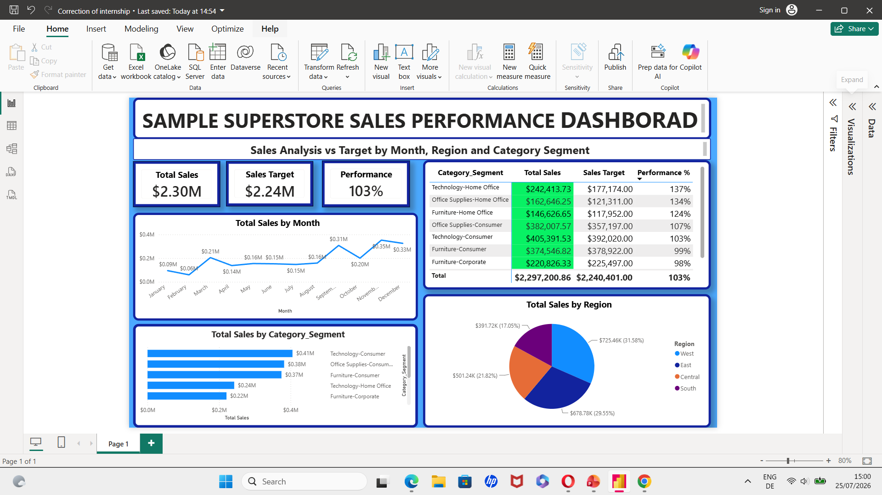
Confectionery Sales Dashboard
Objective
Designed an interactive Power BI dashboard to analyze confectionery sales performance,
Identify sales trends and support business decision-making.
Tools Used
- Microsoft Excel
- Power BI
- Power Query
- DAX
Key insights
- Analysed sales performance across products, categories, and regions.
- Tracked monthly sales trends using interactive visualizations.
- Identified top performing products and regions,
- Created KPI cards to monitor Total Sales, profit and Sales performance
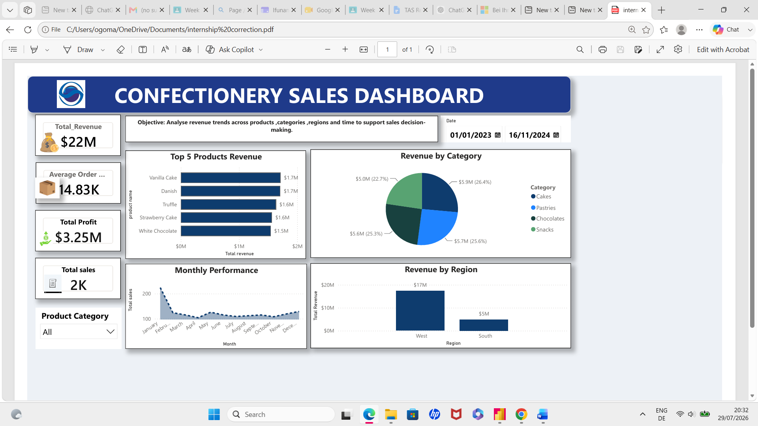

Contact
Email: Ogomalachy@gmail.com

