Goal: Introduce your dataset, perform structured data exploration, and describe patterns in your variables to prepare for modeling later in the semester.

Assignment Components (Total: 50 points)

- Study Context and Dataset Description (10 points)
- Describe the broader purpose of the study the data were collected for.
  - The data was collected to study species that are drought tolerant, or drought avoidant based on different species and location. We aimed to see if ecosystems drive relation of plant to drought. Comparing some plant functional traits to leaf spectral value, we aim to find which leaf spectral value correlates strongly with each functional trait and this is further divided into functional traits that identify drought tolerant vs drought avoidant species and see if both behaviors have same spectral signatures.
  - It would be interesting to mention that one of the criteria for defining data collection was the ecosystem boundaries where vegetation is more exposed to drought events.
- Describe your specific dataset:
Trait/Variables I will use | Data source | Definition of variables | Sampling context
Steam diameter changes | Dendrometer | Are you planning to calculate the daily variation from dendrometers?
Leaf thickness (LT; mm) | Digital caliper | general thickness, toughness | Measured at 3 different locations in the leaf and averaged to get LT
Water potential (Mpa) | Scholander type pressure chamber | Leaf water relation | Measured predawn which Measures the plant’s water status after overnight equilibration, reflecting near-maximum hydration and mid-day which Captures the plant’s water status during peak transpiration, indicating daily water stress.
Leaf water content (LWC; g) | Weighed the leaf fresh weight and leaf dry weight | The proportion of water in a leaf relative to its fresh mass, indicating the leaf’s hydration status. | We sampled also at predawn and midday. Predawn leaf water content: Reflects the leaf’s maximum hydration after overnight water uptake and minimal transpiration.  Midday leaf water content: Reflects the leaf’s hydration under peak transpiration and daily water stress.
Diameter by breast height (DBH; m) | Measuring tape | This is the stem diameter used to quantify size of the tree. | Measured once.
Tree height (m) | Laser scanner | The vertical distance from the base of a tree (ground level) to the top of its highest point. | Measured once.
Leaf dry mass per area (LMA; m²/g) | Scanned the leaf for leaf area using LI-3100C Area Meter and dried weight was weighed with a measuring scale | The dry mass of a leaf divided by its surface area, indicating leaf density and structural investment. | Measured by collecting fully expanded leaves, midday and predawn, to compare leaf structural traits across species, environmental conditions.
Stress level | Physical inspection of plant stress following a protocol from USDA | A quantitative measure of the physiological strain a plant experiences which range from 0 to 10. 0 means dead/and very stressed out. And 10 means very healthy. | Assessed through physical inspection of plant stress following a USDA protocol.
Vapor pressure deficit (VPD; kpa) | Measured the leaf sample temperature using a laser scanner temperature gun.  Measured environmental temperature and relative humidity using a sensor. This value is plugged into a formular which gives us VPD for each plant level and predawn and mid-day | The difference between the amount of moisture in the air and the maximum amount of moisture the air can hold at a given temperature, indicating the atmospheric demand for water. | Calculated using air temperature and relative humidity, often measured once the leaf is taken down to assess the evaporative demand on plants.
Precipitation | Remote sensor | Total amount of water (rain, snow, sleet, or hail) falling over a specific period. | Measured in millimeters at designated stations, recorded daily
Leaf spectral values | Filed collected using a spectrophotometer in the spectral range of the 350 to 2500 nm. with an attached leaf spectral clip from ASD | Reflectance or absorbance of light by a leaf at specific wavelengths, indicating physiological and biochemical properties | Measured on individual leaves using a spectroradiometer, at predawn or midday; values recorded for multiple spectral bands.

  - Source of the data
    - Probably it would be good to mention the two field campaigns (2024 and 2025) conducted by the Tree Stress and Alert System project at SICCS.

  - Definitions of variables
  - Sampling context (e.g., units, locations, times)
    - Map(s) showing the distribution of plots across ecosystems
    - Dataset timeframe (2024-2025)
      - Dendrometer datasets (2024-2025?). Readings every 15 minutes.
        - Variables: Steam diameter changes in microns and temperature ©
    - Summer 2025.
      - ….
      - ….

  - What variables you plan to use
- Clearly state:
  - What hypotheses you may test later
    - Using the field samples, we aim to clearly group our species from each plot/ecosystem into drought tolerant vs drought avoidant.
    - Study if our ecosystem/plot drive relation of plant to drought
    - Investigate which spectral range correlates strongly with each functional trait that is also the driver of our plant drought behavior.

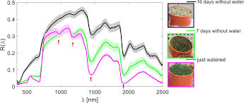
- Attribute Types and Summary Statistics (10 points)
- Identify the attribute type (e.g., continuous, ordinal, binary, nominal) of each variable.
Trait/Variables I will use | attribute type | Summary
Leaf thickness (LT; mm) | Numerical (continuous) | Mean:0.34  Median:0.33  Variance:2.9e-03  Percentiles: 0.43
Water potential (Mpa) | Numerical (continuous) | Mean:-1.181  Median: -195  Variance:8.5e-02  Percentiles:-0.72
Leaf water content (LWC; g) | Numerical (continuous) | Mean: 2.427  Median: 2.445  Variance:1.9e-01  Percentiles:3.11
Diameter by breast height (DBH; m) | Numerical (continuous) | Mean:0.2417  Median:0.2500  Variance:5.8e-03  Percentiles:0.36
Tree height (m) | Numerical (continuous) | Mean: 12.12  Median:11.95  Variance:8.0e+00  Percentiles:16.42
Leaf dry mass per area (LMA; m²/g) | Numerical (continuous) | Mean: 0.01222  Median: 0.01240  Variance:1.3e-05  Percentiles:0.018
Stress level | Ordinal | Mean: 1.875  Median:2.000  Variance:6.1e-01  Percentiles:3.0
Vapor pressure deficit (VPD; kpa) | Numerical (continuous) | Mean:1.848  Median:1.895  Variance:2.2e-01  Percentiles:2.60
Precipitation | Numerical (continuous) | Mean:919.4  Median:928.0  Variance:2.6e+04  Percentiles:1196.10
Leaf spectral values | Numerical (discrete) | Mean:2884  Median:2947  Variance:1.3e+06  Percentiles:4733.5
Species | Nominal | 4 different species.  A=29  B=35  C=26  D=30
Plot | Nominal | 9 different plots.

- Report summary statistics appropriate to each variable:
  - Distributions, frequencies
  - Means, medians, variance, percentiles, etc.
Data Exploration Using Zuur’s 8-Step Protocol (20 points)
- Work through all 8 data exploration steps as discussed in class and from the Zuur et al. reading.
  - No outliers
  - There is a variance in the dataset. I used the boxplot to check for variance between water potential across our plots and species.
  - The water potential is not normally distributed. The histogram returned a right skewed curve.
  - No zero distribution in our dataset water potential
  - The dataset doesn’t show any colleranity but it is important to note that this is a pseudo dataset.
  - No interaction between my X and Y.
  - There is an interaction between water potential, LT and species.
  - The observations (our response variable) are independent.
- Support with graphs and appropriate statistics:
  - Histograms, boxplots, scatterplots
  - 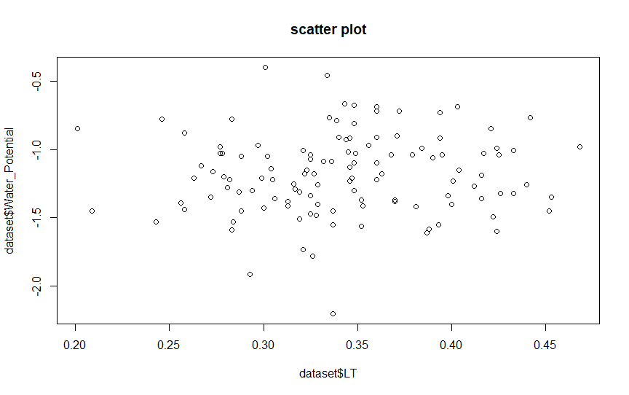
  - 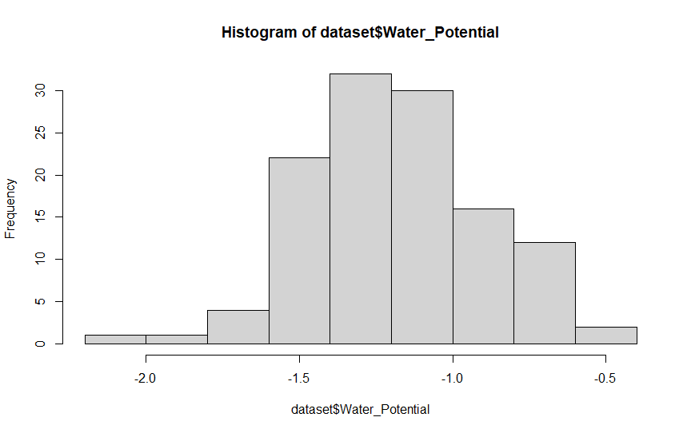
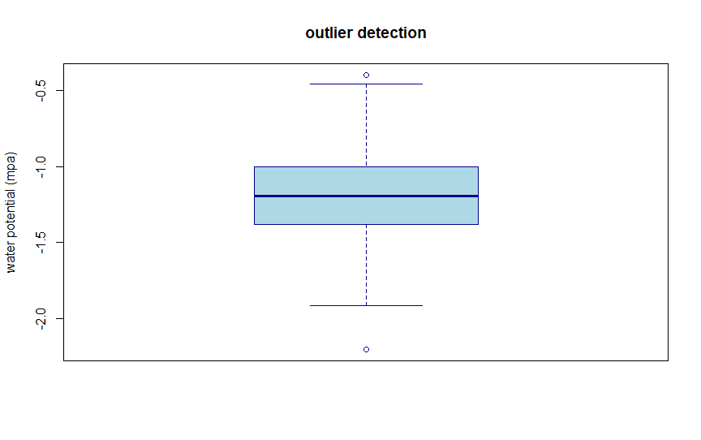
  - Outlier detection
  - Collinearity checks
  - 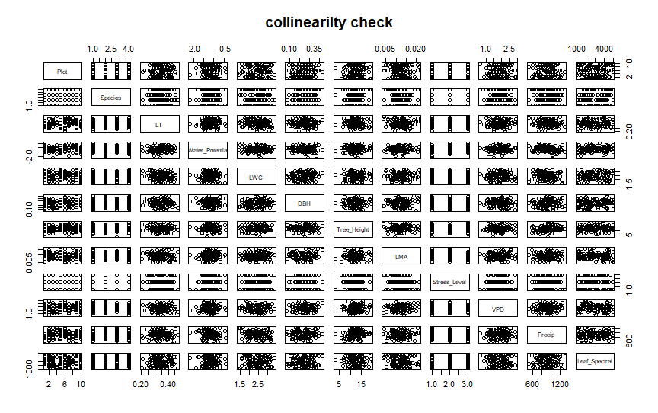
  - Missing data considerations
    - No missing data

- Highlight Key Patterns (5 points)
- Describe the main patterns or surprises found in your data.
  - From what I am seeing, I am not seeing any clear pattern in the dataset. But it is good to point out that this is a pseudo dataset and the result will definitely vary when I try with my main dataset.
- Relate patterns back to your research questions or model expectations.
  - Based on the result, we cant use leaf functional traits to relate to plant drought behavior.

