Mechanism for Continuous Drought Stress: linking tree water deficit and climate water balance with functional traits across drought prone regions.

Ogonna Eli¹, Paul Arellano¹, Scott Larocca¹, Revanth Munugala ¹, Michael Gowanlock ¹, Chris Doughty ¹, Christopher Hakkenberg ¹, Scott Goetz ¹, Alexander Shenkin¹,

¹Northern Arizona University, School of Informatics, Computing and Cybersecurity, 1295 S Knoles, P.O Box 5693, Flagstaff, AZ 86011

Corresponding author:
Name: Ogonna Eli
Email: Ogonnaeli@yahoo.com

Abstract:

Tree water use has a significant impact on whole plant susceptibility to functional decline under drought; however, water storage structures have an inherent carbon cost. While several variables exist to quantify movement of water in ecological and physiological studies, these variables do not account for the functional implications of water use strategy by different species. This study seeks to improve our understanding of daily tree water deficit (TWD) and daily stem variation (DV) as a mechanism of continuous drought monitoring. We presented a novel experiment designed to quantitively test outstanding gaps in the literature focusing on three objectives: (1) use TWD and DV as continuous drought mechanism and how this variables are affected by variance caused by species and location, (2) determine the relative contributions of environmental variables to TWD and DV across diverse species and location, and (3) understand the implications of variance in leaf functional traits for drought tolerance. Towards these objectives, we parameterized empirical data for 14 diverse species across different locations. One of the criteria for defining data collection is the ecosystem boundaries where vegetation is more exposed to drought events. We found TWD to be better drought metrics compared to DV (P value <0.01) and is sensitive to species and location (ICC = 0.76). We concluded that long-term changes in water movement and the use of the stored water are significantly influenced by species identification. Traits, visual stress signs from trees, and species explain a lot, but plot-level differences are also important. Overall, traits, visual stress signs from trees, species, and plots explain about two-thirds of why trees shrink differently. In summary, while TWD is a great tool for continuous drought monitoring, it is good to know that species and location also affect how individual trees respond.

Key words: Dendrometer, Daily Stem variation, Functional traits, Water movement, species viability

Introduction

Droughts associated with climate change negatively impact crop productivity (Bharambe et al., 2023), biodiversity (Weiskopf et al., 2020), and ecosystem services (Malhi et al., 2020). As droughts occur more frequently and with greater severity (Gu et al., 2020), understanding the strategies plants use to tolerate drought becomes more critical for the sustainability of natural ecosystems. Widespread plant mortality events have catastrophic effects on carbon and water cycles (Bolan et al., 2024) and the functional stability of ecosystems (Fry et al., 2014; Roeder et al., 2021; Turnbull et al., 2016; Wang et al., 2012) largely due to the role of plant tissues in net ecosystem hydraulic exchange. During drought, water stored in plant tissue may maintain plant viability (Leuschner et al., 2019; Meinzer et al., 2014) and act as a capacitor, modulating the effect of soil water limitation at the ecosystem scale (Sebastian et al., 2023). As stored water can actively be moved between the cell membrane and lumen (Chavarria & dos Santos, 2012) and across leaf tissues (Ievinsh, 2023; Wiebe & Al-Saadi, 1976) to maintain control of plants’ metabolic process via the regulation of turgor, the dynamic movement of water within the tree may be a better indicator of plant and ecosystem water status than bulk water volume (Scholz et al., 2007). This dynamic movement of water and leaf function more broadly is highly dependent upon the structures that make up the leaf (Buckley et al., 2015) with strong implications for plant survival during drought (Martínez‐Vilalta & Garcia‐Forner, 2017; Tholen et al., 2012). However, the mechanisms that directly link shifts in trees tissues’ water movement to dynamic tree water relations as water status declines, in addition to its implications for thresholds for functional decline under drought have not yet been established.

Drought tolerators may adopt thick, rigid cell walls as part of a general, high-investment stress tolerance strategy (Ahl et al., 2019). The quantitative effects of these structural tradeoffs between stored water and drought behavior in plants are not well understood, and stored water may accumulate in these stress tolerators from small additive contributions across many tissues (Chaves, 2004; Nguyen et al., 2017). A better understanding of the effect of the location and species explicit movement of water sources in plant water relations and their impact on drought response would enhance our ability to understand the capacity of certain species to persist in both chronically and acutely droughted environments. Despite the anticipated variance across species and groups, broad angiosperm leaves converge on the same general form due to the fundamental tradeoff between carbon gain and water loss. The vascular system is responsible for the bulk of water movement within the leaf and has been suggested to contribute substantially to leaf mass per area (Blonder et al., 2020). While the bulk of leaf volume is dedicated to photosynthetic tissues in order to maintain net photosynthetic yield (Flexas et al., 2016; Lawson et al., 2014; McAdam & Brodribb, 2018). Identifying continuous tree water status can improve forest monitoring. Dendrometers has proven as a tool that captures variations in daily system diameter, and it’s measured in µm scales. Using the dendrometer, lots of researchers have computed tree water deficit (TWD) (Steppe, 2018) and daily variation (DV) of the stem as measure of tree stress (De Swaef et al., 2015; Deslauriers et al., 2007; Dietrich et al., 2018). TWD is the recorded difference between actual and recorded maximum stem diameter, while TWD looks at the daily difference between the maximum stem diameter and daily stem variation, DV looks at daily difference between maximum and minimum stem diameter. TWD is also sensitive to environmental conditions like vapor pressure deficit, soil moisture, water storage and water use regulations (De Swaef et al., 2015; Dunkleberger et al., 2023; Sánchez-Costa et al., 2015; Zweifel et al., 2005). Variables derived from dendrometers plays a big role in assessing tree drought mechanisms.

Here, we tested the significant of TWD and DV as drought response mechanisms and how this movement of water is affected by environmental variables, location and species differences. We presented a novel experiment designed to quantitively test outstanding gaps in the literature focusing on three objectives: (1) use TWD and DV as continuous drought mechanism and how this variables are affected by variance caused by species and location, (2) determine the relative contributions of environmental variables to TWD and DV across diverse species and location, and (3) understand the implications of variance in leaf functional traits for drought tolerance. To test these objectives, we combined novel data (fourteen species grown across Arizona) with fifteen minutes measurement of stem diameter swelling and shrinking. We identified the generalizable principles linking continuous tree water deficit mechanism to environmental variables with species specific tree function across climates and leaf habits. H1: we expect TWD to be greatly increased by climate variables especially less water input into an ecosystem (precipitation) and higher water output from an ecosystem (evapotranspiration). And we also expect this to vary by species and location with species in drier climate having higher TWD as climate gets drier. H2: Using the TWD slope from the Sen’s slope, what can associate with what functional trait tells us if a tree is experiencing a decline, incline or stable TWD. We expect traits that play a role in plant water relations to show a mechanism for state of plant water movement. H3: we expect species that live in the same microclimate to have same adaptive functional trait. To test these three hypotheses, we combined novel data (14 native species grown in a forest across in Arizona) and identified the generalizable principles linking water movement with environmental variables and leaf function across climates of origin and leaf habit.

Methods:

Plant Material
To quantify the characteristics of drought tolerant and drought avoidant traits across functionally diverse species, we integrated physiological laboratory and field work experiments study for 14 different species (Table 1). To identify generalizable principles linking drought behavior to leaf function, we selected focal species based on taxonomic and functional diversity. We used the canopy height dataset from (Tolan et al., 2024)

Study Site
The sampled plants were across the state of Arizona USA. We have different study plots across different ecosystems available in Arizona, USA (Table 1). The study area experiences four different seasons in a semi-arid climate. Summers are hot, with typical highs in the 42°C and typical low in the 25°C with the driest month in June, and after the summers, there is a wet season that brings thunderstorms. In Northern Arizona, they also experience harsh winters and large amounts of snowfall. The study area extends from approximately 31.33° N to 37.00° N latitude and 114.82° W to 109.05° W longitude. The forested area is 25% of the total land area approximately 18.6 million acres. The Dominant Forest type is the Pinyon-Juniper woodlands which cover almost 60% of the forested area. Other forest types include woodland hardwoods as the second most abundant, accounting for about 19.5% of the forest land. Higher elevations feature ponderosa pine forests.

Functional Traits
To identify associations between leaf morphology and drought behavior, we measured fresh leaves where we quantified key functional traits including leaf water content during the summer of 2024 and summer of 2025. The fresh leaves were weighed using a weighing balance (± 0.01 mg; CQT 202 Core Portable Compact Balance, Adam Equipment, Milton Keynes, UK) to get fresh mass (FM) and the leaf was oven dried for 57.9 hours using an oven to get the dry mass of the leaf (DM). We used this FM and DM to measure the leaf water content (LWC; g) $\left(LWC = \frac{FM -DM}{FM} ADDIN ZOTERO_ITEM CSL_CITATION \{"citationID":"TxGeqiRh","properties":\{"formattedCitation":"(Zhou et al., 2021)","plainCitation":"(Zhou et al., 2021)","noteIndex":0\},"citationItems":[\{"id":798,"uris":["http://zotero.org/users/10110688/items/8PX3AVPA"],"itemData":\{"id":798,"type":"article-journal","container-title":"Ecological Indicators","DOI":"10.1016/j.ecolind.2021.107395","ISSN":"1470160X","journalAbbreviation":"Ecological Indicators","language":"en","page":"107395","source":"DOI.org (Crossref)","title":"Capability of leaf water content and its threshold values in reflection of soil-plant water status in maize during prolonged drought","volume":"124","author":[\{"family":"Zhou","given":"Huailin"\},\{"family":"Zhou","given":"Guangsheng"\},\{"family":"He","given":"Qijin"\},\{"family":"Zhou","given":"Li"\},\{"family":"Ji","given":"Yuhe"\},\{"family":"Lv","given":"Xiaomin"\}],"issued":\{"date-parts":[["2021",5]]\}\}\}],"schema":"https://github.com/citation-style-language/schema/raw/master/csl-citation.json"\} (Zhou et al., 2021)\right)$.

We calculated leaf dry matter content (LDMC; g) as the ratio of leaf dry mass to fresh mass (DM$÷$FM) (Cornelissen et al., 2003; Garnier et al., 2001). All the functional trait measurements were taken for predawn just for the summer of 2025 and midday for both years. We also did a one-time measurement for the tree height (Height; m) using the XX and the diameter by breast height (DBH; cm) using XX in 2024 and 2025.

Plant Water Relations
To assess the species-specific drought responses, we systematically measured predawn and midday leaves and collected paired measurements of water potential (WP; Mpa) using a Scholander type pressure chamber; PMS Instrument; model 1505D. One line about why predawn and midday were taken. The tree water deficit (TWD) was estimated for one year using dendrometers. We tagged a total number of 79 trees but included only 74 trees in our analysis. XXNUMBER OF trees were tagged dendrometers in the summer of 2024 and added XXNUMBER OF new ones in the summer of 2025 to estimate relative variation in stem diameter. Before we installed the dendrometers, we removed the outer part of the bark from each tree. We derived the TWD using equation 2 from (Ziegler et al., 2024) where TWD = $d_{max}-d$; dmax is the maximum value from the dendrometer for that individual tree throughout the experiments time period which is also assumed to be the maximum tree hydration and d is the current absolute stem diameter. We used the trend from the dendrometer to classify our trees into increasing which means the tree had shown a positive growth in the past year, decreasing which means the tree had shown a negative growth in the past year and stable for trees that didn’t show any decrease or increase. To explain the health trend from our dendrometer data, we include the environmental covariates from GEE. We incorporated the GRIDMET from the University of Idaho Gridded Surface Meteorological Dataset (Abatzoglou, 2013) for daily precipitation and vapor pressure deficit, the evapotranspiration (ET) dataset from MODIS/Terra Net Evapotranspiration 8-Day L4 Global 500m SIN Grid V061 (Running et al., 2021), we used the am soil moisture from SPL3SMP_E.006 SMAP L3 Radiometer Global Daily 9 km Soil Moisture dataset (ONeill et al., 2023), And finally, we also incorporated the ambient temperature measured by the dendrometer. These variables were used to explain the health of tree trend. We also estimated the daily variation of stem diameter by subtracting the max for each day from min of the data, this gave us the daily diameter variation (DV). During the field season, we classified the trees to an ordinal stress level using visual inspection of the tree canopy, tree stem and bark XXCITE.

Statistical Analyses
All data were analyzed in R (R Core Team (2023). Prior to the formal regression model, data cleaning and processing were done using functions from the tidyverse package (Wickham et al., 2019). During the data exploration stage, we noticed we had lots of missing and zero data points from the dendrometer reading which were systematically removed from the dataset.

To properly classify tree health trend, we used the additive decompose function in R to decompose the time series dataset into trend using moving averages, this enabled us to account for only the trend in the data without noise from seasonality (Kendall & Stuart, 1969). To get the trend in our dendrometer value and test whether the DV time series in R is showing an increasing, decreasing, or stable trend; we used the Mann-Kendall Trend Test (Hipel, 1994; Libiseller & Grimvall, 2002). If the p value is less than 0.05, we considered the trend significant and using the direction of the Sen’s slope estimate (Sen, 1968), we determined if it’s an increasing (positive slope) or decreasing trend (negative slope) and if the test isn’t significant, we assumed the trend is stable. For the analysis, we had 26 trees show a decreasing trend, 33 trees show an increasing trend, and 17 trees are stable and 1 tree without enough data points for a time series decomposition. We also assessed the strength of this daily variation against TWD. We applied the same trend pattern using TWD time series data and we have 36 trees decreasing, 33 trees are increasing while 9 is stable and we didn’t have enough data for 1 tree.

We used this trend as our response variable in a multinominal regression analysis to study functional mechanisms in tree drought stress and looked at the effect of our climate covariates on the TWD and DV to assess continuous drought stress mechanism. We assessed how environmental variable plays a role in tree daily diameter swelling and shrinkage with tree water deficit. Also looked at TWD as a proxy for tree water potential and the role of DV and TWD in identifying mechanisms for continuous tree drought stress. To look at the effect of environmental variables, species and location on TWD and DV, we used the linear mixed model from the nlme package (Davidian & Giltinan, 2017; Mixed-Effects Models in S and S-PLUS, 2000). We systemically remove NA’s and we used only 74 dendrometers for this. Minimum temperature was dropped from the list of the predictors to prevent multicollinearity with maximum temperature.

To test the functional mechanism in tree drought stress, we used the slope from the detrending from TWD/DV and our functional traits from the summer of 2024 and 2025. We averaged the traits from both summers. To standardize our predictors, we scaled numeric variables to compare their relative importance in our model. To identify the effect of plot/location on the TWD response we used a mixed model from the nlme package and using model selection, we selected 3 predictors that have effect on our response (TWD slope). We ended up with a final model with LWC, stress level and species as our final predictors of TWD slope.

To determine the significance of TWD or DV as a stress level indicator, we used an analysis of variance (ANOVA) test to look at the difference in the mean of TWD and DV on zero to ten stress level indices, where zero represents dead trees and 10 represents very healthy trees. The stress level index was computed from physical observations using USDA protocol XXCITE. Use used the cumulative sum of TWD, DV and the first stress level.

Results:
Mechanism for Continuous Drought Stress.
We assessed the role of DV and TWD as a continuous drought stress mechanism. We looked at 74 different trees across 11 locations and 14 different species (Table 1). Firstly, we evaluated the role of TWD irrespective of species or location. The soil rehydration overnight (soil moisture am) and precipitation generally doesn’t have any effect on the TWD (P value > 0.05; Fig. 2A) while the maximum daily temperature is significant (P value = 0.02), it has a negative effect on TWD where the higher the temperature, the lower the TWD. Therefore, the higher the temperature, the trees tend to be less stressed and less diameter shrinkage and the lower the temperature the higher the stem diameter shrinkage (Estimate of -32.16; Fig. 2A). On the other hand, we have ET and precipitation which are metrics for water output and water input in an ecosystem respectively. ET has a positive effect on TWD. Therefore, the higher the ET, the higher the TWD. Consequently, the ecosystem's equilibrium between water input (precipitation) and water loss (ET) is reflected in the TWD of trees. TWD is influenced by net water availability, rising when input exceeds loss and falling when loss exceeds input (P value <0.001; Fig. 2A). Lastly, we looked at VPD, which has an inverse relationship where an increase in VPD leads to a decrease in TWD (Estimate of -48.12; P value = 0.001; Fig.2A), in contrast to expected physiology between VPD and tree stress where high VPD, caused by dry, warm air, puts stress on trees we found out that higher VPD leads to lower TWD. In contrast to TWD, DV has a different mechanistic behavior to environmental conditions. ET has a positive significant effect on the DV which shows as the ET goes up the DV goes up as well (P value 0.014; Fig. 2B). VPD, soil moisture, precipitation and max temperature showed to have no significant effect on DV. DV shows daily change in the stem diameter whether negative or positive, but TWD gives more details on how the environment affects the trees and how they behavior under drought stress. Maximum temperature also has no significant effect on DV.
We have an interclass correlation coefficient (ICC) of 0.76 and 0.02 for TWD and DV respectively. Thus, about 76% and 2% of the variance unexplained after the variance explained by our fixed effects can be explained by the differences between our specific trees for TWD. This explains that tree identity is very important in explaining TWD and it plays little to no role in explaining DV. This result is also supported by the marginal R² and the conditional R². The marginal and conditional R² of TWD is 0.007 and 0.76 respectively. These account for the variance unaccounted for by differences in trees. Conditional R² explains variance explained by the entire model (i.e. the fixed and random effects) and the marginal R² is the variance explained just by our fixed effects. This shows that our random effects (difference in trees) explained a lot of our dataset and our fixed effect (environmental variation) explains so little about the continuous drought mechanism of trees in TWD. A higher conditional R² than a marginal R² simply means that the random effects explain additional variance compared to the fixed effects. While the TWD variation is heavily explained by differences in trees, DV has no strong explanation for either tree differences or environmental variable (marginal and conditional R² of DV is 0.004 and 0.021 respectively).

Relative Contributions of Environmental Variables to TWD and DV across Diverse Species and Location
We looked at how each species behave with variation in TWD and showed the species that have a mechanistic advantage to difference in environmental variable. Generally, PIPO and POTR have a positive significant relationship with TWD (Table 2), therefore, they tend to do well overall and have higher TWD. We also looked at how each environmental variable affects the TWD of different species. Under lower temperatures JUOS and PIED shows a higher TWD value and higher temperature leads to lower TWD and less stress (Table 2) while JUMO has higher TWD as the temperature increases. Therefore, JUOS will continue to thrive as climate gets warmer JUMO will suffer from drought as climate gets warmer. JUOS, which can be classified as a drought tolerant species (Linton et al., 1998a; Willson et al., 2008), this can relate to water use efficiency mechanism where under higher temperature which often leads to more ET (Hatfield & Dold, 2019), PIED species which can be classified as drought avoidant (Linton et al., 1998b) is known to close their stomata to prevent any form of water movement but opens it up under lower temperature which is reflected in the stem diameter increase and decrease (Guérin et al., 2018; Linton et al., 1998b; Robakowski et al., 2020). It is good to keep in mind that higher TWD signify drought stress and lower TWD means less drought stress. So, the decrease in temperature will increase the TWD of JUOS and PIED but will the increase in temperature will increase the TWD of JUMO which shows high stress by showing decrease in the stem diameter. We also looked at the effect of ET and as the ET goes higher, the TWD of JUMO, JUOS, PIED and PIPO get higher. So, we tend to have lower TWD at lower water output from the ecosystem. JUOS and PIED, which tends to grow in a Pinyon-Juniper Forest, shows to cope better with heat (their TWD goes down when the temperature gets higher) but when ET increases, they tend to get stressed from more water loss, therefore, these species will continue to thrive in warmer climate but suffer in drier climate conditions (Table 2). Lastly, we looked at how location might play a role in TWD of the species located there. According to our model, there is a significant relationship between site and environmental factors (Table 3). For ARB and KM, maximum temperature has significant and primarily inverse impacts on TWD. Where the lower the temperature, the higher the tree water deficit causes more cell shrinkage. Meanwhile evapotranspiration has different consequences (Table 3). At ARB, BR, FR, JD and LM the higher the ET, the higher the tree stress.
TWD and DV as Tools for Visual Tree Stress Evaluation
Overall, we assessed the strength of TWD and DV as stress metrics by running an ANOVA test, we compared the cumulative TWD and DV with the visual stress level index that was measured in the field. The result showed that TWD significantly effect of tress stress level can be showed by TWD (P value = 0.01). Pairwise comparisons using Tukey’s HSD test showed that healthy trees (10) had significantly higher TWD that stressed trees (1-9) (Fig. 3A; P value = 0.007), while the differences between healthy trees and dead trees (0) was not significant (P value = 0.79) and also the difference between the stressed trees and dead trees wasn’t significant ( P value = 0.38). This result suggests that TWD can effectively separate healthy and stress trees, while as dead trees do not differ significantly from either group. On the other hand, we looked at DV as a tool for visual tree stress evaluation, overall, DV doesn’t have any significant relationship with visual stress assessment (P value = 0.31; Fig.3B). These results suggest that DV is not a sensitive metric for distinguishing stress levels in these trees.

Functional Mechanism for Tree Water Deficit
Using the best model from model selection, the only significant relationship between our predictors and response variables is LWC, stress level and species in our final model. The p value is less than 0.05 (LWC P value = 0.023) which means our model with LWC has a slope different from 0 and it’s better than our null model (which is the model without any of the predictors and slope is == 0). The final model intercept is 1.25, so when our predictor is at 0, we expect a 1.25 change in the slope of the TWD. The slope of LWC is at -0.47, therefore, for any 1 unit increase in LWC, we expect a decrease by 0.47 in our TWD slope. This indicates that as LWC increases, the TWD slope decreases, suggesting that trees with higher leaf water content experience smaller changes in TWD (Fig. 4A). The stress level linear relationship with the TWD slope isn’t significant (P value = 0.792), using the visually condition of a tree bark, canopy and stem won’t be enough to detect the tree water deficit. Though the linear relationship isn’t significant, the cubic and 4th degree are significant (P value = 0.018 & 0.029 respectively). Though they are significant, they have a different effect on the TWD. Stress Level index which goes from 0 (dead) to 10 (healthy). Stress levels 3 and 4 are really evident stressed-out tree. The positive cubic coefficient (2.64) means the middle range of stress values will increase the TWD faster than at the extremes. When the tress level is at 4th degrees, the TWD slope drops at very low (dead) and very high (healthy) stress levels (Fig. 4B). Lastly, we looked at effect of species on the magnitude of TWD. Out of 12 species, only 4 species had a significant relationship with the slope of TWD. JUOS, PIPO, PIST and lastly QUEM with a P value of 0.001, <0.001, 0.01 and <0.001 respectively. They all have a negative intercept of -4.19, -2.35, -3.58 and -.6.85 for JUOS, PIPO, PIST, QUEM respectively. Therefore, these species reduce the slope of TWD (Fig. 4C). This suggests more stable or improving water status over time. We also looked at the conditional R² from our mixed model where we accounted for the variance unaccounted for by plot location is 0.66, which explains the variance explained by the entire model (i.e. the fixed and random effects) and the marginal R² of 0.41 is the variance explained just by our fixed effects. This shows that our random effects explained a lot of our dataset. A higher conditional R² than a marginal R² simply means that the random effects explain additional variance compared to the fixed effects. The interclass correlation coefficient (ICC) is 0.42. This tells us that 42% of the unexplained variance in our model is explained by our plot as random variables which is more than 40% of the variance in our response. So, while environmental variables and species difference is important, we should not underestimate the role of location, microclimate in the continuous drought mechanism.

Discussion and Conclusion
This variable standing alone makes less ecophysiology meaning compared when you look at them all together. As a dry habitat species, JUMO tends to have continuous shrinkage as the conditions get extreme as they experience greater water loss and stress (high TWD as maximum temperature and ET gets high too) considering they are also drought tolerant species and have different WUE mechanism (Linton et al., 1998c; Plaut et al., 2012). JUOS and PIED which tend to occur in a similar ecosystem (Pinyon-Juniper Forest (Muldavin & Triepke, 2019)) also have few conditions in similar where the higher the temperature, the lower the TWD and the higher the ET the higher the TWD. This shows that JUOS and PIED will have more drought induced mortality than heat induced mortality as they show signs of poor relationship to drought as they increase tissue shrinkage from stress of low water availability as weather gets drier but continues growth even as temperature increases. Lastly, PIPO, which is a dominant species in our study area, shows high TWD even if overnight soil hydration is high but less water is available in the ecosystem (lower precipitation) and ET is high. Even if more moisture is available, but the rate of water loss is high too, PIPO will tend to have high cell shrinkage showing less growth/ high TWD therefore, more water stress. So, for PIPO, they tend to behave better in better conditions where they have more water available but the rate of loss of water is high too (high ET), then PIPO will be at risk of drought-induced mortality. In cool conditions, even low water supply can result in low stress because demand is limited. Therefore, PIPO will tend to thrive in conditions that are cool, wet soil, moderate ET and sufficient precipitation. Stress is not always increased by temperature. While ARB and KM appear to reduce their deficit with higher temperatures because of stomatal closure or microclimate effects (Basra & Basra, 1997; Gusta & Chen, 1987). Higher maximum temperatures appear to be associated with less water stress at most locations. Conditions unique to the place, such as soil depth, microclimate, or flora type, may be reflected in that. With the increase in ET, there is an increase in tree water deficit.
Ecologically, we found that as the LWC increases, the TWD slope decreases, which suggests that trees with higher leaf water content experience a smaller change in tree water deficit (TWD). This can be attributed to the role of leaf stored water during stress mitigation. Water storage, in all its forms, provides a mechanism to control the water status of leaf. Under water deficits, stored water may maintain plant viability. Buffering of stored water could serve as an advantageous drought response strategy (Leuschner et al., 2019; Meinzer et al., 2014). Visual stress signal such as leaf Chloris, bark injury or defoliation has a nonlinear effect on shrinkage. The "wiggly" effect is caused by stress levels that either enhance or decrease TWD. Long-term changes in water shortage and the use of the stored water are significantly influenced by species identification. Traits, visual stress signs from trees, and species explain a lot, but plot-level differences are also important. Overall, traits, visual stress signs from trees, species, and plots explain about two-thirds of why trees shrink differently. In summary, while TWD is a great tool for continuous drought monitoring, it is good to know that species and location also affect how individual trees respond.

Authors' Contributions
Ogonna Eli: Writing – review & editing, Writing – original draft, Methodology, Formal analysis, Data curation, Conceptualization. Paul Arellano: Writing – review & editing, Methodology, Conceptualization, Formal analysis. Scott Larocca: Writing – review & editing, Data curation, Methodology. Revanth Munugala: Writing – review & editing. Michael Gowanlock: Writing – review & editing, Funding acquisition. Chris Doughty: Funding acquisition, Writing – review & editing. Christopher Hakkenberg: Funding acquisition, Writing – review & editing. Scott Goetz: Funding acquisition, Writing – review & editing. Alexander Shenkin: Writing – review & editing, Funding acquisition, Conceptualization.
Funding
This work was supported by the Arizona Board of Regents for the funded project on The Arizona Tree Stress Explorer and Alert System (ABOR 2950013).
Conflict of Interest
The authors declare that they have no known competing financial interests or personal relationships that could have appeared to influence the work reported in this paper.
Data Availability Statement
The datasets used in this study include GRIDMET from the University of Idaho Gridded Surface Meteorological Dataset for daily precipitation and vapor pressure deficit, the evapotranspiration (ET) dataset from MODIS/Terra Net Evapotranspiration 8-Day L4 Global 500m SIN Grid V061, the am soil moisture from SPL3SMP_E.006 SMAP L3 Radiometer Global Daily 9 km Soil Moisture dataset, all accessed via the Google Earth Engine platform (accessed on 20 September 2025; https://developers.google.com/earth-engine/datasets/). The rest of the data that underlie this study are available upon request.

Figures and Tables
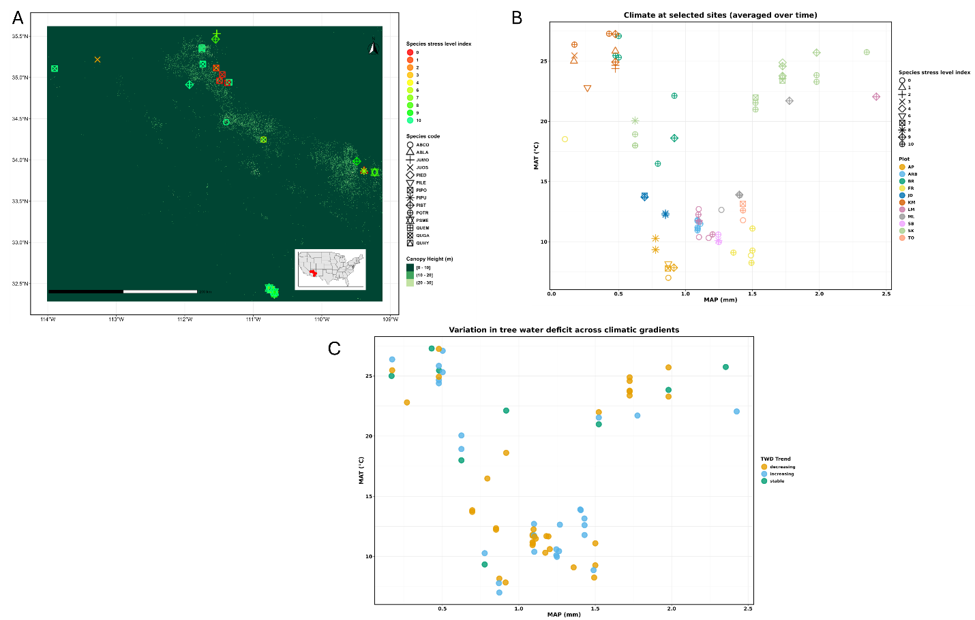
Fig. 1: A) Distribution of the fourteen selected species and 11 different locations in Arizona USA that were selected for this study. The shape of the symbols represents the different species, and the color represents the stress level of the species. The stress level index was decided by following the protocol from the USDA. B) mean annual temperature (MAT) and mean annual precipitation sum (MAP) at the selected sites. The shape of the symbols represents the different tree stress level index (0 = Dead, 1–9 = stressed, 10 = healthy), and the color represents the plot. C) mean annual temperature (MAT) and mean annual precipitation sum (MAP) and the color represents the tree water deficit (TWD) trend.

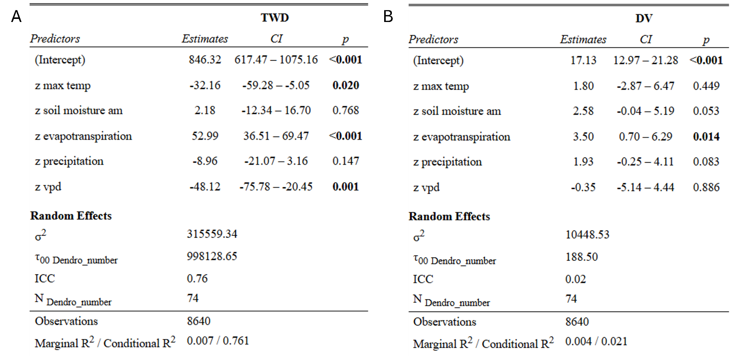
Fig. 2: The relationship between tree water deficit from continuous movement of the stem diameter (TWD) and stem diameter daily variation from continuous movement (DV) between trees irrespective of species and plot. Number of trees sampled = 74. The z_ prefix means the variables were scaled before analysis.

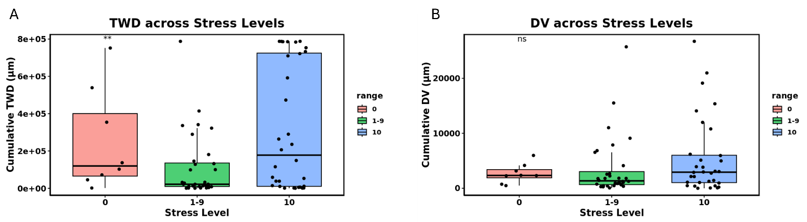
Fig. 3: Boxplots of the distribution of values per stress category, with jittered points representing individual trees. A) Cumulative tree water deficit (TWD) and B) cumulative daily variation (DV) across stress levels in trees (0 = Dead, 1–9 = stressed, 10 = healthy). ANOVA results indicate that TWD differs significantly between stressed (1–9) and healthy (10) trees (P value = 0.01), while DV shows no significant differences across stress levels. **P value <0.01, ns mean non-significant, degree of freedom for residual is 69.

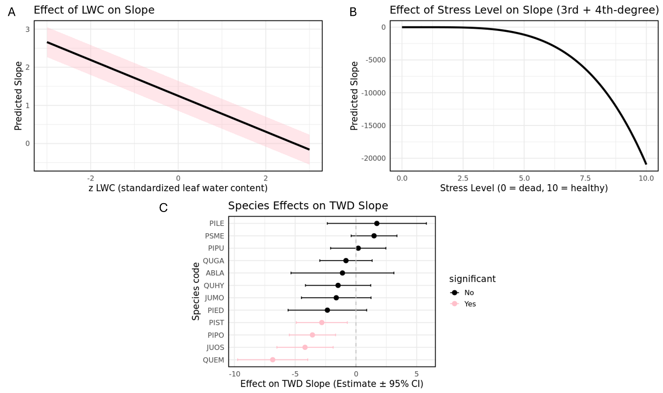
Fig. 4: The relationship between slopes of the tree water deficit calculated from the detrended Sen’s slope of the continuous movement of the stem diameter (TWD). A) result from the significant predictor of TWD slope. Leaf water content (LWC). B) predicting the drought stress from visual inspection of the tree. Stress level index was visually estimated from looking at the tree canopy, bark and stem. C) the effect of species in reducing or increasing the slope of TWD. Only PIST which is Pinus strobiformis, PIPO which is Pinus ponderosa, JUOS which is Juniperus osteosperma and QUEM which is Quercus emoryi are significant (P value <0.05). Number of trees sampled = 74.

Table 1. Species Taxonomic classification and species distribution across all study plot where AP, ARB, BR, FR, JD, KM, LM, ML, SB, SK, TO
Species Taxonomic Name | Species Common Name | Plant Code | Habitat preference (wet/dry) | Plot observed
Pinus strobiformis | Southwestern White Pine | PIST | Wet | AP, SK
Pseudotsuga menziesii | Douglas Fir | PSME | Wet | AP, SK
Abies concolor | White Fir | ABCO | Wet | AP, SK, SB, TO, ML
Abies lasiocarpa var. arizonica | Corkbark Fir | ABLA | Wet | AP
Picea pungens | Blue Spruce | PIPU | Wet | AP, ARB, FR, KM, LM, ML, SK
Pinus ponderosa | Ponderosa Pine | PIPO | Dry | ARB, FR, KM, LM, ML, SK
Juniperus monosperma | One-seed juniper | JUMO | Dry | BR, JD
Populus tremuloides | Quaking Aspen | POTR | Wet | FR
Pinus edulis | Pinyon Pine | PIED | Dry | BR, JD
Juniperus osteosperma | Utah juniper | JUOS | Dry | KM, LM
Quercus gambelii | Gambel Oak | QUGA | Dry | LM, ML, TO
Quercus emoryi | Emory oak | QUEM | Dry | SK
Quercus hypoleucoides | Silverleaf Oak | QUHY | Dry | SK
Pinus leiophylla var. chihuahuana | Chihuahuan pine | PILE | Dry | SK

Table 2: The filtered summary output of a linear mixed-effects model (lme from the nlme package) fitted to our dataset showing cases where the P value is less than 0.05. It shows the relationship between TWD (Tree Water Deficit) and environmental factors based on species (SP_CODE). Where max_temp stands for maximum temperature measured on the dendrometer and its tree specific; evapotranspiration stands for the rate of water loss out of the ecosystem. The SP_CODE is unique to each species, and it is an abbreviation of the 1st two genus and 1st two species names. Where PIPO is Pinus ponderosa; POTR is Populus tremuloides; JUMO is Juniperus monosperma; JUOS is Juniperus osteosperma; PIED is Pinus edulisi. The value and std. Error were rounded to the nearest whole number, and the T value and P value were rounded to the nearest 3 decimal places. ***P<0.001, **P<0.01, *P<0.05. The z_ prefix means the variables were scaled before analysis.
variable | Value | Std.Error | DF | t-value | p-value | signif
PIPO | 893 | 333 | 61 | 2.679 | 0.009 | **
POTR | 1,782 | 779 | 61 | 2.287 | 0.026 | *
z_max_temp:JUMO | 125 | 58 | 8,495 | 2.144 | 0.032 | *
z_max_temp:JUOS | -270 | 75 | 8,495 | -3.592 | 0.000 | ***
z_max_temp:PIED | -147 | 64 | 8,495 | -2.298 | 0.022 | *
z_evapotranspiration:JUMO | 216 | 40 | 8,495 | 5.345 | 0.000 | ***
z_evapotranspiration:JUOS | 318 | 51 | 8,495 | 6.234 | 0.000 | ***
z_evapotranspiration:PIED | 182 | 60 | 8,495 | 3.032 | 0.002 | **
z_evapotranspiration:PIPO | 97 | 27 | 8,495 | 3.662 | 0.000 | ***

Table 3: The filtered summary output of a linear mixed-effects model (lme from the nlme package) fitted to our dataset showing cases where the P value is less than 0.05. It shows the relationship between TWD (Tree Water Deficit) and environmental factors based on our various locations (PLOT). Where max_temp stands for maximum temperature measured on the dendrometer and its tree specific; evapotranspiration stands for the rate of water loss out of the ecosystem. The PLOT code is unique to each plot. Where ARB is arboretum plot located in Flagstaff Northern Arizona, USA this plot contains just PIPO which Pinus ponderosa; KM is our Kingman plot which is in Western Arizona, USA This plot contains a mixture of PIPO and JUOS which is Juniperus osteosperma; BR plot and JD plot for Bradshaw ranch located in Sedona Northern Arizona and Flagstaff Northern Arizona, USA with recent Juniper die off in 2022 respectively, these plots contains a mixture of JUMO which is Juniperus monosperma and PIED which is Pinus edulis; FR is a plot located in Fire road in Flagstaff Northern Arizona, USA, this plots contains PIPU which is Picea pungens, POTR which is Populus tremuloides, and PIPO; LM plot also in Flagstaff Northern Arizona with PIPU, PIPO, JUOS, QUGA which is Quercus gambelii. The value and std. Error were rounded to the nearest whole number, and the t value and p value were rounded to the nearest 3 decimal places. ***p<0.001, **p<0.01, *p<0.05. The z_ prefix means the variables were scaled before analysis.
Variable | Value | Std.Error | DF | T-value | P-value | signif
ARB | 1,649 | 534 | 63 | 3.086 | 0.003 | **
z_max_temp:ARB | -163 | 68 | 8,511 | -2.385 | 0.017 | *
z_max_temp:KM | -380 | 122 | 8,511 | -3.111 | 0.002 | **
z_evapotranspiration:ARB | 161 | 39 | 8,511 | 4.187 | 0.000 | ***
z_evapotranspiration:BR | 295 | 61 | 8,511 | 4.841 | 0.000 | ***
z_evapotranspiration:FR | 80 | 40 | 8,511 | 1.993 | 0.046 | *
z_evapotranspiration:JD | 266 | 48 | 8,511 | 5.500 | 0.000 | ***
z_evapotranspiration:LM | 160 | 42 | 8,511 | 3.780 | 0.000 | ***

References
Abatzoglou, J. T. (2013). Development of gridded surface meteorological data for ecological applications and modelling. International Journal of Climatology, 33(1), 121–131. https://doi.org/10.1002/joc.3413
Ahl, L. I., Mravec, J., Jørgensen, B., Rudall, P. J., Rønsted, N., & Grace, O. M. (2019). Dynamics of intracellular mannan and cell wall folding in the drought responses of succulent Aloe species. Plant, Cell & Environment, 42(8), 2458–2471. https://doi.org/10.1111/pce.13560
Basra, A. S., & Basra, R. K. (1997). Mechanisms of environmental stress resistance in plants. Routledge.
Bharambe, K. P., Shimizu, Y., Kantoush, S. A., Sumi, T., & Saber, M. (2023). Impacts of climate change on drought and its consequences on the agricultural crop under worst-case scenario over the Godavari River Basin, India. Climate Services, 32, 100415. https://doi.org/10.1016/j.cliser.2023.100415
Blonder, B., Both, S., Jodra, M., Xu, H., Fricker, M., Matos, I. S., Majalap, N., Burslem, D. F. R. P., Teh, Y. A., & Malhi, Y. (2020). Linking functional traits to multiscale statistics of leaf venation networks. New Phytologist, 228(6), 1796–1810. https://doi.org/10.1111/nph.16830
Bolan, S., Padhye, L. P., Jasemizad, T., Govarthanan, M., Karmegam, N., Wijesekara, H., Amarasiri, D., Hou, D., Zhou, P., Biswal, B. K., Balasubramanian, R., Wang, H., Siddique, K. H. M., Rinklebe, J., Kirkham, M. B., & Bolan, N. (2024). Impacts of climate change on the fate of contaminants through extreme weather events. Science of The Total Environment, 909, 168388. https://doi.org/10.1016/j.scitotenv.2023.168388
Buckley, T. N., John, G. P., Scoffoni, C., & Sack, L. (2015). How Does Leaf Anatomy Influence Water Transport outside the Xylem? Plant Physiology, 168(4), 1616–1635. https://doi.org/10.1104/pp.15.00731
Chavarria, G., & dos Santos, H. P. (2012). Plant Water Relations: Absorption, Transport and Control Mechanisms. In G. Montanaro (Ed.), Advances in Selected Plant Physiology Aspects. InTech. https://doi.org/10.5772/33478
Chaves, M. M. (2004). Mechanisms underlying plant resilience to water deficits: Prospects for water-saving agriculture. Journal of Experimental Botany, 55(407), 2365–2384. https://doi.org/10.1093/jxb/erh269
Cornelissen, J. H. C., Lavorel, S., Garnier, E., Díaz, S., Buchmann, N., Gurvich, D. E., Reich, P. B., Steege, H. ter, Morgan, H. D., Heijden, M. G. A. van der, Pausas, J. G., & Poorter, H. (2003). A handbook of protocols for standardised and easy measurement of plant functional traits worldwide. Australian Journal of Botany, 51(4), 335. https://doi.org/10.1071/BT02124
Davidian, M., & Giltinan, D. M. (2017). Nonlinear Models for Repeated Measurement Data (1st ed.). Routledge. https://doi.org/10.1201/9780203745502
De Swaef, T., De Schepper, V., Vandegehuchte, M. W., & Steppe, K. (2015). Stem diameter variations as a versatile research tool in ecophysiology. Tree Physiology, 35(10), 1047–1061. https://doi.org/10.1093/treephys/tpv080
Deslauriers, A., Rossi, S., & Anfodillo, T. (2007). Dendrometer and intra-annual tree growth: What kind of information can be inferred? Dendrochronologia, 25(2), 113–124. https://doi.org/10.1016/j.dendro.2007.05.003
Dietrich, L., Zweifel, R., & Kahmen, A. (2018). Daily stem diameter variations can predict the canopy water status of mature temperate trees. Tree Physiology, 38(7), 941–952. https://doi.org/10.1093/treephys/tpy023
Dunkleberger, R., Sauchyn, D. J., & Vanderwel, M. C. (2023). Using thermal imagery and changes in stem radius to assess water stress in two coniferous tree species. Agricultural and Forest Meteorology, 341, 109686. https://doi.org/10.1016/j.agrformet.2023.109686
Flexas, J., Díaz‐Espejo, A., Conesa, M. A., Coopman, R. E., Douthe, C., Gago, J., Gallé, A., Galmés, J., Medrano, H., Ribas‐Carbo, M., Tomàs, M., & Niinemets, Ü. (2016). Mesophyll conductance to CO ₂ and Rubisco as targets for improving intrinsic water use efficiency in C ₃ plants. Plant, Cell & Environment, 39(5), 965–982. https://doi.org/10.1111/pce.12622
Franceschi, E., Moser-Reischl, A., Honold, M., Rahman, M. A., Pretzsch, H., Pauleit, S., & Rötzer, T. (2023). Urban environment, drought events and climate change strongly affect the growth of common urban tree species in a temperate city. Urban Forestry & Urban Greening, 88, 128083. https://doi.org/10.1016/j.ufug.2023.128083
Fry, E. L., Manning, P., & Power, S. A. (2014). Ecosystem functions are resistant to extreme changes to rainfall regimes in a mesotrophic grassland. Plant and Soil, 381(1–2), 351–365. https://doi.org/10.1007/s11104-014-2137-2
Garnier, E., Shipley, B., Roumet, C., & Laurent, G. (2001). A standardized protocol for the determination of specific leaf area and leaf dry matter content: Protocol for the determination of leaf traits. Functional Ecology, 15(5), 688–695. https://doi.org/10.1046/j.0269-8463.2001.00563.x
Gu, L., Chen, J., Yin, J., Sullivan, S. C., Wang, H.-M., Guo, S., Zhang, L., & Kim, J.-S. (2020). Projected increases in magnitude and socioeconomic exposure of global droughts in 1.5 and 2 °C warmer climates. Hydrology and Earth System Sciences, 24(1), 451–472. https://doi.org/10.5194/hess-24-451-2020
Guérin, M., Martin‐Benito, D., von Arx, G., Andreu‐Hayles, L., Griffin, K. L., Hamdan, R., McDowell, N. G., Muscarella, R., Pockman, W., & Gentine, P. (2018). Interannual variations in needle and sapwood traits of Pinus edulis branches under an experimental drought. Ecology and Evolution, 8(3), 1655–1672.
Gusta, L., & Chen, T. (1987). The physiology of water and temperature stress. Wheat and Wheat Improvement, 13, 115–150.
Hatfield, J. L., & Dold, C. (2019). Water-use efficiency: Advances and challenges in a changing climate. Frontiers in Plant Science, 10, 103.
Hipel, K. W. (with MacLeod, A. I.). (1994). Time series modelling of water resources and environmental systems. Elsevier.
Ievinsh, G. (2023). Water Content of Plant Tissues: So Simple That Almost Forgotten? Plants, 12(6), 1238. https://doi.org/10.3390/plants12061238
Kendall, M. G., & Stuart, A. (1969). The Advanced Theory of Statistics. Vol. 3. Biometrics, 25(2), 435.
Lawson, T., Simkin, A. J., Kelly, G., & Granot, D. (2014). Mesophyll photosynthesis and guard cell metabolism impacts on stomatal behaviour. New Phytologist, 203(4), 1064–1081. https://doi.org/10.1111/nph.12945
Libiseller, C., & Grimvall, A. (2002). Performance of partial Mann–Kendall tests for trend detection in the presence of covariates. Environmetrics, 13(1), 71–84. https://doi.org/10.1002/env.507
Linton, M., Sperry, J., & Williams, D. (1998a). Limits to water transport in Juniperus osteosperma and Pinus edulis: Implications for drought tolerance and regulation of transpiration. Functional Ecology, 12(6), 906–911.
Linton, M., Sperry, J., & Williams, D. (1998b). Limits to water transport in Juniperus osteosperma and Pinus edulis: Implications for drought tolerance and regulation of transpiration. Functional Ecology, 12(6), 906–911.
Linton, M., Sperry, J., & Williams, D. (1998c). Limits to water transport in Juniperus osteosperma and Pinus edulis: Implications for drought tolerance and regulation of transpiration. Functional Ecology, 12(6), 906–911.
Malhi, Y., Franklin, J., Seddon, N., Solan, M., Turner, M. G., Field, C. B., & Knowlton, N. (2020). Climate change and ecosystems: Threats, opportunities and solutions. Philosophical Transactions of the Royal Society B: Biological Sciences, 375(1794), 20190104. https://doi.org/10.1098/rstb.2019.0104
Martínez‐Vilalta, J., & Garcia‐Forner, N. (2017). Water potential regulation, stomatal behaviour and hydraulic transport under drought: Deconstructing the iso/anisohydric concept. Plant, Cell & Environment, 40(6), 962–976. https://doi.org/10.1111/pce.12846
McAdam, S. A. M., & Brodribb, T. J. (2018). Mesophyll Cells Are the Main Site of Abscisic Acid Biosynthesis in Water-Stressed Leaves. Plant Physiology, 177(3), 911–917. https://doi.org/10.1104/pp.17.01829
Mixed-Effects Models in S and S-PLUS. (2000). Springer-Verlag. https://doi.org/10.1007/b98882
Muldavin, E., & Triepke, F. J. (2019). North American Pinyon ‚Juniper Woodlands: Ecological Composition, Dynamics, and Future Trends. Reference Module in Earth Systems and Environmental Sciences.
Nguyen, H. T., Meir, P., Wolfe, J., Mencuccini, M., & Ball, M. C. (2017). Plumbing the depths: Extracellular water storage in specialized leaf structures and its functional expression in a three‐domain pressure –volume relationship. Plant, Cell & Environment, 40(7), 1021–1038. https://doi.org/10.1111/pce.12788
ONeill, P., Chan, S., Njoku, E., Jackson, T., Bindlish, R., Chaubell, J., & Colliander, A. (2023). SMAP Enhanced L3 Radiometer Global and Polar Grid Daily 9 km EASE-Grid Soil Moisture, Version 6 [Dataset]. NASA National Snow and Ice Data Center Distributed Active Archive Center. https://doi.org/10.5067/M20OXIZHY3RJ
Plaut, J. A., Yepez, E. A., Hill, J., Pangle, R., Sperry, J. S., Pockman, W. T., & Mcdowell, N. G. (2012). Hydraulic limits preceding mortality in a piñon–juniper woodland under experimental drought. Plant, Cell & Environment, 35(9), 1601–1617. https://doi.org/10.1111/j.1365-3040.2012.02512.x
Robakowski, P., Wyka, T. P., Kowalkowski, W., Barzdajn, W., Pers-Kamczyc, E., Jankowski, A., & Politycka, B. (2020). Practical implications of different phenotypic and molecular responses of evergreen conifer and broadleaf deciduous forest tree species to regulated water deficit in a container nursery. Forests, 11(9), 1011.
Roeder, A., Schweingruber, F. H., Ebeling, A., Eisenhauer, N., Fischer, M., & Roscher, C. (2021). Plant diversity effects on plant longevity and their relationships to population stability in experimental grasslands. Journal of Ecology, 109(7), 2566–2579. https://doi.org/10.1111/1365-2745.13661
Running, S., Mu, Q., & Zhao, M. (2021). MODIS/Terra Net Evapotranspiration 8-Day L4 Global 500m SIN Grid V061 [Dataset]. NASA Land Processes Distributed Active Archive Center. https://doi.org/10.5067/MODIS/MOD16A2.061
Sánchez-Costa, E., Poyatos, R., & Sabaté, S. (2015). Contrasting growth and water use strategies in four co-occurring Mediterranean tree species revealed by concurrent measurements of sap flow and stem diameter variations. Agricultural and Forest Meteorology, 207, 24–37. https://doi.org/10.1016/j.agrformet.2015.03.012
Scholz, F. G., Bucci, S. J., Goldstein, G., Meinzer, F. C., Franco, A. C., & Miralles‐Wilhelm, F. (2007). Biophysical properties and functional significance of stem water storage tissues in Neotropical savanna trees. Plant, Cell & Environment, 30(2), 236–248. https://doi.org/10.1111/j.1365-3040.2006.01623.x
Sebastian, D. E., Murtugudde, R., & Ghosh, S. (2023). Soil–vegetation moisture capacitor maintains dry season vegetation productivity over India. Scientific Reports, 13(1), 888. https://doi.org/10.1038/s41598-022-27277-6
Sen, P. K. (1968). Estimates of the Regression Coefficient Based on Kendall’s Tau. Journal of the American Statistical Association, 63(324), 1379–1389. https://doi.org/10.1080/01621459.1968.10480934
Steppe, K. (2018). The potential of the tree water potential. Tree Physiology, 38(7), 937–940. https://doi.org/10.1093/treephys/tpy064
Tholen, D., Boom, C., & Zhu, X.-G. (2012). Opinion: Prospects for improving photosynthesis by altering leaf anatomy. Plant Science, 197, 92–101. https://doi.org/10.1016/j.plantsci.2012.09.005
Tolan, J., Yang, H.-I., Nosarzewski, B., Couairon, G., Vo, H. V., Brandt, J., Spore, J., Majumdar, S., Haziza, D., Vamaraju, J., Moutakanni, T., Bojanowski, P., Johns, T., White, B., Tiecke, T., & Couprie, C. (2024). Very high resolution canopy height maps from RGB imagery using self-supervised vision transformer and convolutional decoder trained on aerial lidar. Remote Sensing of Environment, 300, 113888. https://doi.org/10.1016/j.rse.2023.113888
Turnbull, L. A., Isbell, F., Purves, D. W., Loreau, M., & Hector, A. (2016). Understanding the value of plant diversity for ecosystem functioning through niche theory. Proceedings of the Royal Society B: Biological Sciences, 283(1844), 20160536. https://doi.org/10.1098/rspb.2016.0536
Van Der Maaten, E., Van Der Maaten-Theunissen, M., Smiljanić, M., Rossi, S., Simard, S., Wilmking, M., Deslauriers, A., Fonti, P., Von Arx, G., & Bouriaud, O. (2016). dendrometeR: Analyzing the pulse of trees in R. Dendrochronologia, 40, 12–16. https://doi.org/10.1016/j.dendro.2016.06.001
Wang, W., Peng, C., Kneeshaw, D. D., Larocque, G. R., & Luo, Z. (2012). Drought-induced tree mortality: Ecological consequences, causes, and modeling. Environmental Reviews, 20(2), 109–121. https://doi.org/10.1139/a2012-004
Weiskopf, S. R., Rubenstein, M. A., Crozier, L. G., Gaichas, S., Griffis, R., Halofsky, J. E., Hyde, K. J. W., Morelli, T. L., Morisette, J. T., Muñoz, R. C., Pershing, A. J., Peterson, D. L., Poudel, R., Staudinger, M. D., Sutton-Grier, A. E., Thompson, L., Vose, J., Weltzin, J. F., & Whyte, K. P. (2020). Climate change effects on biodiversity, ecosystems, ecosystem services, and natural resource management in the United States. Science of The Total Environment, 733, 137782. https://doi.org/10.1016/j.scitotenv.2020.137782
Wickham, H., Averick, M., Bryan, J., Chang, W., McGowan, L., François, R., Grolemund, G., Hayes, A., Henry, L., Hester, J., Kuhn, M., Pedersen, T., Miller, E., Bache, S., Müller, K., Ooms, J., Robinson, D., Seidel, D., Spinu, V., … Yutani, H. (2019). Welcome to the Tidyverse. Journal of Open Source Software, 4(43), 1686. https://doi.org/10.21105/joss.01686
Wiebe, H. H., & Al-Saadi, H. A. (1976). Matric Bound Water of Water Tissue from Succulents. Physiologia Plantarum, 36(1), 47–51. https://doi.org/10.1111/j.1399-3054.1976.tb05026.x
Willson, C. J., Manos, P. S., & Jackson, R. B. (2008). Hydraulic traits are influenced by phylogenetic history in the drought‐resistant, invasive genus Juniperus (Cupressaceae). American Journal of Botany, 95(3), 299–314.
Zhou, H., Zhou, G., He, Q., Zhou, L., Ji, Y., & Lv, X. (2021). Capability of leaf water content and its threshold values in reflection of soil–plant water status in maize during prolonged drought. Ecological Indicators, 124, 107395. https://doi.org/10.1016/j.ecolind.2021.107395
Ziegler, Y., Grote, R., Alongi, F., Knüver, T., & Ruehr, N. K. (2024). Capturing drought stress signals: The potential of dendrometers for monitoring tree water status. Tree Physiology, 44(12), tpae140. https://doi.org/10.1093/treephys/tpae140
Zweifel, R., Zimmermann, L., & Newbery, D. M. (2005). Modeling tree water deficit from microclimate: An approach to quantifying drought stress. Tree Physiology, 25(2), 147–156. https://doi.org/10.1093/treephys/25.2.147

