**Deadlocks Monitoring**

**Summary**

Deadlocks cause to an application performance. Users can experience that the application being slow or broken. When a deadlock occurs in SQL Server, two or more transactions are running and holding locks on data. Both tasks wait for the other to give up. In order to keep responding the database, SQL Server picks the least expensive query and roll back it. The query that’s eliminated is called the deadlock victim.

SQL Server Extended Events are the light weigh event driven data collection for SQL Server. It is beneficial to tracing and detecting deadlocks in the busy servers. There are two options for receiving deadlock information using Extended Events:

* System health events
* Dedicated session for deadlock events

**System Health Events**

By default the SQL Server runs the system health event which will log the deadlock that have happen in the past. The deadlock details can be extracted from the system health event using GUI available in SQL Server 2012 with ‘xml_deadlock_report’ Filter shown in the Figure 1 or running the following query:

Use Master

SELECT

xed.value('@timestamp', 'datetime') as Creation_Date,

xed.query('.') AS Extend_Event

FROM

(

SELECT CAST([target_data] AS XML) AS Target_Data

FROM sys.dm_xe_session_targets AS xt

INNER JOIN sys.dm_xe_sessions AS xs

ON xs.address = xt.event_session_address

WHERE xs.name = N'system_health'

AND xt.target_name = N'ring_buffer'

) AS XML_Data

CROSS APPLY Target_Data.nodes('RingBufferTarget/event[@name="xml_deadlock_report"]') AS XEventData(xed)

ORDER BY Creation_Date DESC

The result of query returns the deadlocks event information in the XML format:



**Figure 1. System Health Events log with ‘xml_deadlock_report’ Filter.**

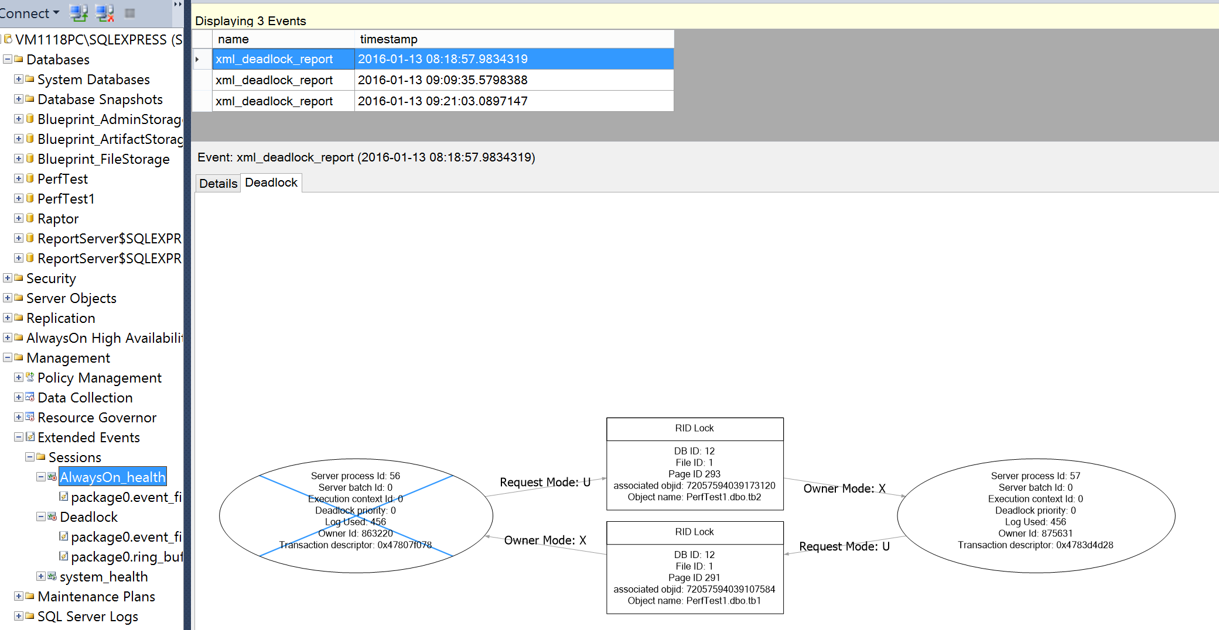

**Dedicated session for deadlock events**

It is possible to create a dedicated session for deadlock events to monitor the deadlocks explicitly. This guidance provided the main steps to create a dedicated session for deadlock events.

1. Connect to Management studio in the SQL Server 2012 instance and open Extended Events:

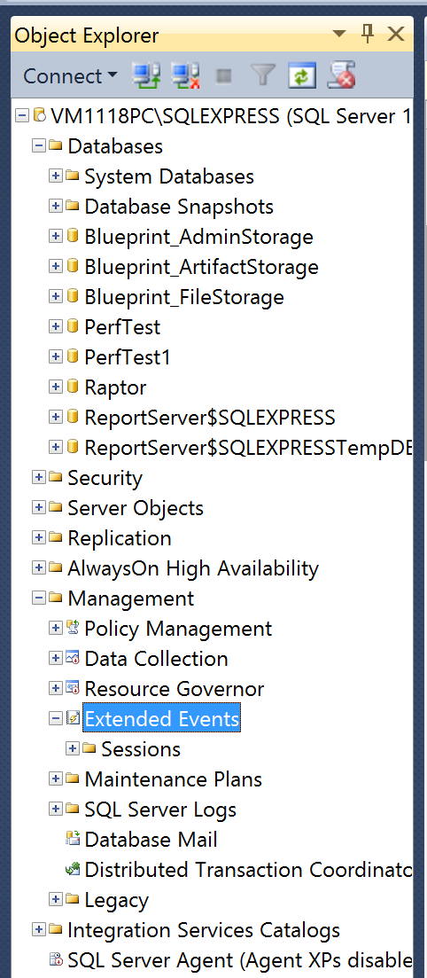

1. Create a new Session named ‘Deadlocks’ and check ‘Start the event session at server startup’:

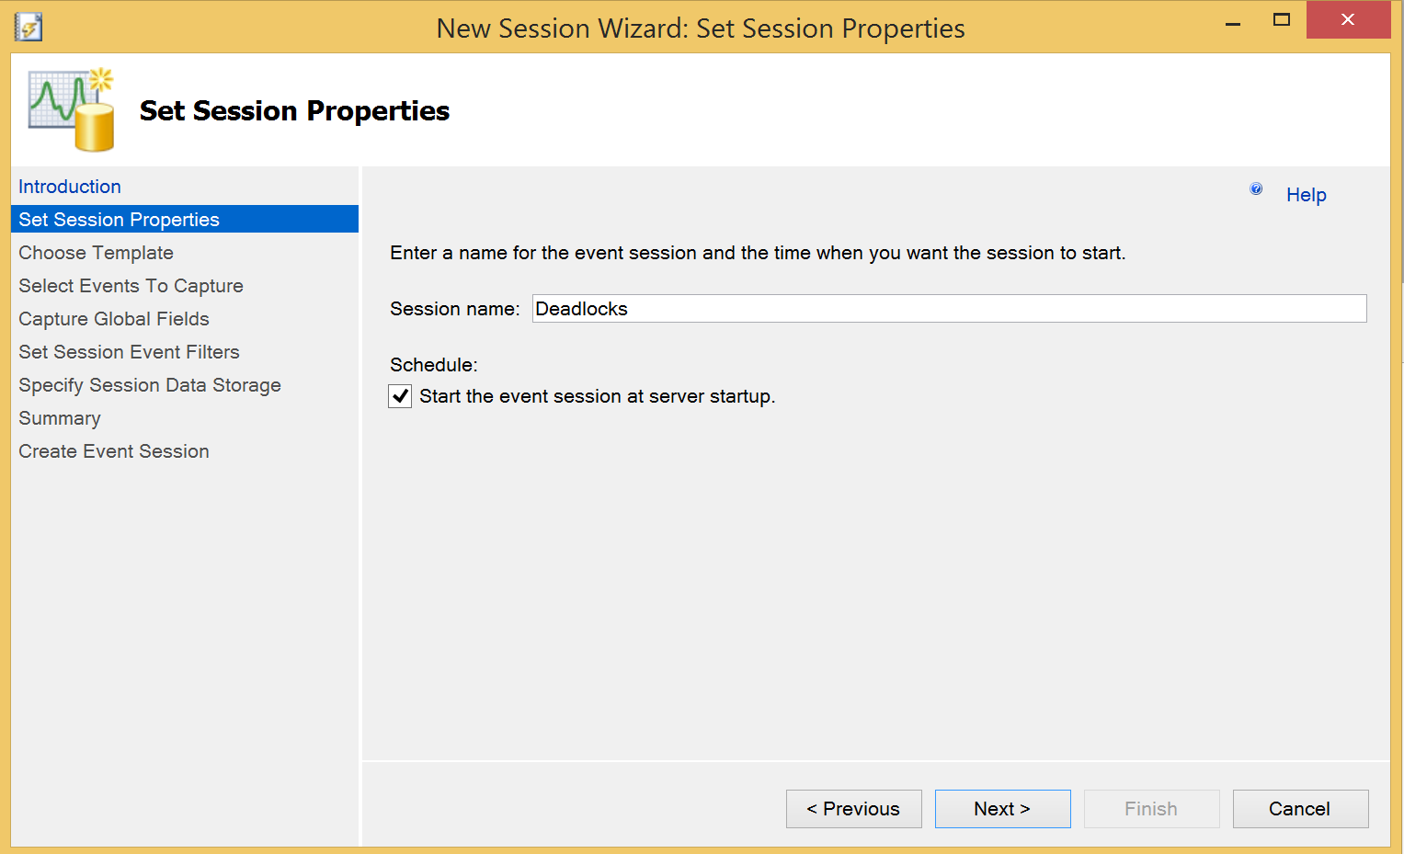

1. Select the ‘xml_deadlock_report’ event in the ‘Select Events To Capture’:

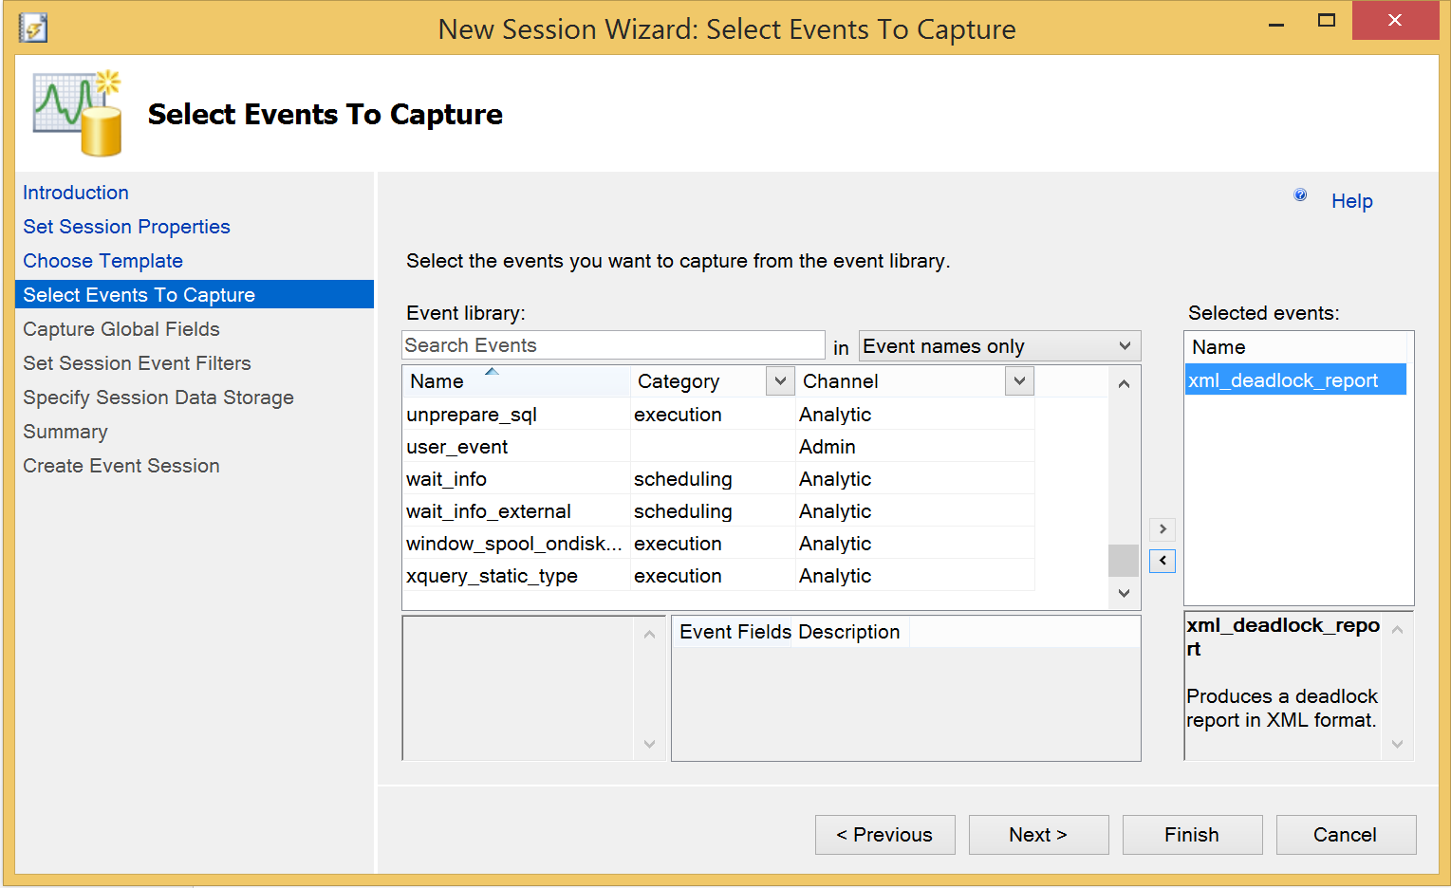

1. Select ‘database_id’ and ‘database_name’ in the ‘Capture Global Fields’:

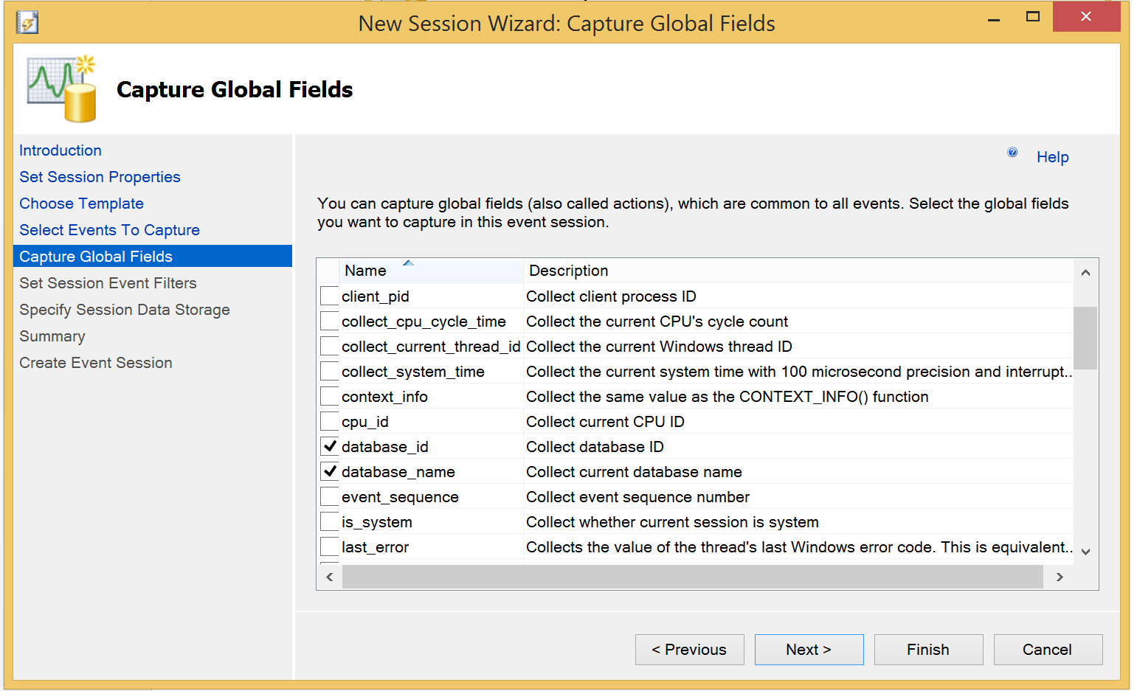

1. Save output into files:

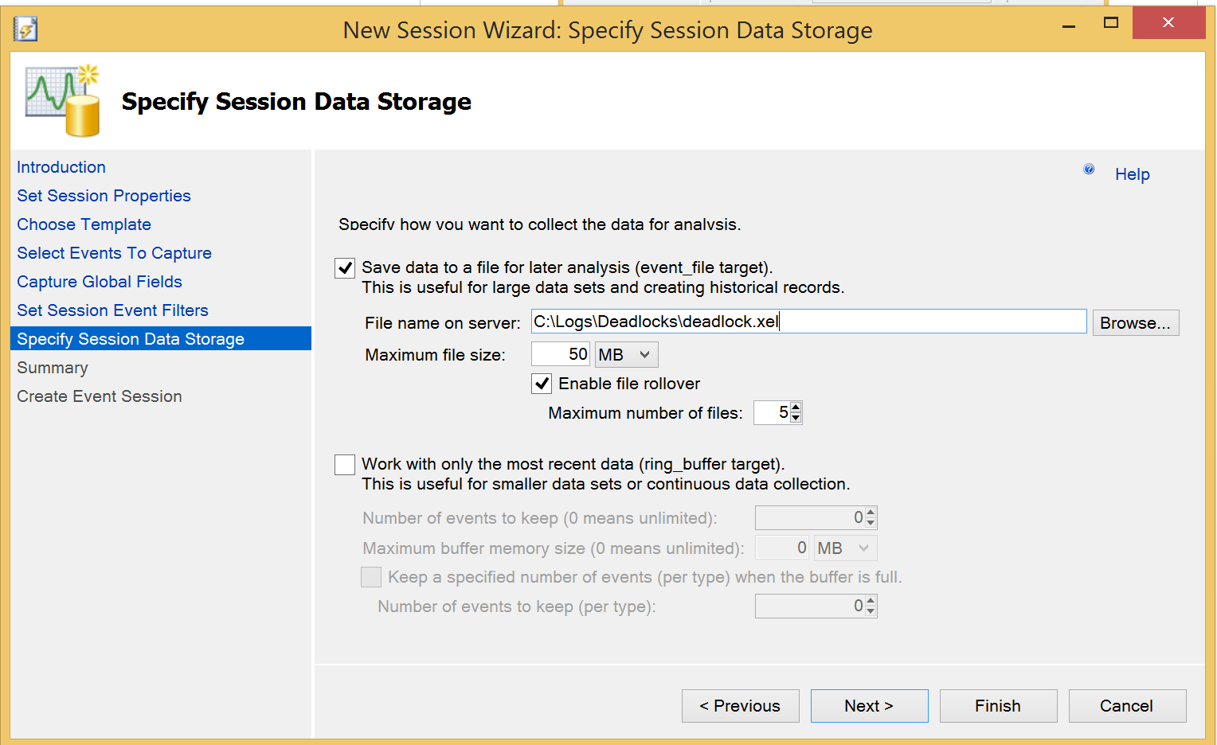

1. Start created session:

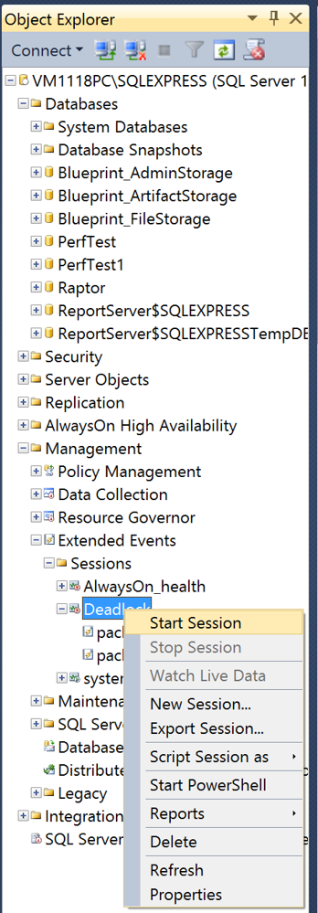

1. Analyze the data captured for deadlock events:

