Cryptography and Network Security Integrated Situation Technical Report
TODO: Daniel Ben
TODO: 4202670040
ULK Polytechnic Institute
September 27, 2026

1 Introduction
This report covers the security review of a polytechnic institute that stores student records on a central server and transfers files between two campuses. A prior review identified weak staff passwords, outdated software, unencrypted file transfers, and guest network access to the records server, along with repeated connection attempts from an unfamiliar external address. This report presents a risk assessment of the scenario, a Python toolkit implementing file encryption and integrity verification, and firewall rules restricting network access to the records server, together with test evidence for each.

2 Risk Assessment

2.1 Assets, Vulnerabilities and Consequences
Asset | Vulnerability | Consequence
Central student  records server | Weak staff passwords | Unauthorized access to student records, data theft or tampering
File transfer between campuses | Unencrypted file trans-  fers | Interception of records in transit (eavesdropping / man-in-themiddle)
Records server network access | Guest network access to the records server | An unauthenticated device on the guest network could reach and attack the server

2.2 Risk Ranking
Rank | Risk | Likelihood | Impact
1 | Guest network access to server | High | High
2 | Weak staff passwords | Medium | High
3 | Unencrypted file transfers | Medium | Medium
Guest network access was ranked highest because the scenario reports repeated connection attempts from an unfamiliar external address, indicating this risk is already being actively probed rather than merely theoretical. Weak staff passwords were ranked second: likely to be exploited given how common credential guessing is, with high impact if it succeeds. Unencrypted transfers were ranked third, as intercepting them typically requires the attacker to already have network position, a precondition partly addressed by mitigating risk 1.

2.3 Recommended Controls
Risk | Recommended Control
Guest network access to records server | Network segmentation — place the records server on a subnet not reachable from the guest network, enforced by firewall rules (implemented in Section 4 of this report)
Weak staff passwords | Enforce a password policy (minimum length-  /complexity) and multi-factor authentication
Unencrypted file transfers | Use an encrypted transfer protocol (e.g.  SFTP or TLS) instead of plain FTP

3 Encryption, Decryption and Integrity Verification

3.1 Design
The toolkit (crypto toolkit.py) uses symmetric encryption (Fernet, built on AES) to encrypt and decrypt the sample student record file, and SHA-256 to compute an integrity hash that can later detect whether the file has been modified.

3.2 Execution and Evidence
The toolkit was run on Windows PowerShell against a sample student record file. Full terminal output is captured in Figure 1.
PS> python crypto_toolkit.py generate-key secret.key
Key generated and saved to secret.key
PS> python crypto_toolkit.py encrypt sample_student_record.txt sample_student_record.enc secret.key
Encrypted ’sample_student_record.txt’ -> ’sample_student_record.enc’
PS> python crypto_toolkit.py decrypt sample_student_record.enc sample_student_record.dec secret.key
Decrypted ’sample_student_record.enc’ -> ’sample_student_record.dec’
PS> fc.exe sample_student_record.txt sample_student_record.dec
Comparing files sample_student_record.txt and SAMPLE_STUDENT_RECORD.DEC FC: no differences encountered
PS> python crypto_toolkit.py hash sample_student_record.txt SHA-256 of ’sample_student_record.txt’: a2c6ec5cad425e11fbc69431d0235d5243e118bd0db7f84e57930cdf518aa336
Saved to ’sample_student_record.txt.sha256’
PS> python crypto_toolkit.py verify sample_student_record.txt sample_student_record.txt.sha256
Integrity check PASSED: file has not changed.
PS> python crypto_toolkit.py encrypt does_not_exist.txt out.enc secret.key
Error: Input file not found: does_not_exist.txt
fc.exe confirmed the decrypted file is byte-for-byte identical to the original, the SHA-256 verification passed on the unmodified file, and attempting to encrypt a non-existent file produced a clean error message rather than a crash, satisfying task 2d.
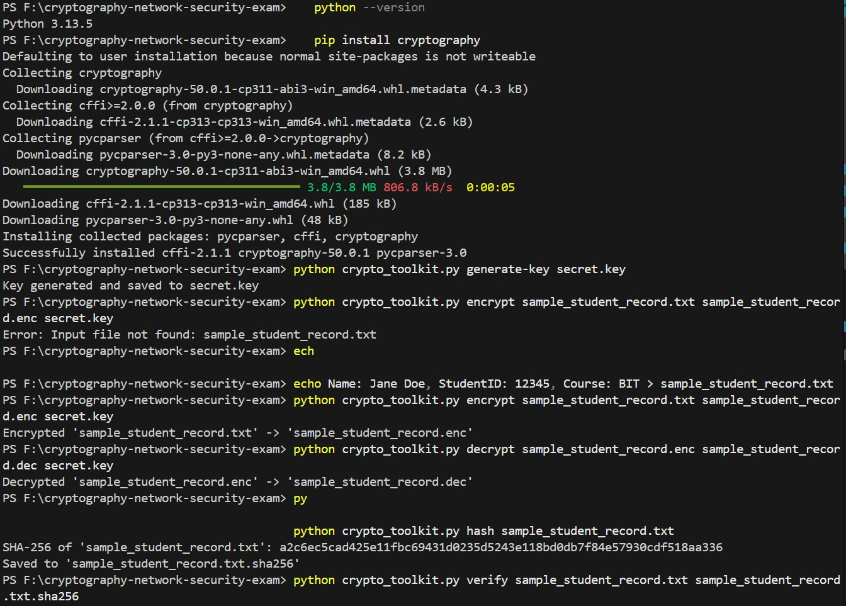
Figure 1: Terminal output of the encryption, decryption and hashing workflow.

4 Network Traffic Filtering

4.1 Environment
Testing was carried out on a Windows 11 laptop using Windows Defender Firewall (via the NetFirewallRule PowerShell cmdlets) in place of iptables/ufw, since no dedicated Linux lab machine was available. A Python HTTP server on port 5000 simulated the student records service. The laptop hosted its own Mobile Hotspot so a phone could connect as a genuinely separate device, avoiding the client-isolation restriction present on the original mobile hotspot network.

4.2 Firewall Rules Applied
$staffIP = "192.168.137.24"
New-NetFirewallRule -DisplayName "Block-Others-5000" -Direction Inbound -
Protocol TCP ‘
-LocalPort 5000 -RemoteAddress Any -Action Block
New-NetFirewallRule -DisplayName "Allow-Staff-5000" -Direction Inbound -
Protocol TCP ‘
-LocalPort 5000 -RemoteAddress $staffIP -Action Allow
Note: Windows Defender Firewall gives Block rules unconditional precedence over Allow rules, unlike iptables where rule order determines precedence. The two rules were therefore toggled with Enable/Disable-NetFirewallRule between tests to produce three unambiguous results.

4.3 Test Procedure and Results
Test 1 — Permitted connection. With Allow-Staff-5000 active and Block-Others-5000 disabled, the staff device (phone) loaded http://192.168.137.1:5000 successfully, showing a directory listing of the service (Figure 2).
Test 2 — Blocked connection. With Block-Others-5000 enabled and Allow-Staff-5000 disabled, the same device could no longer reach the service; the browser returned ERR CONNECTION TIMED OUT (Figure 3).
Test 3 — Blocked connection (repeat). Under the same blocked state as Test 2, a repeat attempt confirmed the block was consistent.
Limitation: only one spare physical device was available for testing rather than three separate network segments. Tests 2 and 3 both use the same device with its permission revoked, which still validly demonstrates that the block rule consistently denies unauthorised access.

5 Conclusion
The three highest-priority risks identified were guest network access to the records server, weak staff passwords, and unencrypted file transfers between campuses, with guest network access ranked most urgent due to evidence of active probing already occurring. Two of the identified risks were directly mitigated in this exercise: the encryption and integrity toolkit addresses confidentiality and tamper-detection for stored/transferred records, while the firewall rules address unauthorised network access by restricting the records service to a single authorised device and blocking all other sources. Together, these controls close the two most immediately exploitable weaknesses in the scenario. Remaining risks, particularly weak staff passwords and outdated software, would need to be addressed through policy and patch management measures outside the scope of the toolkit built here.
GitHub Repository: https://github.com/ogonjo01/cryptography-network-security-exam
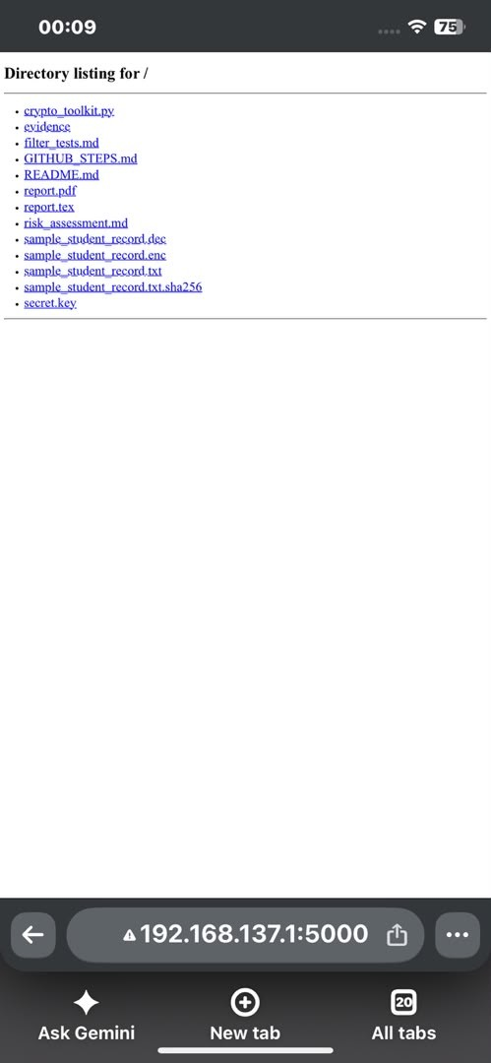
Figure 2: Test 1: permitted connection — service reachable from the staff device.
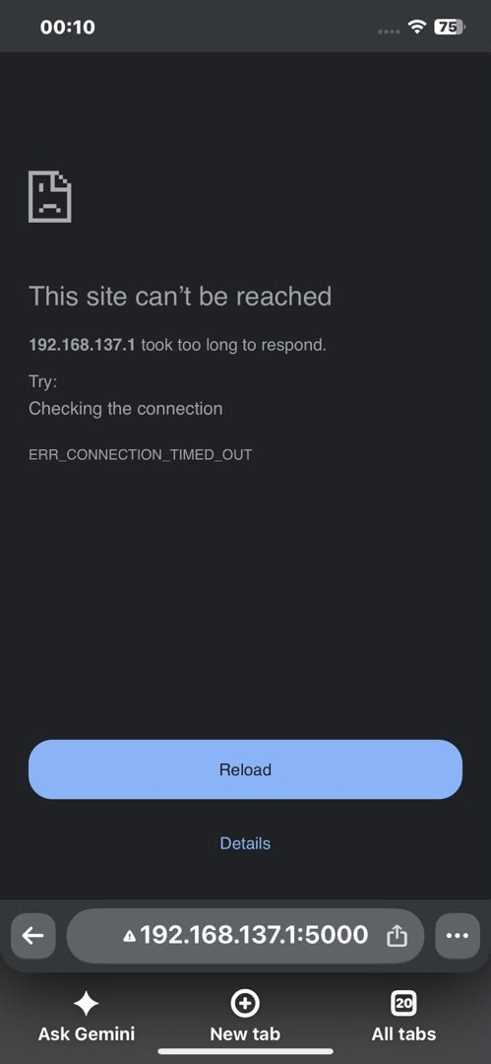
Figure 3: Test 2: blocked connection — connection timed out after the allow rule was removed.

