**INTRODUCTION**

The H-1B visa program serves as a gateway for skilled international professionals to contribute to the U.S. workforce, particularly in high-demand sectors such as technology, engineering, and healthcare. As global demand for skilled labor intensifies, understanding the dynamics of H-1B applicants becomes essential for policymakers, employers, and researchers alike. This study employs multivariate analysis to explore complex interdependencies across several variables, including gender, age, country of origin, education level, job title, wage, geographic employment location, employer, and visa processing trends. By incorporating multiple data dimensions, this research aims to uncover nuanced insights and identify patterns that are not visible through univariate or bivariate analyses solely.

Visualizations presented in this poster provide a data-driven perspective on the evolving trends in H-1B applications from 2021 to 2024, helping to inform decisions around workforce diversity, talent acquisition strategies, and immigration policy.

**OBJECTIVES**

This study aims to uncover key trends and patterns within the H-1B visa application process by conducting multivariate analysis and visual exploration. The primary objectives include:

1. Demographic Insights:

* Analyze the gender distribution of H-1B applicants from the top five countries of birth, segmented by status type and observed over multiple years.
* Evaluate the average age of applicants by job title and gender, highlighting trends across time.

1. Geographic Distribution:

Examine the geographic distribution of H-1B employment based on:

* Average annual wage by worksite state
* Average number of employees in the U.S. by worksite state

1. Employer and Job Title Trends:

* Identify the top employers based on the total number of H-1B beneficiaries.
* Highlight the most common H-1B job titles by total approved applications.

1. Education and Field of Study:

* Investigate trends in approved H-1B applicants by field of study and education level across different years.
* Analyze wage trends in relation to education level and year.

1. Processing Time Analysis:

* Assess processing time trends over the years by beneficiary’s current visa class and the first decision outcome.

**METHODOLOGY**

The initial raw dataset was noisy and had an enormous amount of missing data. To resolve this issue, three approaches are conducted:

* *Divide and Conquer*: Dataset was divvied into two halves by the columns based on the cycles. In H1B registration, two main cycles such as registration and selection. This was done for the purpose of analyzing the cycle process.
* *Separation*: Since the data with nulls removed was prone to huge data loss, the visualizations did not deliver its potential since splitting the data based on the required features for visualization and dropping the nulls just for those parameters were performed.
* *Issue with Wages*: In the raw as well as other divided datasets, there is a consistent issue with the wages feature. The feature has wrong values under the assumption of annual wage. Where, all weekly, monthly and yearly wages are comprised in the annual wage column. A prediction model to classify each of the instances into its actual class and convert it into annual format. Thus, this dataset is partially examined for the visualizations involving compensation related features.

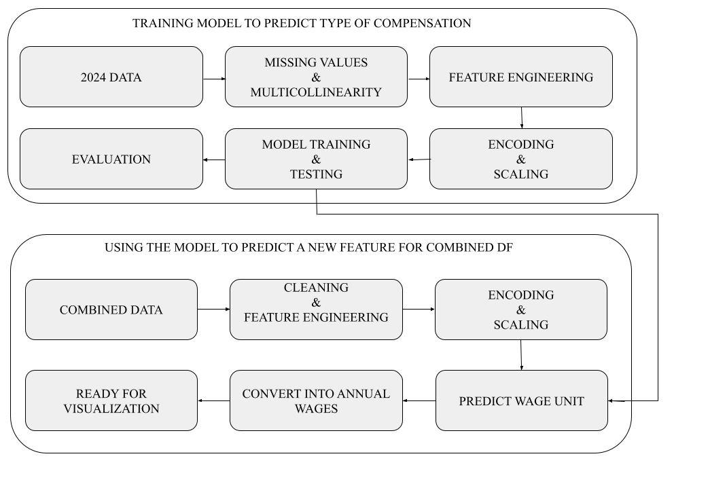

**KEY FINDINGS**

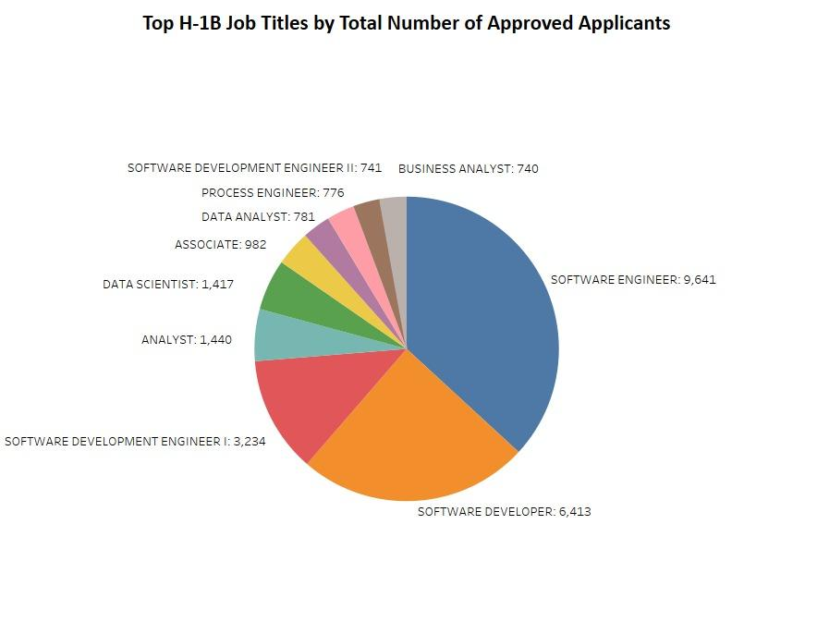

Software Engineer topped the chart with over 9,600 approvals, followed by Software Developer and Software Development Engineer I. Analytical and data-driven roles such as Data Scientist, Analyst, and Business Analyst also featured prominently. The top roles are heavily skewed toward tech and software-related positions.

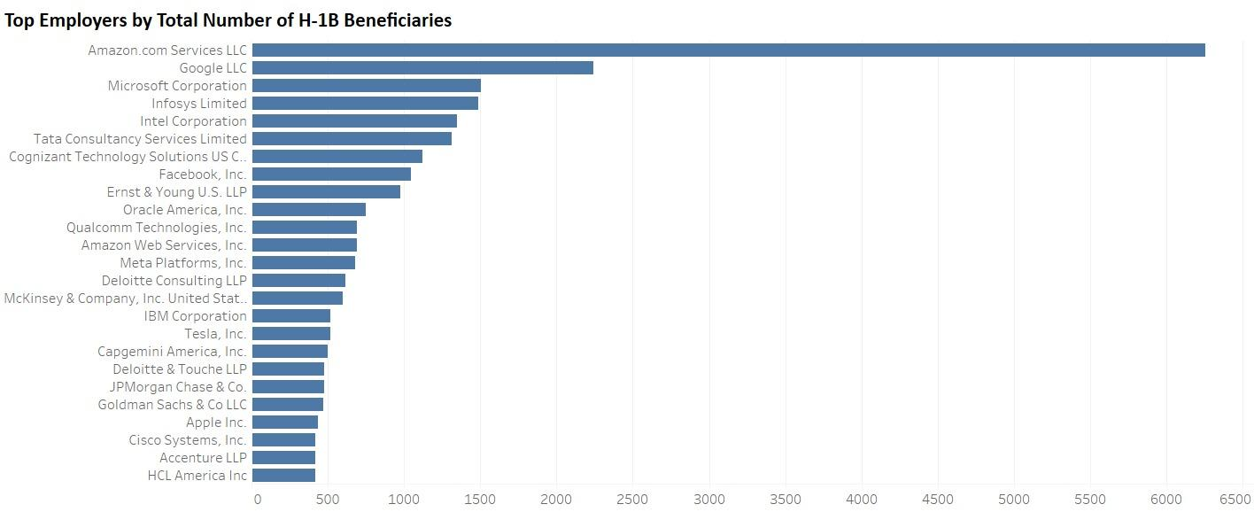

Amazon, Google, and Microsoft were the top three employers sponsoring H-1B visas. Other significant sponsors include Infosys, Intel, and Tata Consultancy Services, indicating the dominance of tech companies in H-1B hiring.

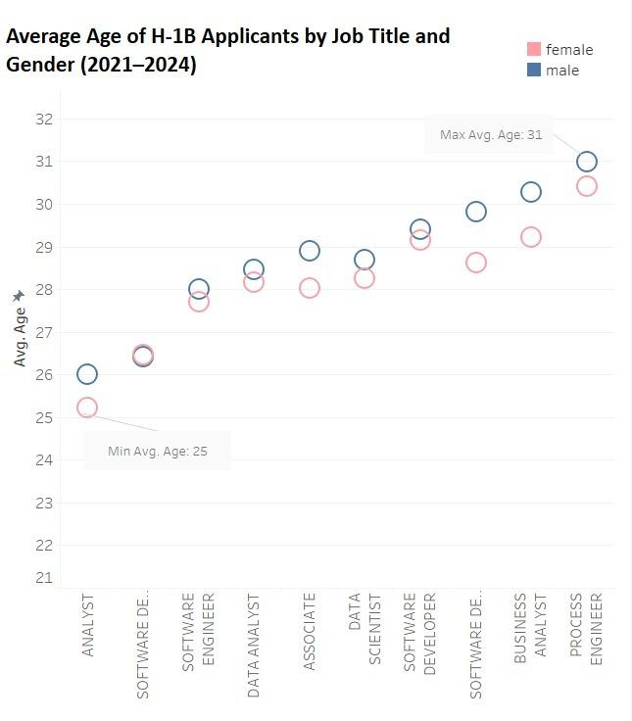

Average age ranged from 25 to 31, with Analyst roles attracting younger applicants and Process Engineer roles skewing older. Males generally had slightly higher average ages than females across all job titles.

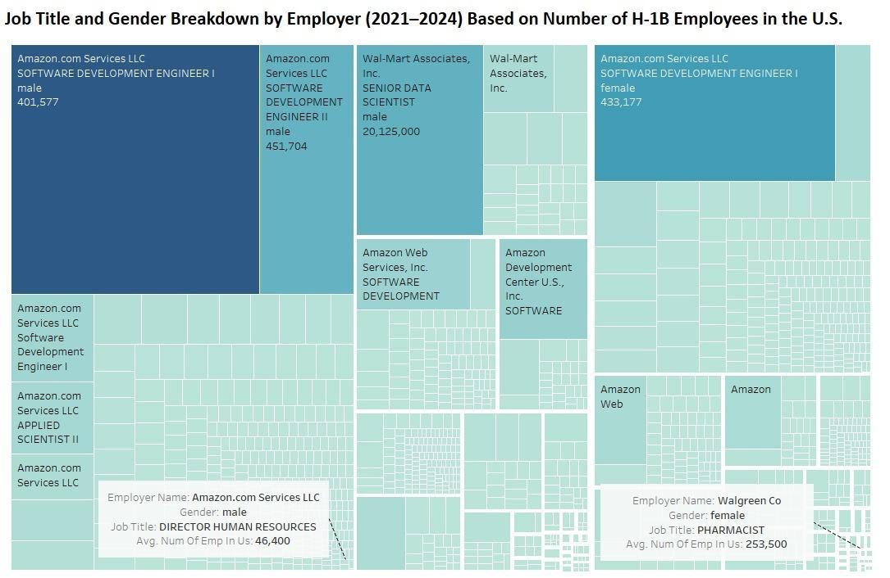

Amazon.com Services LLC employed the largest number of H-1B workers, particularly in Software Development Engineer I & II roles. Walmart had significant numbers for roles like Senior Data Scientist (male), while Walgreens saw high female representation in Pharmacist positions. Gender roles are clearly associated with job type and employer preferences.

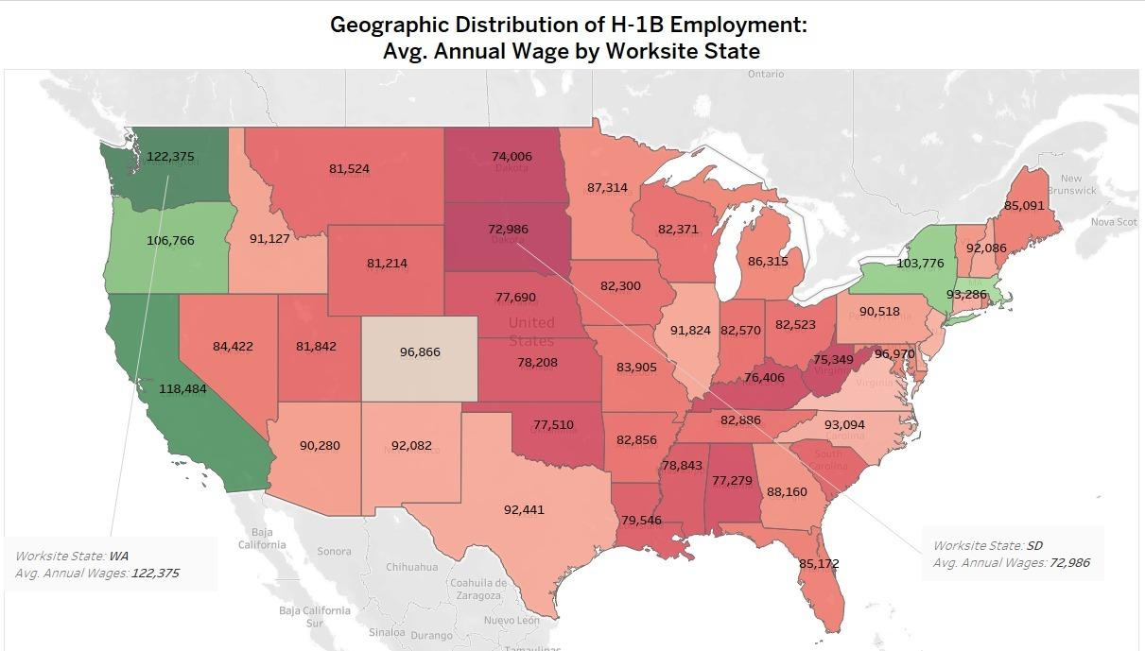

Washington ($122,375), California ($118,484), and Massachusetts ($103,776) offered the highest wages. States like South Dakota ($72,986) and North Dakota ($74,006) recorded the lowest average wages. High-tech regions on the coasts led the wage scale, correlating with major tech employers.

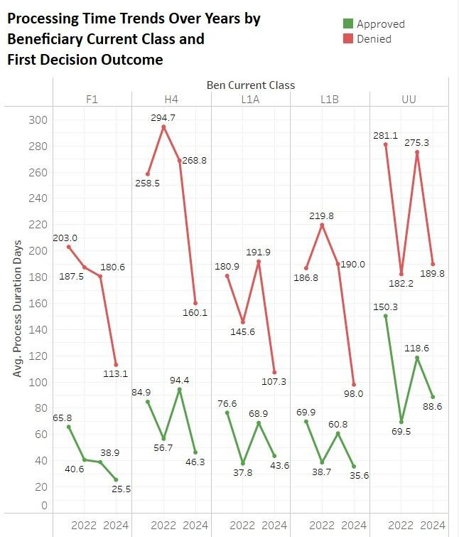

Denied applications consistently had longer processing times than approved ones. H4 and UU visa classes had the highest processing durations when denied (reaching nearly 295 days). Approved applications saw a steady decrease in processing time from 2022 to 2024 across most visa classes.

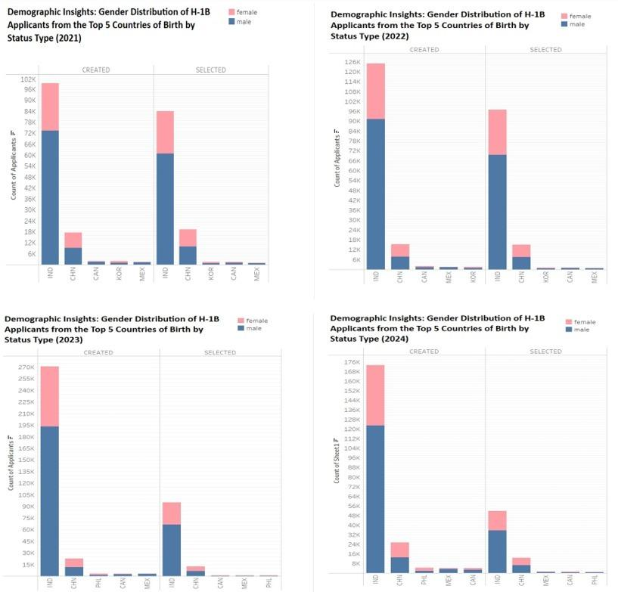

Across all four years, India had the highest volume of applicants, with male applicants significantly outnumbering female applicants. This gender imbalance sustained in both “Created” and “Selected” application stages. Other countries (China, South Korea, Philippines, Canada, Mexico) contributed far fewer applicants, with varying degrees of gender distribution.

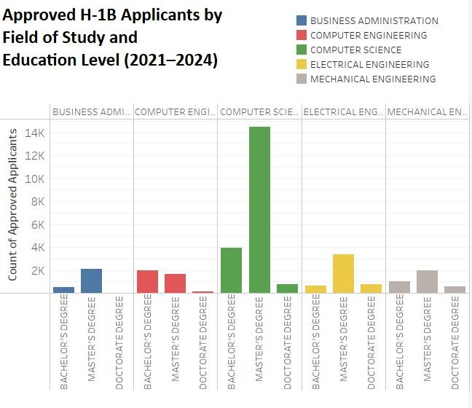

Computer Science at the Master’s degree level had the highest number of approvals, surpassing 14,000 applicants. Electrical and Mechanical Engineering also showed strong presence, especially at the Bachelor's and Master's levels. Doctorate-level approvals were significantly lower across all fields as there are less applicants who have doctoral degrees when compared to other categories. Somehow, doctoral and professional degrees have less denial rates and this fact is backed up by the analysis conducted.

**DISCUSSION**

* Indian males dominate both applications and selections. However, this imbalance highlights a need for gender inclusion strategies in H-1B hiring practices.
* Younger applicants are seen in tech-heavy roles. Gender differences in average age could hint at systemic access issues or career trajectory differences.
* High-paying states are also high-employment hubs, suggesting that tech companies are geographically concentrated in areas with robust infrastructure and talent pools.
* Big tech firms like Amazon and Google dominate H-1B hiring, particularly for software roles. However, there’s increasing female representation in select roles, especially among large employers.
* Longer processing times correlate with denial rates, suggesting bureaucratic bottlenecks or stricter scrutiny for specific visa categories (especially H4 and UU).

These patterns demonstrate that applicant outcomes are influenced not just by isolated factors but by intersections of demographic, geographic, and institutional variables that are validating the application of multivariate analysis for this study.

**CONCLUSION**

This multivariate analysis reveals nuanced dynamics within the H-1B applicant ecosystem. While technical roles and Master’s-level education dominate approvals, the disproportionate male representation across top countries and employers remains persistent, suggesting systemic barriers to gender diversity. Surprisingly, processing delays are not uniform referring to applicants from dependent visa categories like H4 face significantly higher rejection delays, potentially discouraging otherwise qualified candidates. Moreover, despite high wages in coastal states, some mid-tier states like Colorado and Texas maintain competitive pay with higher applicant volumes, reflecting the gradual geographic decentralization of tech talent.

These insights demonstrate that beyond easily observable trends, intersections between gender, geography, visa type, and employer behavior offer a broader view of the evolving skilled migration landscape in the U.S.

**REFERENCES**

* BloombergGraphics. (2025). US H‑1B visa lottery and petition data FY 2021–2024 [Data set]. GitHub. https://github.com/BloombergGraphics/2024-h1b-immigration-data
* U.S. Citizenship and Immigration Services. (n.d.). H-1B employer data hub. U.S. Department of Homeland Security. https://www.uscis.gov/tools/reports-and-studies/h-1b-employer-data-hub
* U.S. Citizenship and Immigration Services. (2019, April). USCIS launches H-1B employer data hub. https://www.uscis.gov/archive/uscis-launches-h-1b-employer-data-hub
* U.S. Citizenship and Immigration Services. (2021, February 5). H-1B specialty occupations, DOD cooperative research and development project workers, and fashion models. https://www.uscis.gov/working-in-the-united-states/h-1b-specialty-occupations
* U.S. Citizenship and Immigration Services. (n.d.). H-1B cap season. https://www.uscis.gov/working-in-the-united-states/temporary-workers/h-1b-specialty-occupations/h-1b-cap-season

**CONTACTS**

* www.linkedin.com/in/omer-gorgun
* https://github.com/ogorgun41