Configuring Cloud
1. Firstly I created tomcat7 gear in openshift.
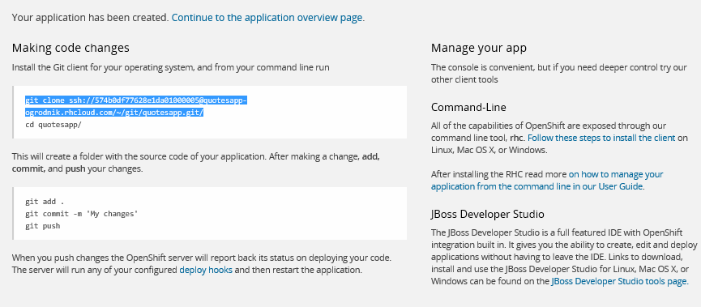
2. Then I added MySQL database
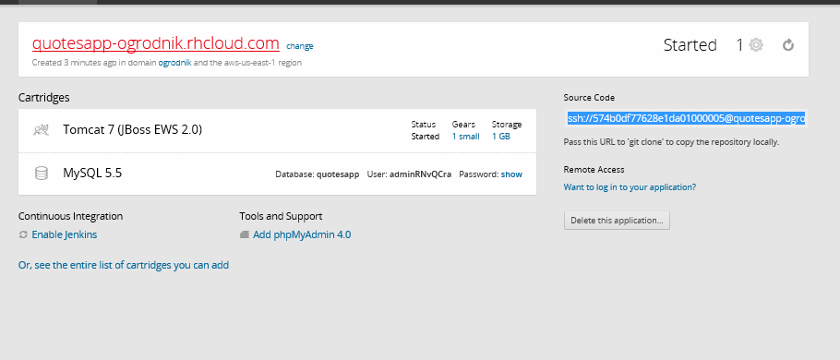
3. I downloaded default openshift project created automaicaly by openshift. It contained .openshift folder with configuration.
4. I uploaded JDBC driver in $OPENSHIFT_DIR_DATA
“wget http://central.maven.org/maven2/mysql/mysql-connector-java/5.1.25/mysql-connector-java-5.1.25.jar”
5. I configured:
server.xml
context.xml
to configure database connection pool and:
catalania.properties
to add path to my driver
6. I created port-forwarding configuration using
rhc port-forward <application>
7. I installled MYSQL Workbench
http://dev.mysql.com/downloads/file/?id=460621
8. I connected to MySQL database on openshift
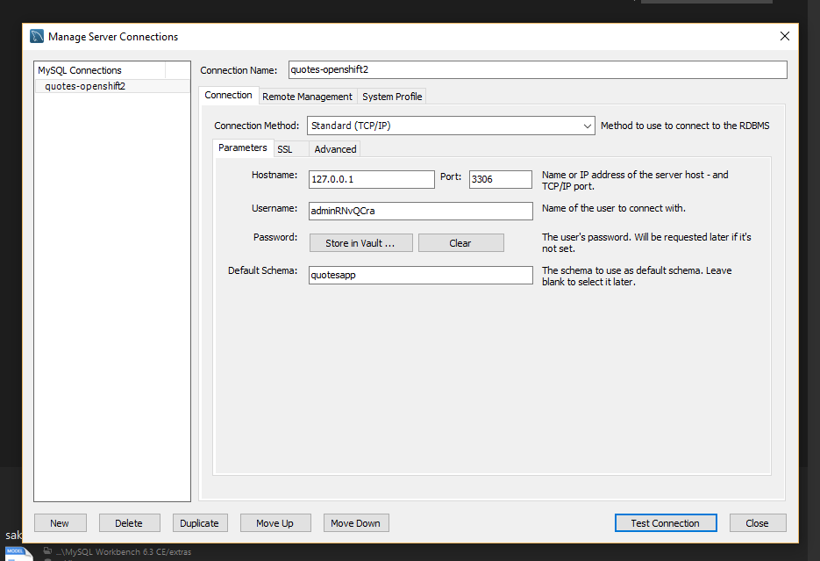
9Then when i started running script using this tool it was very slow so i added phpMyAdmin in my cartridge and i imported data using this tool. (I created data.sql file earlier)

This is how the application looks like:
