1. You will be given PQHR.xlsx excel file with two sheets.
1. Employee
o EmployeeID
o Name
o Department
o Job_Title
o Hire_Date
o Date of Birth
o Gender
o Salary
2. Training
o EmployeeID
o Training_Name
o Training_Date
o Status (Completed / Not Completed)
Using these two tables, answer following questions.
A. Create simple PivotTable showing for each Gender:
- Number of Employees
- Average Salary
- Minimum and maximum Age
- % of employees who completed training
B. Create simple PivotTable showing for each Department:
- Average Salary
- Training Completion Rate
- Average Tenure

2. Using the data in EmployeeSurvey and EmployeeData sheet from HR-Model.xlsx file create following report
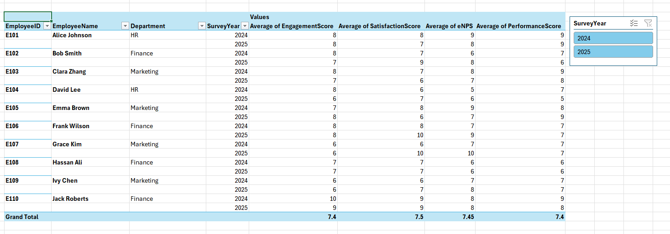
3. Add Supervisor Name to EmployeeData sheet from HR-Model.xlsx.
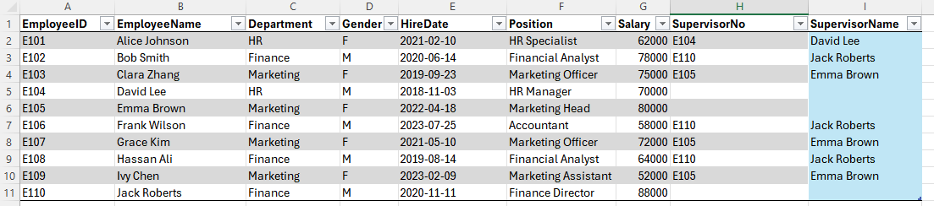

4. Power Query Example with Acoocunt Payable Data.
Note:If you are MAC user, you do not need to combine all 4 files. Just use one file.

