Before Midterm

Focus on Bias -variance tradeoff, underfitting, overfitting, bagging, boosting the algorithm behind XGBoost

For the algorithm behind XGBoost

https://towardsdatascience.com/all-you-need-to-know-about-gradient-boosting-algorithm-part-1-regression-2520a34a502

1) 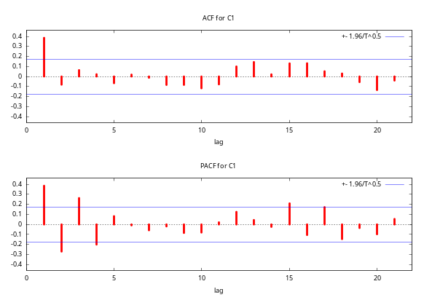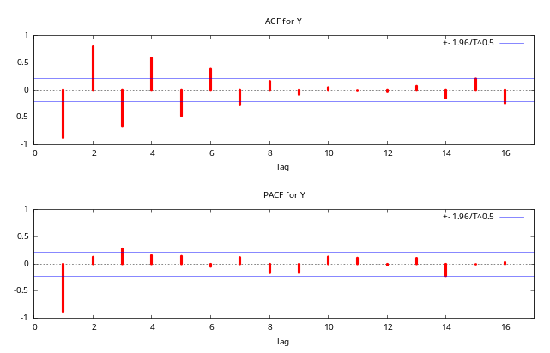
a)Concstruct ARMA model for the corrrelagram?

(Alternative question might be MA process)
b)The parameter for AR(1) model estimated is given in the table below. Forecast point estimate for 2006 and construct for confidence interval at 95%

 | coefficient | std. error | t-ratio | p-value
Constant | 115.265 | 7.57028 | 15.23 | 3.30E-24
AR1 | -0.528921 | 0.098906 | -5.348 | 1.00E-06

For 95% confidence intervals, z(0.025) = 1.96

Obs | C1 | prediction | std. error
2004 | 99 | 69.2
2005 | 72 | 62.9
2006 |  | - | 3.8968

2)
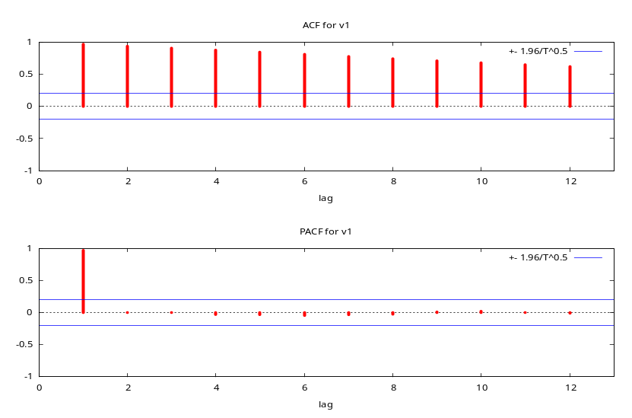
- Based on above series, can you say that whether the series have a trend or not? Why? What can we do in order to remove trend?

- For the series below, can you say that whether the series is stastionary or not? Why? Which autocorrelation coefficients are siginificantly different than 0 at the 5% significance level?

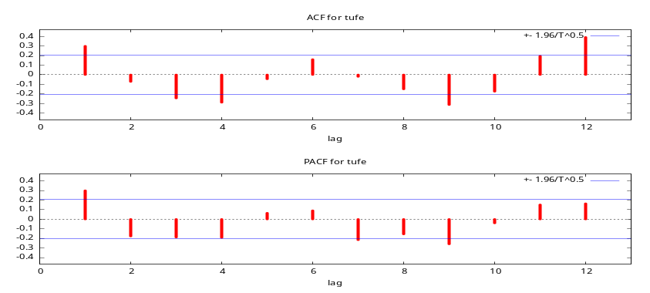
3)What is univaritate and multivariate time series model? Give example of multivariate time series model? What kind of models can be used for multivariate time series model?

4)What is the advantages of TBATS over other univariate models?

5)How many parameters are needed for Holt winters model? Briefly explains. How it is different than Holt model and exponential smoothing?

6) What is Dampened in ETS?

7)How can you calculate seasonality component with the help of Moving average technique?

6)What is the difference between k-means and kNN?

7)Briefly explain k-means and hierarchical agglomerative clustering. How can we decide number of k in k-means? How can we decide number of clusters in hierarchical agglomerative clustering?

8)How is logistic regression different than linear regression model?

9)Briefly explain Support Vector Machine model?

10) What is unsupervised learning model and supervised model? Give example to each.

11)What is the assumption in Naïve Bayes classification method?

11) What is clustering? How is clustering different than PCA?

12) How many factors do we have for the data given information below.

Eigen values
Matrix trace | 7,000000
Average | 1,000000

Axis | Eigen value | Difference | Proportion (%) | Histogram | Cumulative (%)
1 | 3,312890 | 0,697075 | 47,33 % |  | 47,33 %
2 | 2,615816 | 2,041187 | 37,37 % |  | 84,70 %
3 | 0,574629 | 0,334749 | 8,21 % |  | 92,90 %
4 | 0,239880 | 0,105424 | 3,43 % |  | 96,33 %
5 | 0,134456 | 0,049013 | 1,92 % |  | 98,25 %
6 | 0,085443 | 0,048556 | 1,22 % |  | 99,47 %
7 | 0,036887 | - | 0,53 % |  | 100,00 %
Tot. | 7,000000 | - | - | - | -

Which variables belong to which factors for the rotated factor analysis shown below?

What is the variance explained for each factors? What percentage of variance are explained for What percentage of variance are explained by these two factors for TASTE?

Attribute | Axis_1 | Axis_2 | Var. Expl.
- | Corr. | Corr.
TASTE | 0,95995 | -0,02767
AROMA | 0,95825 | 0,01387
COLOR | 0,95223 | 0,05838
REPUTAT | -0,51175 | -0,53285
SIZE | 0,06642 | 0,94706
ALCOHOL | 0,02378 | 0,94239
COST | -0,06093 | 0,91560
Var. Expl.

13) If (Outlook=Sunny, Temperature=Cool, Humidity=High, Wind=Strong), can we classifiy this as P(Yes) or P(No) based on Naïve Bayes.

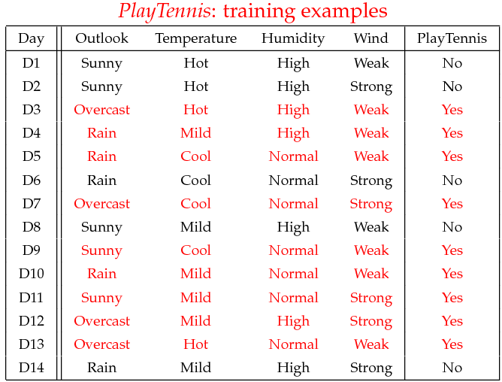

14)

Logit Regression Results
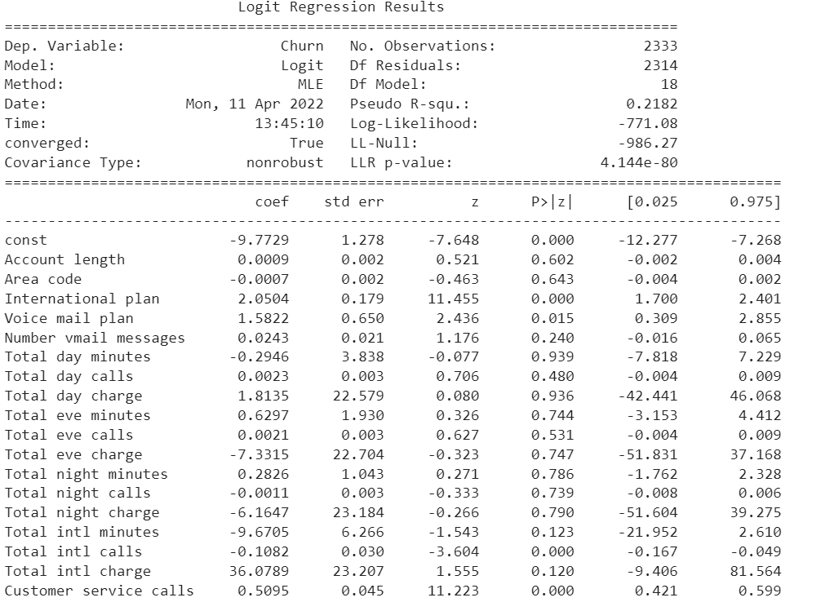
A) Which variables are significantly diffrent than 0 at 5% significant level?
B)Among signicant variables, which one increases the probability of churn?

15) In the table below, coefficients of first and second lag for a series are given. If the number of observation is 25, test the claim that coefficients of first lag are different from 0.Take the critical value of t as 2 .
Lag | Autocorrelation Coefficient
1 | 0.3
2 | 0.2

Note: The Standard error of first time lag is 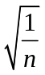

16)

Period |  | Number of Complaints
2011 |  | 130
2012 |  | 145
2013 |  | 140
In the table above, the number of complaints for each year is given. There is no trend or seasonality in the series. Based on the following methods, what is the forecast for number of complaints in 2014?
a)Naive method
b)2 year moving average
c) Exponential smoothing method. Use a= 0.6 for smoothing parameter.

