**Chapter 1**

1)Define six reasons why firms invest IT.

2)Explain why and how firms ‘ motivation to invest I IT changes during COVID.

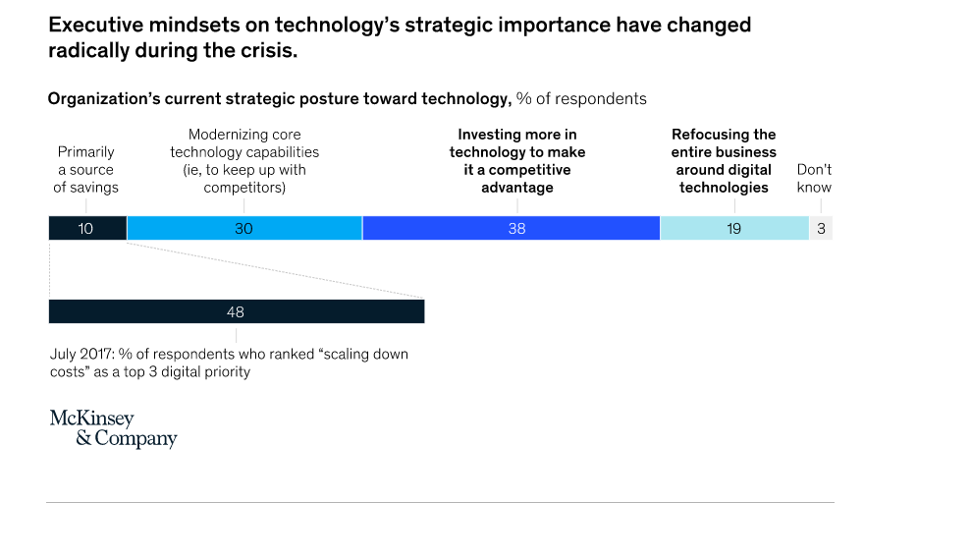

3)Describe Information system. How is data is different than information? Explain the difference between behavioral and technological view? What is socio technical

4)What are of input, output and processing in system used in Uber (taxi apps)?

5)What is complementary asset and how it explains fims’ different return on IT investments.

6)Give one example of complementary asset from managerial, organizational and social asset.

7) MedTech Solutions, a healthcare software company, invested heavily in implementing an advanced AI-driven diagnostic system. The technology was state-of-the-art, with the potential to significantly improve diagnosis accuracy and reduce patient wait times. However, despite its technical superiority, the system failed to deliver expected benefits. Doctors and nurses found it difficult to use, resisted the change, and continued relying on traditional diagnostic methods.

**Questions:**

1. How does this case illustrate the difference between the technological approach and the behavioral approach?
2. Why is it essential for organizations to consider both technological and behavioral aspects when implementing new systems?
3. How does the sociotechnical process play a role in ensuring successful technology adoption? What could MedTech Solutions have done differently?

8)How is operational excellence achieved by IT? Give an example to it

9)Explain the difference between information technology (IT) and information systems (IS).

10) Two competing retail chains, **RetailX** and **ShopEase**, both invested in advanced AI-driven customer analytics and inventory management systems. However, their results were vastly different.

* **RetailX** saw a significant increase in sales, improved customer satisfaction, and optimized inventory levels.
* **ShopEase**, despite using the same technology, struggled with inefficiencies, employee resistance, and no noticeable improvement in profitability.

Upon analysis, it was found that **RetailX** had also invested in complementary assets such as effective leadership, streamlined processes, and a strong customer-centric culture, whereas **ShopEase** had not.

**Questions:**

1. What are complementary assets, and how do they influence the return on IT investments?
2. How do complementary assets explain the difference in IT investment outcomes between RetailX and ShopEase?
3. Provide one example of a complementary asset from each of the following categories and explain how it could contribute to IT success:
   * **Managerial asset** (e.g., leadership style, strategic decision-making)
   * **Organizational asset** (e.g., business processes, corporate culture)
   * **Social asset** (e.g., government regulations, industry standards)

**Chapter 2**

1)What is business process? How information system improves business process?

2)Explain what is TPS,MIS,ESS,DSS.

3) What are the information systems served to different level of hierarchy? Give an example to each type

4) Most organizations operate with a functional structure (e.g., separate departments for HR, Finance, Marketing, Operations). However, business processes (e.g., order fulfillment, customer service, product development) cut across multiple functions, leading to several problems such as silo mentality, process bottleneck, data fragmentation, duplication of work and slow decision making. Briefly explain these problems and How can you solve these problems with enterprise application systems?

5) What are the business intelligence and analytics tools? How business intelligent tools are different than business analytics tools?

6)How is it possible for Enterprise resource planning (ERP) systems decentralize decision making while ERP is centralized system?

7) How is ERP is different than Supply chain management systems?

8) An International company struggles with capturing and sharing knowledge across its global workforce. Employees often reinvent solutions because they cannot access past projects or expertise. As an external consultant , what kind of solution you can suggest?

9) A marketing firm struggles with fragmented customer data, making it difficult to run effective campaigns. Data is stored in separate systems, and there is no unified view of customer interactions. What solutions would you suggest to address this firm’s challenges?

10) A financial services firm struggles with slow decision-making due to fragmented data and lack of collaboration between departments. Middle managers rely on outdated reports, while senior management lacks real-time insights into the firm’s financial performance. What kind of information system solutions would you suggest to address this firm’s challenges (TPS,DSS,MIS,ESS)?

11) Sanofi Pasteur faced issues with hierarchical, top-down processes, a large geographically dispersed workforce, and a lack of collaboration and idea sharing. What were the key problems Sanofi Pasteur faced, and how did they address them?

12)How do Management Information Systems (MIS) differ from Decision Support Systems (DSS)?

13) How do Management Information Systems (MIS) differ from Executive Support Systems (ESS)?

**Chapter 3**

1)What is transaction cost theory? How IT affect transactions cost and form size?

2)What is agency cost theory? Explain briefly the effect of agency cost theory on organization ?

3)Based on case study discussed in class, what kind of middle level manager role may be or may not be replaced by IT?

4) What is meant by the phrase “IT should flatten hierarchies?”

5)What is the role of internet in Porter’s five force model?

6)How can IT help firm to achieve

a)low cost leadership

b)product differentiation

c)niche product

d)customer or supplier intimacy?

7)Why do we need Business value chain? What is the role of IT in Business value chain analysis?

8)A firm’s value chain can be linked to the value chains of its suppliers, distributors,

and customers. This is called value web. If you are ecommerce site such as Amazon.com what kind of information system you can build for customer, supplier and logistic firms?

9) What is network economics? Give a product or business model that exhibit network affect. How is Internet technology useful from a network economics perspective? Give examples

10) What are the example of mobile platform? What kind of player do we have in mobile platform?

11) Question might come from following case

By keeping prices low and shelves well stocked using a legendary inventory replenishment system, Walmart became the leading retail business in the United States. Walmart’s continuous replenishment system sends orders for new merchandise directly to suppliers as soon as consumers pay for their purchases at the cash register. Point-of-sale terminals record the bar code of each item passing the checkout counter and send a purchase transaction directly to a central computer at Walmart headquarters. The computer collects the orders from all Walmart stores and transmits them to suppliers. Suppliers can also access Walmart’s sales and inventory data using web technology. Because the system replenishes inventory with lightning speed, Walmart does not need to spend much money on maintaining large inventories of goods in its own warehouses. The system also enables Walmart to adjust purchases of store items to meet customer demands. Competitors, such as Sears, have been spending 24.9 percent of sales on overhead. But by using systems to keep operating costs low, Walmart pays only 16.6 percent of sales revenue for overhead. Operating costs average 20.7 percent of sales in the retail industry.

12)What is core competency and how IT help to achieve it. Give an example

13) What is virtual firm? how it is different than digital firm ? Give example to both.

14) Question might come from following case

Hilton Hotels’ OnQ system analyzes detailed data collected on active guests in all of its properties to determine the preferences of each guest and each guest’s profitability. Hilton uses this information to give its most profitable customers additional privileges, such as late checkouts. Contemporary customer relationship management (CRM) systems feature analytical capabilities for this type of intensive data analysis. Credit card companies are able to use this strategy to predict their most profitable cardholders. The companies gather vast quantities of data about consumer purchases and other behaviors and mine these data to construct detailed profiles that identify cardholders who might be good or bad credit risks.

15) Scenario: TechConnect, a startup specializing in cloud-based collaboration tools, wants to leverage network effects to grow its customer base and increase profitability. Questions: How can TechConnect apply the principles of network economics to scale its business? Compare the virtual company model with a traditional company model. How might TechConnect benefit from adopting a virtual company approach? How could TechConnect position itself within a business ecosystem to enhance its competitive advantage?

Chapter 5

What is total cost of ownership? Why is it important for business to consider total cost of ownership rather than software and hardware cost only?

What is scalability? Why is it essential to the success of the modern business firm?

List and describe seven services that comprise IT infrastructure

What is cloud computing? Example /advantages/Disadvantages. Describe three types of cloud computing?

What is edge computing?

xplain why standards are so important in information technology. What standards have

been important for the growth of Internet technologies?

xplain why standards are so important in information technology. What standards have

been important for the growth of Internet technologies?

Explain why standards are so important in information technology. What standards have

been important for the growth of Internet technologies?

Explain how network economics, declining communication cost and technology standard affect IT infrastructure

What is the role of web services in IT infrastructure?what kind of data standarts it is used?What is the role of Application programming interface in web services?

Explain client/server architecture? Give example or type of servers

The University of Pittsburgh Medical Center (UPMC) relies on information systems to operate 19 hospitals, a network of other care sites, and international and commercial ventures. Demand for additional servers and storage technology was growing by 20 percent each year. UPMC was setting up a separate server for every application, and its servers and other computers were running a number of different operating systems, including several versions of Unix and Windows. UPMC had to manage technologies from many different vendors, including Hewlett-Packard (HP), Sun Microsystems, Microsoft, and IBM. Assess the impact of this situation on business performance. What factors and management decisions must be considered when developing a solution to this problem?

Qantas Airways, Australia’s leading airline, faces cost pressures from high fuel prices and lower levels of global airline traffic. To remain competitive, the airline must find ways to keep costs low while providing a high level of customer service. Qantas had a 30-year-old data center. Management had to decide whether to replace its IT infrastructure with newer technology or outsource it. What factors should be considered by Qantas management when deciding whether to outsource? If Qantas decides to outsource, list and describe points that should be addressed in a service level agreement.

What is open-source software? How can business benefit from open-source software? Give example of open source software.

Chapter 9

How is it possible for ERP decentralize decision making while ERP is centralized system?

If we use different system for each functional unit rather than centralized ERP, what kind of problems can we have?

Based on analytical CRM. What kind of analysis is possible to do? Give 3 example.

What are the benefits of SCM?

What are the benefits of ERP?

What are the benefits of CRM?

Briefly explain components of SCM software.

You have been hired by Croydon Visiting Nurse Services, whose business processes are all manual, paper-based processes. How might a CRM system benefit them.

Why do we need Supply Chain Management software if we have already ERP system implemented in our firm?

What are the components of CRM? Briefly explain and benefits of each component.

Fulbert Timber Merchants in Brixton, UK, features a large selection of building supplies, including timber,

fencing and decking, mouldings, hardwood flooring, sheet materials, windows, doors, ironmongery,

and other materials. The prices of building materials are constantly changing. When a customer inquires

about the price on fixtures, fittings, hangings, and other items, sales representatives consult a manual

price sheet and then call the supplier for the most recent price. The supplier in turn uses a manual price

sheet, which has been updated each day. Often, the supplier must call back Fulbert’s sales reps because

the company does not have the newest pricing information immediately on hand. Assess the business

impact of this situation, describe how this process could be improved with information technology, and

identify the decisions that would have to be made to implement a solution.

**Agile**

What are the differences between waterfall methods and agile methodologies?

What are the disadvantages of waterfall methods?

What are the 4 Agile values?

Can you explain the roles and responsibilities within a Scrum team, and how they contribute to the Agile development process?

What are some common ceremonies or events in Scrum, and what are their main functions?

How does Scrum address challenges related to changing requirements and evolving customer needs in comparison to traditional project management approaches?

How does the concept of "self-organizing teams" in Scrum contribute to employee satisfaction in Agile environments?

What role does task estimation play in Scrum? What are the benefits?

How does adopting Scrum methodologies impact the time-to-market for software products?

How does adopting Scrum methodologies impact the quality and cost for software products?

How do Scrum's adaptive planning and flexible approach help organizations respond more quickly to changes in market demands and customer preferences, thus impacting time-to-market?

In what ways do Scrum's sprint reviews and retrospectives contribute to refining processes and accelerating time-to-market in subsequent development cycles?