Define six reasons why firms invest IT.

Explain why and how firms ‘ motivation to invest I IT changes during COVID.

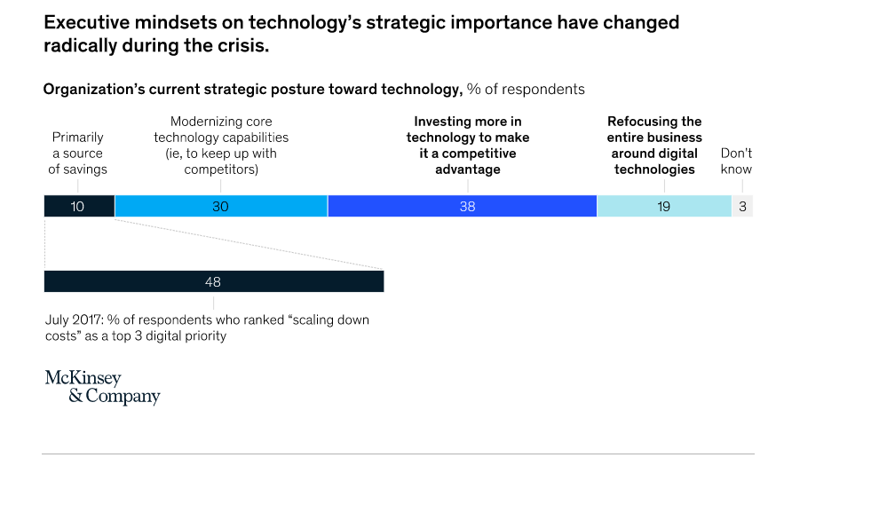

Describe Information system. How is data is different than information? Explain the difference between behaviral and technological view? What is socio technical

What are of input, output and processing in Information systems?

(Possible question might be given text (i.e UPS case study), identify input, output and processing

What is complementry asset and how it explains fims’ different return on IT investments.

Give one example of complemantry asset from managerail, organiztional and social asset.

4)How is technological approach different than behavioral approach? Why should we consider both?

Just give an example (Hint: You can use best technology however your organization could not benefit because ?)

5)How is opeatinal exellency achieved by IT? Give an example to it

8) Explain the difference between information technology (IT) and information systems (IS).

Chapter 2

What is business process? How information system improves business process?

Explain what is TPS,MIS,ESS,DSS.

What are the information systems served to different level of hiearchy? Give an example to each type

Chapter 3

1)What is transaction cost theory? How IT affect transactions cost and form size?

2)What is agency cost theory? Explain briefly the effect of agency cost theory on organization ?

3)Based on case study disscussed in class,what kind of middle level manager role may be or may not be replaced by IT?

4) What is meant by the phrase “IT should flatten hierarchies?”

5)What is the role of internet in Porter’s five force model?

6)How can IT help firm to achieve

a)low cost leadership

b)product differentiation

c)niche product

d)customer or supplier intimacy?

7)Why do we need Business value chain? What is the role of IT in Business value chain analysis?

8)A firm’s value chain can be linked to the value chains of its suppliers, distributors,

and customers. This is called value web. If you are ecommerce site such as Amazon.com what kind of information system you can build for customer, supplier and logistic firms?

9) What is network economics? Give a product or business model that exhibit network affect. How is Internet technology useful from a network economics perspective? Give examples

10) What are the example of mobile platform? What kind of player do we have in mobile platform?

11) Question might come from following case

By keeping prices low and shelves well stocked using a legendary inventory replenishment system, Walmart became the leading retail business in the United States. Walmart’s continuous replenishment system sends orders for new merchandise directly to suppliers as soon as consumers pay for their purchases at the cash register. Point-of-sale terminals record the bar code of each item passing the checkout counter and send a purchase transaction directly to a central computer at Walmart headquarters. The computer collects the orders from all Walmart stores and transmits them to suppliers. Suppliers can also access Walmart’s sales and inventory data using web technology. Because the system replenishes inventory with lightning speed, Walmart does not need to spend much money on maintaining large inventories of goods in its own warehouses. The system also enables Walmart to adjust purchases of store items to meet customer demands. Competitors, such as Sears, have been spending 24.9 percent of sales on overhead. But by using systems to keep operating costs low, Walmart pays only 16.6 percent of sales revenue for overhead. Operating costs average 20.7 percent of sales in the retail industry.

12)What is core competency and how IT help to achieve it. Give an example

13) What is virtual firm? how it is different than digital firm ? Give example to both.

14) Question might come from following case

Hilton Hotels’ OnQ system analyzes detailed data collected on active guests in all of its properties to determine the preferences of each guest and each guest’s profitability. Hilton uses this information to give its most profitable customers additional privileges, such as late checkouts. Contemporary customer relationship management (CRM) systems feature analytical capabilities for this type of intensive data analysis. Credit card companies are able to use this strategy to predict their most profitable cardholders. The companies gather vast quantities of data about consumer purchases and other behaviors and mine these data to construct detailed profiles that identify cardholders who might be good or bad credit risks.

Chapter 5

What is total cost of ownership? Why is it important for business to consider total cost of ownership rather than software and hardware cost only?

What is scalability? Why is it essential to the success of the modern business firm?

List and describe seven services that comprise IT infrastructure

What is cloud computing? Example /advantages/Disadvantages. Describe three types of cloud computing?

What is edge computing?

xplain why standards are so important in information technology. What standards have

been important for the growth of Internet technologies?

xplain why standards are so important in information technology. What standards have

been important for the growth of Internet technologies?

Explain why standards are so important in information technology. What standards have

been important for the growth of Internet technologies?

Explain how network economics, declining communication cost and technology standard affect IT infrastructure

What is the role of web services in IT infrastructure?what kind of data standarts it is used?What is the role of Application programming interface in web services?

Explain client/server architecture? Give example or type of servers

The University of Pittsburgh Medical Center (UPMC) relies on information systems to operate 19 hospitals, a network of other care sites, and international and commercial ventures. Demand for additional servers and storage technology was growing by 20 percent each year. UPMC was setting up a separate server for every application, and its servers and other computers were running a number of different operating systems, including several versions of Unix and Windows. UPMC had to manage technologies from many different vendors, including Hewlett-Packard (HP), Sun Microsystems, Microsoft, and IBM. Assess the impact of this situation on business performance. What factors and management decisions must be considered when developing a solution to this problem?

Qantas Airways, Australia’s leading airline, faces cost pressures from high fuel prices and lower levels of global airline traffic. To remain competitive, the airline must find ways to keep costs low while providing a high level of customer service. Qantas had a 30-year-old data center. Management had to decide whether to replace its IT infrastructure with newer technology or outsource it. What factors should be considered by Qantas management when deciding whether to outsource? If Qantas decides to outsource, list and describe points that should be addressed in a service level agreement.

What is open-source software? How can business benefit from open-source software? Give example of open source software.

Chapter 9

How is it possible for ERP decentralize decision making while ERP is centralized system?

If we use different system for each functional unit rather than centralized ERP, what kind of problems can we have?

Based on analytical CRM. What kind of analysis is possible to do? Give 3 example.

What are the benefits of SCM?

What are the benefits of ERP?

What are the benefits of CRM?

Briefly explain components of SCM software.

You have been hired by Croydon Visiting Nurse Services, whose business processes are all manual, paper-based processes. How might a CRM system benefit them.

Why do we need Supply Chain Management software if we have already ERP system implemented in our firm?

What are the components of CRM? Briefly explain and benefits of each component.

Fulbert Timber Merchants in Brixton, UK, features a large selection of building supplies, including timber,

fencing and decking, mouldings, hardwood flooring, sheet materials, windows, doors, ironmongery,

and other materials. The prices of building materials are constantly changing. When a customer inquires

about the price on fixtures, fittings, hangings, and other items, sales representatives consult a manual

price sheet and then call the supplier for the most recent price. The supplier in turn uses a manual price

sheet, which has been updated each day. Often, the supplier must call back Fulbert’s sales reps because

the company does not have the newest pricing information immediately on hand. Assess the business

impact of this situation, describe how this process could be improved with information technology, and

identify the decisions that would have to be made to implement a solution.