Presentation abstract at the Climate Monitoring SAF workshop, 9.9.2012, Łódź, Poland:
Using CM SAF's MAGICSOL method to retrieve global and direct surface radiation from historical geosynchronous observations
Climate studies require long time series of climate data. Many Essential Climate Variables (ECVs) as defined by the Global Climate Observing System (GCOS), such as cloud albedo, surface incoming shortwave irradiance and direct irradiance, can be measured using space-based remote sensing. The MAGICSOL method from CM SAF is capable of producing these data in a high spatio-temporal resolution using geostationary satellites.
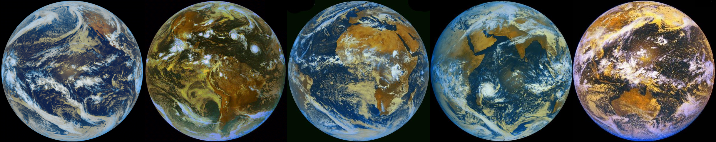Figure 1: Views from the main geostationary positions. From left to right: GOES-WEST, GOES-EAST, Meteosat Prime, Meteosat IODC, GMS. Source: Météo-France 2009, composite by author.
The MAGICSOL method has been used to create a climate data set using the MVIRI sensors on the Meteosat First Generation satellites. The data produced show a high agreement with ground measurements and are robust against sensor degradation, especially when compared with similar data. The CM SAF data set covers the entire full disc view of the Meteosat Prime satellites and extends back in time to the early 1980s.
The MAGICSOL method should also function for other geostationary satellites, making it possible to produce long time series of solar irradiation data on a global scale. Using the MAGICSOL method on the GMS and GOES satellite series to produce these ECVs would make an important contribution to the climate research community.
A feasibility study to validate the use of the MAGICSOL method with historical data from the entire geostationary ring is being carried out by the University of Marburg and International Solar Information Solutions, with extensive support from the German Weather Service and CM SAF. In order to do so, one month of observational data from all geostationary satellites and validation data are being collected for use with the MAGICSOL method. Additionally, the required software is being expanded in order to allow the use of additional satellites.
In the suggested presentation, the need for worldwide irradiation data, MAGICSOL's mode of operation and validation results compared with comparable data sets will be shown. Then the aims of the current study, the potential of historical geosynchronous data, the production chain for the study and its validation scheme will be introduced. Finally, first results will be shown with an outlook on the study's results. Attendees should become familiar with CM SAF's MAGICSOL method, as well as its potential for use with historical geosynchronous data on a worldwide scale.

