THE CONTENT OF THE solution.mod

/\*\*\*\*\*\*\*\*\*\*\*\*\*\*\*\*\*\*\*\*\*\*\*\*\*\*\*\*\*\*\*\*\*\*\*\*\*\*\*\*\*\*\*\*\*

\* OPL 12.6.2.0 Model

\* Author: oguzd

\* Creation Date: 04 May 2023 at 09:27:58

\*\*\*\*\*\*\*\*\*\*\*\*\*\*\*\*\*\*\*\*\*\*\*\*\*\*\*\*\*\*\*\*\*\*\*\*\*\*\*\*\*\*\*\*\*/

//sets

int machines = 25;

int regularOrders = 60;

int additionalOrders = 40;

int allOrders = 100;

//parameters

range macRange = 1..machines;

range regOrderRange = 1..regularOrders;

range addOrderRange = 61..allOrders;

range allOrderRange = 1..allOrders;

int demand[allOrderRange]=...;

int capacity[macRange]=...;

int profit[allOrderRange]=...;

int fixedCost[macRange]=...;

//decision variables

dvar boolean X[allOrderRange][macRange];

dvar boolean Z[macRange];

maximize sum (i in addOrderRange, m in macRange) (profit[i]\*X[i][m]) - sum(m in macRange)(capacity[m]\*Z[m]);

subject to

{

forall(o in regOrderRange)sum ( m in macRange)(X[o][m])== 1;

forall(a in allOrderRange)sum (m in macRange)(X[a][m]) <= 1;

forall(m in macRange)sum (i in allOrderRange)(X[i][m]) <= Z[m];

forall(m in macRange)sum (i in allOrderRange)(demand[i]\*X[i][m]) <= capacity[m] \* Z[m];

forall(m in macRange)sum (m in macRange:m!=4)(Z[m]) <= 7;

}

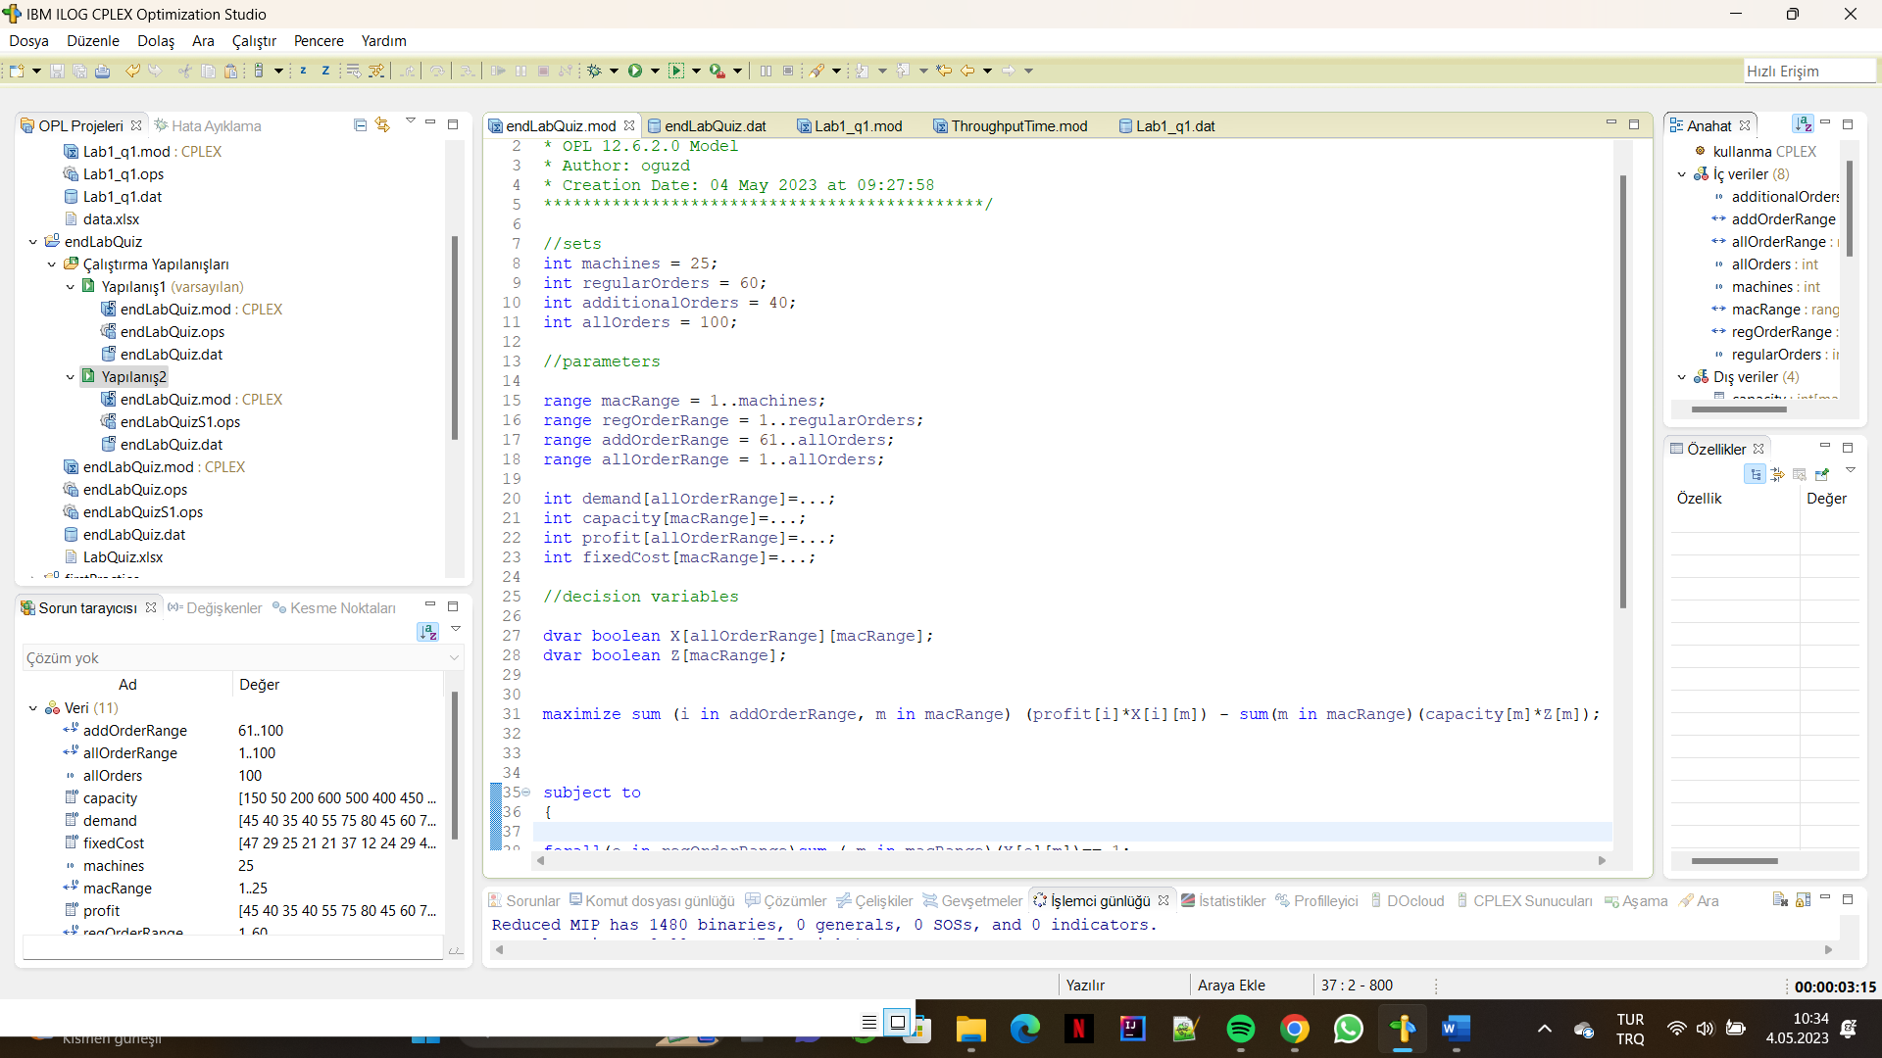

THE CONTENT OF THE solution.dat

/\*\*\*\*\*\*\*\*\*\*\*\*\*\*\*\*\*\*\*\*\*\*\*\*\*\*\*\*\*\*\*\*\*\*\*\*\*\*\*\*\*\*\*\*\*

\* OPL 12.6.2.0 Data

\* Author: oguzd

\* Creation Date: 04 May 2023 at 09:27:58

\*\*\*\*\*\*\*\*\*\*\*\*\*\*\*\*\*\*\*\*\*\*\*\*\*\*\*\*\*\*\*\*\*\*\*\*\*\*\*\*\*\*\*\*\*/

SheetConnection sheet("LabQuiz.xlsx");

demand from SheetRead(sheet,"Orders!B2:B101");

capacity from SheetRead(sheet,"Machines!B2:B26");

profit from SheetRead(sheet,"Orders!B2:B101");

fixedCost from SheetRead(sheet,"Machines!C2:C26");

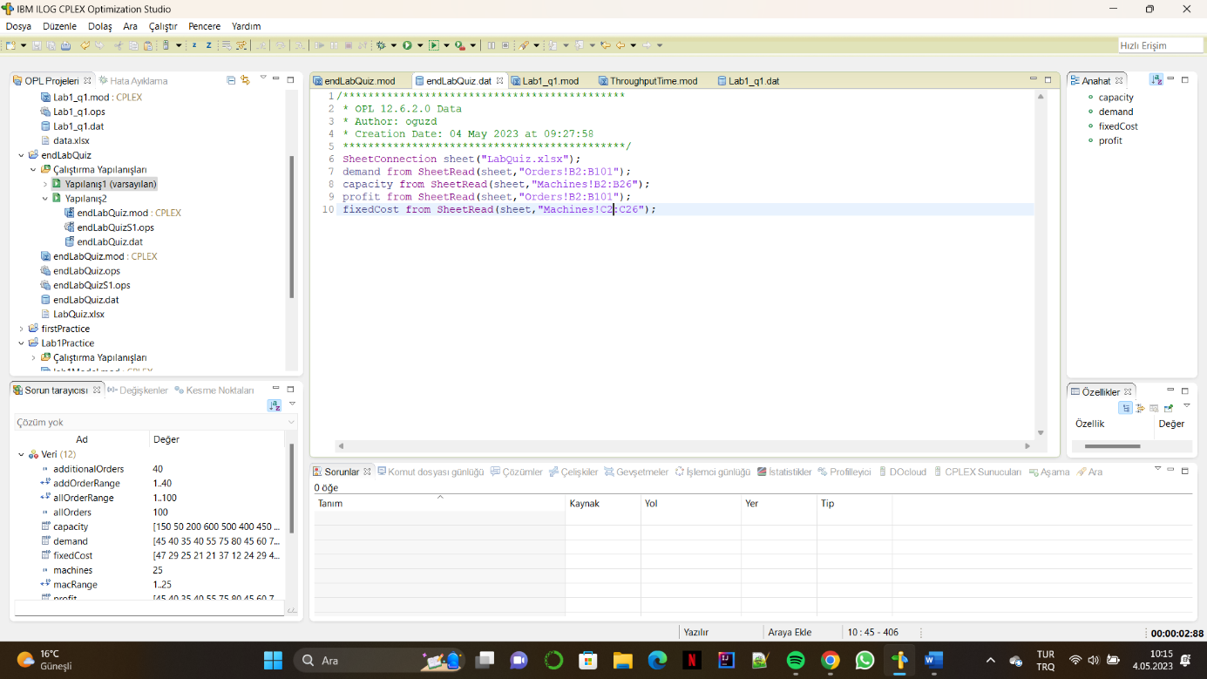

RESULTS OF THE 15 SECONDS

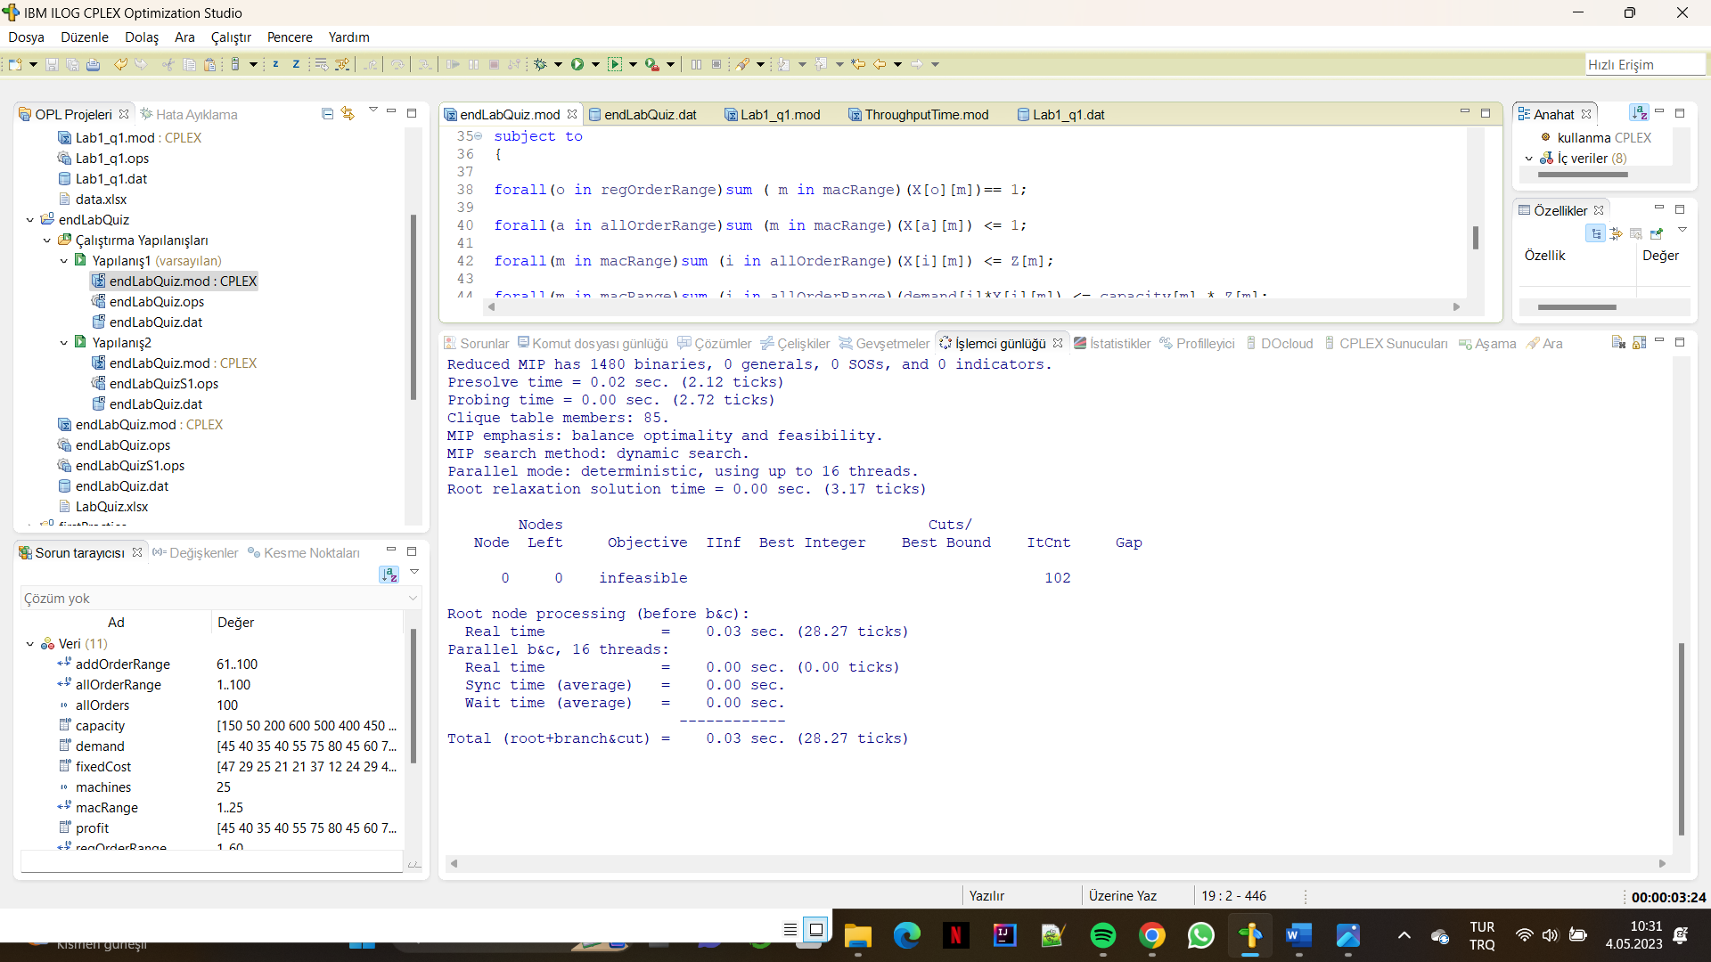

RESULTS OF THE 60 SECONDS

