BeePlan — Final Project Report (SENG 383)
Developer: Şahin Özsoy
Date: 2025-12-27

1. Project Identity & Repository Access
Project Name: BeePlan — Course Schedule Generator
GitHub Repository Link: TBD (will be filled after being added to the repo)
Demo Video: video/beeplan_demo.mp4
Repository structure checklist:
- /src — source code (Python GUI + scheduling logic, clean error handling)
- /docs — design artifacts, AI usage log, V&V test logs
- /Report — final report (PDF + editable DOCX)
- /video — demo video (mp4) placeholder
- README.md — install & run instructions

2. Final Design Artifacts (Last Version)
The design artifacts below reflect the final implemented behavior of BeePlan: loading curriculum/resource data, generating a weekly timetable, and presenting a validation report.

Figure 1 — Activity Diagram
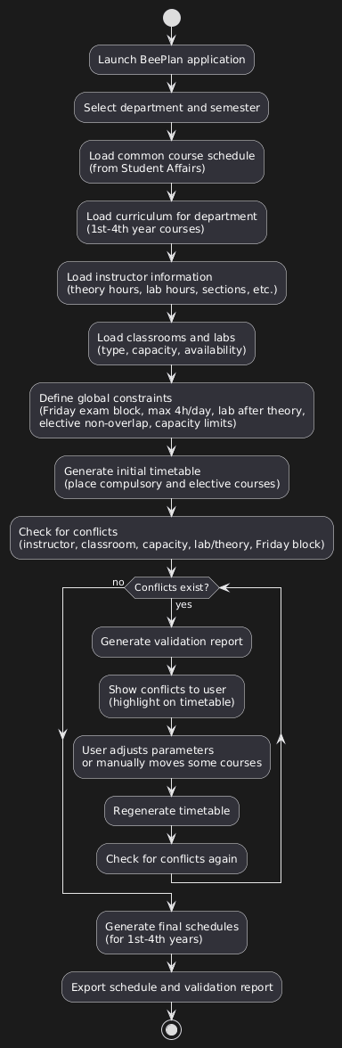

Figure 2 — Class Diagram
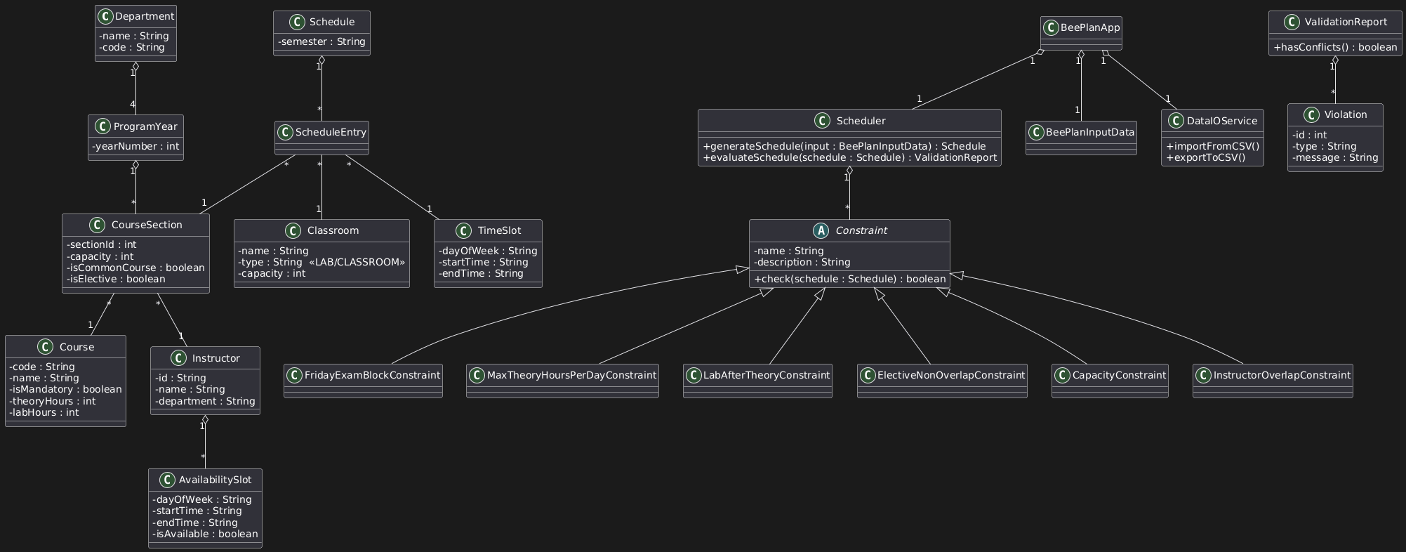

Figure 3 — GUI: Main Window
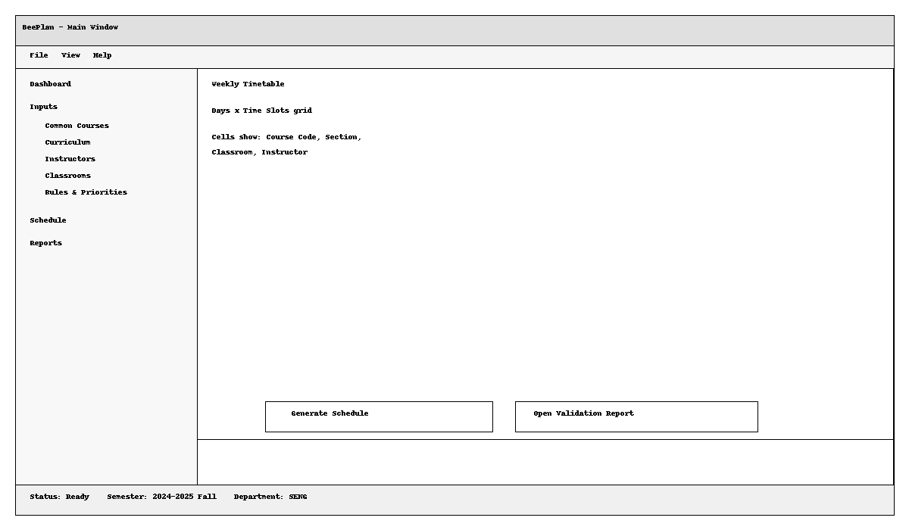

Figure 4 — GUI: Validation Report
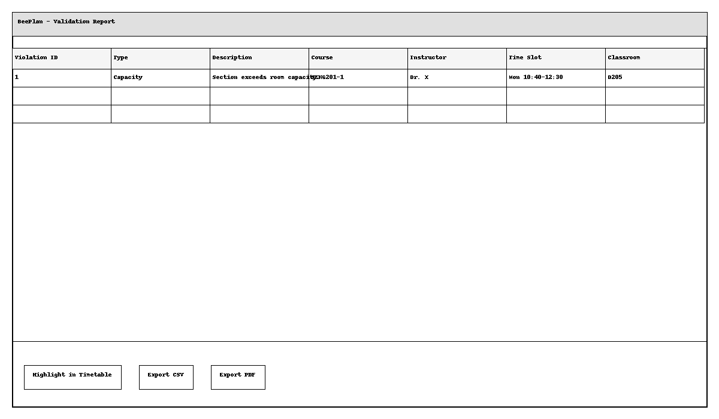

3. AI Usage & Prompts
AI assistance was used as a tutor during design refinement, implementation, debugging, and documentation. A detailed Prompt → Output → Revision log is provided in: docs/beeplan/ai_usage.md.
Phase | Goal | AI Output | Revision / Verification
Design | Clarify workflow & screens | Proposed load→generate→report UI | Matched to design diagrams and required buttons
Coding | Scheduler implementation | Backtracking + heuristics | Verified constraints & added validation report
Testing | Create automated checks | Self-test script | Ensured PASS output on sample data
Debugging | UI visibility for demos | Single-line labels + summary | Ensured schedule is visible even with scaling

4. Verification & Validation (V&V)
Verification was performed via an automated self-test on sample data, and validation was performed through manual GUI test cases. Full logs are in docs/beeplan/vv_tests.md.
Automated self-test:
- python src/self_test.py → PASS on sample data (Assignments>0, Unscheduled=0, Violations=0).
AI Tutor bug/issue evidence:
Screenshots for two resolved issues are expected under docs/beeplan/vv_screenshots/ (bug1.png and bug2.png). These issues focus on demo/visibility reliability and UI correctness.

Limitations & Future Work
This submission is a minimal working implementation intended for course grading. Future improvements could include a richer constraint model, better optimization objectives (e.g., balanced loads), and enhanced UI usability (filtering, drag-and-drop, and richer exports).

