🛠️ How to Use This App
This app is currently in demo mode and is designed to help users test how the fraud detection system works — no real bank data required.
Follow the steps below to experience how it functions:

✅ Step-by-Step Instructions
1. 🔍 Download the Sample File
Look for the green button labeled "Download Sample CSV".
🔹 This file contains dummy transaction data, including a few fraudulent entries so you can test the system properly.
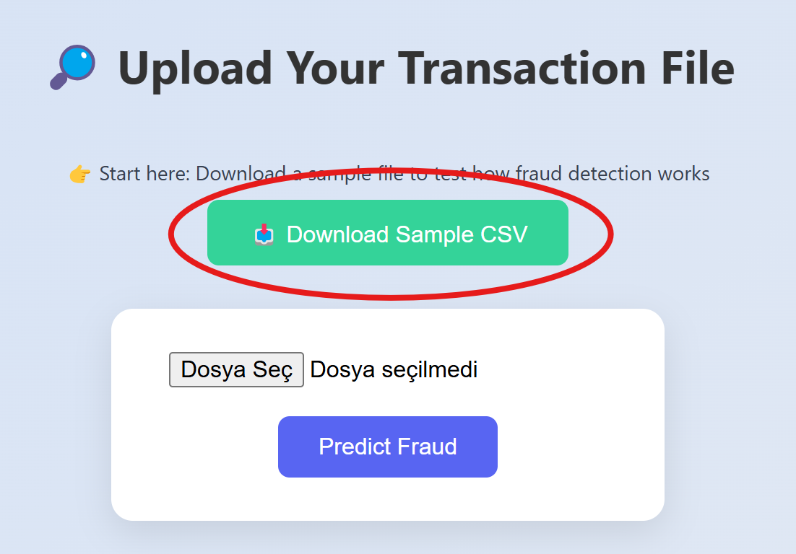

2. 📂 Upload the CSV File
Click the "Dosya Seç" (Choose File) button to select the sample file you just downloaded.
🔹 Once selected, the file name should appear next to the button.
Then click the blue "Predict Fraud" button.
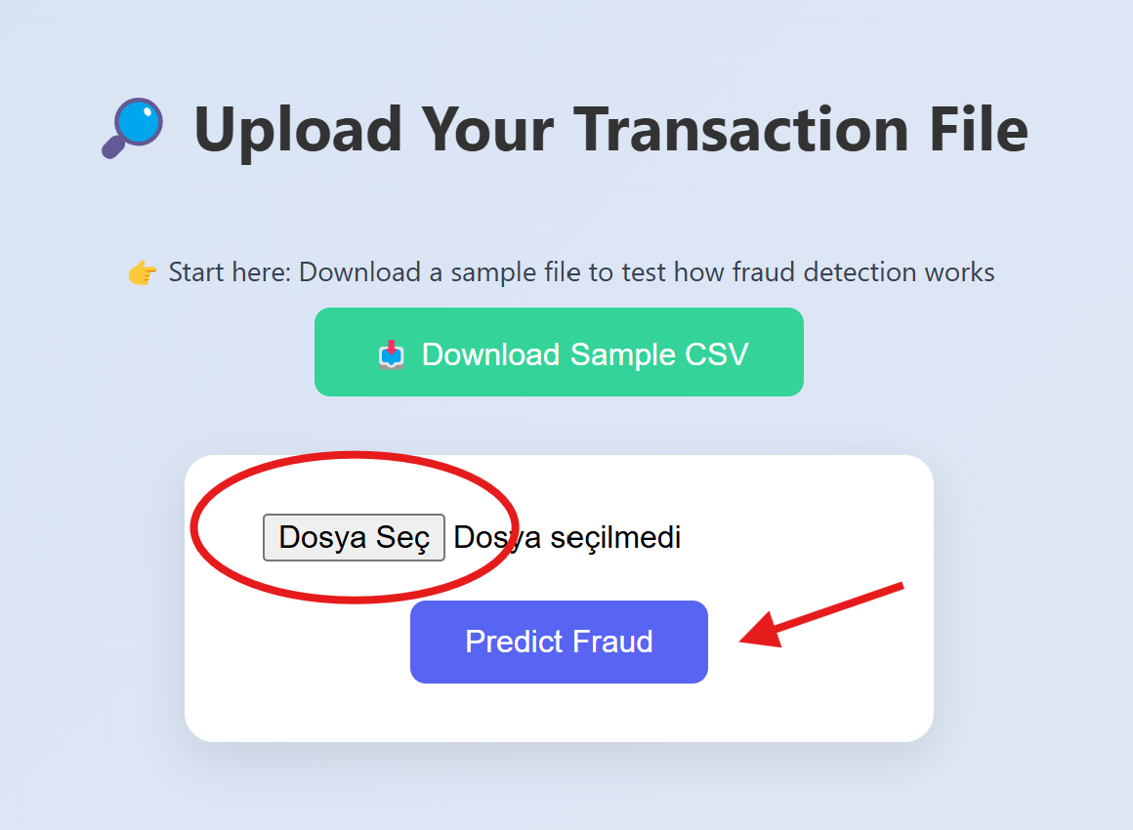

3. 📊 View the Results
The app will instantly analyze the data and return:
- ✅ The number of safe transactions detected
- 🚨 The number of fraudulent transactions caught
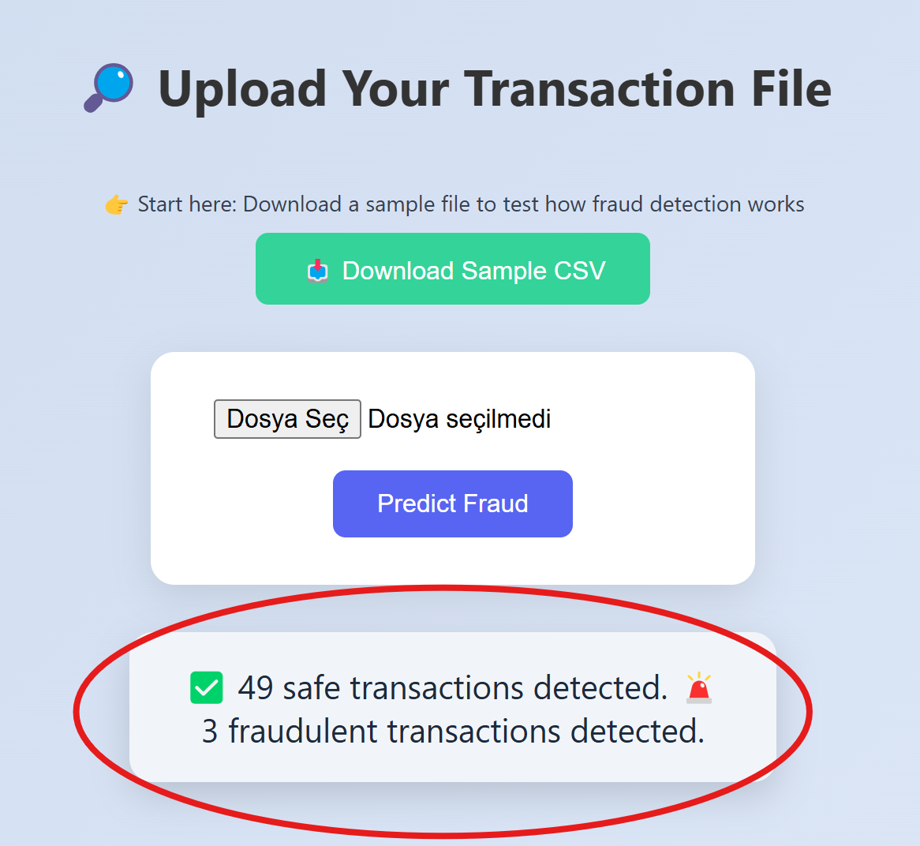
🌟 Demo Limitation Note
This interface is a prototype for demonstration purposes only.
- In a real-world deployment, the uploaded file structure would be securely defined to match real bank transaction schemas.
- No real data is stored or processed.

🚀 Just Click. Upload. Predict.
We designed this flow to be intuitive even for users with no technical background.
Whether you're a data scientist, fraud analyst, or simply curious — this demo is your sneak peek into how fraud detection works in action.

