Fraud Detection Web Application - Project Report

📈 Project Overview
This project aims to build a user-friendly web application that can detect fraudulent credit card transactions. The system uses machine learning to analyze uploaded transaction files (CSV format) and identify whether the transactions are normal (safe) or fraudulent (fraud).
The application was developed carefully to be understandable even for users who are not familiar with machine learning or technical details.

📚 Key Features
- File Upload Interface: Users can upload their transaction files in CSV format.
- Real-Time Prediction: Once uploaded, the application processes all transactions and detects frauds.
- Sample File Download: Users can download a ready-made sample CSV file to test the system easily.
- Stylish and Interactive Design: The interface includes animation effects, hover reactions, and a modern aesthetic.
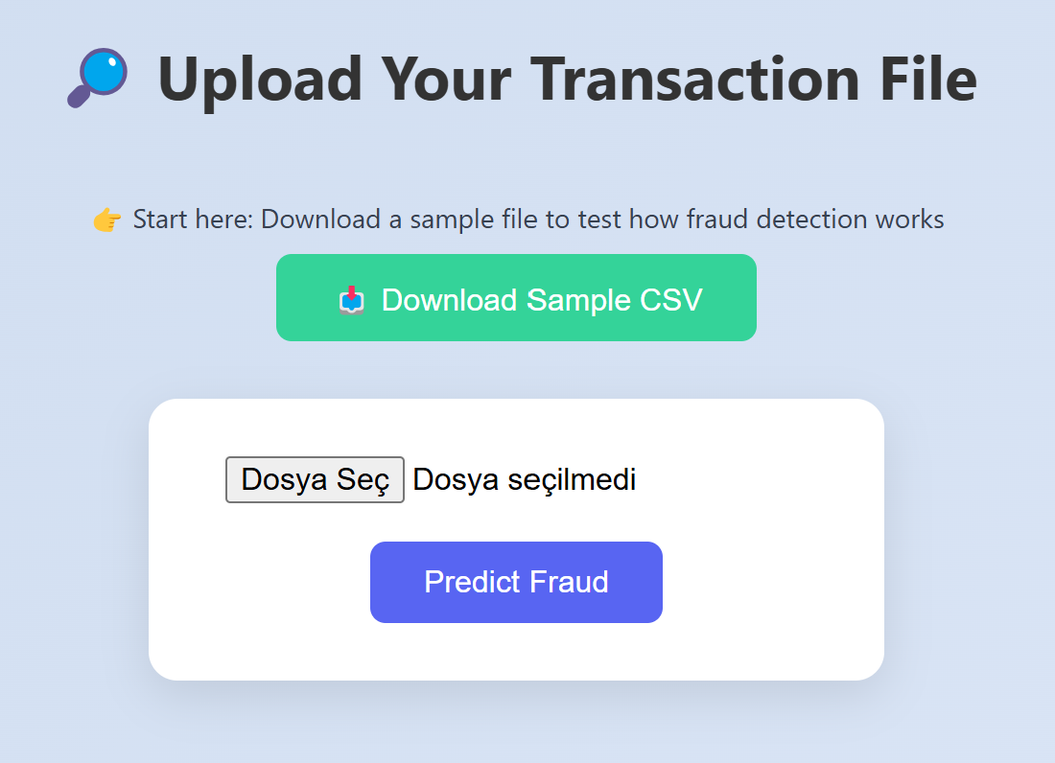

🔢 How the System Works (Simplified)
- Upload: The user selects and uploads a transaction CSV file.
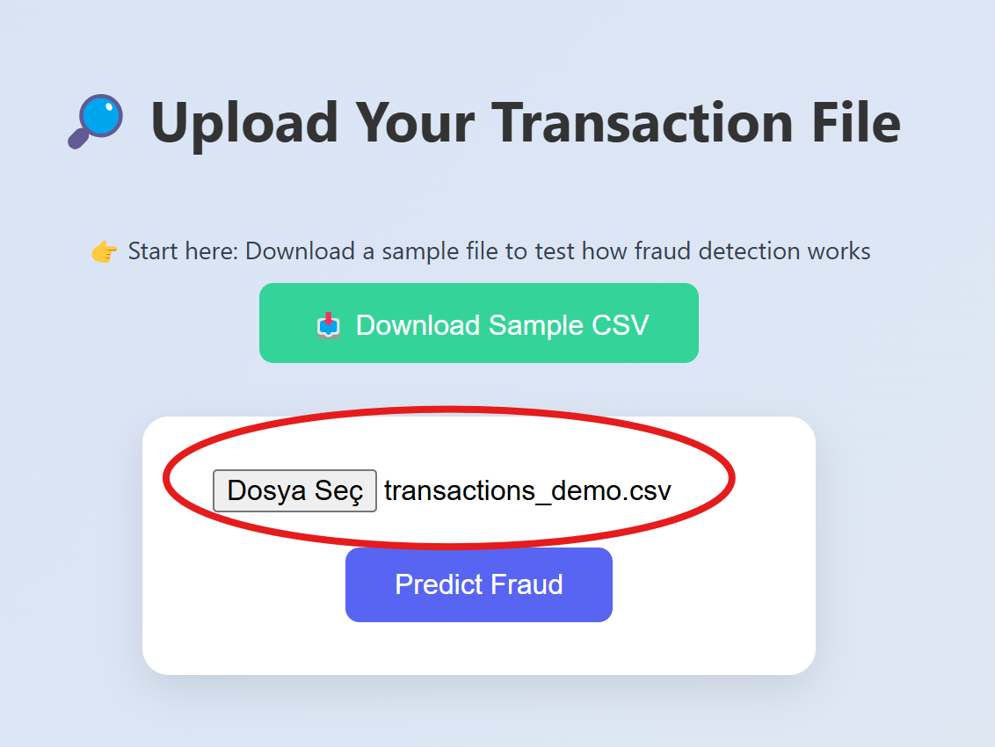
- Processing: The system analyzes each transaction one by one.
- Prediction: The machine learning model determines whether each transaction is likely safe or fraudulent.
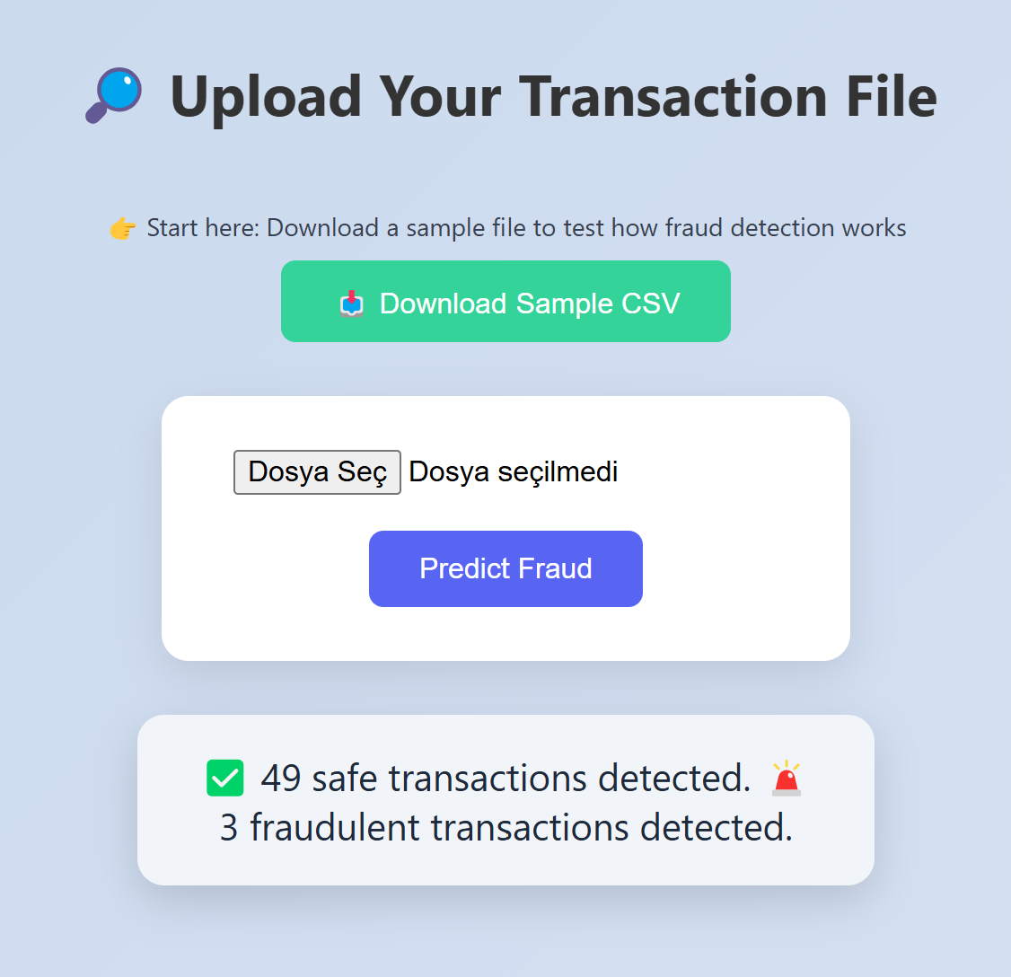
- Results Displayed: A simple summary appears on the screen:
  - Number of Safe Transactions
  - Number of Fraudulent Transactions

🚀 What is Inside the Transaction File?
The transaction file contains numbers representing various hidden patterns related to how transactions are made.
Each transaction includes features such as:
- Time: When the transaction happened
- V1, V2, ..., V28: Special hidden indicators
- Amount: How much money was involved
Note: Users don't need to understand or modify these features. The system reads them automatically.

🌐 Technologies Used
- Python
- Flask (for web interface)
- XGBoost (for fraud detection)
- HTML + CSS (for stylish frontend)
- Pickle (to save and load the machine learning model)

🏋️ Why This Project Matters
- Financial institutions use similar systems to protect against millions of dollars of fraud each year.
- Customers are protected when fraudulent transactions are detected early.
- Businesses save reputation and money by implementing smart fraud detection solutions.

✨ Special Highlights
- The system was designed to be as user-friendly as possible.
- Every part of the interface was built with attention to aesthetics, responsiveness, and simplicity.
- Behind the scenes, advanced machine learning techniques are working invisibly to ensure the highest possible accuracy.

🙏 Thank You for Using Our Fraud Detection App!
This project is dedicated to making complex technology accessible and intuitive for everyone.

