Bilkent University

Department of Computer Engineering

CS319 PROJECT – GROUP #2

**Project Design Report**

**CS 319 Project: Bombalamasyon**

Oğuz Demir – 21201712

Anıl Sert – 21201526

Kaya Yıldırım – 21002071

Kaan Kale – 21000912

**Course Instructor: Uğur DOĞRUSÖZ**

Design Report

Apr 9, 2016

This report is submitted to the GitHub in partial fulfillment of the requirements of the Object Oriented Software Engineering Project, course CS319

Table of Contents

1 Introduction 3

1.1 Purpose of the system 3

1.2 Design goals 3

1.2.1 Ease of Use 3

1.2.2 Reliability 3

1.2.3 Extendibility 4

1.2.4 Responsiveness 4

1.2.5 Portability 4

2 Software Architecture 4

2.1 Subsystem decomposition 4

2.2 Hardware/software mapping 5

2.3 Persistent data management 6

2.4 Access control and security 6

2.5 Boundary conditions 6

3 Subsystem Services 7

3.1 Services of the Controller: 8

3.2 Services of the View: 8

3.3 Services of the Model: 8

4 Low-level design 9

4.1 Object Design Trade-offs 9

4.2 Final object design 10

4.3 Packages 12

4.3.1 Controller Package 12

4.3.2 View Package 12

4.3.3 Model Package 13

4.4 Class Interfaces 15

4.4.1 Model Classes 15

4.4.2 Controller Classes 22

4.4.3 View Classes 25

Table of Figures

Figure 1 Subsystem Decomposition Diagram 5

Figure 2 Detailed UML Class Diagram 10

Figure 3 Controller Package 12

Figure 4 View Package 13

Figure 5 Model Package 14

# Introduction

## Purpose of the system

Bombalamasyon is a system that aims to provide users with modified version of bomberman game with multiplayer and singleplayer features. The main purpose is serving a simple but challenging game for small breaks of computer users. The designed game is poor in terms of today’s game standards (such as complex AI, 3D smooth graphics, fluent movements etc.) so the gameplay of the game is changed to maximize the pleasure of achievement. The “Multiplayer” game mode allows two users to play at the same time from the same computer and to challenge each other. The game is designed to be played from most of computer platforms with different standards and without internet connection. The system also aims to provide a plain interface to make users learn the game easily and improve gaming experience.

## Design goals

In order to compose the system we should clarify the design goals we focused on. These design goals provided in analysis stage from non-functional requirements that we did before design. Here are described design goals:

### Ease of Use

Easiness in the usage is one of the most important design goals because it will determine whether the users continue to play the game or not. The game is designed to be played in small time intervals to enjoy and it would not be successful if the users have trouble while playing this game. Similarly, learning the game should not take much time not to waste the limited game time with learning.

### Reliability

The system is aimed to be bug-free in order to prevent from crashes or errors while gaming. The unexpected terminations at the middle of the games would be annoying for users. Also, any error that can cause loss of game statistic information of game statistics cannot be welcomed by users with high scores.

### Extendibility

The game is planned to be completed in limited time, so it is limited in terms of number of different features and levels. It is important to add new features to games in order to make them more attractive. Also, changes in game, will bring back the users who completed the game and abandon it. So, the system is aimed to be designed in a way that it can be easily extended for new features and levels.

### Responsiveness

The game is interactive game, the players use their in-game characters to complete the game objective. So, the users should immediately see their commands’ effect on the screen. In order to satisfy enough responsiveness for the users, the game view is designed to be refreshed every 0.1 second, in other words, the game shows 10 frames per second.

### Portability

In order to serve the game for the users from different platforms, the system should be portable, platform independent. The system aimed to be developed in Java so that it could be run every computer which has Java Virtual Machine.

# Software Architecture

## Subsystem decomposition

For the system Model-View-Controller (MVC) style is chosen to split system into parts for sharing the complexity of the system among the components. Also, since the components are designed to be independent as much as possible, it increases the readability of the code and extendibility of the system.

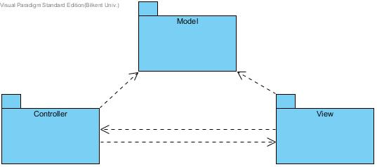

Figure 1 Subsystem Decomposition Diagram

In the Model subsystem we will hold all the game’s model objects which are interacted with each other during the play time and these models will be updated with the advance of the game. The physical events such as movements, collisions, map creations, object creations, ai behavior of bombers are responsibilities of the Model subsystem.

Controller subsystem is the brain of our system. It includes controllers for Game, File Management, and Sound Management. Responsibility of the Controller Subsystem is to manage the flow of the game, take necessary information from files and pass it to other subsystems and to play appropriate sounds according to game state.

View subsystem has all of the view components of the system and the responsibility of the View subsystem is to reflect the correct window with needed information on to the screen. The view is updated and/or current window is changed according to changes in the game state.

## Hardware/software mapping

Bombalamasyon requires Java Runtime Environment (JRE) to be played because it is developed by the using Java programming language. Game can be executed with a single executable Java file.

For the I/O requirements computer needs a keyboard, mouse and a monitor to let player interact with the game. For multiplayer gaming, the keyboard should not have ghosting (blocking some of the keys that are pressed at the same time) when 6 keys are pressed (6 keys: 3 for each player; 2 for direction, 1 for dropping bomb). It requires very little system requirements to be played. Graphical Processing Unit (GPU) is not required to play the game.

File system will be used for .png, .wav, and .txt files in order to take the game data and game images and play sound effects and background music.

## Persistent data management

Files are stored in the hard disk drive. The game keeps names and top ten scores in plain text file in order to display to the player in “High Scores” section. To provide better gaming experience to player, some image and sound files are also used at some parts of the game. When they are needed, these files are read from the disk with their specified directions as parameters. In addition, level data is stored in hard disk drive. There are different game maps for each level in hard drive.

## Access control and security

Bombalamasyon does not implement any user authentication system therefore we do not have any database that stores user credentials. Also, as mentioned earlier (in Hardware / Software Mapping), our game does not require network connection. Therefore, player who has no network connection is able to play the game. So that, there is no restriction or control for access the game. In addition, the game has no user profile, only player names and scores. Therefore, there is not security issues in Bombalamasyon.

## Boundary conditions

Initialization

When player execute the .jar file, the game initializes. Player does not have to install the game.

Secondly, the game tries to load every file that can be needed during execution. If a critical file such as level map is missing, the initialization will fail.

Termination

In order to terminate the game, player can click the “Quit Game” in the main menu. When player is playing the game, he/she wants to exit, firstly the player is need to go to “Pause menu” and then click the “Quit Game”.

Game will return to the main menu if all the levels are done. In case of finishing, high scores are updated if score is higher than 10th best score and the game returns to the main menu.

Game also be closed by the “X” on the top right corner of the window. Unsaved data will be loss.

Error

If any file (game resources) could not be loaded such as images or sounds, the game starts without these files. If the game does not respond because of other issues such as problem at hardware, software or operating system, player lose his/her current data.

# Subsystem Services

The system is decomposed into 3 parts as model, view, controller and there are 4 main services between these components. The flow is the following: when user give the input, the View takes the input as the boundary component, and it passes the related input to the Controller with Controllers’ service. Controller change the game status in itself and/or the properties of the Model with Model’s service. After that, the Controller ask for an update on the View via View’s service and before updating the current view, the View component can take the game data from Model with the service of the model. At the end, view is updated and changes with the user’s input is reflected on screen.

*The names of the services can be designed differently in low level object design. They are just for identification.*

## Services of the Controller:

**takeUserInput**: This service of the controller is used by view component in order to pass the related user input to change the program status (main menu, paused game, in game etc.) and to control the game( move bomberman or drop bomb ). For example, if the user pauses the game while playing, the view component who has the action listeners for the keys, pass the corresponding input through takeUserInput service of controller for changing state and controller change the game status which is stored in the controller itself to “pausedGame”.

## Services of the View:

**updateView**: This service of the view is used by the controller to change the program display between menus or reflect the changes in the game map to screen. The status of the program such as main menu, in-game etc. is passed to the viewer and if it is in-game, the game data is taken from model component with the help of getGameMapData service of the model component.

## Services of the Model:

**getGameMapData**: This service of the model is used by the view component in order to get the game map data, in other words, positions of the game objects with their types.

**updateGameObjects**: This service of the model is used by controller to manage in-game data with the desire of the user within a time interval and to process CPU controlled objects in that interval. The score that is earned during that interval is returned.

# Low-level design

## Object Design Trade-offs

**Extendibility vs Performance:** Since this is a project that is supposed to be completed one semester, not all the possible functionality could be covered due to time limitation. So that, the project is aimed to be extendable for adding new features. In the system and object design, the complex system is divided into subsystems and Façade pattern is followed for intercommunication of the subsystems in order to satisfy more independence between subsystems. However, this brings decrease in performance as a negative outcome. Since, most of the classes are restricted to communicate other classes, this communication is establish through other classes, which means extra function calls and decrease in performance. Extendibility is chosen to follow in design since decrease in performance of a 2D game can be tolerated with powerful CPU’s of modern computers.

**Security vs Performance:** For the game, level, score and settings data is stored on txt files. This leads a security bug since these files can be accessed and manipulated from outside. On the other hand, encrypting the files on write operations and decrypting them on the read will take time and cause decrease in performance. Since a sacrifice is made on performance to have more extendible system, performance instead of security is followed for this trade-off.

## C:\Users\od\Desktop\Class Diagram3.jpgFinal object design

Figure Detailed UML Class Diagram

Façade Pattern

The façade pattern is used in the object design of this project. As mentioned, the system is divided into 3 subsystems according to MVC architectural style. Every designed interaction between the subsystems increases the total complexity of the system because there is different sized and typed data to be passed between subsystems. In order to reduce this complexity, Façade Pattern is used for collecting these interactions under certain main points. These main points are the top level classes of the subsystems and all of the subsystems are designed in a way that they have one such class to communicate with other subsystems. These classes are:

* Model: GameEngine
* Controller: GameManager
* View: Main Frame

Every other class in subsystems can only communicate within the subsystem. This ensures more independent subsystems. The independent subsystems are desired in order to make the system available for future developments. Also, it increases the understandability of the system by different developers.

Singleton Pattern

The GameManager class is the only available class for outside class and other components are created by GameManager. To ensure, only one instance of GameManager can be created, because there is no meaning of having two games at the same time, the singleton pattern is applied on GameManager. GamaManager class have one static variable that holds the instance of the class and one static method for outside classes to create and use the GamaManager.

Player-Role Pattern

For the wall object of the game, player-role pattern is used. Some walls of the game breaks in 2 explosions and change state in the first one. So that, it is not logical to delete the stronger wall, create the weaker wall, arrange the references in the collector of the engine again and again. As a result, walls are designed in a way that they have a role, which represents the type, and this type may or may not change in explosions but the reference on the collector is never changed until total destruction. An abstract class, WallRole is used for the role object, and this role’s destroy method is called by the Wall itself. When a stronger wall is exploded, its role is deleted and its role assigned a new one with weaker one.

## Packages

### Controller Package

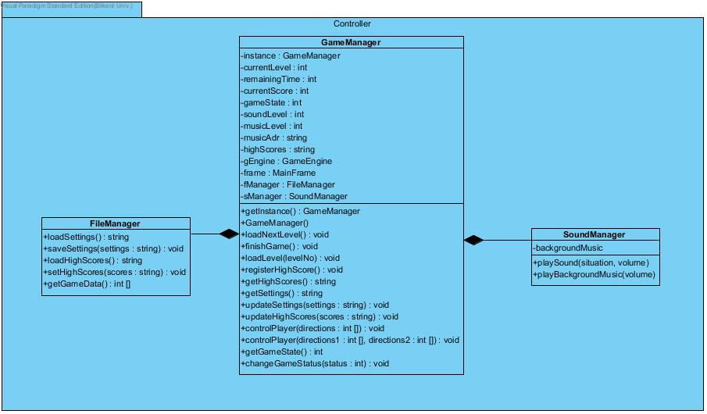Controller Package includes the control mechanisms of the whole system. It also creates and manages the other packages. To use the system by an outside class (i.e, main class), member of that package, GameManager is used. It includes two more classes for file and sound i/o.

Figure Controller Package

### View Package

View package forms the boundary part of the system. It includes the JFrame and the Jpanels, and action listeners for user interactions. For each use case screen, a different panel is used and their visibility is controlled by the main frame. Also, data flow is done through MainFrame to Panels. The control data of the bombers are collected in the MainFrame to be sent to the controller package. For polymorphism, an interface, “Viewer” is implemented by the classes to be updated together by the main frame.

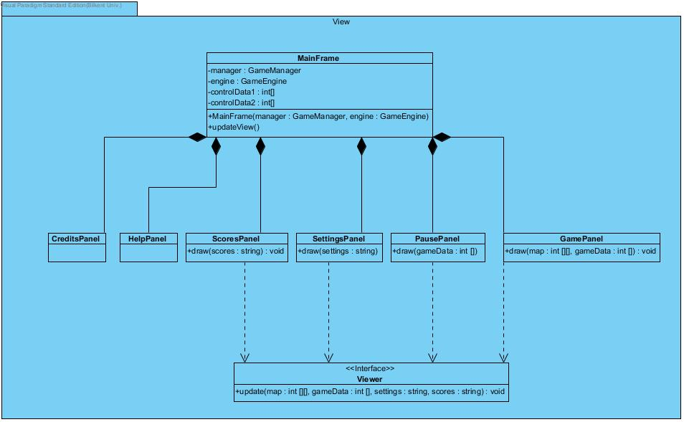

Figure View Package

### Model Package

Model Package is the most crowded package of the system that includes real game objects (bombs, walls, bombers and powerups) together with the model mechanisms (GameEngine and OverlapEngine). The objects are collected under an abstract class for polymorphism. Also, to call the same method for all the object that are influenced by an explosion, bomberman, powerup and wall classes implement an interface, “Explodable”. All the objects are held and modified by the GameEngine but objects can also manipulate the GameEngine in order to delete themselves from collection (with the reference in beExploded method).

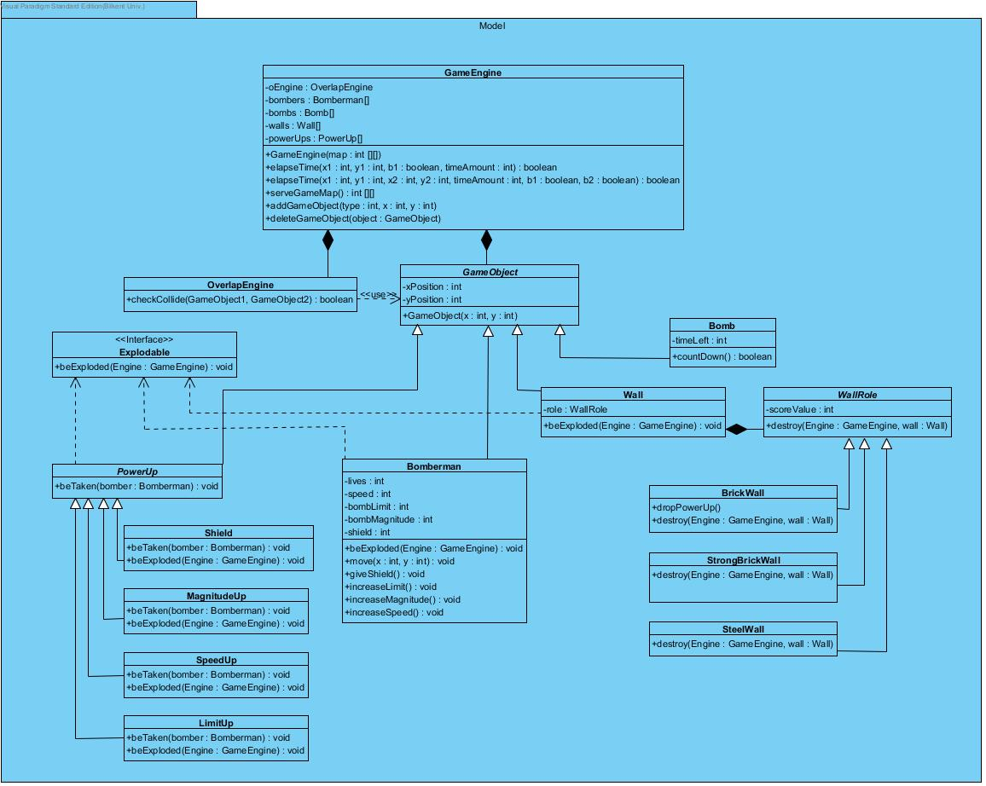

Figure Model Package

## Class Interfaces

### Model Classes

GameEngine Class

GameEngine is the top level class of the model subsystem. The communication between other subsystems is done only through that class as explained before. Class is responsible for holding and manipulating all game objects and serve the game map to be drawn to the View subsystem.

Attributes:

**private OverlapEngine oEngine:**  A reference to the overlap engine to call its method when needed.

**private Bomberman[] bombers:** this attribute holds bomber objects in an array.

**private Bomb[] bombs:** this attribute holds bomb objects in an array.

**private Wall[][] walls:** this attribute holds wall objects in a matrix for ease of access and categorization (only walls in specific region are checked for collision with bombs or bombers).

**private PowerUp[] powerUps:** this attribute holds powerup objects in an array.

Constructor:

**public GameEngine(int[][] map):** Constructor takes the map of walls according to the current level and creates the walls according to that map. Also, 4 bombers in each corners are created and added to the collections. Bomb and powerup collections are created as empty arrays.

Methods:

**public boolean elapseTime(int x1, int y1, boolean b1,int timeAmount):** GameManager call this method in single player game and this method takes 3 commands for the player’s bomber and a time amount which is designed as 1second/desiredFps. This method calls elapseTime of all bomb and if a bomb is exploded, the beExploded() methods of nearby objects are called. The bomberman is moved with the commands and/or a new bomb is dropped.

**public boolean elapseTime(int x1, int y1, int x2, int y2, boolean b1, boolean b1, int timeAmount):** this method is multiplayer version of previous one.

**public int[][] serveGameMap():** Game data to be drawn is returned by this method with the request of view component. It will include the coordinates and the size of each object.

**public void addGameObject(int type, int x, int y):** this method add new new game object.

**public void deleteGameObject(GameObject object):** this method deletes existing game object from game.

GameObject Class

It is abstract class for all game objects with the idea of polymorphism to iterate over bunch of game objects or checking collisions.

Attributes:

**private int xPosition:** this attributeholds current position in coordinate x-axis.

**private int yPosition:** this attribute holds current position in coordinate y-axis.

OverlapEngine Class

This class is used for checking collisions between two objects.

Methods:

**public boolean checkCollide(GameObject gameObject1, GameObject gameObject2):** this method checks if gameObject1 and gameObject2 collides or not and returns the result.

Explodable Interface

It is interface for game objects which are able to be exploded by a bomb.

Methods:

**public void beExploded(GameEngine engine)**

PowerUp Class

This is an abstract class for the powerup objects with the idea of polymorphism to access all powerups with a single reference.

Methods:

**public void beTaken(Bomberman bomber):** if bomber moves and found a powerUp this method invokes and user takes a power up of its type.

Shield Class

This class represents the shield powerup.

Methods:

**public void beTaken(Bomberman bomber):** this method works if user founds a power up in shield type and calls the given Bomberman giveShield method.

**public void beExploded(GameEngine engine):** this method showsif a bomb explodes near a shield (power up) than this power up explodes and deleted from game.

MagnitudeUp Class

This class represents the bomb magnitude increase powerup.

Methods:

**public void beTaken(Bomberman bomber):** this method works if user founds a power up in magnitude type and calls the given Bomberman increaseMagnitude method.

**public void beExploded(GameEngine engine):** this method showsif a bomb explodes near a magnitude up (power up) than this power up explodes and deleted from game.

SpeedUp Class

This class represents the bomberman speed increase powerup.

**Methods**:

**public void beTaken(Bomberman bomber):** this method works if user founds a power up in speed up type and and calls the given Bomberman increaseSpeed method.

**public void beExploded(GameEngine engine):** this method showsif a bomb explodes near a speed up (power up) than this power up explodes and deleted from game.

LimitUp Class

This class represents the bomb amount limit increase powerup.

Methods:

**public void beTaken(Bomberman bomber):** this method works if user founds a power up in limit up type and calls the given Bomberman increaseLimit method.

**public void beExploded(GameEngine engine):** this method showsif a bomb explodes near a limit up (power up) than this power up explodes and deleted from game.

Bomb Class

This class is the representation of bomb objects of the game.

Attributes:

**private int timeLeft:** This attribute holds the remaining time to the explosion.

Methods:

**public boolean countdown():** This method decreases the remaining time in each “elapseTime”. It returns true when the remaining time reaches zero.

Bomberman Class

This class is the representation of bombers in the game.

Attributes:

**private int lives:** This attribute holds the remaining lives until the death.

**private int speed:** This attribute holds the speed of the bomber.

**private int bombLimit:** This attribute holds the maximum number of bombs that the bomber can drop on the map at the same time.

**private int bombMagnitude:** This attribute holds the magnitude of the Bomber’s bomb.

**private int shield:** This attribute holds the remaining time for shield of the Bomber. 0 means no shield.

Methods:

**public void beExploded (GameEngine engine):** This method is called whenever the bomber is collided with an explosion and if there is no lives the game engine is called for deletion.

**public void move (int x, int y):** This method is called for moving the bomber.

**public void giveShield():** This method is called whenever a shield powerup is taken and shield property is set to time of the shield.

**public void increaseLimit():**This method is called whenever a shield powerup is taken and shield property is set to time of the shield.

**public void increaseMagnitude():** This method is called whenever a shield powerup is taken and shield property is set to time of the shield.

**public void increaseSpeed():** This method is called whenever a shield powerup is taken and shield property is set to time of the shield.

Wall Class

This class is the representation of walls in the game. The player-role pattern is applied to walls as explained.

Attributes:

**private WallRole role:**  This attribute holds a reference to the WallRole object to hold the wall type.

Methods:

**public void beExploded (GameEngine engine):** This method is called whenever wall is collided with an explosion. It calls the destroy method of its role.

Wall Role Class

This is an abstract class for collecting the wall types together under a class with the idea of polymorpishm and player-role pattern.

Attributes:

**private int scoreValue:** This attribute hold the score amount to be added on player whenever the wall is exploded. (0 for steel walls)

Methods:

**public void destroy (GameEngine engine, Wall wall):**  Abstract method to be implemented in child classes.

BrickWall Class

This class represent a wall type and extends from Wall Role.

Methods:

**public void destroy (GameEngine engine, Wall wall):** This method is delete this wall from collection of gameEngine with the explosion. It also calls the dropPowerUp method and it may drop a powerup.

**private int dropPowerUp():** This method decides whether a powerup is dropped or not with a certain probability. It also randomize the type of the powerup. (0 for no drop, positive numbers for different types of powerups.)

StrongBrickWall Class

This class represent a wall type and extends from Wall Role.

Methods:

**public void destroy (GameEngine engine, Wall wall):** This method is called with the explosion and changes the property of Wall object to change wall type to Brick Wall.

SteelWall Class

This class represent a wall type and extends from Wall Role. It is everlasting in the game and does not change form.

Methods:

**public void destroy (GameEngine engine, Wall wall):** This method is called with polymorphism but it does not do anything.

### Controller Classes

GameManager Class

GameManager is the top level singleton class of the controller subsystem and communication between the other subsystems is provided with the help of this class. This controller class is responsible for controlling data transfer between the data files and the game and game data are holding within the boundaries of this controller object.

Constructors*:*

**public GameManager():** initializes the GameManager object with default attribute values. It creates instances for GameEngine, MainFrame, SoundManager and FileManager. It takes the default settings from the FileManager and initializes properties accordingly.

Attributes

**private static GameManager instance:** Instance of the class is hold as static variable to satisfy singleton property.

**private int currentLevel:** This attribute holds the current level information that the player is playing.

**private int remainingTime:** This attribute holds the player’s remaining time information to finish the level.

**private int currentScore:** This attribute holds the current score of the player.

**private int gameState:**  This attribute holds the state of current game play. (Ingame- mainmenu-settings- pausedGame etc.)

**private int soundLevel:** This attribute holds the loudness information of the game sound.

**private int musicLevel:** This attribute holds the loudness information of the music level.

**private String musicAdr:** This attribute holds the file nameof the music that are playing in the game.

**private String highScores:** This attribute holds the high scores of the game.

**private GameEngine gEngine:** This attribute holds a reference to GameEngine class to control the physical part of the game with using the engine.

**private MainFrame frame:** This attribute holds a reference to MainFrame class to draws appropriate screens for the game.

**private FileManager fManager:** This attribute holds a reference to FileManager class to use files when needed.

**private SoundManager sManager:** This attribute holds a reference to to SoundManager class to play sounds.

Methods

**public static GameManager getInstance():** This method is used for getting the singleton instance of the class if exist. It creates an instance when it is called for the first time.

**public void loadNextLevel():** this method gets the information for the next level using the FileManager and load next level of the game.

**public void finishGame():** this method finishes the game and change the game state. It request an update from main frame.

**public void loadLevel(int levelNo):** this method takes the level number as a parameter that desired to be loaded and get the level information from files using FileManager. It request an update from main frame.

**public void registerHighScores():** this method is called by the main frame whenever user input is given to register score, and it changes the high scores with the new high score rankings and calls the FileManager to update thefiles.

**public String getHighScores():** this method is called by the main frame to get high score data.

**public String getSettings():** this method is called by the main frame to get settings data

**public void updateSettings(String settings):** this method takes the String of changed settings which come from main frame, and update the properties and files file by using the FileManager.

**public void updateHighScores(String scores):** this method takes the String of changed high scores and update the hish scores file using the FileManager.

**public void controlPlayer(int[] directions):** this method is called by mainframe with the user input for commanding the bomberman. It calls the elapseTime method of gameEngine by transfering array data to parameters.

**public void controlPlayer(int[] directions1, int[] directions2):** this method is the multiplayer version of previous one.

**public int getGameState():** this method is called by the main frame to learn the state of the game.

**public void changeGameStatus(int status):** this methods takes an integer value to change the game status according to that value.It can be called from main frame to change state with user input (i.e, clicking settings from main menu causes state to change to “settings”) or by GameManager itself (i.e, at the end of the game).

FileManager Class

It is the class that helps interaction between the game files (i.e. settings, high score files) and the game.

Methods

**public String loadSettings():** this method reads the settings file and returns the appropriate information as a String.

**public void saveSettings(String settings):** this method takes changed settings as a parameter coming from GameManager and saves the new settings to the settings file.

**public String loadHighScores():** this method reads the high scores file and returns the high scores information as a String.

**public void setHighScores(String scores):** this method takes changed high scores String as a parameter coming from the GameManager and save the change high scores to the high score file.

**public int[] getGameData():** this method returns the level information of the levels that read from gameData files.

SoundManager Class

This class is responsible for playing sound effects and background music in the game. The library to be used for sounds is unknown so types haven’t been fully determined yet.

Attributes

**private backgroundMusic:** this attribute holds the name of background music of the game.

Methods

**public void playSound(int situation, int volume):** this method plays the corresponding sound effect with given volume.

**public void playBackgroundMusic(int volume):** this method plays the background music of the game with the specified volume level.

### View Classes

MainFrame Class

This is a top level class of the view subsystem and data transfers between the model and controller subsystems is done by this class. This class is responsible for drawing the correct screens according to the game state.

Attributes

**private GameManager manager:** this attribute holds a reference to the GameManager class to draws screens with the request of GameManager.

**private GameEngine engine:** this attribute holds a reference to the GameEngine class to take the game data to draw to the screen from GameEngine.

**private int[] controlData1:** this attribute holds the input data for the player1.

**private int[] controlData2:** this attribute holds the input data for the player2 if there are two players playing the game.

Constructors

**public MainFrame(GameManager manager, GameEngine engine):** it initializes the object with the given GameManager and GameEngine references.

Methods

**public void updateView():** this method updates the screen using the panel classes in accordance with the requests of GameManager. It takes game state from GameManager for appopriate screen.

Viewer Interface

This interface is to bring update capability to panels that show changing information.

Methods

**public void update(int [][] map, int [] gameData, string settings, string scores):** It is update method of the panels which takes the all neccesary information as parameters from the main frame in the call.

GamePanel Class

This class is the panel for game area and updated with inputs and the time of the game. It also implements the viewer interface.

Methods

**public void draw (int[][] map, int[] gameData):** this method draws the game screen with the map information and game data given from the GameManager. This method can also be called from the update method of the implemented viewer interface.

PausePanel Class

This class is panel for the pause menu screen. It also implements the viewer interface.

Methods

**public void draw (int[] gameData):** this method draws the pause screen with the given game data values as a parameter given from GameManager. This method can also be called from the update method of the implemented viewer interface.

SettingsPanel Class

This class is panel for the settings screen. It also implements the viewer interface.

Methods

**public void draw(String settings):** this method draws the settings screen with using the settings String that are taken from GameManager. This method can also be called from the update method of the implemented viewer interface.

ScoresPanel Class

This class is panel for the high score screen. It also implements the viewer interface.

Methods

**public void draw(String scores):** this method draws the high scores screen with using the scores information taken from the GameManager. This method can also be called from the update method of the implemented viewer interface.

CreditsPanel Class

This class is panel for the credits screen, it is drawn with certain data about the developers. The way holding data (final variables or function parameters) has not been determined yet.

HelpPanel Class

This class is panel for the helps screen, it is drawn with certain data about the game instructions. The way holding data (final variables or function parameters) has not been determined yet.