|  |
| --- |
| CSE443 – Object Oriented Design and Analysis Course |
| Report |
| Homework 1 |

|  |
| --- |
| OĞUZHAN AGKUŞ  161044003 |

# Preface

I used Intellij Idea IDE for implementing code. I assume that course is project and each homework is a module of this project. Also each sub-project is a Java package. So, the IDE have its own representations. I will not upload whole project file, I will upload only source code. There is a slight possiblity to my source codes will give some errors. I am not sure about that. If it gives some errors, its reason is this. My codes compiles without errors and run successully. I will add output screenhots for each part. Each part has own demo code, own diagrams and javadoc at its directory.

# Question 1 – Linear Equation Solver

My program is a terminal application. It accepts an equations system and solving method. Then solve given equation system with given method. It has two method: Gaussian elimination and matrix inversion. The method can change dynamically at run time. Example input format will be given below with a screenshot.

Custormer’s requirements are appopriate to apply “**Strategy Design Pattern**”. We can create an interface called SolvingMethod and hide solving methods behind it. It should only call solve method of solving methods.

Firstly, I needed to represent the equation system. I have a class for this. Then I implemented the GaussianElimination class. It implements SolvingMethod interface and it has a solve method. After that I implemented MatrixInversion class. But this solution approach needs a lot of matrix operations. It would be better to define another class called MatrixOperations. So, these operations could be used in any other solution methods. Finally, I defined a LinearEquationSolver class. It gets solving method and equation system. It also has method “run”. It calls the solve method of SolvingMethods. Then it prints the results.

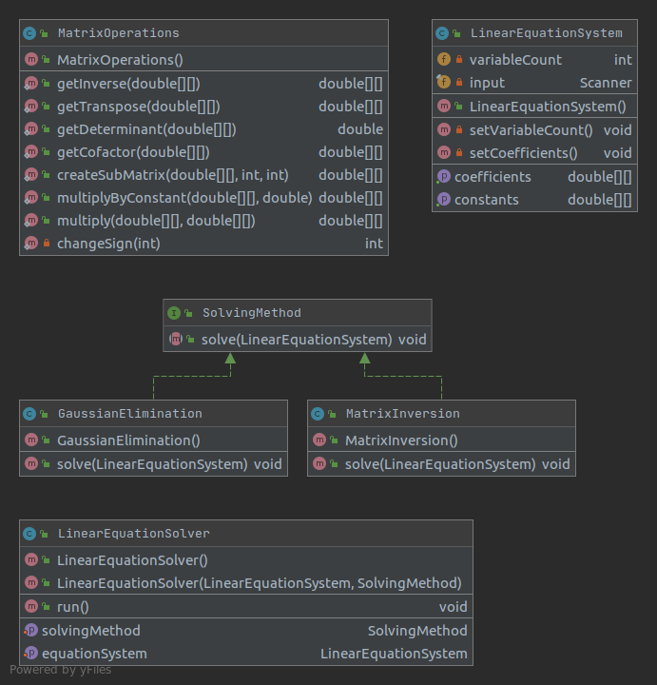

My classes

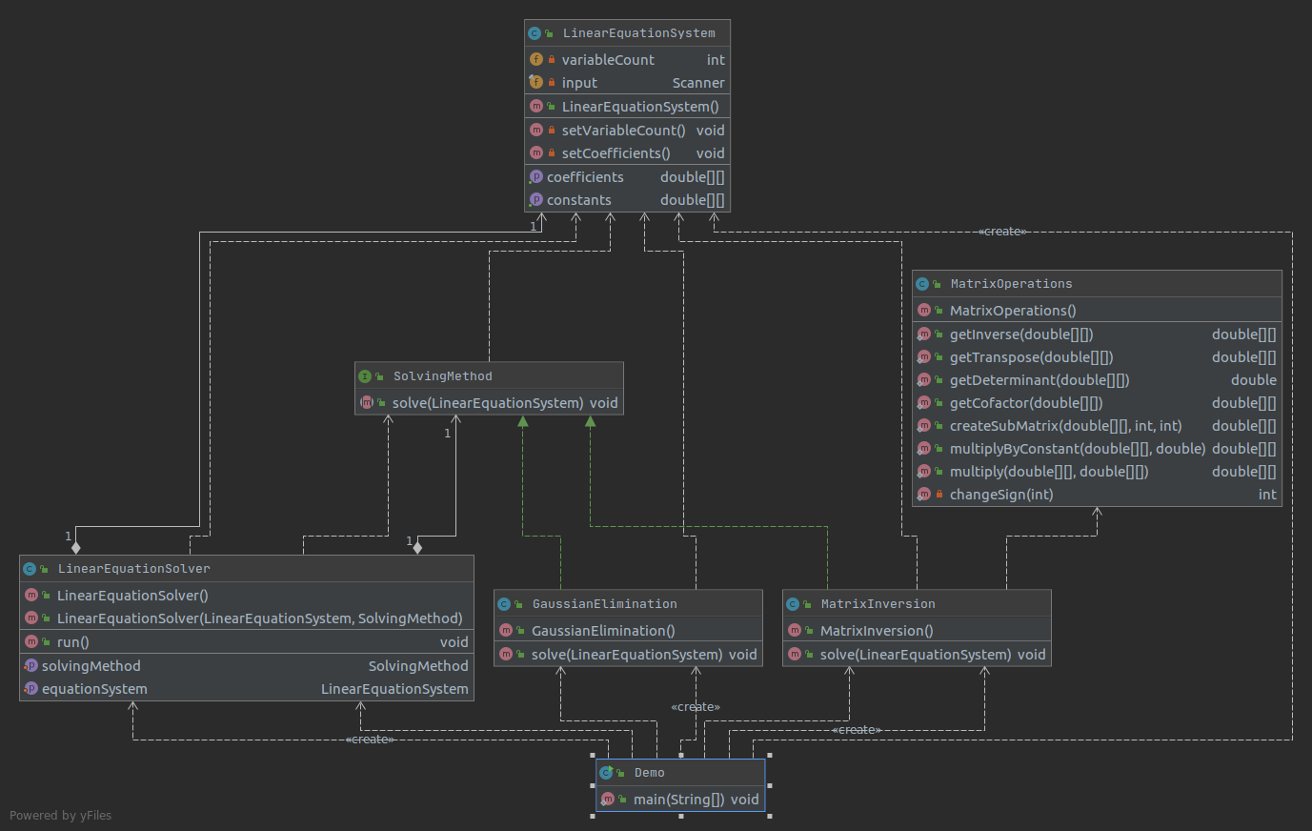

Dependencies between classes

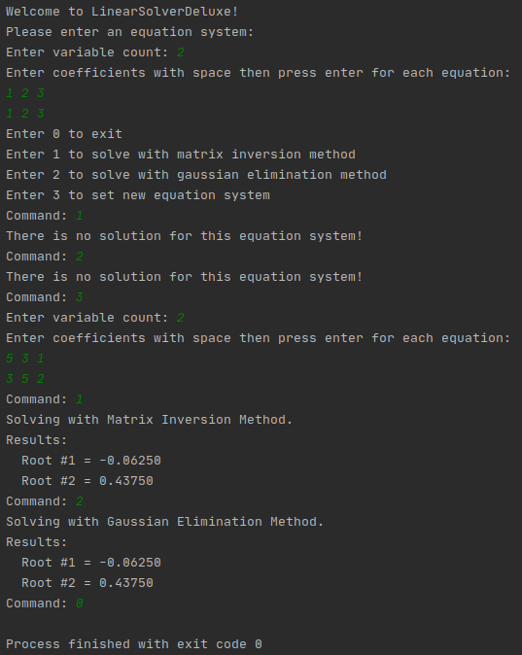

Terminal output

# Question 2 – Subscriber

The given scenario tells that there is two kind of object: subscriber and subscribable. Subscribers can subscribe many subscribable objects. Subscribable objects can have many subscribers. Also subscribers can interest some content types. So, this requrements are appriate to apply **“Observer Design Pattern”**.

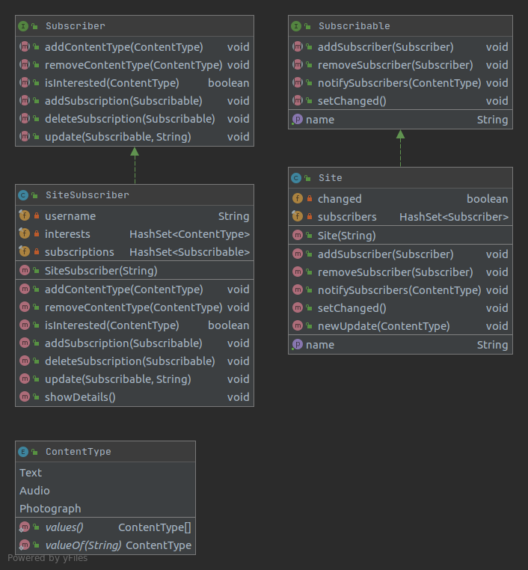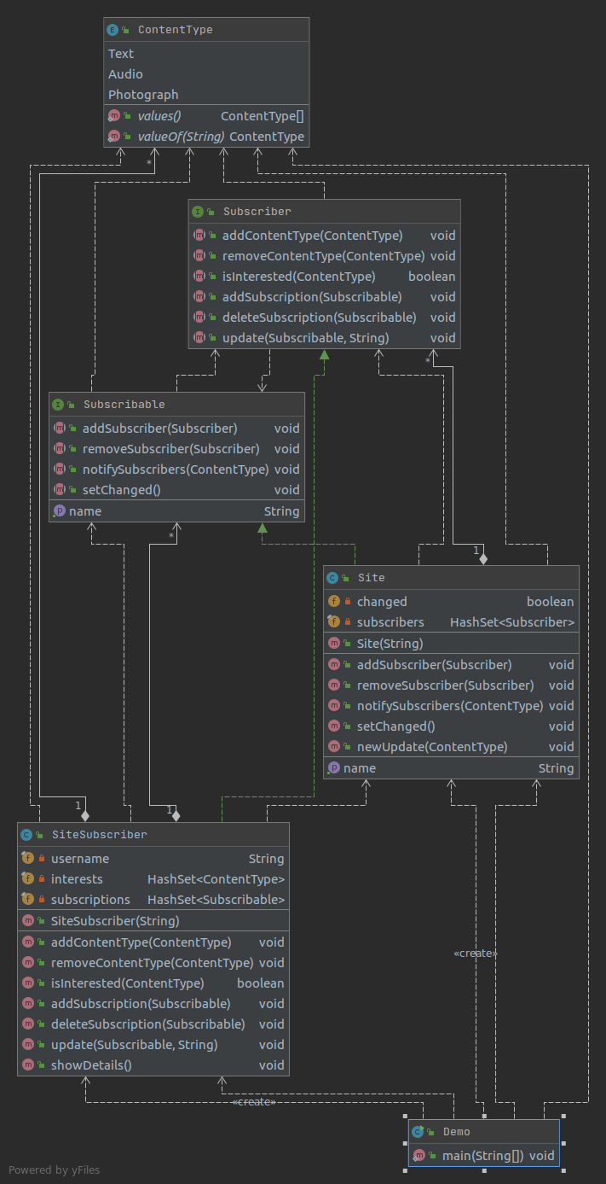Firstly, content types are represented as an enumaration type whose name is ContentType. When we need to add a new content type, we can just add it to this enum. Also we need to define interfaces to represent subscriber and subscribable stuff. Finally, define two classes that implements these interfaces.

Classes

Dependencies

The output of the demo code is below. It shows that all methods works fine. You can follow the demo code which block is result of which methods.

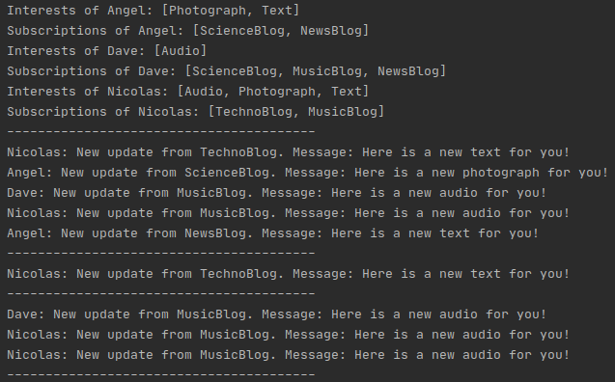

Terminal output

# Question 3 – Exoskeleton

My program is a terminal application. It simulates an ordering system. Firstly, ask you to choose a suit, then add some weapons. Finally, it prints your exoskeleton’s cost and weight. The problem is appropriate to apply **“Decorator Design Pattern”**.

I assume that each equipment is a component. So, Components class is an abstract class. There are two sub-categories for equipments: suit and weapon. They are also abstract classes that extends the Components class: Suit and Weapons classes.

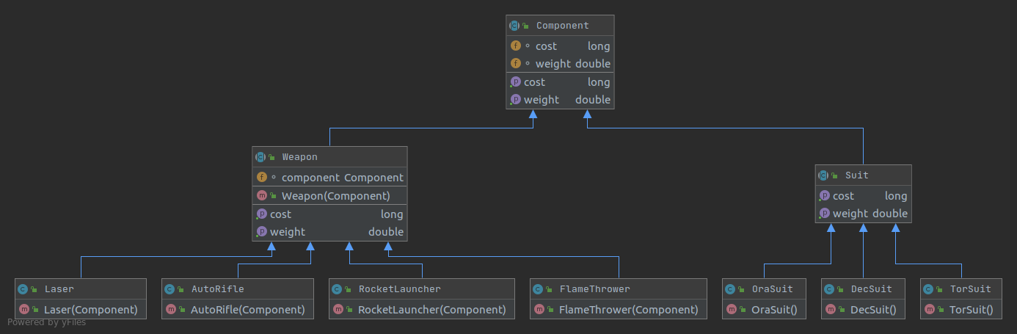

Classes

There are three kind of suits. They all extends Suit class. Each one has own cost and weight.

There are four kind of weapons. They all extends Weapon class. Each one has own cost and weight.

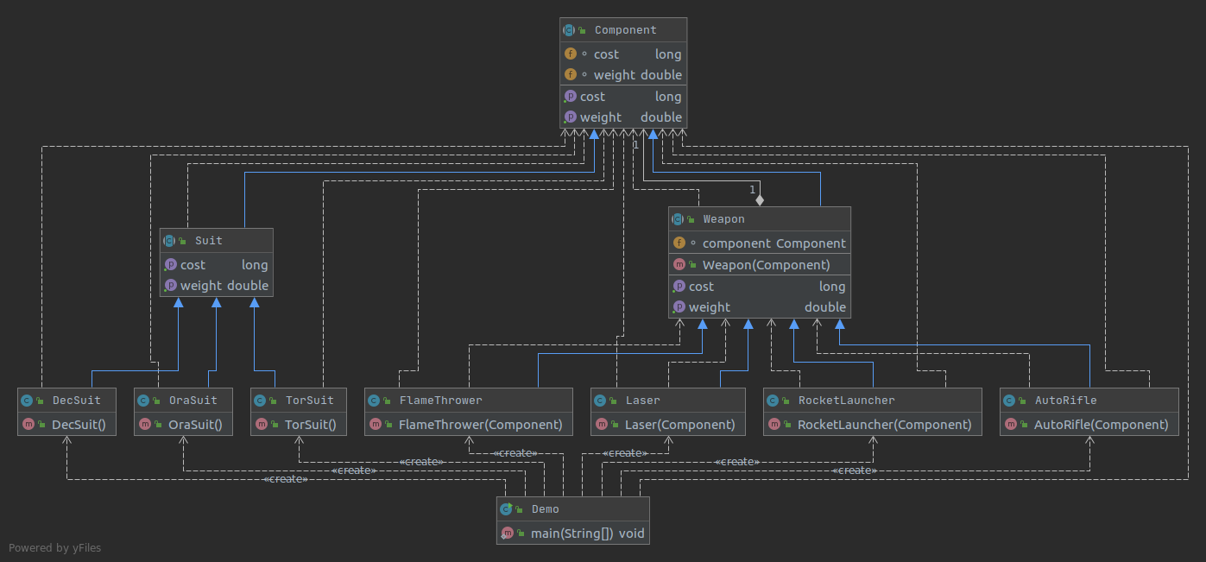

Dependencies

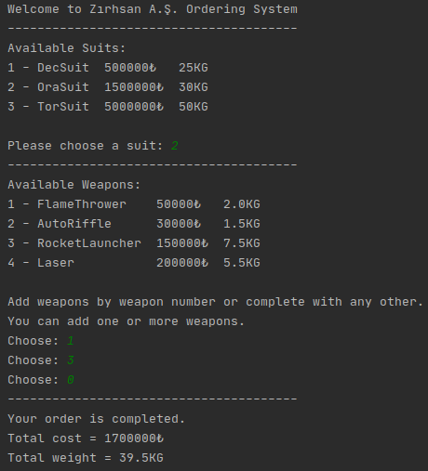

Terminal output