|  |
| --- |
| CSE433 |
| Embedded Systems |
| Assignment 2 Report |

|  |
| --- |
| OĞUZHAN AGKUŞ  161044003 |

# Objective

Design an FSM controller in Verilog but without using all capabilities of Verilog. First raw state diagram and then derive state table and Boolean expressions. Then implement the Boolean expressions with Verilog.

# Assumptions

* Vending machine can take 0.5₺ and 1₺.
* It can supply either water or sandwich.
* Water requires 2.5₺.
* Sandwich requires 5₺.
* The machine can give only 0.5₺ return.
* Customer does not necessarily give any cash. If s/he wants water, does not give more than 3₺. If s/he gives more than 3₺, it means s/he wants sandwich.
* When inserted coin amount reached to 5₺ or 5.5₺, the machine directly supply sandwich without checking selection sensor.
* The machine has no expire condition. It continues where it left.
* Inputs:
  + S1 🡪 0: No coin, 1: Coin entered
  + S2 🡪 0: 0.5₺, 1: 1₺
  + S2 🡪 0: Water, 1: Sandwich
* Outputs:
  + M1 🡪 0: Stop, 1: Run motor for water
  + M2 🡪 0: Stop, 1: Run motor for sandwich
  + M3 🡪 0: Stop, 1: Run motor for return

# State Diagram

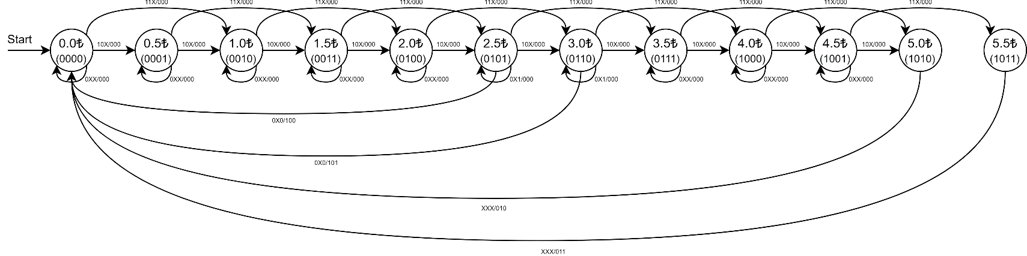

# State Table

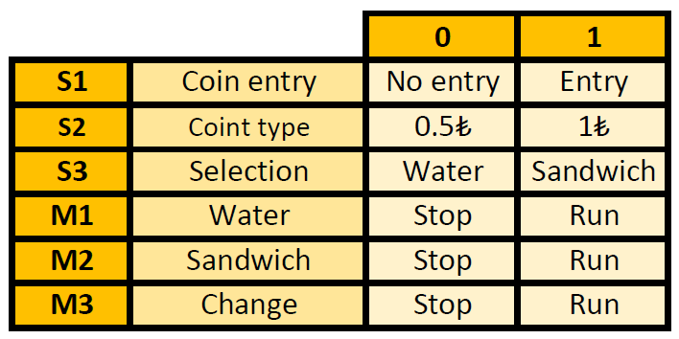

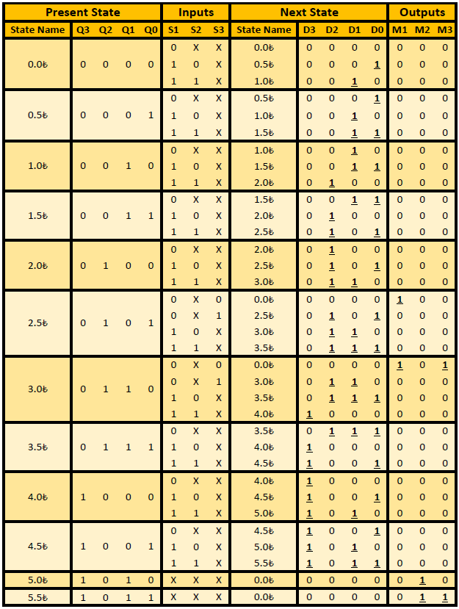

# Boolean Expressions

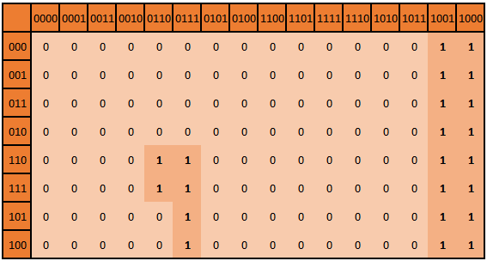

D3 = Q3Q2'Q1' + S1Q3'Q2Q1Q0 + S1S2Q3'Q2Q1

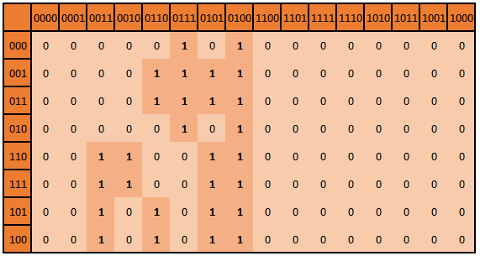

D2 = Q3'Q2Q1'Q0' + S1'Q3'Q2Q1Q0 + S1'S3Q3'Q2 + S1Q3'Q2'Q1Q0 + S1Q3'Q2Q1' + S1S2'Q3'Q2Q0' + S1S2Q3'Q2'Q1

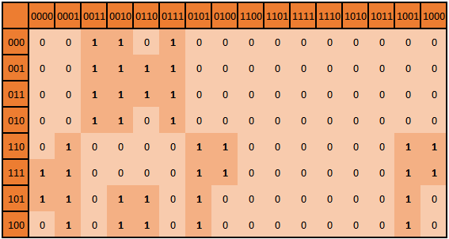

D1 = S1'Q3'Q1Q0 + S1'Q3'Q2'Q1 + S1'S3Q3'Q1 + S1Q3'Q1'Q0 + S1S2'Q3'Q1Q0' + S1Q2'Q1'Q0 + S1S2Q3'Q1' + S1S2Q2'Q1'

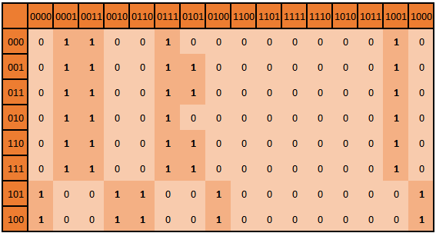

D0 = S1'Q3'Q1Q0 + S1'Q2'Q1'Q0 + S1'S3Q3'Q0 + S1S2'Q3'Q0' + S1S2'Q2'Q1'Q0' + S1S2Q3'Q0 + S2Q2'Q1'Q0

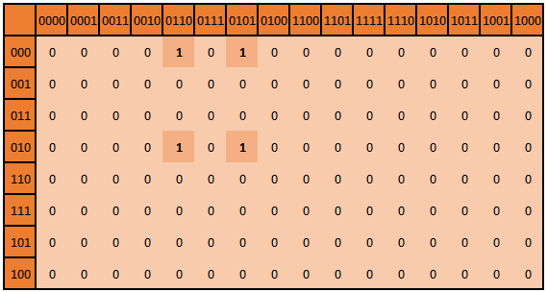

M1 = S1'S3'Q3'Q2Q1'Q0 + S1'S3'Q3'Q2Q1Q0'

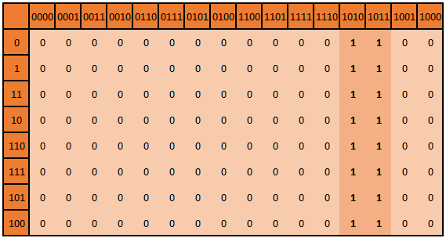

M2 = Q3Q2'Q1

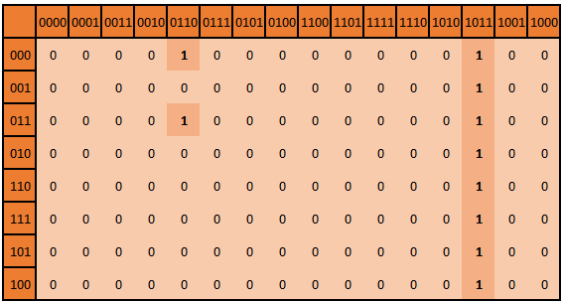

M3 = S1'S3'Q3'Q2Q1Q0' + Q3Q2'Q1Q0

# Testbench Results

There are four scenarios for buying stuffs.

* First one is, inserting 5 1₺, then getting a sandwich.
* Second one is, inserting 1 0.5₺ and 5 1₺, then getting a sandwich with 0.5₺ return.
* Third one is, inserting 1 0.5₺ and 2 1₺, then getting a water.
* Fourth one is, inserting 3 1₺, then getting a water and 0.5₺ return

Follow the motor numbers in graphic.

