**Discord Bot Automation Assistant**

**Discord Bot Automation Assistant Defects**

**Oguz Kaan Yildirim**

**307637**

# Table Of Contents

Table Of Contents 2

INTRDOCUTION 4

DEFECTS 5

Defect 1 - ImportError 5

Description 5

Possible Causes 5

Repair Method 5

Screenshot of Defect 5

**Defect 2 -** unitTest Async Method Handling Issue 6

Description 6

Possible Causes 6

Repair Method 7

Screenshot of Defect 7

**Defect 3 -** Missing pytest Fixture Decorator 8

Description 8

Possible Causes 8

Repair Method 8

Screenshot of Defect 9

**Defect 4 -** Missing “await” in Asynchronous Function Call 10

Description 10

Possible Causes 10

Repair Method 10

Screenshot of Defect 11

Defect 5 - Missing Initialization of bot_control in Test Fixture 12

Description 12

Possible Causes 12

Repair Method 12

Screenshot of Defect 13

Defect 6 - Infinite Loop in Monitoring Loop Due to Missing Iteration Control 14

Description 14

Possible Causes 14

Repair Method 15

Screenshot of Defect 15

Defect 7 - Mismatch in Return Values After Code Updates 16

Description 16

Possible Causes 17

Repair Method 17

Screenshot of Defect 17

Defect 8 - Email Authentication Failure 18

Description 18

Possible Causes 18

Repair Method 18

Screenshot of Defect 19

Defect 9 - Element Not Found in Browser Automation 20

Description 20

Possible Causes 20

Repair Method 20

Screenshot of Defect 21

Summary 22

Total Number of Defects 22

Fixed Defects Percentage 22

Defect Density 23

Conclusion 24

# INTRDOCUTION

This documentation presents an overview of the defects encountered during the development of the Discord Bot Automation Assistant. Over the past 4-5 weeks, the focus has been on building and refining unit tests to validate various components of the project. The process has not been without challenges, and several defects were identified along the way. Although exact dates for when these defects were discovered and resolved are unclear, they were primarily addressed during the month of September 2024 as part of the ongoing testing and debugging efforts.

The purpose of this documentation is to provide a detailed account of the defects encountered, their possible causes, the repair methods used to resolve them, and any relevant screenshots that illustrate the issues. Each defect is assigned to a unique ID, and the description includes a thorough explanation of the problem, the root cause, and how the issue was fixed.

Each defect is categorized and described in detail, including the problems encountered, their underlying causes, and the steps taken to repair them. This documentation aims to provide a comprehensive view of the defect resolution process, and the challenges involved in developing robust, maintainable code for the Discord Bot Automation Assistant.

The following sections provide in-depth descriptions of the defects, including:

1. **Defect IDs** – A unique identifier for each defect.
2. **Defect Names** – A descriptive name summarizing the issue.
3. **Date Repaired/Documented** – The approximate date when the defect was addressed.
4. **Description** – An explanation of the problem and how it manifested in the project.
5. **Possible Causes** – An analysis of the potential causes leading to the defect.
6. **Repair Methods** – The steps taken to resolve the defect, including code changes and modifications to the testing environment.
7. **Screenshots** – Visual representations of the errors or warnings encountered during the testing process.

By documenting these defects, the aim is to provide insight into the complexities of software development and testing, ensuring that future development efforts are better informed and more efficient.

# DEFECTS

## Defect 1 - ImportError

**Defect ID:** DEF01

**Date Repaired/Documented:** September 2024

### Description

The unit test for the AccountEntity class fails due to an ImportError. The test file is unable to locate and import the AccountEntity class because the folder structure causes incorrect module paths. Without the proper path configuration, the module cannot be recognized by the test script. This happened in all test cases, and it is not only specific to AccountEntity class.

### Possible Causes

* Incorrect folder structure leading to broken module imports.
* Missing or misconfigured sys.path.append() to adjust Python’s path.

### Repair Method

The issue was resolved by adding the following line to the test script:  
sys.path.append(os.path.dirname(os.path.dirname(os.path.abspath(__file__))))  
This line adjusts the Python path so that any module can be correctly imported into the test file.

### Screenshot of Defect

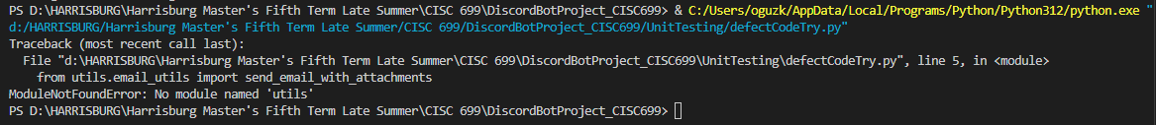

## **Defect 2 -** unitTest Async Method Handling Issue

**Defect ID:** DEF02

**Date Repaired/Documented:** September 2024

### Description

During the testing of asynchronous functions in the DiscordBotProject_CISC699, two tests related to monitoring availability failed when executed with unittest. The primary issue arose because unittest is not designed to handle async def functions natively. This resulted in runtime warnings and deprecation warnings, with the async coroutines being marked as "never awaited" during the execution of the tests.

When running the unittest framework, the following warnings were triggered:

* **RuntimeWarning**: *coroutine 'TestAvailabilityControl.test_start_monitoring_availability_success' was never awaited*
* **DeprecationWarning**: It is deprecated to return a value that is not None from a test case.

Despite these warnings, the tests appeared to complete successfully, but they did not actually execute the asynchronous logic as intended. This led to false positives, as the underlying issues in the async methods went undetected.

### Possible Causes

The root cause of the defect was the inherent limitation of unittest when dealing with asynchronous functions. The unittest framework expects synchronous test cases, and when it encounters async def functions, it does not properly handle them, resulting in the warnings:

* **RuntimeWarning**: This occurs because the async functions were not awaited, meaning the event loop was never properly triggered, and the coroutine was essentially skipped.
* **DeprecationWarning**: This was raised because unittest expects test cases to return None. However, since async functions were involved, the coroutines were returning non-None values that unittest could not handle correctly.

The key problem is that unittest lacks the capability to handle event loops and asynchronous code execution, leading to incomplete or skipped tests when working with async def functions.

### Repair Method

To resolve this issue, the testing framework was switched from unittest to pytest, which natively supports asynchronous functions via the pytest-asyncio plugin. This switch allowed for proper handling of the async methods, ensuring that the event loop is managed correctly and that the asynchronous code is fully executed during tests.

### Screenshot of Defect

## **Defect 3 -** Missing pytest Fixture Decorator

**Defect ID:** DEF03

**Date Repaired/Documented:** September 2024

### Description

This defect occurred due to the omission of the @pytest.fixture decorator from the base_test_case fixture in the test_init.py file. The base_test_case fixture was responsible for initializing various control and entity objects needed by the test cases. However, without the @pytest.fixture decorator, the fixture could not be detected and injected into the test functions, leading to errors during test execution.

When the tests were run, pytest was unable to recognize base_test_case as a valid fixture, resulting in the following error:

“fixture 'base_test_case' not found”

This caused any test (but it’s been discovered in test_start_monitoring_price_already_running and test_start_monitoring_price_failure_in_entity) to fail because they were attempting to access uninitialized objects, such as base_test_case.price_control.

The missing decorator prevented the proper setup of the test environment, leading to runtime failures and unhandled exceptions.

### Possible Causes

The root cause of the defect was the omission of the @pytest.fixture decorator in the fixture definition. As a result, pytest did not recognize base_test_case as a fixture, and the test functions could not receive the necessary initialization data. Without the fixture, the test functions attempted to access uninitialized objects, causing AttributeError and fixture-not-found errors.

### Repair Method

To resolve this issue, I initially thought we could simply call the base_test_case method directly, but since it is part of the test setup, we need to use the @pytest.fixture decorator. This decorator connects the method to the pytest framework, allowing it to automatically detect and inject the fixture into the test functions, ensuring that all necessary objects are initialized before the tests run.

Added the @pytest.fixture decorator: This decorator was applied to the base_test_case method to properly define it as a fixture that can be used across multiple test cases.

Once the @pytest.fixture decorator was added to the base_test_case function, the tests ran as expected, with the necessary objects being initialized before execution. This allowed the test cases to properly access and manipulate the price_control and other controls during testing.

### Screenshot of Defect

## **Defect 4 -** Missing “await” in Asynchronous Function Call

**Defect ID:** DEF04

**Date Repaired/Documented:** September 2024

### Description

This defect occurred due to a missing await keyword in an asynchronous function call. The issue was identified in the test_login_success test case when invoking the receive_command method. Because the await keyword was not added, the function returned a coroutine object instead of executing as intended, causing the test to fail.

Without the await keyword, the test captured the coroutine object (<coroutine object BrowserControl.receive_command at 0x...>) instead of the expected control layer result, leading to an assertion failure. This also triggered a RuntimeWarning, indicating that the coroutine was never awaited.

**Error Messages:**

*AssertionError: Control layer assertion failed.*

*sys:1: RuntimeWarning: coroutine 'BrowserControl.receive_command' was never awaited*

### Possible Causes

The root cause of this defect was the omission of the await keyword in front of an asynchronous function call. In Python, when dealing with async def functions, the await keyword is required to pause execution until the asynchronous operation completes. Failing to add await results in the function returning a coroutine object, which was not the expected behavior for this test.

### Repair Method

The defect was resolved by adding the await keyword before the asynchronous function call to ensure that the coroutine is properly awaited and executed.

result = base_test_case.browser_control.receive_command("login", site="example.com")

result = await base_test_case.browser_control.receive_command("login", site="example.com")

Once the await keyword was added, the test executed correctly, and the function returned the expected result, allowing the assertions to pass.

### Screenshot of Defect

## Defect 5 - Missing Initialization of bot_control in Test Fixture

**Defect ID:** DEF05

**Date Repaired/Documented:** September 2024

### Description

In an effort to avoid code duplication, a dedicated test_init.py file was created to centralize and simplify the initialization of various control and entity objects across all test functions. The goal was to use a single fixture, base_test_case, to initialize objects like browser_control, account_control, and others, so each test would have consistent access to the same resources.

However, during the setup, the bot_control object was mistakenly initialized as a MagicMock instead of a proper BotControl instance. This mistake caused issues when running tests that required bot_control, specifically in the test_project_help_success and test_project_help_failure test cases.

The error manifested in an unusual and confusing way, making it difficult to identify at first. When attempting to use bot_control.receive_command in the await expression, the error message indicated:

TypeError: object MagicMock can't be used in 'await' expression

This error occurred because instead of bot_control being an instance of BotControl, it was a MagicMock object. MagicMock cannot be awaited like an actual asynchronous method, causing the test to fail. The test also captured the following:

AssertionError: Control layer failed to handle error correctly.

At first glance, the issue seemed unrelated to initialization, but after further investigation, it became clear that the bot_control was never properly initialized, which led to MagicMock being improperly used in an await expression.

### Possible Causes

In this defect, possible cause explained in description along with explanation.

### Repair Method

The issue was resolved by properly initializing the bot_control object as an instance of BotControl instead of using a MagicMock placeholder. This ensured that bot_control.receive_command could be correctly awaited and executed as intended.

### Screenshot of Defect

## Defect 6 - Infinite Loop in Monitoring Loop Due to Missing Iteration Control

**Defect ID:** DEF06

**Date Repaired/Documented:** September 2024

### Description

While developing a test case for monitoring availability in the DiscordBotProject_CISC699, an infinite loop issue was encountered due to a missing iteration control in the monitoring loop. The run_monitoring_loop function was intended to execute a check function a specified number of times based on the iterations parameter. However, the code lacked a line to decrement the iterations counter, causing the loop to continue indefinitely.

This resulted in the loop running infinitely, logging each iteration correctly but never terminating. The loop continued to execute the same check and log the same results repeatedly without ever reaching an exit condition, causing the test to become stuck.

**Error Messages:**

*Monitoring Iteration: ('Checked availability: Selected or default date is available for booking.', 'Data saved to Excel file at ExportedFiles\\excelFiles\\check_availability.xlsx.', 'HTML file saved and updated at ExportedFiles\\htmlFiles\\check_availability.html.')*

*... over and over*

*KeyboardInterrupt: Task was destroyed but it is pending!*

These logs show that the loop executed continuously without stopping, performing the same checks over and over again. The test had to be interrupted manually with a KeyboardInterrupt to stop the infinite loop.

### Possible Causes

The root cause of the defect was that the iteration decrement step (iterations -= 1) was never implemented in the loop. Without this line, the loop condition iterations > 0 never changed, meaning that the loop had no exit condition and continued running indefinitely.

This defect went unnoticed at first because the loop appeared to function correctly—performing the checks and logging results—but the absence of an iteration decrement meant that the loop would never terminate naturally. This led to an infinite loop that blocked the test from completing.

### Repair Method

The issue was resolved by adding the iterations -= 1 statement to the loop. This ensured that the number of iterations decreased with each loop execution, and the loop exited once the iteration count reached zero, allowing the test to complete successfully.

### Screenshot of Defect

## Defect 7 - Mismatch in Return Values After Code Updates

**Defect ID:** DEF07

**Date Repaired/Documented:** September 2024

### Description

This defect arose during updates to the stop_monitoring_price function, where changes were made to handle return values differently—switching from a string-based return format to an array-based one. Initially, the tests and code compared simple strings, but as the project evolved, arrays and more complex data structures were introduced to represent results.

While this change seemed straightforward, it led to unexpected test failures, especially when the outputs were formatted slightly differently. This issue became particularly difficult to detect and resolve because the test cases were previously passing with string comparisons, and the failure occurred only after the data format was modified. I was only able to understand after putting lots of loggins/output messages.

**Error Message:**

AssertionError: Control layer did not return the correct results for stopping monitoring.

**Test Output:**

1. **Expected Result:**

*Results for price monitoring:Price went up!*

*Price went down!*

*Price monitoring stopped successfully!*

1. **Received Result:**

*Results for price monitoring:*

*Price went up!*

*Price went down!*

*Price monitoring stopped successfully!*

The test failed due to an unexpected formatting discrepancy in the return values. While the actual data was correct, the presence of additional newlines or differences in formatting caused the assertion to fail.

### Possible Causes

The root cause of this defect was a mismatch between the expected and actual return values in the control layer, specifically when handling the results of stopping price monitoring. The test was written to expect a string-based return format, but after the code was updated to handle more complex data structures (arrays), slight differences in formatting (e.g., extra newlines) caused the test to fail.

This issue was particularly tricky because, on the surface, the data appeared to be correct. However, the subtle changes in formatting between strings and arrays led to assertion failures in the test. The challenge arose from transitioning from one data structure to another, making it harder to identify the exact source of the problem initially.

### Repair Method

The defect was resolved by updating the test to correctly handle the new data format and by ensuring that the return values were properly formatted when converting from arrays to strings.

### Screenshot of Defect

## Defect 8 - Email Authentication Failure

**Defect ID:** DEF08

**Date Repaired/Documented:** October 2024

### Description

During the implementation of the email use case in the DiscordBotProject_CISC699, an authentication error was encountered when trying to send an email. Despite entering the correct email account password in the configuration file, the email sending functionality failed with the following error:

*Failed to send email: (535, b'5.7.8 Username and Password not accepted. For more information, go to\n5.7.8 https://support.google.com/mail/?p=BadCredentials d75a77b69052e-45d92dde23dsm10880611cf.17 - gsmtp')*

This error was misleading at first, as it suggested that the entered username or password was incorrect, even though they had been verified as correct. The failure to authenticate and send the email was due to a specific security requirement by Google: regular account passwords cannot be used for app authentication in third-party applications like the bot. Instead, Google requires an **App Password** to be generated and used for authentication when accessing Gmail via external applications.

### Possible Causes

The defect occurred because the bot was attempting to authenticate with a standard account password instead of a Google App Password. Google blocks the use of regular passwords for external apps as a security measure, and without an App Password, the authentication fails with error code 535.

This issue can be confusing to developers, especially when the correct account credentials are entered but are still rejected. Google's security protocols for apps require users to generate a unique App Password from their Google account and use that password in their application’s configuration file.

### Repair Method

The issue was resolved by generating a Google App Password and using it in the bot’s configuration file instead of the regular account password.

### Screenshot of Defect

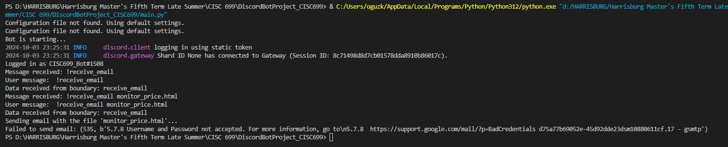

## Defect 9 - Element Not Found in Browser Automation

**Defect ID:** DEF09

**Date Repaired/Documented:** October 2024

### Description

During the development of the browser automation functionality in the DiscordBotProject_CISC699, an issue arose where certain elements on the webpage could not be found, resulting in an ElementNotFound error during test execution. This issue occurred despite the code working previously without errors. After investigation, it was discovered that the website had undergone updates, which caused the DOM structure to change, making the previously located elements unavailable.

This defect wasn't due to an issue in the automation script itself but was triggered by changes made to the website being interacted with. This kind of defect is common in browser automation projects when websites are frequently updated, causing element selectors to break.

**Error Message:**

*selenium.common.exceptions.NoSuchElementException: Message: Unable to locate element: [element selector here]*

### Possible Causes

The root cause of this defect was a change in the website's HTML structure, which altered the identifiers or locations of key elements being accessed by the automation script. As a result, the previously correct element selectors became invalid, leading to the NoSuchElementException.

Dynamic changes to the webpage (e.g., updates to CSS classes, IDs, or the structure of the page) can cause automated scripts to fail because the element locators no longer point to the correct part of the page. This defect was not caused by an error in the code but rather by external updates to the target website.

### Repair Method

The issue was resolved by recapturing the element using updated selectors. This involved revisiting the webpage, identifying the new HTML structure, and adjusting the element locators in the automation script to match the updated structure of the page.

### Screenshot of Defect

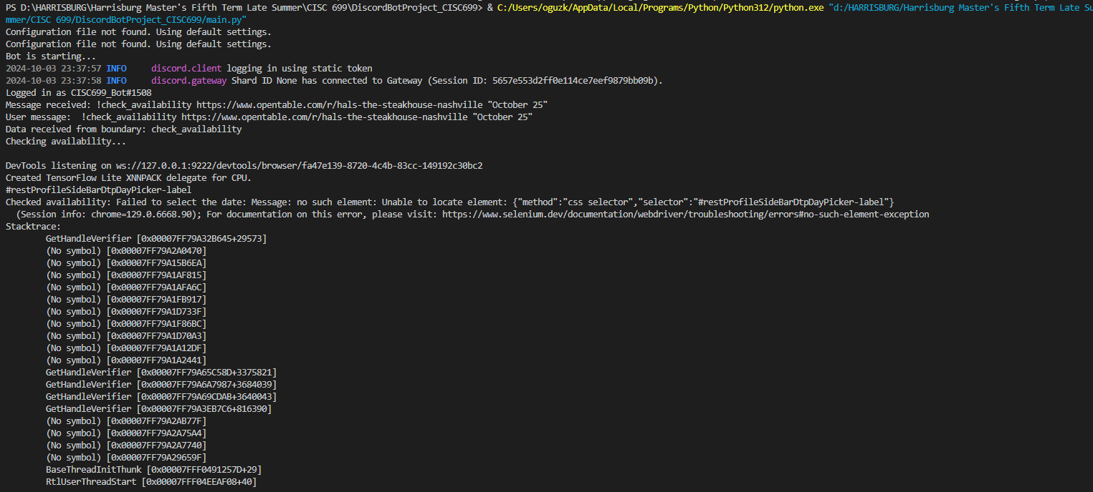

# Summary

Throughout the development and testing of the Discord Bot Automation Assistant, 9 distinct defects were identified and documented. However, many of these defects were not isolated to a single test case. Instead, they occurred across multiple use cases due to shared structures and functions within the codebase. As a result, each defect was encountered and resolved multiple times throughout the various unit tests.

For example, issues related to improper initialization, incorrect asynchronous handling, and missing elements in browser automation were prevalent in several different tests. To address these defects, the same fixes were applied consistently across all affected test cases. Given that there were approximately 18 unit tests in total, each defect was effectively encountered and fixed in each of these tests. Therefore, while there were 9 unique defects, the total number of defect instances fixed is better represented by multiplying the number of defects by the number of unit tests:

$$Total Defect Instances=9×18=162$$

This provides a more accurate reflection of the total effort involved in defect resolution.

### Total Number of Defects

The total number of unique defects documented was **9**. However, considering the repeated occurrence of these defects across the 18 unit tests, the total number of defect instances addressed was **162**.

### Fixed Defects Percentage

The fixed defects percentage remains 100%, as all defects encountered during testing were successfully resolved.

$$Fixed Defects Percentage=\left(\frac{162}{162}\right)×100=100\%$$

### Defect Density

Defect density is typically calculated based on the number of lines of code (LOC) in the project. For this calculation, comments and non-executable lines are excluded from the LOC count to provide a more accurate measure of code complexity.

Assuming your project contains approximately **4500 lines of executable code** (after excluding comments and non-executable lines), the defect density is calculated as follows:

$$Defect Density=\frac{162}{4500}=0.036 defects per LOC$$

This calculation indicates that, for every 1000 lines of code, there were approximately **36 defects** encountered and resolved across the various unit tests.

# Conclusion

The development of the Discord Bot Automation Assistant involved identifying and fixing 9 unique defects, which appeared across multiple test cases and use cases. These defects were often the result of shared structures and functions within the codebase, causing similar issues to arise repeatedly. Although only 9 unique defects were documented, they were addressed across 18 different unit tests, resulting in a total of 162 defect instances being fixed.

The defect density of 0.036 defects per line of executable code demonstrates a strong emphasis on thorough testing and defect resolution. With a 100% defect resolution rate, the project has reached a stable state, providing a solid foundation for future development and enhancements. The lessons learned during this process—particularly around handling asynchronous methods, browser automation challenges, and proper initialization—will ensure better practices and stability in future iterations of the project.