**Three-Layer Architecture for Your Project**

**I. Definition of Layers:**

1. **Presentation Layer:**
   * Manages all interactions with the user through command interfaces on Discord.
   * Components include interfaces for different command types such as navigation, price checks, monitoring, and email notifications.
2. **Business Logic Layer:**
   * Contains the core functional logic that processes user commands and executes the bot's operations.
   * Components include various control objects for managing browser operations, price monitoring, availability checks, and user authentication.
3. **Data Access Layer:**
   * Handles all interactions with data storage and retrieval, which in your case includes exporting data to files like Excel and HTML, given the absence of a traditional database.
   * Components are primarily focused on entity management and data export utilities.

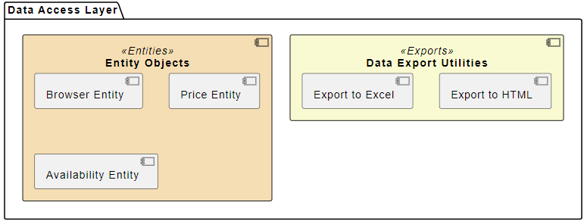

@startuml

skinparam componentStyle uml2

' Define colors for layers and components

skinparam component {

BackgroundColor<<Presentation>> LavenderBlush

BackgroundColor<<Business>> PaleGreen

BackgroundColor<<DataAccess>> PeachPuff

BackgroundColor<<UI>> Lavender

BackgroundColor<<Controls>> PaleGreen

BackgroundColor<<Entities>> Wheat

BackgroundColor<<Exports>> LightGoldenRodYellow

}

' Presentation Layer

package "Presentation Layer" as PL<<Presentation>> {

component "User Interface" as UI <<UI>> {

[Command Handling]

[Monitoring Commands]

[Browser Interaction Commands]

}

}

' Business Logic Layer

package "Business Logic Layer" as BLL<<Business>> {

component "Control Objects" as Controls <<Controls>> {

[Browser Control]

[Price Monitoring Control]

[Availability Monitoring Control]

[User Authentication Control]

[Notification Control]

}

}

' Data Access Layer

package "Data Access Layer" as DAL<<DataAccess>> {

component "Entity Objects" as Entities <<Entities>> {

[Browser Entity]

[Price Entity]

[Availability Entity]

}

component "Data Export Utilities" as Exports <<Exports>> {

[Export to Excel]

[Export to HTML]

}

}

@enduml