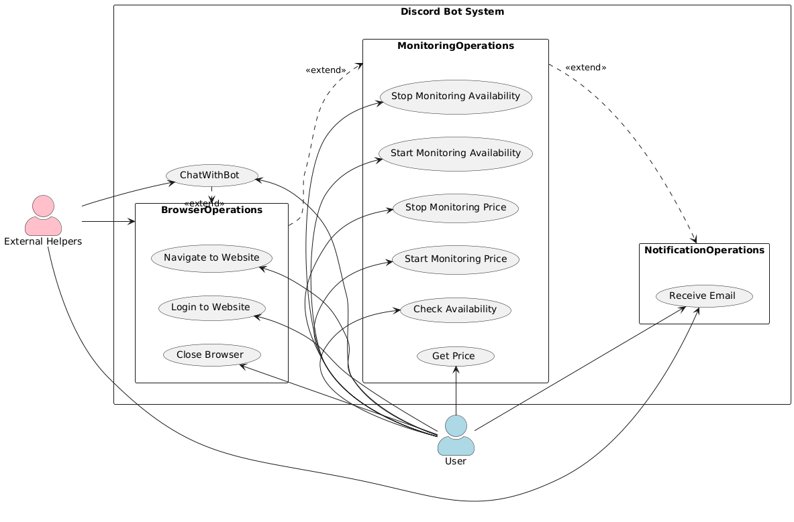

@startuml

left to right direction

skinparam packageStyle rectangle

skinparam actorStyle awesome

' Define actors

actor User #lightblue

actor "External Helpers" as ExternalHelpers #pink

' Define system and packages

package "Discord Bot System" {

' Define use cases

usecase "ChatWithBot" as ChatWithBot

package "BrowserOperations" {

usecase "Navigate to Website" as NavigateWebsite

usecase "Login to Website" as LoginWebsite

usecase "Close Browser" as CloseBrowser

}

package "MonitoringOperations" {

usecase "Check Availability" as CheckAvailability

usecase "Start Monitoring Availability" as StartMonitoringAvailability

usecase "Stop Monitoring Availability" as StopMonitoringAvailability

usecase "Get Price" as GetPrice

usecase "Start Monitoring Price" as StartMonitoringPrice

usecase "Stop Monitoring Price" as StopMonitoringPrice

}

package "NotificationOperations" {

usecase "Receive Email" as ReceiveEmail

}

' Positioning for visual alignment

BrowserOperations -[hidden]d- MonitoringOperations

MonitoringOperations -[hidden]d- NotificationOperations

}

' User interactions with initial use case

User -left-> ChatWithBot

User -left-> NavigateWebsite

User -left-> LoginWebsite

User -left-> CloseBrowser

User -left-> GetPrice

User -left-> CheckAvailability

User -left-> StartMonitoringPrice

User -left-> StopMonitoringPrice

User -left-> StartMonitoringAvailability

User -left-> StopMonitoringAvailability

User -left-> ReceiveEmail

' Package extending relationships

ChatWithBot .right-> BrowserOperations : <<extend>>

BrowserOperations .down-> MonitoringOperations : <<extend>>

MonitoringOperations .down-> NotificationOperations : <<extend>>

' External interactions aligned to the right

ExternalHelpers --> BrowserOperations

ExternalHelpers --> ReceiveEmail

ExternalHelpers --> ChatWithBot

@enduml