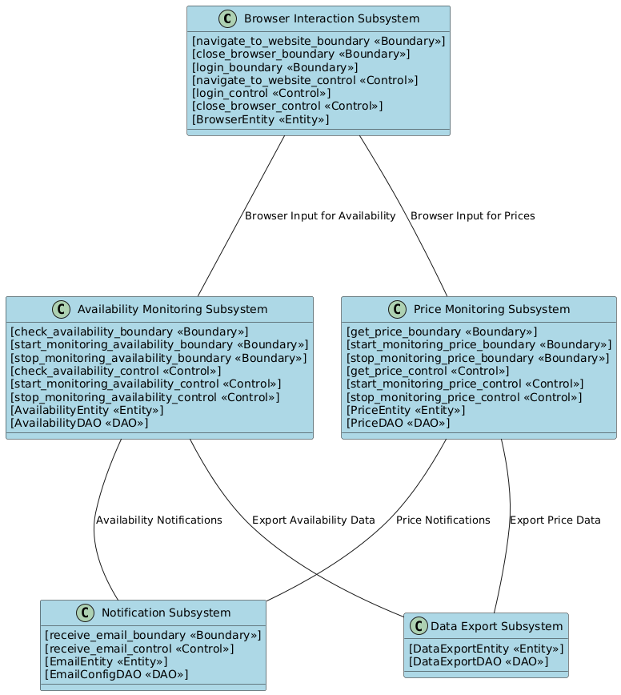

@startuml

class "Browser Interaction Subsystem" as BrowserInteraction #LightBlue {

[navigate_to_website_boundary <<Boundary>>]

[close_browser_boundary <<Boundary>>]

[login_boundary <<Boundary>>]

[navigate_to_website_control <<Control>>]

[login_control <<Control>>]

[close_browser_control <<Control>>]

[BrowserEntity <<Entity>>]

}

class "Availability Monitoring Subsystem" as AvailabilityMonitoring #LightBlue {

[check_availability_boundary <<Boundary>>]

[start_monitoring_availability_boundary <<Boundary>>]

[stop_monitoring_availability_boundary <<Boundary>>]

[check_availability_control <<Control>>]

[start_monitoring_availability_control <<Control>>]

[stop_monitoring_availability_control <<Control>>]

[AvailabilityEntity <<Entity>>]

[AvailabilityDAO <<DAO>>]

}

class "Price Monitoring Subsystem" as PriceMonitoring #LightBlue {

[get_price_boundary <<Boundary>>]

[start_monitoring_price_boundary <<Boundary>>]

[stop_monitoring_price_boundary <<Boundary>>]

[get_price_control <<Control>>]

[start_monitoring_price_control <<Control>>]

[stop_monitoring_price_control <<Control>>]

[PriceEntity <<Entity>>]

[PriceDAO <<DAO>>]

}

class "Notification Subsystem" as Notification #LightBlue{

[receive_email_boundary <<Boundary>>]

[receive_email_control <<Control>>]

[EmailEntity <<Entity>>]

[EmailConfigDAO <<DAO>>]

}

class "Data Export Subsystem" as DataExport #LightBlue{

[DataExportEntity <<Entity>>]

[DataExportDAO <<DAO>>]

}

' Connections between subsystems

BrowserInteraction --down-- AvailabilityMonitoring : "Browser Input for Availability"

BrowserInteraction --down-- PriceMonitoring : "Browser Input for Prices"

AvailabilityMonitoring --down-- Notification : "Availability Notifications"

PriceMonitoring --down-- Notification : "Price Notifications"

AvailabilityMonitoring --down-- DataExport : "Export Availability Data"

PriceMonitoring --down-- DataExport : "Export Price Data"

@enduml