Optimization Techniques

Ömer Mustafa Oğuzoğlu 13253813

Supervisor: Professor Dr. Serdar İPLİKÇİ

**Handwriting recognition approximation**

After a little study of image processing we can understand easily that 0 is black , 255 is white and grey scale changes between 0-255.

In this example I will train colors from 0 to 10 as 0 white and 10 is black.

=0  =0

=1 =1

# How Does it work?

Lets take an image shown up as example.

 **=1** , but its expression as array is $\left(\begin{aligned} x 0 \\ 0 x\end{aligned}\right)$ although we can reshape it to one line array as $\left( x 0 0 x\right)$. And now what we need is a lot of data to train.

Good to know: x = 1 , 2 , 3 , 4 , 5 , 6 , 7 , 8 , 9 , 10

**Input 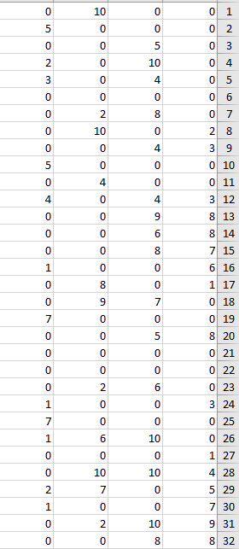 Output** 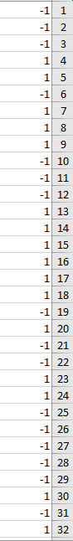

Part of inputs and outputs

# Result

