* + 1. **Problem Statement**.

Autolib is a French company offering self-drive electric cars in Paris. The research will seek to understand electric car usage by solving a research question. Working as a Data Scientist for the Autolib electric car-sharing service company to investigate a claim about the blue cars from the provided Autolib dataset.

The investigation is to check if the mean of Blue Cars taken in the Weekdays is equal to the mean of Utilib Cars taken in Weekdays.

In an effort to do this, we need to identify some areas and periods of interest via sampling. We will use both Z-test and T-Test. There are no postal codes 75015 and 75017; so no investigation on this.

Null Hypothesis, H0 : The mean of Blue Cars taken on weekdays is equal to the mean of Utilib Cars taken on weekdays

Alternative Hypothesis, Ha: The mean of Blue Cars taken on weekdays is different to the mean of Utilib Cars taken on weekdays

* + 1. **Data Description**

The Autolib data used is from <http://bit.ly/DSCoreAutolibDataset> with the following columns.

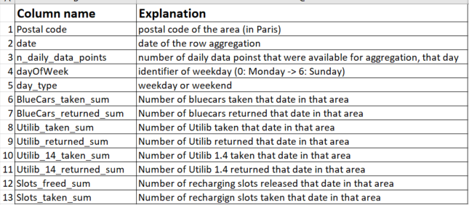

* + 1. **Hypothesis Testing Procedure**

Samples were taken for both Z-test and T-test. In both tests, the distribution was found not to be Gaussian.

* + 1. **Hypothesis Testing Results**

The p-value was 1.057625781313243e-37 with a value of the T-test 14.294337054559918.

The significance level = 0.05. The p-value is less than the significance level, hence, We reject the Null Hypothesis.

* + 1. **Summary and Conclusions**

The Blue Cars and Utilib cars were used equally on average during the weekdays.