
IE-469 Project Report
Group-15
Fall 2025-2026

Emre Uzun

Ahmet Efekan Ersoy 22103060
Oğuz Kağan Özkan 22101748
Egenaz Tunçdemir 22102046

New York City hosts one of the world’s densest and most competitive food-delivery markets. The increasing customer dependence on platforms such as Uber Eats, DoorDash, and Grubhub, combined with heavy traffic congestion and fluctuating driver availability, creates systemic delays in fulfilling on-demand deliveries.
These online delivery applications are widely used in New York City, where 48% of those between the ages of 25 and 34 and 63% of those between the ages of 18 and 24 use them. Only 13% of adults over 35 use these applications, though. Furthermore, the average monthly order volume for third-party apps is roughly 4.6 per user.
Uber Eats has identified three delay sources:
- Lack of available drivers,
- Restaurants not having orders ready on time,
- Traffic congestion.
Only the availability of drivers is directly under the company's control; this is achieved by dynamically adjusting driver distribution and service area coverage for each Manhattan Neighborhood Tabulation Area (NTA).
The goal of this project;
- Determination of the set of restaurants in the service area coverage of each NTA.
- Determination of the driver allocation and service area coverage per NTA that would satisfy driver availability for each new order.
- Developing a decision support system utilizes UserForms that will take the total number of drivers available and run the above methodology.
Q1)
The goal of Question 1 is to find which restaurants are inside the service area of each NTA (Neighborhood Tabulation Area) in Manhattan.
For every NTA, we are given a radius of coverage in miles, and all restaurants must be checked to see if they fall inside this radius. The output is the list of restaurants and their distances from the NTA center.
The NTA Dataset and the Restaurant Dataset are used to solve this problem.
The solution uses a two-step algorithmic approach to strictly satisfy the requirements.
- The radius should emanate from the geographic center point of the NTA:
In the CalculateNTACenters subroutine, we cannot simply use a single point because the input data (Polygon Coordinates) is a list of boundaries. The code parses this long string, extracts every Latitude and Longitude pair (Split(polyRaw, ",")), and calculates the mathematical average (centroid).
- Calculating rectilinear or 'Manhattan' distances is preferred:
In the FindRestaurants subroutine, strictly inside the loop For i = 2 To lastRest, we calculate distance using absolute differences rather than the Pythagorean theorem (straight-line distance).
Because Manhattan has a grid-like street structure, the Manhattan distance (rectilinear distance) is preferred.
This distance formula is:
$$Distance=\left(\left|{Lat}_{center}-{Lat}_{rest}\right|×69\right)+\left(\left|{Lon}_{center}-{Lon}_{rest}\right|×52.5\right)$$
- Coverage could... overlap with other NTAs.
The code loops through every single row of the Manhattan-Restaurants file (lastRest = wsRest.Cells...) and checks,
$$Total Distance ≤radius$$
- Output: All the distances... of all restaurants.
The code clears the Output sheet and writes a clean table.
  - It lists the Restaurant Name (Column A).
  - It lists the Calculated Distance (Column B).
  - It lists the Address (Column C) for verification.
  - This provides exactly the "set of restaurants" requested by the prompt.
Q2)
The aim of Question 2 is to determine how many drivers should be assigned to each NTA and what service area coverage (radius) each NTA should utilize, ensuring that a driver is available immediately when a new customer order arrives.
Uber Eats aims to mitigate delivery delays caused by low driver availability, so we develop a method to estimate the number of drivers required in each NTA under realistic assumptions.
To answer Question 2, we utilized a mathematical model coded in VBA that translates the operational assumptions into rigid constraints. This solution determines the optimal number of drivers (N) and the maximum service radius (R) for each Neighborhood Tabulation Area (NTA) to ensure that every incoming order can be served immediately.
Fixed assumptions used are given in the project description:
- Drivers travel at 9 mph,
- Orders arrive uniformly during lunch and dinner hours,
- Customers choose restaurants equally inside the NTA coverage,
- Drivers can handle one order at a time.
The code performs calculations in three distinct phases:
- Calculating Hourly Demand
First, determine the number of orders that arrive per hour in each NTA based on population demographics.
$$Users=\left(P_{18-24}×0.63\right)+\left(P_{25-34}×0.48\right)+\left(P_{35+}×0.13\right)$$
$$λ_{i}=\frac{Users×4.6({orders}/{mo})}{30(days)×5.5(hours)}×\frac{1}{3}(share)$$
The code applies the usage rates (0.63, 0.48, 0.13), adds up the population rows (pop35_Plus = GetPop(...)), then divides the result to obtain lambda.
- Allocating Drivers
We must allocate the small pool of drivers ($D_{total}$) to the areas where they are most needed because we have no control over the quantity of orders.
$$N_{i}=Total Drivers × \frac{λ_{i}}{\sum{λ}}$$
The code calculates allocN = Round(totalDrivers * (lambda / totalCityDemand), 0). This ensures that a busy neighborhood gets more drivers than a quiet one.
- Optimizing Service Radius
This is the core "Availability" constraint. To ensure a driver is available for each new order, the neighborhood's service capacity must be greater than or equal to the arrival rate of orders.
Constraint: $Capacity ≥Demand$
Trip Time: $T=R/9$
Service Rate per Driver: $μ=1/T=9/R$
Total Capacity: $N_{i}×(9/R)$
Optimized Formula: $N_{i}×\frac{9}{R} ≥λ_{i}⟹ R_{i}≤\frac{9×N_{i}}{λ_{i}}$
Overall, for each NTA, the code uses the GetPop function to collect population numbers for specific age groups. These populations help estimate the number of people in that NTA who are likely to use delivery apps.
Next, the code calculates the expected number of users in each NTA by applying the usage probabilities given in the project (for example, 0.63 for ages 18–24 and 0.48 for ages 25–34).
Using these users, the code computes lambda, which represents the hourly order demand. The code loops through all NTAs again to perform two tasks: Driver Allocation and Radius Calculation. Through these steps, the code ensures that every NTA has enough drivers and a radius that supports immediate driver availability, which is the main requirement of Question 2.
Q3)
The main purpose of Question 3 is to build a Decision Support System that:
- Uses UserForms,
- Takes the total number of available drivers in Manhattan as input,
- Runs the methods developed in Q1 and Q2 (coverage and driver allocation),
- Shows the results clearly, preferably on a map view.
In other words, Q3 transforms the previous calculations into an interactive tool that managers can use without needing to touch formulas or VBA code.
To satisfy the requirement of providing output "displayed preferably on a map screen," the Generate_Map_Dashboard subroutine was developed. Since Excel does not have a native GIS (Geographic Information System) engine for this type of custom radius plotting, a Bubble Chart was engineered to create a visualization that mathematically replicates a map of Manhattan.
Here is how the code translates the mathematical results into a visual Decision Support:
- Simulating a Map Interface
Standard Excel charts automatically scale to fit the data, which often distorts geographic shapes. To create a true "Map Screen," we rigidly locked the chart axes to the geographic boundaries of Manhattan.
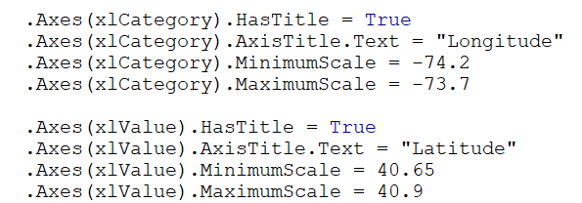
By hard-coding these minimum and maximum scales, the code ensures the chart respects the actual aspect ratio of the city. This ensures that the NTA locations appear in their correct relative positions, creating a recognizable map for the user.
- Visualizing Service Radius (Series 1: Bubbles)
The main output of the VBA optimization is the Service Radius. Visualizing Service Radius using a Bubble Chart, where the size of the bubble corresponds to the calculated radius.
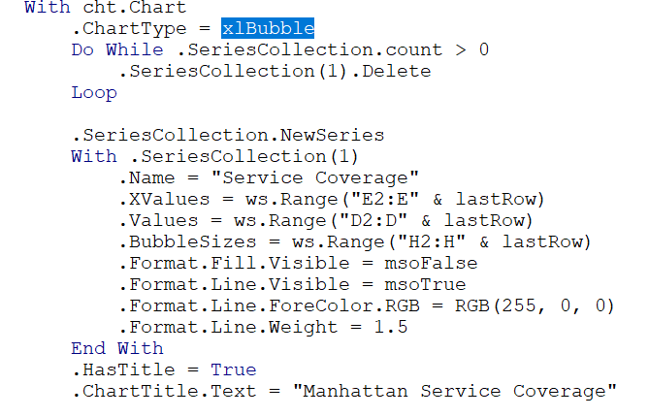
Mapping the Longitude to the X-axis and the Latitude to the Y-axis to place the center of the bubble at the NTA's geographic center.
BubbleSizes is binned to Column H, which contains the optimized radius calculated in the backend. Larger bubbles instantly indicate areas with wider coverage (usually low demand/high driver count), while smaller bubbles indicate dense, high-demand zones.
It is set to Format.Fill.Visible = msoFalse (transparent) and use a red border. This allows decision-makers to see overlaps. If two red circles overlap significantly, it indicates redundant coverage; if there are gaps between circles, it indicates service voids.
After running the model, the DSS displays the results in a clear output table and updates a map or visual chart that shows the number of drivers each NTA receives and the distance they can travel. The system also includes basic error checks to prevent incorrect inputs. Overall, the DSS transforms the project’s analytical model into a practical tool that enables managers to easily evaluate different driver-allocation scenarios in Manhattan.

References:
For FindRestaurants() sub we get help from:
https://learn.microsoft.com/en-us/office/vba/api/excel.range.find

Function CleanVal(v As Variant) As Double
.Find(What:=rowLabel, LookIn:=xlValues, LookAt:=xlPart)
We got help from
https://chatgpt.com/

