Nofit LRT — extension of the line to Haifa and Tirat Carmel: the demand study
This is the ASD-STE100 (Simplified Technical English) version of the summary report. It has the same structure and the same numbers as the Hebrew summary report (Nofit_LRT_Extension_Comprehensive_Report_HE.docx) and as the full English report (Nofit_LRT_Extension_Comprehensive_Report.docx). The figures are the figures of the English report, with their English captions. The numbers of the study are of 5 October 2026. This version is of 22 October 2026.
How this version applies ASD-STE100 Issue 8:
- Each sentence has 25 words or fewer (20 words in an instruction). Each sentence has one topic.
- Each paragraph has one topic and 6 sentences or fewer. Sequences are vertical lists.
- The text uses the active voice and the simple present tense for facts. Each word has one meaning. There are no -ing verb forms.
- The specification permits technical names and technical verbs. The table below gives the technical names of transport models that this report uses.
Technical name | Meaning
LRT | Light rail transit. "The LRT" is the planned Nofit light rail line.
Main route | The Nofit line in construction, Hamifrats – Nazareth, stations M01–M20.
Extension | The planned continuation of the line from Hamifrats through Haifa to Tirat Carmel, stations S01–S24.
Through line | The main route and the extension as one line, without a transfer at Hamifrats.
Metronit | The bus rapid transit (BRT) system of the Haifa area.
Public transport | Bus, Metronit, train and LRT together ("transit" in the English report).
TAZ | Traffic analysis zone, the smallest geographic unit of the model (781 zones).
Corridor area | One of the 25 groups of TAZs along the line, the geography of the report.
Corridor market | The trips between the 174 TAZs of the corridor that start and end in different corridor areas.
Pair | One origin zone and one destination zone.
Path | The sequence of walks, waits and vehicles between the two zones of a pair.
Generalized cost (GC) | One value, in felt minutes, that shows the total effort of a trip.
Felt minute | A minute of trip time after the model applies the weights of the generalized cost.
Transfer penalty | A fixed value that the model adds for each change of vehicle.
LRT premium | A fixed value that the model subtracts from the cost of an LRT path.
λ (lambda) | The cost sensitivity: the number that changes a difference in felt minutes into a difference in choices. λ_T is the value inside public transport.
Logit model | The formula that changes a cost difference into a share of travellers.
Pivot | A calculation that starts from the observed 2022 shares and changes them by the new cost difference; it does not estimate the shares again.
Capture | The number of LRT trips that the model calculates.
Shift | Trips that move from one mode to a different mode when the LRT is added.
Scenario | A year and a demographic forecast: 2040 or 2050; BU (business as usual) or HS (high scenario).
Reference case | The scenario 2050 BU, the through line, the Prioritized regime.
Regime | How the extension operates: Prioritized (full priority at the road junctions) or Unprioritized (at street level, with the traffic).
Peak hour | The busiest 60 minutes of a three-hour period (AM 06:00–09:00, PM 16:00–19:00).
Load | The number of passengers on one segment of the line in one direction.
Headway | The time between two vehicles of the same line.
Feeder | A bus or Metronit leg that brings a traveller to an LRT station.
Level of service | The travel time, access, wait and transfers of a mode between two zones.
Matrix | A table of trips from each zone to each zone.
Caveat | A documented limit of the model. Chapter 8 of METHODOLOGY.md has 34 numbered caveats: 29 apply to the current chain, 5 are retired. A number never changes.
Step | One documented notebook of the chain of 45 steps (step 45 is the demand of the alternatives).

Summary for decision makers
The question. The main route of the Nofit light rail (Hamifrats – Nazareth) is in construction. Must the line continue through Haifa to Tirat Carmel? If yes, must it operate as one line, or must the extension stop at Hamifrats?
This report gives the quantity and the location of the demand for the extension. The base is the travel market that we measured in 2022, increased to 2040 and to 2050. The report also says what the evidence supports and what it does not support.
Reference case. The main case for the plan is the year 2050 with the usual demographic scenario ("2050 BU"). The year 2040 and the high scenario ("HS") show the effect of growth. The reference alternative is the through line (main route + extension) with priority for the extension at the junctions ("Prioritized").
Reference case 2050 BU, main route + extension, Prioritized | Value
LRT passengers on the corridor, AM 06:00–09:00 / AM peak hour | 7,433 / 4,378
Of these: passengers who use the extension (S01–S24) / passengers who travel only between extension stations | 6,003 (81 %) / 3,851
LRT passengers, PM 16:00–19:00 / PM peak hour | 6,135 / 2,934
Through line against a terminal at Hamifrats: extension passengers / all LRT passengers | 6,003 against 5,939 (+1 %) / 7,433 against 5,939 (+25 %)
Source of the passengers (AM, 3 hours) | Metronit 3,731 (33 % of its corridor trips), bus 2,881, car 818 (0.9 % of the corridor car trips)
Maximum load, AM peak hour, one direction | 1,071 at the entry to Hamifrats (segment S24–M02, direction Tirat Carmel); on the extension itself 1,028
Public transport share of the corridor market, before → after | 19.3 % → 20.6 %; the LRT takes 34 % of public transport
Largest markets (AM, 3 hours) | Tirat Carmel ↔ Haifa 2,189 (29 %); inside Haifa 1,663 (22 %); Krayot ↔ Haifa (with a feeder) 1,665 (22 %); main route ↔ Haifa 891 (12 %)
Extension without priority at the junctions (at street level) | 5,700 (-23 %)
Buses 20 % slower in 2050 (sensitivity) | 7,804 (+5 %)
Range for the plan (LRT passengers, AM 06:00–09:00, reference case). The range comes from the cost sensitivity λ at the two ends of its range (0.05 and 0.02 around the central 0.03). This is the widest single factor of the uncertainty experiment (step 40). The LRT premium (0 or 10 minutes) gives a narrower band inside it. The regime is a design decision, not an uncertainty. Thus the table shows it separately.
Case | LRT passengers, 3 hours | LRT passengers, peak hour
Central case for the plan (λ 0.03, premium 5 minutes, Prioritized) | 7,433 | 4,378
Possible low case (λ 0.05: travellers with the lowest sensitivity to cost) | 5,532 | 3,258
Possible high case (λ 0.02: the highest sensitivity) | 10,537 | 6,207
Design decision: extension without priority, central λ | 5,700 | 3,357
What the evidence on the demand supports:
- A market for the extension of approximately 4,000 to 9,000 passengers in the three AM hours in 2050 BU. Most of this market is on the Carmel coast and in the lower city. It has three parts of almost the same size: Tirat Carmel ↔ Haifa, trips inside Haifa, and the Krayot with a feeder.
- The passengers of the extension do not depend on the through line: 6,003 on the through line, against 5,939 if the extension stops at Hamifrats. The benefit of the through line is the transfer that it removes for the 2,849 trips (38 %) that cross Hamifrats. Today these trips use the Metronit without a transfer. The +25 % on the full line is the market of the main route. This market travels in each case.
- Priority at the junctions: the regime at street level loses approximately a quarter of the passengers, most of them on the extension. This effect is larger than the growth between 2040 and 2050.
- A maximum load of approximately 1,000 to 1,400 passengers for each hour and direction at the entry to Hamifrats. This is the demand of a light rail, not of a metro.
- The rank of the alternatives and of the regimes. The order of magnitude of the shift from the Metronit, from the bus and from the car.
What the evidence does not support:
- A passenger forecast for an economic appraisal, for the fleet or for the frequency. The loads are potential movements without a capacity limit. The service plan keeps each bus line and each Metronit line as it operates today. The base is validated at the corridor level, but not at the link level. The cost sensitivity has a range; it is not an estimate for the car owners that the line must attract.
- A statement about the car in 2040 / 2050. The shift from the car to the LRT is an order of magnitude only. It does not change with the road conditions in this model.
- A claim of a "new market". Most LRT passengers are the Metronit and bus passengers of today in a faster vehicle. The net addition to public transport is the shift from the car: some hundreds to approximately one thousand trips in three hours.
- Numbers for one station or one TAZ, and all items about the operation of the main route. The operation of the main route is an assumption.

1. The goal and the objectives
The main route of Nofit (Hamifrats – Nazareth) is in construction. The extension continues the line from Hamifrats through Haifa to Tirat Carmel: 24 stations, 18.7 km along the Haifa coast and the lower city. The study asks three questions about the extension:
- How many passengers will the extension attract?
- Where do these passengers come from?
- How does the demand change with the operation of the extension and with the growth of the metropolis?
The objectives, in the sequence of the work:
- Make a picture of the travel market of the base year 2022 in the AM peak: car, bus, Metronit, rail. The level is the TAZ. The sources are the household travel survey, the ticket data, the timetables and the speed data. Compare this picture with independent counts.
- Increase the base to 2040 and to 2050 with the two demographic scenarios of the metropolitan forecast (BU, business as usual; HS, high scenario). Keep the travel behaviour of 2022.
- Make the level of service (travel time, access, wait, transfers) for the car and for each public transport mode: bus, Metronit, train and LRT. Use the same geography, the timetable of May 2026 and the measured speeds.
- Estimate the demand that the LRT gets from the bus, from the Metronit and from the car when the LRT is added to the service. Do this for the through line, in the two regimes of the extension, in the AM and PM peaks, for each scenario.
- Report what the extension carries as a part of the through line. These are the trips that use at least one segment between S01 and S24 (Tirat Carmel – Hamifrats).
- Say what the chain can do and what it cannot do, with each caveat that we found.
What the study is not: it is not a study of capacity, frequency or fares. It is not an economic appraisal. It is not a calibrated four-step regional model. It is a demand estimate for a corridor, for a first selection between alternatives. We built it from measured data with a documented chain. Its purpose is to give the size and the location of the market, and to rank the alternatives.

2. The "model": the structure, the data and the approach

2.1 The structure
The "model" is a chain of 45 documented steps (Jupyter notebooks). Each step can be run again. The chain has four blocks:
- Base-year matrices (steps 1–22). Person trip matrices for the AM peak 06:00–09:00 (and later also 16:00–19:00 and midday), by mode, on the 778 TAZs of the district. The source is the household travel survey of 2017/18 with expansion weights. The bus layer is calibrated to the RavKav (smart card) journeys of May 2022 with the destination pattern of the on-board survey. The rail layer uses the national series. All layers move from 2018 to 2022.
- Forecast matrices (step 23). The 2022 matrices move to 2040 and 2050 with the population and the employment of each TAZ. The trip rates, the destination choice and the mode split stay at 2022.
- Level of service (steps 25–30, 37, 43, 44). Travel time, access, wait and transfer for each mode on the 25 corridor areas and on the 781 TAZs. The car uses the car speed network of May 2026. The bus and the Metronit use the GTFS file of the Ministry of Transport (22 May 2026, service of Tuesday 2 June 2026). Their run times come from the bus speeds measured in May 2026. The LRT uses a stop-to-stop time function that we calibrated on the Red Line in Tel Aviv.
- LRT capture (steps 31–33, 39, 40, 45). A "pivot" on the mode shares that we observed in 2022 for each pair of TAZs. Inside public transport, the LRT path competes with the bus / Metronit path. The decrease in the cost of all public transport moves trips from the car. Step 45 does this for each alternative, regime, period and scenario.
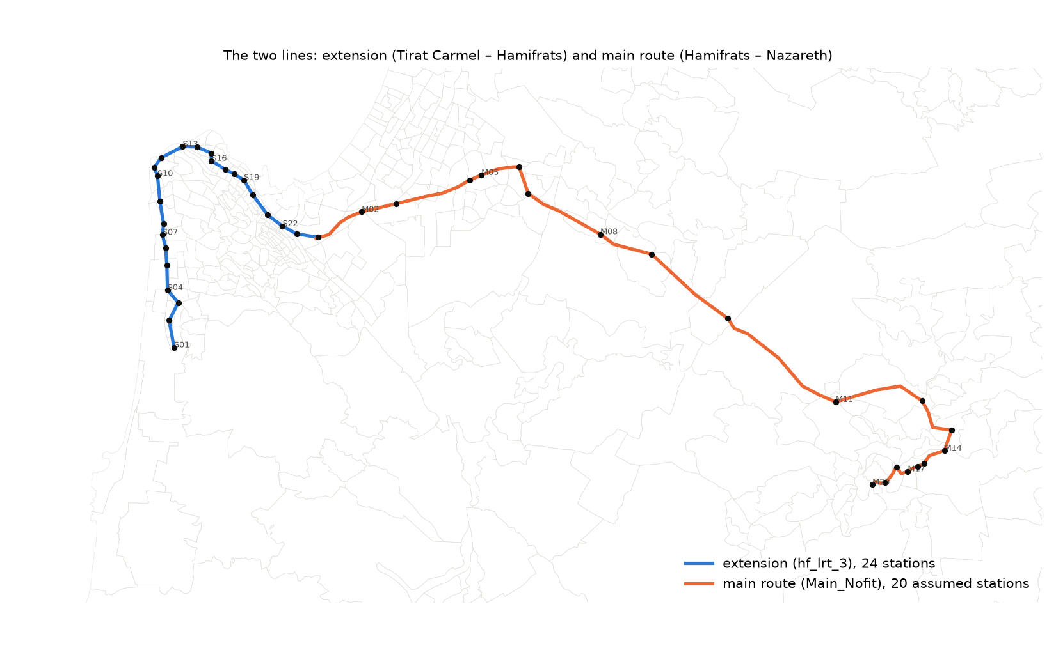
Figure 2.1 — The main route (M01–M20, in construction) and the extension (S01–S24) with the corridor areas.

2.2 The data and their dates
Input | Date / version | Use
Household travel survey (THS) 2017/18 | 2017–2018 | Base matrices by mode, trip rates, estimate of λ
Cellular OD trips, average weekday, by hour | 2018–2019 | Check of the survey matrices
RavKav — linked bus journeys | May 2022 | Bus calibration and the destination pattern
RavKav 2025 — boardings: Metronit, rail, national buses | 51–52 Tuesdays in 2025, 06:00–09:00 | Boardings by stop and TAZ, Metronit and rail matrices
On-board survey — destination probabilities by TAZ | 2022 | Destination pattern below the super-zone level
Population and employment 2020, 2025; forecasts BU / HS 2040, 2050 | 2020 base; version of the metropolitan forecast | Move to 2022 and growth to 2040 / 2050
Road network (Emme) with traffic counts by hour | counts 2017–2023 | Check of the car layer against counts
National GTFS of the Ministry of Transport | file of 22 May 2026; service of 2 June 2026 | Level of service of bus, Metronit and train; time on route
Bus speeds on the street network | May 2026, by day and hour | Observed bus run times; the network for the routes
Car speeds, all the country (GoogleSpeed) | May 2026, by hour | Car time matrices
Alignment and platforms of the extension (hf_lrt_3) | supplied 22 September 2026 | 24 stations, times between stations
Main Nofit route (in construction) and its 20 station nodes | supplied 5 October 2026 | Stations of the main route and run time at 80 km/h
Corridor aggregation V2 — 25 areas, 174 TAZs | supplied 22 September 2026 | Geography of the report
Calibration of LRT run times (Red Line, operator 22) | operation data 2024–2025 | Stop-to-stop time function, with priority / at street level
Research on the weights of out-of-vehicle time | done 4 October 2026 | Walk / wait weights, transfer penalties, LRT premium

2.3 The approach
- Trips of persons, not vehicles. Each matrix contains the trips of the residents of the study area with the two ends inside the area, in the three peak hours.
- Two geographies. The 781 TAZs for the routes, the access and the pivot; the 25 corridor areas for the report and for the profiles along the line. The corridor market is the 174 TAZs of the V2 aggregation. We count the demand on pairs of TAZs in different areas.
- Level of service from measured data. The car times and the bus times come from the speeds measured in May 2026 (07:00 for the AM, 17:00 for the PM). They are not a simulation of congestion. The service is the real timetable. The wait is half the headway (maximum 10 minutes). The access is a walk at 4 km/h × 1.3, up to 1 km, and transfers are possible up to 300 m.
- The level of service stays at May 2026 in each scenario year. The runs for 2040 / 2050 use the car times and the bus times of today, while the demand on the corridor increases by 30–60 %. The future network of the regional model is not available. A network of today with the demand of tomorrow, without the planned projects, is the worse assumption. Section 4.9 shows the effect of slower buses.
- Pivot, not a new estimate. The shares that we observed in 2022 for each pair are the anchor. The LRT changes them in two ways: the probability to select the LRT inside public transport, and the decrease of the total cost. The absolute cost of the car cancels in the pivot (caveat 25).
- The forecasts are "demographic references". They move the pattern of 2022 with the persons and the jobs. They have no change of service, car ownership, fares or work from home. The PM matrices for 2040 / 2050 are the PM base of 2022 increased with the AM growth (caveat 28).
- The LRT is a new path inside public transport. For each pair of TAZs, the path has five parts:
- The station with the lowest access cost at each end.
- The run time of the LRT between these stations.
- A wait of 2.5 minutes (headway 5 minutes).
- An access time of 0.5 minute at each station.
- A feeder leg where the stations are too far to walk: penalty 8 minutes by bus, or 4 minutes by Metronit.
- The LRT premium: 5 minutes against a bus path, 2.5 minutes against a Metronit path.

2.4 The "generalized cost" in simple words
The generalized cost is the "felt" length of a trip, in minutes. A wait at a stop, a walk to the stop and a change of vehicle are less comfortable than a seat in a vehicle. Thus these minutes count more than one time. The result is one number for each trip. This number puts a bus trip, a Metronit trip, an LRT trip and a car trip on the same scale:
Generalized cost = in-vehicle time + 2 × walk time + 2 × wait time + 8 minutes for each transfer (4 minutes between the Metronit and the LRT) − LRT premium (5 minutes against a bus, 2.5 minutes against the Metronit)
The wait is half the headway, with a maximum of 10 minutes. The walk is at 4 km/h on the straight line × 1.3 for the detour of the streets. The transfer penalty is a fixed charge for the uncertainty and the effort of a change of vehicle. It is added to the real time. The first boarding is not a transfer.
The LRT premium shows the preference for a rail vehicle against a bus. The calibrated models in Israel found this preference. The car cost is the drive time at the measured speeds plus 3 minutes for the parking and the walk at the ends. Money is not in the calculation for all modes. The fare is flat and integrated, and there are no data on parking costs for the area.
Component (example: Kiryat Haim → Bat Galim) | By bus | By LRT
Walk to the stop / station | 6 min × 2 = 12 | 9 min × 2 = 18
Wait: headway 10 min → 5 / headway 5 min → 2.5 | 5 × 2 = 10 | 2.5 × 2 = 5
In-vehicle time | 28 | 20
Transfers | 0 | 0
Walk at the end | 4 min × 2 = 8 | 5 min × 2 = 10
LRT premium | 0 | −5
Generalized cost | 58 | 48
Table 2.2 — A calculated example. The LRT trip is cheaper by ten felt minutes, although its walk is longer. The LRT is faster and operates more frequently.
The model does not use the cost alone. It uses the difference between two options and a sensitivity coefficient λ. This coefficient changes felt minutes into a probability. Inside public transport (λ_T = 0.06 for each minute), an advantage of ten minutes gives the LRT approximately 65 % of the passengers of the pair. Twenty minutes give approximately 77 %. An equal cost gives 50 %.
The shift from the car uses the decrease in the cost of all public transport with λ = 0.03, half the sensitivity. It starts from the public transport share that we observed in 2022 for the pair. Where the car has most of the trips, this share is small and the shift is small.

2.5 The sensitivity coefficient λ: what it is, why it is necessary, how we estimated it
What it is. λ is the number that changes a difference in felt minutes into a difference in choices. In the logit model, the public transport cost changes by ΔGC minutes. Then the odds of public transport against the car change by the factor exp(−λ × ΔGC).
With λ = 0.03, one minute moves the odds by 3 %, and ten minutes by approximately 35 %. A large λ means that travellers react strongly to small differences of cost. A small λ means that habit, availability and items outside the cost have the control.
Why it is necessary. All the capture depends on it. The advantage of the LRT against the bus on a pair is a difference in felt minutes. λ_T decides how many public transport passengers of the pair move. λ decides how many car trips move. The λ range alone is −25 % to +40 % of the 2022 capture, more than the regime and the premium.
Why we could not read it from the matrices. The simple estimate is a logit of the public transport share of each pair of areas on the cost difference bus minus car. The sample is 597 pairs and 70,000 trips. It gives λ with the wrong sign and without a fit.
The cause is the composition of the population. The pairs with a cheap public transport are the pairs where the residents have few cars. Thus the share depends on who lives there, not on the minutes. A fit at the pair level cannot separate the two effects.
How we estimated it (step 33). We used the persons in the survey: the AM trips inside the 25 corridor areas (2,310 trips, 543 households). The model is a logit of car against public transport with the cost difference as the explanatory variable. The survey weights apply, and the standard errors are clustered by household.
The car availability, the purpose, the age, the gender, the sector, the student status and the distance stay constant. The car availability has four classes: no car in the household, no licence, more licences than cars, car available. The constant car availability makes λ identifiable. In a group of persons with the same access to a car, the persons with a lower public transport cost select public transport more often.
Model (step 33) | λ for each felt minute | 95 % interval, low | High | Trips
M1: cost difference + car availability, purpose, person, distance (central) | 0.035 | 0.002 | 0.068 | 2,310
M1b: as M1, with the cheaper of bus and Metronit | 0.041 | 0.010 | 0.071 | 2,310
M3: M1 + fixed effects for the origin and destination areas | 0.053 | 0.012 | 0.093 | 2,310
M4: only licence holders in households with a car (the segment that the LRT must get from the car) | 0.008 | -0.025 | 0.041 | 1,443
M1u: M1 without weights | 0.042 | 0.018 | 0.066 | 2,310
M1 on the car matrix of May 2026 (step 37) | 0.040 | 0.008 | 0.073 | 2,310
The assumption in the chain (step 31): λ, range 0.02–0.05; λ_T = 2λ = 0.06 | 0.030 | 0.020 | 0.050
Table 2.3 — The λ estimates (Output/mode_choice/lambda_summary.csv).
The result. The pooled λ is 0.035 (0.002–0.068), with the correct sign, and 0.040 on the car matrix of 2026. By car availability segment:
- Persons in households without a car: 0.083 (significant).
- Persons without a licence: 0.027 (weak).
- Persons with a car available: 0.053 (weak).
- More licences than cars in the household: −0.006.
- Licence holders in households with a car: 0.008 ± 0.017, not different from zero.
The last segment is the segment that the LRT must get from the car. The survey does not have sufficient persons of this type who select public transport on comparable pairs.
What the chain does with it. The chain keeps the assumption λ = 0.03 of step 31. This value is inside the interval of the pooled estimate, on its cautious side. The chain carries the range 0.02–0.05 in each capture run.
It sets λ_T = 2λ inside public transport. The choice between two public transport paths is more sensitive to cost than the choice between car and public transport. The ratio 0.5 is a usual value for nested models; it is an assumption, not an estimate.
The honest interpretation: the data support λ_T on the public transport side, and λ on the car side is a judgement with a range. Thus the shifts from the bus and from the Metronit are the more solid part of each result. The shift from the car is an order of magnitude.

3. The calibration and the base scenario

3.1 The base of 2022
The matrices of the base year come from the travel survey of 2017/18 (16,401 persons, 5,108 households, two survey days). The weights are the corrected household weights. The AM peak is the departure time 06:00–08:59. We calibrated the bus layer to the RavKav journeys of May 2022 with a segmented coverage rule. Where the ticket data cover a pair of super-zones well, they set the quantity. In the other pairs, the survey sets the quantity.
The destination pattern of the on-board survey puts the trips below the super-zone level. The rail layer is the rail trips of the survey, increased with the national series. All layers move from 2018 to 2022 with the population and the employment of the TAZ.
2022, AM 06:00–09:00 | Car | Bus (+ Metronit) | Taxi | Rail
corridor → corridor | 72,331 | 10,255 | 313 | 0
corridor → outside | 47,011 | 8,947 | 573 | 292
outside → corridor | 89,181 | 19,144 | 1,020 | 2,618
outside → outside | 1,145,275 | 79,615 | 7,545 | 1,141
all the study area | 1,353,798 | 117,961 | 9,451 | 4,050
Table 3.1 — The 2022 base by corridor class. On the V2 corridor (25 areas, 174 TAZs), the market between different areas is 56,445 car / 14,133 public transport / 720 taxi trips. The public transport share is 0.20.
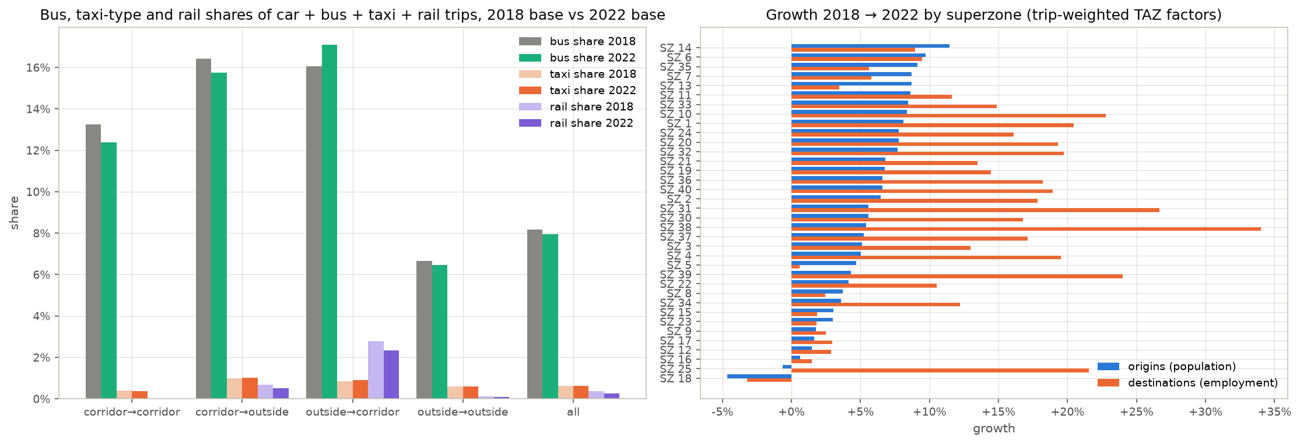
Figure 3.1 — The 2022 layers: car, bus, taxi and rail by super-zone (step 16).

3.2 Tests against independent data
- Bus against the RavKav tickets on the corridor (step 28). On the Haifa trunk, the calibrated survey profile is within 1–4 % of the ticket profile in the direction Nazareth. In the other direction, it is within −14 % / +12 %. After Hamifrats, the two frames differ by up to 1.5 × in one direction (Figure 3.2).
- Bus coverage by time of day (a wave-1b diagnostic under section 5.2 of the guideline). RavKav journeys of May 2022 / raw survey bus trips of 2017/18 = 0.74 in the AM, 0.96 in the PM, 0.92 at midday. The guideline's own test T14 (the 2022 bus layer against the RavKav origins by super-zone) gives 1.28. Trips to education are 40 % of the survey bus trips in the AM, against 13–19 % in the other windows. Without them, the ratio is 1.22 / 1.10 / 1.13. The card data may under-record these trips; the data provider must confirm this.
- Car against the traffic counts on closed cordons (step 36, Figure 3.3). Survey vehicles ÷ counted vehicles = 0.58–0.90 on the outer cordons and 0.61–0.62 in the metropolitan core. This is the expected order for a layer of personal trips of residents against all traffic. Through, commercial and non-resident traffic are not in the survey. The departure profile of the survey has a sharper peak than the road. The peak hour has 62 % of the three hours in the survey, against 38–43 % in the counts (caveat 18).
- Car assignment against the counts on links (step 42). The all-or-nothing assignment on the Emme network gives the correct total: 0.93 on 1,346 links. It does not give the correct pattern: R² 0.47 and RMSE 113 %, against 0.85 and 35 % in the guideline. A layer of person trips without commercial traffic and without route choice does not pass a test at the link level (caveat 23).
- Survey against the cellular trips (step 1b): the super-zone matrices agree in structure. The only systematic difference is the trips inside a zone, which are higher in the survey in each super-zone.
- Validation guideline of the Ministry of Transport (draft 2024, tests T1–T19, 226 items). 75 items pass, 123 fail with a documented explanation, and 10 are findings. The other items are not applicable or not run. The failures are in the tests for a four-step assignment model: link volumes, trip lengths at the TAZ level, trips inside a zone. The trip rates, the mode split and the car profile against the counts pass.
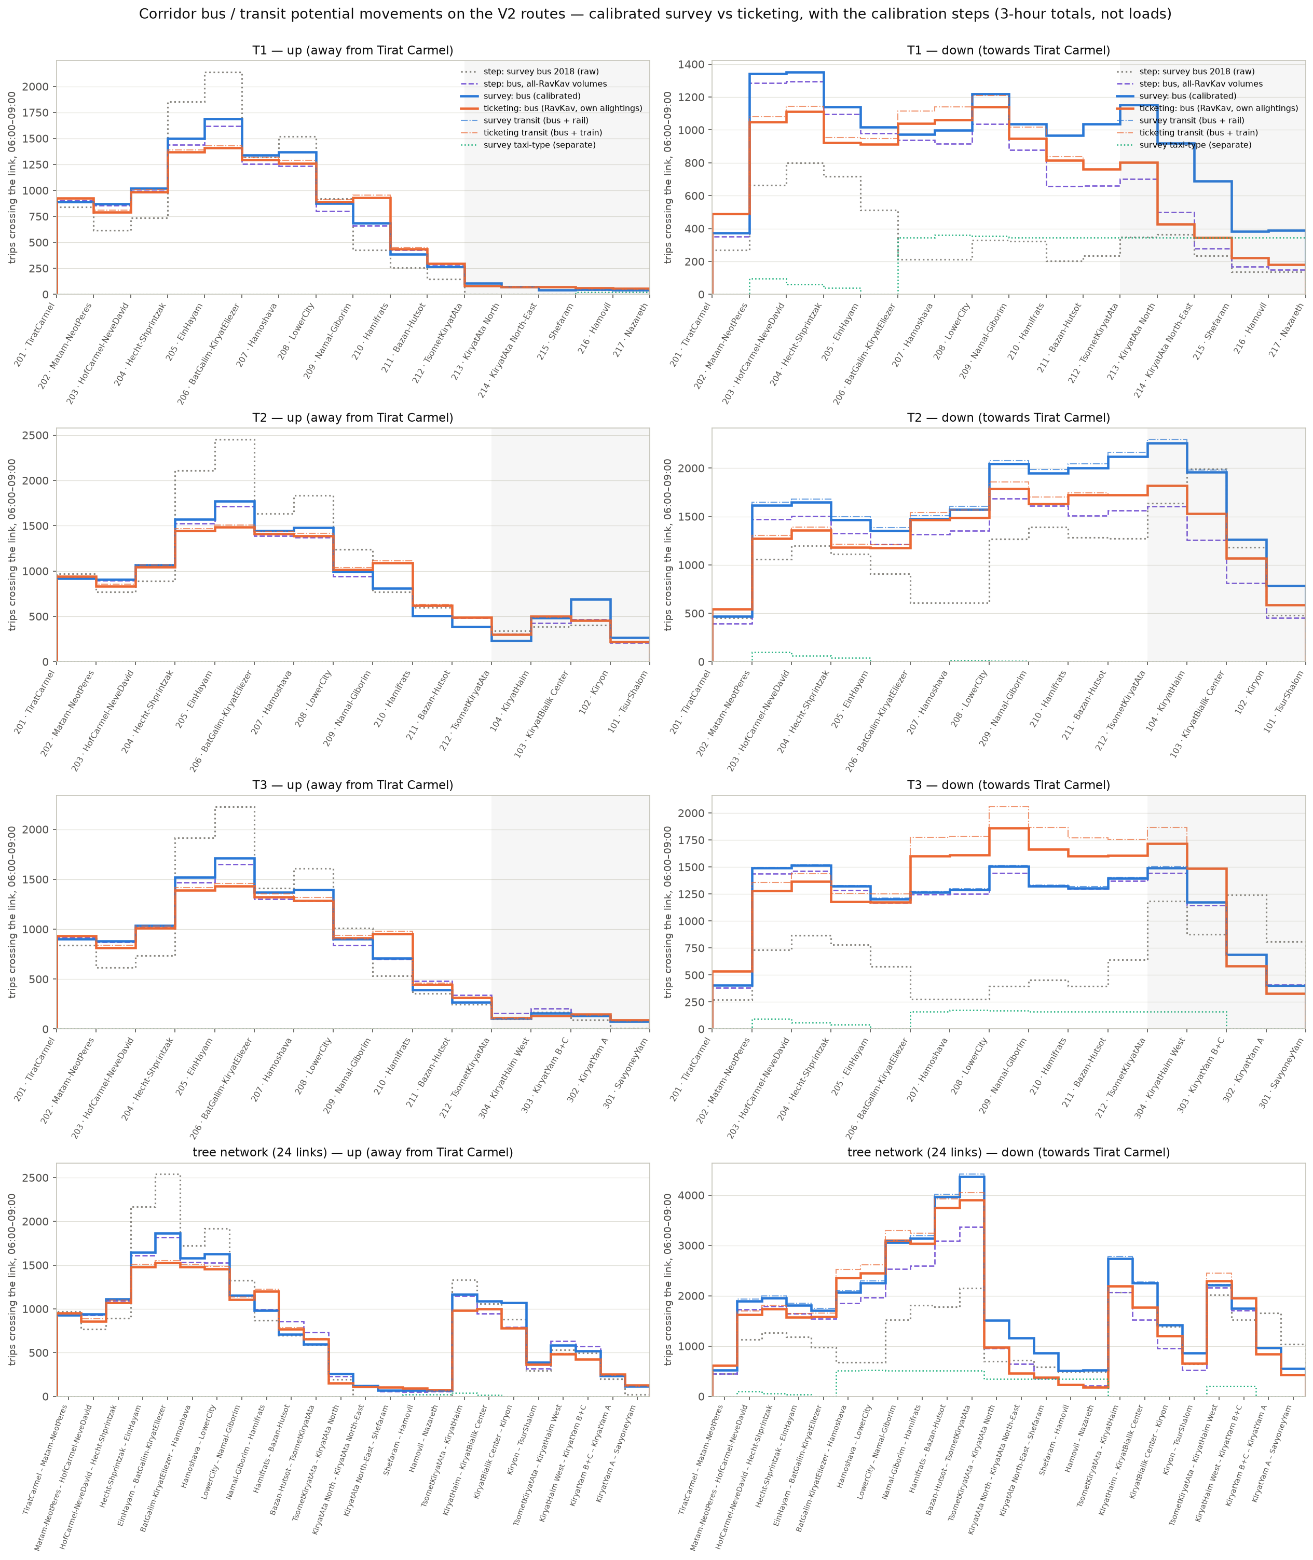
Figure 3.2 — Public transport profile on the corridor: the calibrated survey against the RavKav tickets, by route and direction (step 28).
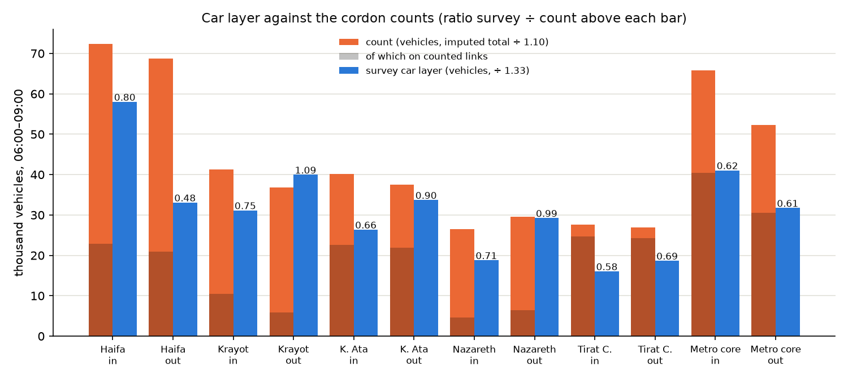
Figure 3.3 — The car layer against the traffic counts on closed cordons (step 36).

3.3 The level of service and the cost sensitivity
We made the level of service of public transport from the timetable with the run times measured in May 2026. Observed ÷ scheduled is 1.09 for a bus trip (Metronit 0.87), 1.00 on hops shorter than 500 m and 1.42 on hops longer than 2 km. On the trunk pairs, the car times on the network of May 2026 are 0.90 × the door-to-door times in the survey. On all pairs, they are 0.95 ×. Thus there is no increase of the car time for 2026 (step 37).
The car speeds of May 2026 almost do not change by hour (caveat 24). Thus the "07:00" matrix is in effect an all-day speed of May 2026.
Generalized cost on the trunk pairs (weighted by trips, AM, felt minutes): car 13.8; bus / Metronit 44.8 at the TAZ level. The area matrix of step 31 gave 27–30. It pooled the headways of all direct lines and the walk to the nearest stop (caveat 26). The LRT on the through line is 48.7 with priority / 57.2 without, with the 5-minute premium. The in-vehicle time of the LRT on the trunk is lower than that of the bus. The disadvantage that remains for the LRT is the access to the station and the transfer where a feeder is necessary.
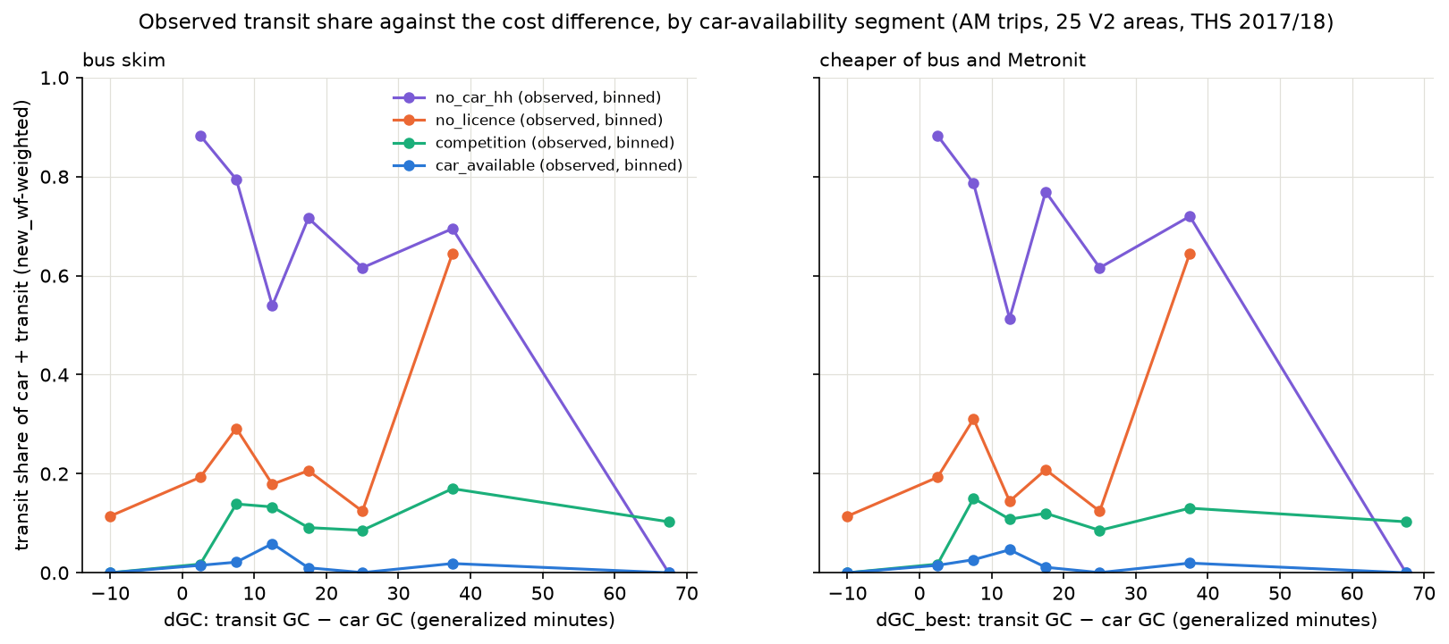
Figure 3.6 — λ by car availability segment, estimate at the person level (step 33).

3.4 The base scenario with the LRT (2022)
We add the main route + extension to the service of 2022. Then the LRT demand in the three AM hours on the corridor market is 5,193 trips with priority (4,209 without). 4,004 of these trips use the extension. 295 come from the car and 4,898 from the bus and the Metronit. The public transport share of the corridor market increases from 20.0 % to 20.8 %.
PM: 4,101 (79 % of the AM). In the peak hour: 3,059 AM and 1,961 PM.
The uncertainty experiment (step 40) and the ranges of step 31 put the 2022 capture between 0.75 × and 1.4 × the central value. The effects are: λ 0.02 → +40 %, λ 0.05 → −25 %; premium 0 → −20 %, premium 10 → +25 %. The regime (run time) is worth approximately 20 % (without priority against with priority), the same order as the λ range.
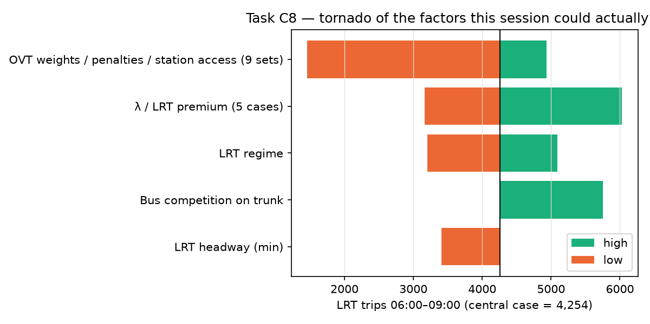
Figure 3.7 — Sensitivity of the 2022 capture to the assumed factors (step 40).
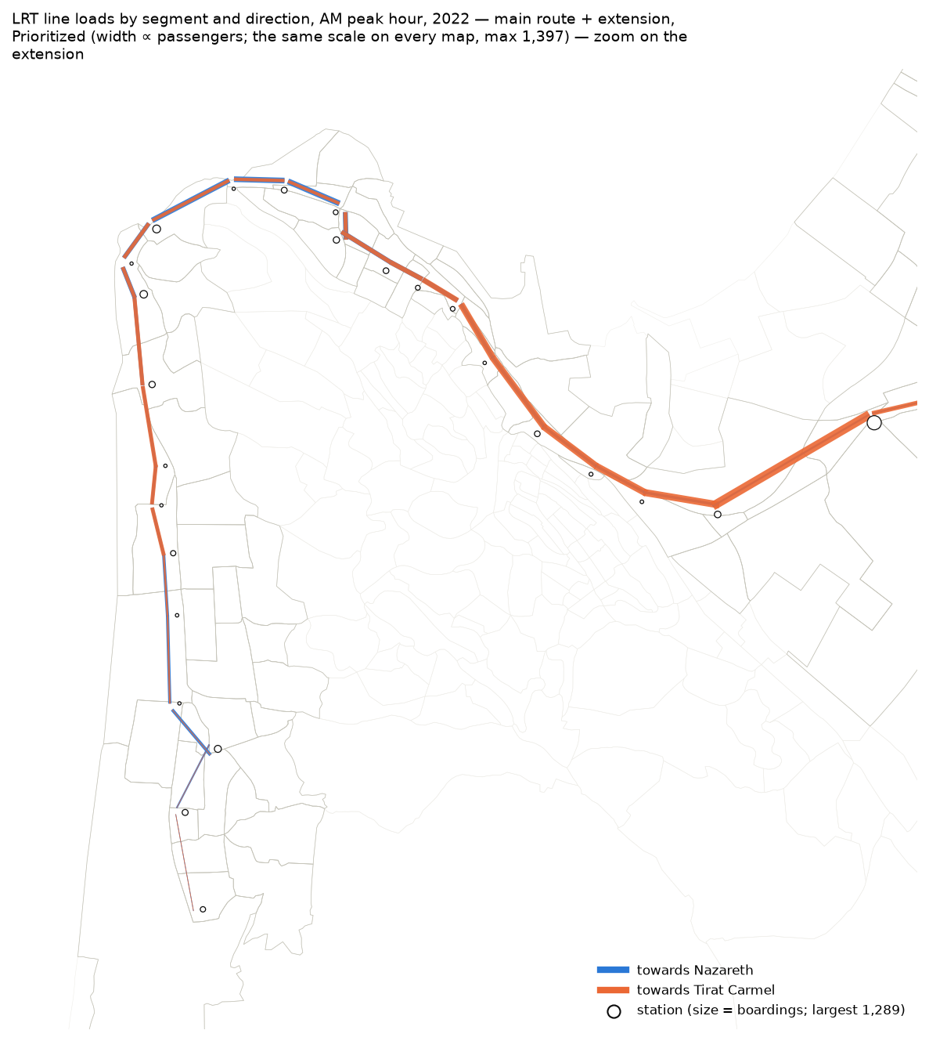
Figure 3.8z — The line loads of 2022, zoom on the extension (Tirat Carmel – Hamifrats).
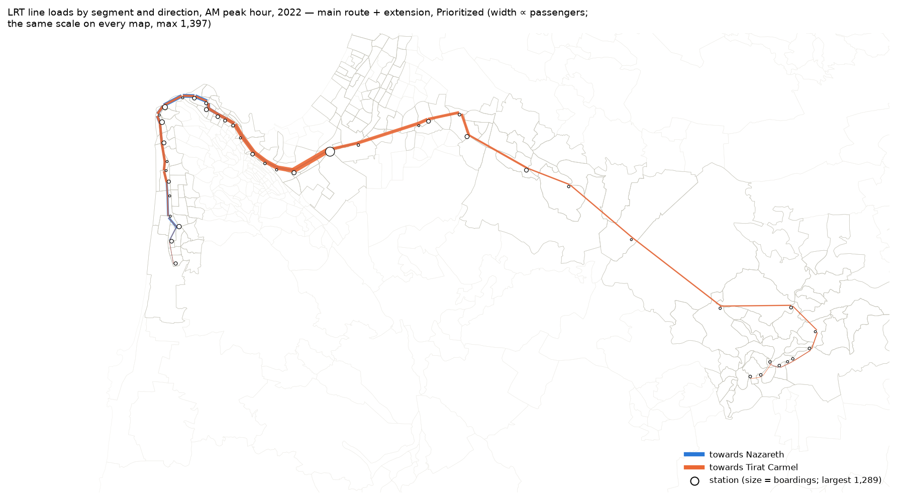
Figure 3.8 — Line loads and station boardings in the peak hour, AM 2022, main route + extension, Prioritized.

3.5 What the model is good for, and what it must not be used for
Good for:
- The size and the location of the corridor market by mode (which areas, which stations), in the three peak hours and in the design hour.
- The rank of alternatives and regimes: through line against extension only, with priority against without priority. The order of magnitude of the shift from the bus, the Metronit and the car.
- The growth of the market in the demographic scenarios, with a constant behaviour.
- Relative statements about the line profile: where the load is maximum, how the directions differ, which part of the line demand uses the extension.
Not for:
- Passenger loads for decisions on capacity, fleet or frequency, or for an economic appraisal. The quantities are not validated at the link level by an external source. The loads are potential movements in three hours between the stations with the lowest access cost, without a capacity limit or crowding.
- A statement that depends on the absolute car time or on the congestion in 2040 / 2050. The pivot cancels the car cost (caveat 25). The matrices use the speeds of May 2026 in each year. The forecast has no change of roads, service or car ownership. The sensitivity with slower buses (4.9) gives a limit for the public transport side (+2–5 %). The car side has no limit in this model.
- The exact split between "from the car" and "from public transport". The trips from the car depend on the aggregation level of the pivot (caveat 27). λ for car owners is not identified (caveat 15). Between the AM forecast scenarios, the car column is not comparable (caveat 29).
- Detail for one TAZ. Below the area level, the matrices are an allocation of the survey trips with weights, not observations.
- The operation of the main route. Its stations, the run at 80 km/h at street level and the headway of 5 minutes are assumptions (caveat 28). The continuation at Hamifrats without a transfer is also an assumption.
The full list of caveats is in chapter 8 of METHODOLOGY.md and in section 3.5 of the English report. Chapter 8 has 34 numbered items: 29 apply to the current chain and 5 are retired. The authors rewrote chapter 8 on 20 October 2026 for the survey-only chain. The caveat numbers did not change.

4. The results: the scenarios of 2040 and 2050
2050 BU is the main reference scenario: the plan year 2050 with the usual demographics. The year 2040 and the high scenario are growth sensitivities. The high scenario also changes the composition of the market (section 4.3). Thus the plan uses the reference scenario, and the high scenario is the upper value of the growth.
All results in this chapter are for the through line (Tirat Carmel – Hamifrats – Nazareth) in the "Prioritized" regime of the extension. The market is the corridor market (pairs of the 174 TAZs in different areas), in periods of three hours. The tables give the totals for three hours with the peak hour values beside them. All charts and maps show the peak hour.
The peak hour factors are the share of the three hours in the busiest 60 minutes of the survey departures. The method is that of step 27, on the two windows. The line loads use the network bus factor of the direction (AM 0.55 direction Nazareth / 0.46 direction Tirat Carmel; PM 0.54 / 0.47). The totals use the factor of the study area (public transport AM 0.59 / PM 0.48). The factors observed in RavKav and in the counts are lower (0.38–0.48). Thus the peak hour values here are the upper value.

4.1 Through line to Nazareth against a terminal of the extension at Hamifrats
We ran the two alternatives on the same matrices and the same base. The first alternative is the extension alone: 24 stations, terminal at Hamifrats. The second alternative is the through line: the extension plus the 20 stations of the main route, one line without a transfer at Hamifrats. "Extension passengers" are all the passengers of the extension-only line. On the through line, they are the passengers that use at least one segment between S01 and S24. The loads are for one direction in the AM peak hour.
Alternative | Extension passengers (3 h) | All LRT passengers (3 h) | All LRT passengers (peak hour) | Maximum load on the extension (peak hour, one direction) | Maximum load on the line (peak hour) | From the car (3 h) | Difference
Extension only (terminal at Hamifrats) | 5,939 | 5,939 | 3,498 | 1,011 | 1,011 | 682 | –
Through line (main route + extension) | 6,003 | 7,433 | 4,378 | 1,028 | 1,071 | 818 | extension passengers +1 %; all LRT +25 %
Table 4.1 — AM, 2050 BU: extension only against the through line, Prioritized.
Alternative | Extension passengers (3 h) | All LRT passengers (3 h) | All LRT passengers (peak hour) | Maximum load on the extension (peak hour, one direction) | Maximum load on the line (peak hour) | From the car (3 h) | Difference
Extension only (terminal at Hamifrats) | 4,960 | 4,960 | 2,372 | 775 | 775 | 308 | –
Through line (main route + extension) | 4,998 | 6,135 | 2,934 | 787 | 787 | 368 | extension passengers +1 %; all LRT +24 %
Table 4.2 — PM, 2050 BU: extension only against the through line, Prioritized.
Scenario | Extension only: passengers | Through line: passengers who use the extension | Gain on the extension | Through line: all passengers | Gain on the line | Extension only: maximum load | Through line: maximum load on the extension | Through line: maximum load on the line
2022 | 3,884 | 4,004 | +3 % | 5,193 | +34 % | 600 | 670 | 840
2040 BU | 4,879 | 4,950 | +1 % | 6,309 | +29 % | 750 | 767 | 966
2050 BU | 5,939 | 6,003 | +1 % | 7,433 | +25 % | 1,011 | 1,028 | 1,071
2040 HS | 5,424 | 5,651 | +4 % | 7,476 | +38 % | 839 | 935 | 1,146
2050 HS | 6,653 | 7,010 | +5 % | 9,225 | +39 % | 1,031 | 1,161 | 1,397
Table 4.2a — The same comparison for each scenario year: AM three hours and AM peak hour loads.
What this means. The through line does not add passengers to the extension in this model: 6,003 against 5,939 (+1 %) in 2050 BU. The 2,849 trips that cross Hamifrats on the through line (38 % of its passengers) also exist with a terminal at Hamifrats. In that case, they go to the Hamifrats station of the extension with a Metronit or bus feeder. There they get on the LRT at S24. The through line replaces the feeder leg with an LRT leg for the same trips.
The +25 % on the full line is the market of the main route (trips between its stations and Hamifrats, 1,429 trips). A main route with a terminal at Hamifrats also carries this market. It is not a benefit of the through line.
What the through line gives, in the terms of the model, is the transfer that it removes for the trips that cross Hamifrats. We did not run a main route with a terminal at Hamifrats beside an extension with a terminal there. That case puts the transfer penalty of 8 minutes (plus a second wait) on each trip that crosses. With λ_T = 0.06, this is approximately a third of the odds of the LRT path on these pairs against the Metronit. Today the Metronit operates through Hamifrats without a transfer.
Thus the reference numbers depend on caveat 28: no transfer at Hamifrats, a headway of 5 minutes, 80 km/h on the main route. The passengers of the extension do not depend on it.

4.2 The shift to the LRT and the demand by mode

Table 4.3 — AM 06:00–09:00: the shift to the LRT and the demand by mode after the LRT, main route + extension, Prioritized (trips in three hours).
Scenario | Car before | Bus before | Metronit before | Public transport before | Car → public transport | Car → LRT | Metronit → LRT | Bus → LRT | Car → public transport (% of car) | Metronit → LRT (% of Metronit) | Bus → LRT (% of bus)
2022 | 56,445 | 6,103 | 8,031 | 14,133 | 563 | 295 | 2,768 | 2,128 | 1.00 % | 34.5 % | 34.9 %
2040 BU | 74,670 | 8,321 | 10,000 | 18,321 | 684 | 353 | 3,308 | 2,648 | 0.92 % | 33.1 % | 31.8 %
2050 BU | 86,417 | 9,370 | 11,282 | 20,652 | 1,421 | 818 | 3,731 | 2,881 | 1.64 % | 33.1 % | 30.7 %
2040 HS | 78,027 | 8,292 | 10,496 | 18,787 | 1,387 | 870 | 3,753 | 2,850 | 1.78 % | 35.8 % | 34.4 %
2050 HS | 89,560 | 9,130 | 12,102 | 21,232 | 2,035 | 1,311 | 4,548 | 3,365 | 2.27 % | 37.6 % | 36.9 %
Demand after the LRT and the share of each mode (of car + public transport on the corridor market):
Scenario | Car after | Metronit after | LRT | LRT in the peak hour | Bus after | Public transport after | Car share | Metronit share | LRT share | Bus share | Public transport share | LRT share of public transport | LRT, slower buses (sensitivity)
2022 | 55,882 | 5,408 | 5,193 | 3,059 | 4,096 | 14,696 | 79.2 % | 7.7 % | 7.4 % | 5.8 % | 20.8 % | 35.3 %
2040 BU | 73,986 | 6,863 | 6,309 | 3,716 | 5,832 | 19,005 | 79.6 % | 7.4 % | 6.8 % | 6.3 % | 20.4 % | 33.2 % | 6,442
2050 BU | 84,996 | 7,816 | 7,433 | 4,378 | 6,824 | 22,073 | 79.4 % | 7.3 % | 6.9 % | 6.4 % | 20.6 % | 33.7 % | 7,804
2040 HS | 76,640 | 6,992 | 7,476 | 4,403 | 5,707 | 20,175 | 79.2 % | 7.2 % | 7.7 % | 5.9 % | 20.8 % | 37.1 % | 7,624
2050 HS | 87,525 | 7,908 | 9,225 | 5,433 | 6,135 | 23,267 | 79.0 % | 7.1 % | 8.3 % | 5.5 % | 21.0 % | 39.6 % | 9,590
The part of the extension, as a part of the through line:
Scenario | LRT | Use the extension | Use the extension, peak hour | Of these: from the car | From the Metronit | From the bus | Only between extension stations | Extension share of the LRT trips | Busiest segment (3 h, one direction) | Busiest segment (peak hour)
2022 | 5,193 | 4,004 | 2,359 | 223 | 2,334 | 1,447 | 2,413 | 77.1 % | 1,840 | 840
2040 BU | 6,309 | 4,950 | 2,915 | 270 | 2,778 | 1,901 | 3,038 | 78.5 % | 2,114 | 966
2050 BU | 7,433 | 6,003 | 3,536 | 733 | 3,162 | 2,108 | 3,851 | 80.8 % | 2,345 | 1,071
2040 HS | 7,476 | 5,651 | 3,328 | 588 | 3,196 | 1,867 | 3,276 | 75.6 % | 2,509 | 1,146
2050 HS | 9,225 | 7,010 | 4,129 | 899 | 3,913 | 2,199 | 4,068 | 76.0 % | 3,058 | 1,397

Table 4.4 — PM 16:00–19:00: the shift to the LRT and the demand by mode after the LRT, main route + extension, Prioritized (trips in three hours).
Scenario | Car before | Bus before | Metronit before | Public transport before | Car → public transport | Car → LRT | Metronit → LRT | Bus → LRT | Car → public transport (% of car) | Metronit → LRT (% of Metronit) | Bus → LRT (% of bus)
2022 | 66,517 | 4,354 | 7,253 | 11,607 | 552 | 274 | 2,322 | 1,504 | 0.83 % | 32.0 % | 34.5 %
2040 BU | 86,451 | 6,392 | 9,218 | 15,610 | 666 | 327 | 2,819 | 2,209 | 0.77 % | 30.6 % | 34.6 %
2050 BU | 100,598 | 7,332 | 10,487 | 17,818 | 741 | 368 | 3,217 | 2,550 | 0.74 % | 30.7 % | 34.8 %
2040 HS | 88,649 | 6,446 | 9,291 | 15,737 | 804 | 425 | 3,050 | 2,144 | 0.91 % | 32.8 % | 33.3 %
2050 HS | 96,724 | 6,438 | 9,892 | 16,329 | 880 | 466 | 3,278 | 2,212 | 0.91 % | 33.1 % | 34.4 %
Demand after the LRT and the share of each mode (of car + public transport on the corridor market):
Scenario | Car after | Metronit after | LRT | LRT in the peak hour | Bus after | Public transport after | Car share | Metronit share | LRT share | Bus share | Public transport share | LRT share of public transport | LRT, slower buses (sensitivity)
2022 | 65,965 | 5,071 | 4,101 | 1,961 | 2,987 | 12,159 | 84.4 % | 6.5 % | 5.2 % | 3.8 % | 15.6 % | 33.7 %
2040 BU | 85,785 | 6,553 | 5,358 | 2,562 | 4,365 | 16,276 | 84.1 % | 6.4 % | 5.2 % | 4.3 % | 15.9 % | 32.9 % | 5,477
2050 BU | 99,857 | 7,444 | 6,135 | 2,934 | 4,981 | 18,560 | 84.3 % | 6.3 % | 5.2 % | 4.2 % | 15.7 % | 33.1 % | 6,399
2040 HS | 87,845 | 6,418 | 5,620 | 2,687 | 4,503 | 16,541 | 84.2 % | 6.1 % | 5.4 % | 4.3 % | 15.8 % | 34.0 % | 5,723
2050 HS | 95,844 | 6,814 | 5,956 | 2,848 | 4,440 | 17,209 | 84.8 % | 6.0 % | 5.3 % | 3.9 % | 15.2 % | 34.6 % | 6,155
The part of the extension, as a part of the through line:
Scenario | LRT | Use the extension | Use the extension, peak hour | Of these: from the car | From the Metronit | From the bus | Only between extension stations | Extension share of the LRT trips | Busiest segment (3 h, one direction) | Busiest segment (peak hour)
2022 | 4,101 | 3,235 | 1,547 | 233 | 1,848 | 1,154 | 2,229 | 78.9 % | 948 | 507
2040 BU | 5,358 | 4,300 | 2,056 | 279 | 2,254 | 1,767 | 2,922 | 80.3 % | 1,284 | 687
2050 BU | 6,135 | 4,998 | 2,390 | 319 | 2,606 | 2,073 | 3,454 | 81.5 % | 1,684 | 787
2040 HS | 5,620 | 4,595 | 2,197 | 381 | 2,508 | 1,707 | 3,138 | 81.8 % | 1,407 | 753
2050 HS | 5,956 | 4,918 | 2,352 | 421 | 2,733 | 1,764 | 3,409 | 82.6 % | 1,398 | 748

How to read the tables. "Before" is the no-build market of the scenario (car, bus with rail, Metronit) on the pairs of corridor TAZs. "Car → public transport" is the trips that the decrease of the total cost moves out of the car. "Car → LRT" is the part of these trips that the LRT carries. The other trips move to the bus or Metronit path of the pair.
"Metronit → LRT" and "Bus → LRT" are the LRT trips that come from the public transport of today. They come from the pairs with a Metronit path or a bus path. The three LRT columns add up to the LRT total. The taxi trips (approximately 700) do not change and are not in the shares.
Note on the car column. The AM shift from the car doubles between 2040 BU and 2050 BU (684 → 1,421) and between 2040 BU and 2040 HS (684 → 1,387). The market increases by only 16 % and 4 %. This is not a demand effect but an aggregation effect (caveat 29).
The shift in each pair is proportional to S·(1−S) of its public transport share. The forecast matrices put trips into pairs that are empty in 2022. Thus the number of pairs with both car trips and public transport trips increases from 1,620 to 5,688.
The PM matrices increase pair by pair from the PM base. They keep the pairs of 2022 and show a smooth car column. Read the shift from the car as an order of magnitude (300–1,300 trips, 0.4–1.5 % of the car trips on the corridor). Do not compare it between scenarios.
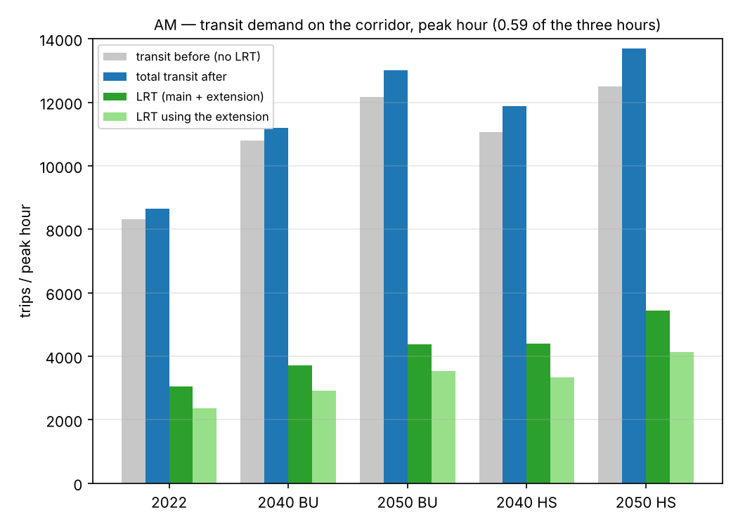
Figure 4.1a — Public transport demand on the corridor by scenario, AM peak hour. The bars: public transport without the LRT, public transport after the LRT, the LRT trips, the LRT trips that use the extension. Same scale as 4.1b.
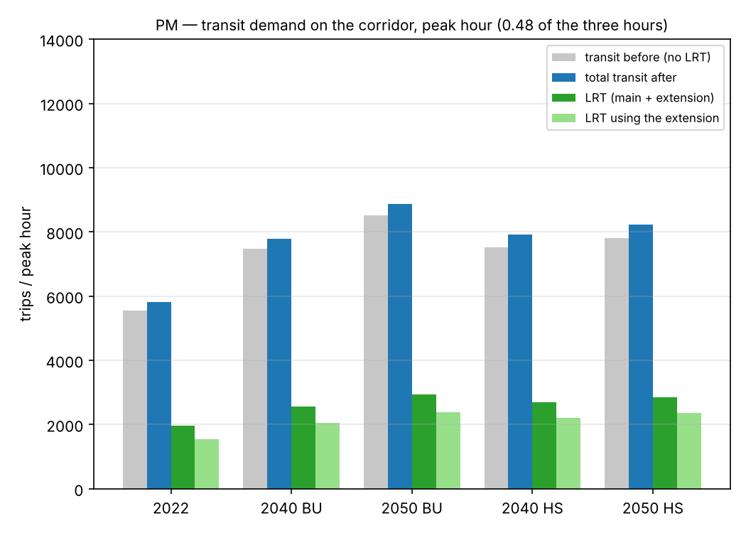
Figure 4.1b — The same for the PM peak hour.
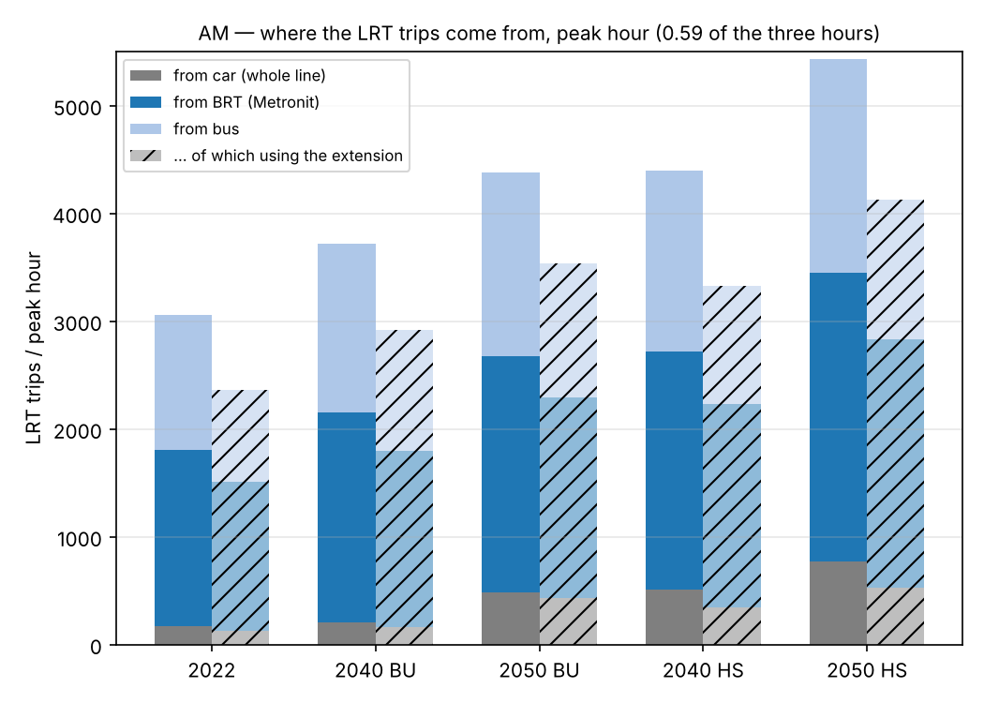
Figure 4.2a — The source of the LRT passengers (car, Metronit, bus) by scenario, AM peak hour: the full line, the part that uses the extension. Same scale as 4.2b.
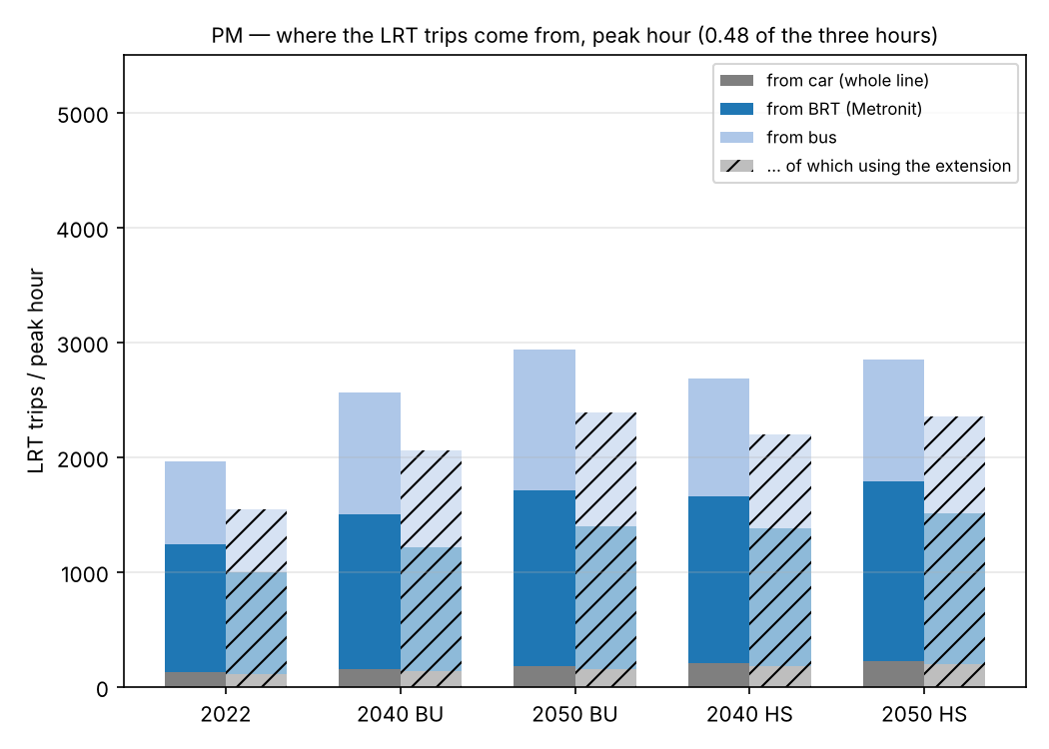
Figure 4.2b — The same for the PM peak hour.

4.3 The source of the demand: the markets
The tables group the LRT trips of the reference scenario by the corridor areas of their two ends (the two directions together). Table 4.7 gives the ten largest pairs of areas. "Haifa" is Matam to Hamifrats (areas 202–210). The Krayot (101–104, 301–304) are not on the line; they reach the line with a bus or Metronit feeder. The main route is Bazan-Hutsot to Nazareth (211–217). "Cross Hamifrats" is the load on segment S24–M02 in the two directions: each trip from one side of the junction to the other side.
Market | LRT trips (3 h) | Share of all LRT trips
Inside Haifa (the two ends between Matam and Hamifrats) | 1,663 | 22 %
Tirat Carmel ↔ Haifa | 2,189 | 29 %
Krayot ↔ Haifa (the Krayot with a feeder) | 1,665 | 22 %
Main route (Kiryat Ata – Nazareth) ↔ Haifa | 891 | 12 %
Main route ↔ Krayot / Tirat Carmel | 522 | 7 %
Inside the main route | 306 | 4 %
Krayot ↔ Tirat Carmel | 193 | 3 %
Cross Hamifrats (use segment S24–M02) | 2,849 | 38 %
Only between extension stations (the two ends at S01–S24) | 3,851 | 52 %
Use the extension (at least one segment) | 6,003 | 81 %
Table 4.5 — The markets of the LRT trips, AM three hours, 2050 BU (total 7,432).
Market | LRT trips (3 h) | Share of all LRT trips
Inside Haifa (the two ends between Matam and Hamifrats) | 3,027 | 33 %
Tirat Carmel ↔ Haifa | 1,041 | 11 %
Krayot ↔ Haifa (the Krayot with a feeder) | 2,030 | 22 %
Main route (Kiryat Ata – Nazareth) ↔ Haifa | 1,533 | 17 %
Main route ↔ Krayot / Tirat Carmel | 846 | 9 %
Inside the main route | 639 | 7 %
Krayot ↔ Tirat Carmel | 105 | 1 %
Cross Hamifrats (use segment S24–M02) | 3,711 | 40 %
Only between extension stations (the two ends at S01–S24) | 4,068 | 44 %
Use the extension (at least one segment) | 7,010 | 76 %
Table 4.6 — The markets of the LRT trips, AM three hours, 2050 HS (total 9,225).
Rank | Pair of areas (the two directions) | LRT trips (3 h) | Share of all LRT trips
1 | TiratCarmel – BatGalim-KiryatEliezer | 820 | 11.0 %
2 | TiratCarmel – Matam-NeotPeres | 481 | 6.5 %
3 | TiratCarmel – LowerCity | 222 | 3.0 %
4 | TiratCarmel – Hecht-Shprintzak | 164 | 2.2 %
5 | Matam-NeotPeres – BatGalim-KiryatEliezer | 153 | 2.1 %
6 | TiratCarmel – Namal-Giborim | 131 | 1.8 %
7 | Hamifrats – Shefaram | 126 | 1.7 %
8 | Hecht-Shprintzak – BatGalim-KiryatEliezer | 113 | 1.5 %
9 | TiratCarmel – Hamifrats | 108 | 1.5 %
10 | TiratCarmel – HofCarmel-NeveDavid | 108 | 1.5 %
Table 4.7 — The ten largest pairs of areas of the LRT trips, AM three hours, 2050 BU. The area names are the English names of the aggregation file.
What this means. In 2050 BU, the market has three parts of almost the same size. They are Tirat Carmel ↔ Haifa (29 %), inside Haifa (22 %) and the Krayot with a feeder to Haifa (22 %). The areas of the main route add 12 % with Haifa, and some percent between them. 38 % of the trips cross Hamifrats, and 52 % stay between extension stations. Tirat Carmel – Bat Galim is the largest pair.
The scenario 2050 HS reads differently: inside Haifa a third, Tirat Carmel a tenth. The high scenario moves population and jobs to the Haifa areas, and it puts trips into pairs that are empty today (caveat 29). Thus the composition, not only the total, depends on the scenario. This is one more reason to plan with the BU reference scenario.

4.4 What occurs to the Metronit
The model keeps each bus line and each Metronit line as it operates today (timetable of June 2026) in each scenario year. It adds the LRT as a new path. No line is removed.
In 2050 BU, 3,731 trips move from the Metronit (33 % of the Metronit trips on the corridor). These are passengers on pairs where the best public transport path today is the Metronit, and where the LRT path has a lower generalized cost. The cause is a faster run on the trunk, a station nearer to the ends, or both. They select the LRT, while the Metronit continues to operate beside it. The other 7,816 Metronit trips stay, because their path is still the cheaper one.
Four conclusions for the numbers:
- The LRT and the Metronit operate together in the model on all the trunk from Hof HaCarmel to the Krayot. Most LRT passengers are the public transport passengers of today in a better vehicle. The public transport market increases only by the shift from the car: some hundreds to approximately one thousand trips in three hours. The LRT replaces current public transport capacity on the trunk much more than it makes a new market.
- A part of the shift "from the Metronit" and "from the bus" is only a change of vehicle on one leg of the trip. It is not a new public transport trip. The LRT path can start or end with a Metronit or bus feeder (penalty 4 / 8 minutes). Such a trip counts as an LRT trip. The Krayot market (1,665 trips) is almost all of this type: Metronit passengers who transfer to the LRT at Hamifrats or on the trunk. Thus a passenger count for the LRT is a count of boardings, not a count of trips that exist only because of the LRT.
- The Metronit service can decrease on the common section after the line opens. Then the passengers that the Metronit keeps in the model (the pairs where it is cheaper) must move to the LRT or to the bus. The LRT loads on the trunk increase, up to a maximum: the Metronit trips on the corridor before the LRT (11,282 in 2050 BU, AM). The opposite case, a new feeder structure that brings the Metronit lines to the LRT stations, improves the access quality and the attraction. We did not model these two cases. The numbers of the report are for the case where the two operate together, the conservative case for the LRT.
- The decision that the LRT and the Metronit operate together on the trunk is a decision of the network plan, outside this study. It changes the LRT loads by up to the Metronit volume on the trunk. This is more than each demand uncertainty in this report. Make this decision before you use the numbers for capacity.

4.5 The flow along the line: LRT, the two directions
Passengers on each segment of the line in the peak hour, by direction: direction Nazareth (S01 → S24 → M20) and direction Tirat Carmel (M20 → M01 → S01). The dashed line shows the junction of the extension (S24) with the main route (M01, the same station at Hamifrats).

All charts in this section use the same vertical scale (1,400 passengers in the peak hour). Thus you can compare the scenarios by eye. There is one chart for each scenario and period with the two directions. Then there is one chart for each direction with the four forecast scenarios side by side.
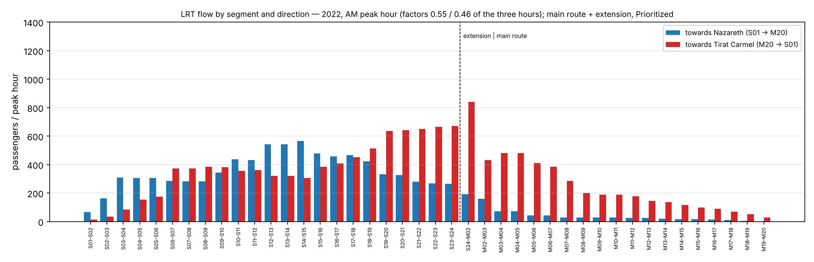
Figure 4.3 — LRT flow by segment and direction, 2022, AM peak hour.
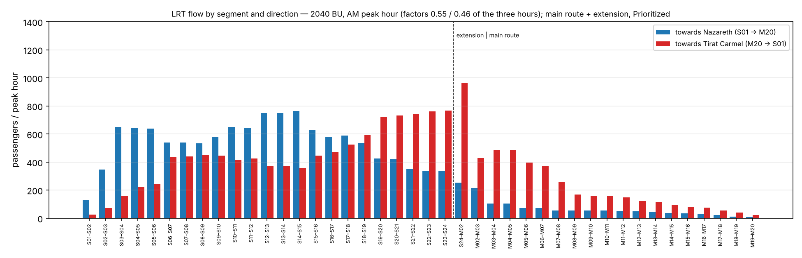
Figure 4.4 — LRT flow by segment and direction, 2040 BU, AM peak hour.
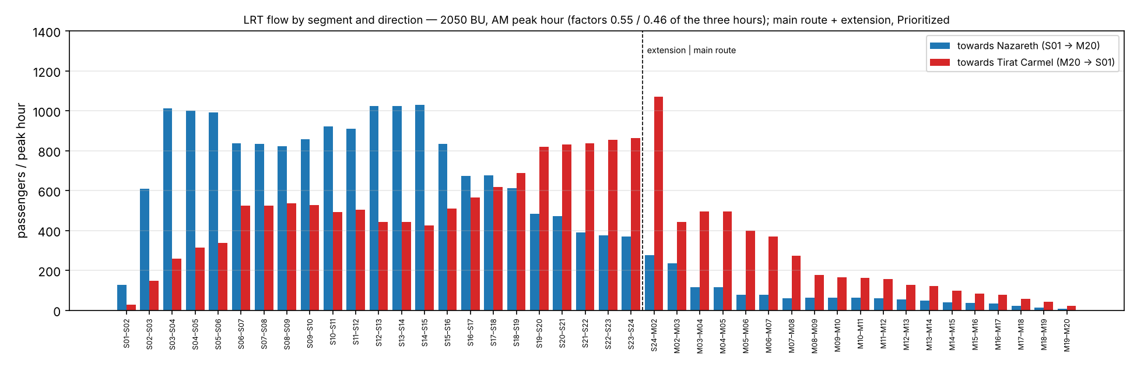
Figure 4.5 — LRT flow by segment and direction, 2050 BU, AM peak hour.
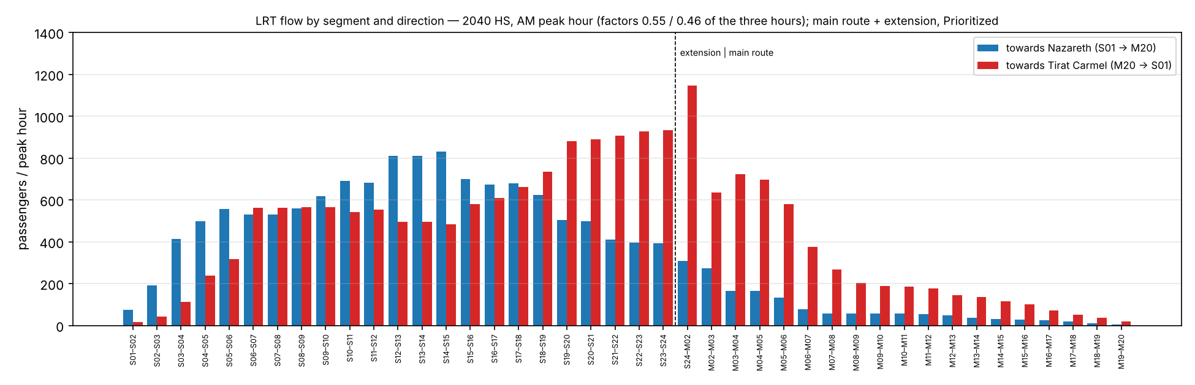
Figure 4.6 — LRT flow by segment and direction, 2040 HS, AM peak hour.
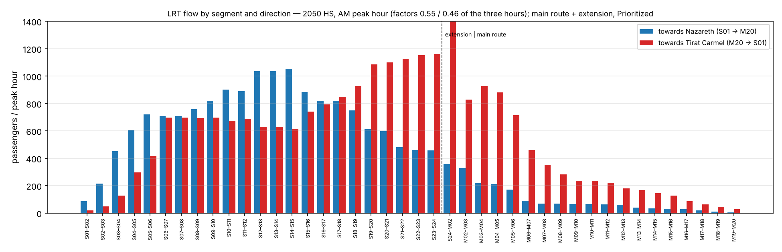
Figure 4.7 — LRT flow by segment and direction, 2050 HS, AM peak hour.
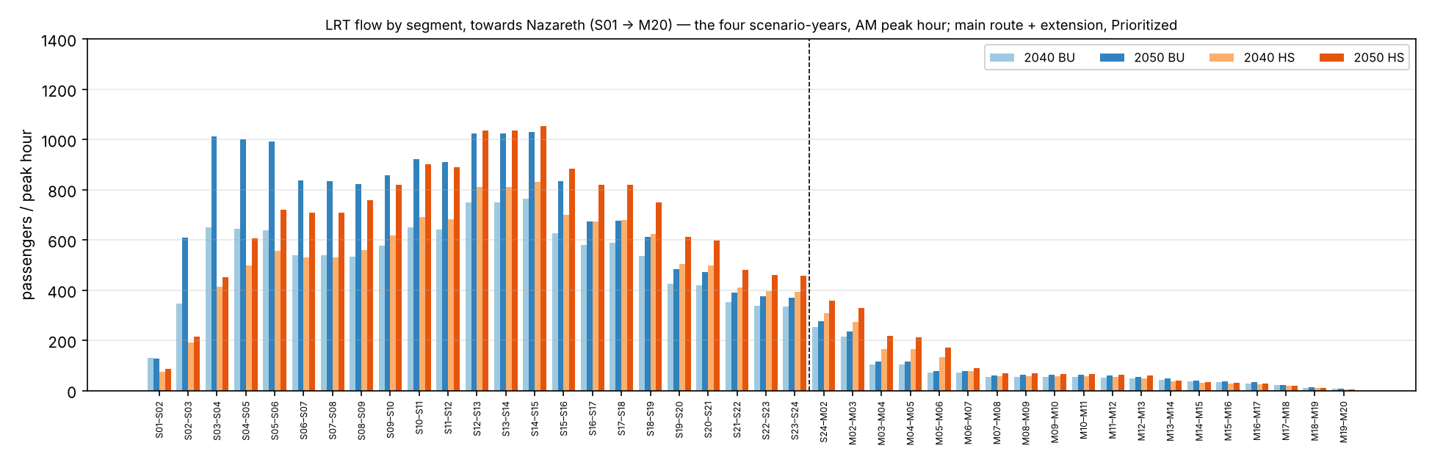
Figure 4.8 — LRT flow by segment, direction Nazareth, the four scenarios, AM peak hour.
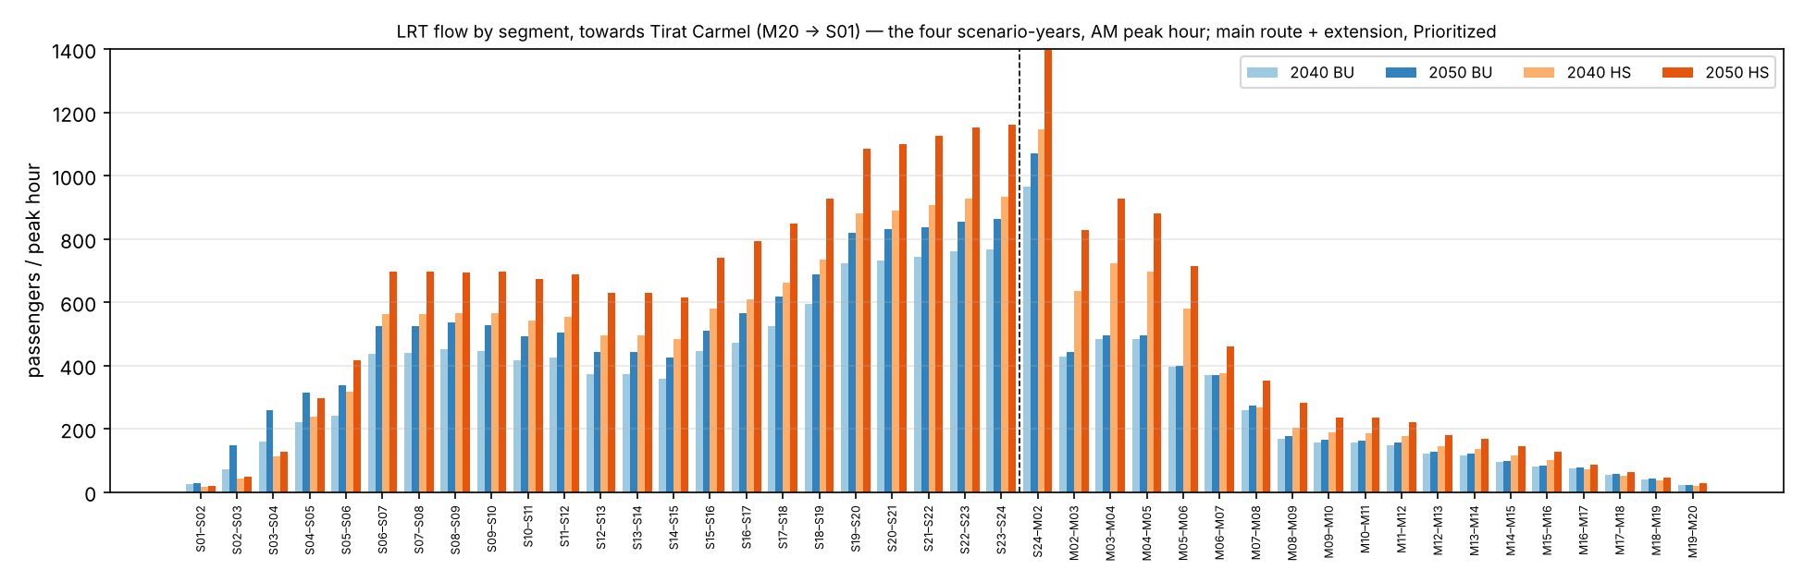
Figure 4.9 — LRT flow by segment, direction Tirat Carmel, the four scenarios, AM peak hour.
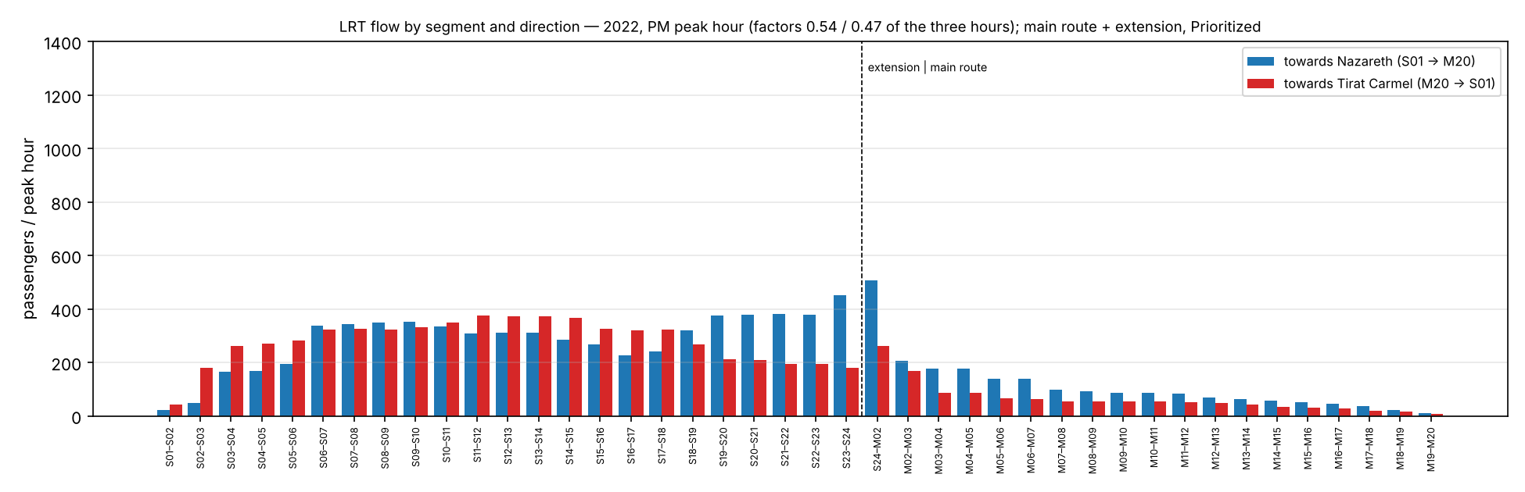
Figure 4.10 — LRT flow by segment and direction, 2022, PM peak hour.
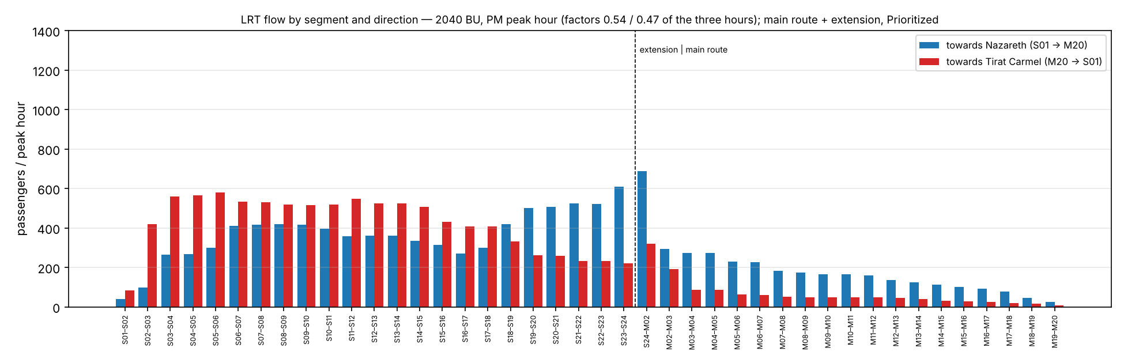
Figure 4.11 — LRT flow by segment and direction, 2040 BU, PM peak hour.
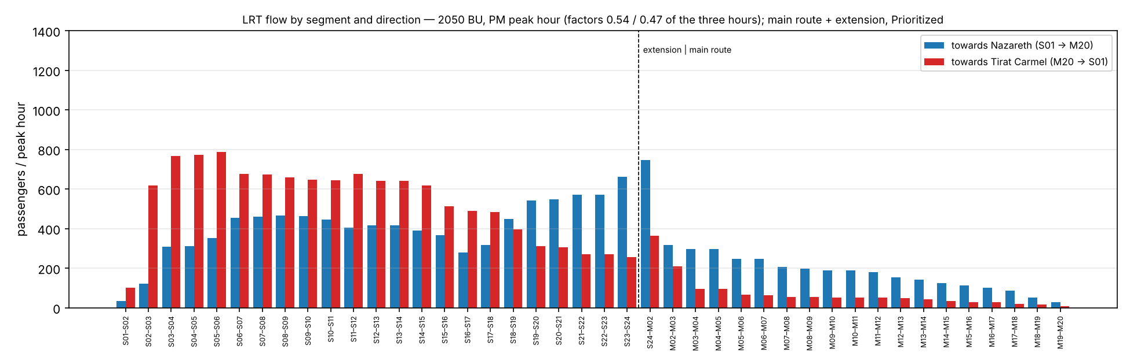
Figure 4.12 — LRT flow by segment and direction, 2050 BU, PM peak hour.
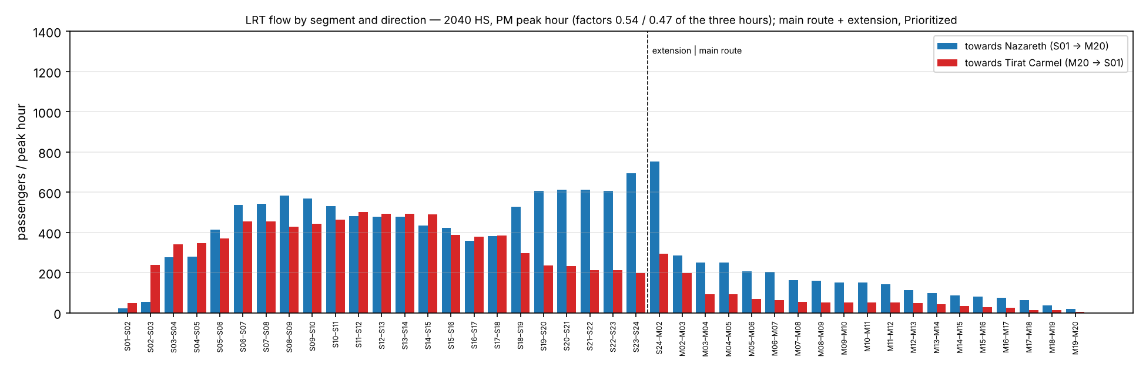
Figure 4.13 — LRT flow by segment and direction, 2040 HS, PM peak hour.
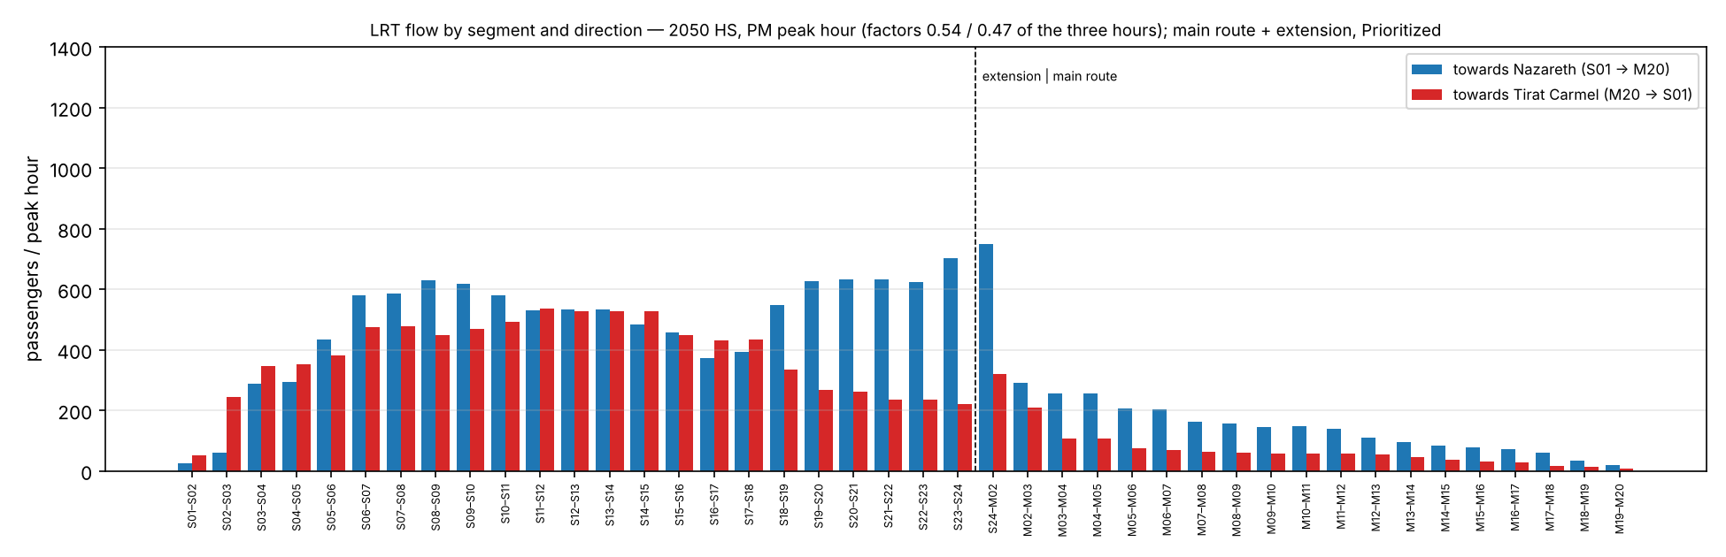
Figure 4.14 — LRT flow by segment and direction, 2050 HS, PM peak hour.
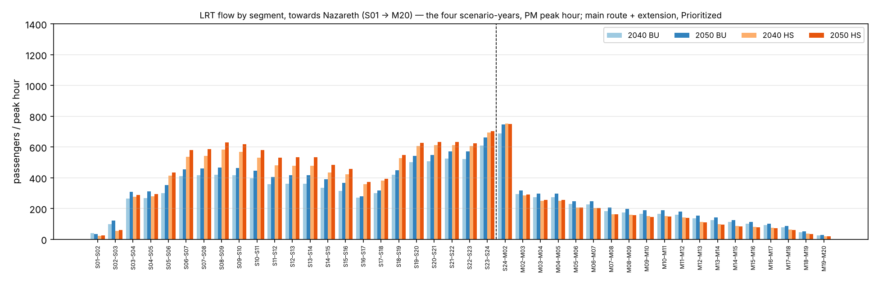
Figure 4.15 — LRT flow by segment, direction Nazareth, the four scenarios, PM peak hour.
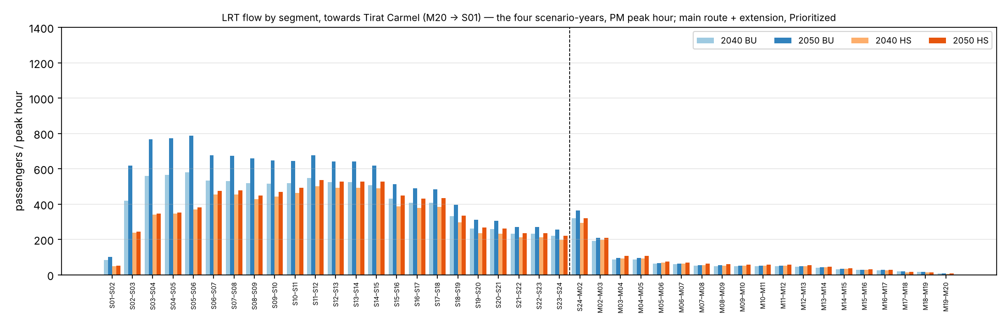
Figure 4.16 — LRT flow by segment, direction Tirat Carmel, the four scenarios, PM peak hour.
The same flows between the corridor areas along the line. Each bar is the load on the segment from one area to the next area (Tirat Carmel → Matam … Hamovil → Nazareth), in the peak hour. One vertical scale (1,400) applies to all area charts in the section. The area names are the English names of the aggregation file.
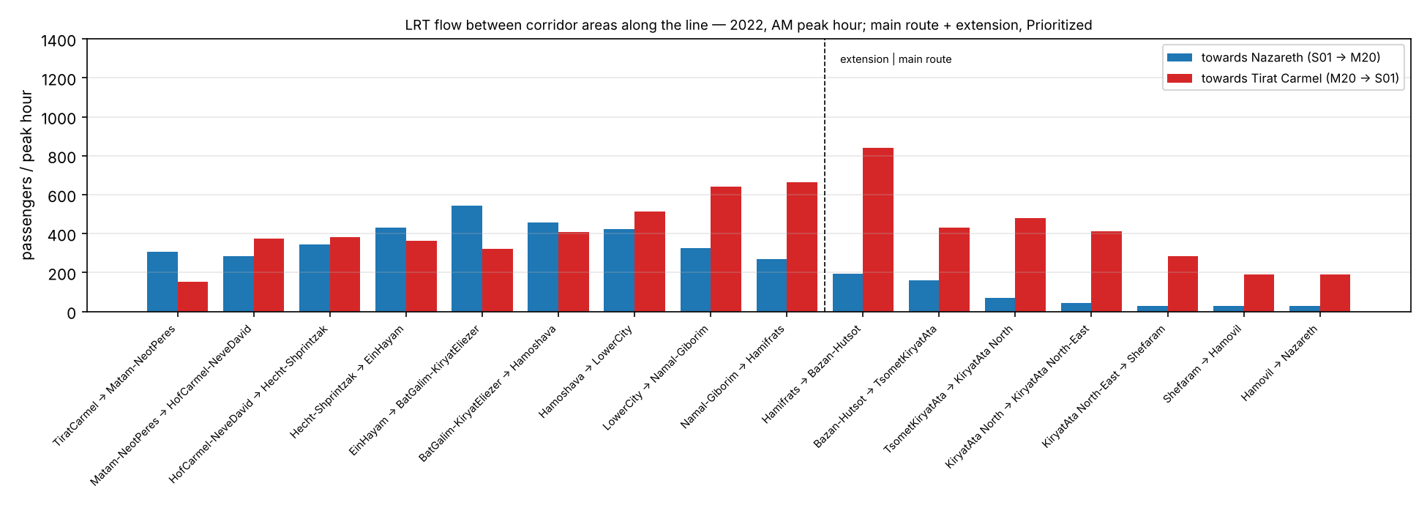
Figure 4.17 — LRT flow between the corridor areas, 2022, AM peak hour.
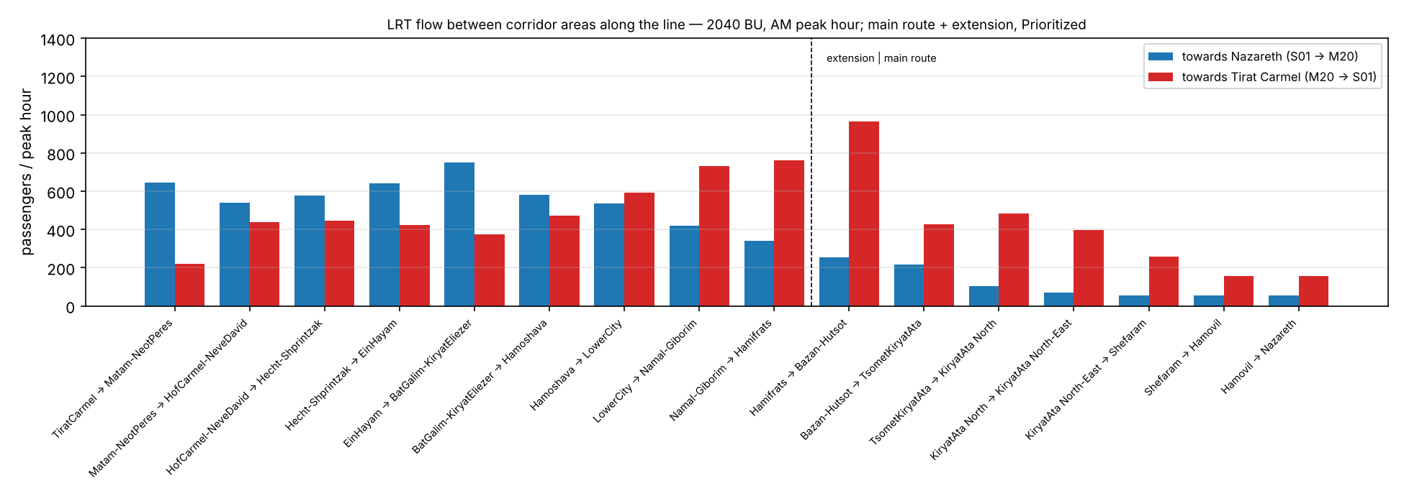
Figure 4.18 — LRT flow between the corridor areas, 2040 BU, AM peak hour.
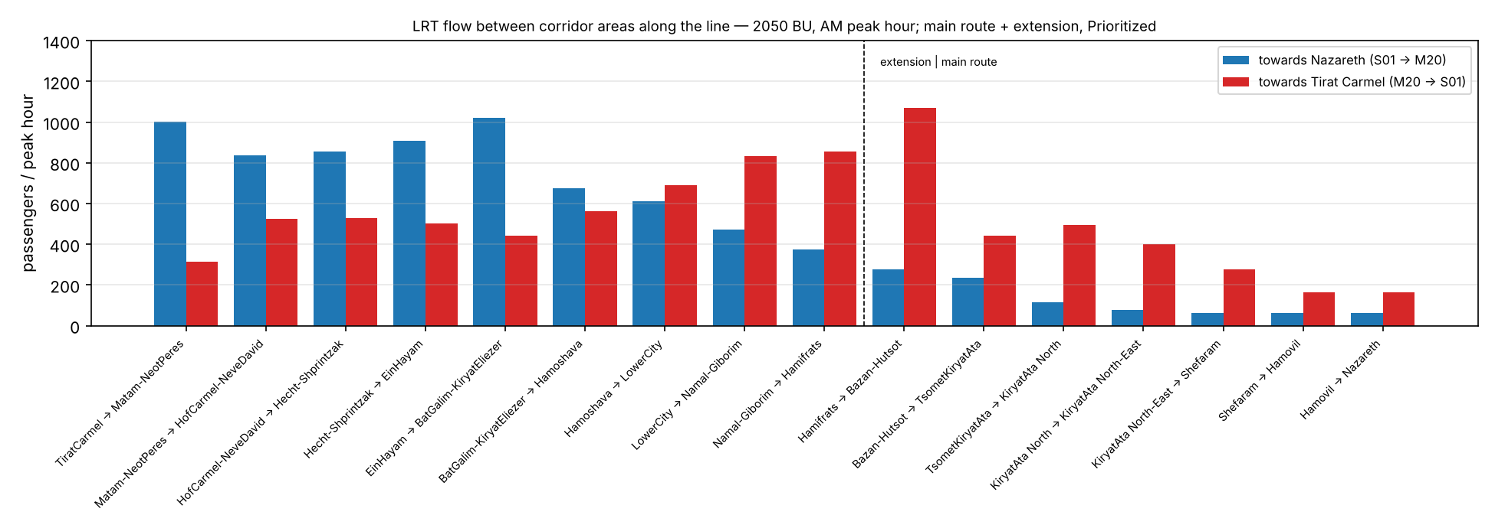
Figure 4.19 — LRT flow between the corridor areas, 2050 BU, AM peak hour.
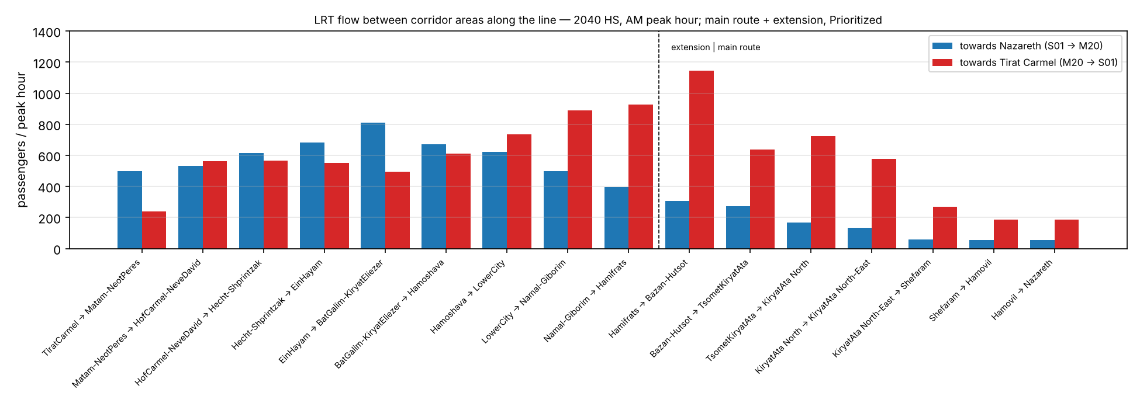
Figure 4.20 — LRT flow between the corridor areas, 2040 HS, AM peak hour.
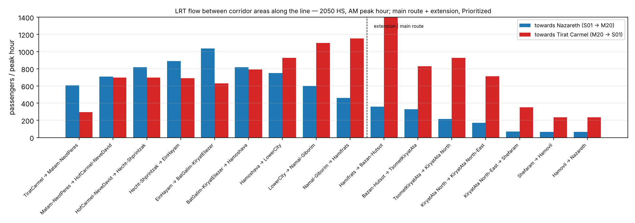
Figure 4.21 — LRT flow between the corridor areas, 2050 HS, AM peak hour.
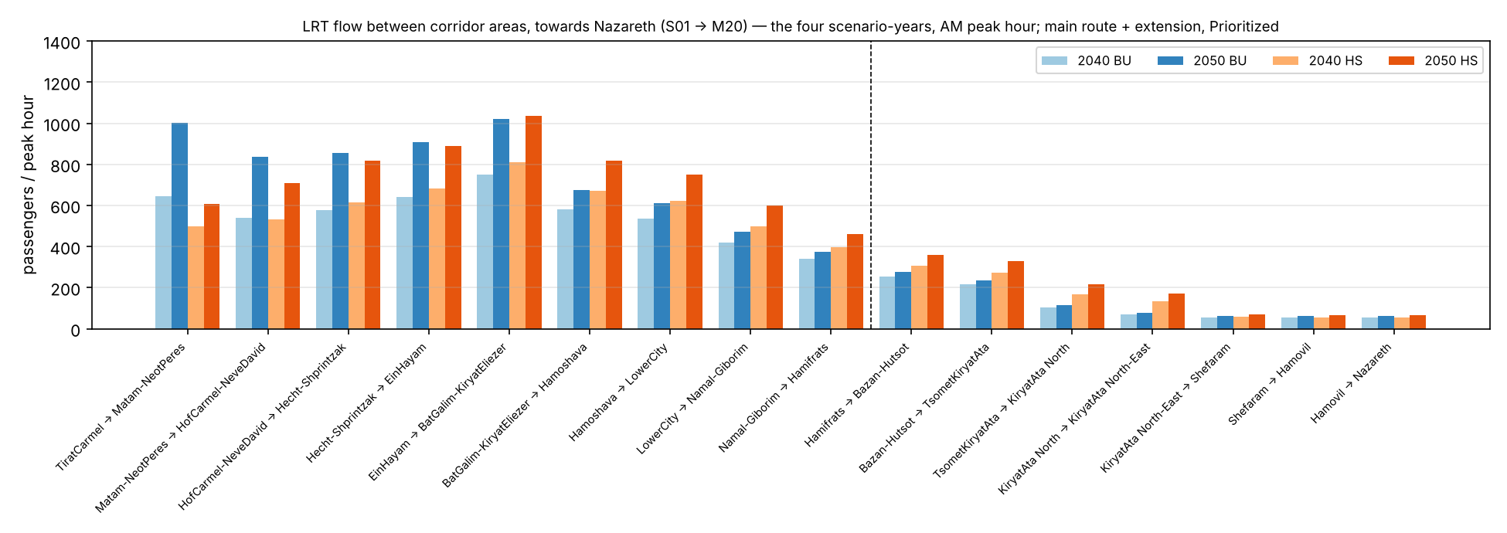
Figure 4.22 — LRT flow between the corridor areas, direction Nazareth, the four scenarios, AM peak hour.
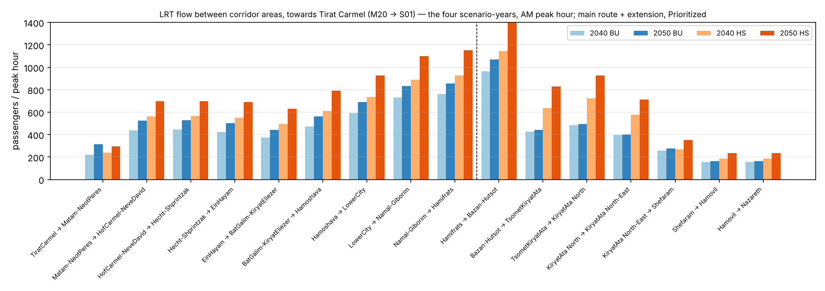
Figure 4.23 — LRT flow between the corridor areas, direction Tirat Carmel, the four scenarios, AM peak hour.
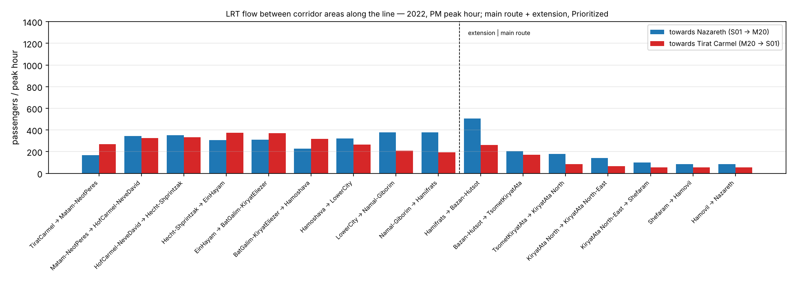
Figure 4.24 — LRT flow between the corridor areas, 2022, PM peak hour.
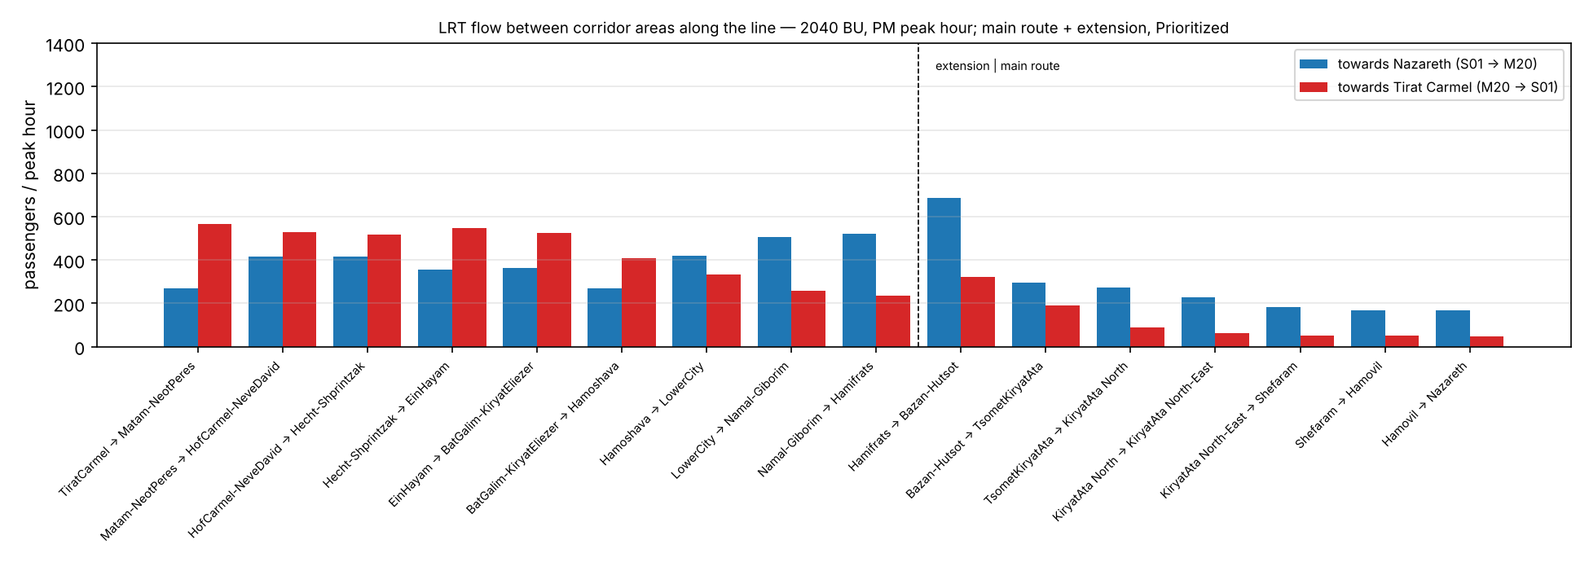
Figure 4.25 — LRT flow between the corridor areas, 2040 BU, PM peak hour.
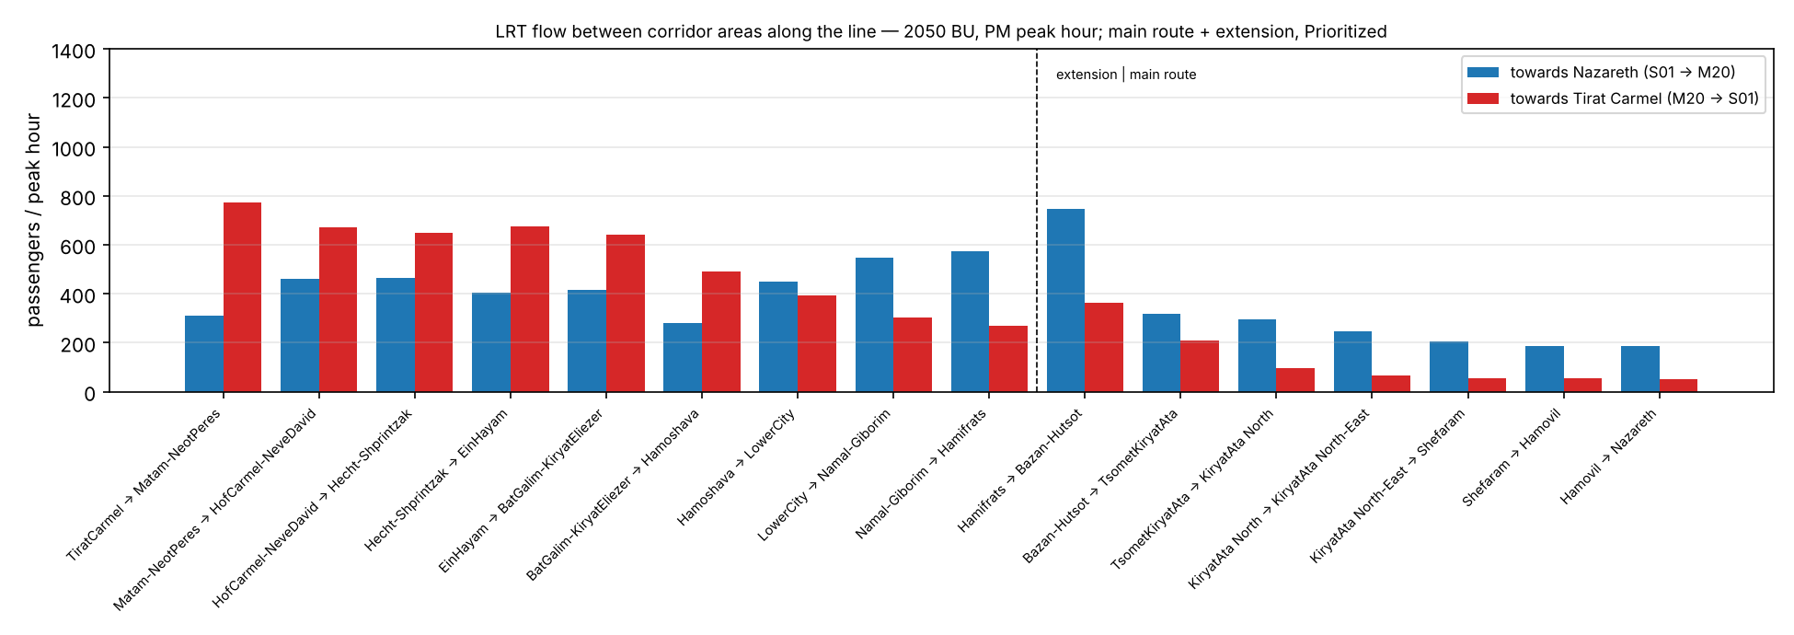
Figure 4.26 — LRT flow between the corridor areas, 2050 BU, PM peak hour.
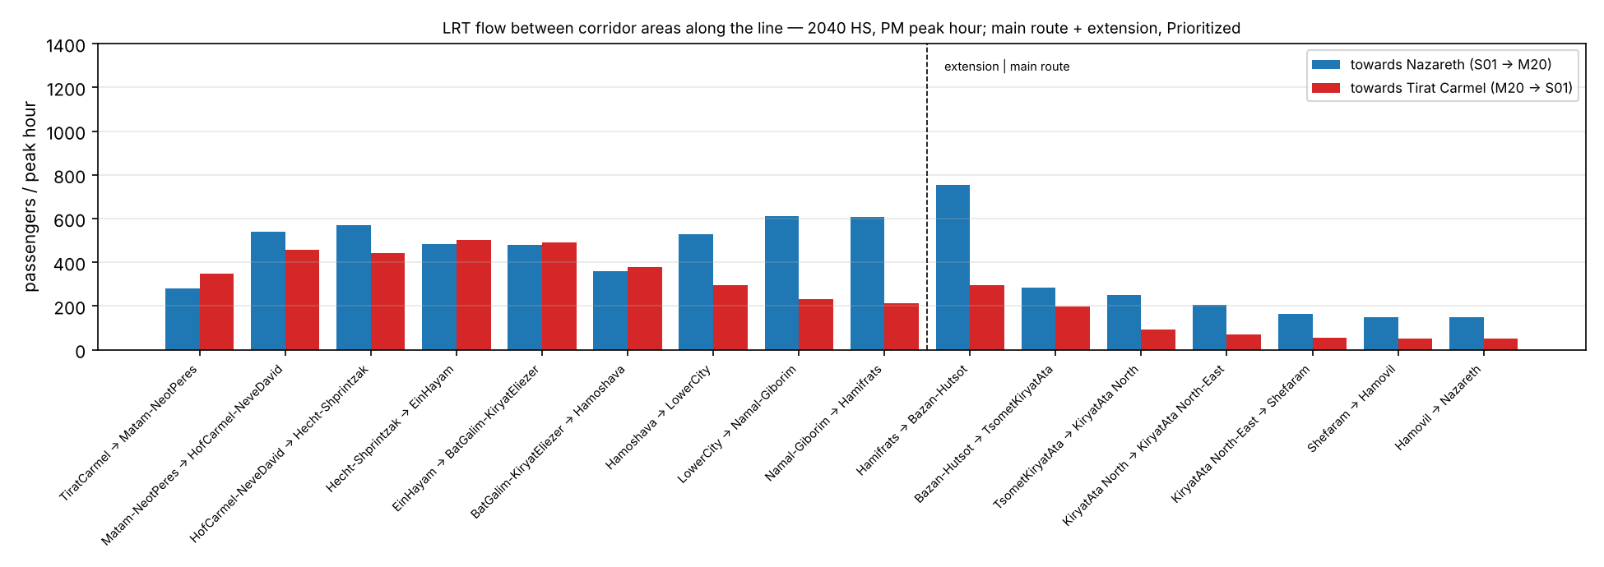
Figure 4.27 — LRT flow between the corridor areas, 2040 HS, PM peak hour.
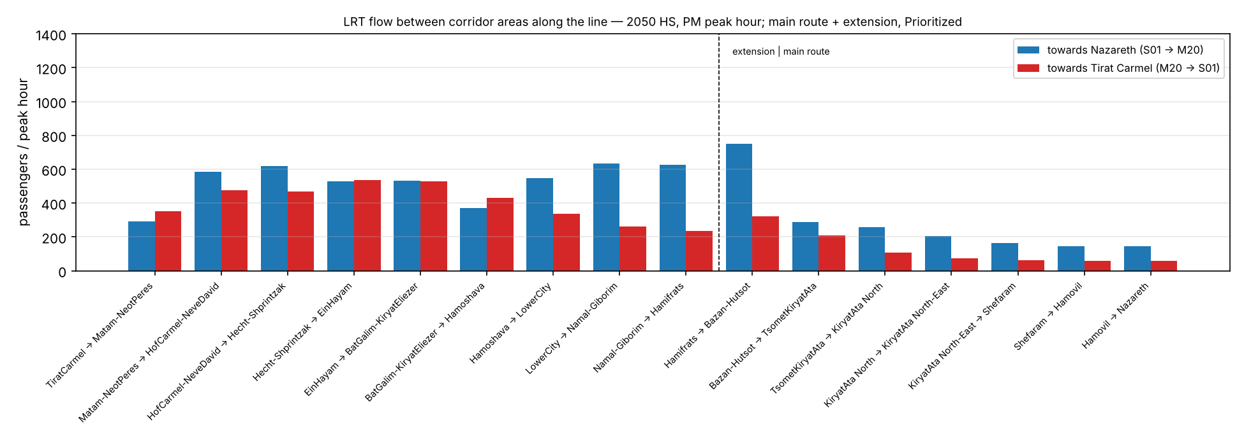
Figure 4.28 — LRT flow between the corridor areas, 2050 HS, PM peak hour.
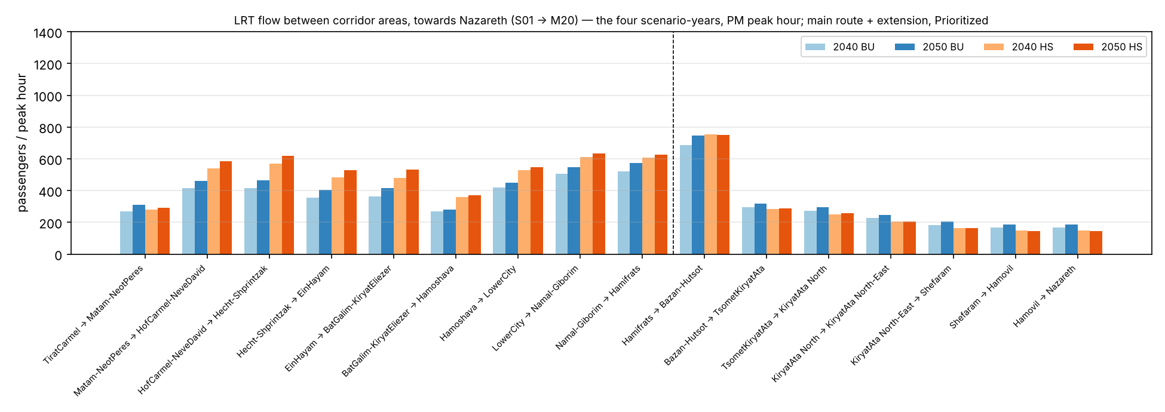
Figure 4.29 — LRT flow between the corridor areas, direction Nazareth, the four scenarios, PM peak hour.
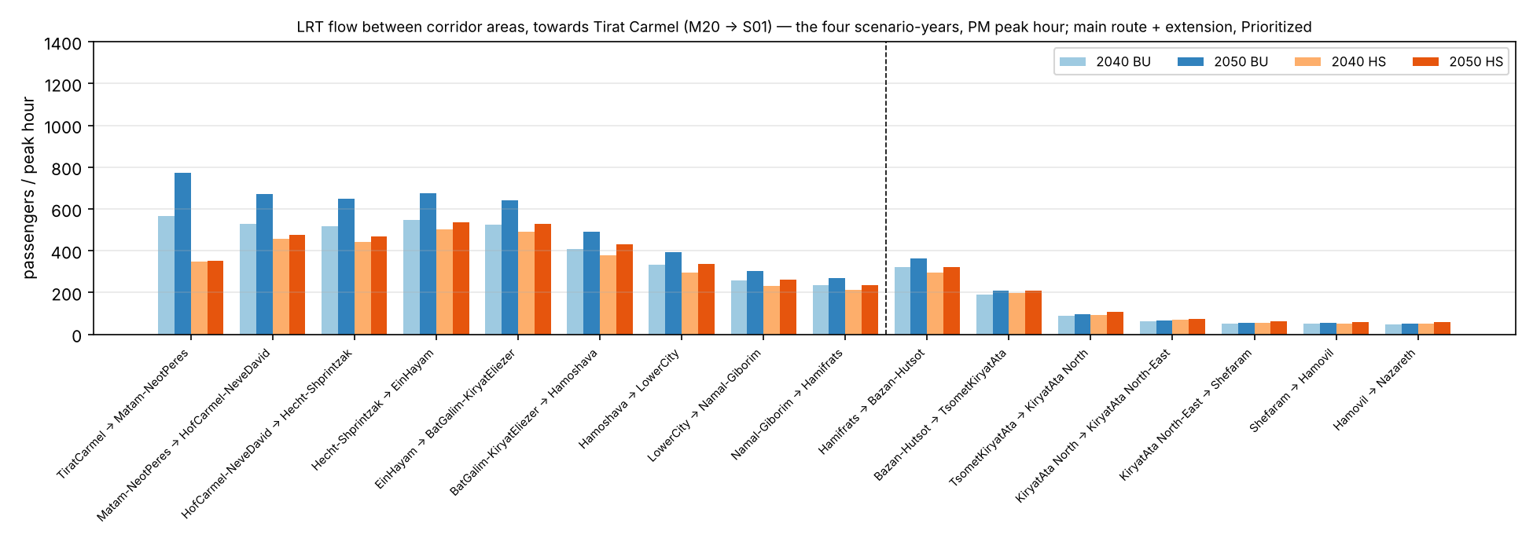
Figure 4.30 — LRT flow between the corridor areas, direction Tirat Carmel, the four scenarios, PM peak hour.

4.6 The flow along the line: all public transport, the two directions
The same profile for all public transport trips of the corridor market: bus, Metronit and LRT after the LRT is added. The trips are loaded along the line between the LRT stations nearest to their ends. This is the public transport demand that the corridor of the line carries. The LRT takes the share of it that section 4.2 shows.
Same structure and same rule: one vertical scale (3,000 passengers in the peak hour) for all charts in the section.
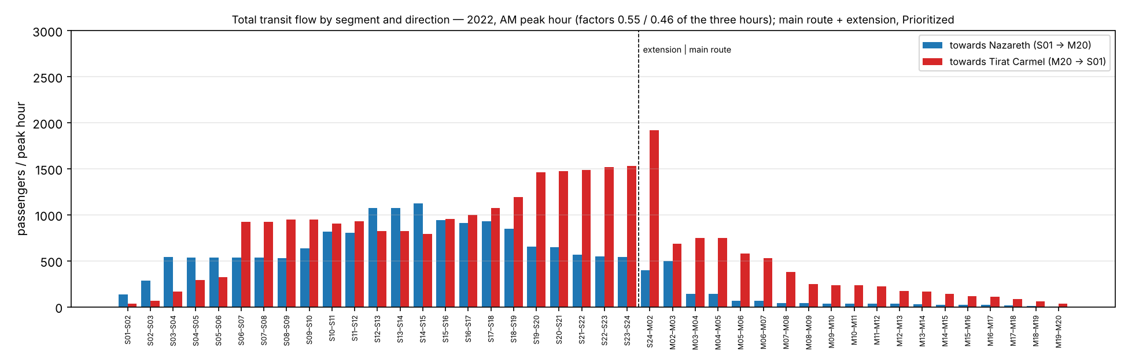
Figure 4.31 — All public transport flow by segment and direction, 2022, AM peak hour.
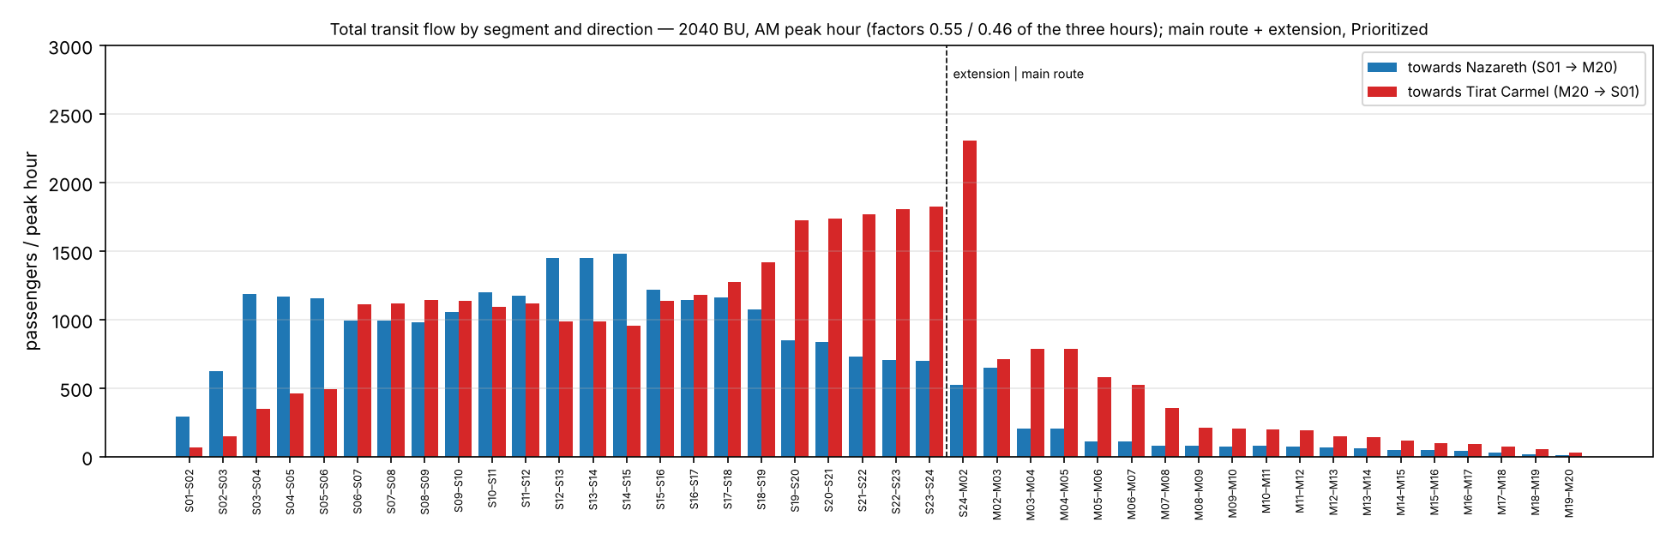
Figure 4.32 — All public transport flow by segment and direction, 2040 BU, AM peak hour.
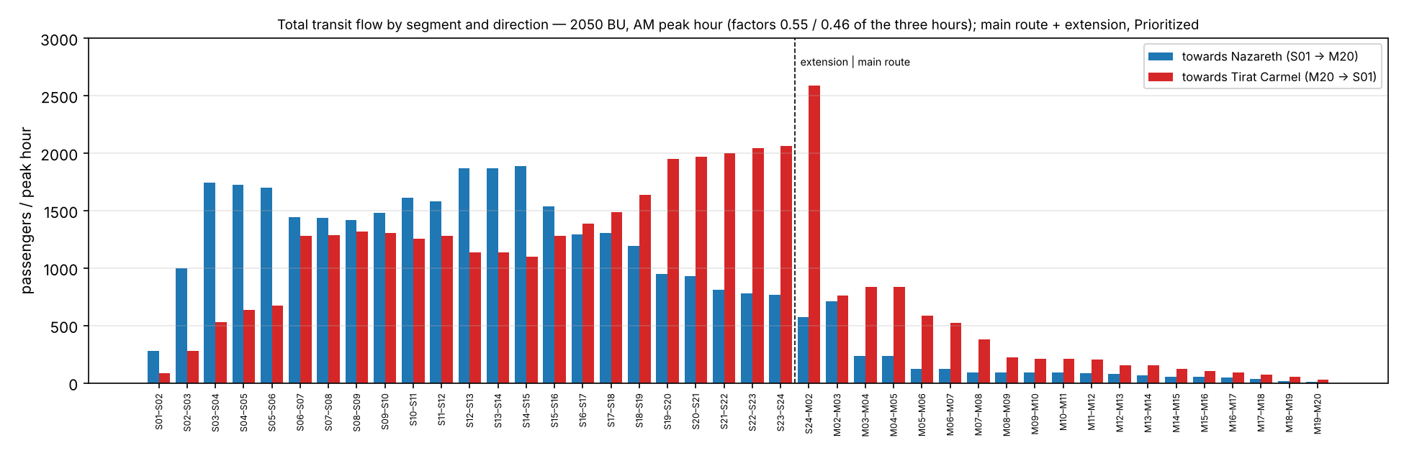
Figure 4.33 — All public transport flow by segment and direction, 2050 BU, AM peak hour.
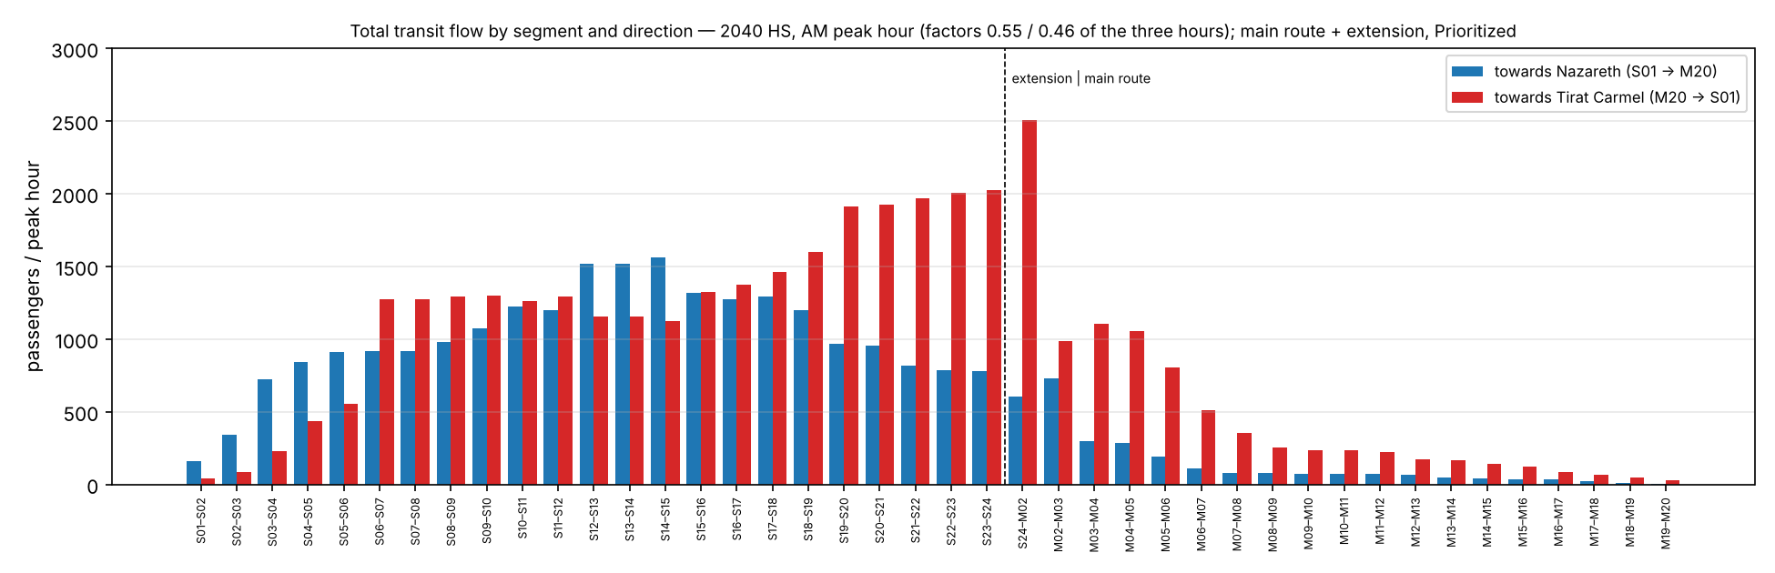
Figure 4.34 — All public transport flow by segment and direction, 2040 HS, AM peak hour.
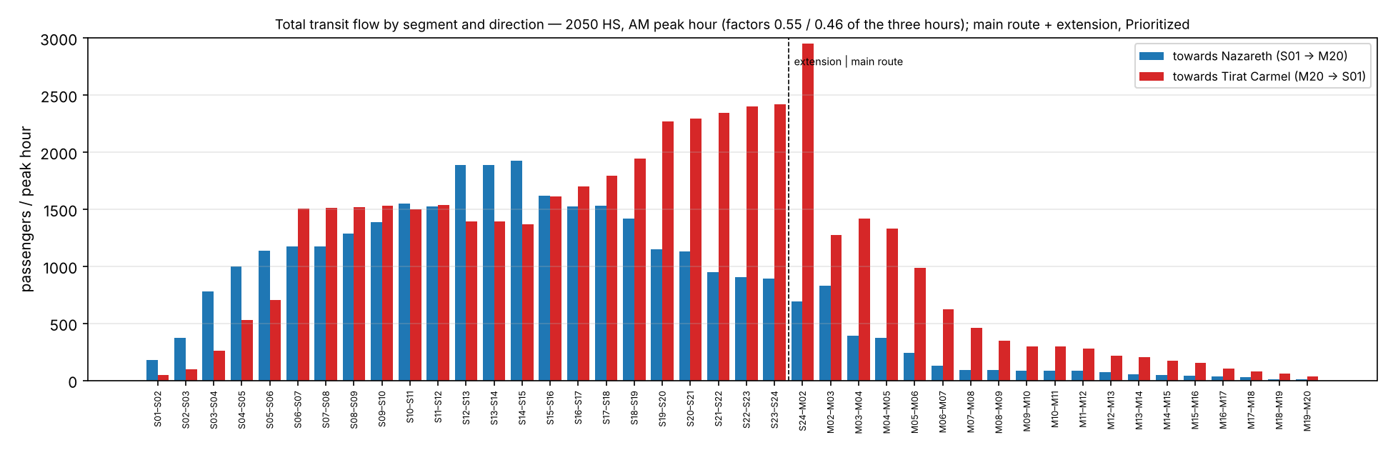
Figure 4.35 — All public transport flow by segment and direction, 2050 HS, AM peak hour.
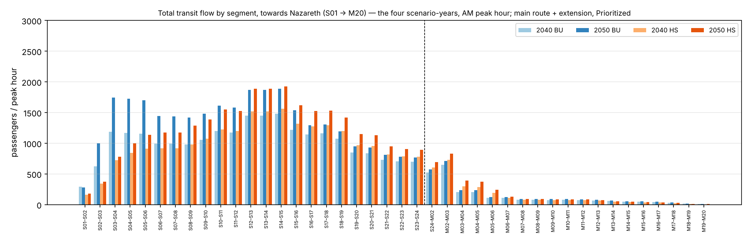
Figure 4.36 — All public transport flow by segment, direction Nazareth, the four scenarios, AM peak hour.
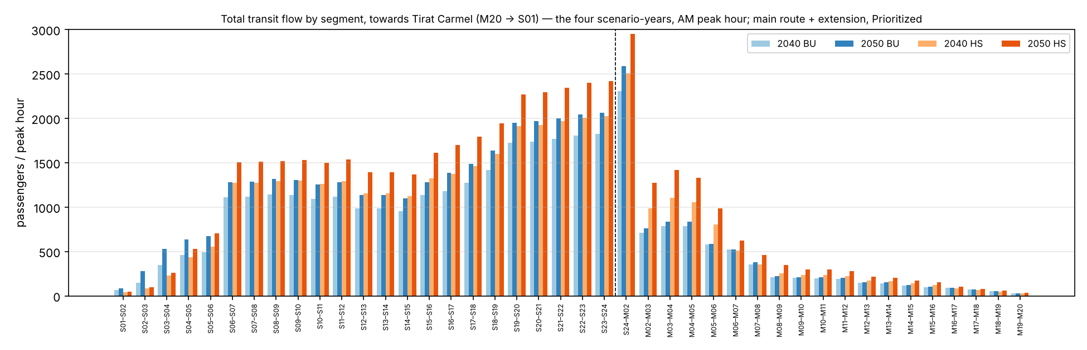
Figure 4.37 — All public transport flow by segment, direction Tirat Carmel, the four scenarios, AM peak hour.
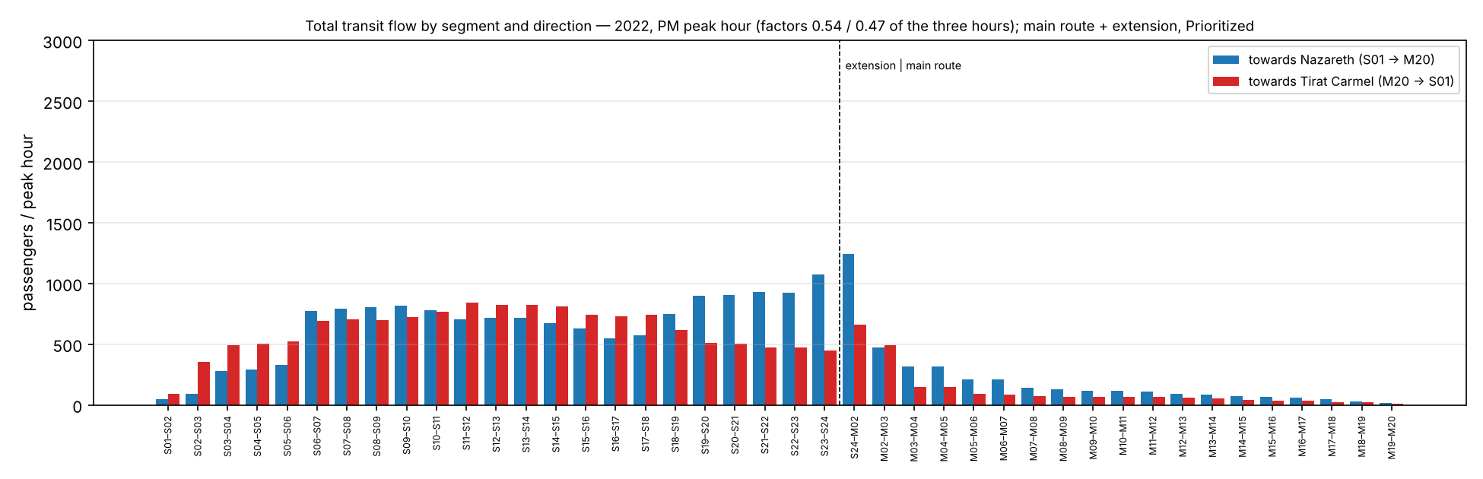
Figure 4.38 — All public transport flow by segment and direction, 2022, PM peak hour.
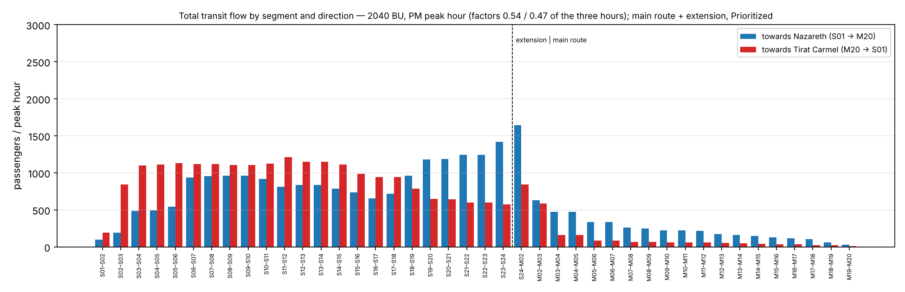
Figure 4.39 — All public transport flow by segment and direction, 2040 BU, PM peak hour.
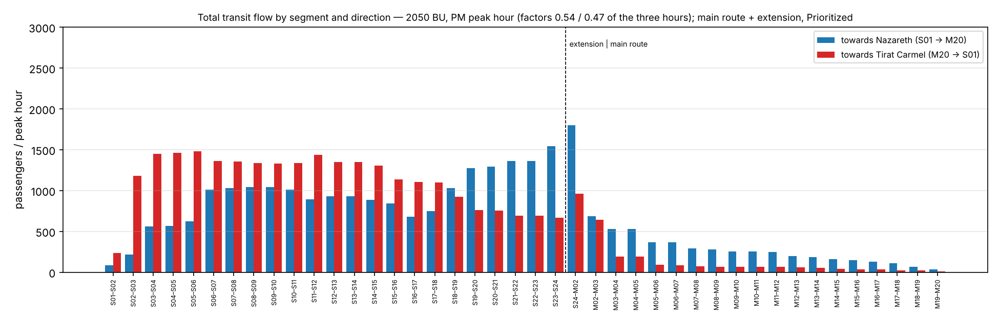
Figure 4.40 — All public transport flow by segment and direction, 2050 BU, PM peak hour.
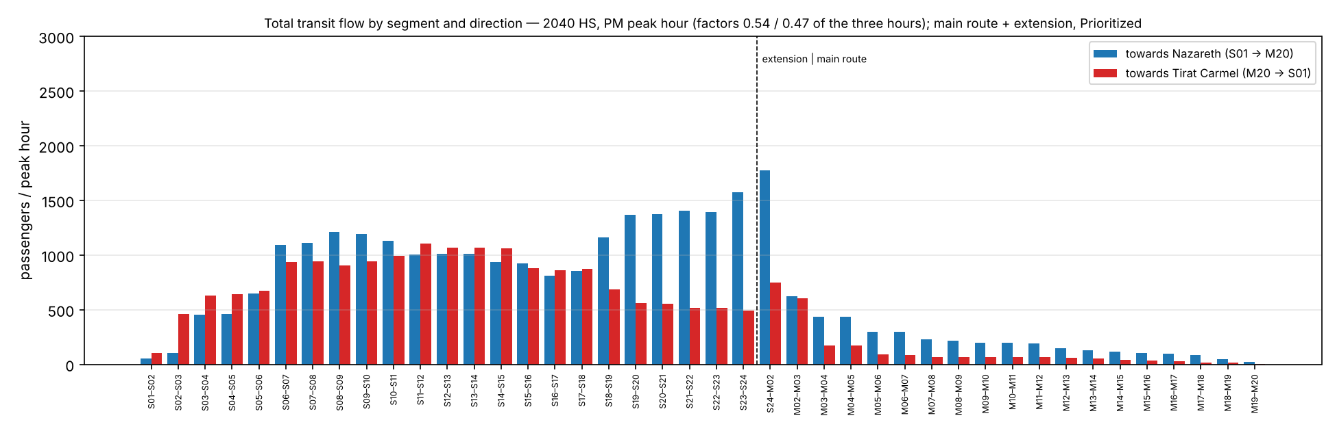
Figure 4.41 — All public transport flow by segment and direction, 2040 HS, PM peak hour.
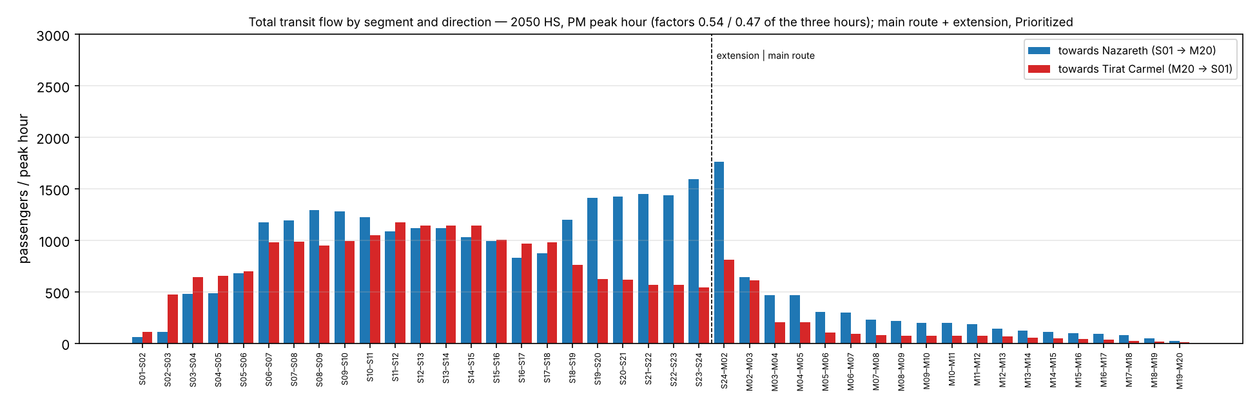
Figure 4.42 — All public transport flow by segment and direction, 2050 HS, PM peak hour.
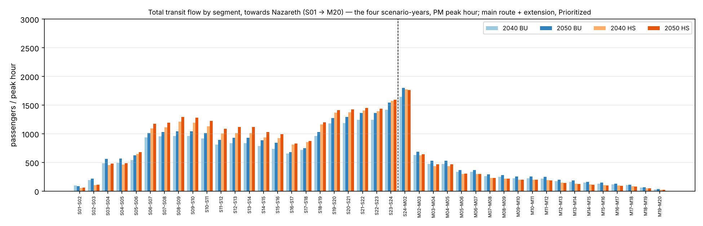
Figure 4.43 — All public transport flow by segment, direction Nazareth, the four scenarios, PM peak hour.
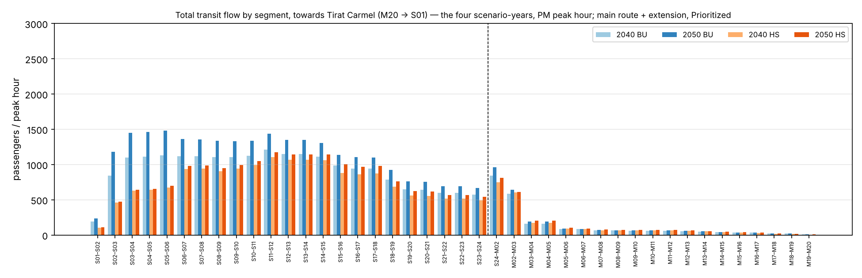
Figure 4.44 — All public transport flow by segment, direction Tirat Carmel, the four scenarios, PM peak hour.
The same between the corridor areas (one vertical scale, 3,000, for all area charts in the section).
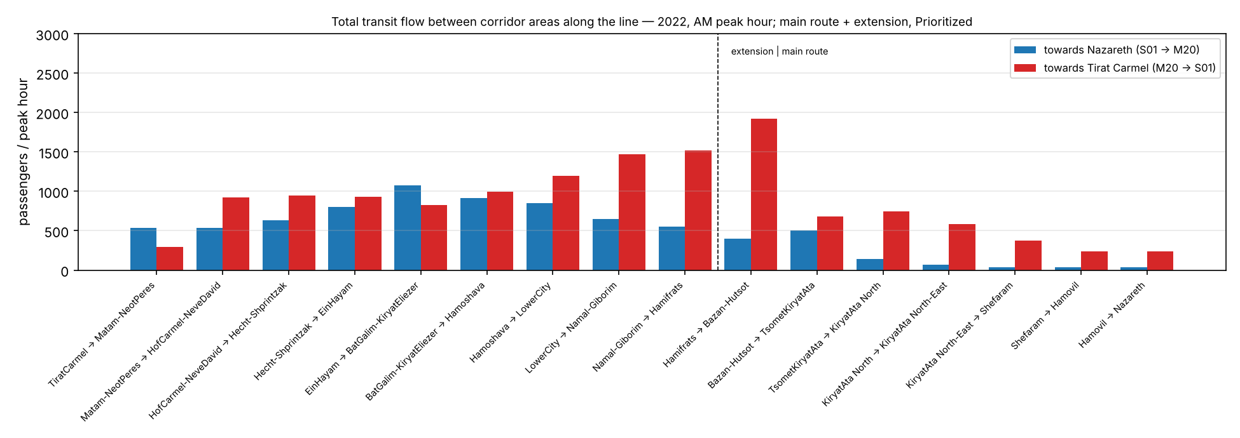
Figure 4.45 — All public transport flow between the corridor areas, 2022, AM peak hour.
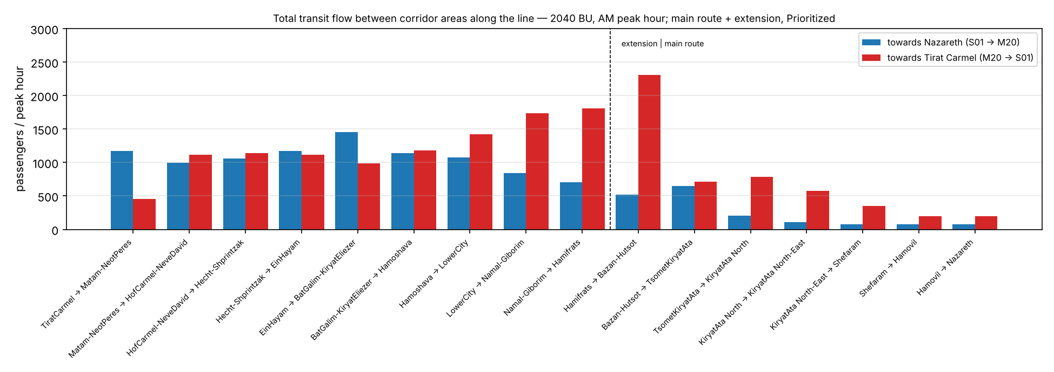
Figure 4.46 — All public transport flow between the corridor areas, 2040 BU, AM peak hour.
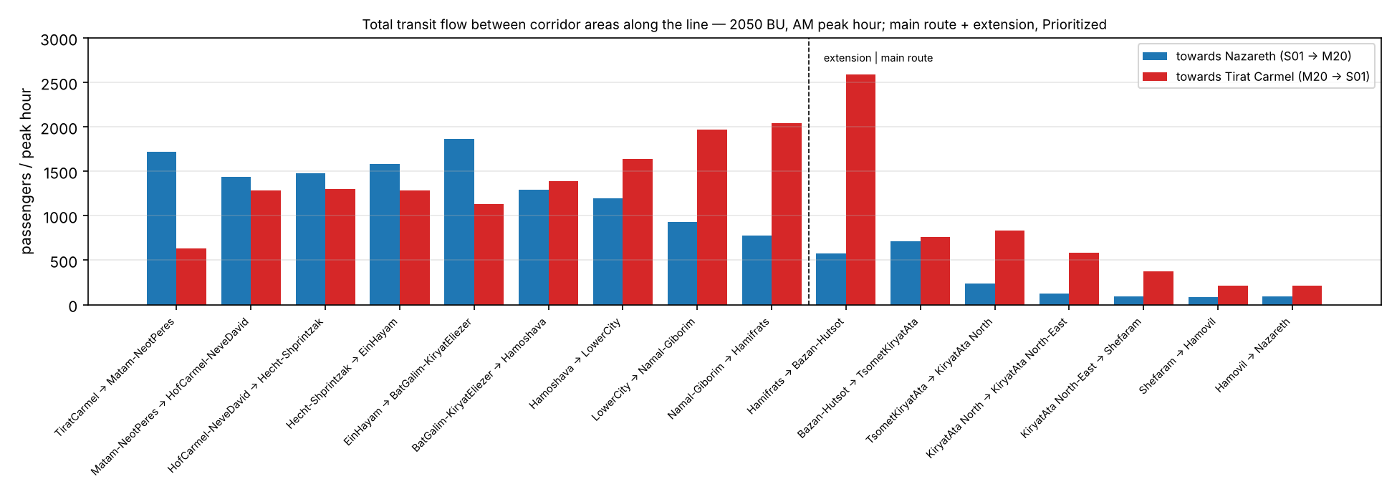
Figure 4.47 — All public transport flow between the corridor areas, 2050 BU, AM peak hour.
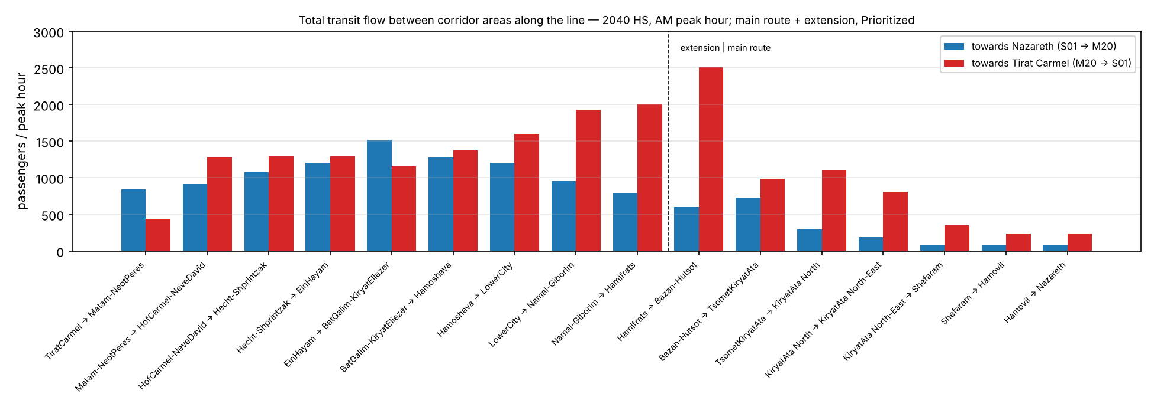
Figure 4.48 — All public transport flow between the corridor areas, 2040 HS, AM peak hour.
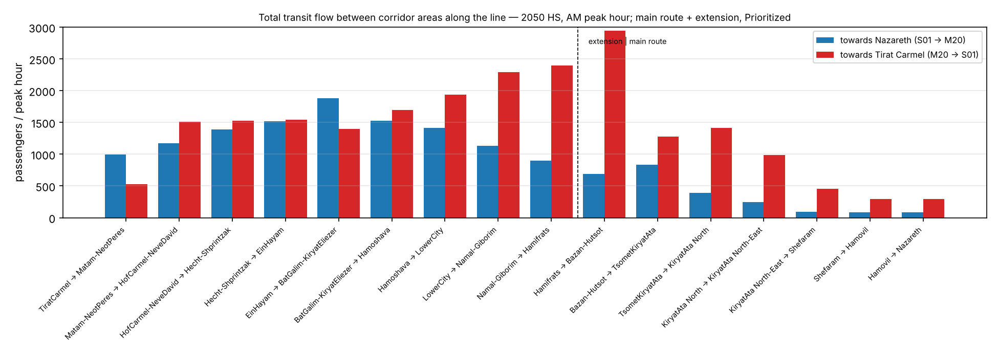
Figure 4.49 — All public transport flow between the corridor areas, 2050 HS, AM peak hour.
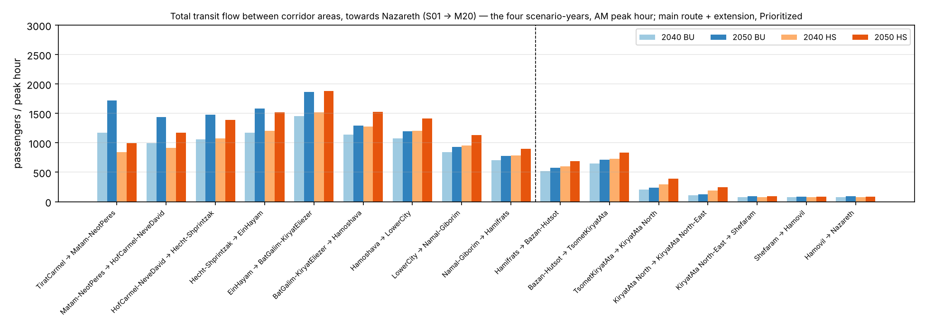
Figure 4.50 — All public transport flow between the corridor areas, direction Nazareth, the four scenarios, AM peak hour.
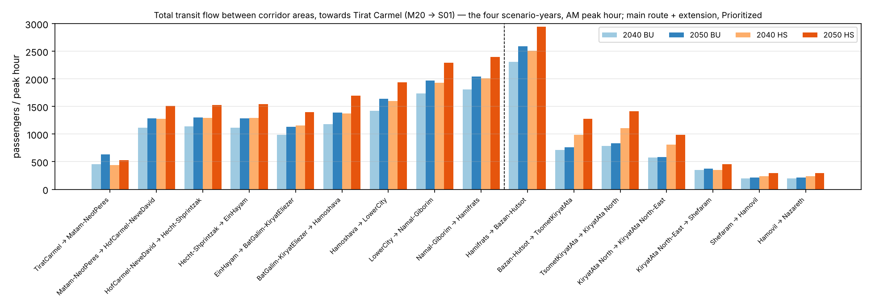
Figure 4.51 — All public transport flow between the corridor areas, direction Tirat Carmel, the four scenarios, AM peak hour.
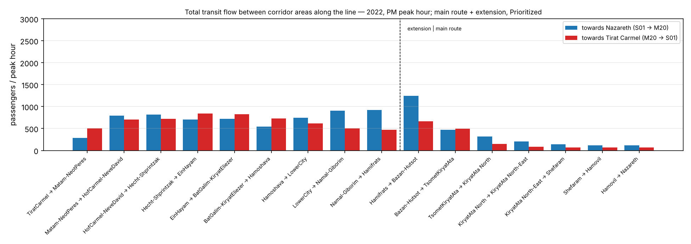
Figure 4.52 — All public transport flow between the corridor areas, 2022, PM peak hour.
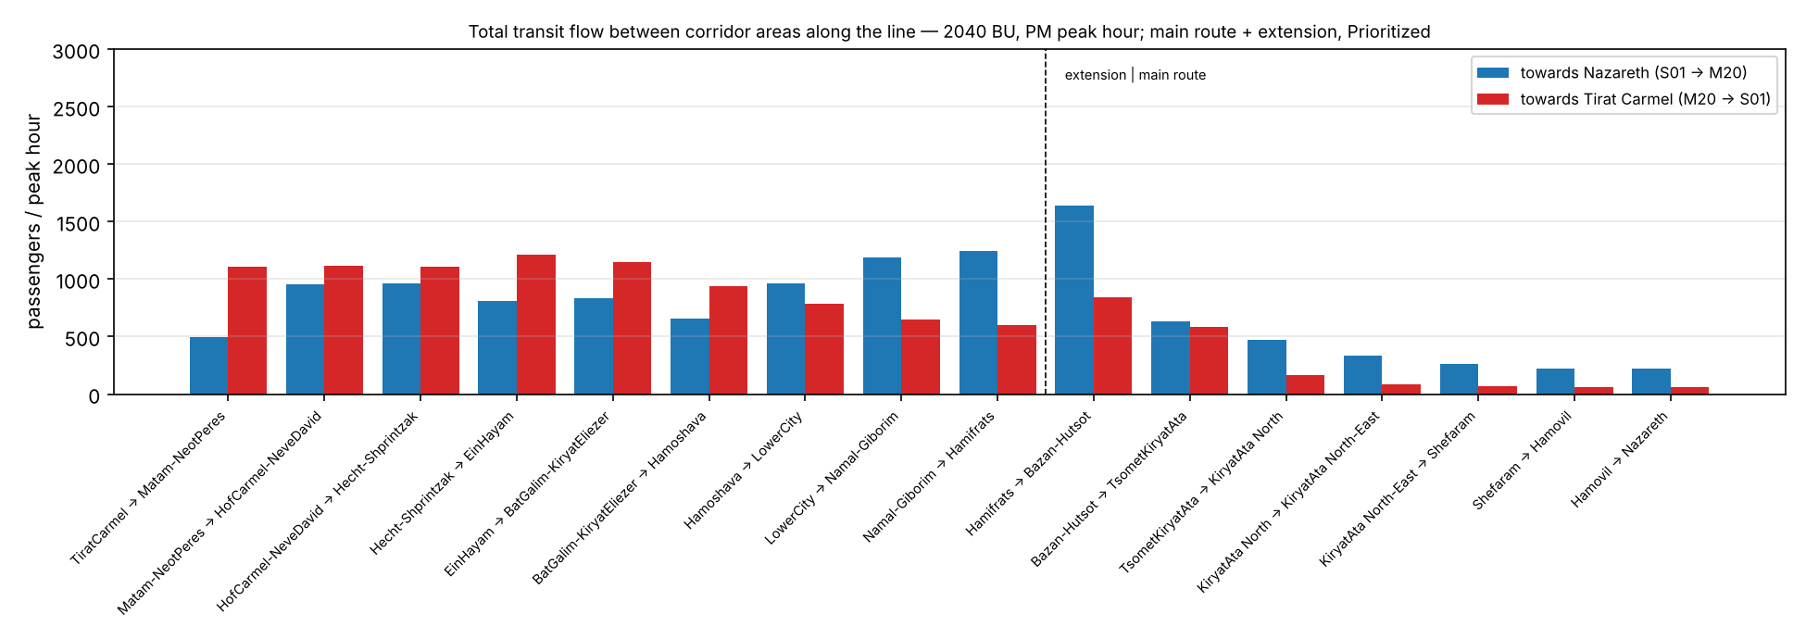
Figure 4.53 — All public transport flow between the corridor areas, 2040 BU, PM peak hour.
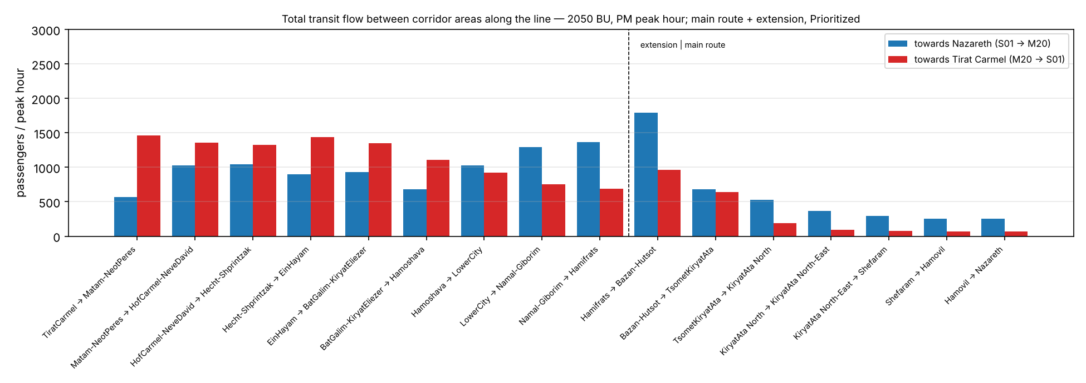
Figure 4.54 — All public transport flow between the corridor areas, 2050 BU, PM peak hour.
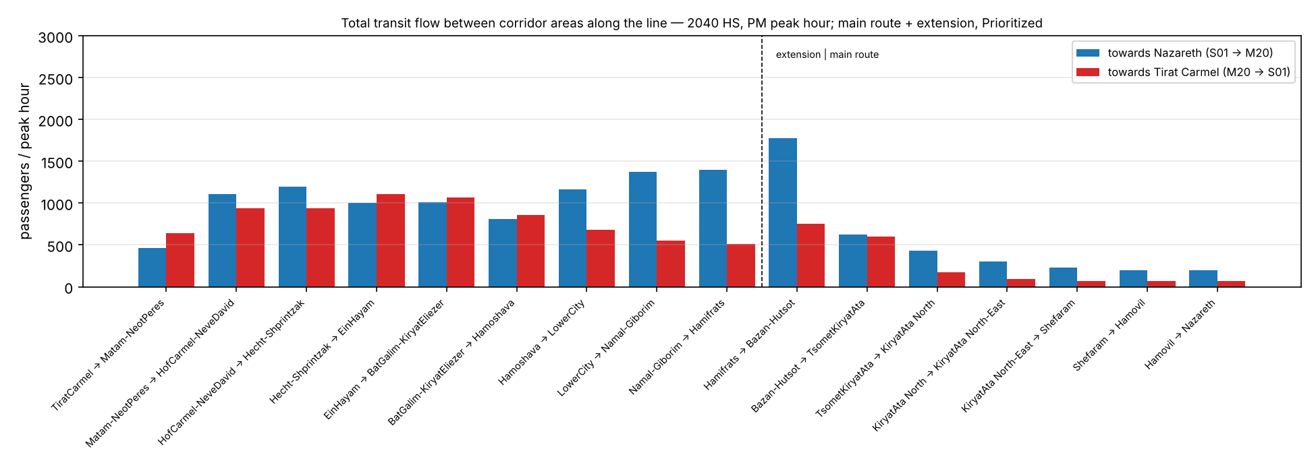
Figure 4.55 — All public transport flow between the corridor areas, 2040 HS, PM peak hour.
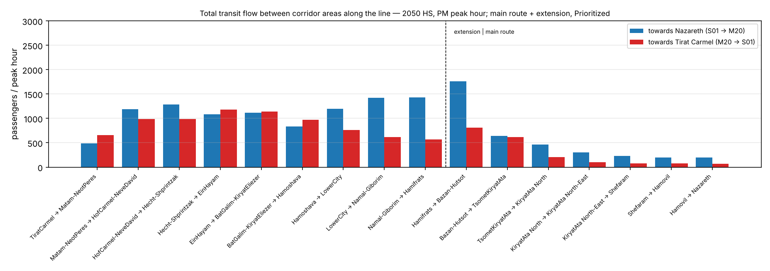
Figure 4.56 — All public transport flow between the corridor areas, 2050 HS, PM peak hour.
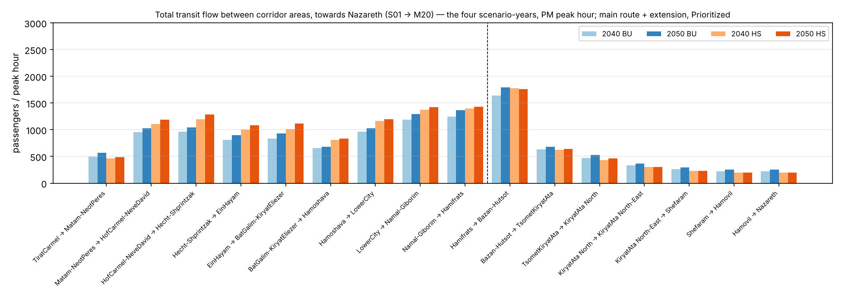
Figure 4.57 — All public transport flow between the corridor areas, direction Nazareth, the four scenarios, PM peak hour.
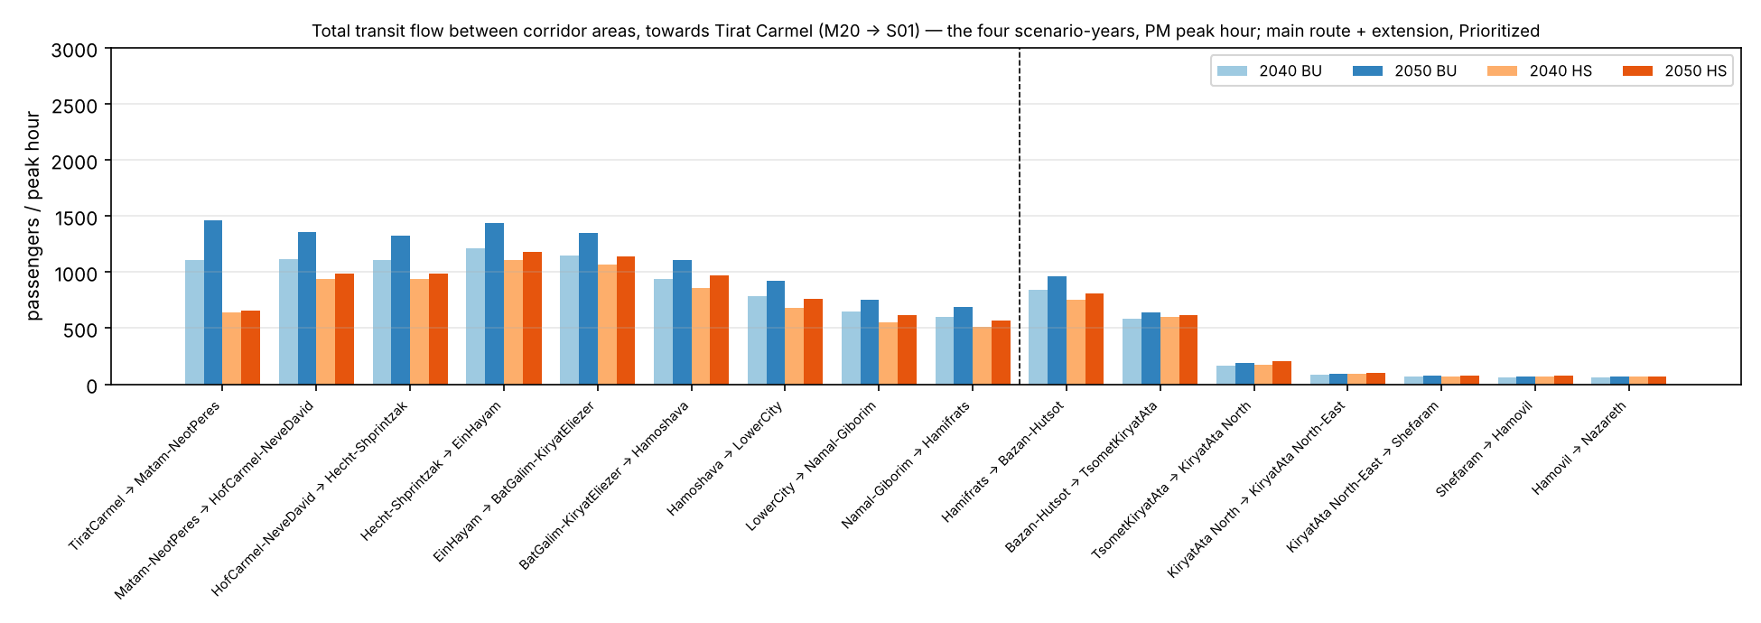
Figure 4.58 — All public transport flow between the corridor areas, direction Tirat Carmel, the four scenarios, PM peak hour.

4.7 The mode split on the route
The split of the corridor market between the car and public transport after the LRT, by scenario and period. The LRT is shown inside public transport.
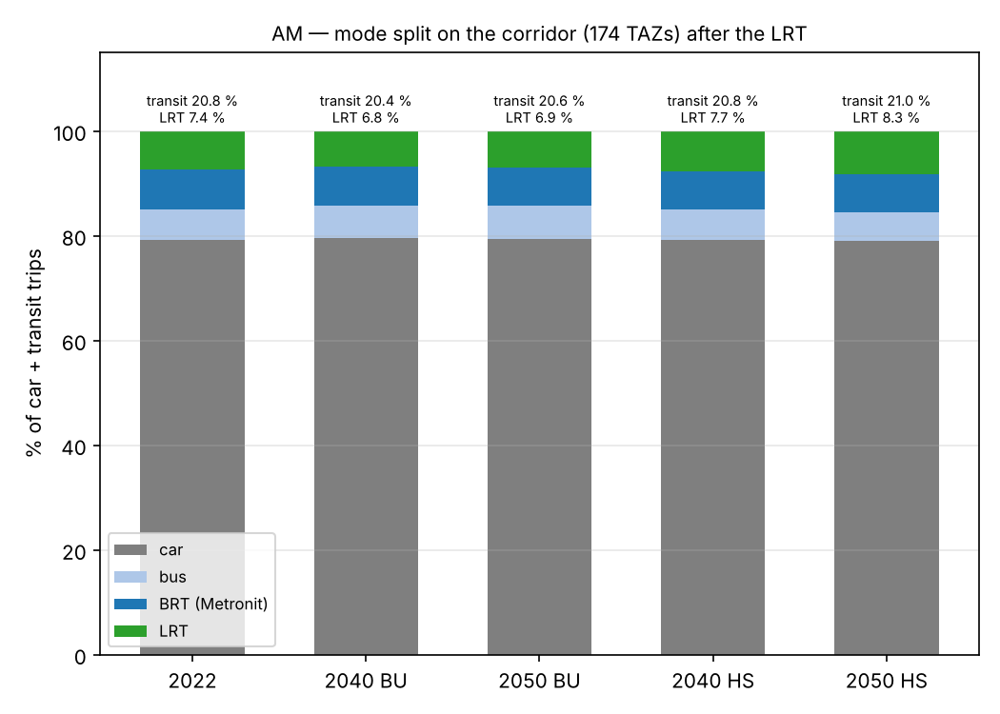
Figure 4.11a — The mode split on the corridor after the LRT: car, bus, Metronit and LRT, AM.
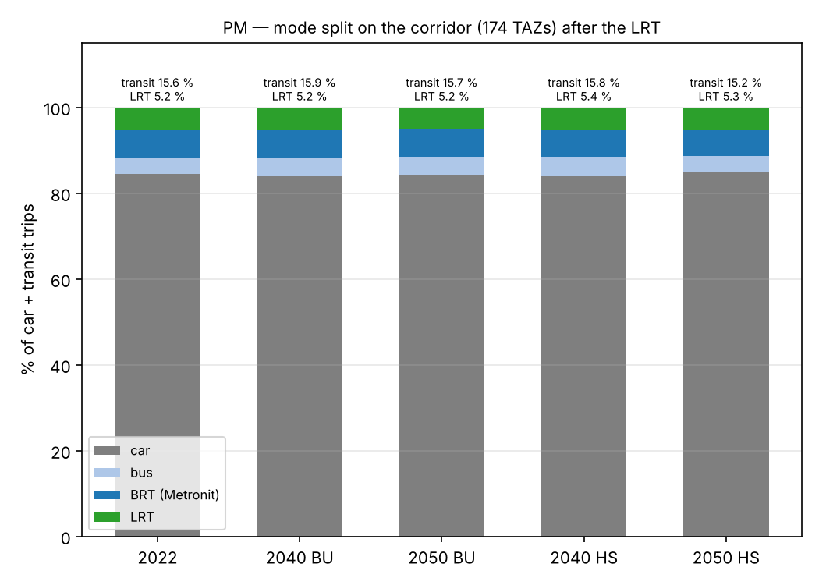
Figure 4.11b — The same for the PM.

4.8 Sensitivity: the regime without priority
Period | Scenario | LRT with priority | LRT without priority | Ratio | Use the extension, with | Use the extension, without | From the car, with | From the car, without
AM | 2040 BU | 6,309 | 4,999 | 0.79 | 4,950 | 3,640 | 353 | 237
AM | 2050 BU | 7,433 | 5,700 | 0.77 | 6,003 | 4,271 | 818 | 450
AM | 2040 HS | 7,476 | 6,010 | 0.80 | 5,651 | 4,185 | 870 | 628
AM | 2050 HS | 9,225 | 7,393 | 0.80 | 7,010 | 5,179 | 1,311 | 934
PM | 2040 BU | 5,358 | 4,263 | 0.80 | 4,300 | 3,205 | 327 | 222
PM | 2050 BU | 6,135 | 4,854 | 0.79 | 4,998 | 3,717 | 368 | 246
PM | 2040 HS | 5,620 | 4,512 | 0.80 | 4,595 | 3,488 | 425 | 290
PM | 2050 HS | 5,956 | 4,768 | 0.80 | 4,918 | 3,730 | 466 | 316
Table 4.8 — LRT trips in the two regimes of the extension. The regime without priority (run at street level) loses approximately a fifth to a quarter of the trips, most of them on the extension. Its end-to-end time on the extension is 65.8 minutes against 40.7.

4.9 Sensitivity: slower buses in 2040 and 2050
Each scenario year runs on the level of service of May 2026. Two conclusions follow. First, a slower car does not change the result in this model. The pivot moves trips only with the change of the public transport "bundle". The car level enters with the shares observed in 2022 (caveat 25).
Second, slower buses do count. A bus in mixed traffic that becomes slower with the road increases the bus cost. The Metronit on its lanes and the LRT with priority keep their times. Thus the central assumption is conservative for the LRT.
The sensitivity: we ran step 45 again with slower buses. We multiply the run time of each bus trip, except the Metronit, by 1.10 in 2040 and by 1.20 in 2050 (BU and HS). The Metronit and the LRT do not change. The bus feeder legs of the LRT paths become slower with the buses. The factors come from a usual volume-delay curve for a road demand that increases by 1.3–1.6 × from approximately 80 % of capacity. They are not calibrated values.
Period | Scenario | Bus factor | LRT central | LRT, slower buses | Ratio | From the car, central | From the car, slower | Use the extension, central | Use the extension, slower
AM | 2040 BU | 1.10 | 6,309 | 6,442 | 1.02 | 353 | 376 | 4,950 | 5,037
AM | 2050 BU | 1.20 | 7,433 | 7,804 | 1.05 | 818 | 948 | 6,003 | 6,283
AM | 2040 HS | 1.10 | 7,476 | 7,624 | 1.02 | 870 | 916 | 5,651 | 5,735
AM | 2050 HS | 1.20 | 9,225 | 9,590 | 1.04 | 1,311 | 1,446 | 7,010 | 7,226
PM | 2040 BU | 1.10 | 5,358 | 5,477 | 1.02 | 327 | 346 | 4,300 | 4,395
PM | 2050 BU | 1.20 | 6,135 | 6,399 | 1.04 | 368 | 411 | 4,998 | 5,212
PM | 2040 HS | 1.10 | 5,620 | 5,723 | 1.02 | 425 | 446 | 4,595 | 4,676
PM | 2050 HS | 1.20 | 5,956 | 6,155 | 1.03 | 466 | 509 | 4,918 | 5,074
Table 4.9 — LRT trips with slower buses against the central case. AM: the LRT gains +2 % to +5 %. The gain is small, because the in-vehicle time of a bus is much less than half of its generalized cost. The walk and the wait have weight 2, and there is the transfer penalty. Also the feeders of the LRT become slower.

4.10 Time on the route
The through line operates in 74.3 minutes with priority and 99.6 minutes without priority, from Tirat Carmel to Nazareth. The extension takes 40.7 / 65.8 minutes. The main route takes 33.7 minutes at 80 km/h with a stop of 10 seconds. Metronit line 1, end to end: 65 minutes in the timetable, 57 minutes in operation. Train: Hof HaCarmel – Kiryat Motzkin, 30–31 minutes. Car between the corridor areas: the speeds of May 2026 plus 3 minutes (the full table is in the English report, Table 4.10).

4.11 Maps
The full set of maps (41 maps: line loads, origins and destinations, LRT share, growth, sources of the shift, travel times) is in Output/figures/alternatives/. Four types of map are here.
One map for each scenario. All maps have the same width scale (the maximum of 2050 HS) and the same scale for the boarding circles. After each map, there is a zoom on the extension (Tirat Carmel – Hamifrats), with the same scale.
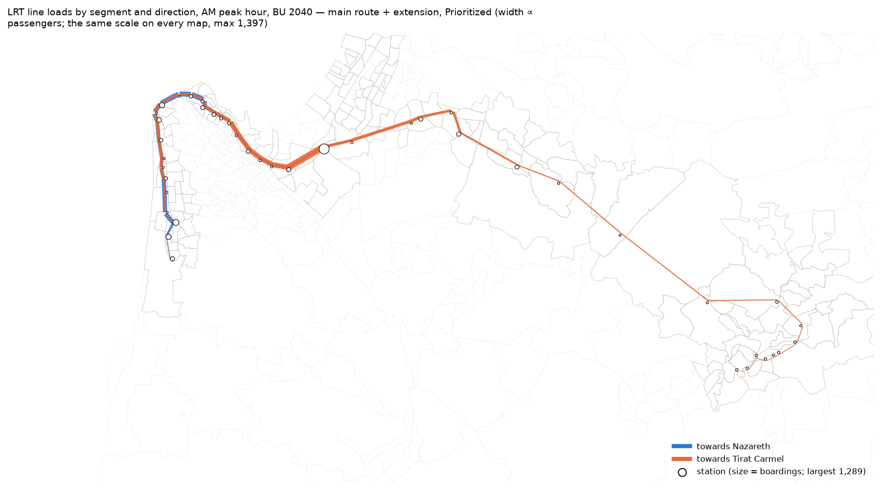
Figure 4.12 — LRT line loads and station boardings in the AM peak hour, 2040 BU, main route + extension, Prioritized.
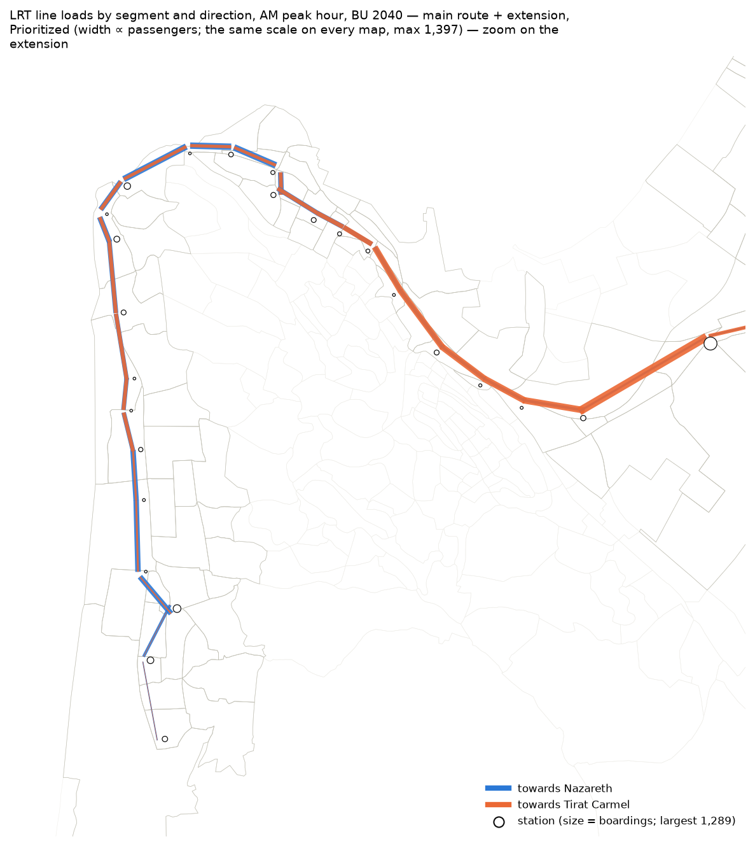
Figure 4.12z — The same map, zoom on the extension.
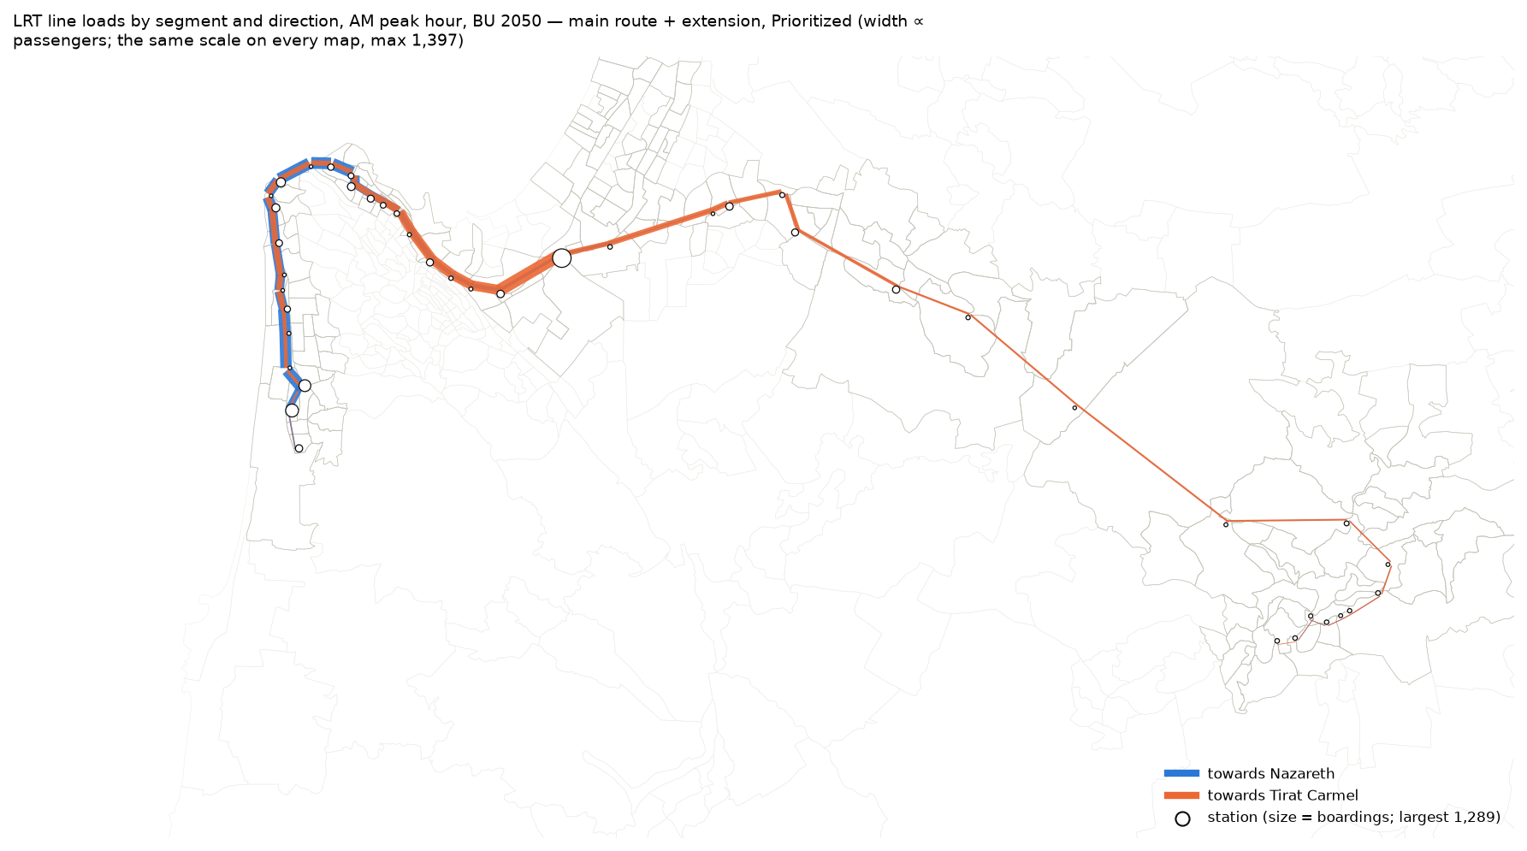
Figure 4.13 — LRT line loads and station boardings in the AM peak hour, 2050 BU, main route + extension, Prioritized.
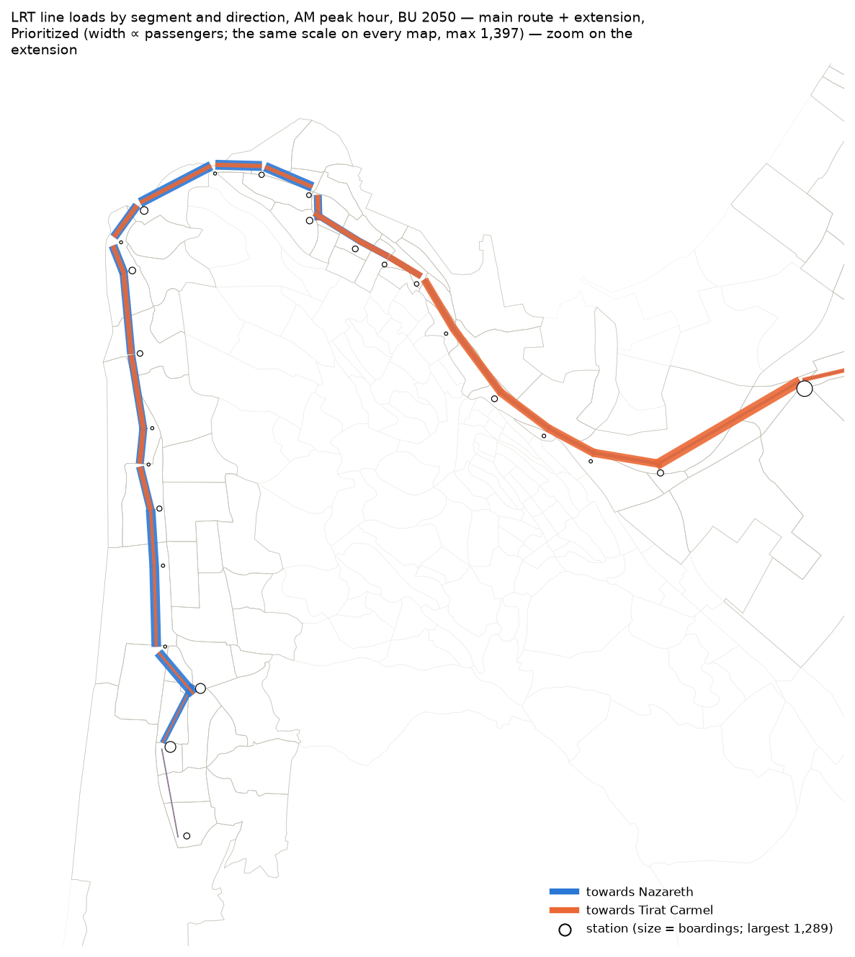
Figure 4.13z — The same map, zoom on the extension.
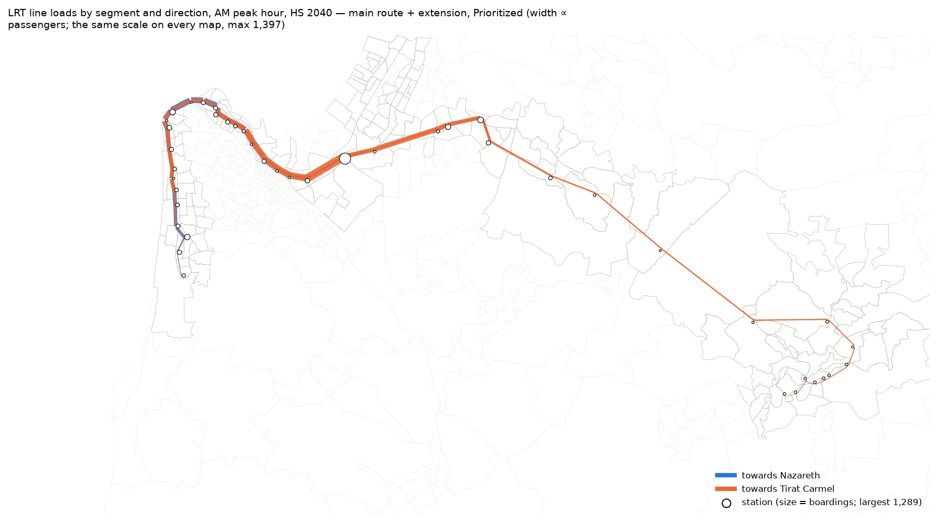
Figure 4.14 — LRT line loads and station boardings in the AM peak hour, 2040 HS, main route + extension, Prioritized.
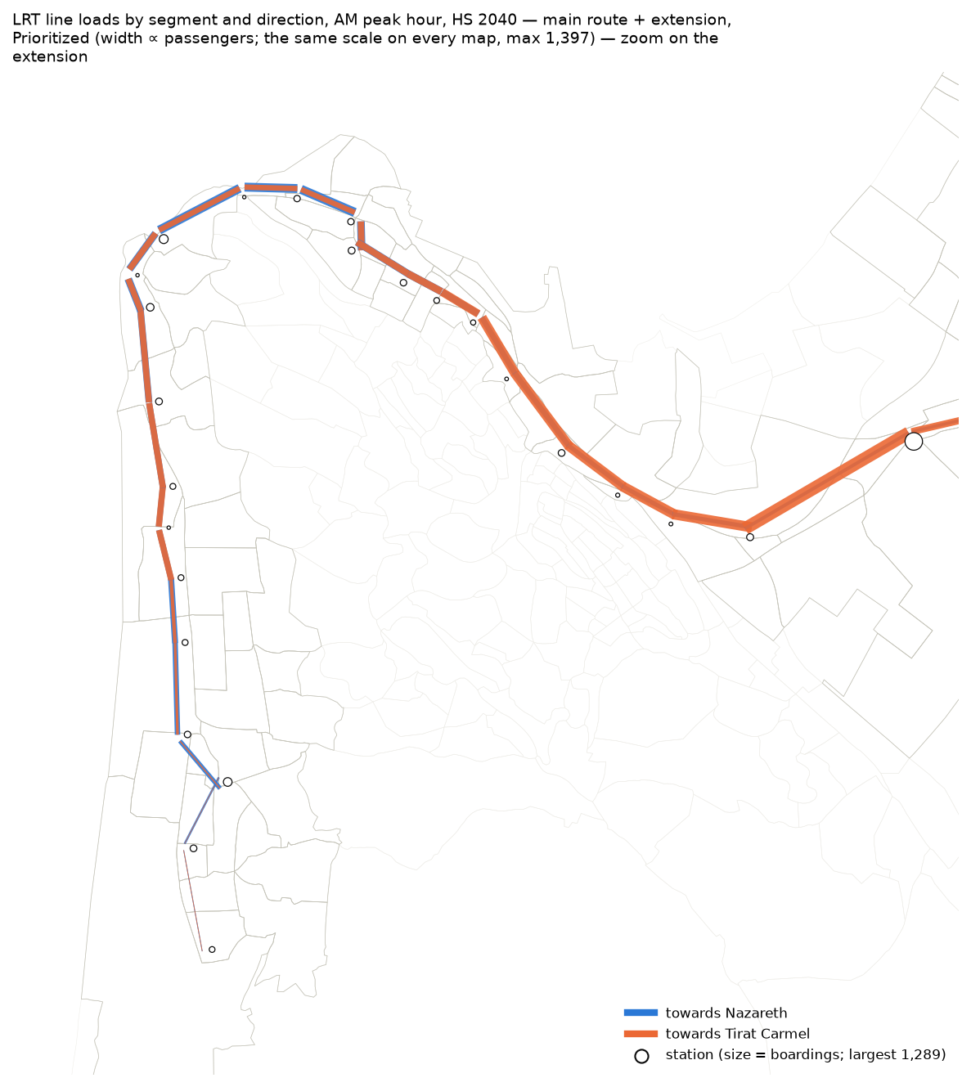
Figure 4.14z — The same map, zoom on the extension.
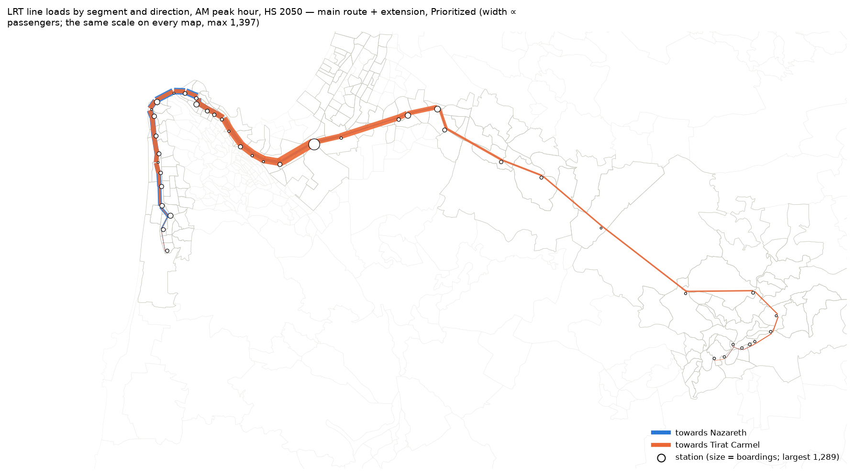
Figure 4.15 — LRT line loads and station boardings in the AM peak hour, 2050 HS, main route + extension, Prioritized.
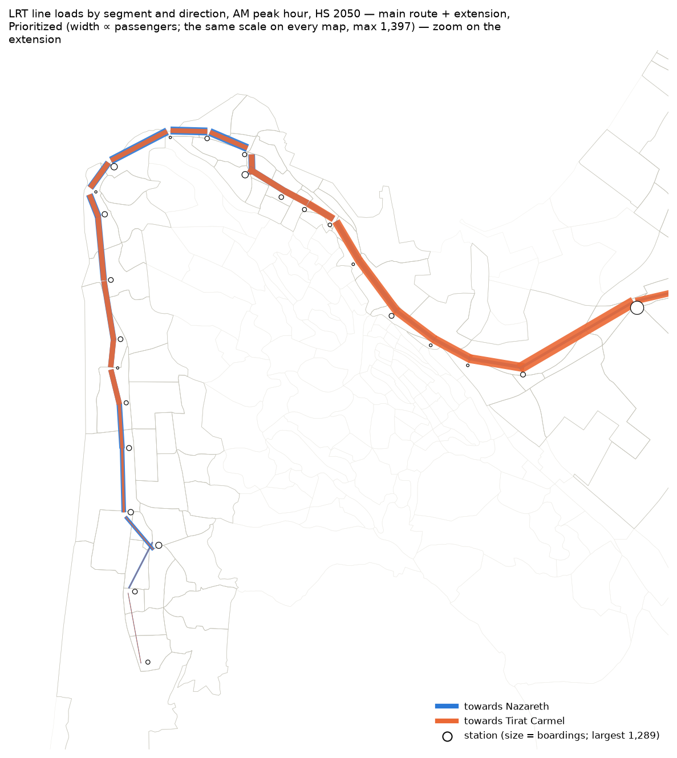
Figure 4.15z — The same map, zoom on the extension.
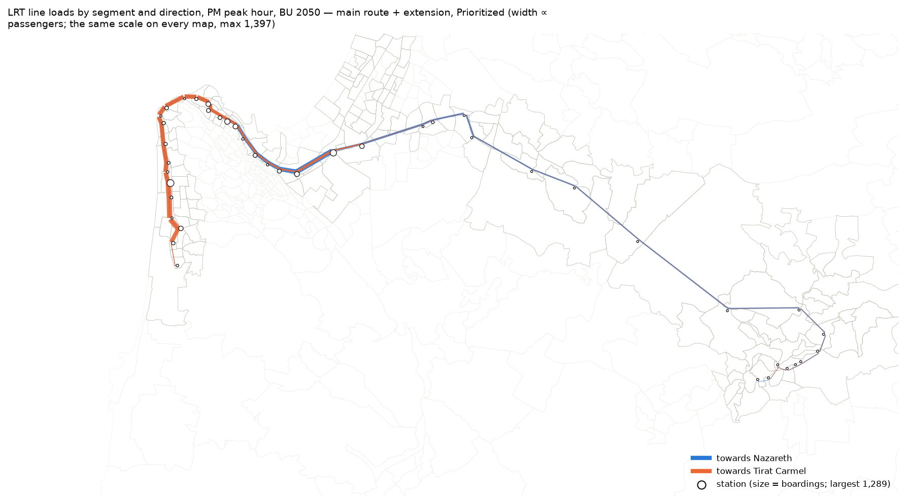
Figure 4.16 — The same for the PM peak hour, 2050 BU.
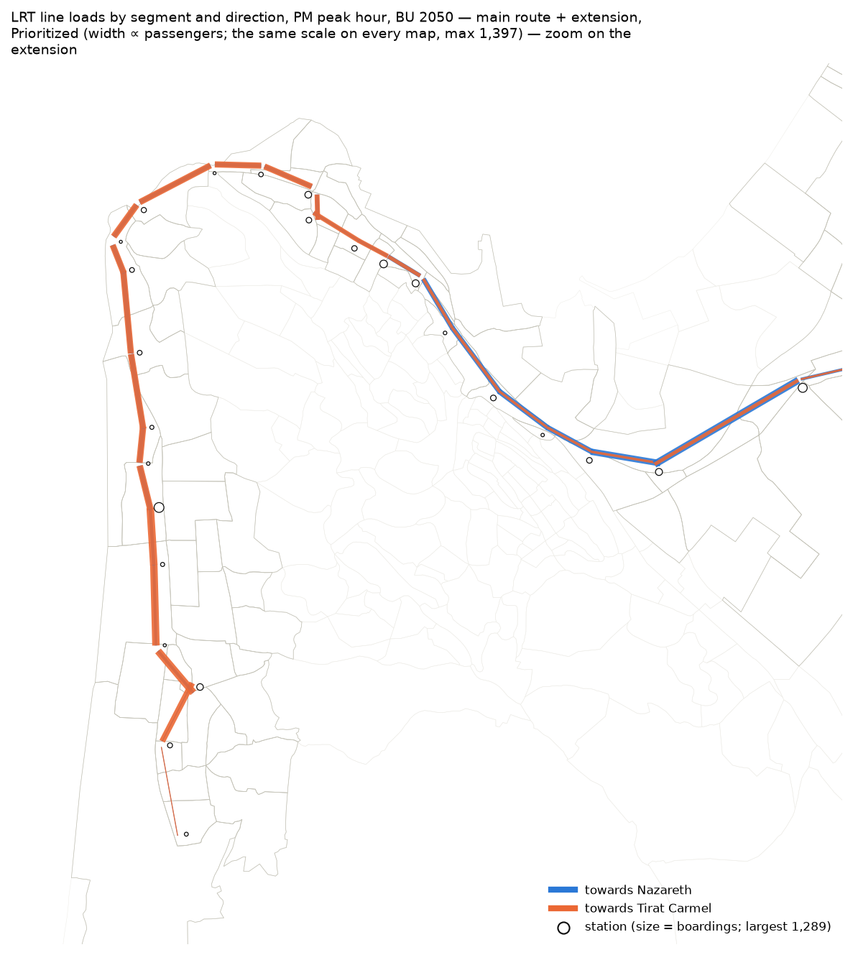
Figure 4.16z — The same map, zoom on the extension.
The growth of the origins of the LRT trips by TAZ, from 2022 to each scenario: one map for each scenario, with one colour scale.
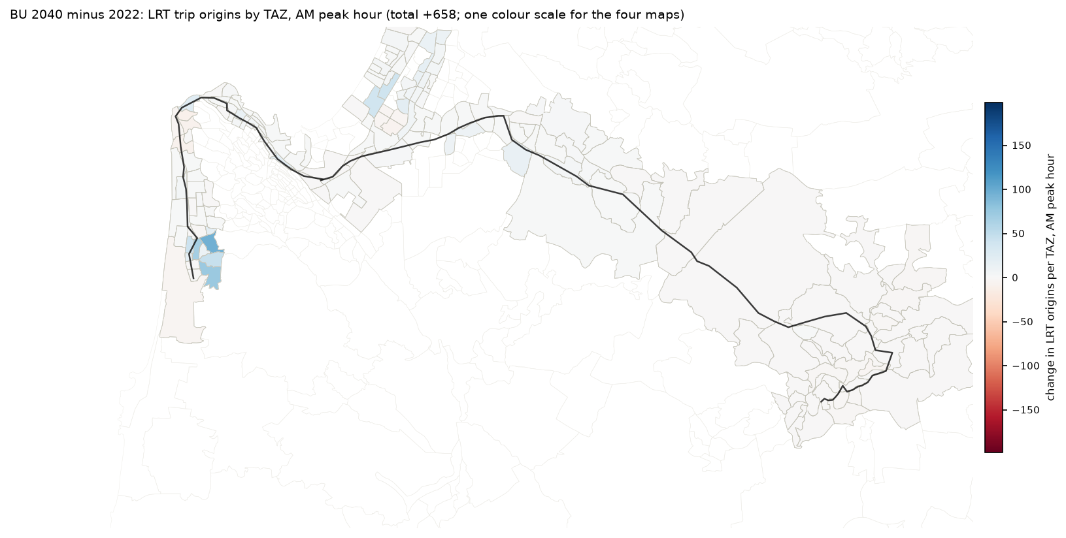
Figure 4.17 — Growth of the origins of the LRT trips by TAZ, 2022 → 2040 BU, AM peak hour.
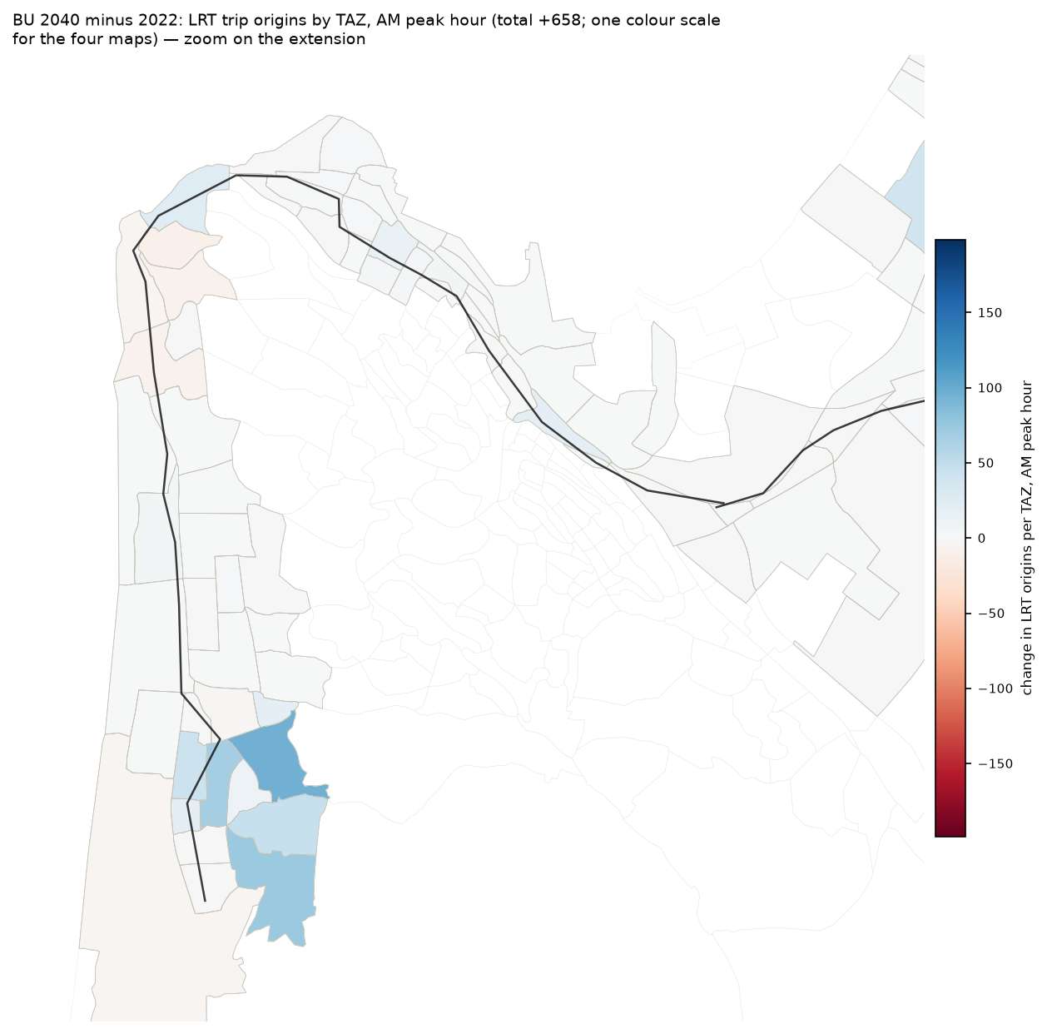
Figure 4.17z — The same map, zoom on the extension.
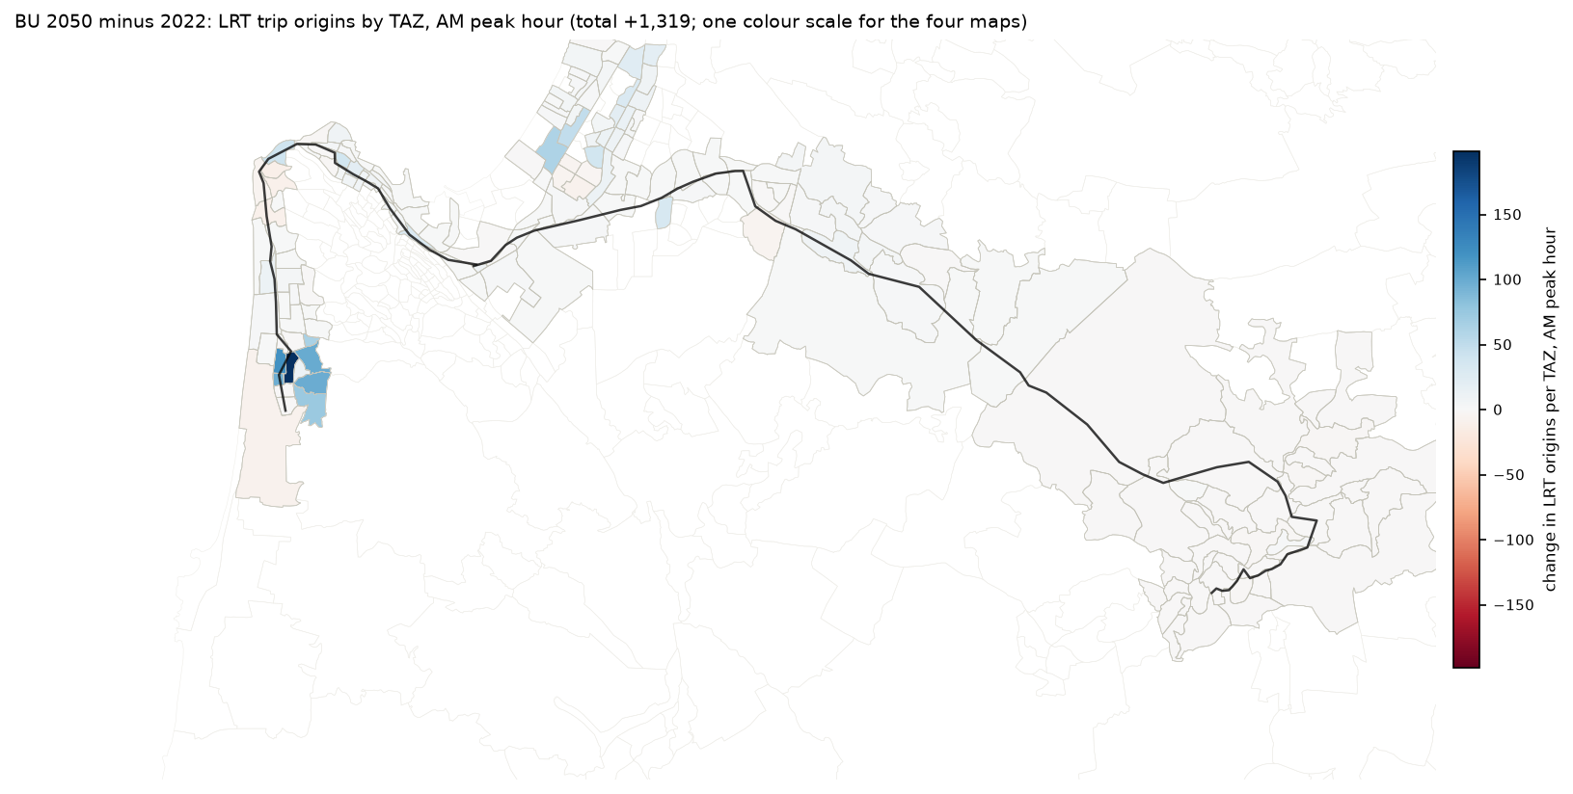
Figure 4.18 — Growth of the origins of the LRT trips by TAZ, 2022 → 2050 BU, AM peak hour.
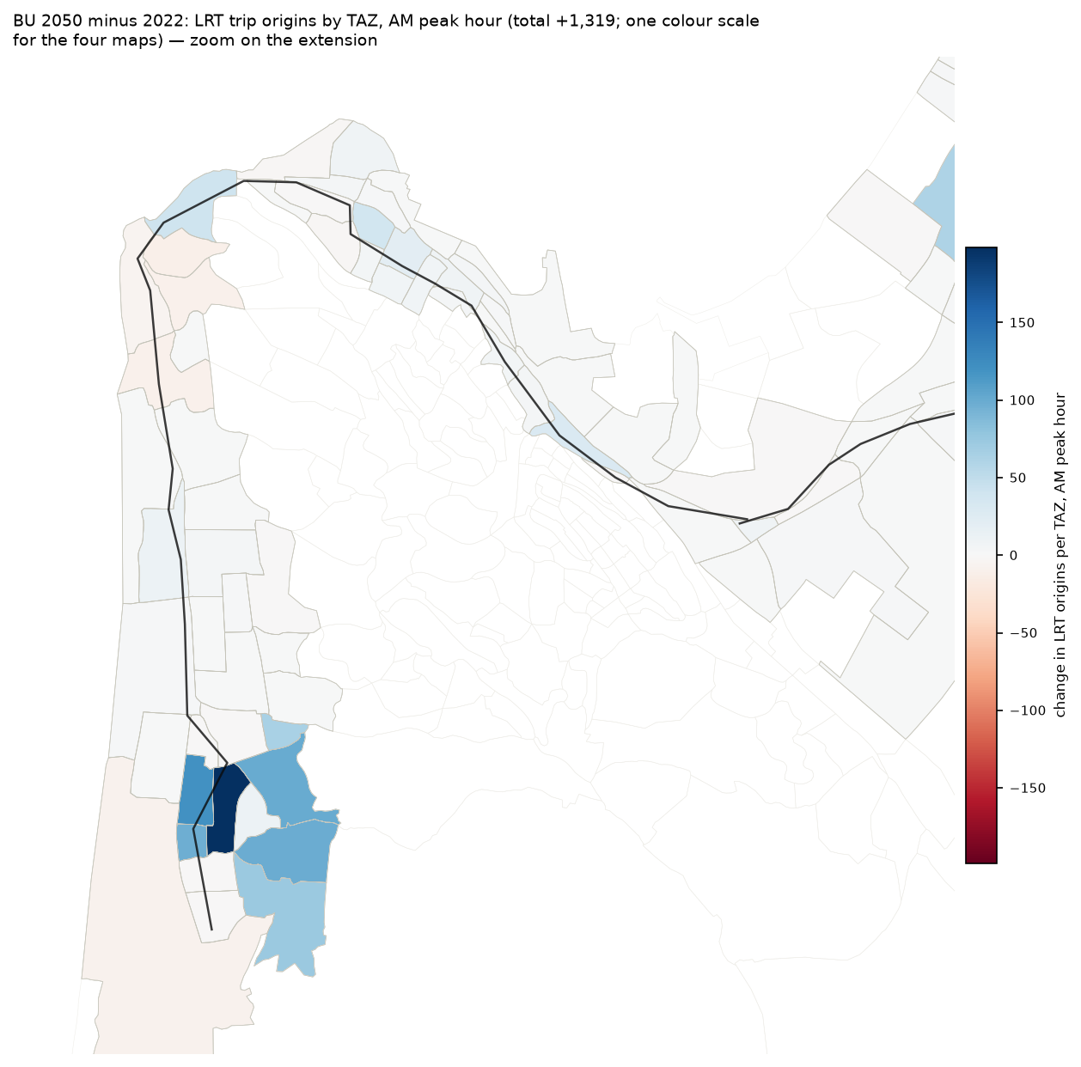
Figure 4.18z — The same map, zoom on the extension.
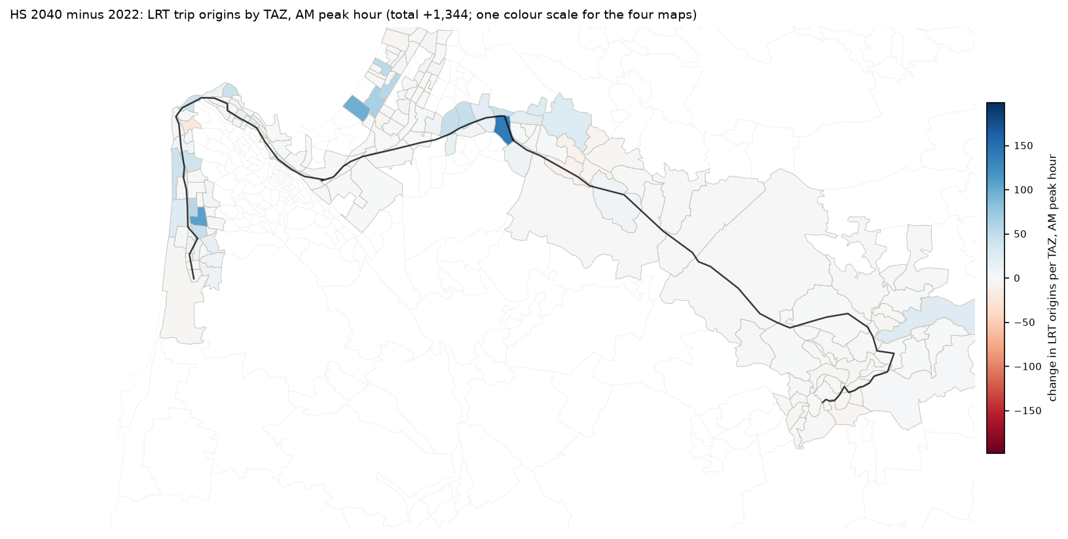
Figure 4.19 — Growth of the origins of the LRT trips by TAZ, 2022 → 2040 HS, AM peak hour.
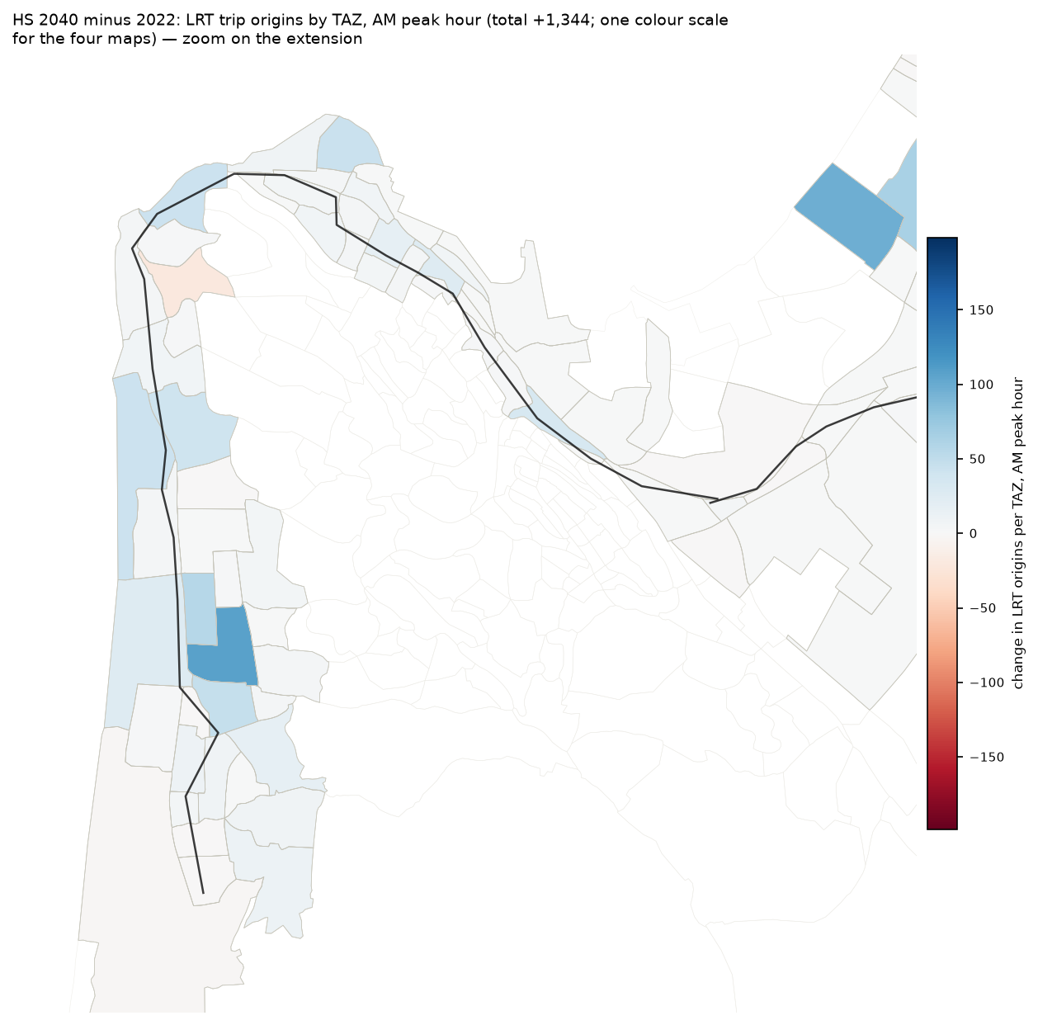
Figure 4.19z — The same map, zoom on the extension.
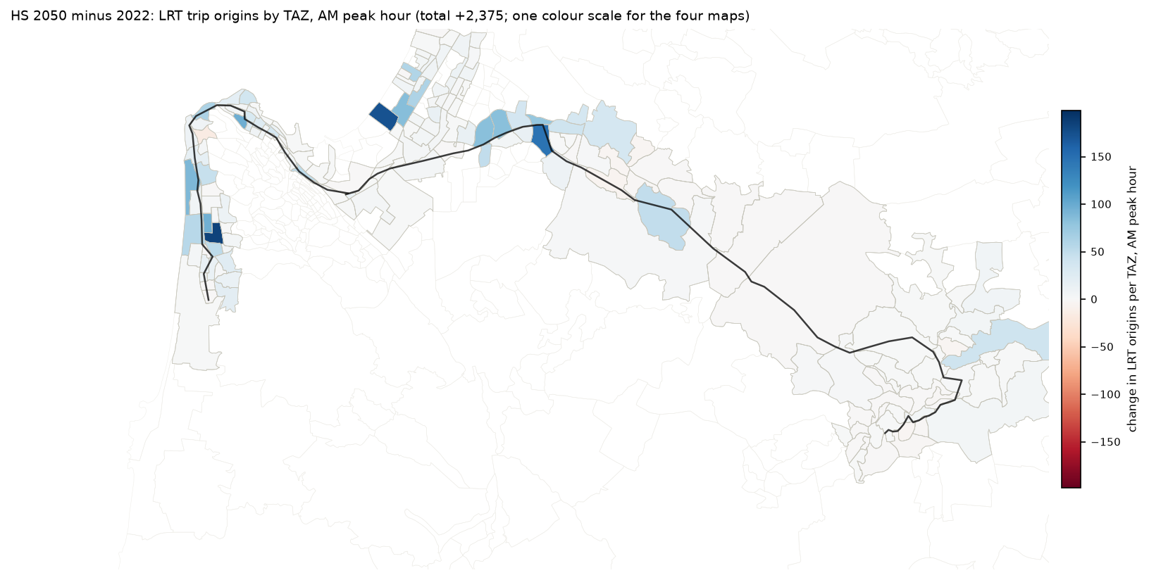
Figure 4.20 — Growth of the origins of the LRT trips by TAZ, 2022 → 2050 HS, AM peak hour.
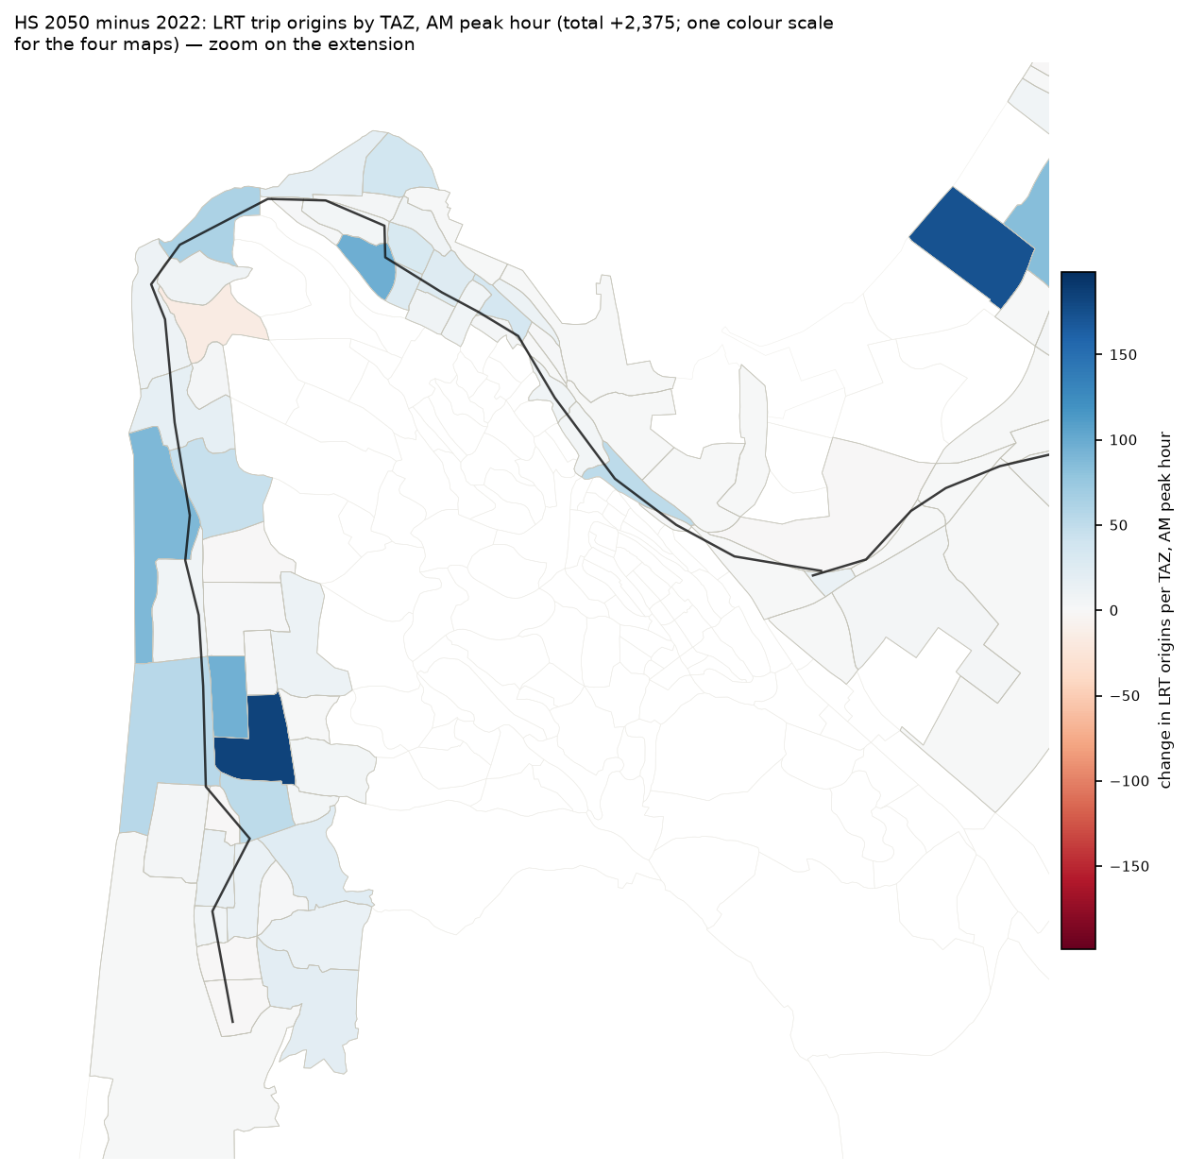
Figure 4.20z — The same map, zoom on the extension.
The sources of the LRT trips by origin TAZ in the reference scenario, one map for each source. The bus map and the Metronit map have one colour scale. The car map has its own scale (its values are an order of magnitude smaller).
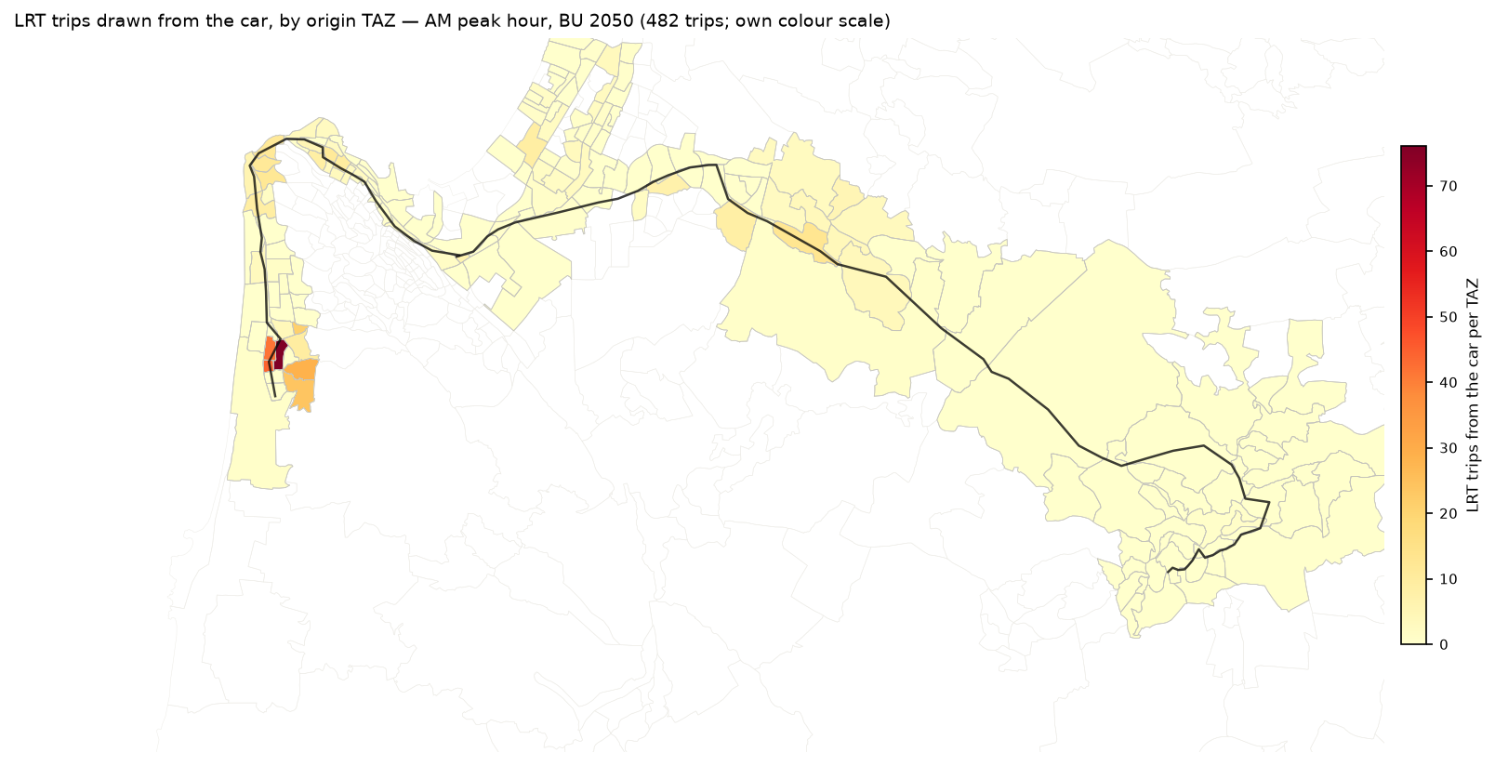
Figure 4.21 — LRT trips from the car by origin TAZ, 2050 BU, AM peak hour.
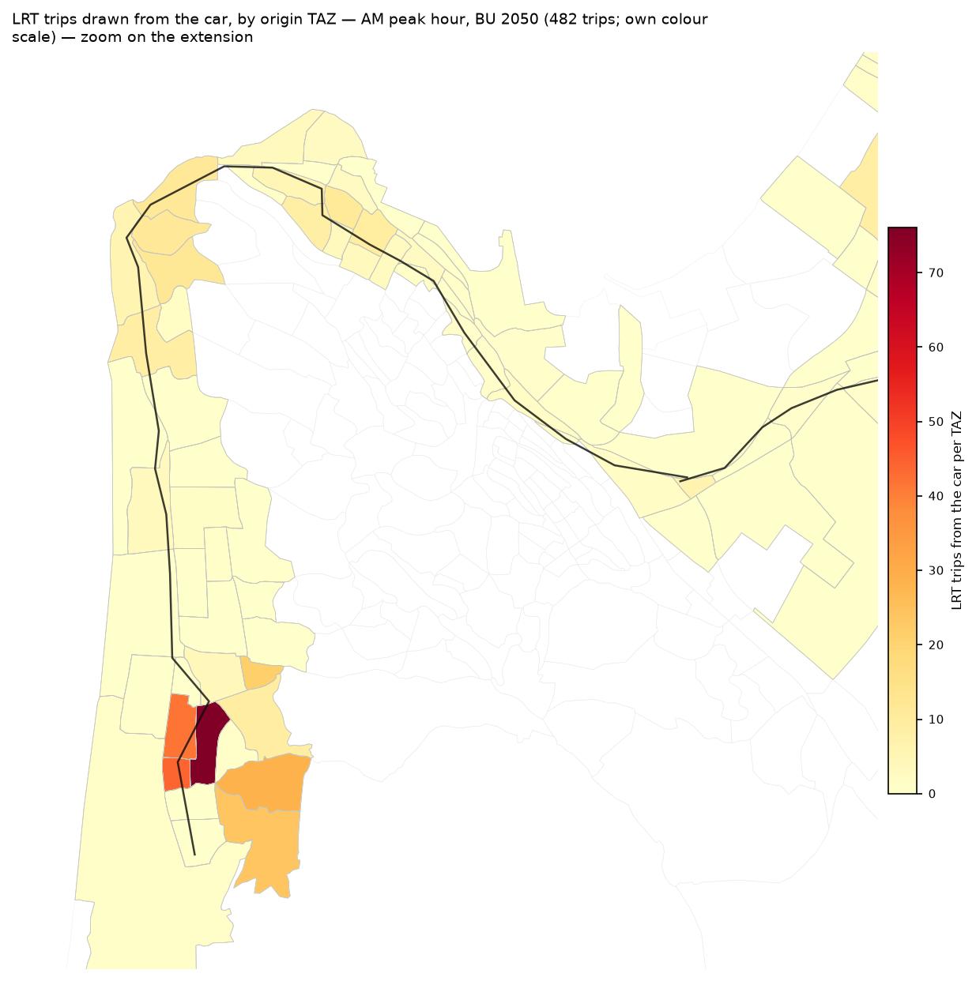
Figure 4.21z — The same map, zoom on the extension.
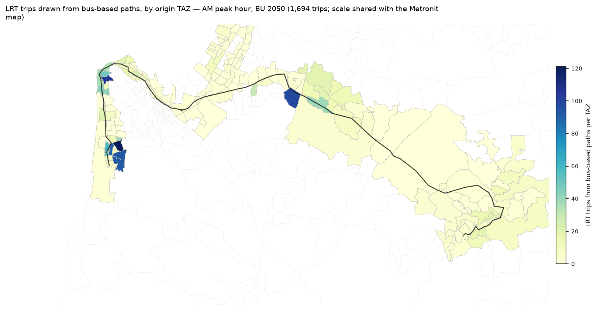
Figure 4.22 — LRT trips from bus paths by origin TAZ, 2050 BU, AM peak hour.
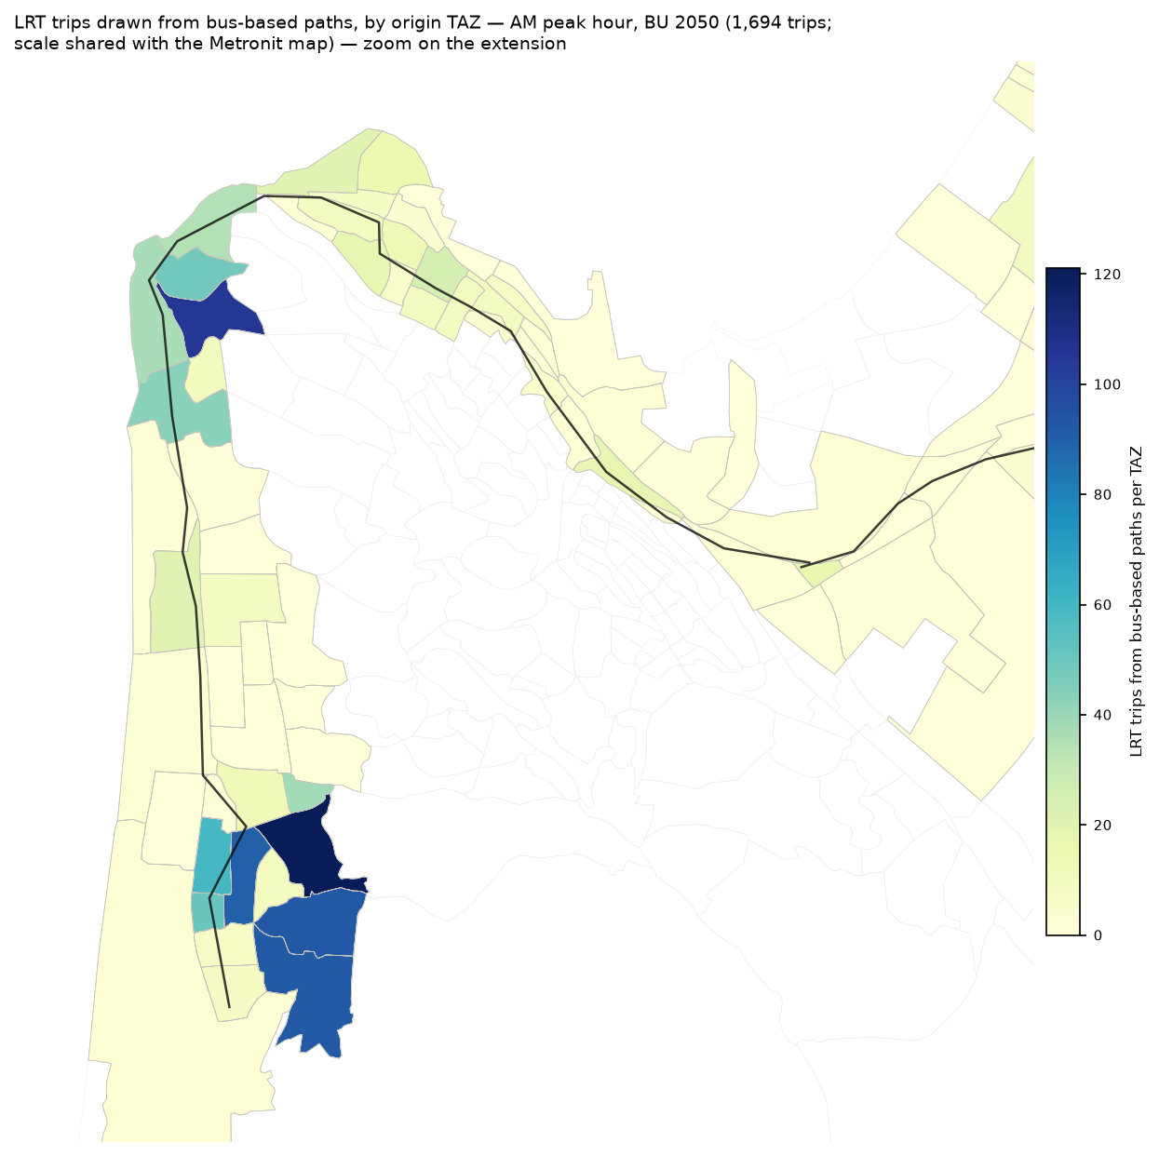
Figure 4.22z — The same map, zoom on the extension.
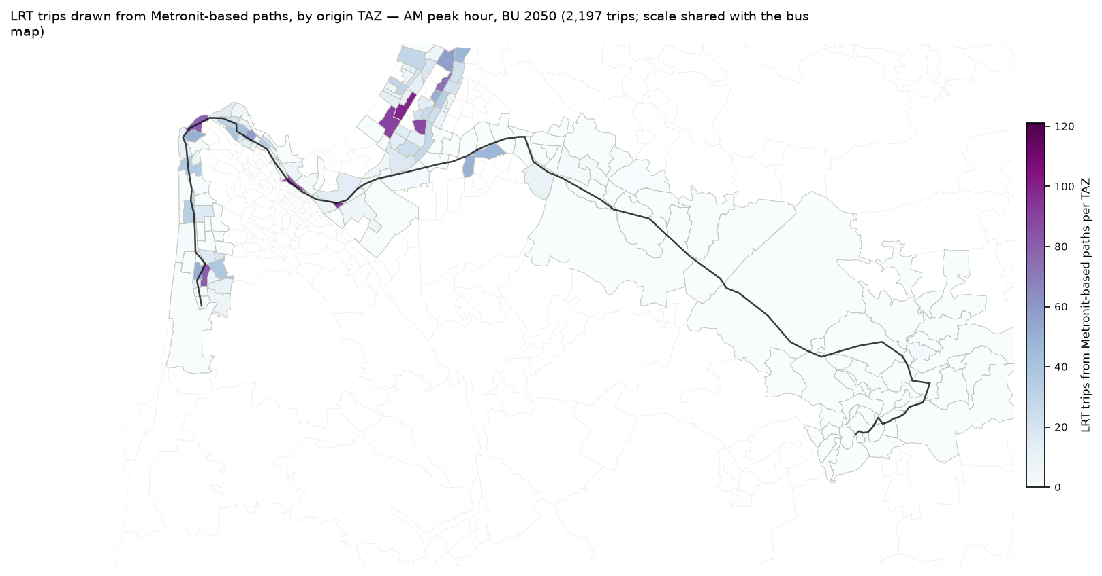
Figure 4.23 — LRT trips from Metronit paths by origin TAZ, 2050 BU, AM peak hour.
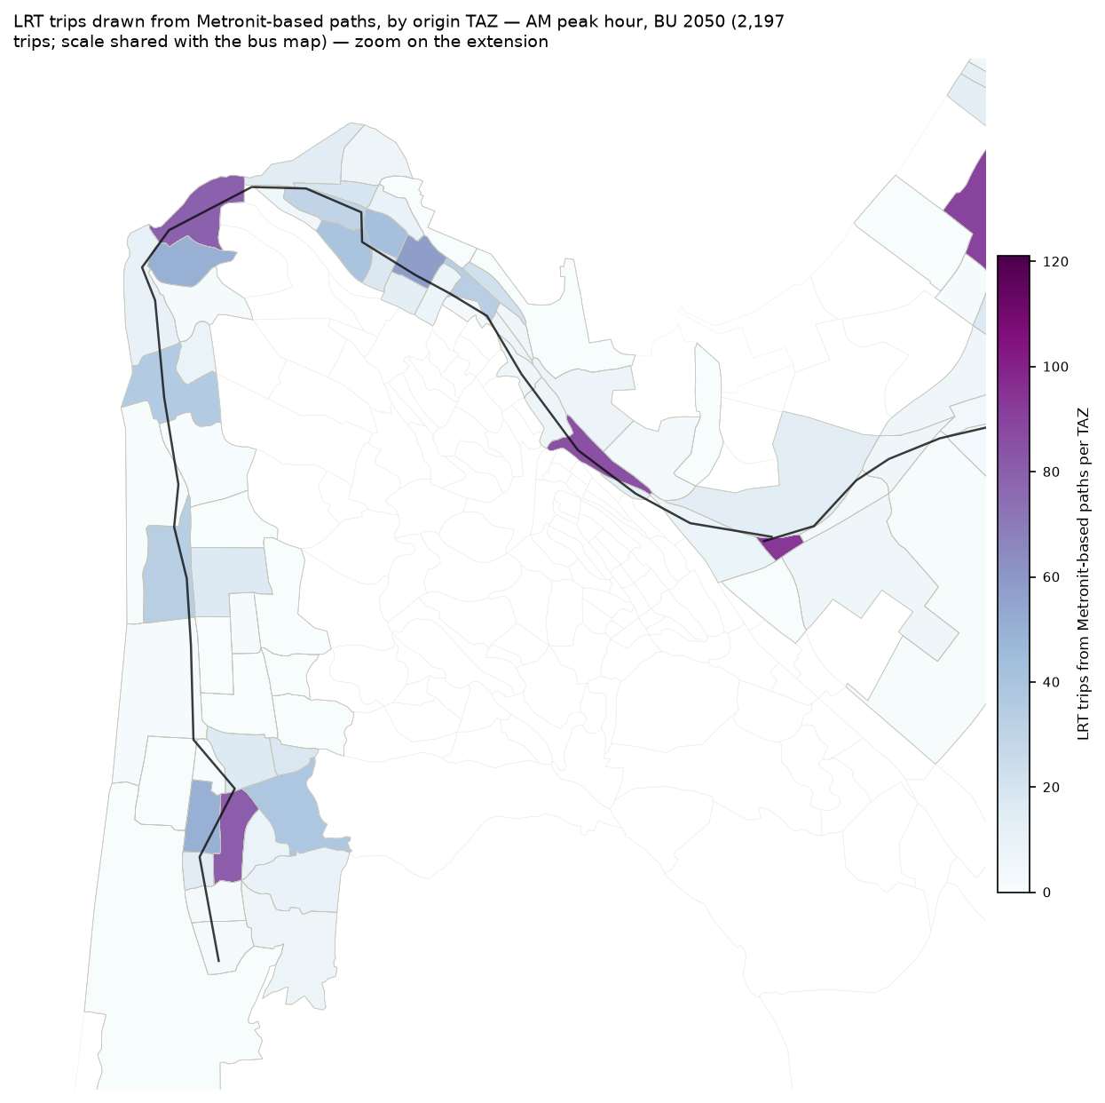
Figure 4.23z — The same map, zoom on the extension.
The generalized cost to the reference destination, the TAZ of the busiest LRT exit station. The maps show the best bus or Metronit path today and the LRT, with one colour scale, then their difference.
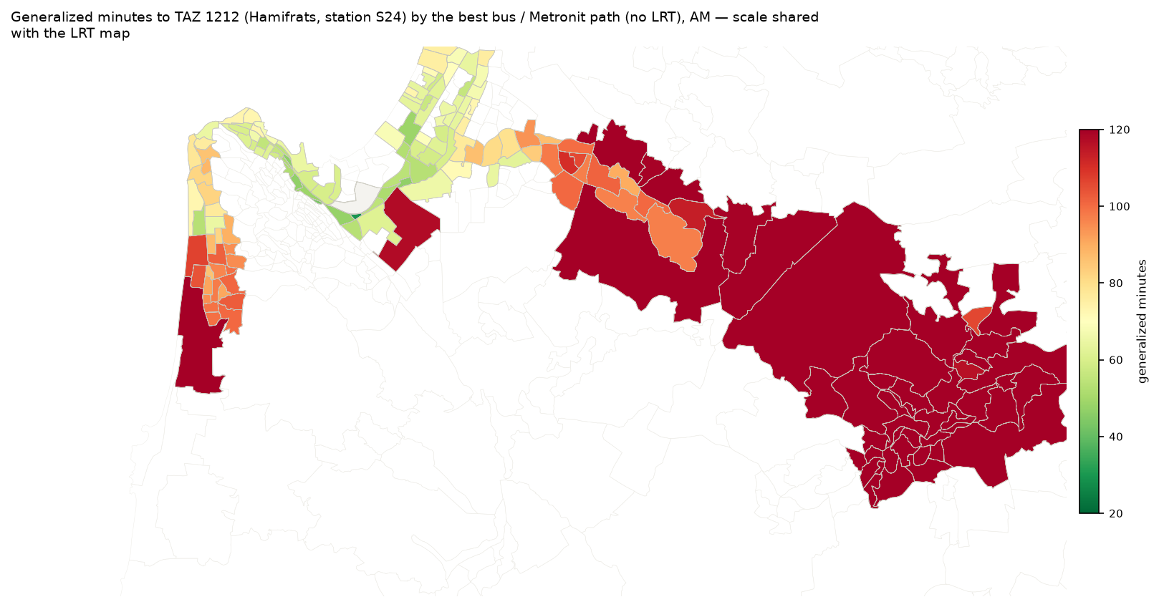
Figure 4.24 — The best bus or Metronit path, without the LRT: felt minutes from each TAZ, AM.
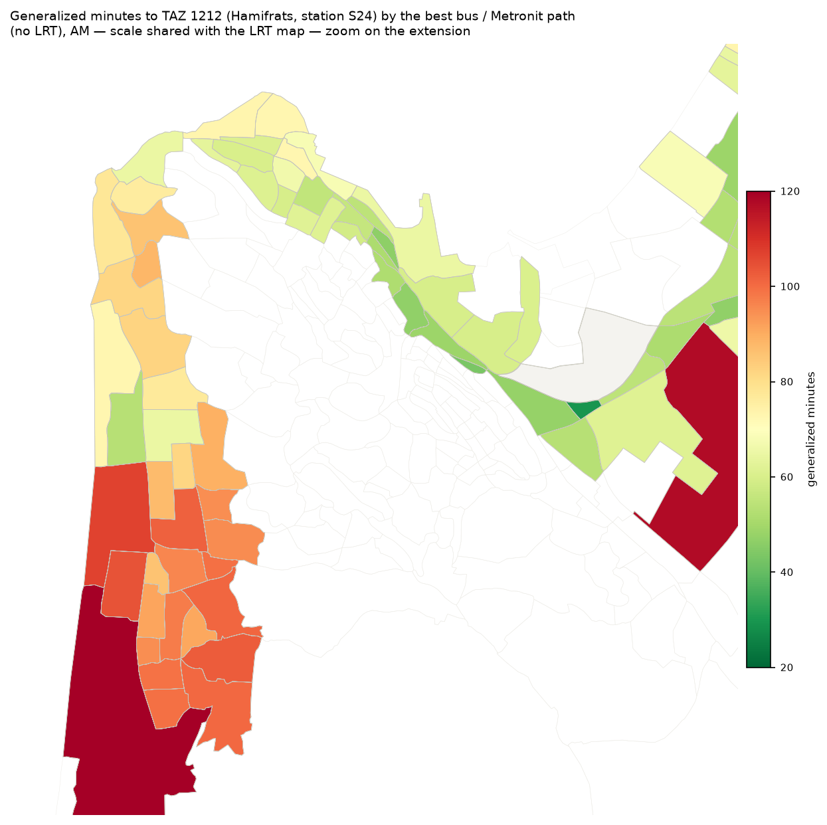
Figure 4.24z — The same map, zoom on the extension.
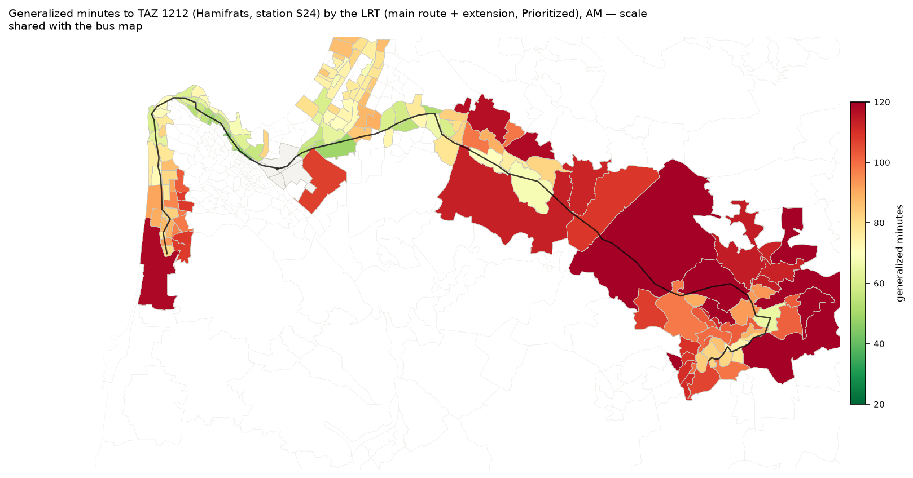
Figure 4.25 — The LRT, main route + extension, Prioritized: felt minutes from each TAZ, AM.
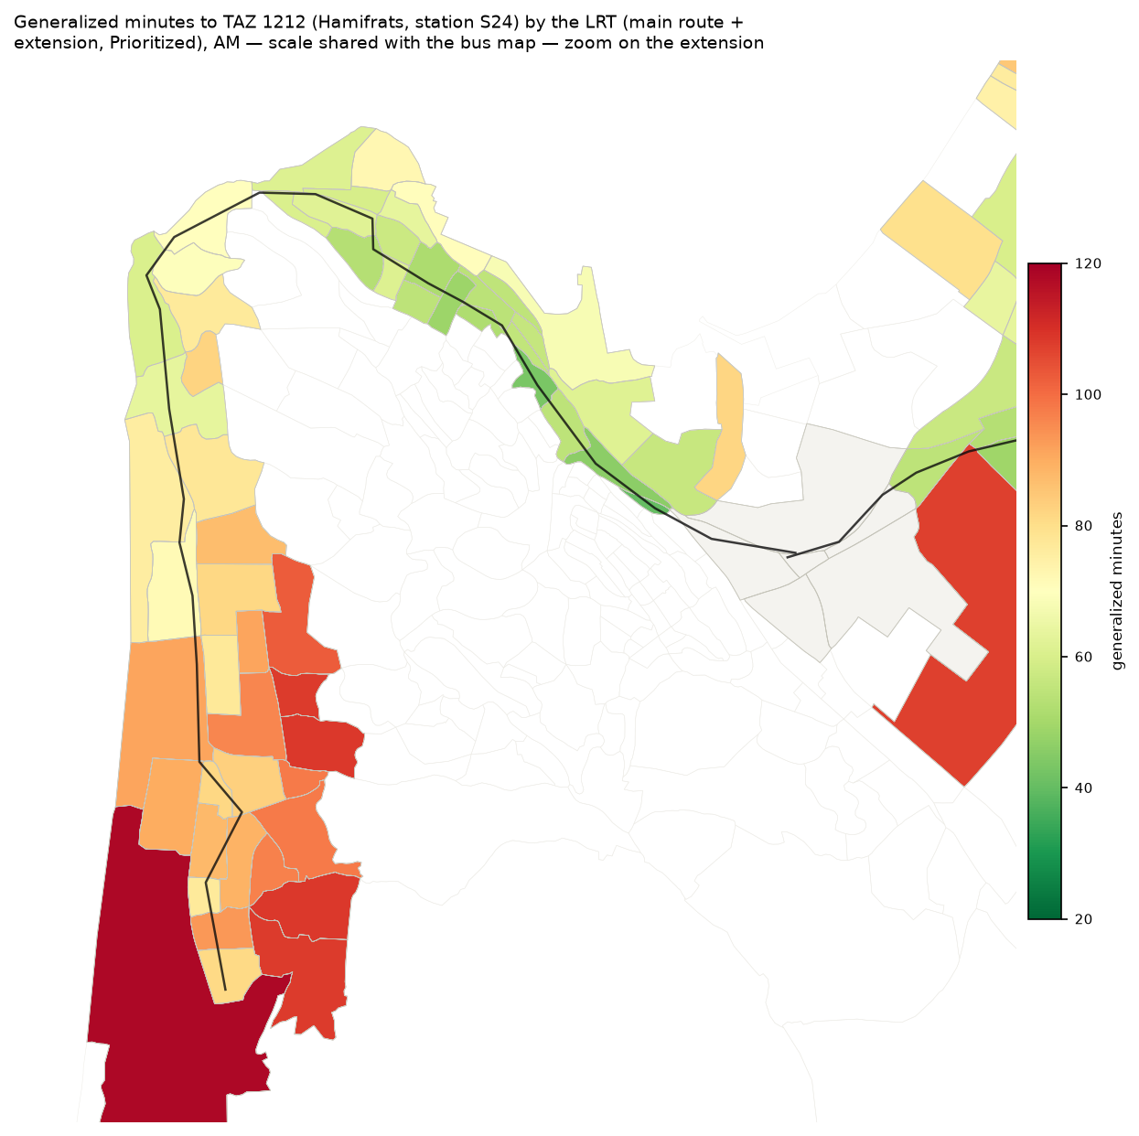
Figure 4.25z — The same map, zoom on the extension.
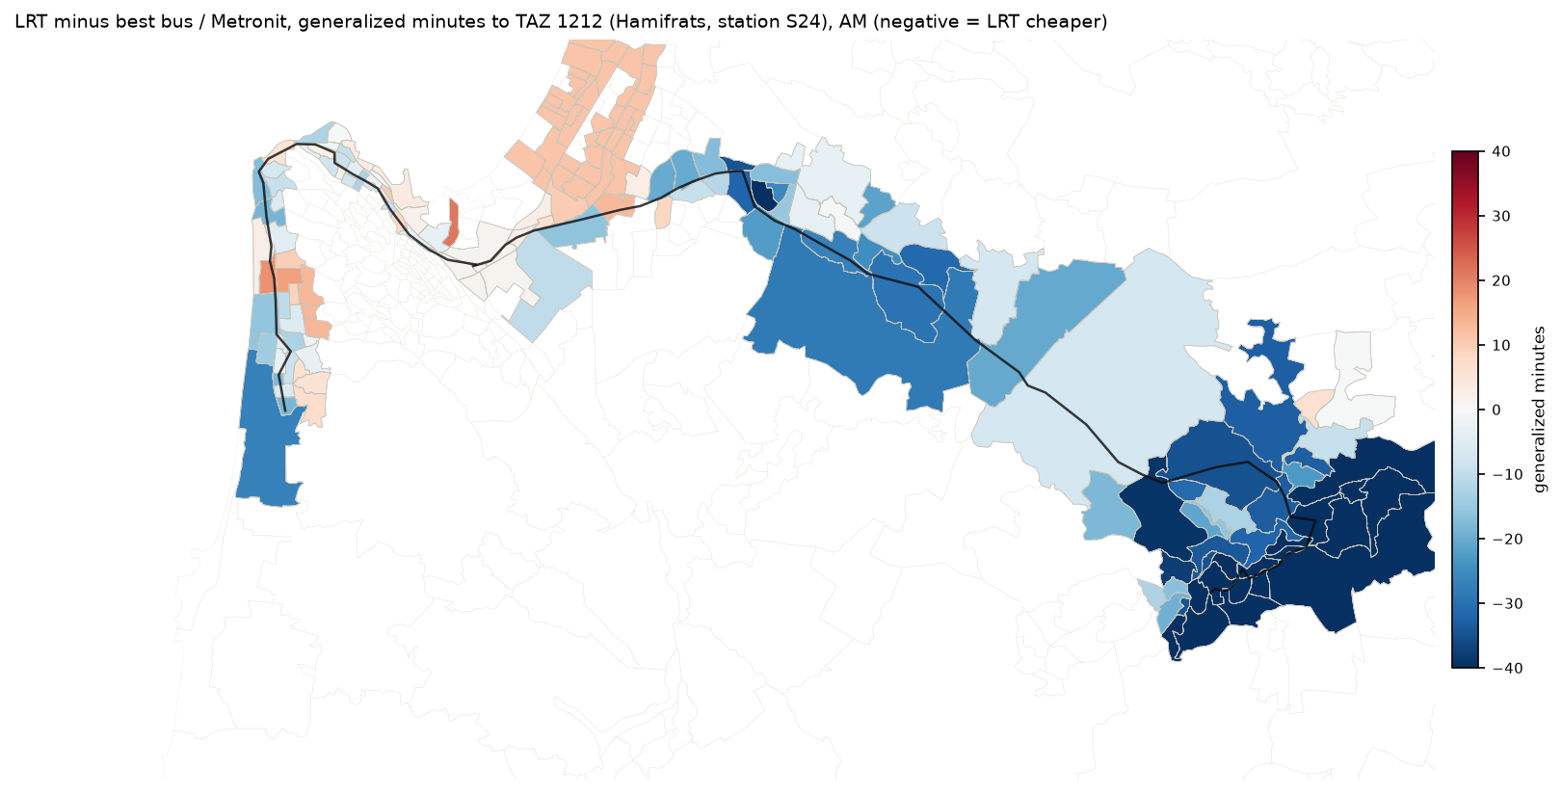
Figure 4.26 — The LRT minus the bus (negative = the LRT is cheaper): felt minutes from each TAZ, AM.
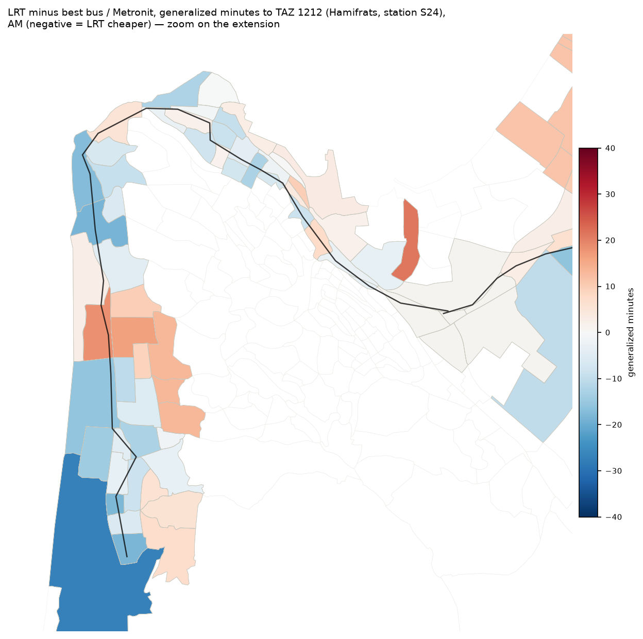
Figure 4.26z — The same map, zoom on the extension.

5. Conclusions
- Reference case. 2050 BU: 7,433 LRT passengers in the three AM hours (4,378 in the peak hour). The range for the plan is 5,532–10,537 with the cost sensitivity. 6,003 passengers use the extension, against 5,939 if the extension stops at Hamifrats. Three markets have almost the same size (Tirat Carmel ↔ Haifa, inside Haifa, the Krayot with a feeder). The maximum load is 1,071 for each hour and direction at the entry to Hamifrats.
- Demand. The through line carries 6,309 trips in the three AM hours in 2040 BU and 9,225 in 2050 HS. The PM is approximately 85 % of the AM. 81 % of the trips use the extension. The extension is where most passengers of the line are. The main route feeds the extension, not the opposite.
- Sources. The LRT is first a new organisation of public transport. 3,308–4,548 trips come from the Metronit (approximately a third of its corridor trips). 2,648–3,365 come from the bus, and 353–1,311 from the car (approximately one percent of the car trips on the corridor). The public transport share of the corridor market increases by approximately one point. The LRT takes approximately a third to two fifths of public transport.
- Profile. In the AM, the busiest segment is the entry to Hamifrats from the main route (S24–M02), direction Tirat Carmel. It carries approximately 1,000 to 1,400 passengers in the peak hour. In the direction Nazareth, the maximum is on the Carmel coast (S14–S15, 770–1,050). In the PM, the two directions are almost in balance. The main route after Kiryat Ata carries some hundreds in each direction, and the extension carries four of each five passengers.
- Growth. Between 2040 BU and 2050 HS, the LRT demand increases by approximately 45 %. This is the rate of the public transport market on the corridor, because the forecast keeps the behaviour of 2022. The high scenario adds 15–25 % to the BU scenario in the same year.
- Regime. Priority at the junctions is worth approximately 20–25 % of the LRT trips. A run at street level increases the time on the extension from 41 to 66 minutes. It loses approximately a quarter of the passengers, most of them on the extension.
- Robustness. The central numbers are in a range of approximately −25 % / +40 % from the cost sensitivity and the LRT premium alone. The level of service stays at May 2026 in each year, and slower buses give the LRT 2–5 % more in the AM. Thus the central case is conservative for the LRT. The shift from the car is the least certain part (caveats 15, 25, 27, 29); read it as an order of magnitude. The shifts from the bus and from the Metronit depend on observed shares and measured service; they are the solid part.
- Use. The results support the size and the location of the extension market, the rank of the regimes and the scale of the trunk load. They do not support decisions on capacity, fleet or frequency, or an economic appraisal, without a validated assignment and a full mode choice model. The next steps are:
- A split of the survey by purpose.
- A specific forecast for the PM.
- The operation plan of the main route.
- A decision about the future of the Metronit.
- A λ for car owners from a source that has the car cost.
Documentation: METHODOLOGY.md chapter 6aq (step 45) and chapter 8; docs/PLAIN_ENGLISH_METHODOLOGY.md part 5; the full English report reports/Nofit_LRT_Extension_Comprehensive_Report.docx; the builder of this report tools/build_comprehensive_report_ste.py.

Appendix A. Calibration of the speed and time function of the light rail
This appendix answers four questions. Where do the run times of the planned line come from? Why did we measure them on the Red Line in Tel Aviv? How did we move the measurement to the Haifa alignment? What do the two regimes of the report (Prioritized and Unprioritized) mean in minutes?

A.1 Why a calibrated function
Because the extension has no timetable yet, the model needs a rule that changes the distance between two stations into minutes. The usual short cut is a design speed. This short cut misses the part of a light rail trip that is not a run. This part is the deceleration, the stop at the platform, the acceleration, and the wait at the road junctions. These minutes decide if the LRT is faster than the bus on a given pair. Thus the study measured them on a light rail in operation in Israel; it did not assume them.
We selected the Red Line in Tel Aviv (operator 22, lines 34447 and 34448). One line operates in the two conditions that the study needs. The first condition is a separated, underground core through Tel Aviv, and the second is a section at street level at each end. The same vehicles and the same operator in the two conditions give two consistent measurements. One is for a line that does not wait at junctions. The other is for a line that operates with the street.

A.2 The data and the cleaning
The vehicle location records of the operator give the time when each tram got to each stop. The extract has 1,078,845 stop records on 132 Thursdays between May 2023 and September 2026. We keep a journey only when it is complete (all 31 stops in sequence). Each stop-to-stop time must be plausible: more than zero and not more than 10 minutes. The result is 26,653 clean journeys and 799,590 stop-to-stop sections: 239,877 underground and 559,713 at the surface.
A section is underground only when its two stations are underground. A section with one surface station counts as a surface section. This is the cautious choice, because the portal sections have a part of the street delay.
Item | Value
Source | Vehicle location records of operator 22, lines 34447 / 34448
Days | 132 Thursdays, 25 May 2023 to 10 September 2026 (in practice 2024–2026: no journey of 2023 passes the completeness test)
Raw records | 1,078,845 stop records in 36,939 journeys
Kept | 26,653 complete, clean journeys; 799,590 stop-to-stop sections
Underground rule | the two stations of the section are in the list of 11 underground stations
Quality rule | each section time is more than 0 and not more than 10 minutes
Table A.1 — The calibration sample.

A.3 The measurement
The calibration is a mean: the minutes that a tram takes, on average, from one stop to the next stop, in each regime. The model needs the mean (the expected time of many trips), not the typical time. Thus we use the mean and not the median.
Underground: 1.961 minutes for each section (95 % interval 1.958–1.963). Surface: 2.393 minutes for each section (2.390–2.395).
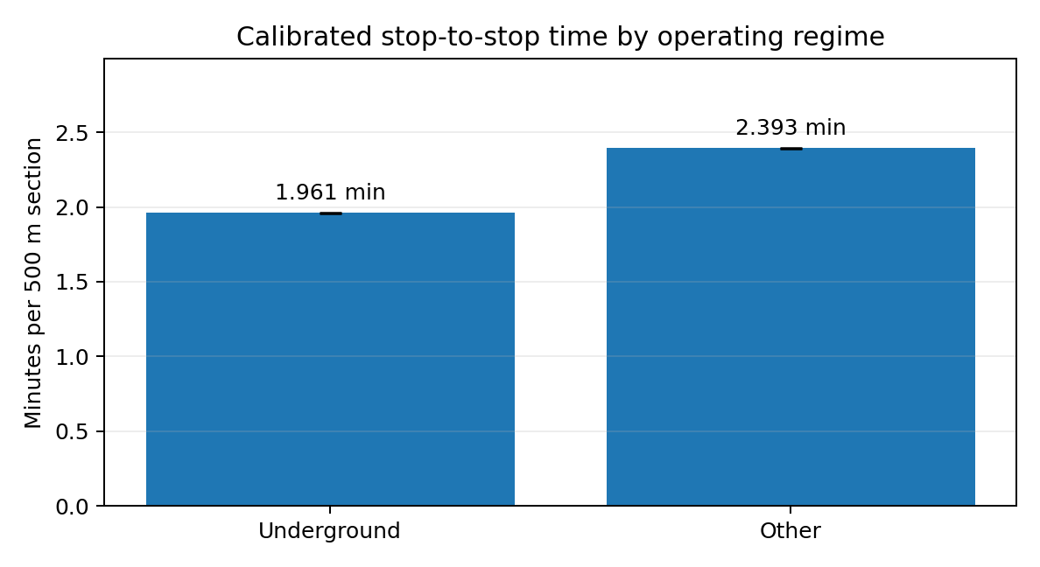
Figure A.1 — Mean stop-to-stop time by regime on the Red Line. The error bars (the 95 % intervals) are too small to see at this scale. Source: the calibration report, figure 1.
The check that the rule is correct: a complete journey on the Red Line has 9 underground sections and 21 surface sections. Thus the rule gives 9 × 1.961 + 21 × 2.393 = 67.9 minutes. The observed mean is 67.9 minutes by construction. The important item is the spread around it. The typical error for one journey is 3.7 minutes (5.5 %). The two directions differ by approximately one minute (68.9 to one end, 66.8 to the other end).
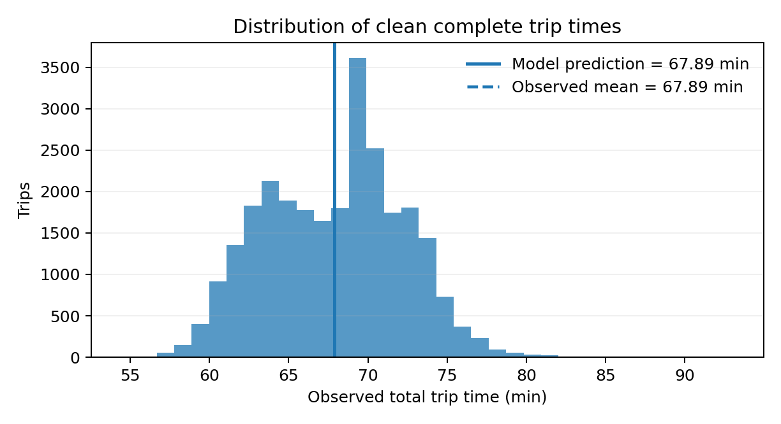
Figure A.2 — Observed end-to-end times of the 26,653 clean journeys against the 67.9 minutes of the rule. Source: the calibration report, figure 3.
Year | Underground, min for each section | Surface, min for each section | Journeys
2024 | 2.007 | 2.528 | 9,482
2025 | 1.946 | 2.365 | 10,752
2026 | 1.919 | 2.240 | 6,419
all years (used) | 1.961 | 2.393 | 26,653
Table A.2 — The same means by year. The operation became faster each year. The study uses the pooled value. This value is 2–6 % slower than 2026 alone, thus a little cautious.

A.4 From the Red Line to Haifa: the correction for the station spacing
A time for each section is useful only if we know the length of a section. The calibration report changed its minutes into speeds with an assumption of 500 metres between stops (15.3 km/h underground, 12.5 km/h at the surface). The timetable of the Red Line gives the distance at each stop. It shows that the underground stations are 970 metres apart on average, and the surface stops 577 metres. Thus 1.961 minutes for an underground section is a section at 30 km/h, not at 15 km/h. The 500 m version applied to Haifa (the first revision of the study) made the underground case two times too slow.
Thus the study divided each section time into two parts, with a fit on the 14,477 scheduled sections of the Red Line. The first part is a run time that increases with the distance. The second part is a fixed stop penalty for the deceleration, the dwell and the acceleration. Then each regime gets a scale factor, the ratio of the observed time to the scheduled time. Thus the rule gives the measured means again on the spacing of the Red Line.
Underground: time = 0.94 × (0.81 min + 1.31 min for each km) → 46 km/h between stops plus 49 seconds at each stop.
Surface: time = 1.02 × (1.23 min + 1.94 min for each km) → 31 km/h between stops plus 74 seconds at each stop.
This form applies to each station spacing. On the Haifa extension, the 24 stations are 815 metres apart on average (354 to 1,396 m). A section takes 1.77 minutes in the underground style (27.6 km/h with the stops) and 2.86 minutes at street level (17.1 km/h).
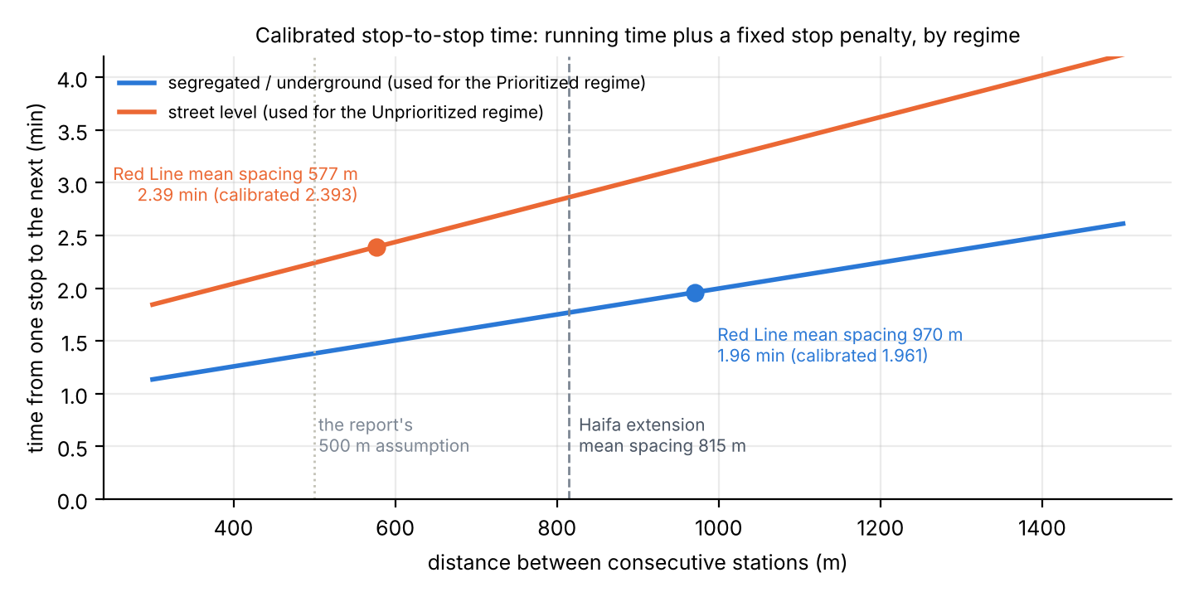
Figure A.3 — The calibrated rule as a function of the station spacing. The dots are the mean spacing of the Red Line; there the rule gives the measured section times. The dashed line is the mean spacing of the Haifa extension. Source: Output/lrt_v2/lrt_calibration_redline_spacing_check.csv.
An example. The first section of the extension, S01 to S02 in Tirat Carmel, is 1,247 metres long. Underground style: 0.94 × (0.81 + 1.31 × 1.247) = 2.30 minutes. Street level: 1.02 × (1.23 + 1.94 × 1.247) = 3.72 minutes. The sum of the 23 sections gives the end-to-end times of the report.
Version of the calibration | Underground style, min S01–S24 | km/h | Street level, min S01–S24 | km/h
Divided form (run time + stop penalty, used) | 40.6 | 27.7 | 65.8 | 17.1
Section form (one calibrated section for each link, for each length) | 45.1 | 24.9 | 55.0 | 20.4
Nominal 500 m form (the speeds of the calibration report; replaced) | 73.5 | 15.3 | 89.7 | 12.5
Table A.3 — End-to-end time of the extension (18.7 km, 24 stations) with the three versions of the calibration. The divided form is the estimate (40.62 min, given as 40.7 in the report). The other two forms are limits. Source: Output/lrt_v2/lrt_end_to_end_summary.csv.
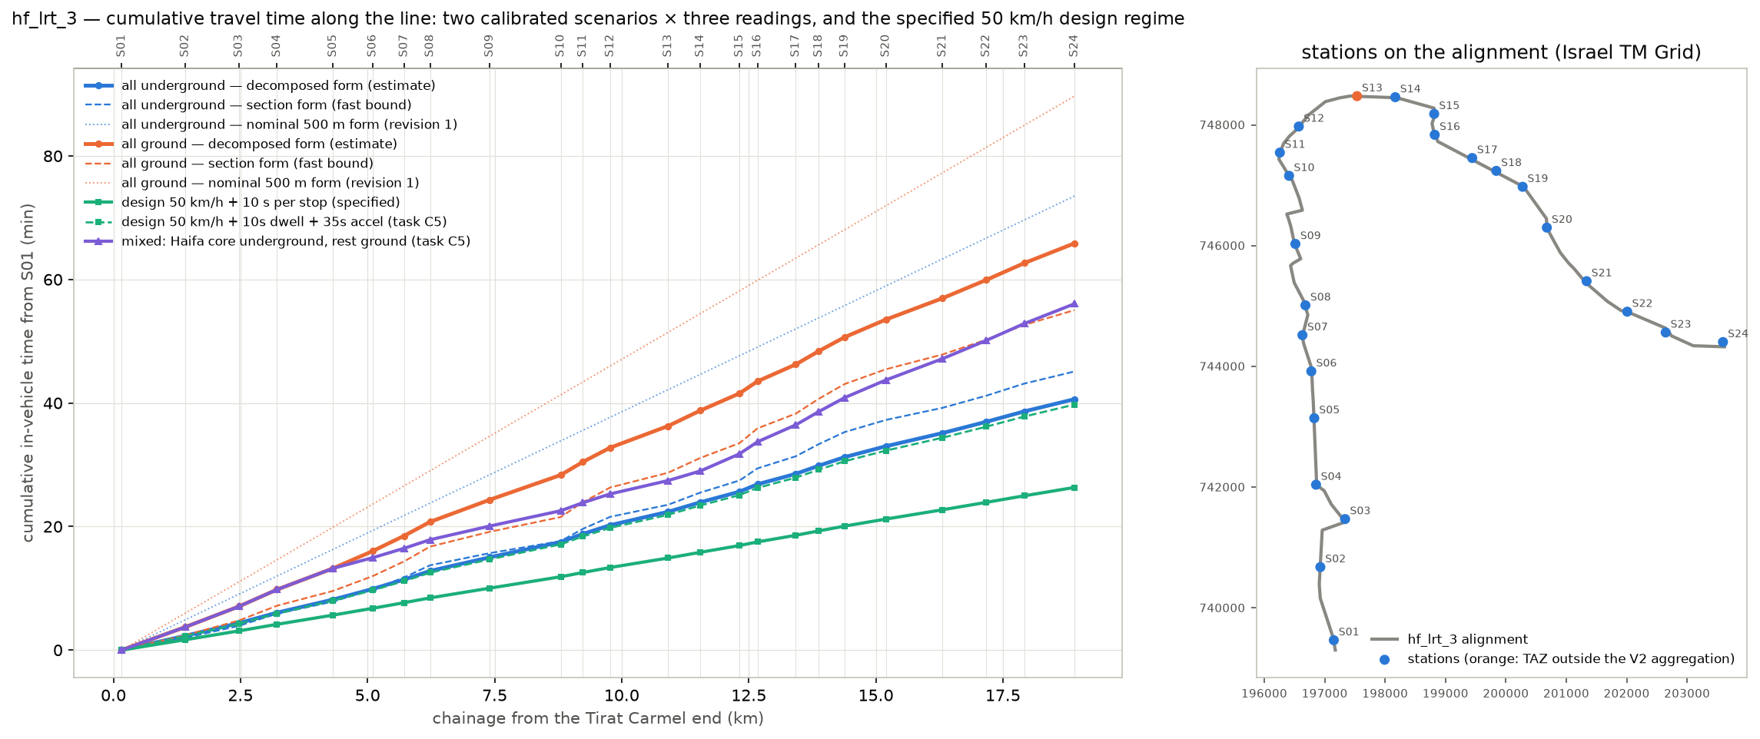
Figure A.4 — Cumulative travel time along the extension for each version and regime, and the stations on the alignment (step 25).

A.5 How the function enters the model
- Prioritized regime: the extension operates with full priority at the road junctions. Thus the model gives it the separated (underground-calibrated) times: 40.7 minutes from Tirat Carmel to Hamifrats. No underground line is planned. The regimes differ only in the run time (decision of 5 October 2026).
- Unprioritized regime: the extension operates at street level and waits at the junctions with the traffic. Thus it gets the surface times: 65.8 minutes. The difference, 25 minutes on 18.7 km, is the value of "priority at the junctions" in time. The report shows that it is worth approximately a quarter of the passengers.
- Main route (Hamifrats to Nazareth): a different type of line, mostly interurban, with stations 2.1 km apart. The client specified 80 km/h between stops and 10 seconds at each stop: 33.7 minutes. This is a specification, not a calibration. It is in the list of caveats of the report (caveat 28).
- Checks on the calibrated regimes: a design speed of 50 km/h with 10 s at each stop gives 26.3 minutes on the extension. An allowance of 35 seconds at each stop for the deceleration and the acceleration gives 39.7 minutes, within 3 % of the calibrated 40.7. Thus the calibrated rule is a line at 46 km/h that loses approximately 50 seconds at each stop. It is not a slow line.
- Headway: a tram each 5 minutes on all the line. Thus the mean wait is 2.5 minutes. The time on route does not include the wait.

A.6 Points to remember
- We measured the rule on Thursdays only and pooled the years 2024–2026. The year 2026 alone is 2–6 % faster.
- The stop penalty contains the dwell times and the acceleration of the Red Line. Different vehicles or dwell rules in Haifa change the times by seconds at each stop, and by tens of seconds on the full line.
- The two regimes are the two pure cases. A line with priority at most junctions, but not at all junctions, is between them. The mixed alignment of step 25 (the Haifa core separated, the ends at street level) gives 56 minutes.
- The results of the report are more sensitive to the station access and to the transfers than to the run time (Appendix D). Thus the calibration decides the comparison of the regimes more than the total level of demand.
Sources: the calibration report (docs/Transit_Travel_Time_Calibration_Report_Operator22.md; the figures are from its docx); METHODOLOGY.md §6w (step 25, revision 2 and addenda); Output/lrt_v2/lrt_calibration_redline_spacing_check.csv, lrt_end_to_end_summary.csv, lrt_line_profile.csv; Output/alternatives/time_on_route.csv.

Appendix B. Out-of-vehicle time: the findings of the research and the values in the model
This appendix answers four questions. Why do the minutes of walk, wait and change of vehicle have a weight? What do the literature and other models say about these weights? What did the study select? How much does the selection change the result? It is a summary of the research memo of 4 October 2026 (docs/OVT_WEIGHTS_PARAMETER_MEMO.md, 275 estimates from five sources of evidence).

B.1 Why the weights are important here
Most of a public transport trip is not in the vehicle. For travellers, a minute of walk, of wait or of change of vehicle is less comfortable than a minute in a vehicle that moves. Each transport model counts these minutes more than one time. The weight is the number of in-vehicle minutes that one out-of-vehicle minute is worth.
For this study, the weights are very important because of the geometry. The extension has 24 stations, but the bus and Metronit network has thousands of stops. On the trunk pairs, the walk to an LRT station is 13.9 minutes, against 5.1 minutes to a bus stop. With a walk weight of 2.0, this is a handicap of 18 minutes before the tram moves. Thus the in-vehicle advantage of the LRT against the bus does not become a cost advantage on most pairs (Appendix D).

B.2 The research
- The appraisal guidance of eleven countries and Israel. The sources are the UK TAG, ATAP of Australia, New Zealand, the Netherlands, Norway, Sweden and Denmark. Also the US FTA and TCQSM, the Israeli Nohal Prat, and the model validation guideline of the Ministry of Transport (2026).
- Meta-analyses and primary studies of the values that travellers give to the walk, the wait and the transfer. The sources are Wardman and co-authors 2001–2026, TRL, the national value-of-time studies of the Netherlands and Norway, London, Madrid, Sydney, Dublin and Copenhagen.
- The parameter files of ten calibrated regional models in the United States and Europe, read in full from their public repositories. The models are ActivitySim for San Francisco, Detroit, Atlanta and Washington; San Diego; Seattle; Chicago; MATSim; OpenTripPlanner; R5.
- Evidence on the walk: speeds, detour factors, slopes, stairs and escalators, delays at crossings, and the distance that persons walk to rail and to bus.
One limitation controls the interpretation of the findings. The research session could not open the guidance documents and the studies (the network policy blocked their hosts). Thus 255 of the 275 values come from published summaries, and only the 20 model parameter files were read in full. By the rule of the research plan, no value is "confirmed". The findings give the range of each parameter, and the position of the study value inside it.

B.3 The findings, parameter by parameter
Parameter | In the model | Evidence | Interpretation
Walk weight | 2.0 | studies ≈ 1.5–1.7; guidance 1.5–2.0 (Israel MoT: out-of-vehicle 2–3); ten calibrated models: 2.0 | 2.0: the median of practice, the bottom of the Israeli range, above the median of the studies. Cautious for the LRT (it has the longer walks).
Wait weight and rule | 2.0; wait = half the headway, maximum 10 min | studies ≈ 1.5; guidance 1.4–2.5; models 1.5 or 2.0; half the headway in all sources | 2.0 kept. At the LRT headway of 5 minutes, the wait of 2.5 minutes is high if anything: many passengers plan their arrival.
Transfer penalty, bus ↔ LRT and bus ↔ bus | 8 felt minutes | studies 5–10 (up to 20 for bus–bus); guidance 5–10; models ≈ 10 | 8 kept; inside each range; moves the capture by less than 1 %.
Transfer penalty, Metronit ↔ LRT | 4 felt minutes (0 until 5 October 2026) | same-platform or cross-platform interchange ≈ 4–5; with a change of level ≈ 7; there is no study of a BRT–LRT interchange | A free transfer was below each value found; 4 adopted as the same-platform median. Each minute here is important: the Krayot market gets to the LRT by Metronit.
Station access time | 0.5 min for each station end (was 0) | physical 1–3 min for each end of an underground station; practice 0.5 min for each level (FTA STOPS), 2 min rail boarding (Sound Transit) | 0.5 adopted for surface stations (no underground station is planned); the test with 1.5 minutes underground cost 23 % of the passengers in the 2022 test.
LRT-specific walk weight | none (the same as the bus) | one unverified summary says that rail access walks have a lower value; none of the ten models does this | Not used. The LRT premium carries the preference for rail.
Walk speed and detour | 4.0 km/h, straight line × 1.3 (was 4.8 km/h) | level walk 1.2–1.4 m/s; models 4.5–4.8 km/h; the Israeli national model reportedly 4 km/h | 4.0 km/h adopted on 5 October 2026 as the Israeli convention; walk times with slopes are an open item.
LRT premium | 5 felt minutes against a bus path, 2.5 against a Metronit path | calibrated models give in-vehicle time on the LRT a value of 0.80–0.85 of the bus time, and on the BRT 0.90–0.95 | A gap of 0.15 on the 14 minutes of the trunk ≈ 5 minutes; a gap of 0.05–0.10 ≈ 1.7–3.3, taken as 2.5.
Table B.1 — The out-of-vehicle parameters: the values of the study against the evidence. Full detail for each parameter in Output/ovt_research/parameter_summary.csv.

B.4 How much the weights change the result
We ran the full chain again on nine parameter sets in the 2022 test case of step 31. This test case is the extension alone, 25 areas, 4,254 LRT trips in the three AM hours with the weights of that time. The sets go from the evidence values, which help the LRT, to the upper end of the Israeli guidance range. The upper end has a deep underground station and an interchange with a change of level; it does not help the LRT.
Parameter set | LRT trips, 2022 test | Against 4,254 | Cause
Evidence medians (walk 1.5, wait 1.5) | 4,935 | +16 % | lower weights make the felt walk of the LRT shorter, more than the walk of the bus
The weights of today (walk 2, wait 2, transfer 8), no Metronit penalty, no station access | 4,254 | central of the test | the model before 5 October 2026
… plus a Metronit ↔ LRT penalty of 4 minutes | 3,837 | −10 % | the trips with a Metronit feeder pay for the change of vehicle
… plus 1.5 min of access for each underground station end instead | 3,257 | −23 % | the largest single item; the adopted 0.5 min at surface stations is a third of it
… plus the two terms | 2,922 | −31 % | the case "the weights of today with the two terms that were missing"
Guidance upper range (walk 2.5, wait 2.5, transfer 10, Metronit 7, access 3) | 1,456 | −66 % | the limit that does not help the LRT
Table B.2 — The chain on the out-of-vehicle parameter sets (chain of step 31, 2022, 25 areas, all underground times). Source: Output/ovt_research/chain_results.csv. The reference case of the report already has the 4-minute Metronit penalty and the 0.5-minute access. Thus it is between the second and the fifth row of this table.
Figure B.1 — The assumption that changes the 2022 LRT number most (step 40). The out-of-vehicle set is the widest factor, before the cost sensitivity and the run regime.
Two conclusions follow. The weights pull in two directions: the evidence supports lower weights, which help the LRT. At the same time, the model had set two terms to zero: the Metronit interchange and the station access. The two are below each value found, which does not help the LRT. The cost sensitivity λ is robust to all of this: a new estimate on each set stays at 0.030–0.036. Thus the weights change the cost differences, not the reaction of the travellers to them.

B.5 The decision of the study, and the open items
- Central case: walk 2.0, wait 2.0, transfer 8, Metronit ↔ LRT 4, station access 0.5 at each end, walk at 4.0 km/h, premium 5 / 2.5. The weights are the median of practice and inside each guidance range. The two new terms enter at their lower medians, because no underground station is planned.
- Sensitivities: the evidence weights (walk and wait 1.5) and the guidance weights (2.5, transfer 10). Also the station access and interchange terms up to their upper values.
- Open items, in the sequence of their value:
- Read the Israeli documents in full. An independent review gives these values for the 2021 Nohal Prat: walk and wait 2.0, 4 km/h, transfer penalties 12 bus–bus, 6 bus–rail, 3 rail–rail. This is not verified here.
- The design of the stations and of the interchange: depth, escalators, a Metronit interchange on the same platform or not.
- Walk times with slopes for Haifa.
- The policy decision: does the guidance range or the evidence median control the central case?
Sources: docs/OVT_WEIGHTS_PARAMETER_MEMO.md and docs/OVT_REPORTS_COMPARISON_2026-10-04.md; METHODOLOGY.md §6al and §6aq; Output/ovt_research/evidence_table.csv, parameter_summary.csv, parameter_sets.csv, chain_results.csv; Output/figures/lrt_capture_tornado.png (step 40).

Appendix C. The cost sensitivity λ: what it is, how the model uses it, with simple examples
This appendix answers five questions:
- What does the number λ ("lambda") do in the model?
- Why are there two of them?
- How does a cost difference become a number of passengers?
- How did we estimate λ from the survey?
- Why does the report give a range?
Section 2.5 of the report gives the short version. This appendix shows the arithmetic.

C.1 The idea
The model does not decide for each traveller. It changes a difference in felt minutes between two options into the share of travellers who select each option, with a smooth curve. Equal costs give an equal split. A small advantage gives a small majority. A large advantage gives a large majority, never 100 %. λ is the slope of this curve.
Share that selects option A = 1 / (1 + e^(λ × (cost of A − cost of B)))
With λ = 0.03 for each felt minute, each minute of advantage changes the odds between the two options by approximately 3 %. Ten minutes change them by approximately 35 %. A large λ means that travellers react strongly to small cost differences. A small λ means that habit, availability and items that the cost does not contain have the control.

C.2 Why there are two λ
- λ_T = 0.06 inside public transport. On a pair of zones that already has a bus or Metronit path, the LRT path competes with it. The two options are similar (the two are public transport, with the same fare). Thus the travellers are sensitive to the minutes between them.
- λ = 0.03 between the car and public transport. When the LRT is added, the public transport "bundle" as a whole becomes better, and some car trips move to it. A car owner compares the car with a public transport option. This car owner reacts to the cost approximately half as strongly as a passenger who selects between two public transport paths.
- The ratio λ_T = 2λ is a usual value for nested models. It is an assumption, not an estimate on this corridor. The data support the size of the pooled λ (C.5). The ratio is a convention of the models.

C.3 Example 1: the LRT against the bus on one pair
Take the example of section 2.4. From Kiryat Haim to Bat Galim, the bus trip feels like 58 minutes and the LRT trip like 48 minutes. This is an advantage of 10 minutes for the LRT (with the premium of 5 minutes). With λ_T = 0.06, the LRT takes 1 / (1 + e^(−0.06 × 10)) = 65 % of the public transport passengers of the pair. If the pair has 100 public transport trips in the AM peak, 65 use the LRT and 35 stay on the bus.
LRT advantage, felt minutes (negative: the LRT is more expensive) | λ_T = 0.03 (λ 0.02) | λ_T = 0.06 (central) | λ_T = 0.10 (λ 0.05)
−10 | 43 % | 35 % | 27 %
−5 | 46 % | 43 % | 38 %
0 | 50 % | 50 % | 50 %
+5 | 54 % | 57 % | 62 %
+10 | 57 % | 65 % | 73 %
+20 | 65 % | 77 % | 88 %
+30 | 71 % | 86 % | 95 %
Table C.1 — Share of the public transport passengers of a pair that select the LRT, by its cost advantage and by the sensitivity.

C.4 Example 2: the car
For the car, the model does not compare the car with the LRT directly. It asks how much the full public transport offer became better when the LRT path was added. Then it moves car trips in proportion to this improvement and to the public transport share of the pair. The improvement is the "composite cost" of the logit model:
Δ = −(1 / λ_T) × ln(1 + e^(−λ_T × d)), with d = cost of the LRT path − premium − cost of the bus path
When the LRT path is 10 felt minutes cheaper (d = −10), Δ = −17.3 minutes. When the two paths are equal, Δ = −11.6. When the LRT path is 10 minutes more expensive, Δ = −7.3. The composite cost decreases even when the LRT is not better than the bus. This is the standard property of the logit model, which gives a value to the presence of two options. This is one reason to read the shift from the car to public transport as an order of magnitude, not as a point estimate.
The new public transport share of the pair follows from the old share, S, and from Δ:
S′ = S × e^(−λΔ) / (S × e^(−λΔ) + 1 − S)
Public transport share of the pair before the LRT | LRT 10 min more expensive than the bus path | LRT equal to the bus path | LRT 10 min cheaper
2 % | 2.5 % (+0.5 points) | 2.8 % (+0.8 points) | 3.3 % (+1.3 points)
5 % | 6.1 % (+1.1 points) | 6.9 % (+1.9 points) | 8.1 % (+3.1 points)
20 % | 23.7 % (+3.7 points) | 26.1 % (+6.1 points) | 29.6 % (+9.6 points)
Table C.2 — New public transport share of a pair after the LRT, λ = 0.03. The shift is largest where public transport already has a share. On the pairs where the car has most trips (2 % public transport, the car-available segment of C.5), the shift is a fraction of a point. The result for the corridor, 0.9 % of the car trips, is the sum of such small shifts.
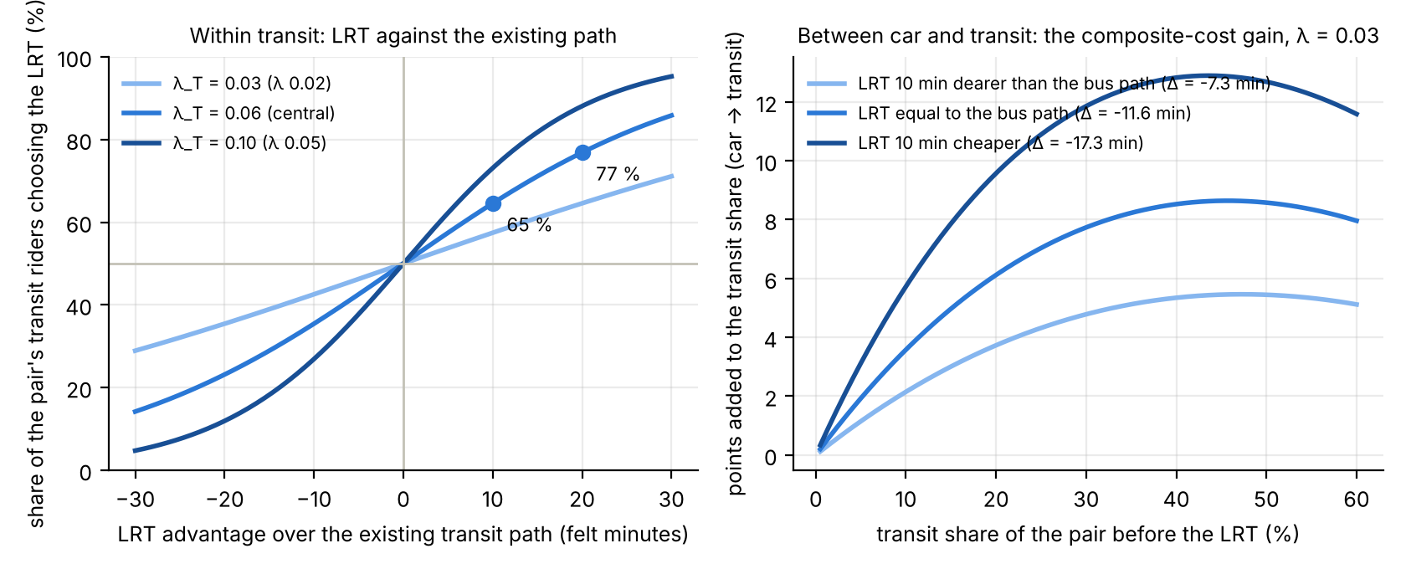
Figure C.1 — The two mechanisms. Left: the LRT share of the public transport passengers of a pair against its cost advantage, for the three sensitivities. Right: the points added to the public transport share of a pair by the shift from the car, against its share before the LRT.
One more rule connects the two examples. Before the pivot, the model smooths the observed 2022 share of the pair to the share of its wider area (weight k = 20 trips). Thus a pair with three survey trips does not change the result. The model pivots on observed shares. Thus, if you remove the LRT, you get the 2022 flows again exactly.

C.5 How we estimated λ
The obvious procedure failed. A fit of the public transport share of each pair of areas on the cost difference bus minus car gives λ with the wrong sign. The sample is 597 pairs and 70,000 trips. The pairs where public transport is cheapest against the car are the pairs where the residents have few cars. Thus the share follows who lives there, not the minutes. A fit at the pair level cannot separate the two effects.
The solution was to use the individual survey records (2,310 AM trips of 543 households inside the corridor areas). We kept the car availability constant. The car availability has four classes: no car in the household, no licence, more licences than cars, or a car for each driver. The purpose of the trip, the age, the gender, the sector and the distance band also stay constant. In a group of persons with the same access to a car, the persons with a smaller public transport cost select public transport more often. This slope is λ.
Model | λ for each felt minute | 95 % low | 95 % high | Trips | Households | Assumed in the chain | Assumed range
M1: dGC + car availability, purpose, person, distance band | 0.035 | 0.002 | 0.068 | 2,310 | 543 | 0.030 | 0.02–0.05
M1b: M1 with the cheaper of bus and Metronit | 0.041 | 0.010 | 0.071 | 2,310 | 543 | 0.030 | 0.02–0.05
M3: M1 + origin and destination area fixed effects | 0.053 | 0.012 | 0.093 | 2,310 | 543 | 0.030 | 0.02–0.05
M4: licence holders in car-owning households only (the segment the LRT would draw from the car) | 0.008 | -0.025 | 0.041 | 1,443 | 424 | 0.030 | 0.02–0.05
M1u: M1 unweighted | 0.042 | 0.018 | 0.066 | 2,310 | 543 | 0.030 | 0.02–0.05
Table C.3 — The estimates at the person level (step 33). M1 is the central specification. M4 limits the sample to licence holders in households with a car. Source: Output/mode_choice/lambda_summary.csv.
Figure C.2 — The observed public transport share against the cost difference, by car availability segment (step 33). There are four separate levels, and a visible slope only for the households without a car.
- The pooled estimate, 0.035 (interval 0.002–0.068), has the correct sign and supports the assumed 0.03, which is on its cautious side. On the car network of May 2026, it is 0.040.
- By segment, it is 0.083 for persons in households without a car. For licence holders in households with a car, it is not different from zero (0.008 ± 0.017). These are the travellers that the LRT must get from the car. The survey has too few such persons who select public transport on comparable pairs to measure their reaction.
- Thus the data support λ_T on the public transport side, and λ on the car side is a judgement with a range. The shifts from the bus and from the Metronit are the more solid part of each result. The shift from the car is an order of magnitude. A stated preference survey of car owners on the corridor is the procedure to get it.

C.6 What λ does to the result
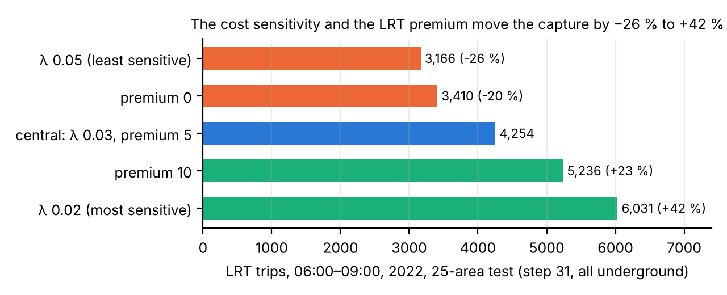
Figure C.3 — The 2022 test capture (step 31, all underground, 25 areas) with the λ and premium cases that the chain carries.
The λ range alone is −26 % to +42 % of the capture, the widest single factor after the out-of-vehicle set. This is why the range for the plan in the report (5,532 to 10,537 AM passengers around the reference 7,433) comes from it. The LRT premium (0 or 10 minutes instead of 5) gives a narrower band inside it, −20 % to +23 %. If you double λ, the shift from the car approximately doubles, and the LRT share of public transport moves away from an equal split. If you halve λ, the opposite occurs.
Sources: METHODOLOGY.md §6ac (step 31), §6ae (step 33), §6ak (step 40), §6aq (step 45); Output/mode_choice/lambda_summary.csv, coefficients_all_models.csv, sample_by_car_segment.csv; Output/skims/lrt_capture_scenarios.csv; the pivot code of notebooks/current/LRT_alternatives_demand.ipynb.

Appendix D. The generalized cost function: why, and how we got to it
This appendix answers four questions. Why does the model change each trip into one number? What is in this number? Where does each component come from? Which decisions and corrections changed the formula between the first draft in September 2026 and the formula of the report?

D.1 Why one number
The model must compare trips that are different in each part. One trip has more walk time. A different trip has less wait time. A third trip has a transfer. A fourth trip is faster, but the stop is far from the home. The model cannot compare these trips directly.
The generalized cost puts all these trips on one scale, the "felt" length of the trip, in minutes. The minutes outside a vehicle count more than one time (Appendix B). A change of vehicle has a fixed charge. The preference for a rail vehicle enters as a bonus.
GC = in-vehicle time + 2 × walk + 2 × wait + 8 for each transfer (4 between the Metronit and the LRT) + 0.5 for each LRT station end − LRT premium (5 against a bus path, 2.5 against a Metronit path)
Component | Source | Count
In-vehicle time | bus and Metronit: timetable of May 2026 with the run times measured on the street network in May 2026 (the buses operate at 1.09 × the timetable in the peak); train: timetable; LRT: the calibrated function of Appendix A; car: the measured network speeds of May 2026 between the zone centroids, plus 3 minutes for the parking and the walk at the ends | weight 1
Walk | straight line × 1.3 for the street detour, at 4 km/h, from the zone to the stops within 1 km, and from stop to stop within 300 m for a transfer | weight 2
Wait | half the combined headway of the lines that serve the pair in the peak hour, maximum 10 minutes; LRT 2.5 minutes (a tram each 5 minutes) | weight 2
Transfer | a fixed charge for the uncertainty and the effort of a change of vehicle, in addition to the real walk and wait; the first boarding is not a transfer | 8 min; 4 min Metronit ↔ LRT
Station access | the time inside a station from the entrance to the platform | 0.5 min for each LRT end
LRT premium | the preference for a rail vehicle at equal time, from the in-vehicle multipliers of the calibrated models | −5 min against a bus path, −2.5 against a Metronit path
Money | fare, parking, fuel | none, by decision (D.2, step 2)
Table D.1 — The components of the generalized cost in the reference case.

D.2 The sequence of decisions
We changed the formula in seven steps between 22 September 2026 and October 2026. Then we did four checks on the full chain of the model.

Step 1. The first formula (LRT capture plan, 22 September 2026)
GC = in-vehicle time + 2 × walk + 2 × wait + 8 for each transfer + (fare + parking) ÷ value of time
The value of time was 30 ILS for each hour, as a temporary value. The weights 2 / 2 / 8 are the middle of the ranges of standard practice: 1.5–2.5 for the walk and the wait, 5–10 for a transfer.

Step 2. We removed the money terms (22 September 2026)
The public transport fare in the area is flat and integrated. A daily maximum makes transfers and return trips free. Thus the fare is the same for each bus, Metronit or LRT trip and for each pair. It cannot change the choice between them.
Against the car, the fare is a constant for each trip. The model starts from the observed 2022 split between car and public transport; it does not calculate the split from the costs (C.4). Thus a constant cost has no effect.
We also removed the parking and fuel costs by the same decision. There are no parking data for the area. From this step, the cost is in minutes only.

Step 3. We replaced the temporary values with measured data (22–23 September 2026)
The first version used a walk of 8 minutes and a headway of 10 minutes for each bus pair. We replaced these values in three stages:
- The national timetable: the walk to the real stops, the wait from the real headways.
- The run times measured on the street network in May 2026. On the arterial hops with the most demand, these times are 1.1–1.4 times the timetable.
- The Metronit as a mode of its own.
We corrected the LRT in-vehicle time for the station spacing (Appendix A). We set the LRT headway to 5 minutes.
We compared the bus times with the door-to-door times that the travellers gave in the survey. The survey times are 7–9 minutes more than the timetable times. The transfer, the wait for the correct line and the delays cause this difference. The transfer and wait terms represent it.

Step 4. The LRT premium (22 September 2026) and the Metronit premium (5 October 2026)
Travellers prefer a rail vehicle at equal time. Calibrated models show this as an in-vehicle multiplier of 0.80–0.85 for the LRT, against 0.90–0.95 for the BRT. On the 14 minutes of in-vehicle time on the trunk, the gap is approximately 5 minutes against a bus path. It is approximately 2.5 minutes against a Metronit path.

Step 5. The transfer structure (22 September and 5 October 2026)
A change between a bus and the LRT costs 8 minutes. The change from the Metronit to the LRT was first free, with the assumption of an integrated interchange on the same platform. The out-of-vehicle research found no study with a value below 4 minutes, even for a cross-platform change. Thus we adopted 4 minutes (Appendix B).

Step 6. Station access and walk speed (5 October 2026)
We added half a minute for each station end, for the way from the entrance to the platform. We changed the walk speed from 4.8 km/h to 4 km/h (the Israeli convention). The two values come from the same research.

Step 7. From areas to zones (steps 44–45, October 2026)
We first made the cost between the 25 corridor areas. A matrix at the area level pools the headways of each line that serves the area and the walk to its nearest stop. No single traveller gets this combination. Thus the bus cost on the trunk was approximately a third too low: 30 felt minutes against 45 at the zone level.
The reference case makes the cost for each pair of zones on the real line graph of the timetable. The LRT boarding is at the station with the lowest access cost at each end.

The checks
- We ran the full chain again on nine out-of-vehicle parameter sets (Appendix B).
- We tested the bus wait rule with the busiest single line instead of the pooled headway. The bus cost increased by 14 %, and the LRT capture increased by 15 %.
- We compared the car times with the door-to-door times in the survey. The car times are 0.90–0.95 of the survey times. Thus we did not increase them.
- We ran the capture on a car network of 2026 and on slower buses in 2050 (section 4.9).

D.3 Two examples
Example 1: Kiryat Haim to Bat Galim. The trip by bus:
- Walk 6 minutes to the stop.
- Wait 5 minutes (a bus each 10 minutes).
- 28 minutes in the vehicle.
- Walk 4 minutes at the end.
GC = 28 + 2 × (6 + 4) + 2 × 5 = 58 felt minutes
The same trip by LRT:
- Walk 9 minutes to the station.
- Wait 2.5 minutes.
- 20 minutes in the vehicle.
- Walk 5 minutes at the end.
GC = 20 + 2 × (9 + 5) + 2 × 2.5 = 53 felt minutes. Subtract the LRT premium of 5 minutes: 48 felt minutes
The LRT trip has more walk time. But its cost is 10 felt minutes lower, because the LRT is faster and operates more frequently. With λ_T = 0.06, this difference gives the LRT 65 % of the public transport passengers of the pair (Appendix C).
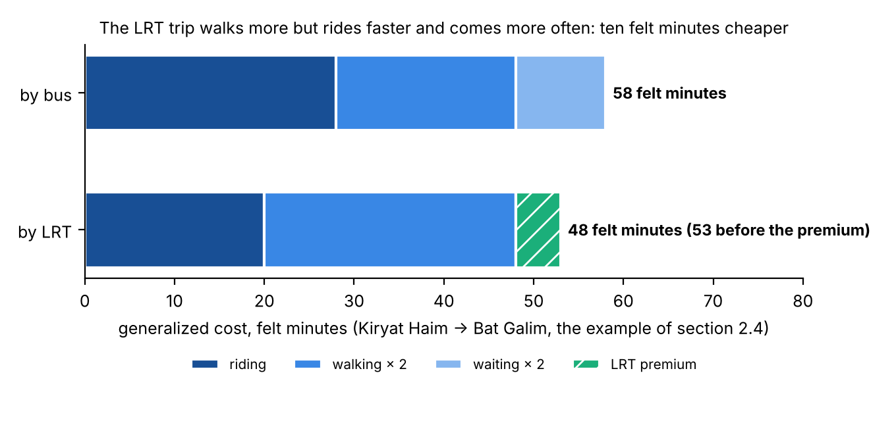
Figure D.1 — Example 1 as felt minutes: in-vehicle time, walk time and wait time (each with a weight of 2), and the LRT premium. No trip in this example has a transfer.
Example 2: the Krayot to Bat Galim, with the Metronit terms. Today, this trip uses the Metronit for the full distance:
- Walk 5 minutes.
- Wait 3 minutes.
- 35 minutes in the vehicle.
GC = 35 + 2 × 5 + 2 × 3 = 51 felt minutes
The LRT path for the same trip has five parts:
- Metronit to Hamifrats: walk 5 minutes, wait 3 minutes, 18 minutes in the vehicle.
- Transfer at Hamifrats: transfer penalty 4 minutes, wait 2.5 minutes, station access 0.5 minutes.
- LRT to Bat Galim: 12 minutes in the vehicle, station access 0.5 minutes at the exit.
- Walk 5 minutes at the end.
- LRT premium against a Metronit path: −2.5 minutes.
GC = 18 + 12 + 2 × (5 + 5) + 2 × (3 + 2.5) + 4 + 0.5 + 0.5 − 2.5 = 63.5 felt minutes
The LRT path has a cost that is 12.5 felt minutes higher. It gets 32 % of the public transport passengers of the pair (the curve of Table C.1). Before 5 October, the model used a transfer penalty of 0 minutes and a station access of 0 minutes for this transfer. With those values, the difference decreases to 7.5 felt minutes, and the LRT share increases to 39 %. Thus these two terms, and not the speed of the LRT, control the result for the Krayot market.

D.4 What the function does not include
- The weights come from published studies and from other calibrated models. They are not calibrated on this corridor. We ran the chain again on nine sets to show the range that the weights open (Appendix B).
- The function has no money terms. Thus it cannot test a fare policy or a parking policy that gives different costs to different modes.
- The function has no terms for crowding, reliability or comfort, except the LRT premium. The walk times have no term for slopes, in a city where slopes are important. The function makes no difference between a stop with a shelter and a stop without a shelter.
- The absolute cost of the car has no effect on the result. The model starts from the split observed in 2022. Thus a slower car in 2050 changes nothing (caveat 25). Only the public transport side of the cost changes the numbers.
- The walk times are averages for each zone, weighted by population and by employment. They are not walk times for each address. The station access time is one value for each end.
Sources: docs/LRT_CAPTURE_PLAN.md; docs/APPENDIX_D_GENERALIZED_COST_STE100.md; METHODOLOGY.md §6x (step 26 and its seven addenda), §6ac (step 31), §6ao (step 44), §6al, §6aq (step 45); Output/alternatives/skims_summary.csv; section 2.4 of this report.

