Nofit LRT Extension
AM-Peak Origin–Destination Demand: Data Fusion, Audits and Results
Travel Habits Survey 2018 · Cellular OD 2018/19 · RavKav ticketing 2022
OnBoard bus survey · Rail smartcards 2019 · Zonal forecasts 2020/2025
Methodology and results report — 8 September 2026
Repository: oh-da/Nofit_LRT_Extension

Contents

(In Word: right-click the table of contents and choose “Update Field” to populate page numbers.)

1. Executive summary
This study builds an AM-peak (6:00–9:00) origin–destination demand picture for the Nofit LRT extension study area (778 traffic analysis zones, Haifa metropolitan region and the wider north) by fusing five independent data sources, each used at the spatial scale and for the component where it is most reliable. The household survey supplies behaviour and mode detail; the cellular matrix supplies population-scale flows between zones; smartcard ticketing supplies a near-census of actual transit journeys; the OnBoard survey supplies passenger-reported bus destinations; and zonal socioeconomic files supply the demographic growth that levels everything to a common 2022 base.
Headline results. The leveled 2022 all-mode matrix over the 25 aggregated analysis areas totals 276,355 AM-peak trips: 251,684 car/other (survey-based, grown demographically), 23,909 bus (RavKav ticketing shaped by OnBoard destinations) and 763 rail. The transit share of AM-peak origins is 8.9% study-wide and 9.9% in the LRT corridor areas, with strong local variation (74% at Neve Yosef — a boarding-attribution artefact discussed in §5.3 — 48% at the Hamifrats hub, 12–30% in the core Haifa corridor areas, and under 2% in park-and-ride-poor Shefaram and Kiryat Bialik South).
The primary TAZ-level deliverable is the hybrid OD matrix (survey × cellular empirical-Bayes fusion, 778×778, as probabilities and as trips), built so that the survey governs behaviour at the superzone scale while cellular structure distributes flows between individual zones — never uniformly.
A material data correction was found and fixed during quality testing: in the RavKav files the journey identifier is not the field its name suggests. The original processing counted every transfer leg as a complete journey, inflating bus OD volumes ×1.52. After correction, the two independent transit measurements — ticketing 2022 and household survey 2018 — agree on scale (ratio 0.91 in the sub-area), which substantially strengthens confidence in the final numbers. All downstream products, comparisons and the source-selection decision were rebuilt on the corrected basis.

2. Objective and study frame
The purpose is a defensible AM-peak OD demand basis for corridor-level analysis of the planned Nofit light-rail extension: all-mode demand between analysis areas, the transit component measured rather than surveyed, and a mode-share table by area with an LRT-corridor flag. Deliverables are matrices at three nested spatial systems:
- 778 study TAZs (TAZ_NUMBER system) — the primary hybrid matrix;
- 36 superzones (SZ_NEW) and 25 GS zones — the calibration scales where the survey is statistically reliable;
- 28 named aggregation areas (205 TAZs around the corridor; 25 remain after a noise filter) — the reporting scale for transit demand and mode shares.
The AM peak is defined as departures between 6:00 and 8:59. A trip is a movement between two activities whose origin and destination both carry a real model-area zone (non-null, non-zero); arrivals whose mode is the survey default code are excluded. Multi-leg transit journeys count once, from first boarding to final alighting.

3. Data inputs and sources
Source | Files | Vintage | Frame | Role
THS activities file | ACTIVITIES_DEC18_corrected.csv (172,529 rows, 5,108 households) + households_with_weights.csv (wf_new) | 2018 | Residents (expanded sample) | First-generation weighted OD matrices, trip definition audit
THS trips file | trips_ths_2017.xlsx (placeno-ordered activities, new_wf weights) — primary survey source | 2017/18 | Residents | Day 1 / Day 2 matrices by mode, day-averaged; hybrid fusion input
Cellular OD | AvgDayHourlyTrips201819 (1,270-zone national system) + TAZ keys | 2018/19 | All persons | Population-scale prior; between-zone structure; within-superzone allocation
RavKav bus ticketing | 4 Tuesday files, May 2022 (2.5–2.9M records each, national) | 2022 | All riders | Measured bus journeys: OD volumes, boardings/alightings
OnBoard bus survey | 6_9_BusProbability_ByTAZ.xlsx (599 origins, row-stochastic) | — | Bus riders | Passenger-reported destination pattern, replaces inferred alightings
Rail smartcards | Train_mtx_table.csv (19 stations, hourly) | 2019 | All riders | Train OD 6–9
Zone keys & GIS | TAZ_North.shp (781 polygons), TAZ_2636_Keys.xlsx, TAZ_GSnew.csv, Submatrix_tazs.xlsx | — | — | Zone conversions, stop→TAZ tagging, area aggregation
Zonal socioeconomics | Zonal_2020.csv (observed), Zonal_BU_2025.csv (forecast): population + employment per TAZ | 2020 / 2025 | All persons | Growth factors for the 2022 vintage alignment

Source quality notes discovered in processing. (i) The trips file stores expansion weights that some spreadsheet exports render as text — an early total mismatch traced to exactly this. (ii) The RavKav files carry ≈7% exact duplicate records, and the identifier semantics are inverted relative to their names (§5.2). (iii) The cellular matrix under-observes short intra-zone trips (§4.3). (iv) The OnBoard file carries an unknown-alighting share (median 7.4% where present), removed by row renormalisation. (v) The rail table includes a “rest of stations” row (TAZ 9999) covering out-of-area stations, excluded by instruction.

4. Methodology

4.1 Trip extraction from the survey
Activities are ordered per person and survey day (placeno sequence). Each consecutive pair of activities with real zones at both ends forms a trip: the departure hour is taken from the origin activity’s departure field (Dep_h ∈ {6,7,8}) and the mode from the destination activity’s mode (the mode used to reach it). Expansion uses the household weights (new_wf). The two survey days are treated as independent observations and averaged, since day-to-day activity patterns differ. Modes aggregate to CAR / TRANSIT / RAIL / OTHER under an agreed dictionary (train separated from bus-type transit so ticketing can replace each separately).
The survey’s national 2,636-zone coding is converted to the 778-TAZ study system through the 1,250-zone key, distributing each coarse flow across member TAZs in proportion to cellular outflow and inflow shares — never uniformly.

4.2 Weighted matrices and their validation against cellular
Day-specific weighted matrices expand to ≈2.3M trips per day study-wide (activities source); the trips-file source agrees with the activities source within 0.2–0.4% on totals with a superzone pattern correlation of r = 0.994 — two independent extraction routes over the same fieldwork. Against the cellular matrix at superzone level the weighted survey correlates at r ≈ 0.855, with one systematic divergence: the survey sees 72–75% of AM trips staying inside their origin superzone, cellular only 34%. This is a measurement difference — short trips are largely invisible to cell-tower handovers — and it shaped the entire fusion design.
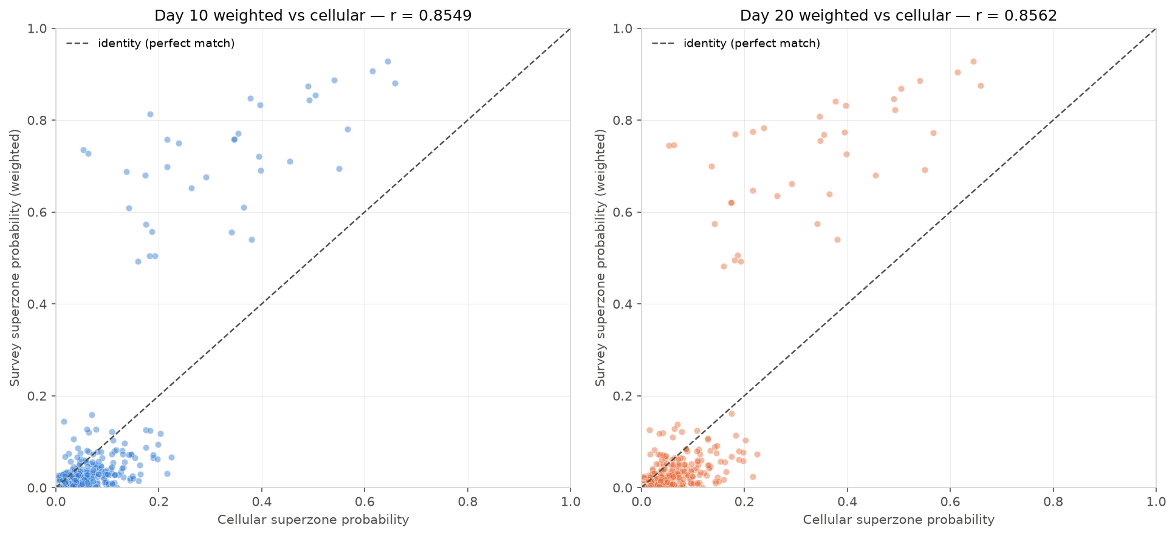
Figure 1 — Weighted survey (Day 10 blue / Day 20 orange) vs cellular, superzone flows; dashed identity line.

4.3 Hybrid fusion: empirical-Bayes shrinkage at the calibrated scale
For each origin superzone A, the fused destination distribution is P*(B|A) = λ_A·P_survey(B|A) + (1−λ_A)·P_cell(B|A) with λ_A = n_A/(n_A + k): origins where the survey observed many departures trust the survey; thin origins lean on cellular. The shrinkage constant k is chosen by cross-day validation — calibrate on one survey day, score against the other with row-wise Jensen–Shannon divergence. The trips-file source gives a genuine interior optimum at k* = 5 (activities source: k* = 2 at superzone scale, k* = 1 at GS scale). At TAZ level the same procedure degenerates (the two days share one household panel), so no TAZ-level shrinkage is fitted — a deliberate negative result that drove the design below.
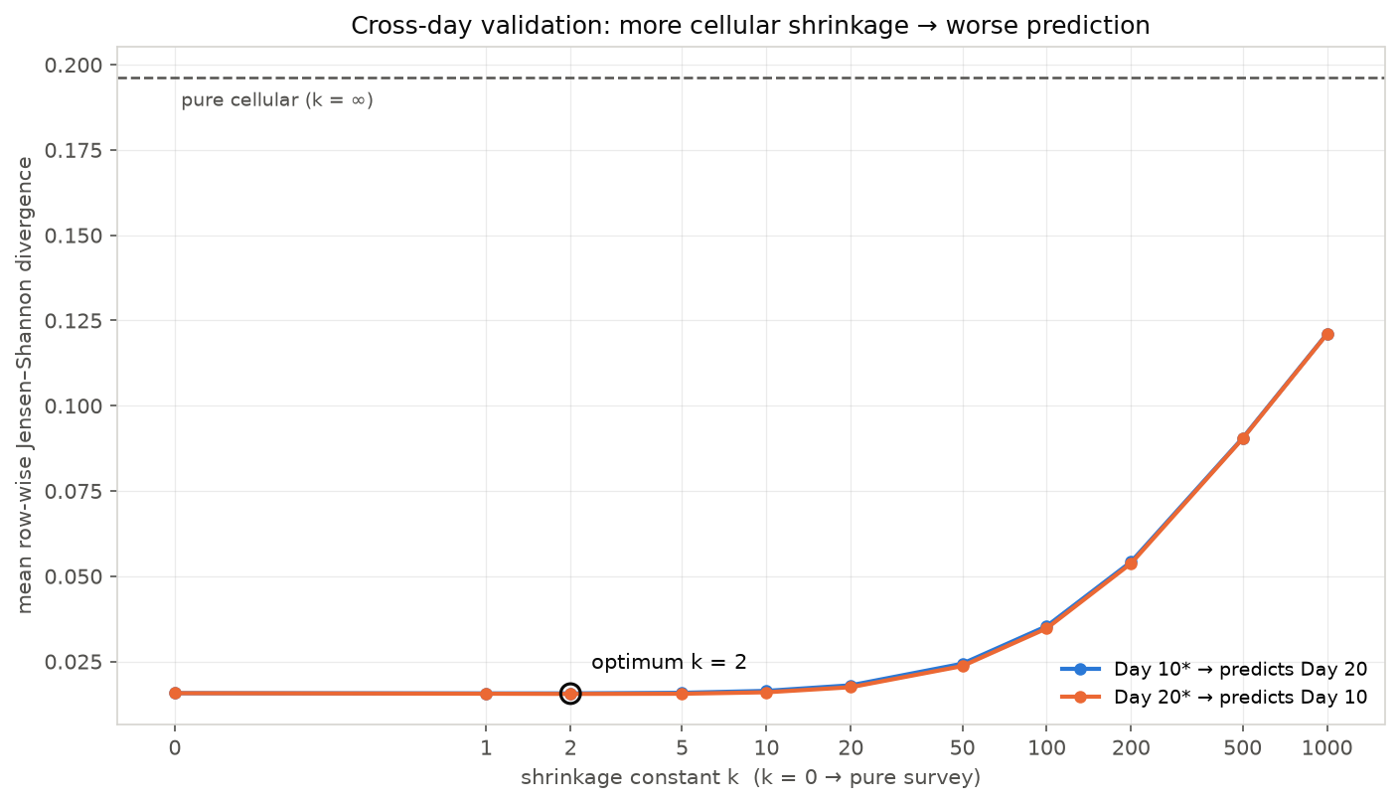
Figure 2 — Cross-day validation curve for the shrinkage constant k (superzone scale).

4.4 TAZ-level matrix via correction factors
The calibrated superzone relationship is pushed down to the 778 TAZs without uniform disaggregation: each superzone pair’s correction factor R_AB = P*(B|A)/P_cell(B|A) multiplies the cellular TAZ-level cells beneath it (C̃_ij = C_ij·R_AB), and rows are renormalised. Cellular structure decides how flows distribute between individual zones; the survey decides how much flow moves between superzones. Median factors: ≈2.2 on intra-superzone cells (survey sees the short trips cellular misses), ≈0.10 on inter-superzone cells.
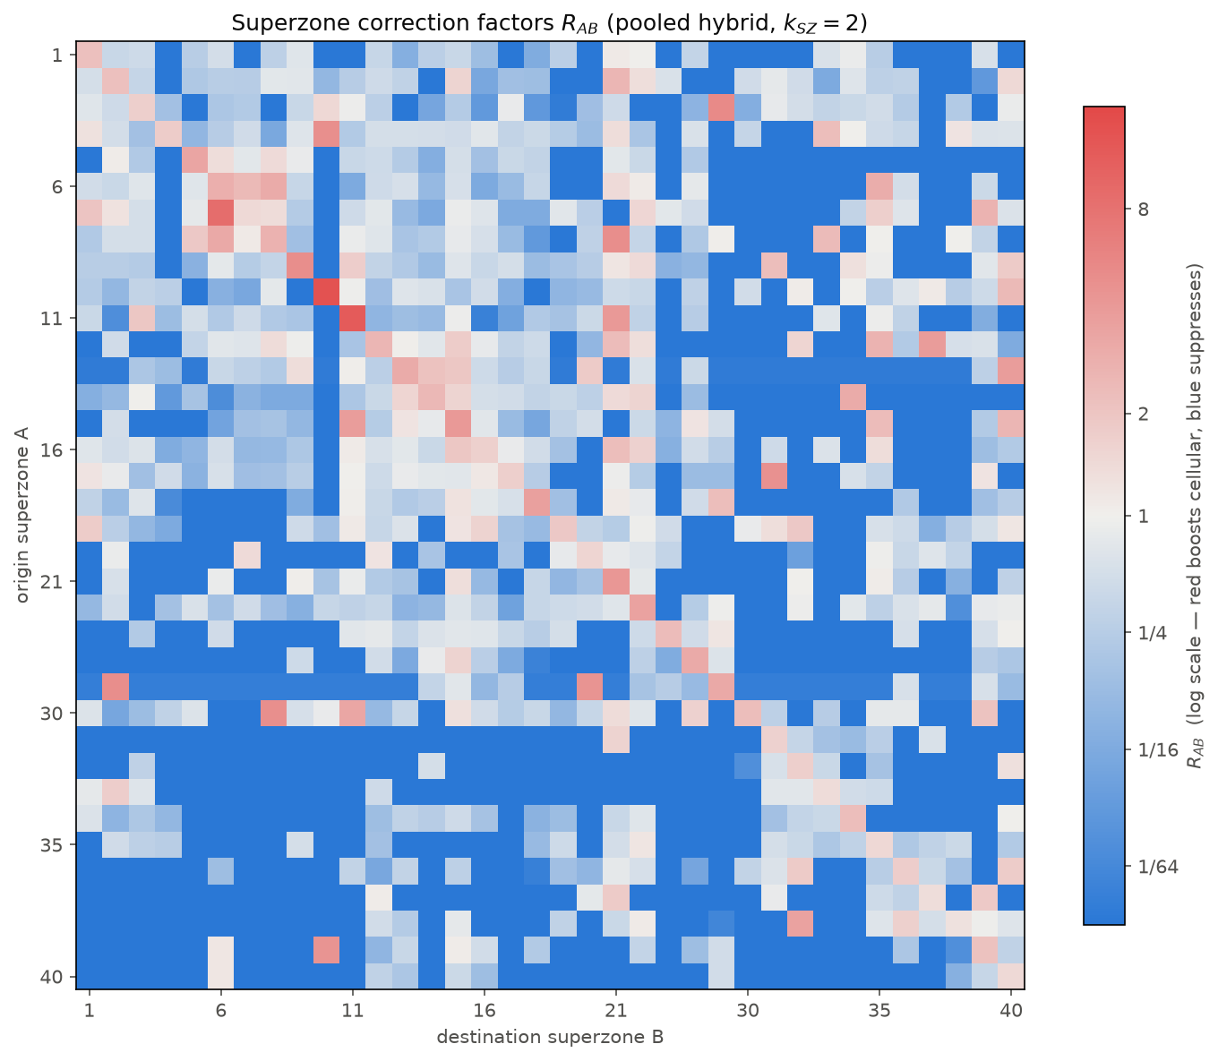
Figure 3 — Correction-factor matrix R_AB (log scale): warm diagonal (survey-boosted short trips), cool off-diagonal.

4.5 Trip generation
Per-person AM-peak generation rates by home zone (home = where the 3:00 AM activity is “Home”): overall ≈0.83 trips per person in 6:00–9:00 on the trips-file source (0.84 on the activities source) over ≈2.60M expanded residents, with a stable superzone ranking across both sources.
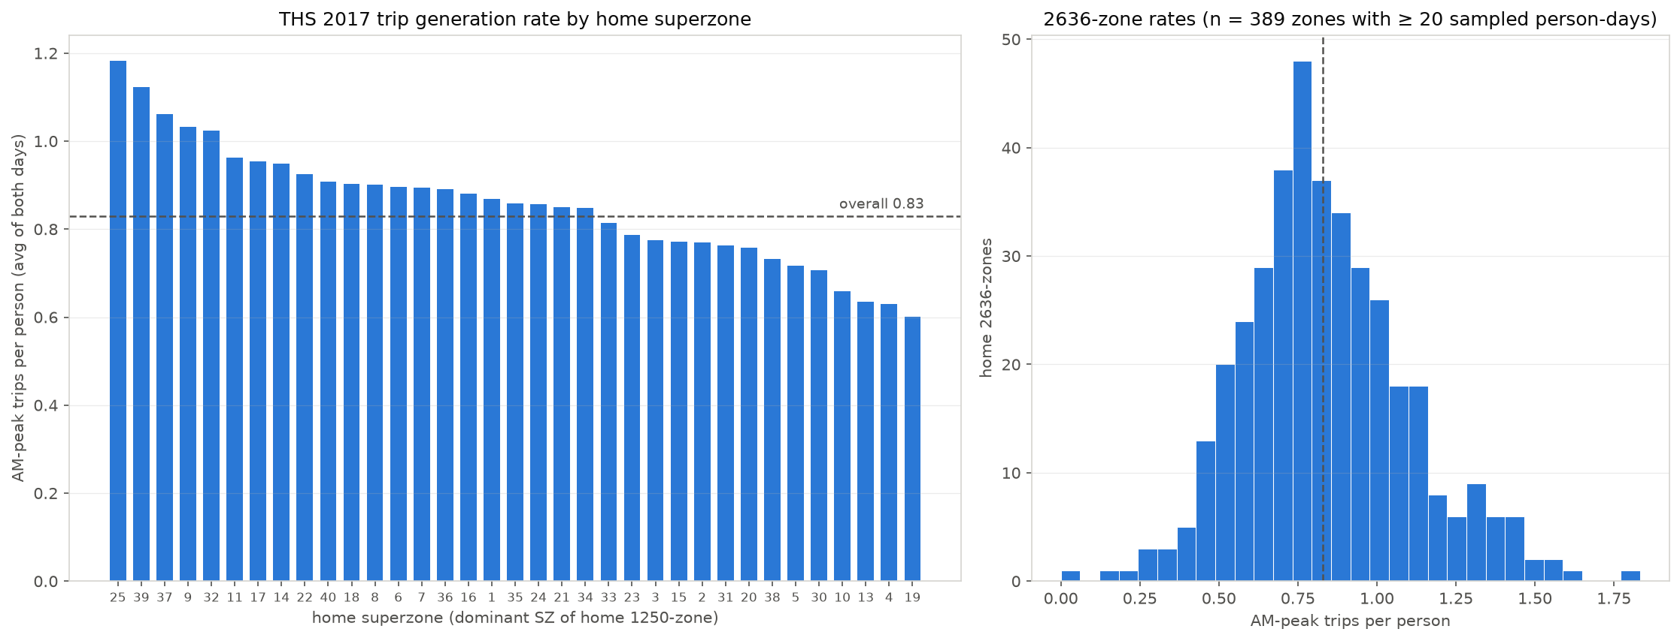
Figure 4 — AM-peak trips per person by home superzone (trips-file source).

4.6 RavKav bus processing
All 27,186 stops appearing in the four files are geocoded and spatially joined to the TAZ polygons (9,924 inside the study area). Records are one row per boarding; the linked-journey identifier groups a passenger’s legs, and origin/destination stops, start hour and the expansion weight are journey-level constants (§5.2 documents the identifier semantics and the correction they forced). After dropping exact duplicate records, journeys are counted once from first boarding to final alighting, filtered to weekday 3 and start hour 6–8, weighted by expansion, and averaged across the four Tuesdays: 94,203 journeys per average Tuesday with both ends in the study area (of ≈510–560k nationally), plus leg-level boardings (157,264) and alightings (147,632) per TAZ.

4.7 OnBoard destination substitution
RavKav’s alighting inference and the OnBoard survey’s passenger-reported destinations disagree at fine grain (r ≈ 0.09 at TAZ level) while agreeing regionally (r ≈ 0.70 at superzone level). Since reported destinations are the stronger signal, each origin’s RavKav volume is redistributed over destinations by the OnBoard probabilities (93.6% of volume covered; the remaining 6.4% keeps RavKav’s own pattern). Totals are preserved exactly.

4.8 Complete transit matrix and the substitution
Rail smartcard trips (hours 6+7+8, 19 named stations, 5,535 trips; 962 with both ends in the sub-area) join the bus matrix at the 25 noise-filtered areas (areas with under 50 daily origins+destinations of bus activity — Adi, Alon Hagalil, Tzipori — are dropped as statistical noise). The adjusted all-mode matrix substitutes measured ticketing for the survey’s weakest components:
ALL_adjusted = (survey ALL − survey TRANSIT − survey RAIL) + bus_RavKav×OnBoard + train_smartcards
The survey keeps CAR/OTHER — components only it can see — while measured data replaces reported transit. On the corrected volumes this substitution is nearly scale-neutral (survey transit share 10.1%, substituted 9.5%): it changes the pattern and the population frame of the transit layer, not its size.

4.9 Vintage alignment to 2022
The layers arrive from 2018 (survey), 2019 (rail) and 2022 (bus). Everything is leveled to 2022, the anchor year of the strongest layer, moving only volumes — never patterns. Per-area growth factors (X₂₀₂₅/X₂₀₂₀)^(4/5) come from the observed-2020 and forecast-2025 zonal files: population on the origin side (AM origins are homes; six pure-employment districts fall back to employment), employment on the destination side. The CAR/OTHER base is Furnessed to the grown margins (235,899 → 251,684, +6.7%; factors 0.948 Nesher to 1.256 Tirat Carmel). Rail scales by the national ridership series (69M → 54.7M passengers, ×0.793). Bus is untouched. May 2022 bus ridership was verified by the study team as not COVID-suppressed, so no pandemic correction is applied beyond the measured rail series.

5. Tests, audits and corrections
Every pipeline stage was validated against an independent reference where one existed. The audit log:
Test / audit | Finding | Resolution
Cellular reconstruction | Rebuilt matrix matches the original notebook cell-by-cell to 6 decimals | Validated; documented replication caveat for coarse-zone flows
Trip definition audit | Stay-at-home activity rows and default-mode arrivals were entering as trips; trips with a missing/zero end zone included | Trip redefined (both ends real zones, default-mode arrivals excluded); all matrices rebuilt
Two extraction routes | Activities-based vs trips-file-based matrices: totals within 0.2–0.4%, superzone r = 0.994 | Trips file adopted as primary source
Weight-total mismatch | User pivot showed ~2.5× more weighted trips than the pipeline | Traced to expansion weights stored as text in the spreadsheet; totals reconciled exactly
Survey day totals | Stray survey-day codes (11, 22) created zero-rate groups halving a generation rate | Restricted to the two real survey days
RavKav duplicates | ≈7% exact duplicate records, including repeated legs | Deduplicated before any aggregation
RavKav identifier semantics | passanger_trip_id is unique per boarding (embeds its timestamp); bus_trip_id is the linked-journey id — the reverse of what the names suggest. Transfer legs were being counted as whole journeys: OD volumes inflated ×1.52 | Journey dedup corrected; verified journey-level fields constant within journeys (0 violations across 4 files); full downstream rebuild
Neve Yosef 84% transit share | Bus “origins” exceeded the cellular all-mode ceiling — physically impossible | Root causes: the leg-counting inflation (above) plus boarding-location attribution at three boundary/trunk stops; share now 74% with the attribution caveat documented

5.1 The journey-deduplication correction
The decisive test came from a simple question — “confirm the data is filtered to first boardings, without transfers.” Verifying it revealed the inverted identifier semantics. The correction moved every downstream number; crucially, it moved them toward the independent references:
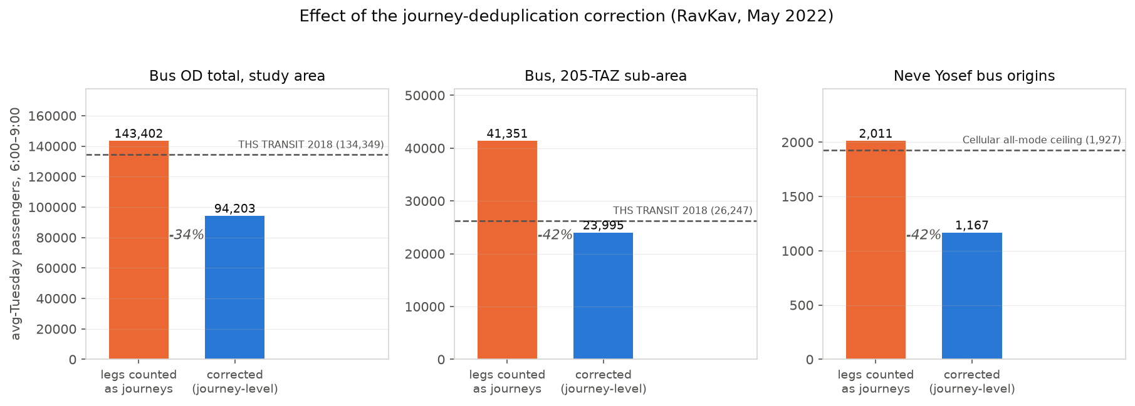
Figure 5 — Before/after the correction, against each quantity’s independent reference (dashed).
After correction, ticketing-2022 and survey-2018 agree on sub-area scale (23,995 vs 26,247; ratio 0.91, cell-level r = 0.76), and Neve Yosef’s bus origins drop below the cellular all-mode ceiling. Two independent instruments now corroborate each other — the strongest validation available to this study.

5.2 Bus vs survey at area level
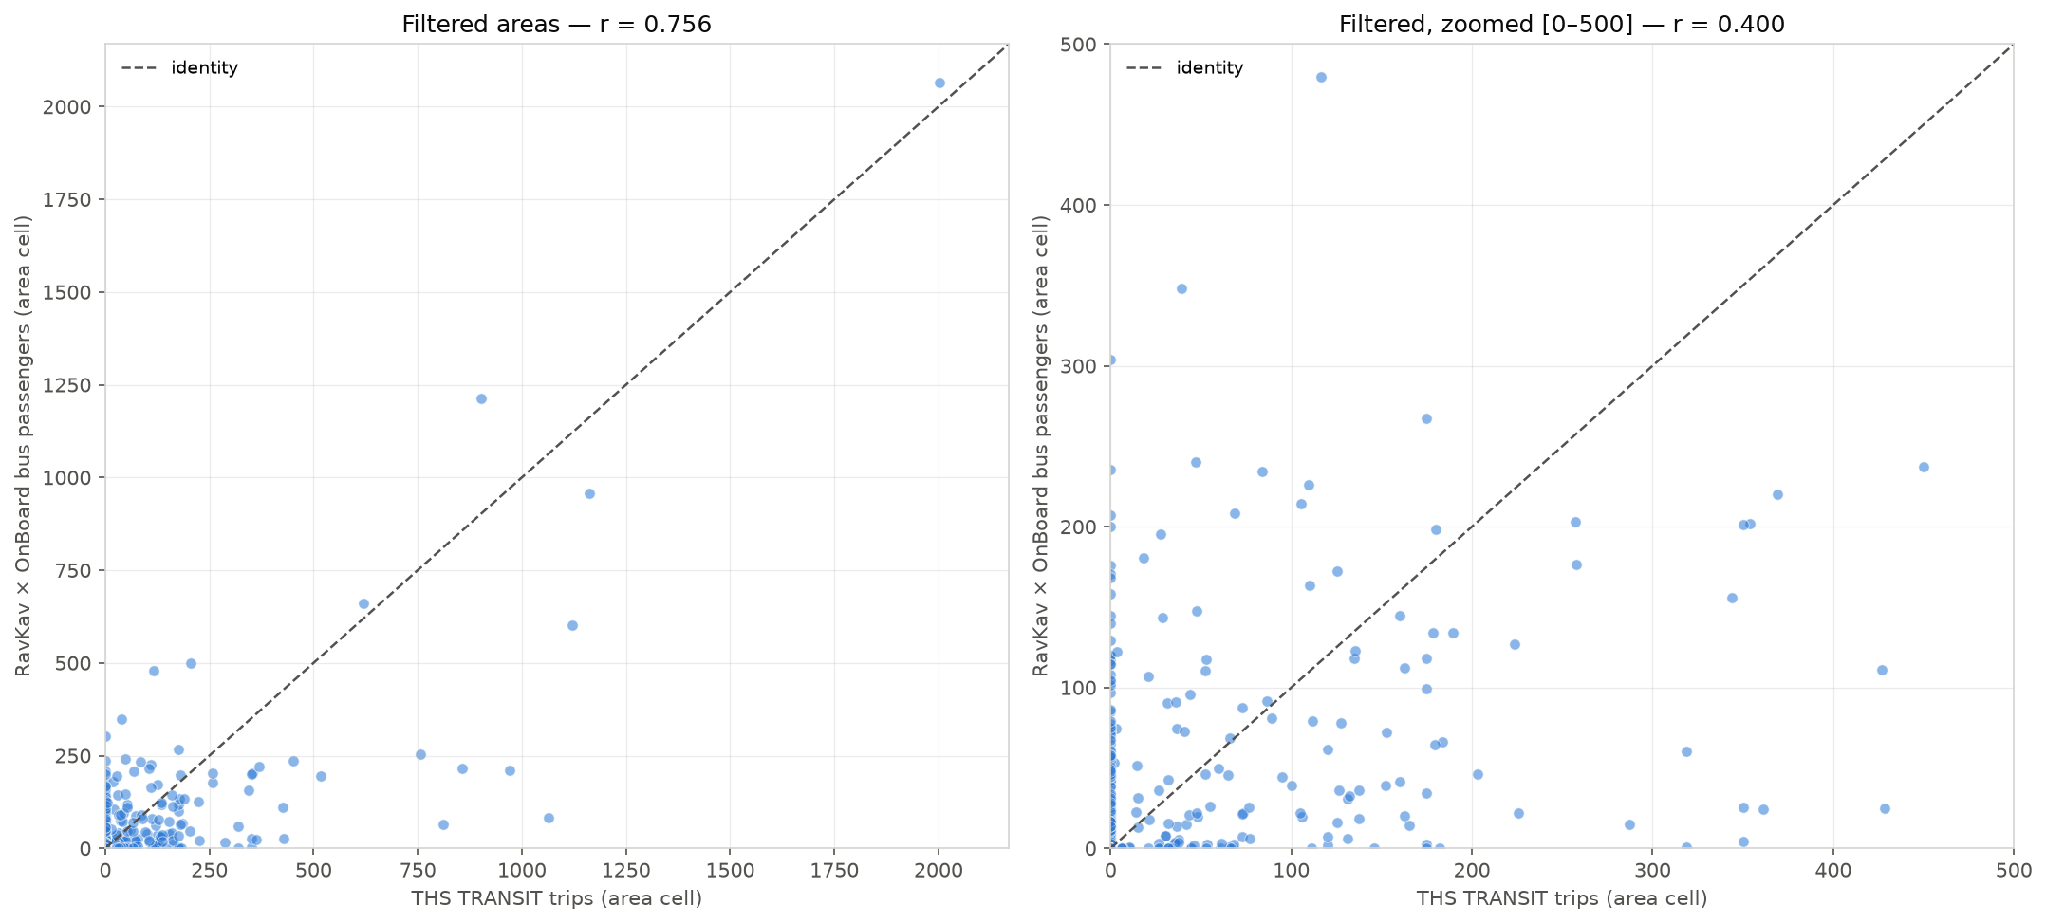
Figure 6 — RavKav×OnBoard vs THS TRANSIT, 25 filtered areas: full range and zoomed to 500.
Large residential areas sit near parity (Kiryat Yam 0.96, Kiryat Motzkin-Bialik 0.89, Tirat Carmel 0.99). Divergence concentrates where it should: hubs and boundary areas (Hamifrats 9.0×, Kiryat Ata Center 1.9×, Neve Yosef 1.8×), where ticketing attributes journeys to the boarding area while the household survey attributes them to the traveller’s true origin. Read as growth, the sub-area ratio is −8.6% over 2018→2022 (−2.2%/yr) — a real, modest decline, confounded by frame differences in both directions.

5.3 The Neve Yosef case
Neve Yosef (TAZs 1311, 1719, 1726, 1727) tops the transit-share table at 74%. Thirty bus stops fall inside its TAZs; three of them — a facing pair straddling the 1311/1726 boundary (stops 47490/47491, ~15 m apart) and stop 43115 — carry ≈40% of journey origins, and stop 47490 alone sees ≈800 boardings against 239 journey starts each morning, with alightings nearly matching boardings. These are trunk-route/transfer stops serving through-demand, not neighbourhood doorsteps. The share is therefore real demand at those stops but not residential mode choice — right for corridor loading, wrong for land-use interpretation. This caveat is carried on all hub areas (Hamifrats foremost).

6. Assumptions, debates and decisions
The design questions that had more than one defensible answer, and how each was settled:
- Intra-zone divergence (survey 72% vs cellular 34% self-containment). Resolved in the survey’s favour by construction: short trips are largely invisible to cell handovers, so the hybrid boosts intra-superzone cells (R_AB ≈ 2.2). An independent short-trip source would arbitrate conclusively.
- Never disaggregate uniformly. Superzone-calibrated relationships reach TAZs only through cellular structure (correction factors on cellular cells, then row normalisation); population-scale structure decides the within-superzone split.
- Cross-day validation limits. Both survey days come from one household panel, so CV measures self-consistency; at TAZ level this bias is disqualifying and no TAZ-level shrinkage is fitted. Documented as a method boundary, not hidden.
- RavKav vs THS for corridor transit demand. Decided for RavKav×OnBoard — originally partly on a level argument (ratio 1.58) that the dedup correction dissolved (0.91). The decision stands on the surviving grounds: a near-census (~550k journeys/day nationally) against ~1,000 sampled transit trips expanded ×150; a frame that includes the non-residents the LRT will carry; and measured hub/transfer demand invisible to a household frame. That the two sources now agree on scale strengthens, not weakens, the choice.
- Boarding location ≠ trip origin. Ticketing origins are first boardings — right for corridor loading, too concentrated for door-to-door OD. Hub-area shares carry an explicit interpretation caveat rather than a redistribution adjustment.
- Frame mix. CAR/OTHER is residents (survey frame, grown demographically); transit is all riders (ticketing). Leveling years does not add missing non-resident car trips. Mildly conservative in the right direction for car-to-LRT shift analysis; documented rather than adjusted.
- COVID. The study team verified May 2022 bus ridership was not pandemic-suppressed; the −8.6% bus reading is treated as real change plus frame. Rail is the exception: the national series itself shows 2022 below the smartcard matrix’s 2019 vintage (54.7M vs 69M), so only rail is scaled.
- Base year 2022, not 2018. Rescaling a census-grade 2022 layer down to match a 4-year-old sample survey would degrade the strongest data; the LRT case wants the current network state. Patterns are never re-leveled — only margins.

7. Results

7.1 Headline progression
All-mode basis (25 areas) | Transit share, all areas | Transit share, corridor
Survey only (2018, reported transit) | 10.1% | —
Substituted, mixed vintages (2018/2019/2022) | 9.5% | 10.7%
Leveled 2022 base (final) | 8.9% | 9.9%

The final 2022 matrix totals 276,355 AM-peak trips: 251,684 car/other + 23,909 bus + 763 rail. The corridor areas account for 97,428 car/other and 11,652 transit origins.

7.2 Mode share by area (2022 base)
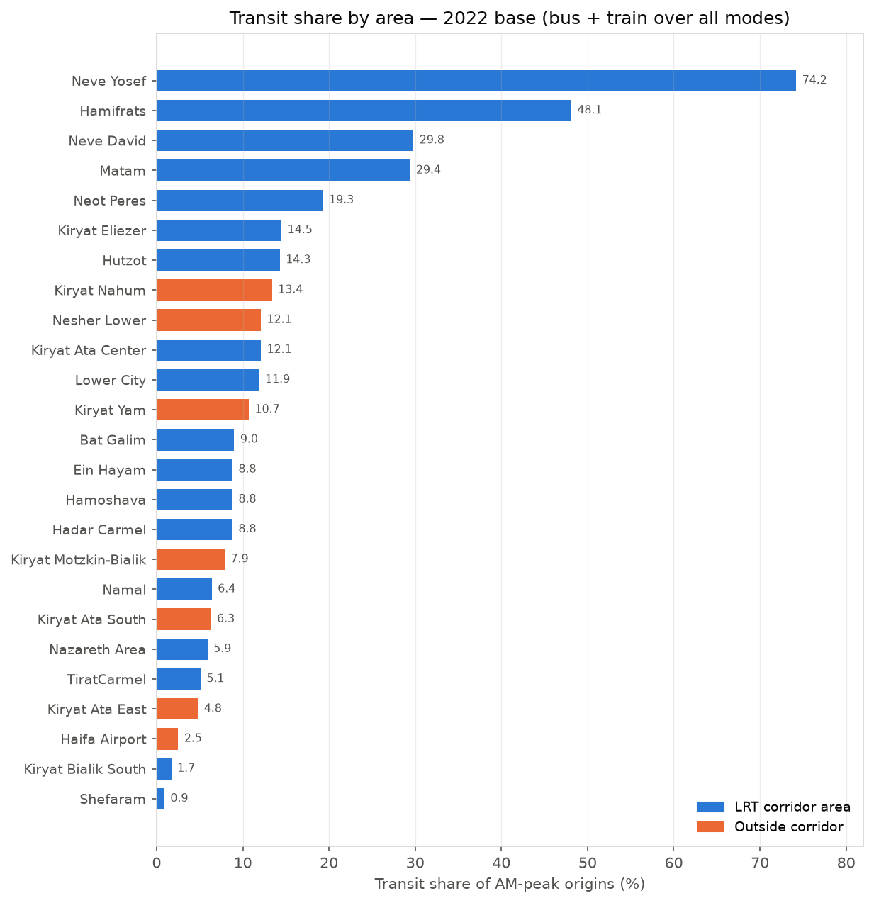
Figure 7 — Transit share of AM-peak origins by area, 2022 base. Hub/boundary areas (Neve Yosef, Hamifrats) reflect boarding attribution, not residential mode choice.
Area | Corridor | Car/other | Bus | Train | Total | Transit share
Neve Yosef | yes | 325 | 936 | 0 | 1,261 | 74.2%
Hamifrats | yes | 1,207 | 1,063 | 55 | 2,325 | 48.1%
Neve David | yes | 2,974 | 1,265 | 0 | 4,239 | 29.8%
Matam | yes | 1,064 | 411 | 33 | 1,508 | 29.4%
Neot Peres | yes | 834 | 199 | 0 | 1,033 | 19.3%
Kiryat Eliezer | yes | 4,764 | 808 | 0 | 5,572 | 14.5%
Hutzot | yes | 1,231 | 180 | 25 | 1,436 | 14.3%
Kiryat Nahum | partial | 966 | 149 | 0 | 1,115 | 13.4%
Kiryat Ata Center | yes | 9,470 | 1,309 | 0 | 10,779 | 12.1%
Nesher Lower | no | 3,712 | 512 | 0 | 4,224 | 12.1%
Lower City | yes | 3,287 | 418 | 26 | 3,731 | 11.9%
Kiryat Yam | no | 34,409 | 4,111 | 0 | 38,520 | 10.7%
Bat Galim | yes | 4,958 | 455 | 36 | 5,449 | 9.0%
Ein Hayam | yes | 4,872 | 473 | 0 | 5,345 | 8.8%
Hamoshava | yes | 3,316 | 320 | 0 | 3,636 | 8.8%
Hadar Carmel | yes | 5,178 | 499 | 0 | 5,677 | 8.8%
Kiryat Motzkin-Bialik | no | 69,481 | 5,353 | 589 | 75,423 | 7.9%
Namal | yes | 1,193 | 82 | 0 | 1,275 | 6.4%
Kiryat Ata South | no | 31,127 | 2,080 | 0 | 33,207 | 6.3%
Nazareth Area | yes | 27,019 | 1,693 | 0 | 28,712 | 5.9%
Tirat Carmel | yes | 21,926 | 1,171 | 0 | 23,097 | 5.1%
Kiryat Ata East | partial | 4,730 | 238 | 0 | 4,968 | 4.8%
Haifa Airport | no | 1,264 | 33 | 0 | 1,297 | 2.5%
Kiryat Bialik South | yes | 4,538 | 80 | 0 | 4,618 | 1.7%
Shefaram | yes | 7,840 | 72 | 0 | 7,912 | 0.9%

7.3 Growth factors applied (2018→2022)
Derived from the zonal 2020 (observed) and 2025 (forecast) files as (X₂₀₂₅/X₂₀₂₀)^(4/5); “(empl.)” marks pure-employment districts whose origin factor falls back to employment growth.
Area | Origin factor (population) | Destination factor (employment)
Tirat Carmel | 1.256 | 1.153
Matam | 1.034 (empl.) | 1.034
Neot Peres | 1.006 | 1.059
Neve David | 1.002 | 0.986
Ein Hayam | 1.033 | 1.020
Bat Galim | 1.012 | 1.008
Kiryat Eliezer | 1.034 | 1.024
Hamoshava | 1.089 | 1.018
Lower City | 1.102 | 1.022
Hadar Carmel | 1.104 | 1.064
Namal | 1.018 (empl.) | 1.018
Neve Yosef | 1.032 | 0.992
Hamifrats | 1.045 (empl.) | 1.045
Hutzot | 1.015 (empl.) | 1.015
Kiryat Nahum | 1.089 (empl.) | 1.089
Kiryat Ata Center | 1.016 | 1.001
Kiryat Bialik South | 1.084 | 1.079
Kiryat Ata East | 1.012 | 0.975
Shefaram | 1.026 | 1.106
Nazareth Area | 1.072 | 1.164
Kiryat Yam | 1.056 | 1.045
Kiryat Motzkin-Bialik | 1.077 | 1.072
Haifa Airport | 1.010 (empl.) | 1.010
Nesher Lower | 0.948 | 0.985
Kiryat Ata South | 1.017 | 1.031

8. Deliverables inventory
All products live under Output/ in the repository; every matrix is origin-rows × destination-columns. The reproducible pipeline is 15 Jupyter notebooks at the repository root, documented step-by-step in METHODOLOGY.md; the source-selection decision record is TRANSIT_DEMAND_PLAN.md.
File | Shape | Content
ths2017/study_taz/hybrid_taz_prob.csv / hybrid_taz_trips.csv | 778×778 | PRIMARY TAZ-level hybrid OD (probabilities / average-weekday trips)
ths2017/study_taz/hybrid_{sz,gs}_*.csv | 36×36 / 25×25 | Calibrated-scale hybrids, λ tables, CV results, correction factors
ths2017/study_taz/matrix_avg_{ALL,CAR,TRANSIT,RAIL,OTHER}_taz.csv | 778×778 | Day-averaged survey matrices by mode group
ths2017/study_taz/submatrices/* | 28×28 | Area-aggregated survey and hybrid matrices, area legend
ths2017/trip_generation_*.csv | per zone | AM-peak per-person generation rates and expanded population
bus/bus_od_taz_avg.csv, bus_od_taz_new.csv | 722×711 / 722×728 | RavKav journey OD; RavKav volumes × OnBoard destinations
bus/bus_od_area_new_filtered.csv | 25×25 | Bus transit demand at areas (noise-filtered)
bus/bus_boardings_alightings_taz.csv, bus_stops_taz.csv, neve_yosef_stops.csv | per TAZ / stop | Leg-level boardings & alightings; stop→TAZ tags; Neve Yosef stop audit
train/train_od_taz_6_9.csv, train_od_area.csv | 19×19 / 25×25 | Rail OD 6–9 (2019 smartcards)
transit/transit_od_area.csv, all_adjusted_area.csv, mode_share_area.csv | 25×25 | Complete transit, substituted all-mode, mode shares (mixed vintages)
transit/*_2022.csv + area_growth_factors_2018_2022.csv | 25×25 | FINAL leveled 2022 base: car/other, all-mode, mode shares, factors
figures/*.png | — | All validation and results charts, including those in this report

9. Caveats and recommended next steps
- Frame mix remains after leveling: non-residents appear in the transit layer only. If a fully all-person matrix is needed, Furness the inter-area cells of the 2022 matrix to demographically-grown cellular margins (keeping intra-area cells survey-based) — the same philosophy as the hybrid.
- Hub attribution: treat Neve Yosef and Hamifrats shares as corridor loading, not residential behaviour; a stop-level assignment model would be needed to redistribute first boardings to true origins.
- Within-superzone origin totals in the TAZ hybrid rest on cellular structure, not a production model; treat individual TAZ origin volumes accordingly.
- 6.4% of bus volume still carries RavKav’s inferred (weaker) destinations where OnBoard coverage is missing.
- Growth factors assume each area’s 2020→2025 trend also held over 2018→2022; refresh when observed 2022 zonal data becomes available (one input file, one notebook re-run).
- Forecast-year demand for the LRT opening year is the natural next step: the 2025 zonal forecast is already in the repository, and the vintage-alignment notebook is the template (grow the 2022 base forward; assign transit growth by corridor scenario rather than demographics alone).

