Nofit LRT Extension
Building the Car, Bus, Taxi-type and Rail Demand Matrices from the Travel Habits Survey
Methodology, tests, results and fitness for the corridor demand assessment, in plain language — revision 3.0
Date: 4 October 2026 (revision 2.2: 23 September 2026; revision 2.1: 21 September 2026; revision 1: 20 September 2026).
Notebooks: THS_2017_cosine_GEH_tests, THS_2017_KS_tests, THS_2017_MSSIM_tests, THS_2017_PCA_car_vs_transit, THS_2017_two_mode_matrix, THS_2017_three_mode_2022, Corridor_flow_profile_survey_2022, Corridor_profile_hybrid_vs_ticketing (file name from an earlier revision), Corridor_peak_hour_2022, THS_vs_RavKav_2025_tests, Car_cordon_counts_validation.
Outputs: Output/ths2017/tests/, Output/ths2017/two_mode/, Output/ths2017/three_mode_2022/, Output/validation/.
What changed in revision 3.0. The report was rewritten in three ways. (1) Everything about the survey × cellular hybrid matrices was removed: its comparison with the survey and the cellular matrix, the superzone conservation test, the rebalanced version and the hybrid figures. The comparison of the survey with the cellular matrix itself is kept in Part B because it describes the survey. (2) The body now reads at the state of the 23 September 2026 rebuild throughout: the survey’s mode codes 4 (group taxi) and 5 (Metronit) are corrected, and the bus calibration uses RavKav’s own inferred alightings as its ticketing reference. Earlier revisions carried a dated note on top of a body at the 21 September state. (3) Part F (tests against RavKav 2022 and 2025 and against road traffic counts) and Section 10 (are the matrices fit for the corridor demand assessment) were added, and Part E was updated. Figures that carried the hybrid or the older calibration were replaced.

1. Summary
This report explains how a set of morning-peak travel demand matrices was built for the Nofit LRT extension study from the household travel survey, how it was tested against the survey itself, against smart-card ticketing and against road traffic counts, and whether the result is fit for assessing demand on the LRT corridor. It is written for readers who know what a demand matrix is but do not want to read the code.
Five pieces of work are covered:
- A survey-only matrix. Built only from the survey trips file and split into car and transit, with the bus part corrected using RavKav ticketing data, segment by segment (Parts A and C).
- A 2022 base. That matrix moved from 2018 to 2022 and split into four layers: car, bus, taxi-type and rail (Part D).
- Corridor profiles and the peak hour. The 2022 layers laid along the LRT line as potential movements, with peak-hour factors from the survey’s minute-level departure times (Part E).
- Tests. Similarity tests of the survey against an independent cellular-phone matrix, a principal-component comparison of car and transit inside the survey (Part B), and tests against two independent sources: RavKav ticketing for 2022 and 2025, and road traffic counts on closed cordons (Part F).
- A conclusion on what the matrices can and cannot be used for in the corridor demand assessment (Section 10).

The main numbers
Layer (morning peak 06:00–09:00, both trip ends in the study area) | 2018 base | 2022 base
Car | 1,283,589 | 1,353,798
Bus (public bus and Metronit, calibrated to RavKav) | 115,430 | 117,961
Taxi-type (group and special taxi, survey only) | 8,910 | 9,451
Rail (door-to-door survey trips) | 5,109 | 4,050
Bus share of car + bus + taxi + rail | 8.2 % | 7.9 %
Bus share, trips with both ends in the LRT corridor | 13.2 % | 12.4 %
Peak hour (departures) and share of the three hours it holds |  | 07:00–08:00; car 0.62, bus 0.59
Busiest transit link, three hours (potential movements) |  | 1,842 towards Nazareth; 1,488 towards Tirat Carmel
Busiest transit link, peak hour (potential movements) |  | 1,085 towards Nazareth; 876 towards Tirat Carmel

The main findings
- Ticketing coverage is uneven, and the survey is the safer source where it is thin. In the Krayot, Acre and Nahariya RavKav records about as many bus journeys as the survey expands to (0.89–1.30), in the four large Haifa superzones 0.58–0.89, and in seven peripheral and Arab-sector superzones only 0.23–0.44. The coverage test is therefore applied per origin superzone and destination segment: 30 origin-by-segment cells keep survey volumes.
- The survey’s bus matrix and RavKav’s own inferred alightings share the same destination structure, to within the survey’s day-to-day noise (cosine 0.89 against 0.89 between the survey’s own two days; PCA overlap 0.81 against 0.83). The on-board survey’s destination pattern does not: it matches the survey no better than chance and carries trips twice as long. The calibration therefore uses RavKav’s own alightings as its ticketing reference.
- The calibrated bus base is 115,430 (2018), 8 % below the survey (125,439) and 25 % above the ticketing (92,440). It moves between 96,000 and 129,500 as the coverage threshold moves from 0.3 to 0.7. The threshold is an assumption, stated as such; the variants are published beside the primary.
- Car and transit share the dominant destination structure, but transit is less local and more Haifa-bound. A transit market cannot be read off the car pattern by scaling, so the base keeps a transit-specific destination pattern.
- The car layer is 0.58–0.90 of the vehicles counted on closed cordons where the crossing links are mostly counted (0.61–0.66 on the metropolitan core and Tirat Carmel inbound). That is the expected order for a layer of residents’ personal trips set against all traffic.
- Corridor profiles are potential movements, not loads. The survey-based and ticketing-based transit profiles agree along the Haifa trunk (survey ÷ ticketing 0.72–1.17 towards Nazareth, 0.79–1.27 towards Tirat Carmel, from Tirat Carmel to Hamifrats). The Nazareth branch is the exception and still needs a bus passenger count.
- The peak hour is 07:00–08:00 and holds 59–66 % of the three hours in the survey, 1.8 times an average hour. The road counts and RavKav boardings show a flatter morning (0.38–0.43 and 0.43–0.48), so the survey factors are an upper bound.
- Fitness for use (Section 10). The matrices are fit for screening-level assessment of the corridor: comparing and ranking alignments and segments, sizing and locating the transit market between line areas, and feeding capture scenarios with a stated range. They are not fit for passenger loads, capacity or frequency sizing, station-level demand, a single ridership forecast or economic appraisal.

2. The data used
Source | What it is | How it is used here
Travel Habits Survey 2017/18, trips file (trips_ths_2017.xlsx) | One row per activity for 16,401 surveyed persons on two survey days, with the mode used to reach each place and a household expansion weight. | The base of everything: trips are formed from consecutive activities, kept if they leave between 06:00 and 09:00, and expanded.
THS person and household tables | Car ownership, licences, age, sector and household weights. | Mode-code check (the trips file’s codes were confirmed against the activities file) and the person-level cost sensitivity used by the capture model.
RavKav bus ticketing, May 2022 | Every bus journey on four Tuesdays, with RavKav’s own inferred alighting stop and transfers linked so a journey is counted once. | Sets how many bus journeys start in each superzone and segment where its coverage is credible, and supplies the destination pattern the survey rows are shrunk towards.
RavKav 2025 (bus, Metronit, rail) | Three smart-card extracts for 2025: boardings, and entry and exit taps at rail stations. | Independent test of the survey bus matrix, boarding-hour peak factors, rail origin–destination check. Not the anchor of the base.
On-board bus survey, 06:00–09:00 | For each boarding zone, where passengers said they were going. | Comparison only. It was the destination pattern of the bus calibration until the tests of Part F showed it does not match the survey.
Zonal socio-economic files 2020 and 2025 | Population and employment per zone, observed (2020) and forecast (2025, BU scenario). | Splits survey zones into study zones; grows the 2018 matrices to 2022.
Train smartcards 2019 | Station-to-station morning trips. | A rail alternative for corridor loading; the survey rail matrix stays the door-to-door layer.
Road traffic counts (Emme network, 23 Sep 2026) | Hourly counts in passenger-car equivalents on 3,241 directional links, dated 2017–2023. | External check of the car layer on six closed cordons (Part F).
Cellular OD matrix 2018–19 | Morning-peak trips between 1,270 national zones, derived from phone movements. | Only in the tests of Part B, as a second view of the same travel. It is not part of the base.
Zone keys and TAZ map | Links between the survey’s zone system, the 778 study TAZs and 36 superzones. The keys table is stored in Git LFS; a committed copy derived from the TAZ shapefile stands in for it. | Zone conversion; trip lengths.

Words used in this report
- OD matrix. A table with one row per origin zone and one column per destination zone. Each cell holds the number of trips from that origin to that destination in the morning peak.
- TAZ, superzone, sub-area, corridor. The 778 study zones. Superzones group them into 36 larger areas; the 28 sub-areas are named districts around the LRT corridor; the corridor itself is 119 TAZs, and 18 sub-areas form the line sequence. The V2 aggregation used in the capture model has 25 areas.
- Expansion weight. The number of real trips each surveyed trip stands for. A survey of about 4,100 households is scaled up to the whole population this way.
- Destination pattern. The share of an origin’s trips going to each destination, ignoring how many trips the origin makes.
- Segment. For a given origin superzone, one of three groups of destinations: local (the same superzone), corridor-bound (another superzone that contains LRT-corridor TAZs), or other.
- Shrinkage (empirical Bayes). When a survey zone has too few observations, its destination pattern is pulled part-way toward a reference pattern. The pull is weaker the more observations the zone has. The strength is a single number, k, chosen by testing on held-out data.
- Furness (iterative proportional fitting). A standard way to scale a matrix so that its row totals and column totals hit given targets while keeping its internal pattern.
- Potential movements. Trips between two line areas, counted on every link between them as if they all used the line. A screening quantity, not a passenger load.
- Peak-hour factor. PHF₃ₕ is the share of the three-hour trips that depart in the busiest 60 minutes (an average hour would be 0.333). PHF₆₀ is the conventional within-hour factor: peak-hour trips divided by four times the busiest 15 minutes (1.0 = a flat hour).

3. Part A — the survey-only matrix

3.1 From activities to trips
The survey file lists the places each person visited during the day, in order. A trip runs from one place to the next. Its departure hour is the hour the person left the first place, and its mode is the mode used to reach the second place. Trips leaving between 06:00 and 09:00 are kept. Each trip counts with its expansion weight. Trips with either end outside the study area are set aside (1,197 sampled trips, about 5 % of the weight; most surveyed rail trips are among them, and bringing them back as an external segment is an open task).
The two survey days are averaged cell by cell to give a representative weekday. The two days are also kept separately. Their agreement with each other is used throughout as a reference for repeatability. It is not a ceiling: the two days are the same households, so they can agree with each other more closely than either agrees with the truth, and a matrix built from the survey can score above it.

3.2 From survey zones to study zones
The survey records places in a national system of 2,636 zones. A key file maps them to 1,250-zone units, and each of those holds up to eight study TAZs. Trips are shared out among a zone’s TAZs using the 2020 zonal file: by population on the origin side and by employment on the destination side. Where a zone has no population, employment is used, and where it has neither, the split is equal.
Below the 1,250-zone level the TAZ detail is therefore a population / employment split, not something the survey observed. Superzone and sub-area figures are the fair level for judging the survey. The split is also purpose-blind: it is a reasonable first assumption for home-to-work trips and a weak one for education, shopping and escort trips, which is on the task list.

3.3 Modes
The trips file codes the main mode of each trip. The codes were confirmed against the survey’s activities file on 23 September 2026 (the person-level mode-choice work), which showed that codes 4 and 5 had been read the wrong way round in the earlier chain, so that the Metronit riders sat in the taxi-type layer. Everything below uses the corrected codes.
Component | Main mode codes | Weekday trips (2018) | Treatment
Car | 10 driver, 11 passenger | 1,283,589 | Survey only
Bus | 3 public bus, 5 Metronit | 125,439 (survey); 115,430 calibrated | Calibrated to ticketing (Part C)
Taxi-type | 4 group taxi, 8 special taxi | 8,910 | Survey only; its own layer from Part D on
Rail | 7 train | 5,109 | Survey only
Other (walk, bicycle, …) | 1, 2, 9, 12, 13, 99 | about 645,000 | Reported, not part of the car / transit matrix
Hired and shared taxis need not share the fares, access or transfer behaviour of scheduled bus, so they are kept apart from the bus layer and are not added to an LRT market by default. Before calibration, transit (bus + taxi-type + rail, 139,458 trips) is 9.8 % of car + transit trips.

4. Part B — how the survey compares with an independent cellular matrix, and car with transit
Two sets of tests describe the survey matrix before any ticketing is involved. The first compares it with a cellular-phone matrix, a second view of the same morning travel. The second compares car and transit destination structure inside the survey. All tests are run at four levels: 36 superzones, 25 GS zones, the 28 sub-areas and the 778 TAZs.
Two references are used everywhere. The first is the survey’s day 1 against its day 2: a measure of how repeatable the survey is, useful for reading the size of a difference, but not an upper bound. The second is a chance level, obtained by scrambling the geography of one matrix and repeating the test: anything at that level is meaningless.

4.1 Cosine similarity — is the demand in the same cells?
Cosine similarity lays both matrices out as long lists of cells and measures the angle between them. It equals 1 when the two lists are proportional, and it ignores the total volume. It is driven by the largest cells, so it is also computed without the diagonal (trips that stay inside one zone) and on destination patterns.
Level | Survey day 1 vs day 2 | Survey vs cellular | Chance level
Superzone (36) | 0.996 | 0.915 | 0.58
GS (25) | 0.999 | 0.953 | 0.28
Sub-areas (28) | 0.997 | 0.897 | 0.20
TAZ (778) | 0.972 | 0.442 | 0.14
Cosine similarity of the raw matrices. Chance level = mean over 2,000 (300 at TAZ) geography scramblings.
What it says: the survey and the cellular matrix share a real regional pattern (0.92 at superzone level, against 0.58 by chance), but well below the survey’s own repeatability (0.996). At TAZ level they agree only at 0.44. Per origin, the worst-matching superzones are the corridor superzones 10 and 11, and the mismatch there is on the diagonal: without it they score 0.75 and 0.69.

4.2 GEH — cell by cell, are the volumes within the usual tolerance?
GEH is the statistic used to validate traffic counts. For two hourly flows m and c it is the square root of 2(m − c)² / (m + c); values under 5 are usually called a good match. The three-hour matrices are divided by 3 first, which gives an average hour, not the busiest one. GEH thresholds were set for link counts, not for weighted OD cells, so the shares below are read relative to each other, not against a fixed pass mark.

The scale audit
Before any rescaling, the survey carries 2,068,158 morning trips inside the study area and the cellular matrix 580,506: 3.6 times more. On trips between different cellular zones the ratio is 2.2. The difference is in short trips: 47 % of survey trips stay inside one cellular zone, against 14 % of cellular trips. After one overall scale factor, only 11 % of superzones have origin totals within GEH 5 of each other. The cellular product misses many short trips and its zone totals differ from the household expansion by more than a single factor. Which side is right cannot be decided without the cellular product’s trip definition (dwell time, minimum distance, device-to-person expansion), which has not been supplied.

The pattern test
The cellular matrix was then given the survey’s origin totals and compared cell by cell. The share of flow within GEH 5 is:
Level | Survey day 1 vs day 2 | Survey vs cellular
Superzone | 46 % | 6 %
GS | 39 % | 1 %
Sub-areas | 63 % | 9 %
TAZ | 79 % | 46 %
Share of flow in cells with GEH < 5, hourly flows, cellular given the survey’s origin totals.
GEH is harsh at aggregate levels because the cells are large (a superzone cell can carry 6,000 trips an hour, where GEH 5 means about ±4 %). Even the two survey days pass in under half of superzone flow. The survey and the cellular matrix agree on 1–9 % of flow at the aggregate levels, against 39–63 % for the two survey days.

4.3 Kolmogorov–Smirnov — are the trip lengths the same?
A KS test compares two distributions and reports D, the largest gap between their cumulative curves. Here it was applied to the distribution of trips by straight-line centroid distance, with and without the diagonal, per origin superzone, per corridor class, and to how concentrated each matrix is in its big cells. No classical p-values are reported: the expansion weights would make everything significant. Instead D is judged against the day 1 vs day 2 value and against a household bootstrap of the survey (200 resamples).
Distribution | Survey day 1 vs day 2 | Survey vs cellular
Trip length, all cells | 0.009 | 0.423
Trip length, without intra-TAZ cells | 0.011 | 0.374
Trip length, without intra-cellular-zone cells | 0.009 | 0.301
Per-origin trip length (flow-weighted) | 0.034 | 0.450
Trip length, corridor to corridor | 0.017 | 0.387
Flow concentration, TAZ level | 0.028 | 0.499
KS statistic D (largest gap in cumulative trip share).
What it says: the survey and the cellular matrix describe different trip-length populations, not noisy versions of one. The median centroid distance is 1.95 km in the survey and 7.6 km in cellular; the bootstrap spread of D is about ±0.01, so a D of 0.42 is nowhere near noise. The gap is not only the diagonal: with every cell inside one cellular zone removed, D is still 0.30. Every origin superzone shows it. The cellular matrix is also far more diffuse: 52 % of its trips sit in cells with fewer than 10 trips an hour, against 11 % of survey trips.
One calibration check: against the distances the survey itself reports, the centroid proxy overstates short trips (median 1.95 km versus 1.11 km reported). Both matrices carry the same proxy, but they weight zones differently, so the comparison is fair only approximately; absolute lengths under 1 km are a zone-geometry artefact.

4.4 MSSIM — do the matrices agree neighbourhood by neighbourhood?
The structural similarity index comes from image comparison and was proposed for OD matrices by Djukic, van Lint and Hoogendoorn. It slides a small window over the matrix and compares, inside each window, the average level, the spread and the correlation of the two matrices, then averages over windows. For that to work, neighbouring rows must be neighbouring zones, so TAZs were ordered along a space-filling curve of their centroids; a window has no fixed physical size. Windows of 5 to 25 zones were tested, on raw trips and on log(1 + trips).
Level, window, scale | Survey day 1 vs day 2 (chance) | Survey vs cellular (chance)
TAZ, 9, raw trips | 0.999 (0.98) | 0.993 (0.99)
TAZ, 9, log | 0.814 (0.14) | 0.128 (0.02)
Superzone, 3, log | 0.686 (0.07) | 0.362 (0.09)
Sub-areas, 3, log | 0.619 (0.07) | 0.257 (0.05)
MSSIM; the chance level (one matrix’s zones scrambled) in brackets.
What it says: on raw trips the index cannot tell anything apart. On the log scale it becomes informative. Survey against cellular is close to chance at TAZ level (0.13, chance 0.02, day-to-day 0.81). The zone ordering and the window size change the results by less than 0.05.

4.5 What the cellular comparison means
- The survey and the cellular product see the same broad geography but a different mix of trips. The cellular product misses short trips and spreads the rest thinly; the survey is concentrated and short. This is a difference in what each source records, not sampling noise; which one is closer to the truth needs the cellular trip definition and external counts, neither of which is in hand.
- Survey rows are stable from day to day at superzone level, thin at TAZ level. Below the superzone, TAZ detail from any source in this study is an allocation, not an observation.
- Absolute volumes rest on the survey expansion only. The road-count check of Part F is the first external test of that expansion.

4.6 Car versus transit inside the survey
The same principal-component tests were run within the survey, with the mode group as the grouping: do car trips and transit trips (bus, taxi-type and rail) share the same destination-choice structure? Each statistic is judged against each mode’s own day-to-day repeatability and a permuted-geography null; transit rows are thin (median 36 sampled trips per origin superzone over two days), so a household bootstrap and a run restricted to the 26 well-sampled origins accompany the headline figures.
Superzone level, k = 20 | Car vs transit | Car day-to-day | Transit day-to-day | Chance
Subspace overlap | 0.75 (bootstrap 0.66–0.76; p = 0.0005) | 0.95 | 0.81 | 0.57
Overlap on the 26 well-sampled origins | 0.83 | 0.98 | 0.86
Transit variance captured by car components | 0.86 |  | 0.89 (by its own)
Mean self-containment | car 0.62, transit 0.45
Common direction of the divergence | yes, p = 0.04

What it says: car and transit share the dominant structure. On the origins where transit is adequately sampled, the two modes agree with each other as closely as transit agrees with itself on another day, and the leading components match one to one (a geographic axis and a self-containment axis). Where they differ is systematic and points one way: transit trips are less local than car trips, and the released share goes to the Haifa core (Hadar, the Carmel centre, the lower city and the port areas gain two to three points of destination share on average; Tirat Carmel, Umm al-Fahm, Beit She’an and Ma’alot lose about two). The well-sampled origins where transit departs most from car are Rekhasim / Zevulun (45 % of transit trips to the Haifa superzones against 9 % of car trips), Shefa-’Amr / Tamra (66 % against 14 %) and Tirat Carmel (71 % against 23 %).
The same tests at other resolutions:
Level (origins with at least n sampled transit trips) | Origins | k | Car vs transit | Car day-to-day | Transit day-to-day | Chance
Superzone × superzone (1) | 35 | 20 | 0.75 | 0.95 | 0.81 | 0.57
Corridor areas × areas (10) | 14 | 5 | 0.57 | 0.91 | 0.65 | 0.18
Corridor areas × areas (20) | 8 | 3 | 0.64 | 0.99 | 0.70 | 0.11
TAZ × superzone (5) | 133 | 15 | 0.75 | 0.90 | 0.89 | 0.43
TAZ × TAZ (5) | 133 | 35 | 0.27 | 0.71 | 0.55 | 0.05
Each row asks how much of the way car trips choose destinations transit trips share, at one map resolution, read against transit’s own repeatability and the chance level.
- Corridor areas. At the corridor aggregation areas the modes are as alike as transit is to itself on another day (0.57 against 0.65; 0.64 against 0.70 for the eight best-sampled areas): nothing finer can be resolved there from the survey. The well-sampled outer areas nevertheless show the Haifa pull plainly (Kiryat Motzkin-Bialik sends 26 % of its transit trips to the Haifa line areas against 6 % of its car trips; Kiryat Yam 13 % against 7 %; Kiryat Ata South 12 % against 3 %), while origins inside Haifa send 70–95 % of both modes there.
- TAZ origins, superzone destinations. 133 TAZs with at least five transit trips. Car vs transit 0.75 against a transit repeatability of 0.89: here the gap is real, not sampling noise, and the test for a common direction confirms it (p = 0.002). This is the row that establishes that transit is systematically less local and more Haifa-bound than car.
- TAZ × TAZ. Car vs transit 0.27, transit day-to-day 0.55, chance 0.05. Both modes are noisy at this resolution, but transit shares only the coarse geography with car: which TAZ within a superzone a transit trip ends in follows the bus stops and trunk routes, not the spread of jobs that places car trips.
Why it matters for the corridor: a transit market cannot be read off the car pattern by scaling. Transit demand from the outer superzones is markedly more Haifa-bound than car demand from the same places, which is the movement a Haifa-oriented line serves, and it is less local, so the intra-superzone trips that dominate the car matrix matter less for transit. This supports keeping a transit-specific destination pattern in the base, as the calibration in Part C does. At sub-area level the comparison is at transit’s noise floor and says nothing; within Haifa, the ticketing products remain the right source.
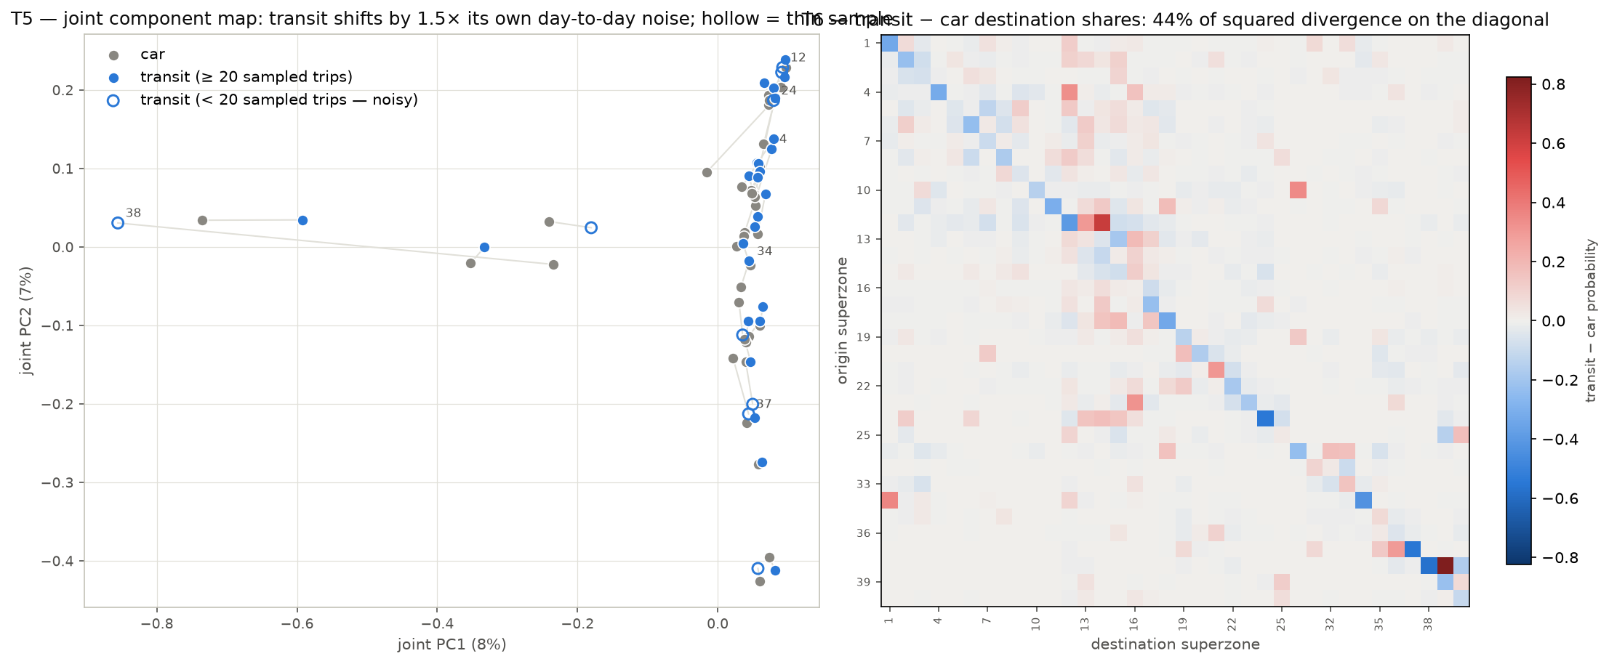
Figure 1. Left: joint component map, car (grey) and transit (blue) profiles of each origin superzone; hollow markers are thin-sample origins. Right: transit minus car destination shares; the Haifa-core columns are systematically positive.
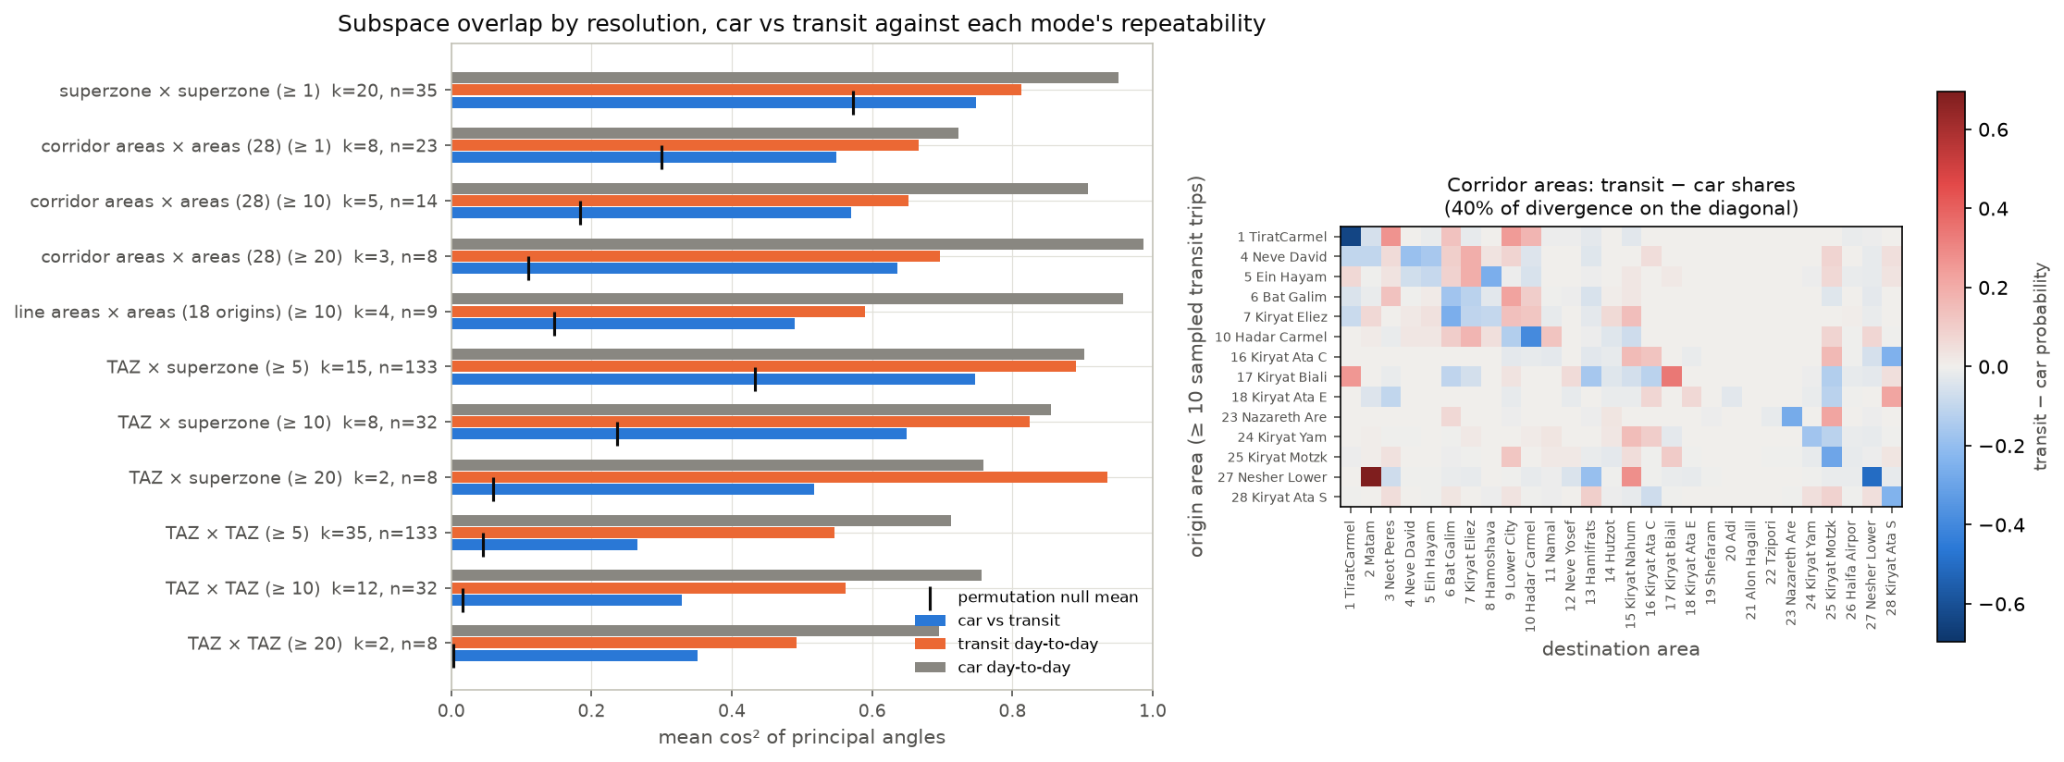
Figure 2. Left: overlap by resolution against each mode’s repeatability and the permutation null. Right: transit minus car destination shares between the corridor aggregation areas.

5. Part C — calibrating the bus part with RavKav

5.1 Why calibrate, and what each source is good at
The household survey sampled only 1,790 bus trips in the morning peak across 36 superzones, so many superzones have only a handful of bus trips and their destination patterns are noisy. RavKav ticketing describes the same bus travel and is close to a census. It says how many people boarded where, on four Tuesdays in May 2022, with transfers linked so each journey is counted once, and it carries RavKav’s own inferred alighting stop for each journey. Its weak points are that destinations are inferred, and that origins are boarding stops rather than homes and include non-residents.
The calibration lets each source do what it is good at, at the scale where it is reliable: the survey where ticketing under-records, ticketing where it is close to complete.

5.2 The three steps
- Step 1 — destination pattern. At superzone level, each origin’s survey destination pattern is blended with the RavKav pattern (RavKav’s own inferred alightings). The weight on the survey is n / (n + k), where n is the number of survey bus trips observed from that origin and k is chosen by validation (5.3).
- Step 2 — volumes, per origin and segment. For each origin superzone, its bus trips are split into three destination segments: local, corridor-bound and other. In each segment with at least five observed survey trips, the ratio of RavKav journeys to survey trips decides: at 0.5 or above, the segment takes the ticketing volume; below 0.5, ticketing is treated as under-covering and the survey volume is kept. Thinner segments follow the decision for the origin as a whole. Within a segment the blended pattern of step 1 spreads the volume over destinations.
- Step 3 — TAZ detail. Inside each origin superzone, the split among TAZs blends the survey’s home-based shares with RavKav boarding shares; inside each destination superzone, the split blends survey arrival shares with RavKav’s inferred alighting shares.
Three other treatments are kept as sensitivities: one ratio per whole origin (the “binary guard”), ticketing volumes everywhere, and one regional factor.

5.3 Choosing the shrinkage constant
Cross-day validation (a blend built on day 1 has to predict day 2) would give k = 0, “never lean on ticketing”. That answer is suspect: the two days are the same households, and bus commuters repeat the same trip. Instead the sampled households were split at random into two halves, forty times, and the blend built on one half had to predict the other half. That criterion has a clear best value at k = 100. At it the mean row Jensen–Shannon divergence is 0.265, against 0.336 for the raw survey rows and 0.267 for the pure RavKav rows: the ticketing pattern alone predicts held-out survey households as well as the blend does, and better than the survey’s own rows. The survey weight is 0.36 on average (trip-weighted), so the pattern is mostly the ticketing’s.
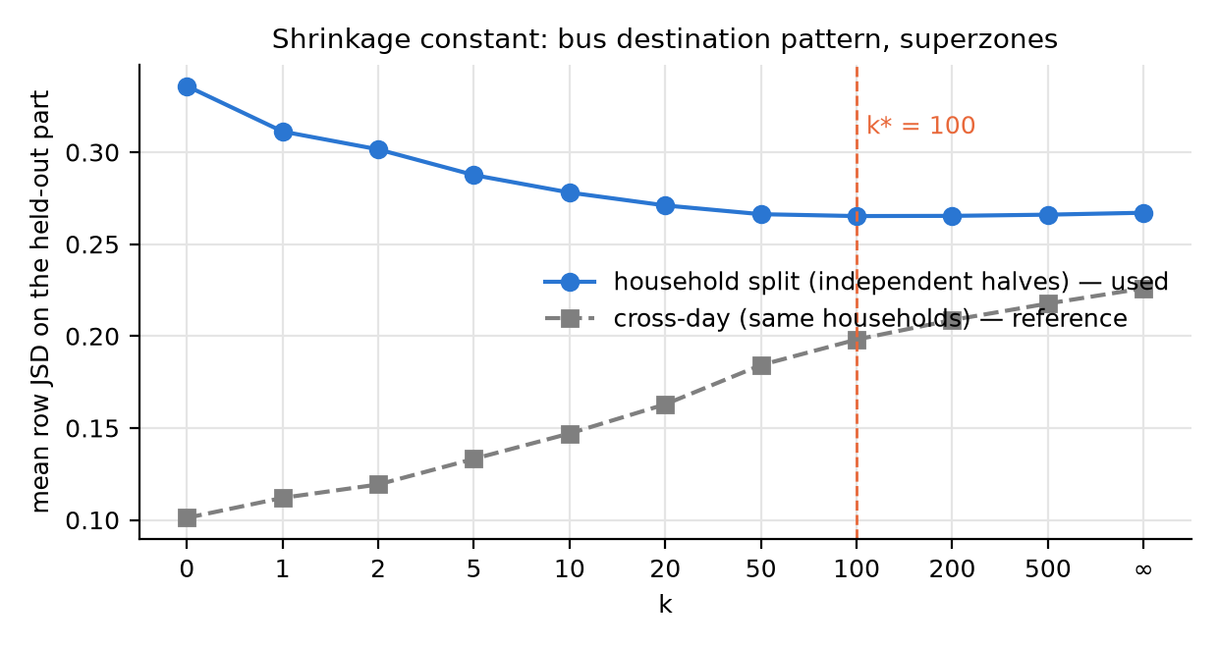
Figure 3. Prediction error of the held-out household half (blue, used) and of the other survey day (grey, reference) against k.

5.4 What the ticketing data covers
Comparing RavKav journeys with survey bus trips per superzone gives a clear geographic pattern. In the Krayot, Acre and Nahariya ticketing records about as many journeys as the survey expands to (0.89–1.30); in the four large Haifa superzones 0.58–0.89; and in seven peripheral and Arab-sector superzones (Nazareth / Kafr Kanna, Shefa-’Amr / Tamra, Daliyat al-Karmel / Isfiya, Sakhnin, Ma’alot, Safed, Beit She’an; an Arab-sector population share of 0.98–1.00 in four of them) only 0.23–0.44. Splitting each origin’s trips by destination segment shows where the shortfall sits:
Superzone | Survey local | RavKav local | Ratio local | Survey corridor-bound | RavKav corridor-bound | Ratio corridor-bound | Ratio other
19 Nazareth, Kafr Kanna | 5,669 | 1,720 | 0.30 | 1,566 | 525 | 0.34 | 0.09
4 Shefa-’Amr, Tamra | 493 | 363 | 0.74 | 981 | 346 | 0.35 | 0.28
23 Daliyat al-Karmel, Isfiya | 850 | 285 | 0.34 | 171 | 238 | 1.39 | 0.34
30 Sakhnin, Arraba | 508 | 149 | 0.29 | 158 | 37 | 0.23 | 0.28
34 Ma’alot, Beit Jann | 1,455 | 482 | 0.33 | 42 | 27 | 0.64 | 0.33
33 Safed | 2,450 | 593 | 0.24 | 0 | 13 | — | 0.35
37 Beit She’an | 665 | 255 | 0.38 | 168 | 134 | 0.80 | 0.31
17 Haifa (Carmel) | 2,567 | 2,012 | 0.78 | 3,756 | 3,668 | 0.98 | 0.84
16 Haifa (Hadar) | 4,339 | 2,313 | 0.53 | 4,637 | 2,891 | 0.62 | 0.43
9 Kiryat Ata | 3,212 | 1,713 | 0.53 | 1,704 | 2,044 | 1.20 | 0.90
Survey bus trips (2018, expanded) and RavKav journeys (May 2022, own alightings) by origin superzone and destination segment.
Under the segmented rule, 30 origin-by-segment cells keep survey volumes: 11 local, 9 corridor-bound and 10 other. All three Nazareth segments keep the survey (0.30, 0.34 and 0.09). The Haifa superzones 14 and 16 pass at 0.59 and 0.53 on their local segments, because RavKav’s own alightings keep 40,816 journeys local where the on-board pattern had kept 23,277.
What a low ratio means is not settled. Ticketing may miss operators, cash fares or un-geocoded stops; the survey expansion may overstate short local bus trips; both may be true. The raw ticketing file records about 3,500 morning boarding legs in the Nazareth superzone against 11,600 survey-expanded bus trips, so the gap is in the ticketing volume itself, not in how journeys were placed on the map. The files carry route ids but no operator field. Which operators and fare types the extract covers is a question for the data provider; until it is answered the threshold of 0.5 is an assumption, and the sensitivity to it is reported below.

5.5 Results and validation
Component (2018) | Survey | Binary guard | Segmented rule (used) | Ticketing everywhere
Bus (public bus + Metronit) | 125,439 | 111,818 | 115,430 | 92,440
of which local (inside one superzone) | 63,878 | 52,325 | 53,950 | 40,816
of which between superzones | 61,560 | 59,493 | 61,481 | 51,624
Transit total (bus + taxi-type + rail) | 139,458 |  | 129,449
Transit share of car + transit | 9.8 % |  | 9.2 %

The segmented total sits 8 % below the survey and 25 % above the ticketing. The rule is asymmetric: where ticketing sees at least half of the survey’s trips it usually sees more than the survey (up to three times at transfer hubs, because journeys are attributed to the boarding stop), and those cells take the ticketing figure; where it sees less than half, the survey figure stays. The local segments keep most of the survey; the inter-superzone segments end at the survey’s level.
Coverage threshold | 0.3 | 0.4 | 0.5 (used) | 0.6 | 0.7
Guarded origin × segment cells | 7 | 22 | 30 | 42 | 51
Bus total, 2018 base | 95,986 | 109,713 | 115,430 | 124,654 | 129,472
of which local | 41,785 | 51,230 | 53,950 | 61,993 | 62,984
Sensitivity of the segmented rule to the coverage threshold.
Against the RavKav matrix on its own alightings, the calibrated bus matrix scores:
Comparison | Cosine, superzones | Cosine, sub-areas | Flow within GEH 5, sub-areas
Raw survey bus vs ticketing | 0.886 | 0.812 | 43 %
Segmented rule (used) vs ticketing | 0.883 | 0.975 | 85 %
Binary guard vs ticketing | 0.892 | 0.973 | 82 %
Ticketing volumes everywhere vs ticketing | 0.993 | — | —
Survey bus, day 1 vs day 2 (repeatability) | 0.888 | 0.921 | 69 %
Agreement with the ticketing matrix before and after calibration. A closer fit to the source used for calibration is a check of direction, not an independent validation; the independent tests are in Part F.
The segmented rule scores slightly below the binary one at superzone level, as expected: it keeps more survey volume in local cells where ticketing is thin. Destination totals were never forced, yet they reach cosine 0.96 with RavKav’s inferred alightings. Inside the corridor the calibration moved the transit share of corridor-to-corridor trips from 12.7 % to 13.6 % (2018 base, transit including taxi-type and rail).

6. Part D — moving to 2022 and splitting into car, bus, taxi-type and rail

6.1 The idea
The survey describes 2018. The ticketing data describes May 2022, which is also the base year the study uses. Rather than mix years, everything of survey vintage is moved to 2022 with the convention the repository already uses at area level, now applied at TAZ level.
The convention holds trip rates constant: each TAZ keeps its 2018 trips per resident on the origin side and its 2018 trips per job on the destination side. Growth comes from the zonal files: the change from 2020 (observed) to 2025 (forecast, BU scenario), taken at four fifths of the five-year change to represent 2018 to 2022. This extrapolates a forecast trend; it does not measure 2018–2022 change. A TAZ uses its own factor only if its 2020 base is at least 500 people (origins) or jobs (destinations); smaller zones take their superzone’s factor. The car matrix is then Furnessed to the grown row and column totals, with the overall total set by the origin side.
Layer | How it moves to 2022
Car | Furnessed to population-grown origins and employment-grown destinations: +5.5 %
Bus, cells that took ticketing volumes | Already May 2022 counts; untouched (74,802 trips)
Bus, coverage-guarded cells | Grown by their TAZ’s population factor: 40,629 → 43,159
Taxi-type (own layer) | Furnessed like car: 8,910 → 9,451
Rail (survey, door-to-door) | Scaled by the national rail ridership change 2019 → 2022 (× 0.793): 5,109 → 4,050; the 2019 station-to-station smartcard matrix scaled the same way is saved beside it

6.2 Results
Trips by corridor class | Car 2018 | Car 2022 | Bus 2018 | Bus 2022 | Taxi 2018 | Taxi 2022 | Rail 2018 | Rail 2022
Corridor → corridor | 66,610 | 72,331 | 10,213 | 10,255 | 314 | 313 | 0 | 0
Corridor → outside | 44,039 | 47,011 | 8,822 | 8,947 | 529 | 573 | 368 | 292
Outside → corridor | 94,672 | 89,181 | 18,953 | 19,144 | 1,008 | 1,020 | 3,302 | 2,618
Outside → outside | 1,078,268 | 1,145,275 | 77,442 | 79,615 | 7,058 | 7,545 | 1,439 | 1,141
All | 1,283,589 | 1,353,798 | 115,430 | 117,961 | 8,910 | 9,451 | 5,109 | 4,050
The four 2022 layers by corridor class.
Three things stand out. Car trips from outside into the corridor fall by 6 % while every other class grows, because the BU-2025 forecast puts employment growth in the corridor TAZs below the regional average; it is a property of the demographic scenario, not of the survey. The survey rail matrix has no trips with both ends in the corridor at all: rail trips are few in the survey (54 observed over two days) and mostly cross the study boundary. The station-based smartcard matrix, scaled to 2022, carries 763 trips with both stations in the sub-area against 104 door-to-door survey rail trips there. And the taxi-type layer is small (313 trips corridor to corridor), so it does not change the corridor market whichever way it is counted.

7. Part E — the 2022 layers along the LRT line

7.1 What a corridor profile is here
The 18 sub-areas that the line passes through are put in order from Tirat Carmel to the Nazareth area. Every trip between two of them is counted on every link between them, in its direction of travel. The result is a profile of potential movements: how many morning trips between line areas could use each link if all of them did. It is a three-hour total. It is not a passenger load, because it says nothing about whether those travellers can reach a station, would choose the LRT over a parallel bus, or travel in the busiest hour; and it is not an upper bound on LRT demand, because trips with one end off the line are not in it.
Busiest link, 2022 layers | Towards Nazareth | Towards Tirat Carmel
Transit (bus + rail): link | Ein Hayam – Bat Galim | Neot Peres – Neve David
Transit: three hours / average hour / peak hour | 1,842 / 614 / 1,085 | 1,488 / 496 / 876
All layers: link | Kiryat Eliezer – Hamoshava | Bat Galim – Kiryat Eliezer
All layers: three hours / peak hour | 6,160 / 3,955 | 6,330 / 3,905
Taxi-type (separate layer): busiest link, three hours | 0 | 178
Potential movements on the busiest links. Full link tables in corridor_link_flows_*_2022.csv.

7.2 Compared with the ticketing-based profile
A transit profile can also be built from the ticketing matrix (RavKav journeys on RavKav’s own alightings, plus the station-based train matrix). Comparing the two like for like gives agreement on the Haifa trunk and a disagreement at the outer end.
- Haifa trunk, Tirat Carmel to Hamifrats. The survey-based profile sits at 0.72–1.17 times the ticketing profile towards Nazareth (1.06 over the Haifa segment) and 0.79–1.27 times towards Tirat Carmel (0.97 over the Haifa segment). The two sources, built from different people and different frames, put the same demand on the same links.
- Beyond Hamifrats. The Kiryat Ata and Nazareth branch carries few trips (at most about 260 in three hours towards Nazareth) and the ratio scatters between 0.85 and 2.4. On RavKav’s own alightings the Nazareth branch swaps sides (ticketing is 0.36 times the survey, where on the on-board pattern it had been 2.5 times), and the two alighting inferences disagree by a factor of 13 for Nazareth’s journeys. Only a bus passenger count on the Haifa trunk and the Nazareth branch can settle it.
- What the earlier gap was. An earlier version of the comparison showed the ticketing profile 2.5–3 times the survey towards Tirat Carmel and from Nazareth. That was the destination pattern of the on-board survey, not coverage: it disappeared once the ticketing was read on RavKav’s own alightings (Part F). Taxi-type is shown on its own, not added to transit; adding it had inflated the survey profile by about half towards Nazareth.
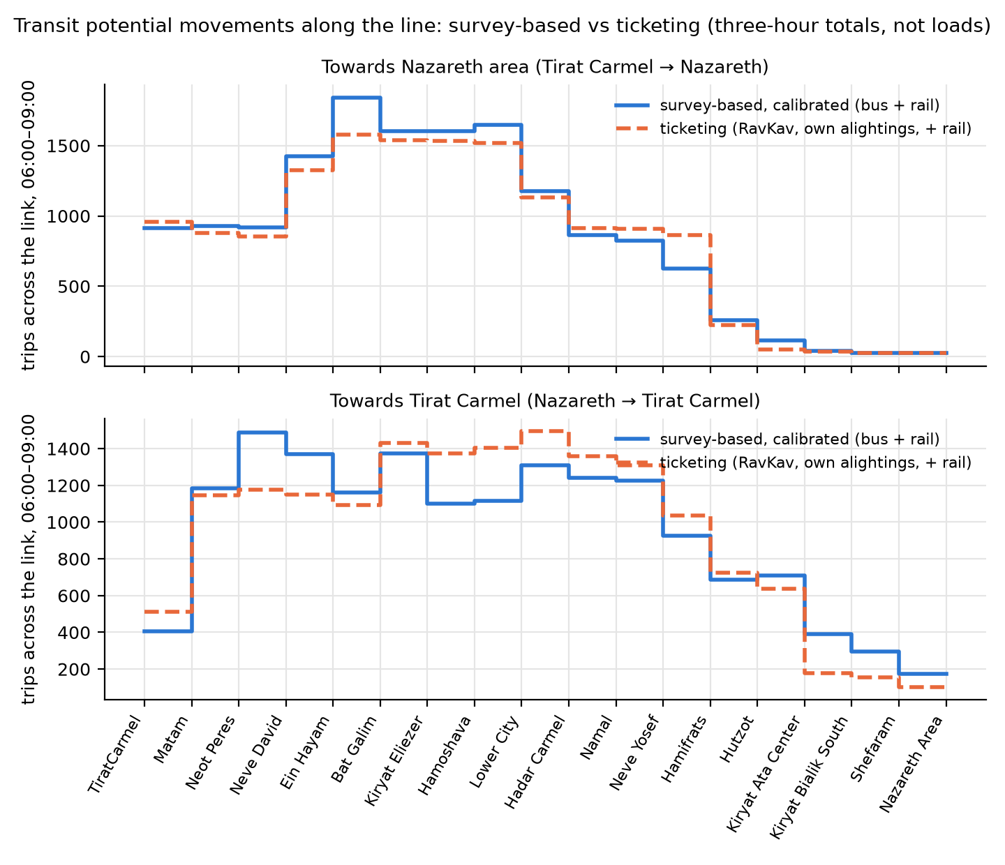
Figure 4. Transit potential movements (bus + rail) along the line, both directions, three-hour totals: survey-based (calibrated) against ticketing on RavKav’s own alightings. Potential movements, not loads.

7.3 The peak hour
Everything above is a three-hour total. The survey records the departure time of every trip to the minute, so the busiest hour can be found directly. Trips were binned in 15-minute intervals over 06:00–09:00; the peak hour is the 60-minute window, in 15-minute steps, that holds the largest share of trips. Two factors describe it: the share of the three hours that falls in the peak hour (an average hour would be 0.333), and the conventional within-hour factor, peak-hour trips divided by four times the busiest quarter-hour (1.0 means a flat hour).
Layer | Peak hour | Share of the 3 hours (study area) | Within-hour factor | Corridor, towards Nazareth (sampled trips) | Corridor, towards Tirat Carmel (sampled trips) | Factor applied
Car | 07:00–08:00 | 0.62 | 0.69 | 0.66 (194) | 0.63 (236) | corridor, by direction
Bus | 07:00–08:00 | 0.59 | 0.77 | 0.68 (83) | 0.57 (44) | study area, 0.59
Taxi-type | 07:00–08:00 | 0.59 | 0.66 | — (0) | 0.93 (7) | study area, 0.59
Rail | 06:15–07:15 | 0.56 | 0.58 | — | — | the bus factor
Peak-hour factors from survey departure times. Household-bootstrap ranges (5th–95th percentile) for the corridor car factors are 0.51–0.81 and 0.47–0.75; for the corridor bus factors 0.59–0.85 and 0.45–0.84.
The peak hour is the same everywhere: 07:00–08:00, with corridor car trips towards Nazareth a quarter-hour later (07:15–08:15) and a third of them still departing after 08:00. It carries about 1.8 times an average hour.
Which factor to apply is a question of sample size. The corridor car trips are numerous enough (about 200 per direction) for a factor per direction. The corridor bus trips are not: 83 and 44 sampled trips give factors of 0.68 and 0.57 whose bootstrap ranges overlap almost entirely, so the bus and taxi-type layers take the study-area factors (0.59 on 1,790 bus trips and 0.59 on 99 taxi-type trips) and rail takes the bus factor. A finer split, one factor per link, is not supported either: only a handful of link-directions, all car, reach 30 sampled trips.
Busiest transit link, peak hour | Towards Nazareth | Towards Tirat Carmel
Average hour (three hours ÷ 3) | 614 | 496
Study-area bus factor, 0.589 (applied) | 1,085 | 876
Corridor pooled bus factor, 0.570 | 1,051 | 849
Corridor direction bus factor | 1,256 (0.682) | 852 (0.573)
Peak-hour transit potential movements on the busiest link under four bus-factor bases. Full table in peak_hour_sensitivity.csv.
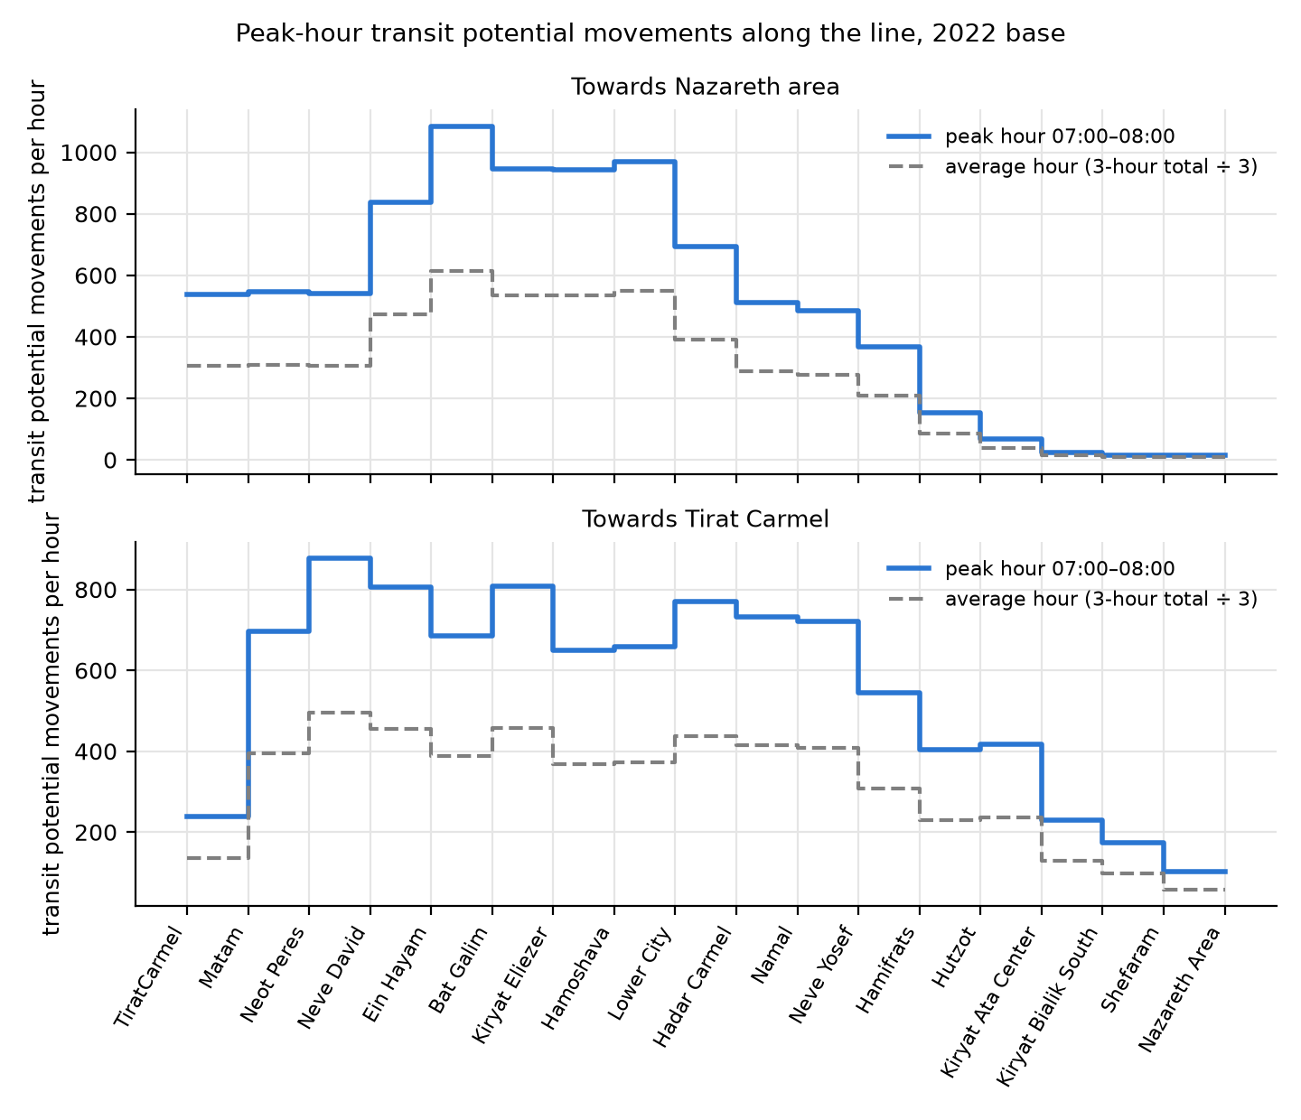
Figure 5. Peak-hour transit potential movements along the line, with the average hour dashed.
What to conclude. First, an average-hour reading of the three-hour profiles understates the survey’s design hour by about 45 %; any capacity or frequency reasoning should start from peak-hour values. Second, the peak-hour transit figures on the Haifa trunk, roughly 900–1,100 potential movements per direction in the busiest hour, are the size of the market between line areas, not a load: they still contain travellers who cannot reach a station conveniently, who would keep a parallel bus, or whose trip crosses the link outside the departure hour. Third, the choice of bus factor basis moves the busiest link by up to 16 %, less than the coverage threshold moves the bus volumes. Fourth, the survey’s peak is probably too sharp, as Part F shows: counts and boardings put less of the morning into the busiest hour.

8. Part F — tests against independent data
The survey matrices were tested against two sources that are not part of the survey: smart-card ticketing, and road traffic counts. The first test is on the bus layer, the second on the car layer.

8.1 The survey against ticketing: RavKav 2022 and 2025
The test suite of Part B (cosine, GEH, KS, MSSIM, PCA) was applied to the survey’s bus matrix against the May 2022 RavKav journeys and the 2025 extracts, each on two destination patterns: RavKav’s own inferred alightings and the on-board survey’s pattern. The survey’s two days are the repeatability reference, and a permuted geography is the chance level.
Pair (superzone level) | Cosine | GEH < 5 (flow-weighted) | KS D (TAZ) | MSSIM (log, w 3) | PCA overlap (k 20)
Survey day 1 vs day 2 (reference) | 0.89 | 0.46 | 0.04 | 0.77 | 0.83 (p 0.002)
Survey bus 2018 vs RavKav 2022, on the on-board pattern | 0.62 | 0.21 | 0.21 | 0.22 | 0.62 (p 0.13, at the null)
Survey bus 2018 vs RavKav 2022, own alightings | 0.89 | 0.31 | 0.05 | 0.50 | 0.81 (p 0.002)
Survey bus 2018 vs RavKav 2025, own-alighting pattern | 0.88 | 0.29 | 0.05 | 0.24 | —
Survey bus 2022 (calibrated) vs RavKav 2025 | 0.87 | 0.58 | 0.11 | 0.77 | 0.87 (p 0.002)
Survey against ticketing, 06:00–09:00, both ends in the 778 study TAZs. KS bootstrap band for the survey vs RavKav own alightings: 0.03–0.10.
- The survey’s bus matrix and RavKav’s own alightings share the same destination structure, to within the survey’s day-to-day noise: cosine 0.89 against 0.89, PCA overlap 0.81 against 0.83, KS D 0.05 inside the household bootstrap band. This comparison is made before any calibration, so it is independent of the calibration rule.
- The on-board pattern shares no destination structure with the survey beyond chance (PCA p 0.13) and carries trips twice as long (median 6.4 km against 3.2–3.6 km). The on-board pattern, not the ticketing volume, is what separates the ticketing products from the survey. This is why the calibration of Part C was rebuilt on RavKav’s own alightings.
- The calibrated 2022 layer reproduces the 2025 boarding pattern. On the 28 sub-areas it scores cosine 0.97 and 91 % of flow within GEH 5 against the 2025 ticketing, against the survey’s own day-to-day 69 %; totals are within 2 %. Its trips are longer than the raw survey’s (KS D 0.11 against the 2025 ticketing, where the raw survey scores 0.05) because the coverage rule takes ticketing volumes on the inter-superzone segments and keeps the survey’s on the guarded local ones.
- RavKav 2022 and 2025 are the same matrix scaled on RavKav’s own alightings (cosine 0.99): 2025 boardings are 1.08 times 2022 study-wide and 1.12 times on the V2 areas. The 2025 layer takes the 2022 alighting pattern by construction, so this checks the boardings, not the alightings.
- Rail. The 2019 station matrix (× 0.793) and the 2025 station matrix agree on their 14 common station TAZs at cosine 0.97, with 2025 carrying twice the trips (1,799 → 3,652). The survey’s door-to-door rail layer against either station matrix scores only 0.4–0.6: the home-superzone frame is not the station frame.
Limits. The frames differ inside every pair (residents’ door-to-door journeys against all riders’ stop-to-stop journeys; for 2025, tag-defined journey origins). The 2025 extracts carry no alightings of their own, so the base was not re-anchored on 2025; two readings of the on-board survey remain possible (it over-represents long lines, or RavKav’s inferred alightings truncate journeys at the next boarding) and the data cannot choose between them.

8.2 The car layer against road traffic counts
A network delivered on 23 September 2026 carries hourly traffic counts in passenger-car equivalents on 3,241 directional links at 698 count stations (dated 2017–2023). The 2022 car layer was compared with them without an assignment, on six closed cordons: a closed cordon is crossed once by every trip with one end inside and one outside, whatever its route. On the demand side the car person-trips are converted to vehicles with the survey’s own morning occupancy (1.33) and through trips (both ends outside, the straight line crossing the cordon) are added. On the count side every car link crossing the cordon is summed, links without a count take the median per lane of the counted links of the same road type, and PCE is converted to vehicles at 1.10.
Cordon | Inbound: survey ÷ count | Outbound: survey ÷ count | Share of the count on counted links (in / out)
Haifa city | 0.80 | 0.48 | 0.32 / 0.30
Krayot | 0.75 | 1.09 | 0.25 / 0.16
Kiryat Ata + Zevulun | 0.66 | 0.90 | 0.56 / 0.58
Nazareth + Nof HaGalil | 0.71 | 0.99 | 0.17 / 0.22
Tirat Carmel | 0.58 | 0.70 | 0.90 / 0.91
Metropolitan core | 0.62 | 0.61 | 0.62 / 0.59
Survey vehicles ÷ counted vehicles, 06:00–09:00. Occupancy 1.33 and PCE 1.10; other occupancy and PCE assumptions move each ratio by about 0.1 either way.
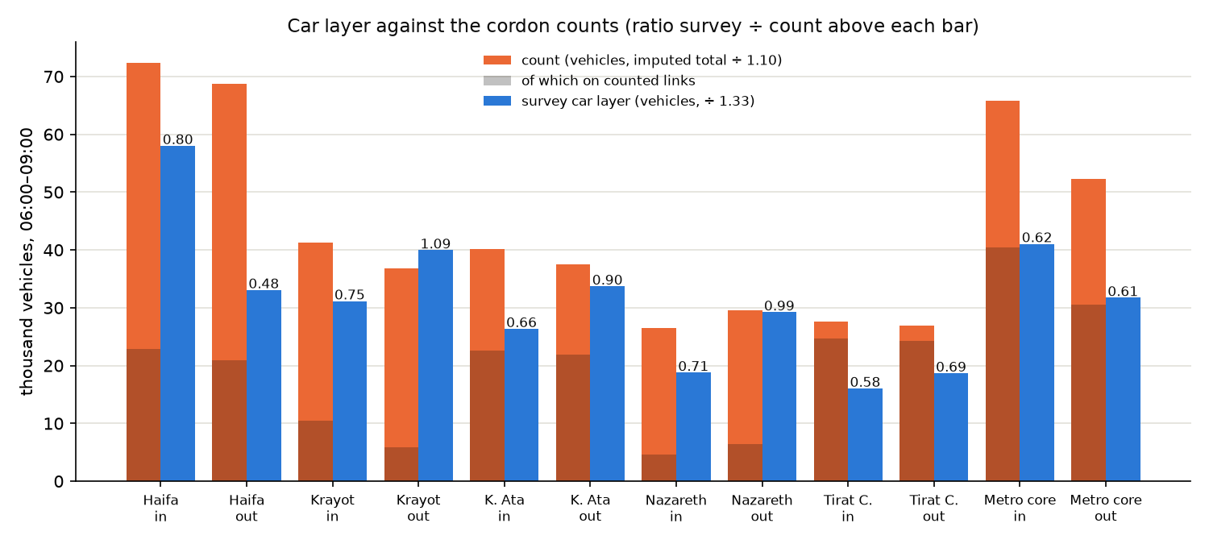
Figure 6. The car layer against the cordon counts: counted vehicles (orange, darker where the links are counted), survey vehicles (blue) and the ratio above each pair.
- Where the crossing links are mostly counted (Tirat Carmel, the metropolitan core, Kiryat Ata), the residents’ car layer is 0.58–0.90 of the counted vehicles, and 0.61–0.66 on the two cordons that enclose the corridor’s market. That is the expected order for a layer of residents’ personal trips against all traffic: trucks and vans, taxis, buses, non-residents, trips with one end outside the study area and the through traffic on Roads 2, 4, 70 and 79 are not in it.
- The Krayot and Nazareth cordons are 75–85 % imputed; their ratios (0.71–1.09) say more about the imputation than about the layer.
- Direction. On links counted in both directions the survey’s inbound share agrees with the counts within 0.08 on five of the six cordons. At the Haifa city cordon the survey is more Haifa-bound (0.64 inbound against 0.47 counted).
- The counts’ morning is much flatter than the survey’s. The busiest clock hour holds 0.38–0.43 of 06:00–09:00 on the road, against 0.62 of the survey’s car departures; RavKav boardings give 0.43–0.48 for transit (bus 0.475, Metronit 0.433) against the survey’s 0.59. The survey’s peak-hour factors are therefore an upper bound.
Limits. This is a cordon-total test, not a link-level one: an all-or-nothing assignment of the car layer to the 3,241 counted links is the next check. The counts are dated 2017–2023 (mostly 2017 and 2021), not 2022.

9. What to keep in mind
- Two frames. Ticketing journeys start at the boarding stop and include non-residents; survey trips start at the front door and cover residents. The calibrated volumes lean towards boardings at transfer hubs and towards doorsteps elsewhere.
- Ticketing coverage. The extract under-records bus travel in many peripheral and Arab-sector superzones. The segmented rule protects that market while taking ticketing volumes where coverage is credible. Its threshold is an assumption (bus base 96,000–129,500 across 0.3–0.7), and the cause of the gap is with the data provider: which operators, cash fares and unvalidated boardings the extract covers.
- Nazareth branch. The two alighting inferences disagree by a factor of 13 for Nazareth’s journeys towards Haifa. A bus passenger count would settle it.
- Taxi-type. A separate layer; do not add it to an LRT market by default.
- Trip rates are frozen. Growth to 2022 keeps 2018 trip rates and uses a forecast trend, not observed 2022 data. Changes in age structure, car ownership or working from home are not represented.
- TAZ detail is synthetic and purpose-blind. Below the 1,250-zone level the survey’s TAZ detail is a population / employment split. Superzones and sub-areas are the fair level. A purpose split (work, education, other) is on the task list.
- Corridor profiles are potential movements. Three-hour totals and peak-departure-hour values between line areas, without station access, route choice or off-line trips.
- Peak-hour factors are an upper bound. The survey’s departure profile is peakier than the road counts and the ticketing boardings.
- Residents with both ends in the study area. Trips with one end outside (about 5 % of the weight) and through traffic are not in the layers; the car layer is not a vehicle-demand matrix.
- The 2025 ticketing layer is a test, not the anchor. It has no alighting inference of its own, its transfer tag’s unit is unresolved, and there is no 2025 car observation.
- Forecasts. The 2040 / 2050 scenario sets are built on this base (step 23) with demographic growth only; behaviour change (ageing, telework, car ownership) is not yet an explicit layer.

10. Conclusion — are the matrices fit for the LRT corridor demand assessment?
Short answer. Yes for the stage the matrices were built for: screening-level assessment of the corridor market. The matrices can be used to compare and rank alignment options and line segments, to size and locate the transit market between the line areas, and to feed capture scenarios with a stated range. They should not be used, as they stand, for passenger loads, capacity or frequency sizing, station-level demand, a single patronage forecast or economic appraisal.

10.1 What supports the use
- The base is built from one coherent source with the right unit. The 2017/18 survey gives residents’ person-journeys with a household expansion, by mode, at TAZ level, with a stable structure at superzone and area level (day 1 vs day 2 cosine 0.996 at superzones).
- The bus layer is anchored to an independent census where the census is credible. Before any calibration the survey’s bus matrix shares the destination structure of RavKav’s own alightings to within the survey’s own noise (cosine 0.89 against 0.89), and the calibrated 2022 layer reproduces the 2025 boarding pattern between sub-areas (cosine 0.97). On the Haifa trunk the survey-based and ticketing transit profiles agree to within about ±30 % link by link (about ±6 % over the Haifa segment).
- The car layer is of the right order of magnitude. On the closed cordons that enclose the corridor’s market it is 0.61–0.66 of the counted vehicles, which is what a residents-only layer should show, and its directional split agrees with the counts within 0.08 on five of six cordons.
- The transit market has its own destination structure. The tests show that car and transit share the dominant structure but that transit is less local and more Haifa-bound; the base keeps a transit-specific pattern instead of scaling the car matrix, which is what a Haifa-oriented line needs.
- The limits are measured, not assumed. The coverage threshold, the bus-factor basis, the peak-hour factor and the mode-code correction have each been tested and their effect on the corridor numbers is known.

10.2 What the matrices can be used for
Use in the corridor assessment | Verdict | Basis and condition
Ranking alignment options and line segments by the market between line areas | Fit (screening) | Corridor profiles from two sources agree on the trunk; use ratios between options rather than absolute counts.
Locating demand: which areas, which pairs, which direction | Fit at superzone and area level | Survey structure matches ticketing within noise; TAZ detail is an allocation and should not be read cell by cell.
Sizing the corridor-internal transit market | Fit as an order of magnitude, with a range | Bus base 96,000–129,500 across the coverage threshold; 12–13 % bus share of corridor-to-corridor trips. Quote the range, not the central value alone.
Base market for the LRT capture model (mode-shift scenarios, 2040 / 2050 sets) | Fit, with stated assumptions | The capture runs on the 25 V2 areas with an assumed λ (0.03; person-level estimate 0.035); the central underground case is 4,250 trips in 06:00–09:00 (3,207 ground, 5,095 in the design regime). Read as a scenario range, not a forecast.
Design-hour scaling of the market | Fit as an upper bound | Survey peak factors (car 0.62, bus 0.59) exceed the counts (0.38–0.43) and boardings (0.43–0.48); the design hour may be up to a third lower for car and about a fifth lower for bus.
Car demand level on the corridor | Partly fit | Residents’ layer only, 0.58–0.90 of counted vehicles; not a vehicle-demand matrix. A link-level assignment check is still to be done.
The Nazareth branch | Not yet fit | The two alighting inferences differ by a factor of 13; needs a bus passenger count.
Station-level or TAZ-level demand, access and egress | Not fit | TAZ detail is a population / employment split, purpose-blind; no station access or route choice in the matrices.
Passenger loads, capacity and frequency sizing | Not fit | Potential movements, not loads; no external validation of bus loads.
A single ridership forecast; economic appraisal | Not fit | No low / base / high band across the full design; trip rates frozen; capture parameters (λ_T, premium) not identified from data.

10.3 Conditions for use
- Quote results with their range (coverage threshold, bus-factor basis, λ) and label them as potential movements or scenario captures.
- Use superzone, area and V2-area figures; do not read TAZ cells as observations.
- Treat the Nazareth branch separately until a count is available, and keep the taxi-type layer apart from transit.
- Carry the survey’s peak-hour factors as the upper bound, with a count- and boarding-based case beside them.

10.4 What would raise the fitness
- Bus passenger counts on the Haifa trunk and the Nazareth branch by section, direction and hour: validates the transit base and settles the Nazareth branch.
- The RavKav definitions (operators, cash fares and unvalidated boardings in the 2022 extract; the meaning of the 2025 transfer tag): replaces the coverage threshold by a coverage model, and allows re-anchoring on 2025.
- A link-level assignment check of the car layer against the 3,241 counted links, and a design-hour case on the observed factors.
- Branch alignments, the underground / ground regime, headways and the opening-year bus network from the planning team: replaces the feeder assumptions for the off-trunk areas.
- A designed uncertainty experiment over the coverage threshold, LRT regime, headway, λ, premium and walk and car sources: turns the central case with whiskers into a low / base / high band.

11. Files
Notebook | What it does | Main outputs
THS_2017_cosine_GEH_tests.ipynb | Cosine and GEH tests, scale audit, corridor classes | Output/ths2017/tests/cosine_geh_summary.csv and detail tables
THS_2017_KS_tests.ipynb | Trip-length and concentration KS tests with bootstrap | Output/ths2017/tests/ks_summary.csv and detail tables
THS_2017_MSSIM_tests.ipynb | Structural similarity by window, scale and ordering | Output/ths2017/tests/mssim_headline.csv, mssim_summary.csv
THS_2017_PCA_car_vs_transit.ipynb | PCA within the survey, car vs transit: overlap, cross-projection, component matching, divergence | Output/ths2017/tests/pca_car_vs_transit_*.csv
THS_2017_two_mode_matrix.ipynb | Survey-only car / transit matrix; bus calibrated per origin × segment on RavKav’s own alightings; variants and threshold sweep | Output/ths2017/two_mode/: car_taz.csv, transit_taz.csv, bus_calibrated_taz.csv, bus_calibration_factors_segments.csv, …
THS_2017_three_mode_2022.ipynb | Move to 2022; split into car, bus, taxi-type, rail | Output/ths2017/three_mode_2022/: {car,bus,taxi,rail}_2022_{taz,sz,area}.csv, all_modes_2022_taz.csv
Corridor_flow_profile_survey_2022.ipynb | Potential movements along the line: total, transit, taxi-type | corridor_link_flows_{total,transit,taxi}_2022.csv
Corridor_profile_hybrid_vs_ticketing.ipynb (file name kept from an earlier revision) | Calibrated survey vs ticketing profile, components, pair contributions, coverage split | corridor_profile_hybrid_vs_ticketing.csv, corridor_profile_coverage_local_vs_intercity.csv
Corridor_peak_hour_2022.ipynb | Peak-hour factors from survey departure times; peak-hour link profiles; bootstrap and sensitivity | peak_hour_factors*.csv, corridor_link_flows_peak_hour_2022.csv, peak_hour_sensitivity.csv
THS_vs_RavKav_2025_tests.ipynb (diagnostics) | The test suite of Part B against RavKav 2022 and 2025 | Output/ths2017/tests/ravkav2025_*.csv
Car_cordon_counts_validation.ipynb (diagnostics) | The car layer against road counts on six closed cordons | Output/validation/car_cordon_counts.csv
Full method details, with every number, are in METHODOLOGY.md sections 6j to 6ah of the repository; section 0 there lists every published file with its base, geography, modes, vintage and status.

